Before the
Federal Communications Commission
Washington, D.C. 20554

In the Matter of  Loral Satellite, Inc.  (Debtor-in-Possession) and  Loral SpaceCom Corporation  (Debtor-in-Possession), Assignors  and  Intelsat North America, LLC, Assignee  Applications for Consent to Assignments of Space Station Authorizations and  Petition for Declaratory Ruling Under  Section 310(b)(4) of the Communications Act of 1934, as Amended | )  )  )  )  )  )  )  )  )  )  )  )  )  )  )  )  ) | File Nos.  SAT-ASG-20030728-00138  SAT-ASG-20030728-00139  ISP-PDR-20030925-00024

ORDER AND AUTHORIZATION

Adopted: February 11, 2004 Released: February 11, 2004

By the Chief, International Bureau

iNTRODUCTION
- In this Order and Authorization, we grant, subject to certain conditions, the Applications filed by Loral Satellite Inc. (Debtor-in-Possession or “DIP”) (“Loral Satellite”), and Loral SpaceCom Corporation (DIP) (“Loral SpaceCom”), (collectively, “Assignors”) and Intelsat North America, LLC (“Intelsat North America” or “Assignee” and together with Assignors, “Applicants”) seeking authority to assign five non-common carrier space station licenses to Intelsat North America. We also grant, subject to the limitations specified herein, the request to change these non-common carrier licenses to dual-use licenses and thus permit Intelsat North America to hold all five space station licenses on both a common carrier and non-common carrier basis. We conclude, pursuant to our review under Section 310(d) of the Communications Act of 1934, as amended (the “Communications Act” or “Act”), that approval of this Application as provided for in this Order and Authorization, will serve the public interest, convenience, and necessity.
- In addition, we find that the proposed assignment of the licenses, subject to the limitations specified herein, is permissible under the Open-Market Reorganization for the Betterment of International Telecommunications Act (“ORBIT Act”) and the foreign ownership provisions of Section 310(b)(4) of the Communications Act. Finally, we condition our grant of authority on compliance with the conditions set forth in the petition filed by United States Department of Justice (“DOJ”), the Federal Bureau of Investigation (“FBI”) and the Department of Homeland Security (“DHS”) (collectively, the “Executive Agencies”).

Background

The Applicants

Assignors
- The Assignors, Loral Satellite and Loral SpaceCom, are both U.S. companies and wholly owned subsidiaries of Loral Space & Communications Corporation (DIP), a U.S. company, which in turn is a wholly owned subsidiary of Loral Space & Communications, Ltd. (DIP) (“Loral Ltd.”), a Bermuda based company. Loral Ltd., through its various subsidiaries and affiliates, is engaged in the satellite services and manufacturing businesses. The Applicants state that Loral’s global fleet of telecommunications satellites is used by television and cable networks to broadcast video programming, and by communications service providers, resellers, corporate and government customers for broadband data transmission, internet services and other value-added communications services.
- Loral Ltd., through its subsidiaries, holds numerous Commission licenses, including space station and Earth station authorizations. Two of Loral Ltd.’s subsidiaries, Loral Satellite and Loral SpaceCom, hold space station authorizations for satellites at orbital locations that are capable of serving the continental United States (“CONUS”). These satellites currently are authorized to operate, or are planned to operate, in the 77° W.L. (Telstar 4), 89° W.L. (Telstar 8), 93° W.L. (Telstar 6), 97° W.L. (Telstar 5) and 129° W.L. (Telstar 7) orbital locations. In addition, Loral SpaceCom’s Telstar 13 satellite at 121° W.L., licensed by Papua New Guinea, has been added to the Commission’s Permitted Space Station List. Other Loral Ltd. subsidiaries that hold Commission authorizations are Loral Orion, Inc. (DIP), CyberStar Licensee, LLC (DIP), and Loral Skynet Network Services, Inc. (DIP). Loral SpaceCom also holds numerous Earth station licenses.
- On July 15, 2003, Loral Ltd., and certain of its subsidiaries, filed for Chapter 11 bankruptcy protection in the United States Bankruptcy Court for the Southern District of New York (“Bankruptcy Court”). On the same day, Loral Ltd., and its wholly-owned subsidiaries, Loral SpaceCom and Loral Satellite, entered into an Asset Purchase Agreement to sell certain of their satellite assets, subject to certain approvals, to Intelsat, Ltd. and Intelsat (Bermuda), Ltd. As indicated in the Assignment Application, Loral plans to continue to hold Commission space station and Earth station authorizations not included in this Assignment Application, and will reorganize with a focus on its satellite manufacturing business and its remaining satellite fleet.

Assignee
- The Assignee, Intelsat North America, is a Delaware limited liability company with a holding company ownership structure. Intelsat North America is wholly owned and controlled by Intelsat LLC, a Delaware limited liability company, which in turn is wholly owned and controlled by Intelsat Holdings LLC, also a Delaware limited liability company. Intelsat Holdings LLC is wholly owned by Intelsat (Bermuda), Ltd., a company incorporated under the laws of Bermuda. Intelsat (Bermuda), Ltd. is wholly owned by Intelsat, Ltd., also a company incorporated under the laws of Bermuda. A list of shareholders that hold interest in Intelsat, Ltd. is provided in Appendix B.
- The Intelsat entities that are part of the holding company ownership structure described above were created as part of the International Telecommunications Satellite Organization’s (“INTELSAT’s”) efforts to privatize. The Commission granted conditional licensing authority to Intelsat LLC, a privatized successor entity of INTELSAT, allowing Intelsat LLC to hold U.S. authorizations for INTELSAT’s existing satellites, planned satellites, and planned system modifications associated with INTELSAT’s frequency assignments in the fixed satellite services C- and Ku-bands existing as of privatization. The Commission permitted Intelsat LLC’s licenses to become effective upon the transfer of INTELSAT’s satellites and associated assets to Intelsat LLC and the transfer of its ITU network filings to the U.S. registry, based on its finding that, although the initial public offering (“IPO”) required under the privatization requirements of the ORBIT Act had not yet been completed, INTELSAT had privatized in a manner consistent with the privatization provisions of the ORBIT Act.
- Until the IPO process is complete, however, Intelsat remains subject to certain restrictions and limitations of the ORBIT Act, and its licenses are subject to a future Commission finding that Intelsat, Ltd. has conducted an IPO as required under Sections 621(2) and (5)(A) of the ORBIT Act. The deadline by which Intelsat, Ltd. is required to conduct an IPO is June 30, 2004. As required by the ORBIT Act, if the IPO is not conducted by June 30, 2004, to achieve “substantial dilution” of ownership by former INTELSAT Signatories, the Commission must “limit through conditions or deny” any pending application or request, and “limit or revoke previous authorizations” for Intelsat LLC’s non-core services consistent with Section 601(b)(i) of the ORBIT Act.

The Proposed Assignment Transaction
- The Applicants seek Commission approval to assign to Intelsat North America, the space station authorizations for Telstar 6 and Telstar 7, held by Loral Satellite, and Telstar 4, Telstar 5 and Telstar 8, held by Loral SpaceCom. Telstar 5, Telstar 6, and Telstar 7, are C/Ku band satellites and currently provide North American coverage at 97° W.L., 93° W.L., and 129°W. L., respectively. Telstar 8, a C/Ku/Ka-band satellite, is currently under construction, and is to be located at 89° W.L. and launched in September 2004. Telstar 4 experienced an in-orbit failure in September 2003; however, the authorization for Telstar 4 will be conveyed as part of the assignment.
- The proposed assignment also involves Telstar 13, which is licensed by Papua New Guinea. Telestar 13 is on the Commission’s Permitted List, which is a listing of all satellites with which U.S. Earth stations with routinely-authorized technical parameters in the conventional C- and Ku-band (known as “ALSAT” Earth stations) are permitted to communicate without additional Commission action, provided that those communications fall within the same technical parameters and conditions established in the Earth stations’ original licenses. The Applicants intend that Intelsat North America become the party in interest for Telstar 13, and state that at the appropriate time, Intelsat North America will notify the Commission of the assignment of Telstar 13 in accordance with the Commission’s procedures for changes of ownership of satellites on the Permitted List.
- The Applicants also seek Commission authorization to change the regulatory classification of the Loral space stations at issue from their current non-common carrier status to dual-use, common carrier/non-common status. In addition, Intelsat North America requests a declaratory ruling that the assignment is in the public interest, notwithstanding the indirect foreign ownership of Intelsat North America in excess of the twenty-five percent benchmark set by Section 310(b)(4) of the Act.
- In addition, the Applicants note that Loral has several pending applications before the Commission that relate to the five satellites involved in the Assignment Application. The Applicants request, that to the extent any of these applications remain pending after the Commission approves the assignment, we dispose of them in Intelsat North America’s name. The Applicants request similar treatment for any applications Loral files in the period after the assignment is approved but before it is consummated.
- The Applicants state that the proposed transaction will benefit the public by ensuring the continued availability of services while promoting competition in various market segments. According to the Applicants, the assignment will promote competition in the domestic C-band, Ku-band and Ka-band businesses. In particular the Applicants contend, the proposed assignment would allow for a new provider of domestic video distribution services in a market with high entry barriers due to the limited number of orbital slots. The Applicants also state that the combination of the Assignors’ domestic satellites with Intelsat North America’s existing international fleet will allow Intelsat North America to offer customers “one stop shopping,” thus enhancing competition in international markets. In addition, the Applicants claim the assignment will serve the purposes of the ORBIT Act by promoting a “fully competitive global market for satellite communications services.” The Applicants further state that the assignment will enable Loral Ltd. to reorganize around its remaining fleet of satellites and its satellite manufacturing operations, and thereby strengthen Loral’s ability to compete in the U.S. satellite manufacturing sector and to remain a competitor in the international satellite business.
- Upon approval and completion of the proposed assignment, Intelsat Global Services Corporation (“IGSC”), a Delaware company ultimately owned by Intelsat, Ltd., will, pursuant to a contract with Intelsat North America, provide the technical services required to operate the satellites and related assets acquired by Intelsat North America from Loral Satellite and Loral SpaceCom. In this capacity, IGSC will have operational control over the satellites and other infrastructure used for domestic communications.
- On July 28, 2003, the Applicants filed the instant Assignment Application for consent to assign space station authorizations held by Loral Satellite and Loral SpaceCom, pending the Bankruptcy Court’s approval of the Asset Purchase Agreement. As contemplated in the Asset Purchase Agreement and the instant Assignment Application, upon appropriate approvals of the proposed assignment and consummation of the transaction, the licensee for these satellites will be Intelsat North America, an indirect U.S. subsidiary of Intelsat, Ltd. The Bankruptcy Court approved the Asset Purchase Agreement on October 30, 2003.
- On August 15, 2003, the International Bureau (“Bureau”) issued a public notice, announcing that the Assignment Application was accepted for filing. This public notice also established a pleading cycle to permit interested parties an opportunity to comment on the Application. In response to the public notice, SES AMERICOM, Inc. (“SES AMERICOM”) filed comments and EchoStar Satellite Corporation (“EchoStar”) filed a petition to deny the Application. The Applicants filed oppositions to these pleadings and SES AMERICOM and EchoStar filed replies. At the Bureau’s request, Intelsat North America filed a Petition for Declaratory Ruling under Section 310(b)(4) to supplement the pending Application. EchoStar filed a petition to dismiss or deny the Petition for Declaratory Ruling. Thereafter, on October 28, 2003, EchoStar filed a notice of withdrawal of all of its pleadings in this proceeding. In addition, we received and considered other correspondence concerning this matter, including a submission by SES AMERICOM of the General Accounting Office (“GAO”) report on procurement processes at the U.S. Department of Defense relating to commercial satellite capacity, letters from members of Congress, a Petition to Adopt Conditions filed by the Executive Agencies, an ex parte letter from StarBand Communications, Inc. (“StarBand”), a late-filed Petition from StarBand, a filing from Loral in opposition to StarBand’s Petition, a reply from StarBand to Loral’s opposition, and a letter from Intelsat North America regarding its commitment to ensure service continuity to certain existing areas and customers of StarBand. These filings are part of the record in this proceeding.

DISCUSSION

Public Interest Standard and Framework For Analysis
- In considering the proposed transaction, the Commission must determine pursuant to Section 310(d) of the Act, whether the proposed assignment of Commission licenses and authorizations will serve the public interest. In addition, because of the foreign ownership interests presented in this case, we must determine whether the proposed assignment of licenses to Intelsat North America is permissible under the foreign ownership provisions of Section 310 (a) and (b) of the Act.
- The legal standards that govern our public interest analysis under Section 310(d) require that we weigh the potential public interest harms against the potential public interest benefits to ensure that, on balance, the proposed transaction will serve the public interest, convenience, and necessity. Our analysis considers the likely competitive effects of the proposed assignment and whether such assignment raises significant anti-competitive issues. We also consider the efficiencies and other public interest benefits that are likely to result from the proposed assignment. Our public interest analysis also considers whether the applicant has the requisite “citizenship, character, financial, technical and other qualifications” to hold a Commission license. In addition, where presented in transfer or assignment transactions, we consider issues of national security, law enforcement, foreign policy and trade policy, including such concerns that may be raised by the Executive Branch.

Qualifications
- As a threshold matter, we must determine whether the Applicants meet the requisite qualifications under Section 310(d) of the Act and our rules. Section 310(d) provides that no Title III license may be transferred, assigned, or disposed of in any manner except upon a finding by the Commission that “the public interest, convenience and necessity will be served thereby.” Among the factors the Commission considers in its public interest review is whether the applicant for a license has the requisite “citizenship, character, financial, technical, and other qualifications.” In general, when evaluating transfers of control or assignments under Section 310(d), we do not re-evaluate the qualifications of the transferor or assignor. Consistent with this general practice, we note that no issues have been raised in this case that would require us to re-evaluate the basic qualifications of the Assignors. Accordingly, we find that Loral Satellite and Loral SpaceCom are qualified to assign the authorizations in this proceeding.
- As to the qualifications of the Assignee, Section 310(d) requires that the Commission consider the qualifications of the proposed Assignee as if the Assignee had applied for the license directly under Section 308 of the Act. Our review of Intelsat North America’s qualifications includes examination of whether Intelsat North America has the requisite “citizenship, character, and financial, technical, and other qualifications” we require of all applicants for a Commission license. No party has challenged the basic qualifications of Intelsat North America, and based on our review of the record in this proceeding, we find no evidence to suggest that Intelsat North America lacks the basic qualifications to hold the space station authorizations currently held by the Assignors. Accordingly, we find that Intelsat North America is qualified as an Assignee.

Foreign Ownership and Section 310(b)(4) Ruling
- In this section, we address issues relevant to our public interest inquiry under the foreign ownership provisions of Section 310 of the Act. Section 310(b)(4) of the Act establishes a twenty-five percent benchmark for indirect, attributable investment by foreign individuals, corporations, and governments in U.S. common carrier radio licensees, but grants the Commission discretion to allow higher levels of foreign ownership if it determines that such ownership is not inconsistent with the public interest. Intelsat North America, although not providing service at this time on a common carrier basis, seeks to hold dual-use non-common carrier and common carrier space station authorizations. Applicants identify proposed indirect foreign investment in Intelsat North America that would exceed the twenty-five percent benchmark set by Section 310(b)(4). Our review, therefore, considers the proposed assignment of these dual-use licenses to Intelsat North America under this Section of the Act. For the reasons discussed below, we conclude that it would not serve the public interest to deny the Assignment Application because of the identified indirect foreign ownership of Intelsat North America.
- In the Foreign Participation Order, the Commission concluded that the public interest would be served by permitting greater investment by individuals or entities from World Trade Organization (“WTO”) Member countries in U.S. common carrier and aeronautical fixed and en route licensees. With respect to indirect foreign investment from WTO Members, the Commission replaced its “effective competitive opportunities,” or “ECO,” test with a rebuttable presumption that such investment generally raises no competitive concerns.
- As discussed in Section II.A above, Intelsat North America is ultimately owned by Intelsat, Ltd., a Bermuda company. Specifically, Intelsat North America is wholly owned by Intelsat LLC, a Delaware limited liability company. Intelsat LLC is, in turn, wholly owned by Intelsat Holdings LLC, also a Delaware limited liability company. Intelsat Holdings LLC is wholly owned by Intelsat (Bermuda), Ltd., which, in turn, is a direct, wholly-owned subsidiary of Intelsat, Ltd. Both Intelsat (Bermuda), Ltd. and its parent, Intelsat, Ltd., are foreign companies organized under the laws of Bermuda.
- The Commission has previously reviewed and approved the indirect foreign ownership of Intelsat North America’s direct parent, Intelsat LLC, in the Intelsat LLC Licensing Order and, most recently, in the Lockheed/Comsat/Intelsat Order, issued by the International Bureau. The Bureau found in the Lockheed/Comsat/Intelsat Order that Intelsat LLC’s ultimate parent, Intelsat, Ltd., and Intelsat, Ltd.’s subsidiary holding company, Intelsat (Bermuda), Ltd., principally conduct business in and from Bermuda and other WTO Member countries. The Bureau also found that the vast majority of foreign equity and voting interests in Intelsat, Ltd. were held by investors from WTO Member countries.
- Intelsat North America asserts in its Petition for Declaratory Ruling that the ownership of Intelsat LLC has not materially changed since the Bureau issued its decision in the Lockheed/Comsat/Intelsat Order. In support, Intelsat North America has provided for the record current shareholder information for Intelsat, Ltd., the ultimate parent of both Intelsat North America and Intelsat LLC. According to the shareholder information, Lockheed Martin, a U.S. company, continues to hold more than 20 percent of the total Intelsat, Ltd. shares, with the remaining interests still widely dispersed among more than 220 entities from more than 145 nations. Intelsat North America also represents that the collective foreign equity and voting interests held by entities from countries that are non-WTO Members is still well below the 25 percent threshold established by the Foreign Participation Order for non-WTO Member investment in U.S. common carrier radio licensees. We find, based on the information in the record, that Intelsat North America is entitled to a rebuttable presumption that its indirect foreign ownership, by and through Intelsat (Bermuda), Ltd. and Intelsat, Ltd., will not pose a risk to competition in the U.S. market that would justify denial of the proposed assignment. There is no evidence in the record that would rebut this presumption and, as discussed in Section III. D below, the proposed transaction does not raise any significant competitive concerns. We also find, in Section III. E below, that national security and law enforcement concerns raised by the Executive Agencies warrant conditioning our approval of the Application as requested in the Petition to Adopt Conditions, filed by the DOJ, FBI and DHS. We therefore conclude, pursuant to Section 310(b)(4), that it will not serve the public interest to prohibit the proposed assignment of the dual-use space station radio licenses to Intelsat North America.
- Specifically, this ruling permits the indirect foreign ownership of Intelsat North America by Intelsat, Ltd. (through Intelsat (Bermuda) Ltd.) (up to and including 100 percent of equity and voting interests) and by Intelsat, Ltd.’s foreign shareholders identified in Appendix B to this Order. Intelsat North America may acquire up to and including an additional, aggregate twenty-five percent indirect equity and/or voting interests from the foreign investors identified in Appendix B or from other foreign individuals or entities without seeking further Commission approval under Section 310(b)(4), subject to the following conditions. First, no single foreign individual or entity, including those named in Appendix B, may acquire indirect equity and/or voting interests in Intelsat North America in excess of twenty-five percent without prior Commission approval. Second, Intelsat North America shall seek prior Commission approval before it accepts any additional indirect equity and/or voting interests from any investor from a non-WTO Member country that, when aggregated with non-WTO investment identified in Appendix B, exceeds twenty-five percent. We emphasize that, as Commission licensees, both Intelsat North America and Intelsat LLC have an affirmative duty to continue to monitor attributable foreign equity and voting interests and to calculate attributable interests consistent with the attribution principles enunciated by the Commission.

Competitive Effects
- As part of our public interest analysis under Section 310(d), we must determine whether the proposed assignment will result in anti-competitive effects in the relevant product markets and the relevant geographic markets. Our review of the competitive effects includes an assessment of potential harms that the proposed transaction may cause, if any, and if so, whether the potential harms are outweighed by the potential benefits. For satellite service providers, the Commission has determined that the relevant markets include both U.S. domestic telecommunications services markets and telecommunications services between the United States and foreign markets. For international telecommunications, the Commission has evaluated the competitive effects on a country-by-country basis, for service between the United States and specific foreign countries, where service between each foreign country and the United States represents a separate geographic market.
- Competitive Harm to Provision of Bundled Services. One of the issues presented in this proceeding is SES AMERICOM’s contention that the proposed assignment of Commission authorizations to Intelsat North America will harm competition in the provision of bundled international and domestic satellite services to the U.S. Government. Specifically, SES AMERICOM maintains that, based on the privileged access INTELSAT had been granted as an intergovernmental organization, its privatized successor, Intelsat, Ltd., and its subsidiaries, including Intelsat North America, currently enjoy market power on many international routes. SES AMERICOM further maintains that, in some countries, Intelsat’s competitors find it difficult to obtain the necessary regulatory approvals for access to those markets. SES AMERICOM notes that currently SES AMERICOM, PanAmSat, and Loral compete for U.S. Government business, but that for contracts that require capacity in certain foreign markets, these providers purchase capacity from Intelsat for resale to the U.S. Government. If the assignment of the Loral satellites to Intelsat is approved, SES AMERICOM claims that Intelsat could decline to act as a subcontractor to PanAmSat and SES AMERICOM or demand higher subcontract prices in order to advance Intelsat’s own offer of bundled international and domestic service to the U.S. Government. According to SES AMERICOM, such a scenario would prevent PanAmSat and SES AMERICOM from effectively competing for many U.S. Government contracts involving a bundle of international and domestic services, effectively limiting a choice of providers available to the U.S. Government. SES AMERICOM argues that, without a choice of providers, the prices paid by the U.S. Government for end-to-end services would be higher.
- SES AMERICOM requests that the Commission impose conditions on approval of the acquisition by Intelsat of Loral’s satellite space station authorizations to prevent the potential harms that it describes will occur if this transaction is approved without conditions. In particular, SES AMERICOM proposes that Intelsat be prohibited from bundling domestic and international services in contracts with the U.S. Government, unless Intelsat shows that it has either: (1) sought bids for subcontracting the domestic portion of its bundled offering from all other domestic providers and treated its domestic unit on an arm’s length, non-discriminatory basis; or (2) offered to serve as a subcontractor for the international portion to each of the other domestic providers at the same prices, terms and conditions as applied to its domestic subsidiary.
- We have evaluated SES AMERICOM’s claims and find that the public interest does not require imposition of the conditions proposed by SES AMERICOM. We find no persuasive evidence in the record that the proposed transaction, if consummated, will likely result in competitive harm in the provision of services to the U.S. Government. SES AMERICOM’s alleged competitive harms are based on foreclosure opportunities related to a vertical relationship between Intelsat and the assets it proposes to acquire from the Assignors, Loral Satellite and Loral SpaceCom. As we interpret SES AMERICOM’s claims, under the proposed transaction, Intelsat will have the incentive and the ability through a foreclosure strategy to disadvantage other domestic suppliers in bidding for bundled international and domestic services to the U.S. Government. However, we find no evidence in the record that participants in the provision of domestic services possess market power and could earn more than competitive profits. Because the firms are not earning more than a competitive return on domestic services, we do not find that the proposed transaction will provide an opportunity for a vertical foreclosure strategy. A vertical foreclosure strategy might be profitable (and therefore provide incentive to a supplier to engage in such strategy) if a supplier can limit access to or raise the price of its input in order to extract a larger share of the profits in the other market. If, as is the case here, firms providing domestic services are not earning more than a competitive return, no vertical foreclosure opportunity would become available with the proposed transaction. To the extent that Intelsat might have preferential access to some markets, the proposed transaction does not provide Intelsat with the ability to extract additional profits. It follows that there is no evidence that a foreclosure strategy would be profitable and thus would allow the merged firm to increase its profits. Moreover, as noted below, for these contracts, the U.S. Government can address these issues, should they arise, through the design of its contract bidding procedures with the proposed remedies or other changes in bidding rules. Consequently, we cannot find that the proposed transaction is likely to result in competitive harm.
- We agree with Intelsat North America that existing treaties, laws, and regulations contain safeguards to deter any potential anti-competitive conduct that concerns SES AMERICOM. There is no dispute that, among other things, U.S. Government agencies can design procurement procedures to address the concerns raised by SES AMERICOM on their behalf. Accordingly, we find that the additional conditions proposed by SES AMERICOM are not warranted in this case.
- We also find that there does not appear to be any significant overlap in the provision of services in the same product or geographic markets in, to, or from the United States by Intelsat with the assets that it proposes to acquire from the Assignors. Intelsat currently offers virtually no U.S. domestic service. The assets that Intelsat proposes to acquire include five U.S. licensed satellites that serve, or are expected to serve, the U.S. market, and one satellite authorized by the Administration of Papua New Guinea that is also capable of serving the U.S. market. Thus, this acquisition involves a relatively limited number of assets and coverage area. As such, we do not find that the transaction will cause concentration to rise in any individual domestic product or geographic market. Consequently, we do not believe that the acquisition of the Loral Satellite and Loral SpaceCom satellites by Intelsat will increase the market power of the merged company in any relevant market.
- Loss of a Competitive Broadband Service. Another issue raised in this proceeding is StarBand’s argument that the proposed transaction is contrary to the public interest because it will (1) cause the loss of service to thousands of consumers who currently depend on services that are provided through the use of transponders on Telstar 7, including StarBand’s two-way broadband Internet access service to rural consumers; and (2) result in the loss of competition by forcing StarBand, which is one of the two remaining two-way satellite broadband Internet access providers, from the marketplace.
- In support of its claim, StarBand refers to a document filed in the Loral Bankruptcy Court, dated November 11, 2003, in which Loral is seeking authorization to enter into a capacity lease with Rainbow DBS Company, LLC (“Rainbow DBS”), the satellite division of Cablevision System Corporation. StarBand claims that, according to Loral’s Bankruptcy Court filing, the Asset Purchase Agreement has been amended to provide terms under which Intelsat will pay an additional $50 million for the Loral assets if Loral successfully concludes a proposed deal with Rainbow DBS for the lease of 19 of the 23 operational Ku-band transponders on Telstar 7 for the remaining life of the satellite (“Loral/Rainbow DBS Agreement”). StarBand submits that, if the contemplated Loral/Rainbow DBS Agreement is consummated, current users of transponder capacity on Telstar 7 will be displaced, causing the loss of service to thousands of consumers. StarBand contends that such result is contrary to the statements the Applicants made in the Assignment Application that “[t]he transaction will neither disrupt service nor cause confusion to Loral’s current customers” and is counter to the Commission’s efforts to promote the availability of broadband Internet access in rural areas.
- StarBand asserts the Commission has authority under Sections 4(i) and 303(r) of the Communications Act to impose conditions on the grant of an application under Section 310(d) to prevent harm to consumers that would otherwise occur and thus ensure the transaction is in the public interest. StarBand therefore requests that the Commission grant the proposed assignment subject to conditions that will preserve the availability of Telstar 7 transponders for the continued provision of two-way satellite broadband Internet access service that is currently provided on Telstar 7. Specifically, StarBand requests that the Commission condition the assignment of Telstar 7 “on the execution of agreements that ensure that the transaction will ‘neither disrupt service nor cause confusion to any of Loral’s current customers’ so that consumers who are being served by StarBand and other ‘current customers’ using transponder capacity on Telstar 7 are not harmed by this transaction.” Absent such a condition, StarBand submits that the Commission should deny the Application.
- Loral responds that StarBand raises purely commercial matters that are irrelevant to the Commission’s consideration of the Assignment Application. Loral asserts that the Commission has consistently declined to intercede in commercial transactions and private disputes because it generally “does not have authority to resolve or address private contractual matters,” and submits that the Commission should not do so in this case. Loral also asserts that StarBand provides no basis on which the Commission should deny the Assignment Application. StarBand replies that it does not, and would not, ask the Commission to settle a purely commercial matter. To the contrary, StarBand reiterates its position that the transaction raises public interest policy issues because of the immediate loss of service that will result for consumers of two-way satellite broadband Internet access service in Alaska and Hawaii; and the loss of service, or at a minimum, disruption in service and additional costs to switch providers that will result for thousands of other rural subscribers of two-way satellite broadband Internet access service.
- As a general matter, we find that the issues presented by StarBand concern negotiations between private parties, the validity of any agreements reached between the parties, and contractual obligations arising out of such negotiations and agreements. Indeed, StarBand acknowledges the extent to which it raises commercial issues and states that it is in the process of making appropriate filings to deal with these issues in both the Loral bankruptcy and the StarBand bankruptcy courts. As the Commission has held, absent a showing of a violation of the Commission’s rules or federal statute, the Commission is not the proper forum to raise private contractual disputes. No such violations of the Commission’s rules or of federal laws are alleged here and consequently, we do not address the apparent contractual disputes between the parties. Thus, any action we take in this proceeding should not be construed to resolve any such disputes. Such issues are best solved through negotiations by the parties, or resolved by the courts having proper jurisdiction.
- Further, we find that StarBand does not provide a convincing case in its reliance on Sections 4(i) and 303(r) of the Communications Act. StarBand advocates that the public interest concerns inherent in this proceeding are directly related to the Commission’s broadband policy objectives to bring broadband services to underserved areas and to encourage investment in broadband technology and services. As StarBand portrays its case, 1200 rural consumers in Alaska and 200 rural consumers in Hawaii will lose the broadband Internet access they currently receive from StarBand with no alternative service available to them for the foreseeable future. In addition, according to StarBand, approximately 22,000 other rural subscribers that StarBand presently serves in the contiguous 48 States using Telstar 7 would also suffer either a loss of service or, at a minimum, disruption in service and several hundred dollars each in additional costs to switch providers. It is with respect to the impact that this transaction will have on current consumers of broadband internet access service that StarBand urges the Commission to act to protect the public interest under Sections 4(i) and 303(r) of the Act.
- The Commission has implemented, and continues to seek ways to implement, numerous measures to encourage the availability and deployment of broadband service to Americans, especially in areas, such as Alaska and Hawaii, where the provision of such service can be difficult and as a practical matter not feasible to deploy. This is one of the Commission’s primary objectives and many initiatives towards meeting this broadband objective are underway. Through these activities, and not through intervention into private commercial contract disputes, the Commission intends to establish regulatory policies that promote competition, innovation, and investment in broadband services and facilities.
- However, to ensure that this transfer does not result in the loss of two-way broadband Internet access service to consumers in Alaska and Hawaii, and in recognition of the adverse consequence that may result if broadband service to Alaska and Hawaii is discontinued, Intelsat has voluntarily committed to continue access to broadband service to those areas and customers in Alaska and Hawaii currently receiving such service from StarBand. We acknowledge this effort and have incorporated and will rely on Intelsat’s commitments, as set forth in Appendix D, as a part of our action herein. We believe such efforts support the Commission’s broadband initiative and serve the public interest.
- In summary, our review finds that the proposed transaction does not raise significant anti-competitive issues and, subject to the discussion above, finds that the proposed transaction is in the public interest. The combination of Intelsat’s operations with the assets that it proposes to acquire from Loral should provide Intelsat with the ability to provide satellite communications services world-wide and allow Intelsat to realize economies of scale and scope. In addition, the transaction should enable Loral to reorganize its business around its remaining satellites and satellite manufacturing business, allowing Loral to enhance competition in these segments of the satellite industry.

National Security, Law Enforcement, Foreign Policy and Trade Policy Concerns
- As part of our public interest analysis, our review takes into consideration concerns relating to national security, law enforcement, foreign policy and trade policy that may present public interest harm, including any such issues raised by the Executive Branch. If the Executive Branch raises national security, law enforcement, foreign policy or trade policy concerns, we accord deference to its expertise on such matters. On December 12, 2003, the Executive Agencies (DOJ, FBI and DHS) filed a Petition to Adopt Conditions, along with attachments in this proceeding.
- Specifically, in the Petition to Adopt Conditions, the Executive Agencies state that their ability to satisfy their obligations to protect the national security, to enforce the laws, and to preserve the safety of the public could be significantly impaired by transactions in which foreign entities will own or operate a part of the U.S. communications system, or in which foreign-located facilities will be used to provide domestic communications services to U.S. customers. The Executive Agencies state that although Intelsat LLC, Intelsat North America LLC, and IGSC are U.S. companies, incorporated under the laws of Delaware, Intelsat, Ltd., the ultimate parent of these companies, is organized under the laws of Bermuda. The Executive Agencies also recognize, however, that Intelsat, Ltd.’s executive management is dominated by U.S. citizens and that the dominant shareholder of Intelsat, Ltd., is Lockheed Martin, a publicly traded U.S. defense company controlled by U.S. investors.
- According to the Executive Agencies, after discussions with the Applicants in connection with the proposed assignment, the Executive Agencies concluded that the commitments set forth in the IGSC By-law Amendment, the Proposed Resolutions and the Letter Agreement are adequate to ensure that the Executive Agencies and other U. S. government entities with responsibility for enforcing the law, protecting the national security and preserving public safety can proceed in a legal, secure and confidential manner to satisfy these responsibilities.
- Accordingly, DOJ, FBI, and DHS advised the Commission that they have no objections to the grant of the Applicants’ Assignment Application, provided that the Commission condition the grant of the assignment of applications on: (i) IGSC adopting, prior to the closing of the subject transactions, the IGSC By-law Amendment; (ii) the adoption by the Board of Directors of Intelsat, Ltd. of the Proposed Resolutions; (iii) compliance by IGSC and Intelsat, Ltd. with the commitments set forth in the IGSC By-law Amendment, the Proposed Resolutions, the Letter Agreement and the October 29, 2003, Letter.
- In assessing the public interest, we consider the record and accord the appropriate level of deference to Executive Branch expertise on national security and law enforcement issues. As the Commission stated in the Foreign Participation Order, foreign participation in the U.S. telecommunications market may implicate significant national security or law enforcement issues uniquely within the expertise of the Executive Branch. Therefore, in accordance with the request of the Executive Agencies, in the absence of any objection from the Applicants, and given the discussion above, we condition our grant of the Application on compliance with the following conditions: (i) IGSC adopting, prior to the closing of the subject transactions, the IGSC By-law Amendment; (ii) the Board of Directors of Intelsat, Ltd. adopting prior to the closing of the subject transactions, the Proposed Resolutions; and (iii) compliance by IGSC and Intelsat, Ltd. with the commitments set forth in the IGSC By-law Amendment, the Proposed Resolutions, the Letter Agreement, and the October 29, 2003 Letter.

other issues

Regulatory Classification of Licenses
- The Applicants request permission to designate the space station authorizations that Intelsat North America would acquire from the Assignors as dual-use non-common carrier/common carrier. The Applicants assert that such dual status would serve the public interest by providing Intelsat North America with greater flexibility to respond to industry and customer demands. The Commission previously held, in the Intelsat LLC Licensing Order, that our rules allow for the operation of space stations on a dual status, common-carrier/non-common carrier basis. In that decision, the Commission granted the request of Intelsat LLC, to operate space station licenses on a dual-use, common carrier/non-common carrier basis on the condition that Intelsat LLC obtain Section 214 authority prior to providing international common carrier services. Based on our review of the record, we find no reason to deny Intelsat North America’s similar request to operate the five space station authorizations at issue in this proceeding on a dual-use basis. We conclude that granting this request will serve the public interest by maximizing the utility of these space station facilities to offer consumers a wider variety of services and choices in service providers.
- We note that this grant of authority does not authorize Intelsat North America to provide international common carrier services. If Intelsat North America wishes to provide such services it, or one of its parent companies, must first obtain additional authorization from the Commission pursuant to Section 214 of the Act. Accordingly, we authorize Intelsat North America to operate the five non-common carrier space station authorizations specified in its Application, on a dual-use non-common carrier/common carrier basis, subject to the condition that Intelsat North America obtain Section 214 authority from the Commission prior to providing international common carrier services. At that time we will determine what, if any, further conditions must be attached to such grant of authority.

ORBIT ACT
- A primary objective of the ORBIT Act is to achieve a fully “pro-competitive privatization” of INTELSAT, which will make it a more effective competitor and promote fairer and more robust competition in the global satellite market. The ORBIT Act imposes general and specific criteria on INTELSAT in order to ensure such pro-competitive privatization and requires the Commission to take certain actions to ensure fulfillment of the criteria.
- In the Intelsat LLC Licensing Order, the Commission granted INTELSAT’s successor entity, Intelsat, Ltd. and its U.S. subsidiary, Intelsat LLC, authorizations for space station licenses in the C- and Ku-bands, subject to the condition that INTELSAT privatize in a manner “consistent with” Sections 621 and 622 of the ORBIT Act. After receiving and considering INTELSAT’s privatization plan, as well as comments from interested parties, the Commission reviewed INTELSAT’s privatization as required under Section 601(b)(1) and (2) of the ORBIT Act to determine whether competitive harm to telecommunications markets would result from INTELSAT’s provision of service in the United States. To make this determination, the ORBIT Act directs the Commission to use the licensing criteria in Sections 621 and 622 of the ORBIT Act.
- In the Intelsat LLC ORBIT Act Compliance Order, the Commission determined that the standard of review for applying Sections 621 and 622 of the ORBIT Act (in order to determine, pursuant to Section 601(b), whether INTELSAT’s privatization will harm competition in the U.S. telecommunications markets) was whether INTELSAT’s proposed privatization plan, as a whole, was “consistent with” the criteria set forth in Sections 621 and 622. The Commission also determined that the ORBIT Act permitted it to authorize Intelsat LLC services prior to Intelsat, Ltd. conducting an IPO within the time frame provided in the ORBIT Act. In doing so, the Commission stated that it would assess whether INTELSAT’s privatization was “consistent with” the criteria in the ORBIT Act and impose such conditions as necessary. Accordingly, in the Intelsat LLC ORBIT Act Compliance Order, the Commission reviewed INTELSAT’s privatization plan in light of each of the criteria in Sections 621 and 622 of the ORBIT Act, and concluded that, as a whole, INTELSAT’s privatization was consistent with those sections.
- Consequently, in the Intelsat LLC ORBIT Act Compliance Order, although Intelsat Ltd. had not conducted an IPO, the Commission found that INTELSAT’s privatization plan was consistent with the criteria in Section 621 and Section 622 and granted Intelsat LLC authorization to hold U.S. licenses. The Commission made clear, however, that Intelsat LLC continued to remain subject to the requirements of the ORBIT Act until Intelsat Ltd. conducted an IPO as required by the ORBIT Act. Importantly, the Commission required that Intelsat LLC file information with the Commission following its IPO to demonstrate that there has been substantial dilution of the aggregate ownership in the company of its former Signatories under the terms of Section 621(2), and until such time, maintained the ability to take action that may be required by the ORBIT Act should Intelsat LLC be found in violation of any provision of the ORBIT Act.
- Thus, our review of the Assignment Application is undertaken in view of the fact that Intelsat remains subject to the ORBIT Act. Among other things, the ORBIT Act requires that Intelsat, Ltd. conduct an IPO to substantially dilute the aggregate ownership of former signatories of INTELSAT, imposes restrictions on exclusive arrangements for the provision of satellite services between the United States and other countries, and provides that, until INTELSAT and its successor or separate entities are privatized, it shall not be permitted to provide additional services pending privatization in accordance with the requirements of the ORBIT Act.

IPO Requirement
- In the Intelsat LLC ORBIT Act Compliance Order, the Commission’s review of the “independence” criteria of the ORBIT Act, which is to be achieved, in part, through an IPO that will “substantially dilute the aggregate ownership of [INTELSAT] by such signatories or former signatories” in the successor entities of INTELSAT, the Commission found that although Intelsat, Ltd. had not conducted an IPO, there was sufficient evidence of Intelsat, Ltd.’s commitment to conduct an IPO consistent with the requirements of the ORBIT Act. Consequently, the Commission conditioned the licenses on Intelsat, Ltd. carrying out its commitment to conduct an IPO consistent with Sections 621(2) and 621(5)(A) of the ORBIT Act. In addition, the Commission required that, within 30 days of conducting an IPO, Intelsat LLC file with the Commission information to demonstrate that the IPO is consistent with Section 621(2) and Section 621(5)(A)(i) of the ORBIT Act, upon which the Commission will then determine whether the ORBIT Act provisions have been satisfied.
- We impose a similar condition on the grant of the assignment of licenses to Intelsat North America in this proceeding. The licenses assigned to Intelsat North America today are conditioned upon Intelsat, Ltd.’s compliance with the IPO requirements of the ORBIT Act. Further, we will require Intelsat North America to file information with the Commission within 30 days following Intelsat Ltd.’s IPO to demonstrate that there has been substantial dilution of the aggregate ownership of its former signatories as required by the ORBIT Act. Upon receiving this information, the Commission will make a determination as to whether Intelsat, Ltd. has conducted an IPO consistent with the requirements of Sections 621(2) and 621(5)(A)(i) of the ORBIT Act.

Exclusivity Arrangements
- In addition, we condition the assignment of these space station authorizations on compliance with Section 648 of the ORBIT Act precluding exclusive arrangements for the provision of satellite service between the United States and other countries. Section 648 provides:
(a) IN GENERAL.--No satellite operator shall acquire or enjoy the exclusive right of handling telecommunications to or from the United States, its territories or possessions, and any other country or territory by reason of any concession, contract, understanding, or working arrangement to which the satellite operator or any persons or companies controlling or controlled by the operator are parties.

(b) EXCEPTION.--In enforcing the provisions of this Section, the Commission—

(1) shall not require the termination of existing satellite telecommunications services under contract with, or tariff commitment to, such satellite operator; but
(2) may require the termination of new services only to the country that has provided the exclusive right to handle telecommunications, if the Commission determines the public interest, convenience, and necessity so requires.

- In the Intelsat LLC Licensing Order, the Commission conditioned its authorizations on Intelsat LLC’s compliance with these provisions, noting that Intelsat LLC indicated its acceptance of this condition. We similarly condition the authority we grant in this proceeding on Intelsat North America’s compliance with these provisions.

Limitation on Expansion into Additional Services
- We further condition our grant of authority in this proceeding on Intelsat’s compliance with Section 602 of the ORBIT Act, which prohibits expansion into “additional services,” prior to privatization in accordance with the ORBIT Act. Section 602 specifically prohibits any successor entity of INTELSAT from expanding to provide certain additional services in the transition period prior to privatization. Section 602 of the ORBIT Act provides:
(a) Limitation – Until INTELSAT, Inmarsat, and their successor or separate entities are privatized in accordance with the requirements of this title, INTELSAT, Inmarsat, and their successor or separate entities, respectively, shall not be permitted to provide additional services. The Commission shall take all necessary measures to implement this requirement, including denial by the Commission of licensing for such services.

Under definitions set forth in the ORBIT Act, the term “additional services” means:
“(12)(B) for INTELSAT, direct-to-home (DTH) or direct broadcast satellite (DBS) video services, or services in the Ka or V bands.”

- We construe this provision to apply to Intelsat North America. As we have explained above, in order to meet the ORBIT Act’s requirements for privatization, Intelsat, Ltd. must complete its IPO procedures. Until this occurs, Intelsat North America cannot provide additional services, i.e., DBS, DTH, Ka, or V-band services.
- Intelsat argues that it is no longer subject to the prohibition on providing “additional services” under the ORBIT Act. Generally, Intelsat argues that the finding by the Commission that INTELSAT’s privatization was consistent with the ORBIT Act in the Intelsat LLC ORBIT Act Compliance Order is in essence a finding that Intelsat has met the privatization criteria specified in the ORBIT Act. We believe that Intelsat’s interpretation is based on a misreading of the Intelsat LLC Orbit Act Compliance Order. In that decision, the Commission did not find that Intelsat had, or could, fully meet the privatization criteria of the ORBIT Act without completing the IPO process. The Commission only found that the ORBIT Act did not intend to penalize Intelsat LLC by delaying access to the U.S. market pending an IPO if its privatization is otherwise consistent with the ORBIT Act’s criteria. In addition, the Commission found that the ORBIT Act provided the Commission discretion to authorize Intelsat LLC services pending Intelsat, Ltd.’s conducting an IPO within the timeframe provided in the ORBIT Act.
- Further, in its review of the “limitation on expansion” criteria in the Intelsat LLC Orbit Act Compliance Order, the Commission discussed Intelsat's provision of capacity to the Offices des Postes et Telecommunications of French Polynesia (“OPT”) at length. The Commission found that Intelsat was providing DTH services and that the issue therefore, was whether the DTH service in question was a service that existed prior to the effective date of the ORBIT Act (March 17, 2001) or whether it constituted an expansion into a new service after March 17. The Commission held that Intelsat’s provision of DTH service to OPT did not violate the ORBIT Act only because it was a pre-existing service, and therefore, it was not considered an "additional" service under Section 621(4) and Section 681(12) of the ORBIT Act. This analysis would have been wholly unnecessary if the Commission was operating under the assumption that Intelsat now urges, i.e., that being "consistent with" the Act means the same thing as "fully privatized" under the Act.
- Additionally, we note that in the Intelsat LLC ORBIT Act Compliance Order, the Commission determined that INTELSAT’s provision of bare capacity to customers, who in turn provide DTH service to end-users, constitutes the provision of DTH service by INTELSAT. The Commission found that because all INTELSAT provided was bare capacity, defining INTELSAT’s business lines by capacity would render meaningless the concepts of core, non-core, and additional services that are central to the structure of the ORBIT Act. We find that the Commission’s rationale for determining that bare capacity provided by INTELSAT to a DTH provider is deemed to be the provision of DTH service by INTELSAT, extends to the provision of other “additional services” (i.e., DBS, Ka- and V-band services) as well.
- Consequently, any provision of bare capacity by Intelsat North America to entities that provide “additional services,” (i.e., DTH, DBS, Ka-band and V-band services), that Intelsat North America will acquire from Loral, or to entities that Intelsat may seek to acquire after the transaction is complete, falls under the ORBIT Act’s definition of additional services, and may not be provided until Intelsat completes the IPO process as required under the ORBIT Act. This would include services that Intelsat may provide to Rainbow DBS to the extent Rainbow DBS uses the capacity to provide DBS, DTH, Ka-band or V-band services. Except to the extent discussed below pursuant to Special Temporary Authority, our grant of authority to Intelsat North America prohibits Intelsat North America from providing additional services until successful completion of the IPO process as required by the ORBIT Act.

Special Temporary Authority
- As noted above, the ORBIT Act prohibits the provision of “additional services” until Intelsat has completed its IPO. We find, however, that requiring Intelsat North America to cease to provide additional services, such as DTH service, immediately upon approval of the Assignment Application would result in disruption and/or discontinuance of service to existing Loral customers who provide such services e to end-users. While we acknowledge that Loral and Intelsat could avoid creating this type of disruption by delaying the transaction until after Intelsat conducts its IPO, we are reluctant to order the parties to alter the transaction in this manner; such governmental interference with the negotiation process could well cause the demise of the agreement between Loral and Intelsat, and, for the reasons set forth above, we believe that consummation of the agreement will serve the public interest, convenience and necessity. Of course, if Loral and Intelsat believe that a delay until after the IPO is manageable, they will have the option of waiting until then to proceed without restrictions on Intelsat’s provision of the additional services obtained from Loral.
- To the extent the parties do not consider such a delay feasible, however, we hereby grant Special Temporary Authority to Intelsat North America to continue to provide the DTH services currently provided by Loral for a period of 180 days in order to allow time for Loral’s existing DTH customers to transition to other service providers. We emphasize that this Special Temporary Authority permits Intelsat North America to continue leasing capacity to Loral’s existing DTH customers solely for the purpose of allowing these customers time to transition to other providers. To ensure that existing Loral customers are aware of this change in terms of their services after the assignment of licenses to Intelsat North America, we require Intelsat North America to notify Loral’s DTH customers, in writing, and within 30 days of the release of this order, that capacity provided by Intelsat North America for the provision of DTH service is now being provided under a grant of Special Temporary Authority and state the date on which such authority will expire. The Special Temporary Authority does not extend to additional services that are not currently being provided by Loral, and does not authorize Intelsat North America to acquire new customers that would provide such services.
- Accordingly, except as provided above with respect to Loral’s existing customers, until such time that the Commission determines that Intelsat has fully complied with the IPO requirement set forth in Section 621(2) of the ORBIT Act, Intelsat North America is prohibited from using the authorizations granted in this Order and Authorization to expand into the “additional services” specified in the ORBIT Act.

Competition Requirement
- Finally, we disagree with SES AMERICOM that we are required to analyze, under the terms of the ORBIT Act, the issue that it raises with respect to the competitive impact of this transaction on federal government procurement. SES AMERICOM states that its primary concern is that, because of Intelsat’s market access in many other parts of the world, Intelsat’s acquisition of the subject satellites might harm competition in the U.S. Government market for domestic satellite services. SES AMERICOM claims that the ORBIT Act requires the Commission to consider the impact of Intelsat’s acquisition of these satellites on competition in the U.S., and that under the ORBIT Act, the Commission may not issue a license unless the Commission determines that such issuance will not harm competition. The Commission has already conducted the competition analysis required by Section 601 of the ORBIT Act. As required under Section 601 of the ORBIT Act, in making the determination as to whether INTELSAT’s privatization will harm telecommunications markets in the United States, the Commission must use the licensing criteria of Sections 621 and 622. In the Intelsat LLC ORBIT Act Compliance Order, the Commission reviewed INTELSAT’s privatization plans in light of each of the criteria in Sections 621 and 622, and concluded that as a whole, INTELSAT’s privatization met the standards of Sections 621 and 622. Thus, the Commission found that under Section 601(b) of the ORBIT Act, authorizing INTELSAT’s services to, from, or within the United States would not harm competition in the telecommunications market of the United States.
- We have separately considered the substance of SES AMERICOM’s arguments as part of our public interest analysis under Section 310(d). As discussed above, we reviewed the arguments made by SES AMERICOM in our evaluation of the competitive effects of the proposed transaction in the relevant markets, and concluded that the evidence was not persuasive to support a finding that the proposed assignment would result in competitive harm in the provision of services to the U.S. Government. Our review concluded that assignment of the space station authorizations to Intelsat North America for services to, from, or within the United States will not harm competition in the telecommunications market of the United States. Consequently, there is no need to impose the conditions proposed by SES AMERICOM.

C. Pending Applications
- The Applicants request that grant of the Applications include authority for assignment to Intelsat North America of: (1) any authorization issued to Loral during the pendency the Commission’s consideration of the Assignment Application or during the period required for consummation of the assignments following approval; and (2) applications that will have been filed by Loral and that are pending at the time of consummation of the proposed assignment. We conclude that any authorizations issued to Loral Satellite, Inc. and Loral SpaceCom Corporation during the pendency of this proceeding or filed after the Assignment Application and still pending at the time of the release of this Order and Authorization should be deemed to be covered by this Order and Authorization. Consistent with Section 1.65 of the Commission’s rules, Applicants should amend any current pending applications, as well as pending applications that may be acted on between the release date of this Order and Authorization and the consummation date, to reflect the transaction approved by this Order and Authorization. We note that the Commission added Loral SpaceCom’s Telstar 13 satellite, which is licensed by Papua New Guinea, to the Commission’s Permitted Space Station List with conditions on August 8, 2003. Accordingly, Intelsat North America should follow the Commission’s procedures for changes of ownership of satellites on the Permitted List.

Conclusion
- We find that the assignment of the satellite space station authorizations held by Loral Satellite, Inc. (Debtor-in-Possession) and Loral SpaceCom Corporation (Debtor-in-Possession) to Intelsat North America, LLC is in the public interest as discussed in this Order and Authorization. This finding is subject to the conditions and limitations stated in the above decision and as noted in the ordering clauses below.

ORDERING CLAUSES
- IT IS ORDERED that, for the foregoing reasons noted herein, including those stated in paragraph 40, assignment of the licenses and authorizations set forth in applications SAT-ASG-20030728-00138 and SAT-ASG-20030728-00139, is in the public interest, and therefore, the applications ARE GRANTED, subject to the conditions stated below.
- IT IS FURTHER ORDERED that, the authorizations granted to Intelsat North America herein are subject to a future Commission finding that Intelsat, Ltd., has conducted an IPO consistent with the requirements of Sections 621(2) and 621(5)(A)(i) of the ORBIT Act and any actions the Commission may take in view of this finding under Section 601(b)(1)(B) of the ORBIT Act.
- IT IS FURTHER ORDERED that, pursuant to Section 310(b)(4) of the Communications Act of 1934, as amended, 47 U.S.C. Section 310(b)(4), the Petition for Declaratory Ruling filed by Intelsat North America (ISP-PDR-20030925-00024) IS GRANTED to the extent specified in this Order and Authorization. Accordingly, Intelsat North America is authorized to accept indirect foreign ownership in excess of the twenty-five percent benchmark in Section 310(b)(4) of the Act, as specified in this Order and Authorization.
- IT IS FURTHER ORDERED that, the Petition to Adopt Conditions filed by the Executive Agencies IS GRANTED, and therefore, pursuant to Section 4(i), 303(r) and 309(f) of the Communications Act of 1934, as amended, 47 U.S.C. Section 4(i), 303(r), 309(f), the grant of the Assignment Application is conditioned upon compliance with the conditions in Appendix C of this Order and Authorization.
- IT IS FURTHER ORDERED that, pursuant to Section 4(i), 303(r) and 309(f) of the Communications Act of 1934, as amended, 47 U.S.C. Section 4(i), 303(r), 309(f), the grant of the instant Assignment Application subjects Intelsat North America to a 180-day Special Temporary Authority under which it may provide “additional services” as defined in the ORBIT Act that are currently provided by Loral. Thereafter, Intelsat North America must discontinue providing these services unless it is no longer subject to the prohibition under the ORBIT Act for providing such additional services.
- IT IS FURTHER ORDERED that Intelsat North America must notify current customers of Loral who are providing DTH services (or other “additional services” as defined under the ORBIT Act), in writing, and within 30 days of the release of this Order and Authorization, that DTH service is now being provided under a grant of Special Temporary Authority as specified in this Order and Authorization.
- IT IS FURTHER ORDERED that the request of StarBand Communications Inc. to accept the late-filed Petition to Adopt Conditions IS GRANTED, and that StarBand’s Petition, Loral’s Opposition thereto, StarBand’s Reply, and Intelsat ARE HEREBY ACCEPTED into the record in this proceeding. IT IS FURTHER ORDERED that the Petition to Adopt Conditions filed by StarBand Communications Inc. IS DENIED.
- IT IS FURTHER ORDERED that, pursuant to Section 1.65 of the Commission’s rules, 47 C.F.R. § 1.65, the Applicants are afforded thirty days from the date of release of this Order and Authorization to amend all pending applications in connection with the instant Application to reflect the new ownership structure approved in this Order and Authorization.
- This Order and Authorization is issued pursuant to Sections 0.261 and 0.331 of the Commission’s rules on delegated authority, 47 C.F.R. §§ 0.261, 0.331, and is effective upon release. Petitions for reconsideration under Section 1.106 or applications for review under Section 1.115 of the Commission’s rules, 47 C.F.R. §§ 1.106, 1.115, may be filed within 30 days of the date of the release of this Order and Authorization. See 47 C.F.R. § 1.4(b)(2).

FEDERAL COMMUNICATIONS COMMISSION

Donald Abelson, Chief
International Bureau

APPENDIX A

File Number for the Assignment Application seeking authority to assign licenses held by Loral SpaceCom Corporatation (Debtor-in-Possession) to Intelsat North America, LLC:
SAT-ASG-20030728-00138
Telstar 4 (C/Ku) @ 89 W.L. to 77 W.L., C-band 4/6 GHz, Ku-band 12/14 GHz
Telstar 5 (C/Ku) @ 97 W.L., C-band 4/6 GHz, Ku-band 12/14 GHz
Telstar 8 (C/Ku/Ka) @ 89 W.L., C-band 4/6 GHz, Ku-band 12/14 GHz, Ka-band 19.7 -20.2 GHz (downlink), 29.5- 30.0 GHz (uplink)

File Number for the Assignment Application seeking authority to assign licenses held by Loral Satellite, Inc. (Debtor-in-Possession) and Intelsat North America, LLC:
SAT-ASG-20030728-00139
Telstar 6 (C/Ku) @ 93 W.L., C-band 4/6 GHz, Ku-band 12/14 GHz
Telstar 7 (C/Ku) @ 129 W.L., C-band 4/6 GHz, Ku-band 12/14 GHz

APPENDIX B
FOREIGN OWNERSHIP INFORMATION
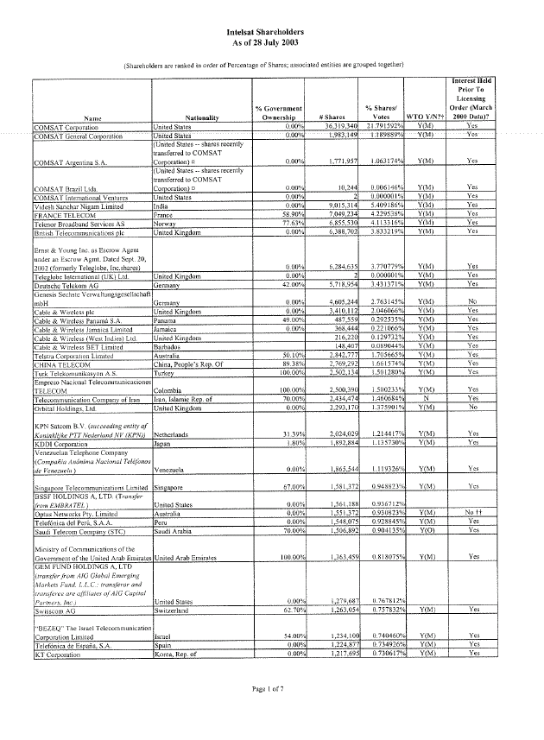
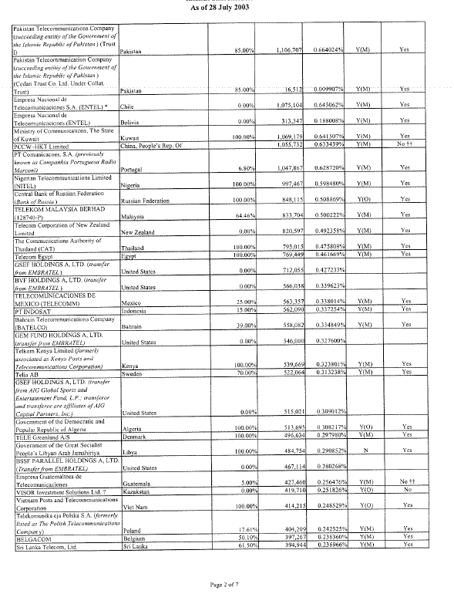
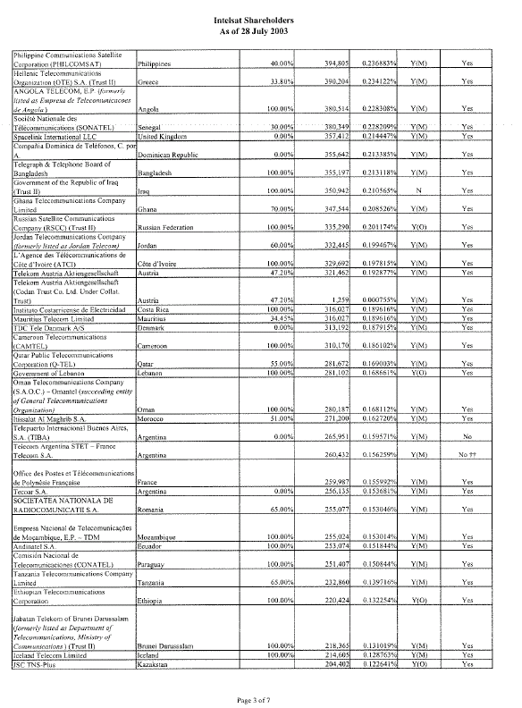
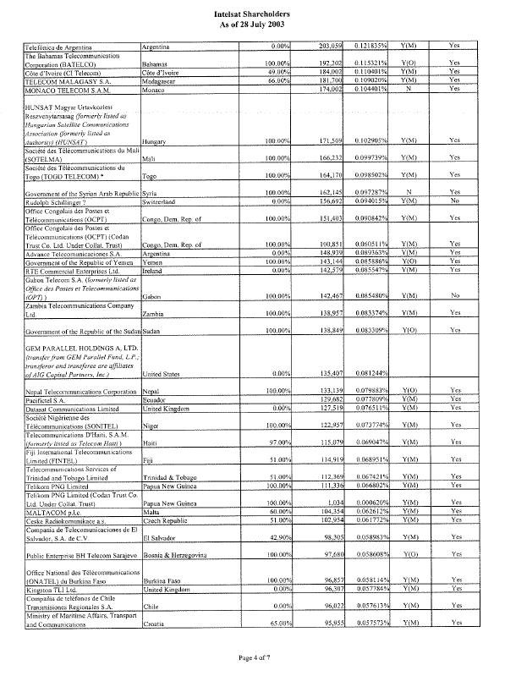
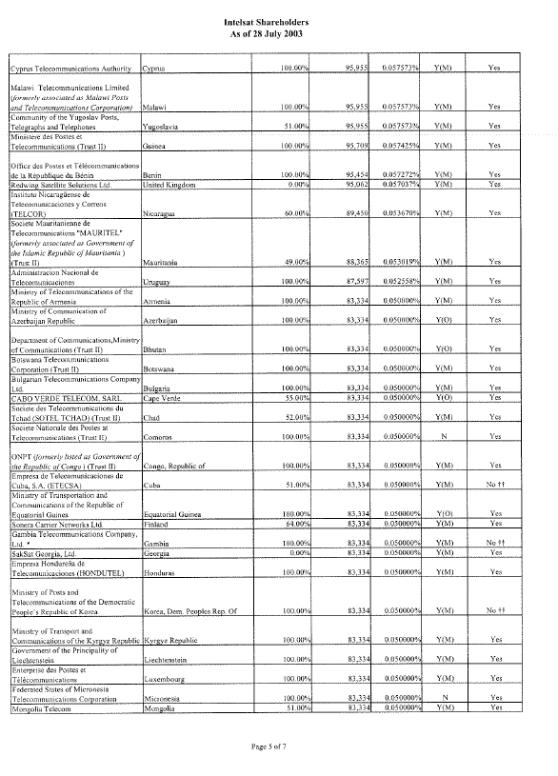
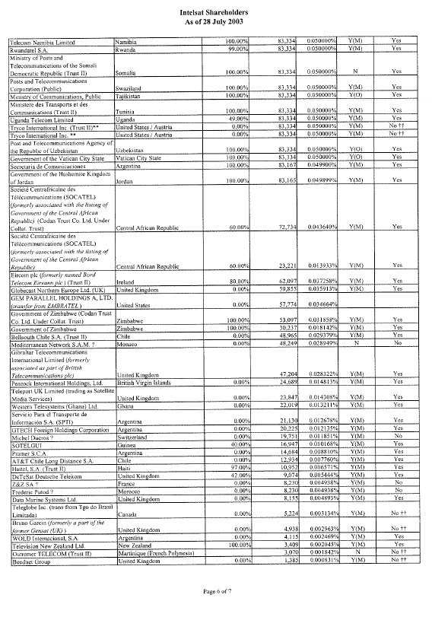
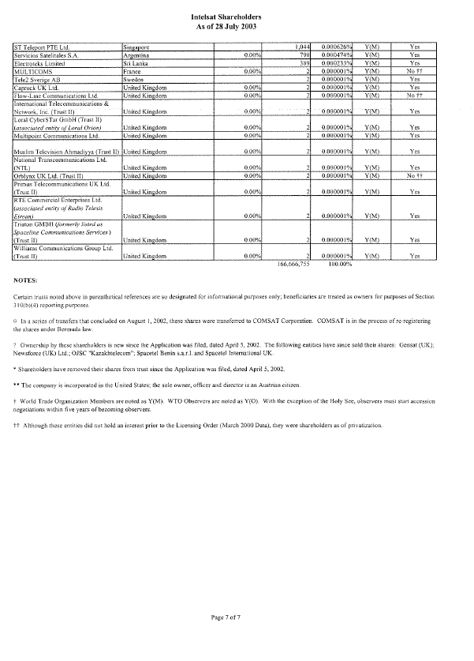
APPENDIX C
Exhibit 1
IGSC By-laws Amendment
1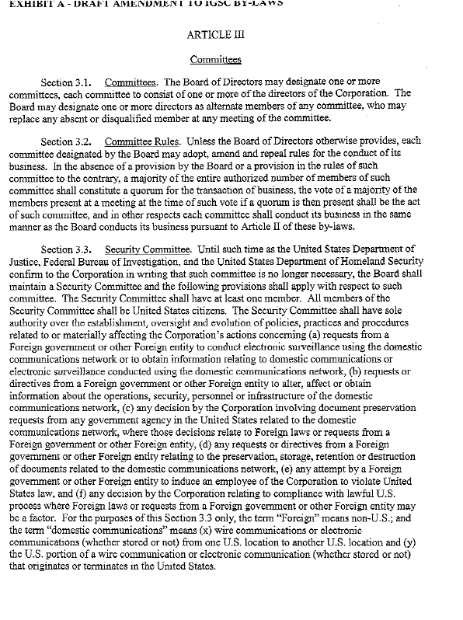
APPENDIX C
Exhibit 2
Proposed Resolutions
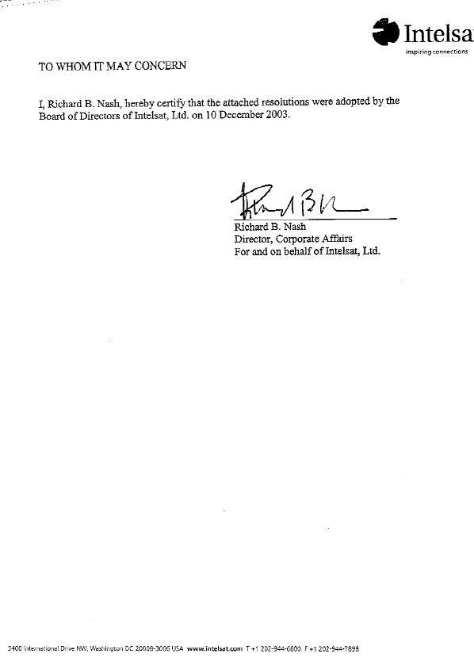
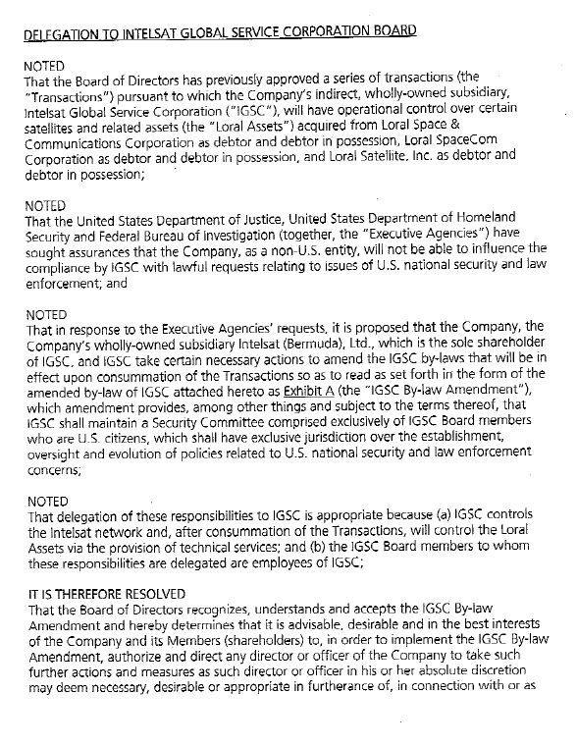
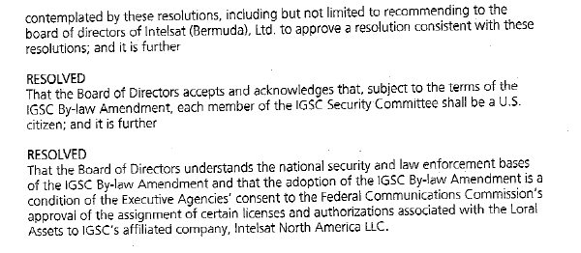
APPENDIX C
Exhibit 3
Letter Agreement
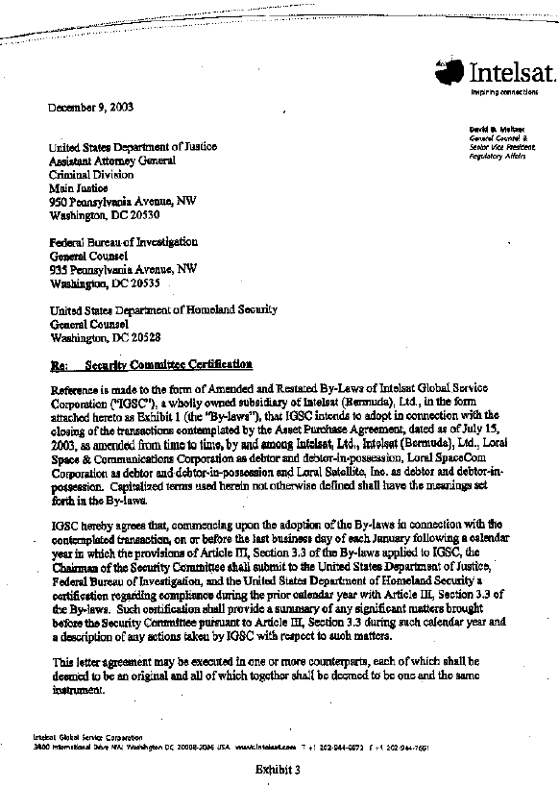
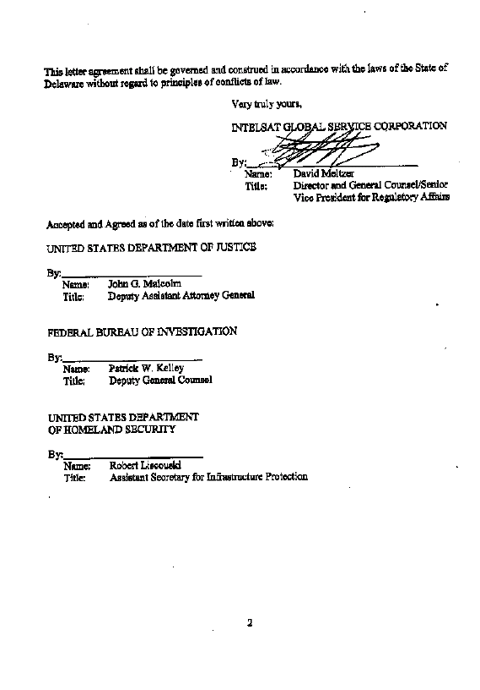
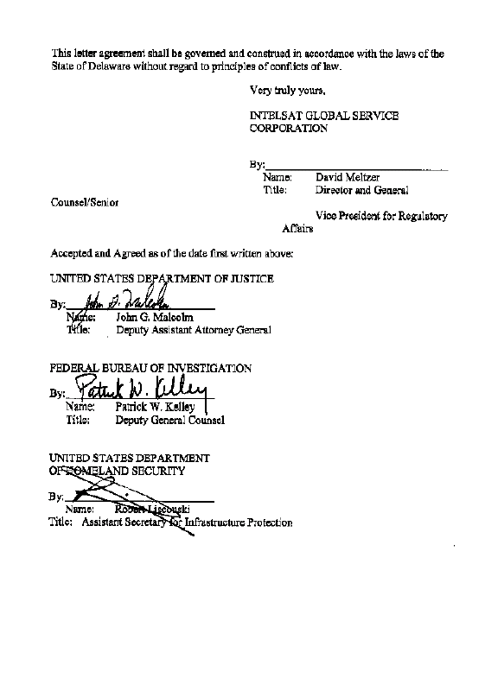
APPENDIX C
Exhibit 4
October 29, 2003 Letter
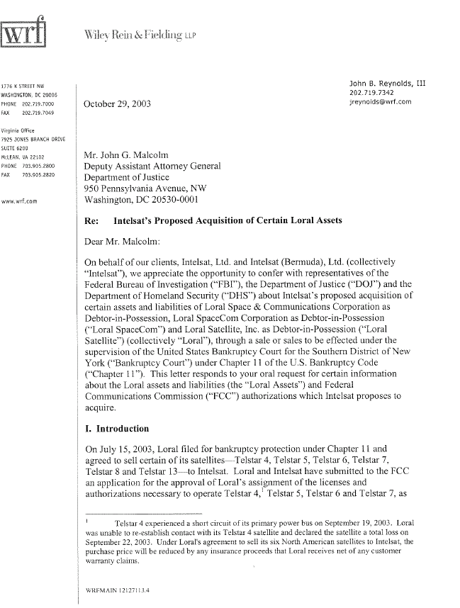
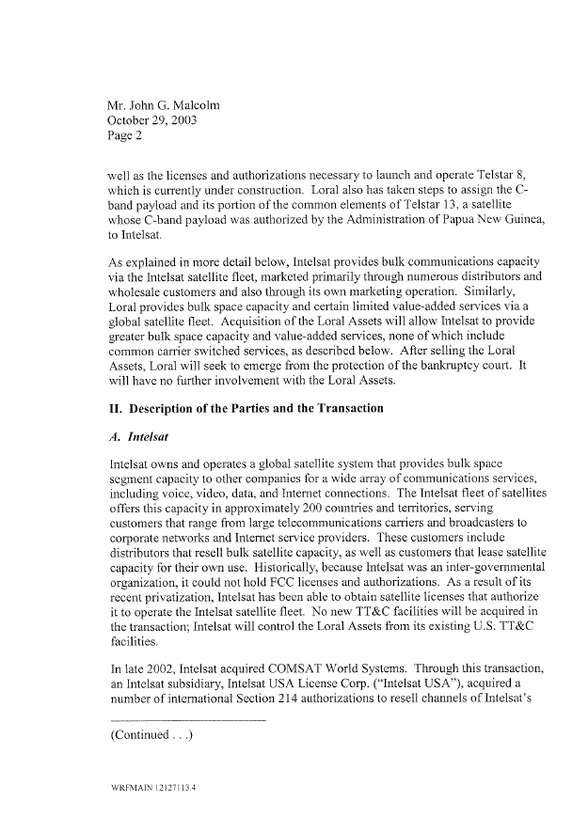
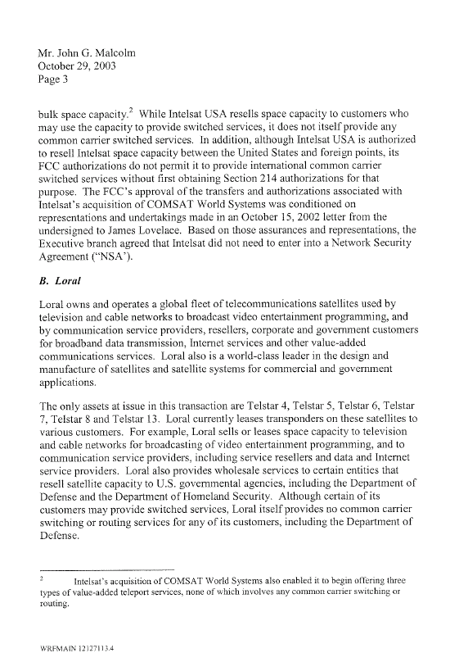
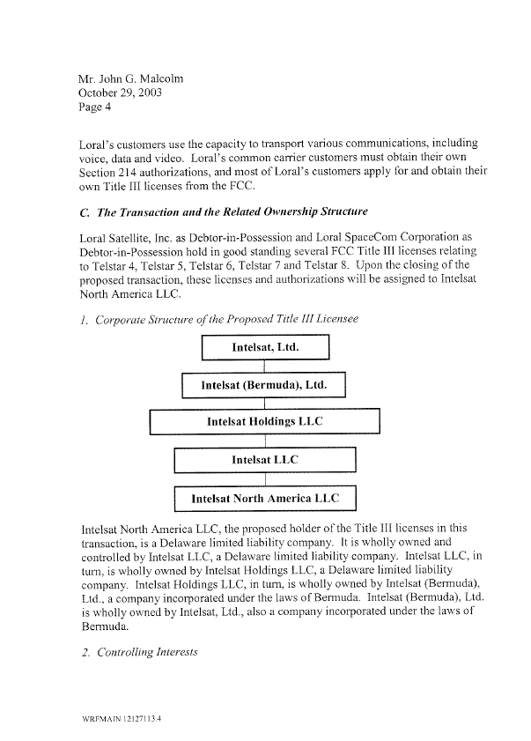
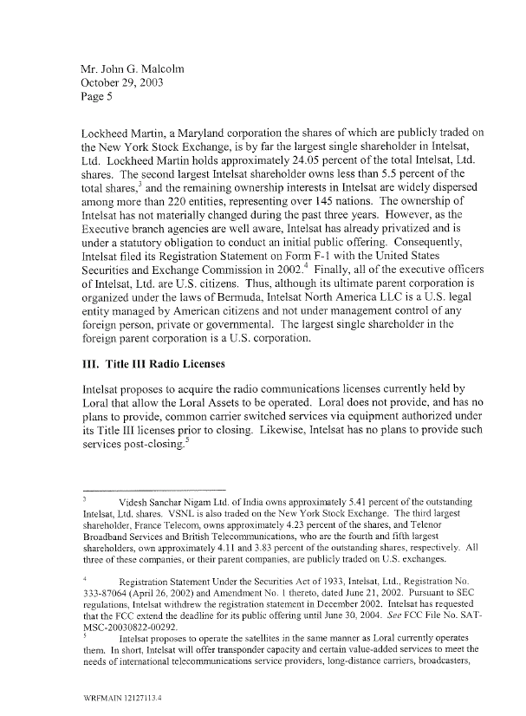
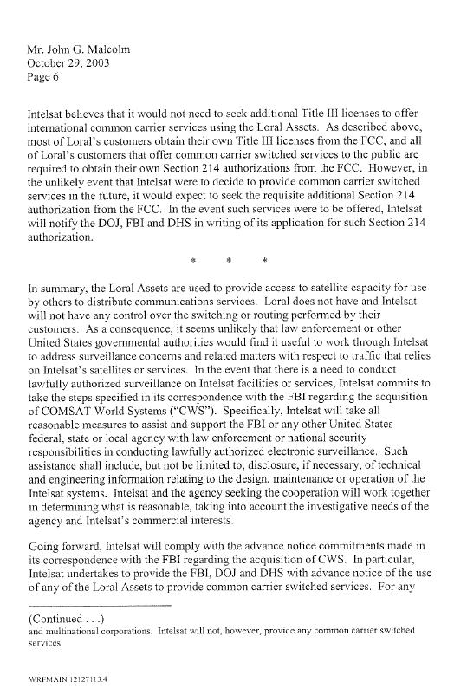
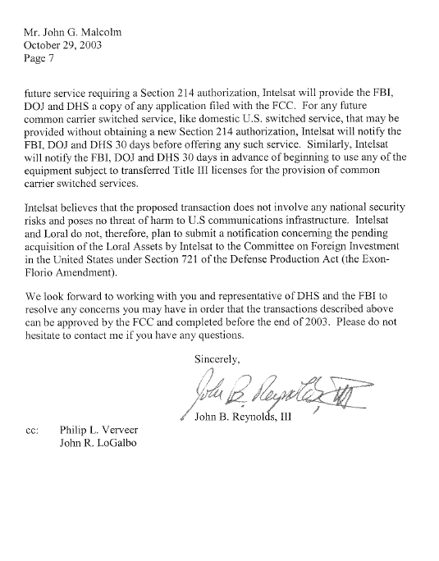
APPENDIX D

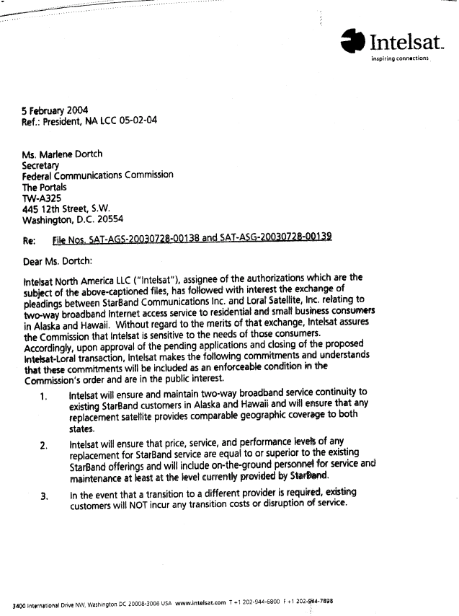
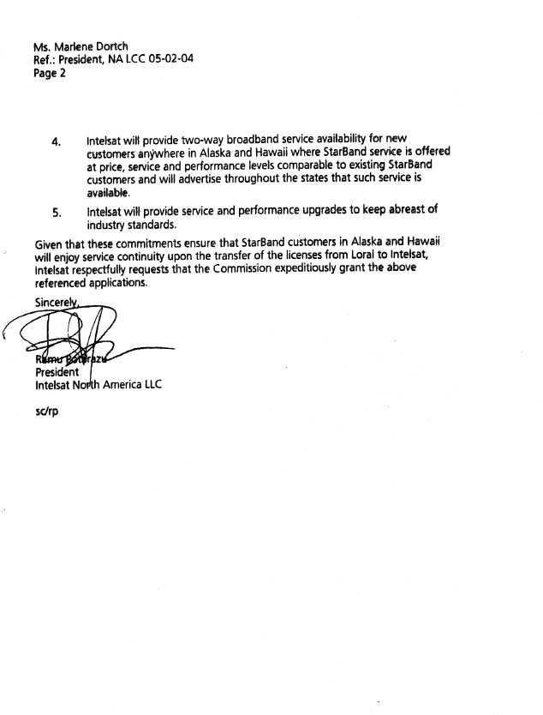

See, Application for Consent to Assignments of Space Station Authorizations, File Nos. SAT-ASG-20030728-00138 and SAT-ASG-20030728-00139 (filed July 28, 2003). Both Applications are considered in this review. Unless stated otherwise, citations to “Assignment Application” or “Application” in this order refers to the narrative provided in each filing. Intelsat North America also filed in this proceeding a “Petition for Declaratory Ruling under Section 310(b)(4) of the Communications Act of 1934, as Amended” (“Petition for Declaratory Ruling”), ISP-PDR-20030925-00024 (filed Sept. 25, 2003).
47 U.S.C. § 310 (d).
ORBIT Act, Pub. L. 106-180, 114 Stat. 48 (2000), as amended, Pub. L. No. 107-233 § 1, 116 Stat. 1480 (2002) (hereinafter cited as “ORBIT Act”).
47 U.S.C. § 310 (b)(4).
Petition to Adopt Conditions to Authorizations and Licenses, File Nos. SAT-ASG-20030728-00138, SAT-ASG-20030728-00139, filed by Executive Agencies (dated Dec. 12, 2003) (“Executive Agencies Petition to Adopt Conditions”).
Application at 7-8. Collectively, Loral Ltd. and its subsidiaries and affiliates are referred to herein as “Loral.”
Loral Ltd. wholly owns Space Systems/Loral Inc. (“SS/L”), which designs and manufactures satellites and satellite systems for commercial and government applications. Application at 7.
Application at 7-8.
Application at 7.
Telstar 4, currently located at 89º W.L., is authorized to move to the 77º W.L. orbit location following the launch of Telstar 8. See, Loral SpaceCom Corporation and Loral Space & Communications Corporation, Applications for Modification of Fixed-Satellite Service Space Station Authorizations, Memorandum Opinion Order and Authorization, DA 03-1045, 18 FCC Rcd 6301 (2003).
Telstar 8 is under construction and is authorized to operate at 89° W.L. Id. at 6306. The Commission extended Loral’s Telstar 8 milestone to complete construction to June 2004 and extended the launch milestone to September 2004. See, Loral SpaceCom Corporation, Debtor-in-Possession, Application for Modification of Fixed Satellite Service Space Station Authorization Telstar 8 and Request for Extension of Milestones and Waiver or Petition for Reconsideration, Memorandum Opinion and Order, DA 03-2766 (rel. Oct. 27, 2003).
The Commission added Telstar 13 to the Commission’s Permitted Space Station List with conditions on August 8, 2003, conditioned upon successful launch of Telstar 13 no later than September 30, 2003. See, Loral SpaceCom Corporation, Petition for Declaratory Ruling to Add Telstar 13 to the Permitted Space Station List, Order, DA 03-2624 (rel. Aug. 8, 2003). Telstar 13 was launched on August 8, 2003.
The Commission granted the pro forma assignment from the various Loral affiliates to these same affiliates as debtors-in-possession in August 2003. See, “stamp-grant” by Jennifer M. Gilsenan, Associate Division Chief, Satellite Division, File Nos. SAT-ASG-20030725-00145, SAT-ASG-20030725-00146, SAT-ASG-20030725-00147 and SAT-ASG-20030725-00148 (granted Aug. 14, 2003); and Public Notice, Satellite Communications Services Information, Actions Taken, Report No. SES-00524, granting SES-ASG-20030725-01109 and SES-ASG-20030725-01121, Aug. 13, 2003.
In re Loral Space & Communications LTD., et al, Debtors, Chapter 11 Case No. 03-41710 (RDD), Joint Administration of Cases 03-41709(RDD) through 03-41728 (RDD), United States Bankruptcy Court, (SDNY).
See, Asset Purchase Agreement Among Intelsat, Ltd., Intelsat (Bermuda), Ltd., Loral Space & Communications Corporation, as Debtor and Debtor in Possession, Loral SpaceCom Corporation, as Debtor and Debtor in Possession, and Loral Satellite, Inc., as Debtor and Debtor in Possession, dated as of July 15, 2003.
Application at 9.
Application at 8. Applicants state that Loral intends to reorganize around its remaining satellite fleet which serves South America, Europe and Asia, and through its Skynet subsidiary, intends to continue to operate an integrated fixed satellite and network services business. The Applicants also state that Loral Ltd. will continue to own and operate SS/L, its satellite manufacturing and design business. Id.
Application at 5. Collectively, Intelsat, Ltd. and its subsidiaries are referred to herein as “Intelsat.”
INTELSAT and the International Maritime Satellite Organization (“Inmarsat”) were originally intergovernmental organizations (“IGOs”) created by international agreements as a result of initiatives undertaken in the early days of development of space technology by the United States under the Communications Satellite Act of 1962.
See, Applications of Intelsat LLC For Authority to Operate, and to Further Construct, Launch, and Operate C-band and Ku-band Satellites that Form a Global Communications System in Geostationary Orbit, Memorandum Opinion Order and Authorization, 15 FCC Rcd 15460 (2000)(“Intelsat LLC Licensing Order”), Recon. denied, 15 FCC Rcd 25234 (2000). Intelsat LLC’s authorizations are for operation in the conventional C-band, which refers to the 3,700-4,200/5,925-6,425 MHz frequency bands. Intelsat LLC is also authorized to operate in the extended C-band frequencies 3,625-3,700/5,850-5.925/6.425-6,650 MHz on certain satellites at certain orbital locations. In addition, Intelsat LLC is authorized to operate in the extended C-band frequencies 3,420-3,625 MHz on the Intelsat-805 at 55.5º W.L. for service to non-US locations. The 3,420-3,600 GHz portion of this frequency band is not a satellite band in the U.S. and is operated by Intelsat outside the U.S. subject to potential interference from worldwide shipborne U.S. military radar operations. The conventional Ku-band refers to the 11.7-12.2/14.0-14.5 GHz frequency bands. Intelsat LLC is also authorized to operate in the extended Ku-frequency bands 10.95-11.2/11.45-11.7/12.5-12.75/13.75-14.0 GHz on certain satellites at certain orbital locations.
See, Applications of Intelsat LLC for Authority to Operate, and to Further Construct, Launch and Operate C-band and Ku-band Satellites that Form a Global Communications System in Geostationary Orbit, Memorandum Opinion Order and Authorization, 16 FCC Rcd 12280, 12290, para. 26 (2001) (“Intelsat LLC ORBIT Act Compliance Order”). INTELSAT privatized at 7:59:59 PM EDT, on July 18, 2001. See, FCC Report to Congress as Required by the ORBIT Act (rel. June 15, 2000) at 3. Upon privatization, former INTELSAT Signatories and non-Signatory investing entities were issued shares in Intelsat Ltd. according to their March 2001 investment shares in INTELSAT. They will be the shareholders of Intelsat Ltd. until it conducts an IPO.
Intelsat LLC ORBIT Act Compliance Order, 16 FCC Rcd at 12303, para. 76.
See, Intelsat LLC Request for Extension of Time Under Section 621(5) of the ORBIT Act, Memorandum Opinion and Order, DA 03-4023 (rel. Dec. 17, 2003).
See, ORBIT Act § 601(b)(i).
Application at 3-4. The authorizations subject to this Assignment Application are listed in Appendix A.
The Commission recently extended Loral’s Telstar 8 milestone to complete construction to June 2004 and extended the launch milestone to September 2004. See, supra note 11.
See, Application at 3. See, also supra note 10.
Application at 9. Telstar 13 is not a U.S. licensed space station, and therefore it is not part of this Assignment Application.
Amendment of the Commission’s Space Station Licensing Rules and Policies, Notice of Proposed Rulemaking, 17 FCC Rcd 3847, 3893 (2002).
Application at 4-5, n. 9, citing requirement under Amendment of the Commission’s Space Station Licensing Rules and Policies, First Report and Order and Further Notice of Proposed Rulemaking, 18 FCC Rcd 10760, paras. 315-316 (2003).
Application at 16.
47 U.S.C. § 310(b)(4). See, Petition for Declaratory Ruling.
Application at 4.
Application at 2.
Application at 10.
Application at 2.
Application at 11.
Application at 8, 12.
Executive Agencies Petition to Adopt Conditions at 2-3.
Application at 9.
See, In re Loral Space Communications LTD, et al., Chapter 11 Case No.: LEAD CASE 03-41710 (RDD), 03-41709 (RDD) through 03-41728 (RDD), (Jointly Administered), Order (a) authorizing and approving (i) the sale of five satellites and related assets free and clear of all liens, claims, interests and encumbrances, (ii) the assumption and assignment of certain executory contracts in connection with such sale, (iii) the fixing of cure costs associated with such assumption, (iv) receipt of advance payment under a new procurement agreement and granting of security interest to secure such advance, and (v) payment of secured lenders from the proceeds of such sale; and (b) granting related relief, United States Bankruptcy Court (SDNY) (dated Oct. 30, 2003).
See, Public Notice, Report No. SPB-191, DA 03-2672 (rel. Aug.15, 2003).
Comments of SES AMERICOM (filed Sept. 15, 2003).
EchoStar Petition to Dismiss Deny or Hold in Abeyance (filed Sept. 15, 2003).
Opposition of Loral Ltd. (filed Sept. 30, 2003); Opposition of Intelsat LLC (filed Sept. 30, 2003); Reply Comments of SES AMERICOM (filed Oct. 10, 2003); and Reply Comments of EchoStar (filed Oct. 10, 2003).
Intelsat North America, LLC Petition for Declaratory Ruling (filed Sept. 25, 2003).
EchoStar Petition to Dismiss or Deny (filed Oct. 14, 2003).
EchoStar Letter, Notice of Withdrawal (filed Oct. 28, 2003).
Letter from SES AMERICOM to the Secretary, Federal Communications Commission (filed Dec. 12, 2003), attaching United States General Accounting Office Report to Congressional Requesters, Satellite Communications Strategic Approach Needed for DOD’s Procurement of Commercial Satellite Bandwidth, GAO-04-206 (December 2003) (“GAO Report, DOD Procurement of Commercial Satellite Bandwidth, December 2003”).
See, e.g., Letter from Rush Holt and Frank Pallone, United States House of Representatives (dated Dec. 15, 2003) (requesting that the Commission adopt safeguards to ensure preservation of the competitive marketplace for commercial satellite services); Letter from Mike Ferguson, United States House of Representatives (dated Dec. 15, 2003) (urging the Commission to give serious attention to the potential effects of this transaction on competition in the U.S. market for domestic satellite services, particularly to the U.S. Government); Letter from Jon S. Corzine and Frank R. Lautenberg, United States House of Representatives (dated Dec. 16, 2003) (urging the Commission to give serious attention to the potential effects of this transaction on competition in the U.S. market for domestic satellite services, particularly to the U.S. Government).
See, supra note 5.
See, Letter to Marlene Dortch, Secretary, Federal Communications Commission, from Earl W. Comstock, Counsel to StarBand (dated Dec. 17, 2003) (“StarBand Ex Parte Filing”). StarBand’s filing included 2 attachments: (1) Notice Of Presentment of Debtors’ Motion For Authorization to Enter Into a Capacity Lease With Rainbow DBS Company, LLC and the associated Motion (“Capacity Lease Motion”); and (2) Asset Purchase Agreement between Intelsat and Loral (dated July 15, 2003) See, also supra paras. 5, 15.
StarBand filed a Petition to Adopt Conditions to Applications, or Absent Conditions, to Deny (dated Dec. 12, 2003) (“StarBand Petition”). Included with StarBand’s Petition was a Motion to Waive for Good Cause Section 25.154(a)(2) of the Commission’s Rules Pursuant to Section 1.3 of Those Rules. Loral filed an opposition to StarBand’s request for waiver. Based on our review, we grant, pursuant to Section 1.3 of our rules, StarBand’s motion and accept the late-filed pleadings filed by StarBand and Loral. We find that inclusion of these comments will facilitate resolution of this case based upon a full and complete factual record.
Opposition to Petition of StarBand Communications Inc. To Adopt Conditions to Applications, or Absent Conditions, to Deny, filed by Loral Satellite, Loral SpaceCom, and Loral Ltd., (dated Jan. 6, 2004) (“Loral Opposition to StarBand Petition”).
Reply of StarBand Communications Inc. to Loral Opposition to Petition of StarBand Communications Inc. to Adopt Conditions to Applications, or Absent Conditions, to Deny (dated Jan. 14, 2004) (“StarBand Reply”).
See, Letter to Marlene Dortch, Secretary, Federal Communications Commission, from Ramu Potarazu, President, Intelsat North America LLC (dated Feb. 5, 2004) (“Intelsat Commitment Letter”).
47 U.S.C. § 310(d).
47 U.S.C. § 310(a), (b).
See, e.g., Application of VoiceStream Wireless Corporation, Powertel, Inc., Transferors, and Deutsche Telekom AG, Transferee, for Consent to Transfer Control of Licenses and Authorizations Pursuant to Sections 214 and 310(d) of the Communications Act and for Declaratory Ruling Pursuant to Section 310 of the Communications Act, Memorandum Opinion and Order, 16 FCC Rcd 9779, 9789 (2001) (“VoiceStream/Deutsche Telekom Order”). See, also AT&T Corp., British Telecommunications, plc, VLT Co. L.L.C., Violet License Co. LLC, and TNV [Bahamas] Limited Applications For Grant of Section 214 Authority, Modification of Authorizations and Assignment of Licenses in Connection with the Proposed Joint Venture Between AT&T Corp. and British Telecommunications, plc, Memorandum Opinion and Order, 14 FCC Rcd 19140, 19147 (1999) (“AT&T/BT Order”); and Applications of NYNEX Corporation, Transferor and Bell Atlantic Corporation, Transferee, For Consent to Transfer Control of NYNEX Corporation and Its Subsidiaries, Memorandum Opinion and Order, 12 FCC Rcd 19985, 20003-04 (1997) (“Bell Atlantic/NYNEX Order”).
See, e.g., AT&T/BT Order, 14 FCC Rcd at 19148.
See, e.g., VoiceStream/Deutsche Telekom Order, 16 FCC Rcd at 9789.
See, e.g. 47 U.S.C. §§ 310 (d) and 308 (b).
See, Rules and Policies on Foreign Participation in the U.S. Telecommunications Market, Report and Order and Order on Reconsideration, 12 FCC Rcd 23891, 23919-21 (1997); Order on Reconsideration, 15 FCC Rcd 18158 (2000) (“Foreign Participation Order”). See, also Amendment of the Commission's Regulatory Policies to Allow Non-U.S. Licensed Satellites Providing Domestic and International Service in the United States, Report and Order, 12 FCC Rcd 24094, 24170 (1997).
47 U.S.C. § 310(d).
47 U.S.C. § 310(d).
47 U.S.C §§ 310(d) and 308.
See, e.g., VoiceStream/Deutsche Telekom Order, 16 FCC Rcd 9779, 9790 (2001). The exception to this rule occurs where issues related to basic qualifications have been designated for hearing by the Commission or have been sufficiently raised in petitions to warrant the designation of a hearing. Id.
47 U.S.C § 308.
With respect to the issues of foreign ownership eligibility and ORBIT Act requirements, see infra Sections III.C. and IV. B.
47 U.S.C. § 310(b)(4) (providing that “No broadcast or common carrier or aeronautical en route or aeronautical fixed radio station license shall be granted to or held by … any corporation directly or indirectly controlled by any other corporation of which more than one-fourth of the capital stock is owned of record or voted by aliens, their representatives, or by a foreign government, or representative thereof, or by any corporation organized under the laws of a foreign country, if the Commission finds that the public interest would be served by the refusal or revocation of such license.”)
Section 310(a) of the Act prohibits any radio license from being “granted to or held by” a foreign government or its representative. See, 47 U.S.C. § 310(a). The ownership structure proposed by Intelsat LLC is such that no foreign government or representative will hold any of the dual-use space station licenses. Section 310(b)(1)-(2) of the Act prohibits common carrier, broadcast and aeronautical fixed or en route radio licenses from being “granted to or held by” aliens, or their representatives, or foreign corporations. See, 47 U.S.C. § 310(b)(1), (2). According to the Applications, no alien, or representative, or foreign corporation will hold the dual-use space station licenses. Accordingly, the proposed transaction does not trigger the foreign ownership provisions of section 310(a), (b)(1)-(2) of the Act. See, VoiceStream/Deutsche Telekom Order, 16 FCC Rcd at 9799-9800, paras. 38-48 (issues related to indirect foreign ownership of common carrier licensees addressed under section 3l0(b)(4)). In addition, because the proposed transaction does not involve direct foreign investment in Intelsat North America, which would hold the space station licenses, it does not trigger Section 310(b)(3) of the Act, which places a 20% limit on direct alien, foreign corporate or government ownership of entities that hold common carrier, broadcast and aeronautical fixed or en route Title III licenses. See, 47 U.S.C. § 310(b)(3).
Foreign Participation Order, 12 FCC Rcd 23891, 23896, para. 9, 23913, para. 50, and 23940, paras. 111-112.
Id.
Intelsat LLC Licensing Order, 15 FCC Rcd at 15483, paras. 44-55.
See, Lockheed Martin Corporation, COMSAT Corporation, and COMSAT Digital Teleport, Inc., Assignors, and Intelsat, Ltd., Intelsat (Bermuda), Ltd., Intelsat LLC and Intelsat USA License Corp., Application for Assignment of Earth Station and Wireless Licenses and Section 214 Authorizations and Petition for Declaratory Ruling, DA 02-2254, 17 FCC Rcd 27732, 27755 paras. 35-46 (IB 2002). (“Lockheed/Comsat/Intelsat Order”).
Lockheed/Comsat/Intelsat Order, 17 FCC Rcd at 27757, para. 38.
Lockheed/Comsat/Intelsat Order, 17 FCC Rcd at 27758, para. 40.
Petition for Declaratory Ruling at 6.
The shareholder list is attached hereto as Appendix B.
Petition for Declaratory Ruling at 6-7. According to the petition, total indirect foreign government ownership of Intelsat, Ltd. currently is no higher than at the time of the Intelsat LLC Licensing Order, approximately 30 percent. Id. at 7 (citing Intelsat LLC Licensing Order, 15 FCC Rcd at 15482). See also, Lockheed/Comsat/Intelsat Order, 17 FCC Rcd at 27759-60, para. 43.
Petition for Declaratory Ruling at 7. The Commission has stated, in the Foreign Participation Order, that “[w]e will deny an application if we find that more than 25 percent of the ownership of an entity that controls a common carrier radio licensee is attributable to parties whose principal place(s) of business are in non-WTO Member countries that do not offer effective competitive opportunities to U.S. investors in the particular service sector in which the applicant seeks to compete in the U.S. market, unless other public interest considerations outweigh that finding.” Id., 12 FCC Rcd at 23946, para. 131. The shareholder list provided by Intelsat North America indicates that non-WTO investors account for approximately 6% of the equity and voting interests in Intelsat, Ltd.
See, e.g., Vodafone Americas Asia Inc., Transferor, and Globalstar Corporation, Transferee, Consent to Transfer Control of Licenses and Section 214 Authorizations and Petition for Declaratory Ruling Allowing Indirect Foreign Ownership, Order and Authorization, DA 02-1557, 17 FCC Rcd 12849, 12866, para. 53 (2002).
See, e.g., VoiceStream/Deutsche Telekom Order, 16 FCC Rcd at 9823, para. 78, 9825, para. 81, 9833, para. 97. See, also Application of WorldCom, Inc., and MCI Communications Corporation for Transfer of Control of MCI Communications Corporation to WorldCom, Inc., Memorandum Opinion and Order, FCC 98-225, 13 FCC Rcd 18025 (1998) (“MCI/WorldCom Order”); Comsat/Lockheed Order, 15 FCC Rcd at 22915, para. 16; and Application of General Electric Capital Corporation and SES Global S.A. for Consent to Transfer Control of Licenses and Authorizations Pursuant to Section 214(a) and 310(d) of the Communications Act and Petition for Declaratory Ruling Pursuant to Section 310(b)(4) of the Communications Act, Order and Authorization, DA 01-2100, 16 FCC Rcd 17575 (2001), Supplemental Order, DA 01-2482, 16 FCC Rcd 18878 (2001) (“GE/SES Order”); Lockheed Comsat/Intelsat, Ltd., Order, DA 02-2254, 17 FCC Rcd 27732, (2002).
Comsat/Lockheed Order, 15 FCC Rcd at 22916, para. 18.
SES AMERICOM Comments at 15-18.
SES AMERICOM Comments at 17.
SES AMERICOM Comments at 17.
SES AMERICOM Comments at 8-18.
SES AMERICOM Comments at 23-24.
See, 1 ABA ANTITRUST SECTION, ANTITRUST LAW DEVELOPMENTS 362 (5th ed. 2002) for a description of vertical relationships and related theories of competitive harm, including foreclosure strategies. Vertical acquisitions include transactions where the firms have or could have supplier-customer relationships.
For example, the GAO Report makes a number of recommendations to DOD, among other things, on the need to develop and implement a strategic approach to acquiring commercial satellite bandwidth services. See, GAO Report on DOD Procurement of Commercial Satellite Bandwidth, December 2003.
Intelsat Opposition at 8-9. See also, Intelsat LLC Orbit Act Compliance Order, 16 FCC Rcd at 12299, paras. 59-62.
Application at 6.
Application at 3, 4.
All satellites, the operational satellites, as well as those under construction, serve almost entirely the U.S. market.
StarBand states that it offers two-way satellite broadband Internet access service to residential and business customers, and that currently its customer base totals approximately 35,000 customers. According to StarBand, its customers consist largely of residential customers (94%); and its business customers (6%), include health care providers, educational facilities, governmental facilities, Native American governmental or community entities, public libraries and Head Start programs. Significantly, StarBand points out that Telstar 7 provides service to two-thirds of its customers (approximately 23,000 residential and business customers), including all of its customers in Alaska (1200 residential and business customers) and Hawaii (200 residential and business customers). StarBand notes that its remaining 12,000 customers are served using transponders leased from SES AMERICOM on its AMC-4 satellite located at 101° W.L. StarBand Petition at 2, 8.
StarBand Petition at 11-12. StarBand states that DIRECWAY is the only other two-way satellite based Internet access provider offering service to residential and business customers in most parts of the United States. StarBand Petition at 3.
StarBand Petition at 7, citing Debtors’ Motion for Authorization to Enter Into A Capacity Lease With Rainbow DBS Company, LLC,” United States Bankruptcy Court for the Southern District of New York, In re Loral Space & Communications Ltd, dated Nov. 11, 2003, at para. 9. See, StarBand Ex Parte Filing, Attachment 1.
StarBand Petition at 8.
StarBand Petition at 6-7, quoting Application at 9.
StarBand Petition at 11-12.
47 U.S.C. §§ 4(i) and 303(r). The Commission may, in certain circumstances, grant interim relief under the authority of Section 4(i) of the Communications Act, which empowers the Commission to "perform any and all acts [and] make such orders, not inconsistent with th[e] Act, as may be necessary in the execution of its functions." 47 U.S.C. §154(i); see also, 47 U.S.C. § 303(r) (Commission may "[m]ake such rules and regulations and prescribe such restrictions and conditions, not inconsistent with law, as may be necessary to carry out the provisions of th[e] Act").
StarBand Petition at 12.
StarBand Petition at 12-13.
StarBand Petition at 12. StarBand provides information on the estimated costs to its customers who would be forced to switch providers if StarBand could not provide service, noting that the cost would be prohibitive to most customers. In addition, StarBand states that most of its customers in Alaska and Hawaii will have no alternative available. StarBand Petition at 9-11.
Loral claims that after StarBand filed for bankruptcy protection, StarBand breached its contract with Loral by making payments at a rate lower than the contract rate. Loral states that it has submitted a claim in the StarBand Bankruptcy Court for the amount of difference between the contract amount and the amount actually paid. Loral Opposition to StarBand Petition at 4.
Loral Opposition to StarBand Petition at 9, citing Loral Corporation Request for a Declaratory Ruling Concerning Section 310(b)(4) of the Communications Act of 1934 and Application of R/L DBS Company for Assignment of Continental Satellite Corporation’s Direct Broadcast Satellite Construction Permit, Memorandum Opinion and Order, 12 FCC Rcd 24325 at para. 13 (1997).
Loral Opposition to StarBand Petition at 9.
StarBand Reply at 2.
StarBand Reply at 3.
StarBand Reply at 2, 5.
See, Loral Corporation Request for a Declaratory Ruling Concerning Section 310(b)(4) of the Communications Act of 1934 and Application of R/L DBS Company for Assignment of Continental Satellite Corporation’s Direct Broadcast Satellite Construction Permit, Memorandum Opinion and Order, 12 FCC Rcd 24325, 24332, citing Detroit Cellular Telephone Co., Memorandum Opinion and Order, 2 FCC Rcd 4420 (1987).
StarBand Petition at 4, 10.
StarBand Petition at 8-10.
The Commission has ongoing proceedings to encourage deployment of advanced telecommunications capabilities, including separate proceedings on cable and wireline broadband services. See, e.g., In the Matter of Inquiry Concerning the Deployment of Advanced Telecommunications Capability to All Americans in a Reasonable And Timely Fashion, and Possible Steps To Accelerate Such Deployment Pursuant to Section 706 of the Telecommunications Act of 1996, 17 FCC Rcd 2844, CC Docket No. 98-146 (2002); In the Matter of Inquiry Concerning High-Speed Access to the Internet Over Cable and Other Facilities, 17 FCC Rcd. 4798, GN Docket No. 00-185, CS Docket No. 02-52 (2002); In the Matter of Appropriate Framework for Broadband Access to the Internet over Wireline Facilities, 17 FCC Rcd. 3019, CC Docket No. 02-33 (2002). See also, In the Matter of Review of Section 251 Unbundling Obligations of Incumbent Local Exchange Carriers, 18 FCC Rcd. 16978, paras. 285-95, CC Docket No. 01-338.
See, Intelsat Commitment Letter setting out the commitments that Intelsat has made with respect to the two-way broadband Internet access service that StarBand currently provides to residential and small business consumers in Alaska and Hawaii through use of Loral’s satellites.
The Intelsat Commitment Letter is attached as Appendix D.
See, Amendment of the Commission's Regulatory Policies to Allow Non-U.S. Licensed Satellites Providing Domestic and International Service in the United States, Report and Order, 12 FCC Rcd 24094, 24170-72 (1997) (“DISCO II Order”).
Foreign Participation Order, 12 FCC Rcd at 23918-21.
See, supra note 5.
The attachments include Exhibit 1, Amendment to IGSC By-Laws (“IGSC By-law Amendment”); Exhibit 2, Proposed Resolutions of the Board of Directors of Intelsat, Ltd. (“Proposed Resolutions”); Exhibit 3, Security Committee Certification Letter Agreement (dated Dec. 9, 2003) (“Letter Agreement”); and Exhibit 4, Letter Abiding by Commitments from Intelsat to Mr. John G. Malcolm, Deputy Assistant Attorney, DOJ (dated Oct. 29, 2003) (“October 29, 2003 Letter”). These exhibits are set forth in Appendix C of this Order and Authorization.
Executive Agencies Petition to Adopt Conditions at 3.
Executive Agencies Petition to Adopt Conditions at 3. See also, supra. para. 25.
Appendix C, Exhibit 1.
Appendix C, Exhibit 2.
Appendix C, Exhibit 3.
Executive Agencies Petition to Adopt Conditions at 3-4. See also, Appendix C. The commitments set forth in these documents require, inter alia, that IGSC establish a Security Committee comprised exclusively of IGSC Board members who are U.S. citizens, which shall have exclusive jurisdiction over the establishment, oversight and evolution of policies related to U.S. national security and law enforcement concerns.
Executive Agencies Petition to Adopt Conditions at 1-2. See also, Appendix C, Exhibits 1-4.
Foreign Participation Order, 12 FCC Rcd at 23919-21, paras. 61-66.
Foreign Participation Order, 12 FCC Rcd at 23919, para. 62.
Appendix C, Exhibits 1-4.
Application at 16.
Application at 17.
Intelsat LLC Licensing Order, 15 FCC Rcd at 15483 para. 51
Id. In seeking authority to operate the C- and Ku-bands satellites, Intelsat LLC requested that its licenses permit flexibility to operate on both a private and common carrier basis, but stated that it had no current plans to provide common carrier services. The Commission granted Intelsat LLC’s request subject to the condition that Intelsat LLC obtain Section 214 authority prior to providing international common carrier services.
47 U.S.C. § 214; 47 C.F.R. § 63.18; see also, 47 C.F.R. § 63.21(h)(permitting, subject to certain limitations, wholly-owned subsidiaries to operate under a parent’s section 214 authorization provided the Commission is notified within 30 days of the subsidiary initiating service).
47 U.S. C. § 214; 47 C.F.R. §§ 63.01 et seq.
“It is the purpose of this Act to promote a fully competitive global market for satellite communication services for the benefit of consumers and providers of satellite services and equipment by fully privatizing the intergovernmental satellite organizations, INTELSAT and Inmarsat.” See, ORBIT Act § 2.
ORBIT Act §§ 621 and 622.
Intelsat LLC Licensing Order, 15 FCC Rcd at 15519, para. 160.
ORBIT Act §§ 601(b)(1) and 601(b)(2). See also, Intelsat LLC ORBIT Act Compliance Order at 12281, para 3.
ORBIT Act § 601(b)(2).
Intelsat LLC ORBIT Act Compliance Order, 16 FCC Rcd at 12287-88, paras. 21-22.
Intelsat LLC ORBIT Act Compliance Order, 16 FCC Rcd at 12288, para. 24.
Intelsat LLC ORBIT Act Compliance Order at 12288-12299, paras. 22, 25-56.
Intelsat LLC ORBIT Act Compliance Order at 12303, para. 71.
Intelsat LLC ORBIT Act Compliance Order at 12303, para. 71.
ORBIT Act § 621(2). Pub. L. 107-233 § 1, amending Pub. L. 106-180 § 621(5)(A)(i) extended the IPO deadline to December 31, 2003 and permitted the Commission to extend this deadline under certain circumstances to June 30, 2004. Id. The Commission extended the IPO deadline to June 30, 2004. See, In the Matter of Intelsat LLC, Request for Extension of Time Under Section 621(5) of the ORBIT Act, DA 03-4023, Memorandum Opinion and Order, (2003).
ORBIT Act § 648.
ORBIT Act § 602(a).
ORBIT Act § 601(b)(2); Intelsat LLC ORBIT Act Compliance Order at 12289, para. 27.
Intelsat LLC ORBIT Act Compliance Order at 12288, para. 24.
Intelsat LLC ORBIT Act Compliance Order at 12303, para. 71; 12304, para. 77.
ORBIT Act § 621(2).
ORBIT Act §§ 621(2), 621(5)(A)(i).
ORBIT Act § 648.
Intelsat LLC Licensing Order, paras. 42 and 172.
47 USCA § 761a.
ORBIT Act, § 681(a)(12)(B).
We note that one of the satellites involved in this assignment is Telstar 8, which is scheduled for launch on September 30, 2004, and will have Ka-band capacity, which is considered an “additional service” under the ORBIT Act. See, e.g., supra. paragraph 9.
Letter from Jennifer D. Hindin on behalf of the Applicants to Marlene H. Dortch, Secretary, Federal Communications Commission (dated Dec. 23, 2003) at 2. (“December 23, 2003 Ex Parte Letter”).
December 23, 2003 Ex Parte Letter at 1-2.
Intelsat LLC ORBIT Act Compliance Order at 12288, para. 24.
Intelsat LLC ORBIT Act Compliance Order at 12288, para. 24, referring to the purpose of Section 601(b)(1(D) of the ORBIT Act.
Intelsat LLC ORBIT Act Compliance Order at 12294-97, paras. 45-50.
The Commission determined that Intelsat was providing DTH service in cases where it leased capacity to other providers, who in turn, provided DTH services to end-users. See, Intelsat LLC ORBIT Act Compliance Order at 12296, para. 49.
Intelsat LLC ORBIT Act Compliance Order at 12296, paras. 49-50.
Intelsat LLC ORBIT Act Compliance Order at 12297, para. 50.
Intelsat LLC ORBIT Act Compliance Order, 16 FCC Rcd at 12294, 12296.
Intelsat LLC ORBIT Act Compliance Order, 16 FCC Rcd at 12296.
The Commission found INTELSAT’s provision of DTH services to French Polynesia was fundamentally in place by the time the ORBIT Act went into effect, and consequently concluded that in the case of French Polynesia, INTELSAT was not providing DTH service in violation of the ORBIT Act. Intelsat LLC ORBIT Act Compliance Order, 16 FCC Rcd at 12294-97 (paras. 49-50).
See, supra paragraph 34. If consummated, the contract would be assumed by Intelsat pursuant to the Purchase Asset Agreement. See, e.g., Loral Opposition to StarBand Petition at 7.
We are aware that certain of Loral’s DTH customers will be affected by this transfer, and note that to the extent other Loral customers use Loral’s capacity to provide “additional services” as defined under the ORBIT Act (i.e., DBS, Ka-band or V-band services), this requirement also applies to those customers.
SES AMERICOM Comments at 13-18; SES AMERICOM Reply at 15.
SES AMERICOM Reply at 6.
SES AMERICOM Reply at 8.
See, Intelsat LLC ORBIT Act Compliance Order at 12286-88.
See, ORBIT Act §§ 601(b)(2)
Intelsat LLC ORBIT Act Compliance Order at 12288-12299, paras. 22, 25-56.
Intelsat LLC ORBIT Act Compliance Order at 12286-88, paras. 17-22; and 12303, para. 71.
See, supra Section III. D, paragraphs 27-31.
Petition for Declaratory Ruling, supra note 1.
47 C.F.R. § 1.65.
See, supra paragraph 10.
See, Amendment of the Commission’s Space Station Licensing Rules and Policies, First Report and Order and Further Notice of Proposed Rulemaking, 18 FCC Rcd 10760, paras. 326-327 (2003).

