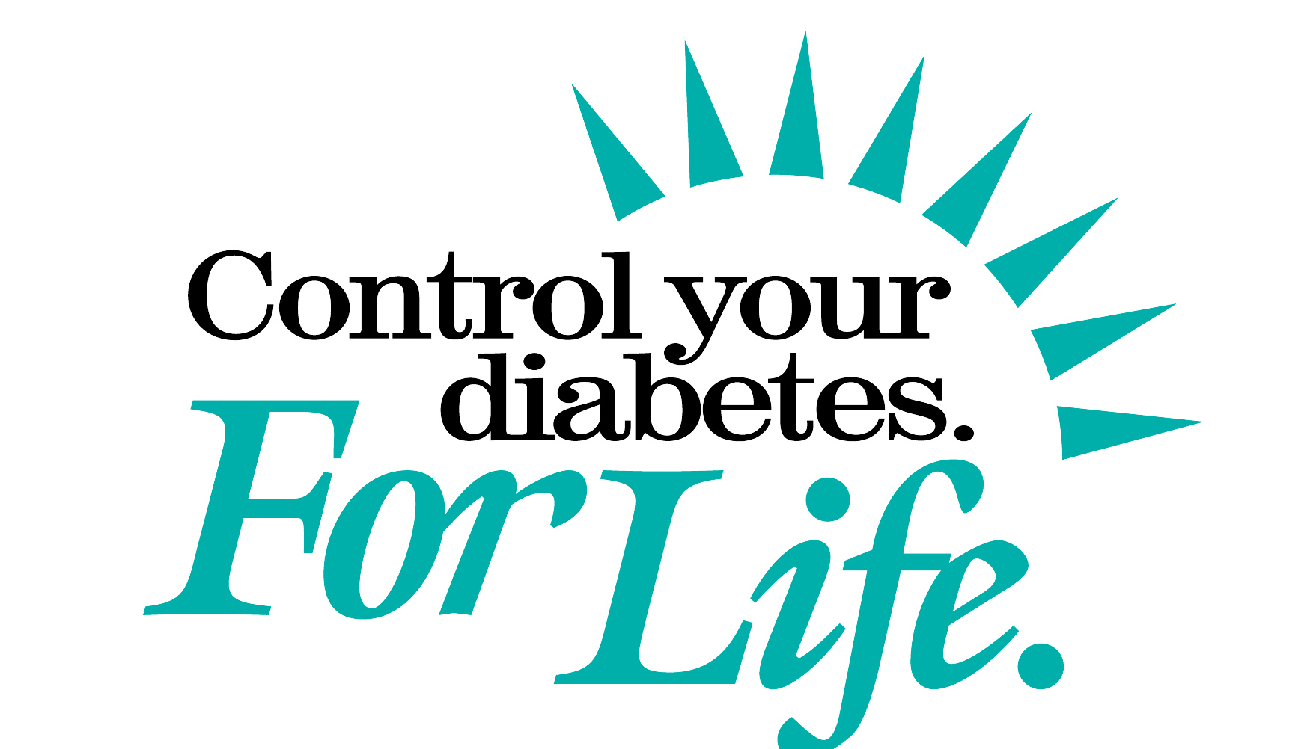

Summer Buffet Tips for People with Diabetes

Barbecues, picnics, and family reunions are gatherings to enjoy and treasure. If you have diabetes, these events can pose special challenges. How can you stick with your meal plan, yet join in the celebration and have some fun? You can do it. If you choose wisely and watch how much you eat, you can have a delicious meal and feel good too. So, grab your plate and head for the buffet table.

Choose the high fiber, low-fat dishes instead of fried, high-fat, high calorie foods. Great choices are beans, peas and lentils, and dark green vegetables such as broccoli, cabbage, spinach and kale. Go for the green bean, three-bean, black bean and black-eyed pea dishes or pasta salads mixed with summer vegetables. Choose whole grain foods such as brown rice, couscous, whole wheat bread and pasta. Everyone benefits from eating these foods, not just people with diabetes.

Watch out for high-fat dishes loaded with mayonnaise, sour cream and butter. Choose veggies that are light on salad dressing, cheese or cream sauce. If you can, make your own dressing with a little olive oil and vinegar. Vegetables and grains should fill up a major portion of your plate, but leave room for some lean meat, poultry or fish. Be sure to choose grilled chicken and remove the skin-- instead of the fried variety. If you're going to make a sandwich, use whole wheat bread with mustard or salsa, rather than mayonnaise.

What's for dessert? Summer means terrific fruits. It's hard to beat a fresh peach, fruit salad, cantaloupe, or watermelon. Fruit is an excellent source of fiber, vitamins and minerals, and has zero fat. Everyone, including people with diabetes, should eat three to four servings of fruit a day. Pies, cakes and cookies are high in fat and cholesterol. If you can't resist, have a small serving.

It’s best to drink water, unsweetened tea, or diet soda. Add a wedge of lemon for flavor. If you choose to drink alcoholic beverages, limit your intake to no more than one drink a day for women, two for men, and drink only with a meal. Eating the right foods to control your blood sugar means being prepared and planning ahead. If you need help putting together a meal plan, ask your health care provider to refer you to a dietitian or diabetes educator. For more information about controlling your diabetes, call the National Diabetes Education Program at 1-800-438-5383 or visit the Program’s website at http://ndep.nih.gov.




Sponsored by the National Diabetes Education Program
A joint Program of the National Institutes of Health and the Centers for
Disease for Control Prevention
http://ndep.nih.gov or http://www.cdc.gov/diabetes

