To change Pop-up Blocker settings

Internet Explore:
#1. Open Internet Explorer
#2. On the Tools menu, point to Pop-up Blocker, and then click Pop-up Blocker Settings

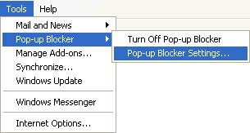

#3 Type the address or URL of the website you want to see pop-ups from, in the Address of Web site to allow box, and then click Add

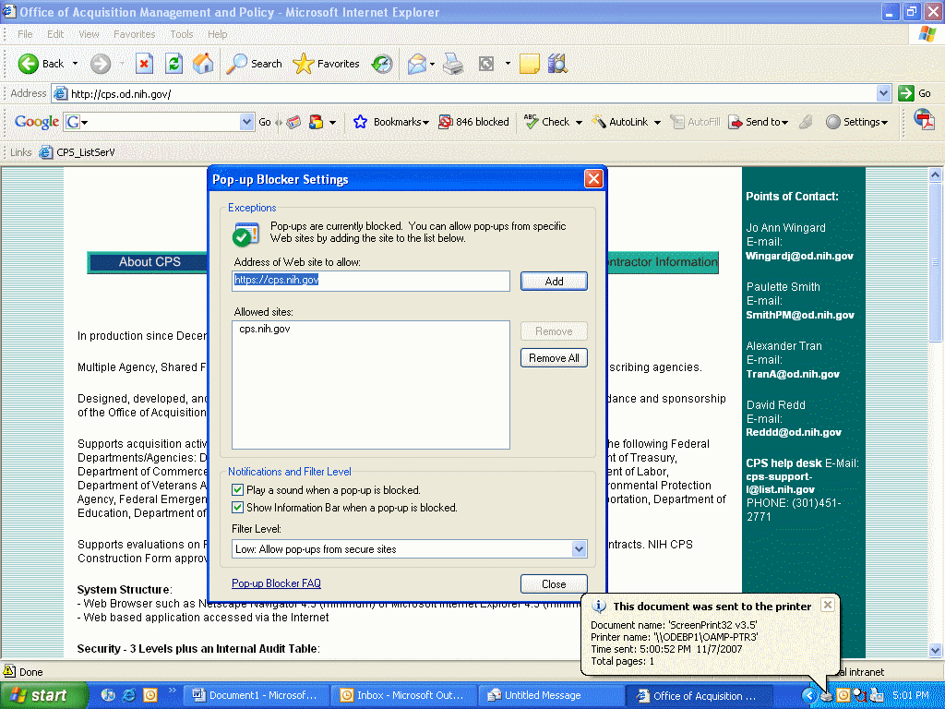

#5 Click “Close” to close the Pop-up Blocker Setting windows
---------------------------------------------------------------------------------------------

Netscape:
1. Open Netscape
2. Tools – popup Manger – Mange Popup
3. Click
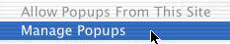 .
4. In the Allow popups from the following web sites box, type the address or URL of the website you want to see pop-ups, and then click Add.

5. Click
.

