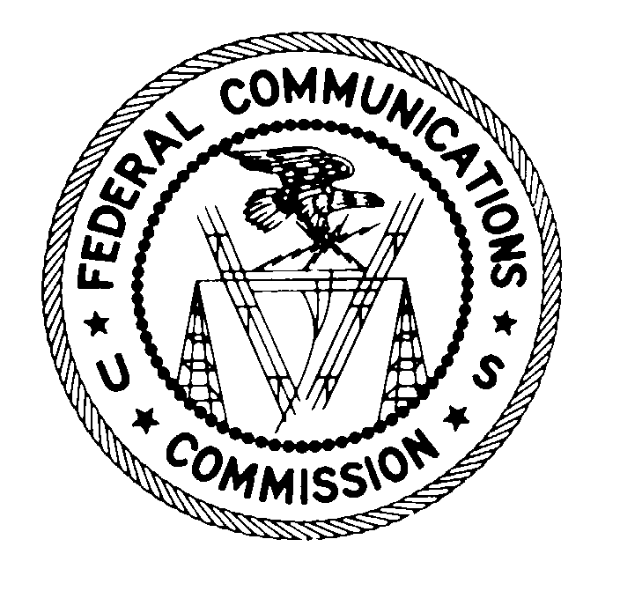
FEDERAL COMMUNICATIONS COMMISSION
WASHINGTON, D.C. 20554

January 28, 2008

VIA CERTIFIED MAIL
RETURN RECEIPT REQUESTED

Ms. Murina C. Bollaro, President
Mr. Rocco A. Bollaro, Jr., Secretary
Garden State Investigations and Security
2 Overlook Drive
Jackson, New Jersey 08527-4849
Re: File No. EB-07-SE-347

Dear Ms. and Mr. Bollaro:
This is an official CITATION, issued pursuant to Section 503(b)(5) of the Communications Act of 1934, as amended (“Act”), 47 U.S.C. § 503(b)(5), to Garden State Investigations and Security (“Garden State”) for marketing in the United States unauthorized radio frequency devices in violation of Section 302(b) of the Act, 47 U.S.C. § 302a(b), and Sections 2.803 and 15.205(a) of the Commission’s Rules (“Rules”), 47 C.F.R. §§ 2.803 and 15.205(a). As explained below, future violations of the Commission’s rules in this regard may subject your company to monetary forfeitures.
By letter of inquiry dated October 2, 2007, the Spectrum Enforcement Division of the Commission’s Enforcement Bureau (“Division”) initiated an investigation into whether Garden State is marketing in the United States, an unauthorized radio frequency jamming or blocking device listed as the “GPS Blocker.” The Division observed an advertisement for the GPS Blocker jammer device on Garden State’s web site, www.gardenstateinvestigations.com, on September 25, 2007.
In Garden State’s October 9, 2007 response, you admit that you imported 15 units of the GPS Blocker jammer device into the United States and began advertising this device on your web site, www.gardenstateinvestigations.com, in August 2007. You also admit to the sale of eight of the GPS Blocker jammer devices to clients within the United States. You state that upon receipt of the Division’s October 2, 2007 letter of inquiry, you ceased all advertisement of the GPS Blocker jammer device. You further state that you destroyed your remaining inventory of seven devices.
Section 302(b) of the Act provides that “[n]o person shall manufacture, import, sell, offer for sale, or ship devices or home electronic equipment and systems, or use devices, which fail to comply with regulations promulgated pursuant to this section.” Section 2.803(a)(1) of the Commission’s implementing regulations provides that:
no person shall sell or lease, or offer for sale or lease (including advertising for sale or lease), or import, ship, or distribute for the purpose of selling or leasing or offering for sale or lease, any radio frequency device unless … [i]n the case of a device subject to certification, such device has been authorized by the Commission in accordance with the rules in this chapter and is properly identified and labeled as required by § 2.925 and other relevant sections in this chapter.
Additionally, Section 2.803(g) of the Rules, 47 C.F.R. § 2.803(g), provides in pertinent part that:
[R]adio frequency devices that could not be authorized or legally operated under the current rules … shall not be operated, advertised, displayed, offered for sale or lease, sold or leased, or otherwise marketed absent a license issued under part 5 of this chapter or a special temporary authorization issued by the Commission.
Pursuant to Section 15.201(b) of the Rules, 47 C.F.R. § 15.201(b), intentional radiators must be authorized in accordance with the Commission’s certification procedures prior to the initiation of marketing in the U.S. It does not, however, appear that the above-cited jammer device is capable of receiving a grant of certification. In this regard, the main purpose of the jammer device is to block or interfere with radio communications. Such use is clearly prohibited by Section 333 of the Act, 47 U.S.C. § 333, which states that “[n]o person shall willfully or maliciously interfere with or cause interference to any radio communications of any station licensed or authorized by or under this Act or operated by the United States Government.” Moreover, the GPS Blocker operates within restricted frequency bands listed in Section 15.205(a) of the Commission’s rules. Thus, these devices cannot comply with the FCC’s technical standards and therefore cannot be certified or marketed. Finally, you note that you received inquiries and had purchases from local law enforcement and federal law enforcement bureaus. While radio frequency devices intended for the federal government or agencies thereof are exempt from the Commission’s rules, there is no similar exemption for sales to state and local law enforcement. Accordingly, it appears that Garden State has violated Section 302(b) of the Communications Act and Sections 2.803 and 15.205(a) of the Commission’s rules by marketing in the United States radio frequency devices that are not eligible for certification.
If, after receipt of this citation, Garden State Investigations and Security violates the Communications Act or the Commission’s Rules in any manner described herein, the Commission may impose monetary forfeitures not to exceed $11,000 for each such violation or each day of a continuing violation.
If you choose to do so, you may respond to this citation within 30 days from the date of this letter either through (1) a personal interview at the Commission’s Field Office nearest to your place of business, or (2) a written statement. Your response should specify the actions that Garden State Investigations and Security is taking to ensure that it does not violate the Commission’s rules governing the marketing of radio frequency jamming devices in the future.
The nearest Commission field office is the Philadelphia, Pennsylvania office. Please call Jacqueline Johnson at 202-418-2871, if you wish to schedule a personal interview. You should schedule any interview to take place within 30 days of the date of this letter. You should send any written statement within 30 days of the date of this letter to:

Kathryn S. Berthot
Chief, Spectrum Enforcement Division
Enforcement Bureau
Federal Communications Commission
445 12th Street, S.W., Rm. 3-C366
Washington, D.C. 20554

Under the Privacy Act of 1974, 5 U.S.C. § 552(a)(e)(3), we are informing you that the Commission’s staff will use all relevant material information before it, including information that you disclose in your interview or written statement, to determine what, if any, enforcement action is required to ensure your compliance with the Communications Act and the Commission’s rules.
The knowing and willful making of any false statement, or the concealment of any material fact, in reply to this citation is punishable by fine or imprisonment under 18 U.S.C. § 1001.
Thank you in advance for your anticipated cooperation.

Sincerely,

Kathryn S. Berthot
Chief, Spectrum Enforcement Division
Enforcement Bureau

Letter from Kathryn S. Berthot, Chief, Spectrum Enforcement Division, Enforcement Bureau, to Garden State Investigations and Security (October 2, 2007).
Letter from Murina C. and Rocco A. Bollaro, Jr., Garden State Investigations and Security, to Jacqueline Johnson, Spectrum Enforcement Division, Enforcement Bureau (October 9, 2007).
Section 15.3(o) of the Rules defines an “intentional radiator” as a “device that intentionally generates and emits radio frequency energy by radiation or induction.” 47 C.F.R. § 15.3(o).
Section 2.803(e)(4) of the Rules defines “marketing” as the “sale or lease, or offering to sale or lease, including advertising for sale or lease, or importation, shipment or distribution for the purpose of selling or leasing or offering for sale or lease.” 47 C.F.R. § 2.803(e)(4).
Section 15.205(a) allows intentional radiators to transmit only spurious emissions in the restricted frequency bands. 47 C.F.R. § 2.1 defines spurious emissions as “[e]missions on a frequency or frequencies which are outside the necessary bandwidth and the level of which may be reduced without affecting the corresponding transmission of information. Spurious emissions include harmonic emissions, parasitic emissions, intermodulation products and frequency conversion products, but exclude out-of-band emissions.” The GPS Blocker (which operates in the 1450 MHz to 1600 MHz bands) intentionally transmits radio frequency energy on restricted frequencies.
See 47 U.S.C. § 302(c); 47 C.F.R. § 2.807(d).
See 47 C.F.R. § 1.80(b)(3).

