Summary of Safety and Effectiveness

General Information
Device Generic Name: | Automatic Implantable CardioDefibrillator (AICD)
Device Trade Name: | See Table 1 Below
Applicant’s Name and Address: | GUIDANT Corporation, Cardiac Rhythm Management  4100 Hamline Avenue North  St. Paul, Minnesota 55112-5798
PMA Number: | P910077/S037 and P960040/S026
Date of Panel Recommendation: | None
Date of Notice of Approval to Applicant | July 18, 2002

The Ventak AICDs were originally approved on July 18, 1997 under PMA P960040 and on June 17, 1994 under PMA P910077. The sponsor submitted the current supplement to further expand the indication for use statement and to refine the original indication for use statement. The updated clinical data to support the expanded indication, i.e., for prophylactic treatment of patients with a prior myocardial infarction and an ejection fraction (EF) ≤ 30% (as defined in the clinical section). are provided in this summary. The pre-clinical test results were presented in the original PMA application and subsequent supplements as shown in Table I below. Written requests for copies of the SSEDs can be obtained from the Dockets Management Branch (HFA-305), Food and Drug Administration, 5630 Fishers Lane, Rm. 1061, Rockville, MD 20857. The summary for P960040 can also be found on the FDA CDRH Internet Home Page located http:/www.fda.gov/cdrh/pmapage.html
Table 1: MADIT II Applicable Devices
Device Family / Model | Submission / Approval Date
VENTAK PRIZM 2 VR/DR  (1860/1861) | P960040_S015 /  approved 8/4/00
VENTAK PRIZM VR/DR  (1850/1851/1855/1856) | P960040_S012 /  approved 1/21/00
VENTAK PRIZM VR/DR HE  (1852/1853) | P960040_S016 /  approved 8/7/00
VENTAK MINI IV  (1790/1793/1796) | P910077_S025 /  approved 12/2/98
VENTAK MINI III HE  (1789) | P910077_S025 /  approved 12/2/98

Indications For Use
Guidant implantable cardioverter defibrillators (ICDs) are indicated in patients who have had spontaneous and/or inducible life-threatening ventricular arrhythmias and those who are at high risk for developing such arrhythmias. In addition, this device is indicated for prophylactic treatment of patients with a prior myocardial infarction and an ejection fraction (EF) <= 30% (as defined in the Clinical Study section).

System Description
Reference the Physician’s System Guide specific to the pulse generator being implanted. Also reference the Model 2920 ZOOM programming manual for use of the programmer.

Contraindications
Use of ICD pulse generators are contraindicated in:
- Patients whose ventricular tachyarrhythmias may have reversible cause, such as 1) digitalis intoxication, 2) electrolyte imbalance, 3) hypoxia, or 4) sepsis, or whose ventricular tachyarrhythmias have a transient cause, such as 1) acute myocardial infarction, 2) electrocution, or 3) drowning
- Patients who have a unipolar pacemaker

Warnings and Precautions
Reference the Physician’s System Guide specific to the device that is being implanted for the complete list of warnings and precautions.

Adverse Events

Observed Adverse Events
The Multicenter Automatic Defibrillator Implantation Trial II (MADIT II) was a prospective, randomized, controlled, multicenter, unblinded study conducted at 76 sites (71 in the United States and 5 in Europe) and enrolled a total of 1,232 patients. Patients were randomly assigned in a 3:2 ratio to receive an ICD (742 patients) or conventional medical therapy (490 patients). There were a total of 22 conventional therapy patients that were crossed over to the ICD group and a total of 32 patients randomized to the ICD arm that were considered crossovers. Of these 32 crossovers, 11 were due to subsequent device explants.

There were no unanticipated adverse events reported in the MADIT II study. There were no patient deaths that occurred during implantation. Table 2 provides information on all adverse events reported from implant through the randomization period in patients attempted or implanted with the MADIT II criteria. The table includes a total of 3,161 events reported for a total of 1,206 patients as of the data cutoff date of January 16, 2002. The number of patients is less than the total enrolled 1,232 patients because not all patients had reached the point of the one-month follow-up. The observed adverse events do not reflect an intention-to-treat analysis.

Table 2: Adverse Events Through the Randomization Period
(3,161 Events in 1,206 patients who reached one month follow-up prior to data cutoff date (1-16-02); 24,814 total device months)
Adverse Event | # Of Events  (# of pts)² | % Complic-ations  (Patients) | Complications per  100 Device  Months  (Events) | %  Observations  (Patients) | Observations per  100 Device  Months (Events)
Total of All Adverse Events (AE) | 3161 (813²) | 49.7 (599) | 7.9 (1761) | 46.9 (566) | 6.3 (1400)
ICD Therapy (Total AEs-treatment group) | 2105 (503) | 51.5 (376) | 8.4 (1172) | 49.9 (364) | 6.7 (933)
Conventional Therapy (Total AEs-control group) | 1056 (310) | 46.8 (223) | 7.0 (589) | 42.4 (202) | 5.5 (476)
TOTAL CARDIOVASCULAR RELATED ADVERSE EVENTS
Device-Related Events¹
Prophylactic replacement | 7 (7) | 0.6 (7) | 0.0 (7) | 0.0 (0) | 0.0 (0)
Lead related problem | 14 (13) | 0.8 (10) | 0.0 (10) | 0.3 (3) | 0.0 (4)
Battery depletion – normal (at EOL) | 2 (2) | 0.2 (2) | 0.0 (2) | 0.0 (0) | 0.0 (0)
Electromagnetic interference (EMI) | 2 (2) | 0.0 (0) | 0.0 (0) | 0.2 (2) | 0.0 (2)
Nonconversion of arrhythmia | 3 (3) | 0.2 (3) | 0.0 (3) | 0.0 (0) | 0.0 (0)
Sense time prolonged / inappropriate | 5 (5) | 0.2 (3) | 0.0 (3) | 0.2 (2) | 0.0 (2)
Generator manufacturing problem | 2 (2) | 0.2 (2) | 0.0 (2) | 0.0 (0) | 0.0 (0)
Pacemaker mediated tachycardia | 79 (47) | 0.0 (0) | 0.0 (0) | 3.9 (47) | 0.4 (79)
Individual events that occurred one time | 18 (18) | 1.0 (10) | 0.0 (10) | 0.8 (8) | 0.0 (8)
Subtotal Device Related Events | 132 (91²) | 2.9 (35) | 0.2 (37) | 4.9 (59) | 0.4 (95)
Procedure Related Events¹
Infection | 13 (13) | 0.8 (9) | 0.0 (9) | 0.3 (4) | 0.0 (4)
Lead problem | 2 (2) | 0.1 (1) | 0.0 (1) | 0.1 (1) | 0.0 (1)
Patient bleeding | 2 (2) | 0.1 (1) | 0.0 (1) | 0.1 (1) | 0.0 (1)
Pulse generator flipped (Twiddler) | 2 (2) | 0.0 (0) | 0.0 (0) | 0.2 (2) | 0.0 (2)
Pocket inflammation/hematoma | 15 (15) | 0.9 (11) | 0.0 (11) | 0.3 (4) | 0.0 (4)
Pain | 10 (10) | 0.1 (1) | 0.0 (1) | 0.7 (9) | 0.0 (9)
Fibrillation, atrial | 2 (2) | 0.0 (0) | 0.0 (0) | 0.2 (2) | 0.0 (2)
Deep Vein Thrombosis | 3 (3) | 0.1 (1) | 0.0 (1) | 0.2 (2) | 0.0 (2)
Anxiety | 2 (2) | 0.0 (0) | 0.0 (0) | 0.2 (2) | 0.0 (2)
Individual events that occurred one time | 17 (17) | 0.8 (8) | 0.0 (8) | 0.9 (9) | 0.0 (9)
Subtotal Procedure Related Events | 68 (59²) | 2.2 (26) | 0.1 (32) | 3.0 (36) | 0.2 (36)
Cardiovascular Related Events(n=730 pts): ICD Therapy (treatment group)
Arrhythmia, atrial | 78 (66) | 4.2 (31) | 0.2 (34) | 5.3 (39) | 0.3 (44)
Arrhythmia, ventricular | 64 (49) | 5.3 (39) | 0.4 (53) | 1.4 (10) | 0.1 (11)
Mitral valve regurgitation | 1 (1) | 0.1 (1) | 0.0 (1) | 0.0 (0) | 0.0 (0)
Congestive heart failure | 444 (227) | 22.9 (167) | 2.2 (304) | 14.1 (103) | 1.0 (140)
Palpitation, pounding heart | 21 (18) | 1.0 (7) | 0.1 (7) | 1.5 (11) | 0.1 (14)
Syncope | 62 (50) | 4.7 (34) | 0.3 (40) | 2.5 (18) | 0.2 (22)
Infarction, myocardial | 34 (28) | 3.8 (28) | 0.2 (34) | 0.0 (0) | 0.0 (0)
Angina pectoris | 166 (110) | 10.0 (73) | 0.8 (112) | 6.0 (44) | 0.4 (54)
Bradycardia, sinus | 8 (8) | 1.0 (7) | 0.1 (7) | 0.1 (1) | 0.0 (1)
Tachycardia | 7 (7) | 0.3 (2) | 0.0 (2) | 0.7 (5) | 0.0 (5)
AV Block, Complete | 1 (1) | 0.1 (1) | 0.0 (1) | 0.0 (0) | 0.0 (0)
Cardiac allograft rejection | 2 (2) | 0.3 (2) | 0.0 (2) | 0.0 (0) | 0.0 (0)
Hypotension | 28 (26) | 1.4 (10) | 0.1 (10) | 2.2 (16) | 0.1 (18)
Hypertension | 6 (6) | 0.1 (1) | 0.0 (1) | 0.7 (5) | 0.0 (5)
Claudication | 10 (7) | 0.8 (6) | 0.1 (9) | 0.1 (1) | 0.0 (1)
Carotid stenosis | 5 (5) | 0.5 (4) | 0.0 (4) | 0.1 (1) | 0.0 (1)
Aneurysm | 1 (1) | 0.1 (1) | 0.0 (1) | 0.0 (0) | 0.0 (0)
Deep vein thrombosis | 9 (9) | 1.0 (7) | 0.1 (7) | 0.3 (2) | 0.0 (2)
Pulmonary Embolus | 4 (4) | 0.5 (4) | 0.0 (4) | 0.0 (0) | 0.0 (0)
Individual events that occurred one time | 5 (5) | 0.5 (4) | 0.0 (4) | 0.1 (1) | 0.0 (1)
Subtotal Cardiovascular Related Events: ICD Therapy (treatment group) | 956 (354) | 36.8 (269) | 4.6 (637) | 26.8 (196) | 2.3 (319)
Cardiovascular Related Events (n=476 pts): Conventional Therapy (control group)
Arrhythmia, atrial | 31 (29) | 3.2 (15) | 0.2 (16) | 3.2 (15) | 0.2 (15)
Arrhythmia, ventricular | 33 (26) | 4.6 (22) | 0.3 (27) | 1.1 (5) | 0.1 (6)
Arrhythmia, general report | 3 (3) | 0.4 (2) | 0.0 (2) | 0.2 (1) | 0.0 (1)
Mitral valve regurgitation | 1 (1) | 0.2 (1) | 0.0 (1) | 0.0 (0) | 0.0 (0)
Congestive heart failure | 212 (128) | 16.6 (79) | 1.5 (126) | 14.3 (68) | 1.0 (86)
Palpitation, pounding heart | 6 (5) | 0.4 (2) | 0.0 (3) | 0.6 (3) | 0.0 (3)
Syncope | 35 (31) | 4.8 (23) | 0.3 (24) | 2.1 (10) | 0.1 (11)
Infarction, myocardial | 19 (17) | 3.6 (17) | 0.2 (19) | 0.0 (0) | 0.0 (0)
Angina pectoris | 93 (71) | 10.7 (51) | 0.8 (64) | 5.5 (26) | 0.3 (29)
Bradycardia, sinus | 8 (8) | 1.7 (8) | 0.1 (8) | 0.0 (0) | 0.0 (0)
AV Block, Complete | 4 (2) | 0.4 (2) | 0.0 (3) | 0.2 (1) | 0.0 (1)
Bundle branch block | 4 (4) | 0.4 (2) | 0.0 (2) | 0.4 (2) | 0.0 (2)
Hypotension | 17 (13) | 1.9 (9) | 0.1 (12) | 1.1 (5) | 0.1 (5)
Hypertension | 2 (2) | 0.0 (0) | 0.0 (0) | 0.4 (2) | 0.0 (2)
Claudication | 6 (4) | 0.6 (3) | 0.1 (5) | 0.2 (1) | 0.0 (1)
Carotid stenosis | 5 (5) | 1.1 (5) | 0.1 (5) | 0.0 (0) | 0.0 (0)
Aneurysm | 3 (3) | 0.6 (3) | 0.0 (3) | 0.0 (0) | 0.0 (0)
Deep vein thrombosis | 3 (3) | 0.6 (3) | 0.0 (3) | 0.0 (0) | 0.0 (0)
Pulmonary Embolus | 2 (2) | 0.4 (2) | 0.0 (2) | 0.0 (0) | 0.0 (0)
Tachycardia | 2 (2) | 0.2 (1) | 0.0 (1) | 0.2 (1) | 0.0 (1)
Individual events that occurred one time | 7 (7) | 1.1 (5) | 0.1 (5) | 0.4 (2) | 0.0 (2)
Subtotal Cardiovascular Related Events: Conventional Therapy (control group) | 496 (222) | 34.7 (165) | 3.9 (331) | 25.0 (119) | 2.0 (165)
Subtotal Cardiovascular Related Events: Both groups | 1452 (576²) | 36.0 (434) | 4.3 (968) | 26.1 (315) | 2.2 (484)
¹ Events include only patients in the ICD treatment group.
² Identifies number of unique patients. Patients may have one or more adverse events.

Mortality

Note: For additional information see Section 10, Summary of MADIT II Clinical Study
There were a total of 202 deaths that occurred during the trial and recorded as of the stop date, November 20, 2001. These deaths occurred during the study periods as shown in Table 3 along with the cause of death as adjudicated by an independent events committee.
Table 3: Cause of Death During the Treatment Period
Cause of Death  (as a percent of total pts) | ICD Therapy  (N=742)  Patients (%) | Conventional Therapy  (N=490)  Patients (%) | Total  (N=202)
Non-Cardiac | 25 (3.4%) | 21 (4.3%) | 46 (3.7%)
Cardiac: Arrhythmic | 28 (3.8%) | 48 (9.8%) | 76 (6.2%)
Cardiac: Non-arrhythmic | 45 (6.1%) | 22 (4.5%) | 67 (5.4%)
Cardiac: Undetermined cause | 1 (0.1%) | 2 (0.4%) | 3 (0.2%)
Unknown | 6 (0.8%) | 4 (0.8%) | 10 (0.8%)
Total Deaths | 105 (14.2%) | 97 (19.8%) | 202 (16.3%)

Potential Adverse Events
Based on the literature and implantable cardioverter defibrillator (ICD) implant experience, the following alphabetical list includes possible adverse events associated with implantation of an ICD system.
Possible Adverse Events
- Acceleration of arrhythmias | - Keloid formation
- Air embolism | - Lead abrasion
- Bleeding | - Lead discontinuity
- Chronic nerve damage | - Lead migration/dislodgement
- Erosion | - Myocardial damage
- Excessive fibrotic tissue growth | - Pneumothorax
- Extrusion | - Potential mortality due to inability to defibrillate or pace
- Fluid accumulation | - Shunting current or insulating myocardium during defibrillation with internal or external paddles
- Formation of hematomas or cysts | - Thromboemboli
- Inappropriate shocks | - Venous occlusion
- Infection | - Venous or cardiac perforation
Patients susceptible to frequent shocks despite antiarrhythmic medical management may develop psychologic intolerance to an ICD system that may include the following:
- Dependency | - Fear of shocking while conscious
- Depression | - Fear that shocking capability may be lost
- Fear of premature battery depletion | - Imagined shocking

Alternate Practices and Procedures
Alternative therapies for the treatment of life-threatening ventricular arrhythmias include the use of antiarrhythmic medication, electrical ablation, cardiac surgery and electronic devices including pacemakers and other legally marketed ICD systems, or a combination thereof.

Marketing History
All Guidant devices for this indication used during the MADIT II clinical study are legally distributed within the United States and outside the United States. These devices are approved for sale in the European Economic Community, Australia, New Zealand, Canada, Hong Kong, Singapore, Indonesia, Lebanon, Malaysia, Malta, Mexico, Israel, Egypt, Saudi Arabia, Turkey, Czech Republic, Slovakia, Slovenia, India, South Africa, and Latin America (Argentina, Bolivia, Chile, Columbia, Dominican Republic, Ecuador, Panama, Venezuela, Uruguay).
None of these devices and/or leads have been withdrawn from the market in any country for any reason related to their safety and effectiveness.

Summary of Pre-Clinical Studies
All Guidant devices used in the MADIT II study were legally marketed (See Table 1, page 1 and Table 2 below). The devices included in Table 2 were used during the study but are no longer manufactured by the sponsor. As such, only devices shown in Table 1 are the subject of this PMA supplement. All ICD systems were previously tested via nonclinical laboratory testing including bench testing, biocompatibility evaluation and animal studies. Device design and system compatibility involved verification and validation of each system. The test results were previously found acceptable.
Table 4: Devices Implanted / No Longer Manufactured
Devices Implanted During MADIT II Study but no longer Manufactured by Guidant
VENTAK MINI III—1782  VENTAK MINI III+—1783  VENTAK MINI III HE—1786/1788 | P910077_S022, approved 1/23/98  P910077_S022, approved 1/23/98  P910077_S025, approved 12/2/98
VENTAK MINI II (1762/1763) | P910077_S012, approved 4/29/96
VENTAK VR (1774/1775) | P960040_S09, approved 5/3/99
VENTAK MINI I (1742/1743/1748) | P910077_S012, approved 4/29/96 and P910077_S022, approved 1/23/98
VENTAK AV III DR (1831/1836) | P960040_S06, approved 8/31/98
VENTAK AV II DDD/DR (1820/1821/1826) | P960040_S03, approved 3/13/98
VENTAK AV (1810/1815) | P960040, approved 7/18/97

Summary of MADIT II Clinical Study
The Multicenter Automatic Defibrillator Implantation Trial II (MADIT II) was designed to determine if implantation of an ICD in high-risk cardiac patients with advanced left ventricular dysfunction could improve overall survival. The previous MADIT I trial demonstrated improved overall survival with an ICD in high-risk patients with coronary heart disease, left ventricular dysfunction, asymptomatic non-sustained ventricular tachyarrhythmias and an inducible nonsuppressible ventricular tachycardia at EP study.

MADIT II Summary of Clinical Study
The MADIT II Clinical Study was conducted to evaluate the potential survival benefit of a prophylactically implanted ICD in patients with a prior myocardial infarction and a left ventricular ejection of < 30 percent. Unlike MADIT I ^{()}, patients enrolled in MADIT II were not required to undergo electrophysiologic testing to induce arrhythmias prior to implant. Patients were randomized to either ICD or conventional therapy. All cause mortality was the primary endpoint of the study.
The MADIT II trial was monitored using a sequential design and on November 20, 2001, after review of the data by the Data and Safety Monitoring Board, the study was stopped. Results of the trial data indicated a 31% decrease in the mortality rate in patients implanted with an ICD device compared to patients randomized to the conventional therapy group, thus meeting its effectiveness endpoint.
The trial began July 11, 1997 and was conducted over a period of four years at 76 investigational centers both within and outside the United States. The inclusion and exclusion criteria for the study have been included in Section 10.1.2.

Study Design
MADIT II was a prospective, randomized [3:2 ICD to conventional (non-ICD) therapy], controlled, unblinded, multi-center trial. Randomization to the ICD group consisted of implantation of a legally marketed Guidant ICD device. Randomization to the conventional therapy group consisted of beta-adrenergic blocking drugs and angiotensin-converting enzyme (ACE) inhibitors when indicated.
Patients provided written informed consent and received a baseline reference examination that included prior clinical history, physical examination and a 12-lead ECG. Following completion of the baseline evaluation, patients were randomized by the Coordination and Data Center (CDC) in a 3:2 fashion to receive either an ICD or conventional medical therapy; randomization was done separately for each center, with blocking, to assure proper balance between the two treatment groups within each center. Each randomized patient remained counted as a member of the original randomization assignment (intention-to-treat) regardless of subsequent crossover or protocol adherence.
Patients randomized to the ICD arm were implanted with Guidant transvenous defibrillator devices by MADIT II investigators. All Guidant ICD systems used during the trial were legally approved devices. Following randomization, patients were seen at a 1-month follow-up visit in the clinic and at 3-month intervals thereafter until termination of the study.
Primary Endpoint
The primary endpoint for MADIT II was all cause mortality.
Primary Objective
The primary objective of the trial was to determine if implantation of ICDs in moderately high-risk coronary patients would result in significant reduction in death when compared to patients treated without an ICD.

Inclusion/Exclusion Criteria
Study inclusion criteria were as follows:
- Patients must have an ejection fraction < 0.30 obtained < 3 months prior to enrollment by angiographic, radionuclide, or echocardiographic methods. This ejection fraction must be obtained at least 30 days following the most recent myocardial infarction, coronary artery bypass graft surgery, or coronary revascularization procedure.
- Patients must have had at least one or more documented Q-wave or other enzyme positive infarctions. If enzyme information is not available, then there must be clear evidence of an infarct identified as a Q-wave on an ECG, fixed defect (scar) on a thallium scan, or infarcted area on a coronary angiogram or echocardiography.
- Patients must be men or women greater than 21 years of age (no upper cut-off).
Study exclusion criteria were as follows:
- Previous cardiac arrest or syncopal ventricular tachycardia unassociated with an acute myocardial infarction (existing ICD indication)
- Patients meeting MADIT I criteria with EF< 0.35, nonsustained VT, and inducible-nonsuppressible VT at electrophysiologic study (existing ICD indication)
- Cardiogenic shock, symptomatic hypotension while in a stable baseline rhythm
- NYHA functional Class IV
- Current use of antiarrhythmic agents except when indicated for atrial arrhythmias
- Coronary artery bypass graft surgery or PTCA within the past 3 months
- Enzyme-positive myocardial infarction < 30 days prior to enrollment
- Patients with angiographic evidence of coronary disease who are candidates for coronary revascularization and are likely to undergo coronary artery bypass graft surgery or PTCA in the foreseeable future
- Patients with irreversible brain damage from preexisting cerebral disease
- Women of childbearing potential not using medically prescribed contraceptive measures
- Presence of any disease, other than the patient’s cardiac disease, associated with a reduced likelihood of survival for the duration of the trial, e.g. cancer, uremia (BUN > 70 mg% and/or creatinine > 30 mg%
- Patients participating in other clinical heart disease trials
- Patients unwilling or unable to cooperate with the study due to dementia, psychological or other related reasons
- Patients who were unable to participate due to one or more logistical considerations
- Patient’s primary care physician refuses to allow patient to participate
- Patients who are on the heart transplant list. If the patient is pending evaluation for the heart transplant list, the patient cannot be enrolled in MADIT II until it is definitively determined that the patient will NOT be placed on the transplant list
- ICD cannot be implanted due to anatomical abnormality or other medical problem

Follow-up schedule
Following randomization, patients were seen at a 1-month follow-up visit in the clinic and at 3-month intervals thereafter until termination of the study. During each clinic visit, an appropriate clinical evaluation was completed. Patients with an ICD device underwent device testing according to an agreed-upon protocol at the investigational center. Patients were followed from between 6 days and 53 months averaging 20 months.

Patient Status
There were a total of 1,232 patients with a prior myocardial infarction and a left ventricular ejection fraction of < 0.30 enrolled in the MADIT II trial. A total of 742 patients were randomized to receive an ICD and 490 patients were randomized to conventional therapy. provides an overview of the patient enrollment.

Figure 1: MADIT II Patient Enrollment Cascade
Primary Endpoint
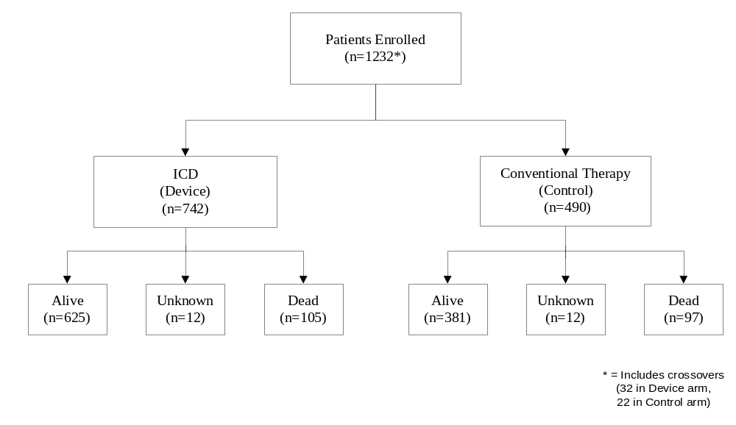

Primary Endpoint
The primary endpoint for MADIT II was death from any cause. Analysis was performed according to the intention-to-treat principle. The trial was designed to have 95 percent power to detect a 38 percent reduction in the two-year mortality rate among the patients in the ICD group, given a postulated two-year mortality rate of 19 percent among patients assigned to conventional therapy, with a two-sided significance level of 5%. For proportional-hazards modeling, power was maintained for a true hazard ratio of 0.63, after allowance for crossovers. A triangular sequential design was used, which was modified for two-sided alternatives. The data was corrected to account for any lag in obtaining data accrued (during weekly monitoring), but not reported before the termination of the trial, with preset boundaries to permit termination of the trial if the ICD therapy was found to be superior to, inferior to, or equal to conventional medical therapy.
Secondary analyses were performed with use of the Cox proportional hazards regression model. Survival curves were determined according to the Kaplan and Meier method, with comparisons of cumulative mortality based on logarithmic transformation. The p-values were termed nominal when they were not adjusted for sequential monitoring. All p-values were two-tailed.
At the recommendation of the Data and Safety Monitoring Board (DSMB), the trial was stopped on November 20, 2001, when it was revealed that the difference in mortality between the two groups had reached the prespecified efficacy boundary (p=0.027) (See Figure 2).
Figure 2: Sequential Monitoring in the Triangular Design
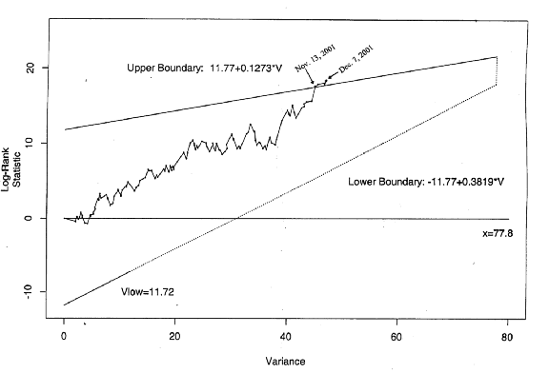

Study Results

Study Duration
Study duration, measured in months, is displayed in Table 5. The mean duration was similar between the ICD group and the conventional therapy group. As expected, the ICD group accumulated >15,000 months of follow-up.
Table 5: MADIT II Study Duration in months
Therapy | No.  (Pts.) | Mean | +SD | Minimum | Maximum | Cumulative
ICD Therapy | 742 | 20.5 | 12.9 | 0.2 | 51.7 | 15,190
Conventional Therapy | 490 | 19.6 | 12.6 | 0.2 | 52.3 | 9,624

Baseline Characteristics
Table 6 provides a summary of the general characteristics of the enrolled MADIT II patient population. Characteristics were balanced across therapy groups and no statistical differences were found during data analysis as indicated by the p-values in the table.
Table 6: Patient Population Characteristics
Characteristic | ICD  Patients  (n=742) | Conventional Therapy Patients  (n=490) | p-value
Age at Enrollment  - > 65 years (patients, %)  - Mean +/- Standard Deviation (years) | 397 (53.5%)  64.4 +/- 10.4 | 262 (53.5%)  64.6 +/- 10.3 | 0.99
Gender (patients, %)  - Male | 623 (83.9%) | 417 (85.1%) | 0.59
LVEF (%)  - Mean +/- Standard Deviation | 23.1 +/- 5.4 | 23.2 +/- 5.6 | 0.93
LVEF*  - < 25% (patients, %) | 502 (76.7%) | 330 (67.3%) | 0.91
New York Heart Association Classification  3 months before enrollment (patients, %)  - No CHF  - Class I  - Class II  - Class III  - Class IV  - Unknown | 179 (24.1%)  75 (10.1%)  258 (34.8%)  187 (25.2%)  33 (4.5%)  10 (1.4%) | 129 (26.3%)  58 (11.8%)  162 (33.1%)  111 (22.7%)  20 (4.1%)  10 (2.0%) | 0.64
Canadian Heart Association Classification  - Class I  - Class II, III, IV  - Angina Decubitus  - No Angina Pectoris  - Unknown | 126 (16.9%)  168 (23.1%)  35 (4.7%)  402 (54.1%)  11 (1.4%) | 81 (16.5%)  120 (24.4%)  15 (3.1%)  268 (54.7%)  6 (1.2%) | 0.62
Ventricular arrhythmias requiring treatment (patients, %) | 74 (10.0%) | 64 (13.1%) | 0.24
Atrial Arrhythmias requiring treatment  (patients, %) | 201 (27.1%) | 120 (24.4%) | 0.56
History of Hypertension (patients, %)  - Hypertension | 411 (55.3%) | 277 (56.5%) | 0.71
Blood Urea Nitrogen (patients, %)  - > 25 mg % | 213 (28.7%) | 153 (31.2%) | 0.52
Diabetes Mellitus (patients, %) | 246 (33.2%) | 184 (37.6%) | 0.45
Non-CABG Revascularization Procedures (patients, %) | 331 (44.6%) | 205 (41.8%) | 0.56
CABG Surgery (patients, %) | 428 (57.7%) | 274 (55.9%) | 0.53
Permanent Pacemaker (patients, %) | 62 (8.4%) | 30 (6.1%) | 0.22
EP Study prior to enrollment (262 patients)  - Inducible | n=150 (20.2%)  8 (5.3%) | n=112 (22.8%)  2 (1.8%) | 0.27  0.25
*Two patients enrolled with EF > 30%.

Medications
Table 7 provides a summary of the medication utilization for the patients enrolled. The two treatment groups were balanced and appropriately treated with standard cardiac therapy. There were no differences in ACE inhibitors, beta blockers or digitalis therapy between the ICD therapy group and the conventional therapy patients.
Table 7: Patient Population Medication Therapy
Medication | ICD  Patients  (n=742) | Conventional Therapy Patients  (n=490) | p-value
ACE inhibitor use (patients, %)  Baseline/Enrollment  Last Follow-up | 574 (77.4%)  533 (71.8%) | 377 (76.9%)  363 (74.1%) | 0.47  0.31
Amiodarone use (patients, %)  Baseline/Enrollment  Last Follow-up | 49 (6.6%)  94 (12.7%) | 36 (7.3%)  51 (10.4%) | 0.41  0.23
Antiarrhythmic use (patients, %)  Baseline/Enrollment  Last Follow-up | 18 (2.4%)  21 (2.8%) | 15 (3.1%)  12 (2.4%) | 0.37  0.43
Aspirin use (patients, %)  Baseline/Enrollment  Last Follow-up | 503 (67.8%)  477 (64.3%) | 344 (70.2%)  332 (67.8%) | 0.30  0.20
Beta blocker use (patients, %)  Baseline/Enrollment  Last Follow-up | 469 (63.2%)  529 (71.3%) | 295 (60.2%)  351 (71.6%) | 0.28  0.46
Digitalis use (patients, %)  Baseline/Enrollment  Last Follow-up | 441 (59.4%)  451 (60.8%) | 277 (56.5%)  290 (59.2%) | 0.29  0.41
Diuretics use (patients, %)  Baseline/Enrollment  Last Follow-up | 541 (72.9%)  562 (75.7%) | 379 (77.3%)  396 (80.8%) | 0.09  0.04
Lipid Lowering use (patients, %)  Baseline/Enrollment  Last Follow-up | 492 (66.3%)  556 (74.9%) | 315 (64.3%)  339 (69.2%) | 0.37  0.04
Sotalol use (patients, %)  Baseline/Enrollment  Last Follow-up | 7 (0.9%)  18 (2.4%) | 3 (0.6%)  4 (0.8%) | 0.38  0.05

All Cause Mortality
The Kaplan-Meier mortality curves depicting mortality for the two groups are shown below in Figure 3. Although the conventional and ICD survival curves remain close during the first nine months, they progressively separate thereafter. Table 8 presents information derived from these curves, with the conclusion that 3-year cumulative all-cause mortality is estimated to be reduced by 29% in those with an ICD.
Figure 3: Kaplan-Meier Mortality Curves Conventional vs. ICD Groups
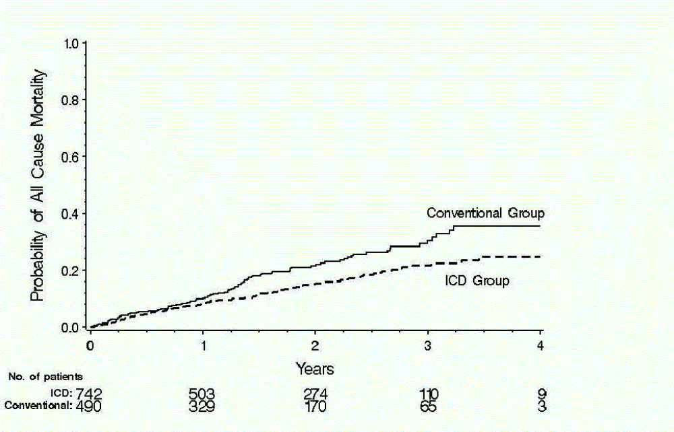
Table 8: Cumulative Mortality and Percentage Reduction
Year | Conventional Arm | ICD Arm | Difference | Reduction | CI*  % | p-value†
1 Year | 9.9 | 8.8 | 1.1 | 11% | -29, 39 | 0.53
2 Years | 21.5 | 15.5 | 6.0 | 28% | 5, 46 | 0.02
3 Years | 30.4 | 21.6 | 8.8 | 29% | 6, 46 | 0.02
*Indicates Confidence Interval for the percentage reduction in cumulative mortality. The cumulative mortality (and associated standard errors) is taken from the Kaplan-Meier analyses; percentage reduction analyses are based on a log transform method.
† For null hypothesis that the percentage (%) reduction is zero.
The pre-specified primary analysis of the trial was based on computation of a hazard ratio, based on an assumption that the two survival curves satisfy a proportional hazards condition (one is a power -- the `hazard ratio' -- of the other), and recognizing the sequential stopping rule of the trial. The hazard ratio is interpreted as the ratio of instantaneous risks of dying, at each point in time, in the two treatment groups. The hazard ratio for the ICD group relative to the conventional therapy group was found to be 0.69, indicating a 31% reduction in instantaneous risk (95% confidence interval, 0.51 to 0.93; p=0.016, reduced from p=0.027 when reaching the stopping boundary, by incorporation of lagged data). The Cox regression analyses used for this purpose were stratified by enrollment centers, thus allowing for somewhat different patient pools at differing locations.
The proportional hazards assumption was evaluated by several standard statistical methods, all providing support. One method is derived from finding parallelism in so-called log (-log) plots of the cumulative hazards. Another is from fitting models that allow for differing hazard ratios in differing intervals of time, and demonstrating that any apparent differences among the period-specific hazard ratios can be attributed to chance. One such analysis is summarized in Table 9.
Table 9: Year-Specific Hazard Ratios (HR)
Year | Estimate | CI
1 Year | 0.87 | 0.59, 1.29
2 Years | 0.56 | 0.29, 1.07
3+ Years | 0.61 | 0.28, 1.34
Overall | 0.69 | 0.51, 0.93
The p-value = 0.16 for differences among the 3 HRs, and the p-value = 0.016 for the overall HR. The exponential mortality curves fit the data very well, with risks of mortality of 0.0100 each month for patients in the conventional therapy group and 0.0069 each month in the ICD group, with the ratio, 0.69, in agreement with that reported above.

Verification of ICD Shock Therapy Treatment
Of the 710 patients that were implanted with an ICD, 134 received appropriate therapy for ventricular tachycardia/ventricular fibrillation (VT/VF) and the probability of therapy increased over time. There was a 34% cumulative probability that ICD patients received therapy from the device for VT/VF within three years (see Figure 4). The probability of first appropriate shock for VF only at one year was 4% and increased to 10% after four years. These percentages are closely related to the survival probability differences observed between the ICD and conventional therapy groups (1% and 11%, respectively) as shown in Figure 3.
Figure 4: Probability of First Therapy Due to VT/VF
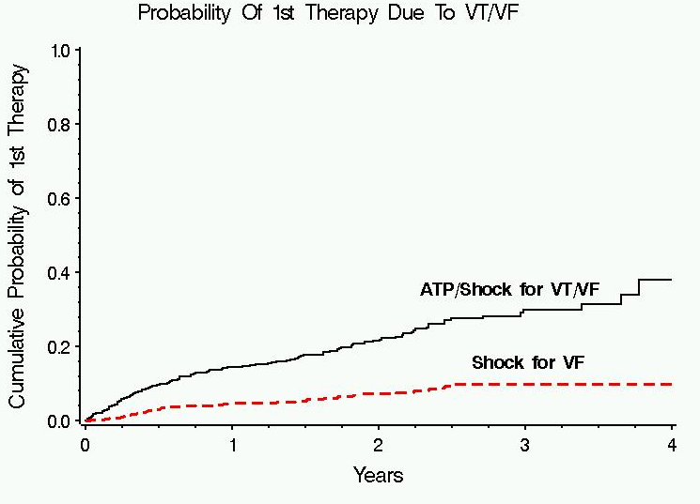

The probability of appropriate ICD shocks for ventricular fibrillation () correlates closely to the difference in the cumulative number of deaths between the ICD and conventional groups as shown in .

Hospitalization Results
The rate of occurrence of adverse events requiring hospitalization was 0.29 per year of observation in both the conventional therapy patients and in the ICD patients. Table 10 provides the summary of all hospitalizations that occurred as a result of adverse events. Adverse events that resulted in hospitalizations do not differ significantly between groups.
Table 10: Adverse Events Requiring Hospitalizations (Rate/Year)
(excludes adverse events that resulted in death)
Treatment Group | Cumulative Years of Observation | Total Number of Individuals with Adverse Events | Rate per Year of Individuals with Adverse Events | p-value
Conventional (n=490) | 703.6 | 201 (41%) | 0.29 | 0.85
ICD Therapy Group (n=742) | 1155.97 | 337 (45%) | 0.29 | 0.85

Table 11 provides a summary of hospitalizations that were required as a result of congestive heart failure (CHF) related adverse events. There were 78 of the 490 patients in the conventional group and 161 of the 742 ICD patients who had one or more hospitalizations that did not result in death. The annual rate of hospitalization for CHF for each treatment group was calculated by dividing the number of patients with one or more hospitalizations for new or worsening CHF by the cumulative years of observation. The rate of hospitalization for CHF per year was somewhat higher in the ICD group (161/1155.97 = 0.14) compared to the conventional therapy group (78/703.6 = 0.11); however, this difference in the rate of hospitalization for CHF was not statistically significant (p=0.11).
Table 11: Heart Failure Adverse Events Requiring Hospitalization (Rate/Year)
(excludes adverse events that resulted in death)
Treatment Group | Cumulative Years of Observation | Total Number of Individuals with Adverse Events | Rate per Year of Individuals with Adverse Events | p-value
Conventional (n=490) | 703.6 | 78 (16%) | 0.11 | 0.11
ICD Therapy Group (n=742) | 1155.97 | 161 (22%) | 0.14 | 0.11

Reasons For Crossover
The MADIT II study was an intention-to-treat analysis, therefore, any patient receiving therapy outside of their randomized therapy group was counted as a crossover. Table 12 details crossovers by treatment group.
Table 12: Reasons for Crossovers by Treatment Group
Description | ICD Therapy  (n=742) | Conventional Therapy  (n=490)
Refusal of therapy | 21 | 0
Met ICD implant criteria | N/A | 21
Heart transplant | 9 | 0
Sepsis related to CABG surgery | 1 | 0
Non-conversion of arrhythmia | 1 | 0
Physician Discretion | 0 | 1
Total Crossovers (54) | 32 | 22
A crossover patient was defined as a patient who, at the time of a specified data cutoff date, was receiving treatment that was different than their originally randomized assignment. Crossovers from the conventional therapy group to the ICD group were strongly discouraged unless a patient was determined to have a strong clinical justification such as positive inducibility during EP testing or spontaneous ventricular arrhythmia event(s) requiring hospitalization that would be an approved indication for receiving an ICD.

Follow-Up Compliance
The compliance rate is calculated by dividing the number of successful visits by the sum of the visits expected for the designated month sequence. Table 13 details reported visit compliance in six month intervals. Compliance to follow-up was > 88% at the majority of required visits. There was no difference in the follow-up rates between the two groups.
Table 13. Follow-Up Compliance
Follow-up Sequence Month | % Compliant  ICD Group | % Compliant  Conventional Therapy Group
1-6 months | 98 | 96
7-12 months | 97 | 95
13-18 months | 96 | 93
19-24 months | 95 | 93
25-30 months | 93 | 89
31-36 months | 97 | 90
37-42 months | 95 | 85
43-51 months | 96 | 100
Total Average | 96 | 94

Subgroup Analysis Of MADIT II Patient Population
Figure 5 provides the hazard ratios and 95 percent confidence intervals for death from any cause in the ICD group as compared to the conventional therapy group according to selected clinical characteristics.
The hazard ratios in the various subgroups were similar, with no statistically significant interactions. The dotted vertical line represents the results for the entire study (nominal hazard ratio, 0.66, without adjustment for the stopping rule). The horizontal lines indicate nominal 95 percent confidence intervals.
Figure 5: Hazard Ratios and 95 Percent Confidence Intervals
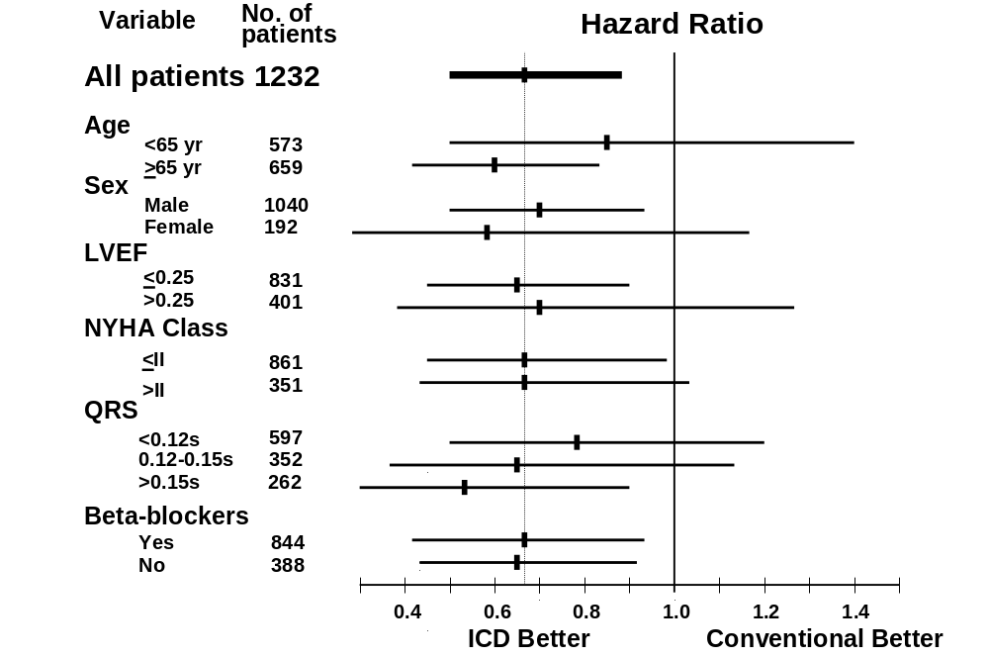

GENDER ANALYSIS
As seen above in the subgroup analysis, there is no significant difference in the hazard ratios and 95 percent confidence intervals for death from any cause in the ICD group as compared to the conventional therapy group according gender. The 95% confidence interval crosses 1.0 because of the smaller number of female patients enrolled in the study. The percentage of female patients enrolled is consistent with similar ICD studies.

Analysis of Inducibility as a Risk Factor
There were 583 patients enrolled in MADIT II who had EP testing performed either prior to or during ICD implant. The definition for inducibility was the same one used for the MADIT I study. Of these 583 patients, 373 (63%) were not inducible and the remaining 210 (36%) were inducible. Of the 210 patients who were inducible, 180 (88%) had EP testing performed at implant using a catheter method and 24 (12%) using the ICD for induction; there was no data on the method of induction for 6 patients.

The occurrence of ICD therapy for VT, VF or VT/VF Combined
Therapy for VT was defined as antitachycardia pacing (ATP) or ICD shock delivered by the device in an attempt to stop an arrhythmia as reported by the enrolling center. Therapy for VF was defined as the delivery of ICD shock therapy. The endpoint for VT/VF was defined by the occurrence of either VT or VF therapy. The occurrence of therapy for each of these groups is provided in Table 14. All analyses were Cox regression analyses, stratified by enrollment center, with time to VT, time to VF or time to VT/VF therapy as the respective endpoint.

Table 14: ICD Patients Receiving One or More Therapies*
Type of ICD Therapy | Number of Patients | Percent of Patients with Therapy Episodes
VT (ATP or shock) | 89 | 15.4%
VF (Shock only) | 36 | 6.2%
VT/VF VF (ATP + shock) | 114 | 19.7%
*Some patients received both types of therapy

Predictions of VT and VF Therapy in ICD Patients
A statistical analysis was performed to evaluate whether inducibility at EP testing provides predictability of the potential effectiveness of an ICD. To this end, the occurrence of each of the three endpoints defined above (VT, VF and VT/VF), in ICD patients with EP testing were evaluated. Analyses were done by Cox proportional hazards regression, stratified by enrollment center. (See Table 15.)
A list of potential risk factors was considered for these endpoints, such as age, gender, and standard cardiological variables like NYHA class, EF, etc., and developed a parsimonious regression model in the 583 ICD patients identified above. GENDER and BUN (dichotomized at up to 25 versus 26 and over) were observed as potential risk factors for these endpoints, with males and elevated BUN associated with increased occurrence of these endpoints. Further analysis investigated whether inducibility added any additional, independent predictive power for each of these endpoints.
The conclusion was that inducibility increases the risk of VT events by perhaps 60% (p=0.07) and decreases the risk of VF events by perhaps 50% (p=0.08). As a consequence of these opposite directional effects of similar magnitudes, there was no reliable evidence that inducibility affects the frequency of VT/VF events (p=0.26); it may be associated with a slight increase since VT events occur more frequently than VF.

Table 15: Therapy Predictability Based on Induced Arrhythmia
Therapy Delivered for the following Type of Arrhythmia | Inducible
 | Yes | No
VF  Yes  No | 7  202 | 29  341
VT  Yes  No | 43  166 | 46  324
VT/VF  Yes  No | 48  161 | 66  304

Conclusions Drawn from the Studies

Safety
Safety of the ICD systems used in the MADIT II study has been established in previous PMA applications. In addition, analysis of the system safety in the MADIT II patient population has been demonstrated, as there were no unanticipated device-related adverse events. Use of the ICD system in the defined MADIT II patient population is found to be within the acceptance boundary for safety.
The rate of adverse events associated with the ICD in the MADIT II population was within acceptable bounds and equivalent to that found in other patient populations who receive ICDs. There were no deaths associated with implantation of the device. There was no difference in the overall number of hospitalizations for the two groups, however there was a trend toward an increase in hospitalizations for congestive heart failure in those patients treated with an ICD.

Effectiveness
Guidant ICD systems have been proven effective in the prophylactic treatment of patients who are at high risk for sudden cardiac death as defined by the clinical trial. Results of the MADIT II study demonstrated that ICD therapy provides a mortality benefit over current conventional medical therapy in the treatment of patients with a history of prior myocardial infarction and advanced left ventricular dysfunction (EF < 0.30).

CDRH Decision
FDA issued an approval order for P960040/S026 and P910077/S37 on July 19, 2002 to expand the indications for Guidant ICDs. This decision was based on the entire results of the MADIT II study. In this clinical study of patients with a previous myocardial infarction and an ejection fraction of < 30%, those randomized to treatment with an ICD had a better survival than those treated with conventional medical therapy. The sponsor has demonstrated that the ICD itself is responsible for the difference in mortality between the two treatment groups by showing that the cumulative probability of receiving a shock for ventricular fibrillation in the treatment group closely approximates the difference in mortality between the two groups, suggesting that if the patient did not have an ICD and had an episode of ventricular fibrillation, they would have died. In addition, the subgroup analysis shows there is approximately the same hazard ratio for death across subgroups. Overall, the incidence of adverse events associated with the ICD is small and there were no deaths associated with ICD implantation

Approval Specifications

Directions for Use: | See labeling.
Hazards to Health from Use of the Device: | See Indications, Contraindications, Warnings, Precautions, and Adverse Events in the Labeling.
Post-approval Requirements, Restrictions: | See approval order.

 Moss AJ, Hall WJ, Cannom DS, et al. Improved survival with an implanted defibrillator in patients with coronary disease at high risk for ventricular arrhythmia. NEJM 1996;335:1993-40.

