National Park Service
Channel Islands National Park

ISLAND FOX RECOVERY PROGRAM
2003 ANNUAL REPORT

Technical Report 04-02

Timothy J. Coonan
Keith A. Rutz
Kathryn McCurdy
David K. Garcelon
Brian C. Latta
Linda Munson

National Park Service
Channel Islands National Park
1901 Spinnaker Drive
Ventura, CA 93001
Voice: (805) 658-5776
Fax: (805) 658-5798
Email: tim_coonan@nps.gov

May 2004

ACKNOWLEDGEMENTS

Island fox recovery at Channel Islands National Park has been a team effort since emergency recovery actions began in 1999. It continues to be so, and we thank the many people whose time, efforts and expertise have kept the program going.

Our thanks go first to the island fox caretakers, who provide the daily care and enriched environments for the foxes. Thanks to Susan Coppelli, Pedro Chavarria, Geoff Cline, Melanie Coulter, Stephanie Provinski, Rachel Wolstenholme, Ryan Rumelhart, Sara Krause, Zac Nelson, and Chris Newman. Others have volunteered their time to caretake for the foxes. For this we thank Ian and Marcella Williams, Tom Dore, Don, Susan and Allie Morris, Ray and Lorrie Aichner, Lindsay Martin, and Wendy Crawford.

Thanks to Erik Aschehoug, Scott Morrisson and Lotus Vermeer of The Nature Conservancy for their support in island fox recovery actions on Santa Cruz Island, including construction and staffing of the captive breeding facilities on that island. Tim Jones, Brent Wilson, Dave Mills, and Sam Spaulding have assisted the fox recovery effort on Santa Cruz with their expertise in maintenance, island logistics, and cultural resources management. Lyndal Laughrin of the UC Santa Cruz Island Reserve has provided much-needed logistical support for fox recovery efforts on that island.

Thanks to San Miguel Island manager Ian Williams, who continues to assist in all phases of the program on San Miguel. Thanks to Cass Bromley and Jeff Sikich of Santa Monica Mountain NRA, who successfully brought the last wild fox on San Miguel into captivity. Thanks also to Seth Riley for loaning them to us for a week.

We thank our project veterinarian, Mark Willett, for conducting veterinary exams, and providing veterinary care to foxes. When circumstances required immediate veterinary care, time and effort were kindly donated by veterinarians Karl Hill and Winston Vickers.

We again thank director Rich Block of the Santa Barbara Zoo for making the zoo an effective partner in island fox captive breeding at the Park. Rich, along with General Curator Alan Varsik and Assistant Curator Ingrid Russell, have kindly donated their staff’s time for veterinary and fox care on the islands, and we have learned much from their staff’s experience with captive island foxes. Thanks to Alan Varsik and Julia Parker of the Zoo for maintaining the island fox studbook.

Thanks to Cheri Asa and Joan Bauman of the St. Louis Zoo for reproductive monitoring of captive foxes. Genetic analysis of the captive island fox populations was conducted by Melissa Gray; thanks also to Kathy Ralls and Jonathon Ballou for their assistance.

Guidance for the program has been provided by members of the island fox conservation working group and others, who have donated time and expertise to program oversight. We thank Kathy Ralls, Cheri Asa, Marsha Sovada, Linda Munson, Bob Wayne, Phil Miller, Devra Kleiman, Rosie Woodroffe, Dave Graber, Peter Dratch, Colleen Lynch, Bob DeLong, Cathy Schwemm, Lyndal Laughrin, Grace Smith, Dan Blumstein, Brian Smith, Paul Collins, Nancy Thomas, Gary Roemer, Mark Willett, Alan Varsik, Ingrid Russell, Julia Parker, and Melissa Gray.

Our thanks go to the dedicated raptor biologists of the Santa Cruz Predatory Bird Research Group for their relentless efforts to trap and remove golden eagles from the northern Channel Islands. We appreciate the work of Dan Driscoll, Craig Himmelwright, Greg Doney, Nick Todd, and Vince McGlinchey.

Thanks to Rhonda Brooks, the late Fred Rodriguez and Doretta Burgess for once again effectively coordinating transportation to the islands. We particularly appreciate the skills and efforts of the Park’s boat crews in getting us and our materials onsite. For this we thank John Provo, Dwight Willey, Keith Duran, and Diane Brooks. Yvonne Morales again effectively coordinated logistics and travel for the annual island fox meeting.

Thanks finally to the Park management team and the rest of the Park staff for supporting these critical emergency actions for island fox recovery. We especially appreciate the support of Kate Faulkner, Chief of Natural Resources Management, Superintendent Russell Galipeau, and Chief Ranger Jack Fitzgerald. Thanks to Cathy Schwemm, David Graber, Peter Dratch and Bridget Fahey, who comprise the park’s island fox steering committee; their counsel continually guides our program. We also appreciate the efforts of those beyond the Park who have recognized the plight of island foxes, and have helped garner the resources necessary to effect recovery. For this we thank Dave Graber, Patty Neubacher and Jay Goldsmith.

TABLE OF CONTENTS

Executive Summary 1
Introduction 4
2003 Meeting of the Island Fox Conservation Working Group 6
Captive Breeding Program Development 8
The Need for Captive Breeding as a Recovery Action 8
Goals and Objectives for Captive Breeding 8
Program Guidance 9
Standard Operating Procedures 9
Facility Design and Construction 9
Veterinary Care 9
Caretaking and Handling 10
Breeding Strategy 10
Diet 10
Overall Breeding Success 11
Recovery of San Miguel Island Foxes 13
Captive Breeding 13
Health/Medical 14
Future Management of San Miguel Captive Island Foxes 16
Status of Wild Fox Population 16
Recovery of Santa Rosa Island Foxes 18
Captive Breeding 18
Health/Medical 18
Future Management of Santa Rosa Captive Island Foxes 19
Status of Wild Fox Population 19
Reintroduction of Santa Rosa Island Foxes 20
Recovery of Santa Cruz Island Foxes 24
Captive Breeding 24
Health/Medical 25
Future Management of Santa Cruz Island Captive Foxes 25
Status of Wild Fox Population 26
Reintroduction of Santa Cruz Island Foxes 26
Removal of Golden Eagles 28
Impact of Eagle Predation on Island Foxes 30
Other Actions Required for Recovery 33
Removal of Feral Pigs from Santa Cruz Island 33
Reintroduction of Bald Eagles to Santa Cruz Island 34
Establishment of Island Fox Recovery Team 34
Budget 36
Future Costs 37
Literature Cited 38
Appendix A Findings of the Island Fox Conservation Working Group 41
Appendix B Breeding Charts and Lists of Foxes in Captivity 59

LIST OF TABLES

Table 1. Average number of pups weaned per litter, 1999-2003. 11
Table 2. Proportion of annual pairings that have produced litters, 1999-2003. 12
Table 3. Growth of captive island fox population, San Miguel Island. 14
Table 4. Reproductive success of captive San Miguel Island foxes, 2002-2003 breeding season. 15
Table 5. Growth of captive island fox population, Santa Rosa Island. 18
Table 6. Reproductive success of captive Santa Rosa Island foxes, 2002-2003 breeding season. 20
Table 7. Release location, date, release type and fate of foxes released to the wild on Santa Rosa Island, winter 2003-2004. 22
Table 8. Reproductive success of captive Santa Cruz Island foxes, 2002-2003 breeding season. 25
Table 9. Release location, date, release type and fate of foxes released to the wild on Santa Cruz Island, December 2003. 27
Table 10. Cause of mortality for radiocollared foxes on Santa Cruz Island, December 2000 to April 2004. 30
Table 11. Costs and funding sources for island fox recovery actions, fiscal year 2003 (1 October 2002 to 30 September 2003). 36
Table 12. Estimated costs and funding sources for island fox recovery actions on the northern Channel Islands, fiscal year 2004. 37
Table 13. Island foxes in captive breeding facility on San Miguel Island. 60
Table 14. Island foxes in captive breeding facility on Santa Rosa Island. 62
Table 15. Island foxes in captive breeding facility on Santa Cruz Island. 64

LIST OF FIGURES

Figure 1. Growth of captive island fox populations, 1999-2003. 1
Figure 2. Location of island fox captive breeding facilities, San Miguel Island. 13
Figure 3. Location of island fox captive breeding facilities, Santa Rosa Island. 17
Figure 4. Most recent locations for island foxes released to the wild in winter 2003-2004, Santa Rosa Island. RM-01, RF-102, RM-02 and RF-103 have been recaptured and returned to captivity. 23
Figure 5. Location of island fox captive breeding facilities, Santa Cruz Island. 24
Figure 6. Golden eagles remaining on the northern Channel Islands, March 2004. 29
Figure 7. Rolling annual survivorship, with 95% CI, of wild island foxes on Santa Cruz Island, as determined by staggered entry Kaplan-Meier analysis. 32
Figure 8. Breeding and pedigree chart for captive San Miguel Island foxes. 60
Figure 9. Breeding and pedigree chart for captive Santa Rosa Island foxes. 62
Figure 10. Breeding and pedigree chart for captive Santa Cruz Island foxes. 64

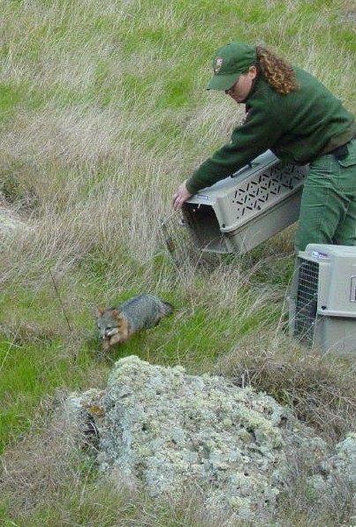

Island fox released from captivity on Santa Rosa Island, December, 2003

Executive Summary
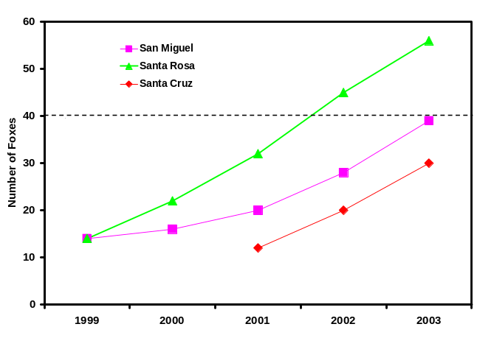
Figure 1. Growth of captive island fox populations, 1999-2003.

From 1995 to 2000, island fox (Urocyon littoralis) populations on San Miguel, Santa Rosa and Santa Cruz Islands declined by as much as 95% due to predation by golden eagles (Aquila chrysaetos). Faced with the likely extinction of 3 island fox subspecies, the National Park Service began implementing recovery actions for island foxes on the northern Channel Islands in 1999. Such actions included removal of golden eagles and captive breeding of island foxes. In this report we describe progress in island fox recovery in 2003.

Summary
Of utmost importance to the recovery effort is the impact of golden eagles on both wild foxes and foxes released from captivity. In 2003, continued removal of golden eagles resulted in rising annual survivorship of wild island foxes on Santa Cruz Island. However, over half of the captive foxes released to the wild on Santa Cruz Island in 2003 were killed by golden eagles within several weeks of release. In comparison, only 1 of 8 foxes released on Santa Rosa Island in 2003-2004 died from predation. Reintroduction of captive foxes to the wild is not an effective recovery tool under the high predation rate observed on Santa Cruz Island. If predation can be sufficiently mitigated, then releases would continue on Santa Cruz and Santa Rosa Islands in fall 2004, and initial releases could be conducted on San Miguel Island. However, if foxes cannot be released to the wild in fall 2004 because of the threat of eagle predation, then moving a portion of the breeding program to mainland institutions should be considered.

Captive Breeding
Generally, captive fox populations on the islands grew at adequate rates. However, in 2003 the rising cost of keeping foxes in captivity on the islands, both financially and biologically, became apparent. Several problems arose in captivity that we had not previously encountered. First, 3 pairs that had previously produced litters failed to reproduce in 2003, probably due to leaving a pup from the previous year in their pens. Second, several males injured their mates during breeding season, and had to be separated from them; production from those prospective pairings is thus lost for the 2003-2004 breeding season. Third, some released foxes dispersed from their release sites to the captive pen areas, and their interactions with captive foxes caused injury to both wild and captive animals.

Captive island fox populations grew to levels in 2003 that were at or close to the targeted captive breeding population size of 40 foxes (20 pairs) (Fig. 1), and reproductive success in captivity was similar to that observed in the wild. Since 1999, 20% of young adult females have produced a litter in captivity, as have 60% of older females. Average number of pups weaned per litter was 2.3.

San Miguel Island Foxes
The captive population of San Miguel island foxes (U. l. littoralis) grew from 28 to 38 individuals with the addition of 10 pups in spring 2003. The San Miguel population remains skewed toward males (23 males:15 females). Seven of 14 potential founders (wild-born foxes) had successfully bred by 2003. The last remaining wild fox was trapped and brought into captivity in November 2003, although she died a month later. Production in spring 2004 from the 15 pairs should put the captive population above 20 pairs, and releases to the wild will commence in fall 2004 if eagle predation has been sufficiently mitigated.

Santa Rosa Island Foxes
The captive population of Santa Rosa Island foxes (U. l. santarosae) grew from 45 to 56 foxes in captivity, with the birth of 11 pups in spring 2003. In winter 2003/2004 initial releases to the wild of captive Santa Rosa foxes commenced. Twelve foxes were released to the wild from December 2003 to February 2004. Four of the released animals were recaptured and brought back into captivity because their use area included the captive pen facilities, and interactions between captive and released foxes had resulted in injuries to 2 captive and 2 wild foxes. To prevent this, perimeter fences will be constructed around captive breeding facilities in summer 2004. Of the 8 released foxes remaining in the wild, 1 died from eagle predation in February 2002. The Santa Rosa Island fox captive population is skewed toward females (19 males:28 females), and 11 of 14 potential founders had bred by 2003. Two males are currently not paired for breeding because they have a history of causing injuries to potential mates.

Santa Cruz Island Foxes
Unlike San Miguel and Santa Rosa islands, Santa Cruz Island has a remnant wild population numbering around 100. Because of this, the captive breeding program on Santa Cruz is not as large as on the other two islands. In 2003 the captive Santa Cruz Island fox population (U. l. santacruzae) grew from 20 to 30 foxes with the production of 10 pups in spring 2003. Nine foxes were released to the wild in December 2003. Five of the 9 foxes died from eagle predation within 3 weeks of release, and so the remaining 4 foxes were brought back into captivity in January 2004. The Nature Conservancy is building a second captive breeding facility on Santa Cruz Island in order to adequately house the current number of captive foxes, as well as pups likely to be produced in spring 2004.

Removal of Golden Eagles
Using live-trapping methods, staff from the Santa Cruz Predatory Bird Research Group removed 7 golden eagles from Santa Cruz Island, and 2 from Santa Rosa Island, bringing to 31 the total number of eagles removed from the islands since 1999. Eagles captured in 2003 included 2 adult males, 1 subadult female, 2 subadult males, 1 near adult male, 1 juvenile female, and 2 fledglings captured by hand in nests. One of the adult males was from a territorial pair (Trap Canyon on Santa Rosa Island). At the end of 2003 there were as many as 14 golden eagles left on Santa Cruz and Santa Rosa Islands, including 4 pairs likely to breed in spring 2004. Intensive live-trapping will occur in spring 2004 to remove as many of the remaining eagles as possible.

Impact of Remaining Eagles on Foxes
Radiotelemetry monitoring of the wild Santa Cruz Island fox population indicated that annual survivorship had risen to above 80% by the end of 2003, which is the level required for a stable or increasing population. There appears to be a substantial difference between survivorship of wild foxes on Santa Cruz Island and survivorship of captive-raised foxes released to the wild on that island.

Health of Captive Island Foxes
One fox died in captivity on San Miguel in 2003, and 2 on Santa Rosa in early 2004. Two of the 3 foxes died from wounds inflicted by penmates, in one case a male, and in the other several females. The third mortality was due to chronic kidney failure.

Several captive foxes suffered from prolapsed rectums, which could possibly be caused by parasites. Captive foxes on San Miguel harbor 3 parasites with potential to impact fox health: Angiocaulus, Spirocerca and Uncinaria. Foxes on Santa Rosa have not tested positive for Angiocaulus. To date few foxes have been treated for internal parasites, due to the unknown risks associated with such treatment. Some foxes on Santa Rosa and Santa Cruz had significant flea infestations, and were treated during annual veterinary exams. All captive foxes are vaccinated annually against canine distemper virus (CDV). Three necropsied foxes had evidence of surviving a previous raptor attack.

Other Management Actions Required
The Nature Conservancy and the NPS will begin removal of feral pigs (Sus scrofa) from Santa Cruz Island in 2004, a project that is estimated to take 2-4 years to complete. The NPS is also cooperating with other agencies in a feasibility study to determine if bald eagles (Haliaeetus leucocephalus) can be restored to the northern Channel Islands. In the summer of 2002, 12 eaglets were reintroduced to Santa Cruz Island, and 11 in 2003. Of those eagles, 15 remain on the northern Channel Islands. Annual supplementation with up to 12 eagles will continue until 2007.

Annual Working Group Meeting
The Island Fox Conservation Working Group, a loose affiliation of entities concerned with conservation of island foxes, met again in 2003 to consider current conservation challenges faced by the species. The primary issue identified by the group was the threat posed by the remaining golden eagles. The group recommended that lethal removal be considered as an option for eagle removal.

Introduction

The island fox, a diminutive relative of the gray fox (U. cinereoargenteus), is endemic to the California Channel Islands. The fox exists as 6 different subspecies on each of the 6 islands, a distinction upheld by morphological and genetic work (Wayne et al. 1991, Collins 1993). The subspecies on the 3 northern Channel Islands are in genuine danger of extinction from unnatural levels of golden eagle predation and from extremely low population levels.

In December 2001, the U.S. Fish and Wildlife Service proposed for listing as endangered 4 subspecies of the island fox, including the 3 subspecies in the Park (San Miguel Island fox [U.l. littoralis]; Santa Rosa Island fox [ U.l. santarosae], and Santa Cruz Island fox [U.l. santacruzae]) as well as the subspecies on Santa Catalina Island (U.l. catalinae). The final rule listing those subspecies as endangered was published in the Federal Register on March 5, 2004 (USFWS 2004).

Island fox populations were annually monitored on San Miguel Island from 1993 to 1999, and on Santa Cruz Island from 1993 to present. The island fox population on San Miguel declined beginning in 1994 with the adult population falling from 450 in 1994 to 15 in 1999 (Coonan et al. in review). The Santa Cruz population declined from approximately 2,000 adults in 1994 to perhaps less than 135 in 2000 (Roemer 1999), and the current population is probably less than 100 adults (D. Garcelon, Institute for Wildlife Studies, unpubl. data). Survey data from Santa Rosa Island (G. Roemer, Institute for Wildlife Studies, unpublished data) indicate that island foxes experienced a similar catastrophic decline on that island as well. Foxes on Santa Rosa may have numbered more than 1,500 in 1994 (Roemer et al. 1994) but declined to 14 animals by 2000 (Coonan and Rutz 2001. Prior to implementation of island fox recovery efforts, Roemer (1999) estimated time to extinction at 5 years for island foxes on San Miguel and 12 years for island foxes on Santa Cruz.

Predation by golden eagles (Aquila chrysaetos) is the primary mortality factor now acting upon island foxes on the northern Channel Islands, and is likely responsible for the massive decline of the 3 northern subspecies from 1994 to 2000 (Roemer et al. 2001a). Evidence from several studies supports this. Golden eagle predation was identified as cause of death for 19 of 21 island fox carcasses found on Santa Cruz Island from 1993 to 1995 (Roemer et al. 2001a). On San Miguel Island in 1998-1999, 4 of 8 radiocollared island foxes were killed by golden eagles in a 4-month period, and another 2 died of unknown causes (Coonan et al. in review). In 2001-2002, 15 of 18 mortalities of radiocollared foxes on Santa Cruz Island were due to golden eagle predation (D. Garcelon, Institute for Wildlife Studies, unpubl. data).

The observed level of golden eagle predation is unnatural. Until recently, golden eagles have never bred on the Channel Islands and their recent appearance is due to a prey base, feral pigs (Sus scrofa), that was not present prehistorically. The absence of bald eagles (Haliaeetus leucocephalus), which bred historically on the islands and whose presence may have kept golden eagles away, is another factor contributing to golden eagle predation. Moreover, on much of the northern Channel Islands, historic sheep grazing changed the predominant vegetation from shrub to non-native grasslands, which offer much less cover from aerial predators.

Upon receiving recommendations from a convened panel of experts, the Park began taking emergency recovery actions in 1999. In summer 1999, the Park constructed pens on San Miguel and began capture of wild island foxes. By January 2000, 14 island foxes had been captured and placed in the pens. Four of those were males, and so were paired with 4 females for breeding. The captive population on San Miguel increased from 14 to 38 animals after 4 years of breeding. A successful 2004 breeding season (>10 pups) could put the captive San Miguel island foxes in position for initial releases to the wild in fall 2004.

A captive breeding program was initiated for Santa Rosa Island in 2000. The initial captive population on Santa Rosa was 14 animals, which proved to be the island’s remaining fox population. Some females were pregnant when captured, and 3 litters were born in captivity in 2000. With an increase to 56 foxes in 2003, the captive population on Santa Rosa exceeded the target captive population size of 40 foxes, and initial releases began in winter 2003/2004.

The status of eagles and foxes on Santa Cruz Island was assessed at the 2001 Recovery Team Meeting, and indications were that captive breeding was warranted for that island fox population. In February 2002, a 10-pen captive breeding facility was built on Santa Cruz Island by the National Park Service and The Nature Conservancy. This facility was stocked with 12 adult island foxes caught in pairs or as individuals from separate areas of the island. The captive population increased to 30 foxes in 2003, and small releases were conducted in 2002 and 2003.

The Park established a cooperative agreement with the Santa Cruz Predatory Bird Research Group (SCPBRG) in 1999 for the purpose of relocating golden eagles from the northern Channel Islands. Personnel from the SCPBRG began eagle survey and removal on Santa Cruz Island, the island with the most recent sightings, in late summer 1999. Golden eagles are now known to breed on both Santa Cruz and Santa Rosa Islands. To date 32 golden eagles have been removed from Santa Cruz Island, the majority by bownet trapping. Captured birds were released in northeastern California, and satellite telemetry indicates none have attempted to return to the islands. Approximately 11 eagles remain on Santa Cruz and 3 on Santa Rosa.

In August 2003, the Park completed a recovery strategy for island foxes on the northern Channel Islands (Coonan 2003). The recovery strategy is in the format of a U.S. Fish and Wildlife Service recovery plan, identifying threats to the species, delineating goals, objectives and recovery criteria, and presenting a schedule and cost estimates for recovery actions. Appropriate recovery goals for each of the 3 island fox subspecies in the northern Channel Islands were determined via demographic modeling. Population viability analysis was used to identify target population levels which would minimize the chance of extinction. Modeling was then used to set an augmentation (captive breeding and release) schedule that would achieve those targeted goals in a reasonable timeframe.

The island fox recovery strategy calls for a continuation of the emergency actions of island fox captive breeding and golden eagle removal, as well as the separately funded actions of feral pig removal from Santa Cruz Island and reintroduction of bald eagles to the northern Channel Islands. Full recovery of the San Miguel subspecies may take as long as a decade, although recovery on Santa Rosa and Santa Cruz may occur sooner. The plan was developed with input from U.S. Fish and Wildlife Service, and could be adopted as part of a FWS recovery plan for the species, now that the three park subspecies are listed.

2003 Meeting of the Island Fox Conservation Working Group

Since 1999, the NPS has convened a group of experts annually to help evaluate the status of island foxes on park lands, and to make findings regarding appropriate recovery actions. The Island Fox Conservation Working Group, as it is called, is a loose affiliation of public agency representatives, landowners, conservancies, zoological institutions, non-profits and academics concerned about conservation efforts for the island fox.

The working group serves as a forum for information exchange and evaluation of recovery efforts. The working group communicates primarily through an annual meeting, but also via email and telephone conference calls. The group further divides into subject matter groups to tackle most issues. The individual working groups for this year’s meeting were captive breeding, veterinary care, wild population management, and reintroduction of island foxes. The group annually reports the status of island foxes on all islands and lists findings in regard to threats to the species and appropriate mitigation actions (see Appendix A).

The primary issue identified by the group in 2003 was the inability of live-capture efforts to remove all golden eagles from the northern Channel Islands, and the continued threat to island foxes posed by the remaining eagles. Consensus of the group was that eagle predation had not been sufficiently mitigated by live-capture methods, and that lethal control of eagles must be considered if island foxes were to be recovered. The group also noted the recent discovery of breeding golden eagles on Santa Rosa Island, and the presence of a non-native prey base (mule deer and elk) there. One discussion group recommended that deer carcasses and gut piles from the deer hunt on that island be made unavailable to eagles.

The Working Group was divided on whether it was advisable to release foxes to the wild under these conditions, but recognized that if foxes could not be released, the park should consider the option of moving a portion of captive breeding to mainland institutions. This would require adequate quarantine and treatment procedures to insure no transmittal of pathogens (disease and parasites) from the islands to the mainland, or from the mainland to the islands.

Due to the formidable threat posed by canine diseases and parasites, the veterinary group recommended that all dogs used on park islands undergo strict vaccination and quarantine prior to arriving on the island.

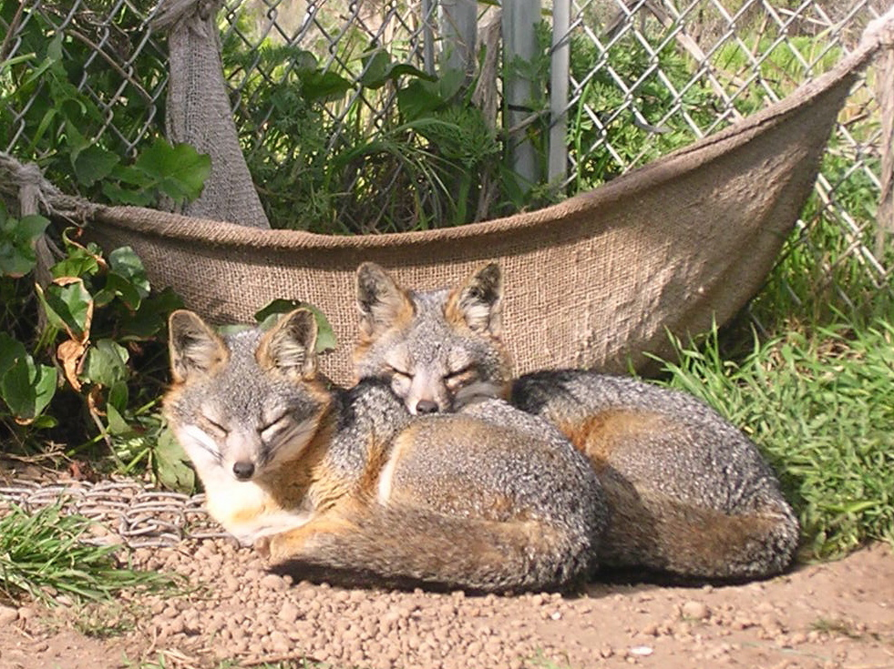
Captive foxes, San Miguel Island, 2004

Captive Breeding Program Development

The Need for Captive Breeding as a Recovery Action

The Park’s island fox recovery plan (Coonan 2003) identifies captive breeding as a critical recovery element necessary to recover island fox populations to viable levels on the northern Channel Islands. Current island fox populations on San Miguel, Santa Rosa, and Santa Cruz Islands number 38, 54, and <100 foxes, respectively. The probability of extinction is high for these critically low populations (Roemer et al. 2001b) and the populations require augmentation to reach viable levels. Demographic modeling suggests that an appropriate augmentation schedule can return island foxes to viable population levels within a reasonable timeframe (a decade). The original island fox recovery team and the current Island Fox Conservation Working Group recommend captive breeding as a recovery action. Once golden eagles are removed from the northern Channel Islands, captive breeding will be the most important recovery action implemented for island foxes, and will require commitments of resources and personnel far exceeding any other recovery action. In this context we report on the status of the program after 4 years of breeding.

Goals and Objectives for Captive Breeding

The following goals and objectives for the island fox captive breeding program at Channel Islands National Park were developed upon consultation with the captive breeding sub-group of the Island Fox Conservation Working Group.

OVERALL GOAL
To develop a captive breeding program for island foxes on San Miguel Island (U. l. littoralis), Santa Rosa Island (U. l. santarosae) and Santa Cruz Island (U. l. santacruzae) in order to increase their wild populations to viable levels.

OVERALL OBJECTIVE
To design and implement captive breeding programs for the primary purpose of generating animals suitable for reintroduction into appropriate habitat, once the threats to the populations in those habitats have been minimized or eliminated.

SPECIFIC OBJECTIVES
- Define scope and duration of program; set facility size and configuration.
- Construct and populate breeding facilities for the San Miguel, Santa Rosa and Santa Cruz Island fox populations.
- Pair animals for breeding; monitor breeding behavior and results.
- Develop appropriate release strategies.
- Release foxes annually back into the wild; monitor wild foxes.

Program Guidance

Guidance for the captive breeding program has been provided generally by the captive breeding and veterinary sub-groups of the Island Fox Conservation Working Group, and their findings and recommendations have been incorporated into the Park’s captive breeding program (Coonan and Rutz 2001, 2002, 2003). For guidance in design of captive enclosures and development of husbandry protocols, we consulted the American Zoological Associations’ management recommendations for small canids in captivity, as well as the American Society of Mammalogists’ guidelines for the capture, handling and care of mammals (American Society of Mammalogists 1987). Further guidance is provided annually by the Island Fox Conservation Working Group.

Standard Operating Procedures

The following standard operating procedures have been developed for the captive breeding program:

Facility Design and Construction
- In order to minimize the chance of disease, parasites or other catastrophe causing extirpation of captive populations, San Miguel and Santa Rosa Islands each have two separate breeding facilities.
- Staff level must be adequate for caretaking 40-50 animals at two sites.
- Sufficient distance is maintained between pens, while within the pens hiding places are provided; thus animals have visual contact with others when they choose.
- Annual pen construction is completed by October to allow pairs sufficient time to bond prior to breeding.
- There should is a minimum of two isolation areas at each facility.
- The threat of wildfire at captive breeding facilities is addressed by the Park’s fire management program, and Vari-Kennels are available for immediate evacuation of foxes.

Veterinary Care
- If foxes are brought to the mainland for veterinary care, they cannot be returned to the islands, because of possible disease/parasite transmission.
- Captive foxes are given regular veterinary examinations, using a standardized veterinary protocol.
- Each captive breeding population has access to a veterinary/quarantine facility where animals may be treated.
- Protocols are implemented to minimize the risk of people or equipment transferring pathogens among islands, and to minimize parasite loads in the captive populations.

Caretaking and Handling
- Human contact with captive foxes is minimized to avoid acclimating them to humans, and to ensure they are as wild as possible upon release.
- Handling and disturbance of captive island foxes is avoided during the full extent of the breeding season (January through June).

Breeding Strategy
- Mated pairs are kept together as long as they reproduce successfully; non-reproductive pairs are kept together for at least two breeding seasons.
- Pairings of siblings or parent/offspring are avoided using genotyping of individual animals, and estimation of relatedness.
- Video monitoring is used to the extent practicable to document breeding behavior or lack thereof, and to record birth dates, pup fate, and neonatal care.
- Captive-born foxes are preferentially paired with wild-born individuals, provided existing pairs are not broken up, to minimize loss of wild behavioral traits.
- Birth, death and breeding records are maintained in a studbook.
- Excess females may be housed together if compatible to allow for social interaction or to possibly test reproductive potential of one male with two females. However, no more than two females should be housed together in one pen.

Diet
- The fox diet comprises a high-quality dry dog (24% crude protein, 14% crude fat) (Innova® Dog Food™, Natura Pet Products, Santa Clara, CA) supplemented with hard-boiled eggs, and a variety of fruits and vegetables. This is supplemented several times per week by live deer mice or dead coturnix quail.
- Captive foxes are not given moist meat-based food, such as canned cat or dog food, or fruits high in citric acid, since they may cause gingivitis and tooth loss.
- The amount of food given daily is on average 3-4% dry weight of the foxes’ body weight (i.e., a 2.3 kg adult receives 90 g of food daily).
- During breeding season, females suspected to be pregnant or with litters are fed dog kibble with higher crude protein (26%) and more essential fatty acids (Innova® Puppy Food™, Natura Pet Products, Santa Clara, CA). Family groups are fed this diet until the pups reach adult body size (October).

Overall Breeding Success

In 2003, the San Miguel captive population increased from 28 to 38 individuals, with 10 pups born to 5 litters. On Santa Rosa the captive population increased from 45 to 56 individuals with 11 pups born to 4 litters. On Santa Cruz the captive population increased to 30 individuals with the addition of 10 pups born to 5 litters.

Fourteen of 38 paired females produced litters in 2003 (37%) compared to 9 of 21 in 2002 (43%) and 7 of 13 in 2001 (54%). The percentage of successfully breeding females declined because only 1 of 17 pairings involving captive-born females has produced a litter, and only 5 out of 10 female founders on San Miguel have bred. Thus the number of founders remains low on San Miguel (7; see Appendix C). This is, in part, a consequence of a lack of males. Only 4 of 14 animals brought into captivity in 1999 were males. On Santa Rosa, 11 of 14 potential founders have bred.

Overall, reproductive output is similar to that observed in the wild. The average number of pups weaned in captive litters (2.3, n = 35 litters) is similar to the average number of pups weaned in the wild on San Miguel from 1993 to 1998 (2.0, n = 34) (Coonan et al. in review). Among the captive populations, the number of pups weaned per litter was slightly higher on Santa Cruz Island (Table 1), but this is heavily influenced by 1 litter of 5 pups weaned in 2002.

The proportion of females that produced litters was also similar to that observed in the wild. In captivity, 31 of 78 annual pairings (39.7%) have produced litters (Table 2), compared to 42.8% in the wild (54/126 pairings; Coonan et al. in review). The proportion of females breeding was higher on Santa Rosa and Santa Cruz than on San Miguel (Table 2).

Female age was a factor in reproduction, as in the wild. The proportion of Age Class I females (1-2 years old) breeding in captivity was 22.7%, similar to the 19% observed in the wild (Coonan et al. in review). The proportion of older females that bred in captivity (47.3%) was less than that observed in the wild on San Miguel (60.0%; Coonan et al. in review).

Mate history affected likelihood of breeding. Most captive fox pairs were not successful in their first year of mating. Only 32.6% of 43 first-year matings were successful, whereas 66.7% of 34 second and third-year matings were successful.

Table 1. Average number of pups weaned per litter, 1999-2003.
Island | Avg. No. of Pups Weaned | n
San Miguel | 2.3 | 11
Santa Rosa | 2.3 | 18
Santa Cruz | 2.5 | 6

Table 2. Proportion of annual pairings that have produced litters, 1999-2003.
Island | Litter | No Litter | Total | % Success
San Miguel | 11 | 20 | 31 | 35.5
Santa Rosa | 15 | 21 | 36 | 41.7
Santa Cruz | 5 | 5 | 10 | 50.0
Total | 31 | 47 | 78 | 39.7

Another factor affecting the growth of the captive populations is the uneven sex ratios in the captive-born litters. The sex ratio is biased toward males on San Miguel (23 males:15 females), where males comprise 19 of 25 pups (76%) born in captivity. On Santa Rosa, the sex ratio is biased toward females (19 males:28 females), and of the 42 pups born, 26 have been female. There were 11 unmated animals on Santa Rosa and San Miguel in 2001, 8 unmated animals in 2002, and 17 in 2003.

In summary, reproductive success for captive foxes was similar to that of wild foxes from San Miguel from 1993-1998. Age Class I females rarely bred, and the average number of pups weaned was similar for captive and wild foxes. First-year matings were successful only a third of the time. There has been a general failure of captive-born females to breed, though many of these matings were of first-year animals.

Recovery of San Miguel Island Foxes

Captive Breeding
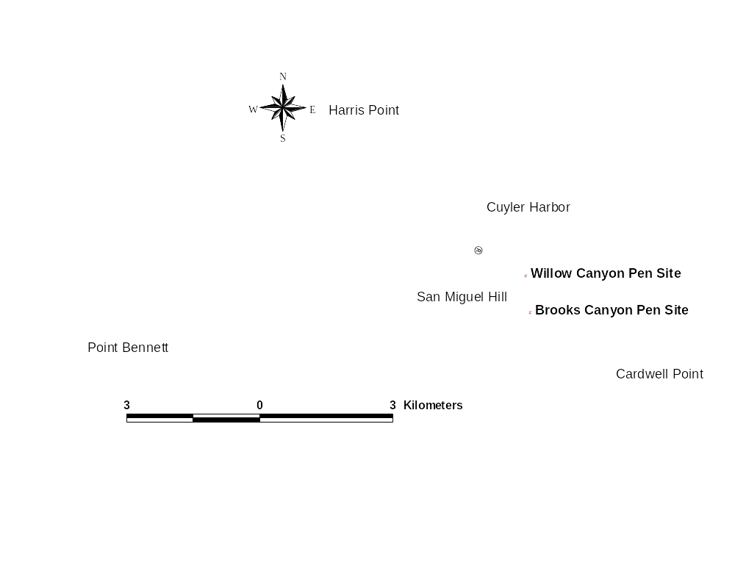
Figure 2. Location of island fox captive breeding facilities, San Miguel Island.

During 2003, the San Miguel captive population grew from 28 to 38 foxes (Tables 3 and 4). The 1 fox left in the wild was captured in September 2003, but died in captivity on December 31, 2003. Ten pups, 7 males and 3 females, were born to 5 litters in April 2003 (Table 5). Two potential founder females (71071 and F6558) bred for the first time in 2003, bringing the number of founders to 7. Seven pairings, including 4 other potential founder females, did not produce litters. Of the 7, 5 were first-year pairs which are generally less likely to breed. Three pairs were split, and the individuals were assigned new mates for the 2003-2004 breeding season.

In November, pairings were made for the 2003-2004 breeding season. There are 15 pairs on San Miguel for the breeding season, with 8 unmated males. Changes for the 2004 season include new pairings for 2 potential founder females, B0B25 and 7534A, who had failed previously with 1 and 2 males, respectively.

Genetic analysis conducted on the captive fox populations (Gray and Roemer 2001) had allowed previous determination of relatedness among foxes and was used to select new pairings. However, there is substantial overlap of relatedness (“r”) values for related and unrelated foxes on San Miguel, due to the lack of genetic variation in the population, and the level of genetic variation in the population has declined since 1988 (Gray and Roemer 2001).

Table 3. Growth of captive island fox population, San Miguel Island.
 | Adults |  |  |  | Pups |  |  |  | Total
Year |  | F | M | Total | F | M | Total | Died | Captive
2000 |  | 10 | 4 | 14* | 1 | 1 | 2 | 0 | 16
2001 |  | 11 | 5 | 16 | 0 | 5 | 5 | 1 | 20
2002 |  | 10 | 10 | 20 | 2 | 6 | 8 | 0 | 28
2003 |  | 15 | 23 | 38 | 3 | 7 | 10 | 1 | 38
*Founding population

Health/Medical
One fox died in captivity on San Miguel in 2003. The last wild fox on San Miguel, female 85619, was captured and brought into captivity in September 2003, but died on December 31 2003, from wounds apparently inflicted by her penmate (see Status of Wild Fox Population, below).

Since 1999 there have been 2 deaths in captivity on San Miguel, the previous occurring in December 2001, when an older, unmated female died of old-age related conditions.

Veterinary examinations on San Miguel foxes were conducted by project veterinarian Mark Willett, DVM, in July 2003. Routine general physical examinations were performed in a nose to tail fashion, and included otoscopic examination. Blood samples were obtained from all animals for complete hematology and blood chemistry analysis.

Foxes examined in 2003 were generally in good health. There is a conspicuous absence of ectoparasites in the San Miguel foxes, compared to Santa Rosa foxes, and there is very little problem with crusty eyes.

Captive foxes on San Miguel Island have 3 internal parasites which have the potential to pose significant health problems: Angiocaulus, Spirocerca, and Uncinaria. Of the 3, Uncinaria, or hookworm, poses the least threat to fox health, as it is relatively innocuous compared to other hookworms, such as Ancylostoma caninum (Georgi and Georgi 1991). Angiocaulus is not found in foxes from other islands (L. Munson, UC Davis, unpubl. data). Whereas the pathogenicity of Angiocaulus is largely unknown, necropsy of a San Miguel island fox indicated that Angiocaulus had caused extensive pulmonary granulomas and was present in heart blood. If such foxes were treated with an anthelmintic which crossed into the bloodstream and killed the Angiocaulus, a fatal outcome might occur (Linda Munson, UC Davis, pers. comm.). Moreover, Spirocerca are present in the wall of the colon and, if killed by an anthelmintic, may cause an inflammatory reaction that could result in an intestinal rupture.

To date foxes have not been treated for Angiocaulus or Spirocerca, because there are no clinical signs warranting such treatment, and the risks of treating foxes for such novel parasites are unknown. A risk analysis currently being conducted by the U.S.G.S. Biological Resource Division’s Wildlife Health Center (R. Sohn, U.S.G.S. Biological Resources Division, unpubl. data) will present recommendations for treatment of individual animals for internal parasites.

One San Miguel fox developed a prolapsed rectum in September 2003. The prolapse repaired itself. This was the second instance of a prolapsed rectum on San Miguel; the first occurred in female 92C32 in 1999. There have been several other prolapsed rectums on Santa Rosa Island, and necropsy of 1 Santa Cruz Island fox revealed cause of death to be septicemia brought about by necrosis of a prolapsed rectum. The prolapse may have been caused by a Spirocerca granuloma in the lower intestine (L. Munson, University of California, Davis, unpubl. data).

Table 4. Reproductive success of captive San Miguel Island foxes, 2002-2003 breeding season.
Pen | ID | Sex | Age¹ | Paired | Result | Litter Size | Birth Date
M01 | 85764 | F | 1 | 11/2/2002 | No Litter
 | 87F53 | M | 1
M03 | 92C32 | F | 5 | 7/16/1999 | Litter | 3 | ≈4/10/2003
 | 7574A | M | 5
M07 | 90D1A | F | 5 | 9/4/1999 | Litter | 1 | ≈4/10/2003
 | 44829 | M | 5
M09 | 7534A | F | 10 | 10/17/2001 | No Litter
 | 83C24 | M | 2
M11 | E2677 | F | 5 | 10/17/2000 | Litter | 2 | ≈4/10/2003
 | 47B06 | M | 3
M12 | B0B25 | F | 4 | 10/17/2001 | No Litter
 | 70C1D | M | 2
M13 | F6558 | F | 4 | 10/17/2002 | Litter | 2 | ≈4/10/2003
 | 11F73 | M | 2
M14 | 60921 | F | 5 | 10/27/2002 | No Litter
 | 57150 | M | 5
M15 | B7E0A | F | 1 | 11/4/2002 | No Litter
 | B0E36 | M | 1
M17 | 11929 | F | 3 | 10/17/2001 | No Litter
 | C7303 | M | 2
M18 | 71071 | F | 4 | 10/17/2001 | Litter | 2 | ≈4/10/2003
 | C4A16 | M | 2
M19 | 92804 | F | 11 | 10/27/2002 | No Litter
 | 85D02 | M | 4
¹In years, as of fall 2002

It is possible that foxes with Spirocerca and a history of prolapse will be treated with an anthelminthic to prevent such fatal results.

All adult foxes in captivity on San Miguel received both the initial and booster doses of CDV vaccine (Merial Ltd., Athens, GA) during vet examinations in summer 2003. The vaccine is a canary pox vectored recombinant canine distemper virus used successfully on Santa Catalina island foxes (Kohlmann et al. 2003).

Future Management of San Miguel Captive Island Foxes
Of the 38 foxes in captivity, 15 are females, and thus there are 15 mated pairs for the 2003-2004 breeding season, with 8 unmated males. In 2002-2003, 12 pairs produced 10 pups in 5 litters. The 15 pairs for the upcoming breeding season are therefore likely to produce 12 pups, of which perhaps 4 will be females (assuming the consistent male bias in pups continues). The captive population is likely to number 50 foxes by summer 2004, with a total of 19 pairs for the 2004-2005 breeding season, and 12 unmated males.

Capacity of the captive facility is 40 animals (20 breeding pens). If eagle predation is sufficiently mitigated by fall 2004, initial releases of San Miguel foxes to the wild may occur. But if eagle predation is not sufficiently mitigated and the decision is made to keep foxes in captivity, then either 10 additional pens must be built on the island, or a portion of the captive breeding program must be moved to mainland institutions. The latter would require development of adequate quarantine, vaccination and treatment procedures for insuring that pathogens are not transferred between the mainland and the island, or the island and the mainland. A sub-group of the Island Fox Conservation Working Group is currently developing a risk assessment to determine if such procedures can be developed.

Status of Wild Fox Population
A National Park Service crew from Santa Monica Mountains National Recreational Area captured the last wild fox, 85619, on San Miguel on September 26, 2003, using padded leghold traps. She was placed in pen M2 by herself. In November, biopsies performed on samples from masses on her hip and anus proved negative for cancer.

On November 24, 2003, male B0E36 was placed in her pen for breeding purposes. Genotyping of blood samples from 85619 in relation to the other captive foxes indicated that B0E36 had the lowest relatedness value (r = -0.79405) of the unmated males in the population (M. Gray, University of California, Los Angeles, unpubl. data). Keepers noticed no agonistic/aggressive interaction between the two over the next month, although they were never observed together.

On December 30, 2003, a volunteer caretaker on San Miguel noticed that 85619 appeared unstable. The next day, she was found dead in her pen. Necropsy results from Dr. Linda Munson at University of California, Davis, suggest that 85619 likely died from trauma associated with injuries inflicted by her mate. The fox had a fractured hind leg, with puncture wounds and extensive hemorrhages. She also had hemorrhages on the sternum, deep near the kidneys, and around the brain, implying she was shaken. The aged fox also had thyroid tumors, chronic kidney and heart disease and colonic spirocercosis with an intestinal perforation. It is possible that general debility from these other conditions incited the cagemate aggression. Dr. Munson also found healed lesions on either side of her ribcage, which suggests that the fox survived a previous raptor attack. Two other necropsied foxes, one from Santa Cruz and one from Santa Rosa Island, have shown similar lesions suggesting a failed raptor attack. This fox had no evidence of Angiocaulus or Uncinaria.

With the capture and subsequent death of 85619, there are currently no foxes in the wild on San Miguel Island. However, if pup production in spring 2004 is sufficient, and if eagle predation has been sufficiently mitigated, then initial releases to the wild may occur in fall 2004.

Figure 3. Location of island fox captive breeding facilities, Santa Rosa Island.

Recovery of Santa Rosa Island Foxes

Captive Breeding
During 2003, the Santa Rosa captive population grew from 45 to 56 foxes with the birth of 11 pups (5 males, 6 females) to 4 litters in captivity (Tables 5 and 6). Four of 16 pairings (25%) produced a litter in 2003 (Table 8). Three of the unsuccessful pairs (in pens R05, R07 and R09) had previously produced litters, but female pups from the previous year had been left in the respective pens. This may have prevented breeding in those pairs in 2003. Five unsuccessful pairs contained juvenile females, or were pairs with no previous history together. Eleven of 14 potential founders have bred thus far on Santa Rosa Island. In fall 2003, 4 pairs were split because they had not produced pups in 2-3 breeding seasons.

In late 2003 and early 2004, 12 Santa Rosa Island foxes were released to the wild (see below). Four of the released foxes were returned to captivity. Two captive foxes died in early 2004, thus leaving 46 foxes in captivity on Santa Rosa Island. For the 2003-2004 breeding season there are 17 pairs in captivity, including 2 pairs comprising animals recaptured after release to the wild. There are also 2 males in captivity that are unpaired, and are housed individually, because of their history of injuring females with whom they have been paired. There are 10 unmated females in the Santa Rosa Island captive breeding facility.

Table 5. Growth of captive island fox population, Santa Rosa Island.
 |  | Adults |  |  | Pups |  |  |  | Total
Year | F |  | M | Total | F | M | Total | Died | Captive
2000 | 8 |  | 4 | 12¹ | 5² | 5² | 10 | 0 | 22
2001 | 14 |  | 9 | 23 | 7 | 3 | 10 | 1 | 32
2002 | 20 |  | 12 | 32 | 9 | 4 | 13 | 0 | 45
2003 | 29 |  | 16 | 45 | 6 | 5 | 11 | 0 | 56
¹Founding population
²Includes 8 pups born in captivity, and 2 pups (1 male, 1 female) born in the wild

Health/Medical
Captive Santa Rosa Island foxes received veterinary examinations from project veterinarian Mark Willet, DVM, in August and September of 2003. Routine general physical examinations were performed in a nose to tail fashion, and included otoscopic examinations. Blood samples were obtained from all animals for complete hematology and blood chemistry analysis.

No foxes died in captivity on Santa Rosa Island in 2003, but 2 died in early 2004. First, female B715F, unmated and born in 2002, died on February 3, 2004, of injuries apparently inflicted by at least 1 of her 3 penmates, all of which were unmated females. Second, male D3D76 died of chronic kidney failure on March 5, 2004. D3D76 was a wild-born founder who had sired 8 pups in captivity and had the most descendants (19) of any founder. The chronic kidney failure was confirmed by the elevated concentrations of compounds normally filtered by kidney byproducts (blood urea nitrogen and creatinine) in annual blood samples. The deaths of the 2 foxes in early 2004 bring the total number of captive deaths on Santa Rosa to 3. In March 2001, founder female A7015 died of cancer.

Foxes examined were in generally good or excellent condition, with a few exceptions. There have been 3 cases of rectal prolapse in a total of 2 foxes since 2000. One fox, male F3D2F, prolapsed during veterinary examination in August 2002, at which time the rectum was repaired with a purse-string suture. F3D2F suffered another prolapse in March 2004, again requiring a suture. There is a mass on the side of his rectum which may be causing the prolapse, and the lump may be caused by the parasite Spirocerca, for which F3D2F has tested positive (Karl Hill, DVM, Santa Barbara Zoo, pers. comm.). Consequently, F3D2F may be treated for Spirocerca in 2004.

Several males (75125, B4B2B, and D4C78) have injured females during the breeding season. Those males have been removed from mating pens and housed individually, and/or released to the wild, resulting in effective loss of potential breeding pairs. One male fox thus released (75125) subsequently paired up in the wild with another released captive fox (95906). The pair was brought back into captivity because their use area included the captive facilities, and are cohabiting in captivity without further incident.

Foxes on Santa Rosa have more problems with ectoparasites (fleas and ticks) than do San Miguel foxes. All foxes were treated with Frontline (Merial Ltd., Athens, GA) during 2003 vet exams. All adult foxes received both the initial and booster CDV vaccinations. No pups were vaccinated.

Future Management of Santa Rosa Captive Island Foxes
Of the 46 foxes in captivity, 19 are males, and there are 17 mated pairs for the 2003-2004 breeding season, with 10 unmated females. Given past reproductive rates, the 17 pairs for the upcoming breeding season are likely to produce 15 pups, of which perhaps 8 will be females. The captive population is likely to number at least 60 foxes by summer 2004 with perhaps 24 males and 36 females.

Capacity of the captive facility is 40 animals (20 breeding pens). If eagle predation is sufficiently mitigated by fall 2004, another release of Santa Rosa foxes to the wild may occur. But if eagle predation is not sufficiently mitigated and the decision is made to keep foxes in captivity, then either 10 additional pens must be built on the island, or a portion of the captive breeding program must be moved to mainland institutions.

Status of Wild Fox Population
As of May 2004, there are 7 island foxes (1 male and 6 females) in the wild on Santa Rosa Island, as a result of a recent reintroduction. Twelve island foxes were released to the wild from December 2003 to February 2004 (see Reintroduction of Santa Rosa Island Foxes, below). Four were returned to captivity, and 1 died from eagle predation.
Table 6. Reproductive success of captive Santa Rosa Island foxes, 2002-2003 breeding season.
Pen | ID | Sex | Age | Paired | Result | Litter Size | Birth Date
R02 | D187A | F | 5 | 10/19/2001 | Litter | 2 | ≈April 6, 2003
 | 0654E | M | 3
R03 | 2410E | F | 3 | 10/17/2001 | No Litter
 | B4B2B | M | 2
R04 | 60B1D | F | 2 | 10/24/2002 | Litter | 3 | ≈April 9, 2003
 | 53723 | M | 1
R05 | F0223 | M | 5
 | F4A18 | F | 4 | 10/19/2000 | No Litter
R06 | 37E00 | M | 3
 | 37C61 | F | 3 | 10/19/2000 | No Litter
R07 | 10030 | F | 5 | 10/19/2000 | No Litter
 | 70518 | M | 3
R09 | 95B34 | F | 4 | 10/19/2000 | No Litter
 | 84F28 | M | 3
R10 | 33131 | F | 4 | 10/19/2000 | No Litter
 | A045A | M | 3
R11 | 3512D | F | 5 | 11/05/2000 | Litter | 3 | ≈April 6, 2003
 | 73D0D | M | 4
R12 | 07061 | F | 5 | 10/24/2002 | No Litter
 | 51E3E | M | 1
R14 | E5100 | F | 3 | 1/17/2001 | No Litter
 | F3D2F | M | 2
R15 | 96C2E | F | 2 | 11/17/2001 | No Litter
 | 75125 | M | 2
R16 | B067E | M | 5
 | 13C24 | F | 3 | 11/17/2001 | No Litter
R18 | F3950 | F | 2 | 10/24/2002 | No Litter
 | 7792E | M | 1
R19 | 1612C | F | 4 | 11/17/2001 | Litter | 3 | ≈April 6, 2003
 | D3D76 | M | 4
R20 | A180A | F | 3 | 10/24/2002 | No Litter
 | 1271E | M | 1
²in years, as of fall 2002

Reintroduction of Santa Rosa Island Foxes

Because the success of further eagle removal remains uncertain, island fox recovery may necessarily occur in an environment with eagles. Recent estimates of annual fox survivorship on Santa Cruz Island exceeded that required for a stable or increasing population, but it is unknown whether survivorship of foxes released from captivity will equal that of wild foxes, or if survivorship values will differ between islands. A limited release of captive island foxes on Santa Rosa Island, coupled with intense post-release monitoring, will indicate whether survivorship of released foxes is acceptable under current conditions. If it is not, then fox recovery will require either a greatly expanded captive production, which may necessitate moving a portion of the captive breeding program to the mainland, or other, more effective methods for eagle removal.

To this end, captive foxes were experimentally released to the wild on Santa Rosa Island in winter 2003-2004. The objectives of the release were to:
• investigate survivorship of captive island foxes released to the wild, under conditions of partial removal of golden eagles, and compare survivorship to that of wild island foxes
• test release methods, and
• begin reestablishment of a wild population on Santa Rosa Island

Foxes selected for release were well-represented genetically in the captive populations (Gray 2003, Gray et al. 2003). Foxes were released as mated pairs that had been housed together for >1 yr, as single animals, or as groups of unpaired animals that had been placed together in a socialization pen for 10-18 days. Foxes were outfitted with radiotelemetry collars and were released directly from small portable kennels. Feeding stations provided supplemental food, and foxes were recaptured at intervals of 1 week and one month to determine physical condition. Foxes were returned to captivity if they had lost >20% of their release weight. As a contingency for eagle predation, if ≥50% of the released foxes die in the year after reintroduction (December 2003 to December 2004), the remaining released foxes will be recaptured and returned to captivity.

From December 2003 to February 2004, 12 foxes were released to the wild (Table 9). Released foxes comprised 3 juveniles (born in 2003), 3 1-year olds, 2 2-year olds, 2 3-year olds, 1 4-year old, and 1 5-year old. Three of the 12 animals were males. Four of the animals were released as mated pairs. Foxes were released in 3 areas: Lobo Canyon, Arlington Canyon, and Tecolote Canyon.

One released fox (female RF-101) died from eagle predation in February 2004. Upon detection of a mortality signal from her radiocollar, her carcass was recovered in Trap Canyon, near a golden eagle nest site that produced a chick in 2003. A golden eagle pair had initiated a breeding attempt in the area, and was thought to be incubating at the site, until they apparently abandoned in late March 2004 (B. Latta, Santa Cruz Predatory Bird Research Group, unpubl. data).

Four released foxes (2 apparent pairs) were captured and returned to captivity because they dispersed from their release areas to the captive pen sites near Beecher’s Bay (Fig. 4). Their use of the pen site areas resulted in interactions between captive and wild foxes, and injuries to 2 captive and 2 wild foxes.

Table 7. Release location, date, release type and fate of foxes released to the wild on Santa Rosa Island, winter 2003-2004.
PIT tag | ID | Sex | Age | Date | Release Type¹ | Area | Fate
B067E | RM-1 | M | 5 | 11/20/2003 | MP | Lobo Canyon | Returned to captivity  01/06/2004
13C24 | RF-101 | F | 3 | 11/20/2003 | MP | Lobo Canyon | Died 2/20/04 from predation
47304 | RF-102 | F | 1 | 11/21/2003 | Gr | Lobo Canyon | Returned to captivity  01/30/2004
95906 | RF-103 | F | 1 | 11/21/2003 | Gr | Lobo Canyon | Returned to captivity  02/08/2004
A266D | RF-104 | F | Juv. | 11/21/2003 | Gr | Lobo Canyon | In wild
75125 | RM-2 | M | 2 | 12/08/2003 | S | Lobo Canyon | Returned to captivity  02/02/2004
33131 | RF-106 | F | 4 | 01/17/2004 | MP | Arlington Canyon | In wild
A045A | RM-3 | M | 3 | 01/17/2004 | MP | Arlington Canyon | In wild
14125 | RF-107 | F | Juv. | 01/19/2004 | Gr | Tecolote Canyon | In wild
34614 | RF-108 | F | 2 | 01/19/2004 | Gr | Tecolote Canyon | In wild
01460 | RF-109 | F | 1 | 02/05/2004 | Gr | Tecolote Canyon | In wild
A7954 | RF-110 | F | Juv. | 02/05/2004 | Gr | Tecolote Canyon | In wild
¹MP = mated pair
Gr = Group
S = single animal

The 2 released pairs did not stay together in the wild. The male from the first pair released (RM-1) began associating with a female (RF-102) from a group released the following day. The 2 were brought into captivity in January due to impacts on captive foxes, and are housed together because of the potential pair bond that may have formed. Radiotelemetry tracking suggests that the male from the second released pair (RM-3) may have paired up in the wild with female RF-108. Also, the single male released (RM-2) appeared to pair up in the wild with female RF-103. The pair was brought back into captivity in February because their use area included the captive breeding pen sites.

Most released foxes dispersed from their release sites and established use areas elsewhere. Two foxes dispersed significantly from their release site in Tecolote Canyon (Fig. 4). Female RF-109 moved 7.2 km from the release site to a location near China Camp on the southwest coast, and female RF-109 moved 15.2 km from the release site to an area on the southeast coast.

Figure 4. Most recent locations for island foxes released to the wild in winter 2003-2004, Santa Rosa Island. RM-01, RF-102, RM-02 and RF-103 have been recaptured and returned to captivity.

Recovery of Santa Cruz Island Foxes

Captive Breeding

The primary Santa Cruz Island facility was constructed in February 2002 and consists of 10 pens spread along Renegade Ridge near the Navy site (Fig. 4). The Nature Conservancy is currently building a second facility of 10 pens in the Central Valley. There are currently 10 pairs and a total of 25 foxes in captivity on Santa Cruz Island (Table 9).

Of the 10 pairs in the facility for the 2002-2003 breeding season, 5 produced litters, and 10 pups were born (Table 10). A total of 9 foxes from the facility were released to the wild in December 2003 (see Reintroduction of Foxes to the Wild, below). Five of the 9 were killed by golden eagles within several weeks of release, and so the remaining 4 were returned to captivity.
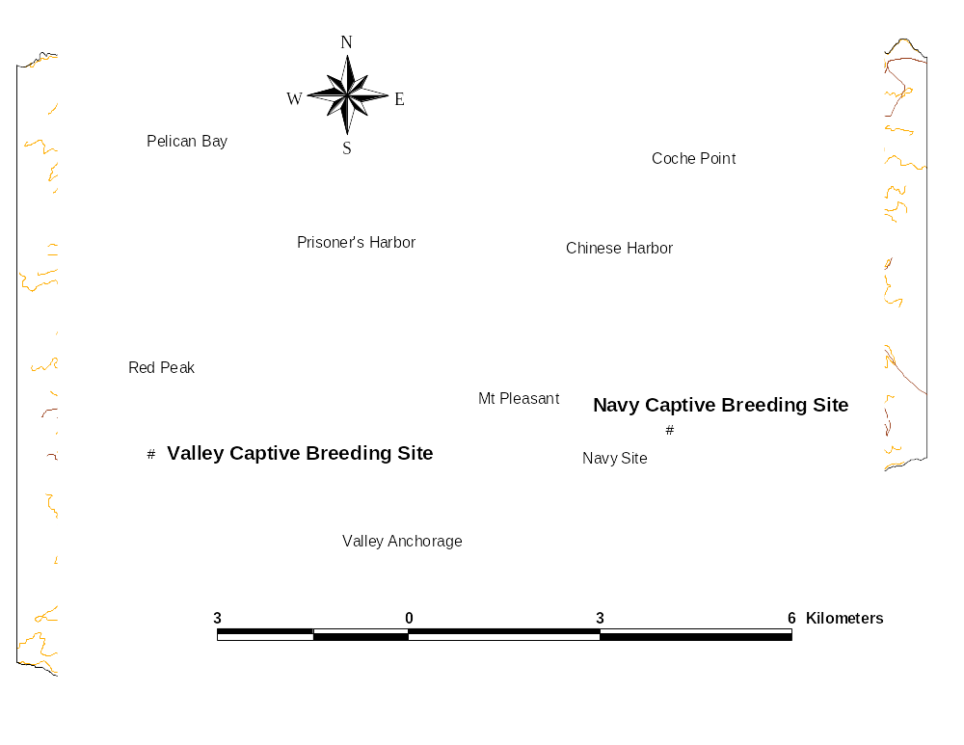
Figure 5. Location of island fox captive breeding facilities, Santa Cruz Island.

Health/Medical
Captive Santa Cruz Island foxes received veterinary examinations from project veterinarian Mark Willet, DVM, in June 2003. Routine general physical examinations were performed in a nose to tail fashion, and included otoscopic examination. Blood samples were obtained from all animals for complete blood chemistry analysis. Foxes were generally in good or excellent health, although all required treatment for ectoparasites. All captive adult animals on Santa Cruz received initial and booster CDV vaccinations. One male (D0926) was separated from his penmate because he had injured her repeatedly. He was released to the wild in November 2003 and then recaptured and brought into captivity in January 2004. He is now housed individually. The injured female, 16C30, has been paired with male F3F0E.

Table 8. Reproductive success of captive Santa Cruz Island foxes, 2002-2003 breeding season.
Pen | ID | Sex | Age¹ | Paired | Result | Litter Size | Birth Date
C01 | A4628 | M | 6
 | 30B2D | F | 4 | 3/11/2002 | Litter | 2 | unknown
C02 | D2C13 | F | 3 | 3/1/2002 | Litter | 2 | unknown
 | A6D41 | M | 3
C03 | 0786F | F | 5 | 3/3/2002 | NL | 0
 | 1415A | M | 3
C04 | B506A | M | 3
 | C5D0E | F | 3 | 1/15/2003 | NL | 0
C05 | 36172 | M | 4
 | 72901 | F | 3 | 2/27/2002 | NL | 0
C06 | 86F17 | F | 3 | 3/10/2002 | Litter | 2 | ≈April 12, 2003
 | 86B1A | M | 3
C07 | 45411 | M | 3
 | D2210 | F | 2 | 3/11/2002 | Litter | 2 | unknown
C08 | 16C30 | F | 2 | 11/1/2002 | NL | 0
 | D0926 | M | 1
C09 | 1783E | M | 6
 | 87035 | F | 5 | 12/4/2002 | Litter | 2 | unknown
C10 | C002B | M | 1
 | 73863 | F | 1 | 10/4/2002 | NL | 0
¹In years, as of fall 2002

Future Management of Santa Cruz Island Captive Foxes
The 10 pairs currently in captivity are likely to produce 10 pups in spring 2004, putting the captive population at 35 animals, and essentially filling the captive facility. If foxes cannot be released to the wild in fall 2004 because of the threat of eagle predation, then additional pens must be built to accommodate captive production in spring 2005, or a portion of the breeding program must be moved to the mainland.

Status of Wild Fox Population

Results from island-wide trapping efforts in 2001 and 2001 suggest that the Santa Cruz Island fox wild population may be stable, but not increasing. Island fox trapping success in 2002 (14.6%) was nearly identical to that in 2001 (17.7%), and similar number of individuals were caught in 2002 (70 adults, 27 pups) as in 2001 (75 adults, 32 pups) (Dennis et al. 2002, Newman et al. 2003).

Reintroduction of Santa Cruz Island Foxes

Because the success of further eagle removal remains uncertain, island fox recovery may necessarily occur in an environment with eagles. Recent estimates of annual fox survivorship on Santa Cruz Island approached that required for a stable or increasing population, but it is unknown whether survivorship of foxes released from captivity will equal that of wild foxes, or if survivorship values will differ between islands.

An experimental release of captive foxes to the wild on Santa Cruz Island occurred in November-December 2003. The purpose of the release was to:
• investigate survivorship of captive island foxes released to the wild, under conditions of partial removal of golden eagles, and compare survivorship to that of wild island foxes, and
• test release methods

Foxes were released as mated pairs which had been housed together for >1 yr, as single animals, or as groups of unpaired animals which had been placed together in a socialization pen for 10-18 days. Foxes were outfitted with radiotelemetry collars and were released directly from small portable kennels. Feeding stations provided supplemental food, and foxes were recaptured at intervals of 1 week and one month to determine physical condition. Foxes were returned to captivity if they had lost >20% of their release weight. As a contingency for eagle predation, if radiotelemetry monitoring indicated that ≥50% of the released foxes died in the year after reintroduction (November 2003 to November 2004), the remaining released foxes would be recaptured and returned to captivity.

Two releases occurred on Santa Cruz Island in 2003. A mated pair and a single male were released in Coches Prietos Canyon in November, and 6 unmated foxes were released in the Del Norte area in December (Table 7). The Del Norte release comprised 2 groups of 3 animals, each of which had been housed together in a socialization pen prior to the release.

Five of the 9 released foxes died from eagle predation within 2 months of release. Because this met the contingency threshold for eagle predation, the remaining 4 released animals were recaptured and brought back into captivity in early January.

The 5 mortalities all occurred within a period of 13 days, and it is possible that 1 golden eagle was responsible for all 5 mortalities (B. Latta, Santa Cruz Predatory Bird Research Group, pers. comm.). On January 20, 2004, SCPBRG staff captured the male from the Cascada pair of adult golden eagles. The Cascada male may have been responsible for the mortalities of the released foxes, because they all occurred in the territory of the Cascada eagle.

The high predation rate on released foxes stands in marked contrast to the lower predation rate on wild foxes on Santa Cruz Island (see Impact of Eagle Predation on Island Foxes, below). Released foxes may be more vulnerable to predation for any of a number of reasons. First, wild foxes may be more nocturnal than foxes released from captivity. Diurnal activity patterns of released foxes may expose them more to golden eagle predation. Second, released foxes may utilize cover less than wild foxes. Third, released foxes may move more than wild foxes. The latter generally have established home ranges and many are members of mated pairs. Movements of released foxes away from release sites, to acquire mates and establish home ranges or use areas, may expose them more to predation.

Given the high predation rate on released foxes, release of foxes from captivity is unlikely to be an effective recovery action on Santa Cruz Island until the predation environment changes considerably.

Table 9. Release location, date, release type and fate of foxes released to the wild on Santa Cruz Island, December 2003.
PIT tag | ID | Sex | Age | Date | Release Type¹ | Area | Fate
D0926 | M87 | M | 1 | 11/21/2003 | S | Coches Prietos | Returned to captivity 01/08/2004
C002B | M60 | M | 1 | 11/21/2003 | MP | Coches Prietos | Died 01/01/2004 from predation
73863 | F82 | F | 1 | 11/21/2003 | MP | Coches Prietos | Died 01/01/2004 from predation
01C77 | F88 | F | Juv. | 12/09/2003 | Gr | Del Norte | Returned to captivity 01/05/2004
E250C | F87 | F | Juv. | 12/09/2004 | Gr | Del Norte | Returned to captivity 01/05/2004
A1570 | M92 | M | 1 | 12/09/2004 | Gr | Del Norte | Died 01/03/2004 from predation
F3F0E | M91 | M | Juv. | 12/09/2004 | Gr | Del Norte | Returned to captivity 01/05/2004
E3564 | F90 | F | Juv. | 12/09/2004 | Gr | Del Norte | Died from 12/27/2003 predation
37F3A | F89 | F | Juv. | 12/09/2004 | Gr | Del Norte | Died 12/21/2003 from predation
¹MP = mated pair
Gr = Group
S = single animal

Removal of Golden Eagles

Staff from the Santa Cruz Predatory Bird Research Group (SCPBRG) continued their efforts to remove golden eagles via bownet or other live-capture method in 2003. A total of 9 golden eagles was removed from the islands in 2003. An additional eagle (the Cascada male) was trapped and relocated in early 2004, bringing the total removed since 1999 to 32 eagles. In 2003 golden eagles were observed breeding on Santa Rosa Island, where they apparently are supported by the herds of non-native mule deer and elk. As many as 14 eagles remained on the islands as of early 2004 (Fig. 6).

In 1999 NPS established a cooperative agreement with the SCPBRG for relocation of golden eagles from the northern Channel Islands. The primary technique used has been a dug-in, radio-controlled bownet placed in areas that eagles frequented (Jackman et al. 1994). Bait used included dead feral pigs, live feral pigs, and live rabbits. The bownet was set in place prior to dawn. If an eagle alighted on the prey, the net was deployed via radio signal from a distant hidden observation point. Captured eagles were banded and measured, and transported in large commercial sky kennels modified for raptor transport. Most eagles were driven to the airstrip and flown off the island by the next morning, and then driven or flown by commercial airliner and driven to one of several release sites, east of the Sierra Nevada range. Releases occurred usually within 24 hours of capture.

Of the 9 eagles captured in 2003, 6 were captured at a carrion chum site set up for juvenile bald eagles in the China Pines area of Santa Cruz Island. Only 1 of 4 known territorial birds, the male from the Trap Canyon territory on Santa Rosa Island, was captured. Two eyases (hatchlings) were removed from nests by hand, 1 from the Trap Canyon nest and 1 from the Cascada nest on Santa Cruz Island.

For the first time, golden eagles were recorded breeding on Santa
Rosa Island. A pair bred at Trap Canyon (Fig. 6), producing a chick that was removed by hand in June and hacked out on the mainland in northern California. Another pair began a nesting attempt in the Trancion Canyon area but abandoned the attempt in March. Post-nesting examination of the nests revealed several nests in each territory, with several distinct layers, indicating golden eagles have bred on Santa Rosa, undiscovered, since as early as 1997. This is further supported by the presence of island fox remains in the lower levels; foxes were last extant on the island in 2000.

Prey remains of numerous birds and mammals were found in the Santa Rosa nests. Because golden eagles only deliver prey to nests with hatchlings, the presence of prey remains represent the prey delivered during the hatchling phase of nesting (April, May and June), and also indicates successful breeding (production of at least 1 chick) in those years. Avian remains included gulls, cormorants, ravens, and meadowlarks. Mammalian prey included foxes, skunks, and mule deer fawns. The latter were not present in every layer, but mule deer fawns in some years apparently provide golden eagles with the small portable prey required for raising chicks. Moreover, carcasses from deer and elk are readily available from August through November on Santa Rosa Island, due to the annual hunt and cull that occurs during that time period. The carcasses are a food source for golden eagles during the period when they are garnering the energetic resources required for breeding.

Figure 6. Golden eagles remaining on the northern Channel Islands, March 2004.

Up to 8 nests were observed on the north slope of Santa Cruz Island during a helicopter survey. The nests were discovered in an area not heretofore known as a possible breeding territory. Both the north slope territory on Santa Cruz Island and the Trap Canyon territory on Santa Rosa Island may be a source of many of the golden eagles observed on the islands since 1999.

By the end of 2003 there were as many as 14 golden eagles on Santa Cruz and Santa Rosa Islands (Fig. 6), including 4 potential pairs of breeding adults. Intensive live-capture operations are planned for spring and summer 2004.

Impact of Eagle Predation on Island Foxes

A radiotelemetry study conducted on Santa Cruz Island since 2002 provides evidence that although eagle predation is ongoing, annual survival of wild island foxes has increased during the period of eagle removal, and is at or above 80%, the target identified by demographic modeling as necessary for a stable or increasing population. However, eagle predation on foxes released to the wild from captivity on Santa Cruz Island is substantially higher.

Table 10. Cause of mortality for radiocollared foxes on Santa Cruz Island, December 2000 to April 2004.
No. | Date | ID | Sex | Age | Status | Mortality Cause
1 | 3/23/2001 | M5 | M | 1 | Wild | Predation
2 | 5/23/2001 | F7 | F | A | Wild | Predation
3 | 6/1/2001 | F1 | F |  | Wild | Predation
4 | 6/13/2001 | M13 | M | 4 | Wild | Predation
5 | 8/24/2001 | M23 | M | 1 | Wild | Predation
6 | 9/29/2001 | F4 | F | 2 | Wild | Predation
7 | 11/16/2001 | M17 | M | 1 | Wild | Predation
8 | 11/17/2001 | F11 | F | 1 | Wild | Predation
9 | 11/17/2001 | M4 | M | 1 | Wild | Septicemia
10 | 3/3/2002 | F36 | F | 1 | Wild | Predation
11 | 3/28/2002 | M12 | M | 2 | Wild | Predation
12 | 4/11/2002 | M19 | M | 1 | Wild | Predation
13 | 8/16/2002 | M11 | M | 3 | Wild | Undetermined
14 | 11/9/2002 | M15 | M | 1 | Wild | Blunt trauma
15 | 12/17/2002 | M68 | M | 0 | Captive | Predation
16 | 12/20/2002 | M70 | M | 0 | Captive | Predation
17 | 1/23/2003 | F39 | F | 1 | Wild | Predation
18 | 1/31/2003 | M49 | M | 1 | Wild | Predation
19 | 4/10/2003 | M6 | M | 2 | Wild | Predation
20 | 11/14/2003 | F45 | F | 3 | Wild | Predation
21 | 12/3/2003 | F2 | F | 4 | Wild | Septicemia
22 | 12/22/2003 | F89 | F | 0 | Captive | Predation
23 | 12/25/2003 | F90 | F | 0 | Captive | Predation
24 | 1/1/2004 | M60 | M | 1 | Captive | Predation
25 | 1/1/2004 | F82 | F | 1 | Captive | Predation
26 | 1/3/2004 | M92 | M | 0 | Captive | Predation
27 | 2/7/2004 | F65 | F | 1 | Wild | Predation
28 | 2/22/2004 | F80 | F | 1 | Wild | Predation
29 | 3/15/2004 | F62 | F | 1 | Wild | Predation

Since December 2000, the Institute for Wildlife Studies, with funding from The Nature Conservancy, has been conducting a study of mortality factors for island foxes on Santa Cruz Island. The Institute has maintained a standing sample of approximately 25 radiocollared island foxes, though the number of collars was increased to over 60 in January 2004. Radiocollared animals are checked for mortality status several times per week. Upon receipt of a mortality signal, the carcass is recovered and sent to the Veterinary Medical Teaching Hospital at University of California, Davis, for necropsy. Physical evidence of predation by golden eagles includes degloving of limbs, removal of viscera, talon holes, and hemorrhaging (Roemer et al. 2001a).

From December 2000 to April 2004, 29 radiocollared foxes died, and golden eagle predation was identified as the cause of mortality for 25 (86%) of the 29 foxes (Table 10). Other causes of mortality included septicemia resulting from a necrotic prolapsed rectum, which may have been caused by infection with the parasite Spirocerca (fox no. 21). Another fox (no. 9) died from septicemia that may have arisen from infection of a Spirocerca lesion in the colon. One fox (no. 14) died from blunt trauma when the snag under which he had been resting apparently collapsed, perhaps during heavy precipitation. In one fox the cause of death could not be determined because of the advanced decomposition of the carcass.

Seven of the 29 foxes were animals released from captivity, and their mortalities occurred within several weeks of release. In 2002, 2 of 3 foxes released to the wild from captivity subsequently died from eagle predation. In 2003/2004, 5 of 9 foxes released from captivity were killed by eagles within several weeks of release. All of the released animals that died were juveniles (young of the year) or yearlings (1.5 yrs old).

To compare the high predation rate on released captive foxes with that on wild foxes, we estimated annual survivorship of wild foxes with a staggered entry, Kaplan-Meier procedure (Pollock et al. 1989). Under this procedure, survivorship starts out at 100% and declines with each successive mortality. For each month beginning in January 2002, we estimated survivorship for the previous 12 months, and so compiled rolling annual survivorship over the study period. Annual survivorship increased over the study period from approximately 60% to over 80% (Fig. 7), perhaps due to the removal of 27 adult, subadult and juvenile golden eagles during the period.

In comparison, fox survivorship in 1993-1994 on Santa Cruz Island, prior to the decline, was over 80%, but declined to 39% the following year due to eagle predation (Roemer et al. 2001a). Island fox survivorship on San Miguel Island in 1998-1999, prior to bringing foxes into captivity, was 12% (Coonan et al. in review). Thus, current survivorship on Santa Cruz Island is greater than that recorded during the island fox population decline.

Annual survivorship of at least 80% is necessary for recovery of island fox populations (Roemer et al. 2001b). Demographic modeling shows that a Santa Cruz island fox population with 80% annual survivorship has a >99% chance of recovering to carrying capacity, but a population with 70% survivorship never increases beyond the current low level of 75 foxes, and has a 50% chance of going extinct (T. Coonan, National Park Service, unpubl. data).

The high predation rate on released Santa Cruz Island foxes stands in contrast with the initial survival of island foxes released to the wild on Santa Rosa Island. On that island, 12 foxes were released from captivity from December 2003 to February 2004. Four were returned to captivity (see Reintroduction of Santa Rosa Island Foxes under Recovery of Santa Rosa Island Foxes, above) and 1 was killed by golden eagles in January 2004.

If these survival rates hold, it may be advisable to continue releases in fall 2004 on Santa Rosa Island, and begin initial releases on San Miguel Island. However, it is possible that predation on Santa Rosa released foxes will increase in the near future, and that the contingency threshold of 3 additional fox predation mortalities will be reached. If that happens, the remaining foxes would be trapped and returned to captivity, and subsequent releases would necessarily await a substantial change in the eagle predation environment.
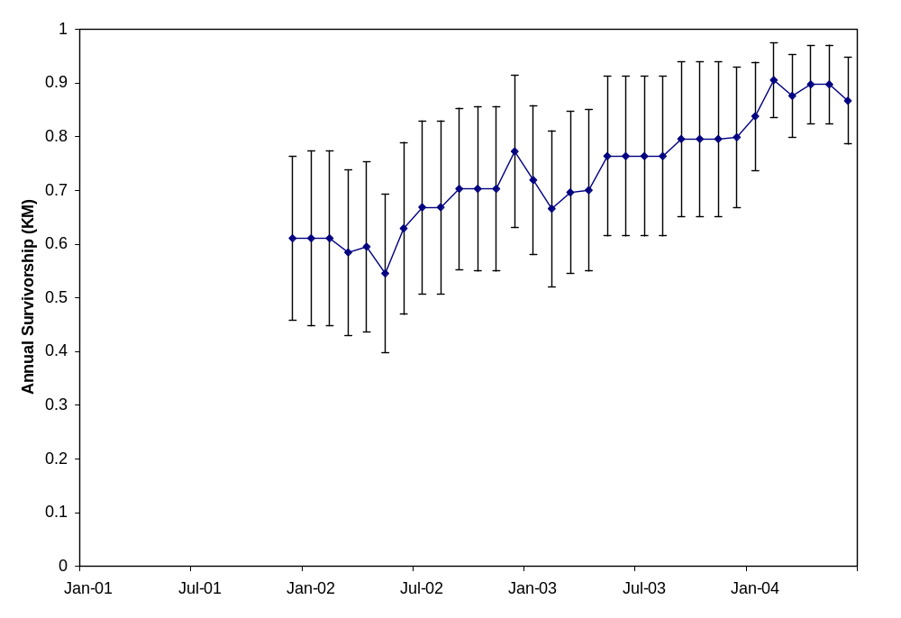
Figure 7. Rolling annual survivorship, with 95% CI, of wild island foxes on Santa Cruz Island, as determined by staggered entry Kaplan-Meier analysis.

Other Actions Required for Recovery

The immediate actions required for island fox recovery are captive breeding of island foxes and removal of golden eagles. Additional, longer term actions required for island fox recovery include removal of pigs from Santa Cruz Island, and reintroduction of bald eagles to the northern Channel Islands (Coonan 2003). The former is required to remove an alien prey base that supports golden eagle use of the islands, and the latter is required to return bald eagles to their former role as apex predator in the system. It is hoped that breeding bald eagles may deter future golden eagle use of the islands.

An additional action required is to assemble an island fox recovery team that can effectively assist the management agencies in making decisions about island fox recovery efforts. Difficult decisions are on the immediate horizon. Predation rates on released foxes are high, captive fox populations have grown to facility capacities on all islands, and up to 14 golden eagles still exist on the islands. Island fox management decisions, such as whether to release foxes in fall 2004, are thus complicated, and technical assistance from a fox recovery team is essential to informing such decisions.

Removal of Feral Pigs from Santa Cruz Island

Environmental compliance and planning for the removal of feral pigs from Santa Cruz Island is now complete (NPS 2002), and funding has been secured from the NPS and The Nature Conservancy. A contractor is currently being selected and pig removal should begin in summer 2004. Removal of pigs should be completed within 2-4 years, and the majority of the pigs may be removed very quickly, perhaps within 1-2 years.

Demographic modeling of pig, fox and golden eagle populations (Courchamp et al. 2003) suggests that as the pig population declines due to removal, golden eagles may switch to preying on foxes and drive the remaining wild foxes to extinction. However, such accelerated predation might not occur, because eagles take many other prey besides pigs and foxes on the Channel Islands, and thus there may not be one-for-one switching from pigs to foxes (B. Latta, Santa Cruz Predatory Bird Research Group, personal communication). Additionally, pigs have fluctuated markedly in the past, perhaps from lows of less than 1,000 pigs to highs of greater than 5,000 pigs (R. Klinger, University of California, Davis, unpubl. data) without driving foxes to extinction. Since 2000, predation rates on foxes are more related to the number of eagles present than the number of pigs present (T. Coonan, National Park Service, unpubl. data). That is, as the number of eagles removed has increased, and the number of eagles remaining has decreased, survival of wild island foxes has increased (see Impact of Eagle Predation on Island Foxes, above).

Though the model may have more heuristic than predictive power, the conservative approach is to attempt to detect such an effect, and mitigate it. To detect such an effect in a timely fashion, The Nature Conservancy has funded an expansion of the current island fox radiotelemetry study on Santa Cruz Island. As of January 2004 the number of radiocollared foxes in the study had increased from the previous standing sample of 20-25 foxes to over 60 foxes (D. Garcelon, Institute for Wildlife Studies, unpubl. data). If predation increases significantly due to pig removal, then appropriate mitigation would comprise capturing and bringing into captivity additional island foxes.

Reintroduction of Bald Eagles to Santa Cruz Island

In 2002, the Institute for Wildlife Studies began a feasibility study to determine if bald eagles could be successfully reintroduced to the northern Channel Islands. The study is funded by settlements monies from the Montrose Settlements Restoration Program (NOAA et al. 2002), because the disappearance of bald eagles from the Channel Islands in the mid-2oth century was due to the effects of organochlorine contaminants in the marine ecosystem of southern California. As of spring 2004 there were a total of 15 juvenile bald eagles on the northern Channel Islands, as a result of reintroductions in summer 2002 and summer 2003.

The goal of the study is to release up to 12 juvenile bald eagles annually on the northern Channel Islands for 5 years, and to monitor released eagles and their prey for contaminant levels to determine if levels are sufficiently low to allow breeding. Twelve juvenile eagles were released from hack towers on Santa Cruz Island in 2002, and 11 in 2003. Because bald eagles mature at 4-5 years of age, birds from the first (2002) release group may begin breeding in 2006 or 2007. As of spring 2004, 7 eagles from the 2002 release and 8 released in 2003 were alive on the islands (Garcelon 2004). Two released birds dispersed to the mainland and are currently in Utah and Oregon, respectively. The remaining 6 eagles died, likely from attempting to cross the Santa Barbara Channel.

Bald eagles from both release years have been recorded on Santa Rosa Island during late fall and winter. Released bald eagles have been observed feeding on carcasses and gut piles from the commercial hunt and annual cull of mule deer and elk on that island.

Establishment of Island Fox Recovery Team

On March 1, 2004, the U.S. Fish and Wildlife Service listed the island fox subspecies on San Miguel, Santa Rosa, Santa Cruz and Santa Catalina Islands as endangered (USFWS 2004). Now that the 4 subspecies are listed, the Service is in the process of assembling an island fox recovery team. Although many typical recovery teams are convened in order to develop a recovery plan for a particular species, the Service recognizes that island fox recovery actions are well under way, and are guided by an island fox recovery strategy document that is akin to a recovery plan. The Service also recognizes the contributions toward island fox recovery made by the Island Fox Conservation Working Group and its members. Accordingly, the recovery team that is being assembled will utilize the expertise existing in the Working Group, and will insure continued participation by those experts. Moreover, the focus of the recovery team will be less on development of a recovery plan, and more on providing the management agencies with the technical expertise required for informed island fox decision-making.

An overall recovery coordination group will assign technical questions to a number of technical advisory groups. Upon receipt of results from the technical advisory group, the coordination team will pass on recommendations to the management agencies. Thus the overall effort will be similar to the current function of the existing Island Fox Conservation Working Group.

Examples of issues to be addressed by technical advisory groups include the following:

- How could mate-choice be incorporated into selection of pairs for breeding?

- What are the consequences for San Miguel Island fox recovery of the male-biased sex ratio in captive pups produced on that island?

- How can mainland zoos accommodate island foxes, if we need to move a portion of captive breeding to the mainland this fall? Would a research colony be preferable to holding island foxes in zoos?

- Given current number of eagles on the islands, and current predation rates on wild and reintroduced foxes, how successful must eagle removal be this spring to allow for additional fox releases next fall?

- What are the mitigation measures that must be implemented in order for foxes to go the mainland and back without transferring pathogens to mainland zoos, or back to wild island foxes?

- What reintroduction methods should be used for island foxes?

- What caretaking/veterinary procedures should island fox caretakers implement (development of an island fox caretaker handbook)?

- How can island fox genetic and studbook (pedigree) data be used efficiently to choose animals for matings, for release to the wild, and for relocation to mainland institutions?

- Given whatever success the current intensive eagle removal achieves, what methods and level of effort should eagle management have in the next capture season, and beyond?

- How should wild island fox populations, and island foxes released to the wild, be monitored?

- How and where should island fox biological samples (blood and tissue) be stored for future analysis? Can a central repository be established?

Budget

A total of approximately $816,000 was spent on island fox recovery on the northern Channel Islands in fiscal year 2003 (Table 11), and a variety of funding sources contributed to the effort. Captive breeding costs totaled approximately $467,422, and included the costs of island fox care on 3 islands. National Park Service monies from the Natural Resource Preservation Program and the 20% Fee Demonstration program comprised the largest single funding sources, at $237,000 and $258,000, respectively. Overall, National Park Service funds accounted for $643,000 (79%) of the effort. The Nature Conservancy continued its support of the wild fox survivorship project on Santa Cruz Island, and funded fox caretaking for the captive breeding facility on that island.

Table 11. Costs and funding sources for island fox recovery actions, fiscal year 2003 (1 October 2002 to 30 September 2003).
Fiscal Year 2003 | NPS 20% Fee | NPS NRPP | NPS Parkbase | TNC | Total
Program Coord. |  |  | 86,447 |  | 86,447
Captive Breeding
Personnel | 63,888 | 133,609 | 65,000 | 48,000 | 310,497
Island perdiem | 8,686 | 19,044 |  |  | 27,730
Flights | 20,290 | 11,867 |  |  | 32,157
Fox food | 7,110 | 9,745 |  |  | 16,855
Supplies/equipment | 8,630 | 49,404 |  |  | 58,034
Vet care | 17,465 |  |  |  | 17,465
Vet tests | 3,708 |  |  |  | 3,708
Vet supplies | 996 |  |  |  | 996
Total Captive Breeding | 130,773 | 223,669 | 65,000 | 48,000 | 467,442
Eagle Removal | 126,917 |  |  | 25,000 | 151,917
SCI fox monitoring |  |  |  | 100,000 | 100,000
Island Fox Meeting |  | 10,000 |  |  | 10,000
TOTAL | 257,690 | 233,669 | 151,447 | 173,000 | 815,806

Future Costs

Estimated costs for island fox recovery actions in fiscal year 2004 total over $1,000,000 (Table 12). The substantial increase from recovery costs in previous years is primarily due to the intensive live-capture operation for removal of golden eagles, scheduled for spring 2004. Additional expenses include costs for building perimeter fences around captive facilities on Santa Rosa and San Miguel Islands, to prevent interactions between captive and wild foxes, as well as the costs of testing sperm quality in male island foxes on Santa Cruz and Santa Rosa Islands.

Available funding sources include remaining monies from the 20% Fee Demonstration project, settlement monies from environmental contaminant cases, the second year of a Natural Resource Preservation Program project, and substantial funding from The Nature Conservancy.

Table 12. Estimated costs and funding sources for island fox recovery actions on the northern Channel Islands, fiscal year 2004.
Fiscal Year 2004 | Fox Donation Account | NPF Settlement | NPS 20% Fee Demo | NPS NRPP | NPS Parkbase | TNC | Total
Program Coord. |  |  |  |  | 90,337 |  | 90,337
Captive Breeding
Personnel |  |  | 102,741 | 160,690 |  | 48,000 | 311,431
Island perdiem |  |  |  | 26,861 |  |  | 26,861
Flights |  |  |  | 35,216 |  |  | 35,216
Fox food |  |  |  | 29,387 |  |  | 29,387
Supplies/equipment |  |  |  | 42,742 |  |  | 42,742
Perimeter fencing | 20,000 |  |  |  |  |  | 20,000
Repr. Testing |  |  |  | 3,000 |  |  | 3,000
Vet care | 12,542 |  |  |  |  |  | 12,542
Vet tests |  |  |  | 11,024 |  |  | 11,024
Vet supplies |  |  |  | 1,082 |  |  | 1,082
Total Captive Breeding | 32,542 | 0 | 102,741 | 310,002 | 0 | 48,000 | 493,286
Eagle Removal |  | 75,000 |  | 17,920 |  | 375,000 | 467,920
SCI fox monitoring |  |  |  |  |  | 100,000 | 100,000
Island Fox Meeting |  |  |  | 10,000 |  |  | 10,000
TOTAL | 32,542 | 75,000 | 102,741 | 337,922 | 90,337 | 523,000 | 1,161,542

Literature Cited

American Society of Mammalogists. 1987. Acceptable field methods in Mammalogy: preliminary guidelines approved by the American Society of Mammalogists. ad hoc Committee on Acceptable Field Methods in Mammalogy. Journal of Mammalogy 68:1-18.

Collins, P. W. 1993. Taxonomic and biogeographic relationships of the island fox (Urocyon littoralis) and gray fox (U. cinereoargenteus) from Western North America. Pages 351-390 in Hochberg, F. G., (ed.), Third California Islands Symposium: Recent Advances in Research on the California Islands. Santa Barbara Museum of Natural History, Santa Barbara, California. 661 pp.

Coonan, T. J., C. A. Schwemm, G. W. Roemer, D. K. Garcelon, and L. Munson. In review. Decline of island foxes to near extinction on San Miguel Island, California. Submitted to Southwestern Naturalist.

Coonan, T. J. 2003. Recovery strategy for island foxes (Urocyon littoralis) on the northern Channel Islands. National Park Service, Ventura, California. 81 pp.

Courchamp, F., R. Woodroffe, and G. Roemer. 2003. Removing protected populations to save endangered species. Science (302):1532.

Coonan, T., and K. Rutz. 2001. Island fox captive breeding program, 1999-2000 annual report. Technical Report 01-01. National Park Service. 38 pp.

Coonan, T., and K. Rutz. 2002. Island fox captive breeding program, 2001 annual report. Technical Report 02-01. National Park Service. 55 pp.

Coonan, T., and K. Rutz. 2003. Island fox captive breeding program, 2002 annual report. Technical Report 03-01. National Park Service. 52 pp.

Coonan, T. J., C. A. Schwemm, G. W. Roemer, and G. Austin. 2000. Population decline of island foxes (Urocyon littoralis littoralis) on San Miguel Island. Pages 289-297 in Browne, D. K., K. L. Mitchell, and H. W. Chaney, (eds.), Proceedings of the 5th California Islands Symposium. U.S. Department of the Interior, Minerals Management Service, Pacific OCS Region.

Dennis, M., K. Randall, G. Schmidt, and D. Garcelon. 2002. Island fox (Urocyon littoralis santacruzae) distribution, abundance and survival on Santa Cruz Island, California. Progress report: for work conducted between 08 Feb 2002 and 31 Mar. 2002. Institute for Wildlife Studies, Arcata, California. 24 pp.

Garcelon, D. K. 2004. Bald eagle restoration on the northern Channel Islands, California, May 2003-December 2003, 2nd annual report. Unpublished manuscript on file at park headquarters, Channel Islands National Park, Ventura, California.

Georgi, J. V., and M. E. Georgi. 1991. Canine clinical parasitology. Lea and Febiger, Philadelphia. 227 pp.

Gray, M. M. 2003. Relatedness of Santa Cruz captive population and female 07061 within the Santa Rosa captive population. Unpublished report on file at park headquarters, Channel Islands National Park, Ventura, California. 16 pp.

Gray, M., J. Ballou, and K. Ralls. 2003. Santa Rosa island fox microsatellite and pedigree analysis. Unpublished report on file at Park headquarters, Channel Islands National Park, Ventura, California. 6 pp.

Gray, M. M., and G. W. Roemer. 2001. Genetic assessment of relatedness among individuals in the island fox (Urocyon littoralis) captive breeding program. Unpublished report on file at Park headquarters, Channel Islands National Park, Ventura, California. 23 pp.

Jackman, R. E., W. G. Hunt, D. E. Driscoll, and F. J. Lapsansky. 1994. Refinements to selective trapping techniques: a radio-controlled bow net and power snare for bald and golden eagles. Journal of Raptor Research. 28:268-273.

Kohlmann, S. G., G. A. Schmidt, R. C. Wolstenholme, and D. K. Garcelon. 2003. Island fox recovery efforts on Santa Catalina Island, California, October 2001-October 2002, annual report. Unpublished report prepared by the Institute for Wildlife Studies, Arcata, California, for Ecological Restoration Department, Santa Catalina Island Conservancy, Avalon, California. 83 pp.

National Oceanic and Atmospheric Administration, U. S. Fish and Wildlife Service, National Park Service, California Department of Fish and Game, California State Lands Commission, and California Department of Parks and Recreation. 2002. Feasibility study for reestablishment of bald eagles on the northern Channel Islands, California; environmental assessment. Montrose Settlements Restoration Program, Long Beach, California. 54 pp.

National Park Service. 2002. Santa Cruz Island primary restoration program, final environmental impact statement. National Park Service, Channel Islands National Park, Ventura, California. 249 pp.

Newman, C., G. A. Schmidt, and D. K. Garcelon. 2003. Island fox (Urocyon littoralis santacruzae) distribution, abundance and survival on Santa Cruz Island, California. Progress report: for work conducted between 01 December 2002 through 31 January 2003. Institute for Wildlife Studies, Arcata, California. 25 pp.

Pollock, K. H., S. R. Winterstein, and M. J. Conroy. 1989. Estimation and analysis of survival distributions for radio-tagged animals. Biometrics 45:99-109.

Roemer, G. W. 1999. The ecology and conservation of the island fox. Ph.D. dissertation, University of California, Los Angeles.

Roemer, G. W., T. J. Coonan, D. Garcelon, D. K. Bascompte, and L. Laughrin. 2001a. Feral pigs facilitate hyperpredation by golden eagles and indirectly cause the decline of the island fox. Animal Conservation 4: 307-318.

Roemer, G. W., D. K. Garcelon, T. J. Coonan, and C. A. Schwemm. 1994. The use of capture-recapture methods for estimating, monitoring, and conserving island fox populations. Pages 387-400 in Halvorson, W.L, and G.J. Maender, (eds.), The Fourth California Channel Islands Symposium: Update on the Status of Resources. Santa Barbara Museum of Natural History, Santa Barbara, California.

Roemer, G. W., P. S. Miller, J. Laake, C. Wilcox and T. J. Coonan. 2001b. Island fox demographic workshop report. Unpublished manuscript on file at Park headquarters, Channel Islands National Park. 43 pp.

U. S. Fish and Wildlife Service. 2004. Endangered and threatened wildlife and plants; listing the San Miguel Island fox, Santa Rosa Island fox, Santa Cruz island fox, and Santa Catalina Island fox as endangered. Federal Register 69(44): 10335-10353.

Wayne, R. K., S. B. George, D. Gilbert, P. W. Collins, S. D. Kovach, D. Girman, and N. Lehman. 1991. A morphologic and genetic study of the island fox, Urocyon littoralis. Evolution 45(8):1849-1868.

Appendix A Findings of the Island Fox Conservation Working Group

FINDINGS OF THE
ISLAND FOX CONSERVATION WORKING GROUP
JUNE 24-26, 2003
VENTURA, CALIFORNIA
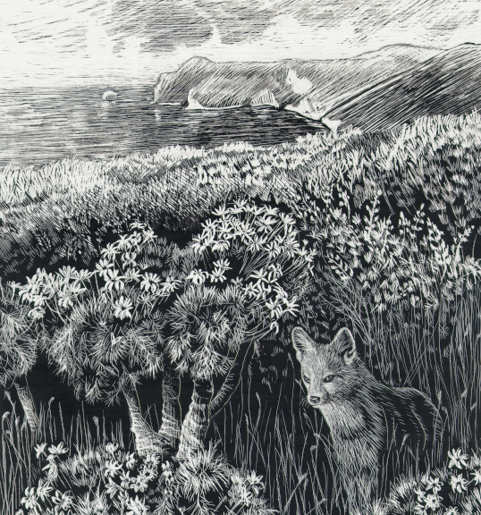

National Park Service
Channel Islands National Park
1901 Spinnaker Drive
Ventura, CA 93001
Work: (805) 658-5776
Fax: (805) 658-5798
Email: tim_coonan@nps.gov

Tim Coonan, Coordinator
National Park Service
Channel Islands National Park
1901 Spinnaker Drive
Ventura, CA 93001
Work: (805) 658-5776
Fax: (805) 658-5798
Email: tim_coonan@nps.gov

SUMMARY:

From June 24-26, 2003, the Island Fox Conservation Working Group conducted its fifth annual meeting in Ventura, California. The working group is a loose affiliation of agency, conservancy, zoo, non-profit and academic representatives concerned with conservation of the island fox (Urocyon littoralis). The group meets annually to exchange information about island fox status and recovery actions, to evaluate recovery efforts, and to identify management concerns and research needs.

Seventy people attended the meeting, representing such entities as National Park Service, U. S. Fish and Wildlife Service California Department of Fish and Game, ,U. S. Navy, The Nature Conservancy, Defenders of Wildlife, Smithsonian Institution, the IUCN Canid Specialist Group, the Institute for Wildlife Studies, the mainland zoo community, as well the University of California and other universities and organizations (see Appendix A).

Island fox subspecies on the northern Channel Islands are characterized by low population sizes. Of the San Miguel Island subspecies (U. l. littoralis), all but one are in captivity. The captive population has grown from 14 individuals to 38, but reproduction continues to be lower than in other captive populations. No Santa Rosa island foxes (U. l. santarosae) exist in the wild, and the captive population now numbers 56 individuals. There are an estimated 75-100 Santa Cruz island foxes (U. l. santacruzae) in the wild, and a captive population of 28 individuals.

The three subspecies on the southern Channel Islands exist at different population sizes and are influenced by different factors. Santa Catalina island foxes (U. l. catalinae) number about 220, and are recovering from an outbreak of canine distemper virus in 1999-2000. San Clemente island foxes (U. l. clementae) may number around 500, but are in long-term decline for reasons that are not apparent. With an estimated population size of 550-830 foxes, San Nicolas island foxes (U. l. dickeyi) remain the most dense and stable of the six island fox subspecies.

Of the six island fox subspecies, those on San Miguel, Santa Rosa, Santa Cruz and Santa Catalina Islands were proposed for federal listing as endangered by the U.S. Fish and Wildlife Service in December 2001. As of June 2003 the Service had not completed a final rule regarding the listing.

The most pressing issue for island fox conservation continues to be golden eagle predation, which is hindering island fox recovery on the northern Channel Islands. Although 9 golden eagles were captured and removed in winter/spring 2003, there are currently as many as 3 eagles on Santa Rosa, and as many as 5 on Santa Cruz. Capture efforts in late spring failed to catch 3 of the 4 known breeding eagles on the two islands. Annual island fox survivorship in the wild Santa Cruz Island population, which is a barometer of the success of eagle control, was 60% in 2001 and 70% in 2002. Demographic modeling shows that at least 80% is required to avoid population decline.

Consensus of the group was that although eagle removal has apparently increased the annual survivorship of island foxes, eagle predation has not been adequately mitigated by live-capture efforts, and that lethal control must be considered as an option if foxes are to be recovered. The best use of lethal would be limited use under specific conditions; for example, on nesting adults which had eluded live-capture efforts.

The recent discovery of breeding golden eagles on Santa Rosa Island and the connection between those eagles and the island’s non-native mule deer is alarming. One discussion group recommended that deer carcasses and gut piles from the deer hunt and cull be made unavailable to eagles.

Two discussion groups recommended that captive foxes in the northern Channel Islands not be released to the wild under these conditions. Reintroducing foxes in the face of considerable eagle presence may require larger captive populations and a longer effort, in order to achieve viable wild fox populations. Captive fox populations currently exceed facility capacity on Santa Rosa and Santa Cruz Islands, and are at capacity on San Miguel. Delaying releases would require finding additional housing and care for foxes, either on the islands or on the mainland. Housing additional foxes on the islands would require building additional pens, hiring additional staff, and incurring additional food and veterinary costs. There is a question of whether the park could sustain an expanded program either logistically or financially.

Although housing additional foxes in mainland zoos may be an option in the long run, it is not an option in the short-term. No institution would be willing to take foxes this fall. Moreover, captive breeding has been conducted on-island thus far because captive foxes returning from the mainland could introduce pathogens to naïve island populations. The veterinary discussion group recommended that a risk analysis be conducted prior to moving foxes to the mainland and back again. The island foxes currently housed at six mainland institutions are all from San Clemente Island. If zoos are to play a larger role in island fox captive breeding, the American Zoo and Aquarium Association’s Canid Taxon Advisory Group should be approached with such a request.

A recent assay of wild island fox blood samples discovered evidence of previous exposure to canine distemper virus on all islands with wild foxes. Apparently, the virus occasionally goes through wild island fox populations and is not entirely lethal (as evident by the existence of survivors with evidence of exposure). Because wild foxes with antibodies against CDV have immunity, and thus protection against the next outbreak, a greater degree of protection could be conferred to wild populations by vaccinating wild foxes against CDV.

As evident by the distemper caused-island fox decline on Santa Catalina Island, domestic dogs represent a real threat of disease to all island fox populations. The veterinary group recommended that all dogs used on park islands undergo strict vaccination and quarantine prior to arriving on the island.

MEETING PURPOSE:

The purpose of the annual meeting was three-fold:

- To exchange information and updates regarding island fox status, management actions, and research on all islands
- To provide an annual technical review of current recovery efforts
- To identify island fox management and research needs, and to foster cooperative efforts among the different agencies and landowners

The Island Fox Conservation Working Group is a loose affiliation of public agency representatives, landowners, conservancies, zoological institutions, non-profits and academics concerned about conservation efforts for the island fox. The island fox is in decline on four and perhaps as many as five of the six Channel Islands on which it occurs. The species is listed as Threatened by the State of California and was recently proposed to be Federally listed as Endangered. Because there is, as yet, no coordinated recovery program for this species, the working group serves as a forum for information exchange and evaluation of current recovery efforts. The working group communicates primarily through an annual meeting, but also via email and telephone conference calls. The group further divides into subject matter groups to tackle most issues. The individual working groups for this year’s meeting were veterinary issues, wild population management, captive breeding, and reintroduction.

BACKGROUND AND ISSUES:

Island fox populations on the three northern islands (San Miguel, Santa Rosa and Santa Cruz) declined catastrophically from 1995 to 1999, and predation by golden eagles was identified as the primary cause of the decline. A group of experts convened by the National Park Service in 1999 concluded that island foxes were threatened with extinction on San Miguel and Santa Rosa Islands, and so identified the need to remove golden eagles from the northern Channel Islands and to begin a captive breeding program for island foxes on those islands. The Park began implementing emergency recovery actions in summer 1999. Captive breeding of island foxes began on San Miguel Island in 1999, on Santa Rosa Island in 2000, and on Santa Cruz Island in 2002.

Golden eagle predation on island foxes on the northern Channel Islands is facilitated by an alien prey base of feral pigs on Santa Cruz Island, and mule deer on Santa Rosa Island. Moreover, the more diurnal nature of the island fox, compared to other fox species, and the conversion of native shrubland to alien annual grassland have increased the vulnerability of island foxes to eagle predation. Breeding bald eagles, which are highly territorial and may have deterred golden eagles from using the islands, bred on the islands historically. Bald eagles were missing from the northern Channel Islands since the 1950’s due to the effects of organochlorine pesticides and direct persecution by humans, until annual releases of juveniles began in 2002 on Santa Cruz Island to test the feasibility of reintroduction. Settlement monies from the Montrose Chemical Company contaminant case are funding the 3-5 year effort. Long-term solutions to the problem of golden eagle predation also require the removal of feral pigs from Santa Cruz Island. Pig removal is scheduled to begin in 2003/2004, as a joint project by the National Park Service and The Nature Conservancy.

The island fox population on Santa Catalina Island in the southern Channel Islands declined precipitously from 1999 to 2000 due to an epidemic of canine distemper virus. The epidemic decimated island fox populations on the eastern 80% of the island. In conjunction with the Catalina Island Conservancy, the Institute for Wildlife Studies began a field vaccination program for wild foxes on Catalina, has recently relocated foxes from the west end to the east end, and has released pups produced via captive breeding . The recent canine distemper outbreak on Catalina underscores the vulnerability of island foxes to canine distemper and other diseases.

Currently, there are four island fox captive breeding facilities on the Channel Islands, and island foxes are held in captivity at six mainland zoological institutions. Because island foxes were never bred in captivity prior to establishment of these programs, quick development of appropriate husbandry methods has been a priority. Much of the island fox’s reproductive physiology is still unknown, as are reasons for the relative lack of reproductive success in the San Miguel captive breeding program.

The influence of disease and parasites as island fox mortality factors remains a concern for all populations. Parasites are of particular concern on San Miguel Island.

The continued predation by golden eagles Santa Cruz island foxes remains the primary concern for foxes on the northern Channel Islands. In the southern islands, there are concerns about the effects of loggerhead shrike predator management activities, feral cats, and habitat changes on the San Clemente island fox, which appears to be in a long-term decline for reasons that are not apparent.

The primary conservation issues discussed at the 2003 meeting were:

- the relative success of golden eagle removal, and the need for lethal removal as a tool
- whether or not to release animals to the wild on the northern Channel Islands, in the face of continued golden eagle presence and predation
- in the absence of releases, how to house the increasing number of captive foxes
- the role of mainland zoos, or any other entity, in captive breeding if the effort needs to be expanded beyond the current level at the park
- the status of the Santa Cruz wild population and the role of captive breeding on the island
- the prevalence and threat of canine diseases, and the need to vaccinate the wild populations against canine distemper
- possible negative impacts of pig removal on island foxes
- funding for island fox recovery efforts
- vaccine and quarantine guidelines for dogs working on the islands

STATUS OF EACH SUBSPECIES:

San Miguel Island

Addition of 10 pups in spring 2003 increased the San Miguel captive population to 38 foxes (23 males and 15 females). One adult female remains in the wild, as recorded by remote automated cameras. Pup production continues to be skewed toward males (18 of 23 pups). Seven of the original 14 animals brought into captivity have now bred. Although breeding success continues to be low (only 5 of 12 pairs produced a litter in 2003), addition of pups in spring 2004 will likely increase the San Miguel captive population to the target of 20 pairs, and allow initial releases to the wild in fall 2004.

Santa Rosa Island

There are currently no wild foxes on Santa Rosa Island. Production of 11 pups in spring 2003 brought the captive population to 56 foxes, but was less than pup production in spring 2002 (13 pups). Only four of 16 pairs produced litters in 2003. Three pairs that had previously produced litters did not produce in 2003, perhaps because a pup from the previous year was housed in the pen with each of those pairs. Of the 44 pups born since 2000, 27 have been female, and the overall captive sex ratio is 21 males to 35 females. An experimental release scheduled for January 2003 was canceled due to the presence of breeding golden eagles on the island. An experimental release may occur in fall or winter 2003-2004.

Santa Cruz Island

Islandwide trapping efforts by the Institute for Wildlife Studies in summer 2002 resulted in the capture of 97 individuals, and trapping success suggests that the Santa Cruz Island wild fox population did not decline between 2001 and 2002. Seven radiocollared foxes died during 2002, and eagle predation was cause of death for 5 of the 7. Those 5 eagle-caused mortalities included 2 of 3 captive-born juveniles released in December 2002. The previous year, eagle predation accounted for 8 of 9 mortalities of radiocollared foxes on Santa Cruz Island. Annual survivorship of island foxes, as estimated from radiotelemetry, was 61% in 2001 and 70% in 2002. Annual survivorship of 80% is required for an increasing population.

Five of the 10 captive fox pairs on Santa Cruz Island produced litters in spring 2003. The 10 pups increased the captive population to 30 animals. Pups produced in spring 2003 will likely be released to the wild in fall 2003.

San Nicolas Island

Grace Smith of the U.S. Navy and Greg Schmidt of the Institute for Wildlife Studies reported that the island fox population on San Nicolas continues to be dense and stable. Two grids trapped in summer 2002 had adult densities of over 20 foxes per square kilometer, which are the highest densities reported yet for the species. The islandwide estimate, based on mark-recapture estimates from grid trapping, is 550-830 foxes.

Santa Catalina Island

Dr. Winston Vickers of the Institute for Wildlife Studies reported that 8 of the 11 Santa Catalina Island captive females produced litters in spring 2003. Twenty-four -hour post-whelping monitoring revealed several cases of inattentive females, and triggered aggressive neonatal care by staff. Pups were pulled from inattentive females, hand-raised for 1-2 days, and fostered successfully into other captive litters. The island’s captive breeding facility produced 16 pups in 2003. Greg Schmidt and Steve Kohlmann of the Institute reported on the success of island fox translocations and release of captive foxes. Survivorship has been high for the two translocations conducted thus far, and for the two releases of captive-born animals. The islandwide population is estimated to be 220 foxes, and the probability of extinction, as estimated via population viability analysis, is less than 1%. The apparent success of translocations and captive breeding suggest that such actions may be necessary for only a few more years.

San Clemente Island

Greg Schmidt of the Institute for Wildlife Studies reported results from annual monitoring of island foxes on San Clemente Island, a study that began in 1988. Island foxes are generally declining on San Clemente Island, for unknown reasons. The role of predator management activities, instituted for recovery of endangered San Clemente Island shrikes, in the apparent decline is still unclear. Of the three long-term grids monitored, there has been moderate fox control on two. Generally, there are higher fox numbers where predator control has been minimal, and where feral cat abundance is lower.

GOLDEN EAGLE REMOVAL:

Since fall 1999, staff from the Santa Cruz Predatory Bird Research Group have live-captured and removed 31 golden eagles from the northern Channel Islands. Captured birds include 26 adult, sub-adult or juvenile eagles captured via bow-net and released in northeastern California, and 5 eaglets captured by hand from island nests and fostered into mainland golden eagle nests or hacked on the mainland. Satellite radiotelemetry affixed to the first 12 captured birds showed that none returned to the Channel Islands for the 1.5-year life of the tag. Cost of total eagle trapping efforts after four years was approximately $527,000.

Captures in 2003 include 6 eagles captured on Santa Cruz Island in February and March 2003 at a site where carrion was being provided for juvenile bald eagles released on the island in summer 2002. Golden eagles were likely attracted to the carrion site by the presence of bald eagles.

Although golden eagle breeding had been documented on Santa Cruz Island since 1999, golden eagles were never known to breed on Santa Rosa Island until this year. Two breeding pairs of golden eagles were discovered on the island in January and February 2003. One pair abandoned their nest attempt in March, and the other pair produced one chick, which was removed by hand from the nest in June. The adult male from the latter pair was live-captured in May 2003.

Because several alternate nests were observed in the Santa Rosa golden eagle territories, eagles have likely been breeding on Santa Rosa for several years, and Santa Rosa eagle nests may be the source of many eagles observed on neighboring Santa Cruz Island. A cursory examination of prey items in the nests found remains of deer fawns, skunks, foxes, and many birds (ravens, mallards, barn owls, California quail, western meadowlarks). The presence of numerous fox remains indicates that golden eagles had colonized the island by 1998 or 1999, when foxes were still extant on the island. The presence of deer fawn remains underscores the importance of mule deer to golden eagles on Santa Rosa Island. Carcasses from the cull in November and December allow golden eagles to accrue the energetic resources necessary to attempt breeding, and fawn availability in the spring allows nesting eagles to successfully fledge young.

By the end of trapping efforts in summer 2003, there were estimated to be 8 golden eagles left on the northern Channel Islands. This included 3 adults on Santa Rosa, 3 adults on Santa Cruz, and 2 subadults on Santa Cruz.

PATHOLOGY, DISEASE AND PARASITES, AND REPRODUCTION:

Dr. Linda Munson of UC Davis reported on her continuing study of island fox pathology. After five years, 290 island fox carcasses have been necropsied. A database of lesions and parasites has been compiled, with the goal of distinguishing debilitating and fatal diseases from incidental causes of mortality or morbidity.

Factors that are of concern include the following:

- Emaciation has been observed in some southern Channel Island foxes, in the presence of apparent food and good dentition, for unknown reasons.
- Amyloidosis, the presence of abnormal protein deposits, has been observed in emaciated foxes.
- Systemic mineralization has been observed in foxes from San Clemente Island.
- Ear mites have produced lesions and chronic inflammation of the ear canal in many Santa Catalina Island foxes, and in several cases were associated with aggressive ceruminous gland carcinomas which caused mortality.
- Colonic lesions due to spirocercid parasites were observed in foxes from San Miguel, Santa Rosa, Santa Cruz, and San Nicolas islands. Such lesions could cause perforation of the gut.
- Some neonatal deaths also occurred in captive foxes.
- Canine distemper virus (CDV) was the cause of the recent island fox decline on Santa Catalina Island, and remains a primary concern for all island fox populations. A 2001-2002 serosurvey (see below) showed that wild foxes on Santa Catalina, San Nicolas, San Clemente and Santa Cruz islands had evidence of exposure to CDV. This indicates that CDV is not fully lethal, but is occasionally epizootic in island fox populations. Since previous exposure confers immunity against CDV, the proportion of the sample that is seropositive is a measure of the level of protection afforded to the population. Less than 50% seroprevalence on Santa Clemente Island indicates that population is not adequately protected against an epizootic of CDV, and vaccinating wild foxes could increase the proportion of wild foxes that would survive the next epidemic. Vaccination may also be appropriate for Santa Cruz Island foxes, though they show 77% seroprevalence; the critical status of that population may be sufficient reason to increase protection through vaccination.

Dr. Deanna Fritcher of UC Davis reported on her 2001-2002 serosurvey of wild foxes on San Clemente, Santa Catalina, San Nicolas, and Santa Cruz Islands (there are no wild foxes on Santa Rosa, and only one on San Miguel). In addition to the CDV results mentioned above, incidence of canine parvovirus (CPV) increased 90-100% since 1988; there were particularly high titers on San Clemente Island. Dr. Fritcher also reported on her study of island fox pregnancy rates, neonatal mortality, and perinatal mortality on Santa Catalina Island. Pregnancy rates were higher in wild foxes than in captive foxes, but perinatal mortality was less in captivity.

Dr. Sharon Patton of the University of Tennessee reported on preliminary results from the risk assessment for treating parasites in captive island foxes, a project directed by Dr. Rex Sohn of the USGS-Biological Resources Division’s National Wildlife Health Center. Fecal parasite surveys were conducted for captive foxes on San Miguel, Santa Rosa and Santa Cruz Islands. Overall, parasites were most prevalent in San Miguel foxes. All San Miguel samples were positive for the hookworm Uncinaria stenocephala, compared to 10-30% of the samples from the other two islands. Compared to other hookworms, U. stenocephala has much less impact on individual health. Spirocercids were found in 70-90% of the samples from all three islands. Adult spirocercids were found in nodules in the colon of some necropsied foxes, which is a unique location; spirocercids in mainland hosts are found in the esophagus. The lungworm Angiocaulus gubernaculatus was found only in San Miguel foxes, where it was present in 35% of the pens. The panel convened for the risk assessment has determined that currently there is little clinical justification for the use of anthelmintics in island foxes, and the primary concerns for such use would be the effect on non-target sprirocercids and Angiocaulus. The panel compiled a list of preferred anthelmintics, recommended dosages, and contraindications, should treatment for internal parasites be required.

Dr. Cheri Asa of the St. Louis Zoo reported on the success of a relaxin blood test for pregnancy (the occurrence of pseudopregnancy in island foxes prevents determination of pregnancy via monitoring progesterone and estradiol). Dr. Asa also summarized her island fox reproductive studies to date. Unlike every other canid studied thus far, female island foxes do not ovulate every breeding season. Most female island foxes paired with males ovulate, but those housed with other females or by themselves do not. This appears to be a case of induced ovulation, but induced estrus cannot be ruled out.

GENETICS:

Melissa Gray of UCLA reported on the use of genetic information to develop a release strategy for Santa Rosa Island captive foxes. A pedigree developed from relatedness values was used to identify over-represented individuals, and their descendants, for release. All founders on Santa Rosa are highly related. Her recent analysis of the Santa Cruz Island captive and wild populations showed that the mean number of alleles was higher than in the San Miguel or Santa Rosa populations, that average inbreeding was low, and that the captive population had captured an adequate sample of the population’s genetic diversity.

Andres Aguilar, also of UCLA, reported on fitness–related genetic variation in island foxes. Genotyping heretofore had been done on so-called neutral markers, which have no known relation to fitness. Analysis of genes that code for the major histocompatibility complex (MHC) in island foxes revealed heterozygosity in San Nicolas Island foxes, which had previously showed no variation at other loci.

MAINLAND ZOO POPULATION:

Assistant Curator Ingrid Russell of the Santa Barbara Zoo reported a total of 16 island foxes held in the following mainland zoos: Santa Barbara Zoo, California Living Desert Museum, Charles Paddock Zoo, Utah’s Hogle Zoo, the Orange County Zoo, and the Los Angeles Zoo. Thus far there has been a male bias in pups born in mainland zoos.

LEGAL STATUS:

In December 2001 the U.S. Fish and Wildlife Service proposed to list four island fox subspecies (San Miguel, Santa Rosa, Santa Cruz, and Santa Catalina) as Endangered under the Federal Endangered Species Act. The Service had one year from date of publication of the proposed rule to make a final decision on listing. By June 2003 the Service had not published a final rule.

FINDINGS:

Veterinary Issues

- Veterinary care for captive island foxes: Fox care technicians should follow appropriate veterinary guidelines. The appropriate veterinarian should be contacted if an animal appears sick or injured. All fox care staff should be properly trained, and such training should be coordinated between the NPS and IWS. Such training should include first aid training for injuries, taking and handling of blood samples, neonatal care, treatment for shock, “trigger points” for hospitalization or treatment. Project veterinarians should impart this information via annual short courses.

- Guidelines for use of dogs: Strict guidelines should be implemented for vaccination and quarantine for dogs on islands, including pet dogs on Santa Catalina Island, pig hunting dogs on Santa Cruz Island, and ranch dogs on Santa Rosa Island. We recommend implementation of the park’s draft guidelines, as amended, for use of dogs in the park.

- Canine distemper virus vaccination: Recent serological surveys show that wild foxes have antibodies against canine distemper virus (CDV). This indicates that CDV is occasionally epizootic in island fox populations. Those that have antibodies have immunity, but low seroprevalence on San Clemente Island indicates that populations is not adequately protected. Vaccinating a portion of the wild population on that island, and on Santa Cruz Island, could confer an immunologic advantage to those foxes in the face of an epidemic.

- Rabies: There is currently not a sufficient risk of rabies on the islands to warrant vaccination of foxes for rabies, but we do recommend rabies vaccinations for all staff handling island foxes.

- Diagnosis of pregnancy and evaluation of sperm quality: Knowledge of fertility and pregnancy would optimize management of captive foxes, and could determine cause of reproductive failure. Because handling constitutes a stress that may impair reproductive function, we recommend that pregnancy tests (utrasound and/or relaxin assays) and semen evaluation only be conducted on captive foxes that have thus far failed to produce pups. Those procedures should be implemented under the guidelines developed.

- Potential inter-island or mainland-island movement of foxes: The unique parasites/pathogens on some islands and the insular evolution of foxes without mainland diseases make the risk of acquiring or transmitting disease substantial for such movements. We recommend that such movement be discouraged, that a specific risk analysis be conducted prior to any move, and that strict quarantine procedures be observed for such movements.

- Veterinary handbook: We will develop a veterinary handbook for use in the island fox captive breeding programs, and in zoos. The handbook should be completed by spring 2004.

Management of Wild Island Fox Populations

- Golden eagle monitoring: Because golden eagle predation is still the primary mortality factor for island foxes on the northern Channel Islands, and because such predation will hinder recovery, monitoring efforts for golden eagles should be increased. Analysis of golden eagle feathers/blood could determine the source of eagles (mainland or island). The newly discovered nests on Santa Rosa Island should be excavated to investigate the prey base supporting golden eagle nesting on that island.

- Lethal removal of golden eagles: Removal of golden eagles should be the highest priority management action, with a goal of no resident eagles, and lethal removal of golden eagles needs to be a management option. Eagle removal, and fox recovery, will likely fail without it. The tool might best be used in a selective fashion, for breeding females that have eluded capture by other methods. The approach needs to be adaptive in nature. The administrative process for obtaining a permit should be assessed, and the feasibility of lethal removal investigated. Above all, the process should be expedited.

- Management of eagle prey base: Golden eagles on Santa Rosa Island are supported by non-native mule deer, and that food source needs to be reduced or eliminated. Gut piles from the annual hunt and carcasses from the annual cull should be removed from the field or otherwise made unavailable to eagles. Deer carcasses should be made available for golden eagle capture efforts.

The effect of pig removal on golden eagle prey selection and use of the islands in unknown. If predation on foxes increases as a result of pig carcass availability, or conversely, absence of pigs and prey-switching to island foxes, then a contingency plan should be in place to pull more foxes into captivity. Pig carcasses should ideally be made unavailable to eagles. The sample of collared foxes should be increased to allow greater resolution in estimating survivorship and mortality sources for foxes.

- San Clemente fox decline: Research should be conducted to investigate cause(s) of the apparent island fox decline on San Clemente Island. Specifically, has the expansion of alien annual grasslands decreased the amount of high-quality habitat available for foxes? Is social disruption occurring? Do foxes compete with feral cats?

Management of Captive Fox Populations

- Expansion of captive breeding facilities on islands: Although Santa Rosa facilities are currently at capacity, we reinforce last year's recommendation that fox releases should not occur while eagles remain. Furthermore, it would reduce the Santa Rosa population’s chances of survival if growth of the captive population ceased or slowed due to lack of space. We recommend the construction of 10 additional pens on Santa Rosa as soon as possible and the acquisition of additional staff to care for the captive foxes.

Santa Cruz facilities are also at capacity. Should pig removal on Santa Cruz result in increased fox predation by golden eagles, additional caging will be required to facilitate captive breeding to off-set increased predation rates post-release and may be required as sanctuary housing for additional Santa Cruz foxes. The Santa Cruz population is known to be among the most genetically variable fox population and the loss of additional genetic variation in this population should be avoided.

Captive breeding programs generally aspire to maximize gene diversity in founding populations. Population modeling should be conducted to examine the impacts of different strategies of breeding and sanctuary on the retention of genetic diversity in the presence and absence of releases and in the presence and absence of facility expansion. Sanctuary could be provided by capturing fox pups instead of adults. This would minimize negative demographic effects on the wild population. Additionally, the existing wild population on Santa Cruz should be evaluated for a minimal acceptable population size, representing the population size at which the remaining Santa Cruz specimens will be captured for sanctuary housing in the event of further population decline. Genetic and demographic criteria should be used to prioritize individuals for sanctuary housing. Based on the results of this modeling exercise, we recommend construction of additional enclosures and additional staff on Santa Cruz as necessary.

San Miguel facilities are projected to be at capacity after the next breeding season. Thus, construction of additional facilities there will likely be necessary soon.

- Potential for moving foxes to mainland facilities: If it is not possible to expand breeding facilities on the islands, the movement of some island foxes to the mainland will be necessary. Investigations into the potential for housing island foxes on the mainland should begin immediately, as development/recruitment of mainland facilities will take time.

- Fire evacuation plans: We recommend the development of a fire evacuation plan to facilitate removal of a genetically representative and demographically robust sample of foxes from each island breeding facility in the event of fire emergency. Creation of this plan can be facilitated utilizing studbook data and should be updated annually. Genetic prioritization should be accompanied by staff safety protocols and “Rules of Engagement”.

- Maintenance of subspecies: We repeat the recommendation from last year that a thorough risk analysis should be undertaken on the likely costs and benefits of allowing some genetic mixture between subspecies, especially the Santa Rosa and San Miguel populations. Assessment of the probable demographic and genetic effects on the populations should be combined with assessment of the probable disease risks. If the risk assessment is favorable, an action plan should be developed.

- Behavioral observations of captive foxes: We recommend the formation of a committee to investigate and coordinate behavioral observations at captive breeding facilities and develop research questions. We recommend that existing ethograms (behavioral data recording sheets) be combined and evaluated. Collection of behavioral data should be standardized across zoological institutions and island breeding facilities to enable and enhance comparative data analysis.

- Mate-choice experiments: We recommend that mate-choice experiments be conducted where possible. Foxes that have not bred successfully with their assigned mate may be more likely to breed with a mate of their own choice. San Miguel and Santa Rosa captive facilities lend themselves to such experiments due to biased sex ratios.

- Mainland zoo population: The zoo population, which consists of foxes from San Clemente Island, currently has no clear short-term or long-term management goals. It is critical that goals be established to ensure responsible management of this population. In addition, clear management goals will encourage further and expanded participation in the Island Fox Population Management Plan by zoological institutions. The mainland zoo community is waiting for input from the Island Fox Conservation Team to guide zoo fox management goals. Potential management goals are a) to develop a long-term genetically viable population of San Clemente foxes; b) to continue to house San Clemente foxes in small numbers for education programs; c) to phase-out San Clemente foxes, thus creating space for other sub-species for a breeding program; and d) to house surplus non-breeders from island breeding facilities. The Canid TAG should be contacted prior to the AZA Annual Meeting in September 2003 to discuss goals for this population.

- Interactions of wild and captive foxes: We recommend continuation of current measures to avoid problem interactions between captive and wild foxes. Shock collars appear to be the most viable option as barriers are likely to be ineffective and removal of wild foxes causing problems will likely result in movement of additional foxes into the territory.

- Mainland research facility: We do not recommend immediate creation of a mainland research facility. While existing foxes on the mainland may be utilized for research, research alone is not sufficient reason for island/mainland movements. The resources needed to create such a facility might be better spent in facility expansions at existing island sites. None of the currently participating zoos have the resources to support such a facility at this time or to breed foxes at a rate to stock such a facility. In the absence of the ability to move specimens between mainland and islands, it is unlikely that specimens from islands could or should be used to stock such a facility. However, if the decision is made to move foxes from the islands to the mainland, it would be highly desirable to find a facility that could house sufficient numbers of foxes to support a research program.

Reintroduction of Island Foxes

- Reintroduction planning: We recommend that different island groups do collaborative modeling and planning of release programs, including logistical and political constraints, to improve recovery potential and to enhance the scientific basis of recovery. Specifically, we recommend the development of standard protocols when possible to aid the development of comparable data sets, which should permit rigorous evaluation of methodologies.

- Conditions for release: Given the continuing presence of golden eagles, we recommend for this year that foxes not be released on the islands. We recommend building temporary holding facilities and developing alternative options for assistance by non-NPS staff in the care of captive- held foxes. We also recommend looking at alternative options for long-term care of captive-held foxes, including mainland facilities.

- Choice of foxes for release: In the absence of golden eagles, we recommend that non-reproducing genetically surplus foxes be considered for release to study behavioral ecology post-release and to maintain ecosystem function.

- Post-release monitoring: Foxes should not be released without a monitoring plan in place which clearly explains how the release will promote recovery or improve knowledge of fox biology. At a minimum, foxes would be monitored to detect mortalities rapidly, which would allow more accurate identification of causes of mortality. More intensive monitoring is preferable and would result in information regarding basic biology and ecology of the foxes, including movements, habitat use, foraging, interactions, home range etc. We recommend that initial monitoring include systematic trapping of released foxes in order to assess the status of individual foxes, along with intensive telemetry monitoring. A review of the monitoring program should allow us to determine the most effective way to identify foxes that might need recovery for future releases.

APPENDIX A

LIST OF MEETING PARTICIPANTS

Angela Aarhus  Catalina Island Conservancy | Andres Aguilar  UCLA
Cheryl Asa  St. Louis Zoo | Erik Aschehoug  The Nature Conservancy
Vickie Bakker  UC Davis | Karen Blumenshine  Santa Barbara Zoo
Dan Blumstein  UCLA | Kevin Breen  Orange County Zoo
Kelly Brock  U.S. Navy, SW | Pedro Chavarria  National Park Service
Matt Christianson  Institute for Wildlife Studies | Geoff Cline  Institute for Wildlife Studies
Paul Collins  Santa Barbara Museum of Natural History | Tim Coonan  National Park Service
Susan Coppelli  National Park Service | Keri Dearborn  Los Angeles Zoo
Bob DeLong  NMFS National Marine Mammal Lab | Forrest deSpain  Orange County Zoo
Katie Drexhage  USFWS – Ventura Field Office | Jana Edwards
Bridget Fahey  USFWS – Ventura Field Office | Erin Fleming  Los Angeles Zoo
Deanna Fritcher  UC Davis Wildlife Health Center | David Garcelon  Institute for Wildlife Studies
Keith Gilchrist  Charles Paddock Zoo | Dave Graber  National Park Service
Melissa Gray  UCLA | Lynn Hall  Fennec Breeder
Karl Hill  Santa Barbara Zoo | Dale Kernahan  Santa Barbara Zoo
Devra Kleiman  Smithsonian Institute | Steve Kohlmann  Institute for Wildlife Studies
Brian Latta  Santa Cruz Predatory Bird Research Group | Lyndal Laughrin  UC Santa Cruz Island Preserve
David Lawhead  CDFG | Andrea Lehotsky  National Park Service
Colleen Lynch  American Zoo and Aquarium Association | Catrina Martin  U.S. Fish and Wildlife Service
Jonna Mazet  UC Davis Wildlife Health Center | Kate McCurdy  National Park Service
Mary Ann Meyers | Pat Meyer  Los Angeles Zoo
Samantha Moorehead  Santa Barbara Zoo | Linda Munson  UC Davis
Christopher Newman  Institute for Wildlife Studies | Julia Parker  Santa Barbara Zoo
Sharon Patton  Univ. of Tennessee, Knoxville | Stephanie Provinsky  National Park Service
Katherine Ralls  Smithsonian Institution | Gary Roemer  New Mexico State University
Ingrid Russell  Santa Barbara Zoo | Keith Rutz  National Park Service
Greg Schmidt  Institute for Wildlife Studies | Sheri Schroeder
Peter Schuyler  Catalina Island Conservancy | Cathy Schwemm  National Park Service
Brian Smith  UCLA | Grace Smith  U.S. Navy, San Nicolas Island
Rex Sohn  USGS-BRD Nat. Wildlife Health Center | Marsha Sovada  USGS-BRD North. Prairie Wildl. Res. Center
Wendy Stanford  Santa Barbara Zoo | Nancy Thomas  USGS-BRD Nat. Wildlife Health Center
Anna Toline  USFWS – Ventura Field Office | Winston Vickers  Institute for Wildlife Management
Sandy Vissman  USFWS – Carlsbad Field Office | Bob Wayne  UCLA
Cynthia Wilkerson  Defenders of Wildlife | Mark Willett  NPS contract vet
Ian Williams  National Park Service | Rosie Woodroffe  UC Davis

Appendix B Breeding Charts and Lists of Foxes in Captivity

Figure 8. Breeding and pedigree chart for captive San Miguel Island foxes.

Table 13. Island foxes in captive breeding facility on San Miguel Island.
Pen¹ | ID | Sex | Age² | Born | Sire | Dam | Capture Date | Capture Area
M01 | 85764 | F | 2 | Captive | 44829 | 90D1A
 | 87F53 | M | 2 | Captive | 7574A | 92C32
M02 | B0E36 | M | 2 | Captive | 7574A | 92C32
M03 | 7574A | M | 6 | Wild |  |  | 5/14/1999 | Willow Canyon
 | 92C32 | F | 6 | Wild |  |  | 5/17/1999 | Willow Canyon
M04 | 84E33 | M | 1 | Captive | 44829 | 90D1A
M07 | 90D1A | F | 6 | Wild |  |  | 9/2/1999 | Willow Canyon
 | 44829 | M | 6 | Wild |  |  | 9/4/1999 | Willow Canyon
M08 | 53A78 | F | 1 | Captive | 47B06 | E2677
 | C111F | M | 1 | Captive | 7574A | 92C32
M09 | 7534A | F | 11 | Wild |  |  | 9/4/1999 | Nidever Canyon
 | 70C1D | M | 3 | Captive | 44829 | 90D1A
M10 | C311C | M | 1 | Captive | 11F73 | F6558
 | 52F0C | M | 1 | Captive | 11F73 | F6558
M11 | 47B06 | M | 4 | Captive | 44829 | 90D1A
 | E2677 | F | 6 | Wild |  |  | 9/11/1999 | Willow Canyon
M12 | 91167 | M | 1 | Captive | 7574A | 92C32
 | B0B25 | F | 5 | Wild |  |  | 9/28/1999 | Nidever Canyon
M13 | 11F73 | M | 3 | Captive | 44829 | 90D1A
 | F6558 | F | 5 | Wild |  |  | 10/4/1999 | Green Mountain
M14 | 57150 | M | 6 | Wild |  |  | 10/4/1999 | Green Mountain
 | 60921 | F | 6 | Wild |  |  | 9/24/1999 | Green Mountain
M15 | B7E0A | F | 2 | Captive | 47B06 | E2677
 | E666D | M | 1 | Captive | C4A16 | 71071
M16 | 90C7D | F | 1 | Captive | C4A16 | 71071
 | 83C24 | M | 3 | Captive | 44829 | 90D1A
M17 | C7303 | M | 3 | Captive | 7574A | 92C32
 | 11929 | F | 4 | Captive | 44829 | 90D1A
M18 | C4A16 | M | 3 | Captive | 7574A | 92C32
 | 71071 | F | 5 | Wild |  |  | 8/23/1999 | Cardwell
M19 | 92804 | F | 12 | Wild |  |  | 10/24/1999 | Willow Canyon
 | 85D02 | M | 5 | Wild |  |  | 9/17/1999 | Cardwell
M20 | B4E60 | M | 2 | Captive | 44829 | 90D1A
 | E270B | M | 2 | Captive | 44829 | 90D1A
M21 | 66C6E | M | 2 | Captive | 47B06 | E2677
 | 13212 | M | 2 | Captive | 47B06 | E2677
M22 | 03A13 | F | 1 | Captive | 47B06 | E2677
 | 5797C | M | 1 | Captive | 7574A | 92C32
¹Pens M01-M11 are at Willow Canyon site; pens M12-M21 are at Brooks Canyon site.
²in years, as of fall 2003

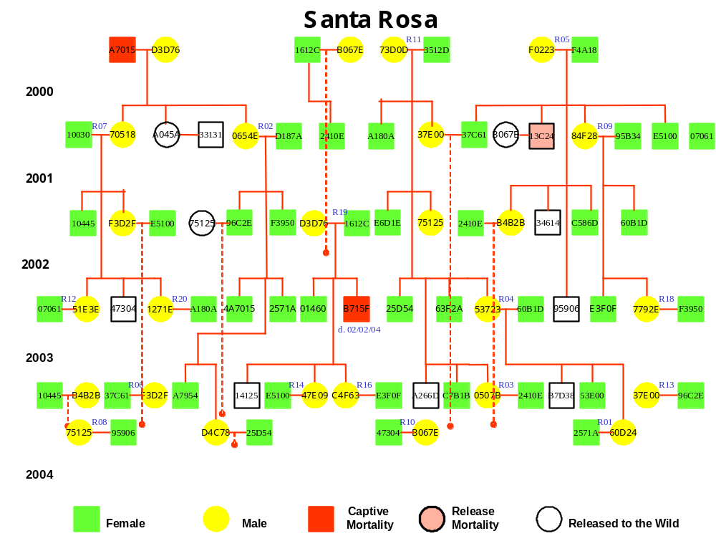

Figure 9. Breeding and pedigree chart for captive Santa Rosa Island foxes.

Table 14. Island foxes in captive breeding facility on Santa Rosa Island.
Pen | PitTag | Sex | Age | Born | Sire | Dam | Date Captured | Capture Area
R01 | 2571A | F | 2 | Captive | 0654E | D187A
 | 60D24 | M | 1 | Captive | 53723 | 60B1D
R02 | D187A | F | 6 | Wild |  |  | 4/5/2000 | Smith Highway
 | 0654E | M | 4 | Captive |  | A7015
R03 | 0507B | M | 1 | Captive | 73D0D | 3512D
 | 2410E | F | 4 | Captive |  | 1612C
R04 | 60B1D | F | 3 | Captive | 84F28 | 95B34
 | 53723 | M | 2 | Captive | 73D0D | 3512D
R05 | F0223 | M | 6 | Wild |  |  | 4/6/2000 | Smith Highway
 | F4A18 | F | 5 | Wild |  |  | 3/29/2000 | Smith Highway
R06 | 37C61 | F | 4 | Captive |  | F4A18
 | F3D2F | M | 3 | Captive | 70518 | 10030
R07 | 70518 | M | 4 | Captive |  | A7015
 | 10030 | F | 6 | Wild |  |  | 4/5/2000 | Smith Highway
R08 | 75125 | M | 3 | Captive | 73D0D | 3512D
 | 95906 | F | 2 | Captive | F0223 | F4A18
R09 | 84F28 | M | 4 | Captive |  | F4A18
 | 95B34 | F | 5 | Wild |  |  | 9/1/2000 | Torrey Pines
R10 | B067E | M | 6 | Wild |  |  | 3/26/2000 | Smith Highway
 | 47304 | F | 2 | Captive | 70518 | 10030
R11 | 73D0D | M | 5 | Wild |  |  | 7/24/2000 | Torrey Pines
 | 3512D | F | 6 | Wild |  |  | 11/5/2000 | Skunk Point
R12 | 51E3E | M | 2 | Captive | 70518 | 10030
 | 07061 | F | 6 | Wild |  |  | 5/14/2001 | Windmill Canyon
R13 | 37E00 | M | 4 | Wild |  |  | 9/9/2000 | Skunk Point
 | 96C2E | F | 3 | Captive | 0654E | D187A
R14 | E5100 | F | 4 | Captive |  | F4A18
 | 47E09 | M | 1 | Captive | D3D76 | 1612C
R15 | 52E0D | F | 1 | Captive | 53723 | 60B1D
 | C7B1B | F | 1 | Captive | 73D0D | 3512D
R16 | E3F0F | F | 2 | Captive | 84F28 | 95B34
 | C4F63 | M | 1 | Captive | D3D76 | 1612C
R17 | D4C78 | M | 1 | Captive | 0654E | D187A
R18 | 7792E | M | 2 | Captive | 84F28 | 95B34
 | F3950 | F | 3 | Captive | 0654E | D187A
R19 | 1612C | F | 5 | Wild |  |  | 3/23/2000 | Smith Highway
 | D3D76 | M | 5 | Wild |  |  | 3/24/2000 | Smith Highway
R20 | 1271E | M | 2 | Captive | 70518 | 10030
 | A180A | F | 4 | Wild |  |  | 10/24/2000 | Skunk Point
R21A | 63F2A | F | 2 | Captive | 73D0D | 3512D
R21B | B4B2B | M | 3 | Captive | F0223 | F4A18
R22A | B7D38 | F | 1 | Captive | 53723 | 60B1D
R22B | 10445 | F | 3 | Captive | 70518 | 10030
R23A | 4A7015 | F | 2 | Captive | 0654E | D187A
R23B | E6D1E | F | 3 | Captive | 73D0D | 3512D
RQ1 | C586D | F | 3 | Captive | F0223 | F4A18
RQ2 | 25D54 | F | 2 | Captive | 73D0D | 3512D
¹Pens R01-R12, R21-R23, and RQ1-2 are at Windmill Canyon site, pens R13-R20 are at Caballo del Muerto site
²in years, as of fall 2003

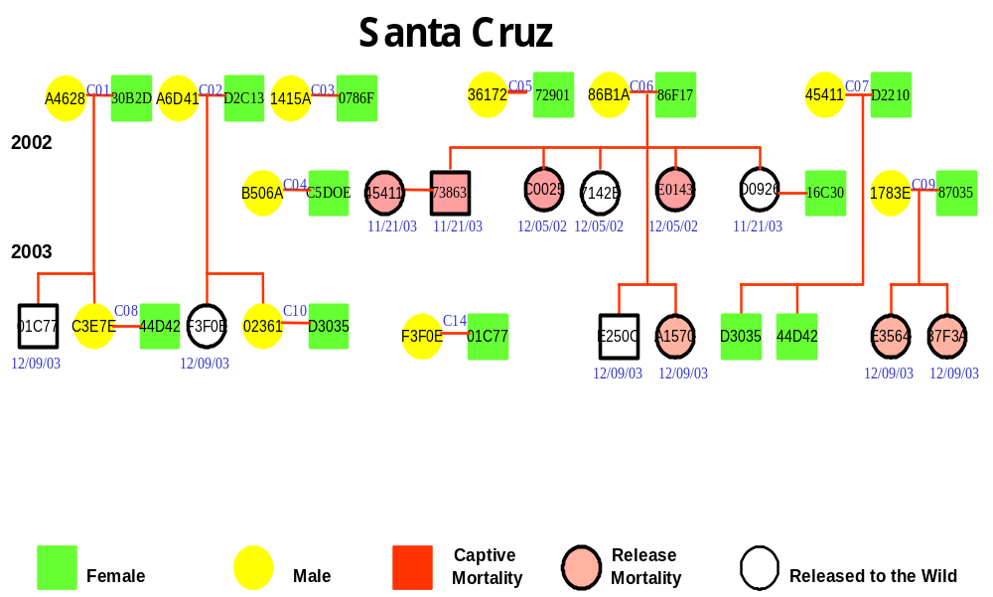
Figure 10. Breeding and pedigree chart for Santa Cruz Island foxes.

Table 15. Island foxes in captive breeding facility on Santa Cruz Island.
Pen | ID | Sex | Age | Born | Sire | Dam | Date Captured | Capture Area
C01 | A4628 | M | 7 | Wild |  |  | 3/11/2002 | Islay Canyon
 | 30B2D | F | 5 | Wild |  |  | 2/27/2002 | Cebada Canyon
C02 | A6D41 | M | 4 | Wild |  |  | 2/27/2002 | Sauces Canyon
 | D2C13 | F | 4 | Wild |  |  | 2/27/2002 | Prisoner's Marsh
C03 | 0786F | F | 6 | Wild |  |  | 3/2/2002 | China Pines
 | 1415A | M | 4 | Wild |  |  | 3/3/2002 | China Pines
C04 | B506A | M | 4 | Wild |  |  | 1/15/2003 | Isthmus
 | C5D0E | F | 4 | Wild |  |  | 1/15/2003 | Isthmus
C05 | 36172 | M | 5 | Wild |  |  | 2/27/2002 | Pelican Bay Trail
 | 72901 | F | 4 | Wild |  |  | 2/27/2002 | Prisoner's Canyon
C06 | 86B1A | M | 4 | Wild |  |  | 2/27/2002 | Pozo Canyon
 | 86F17 | F | 4 | Wild |  |  | 3/10/2002 | Pozo
C07 | D2210 | F | 3 | Wild |  |  | 3/11/2002 | Cebada Canyon
 | 45411 | M | 4 | Wild |  |  | 3/1/2002 | China Pines
C08 | 44D52 | F | 1 | Captive | 45411 | D2210
 | C3E7E | M | 1 | Captive | A4628 | 30B2D
C09 | 1783E | M | 7 | Wild |  |  | 12/4/2002 | Coches Prietos
 | 87035 | F | 6 | Wild |  |  | 12/4/2002 | Coches Prietos
C10 | D3035 | F | 1 | Captive | 45411 | D2210
 | 02361 | M | 1 | Captive | A6D41 | D2C13
C13 | D0926 | M | 2 | Captive | 86B1A | 86F17
C14 | 16C30 | F | 3 | Wild |  |  | 6/6/2002 | Isthmus Pen Site
 | F3F0E | M | 1 | Captive | A6D41 | D2C13
C15 | E250C | F | 1 | Captive | 86B1A | 86F17
 | 01C77 | F | 1 | Captive | A4628 | 30B2D
¹in years, as of fall 2003

