Kaloko-Honokōhau National Historical Park

Fire Management Plan

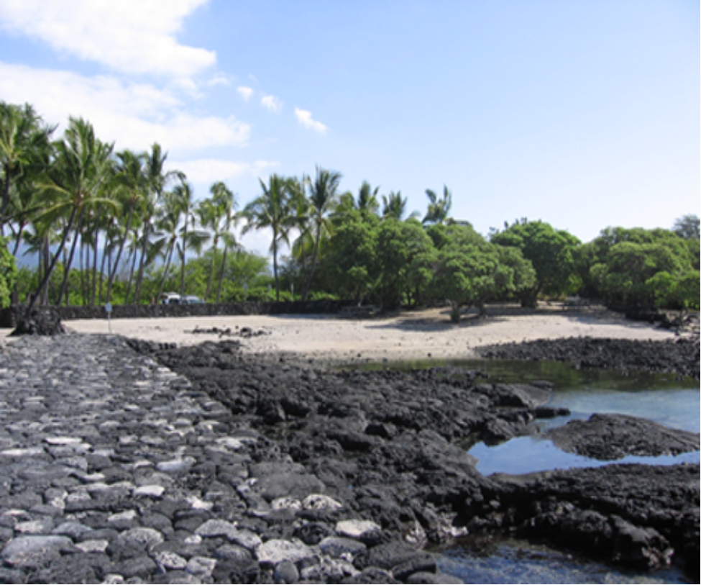

May

2008

TABLE OF CONTENTS

I. INTRODUCTION 3

II. RELATIONSHIP TO LAND MANAGEMENT PLANNING/FIRE POLICY 6

III. WILDLAND FIRE MANAGEMENT 8
A. General Management Considerations 8 Collaboration
Priority Setting
Accountability

B. Wildland Fire Management Goals 8

- Wildland Fire Management Options 9
Wildland Fire Suppression
Wildland Fire Use
Prescribed Fire
Non-Fire Applications

D. Descriptions of Wildland Fire Management Strategies by Fire Management Units 10
Fire History
Fire Regime-Wildland Fuel Alteration
Range of Potential Fire Behavior
Fire Management Unit Characteristics
Fire Management Unit Objectives
Operational Considerations with Implementation

IV. Wildland Fire Management Program Components 13
A. Wildland Fire Suppression 13 Safety
Wildland Fuel Management
Fire Prevention/Education Activities
Annual Fire Training and Qualifications Fire Season
Readiness of Personnel, Equipment and Supplies
Step-Up Staffing Plan Initial Attack
Extended Attack
Aviation Management

B. Wildland Fire Use 22

- Prescribed Fire 22
Prescribed Fire Planning
NPS Prescribed Fire Burn Plan
Approval Authority
Prescribed Fire Operations
Prescribed Fire Evaluations
Exceeding Prescribed Fire Burn Plan Parameters
Air Quality and Smoke Management

- Non-Fire Fuel Applications 26

- Emergency Rehabilitation and Restoration 26
Suppression Damage Repair
Burned Area Emergency Rehabilitation
Emergency Stabilization
Restoration

V. Fire Management Organization and Budget 28
VI. Monitoring and Evaluation 31
VII. References 33

VIII. Glossary 34

Tables 36
Table 1. Fire Behavior Potential
Table 2. Annual Fire Management Reports-Records

Exhibits
Exhibit 1 – Wildland Fire Management Policy
Exhibit 2 – Wildland Fire Situation Analysis (WFSA)
Exhibit 3 – Cooperative Agreement (NPS-HCFD)
Exhibit 4 – Delegation of Authority Letter (Sample)
Exhibit 5 – MIST Guidelines
Exhibit 6 – NPS Prescribed Burn Plan
Exhibit 7 – Fire Management Organizational Chart
I. INTRODUCTION

The purpose of this plan is to develop the park’s fire management program to better protect human life, property, cultural resources; and to protect, maintain or restore natural resources. This plan will serve as (1) programmatic direction for all fire management activities, and (2) the basis for future funding, particularly for the use of prescribed fire and fuels treatments.

Under the direction of Director’s Order 18, parks are required to complete and review annually a park-specific Fire Management Plan (FMP). National Park Service Director’s Order 18 states: “each park with vegetation capable of carrying fire to prepare a fire management plan to guide a fire management program that is responsive to the park’s natural and cultural resource objectives and to safety considerations for park visitor, employees, and developed facilities. Alternatives to be implemented will be described in detail in a draft Fire Management Plan. The Environmental Assessment developed in support of the fire management plan will consider effects on air quality, water quality, health and safety, and natural and cultural resource management objectives.”

An Environmental Assessment (EA) has been prepared to evaluate and provide public input to the wildland fire management program at Kaloko-Honokōhau National Historical Park (NHP). The Environmental Assessment, required by the National Environmental Policy Act (NEPA), outlines the different alternatives that will be considered in the park’s Fire Management Plan. The EA compared issues, concerns, resource effects and environmental impacts associated with three fire management alternatives for this NHP. The three alternatives were:

- Alternative 1-No Action. The park would continue the fire management program that exists today, which is immediate suppression of all wildfire without an approved Fire Management Plan (FMP). This Alternative was not a viable choice since it did not provide for the required approved FMP. The existing impacts of Alternative 1, No Action, sets a baseline of existing impacts continued into the future against which to compare the impacts of Alternatives 2 and 3.
- Alternative 2-Minimum Management Action. This alternative includes the completion of an approved Fire Management Plan as required by Director’s Order #18. This alternative also includes the suppression of all natural and human ignited wildfires.
- Alternative 3-Proposed Action. This alternative includes the completion of an approved Fire Management Plan as required by Director’s Order #18. This alternative also includes the suppression of all natural and unplanned human ignited fires. Prescribed fire will be limited to the use of a hand held propane torch for point application removal of invasive, non-native pickleweed surrounding wetlands, anchialine ponds, and coastal beach strand.

The alternative selected that best met resource management objectives while also protecting life and property was the third alternative. It includes the limited use of prescribed fire for the reduction of invasive non-native pickleweed.

This FMP also meets the requirements of the National Historical Preservation Act (NHPA). The assessment of wildfire, suppression, and prescribed fire related effects to cultural resources were addressed in the EA.
The EA did not address all possible actions. For example, Alternative 3, Preferred Action, allows for prescribed burning of pickleweed, but it does not allow for prescribed burning of other alien plant species. Expanding the use of prescribed fire that is not analyzed in this document may require additional NEPA compliance. Section 106 compliance to NHPA will also be conducted for all affected cultural resources.

This plan formally documents the Kaloko-Honokōhau NHP (KAHO) fire program and will help to achieve the goals and objectives described in park management documents. The development of this plan and EA has been a collaborative interdisciplinary effort including Park resource specialist and consultants.

Strategies and activities outlined in this FMP utilize a variety of Federal and USDI Departmental authorities derived from various legislative acts and laws:
- The Organic Act of August 25, 1916, Section 102, established the National Park Service (NPS) and defined the purpose of the agency as “to conserve the scenery and the natural and historic objects and the wildlife therein and to provide for the enjoyment of the same in such manner and by such means as will leave them unimpaired for the enjoyment of future generations."
- National Trust Act of March 27, 1978 (P.L. 96-250) in which “Congress declares that …… the protection, management, and administration of ……(the National Parks)… shall be conducted in light of the high public value and integrity of the National Park System and shall not be exercised in derogation of the values and purposes for which these various areas have been established, except as … directly and specifically provided by Congress.”

The authority for FIREPRO funding (Normal Fire Year Programming) and all emergency fire accounts is found in the following authorities:
- Section 102 of the General Provisions of the Department of Interior's annual Appropriations Bill provides the authority under which appropriated monies can be expended or transferred to fund expenditures arising from the emergency prevention and suppression of wildland fire.
- Public Law 101-121, Department of the Interior and Related Agencies Appropriation Act of 1990 - established the funding mechanism for normal year expenditures of funds for fire management purposes.
- 31 USC 665 (E) (1) (B) - provides the authority to exceed appropriations due to wildland fire management activities involving the safety of human life and protection of property.

Authorities for procurement and administrative activities necessary to support wildland fire suppression missions are contained in the Interagency Incident Business Management Handbook.

Authority for interagency agreements is found in "Interagency Agreement between the Bureau of Land Management, Bureau of Indian Affairs, National Park Service, U.S. Fish and Wildlife Service of the United States Department of the Interior and the Forest Service of the United States Department of Agriculture" (1982).

Authorities to enter into agreements with state, county, and municipal governments; and with private companies, groups, corporations, and individuals are cited in NPS-20 (Federal Assistance and Interagency Agreements).

Authority for rendering emergency fire or rescue assistance outside the National Park System is covered by the Act of August 8, 1953 (16 USC 1b(1) and the Departmental Manual (910 DM).

II RELATIONSHIP TO LAND MANAGEMENT PLANNING/FIRE POLICY

Legislation establishing the National Park Service and Kaloko-Honokōhau NHP defines the broad purpose of the park.

The 1916 Organic Act (16 USC 1) establishing the National Park Service states that the purpose of the national parks is “to conserve the scenery and the natural and historic objects and the wildlife therein and to provide for the enjoyment of the same in such manner and by such means as will leave them unimpaired for the enjoyment of future generations.”

Kaloko-Honokōhau National Historical Park (Kaloko-Honokōhau) is located on the western coast of the island of Hawaii near the town of Kailua-Kona. The 1160-acre Park was established as a National Historical Park in 1978, in order to, according to the enabling legislation for Kaloko Honokohau, “...provide a center for the preservation, interpretation, and perpetuation of traditional native Hawaiian activities and culture, and to demonstrate historic land use patterns as well as to provide a needed resource for the education, enjoyment, and appreciation of such traditional native Hawaiian activities and culture by local residents and visitors….” (16 USC Chapter 1, Subchapter XLII-A, § 396d-f).

Kaloko-Honokōhau is the site of an ancient Hawaiian settlement, and as such, the Park contains an abundance of cultural and historic resources, including Kaloko Fishpond (an example of pre-western contact native Hawaiian engineering and technological achievements), Pu’u’oina Heiau (an example of a platform temple), grave features, trails, and other archeological sites. Native Hawaiians are also free to use Kaloko-Honokōhau for unplanned ceremonies and cultural events throughout the year, including celebrating the festivities associated with Makahiki, a designated period of time at the end of the harvesting season observed by Hawaiians with ceremonies, festive events, and sporting competitions.

Kaloko-Honokōhau also contains important natural resources. In particular, numerous wetlands exist within the boundaries of the Park, and some of these are considered among the most productive endangered waterbird wetlands on Hawaii Island (Morin 1998). In addition to serving as important bird habitat, Kaloko-Honokōhau also provides habitat for various other wildlife, including marine wildlife and including species listed as threatened or endangered

The Park contains a wealth of cultural and historic resources that together, serve to re-create the atmosphere of Hawaiian life prior to contact with Western civilization in 1778. In particular, Kaloko-Honokōhau NHP preserves a complex of archeological sites, including temple and house platforms, fishponds, and coastal village sites.

Although the Park was created largely to preserve the cultural/archeological history it illustrates, there are also notable natural resources. Habitat exists for many wildlife species, including native species and those species considered threatened and endangered.

The General Management Plan for Kaloko-Honokōhau NHP identified four major cultural resource management issues and five major natural resource management issues.

The four major cultural resource management issues are:
- The identification and inventory of archaeological resources.
- The identification and protection of cultural resources.
- The preservation and stabilization of major archaeological resources.
- The restoration and traditional use of selected cultural resources.

The five major natural resource management issues are:
- The protection of anchialine pond resources.
- Endangered water bird habitat restoration and monitoring.
- The protection of sensitive species other than water birds.
- Vegetation restoration and management.
- Understanding and managing human impacts on marine resources.

The FMP is a detailed Action Plan of strategies and actions intended to provide programmatic direction for the effective management of wildland and prescribed fire for Kaloko-Honokōhau National Historical Park. It is in accordance with the Federal Wildland Fire Management Policy and Program Review (USDA/USDI 1995 and 2001) which recommends that: Fire, as a critical, natural process will be integrated into land and resource management plans and activities on a landscape scale, across agency boundaries and will be based upon best available science. All use of fire for resource management requires a formal prescription. Management actions taken on wildland fires will be consistent with approved Fire Management Plans.
The FMP will serve as the implementation document to help achieve historic vegetational landscape management objectives, and fire protection goals defined in the General Management Plan, and/or other approved management plans for this site. It also recognizes that the use of prescribed fire appears to be beneficial for the reduction of pickleweed.

The FMP is also designed to promote agency standardization, represent continued interagency cooperation, and serve as a reference and guidance for personnel, consistent with the Federal Wildland Fire Management Policy and Program Review.

Development and maintenance of this FMP involves a dynamic and interdisciplinary process that considers existing and future land use, cultural and natural resource values, and public concerns. However, the FMP should be updated when changing conditions on this historic site significantly influence the implementation of fire management strategies presented in this plan or when the GMP is changed.
III WILDLAND FIRE MANAGEMENT

A. General Management Considerations

Fire management goals, strategies, and potential impacts need to be evaluated in the context of park purpose. Park purpose is based on the enabling legislation that created Kaloko-Honokōhau National Historical Park and other federal laws that affect management of the park. On-the-ground guidance for implementing these laws is provided by National Park Service Management Policies (2001) and Kaloko-Honokōhau National Historical Park resource management goals and strategies. KAHO will follow the core principles described in the 10-year Comprehensive Strategy of the Interagency National Fire Plan:

Collaboration: Kaloko-Honokōhau National Historical Park will continue to strengthen its partnerships with local, state, and federal cooperators on and adjacent to the unit. KAHO will continue to provide assistance and direction to local fire departments and fire safe councils by reviewing grant and Rural Fire Assistance applications and pursuing approval of such grants for the purpose of reducing fuel loading in and adjacent to their communities and providing protection for their communities. KAHO will continue to develop agreements and operating plans to facilitate mutual cooperation in detection, prevention, training and suppression activities.

Priority Setting: KAHO, as directed by the National Fire Plan, will continue to prioritize fuel treatment and restoration projects in an interdisciplinary forum. The National Fire Danger Rating System (NFDRS) utilizes fire weather and fire history to produce fire danger indices (Energy Release Component) to assist managers in assessing risk and conducting fire business.

Accountability: Kaloko-Honokōhau National Historical Park will maintain, establish and employ cost effective measures, standards, reporting processes and budget information in implementation plans, FIREPRO (National Park Service wildland fire disciplines planning and budgeting program), FPA (2006), National Fire Plan Operations Reporting System (NFPORS), Wildland Fire Situation Analysis (WFSA) and Wildland Fire Implementation Plans (WFIP).

B. Wildland Fire Management Goals
The goals for fire management in Kaloko-Honokōhau National Historical Park are consistent with park management documents, regional and national direction. The following are fire management goals that will guide fire management actions throughout the park:
- Firefighter safety is the highest priority of every fire management activity.
- Suppress all wildland fires regardless of ignition source to protect the public, private property, natural, cultural and historic resources of the unit.
- Utilize suppression methods/tactics least damaging to resources and the environment.
- Use prescribed fire where and when appropriate as a tool to meet resource objectives within the unit.
- Maintain the highest standards of professional and technical expertise in planning and safely implementing an effective wildland fire management program.
- Fire personnel will be equipped with personal protective equipment appropriate to incident assignment.
- All NPS employees assigned to wildland fire incidents, or used with prescribed fire, will meet training and qualification standards for that position, set by the National Wildfire Coordinating Group (NWCG 310-1).
- Mutual aid cooperators, responding to NPS fires under Memoranda of Agreement, will meet their respective personal protective equipment and qualifications during initial action operations. However, during project fire or extended operations, cooperators will meet NWCG qualification standards.
- Educate employees and the public about the scope and effect of wildland fire management, including fuels management and resource protection.
- Integrate fire management with all other aspects of park management.

C. Wildland Fire Management Options
The Kaloko-Honokōhau National Historical Park wildland fire policy is to conduct wildland fire actions in a timely, effective and efficient manner with the highest regard for firefighter and public safety. Every wildland fire requires an appropriate management response based on management direction. Wildland and prescribed fire are used whenever appropriate as tools to achieve resource management objectives. All fires not ignited by managers for specific purposes are considered wildland fires.

Wildland Fire Suppression
Suppression management response will be initiated on all wildland fires that occur within or enter the Kaloko-Honokōhau NHP. All human caused fires will receive a suppression response commensurate with values-to-be-protected, firefighter and public safety, and cost efficiency.

Wildland Fire Use
Wildland Fire Use is the management of naturally ignited wildland fires to accomplish specific pre-stated resource management objectives in predefined geographic areas outlined in the FMP. Due to the size of this NHP, the amount (loading) of biomass accumulation that could cause damage to cultural resources and NPS facilities, and historical data that indicates this geographic area does not appear to have naturally ignited occurrences, this fire management response is not considered appropriate for this unit. All wildland fires will be suppressed using appropriate management response.

Prescribed Fire

Prescribed fires are intentionally ignited under predetermined environmental parameters to accomplish various resource management objectives. All prescription parameters, actions, and measurable objectives are stated in a project burn plan, approved by the superintendent prior to ignition. At Kaloko-Honokōhau NHP, prescribed fire will be limited to the use of a hand held propane torch for point application removal of invasive, non-native pickleweed surrounding wetlands, anchialine ponds, and coastal beach strand.

Non-Fire Applications
Non-fire applications, including hand treatments, and chemical applications can be used to meet hazardous fuel treatments or restoration goals. Although costs can be considerably more, it is generally more successful and greater control of risk factors can be achieved.

D. Descriptions of Wildland Fire Management Strategies by Fire Management Units
A Fire Management Unit (FMU) is “a unique land management area defined by land objectives, topographic features, values to be protected, political boundaries, fuel types, or major fire regimes.”

Kaloko-Honokōhau NHP will be treated as one FMU. The size, vegetation, wildland fuel concerns, management goals, and suggested fire management strategies/activities in this FMP are applicable for the entire unit.

Fire History
No wildland fires have been recorded in this park since its establishment in 1978. Prior to that date, fire history can only be speculated.

In the past the park has used hand held torches to singe the pickleweed which causes die back of the plant. Regrowth is repeatedly treated with fire until the plant eventually dies and the roots decay. This method of control has shown positive results in the reduction of pickleweed.

Fire Regime – Wildland Fuel Alteration
Today’s wildland environment at Kaloko-Honokōhau NHP continues its adaptation with the potential of more frequent, low – moderate intensity surface fires. With the onset of Western Civilization, native flora has gradually given way to a more fire climax community of exotic vegetation supporting increased fuel loads and flammability. Today’s fuel situation has a greater biomass (loading) of both fine size and larger size fuels which are more easily ignited, quickly develop heat intensity and facilitate quick rates of spread.

There is concern that with increased alien and shrub fuels over the park’s landscape and with increased visitor use, fire occurrence may increase. Some of the established hiking trails pass through areas primarily occupied by the more flammable alien grasses and shrubs than native flora. The park is more “fire prone” than in the past.

Range of Potential Fire Behavior
The climate referenced in this plan and wildland fuels described in this plan, present a fire environment that can be a threat for public safety and a concern with achievement of overall management goals/objectives. More recent fires in/near other NPS sites on the west side of the Island of Hawaii in these flashy fuels have exhibited rates of spread and fire behavior similar to Fire Behavior Fuel Model 3 (heavy loading of grass fuels). See Table 1.

Fire Management Unit Characteristics

Location:
Kaloko-Honokōhau NHP is located on the west side of the Island of Hawaii, along the Kona Coast, approximately two miles south of the Keahole Airport.

Climate:
A warm sub-tropical weather pattern is common for the area, with periodic rains and periods of drought. Clouds that do form inland usually disperse before they reach the park.

Mean annual temperature is about 80 degrees Fahrenheit. Summer temperatures are slightly higher. Annual precipitation at the airport averages near 20 inches. Average daily minimum and maximum relative humidity ranges from 44% in November to 87% in July.

Adjacent Land Pattern:
The town of Kailua Kona lies approximately three miles south of the park. The area in between is primarily industrial development. North of the park is sparsely populated and currently used primarily for recreational activities associated with the Kona coastline. The area will soon be developed into a golf course and luxury homes. The eastern boundary of the park coincides with Highway 19. Coastal access is via the Honokohau Harbor parking area, located at the park’s southern boundary, and eventually from Highway 19 which is still under development. Honokohau Harbor is planning for future expansion and development.

Fire Management Unit Objectives
Objectives identified by/for the Kaloko-Honokōhau NHP Fire Management Unit are:
- Protect human life and property both within and adjacent to park area.
- Perpetuate or recreate the natural scene that characterized landscape during the time it was once a thriving Hawaiian settlement. The natural scene will be regarded as the species composition, distribution and pattern of vegetation present during that time span.
- Protect all cultural and natural resources at Kaloko-Honokōhau NHP and intrinsic values from unacceptable impacts that could result from fire management activities.
- Suppression of all wildland fires. Implement suppression strategies/tactics that result in minimal or no cultural and resource damage, minimize costs, consistent with values at risk.
- Mitigate and/or rehabilitate human-induced impacts to resources or natural processes caused during wildfire or suppression activities.
- Promote an interagency approach to managing wildland fires on an ecosystem basis.
- Promote public understanding of fire management programs and objectives.
- Prevent human caused ignitions.
- Organize and maintain a fire management program capability that consistently applies the highest standards of professional and technical expertise.
- Encourage research to advance understanding of fire behavior, effects, ecology, and management.
- Integrate fire management with all other aspects of park management.

Operational Considerations with Implementation
The impacts of wildfire and suppression activities on people, property, and resources were analyzed through an EA. Implementation of this Fire Management Plan will be consistent with the findings of the accompanying EA.

IV. Wildland Fire Management Program Components

Based on recent ecological and historical surveys it is concluded that only careful use of fire would re-create the desired effects within the park. It is estimated that a majority of plant species now present were probably introduced since 1830. The indigenous species that remain in the park contribute insignificantly to the overall species composition and total plant occurrence. These native species remain localized in occurrence to areas that are partially protected from human impact and most importantly, spread of wildland fire. It is felt that fire spread over an extensive area, would favor increased establishment of alien species and further lessen survival of native plants. Site-specific controlled use of fire could be beneficial for native species, however.

The existence of very flammable alien grass fuels and the concern for their expansion over the area, supports a need for an immediate suppression strategy as the only appropriate management response for all wildland fires at Kaloko-Honokōhau NHP. The concern for public safety (possible entrapment while on the hiking trail) further supports this appropriate management response.

A. Wildland Fire Suppression
Suppression management response will be initiated on all wildland fires that occur within or enter the Kaloko-Honokōhau NHP. However, suppression actions will follow the direction provided by the Federal Wildland Fire Management Policy, i.e. “fires are suppressed at minimum cost, considering firefighter and public safety, benefits, and values to be protected, consistent with resource objectives.”

This direction calls for prudent selection of tactics to achieve a suppression response with minimal cultural and natural resource damage caused from the suppression actions.

A suppression management response could vary from fire to fire and sometimes even along the perimeter of a fire. The level of suppression response intensity will always be a ‘control’ strategy. Fire danger is determined from the National Fire Danger Rating System (NFDR), which is determined daily from the fire weather forecast. An NFDRS remote weather station has been installed at Kaloko-Honokōhau NHP and will provide NFDRS indices in the near future. An accurate impression of existing fire danger can be determined based on weather data available from the station posted hourly.

All suppression actions will be done in accordance with policy, priorities, strategies and appropriate tactics outlined in this FMP and the findings of the EA.

Safety
Firefighting is an inherently dangerous occupation and requires the active involvement of all personnel to exercise due caution and participate in safety awareness. Prevention of injury is the overriding consideration during all operations. At no time will the protection of resources be placed before the safety of fire management personnel. The Fire Management Officer at Hawaii Volcanoes National Park outlines safety policy in general discussion in the Wildland Fire Operation Guide. This document advocates that all operations be carried out in accordance with safety practices as set by Reference Manuals 18, 58, and 60, the Fireline handbook (NWCG 410-1), and the Incident Response Pocket Guide (NWCG 1077).

Wildland Fuel Management
Major goal of the fuel management strategy is to achieve and maintain a fuel level that facilitates protection of life, property, natural and cultural resources, and helps establish a healthy ecosystem.

Management of wildland fuels is critical in terms of fire behavior and possible resource damage that could result from a wildland incident, and in achieving a particular species composition for ecosystem management or restoring the historic scene. The importance of intentionally managing the wildland fuels in order for a successful fire management program for this NHP is reiterated in DO – 18:
- NPS units will identify, manage, and reduce where appropriate, accumulations of hazardous fuels.
- NPS units will reduce, to the extent possible, hazardous fuels in wildland/urban interface. (This can be further interpolated to include NPS facilities, or developed sites within the NPS unit, or adjacent to the unit.)
- Prescribed fire and non-fire techniques are appropriate tools for reducing hazardous fuels.

A major change in wildland fuels existing today are non-native plants that have flourished, particularly kiawe or mesquite, ekoa and fountain grass. Fountain grass serves as the primary fine fuels for sustaining fire spread. These non-native species seem to dominate a majority of the park where there is favorable soil for plant establishment.

Both kiawe and ekoa have been observed to sprout vigorously after wildland fires that have occurred at other NPS sites. Fountain grass appears to be a vigorous post burn competitor. The growth form of this plant is a robust bunchgrass, which ultimately results in a high fine fuel loading, easily receptive for an ignition that can spread quickly with high heat intensity.

The possibility exists that, if left unchecked, these alien species will continue to expand their range throughout the park, thereby lessening the opportunity for restoration of native species.
The following fire management strategies will be taken to manage wildland fuels:
- Continue to reduce hazardous wildland fuels.
- Remove downed fuels/debris from the coconut groves and high visitor use areas and remove from park grounds.

These strategies support goals and objectives identified as overall management for this NHP. Their implementation is consistent with capabilities provided by the current management staff, occasional support from adjacent NPS units and mutual agreements with the Hawaii County Fire Department (Exhibit 3).

Fire Prevention/Education Activities

Prevention Workload Analysis
Periodically Kaloko-Honokōhau NHP should utilize the Prevention Workload Analysis (PWA) to identify potential ignition-causing situations that warrant corrective action and verify the most appropriate, cost effective wildland fire prevention activities to implement.

Normally the following components are the major considerations for a PWA:
- Risks - those uses or human activities that have the potential to result in a wildland fire ignition.
- Hazards - the fuels and topography of an area that have the potential for a “large” or “difficult to control” fire from a human-caused ignition.
- Values - natural, cultural or developed areas where loss or destructive effects by a wildland fire would be unacceptable.

After evaluating these components, it should be possible to determine where, when, and how to implement effective fire prevention activities.

It will be the responsibility of the Pacific Island Fire Management Officer (FMO) in coordination with the park’s Chief Ranger to perform an annual review of wildland fire causes and verify the effectiveness of the current programmatic prevention strategies. Activities can be included or deleted in the annual Fire Management Program, if deemed necessary.

Another reference to consult during this review is the NWCG Wildfire Prevention Strategies (1998).

The Kaloko-Honokōhau NHP Fire Management Program will attempt to use a cost effective mix of wildland fire prevention strategies (activities) within the broad categories of education, engineering, enforcement and administration.

A brief description of each category is:
- Education: Activities aimed at changing people’s behavior by awareness and knowledge.
- Engineering: Activities designed to shield an ignition source (e.g. spark arrester) or remove the fuel that ignites from a spark or fire brand (e.g. clearance around a home).
- Enforcement: Activities used to gain compliance with fire regulations and ordinances.
- Administration: Activities such as planning, budgeting and training.

The following suggestions are activities for consideration. Which activities to implement however should depend on results from a Wildland Fire Prevention Workload Analysis. This process is described later in this section.

Education
Educational activities will focus on educating park visitors and adjacent landowners about fire prevention regulations, appropriate prevention activities and current fire danger ratings using media, signs, and verbal contact.

Additionally, fire prevention education should also be focused toward park employees so it can be integrated into their jobs and appropriate fire prevention messages developed for properties adjacent to the Park.

Kaloko-Honokōhau NHP will continue, or initiate, wildland fire prevention efforts with the following cooperators or public(s):
- Use of signs, posters, and notices on bulletin boards as a means of public education. Fire awareness bulletins will be issued at fixed stations.
- Issuance of warnings to the public, particularly during periods of high fire danger, through contacts by rangers and public service announcements (radio).
- Display/distribute fire use information and wildfire prevention items at annual Community or County events.
- Display/distribute fire use information and wildfire prevention items jointly with local Interagency Fire Prevention Committee.
- Expand the annual wildland fire prevention program at schools to include fire use information and/or current data of recent prescribed burns & positive effects.

- Engineering/Maintenance
- Ensure equipment operators (or contractors) use fire prevention devices (i.e., spark arrestor) on all field equipment.
- Evaluate park structures for flammable construction materials and the need for hazardous wildland fuel reduction work.

- Administration
- Park employees incorporate fire prevention awareness as opportunities arise during dialogue with visitors, property owners, and cooperators.
- Ensure fire prevention awareness is included in dialogue with park neighbors.
- Chief Ranger and Pacific Island FMO jointly decide when wildland fuel conditions are such to warrant prohibiting open fires in the park and smoking on visitor trails.

Enforcement
- Continue to conduct routine patrols as means to inform and enforce regulations regarding campfires, smoking, etc., as appropriate.
- Conduct area closures when extreme fire danger warrants.

Annual Fire Training and Qualifications
Annually the Chief Ranger and Pacific Island FMO will:
- Maintain a list, identifying individuals currently qualified for both wildland fire suppression and prescribed fire positions, including the various support/overhead positions.
- Assess/prioritize training needs and personnel to attend.
- Ensure knowledgeable, quality individuals are used as instructors, even if there is the need to recruit from outside the agency.

The list of individuals qualified for various wildland fire/prescribed fire position(s), including support positions, will be coordinated annually with the Pacific Island Fire Management Officer.

The assessment of training needs will be coordinated with the Pacific Island FMO, along with recommendations for training schedule revisions when necessary. Efforts will be made to have personnel attend sessions presented by other agencies when none are available locally.

Qualifications
Kaloko-Honokōhau NHP Fire Management Program will follow the National Wildfire Coordinating Group (NWCG) Standards in determining qualifications for the various wildland and prescribed fire positions. Reference NWCG Publication 310-1 regarding requirements and qualifications for wildland and prescribed fire positions.

First year firefighters and all red-carded personnel will need to pass physical fitness requirements commensurate with their red card qualifications. Information about this requirement can be obtained from the Chief Ranger or Pacific Island FMO. Individuals who pass the fitness physical, are qualified to attend Basic Fire Behavior (S-190), Fire Suppression (S-130), Standards of Survival and the 8 hour annual Refresher Course. Basic knowledge of the Incident Command System (ICS) is also required.

All personnel involved in wildland and prescribed fire activity will be required to attend the 8 hour Refresher Course and perform the Work Capacity Test (WCT) annually.

Advancement Positions
Efforts will be made to assign individuals seeking the next higher incident or prescribed fire position, with others already qualified for that position. The intentions are to improve knowledge and performance based on training experiences. These efforts will be coordinated through the Western Region Coordinating Office.

Besides NWCG Courses/Sessions, the following training considerations will be assessed and conducted as needed:
- All Park staff trained in first aid and cardio-pulmonary resuscitation.
- One Day Preparedness Session for Chief Ranger, all “fire protection” employees, and County Fire Department cooperators. This session is for reviewing major parts of FMP, use of Wildland Fire Situation Analysis (WFSA), and location of electrical cutoffs, water main or hydrants. (Optional attendance for portions of the session by Superintendent and other Park employees.)
- "Minimum Impact Fire Suppression Tactics" Techniques (MIST) training for Chief Rangers and “fire protection” employees.
- Role and Responsibilities of Resource Advisor.

Resource Advisor
The Resource Advisor is an important fire incident position, especially with wildland fires that involve extended attack, or are using mechanized equipment. This person serves as the representative for the NPS Unit (Chief Ranger/Superintendent, depending on the complexity of the fire). He or she must meet regularly with the incident commander and/or the appropriate section unit leaders of the incident team, to assure that all natural/cultural resources and management concerns are adequately considered and protected during an incident.

The Chief Ranger and Pacific Island FMO will maintain a current list of persons qualified to serve as Resource Advisors. It should be reviewed/updated annually, and included in Mobilization Plans for the Pacific Islands.

Resource Advisors will be identified prior to the fire season, considering the following criteria:
- Training
- Broad resource background and experience
- Knowledge of the park’s archeological, natural, & cultural resources and management objectives
- Awareness of, and ability to communicate concept of appropriate management response and tactics
- Familiarity and preferably experience with wildland fire or use of prescribed fire
- Awareness of role and responsibility of a Resource Advisor
- Assertiveness

Fire Season
Fire season is regarded as year long. The existing amount of fine size wildland fuels, and the fact that drought periods can and have occurred anytime during a calendar year, provide a wildland situation where a fire start could ignite, quickly build heat intensity and spread any day of the year. The amount of moisture for this area (20 inches annual average rainfall), contributes to this possibility.

Readiness of Personnel, Equipment and Supplies
According to current Fire Management Program for the Pacific Islands, Kaloko-Honokōhau NHP is designated as a five person readiness fire cache. Annually, the Chief Ranger will conduct an inventory to ensure all necessary personal protective gear, tools, and items are in place to support a five person crew for immediate dispatch, for a wildland fire on-site or at another NPS unit. A check list of equipment/items expected to be in a fire cache for a five person crew is available from (or should be developed) by the Pacific Island FMO.

Individuals assigned to be members of this fire crew should also have their own “personal gear bag” packed and ready to take with them when a dispatch is received, i.e. extra clothing, personal medicine, hygiene items, etc. in the event an incident extends beyond the first burning period.

Since the park has a year round fire season, personnel, equipment and fire cache must be a constant state of readiness.

Equipment
Equipment purchased with Fire Management funds or assigned for that use will be used for fire protection purposes only, except in emergencies. All tools will be marked with red paint and kept separate from other utility tools. The Chief Ranger is responsible to ensure proper use and maintenance for all fire equipment.

Supplies
The Chief Ranger is responsible for maintaining perishable supplies such as rations and batteries in sufficient quantity at the fire cache.

Contract Equipment Agreements
Periodically throughout the year, a check should be performed on the automatic fire detection system, which is linked to the burglar alarm system. Likewise an inspection will be made to ensure that all fire extinguishers meet NFPA standards, are tested, and maintained according to the National Fire Code and manufacturer’s instructions. All park employees will be trained in the use of fire extinguishers.

Fire Weather and Fire Danger
The park installed a Remote Automated Weather Station (RAWS) in 2005 for daily observations or to determine the various indices in accordance with the National Fire Danger Rating System (NFDRS). The system is monitored daily by the Pacific Islands Fire Management Office.

Wildland Fire Detection
Due to size of the park and its visibility from nearby heavily traveled roadways, detection is provided by park employees, visitors or traveling public(s). Increased detection patrols may be warranted during extreme fire danger or heavily visited periods of time.

The receiving employee at the Park Headquarters will confirm the location and immediately call 911 and inform the Chief Ranger. The Chief Ranger will coordinate initial attack performed by the NHP crew; notify the local fire department(s) and Pacific Island FMO. The Chief Ranger may request additional support.

Step – Up Staffing Plan
Due to the small size of the park and staff, only a limited step-up plan can be initiated, therefore no formalized document outlining or authorizing step-by-step procedures to follow at each increasing level of fire danger was deemed necessary.

As fire danger increases, emphasis will proportionately be more toward either intensifying existing preparedness or prevention activities, or implementing additional measures. If the appropriate activities to implement extend beyond capabilities of existing park staff, measures will be pursued for emergency preparedness funding or personnel detail assignments from other NPS units. These measures will be coordinated through the Pacific Island FMO.

Initial Attack
Initial attack is immediate suppression response consistent with firefighter and public safety, and values to be protected. Emphasis should be for smallest acreage possible in order to lessen the population of undesired alien plants following the burn. Of equal importance is the need to emphasize use of minimum impact suppression tactics (MIST) to ensure protection of cultural and natural resource values. The priority for immediate initial attack throughout the park and these two points of emphasis are consistent with management goals of the park as reiterated in the legislation that established this site.

In some cases, confinement strategy maybe the most appropriate initial attack response tactic to maximize firefighter safety, and minimize suppression costs -- especially when suppression resources are critical or non-available. Another consideration are those areas of the park where threat of increased alien grasses during the post burn period is not a concern and cultural or archeological values are not threatened. In both situations above, suppression costs could be lessened. Ideally, such areas should be identified prior to implementation.

Management of all wildland fires will be conducted under the Incident Command System. When Hawai’i County Fire Department (HCFD) arrives, the park representative will establish a joint command. The park representative will inform HCFD of park priorities and will remain on-scene until demobilized, to ensure compliance with park policy. Park staff and the county will be responsible to the designated Park Incident Commander (IC). The IC will determine protection priorities, strategies, and suppression tactics to be used.

All park employees should remain constantly aware of the fire situation and location of electrical/telephone wiring or devices, hazardous materials, and park structures that could be threatened by the fire, and coordinate necessary precaution measures with the IC.

Throughout the life of an incident, an IC may be replaced by a more qualified person if fire behavior or incident complexity exceeds red carded abilities of the assigned IC.

Should a non red-carded person discover a fire, the person should call 911 and report the fire to the Chief Ranger’s Office immediately.

Twenty-four hours after the fire is declared controlled, a final check will be made before declaring the fire out. Subsequent checks may be warranted in the event that high fire danger conditions persist.

A cooperative agreement outlining working relationships between NPS and the HCFD exist and should be jointly reviewed annually, (Reference Exhibit 3). The Kailua-Kona Fire Station will most likely serve as first responder for wildland fires within the park.

Extended Attack
The Chief Ranger and Pacific Island FMO along with the Superintendent will determine the need for the management transition of an incident to a Type II or Type I Incident Management Team.

The objective of this process is to lessen the burden from the respective agency when an incident exceeds local management capabilities. Procedures for activation and implementation of an Incident Management Team are in the Western Region Mobilization Plan.

Preparation of a WFSA for an “extended attack” and/or large fire organization will be done as a means to evaluate & document the appropriate management response(s)/strategies to further manage the fire (Reference Exhibit 2). Follow WFSA procedures outlined in the Wildland and Prescribed Fire Management Policy Guide).

If fire spread and size exceed the management response outlined in the current WFSA, the WFSA needs revised to reflect this change and the management response that will be implemented.

It will be the responsibility of the Chief Ranger to initiate this document. The Park Superintendent is responsible for its approval, although this may be delegated in writing to another NPS person, if desired.

Enhanced resource values may be a collateral benefit of the planned action under the WFSA, but cannot be part of the objective of the management response.

Example letter of “Delegation of Authority” is listed in the Pacific Islands Mobilization Plan, and referenced in the Appendix of this FMP (Exhibit 4). These letters should be reviewed and verified annually by the Park Superintendent, Chief Ranger, and Pacific Island FMO.

The Park Superintendent is responsible for signing the Delegation of Authority Letter (Exhibit 4), although in most situations unless the incident is high complexity or involves a large size, this responsibility may be delegated to another NPS individual.

Aviation Management
The park does not have an aviation program and will not order the use of helicopter support during fire operations. Only a qualified helicopter operations manager can order aviation support. The Hawaii County Fire Department may utilize helicopter support during fire operations which will be governed by their policies, procedures and designated landing areas. Helicopters will not land in the park except for emergency landings. Should the need for a helicopter landing area arise for other than emergency purposes, prior approval must be obtained from the park superintendent and the designated area approved by a resource advisor or the chief of resource management and the chief ranger.

Wetlands and natural water resources, such as anchialine ponds, within the park will not be used for helicopter bucket operations or as a source of water for fire suppression.

B. Wildland Fire Use
Due to the size of this NHP, the amount (loading) of biomass accumulation that could cause damage to cultural resources and NPS facilities, and historical data that indicates this geographic area does not appear to have naturally ignited occurrences, this fire management response is not considered appropriate for this unit. All wildland fires will be suppressed using appropriate management response.

C. Prescribed Fire

Prescribed fires are intentionally ignited under predetermined environmental parameters to accomplish various resource management objectives. All prescription parameters, actions, and measurable objectives are stated in a project burn plan, approved by the superintendent prior to ignition. At Kaloko-Honokōhau NHP, prescribed fire will be limited to the use of a hand held propane torch for point application removal of invasive, non-native pickleweed surrounding wetlands, anchialine ponds, and coastal beach strand.

Prescribed Fire Planning
A prescribed burn activity can be proposed by any resource manager or specialist. A proposal should contain, as a minimum, the objective and future conditions desired from the burn. This information is essential to assist in the development of an appropriate burning prescription and professional burn plan.

The Pacific Island Fire Management Officer (FMO) will assist with preparation of a prescribed burn plan and recommend a Prescribed Burn Boss. Together they should conduct a field reconnaissance of the proposed burn site(s) with appropriate managers and specialists to verify project objectives, identify specific concerns, assess effects, and develop appropriate implementation procedures.

Planning and execution of prescribed fires will be funded from the benefiting function. Only persons meeting NWCG Prescribed Fire qualification standards will be used as prescribed burn personnel. Training of personnel to meet qualifications required for prescribed fire can be funded from fire and/or project funds.

NPS Prescribed Fire Burn Plan
All elements identified in the current NPS Prescribed Burn Plan (Exhibit 6) will be addressed for each prescribed burn project. However to what extent each element needs to be addressed depends on the objectives to be accomplished and the complexity of the burn.

A prescribed fire burn plan will contain, as a minimum the following elements:
- Description of the Prescribed Burn Area, including map.
- Goals and Objectives, identifying purpose of the burn, resource management goals, and specific objectives to be achieved stated in measurable terms.
- Range of Acceptable Results Expected, expressed in quantifiable terms.
- Project Assessment, identifying both (a) level of complexity and (b) risk assessment; (as a minimum, consider all risk and complexity elements described in the Wildland and Prescribed Fire Policy Guide, page 43).
- Organization, a brief outline of the prescribed fire positions for the burn project, skills-knowledge level of the positions, and who will serve in those positions.
- Prescribed Fire Implementation Actions. Actions as (a) pre-burn consideration, on-and off-site, (b) briefing, (c) test fire, (d) prescribed fire prescription, including environment and fire behavior parameters, (e) special conditions, public and personal safety, (f) burn organization, (g) ignition operation, and (h) holding provisions.
- Cooperation. Listing provisions for interagency and intra-agency coordination, public involvement, and burn-day notification.
- Contingency. Identifying actions if prescription parameters are exceeded and the fire cannot be returned to prescription within projected funds.
- Funding. Stating source of funding for the burn project and estimated costs.
- Smoke Management and Air Quality. Describing how the project will comply with the various air quality regulations pertinent for the area affected by the burn.
- Monitoring. Provisions and/or documentation to ensure project is implemented within prescription parameters, and adequate information is acquired to facilitate short-term and long-term evaluation.
- Post-Burn Activities. Provisions for post burn evaluations. It needs to be emphasized that to evaluate some project objectives, pre-burn data may be necessary.

Approval Authority
According to national policy the Superintendent will ensure that prescribed burn plans and the personnel executing them meet minimum National and Regional requirements.

The Superintendent is the approving officer of a prescribed burn plan(s), however this authority may be delegated to an assistant or the FMO pending the complexity of the prescribed fire project. The burn plan should have Regional FMO or peer review prior to approval.

Prescribed Fire Operations
All prescribed fires will have an approved NPS Prescribed Burn Plan which addresses specifically the objectives, burning prescription, procedures and standards that will be followed in conducting the prescribed burn.

Personnel involved in the project must meet the skills/knowledge level determined by the complexity of the burn, and the fitness level for the prescribed burning position they are performing.

The size and qualifications of the prescribed burn team will be established in the burning plan. All members must meet current qualification standards. If qualified individuals are not available at the local area at the time of project implementation, a resource order for qualified individuals will be made. These individuals must be available on site, before the project is implemented.

Prior to ignition, the designated Prescribed Burn Boss will verify that all pre-burn considerations outlined in the burn plan are completed. This person will also conduct a briefing with the crew regarding project objectives, burning parameters/prescription, ignition instruction, communications, job hazard analysis and safety considerations.

Twenty four hours prior to ignition of the prescribed burn the designated Burn Boss will notify the media and other local and State contacts listed in the burn plan with the following information:
  - location
  - purpose of burn
  - type of burn
  - number of acres
  - number of resources used
  - any anticipated concerns/needs for resources

All prescribed fires will be carried out in strict compliance with the approved Prescribed Fire Burn Plan.

Prescribed Fire Evaluations
All prescribed fires will be evaluated to determine if objectives were met. The extent of this evaluation depends on the sensitivity of the objectives to be accomplished. The evaluation process could range from pre/post photo points to more extensive data-gathering methods as outlined in the NWCG Prescribed Fire Monitoring Handbook.

Exceeding Prescribed Fire Burn Plan Parameters
Prescribed burns that exceed prescription parameters outlined in the approved burn plan and cannot be brought back into prescription within the budgeted project cost, will need to be managed in the suppression response. A WFSA will be initiated to determine the appropriate suppression strategy and tactics to use (Reference Exhibit 2). Follow WFSA procedures outlined in the Wildland and Prescribed Fire Management Policy Guide.

Fire suppression actions will follow the concepts/strategies described in the Fire Suppression sections of this FMP.

Air Quality and Smoke Management

The park is a Class Il airshed under the Clean Air Act. Air quality is an important resource in the park however it is often influenced by natural pollutants dependant on wind patterns. Trade winds are the prevailing winds in Hawaii, except for the Kona coast of Hawai’i Island. The leeward, or Kona Coast, is protected from the trade winds by Mauna Loa, Mauna Kea, and Hualalai mountains. Kaloko-Honokōhau National Historical Park is located at the leeward slope of Hualalai volcano, and is effectively blocked from the trade winds. The Kona coast is reliant on the diurnal sea and air circulation system that drives wind flow down slope and offshore from early evening to late morning, and upslope from late morning to early evening (Atlas of Hawaii, 1998). The active volcano, Kilauea, located on the southeast portion of Hawai’i Island, produces gases locally called “vog” (a combination of “volcano” and “fog”). Halemaumau, located within Kilauea crater and Pu’u ‘O’o, on the East Rift of Kilauea emit particulates. Lava entering the ocean produces very large quantities of sulfur dioxide and sulfate particulates. Vog is carried by the trade winds over the south end of the island and becomes trapped in the leeward/Kona area. The diurnal wind pattern is not sufficient to clear the air of vog. The presence of vog, or particulates, gasses and fumes produced by the active volcano, Kilauea, will also be analyzed on site through the Burn Plan. Unacceptable impacts on air quality will halt burning activities until favorable conditions prevail.

There is concern that smoke may impair visibility on access roads to/from or within the park or State Highway 19 during wildland fires. Hawai’i County Police will be notified of the possibility to assist with traffic control in order to prevent accidents due to poor visibility.

Federal, State and Local Air Quality plans/ordinances will be consulted during development of prescribed fire projects. These plans should serve as the basis to assess concerns and identify appropriate mitigating procedures to implement. These concerns and intended mitigating measures will need to be included in the prescribed burn plan.

D. Non-Fire Fuel Applications
At Kaloko-Honokōhau NHP, burnable biomass and fuels are manually and chemically removed. Exotic grasses and shrubs are treated with non-restricted use herbicide and stumps of larger shrubs and trees are treated and left in place to decay. Downed debris from trees are regularly removed by hand from high visitor use areas. The waste/burnable fuel is hauled out by a local contractor.

Herbicide and hand clearing is expected to be used to help control populations of alien plants as a part of the exotic plant eradication program and hazardous fuel reduction.

Planning, programming and budgeting for these projects will utilize appropriate project forms and procedure for approval prior to implementation.

Monitoring of pre and post project conditions and costs will be documented for overall program evaluation and future planning.

E. Emergency Rehabilitation and Restoration
Rehabilitation actions need to be considered with every fire management activity. The following sections apply to the short and long term rehabilitation guidelines and procedures for impacts caused by (1) fire suppression activities and (2), the wildland fire. The policy related to Burned Area Emergency Rehabilitation (BAER) is found in DM 620, Part 3 and the interagency guidebook. There are four components to the emergency stabilization and rehabilitation program. All rehabilitation and restoration will be conducted in accordance with Department and Agency policy and will be coordinated through Resource Advisors and Park Staff.

Suppression Damage Repair
Assess and implement actions to rehabilitate cultural, natural resource or environmental damage caused by suppression activities. The primary purpose is to leave the fire suppression damaged area(s) as natural appearing as possible.

Initiate implementation of these fire suppression rehabilitation actions while fire suppression crews, equipment, and resources are still on the site and is the responsibility of the IC. These actions are appropriately financed from emergency operation funds.

Burned Area Emergency Rehabilitation
Refer to the USDI-NPS Burned Area Emergency Rehabilitation (BAER) Handbook for appropriate planning, financing, and implementing this wildland fire rehabilitation activity. These funds are designed to repair damage to resources caused by the fire, generally 1-3 years following the fire and are the responsibility of the Agency Administrator. Topography at Kaloko-Honokōhau NHP is such that major erosion after fires is not expected to be a problem. Natural re-vegetation is desired and has been allowed to occur. Natural regeneration of ground cover after fires has been satisfactory to ensure adequate protection of soils, although some are undesired alien species. Special consideration needs to be taken for burned areas. Appropriate mitigating measures, including possible seeding, may be necessary to ensure control of undesired plants do not occur.

Emergency Stabilization
These are emergency actions to protect life and property from post-fire events, generally 1-12 months following the fire. It is the responsibility of the Agency Administrator to acquire funding and implement an emergency stabilization program.

Restoration
Restoration activities are long-term ecosystem restoration actions to mitigate impacts from the fire and are generally conducted 3 or more years after the fire. It is the Agency Administrator’s responsibility to implement restoration programs and is funded out of the regular program.
V. Fire Management Organization And budget

The staff at Kaloko-Honokōhau NHP consists of eleven full time equivalent (F.T.E.) positions. Together they coordinate and fulfill the various roles and responsibilities associated with the programs and activities to accomplish the park goals/objectives.

Firefighters are park employees that have collateral duties.

The park staff works closely with the County Fire Department(s) for suppressions of all wildland fires within the park. A cooperative agreement exist between the National Park Service and the County Fire Departments of Hawai’i (Reference Exhibit 3).

In a wildfire suppression, both park and county will be responsible to the Kaloko-Honokōhau NHP IC when working within the administrative boundaries of the park. The IC will determine protection priorities and strategies, including suppression tactics, to be used and other necessary work assignments.

The Kaloko-Honokōhau NHP Fire Management Organization is a direct line from the Superintendent – Chief Ranger, with direct coordination with the Pacific Island FMO. No park personnel are assigned to the FMO, but coordination is expected by the Superintendent from the other discipline specialists/managers and cooperators, in order to accomplish the fire management activities.

Initial suppression response and/or extended response with wildland fire will primarily be with the respective fire departments (cooperatives) coordinated by the Pacific Island FMO.

An organizational chart outlining the various fire management activity responsibilities with NPS positions is displayed in Exhibit 7.

The major positions, roles and responsibilities and how they relate to the rest of the park’s organizational structure are as follows:

Incident Commander (IC) Designation
When qualified, the Chief Ranger automatically assumes suppression responsibilities as Incident Commander unless he/she elects to delegate these responsibilities to an individual whom he/she feels is more capable of assuming the job.

The first responding individual on initial attack will take appropriate action commensurate with their qualifications and make proper notifications (911 and Chief Ranger) until the qualified IC arrives. On all fires within or threatening the park, the Pacific Islands FMO will be notified.

On Mutual Aid Fires outside the Park, the first responding individual on initial attack will take and direct appropriate action until relieved by an agency representative of the lands involved.

The IC must constantly be aware of the possibility that park visitors may be ahead or upslope from a fire.

Superintendent
The Kaloko-Honokōhau NHP Superintendent is responsible for overall implementation of the fire management program. The superintendent has designated full authority to the Chief Ranger, Protection Division for all fire management strategies & activities outlined in the FMP.

The park superintendent is responsible for periodic informal assessments to certify that all activities of wildland fire management program is still acceptable. The park superintendent under certain conditions may delegate this responsibility to another organizational level.

Chief Ranger
As head of the Protection Division, he/she serves as the park’s Fire Management Officer and is responsible to the Superintendent for accomplishments and results of strategies and activities of the FMP. The Chief of Protection supervises and advises the ranger and maintenance personnel in implementing the FMP including calling for assistance as needed from the other NPS units, local & State agencies. This person assists with coordination of Service-wide mobilization and inter-island operations with Pacific Island FMO stationed at Hawai'i Volcanoes National Park.

Resource Advisor
The Resource Advisor is an important fire incident position, especially with wildland fires that involve extended attack, or are using mechanized equipment. This person serves as the representative for the NPS Unit (Chief Ranger/Superintendent, depending on the complexity of the fire). He or she must meet regularly with the incident commander and/or the appropriate section unit leaders of the incident team, to assure that all natural/cultural resources and management concerns are adequately considered and protected during an incident.

Permanent and Seasonal Rangers
These employees will be assigned to various positions in wildland fire suppression and/or prescribed fire positions according to their capabilities and training.

Research Scientist
Since a portion of fire use is intended as a research project, a research scientist is shown on the Fire Management Organization Chart. This position may be a Kaloko-Honokōhau NHP employee or could be from another park, agency or even an academic institution. This person will coordinate with the Pacific Island FMO with development and implementation of all fire related research at the site. This will involve review of prescribed burn plans for experimental and management purposes, and monitoring the effects on vegetation for evaluation and documentation.

Safety Officer (designated)
This individual has direct authority from the Superintendent to ensure that safety is a priority concern, unsafe acts and safety hazards are eliminated and proper safety training is implemented, including all fire management activities.

Budget
Fire Program Analysis (FPA) budgeting tool is in development and will replace the current process (FIREPRO) KAHO is part of the Pacific Islands Fire Program Unit (FPU) and will be involved in the annual fire budget development process for this budgeting process.

Some regional fire management funds are allocated annually for various fire management activities such as hazardous fuel reduction, preparedness, prevention, personnel training travel expense and fire cache.

Funding for wildland fuel reduction projects (chemical and manual removal of exotic vegetation) could vary from year to year, pending federal funding. After projects have been prioritized, usual annual program and budgeting procedures will be followed.

vi. Monitoring And Evaluation

Monitoring and evaluation procedures will be professionally conducted to ensure the Fire Management Program and projects are implemented to achieve management/project objectives, and such results are utilized to improve quality of the program and future projects. Normally this is a joint effort between NPS research and resource management. A research scientist from outside the agency may be involved.

Monitoring is the task of ensuring a project is implemented according to the plan. On larger size program activities or more complex projects, usually at least one person may be designated to specifically perform this task.

Monitoring will to occur with every prescribed burn project. Documentation formats are provided in the NWCG Prescribed Fire Monitoring Handbook.

Evaluation is the task of comparing whether or not program activities or project objectives were achieved. In most case, a professional evaluation cannot be performed unless some information is available or collected prior to implementation.

Most programs identified in the park’s overall management plan(s) suggest monitoring and evaluation actions. Three levels of monitoring and evaluation will be performed: implementation monitoring, effectiveness monitoring and validation monitoring.
- The purpose of implementation monitoring is to determine if the individual program activities or projects are being implemented and managed in accordance with the RMP Standards and Guidelines, strategies or procedures outlined in this FMP.
- The purpose of effectiveness monitoring is to determine if the individual program activities, or projects, are effective in meeting the management goals and objectives of the park, and/or Fire Management Program.
- Purpose of validation monitoring is to determine whether the assumptions used in developing the Fire Management Program or this FMP need adapted to achieve the goals and objectives.

Each year the Chief Ranger and Pacific Islands FMO will review the FMP to determine the necessity for revisions. Specific information and documentation to be reviewed might include:
- Prescribed Fire- Evaluations of prescribed fires
- Wildland Wildfires
  - Individual Fire Reports
  - Documentation for choice of suppression strategy
  - Evaluation of rationale/documentation for AMR
  - All WFSA's prepared, if necessary
- Other Fire Management Program Elements
  - Fire Prevention Activities (PWA considerations)
  - Fire Management Analysis (FIREPRO)
  - Changes in Pacific Island Fire Mgt. budget
  - Major changes in park wildland fuel hazard(s)
  - Any policy changes that could affect Fire Management Program (FMP strategies or activities).

VII. References

Daehler, Curtis C. Using Fire to Restore and Manage Pili Grasslands at Pu’ukohola NHS, November, 1998. Department of Botany, University of Hawai’i Manoa, Honolulu, HI.

Hawaii Volcanoes National Park. Fire Management Plan. 2004

Haleakala National Park. Fire Management Plan. November, 1990.

National Wildfire Coordinating Group. Prescribed Fire Handbook. National Interagency Fire Center, Boise, Idaho.

National Wildfire Coordinating Group. Western Region Prescribed Fire Monitoring Handbook. National Interagency Fire Center, Boise, Idaho.

National Wildfire Coordinating Group, 1998. Wildfire Prevention Strategies.

Publication # NFES 1572. National Interagency Fire Center, Boise, Idaho.

Pu’ukohola National Historic Site. Fire Management Plan. June, 1992.

U.S.D.I. BAER Handbook. National Office, Washington D.C.

Rock, 1974 and Carlquist, 1970. Observations & Comments Regarding Native Vegetation Change on Island of Hawai’i.

U.S.D.I. BAER Handbook. National Office, Washington D.C.

U.S.D.I. DO-18 (NPS Director’s Order),NPS Fire Management Policy. 2000.

Zimmerman, G. Thomas (NPS) & David L. Bunnell (FS). 1998. Wildland and Prescribed Management Policy - Implementation Procedures Reference Guide. National Interagency Fire Center, Boise, Idaho.
VIII. Glossary

Appropriate Management Response - Specific actions taken in response to a wildland fire to implement protection and fire use objectives.

Monitor - (confine) To allow a fire to burn within determined boundaries established either prior to the fire, during the fire, or in an wildland fire situation analysis.

Monitor + Contingency action - (Contain) Any action necessary to keep fire within predetermined boundaries which can reasonably be expected to check the fire's spread under prevailing conditions.

Contingency Plan - A back-up plan of action for implementation when actions described in the primary plan are no longer appropriate. On prescribed fires, these are the actions to be taken if the fire is declared out of prescription and designated a wildfire.

Direct Suppression - (Control) direct suppression is to complete a line around the fire, any spot fires, and any interior islands to be saved; to burn out any unburned are a adjacent to the fire side of the control line; and to cool down all hot spots that are immediate threats to the line until the line can reasonably be expected to hold under foreseeable conditions.

Escaped Fire - A fire that has exceeded the first calculation of initial attack resources and reasonable reinforcements necessary for prompt control or that exceeds its fire prescription.

Fire Management Unit (FMU) - A term used to denote the division of an area for fire planning purposes based on common fire management objectives

Flame length - Average length of the flame at the head of the fire. A visual measurement that can be equated with fireline intensity, which is a calculation.

Fuel Model - A simulated fuel complex for which all the fuel descriptors required for the solution of a mathematical fire spread model have been specified

Holding Plan - A plan necessary to maintain a fire within a designated area. On prescribed fires, this plan describes actions to be taken to maintain the fire within prescription such as line construction, burnout, mop-up, and facilities protection.

Minimum Impact Suppression - The application of strategy and tactics which effectively meet suppression and resource objectives with the least cultural, environmental, and social impacts.

Minimum Tool - Apply only the minimum impact policy, device, force, regulation, instruments, or procedure to bring about a desired result.

Monitoring Team - A team, designated in writing by the responsible line officer, whose function is the daily monitoring of wildland fire use and there commendation of management options for those fires.

Prescribed Fire - Any fire ignited by management actions to meet specific objectives. A written approved prescribed fire plan must exist, and NEPA requirements must be met prior to ignition.

Prescription - Measurable criteria that guide selection of appropriate management actions and response. Prescription criteria may include safety, economic, public health, environmental, geographic, administrative, social or legal considerations.

Wild Fire - An unwanted wildland fire.

Wildland Fire Implementation Plan (WFIP) - A progressively developed assessment and operational management plan that documents the analysis and selection of strategies and describes the appropriate management response for a wildland fire or a wildland fire being managed for resource benefits. A full WFIP consists of three stages. Different levels of completion may occur for differing management strategies (i.e., fires managed for resource benefits will require tow to three stages of the WFIP completed while some fires that receive a suppression response may only have one or two stages completed).

Wildland Fire - Any non-structure fire, other than prescribed fire, that occurs in the wildland.

Wildland Fire Situation Analysis (WFSA) - A decision making process that evaluates alternative management strategies against selected safety, social, economical, political, and resource management objectives as selection criteria.

Wildland Fire Use - Fires in designated areas, which are ignited by lightning and are allowed to burn under preplanned, specified conditions and objectives, to achieve resource management benefits.

Table 1*

Fire Behavior Potential

Fuel Model | Flame Length | ROS | Comments
1 | 4 feet | 78 ch/hr | Native grasses
3 | 12 feet | 104 ch/hr | Existing alien grasses

*Comparison of potential fire behavior between native and alien grasses based on representative 90% weather parameters of 8% fire fuel moisture and 5 m.p.h. wind speed.

Table 2
Annual Fire Management Reports - Records
Record/Report | Revision/Preparation Frequency | Responsible | Distribution
DI-1202 | Per incident | IC | FMO/VAX
Fire Weather Records | Daily from RAWS  Daily from HQ Station | Chief, PR | Park
FMP Review | Annual | Chief, PR | Memo to Files
FMP Revision | Every three years | Chief, PR | Park
FIREPRO Submission | Annual | FMO | WRO/NIFC
Park Situation Report | As needed | Chief, RM, FMO | FMO/NIFC, Districts
National Situation Report | As requested | FMO | Requester
Fire Danger/MC | Daily, when High to Extreme | Chief, RM. FMO | FMO, Supt/Chiefs/ Districts
Emergency Firefighter Suppression Account | Per Wildfire | IC | FMO/Supt/WR
WR Burn Plan/NPS Complexity Analysis | Per Prescribed Burn | PBB or PFM | FMO/Supt
Red Cards | Annual | FMO | All appropriate fire personnel

Exhibit 1
Wildland Fire Management Policy
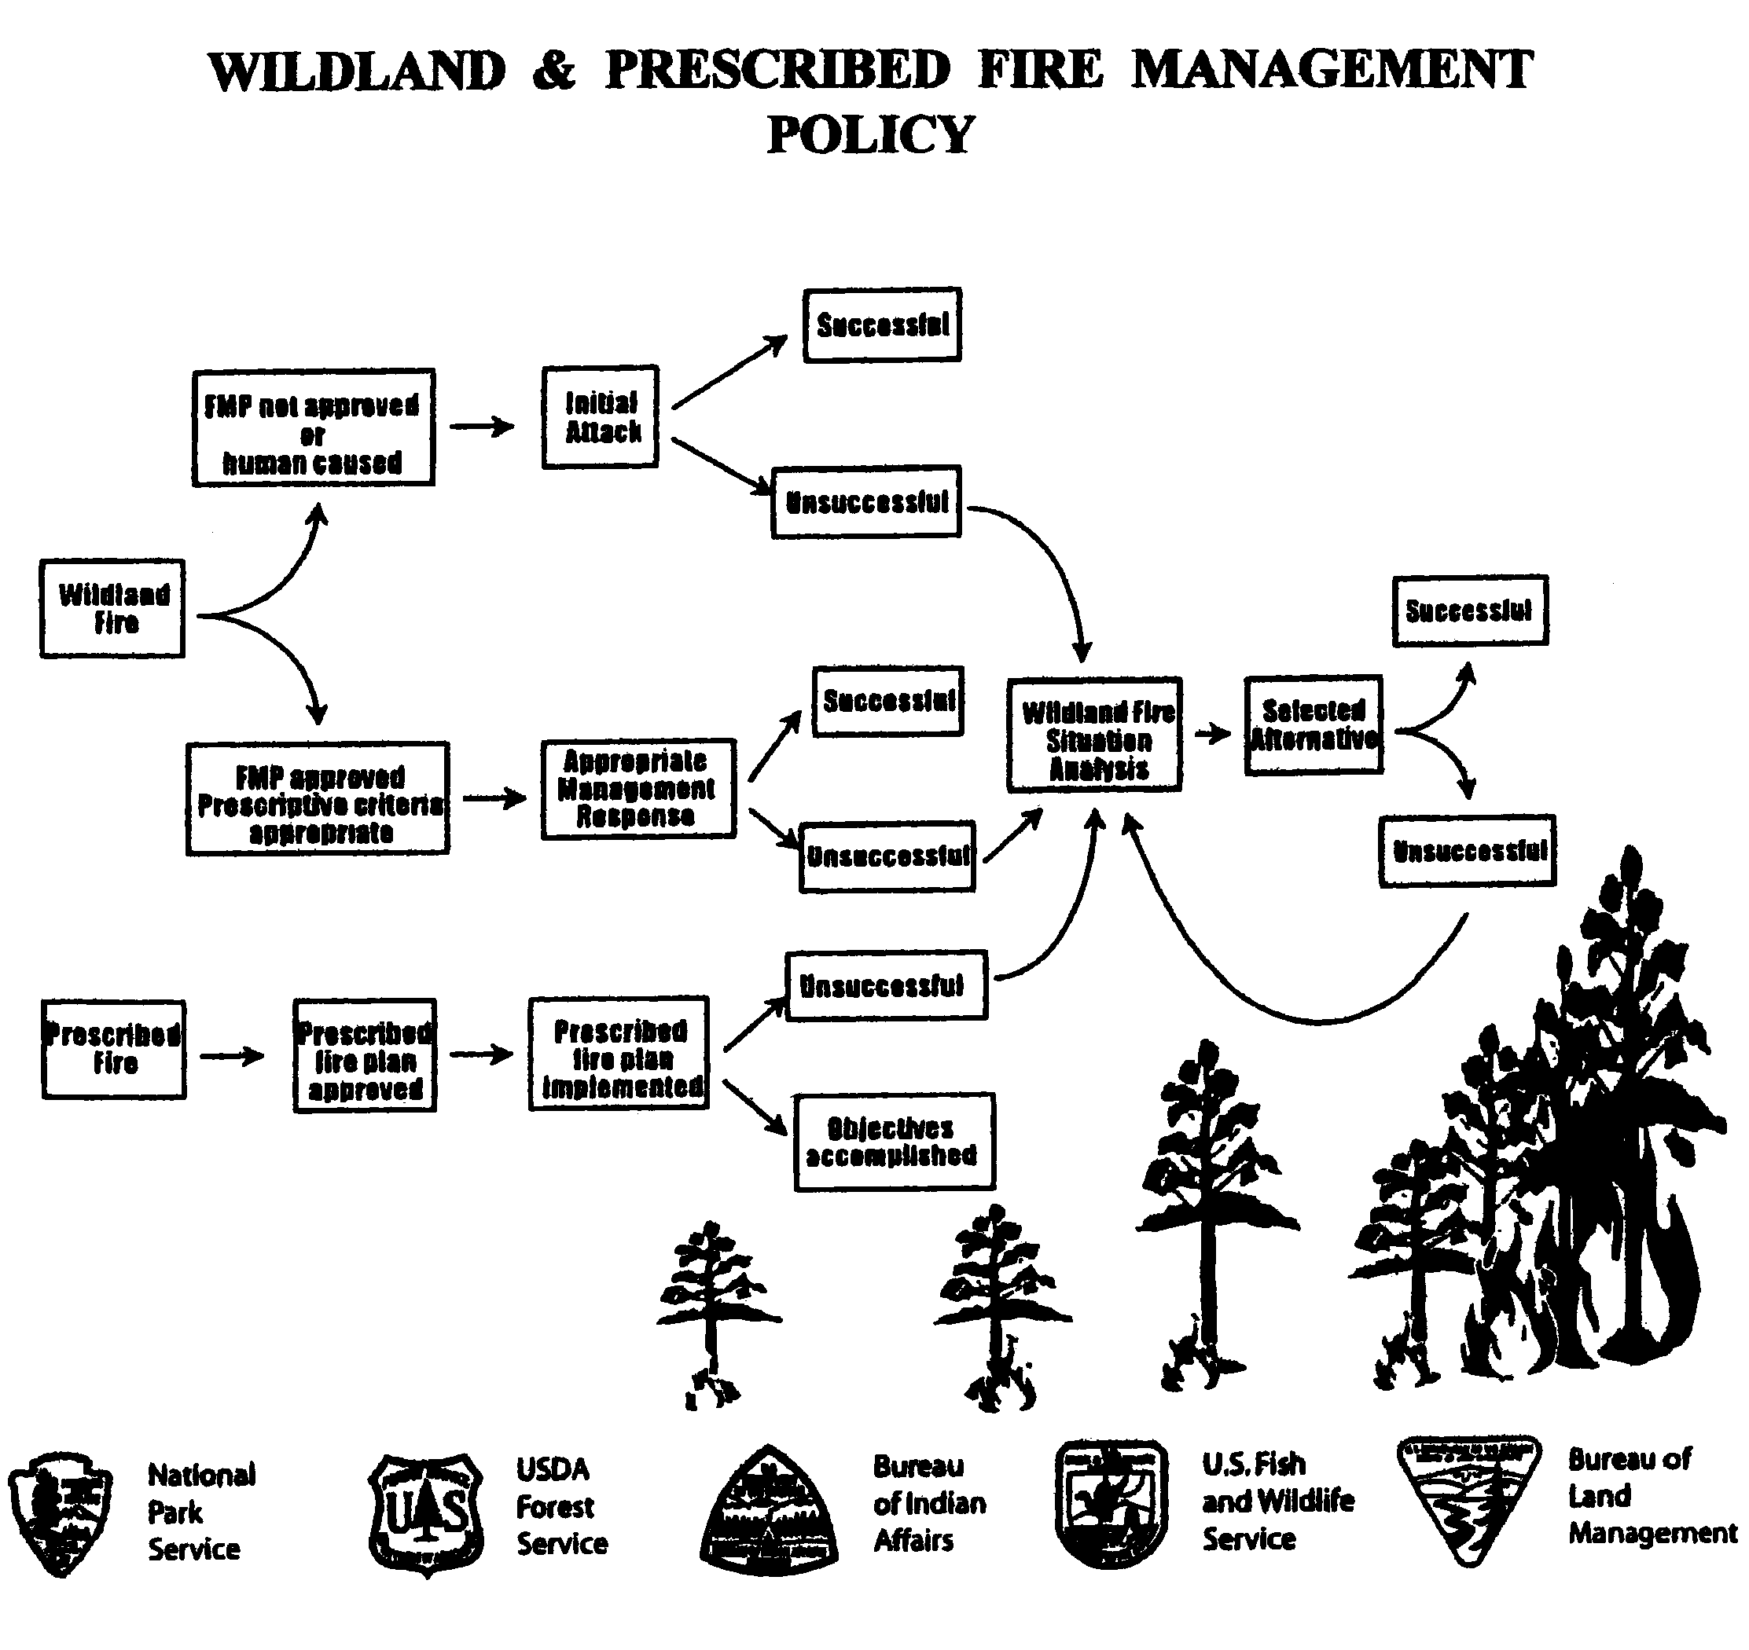
Exhibit 2
Wildland Fire Situation Analysis (WFSA)
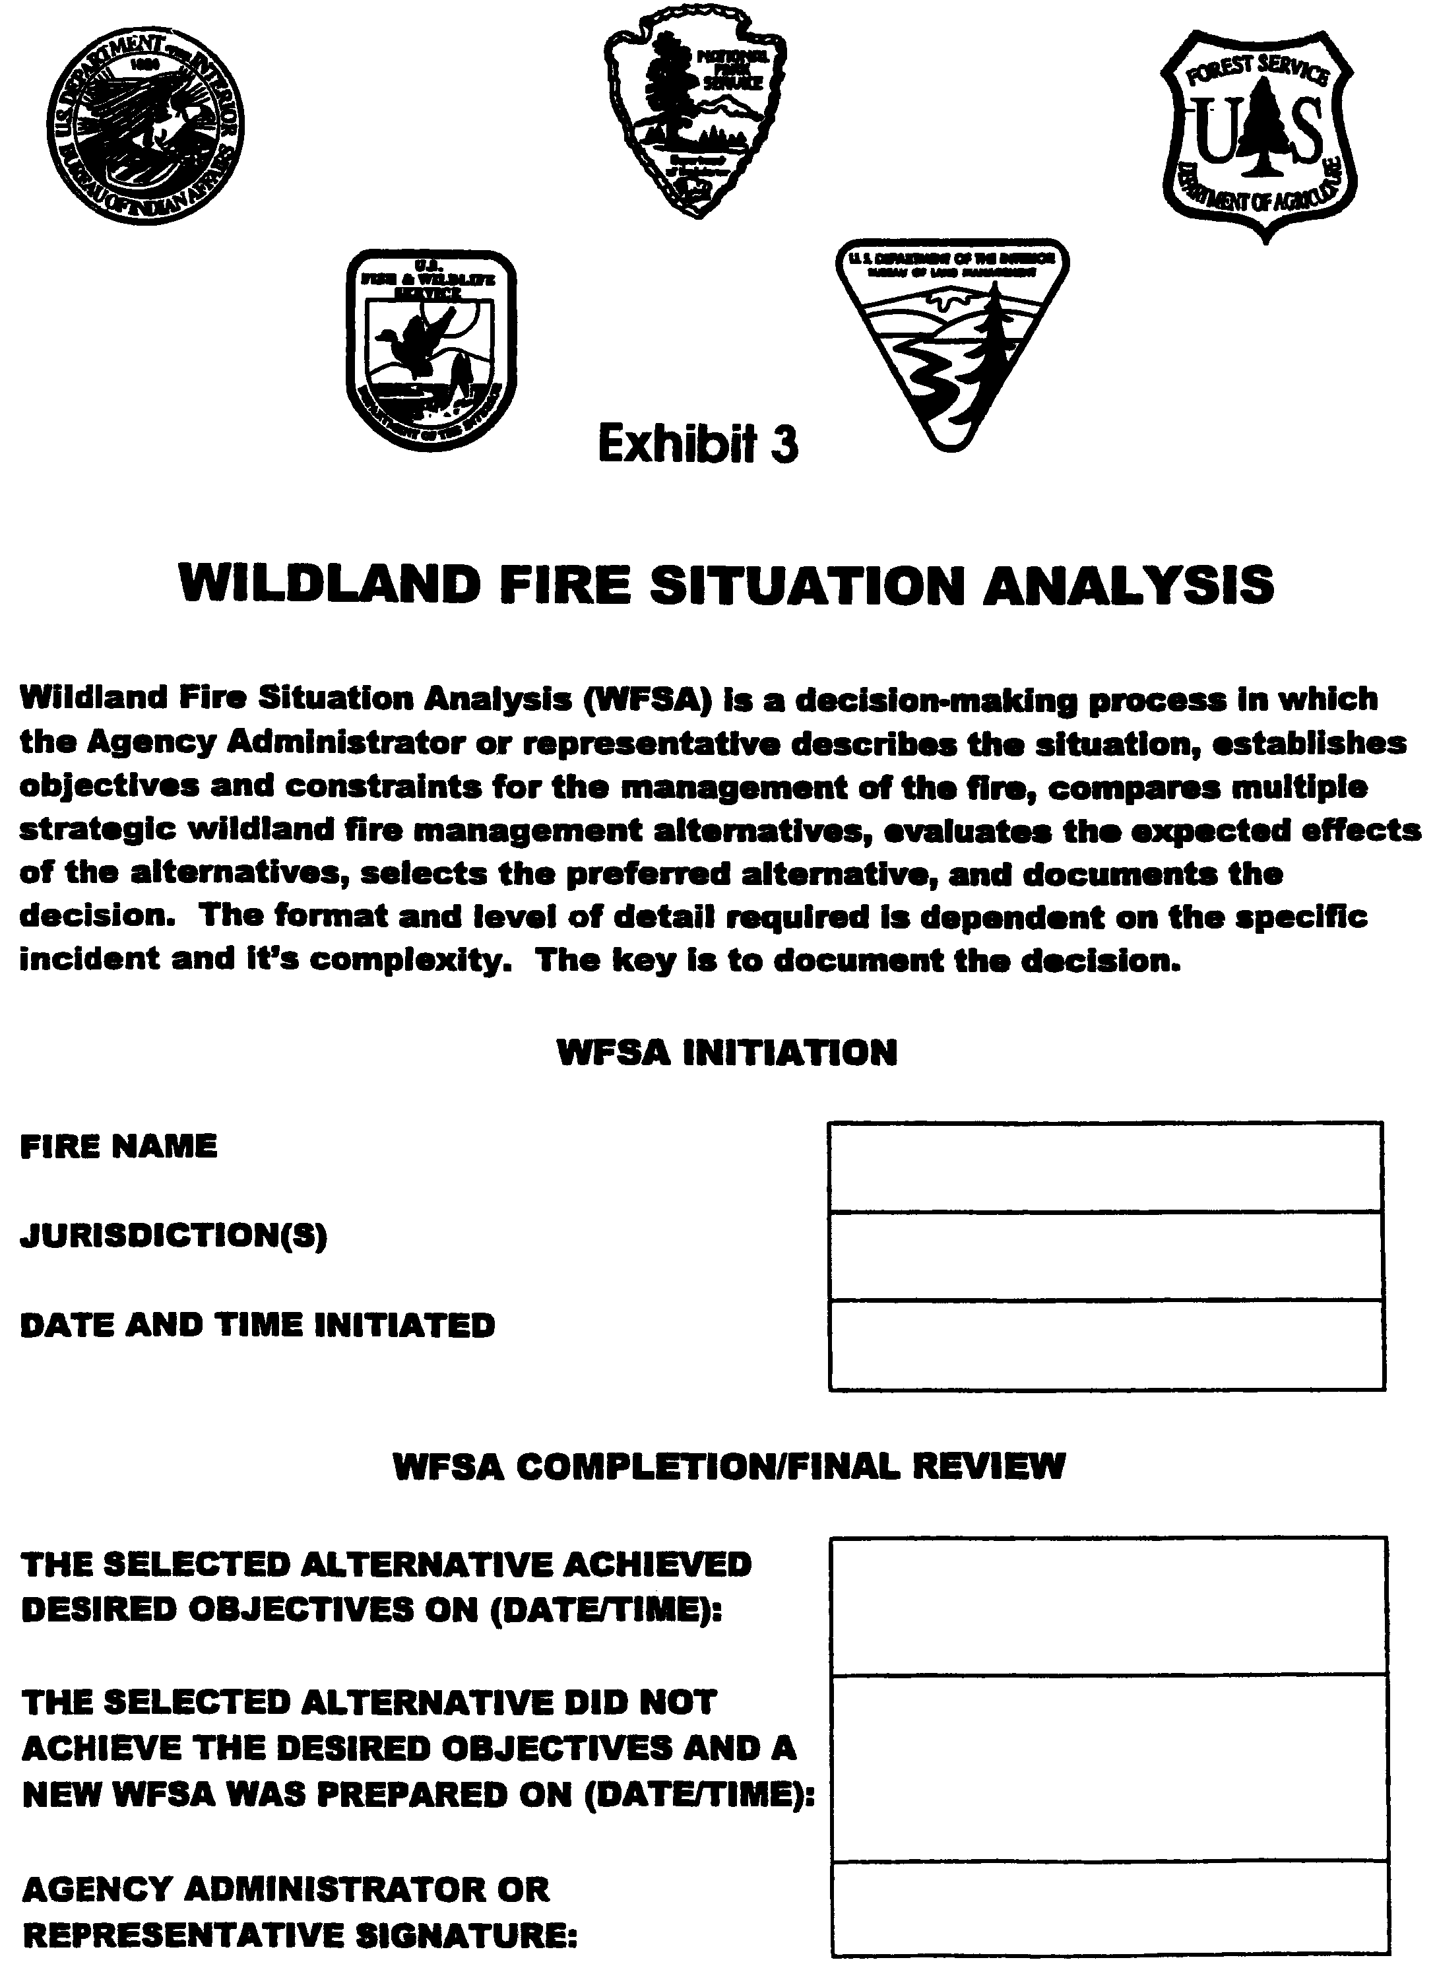
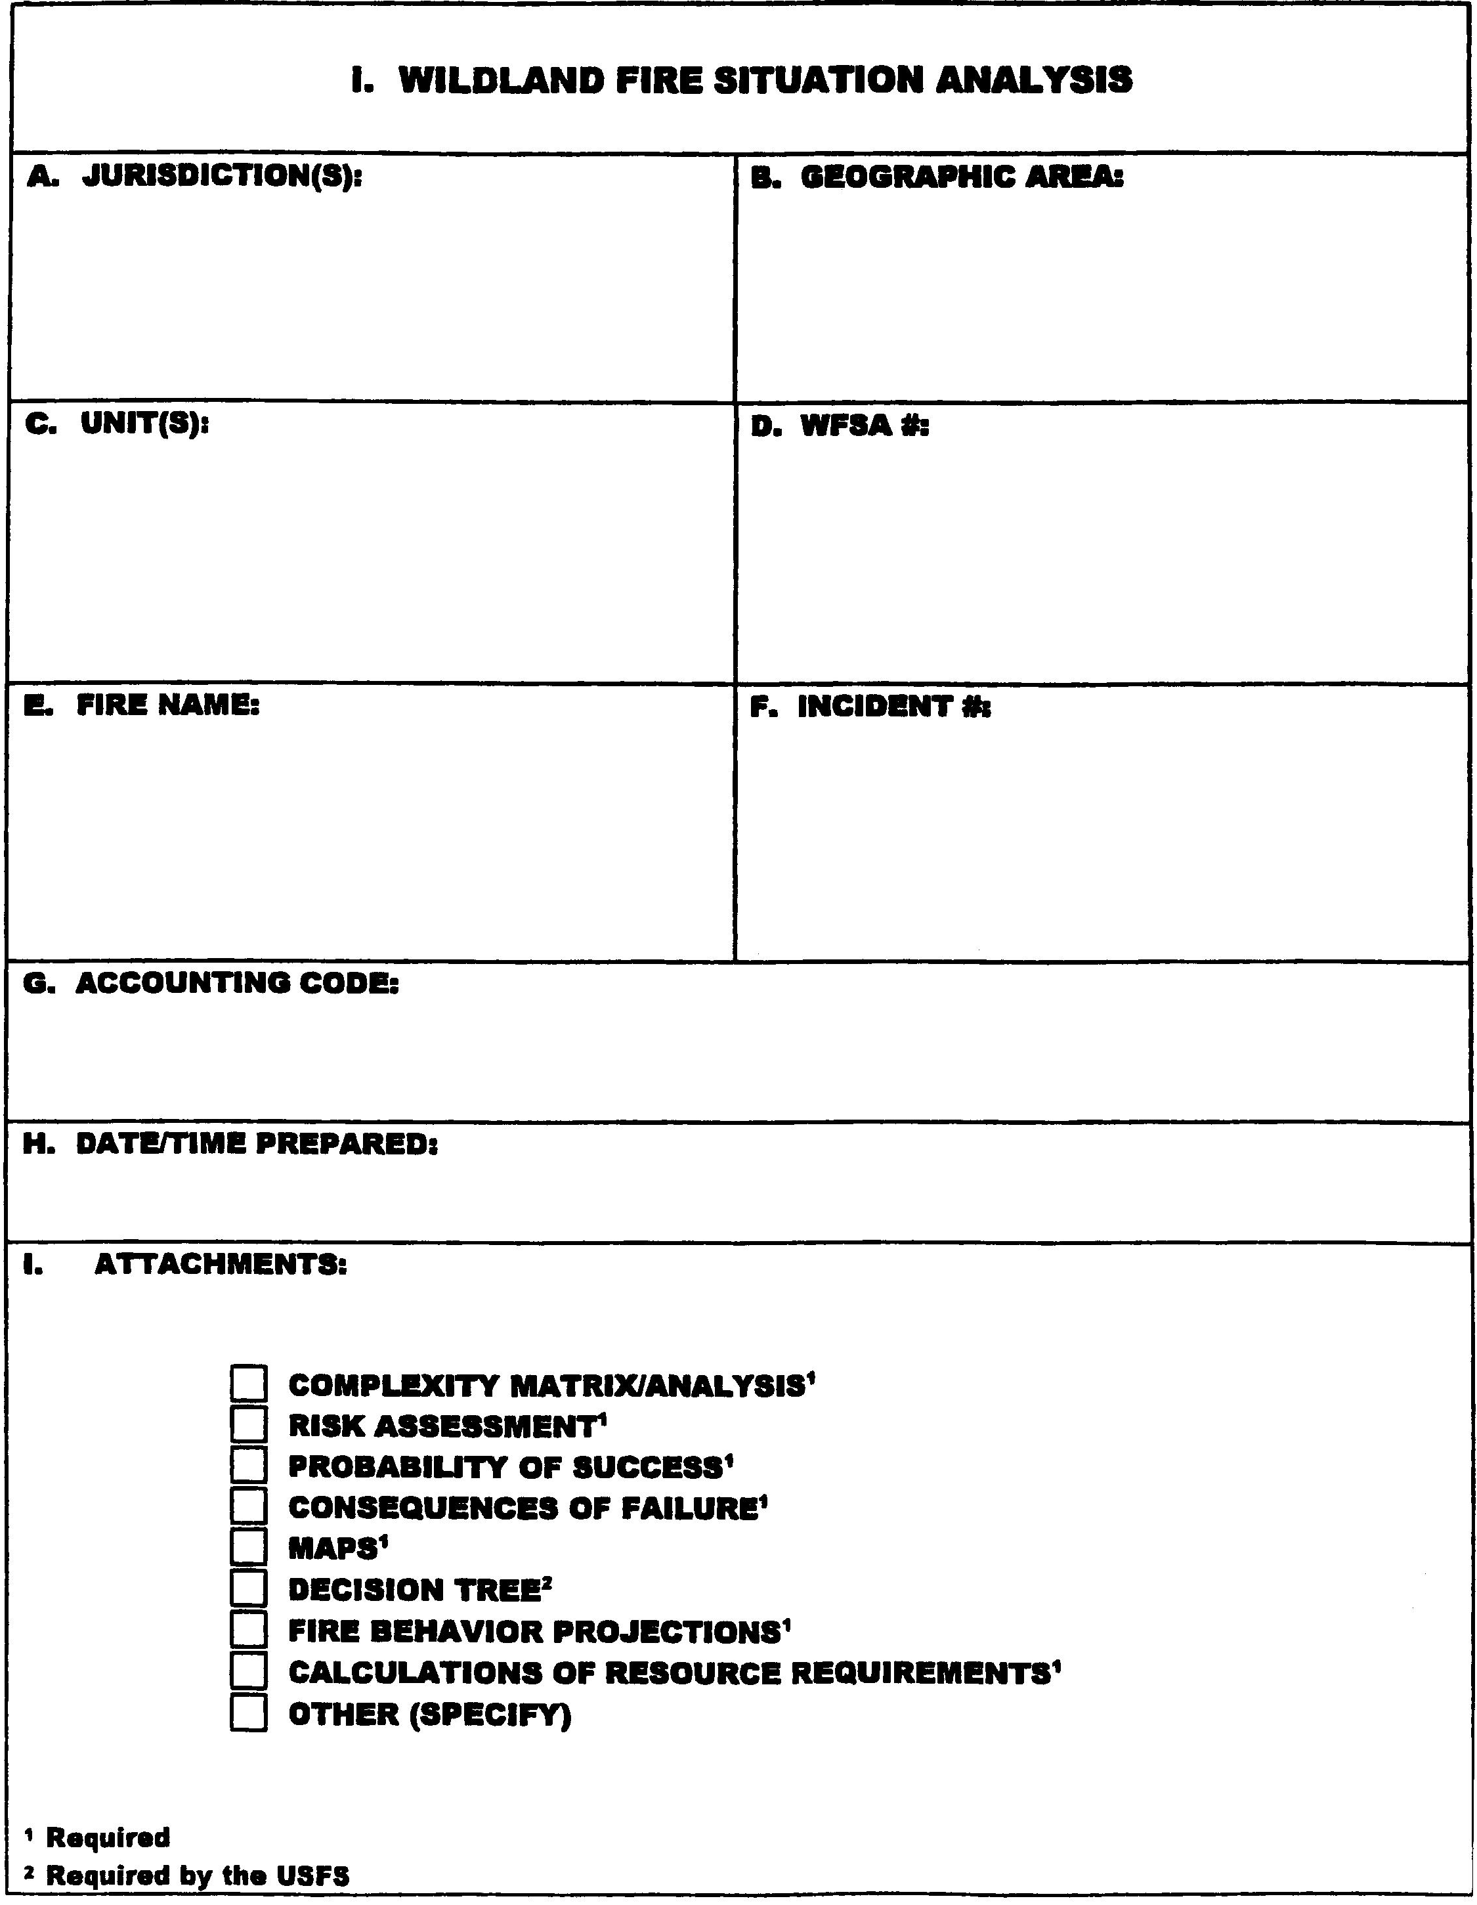
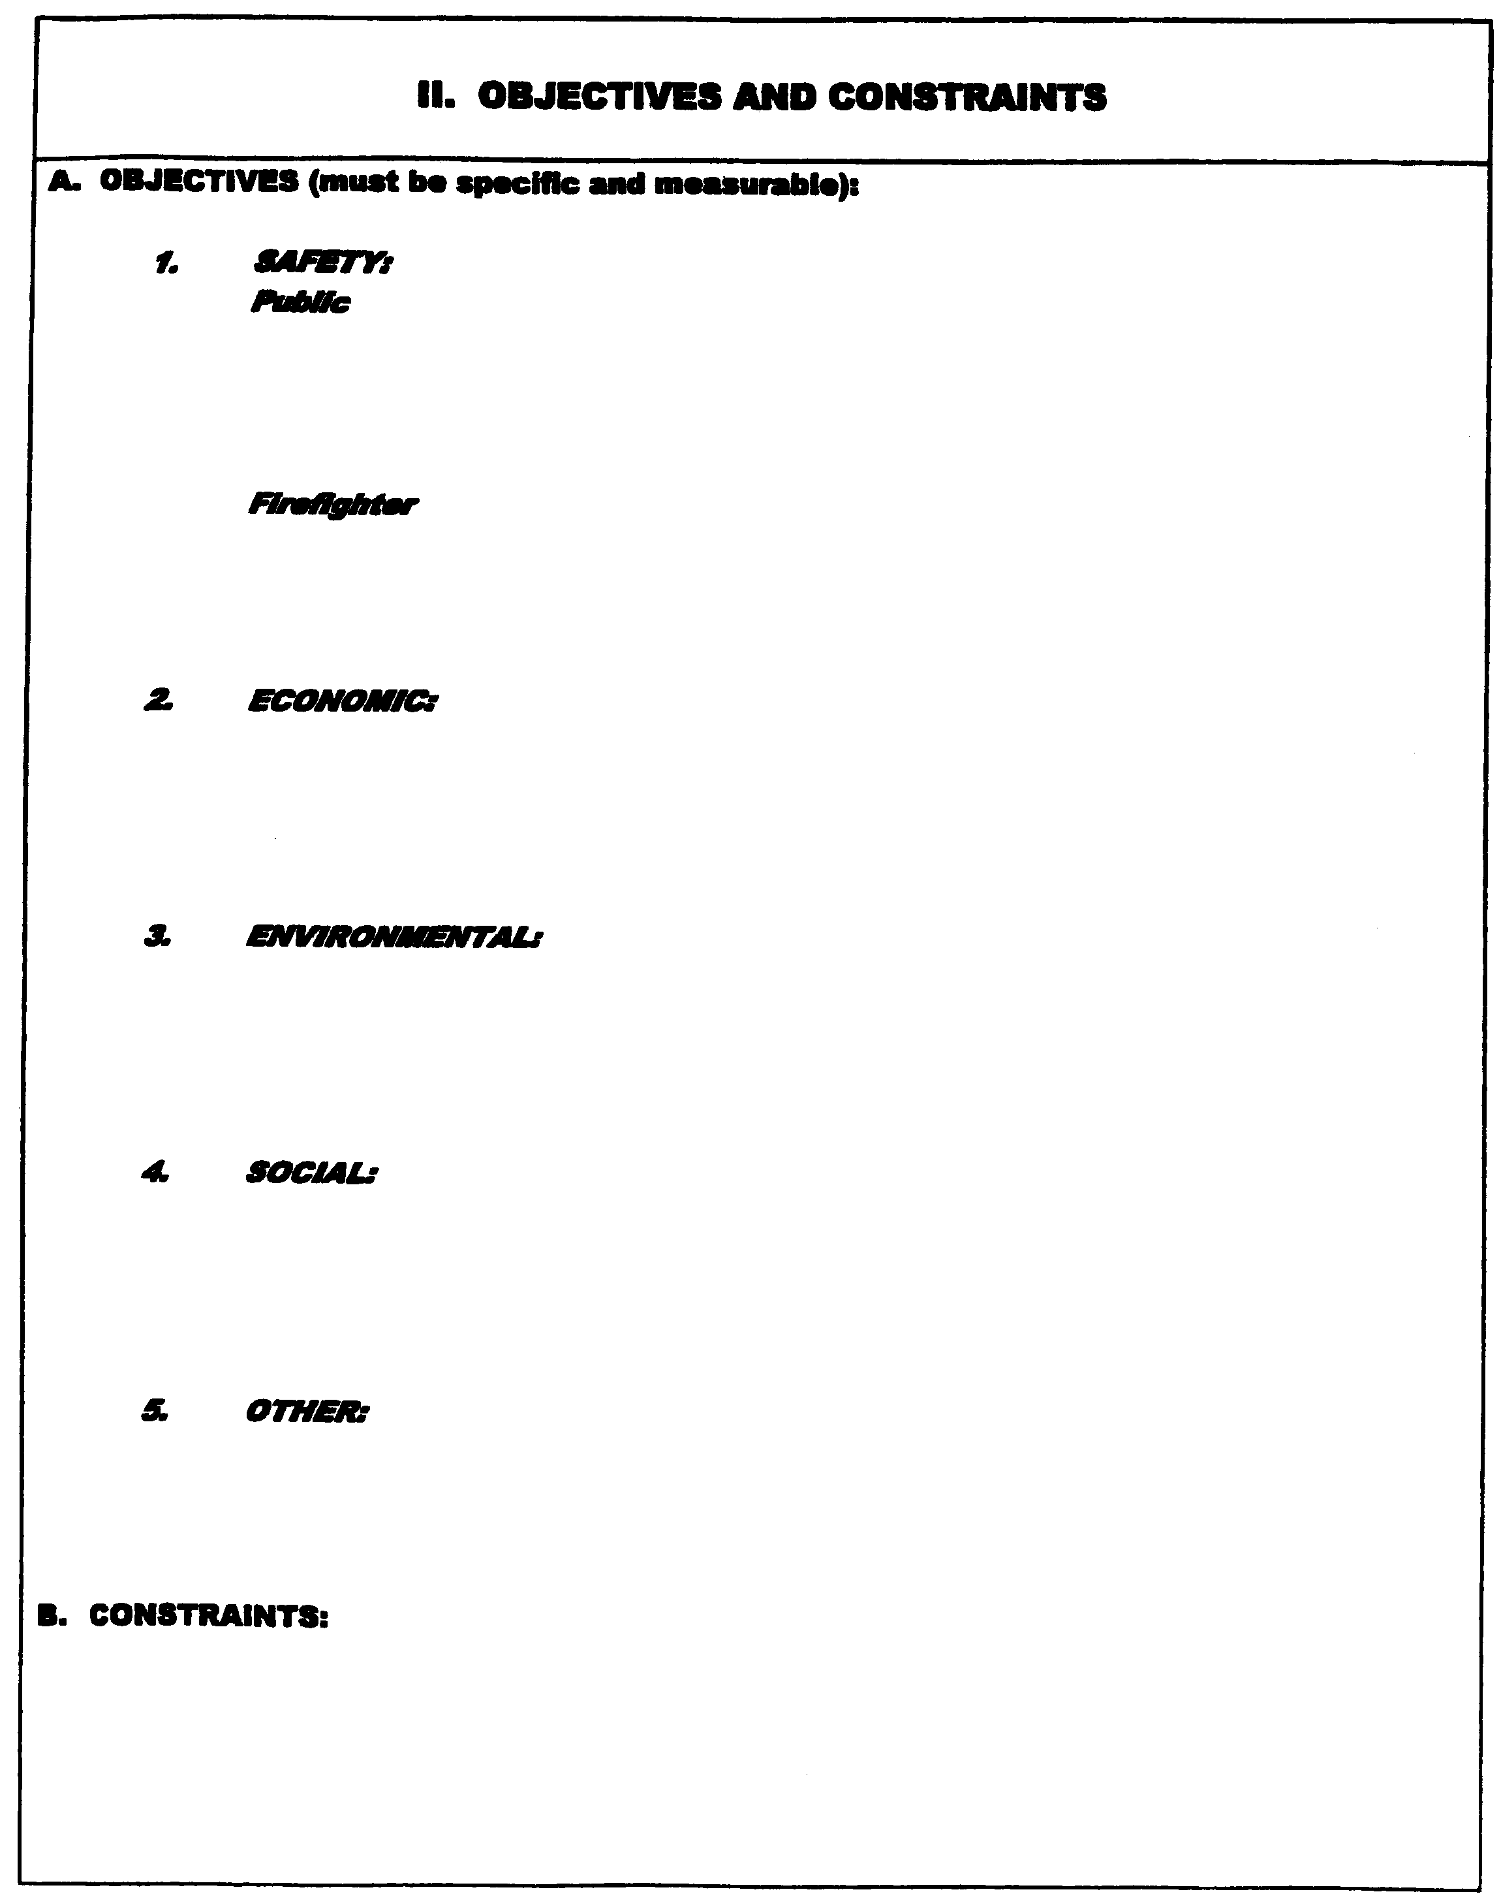
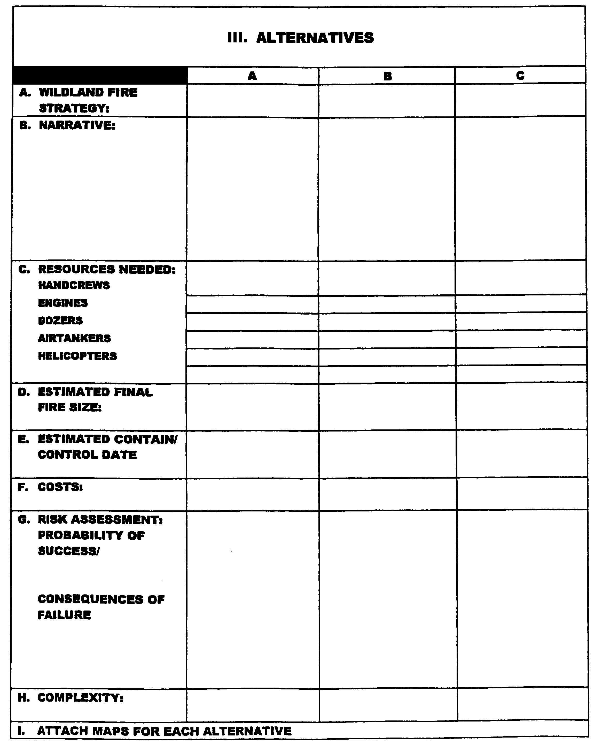

IV. EVALUATION OF ALTERNATIVES
A. EVALUATION PROCESS | A | B | C

SAFETY
Firefighter
Aviation
Public

Sum of Safety Values

ECONOMIC
Forage
Improvements
Recreation
Timber
Water
Wilderness
Wildlife
Other (specify)

Sum of Economic Values

ENVIRONMENTAL
Air
Visual
Fuels
T & E Species
Other (specify)

Sum of Environmental Values

SOCIAL
Employment
Public Concern
Cultural
Other (specify)

Sum of Social Values

OTHER
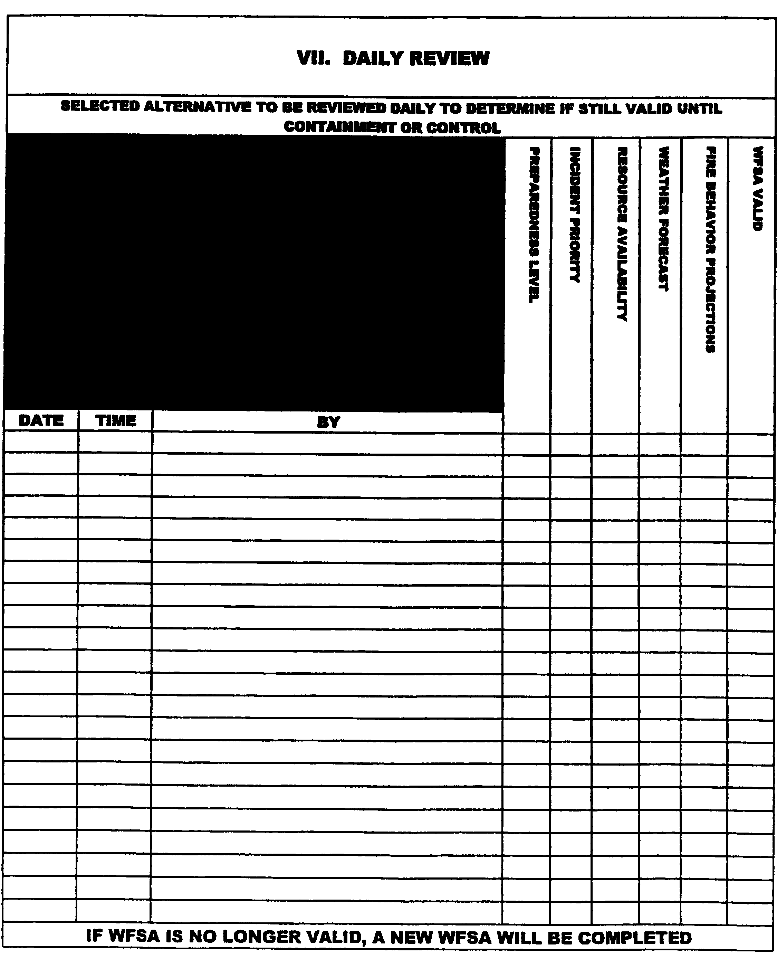
Exhibit 4
Sample Delegation of Authority:
Delegation of Authority
Kaloko-Honokohau
National Historical Park

As of ____Date/Time_____, I have delegated authority to manage the ____________Fire, to Incident Commander ________________ and his Incident Management Team.

The fire, which originated as a single roadside fire, occurring on ____Date____, is burning in the ________________area. My considerations for management of this fire are:
- Provide for firefighter and public safety.
- Manage the fire with as little environmental damage as possible. The guide to minimum impact suppression tactics (MIST) is attached.
- Key cultural features requiring priority protection are densely located on the surface and you will work with local resource advisors to best protect these resources.
- Key resources considerations are: protecting endangered species by avoiding retardant and foams from entering the wetlands and anchialine ponds.
- Restrictions for suppression actions include: no tracked vehicles beyond established roads. No retardant will be used within 100 feet of water.
- Minimum tools for use are Type 2/3 helicopters, chainsaws, hand tools, and portable pumps.
- My agency Resource Advisor will be Richard Boston (Resources Manager and Archaeologist).
- The ______________ flank of the fire borders private property and must be protected if threatened. ______________ of the Hawaii County Fire Department will be the local representative.
- Manage the fire cost-effectively for the values at risk.
- Provide training opportunities for the resources area personnel to strengthen our organizational capabilities.
- Minimum disruption of residential access to private property, and visitor use consistent with public safety.

Geraldine K. Bell, Superintendent (Date)
Amendment to Delegation of Authority

The Delegation of Authority dated_______________, issued to Incident Commander ________________ for the management of the _______________Fire, is hereby amended as follows. This will be effective at Date/Time.

(Item number and information listed here).

Geraldine K. Bell, Superintendent (Date)

