M. Kubantsev
04/09/07

Combining Photogrammetry with Coordinate Measuring Machine Survey of the CMS Forward Pixel Detector

Introduction
Photogrammery technique is widely used in physics experiment for survey experimental setup geometry especially on large scale (of meters to tens of meters and more) to connect different parts of the detector installed in the experimental hall. Less known application is possibility to measure relative position of various parts of the detector on scale of few centimeters to a meter, where accuracy of measurements is approaching to one obtained with coordinate measuring machines, and of order of few microns to 10 microns. In this case the advantage is to make measurements from save distance of fraction of meter (down to 50 cm) from a very delicate object of complicated shape. The same surveyed object has to be installed on the coordinate measuring machine with a touch probe or optical lens and touched with force of few tens of grams and/or approached to the distance of less then few centimeters (4-10 cm) with bulky lens. This creates limitations for measurements of some deep fiducials or targets inside the object and creates serious hazards during measurements mechanically endangering the delicate and very precious object (like a silicon detector) and the machine itself.
The CMS Forward Pixel Detector consisting of eight half disks of complicated shape installed in four service half cylinders (Fig. 1). The turbine geometry of the individual
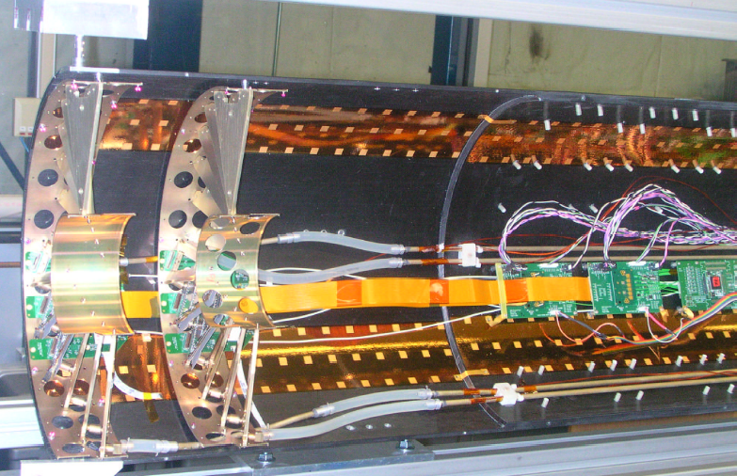

Fig.1 The half cylinder with two half disks installed for the 07-Pilot Run

half disk carrying panels with the silicon sensors requires precision 3D survey of the silicon sensor positions with limited access. The sensors have fiducials with dimensions of 60 microns, which can be surveyed only with a coordinate measuring machine with optical probe. These fiducials cannot be seen on the photogrammetry pictures, because in this case only special optical targets of size over 1 mm in diameter can be clearly visible and processed through the geometry reconstruction.

Survey work steps
To make full survey of the detector we suggest the following chain of measurements allowing us to align all elements of the detector with global coordinate system of the CMS detector
First, we measure sensor positions (using fiducials) on individual panels with the OGP CMM with typical precision of 1 micron in a sensor plane and 2-3 microns in orthogonal direction.
Second, after installation of the panels on the half-disk we measure again the sensor fiducial positions relative to each other together with survey spheres mounted on the outer ring of the half-disk and several 1 mm photogrammetry optical targets installed on several panels. The half-disk was installed on the support plate using three mounting legs. The CMM with inter-calibrated optical lens and touch probe is used. The maximum diameter of the targets is limited to 1 mm due to optical lens field of view. Use of other lens is not permitted by the size and visibility of silicon sensor fiducials. Note, that each side of the half disk is measured separately. Additional survey spheres together with the spheres mounted on the disk are used to connect these to sets of measurements in one coordinate system.
Third, we make a set of photogrammetry pictures of the 1mm targets together with other coded targets using the VSTAR system and make 3D reconstruction of these targets. We compare the results with CMM measurements. Typical agreement is about 10 microns. Additional 3 mm targets installed on the half-disk inner and outer rings are used in addition to 1 mm targets due to difficulty to reconstruct 1 mm targets at CERN. Note, that the picture shooting is made from minimal distance allowed by the camera of 50-70 cm, which allows recognize and reconstruct 1 mm optical targets on the panels with nominal accuracy better then 10 microns.
Fourth, after installation of the half-disks into the service cylinder we survey their positions relative to the supporting structure (leg balls) using combination of touch probe measurements of the survey spheres on the disks, service half-cylinder and supporting structure and photogrammetry targets. It allows inter-calibration of these two methods and determining of sensor positions relative to the supporting structure.
Fifth, we suggest after shipment to CERN, when the half-disks are dismantled and delivered separately and the detector is re-assembled, the CERN alignment group will re-survey the service cylinder using photogrammery. At this step the half cylinder with the half-disks is surveyed relative to the supporting rails using all optical targets available including 1 mm ones. Additional removable optical targets required on the end flange to make further connection with external fiducial CMS system during final installation into the detector.
Sixth, we suggest the CERN alignment group will make final survey of the end flange removable targets relative to the CMS targets using photogrammetry after Forward Pixel installation into the CMS. Four CERN photogrammetry targets are to be installed into holes in the end flange using proposed fixtures described in the Appendix.
The results of the measurements described above are analyzed in assumption that the half disk is a rigid body.

Half-disk photogrammetry survey.
Photogrammetry survey of half-disk is done just after CMM measurements on the same support plate as shown in Fig.2. The disk is placed vertically and surrounded by coded targets. AutoBar is placed in the center of the array.

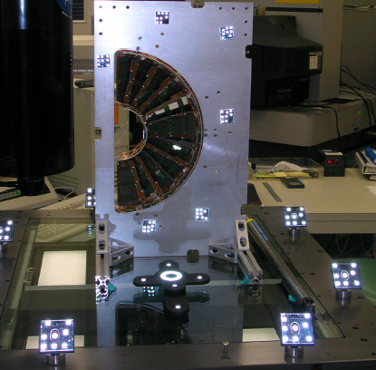
Fig.2 Photogrammetry session for –Z2 half disk.

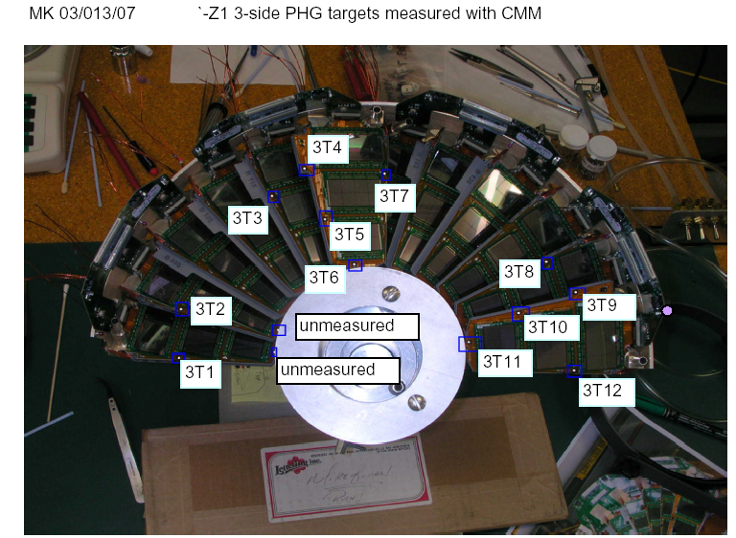

Fig.4a Optical targets for –Z1_3-side half disk

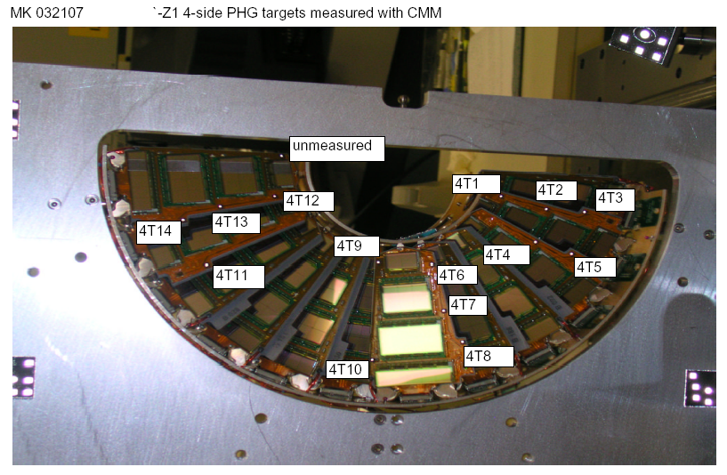

Fig.4b Optical targets for –Z1_4-side half disk
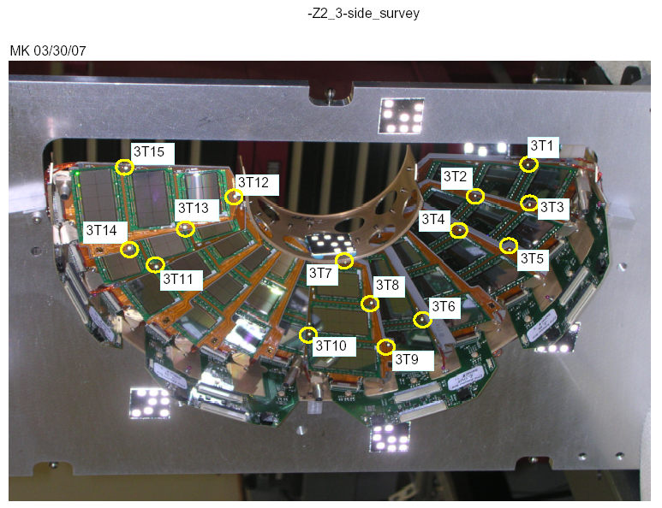
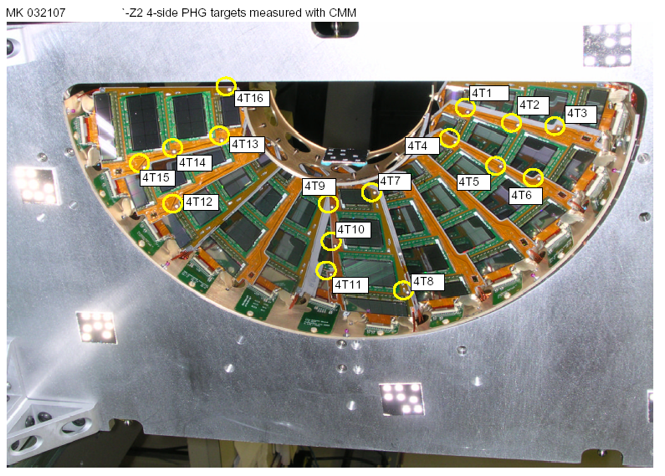
Fig.4c Optical targets for –Z2_3-side half disk

Fig.4d Optical targets for –Z2_4-side half disk

At the first step the 1mm optical targets are photographed and reconstructed simultaneously on both sides of the half disk (12-16 targets on each side, the picture of the targets with numbers is shown in Fig.4a-d). The results are presented in the files attached:
-Z1 Half Disk_20mar07
-Z2 Half Disk_29mar07
Here all photogrammetry target coordinates (X,Y,Z) and estimated reconstruction errors (Sigma = R.M.S./SQRT(Nmeasurements) are presented in the working coordinate system of the STAR package (usually connected with the AutoBar).

Comparison of two survey methods.
Four files (txt) with optical target coordinates are extracted from the CMM measurement data:
3-side_-z1_targets
4-side_-z1_targets
3-side_-z2_targets
4-side_-z2_targets.
Photogrammetry measured coordinates of the optical targets on the panels are fitted and translated to the coordinates of the corresponding targets on two half-disk sides measured by CMM. The results are shown in following attached txt.files for two sides of the half-disk in the corresponding CMM coordinate systems separately:
3-side_-z1_targetsTrans
4-side_-z1_targetsTrans
3-side_-z2_targetsTrans
4-side_-z2_targetsTrans
Some unmeasured 1mm targets has suffix “u”. Coordinates of other auxiliary photogrammetry targets are presented. The differences between reconstructed target coordinates by two methods are shown in:
3-side_-z1_targetsTrans_R
4-side_-z1_targetsTrans_R
3-side_-z2_targetsTrans_R
4-side_-z2_targetsTrans_R
The following observation is to be made: as the repeatability of the CMM measurement is of order 1-3 microns and photogrammetry error estimation is about 4-10 microns the agreement between two data sets is significantly worse and is about 10-20 microns. Close inspection shows that about half of the points have significantly higher discrepancy between two measurements (20-40 microns) then average indicating possible systematics involved. As the CMM measurements are done using automatic pattern recognition of the targets with measuring effective “center of gravity” of the target image, there is possibility that some irregularities in the target shape can cause such discrepancy. Further investigation is under way.
As the targets on both sides of the half-disk are reconstructed together with photogrammetry it provides independent check of the CMM based procedure of connection of coordinates of two sides of the disk with survey spheres. Such comparison is pending.

APPENDIX
M. Kubantsev 04/09/07
An Adapter for CERN Survey Targets on the End Flange of the Half Cylinder.

The message below describes requirements for a photogrammetry target adapter we may use for final survey of the half cylinder in the CMS detector. This adapter can be attached to the end flange using designated holes. The sketch of the possible adapter is attached together with CERN drawing. I propose to make 4 such adapters for each half cylinder, total 16.

_____________________________________________
From Antje Behrens <Antje.Behrens@cern.ch>
Date Thu, 21 Sep 2006 16:30:56 +0200
To Paolo Petagna <Paolo.Petagna@cern.ch>, swalk@fnal.gov
Cc Raphael Goudard <Raphael.Goudard@cern.ch>
Subject Survey reference hole
Dear Simon,

Please find enclosed a drawing of the survey reference hole. Only the
parameter A3 (8mm H7 hole), B3 and C3 are valid, we do not need the
thread.

If you manage to integrate these holes with the necessary space to
insert a target, we will be free later to choose the measurement system
(theodolite / photogrammetry).

Please let us know if you succeeded, or if we have to switch to a
different hole diameter (and a different target type).

Best regards
Antje

