UML Description: Level 2 Use Cases and Analysis View
Boeing Corporation and Battelle Ocean Sciences

An IOOS Demonstration Project

July 2006

NOAA Coastal Services Center
2234 South Hobson Avenue • Charleston, SC 29405-2413
843-740-1200 (phone) • 843-740-1224 (fax)
This page intentionally blank
Table of Contents
1 Scope 1
1.1 Identification 1
1.2 ICOOS IIS Data Mart Use Cases 1
1.2.1 Manage Web Page Data Transfer (Use Case) 3
1.2.2 Conduct Web Page Transfer (Association) 5
1.2.2.1.1 Provide Web Page (Acquire Data Role) 5
1.2.2.1.2 Capture Web Page (Manage Web Page Data Transfer Role) 5
1.2.3 Supply Mixed-Content Web Page Data (Association) 5
1.2.3.1.1 Extract Data From Web Page (Manage Web Page Data Transfer Role) 6
1.2.3.1.2 Standardize Extracted Web Page Data (Integrate Mixed-Content Data Role) 6
1.2.4 Integrate Mixed-Content Data (Use Case) 6
1.2.5 Supply Standardized Data (Association) 7
1.2.5.1.1 Provide Standardized Data (Supply Standardized Data Role) 7
1.2.5.1.2 Store Standardized Data (Record Standardized Data Role) 8
1.2.6 Conduct OPeNDAP Data Transfer (Association) 8
1.2.6.1.1 Provide Data Per OPeNDAP (Acquire Data Role) 8
1.2.6.1.2 Capture OPeNDAP Data Files (Manage OPeNDAP Data Transfer Role) 8
1.2.7 Manage OPeNDAP Data Transfer (Use Case) 8
1.2.8 Supply Mixed-Content OPeNDAP Data (Association) 11
1.2.8.1.1 Extract Data From OPeNDAP Download (Manage OPeNDAP Data Transfer Role) 11
1.2.8.1.2 Standardize Extracted OPeNDAP Data (Integrate Mixed-Content Data Role) 11
2 ETL Program Level 2 Analysis View 12
2.1 Timer (Class) 15
2.1.1 Period (Timer Attribute) 15
2.1.2 Start Signal (Timer Attribute) 15
2.2 Initiates (Association) 15
2.2.1 Issue Start (Timer Role) 15
2.2.2 Start ETL Program (Transformation Manager Role) 16
2.3 Transformation Manager (Class) 16
2.3.1 Executive (Transformation Manager Attribute) 16
2.3.2 Process Monitor (Transformation Manager Attribute) 16
2.3.3 Scraper Sequencer (Transformation Manager Attribute) 17
2.3.4 Retrieval Sequencer (Transformation Manager Attribute) 17
2.3.5 Storage Sequencer (Transformation Manger Attribute) 17
2.3.6 OPeNDAP Interface Sequencer (Transformation Manger Attribute) 17
2.4 Coordinates Actions of (Association) 17
2.4.1 Control Data Flow (Transformation Manager Role) 17
2.4.2 Provide Interface (Data Storage Interface Role) 18
2.5 Data Storage Interface (Class) 18
2.5.1 Station Table Interface (Data Storage Interface Attribute) 18
2.5.2 Location History Table Interface (Data Storage Interface Attribute) 18
2.5.3 Collection Platform Table Interface (Data Storage Interface Attribute) 18
2.5.4 Operational Status Table Interface (Data Storage Interface Attribute) 18
2.5.5 Collection Sensor Table Interface (Data Storage Interface Attribute) 19
2.5.6 Sensor Table Interface (Data Storage Interface Attribute) 19
2.5.7 Measurement Table Interface (Data Storage Interface Attribute) 19
2.5.8 Station Type Table Interface (Data Storage Interface Attribute) 19
2.5.9 Benchmark Reference Table Interface (Data Storage Interface Attribute) 19
2.5.10 Benchmark Table Interface (Data Storage Interface Attribute) 19
2.5.11 Extraction Type Table Interface (Data Storage Interface Attribute) 19
2.5.12 Participating Station Table Interface (Data Storage Interface Attribute) 20
2.5.13 Observation Type Table Interface (Data Storage Interface Attribute) 20
2.5.14 Observation Structure Table Interface (Data Storage Interface Attribute) 20
2.5.15 Observation Attribute Table Interface (Data Storage Interface Attribute) 20
2.5.16 Observed Data Table Interface (Data Storage Interface Attribute) 20
2.5.17 Range Edit Table Interface (Data Storage Interface Attribute) 20
2.5.18 Discrete Edit Table Interface (Data Storage Interface Attribute) 21
2.5.19 Exclude Edit Table Interface (Data Storage Interface Attribute) 21
2.5.20 OPeNDAP and Predictions Tables Interfaces(Data Storage Interface Attribute) 21
2.6 Exchanges Observation Data with (Association) 21
2.6.1 Issue Requests and Data (Data Storage Interface Role) 21
2.6.2 Store and Retrieve (Relational Data Base Manager Role) 21
2.7 Are Fetched by (#1) (Association) 21
2.7.1 Retrieve (Data Storage Interface Role) 22
2.7.2 Wait for Use (Scraper Settings Role) 22
2.8 Are Fetched by (#2) (Association) 22
2.8.1 Retrieve (Data Storage Interface Role) 22
2.8.2 Wait for Use (OPeNDAP Settings Role) 22
2.9 Scraper Settings (Class) 22
2.9.1 Extraction Type (Scraper Settings Attribute) 23
2.9.2 Participating Station (Scraper Settings Attribute) 23
2.9.3 Station Summary (Scraper Settings Attribute) 23
2.9.4 Observation Type (Scraper Settings Attribute) 23
2.9.5 Observation Structure (Scraper Settings Attribute) 23
2.9.6 Attribute Summary (Scraper Settings Attribute) 23
2.9.7 Observation Attribute (Scraper Settings Attribute) 23
2.9.8 Range Edit (Scraper Settings Attribute) 24
2.9.9 Discrete Edit (Scraper Settings Attribute) 24
2.9.10 Exclude Edit (Scraper Settings Attribute) 24
2.9.11 Station URL (Scraper Settings Attribute) 24
2.10 OPeNDAP Settings (Class) 24
2.10.1 Extraction Type (OPeNDAP Settings Attribute) 25
2.10.2 Participating Data Source (OPeNDAP Settings Attribute) 25
2.10.3 Data Source Summary (OPeNDAP Settings Attribute) 25
2.10.4 Observation Type (OPeNDAP Settings Attribute) 25
2.10.5 Observation Structure (OPeNDAP Settings Attribute) 25
2.10.6 Attribute Summary (OPeNDAP Settings Attribute) 25
2.10.7 Observation Attribute (OPeNDAP Settings Attribute) 26
2.10.8 Range Edit (OPeNDAP Settings Attribute) 26
2.10.9 Discrete Edit (OPeNDAP Settings Attribute) 26
2.10.10 Exclude Edit (OPeNDAP Settings Attribute) 26
2.10.11 Data Source URL (OPeNDAP Settings Attribute) 26
2.11 Guide Operation of (#1) (Association) 26
2.11.1 Support Scraper Access (Scraper Settings Role) 27
2.11.2 Consult Settings (Web Page Scraper Role) 27
2.12 Guide Operation of (#2) (Association) 27
2.12.1 Support OPeNDAP Access (OPeNDAP Settings Role) 27
2.12.2 (OPeNDAP Interface Role) 27
2.13 Base Template (Class) 27
2.13.1 Applicable Agent (Base Template Attribute) 27
2.13.2 Pattern Definition (Base Template Attribute) 27
2.14 OPeNDAP Base Template (Class) 28
2.14.1 Host Agent (OPeNDAP Base Template Attribute) 28
2.14.2 File Pattern (OPeNDAP Base Template Attribute) 28
2.15 Enables Web Page Parsing by (Association) 28
2.15.1 Reveal Pattern (Base Template Role) 28
2.15.2 Read Pattern (Web Page Scraper Role) 28
2.16 Enables File Parsing by (Association) 28
2.16.1 Consult Pattern (OPeNDAP Interface Role) 28
2.16.2 Provide Pattern (OPeNDAP Base Template Role) 29
2.17 Coordinates ETL Activities of (Association) 29
2.17.1 Control Scraper (Transformation Manager Role) 29
2.17.2 Parse Web Page (Web Page Scraper Role) 29
2.18 Coordinates ETL OPeNDAP Activities of (Association) 29
2.18.1 Parse Data File (OPeNDAP Interface Role) 29
2.18.2 Control OPeNDAP Interface (Transformation Manager Role) 29
2.19 Web Page Scraper (Class) 30
2.19.1 Target Station List (Web Page Scraper Attribute) 30
2.19.2 Station Connector (Web Page Scraper Attribute) 30
2.19.3 Web Page Acquisition (Web Page Scraper Attribute) 30
2.19.4 Template Loader (Web Page Scraper Attribute) 30
2.19.5 Web Page Parser (Web Page Scraper Attribute) 30
2.19.6 Observation Extractor (Web Page Scraper Attribute) 31
2.19.7 Settings Acquisition (Web Page Scraper Attribute) 31
2.19.8 Exceptions Handler (Web Page Scraper Attribute) 31
2.19.9 Data Checker (Web Page Scraper Attribute) 31
2.20 OPeNDAP Interface (Class) 31
2.20.1 Target Data Source (OPeNDAP Interface Attribute) 32
2.20.2 Data Source Connector (OPeNDAP Interface Attribute) 32
2.20.3 OPeNDAP Query Builder (OPeNDAP Interface Attribute) 32
2.20.4 Template Loader (OPeNDAP Interface Attribute) 32
2.20.5 Data File Parser (OPeNDAP Interface Attribute) 32
2.20.6 Data Extractor (OPeNDAP Interface Attribute) 32
2.20.7 Settings Acquisition (OPeNDAP Interface Attribute) 32
2.20.8 Exceptions Handler (OPeNDAP Interface Attribute) 33
2.20.9 Data Checker (OPeNDAP Interface Attribute) 33
2.20.10 File Handler (OPeNDAP Interface Attribute) 33
2.20.11 Query Sender (OPeNDAP Interface Attribute) 33
2.21 Is Created by (#1) (Association) 34
2.21.1 Extract Observation (Web Page Scraper Role) 34
2.21.2 Contain Observation Data (Extracted Observation Role) 34
2.22 Is Created by (#2) (Association) 34
2.22.1 Read Observation Data (OPeNDAP Interface Role) 34
2.22.2 Contain Observation Data (Extracted Observation Role) 34
2.23 Extracted Observation (Class) 34
2.23.1 Type (Extracted Observation Attribute) 35
2.23.2 Short Name (Extracted Observation Attribute) 35
2.23.3 Value (Extracted Observation Attribute) 35
2.23.4 Date (Extracted Observation Attribute) 35
2.23.5 Time (Extracted Observation Attribute) 36
2.24 Provides Extracted Observation to (#1) (Association) 36
2.24.1 Prepare Extracted Observation (Web Page Scraper Role) 36
2.24.2 Acquire Extracted Observation (Data Storage Interface Role) 36
2.25 Provides Extracted Observation to (#2) (Association) 37
2.25.1 Prepare Extracted Observation (OPeNDAP Interface Role) 37
2.25.2 Acquire Extracted Observation (Data Storage Interface Role) 37
2.26 Relational Database Manager (Class) 37
2.26.1 Scraper Service (Relational Database Manager Attribute) 37
2.26.2 Loader Interface (Relational Database Manager Attribute) 37
2.26.3 OPeNDAP Interface Service (Relational Database Manager Attribute) 37
2.27 Controls Operation of (Association) 38
2.27.1 Manage Observations Data Flows (Relational Database Manager Role) 38
2.27.2 Store Observations Data (Working Database Role) 38
2.28 Working Database (Class) 38
2.28.1 Observations Data (Working Database Attribute) 38
2.28.2 Scraper Data (Working Database Attribute) 38
2.28.3 Business Schema (Working Database Attribute) 39
2.28.4 OPeNDAP Data (Working Database Attribute) 39
2.29 Loader (Class) 39
2.29.1 Query Generator (Loader Attribute) 39
2.29.2 Geographic Positioner (Loader Attribute) 39
2.29.3 GIS Output (Loader Attribute) 39
2.30 Coordinates Activation of (Association) 39
2.30.1 Control Loading (Transformation Manager Role) 40
2.30.2 Prepare Geospatial Data (Loader Role) 40
2.31 Obtains New Observations Data From (Association) 40
2.31.1 Issue Retrieval Requests (Loader Role) 40
2.31.2 Retrieve Observations Data (Relational Database Manager Role) 40
2.32 Geospatial Interface (Class) 41
3 Geospatial Data Repository Level 2 Analysis View 42
3.1 Geospatial Database Manager (Class) 43
3.1.1 ETL Program Interface (Geospatial Database Manager Attribute) 44
3.1.2 Client Interface (Geospatial Database Manager Attribute) 44
3.2 Geospatial Interface (Class) 44
3.3 Controls Operations in (Association) 44
3.3.1 Manage Geospatial Data Flows (Geospatial Database Manager Role) 44
3.3.2 Store Geospatial Data (Geospatial Database Role) 44
3.4 Geospatial Database (Class) 44
3.4.1 Geospatial Data (Geospatial Database Attribute) 45
3.4.2 Geospatial Schema (Geospatial Database Attribute) 45
3.5 Web Feature Service (Class) 45

List of Figures

Figure 1-1. ICOOS IIS Level 2 Use Cases for "Stage Data." 2
Figure 2-1. ICOOS IIS ETL Program Level 2 Classes. 14
Figure 3-1. ICOOS IIS Geospatial Data Repository Level 2 Classes. 41

Abstract
The ICOOS Integrated Information System demonstration process described herein encompasses services that integrate mixed-content source data into a current standardized-content geospatial collection and make the collection available to coastal inundation models and tools employed by user personnel on remote terminals.
This document presents the level 2 use cases and analysis view of the business policies and processes employed by the Extract, Transfer, and Load (ETL) Program in the ICOOS IIS Data Mart.

Scope
This document presents the level 2 object oriented use cases and analysis view of the ICOOS Data Mart for review and comment. This is the policies and processes (requirements) view of the ICOOS Data Mart product.
This document examines only the ICOOS IIS Data Mart at Level 2 magnification. The companion document, Integrated Coastal and Ocean Observing Systems (ICOOS) Integrated Information System (IIS) UML Description: Level 1 Use Cases and Analysis View, looks at the overall ICOOS and shows the Data Mart's occupancy within it.

Identification
The formal title of the system-level entity is "Integrated Information System for the Integrated Coastal and Ocean Observing Systems." The title is abbreviated to "ICOOS IIS x.y" where "x" represents the version number and "y" represents the release number.
The ICOOS IIS is also known as "ICOOS IIS Data Mart," "ICOOS Data Mart," and "Data Mart."

ICOOS IIS Data Mart Use Cases
The Level 2 view of the Stage Data use case is shown in Figure 1-1 below. The figure shows associations between the Level 1 use cases Acquire Data, Publish Data, and Manage Storage and the Level 2 use cases that make up Stage Data.
The Stage Data use case consists of the following Level 2 use cases:
1. Manage Web Page Data Transfer
2. Integrate Mixed-Content Data
3. Record Standardized Data
4. Manage OPeNDAP Data Transfer
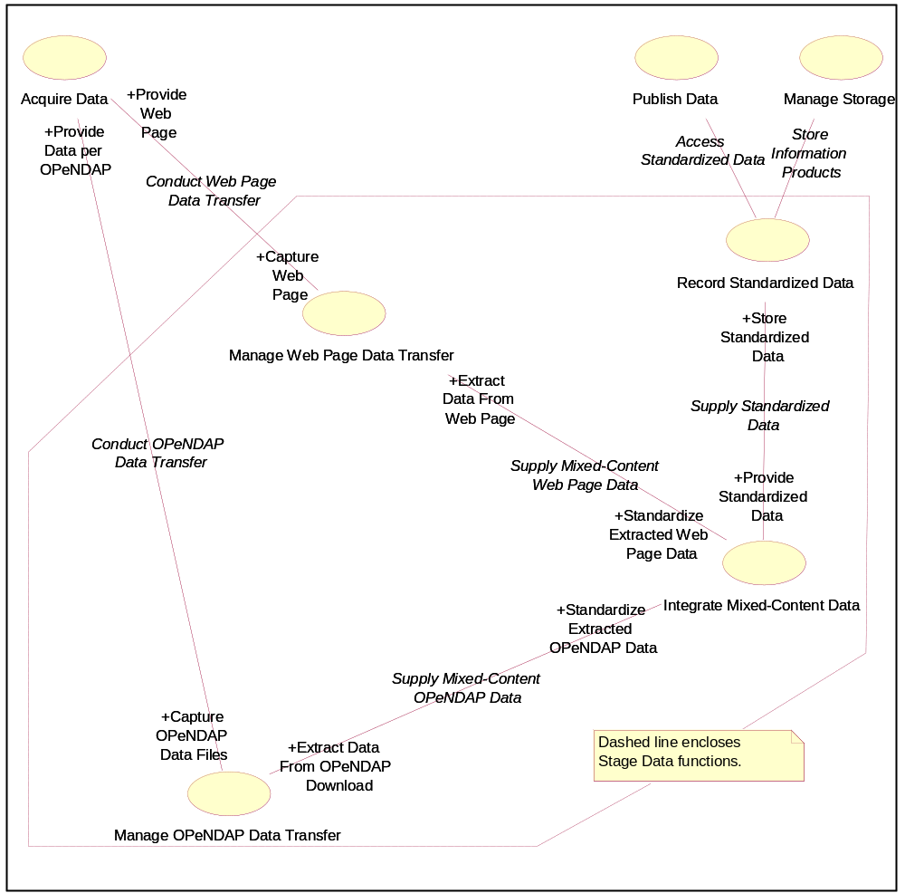
Figure 1-1. ICOOS IIS Level 2 Use Cases for "Stage Data."
The Level 2 use cases interact with each other through the following associations:
1. Conduct Web Page Data Transfer
2. Supply Mixed-Content Web Page Data
3. Supply Standardized Data
4. Conduct OPeNDAP Data Transfer
5. Supply Mixed-Content OPeNDAP Data
The Level 2 use cases and their associations represented in the diagram are discussed in the paragraphs below.

Manage Web Page Data Transfer (Use Case)
SUMMARY.
The functionality of this use case periodically connects with Data Warehouses that communicate data via web pages.
Incoming web page code is parsed for its data content. Observation data are copied out and are made available for standardization.
USE CASE #1.
Manage Web Page Data Transfer.
ACTORS.
Acquire Data (Level 1), Integrate Mixed-Content Data.
DESCRIPTION.
Check the predefined set of data providers. For each data provider, establish a communication link to be used at appropriate times consistent with the provider's update cycle. Bring the incoming web page code into a work area. Terminate the link when the data transfer is complete. Find mixed-content observation data within the web page code. Copy the mixed-content data and apply appropriate identification tags. Provide the mixed-content data to the Integrate Mixed-Content Data functionality.
PRECONDITIONS.
1. Identities of the data providers are known.
2. Communication channels between the Data Mart and the data providers are not established.
3. The physical means exists for establishing the communication channels.
4. The procedures for establishing the communication channels are known.
5. The Data Mart can acquire data using web page scraping processes.
6. The Manage Web Page Data Transfer function is idle until notified that the data channel is to be opened.
7. The observation data are embedded within the web page code.
8. Data embedded in the web page code are in mixed-content format.
POSTCONDITIONS.
1. Mixed-content observation data are separated from the web page code.
2. The mixed-content data are accessible for standardization.
3. The Manage Web Page Data Transfer functionality is ready to handle web page code from a new provider.
4. The connection to the data provider is closed when the data transfer is complete.
PRIORITY.
Manage Web Page Data Transfer is a Priority 1 function crucial to the operation of the first instantiation of the Data Mart prototype.
NORMAL COURSE.
Be idle while watching for indication that a web page data transfer is imminent. Determine the identity of the data provider to be contacted. When the proper time arrives, establish the communication channel with the data provider. Capture the incoming web page code. Close the connection with a data provider when the data transfer process is finished. Find observation data embedded in the web page code. Copy out the observation data. Make the observation data available for downstream processes. Clear internal processes. Return to idle.
ALTERNATIVE COURSES.
1. When data are missing from the web page code, flag the missing data.
2. If the web page code format has changed since the last access, flag the missing data.
3. When the data provider has changed in an unrecognizable way, terminate the connection process with this provider and initiate the connection process for the next provider at the appropriate time.
4. When the data provider is not available, terminate the connection process with this provider and initiate the connection process for the next provider at the appropriate time.
SPECIAL REQUIREMENTS.
1. No format or data requirements are to be propagated back to the web page provider.
2. Associate extracted data with appropriate identification information.
3. Provide indication when the processing of a web page processing is completed.
ASSUMPTIONS.
1. Web page formats change infrequently.
2. Error checking occurs in the communication services levels.
3. The identifications of data providers are known.
4. Each data provider is uniquely described for identification, address, interface protocol, contact times, and any other parameter relevant to establishing the communication channel within the Data Mart (searching is not required).
5. The population of data providers is small enough to avoid impacting time-based access.

Conduct Web Page Transfer (Association)
The functionality resident in Manage Web Page Data Transfer carries out data transfers with data providers that communicate using web pages.

Provide Web Page (Acquire Data Role)
Communication functions in Acquire Data assemble the web page code and send it to the ICOOS Data Mart when the data channel is opened.

Capture Web Page (Manage Web Page Data Transfer Role)
The Manage Web Page Data Transfer function stores the incoming web page code where it can be examined.

Supply Mixed-Content Web Page Data (Association)
Mixed-content data extracted from the web page code are made available for standardization in units of measure and numerical formats.

Extract Data From Web Page (Manage Web Page Data Transfer Role)
Mixed-content data are copied out of the web page code and associated with identification information in preparation for standardization.

Standardize Extracted Web Page Data (Integrate Mixed-Content Data Role)
The mixed-content web page data are made consistent with units and formats used by the Data Mart.

Integrate Mixed-Content Data (Use Case)
SUMMARY.
This functionality converts mixed-content data into the standardized units and formats used in the data repository. The standardized data are made available for storage in the data repository.
USE CASE #2.
Integrate Mixed-Content Data.
ACTORS.
Manage Web Page Data Transfer, Manage OPeNDAP Data Transfer, Record Standardized Data.
DESCRIPTION.
Watch for a signal from the Manage Web Page Data Transfer functionality or the Manage OPeNDAP Data Transfer functionality indicating that mixed-content data are available for standardization processing. Operate on the mixed-content data to make them consistent in units and formats with Data Mart standards policies. Indicate that the data are ready for storage when the standardization process is complete.
PRECONDITIONS.
1. Mixed-content observation data are ready for standardization processing.
2. ICOOS Data Mart standards policies are known and implemented in the integration functions.
3. The mixed-content observation data are associated with identifications.
POSTCONDITIONS.
1. The observation data are consistent with ICOOS Data Mart standards policies.
2. The standardized observation data are ready for storage.
PRIORITY.
Integrate Mixed-Content Data is a Priority 1 function crucial to the operation of the first instantiation of the ICOOS Data Mart prototype. It may require augmentation when new interfacing capabilities (such as OPeNDAP) are added.
NORMAL COURSE.
Watch for indication that mixed-content data are available for standardization processing. Convert the mixed-content observation data to standardized-content in accordance with ICOOS Data Mart standards policies. When standardization is complete, make the data available for storage.
ALTERNATIVE COURSES.
1. When the repository is absent, overwrite the previous standardized data.
ASSUMPTIONS.
None identified.

Supply Standardized Data (Association)
Incoming realtime observation data that conform to the Data Mart's standards policies are transferred to the data repository.

Provide Standardized Data (Supply Standardized Data Role)
Observation data consistent with Data Mart standards policies are made available for storage upon completion of the standardization process.

Store Standardized Data (Record Standardized Data Role)
Observation data consistent with Data Mart standards policies are made available for storage upon completion of the standardization process.

Conduct OPeNDAP Data Transfer (Association)
The functionality resident in Manage OPeNDAP Data Transfer carries out data transfers with OPeNDAP-capable data providers.

Provide Data Per OPeNDAP (Acquire Data Role)
When OPeNDAP protocol is in effect, data providers respond to data requests from the Data Mart by retrieving the requested data, assembling network-compatible files, and transmitting the data files to the ICOOS Data Mart.

Capture OPeNDAP Data Files (Manage OPeNDAP Data Transfer Role)
Functionality in Manage OPeNDAP Data Transfer issues OPeNDAP-compliant data queries and receives the resulting files sent by the data provider.

Manage OPeNDAP Data Transfer (Use Case)
SUMMARY.
This functionality controls the OPeNDAP capability of the ICOOS Data Mart. The functionality periodically connects with OPeNDAP-compliant data providers and issues requests. Data files are received and their observations are extracted. The observations are made available for standardization. The observations can be actual measurements or predictions.
USE CASE #4.
Manage OPeNDAP Data Transfer.
ACTORS.
Acquire Data (Level 1), Integrate Mixed-Content Data.
DESCRIPTION.
Check the predefined set of data providers. For each data provider, establish a communication link to be used at appropriate times consistent with the providers update cycle. Prepare the OPeNDAP-compliant data request. Send the OPeNDAP-compliant data request to the data provider. Receive requested data files. Bring the incoming files into a work area. Terminate the link when the data transfer is complete. Find mixed-content observation data within the data files. Copy out the mixed-content data and apply appropriate identification tags. Provide the mixed-content data to the Integrate Mixed-Content Data functionality.
PRECONDITIONS.
1. The Manage OPeNDAP Data Transfer functionality is idle until notified that the data channel is to be opened to an OPeNDAP-capable data provider.
2. For gridded data, the time window and rectangular geographic boundaries are known.
3. For discrete location data, the reporting station and time window are known.
4. Specific desired measurement types are known.
5. Files from the provider contain measurements in mixed-content formats.
6. Identities of the data providers are known.
7. Communication channels between the Data Mart and the data providers are not established.
8. The physical means exists for establishing the communication channels.
9. The procedures for establishing the communication channels are known.
10. The Data Mart can acquire data using OPeNDAP processes.
11. The observation data are contained in downloaded data files.
12. Data embedded in the web page code are in mixed-content format.
POSTCONDITIONS.
1. The mixed-content observation data are identified.
2. The mixed-content data are accessible for standardization.
3. The Manage OPeNDAP Data Transfer functionality is ready to handle OPeNDAP interfacing with a new provider.
4. The connection to the data provider is closed when the data transfer is complete.
PRIORITY.
Manage Web Page Data Transfer is a Priority 2 function behind the Priority 1 Manage Web Page Data Transfer function. Its purpose is to refine and advance the capabilities of the ICOOS Prototype that are initially established using the Priority 1 function.
NORMAL COURSE.
Be idle while watching for indication that an OPeNDAP interfacing is imminent. Determine the identity of the data provider to be contacted. When the proper time arrives, establish the communication channel with the data provider. Assemble a data request and sent it to the data provider. Capture the incoming data file sent by the provider in response to the request. Find observation data in the file. Copy out the observation data and associate with identifiers. Make the observation data available for downstream processes. Clear internal processes. Return to idle.
ALTERNATIVE COURSES.
1. When data are missing from the files, flag the missing data.
2. If the data provider does not respond to OPeNDAP queries, flag the failure, close the connection, clear internal processes, and return to idle.
SPECIAL REQUIREMENTS.
1. No format or data requirements are to be propagated back to the OPeNDAP data provider.
2. Associate extracted data with appropriate identification information.
3. Provide indication when the processing of OPeNDAP files is completed.
ASSUMPTIONS.
1. Error checking occurs in the communication services levels.
2. The identifications of data providers are known.
3. Each data provider is uniquely described for identification, address, interface protocol, contact times, and any other parameter relevant to establishing the communication channel within the Data Mart (searching is not required).
4. The population of data providers is small enough to avoid impacting time-based access.

Supply Mixed-Content OPeNDAP Data (Association)
Mixed-content data extracted from the OPeNDAP files are made available for standardization in units of measure and numerical formats.

Extract Data From OPeNDAP Download (Manage OPeNDAP Data Transfer Role)
Mixed-content data are copied out of the OPeNDAP files and associated with identification information in preparation for standardization.

Standardize Extracted OPeNDAP Data (Integrate Mixed-Content Data Role)
The mixed-content OPeNDAP data are made consistent with units and formats used by the Data Mart.

ETL Program Level 2 Analysis View
This section focuses on the Level 2 analysis view of the ETL Program within the ICOOS Data Mart. The analysis view depicts policies and processes as classes of objects constituting the business model (requirements) of the ETL Program.
Instantiations of the ETL Program Class periodically interface with data warehouses to request realtime observation data for stations within the area of interest (AOI). ETL programs acquire the web pages or OPeNDAP files provided by the warehouses, read out the observation data , and put the observations into the Data Mart's geospatial database.
Figure 2-2 graphically depicts the Level 2 classes arranged to show how they relate to one another inside the Level 1 ETL Program Class. The Level 2 classes of processes shown as component parts of the Level 1 ETL Program Class are:
1. Timer
2. Transformation Manager
3. Data Storage Interface
4. Relational Data Base Manager
5. Working Database
6. Loader
7. Web Page Scraper
8. Base Template
9. Scraper Settings
10. OPeNDAP Interface
11. OPeNDAP Base Template
12. OPeNDAP Settings
13. Extracted Observation
14. Web Page Interface
15. OPeNDAP
16 Geospatial Interface
Items 1 through 6 manage information flows. Items 7, 8, and 9 obtain observation data from web pages. Items 10, 11, and 12 obtain observation data from OPeNDAP file downloads. Item 13 describes the principal article sought by the ETL Program. Items 14 and 15 transport observations (actual and predicted) to the Data Mart. Item 16 is the gateway to the user-accessible geospatial database.
The classes are associated with one another through the following associations:
1. Initiates (an instantiation of the Timer Class starts an instantiation of the Transformation Manager Class)
2. Coordinates Actions of (an instantiation of the Transformation Manager Class coordinates the activities of an instantiation of the Data Storage Interface Class)
3. Coordinates ETL Activities of (a transformation manager coordinates operation of a web page scraper)
4. Acquires HTML Web Page From (an instantiation of the Web Page Scraper Class obtains a web page from an instantiation of the Data Warehouse Class)
5. Enables Web Page Parsing by (a base template tells a web page scraper where the observations are located on a web page)
6. Provides Extracted Observation to (a web page scraper makes its output available to a data storage interface)
7. Are Fetched by (#1) (scraper settings are retrieved from a Data Mart's relational database by a data storage interface)
8. Guide Operation of (#1) (scraper settings define how a web page scraper works with a particular data warehouse)
9. Is Created by (#1) (some extracted observations are created by a web scraper during web page parsing)
10. Exchanges Observation Data with (a data storage interface and a relational database manager conduct a two-way data flow between the ETL program and relational database)
11. Controls Operations of (the relational data base manager supervises the flow of data into and out of the working database)
12. Coordinates Activation of (the transformation manager starts the loader at the appropriate step of the sequence)
13. Obtains New Observations Data From (the loader queries the relational data base manager to get the latest realtime observations)
14. Coordinates ETL OPeNDAP Activities of (a transformation manager coordinates the activities of the OPeNDAP Interface process)
15. Enables File Parsing by (an OPeNDAP Base Template tells an OPeNDAP Interface where the observations are located in a downloaded OPeNDAP data file)
16. Provides Extracted Observation to (#2) (an OPeNDAP Interface makes its output available to a data storage interface)
17. Is Created by (#2) (some extracted observations are created by the OPeNDAP Interface)
18. Guide Operation of (#2) (OPeNDAP Settings define how an OPeNDAP Interface works with a particular data warehouse).

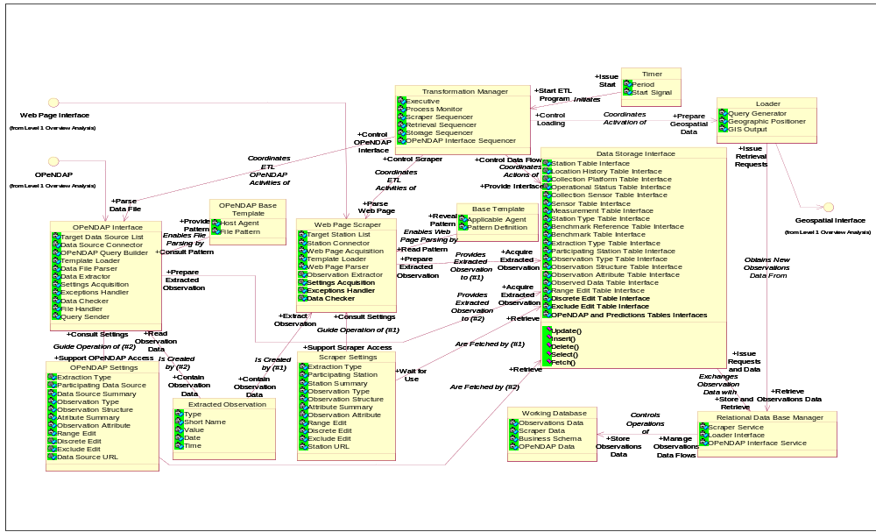
Figure 2-2. ICOOS IIS ETL Program Level 2 Classes.

Timer (Class)
Members of the Timer Class coordinate Data Mart observations acquisition activities with warehouse reporting cycles.
Warehouses collect observations from their stations at regular time intervals, then report them through their station web pages or OPeNDAP portals. Instantiations of the Timer Class are synchronized with the warehouse cycles.

Period (Timer Attribute)
The Period is how often the timer emits a signal to activate the Data Mart's warehouse connection processes. A period is determined from how often a warehouse's data store is populated with new realtime observations.

Start Signal (Timer Attribute)
The Start Signal tells members of the Transformation Manager Class to begin a new cycle of observations acquisition.

Initiates (Association)
The timer signals the transformation manager when it is time to start the ETL program processes.

Issue Start (Timer Role)
The timer issues the start signal when the time has arrived to begin ETL processing.

Start ETL Program (Transformation Manager Role)
The transformation manager starts the ETL program processing upon receipt of the start signal from the timer.

Transformation Manager (Class)
An instantiation of the Transformation Manager Class coordinates the internal operation of an ETL program. It supervises the extraction, transfer, and loading of observations from a web page or downloaded data file to the Data Mart relational database.
The transformation manager starts the data fetch operation upon receipt of a signal from the timer. The manager determines which interface functionality to activate (web page or OPeNDAP). The manager activates processes in the Data Storage Interface Class to retrieve operational settings from the Data Mart's relational database for loading into the web page scraper or the OPeNDAP Interface. It then starts scraper or OPeNDAP processes that load the base template, connect to a warehouse's station's URL, acquire the web page or data file, parse the web page or data file, create extracted observations, check the observation data, and manage responses to exceptions (such as a failed URL, a nonreporting station, missing observation data, and quality issues).

Executive (Transformation Manager Attribute)
The Executive watches for the timer signal, then activates the performance monitor and sequencers.

Process Monitor (Transformation Manager Attribute)
The Process Monitor checks for initializations and completions of processes in the ETL Program. The monitor issues an alert in response to an unexpected event in the ETL Program.
An example of an unexpected event is the noncompletion of a settings retrieval from the relational database.

Scraper Sequencer (Transformation Manager Attribute)
The Scraper Sequencer activates scraper processes in logical order.

Retrieval Sequencer (Transformation Manager Attribute)
The Retrieval Sequencer coordinates interface functions that retrieve scraper or OPeNDAP settings from the relational database.

Storage Sequencer (Transformation Manger Attribute)
The Storage Sequencer coordinates interface functions for storing extracted observations and associated information in the relational database.

OPeNDAP Interface Sequencer (Transformation Manger Attribute)
The OPeNDAP Interface Sequencer activates interfacing processes in logical order.

Coordinates Actions of (Association)
The transformation manager controls and monitors functions in the data storage interface to coordinate data flow activities with other ETL program actions.

Control Data Flow (Transformation Manager Role)
The transformation manager issues commands to the data storage interface to perform data flow operations consistent with the processing state of the scraper and OPeNDAP interface. Retrievals are performed to acquire settings, and database insertions are performed after the observations are extracted.

Provide Interface (Data Storage Interface Role)
The data storage interface functions carry out data flow operations between the ETL Program and the Relational Database Manager in response to commands from the transformation manager.

Data Storage Interface (Class)
The Data Storage Interface contains proxies that put observation data into, and retrieve settings from, the Data Mart's relational database. The proxies are activated by the transformation manager, web page scraper, and OPeNDAP interface. There is an interface proxy for each table in the relational database.

Station Table Interface (Data Storage Interface Attribute)
The Station Table Interface contains functions to insert, delete, update, select, and retrieve data stored in the Station Table in the Data Mart's relational database.

Location History Table Interface (Data Storage Interface Attribute)
The Location History Table Interface contains functions to insert, delete, update, select, and retrieve data stored in the Location History Table in the Data Mart's relational database.

Collection Platform Table Interface (Data Storage Interface Attribute)
The Collection Platform Table Interface contains functions to insert, delete, update, select, and retrieve data stored in the Collection Platform Table in the Data Mart's relational database.

Operational Status Table Interface (Data Storage Interface Attribute)
The Operational Status Table Interface contains functions to insert, delete, update, select, and retrieve data stored in the Operational Status Table in the Data Mart's relational database.

Collection Sensor Table Interface (Data Storage Interface Attribute)
The Collection Sensor Table Interface contains functions to insert, delete, update, select, and retrieve data stored in the Collection Sensor Table in the Data Mart's relational database.

Sensor Table Interface (Data Storage Interface Attribute)
The Sensor Table Interface contains functions to insert, delete, update, select, and retrieve data stored in the Sensor Table in the Data Mart's relational database.

Measurement Table Interface (Data Storage Interface Attribute)
The Measurement Table Interface contains functions to insert, delete, update, select, and retrieve data stored in the Measurement Table in the Data Mart's relational database.

Station Type Table Interface (Data Storage Interface Attribute)
The Station Type Interface contains functions to insert, delete, update, select, and retrieve data stored in the Station Type Table in the Data Mart's relational database.

Benchmark Reference Table Interface (Data Storage Interface Attribute)
The Benchmark Reference Table Interface contains functions to insert, delete, update, select, and retrieve data stored in the Benchmark Reference Table in the Data Mart's relational database.

Benchmark Table Interface (Data Storage Interface Attribute)
The Benchmark Table Interface contains functions to insert, delete, update, select, and retrieve data stored in the Benchmark Table in the Data Mart's relational database.

Extraction Type Table Interface (Data Storage Interface Attribute)
The Extraction Type Table Interface contains functions to insert, delete, update, select, and retrieve data stored in the Extraction Type Table in the Data Mart's relational database.

Participating Station Table Interface (Data Storage Interface Attribute)
The Participating Station Table Interface contains functions to insert, delete, update, select, and retrieve data stored in the Participating Station Table in the Data Mart's relational database.

Observation Type Table Interface (Data Storage Interface Attribute)
The Observation Type Table Interface contains functions to insert, delete, update, select, and retrieve data stored in the Observation Type Table in the Data Mart's relational database.

Observation Structure Table Interface (Data Storage Interface Attribute)
The Observation Structure Table Interface contains functions to insert, delete, update, select, and retrieve data stored in the Observation Structure Table in the Data Mart's relational database.

Observation Attribute Table Interface (Data Storage Interface Attribute)
The Observation Attribute Table Interface contains functions to insert, delete, update, select, and retrieve data stored in the Observation Attribute Table in the Data Mart's relational database.

Observed Data Table Interface (Data Storage Interface Attribute)
The Observed Data Table Interface contains functions to insert, delete, update, select, and retrieve data stored in the Observed Data Table in the Data Mart's relational database.

Range Edit Table Interface (Data Storage Interface Attribute)
The Range Edit Table Interface contains functions to insert, delete, update, select, and retrieve data stored in the Range Edit Table in the Data Mart's relational database.

Discrete Edit Table Interface (Data Storage Interface Attribute)
The Discrete Edit Table Interface contains functions to insert, delete, update, select, and retrieve data stored in the Discrete Edit Table in the Data Mart's relational database.

Exclude Edit Table Interface (Data Storage Interface Attribute)
The Exclude Edit Table Interface contains functions to insert, delete, update, select, and retrieve data stored in the Exclude Edit Table in the Data Mart's relational database.

OPeNDAP and Predictions Tables Interfaces(Data Storage Interface Attribute)
This is a placeholder entry reserving definitions of interfaces for predictions tables and OPeNDAP settings data.

Exchanges Observation Data with (Association)
This is a two-way data flow consisting of requests and data.

Issue Requests and Data (Data Storage Interface Role)
The data storage interface sends observation data and handling instructions to the relational database manager for storage or retrieval in the database.

Store and Retrieve (Relational Data Base Manager Role)
The relational data base manager stores data in accordance with instructions from the data storage interface. The database manager retrieves data in response to queries issued by the data storage interface.

Are Fetched by (#1) (Association)
Operational settings for the scraper that are stored in the Data Mart's relational database are retrieved by data storage interface functions and are made available for use by the scraper.

Retrieve (Data Storage Interface Role)
The data storage interface functions retrieve the scraper's operational settings from the relational database.

Wait for Use (Scraper Settings Role)
The scraper's operational settings are placed where the scraper can access them.

Are Fetched by (#2) (Association)
Operational settings for the OPeNDAP Interface that are stored in the Data Mart's relational database are retrieved by data storage interface functions and are made available for use by the OPeNDAP Interface.

Retrieve (Data Storage Interface Role)
The data storage interface functions retrieve the OPeNDAP Interface's operational settings from the relational database.

Wait for Use (OPeNDAP Settings Role)
The OPeNDAP Interface's operational settings are placed where the OPeNDAP Interface can access them.

Scraper Settings (Class)
The Scraper Settings consist of parameters that "dial in" the desired function mode of scraper processes and provide traceability to storage locations in the Data Mart. Scraper settings are stored in the Data Mart's relational database. They are retrieved from the database and installed before the scraper begins working with a station's web page code.
Some identification parameters in the settings are associated with the extracted observations during transfer from the scraper to storage. Examples are the participating station and observation type. Others tell the scraper how to perform certain quality control functions, like range checking.

Extraction Type (Scraper Settings Attribute)
The Extraction Type parameters link an observation with its cycle and processing type in the Data Mart. The scraper uses the type information to determine how to process the value parsed from the web page.

Participating Station (Scraper Settings Attribute)
The Participating Station parameter enables the scraper to find the station's URL. It is associated with extracted observations when they are turned over to the data storage interface.

Station Summary (Scraper Settings Attribute)
The Station Summary contains factors that relate a station's position and ID information at the time of the observations to the storage location in the relational database. It connects the observation to most of the significant descriptors of a station.
This information also accounts for station relocation due to its physical movement.

Observation Type (Scraper Settings Attribute)
The Observation Type is a logical link to the observation's name and description in the Data Mart's relational database.

Observation Structure (Scraper Settings Attribute)
Observation Structure consists of Data Mart internal flags that relate the observation to its description and tell where it is to be stored in the relational database.

Attribute Summary (Scraper Settings Attribute)
The Attribute Summary tells the scraper how many observations to look for.

Observation Attribute (Scraper Settings Attribute)
The Observation Attribute relates a particular observation to the specification of its name, type, units, resolution, precision, etc. within the Data Mart relational database.

Range Edit (Scraper Settings Attribute)
The Range Edit parameters enable the scraper to perform quality control range checking for each observation's value.

Discrete Edit (Scraper Settings Attribute)
The Discrete Edit parameters enable the scraper to check for reporting of allowable indicators in an observation.
Examples of allowable discrete indicators are found in the observation reporting wind direction. Two allowed discrete indicators are "S," for south and "SSW" for south-southwest.

Exclude Edit (Scraper Settings Attribute)
The Exclude Edit settings enable the scraper to recognize when an observation's contents indicate that no value exists.
Example:
Sometimes a station's web page observation column contains an entry like "999.99," or "-99," or "-" because no measurement value exists. The absence could be because the station is not equipped with the appropriate sensor, or that the sensor is malfunctioning.

Station URL (Scraper Settings Attribute)
The Station URL enables the scraper to connect to the data warehouse and acquire the web page for the target station.

OPeNDAP Settings (Class)
The OPeNDAP Settings consist of parameters that control the desired function mode of the OPeNDAP Interface and provide traceability to storage locations in the Data Mart. OPeNDAP settings are stored in the Data Mart's relational database. They are retrieved from the database and installed before the OPeNDAP Interface begins working with the data provider and the incoming data.
Some identification parameters in the settings are associated with the extracted data during transfer from the OPeNDAP Interface instantiation to storage. Examples are the data source and data type (actual observation or prediction). Others tell the OPeNDAP Interface instantiation how to perform certain quality control functions, like range checking.

Extraction Type (OPeNDAP Settings Attribute)
The Extraction Type parameters link an observation with its cycle and processing type in the Data Mart. The OPeNDAP Interface uses the type information to determine how to process the value parsed from the data file.

Participating Data Source (OPeNDAP Settings Attribute)
The Participating Data Source parameter enables the OPeNDAP Interface to find the data source's URL. It is associated with extracted observation and prediction data when they are turned over to the data storage interface.

Data Source Summary (OPeNDAP Settings Attribute)
The Data Source Summary contains factors that relate a data source's position and ID information (at the time of the observation or prediction) to the storage location in the relational database. It connects the observation or prediction to most of the significant descriptors of the data source.
This information also accounts for station relocation due to its physical movement, and differentiates between physical stations and models.

Observation Type (OPeNDAP Settings Attribute)
The Observation Type is a logical link to the observation's or prediction's name and description in the Data Mart's relational database. An Observation Type can be "actual" (for a realworld measurement) or "prediction" (for a model forecast).

Observation Structure (OPeNDAP Settings Attribute)
Observation Structure consists of Data Mart internal flags that relate the observation or prediction to its description and tell where it is to be stored in the relational database.

Attribute Summary (OPeNDAP Settings Attribute)
The Attribute Summary tells the OPeNDAP Interface how many observations or predictions to look for in a downloaded data file.

Observation Attribute (OPeNDAP Settings Attribute)
The Observation Attribute relates a particular observation or prediction to the specification of its name, type, units, resolution, precision, etc. within the Data Mart relational database.

Range Edit (OPeNDAP Settings Attribute)
The Range Edit parameters enable the OPeNDAP Interface to perform quality control range checking for each observation's or prediction's value.

Discrete Edit (OPeNDAP Settings Attribute)
The Discrete Edit parameters enable the OPeNDAP Interface to check for reporting of allowable indicators in an observation or prediction.
Examples of allowable discrete indicators are found in the observation reporting wind direction. Two allowed discrete indicators are "S," for south and "SSW" for south-southwest.

Exclude Edit (OPeNDAP Settings Attribute)
The Exclude Edit settings enable the OPeNDAP Interface to recognize when an observation's or prediction's contents indicate that no value exists.
Example:
Sometimes a downloaded OPeNDAP file data column contains an entry like "999.99," or "-99," or "-" because no measurement or predicted value exists. The absence could be because the station is not equipped with the appropriate sensor, the sensor is malfunctioning, or the model is configured to skip the prediction.

Data Source URL (OPeNDAP Settings Attribute)
The Data Source URL enables the OPeNDAP Interface to connect to the data warehouse, issue data queries, and acquire the data files for the targeted domain.

Guide Operation of (#1) (Association)
The settings are preset controls used by the scraper to define its operation.

Support Scraper Access (Scraper Settings Role)
The scraper settings are accessed by the scraper.

Consult Settings (Web Page Scraper Role)
The scraper refers to the settings to define its functions during operation.

Guide Operation of (#2) (Association)
The settings are preset controls used by the OPeNDAP Interface to define its operation. These may include pro forma data requests for specific observations in particular geographic areas.

Support OPeNDAP Access (OPeNDAP Settings Role)
The OPeNDAP settings are accessed by the OPeNDAP Interface.

(OPeNDAP Interface Role)
The OPeNDAP Interface refers to the settings to define its functions during operation.

Base Template (Class)
The Base Template describes the layout of a station's web page code. It is used by the web page scraper to find observations embedded in the code.
Normally, a single base template applies to all stations accessed through the same data warehouse. The warehouse usually creates all of its station's web pages to the same format.

Applicable Agent (Base Template Attribute)
The Applicable Agent is the entity (usually a data warehouse) responsible for implementing the stations' web page format.

Pattern Definition (Base Template Attribute)
The Pattern Definition tells the scraper where to look for observation data embedded in a station's web page code.

OPeNDAP Base Template (Class)
The OPeNDAP Base Template describes the layout of a warehouse's downloaded data file. It is used by the OPeNDAP Interface to find observation data in the file.

Host Agent (OPeNDAP Base Template Attribute)
The Host Agent is the entity (usually a data warehouse) hosting the OPeNDAP website.

File Pattern (OPeNDAP Base Template Attribute)
The File Pattern tells the OPeNDAP Interface where to look for observation data in the downloaded data file.

Enables Web Page Parsing by (Association)
The base template points to places in the web page code format where observation data can be found.

Reveal Pattern (Base Template Role)
The base template contains pattern information that can be read by the scraper to locate observation data in a station's web page code.

Read Pattern (Web Page Scraper Role)
The scraper uses references in the base template to find the places in the web page code where the observation data are stored.

Enables File Parsing by (Association)
The OPeNDAP Base Template tells the OPeNDAP Interface where to find observation data in the downloaded data file.

Consult Pattern (OPeNDAP Interface Role)
The OPeNDAP Interface uses the base template to find the observation data.

Provide Pattern (OPeNDAP Base Template Role)
The base template contains pattern information that can be read by the OPeNDAP Interface to locate observation data in the downloaded data file.

Coordinates ETL Activities of (Association)
The transformation manager controls and monitors functions in the web page scraper to coordinate scraper activities with other ETL program actions.

Control Scraper (Transformation Manager Role)
The transformation manager issues start and stop commands, and monitors the operating status of scraper functions.

Parse Web Page (Web Page Scraper Role)
The web page scraper contains functions that acquire a web page and copy out the observations embedded in the code. The functions are activated by the transformation manager. The scraper's constituent functions report their modes and statuses to the transformation manager.

Coordinates ETL OPeNDAP Activities of (Association)
The Transformation Manager controls and monitors functions in the OPeNDAP Interface to coordinate its activities with other ETL program actions.

Parse Data File (OPeNDAP Interface Role)
The OPeNDAP Interface contains functions that capture an incoming observation data file and copy out the observations data. The functions are activated by the transformation manager. The OPeNDAP Interface's constituent functions report their modes and statuses to the transformation manager.

Control OPeNDAP Interface (Transformation Manager Role)
The transformation manager issues start and stop commands, and monitors the operating status of the OPeNDAP Interface functions.

Web Page Scraper (Class)
The purpose of each instantiation of the Web Page Scraper Class is to copy the realtime observations from a station's web page and make them available for storage in the Data Mart's relational database.
A scraper is controlled by a transformation manager that starts the processing in response to a timing signal. For each station web page, the manager configures the scraper with operational settings retrieved from the relational database. The scraper connects to the station's data warehouse to obtain the web page code containing the station's realtime observations. Using the base template describing the web page's pattern, the scraper parses the web page code to create extracted observations formatted for efficient handling by Data Mart processes. The extracted observations are handed over to the data storage interface for placement into the Data Mart relational database.

Target Station List (Web Page Scraper Attribute)
The Target Station List defines the web page domain dedicated to a particular instantiation of the Web Page Scraper Class. The scraper acquires the web page for each station in the list.

Station Connector (Web Page Scraper Attribute)
The Station Connector uses a station's URL to bring the station's web page code into the Data Mart.

Web Page Acquisition (Web Page Scraper Attribute)
The Web Page Acquisition process captures the station's incoming web page code into a logic work area where it can be interpreted by other scraper functions.

Template Loader (Web Page Scraper Attribute)
The Template Loader finds the base template applicable to the target station and aims the parsing functions at the realtime observation data embedded in the web page code.

Web Page Parser (Web Page Scraper Attribute)
The Web Page Parser segregates the observation data from the web page code.

Observation Extractor (Web Page Scraper Attribute)
The Observation Extractor places the parsed observation data into a format compatible with data handling functions in the Data Mart. The extractor creates instantiations of the Extracted Observation Class.

Settings Acquisition (Web Page Scraper Attribute)
The Settings Acquisition process positions the settings parameters for use by scraper functions.

Exceptions Handler (Web Page Scraper Attribute)
The Exceptions Handler detects missing web pages, nonreporting stations, absent data, web page format changes, and other lapses of essential functions. It sets indications that direct the scraper's subsequent operations.
Subsequent operations include moving on to the next station if a web page is missing, inserting fillers when observations are missing, and flagging a station when its web page format is inconsistent with the base template.

Data Checker (Web Page Scraper Attribute)
The Data Checker performs quality tests on extracted observations to detect errors, range limit violations, and statistical anomalies.

OPeNDAP Interface (Class)
Instantiations of the OPeNDAP Interface Class obtain data files from OPeNDAP-enabled providers and make their contents available for storage in the Data Mart's relational database. The OPeNDAP Interface Class deals with two types of observation data: actual and predictions.
An OPeNDAP Interface instantiation is controlled by a transformation manager that starts the processing in response to a timing signal. For each OPeNDAP-enabled data provider, the manager configures the OPeNDAP Interface instantiation with operational settings retrieved from the relational database. The settings enable connection, query, and data receipt in accordance with the OPeNDAP protocol.
Using the base template describing the data files' patterns, the OPeNDAP Interface extracts actual or predicted observation data in a format that expedites efficient handling by Data Mart processes. The extracted data are handed over to the data storage interface for placement into the Data Mart relational database.

Target Data Source (OPeNDAP Interface Attribute)
The Target Data Source List defines the web page domain dedicated to a particular instantiation of the OPeNDAP Interface Class. The OPeNDAP Interface queries each data provider in the list to obtain actual and predicted observation data files.

Data Source Connector (OPeNDAP Interface Attribute)
The Data Source Connector uses a web URL to activate the data provider's OPeNDAP functionality.

OPeNDAP Query Builder (OPeNDAP Interface Attribute)
The OPeNDAP Query Builder assembles the OPeNDAP data request.

Template Loader (OPeNDAP Interface Attribute)
The Template Loader finds the base template applicable to the target data provider and aims the parsing functions at the observation data embedded in the downloaded data files.

Data File Parser (OPeNDAP Interface Attribute)
The Data File Parser finds the observation data in the downloaded data files.

Data Extractor (OPeNDAP Interface Attribute)
The Observation Extractor places the parsed observation data into a format compatible with data handling functions in the Data Mart. The extractor creates instantiations of the Extracted Observation Class.

Settings Acquisition (OPeNDAP Interface Attribute)
The Settings Acquisition process positions the settings parameters for use by OPeNDAP Interface functions.

Exceptions Handler (OPeNDAP Interface Attribute)
The Exceptions Handler detects missing data in downloaded data files, nonreporting data providers, data file format changes, and other lapses of essential functions. It sets indications that direct the OPeNDAP Interface's subsequent operations.
Subsequent operations include moving on to the data provider if there is no OPeNDAP response, inserting fillers when observations are missing, and flagging a data provider when its downloaded data file is inconsistent with the base template.

Data Checker (OPeNDAP Interface Attribute)
The Data Checker performs quality tests on extracted observations to detect errors, range limit violations, and statistical anomalies.

File Handler (OPeNDAP Interface Attribute)
The File Handler captures incoming OPeNDAP files and places them in working areas for parsing and data extraction.

Query Sender (OPeNDAP Interface Attribute)
The Query Sender sends the OPeNDAP data request to the OPeNDAP-enabled data provider.

Is Created by (#1) (Association)
The extracted observation is created by the scraper during web page parsing.

Extract Observation (Web Page Scraper Role)
The scraper creates the extracted observation upon copying out the data in the web page code, as specified by the base template and scraper settings.

Contain Observation Data (Extracted Observation Role)
The extracted observation contains the name-value pair extracted from the web page code.

Is Created by (#2) (Association)
The extracted observation is created by the OPeNDAP Interface during data file parsing.

Read Observation Data (OPeNDAP Interface Role)
The OPeNDAP Interface creates the extracted observation upon copying out the data in the downloaded file.

Contain Observation Data (Extracted Observation Role)
The extracted observation contains the name-value pair extracted from the downloaded data file.

Extracted Observation (Class)
Extracted Observations are created by the web page scraper and the OPeNDAP Interface. Each extracted observation is formatted to enable efficient handling by Data Mart processes.
The ICOOS IIS deals with two basic types of observations: "actual" and "predicted." An extracted observation is either an actual measurement or an output of a predictive model.
Extracted observations are associated with certain settings (like participating station and observation type) to facilitate handling and storage. Extracted observations are passed by the scraper or OPeNDAP Interface to the data storage interface for handoff to the relational database where they are stored and accessed for 30 days.
An observation may have different names, depending on the provider. When there are two or more names for the same observation, the ICOOS IIS normalizes the different names to a common vernacular.

Type (Extracted Observation Attribute)
The Type is either "actual" or "prediction." The Type designator indicates whether an extracted observation is the result of an actual measurement of conditions or is the output of a predictive model.

Short Name (Extracted Observation Attribute)
The Short Name is the name of the observation. When there are two or more names for the same observation, the ICOOS IIS normalizes the different names to a common vernacular.

Value (Extracted Observation Attribute)
The Value is the quantitative measurement reported by an observation.
For an "actual" observation, it is the reading of a measurement reported by a sensor and recorded by an instantiation of the Data Collection Package Class (see the Level 1 diagram in the Logical View folder) when assembling observations from measurements and timing marks.
For a "prediction," it is the calculated quantity output by a forecasting model.

Date (Extracted Observation Attribute)
The Date is the year, month, and day of the observation.
For an "actual" observation, it is originally recorded by an instantiation of the Data Collection Package Class when assembling observations from measurements and timing marks.
For a "prediction," it signifies when in the future the observation will assume the expected quantity.

Time (Extracted Observation Attribute)
The Time tells when the observation is made. It consists of hours, minutes, seconds, and time zone.
For an "actual" observation, time is originally recorded by an instantiation of the Data Collection Package Class when assembling observations from measurements and timing marks.

For a "prediction," it signifies when in the future the observation will assume the expected quantity.

Provides Extracted Observation to (#1) (Association)
The scraper is a source of observation data that gets stored by the data storage interface.

Prepare Extracted Observation (Web Page Scraper Role)
The scraper places the extracted observation in a place and format accessible to data storage interface functions.

Acquire Extracted Observation (Data Storage Interface Role)
The data storage interface transfers the extracted observation into a form that can be handled by the relational database manager.
This can involve copying observation data into the right places in pre-canned database storage commands.

Provides Extracted Observation to (#2) (Association)
The OPeNDAP Interface is a source of observation data that gets stored by the data storage interface.

Prepare Extracted Observation (OPeNDAP Interface Role)
The OPeNDAP Interface places the extracted observation in a place and format accessible to data storage interface functions.

Acquire Extracted Observation (Data Storage Interface Role)
The data storage interface transfers the extracted observation into a form that can be handled by the relational database manager.
This can involve copying observation data into the right places in pre-canned database storage commands.

Relational Database Manager (Class)
The relational data base manager is responsible for the operation of the ETL internal working database.

Scraper Service (Relational Database Manager Attribute)
The Scraper Service interfaces with the Data Storage Interface function for storing observations data and retrieving scraper settings.

Loader Interface (Relational Database Manager Attribute)
The Loader Interface supports the receiving of retrieval requests from the loader and providing newly acquired observations data to the loader.

OPeNDAP Interface Service (Relational Database Manager Attribute)
The OPeNDAP Interface Service interfaces with the Data Storage Interface function for storing observations data and retrieving OPeNDAP Interface settings.

Controls Operation of (Association)
Observation data flow into and out of the ETL internal working database under control of the relational data base manager.

Manage Observations Data Flows (Relational Database Manager Role)
The relational database manager operates the data storage and retrieval activities of the ETL internal working database.

Store Observations Data (Working Database Role)
The working database stores and provides data as required by the relational database manager.

Working Database (Class)
The ETL internal working database temporarily stores observation data collected by the scraper and OPeNDAP Interface. After the scraper or OPeNDAP Interface completes its run, the data are retrieved by the loader for association with location and geospatial format descriptors. The database also contains settings that control operation of the scraper and OPeNDAP Interface. The working database resides within the ETL Program and is not visible to outside users.

Observations Data (Working Database Attribute)
Observations data extracted from data warehouse web pages or OPeNDAP files are stored until needed by the loader. At this stage, the observations are considered to be "business" data, not "geospatial" data.

Scraper Data (Working Database Attribute)
Settings needed to control scraper operations are stored in the ETL internal working database.

Business Schema (Working Database Attribute)
The Business Schema describes the internal organization of the working database into data tables and data formats.

OPeNDAP Data (Working Database Attribute)
Settings needed to control OPeNDAP Interface operations are stored in the ETL internal working database.

Loader (Class)
Loader functions create geospatial data by associating the new incoming observations stored in the ETL internal working database with position and format information. The loader then provides the geospatial data to the Data Mart's geospatial database manager for storage in the geospatial database. The transformation manager starts the loader functions after the scraper has completed its task.

Query Generator (Loader Attribute)
The Query Generator issues retrieval requests to the ETL internal working relational database manager. Its purpose is to bring up the newly acquired observations data for use by the Geographic Positioner.

Geographic Positioner (Loader Attribute)
The Geographic Positioner converts the newly acquired observations data into geospatial data by associating the observations with geographic position and GIS format parameters.

GIS Output (Loader Attribute)
The GIS Output is the interface between the ETL Program and the Data Mart's geospatial database. GIS Output provides geospatially formatted realtime data to the geospatial database manager with storage instructions.

Coordinates Activation of (Association)
The transformation manager controls and monitors functions that transfer observation data from the working database to the geospatial database.

Control Loading (Transformation Manager Role)
Loader functions are run after new observation data are placed into the ETL internal working database.

Prepare Geospatial Data (Loader Role)
Loader functions associate data residing in the ETL internal working database with location and formatting information. The resulting associated data are loaded into the geospatial database for access by clients.

Obtains New Observations Data From (Association)
The loader functions obtain the latest observation data from the ETL internal working database.

Issue Retrieval Requests (Loader Role)
Loader functions query the ETL internal working database to obtain the latest observation data.

Retrieve Observations Data (Relational Database Manager Role)
Functions in the ETL internal working database provide the latest observation data in response to queries from the loader functions.

Geospatial Interface (Class)
The Geospatial Interface enables instantiations of the ETL Program Class to provide geospatial data to the Data Mart's Geospatial Data Repository for storage and to support data requests from users.
Storage instructions and incoming geospatial data are passed to the geospatial database manager by the loader functions via the Geospatial Interface.

Geospatial Data Repository Level 2 Analysis View
This section focuses on the Level 2 analysis view of the Geospatial Data Repository within the ICOOS Data Mart. The analysis view depicts policies and processes as classes of objects constituting the business model (requirements) of the Geospatial Data Repository.
The Level 2 classes shown in Figure 3-3 are
1. Geospatial Database Manager
2. Geospatial Database
3. Geospatial Interface
4. Web Feature Service
The classes are associated with one another through the following association:
1. Controls Operations in (an instantiation of the Geospatial Database Manager manages the data inflows and outflows of an instantiation of the Geospatial Database)
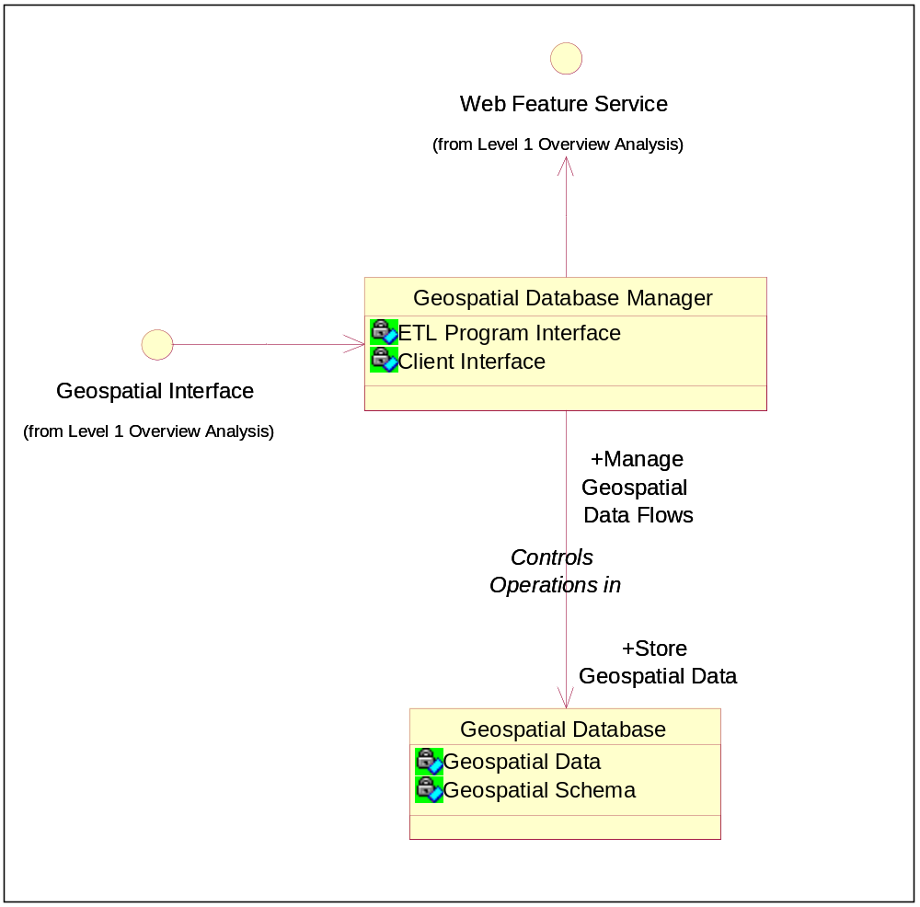
Figure 3-3. ICOOS IIS Geospatial Data Repository Level 2 Classes.

Geospatial Database Manager (Class)
The geospatial database manager is responsible for the operation of the Data Mart's geospatial database

ETL Program Interface (Geospatial Database Manager Attribute)
The ETL Program interface supports the loader by receiving geospatial data and responding to storage instructions.

Client Interface (Geospatial Database Manager Attribute)
The Client Interface receives data requests from clients and provides the requested data for transmittal to clients.

Geospatial Interface (Class)
This is a shared interface discussed in Paragraph 2.32.

Controls Operations in (Association)
Geospatial database manager functions supervise operations within the Data Mart's geospatial database.

Manage Geospatial Data Flows (Geospatial Database Manager Role)
Functions of the geospatial database manager oversee data flows of into and out of the geospatial database.

Store Geospatial Data (Geospatial Database Role)
The geospatial database stores and provides geospatial data as required by the geospatial database manager.

Geospatial Database (Class)
The geospatial database stores all observation data collected by the ETL Program. This database is visible to ICOOS users through the geospatial database manager.

Geospatial Data (Geospatial Database Attribute)
The Geospatial Data consist of "realtime" observations and predicted observations, and are stored for up to 30 days.

Geospatial Schema (Geospatial Database Attribute)
The Geospatial Schema describes the internal organization of the geospatial database into tables and data formats.

Web Feature Service (Class)
Geospatial data gathered by the ICOOS Data Mart are provided to Data Users via the Web Feature Service (WFS) interface.
Glossary
Acronym or Nomenclature | Definition
AOI | Area of Interest
ETL | Extract, Transfer, and Load
ICOOS | Integrated Coastal and Ocean Observations System
IIS | Integrated Information System
NCO | Network Centric Operations
NCO/P&T | Network Centric Operations Programs and Technologies
NOAA | National Oceanic and Atmospheric Administration
NTDE | National Tidal Data Epoch
UML | Unified Modeling Language
URL | Uniform Resource Locator
WA | Washington (state)
WFS | Web Feature Service

