Dambreak
Catalog Reviewer and ESTimator (DamCREST)
Quick User’s Guide

November 10, 2004
NWS Office of Hydrologic Development

This document provides an overview of the DamCrest application for the purpose of enabling a new user to test the application.

1.0 Overview

The DamCREST application is an interactive tool which allows the forecast to review the results of previously generated estimates of the flooding which results from a dam break incident. It also allows the user to run the Simplified DamBreak model to generate new forecasts of dam break scenarios. When reviewing the previous results, the user is reviewing information stored in a catalog of information stored in a relational database. When executing the model, the user can extract information from the catalog for use as input, and output results are generated. These results can be stored in the catalog for future use.

1.1 Database Specifications

DamCREST uses the AWIPS Informix Relational Database Management System and is located in the Informix database as dc_ob5xxx, where xxx - the office identifier. The Relational structure for dc_ob5xxx is comprised of 7 tables:

Table Description Key

dammaster Master table nidid
damfeatures Features for each dam nidid
damreservoir Dam’s reservoir info nidid, type, elevation (currently empty)
downstream Dam’s downstream points nidid, down_name
sdbin SMPDBK model input nidid, src, scenario
sdbout SMPDBK model output nidid, down_name, src, scenario
sectionpair Channel cross-section pairs nidid, down_name, pair_num, xsec_type

For every table, the unique identifier key includes the National Inventory of Dams identifier (nidid).

These tables contain information on primary dam attribute fields (dammaster) and additional dam physical data about dam (damfeatures); both these tables contain one entry for each dam. Also included are information about downstream location (downstream) and cross-section (sectionpair) data. The Simplified DamBreak (SMPDBK) model input data (sdbin) and output data (sdbout) are stored. Lastly, a table containing reservoir capacity information (damreservoir) is provided, although it is empty and intended for future use.

New dams can be added to the catalog, existing dams can be deleted from the catalog, a dam can be copied (i.e. cloned) under a newly created nidid, and dam data can be edited.

1.2 Starting DamCREST

Launch the application by executing the script run_damcrest. This script is executed by selecting Dam Catalog from the AWIPS menu systems.

If the DamCREST application is properly installed, the user will see the following set of messages in the DamCREST standard output window (background window):

“User has DAMCAT”.
“Found sdbj.LX”.
“Found JClass components”
“Found FLDAT components.”
“Initializing DAMCAT Search Tool…”

If any negative messages are displayed such as “Could not find…”, the corresponding settings must be checked and changed, and the application must be restarted. Continue this until all messages are positive.

Upon startup, the “Search Results” list will display all dams existing in the database if the “damcrest.hasListAllDams” token is set to “true”. This and all tokens are controlled by the Application Defaults system (.Apps_defaults and .Apps_defaults_site files) used by the Hydrologic software. If the token is not set to true, then the empty “Search Results” list will be displayed. The token is set to “true” by default.

1.3 Application Modes

The DamCrest application has four primary interface windows, each of which comprises an operational mode. The name of the interface window is listed below, followed by a brief functional description. Each mode is discussed in the following sections.

1) DamCat – Search Tool => Also called the Lookup Mode window, it is the initial window that lists dam(s), allowing the user to filter and search for individual dams. The other 3 windows can be accessed from this window.

2) DamCat – DamView - <dam identifier> => This is the Tabular Update Mode, which allows the user to directly edit the Dam Catalog data using a tabular-based interface.

3) Output Manager => Provides the user the means to view the output data from the catalog and model runs using various user-friendly displays.

4) Model Input Editor – Database Mode – Editing DamCat Entry - <dam identifier> => This allows an easy method for managing the input data for the Simplified Dam Break Model.
2. Lookup Mode

“DAMCAT - Search Tool” window is the first window to be displayed The Lookup mode (“DAMCAT – Search Tool” window) filters a subset of dams or a particular dam, or it can display a list of all dams in the catalog.

2.1 Main Window Components

The program begins with the “DAMCAT – Search Tool” window, with the following components:
- search categories drop-down combo box
- search criteria drop-down combo box
- search text field
- buttons “More” and “Fewer”
- set of buttons “Search”, “List All Dams”, “Clear Search Fields”, “Create New Dam”, “Clone A Dam” (grayed), “Delete A Dam” (grayed)
- Search Results; contains a list of search results
- set of buttons “Edit Dam Data” (grayed), “View Forecast Info” (grayed), “Run SMPDBK Model” (grayed), “Print”, and “Quit”.

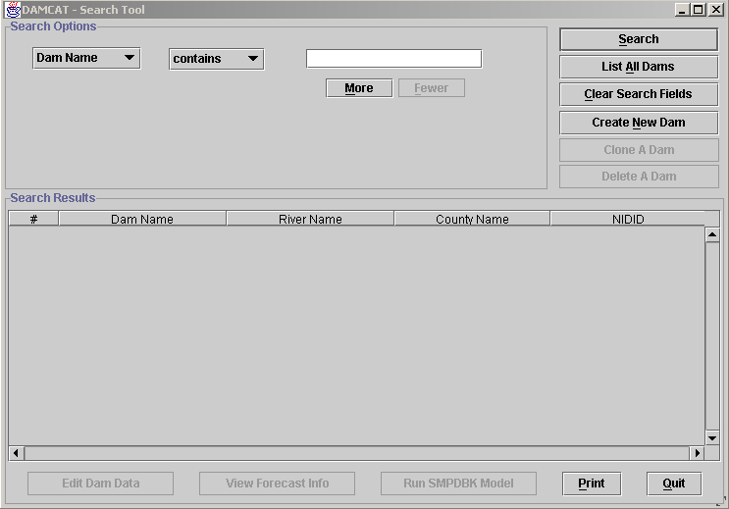

Figure 1. "DAMCAT - Search Tool" window initial screen.
2.2 Search Options

The search categories drop-down combo box contains the following search categories: “Dam Name”, “River Name”, County Name”, “NIDID”, “HSA”, “RFC”, “DH”, “Max Storage”, “Longitude”, “Latitude”.

The search options drop-down combo box contains the following search options for the string fields: “contains” and “equals”. For the numeric fields, the following search options are available: “equals”, “is greater than”, “is less than”, “is between”.

In the search text field, a string or substring is needed, or the numeric value on which the search is provided. The buttons “More” and “Fewer” provide the ability to combine several different fields to define search criteria. The user may choose the search field in the search categories drop-down combo box, or may choose option in the search options drop-down combo box, then click on the button “More”. A new set of combo boxes and a search field will be displayed to allow the user to choose another search criterion. Up to three different criteria could be combined for one search. By clicking on the button “Fewer” the number of search combo boxes will be reduced by one row.

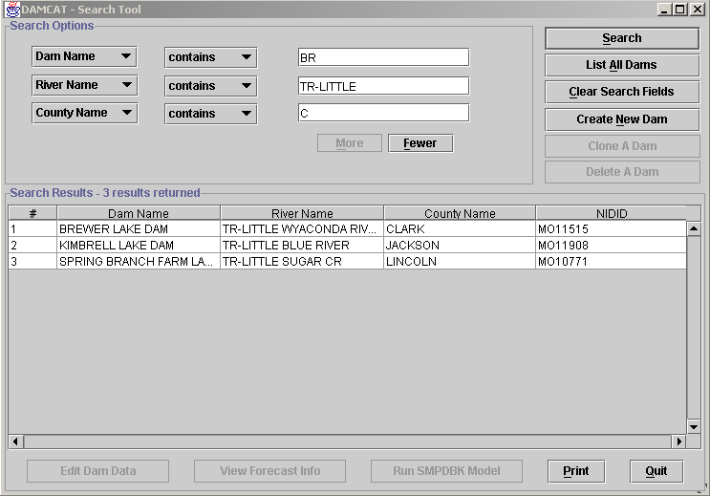

Figure 2. "DAMCAT - Search Tool" window, the "More" button was clicked to display more search options.
When the “Search” button is clicked, the database search is conducted, and the result is displayed in the “Search Results” list. The number of returned dams is included in the “Search Results” list header, as in: “Search Results – “[number of dams] results returned”.

Search results are listed in alphabetical order of the “Dam Name” by default. The user may click on any of the following column names – “Dam Name”, “River Name”, “County Name”, “NIDID” or “#” to change the order of the results list. When the “#” field is chosen, the list will be ordered alphabetically by the “Dam Name” because the serial numbering of the data is alphabetically based.

With a click on the “Clear Search Fields”, the search fields will be cleared and a new search can be conducted. The search results box may initially be populated or may be empty, depending on how the damcrest.hasListAllDams token is set. Not listing all the dams allows the window to display quicker.

2.3 List All Dams

When the “List All Dams” button is selected, the list of all dams in the database is returned. If the application is configured to list all dams at startup, the tool will automatically search the database and display the results.

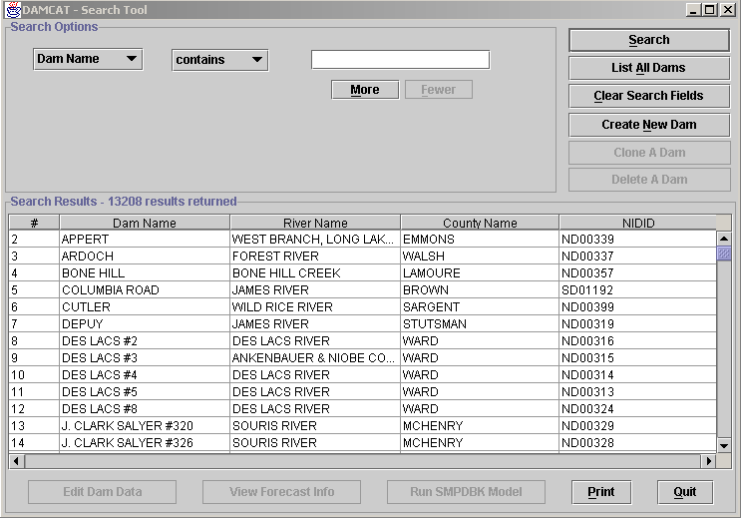
Figure 3. "List All Dams" button results in a query of all records.
2.4 Creating New Dam

When the "Create New Dam" button is selected, a dialog window prompts
the user to pick a state in the combo box where a new dam should be created. A new NIDID is calculated by the program and has the format “SS99nnn” where the first two characters (SS) are a state abbreviation supplied by the user, the next two characters (99) indicate that a new dam is created manually, and a number of this dam in the particular state (nnn) is an integer number.

With a click on “OK” in the “Choose a State” dialog window, an empty set of data, with string data fields empty or defaults set to 0.0 for numeric fields, is added to the database. This record is added to the DamMaster and DamFeatures tables in the DamCatalog database; no other data are created. After selecting the state, the user is placed in the Tabular Edit Mode.

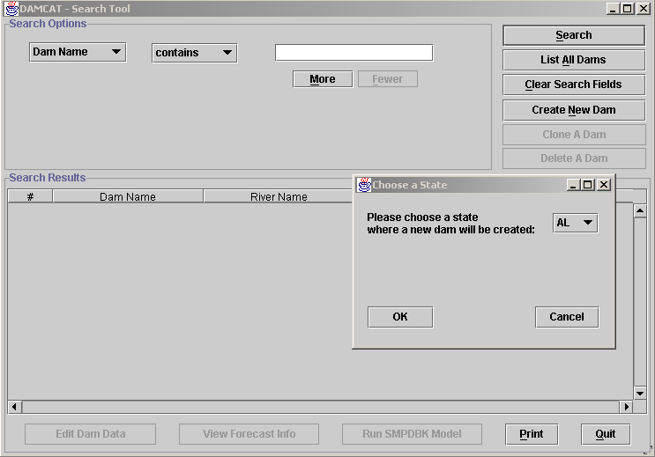

Figure 4. "Create New Dam" button selected, a dialog window prompts the user to pick a state in the combo box where a new dam should be created.

2.5 Working With An Individual Dam

A particular dam should then be highlighted in the “Search Results” list. When a particular dam is highlighted, all desensitized (i.e. grayed) buttons are enabled. These buttons include:

- Clone A Dam
- Delete A Dam

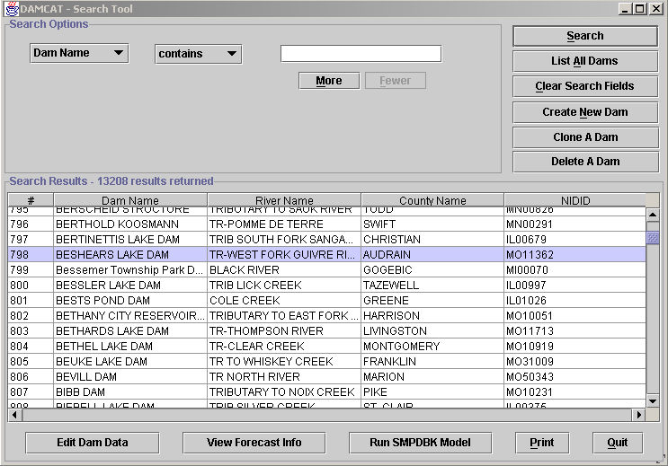

Figure 5. A dam in the list of returned results is highlighted.

    - Cloning a Dam

When the “Clone A Dam” is selected, the dam highlighted in the list of
dams is cloned (copied with all data) with a new nidid identifier. Similar to when a new dam is created, the user is prompted to select a state and the new dam is assigned a number. The user is then placed in the Tabular Edit Mode. This record could then be updated and saved.

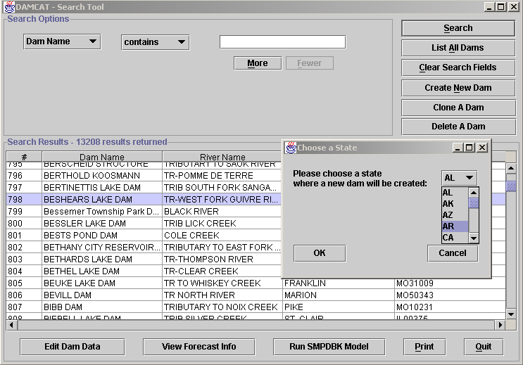
Figure 6. A highlighted dam will be cloned - all information of the highlighted dam will be copied to a newly created dam and saved in the database.

2.5.2 Deleting a Dam

When “Delete A Dam” is clicked for a highlighted dam in the “Search Results”, a confirmation dialog window is displayed. The corresponding dam will be deleted from the database after the user confirms deleting the chosen dam. The “Search Results” list will be updated immediately.

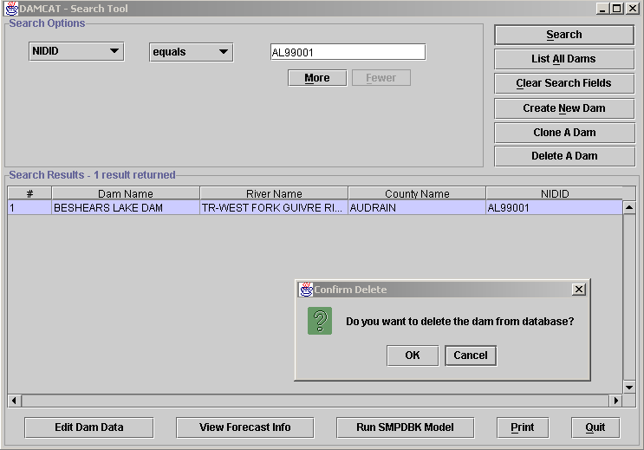

Figure 7. If confirmation is received, the dam is deleted from the database.

2.6 Entering Other Modes for Selected Dam

For a particular dam that is highlighted, the user can enter other modes and operate on the data for the dam by selecting other buttons. These modes go into more depth later with figures.

- Edit Dam Data
- View Forecast Info
- Run SMPDBK Model

2.6.1 Edit Dam Data

With a click on the “Edit Dam Data” the user is navigated to the Tabular Update mode. The “DAMCAT – Dam View – [dam NIDID] multiple tab window is displayed. The “General” tab is opened by default.

2.6.2 View Forecast Info

When the “View Forecast Info” button is clicked, the “Output Manager” window is opened on the “Stored Forecast Text” tab by default, and results of the last model run stored in the database are displayed if they exist.

If the SMPDBK dam break model was never run on this particular dam or results of the model run were never saved to the database, the message “No stored forecast in the database, the model should run first” is displayed. With a click on the “OK” button, the model will run, and more windows: “Model Input Editor” and “Output Manager” will be opened.

To save this model run results to the database, the user must either: a) choose the “Update Database” menu item under the “Database” menu or, b) choose the “yes” button in the dialog box with the message “Do you want to save changes to the database?” which will appear when “Close” menu item is chosen under the “Database” menu. In both cases the message “Successfully updated database entry [dam NIDID]” is displayed, and these first time model run results will be stored to the database.

When the next time the button “View Forecast Info” is clicked for this particular dam, the “Output Manager” window will be opened on the “Stored Forecast Text” tab. If the set of input to the model parameters is not fully presented or some of them are invalid, the user will be provided steps to fix it and run the model.

2.6.3 Run SMPDBK Model

When the “Run SMPDBK Model” button is clicked, the “Model Input Editor” and “Output Manager” windows are opened. The model is run, and results are displayed in the “Output Manager” window. After closing the “Output Manager”, the user stays in the “Model GUI” window. With attempt to close the “Model Input Editor” window, the user will be asked to save changes to the database. If the “Yes” button is chosen, the message “Successfully updated database entry [dam NIDID]” is displayed, and model run results will be stored to the database and any changes will be saved. If the “No” button is chosen, no changes will be stored.

Note: The input data set to the model is fully presented, but some input parameters may be revised by the model and changed. In this case the warning message is displayed on the screen. To continue, the “OK” button should be clicked. The warning message is displayed one per corresponding scenario. After running all scenarios, the model run results will be displayed in the “Output Manager – most recent model run” window, as with the previously described case.

2.7 Printing Search Results

When the “Print” button is clicked, the “Search Results” table in the “DAMCAT - Search Tool” window is sent to the printer.

2.8 Exiting DamCREST

When the “Quit” button is clicked, the application exits.

3. Tabular DB Update Mode

The “DAMCAT – Dam View” window (Tabular DB Update mode) is designed to allow the user to update, insert, and delete dams, new downstream points, and new cross-sections. Any changes made are saved to the Dam Catalog database. This mode can be entered after a particular dam is highlighted in the list of the returned results, and by the user double clicking on the selected dam or single-clicking on the “Edit Dam Data” button.

The Tabular DB Update mode is intended for the more advanced user, one who is familiar not only with the hydrology of the application, but also with the database behind the application interface. Based on this assumption, the maximum amount of data is exposed and available to the user in this window. It is best if the user understands the scientific SMPDBK model itself and the relationship between the data before changing/inserting/deleting data by way of these screens.

Note that the database key fields are not editable. The “updated” time field is also not editable. It is automatically set by the DamCREST software to contain the current date/time when the database table is modified.

3.1 Tabs for Tabular Update mode

The information is presented in different groups, accessible by selecting the “tabs” near the top of the interface. The tabs available and the database tables for which they display data are:

a) General – contains informational data of the dam, information under this tab is displayed by default when the window is opened. (DamMaster, DamFeatures)

b) Construction – contains technical information of the dam and reservoir. (DamFeatures)

c) Regulatory – contains the owner, inspection, type of agency information, etc. (Dam Features)

d) Downstream – contains data about downstream point.(Downstream)

e) Cross Sections – contains cross - section pair data. (SectionPair)

f) Input – contains input data to the model. (SdbIn)

g) Output – contains output data of the model run. (SdbOut)

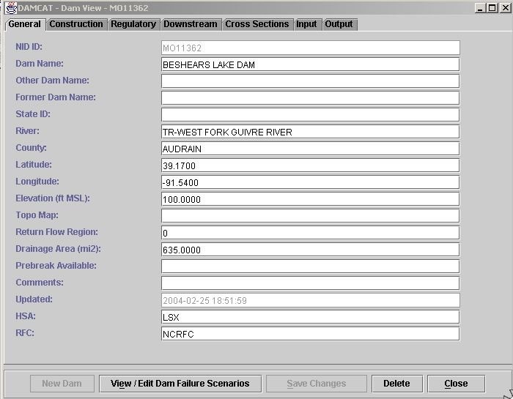

Figure 8. The "General" tab is chosen in the "DAMCAT - Dam View - Dam NIDID" window.

3.2 Buttons for Tabular Update Mode

At the bottom of the window are buttons which are described below.

3.2.1 New Entity Buttons

Each tab has a “new” button for either “New Dam” / ”New D/S Point” / “New XSection” / “New Input” / “New Output” button. The name of the button is dynamically changed depending on which tab is chosen.

These are used to insert a new downstream point, a new cross-section, a new input, and a new output record to the database. With a click on any “New …” button, the user will be prompted to fill up the primary key fields in the dialog box to insert a record. The “Save Changes” button is disabled initially. It becomes enabled when any of “New...” buttons except the “New Dam” is clicked, and the key field values are filled in the dialog box, and the button “OK” is chosen.

When one of the following tabs: “General”, “Construction” or “Regulatory” is opened, the “New Dam” button is grayed. This means that the user cannot insert a new dam from any of these tabs. A new dam could be inserted to the database from the “DAMCAT – Search Tool” window when the "Create a New Dam" button is clicked.

Note: An entry for Output data may be inserted only when the corresponding input record, i.e. the source-scenario part of its key for a particular dam, already exists in the Input table. An exception to this is if the source field to be inserted starts with the “#” character. In this case, the Output table (SdbOut) will be updated, and the corresponding record will be inserted into the Input table (SdbIn) but the model will never run to check such a record for consistency. The purpose of this feature is to allow storage in the database of “dirty” output entries, for which the model will produce errors.

3.2.2 View/Edit Failure Scenarios

The “View / Edit Failure Scenarios” button navigates to the “Model Input Editor” window. This is discussed later.

3.2.3 Save Changes

The “Save Changes” button allows the user save changes to the database. When any of the tabs in the window is opened, the “Save Changes” button is grayed initially. The “Save Changes” button becomes enabled when the user starts making changes in either the chosen text field under the tabs: “General”, “Construction” or “Regulatory”, or
in the chosen cell of the table under any other tab and after the cursor is moved to the next cell.

To save changes to the database, the “Save Changes” must be clicked. It becomes grayed until the next change is made in the text field or table.

3.2.4 Delete Information

The “Delete” button is designed to delete a dam, a downstream point, a cross-section(s).

A dam can be deleted when the “Delete” button is clicked under the “General” tab. The “Confirm Delete” dialog message box is displayed to confirm that a dam will be deleted from the database. With a click on the “OK” button, the informational message box with the message that dam will be deleted is displayed and a dam is deleted from the database.

The “Delete” button is disabled under the “Construction” and the “Regulatory” tabs, the dam cannot be deleted from any of these two tabs.

To delete a downstream point, a cross-section, or a row in an input or an output table, a row needs to be highlighted. Otherwise the message box with the message “No rows were selected to delete” is displayed.

Note, that the multiple highlighted rows could be deleted under the “Cross Sections” tab. This was implemented to allow delete all cross-section pairs of a particular downstream point at once.

3.2.5 Close Window

The “Close” closes the window.

4. Output Manager Mode

The “Output Manager” window is accessible from multiple paths, including the search window and the view forecast information window.

Model run output results are presented in the tabbed “Output Manager” window (Output Manager mode) under the following tabs:

- Graphic
- Output Data Table
- Water Surface Profile Chart
- Peak Discharge Profile Chart
- Export to FLDVIEW
- SMPDBK Output Text
- Stored Forecast Text (if exists).

Any display can be chosen with a click on the correspondent tab. Each of these tabs is described below. An additional tab can be displayed, the Warnings tab, if some input parameters was revised by the model and changed.

4.1. Output Manager Tab Displays

Information is displayed for a given source-scenario combination, which is shown at the top of the window. When switching source-scenarios, the display always reverts to the stored forecast tab. The “High Fast” scenario model run results are displayed by default.

4.1.1 Graphic

This graphically displays a dam break. The “Graphic” tab is opened by default when the button “Run SMPDBK Model” is clicked in the “DAMCAT – Search Tool” window or the menu item “Run SMPDBK” under menu “Model” is chosen in the “Model Input Editor” window.

This mode includes a distance, Distance: selection box, which lists a set of the downstream points (include at dam point). The model run results are displayed on the screen for the chosen downstream point, by default they are displayed for the first downstream point. Another downstream point could be chosen from the “Distance:” combo box, or alternatively, on the graph itself with a click on the black dot marker to highlight it. The downstream point dot marker is highlighted as a small yellow icon.

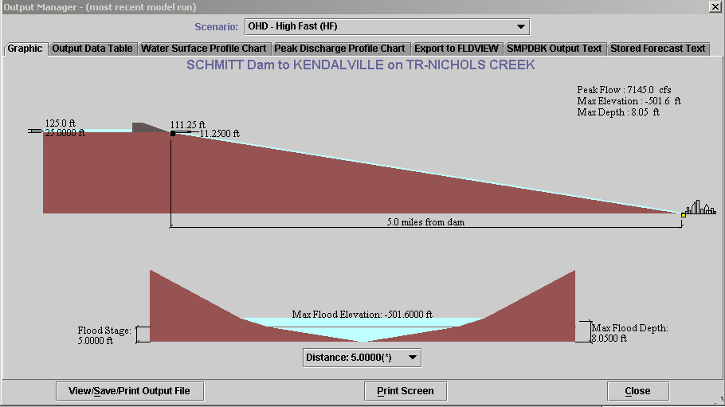
Figure 9. “Graphic” tab in the “Output Manager” window.

4.1.2 Output Data Table

The Output Data table displays the modeled dam break flow characteristics for each downstream location from the SdbOut table.

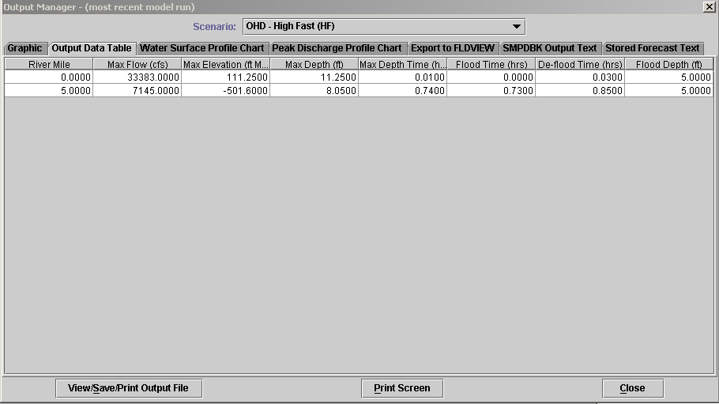
Figure 10. “Output Data Table" tab in the "Output Manager" window.

4.1.3 Water Surface Profile Chart

The window graphically presents the relationship of the water surface and invert elevations to the downstream distance from the dam.

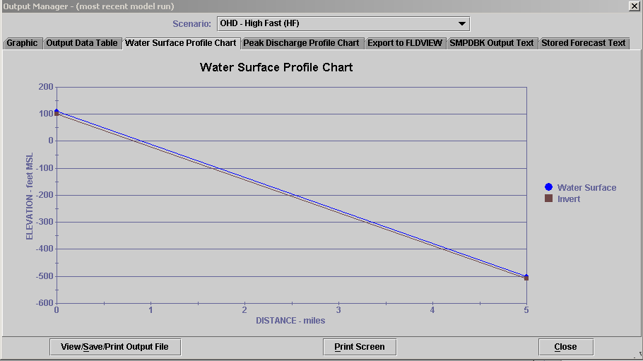
Figure 11. "Water Surface Profile Chart" tab in the “Output Manager” window.

4.1.4 Peak Discharge Profile Chart

This window graphically presents relation of the discharge and the downstream distance from the dam.

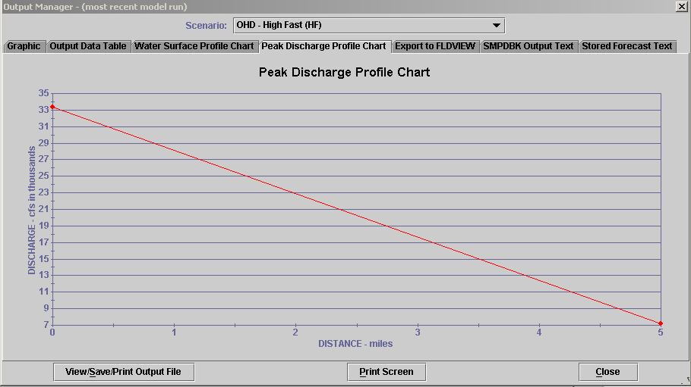
Figure 12. "Peak Discharge Profile Chart" tab in the "Output Manager" window.

    - Export to FLDVIEW

Selecting this tab results in the display of the set of the downstream points in the text box, “Generate FLDVIEW Files (.xy, .fcs)” button in lower part of it, and the buttons “Save Output File”, “Print Results”, and “Close” reside on the panel. The user has the choice to select a particular cross-section or to choose all cross-sections data as an input to .xy and .fcs FLDVIEW files.

When the “Generate FLDVIEW Files” is clicked, the .xy and .fcs input to FLDVIEW files will be generated and saved in the user defined directory. Note: If the longitude or latitude is 0.0 for a downstream point, then the message: ”The cross sections at the end points of the selection range must have non-zero latitude and longitude“ will be displayed.

When either the “View / Save /Print Output File” buttons are selected, the .xy and .fcs files could be saved in the user defined directory, viewed, and printed.

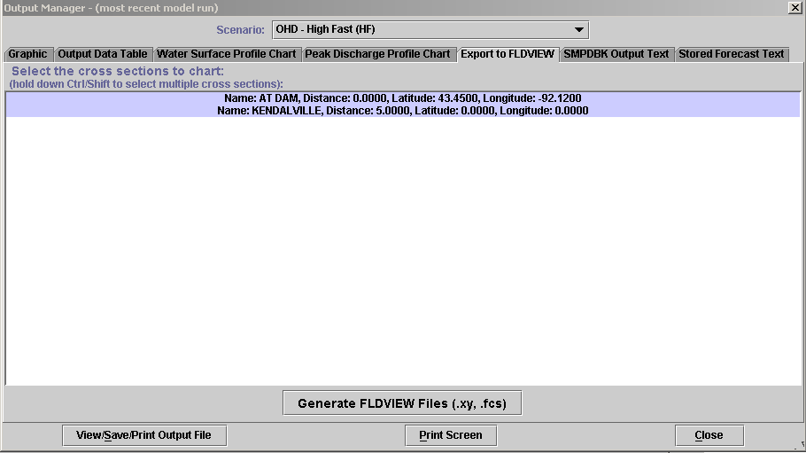
Figure 13. "Export to FLDVIEW" tab in the "Output Manager" window.

4.1.6 SMPDBK Output Text

This displays the results of the Simplified Dam Break (SMPDBK) model run in the textual presentation.

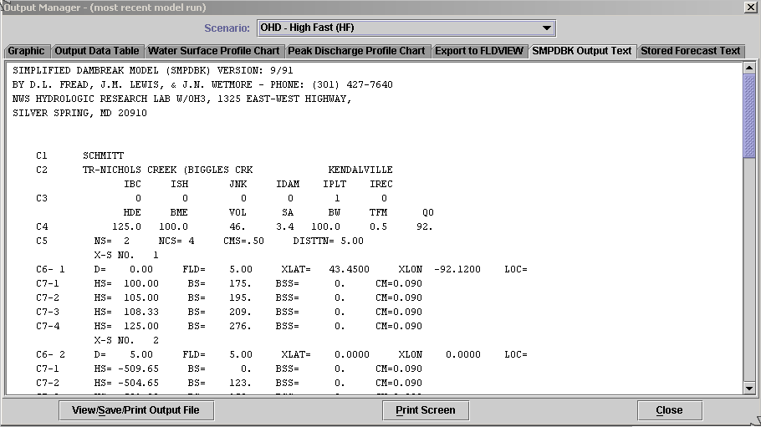
Figure 14. "SMPDBK Output Text" tab in the "Output Manager" window.

4.1.7 Stored Forecast Text

This is designed to display the stored in the database results of the previous run if it exists. If there are no stored results, this tab will be omitted. This tab is opened by default when the “View Forecast Info” button is clicked in the “DAMCAT – Search Tool” window.

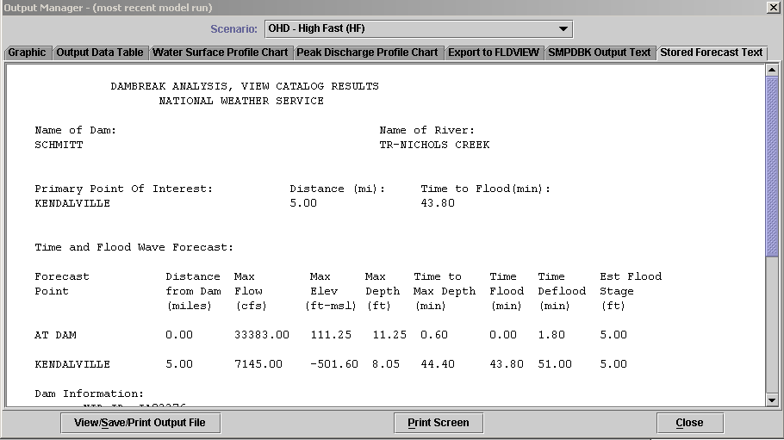
Figure 15. "Stored Forecast Text" tab in the "Output Manager" window.

4.1.8 Warnings
If the model produced any warning messages during a run, the additional “Warnings” tab will be displayed.

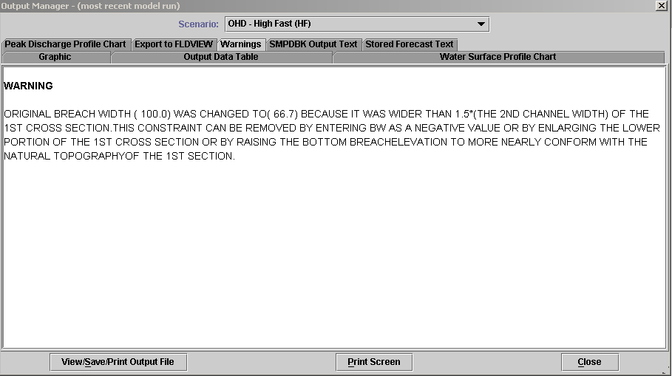

Figure 16. "Warnings" tab in the "Output Manager" window.

4.2 Additional Buttons

In the lower part of the “Output Manager” window the following buttons reside: “View/Save/Print Output File”, “Print Screen”, and “Close”.

The “View/Save/Print Output File” button is designed to work with the “SMPDBK Output Text” and the “Stored Forecast Text” tabs only. This opens the editor.

When the “Print Screen” is clicked, the GUI snapshot under the chosen tab is sent to the printer. When the “Close” button is clicked, the window will be closed.
5. Model Input Editor Mode

The “Model Input Editor – Database Mode – Editing DAMCAT Entry:” window (Model Input Editor mode) displays all the data used as input to run the model, read from different database tables. The user can also make updates of the database tables via this window.

5.1 Multiple Methods for Opening the “Model Input Editor” Window

5.1.1 Select on the “Edit Dam Data” button in the “DAMCAT - Search Tool” window, then click on the “View/Edit Failure Scenarios” button in the next opened “DAMCAT – Dam View [dam NIDID]” window navigates the user to the “Model Input Editor” screen.

5.1.2 Select the “Run SMPDBK Model” button in the “DAMCAT - Search Tool” window. The model will run, and the “Output Manager” window will be opened along with the “Model Input Editor” window.

Note: If model cannot run because of insufficient data, the first approach should be used. Data inserted into the text fields will be tested for consistency. When attempting to run the model with inconsistent input data, an error message will be displayed. Edited data can be saved to the database.

The test on uniqueness is provided. With any attempt to insert a duplicate source - scenario combination, an error message will be displayed.

5.2 The “Model Input Editor” Window Layout

The “Model Input Editor “ window layout has a hierarchical structure. A given dam can have multiple dam break source-scenarios associated with it. Each dam can have multiple downstream points defined for it. A minimum of two downstream points are needed to run the model. The dam location itself is considered a downstream location. For each downstream location, their channel/river cross-section is defined using cross-section pairs, which specify the channel width at various elevations. There is a minimum of two pairs to run the model.
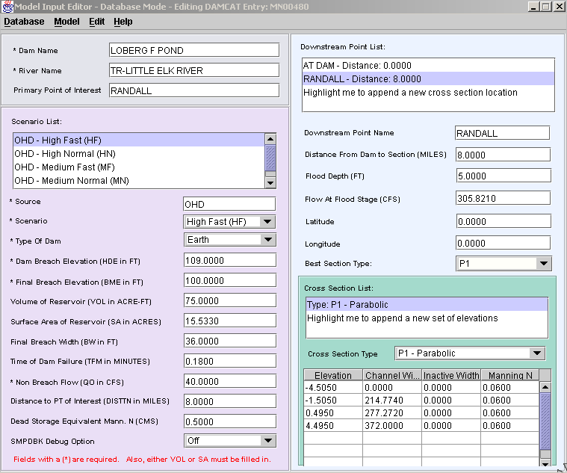

Figure17. The "Model Input Editor" window.

In the upper left part is the informational data about the dam, taken from the DamMaster table. This part of the window has a gray background.

In the lower left part is the data for the selected source-scenarios, taken from SdbIn table. It is the input to the model data.

In the upper right part is the downstream data points taken from the DownStream table. This part of the window has light blue background.

In the lower right part is the cross-section data taken from the SectionPair table.

The output data from SdbOut table cannot be viewed or updated via the “Model Input Editor” window.

5.2.1 Insert or Update a Scenario

The model input data displayed in the fields of the lower left part of the window are associated with the scenario highlighted in the “Scenario List”.

The user is able to choose a debug option for the Simplified Dambreak model in the “SMPDBK Debug Option” combo box. By default it is turned off. With the debug option turned on the debug information will be displayed. When the debug option will be set on the system level, more debug information will be displayed.

The user can add a new scenario to the existing list of scenarios by clicking on the “Highlight me to append a new scenario” option in the “Scenario List” or hit “Insert” key on the keyboard. To delete a highlighted scenario the “Delete” key should be used.

Initially the source and scenario may be displayed as “Not Specified”, in which case all text fields are zeroed. They must be updated manually. The scenario could be picked from the “Scenario” combo box, and the source type in the “Source” text field.

5.2.2 Insert or Update a Downstream Point

The dam could have several downstream points – a minimum of two is required to run the model. The data displayed in the fields is associated with the downstream point highlighted in the “Downstream Point List”.

The “Best Section Type” combo contains all cross-section types available for the particular down-stream point. The “Best Section Type” means that the model will run on the cross-section data for this type. The user can pick any of existed in the combo box option to run the model.

The user can add a new downstream point to the existing list of downstream points by clicking on the “Highlight me to append a new cross-section location” option in the “Downstream Point List” or hit “Insert” key on the keyboard. To delete the highlighted downstream point the “Delete” key should be used.

Initially the downstream point name may be displayed as “Not Specified”, in which case all text fields are zeroed, and they must be updated manually. The “Best Section Type” combo box is set to “M1 – manual”.

5.2.3 Insert or Update a Cross-Section Pair

The dam could have several cross-section pairs for a given downstream point – a minimum of two are required to run the model. The data displayed in the fields is associated with the downstream point highlighted in the “Downstream Point List”. The set of the cross-section pairs’ data is displayed for the chosen downstream point.

Note: If the cross-section part of the window is empty, the cross-section type should be chosen in the “Cross-Section List”. Cross-section data for the highlighted downstream point will populate the lower right part of the GUI. If another downstream point is selected from the “Downstream Point List”, then the user will select the cross-section type in the “Cross-Section List” valid for the chosen downstream point, and the cross-section data will be displayed for the associated downstream point.

The user can add a new cross-section to existing list of cross-sections by clicking on the “Highlight me to append a new set of elevations” option in the “Cross Section List” or hit “Insert” key on the keyboard. To delete highlighted cross-section the “Delete” key should be used. Initially the cross-section type is displayed as “M1 - Manual”, all cross-section text fields are empty, and they must be updated manually.

5.3 Menu Options

The menu at the top of the window provides the user the ability to update and close the window using the Database options, to Run and Display data using the Model options, and to Edit Text data using the Edit option, and to display the About option using the Help option.

5.3.1 Database - Update

When the user chooses the “Update Database” under the “Database” menu, data inserted into the text fields will be tested for consistency. When attempting to run the model with inconsistent input data, an error message will be displayed.

The test on uniqueness is provided. With any attempt to insert the duplicate key combination, the error message will be displayed.

If the model will run without errors, the corresponding tables will be updated in the database.

5.3.2 Model - Run SMPBDK

To run the Simplified DamBreak Model, select the “Run SMPDBK” menu item under the “Model” menu.

Several different cases are possible:

a) The input data set to the model is fully presented, data is valid. The model will run. The “Output Manager – (the most recent model run)” tab window is opened, the “Graphic” tab with the graphic representation of the model run results is displayed by default. In the “Scenario” combo box the scenario on which the model ran is displayed. The model run results are presented for the first downstream point by default. This could be changed with choosing another parameter in the “Distance” combo box in the lower part of the “Output Manager” window.

b) The input data set to the model is fully presented, but some input parameters was revised by the model and changed. In this case the warning message is displayed on the screen. To continue, the “OK” button should be clicked. The warning message is displayed one per corresponding scenario. After running all scenarios, the model run results will be displayed in the “Output Manager – most recent model run)” window, in analogy with the previously described case.

c) The model cannot run because the input set of parameters is not fully presented and/or there are some fixes of the input parameters needed to run the model, the user will be provided through set of the user friendly prompts to indicate what needs to be done to obtain the desired results. The messages on screen will vary depending on which parameters should be inserted or changed to provide a successful model run. To supply changes or to insert the parameters, the “Model Input Editor” window will be opened.

    - Model – Display SMPDBK Output

Allows the user to view SMPDBK output file.

5.3.4 Edit – Edit Text File

Accesses SMPDBK input file using user-specified editor.

END OF DOCUMENT

