    United States Environmental  Protection Agency  Office of Ground Water and  Drinking Water  Contract No.  EPA BPA OARMSC-SYS-04  SDWIS Project  Product Control No.  Systalex-SDWIS-01-6.d2a  Deliverable No. 6.d2a  December 20, 2006 |   SDWIS/LabToState 1.0  Requirements and Design Document

SDWIS/LabToState 1.0
REQUIREMENTS AND DESIGN DOCUMENT

CONTRACT NO. EPA BPA OARMSC-SYS-04
SDWIS PROJECT

Prepared for:

United States Environmental Protection Agency
Office of Ground Water and Drinking Water
Drinking Water Protection Division
1200 Pennsylvania Ave., NW
Washington, DC 20460

Contracting Officer Representative

Edward Cottrill

Prepared by:

SAIC Solutions Delivery Center
Science Applications International Corporation
6565 Arlington Boulevard
Falls Church, VA 22042

CONTENTS
1.0 INTRODUCTION 1
1.1 Purpose and Scope 1
1.2 Joint Requirement Planning and Joint Application Design Process 1
1.3 Document Overview 1
2.0 SDWIS/LabToState Overview 2
3.0 SYSTEM DESCRIPTION 4
3.1 Equipment and Operating Systems 4
3.2 Support Software 4
4.0 Requirements 5
4.1 Data Requirements 5
4.2 Functional Requirements 6
4.3 Interface Requirements 7
4.3.1 Software Interface Requirements 7
4.3.2 User Interface Requirements 8
4.4 Other Requirements 9
5.0 Technical Description 10
5.1 Deployment Specifications 10
5.2 Technical Components 11
5.3 Technical Architecture 13
5.4 File Submission and Storage 14
5.5 Database Structure and Access 15
5.6 XML Document Mapping 17
6.0 Site Customization Files 17
6.1 Site Properties File 18
6.2 Data Source Registration File 18
6.3 Sample Data File Content Configuration 19
6.4 User Identification XML Document 20
6.5 Release Statement File 21
7.0 Design Specifications 22
7.1 User Interface Components 22
7.1.1 Servlet Filters 23
7.1.2 User Login Page 24
7.1.3 Job Listing Page 25
7.1.4 Upload And Validate Page 26
7.1.5 Confirmation Page 29
7.1.6 Certification Page 29
7.1.7 Daily Log Files List Page 30
7.1.8 Servlets 31
7.1.9 SDWIS/LabToState Reports 32
7.2 Services Manager Component 33
7.3 Data Source Manger Component 34
7.3.1 CSV Plug-In 35
7.3.2 SQL Plug-In 36
7.4 XML Generation Component 36
7.4.1 XML Document Handler 37
7.4.2 JAXB Facade 39
7.5 XML Validation Component 39
7.6 Document Deliver Manager 40
7.7 Utility Components 41
8.0 SDWIS/LabToSTate Testing Approach 43
9.0 REQUIREMENTS TRACEABILITY MATRIX 44

APPENDIX A List of Work Group Participants
APPENDIX B Interface Specifications
APPENDIX C Site Properties File Name/Value Pairs
APPENDIX D Object and Element Configuration Files
APPENDIX E Report Content and Layout
APPENDIX F Java Detail Program Specifications
APPENDIX G Requirements Traceability Matrix

EXHIBITS

Exhibit 1. SDWIS/LabToState Deployment 11
Exhibit 2. SDWIS/LabToState Dataflow 12
Exhibit 3. Chain of Responsibility Design Pattern 14
Exhibit 4. Log Table Columns and Descriptions 15
Exhibit 5. DDL Creating Log Table. 16
Exhibit 6. Data-Source Plug-In Registration File; Plugins.txt 18
Exhibit 7. Object Configuration File 19
Exhibit 8. Element Configuration Files 20
Exhibit 9. Example of CSV File 20
Exhibit 10. User Authentication XML Document 21
Exhibit 11. Release Statement File 22
Exhibit 12. Standard Web Page Presentation. 24
Exhibit 13. User Login Page 25
Exhibit 14. Home/Job Listing Page 26
Exhibit 15. Upload and Validate Page 28
Exhibit 16. Confirmation Page 29
Exhibit 17. Certification Page 30
Exhibit 18. Daily Log Files Page 31
Exhibit 19. Report Names and XSLT Stylesheet Names 33
Exhibit 20. Services Manager Component Class Hierarchy Diagram 34
Exhibit 21. Data Source Component Class Hierarchy Diagram 35
Exhibit 22. XML Generation Component Class Hierarchy Diagram 37
Exhibit 23. XML Document Handler Responsibilities 38
Exhibit 24. XML Validation Component Class Hierarchy Diagram 40
Exhibit 25. Java Utility Classes 41

This page is intentionally left blank.

INTRODUCTION
The United States Environmental Protection Agency (EPA) Office of Ground Water and Drinking Water (OGWDW) is responsible for implementing the Public Water System Supervision Program established under the auspices of the Safe Drinking Water Act of 1974 (Public Law 93-523) and the 1996 Amendments to the Act (Public Law 104-183).

EPA asked the Safe Drinking Water Information System (SDWIS) Project Team to develop requirements specifications, a detailed design, and production software for SDWIS/LabToState. The SDWIS/LabToState application is a tool to assist laboratories and other entities with formatting, validating, and submitting sample data to the primacy agency.

Purpose and Scope
The SDWIS/LabToState Requirements and Design Document (Systalex-SDWIS-01-6.d2a), dated December 20, 2006, comprises the requirements, detailed design, and program specifications necessary to develop SDWIS/LabToState 1.0. The requirement statements specify the functionality that the software product must satisfy. The document provides a means to identify, trace, and evaluate requirement statements ensuring that each statement is complete, unambiguous, consistent, verifiable, and traceable. The detailed design decomposes and allocates functional and system requirements to specific program units. The SDWIS Project Team uses this document as a roadmap for system design and development activities.

Joint Requirement Planning and Joint Application Design Process
To gather requirements and define the design of SDWIS/LabToState, EPA established a work group of participants from various states and EPA Headquarters. The work group participants identified the high-level functionality the product must satisfy. From the work group, a small focus group was established. The focus group participated in weekly conference calls in which they discussed and reached consensus regarding the implementation of the functionality to which the full work group agreed. The SAIC Project Team frequently demonstrated the product to the focus group allowing them many opportunities to provide input on the product’s functionality and implementation. Additionally, the SDWIS Project Team conducted several conference calls with the full work group delivering updates on the product’s schedule and capabilities. Midway through the development cycle, the SDWIS Project Team demonstrated SDWIS/LabToState to the full work group soliciting input from them on the implementation. Appendix A contains a list of participants in both the work group and focus group.

Document Overview
This document comprises nine sections as follows:

- Section 1, Introduction, describes the project scope and document purpose. It also provides an overview of the SDWIS/LabToState application.

- Section 2, SDWIS/LabToState Overview, provides a functional overview of SDWIS/LabToState, which includes a high-level description explaining its main capabilities.

- Section 3, System Description, describes the operating environment under which SDWIS/LabToState is deployed. It also describes the equipment and supporting software that is used.

- Section 4, Requirements, itemizes the requirement statements for SDWIS/LabToState. The requirement statements are categorized as data requirements, interface requirements, functional requirements, and other requirements (e.g., security and logging).

- Section 5, Technical Description, provides a technical overview enabling a reader to understand the functional capabilities and technical architecture of SDWIS/LabToState. It graphically depicts, with supporting narrative description, each of the major SDWIS/LabToState functional capabilities. Each functional capability is decomposed to a level that illustrates program logic flow.

- Section 6, Site Customization Files, describes the files used to configure SDWIS/LabToState’s operational environment.

- Section 7, Design Specification, provides detailed programming specifications. This section, intended primarily for SDWIS/LabToState developers, identifies each programming unit with specifications that include arguments and processing instructions.

- Section 8, Test Approach, describes the overall testing methodology for the SDWIS/LabToState application.

- Section 9, Requirements Traceability Matrix, describes the Requirements Traceability Matrix (RTM).

SDWIS/LabToState Overview
Laboratories electronically submit sample data to the primacy agencies, where it is processed by SDWIS/XML Sampling. SDWIS/XML Sampling validates the sample data and loads it into the SDWIS/STATE database, where it is used for compliance determination. Sample data submitted to SDWIS/XML Sampling must be formatted in XML documents compatible with one of the following XML schemas:

- SDWIS_eDWR_v1.0.xsd.
- SDWIS_Summary_v1.0.xsd.
- SDWIS_SummaryResult_v1.0.xsd.
- SDWIS_MDBPSummary_v1.0.xsd.

SDWIS/LabToState assists laboratories with formatting, validating, and submitting sample data to the primacy agency. SDWIS/LabToState may be deployed on the primacy agency’s application server as a web-based application with the laboratory using a browser-based client to access it. It may also be distributed to the laboratory for local deployment as a stand-alone client application.

Regardless of how it is deployed, SDWIS/LabToState receives sample data formatted as follows:

- Comma separated value (CSV) files.
- XML documents compatible with the above XML schemas.
- Relational database tables.

Individual sites may also develop and register customized routines, referred to as Data-Source Plug-Ins, to receive sample data in different formats satisfying their specific requirements. Based on the user’s selection, SDWIS/LabToState dynamically calls the registered Data-Source Plug-In to receive, parse, and format the sample data.

To submit CSV files, each site configures the format, content, and order of the data submitted in the CSV file. For example, one primacy agency may require the sample ID as the first element in the CSV file; another primacy agency may require the Laboratory ID as the first element and the Sample ID as the second element. SDWIS/LabToState supports both of these formats through configuration files. Since Data-Source Plug-Ins are registered by site, laboratories using the web-based version deployed at the primacy agency must format sample data according to the specifications defined by the primacy agency to which they are submitting sample data. If the laboratory is unable to follow the primacy agency’s specifications, the laboratory may locally deploy SDWIS/LabToState; configure the software to meet its specifications; locally generate and validate XML documents; and submit the XML document using procedures established by the primacy agency. Those established procedures may include a web-based version of SDWIS/LabToState deployed at the primacy agency.

Using SDWIS/LabToState, the laboratory submits XML documents, CSV files, or some other format to the primacy agency. If the laboratory submits sample data in a format other than XML documents, SDWIS/LabToState parses the sample data and formats it as an XML document compatible with one of the XML schemas supported by SDWIS/XML Sampling.

Regardless of whether it receives XML documents or generates them, SDWIS/LabToState validates the sample data against the published XML schemas and generates reports listing the detected errors. After validation, SDWIS/LabToState sends to the laboratory an e-mail containing a hyperlink to the validation reports. Using the hyperlink, the laboratory user reviews the reports and, if satisfied, he/she enters the laboratory’s PIN Number and releases the XML documents to SDWIS/XML Sampling.

SYSTEM DESCRIPTION
SDWIS/LabToState is designed to operate for laboratories, states, and other primacy agencies. It may be deployed as a web-based application accessed through a browser-based client or as a stand-alone client application hosted on a windows-based operating system.

Equipment and Operating Systems
Because it may be deployed in diverse operating environments, SDWIS/LabToState is a Java-based application using a relational database accessed through standard Java database connectivity (JDBC) drivers. SDWIS/LabToState is based on the Java 2 Enterprise Edition (J2EE) architecture, which is a Java-centric, open standard architecture, designed to be platform-independent. At the client tier, J2EE uses hyper text markup language (HTML) to present the user-interface. By using the J2EE architecture, SDWIS/LabToState may be deployed on any major operating system (e.g., Windows, Unix, Linux) and on different hardware platforms (e.g., Intel, Sun SPARC).

The stand-alone client application version of SDWIS/LabToState uses the same core Java components and UI components as the web-based version. The installation package includes the Java run-time components eliminating the need for laboratories to install separately the Java SDK and an application server.

Support Software
The SDWIS Project Team used the following open source software components to develop and test SDWIS/LabToState:

- Application Server/Web Server. The web-based version of SDWIS/LabToState may be hosted on any J2EE compliant application server. All development and testing was conducted using the Tomcat application server provided by Apache Software Foundation. Tomcat serves as both the application and web server.

- Java 2 Platform Standard Edition, Software Development Kit (SDK). The SDK provides the libraries, Java virtual machine, and other components necessary to run applications written in the Java programming language. SDWIS/LabToState uses Sun Microsystems SDK v1.4.2. Due to SDK v1.4.2 licensing restrictions, the SDK delivered with the standalone client application is SDK v1.5.

- XML Parser. An XML parser reads and validates XML documents. SDWIS/LabToState uses the Xerces XML parser that is Java API for XML Processing (JAXP) 1.2 compliant.

- XSLT Processor. XSLT is a style sheet processor that allows the transformation of XML documents to other formats (e.g., different XML documents, HTML). SDWIS/LabToState uses Xalan, which is provided by Apache Software Foundation.

- Java Architecture for XML Binding (JAXB) is a specification developed by Sun Microsystems that maps an XML schema to its representation in Java code. SDWIS/LabToState uses Sun’s implementation of the JAXB v1.0 specification. It provides a binding compiler and runtime libraries to support the transfer of data between XML documents and Java objects.

- Sitemesh is an open source Java component from Open Symphony that separates the look and feel of a web page from the content. The look and feel is described in a standard template, which is applied to the web page at run time. SDWIS/LabToState uses Sitemesh v2.2.1.

- Mail Server. SDWIS/LabToState interfaces with the operating site's existing SMTP compliant mail server.

- Browser. The web-based version of SDWIS/LabToState was tested using Internet Explorer 6.0.

- Database. Both the web-based and distributed versions of SDWIS/LabToState are delivered with Apache Derby v10.1, which is a Java-based relational data management system developed as an open-source product by Apache Software Foundation. SDWIS/LabToState, however, may be configured to use a site’s existing relational database.

- Hibernate. Hibernate is an implementation of object/relational mapping (ORM). ORM is a programming technique that provides an interface between Java objects and a relational database. This interface is typically referred to as a persistent data layer. Hibernate provides libraries of classes that automatically map requests from the Java classes for persistent data stored in a relational database. Hibernate is a freeware product offered by JBoss and SDWIS/LabToState uses Hibernate v3.0.

Requirements
The following sections describe the different categories of requirements and itemize the SDWIS/LabToState requirement statements in each category.

Data Requirements
Data requirements describe the input and output data components of the sample data submitted by the laboratory to the primacy agency. SDWIS/LabToState receives sample data from the laboratory and formats that sample data into XML documents compatible with the same XML schemas used SDWIS/XML Sampling. The XML schemas supported by SDWIS/LabToState and SDWIS/XML Sampling are as follows:

- SDWIS_eDWR_v1.0.xsd
- SDWIS_Summary_v1.0.xsd
- SDWIS_SummaryResult_v1.0.xsd
- SDWIS_MDBPSummary_v1.0.xsd

The XML schemas and the data elements included in them are fully documented in the SDWIS/XML Sampling Mapping Document and Accompanying Schemas (GSA-SDWIS-01-8.d4d, December 30, 2005).

The following requirement statement describes the SDWIS/LabToState data requirements:

- R95000 — SDWIS/LabToState shall receive sample data from the laboratory as defined in the SDWIS/XML Sampling XML schemas (i.e., SDWIS_eDWR_v1.0.xsd, SDWIS_Summary_v1.0.xsd, SDWIS_SummaryResult_v1.0.xsd, SDWIS_MDBPSummary_v1.0.xsd). The XML schemas are fully documented in the SDWIS/XML Sampling Mapping Document and Accompanying XML Schemas.

Functional Requirements
Functional requirements specify the capabilities that must be implemented by SDWIS/LabToState. They specify "what" the software must do; not "how."

The functional requirements are specified as follows:

- R95010 — SDWIS/LabToState shall format the laboratory’s sample data as XML documents compatible with the SDWIS/XML Sampling XML schemas (i.e., SDWIS_eDWR_v1.0.xsd, SDWIS_Summary_v1.0.xsd, SDWIS_SummaryResult_v1.0.xsd, SDWIS_MDBPSummary_v1.0.xsd). The XML schemas are fully documented in the SDWIS/XML Sampling Mapping Document and Accompanying XML Schemas.

- R95020 — SDWIS/LabToState shall validate the XML documents against the SDWIS/XML Sampling XML schemas (i.e., SDWIS_eDWR_v1.0.xsd, SDWIS_Summary_v1.0.xsd, SDWIS_SummaryResult_v1.0.xsd, SDWIS_MDBPSummary_v1.0.xsd). The XML schemas are fully documented in the SDWIS/XML Sampling Mapping Document and Accompanying XML Schemas.

- R95030 — SDWIS/LabToState shall detect and log errors during the parsing, formatting, and validating of the sample data.

- R95040 — SDWIS/LabToState shall provide the ability for an installation to register routines, referred to as Data-Source Plug-Ins, that receive and parse sample data from the laboratory.

- R95050 — SDWIS/LabToState shall dynamically call the registered routines, referred to as Data-Source Plug-Ins, based on the selection by the user.

- R95060 — SDWIS/LabToState shall provide Data-Source Plug-Ins to receive sample data formatted in comma separated values (CSV) files.

- R95070 — SDWIS/LabToState shall provide Data-Source Plug-Ins to retrieve sample data from a relational database.

- R95080 — SDWIS/LabToState shall provide Data-Source Plug-Ins to receive sample data formatted in XML documents compatible with the XML schemas supported by SDWIS/XML Sampling (i.e., SDWIS_eDWR_v1.0.xsd, SDWIS_Summary_v1.0.xsd, SDWIS_SummaryResult_v1.0.xsd, SDWIS_MDBPSummary_v1.0.xsd).

Interface Requirements
External interface requirements describe the interaction between SDWIS/LabToState and other independent entities. For SDWIS/LabToState, the interface requirements have been further characterized as software interface and user interface requirements. The following sections specify high-level interface requirements.

Software Interface Requirements
Software interface requirements describe the interaction between SDWIS/LabToState and other software applications or entities. SDWIS/LabToState interfaces with the SDWIS/XML Sampling software application and the primacy agency’s State Node. The XML document is delivered directly to SDWIS/XML Sampling by moving it to the Inbox. The XML document may also be delivered to SDWIS/XML Sampling by transferring it to the State Node. If it transferred to the State Node, it is the responsibility of the State Node to move the XML document to SDWIS/XML Sampling’s Inbox.

Initial, high-level software interface requirements for SDWIS/LabToState are specified as follows:

- R95090 — SDWIS/LabToState shall deliver the XML documents to the Inbox used by SDWIS/XML Sampling based on site configuration parameters.

- R95100 — SDWIS/LabToState shall deliver the XML documents to the primacy agency’s State Node based on site configuration parameters.

User Interface Requirements
User interface requirements describe the interaction between SDWIS/LabToState and the user. SDWIS/LabToState user interface requirements are further classified as follows:

- Graphical User Interface (GUI) requirements allow the user to initiate requests for functionality, submit parameters required by that request, and receive responses from the request. For example, SDWIS/LabToState allows users to upload sample data for formatting and validation, and receive a response from the request.

- Status and summary message requirements provide the reporting mechanism for SDWIS/LabToState to provide feedback to the user. For example, errors detected during the validation process will be presented in status messages.

Detailed user interface design requirements such as content, format, and navigation are specified in Section 7.0, Design Specifications. Initial, high-level user interface requirements are specified as follows:

- R95110 — SDWIS/LabToState GUI interfaces and status and summary messages shall comply with EPA’s Section 508 standards that require federal agencies’ electronic and information technology be accessible to people with disabilities.

Comment: It is assumed that all software products produced for SDWIS/LabToState are subject to the requirements of Section 508 of the Rehabilitation Act and 36 CFR 1194, Electronic and Information Technology Accessibility Standards, and are designed for maximum accessibility. For adherence to Section 508 specifications, SDWIS/LabToState was tested against EPA's prioritized level of importance as listed in A Plain Language Overview of the 16 Technical Specifications for Section 508 Accessibility (Jeff Morin, March 2001).

- R95120 — SDWIS/LabToState shall provide a GUI interface allowing users to initiate requests, submit arguments, and receive responses for the following capabilities:

- Upload and validate sample data.
- List the uploaded files containing sample data.
- Release data to SDWIS/XML Sampling.
- List Log Files

- R95130 — SDWIS/LabToState shall notify the user through an e-mail that the submitted sample data is ready for review and approval.

- R95140 — SDWIS/LabToState status and summary messages shall be formatted as HTML documents.

- R95150 — SDWIS/LabToState shall provide the status and summary messages in a printer-friendly format.

Other Requirements
This section describes the security, logging, and implementation requirements for SDWIS/LabToState.

Security Requirements
SDWIS/LabToState grants access to the application based on the submission of a valid User ID and Password. Each User ID is associated to one of two roles referred to as the Laboratory role and the State role. For the Laboratory role, the User ID is also assigned a Laboratory Name and a PIN number. The user assigned to the Laboratory role is granted privileges to upload data files, release those data files to SDWIS/XML Sampling, and list and view files and reports for the assigned laboratory. The user assigned to the State role is granted privileges to all application functionality and to the information for all laboratories. SDWIS/LabToState does not provide any administration capabilities for the User ID and password.

Initial, high-level requirements for application access are specified below.

- R95160 — SDWIS/LabToState shall provide a login interface for users to enter a User ID and password.

- R95170 — SDWIS/LabToState shall deny access to any user failing to supply a valid User ID and password.

Comment: Each primacy agency may deploy its own implementation of user authentication. That implementation must adhere to the interface specifications defined in the SDWIS/LabToState design specifications. SDWIS/LabToState, however, will supply a default implementation. SDWIS/LabToState does not provide user management tools (GUIs to change and monitor user IDs and passwords).

- R95180 — SDWIS/LabToState shall restrict access to data based on the laboratory name assigned to the user.

Comment: SDWIS/LabToState will support two roles: State and Laboratory. Any user assigned the State role is granted access to all data and functionality. Users assigned to the Laboratory role are also assigned to the laboratory for which he/she is able to access data.

- R95190 — SDWIS/LabToState shall deny the release of an XML document to SDWIS/XML Sampling to any user failing to supply a valid PIN Number.

Logging Requirements
SDWIS/LabToState tracks events that occur during processing. For each event, SDWIS/LabToState creates an entry in a log file that provides information about the event.

- R95200 — SDWIS/LabToState shall create a daily log files containing the major processing events.

Comment: The detailed design specifications will document the information captured in the log.

Technical Description
This section provides a technical description of SDWIS/LabToState, beginning with the product’s deployment specifications and an overview of the dataflow among the SDWIS/LabToState components. It follows with a description of SDWISI/LabToState’s technical architecture.

Deployment Specifications
SDWIS/LabToState may be deployed either as a web-based application or as a stand-alone client application. As a web-based application, SDWIS/LabToState is deployed on a J2EE compliant application server available to many users in disparate locations. The users access the application using a browser-based client over the internet. As a stand-alone client application, SDWIS/LabToState is deployed on a windows-based hardware platform and is available to the single user of that hardware platform.

Exhibit 1 depicts the SDWIS/LabToState’s deployment strategy. Deployed at the laboratory, SDWIS/LabToState generates the XML documents locally. Then, the laboratory uploads the XML document to the primacy agency using established procedures, which may include SDWIS/LabToState deployed at the primacy agency.

Using SDWIS/LabToState at the primacy agency, the laboratory uploads sample data formatted in XML documents, CSV files, or another specification implemented by the primacy agency. As required, SDWIS/LabToState generates the XML documents from the uploaded sample data. Next, it validates the XML document regardless of whether it received or generated the XML document. After validating the sample data, the laboratory reviews the results of the validation and releases the sample data for additional processing by SDWIS/XML Sampling.

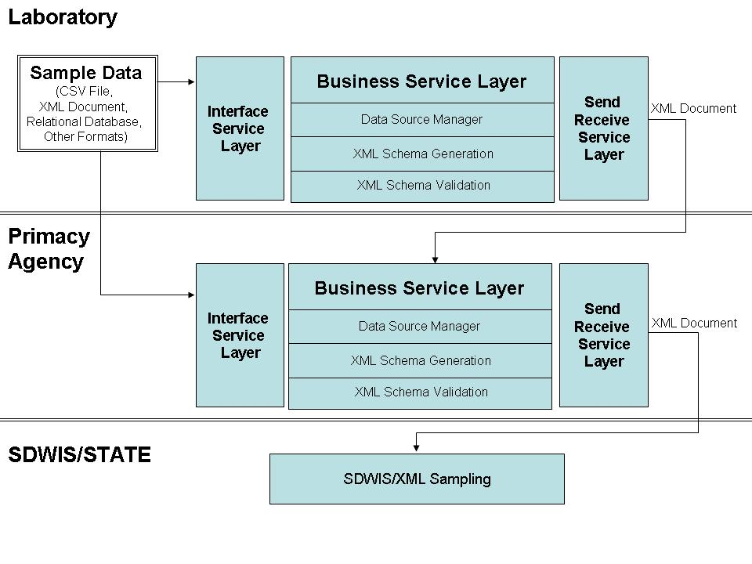
Exhibit 1. SDWIS/LabToState Deployment

Technical Components
SDWIS/LabToState comprises tightly coupled components, each delivering a discrete functional capability. Exhibit 2 depicts the flow of data among the SDWIS/LabToState components.

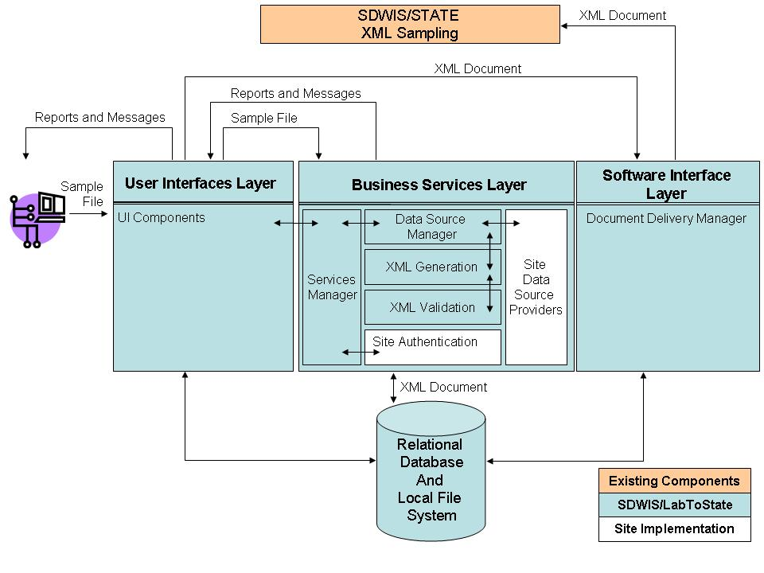
Exhibit 2. SDWIS/LabToState Dataflow

The UI components deliver a request for services to the Business Services Layer. The Business Services Layer consists of the Services Manager, Data Source Manager, XML Generation, and XML Validation components. Each installation may also integrate its own Site Authentication and Site Data Source providers. The Delivery Services Layer is the interface between SDWIS/LabToState and other software applications.

The Service Manager component receives a request for services from the UI components. It interprets the request, performs general housekeeping activities, and initiates the Data Source Manager to process the request.

The Data Source Manager component comprises discrete Data-Source Plug-Ins each retrieving sample data in different file formats. Data-Source Plug-Ins are registered with SDWIS/LabToState and the Services Manager dynamically calls a specific, registered Data-Source Plug-In based on the user’s request. Each Data-Source Plug-In retrieves, parses, and prepares sample data for formatting in XML documents. The Data-Source Plug-Ins delivered with SDWIS/LabToState support CSV files and relational database tables. Each site, however, may develop and register its own Data-Source Plug-Ins. The Data-Source Plug-Ins delivered with SDWIS/LabToState and those developed by the site must adhere to the interface specifications documented in Appendix B. After the Data-Source Plug-In parses, validates, and prepares the sample data, it initiates the XML Generation component.

The XML Generation component accepts sample data and generates the XML document. It saves the generated XML document to the local file system, updates metadata in the database, and initiates the XML Validation component.

The XML Validation component validates the XML document against the appropriate XML schemas, and logs the detected errors. After completing the validation, it returns to the XML Generation component, which returns to the Services Manager component. The Service Manager produces the messages and error reports, and sends e-mail notifications to the laboratory.

Using the User Interface (UI) component, the laboratory user reviews the status of the uploaded sample data through lists, summary reports, detail reports, and the generated XML documents. If the user is satisfied with the uploaded sample data, he/she releases the XML document to SDWIS/XML Sampling. The Document Delivery Manger component transfers the XML document to SDWIS/XML Sampling.

Technical Architecture
This section describes the technical architecture for each component of SDWIS/LabToState. The User Interfaces layer uses JSP pages and servlets to implement UI components. The Services Manager component is a request/response based component comprised of Java classes. These Java classes perform housekeeping and other activities required to administer requests and receive responses. The Service Manager dynamically calls one of the registered Data-Source Plug-Ins based on arguments received from the UI component.

The Data Source Manager, XML Generation, and XML Validation components follow a design pattern commonly referred to as chain of responsibility (CoR). CoR design pattern uses a chain of objects to handle a request. Each object in the chain forwards the request to the next object in the chain until the request is handled.

Exhibit 3 depicts a class diagram representing the CoR design pattern as implemented in SDWIS/LabToState. The classes participating in this design pattern are as follows:

- Client initiates the request for services.

- Handler defines the interface for processing the request and forwards it to the first link in the chain.

- Concrete Handler implements the specific service for which it is responsible. Otherwise, it forwards the request to its successor.

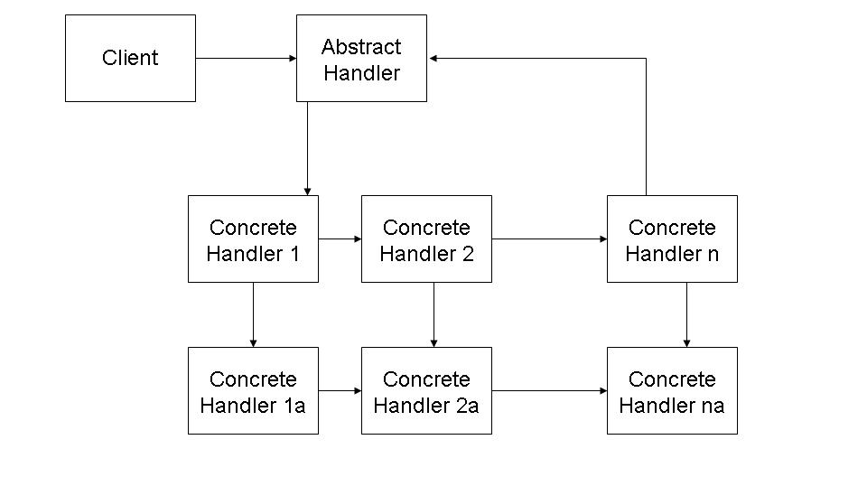
Exhibit 3. Chain of Responsibility Design Pattern

As implemented in SDWIS/LabToState, the Data Source Manger acts as the client. It initiates a request to the XML Generation component. The XML Generation component includes an abstract handler, which defines the interface specification. It also includes four concrete handlers, each generating an XML document compatible with one of the XML schemas used by SDWIS/XML Sampling. In SDWIS/LabToState, the concrete handler calls a second concrete handler to validate the generated XML document. The second level of concrete handlers is the XML Validation component.

The Document Delivery Manager component is a service-oriented architecture comprised of Java classes offered to the Business Services layer. Specifically, it transfers the XML document to the SDWIS/XML Sampling.

Section 7.0, Design Specifications contains the programming specifications for all components.

File Submission and Storage
The laboratory may submit a compressed file (i.e., zip file) containing multiple files of the same format selected (e.g., XML documents, CSV files). The laboratory may also elect to submit a single file format selected. The submitted file is uploaded to the local file system of the hardware platform on which SDWIS/LabToState is deployed. For each submitted file, SDWIS/LabToState creates a directory named as follows:

[LabToStateHome]\jobFolders\[SubmissionDateTime].[RandomNumber]

SDWIS/LabToState uploads the compressed file to that directory. It extracts the files from the compressed file and stores them in the same directory. SDWIS/LabToState uses this directory for all temporary and permanent files created during processing.

Database Structure and Access
SDWIS/LabToState uses a database to log metadata regarding the submitted sample data. That database contains a single table as described in Exhibit 4. The physical name of the table is LOG.

Exhibit 4. Log Table Columns and Descriptions
SDWIS/LabToState Database Table
Table Name | Column Name | Description | Data Type (size)
Log | ID | Contains the Job’s unique identifier. | int
 | CreatedOn | Contains the timestamp when the Job is submitted | timestamp
 | JobFolder_Name | Contains the full path name of the job’s working directory. | varchar (200)
 | Certified | Contains a “Y” if the job is certified; otherwise it contains an “N”. | char (1)
 | Username | Contains the User ID of the user that submitted the Job | varchar (20)
 | Laboratory | Contains the ID of the laboratory associated with the user submitting the Job. | varchar (100)
 | PayloadFileName | Contains the name of the file uploaded by the user. | varchar (100)
 | EdwrFileURI | Contains the complete path to the EDWR XML file for a specific job | varchar (200)
 | SampleSummaryFileURI | Contains the full path name to the Sample Summary XML document generated for the Job. | varchar (200)
 | SampleSummaryResultFileURI | Contains the complete path to the Sample Summary Result XML document generated for the Job. | varchar (200)
 | MDBPSummaryFileURI | Contains the complete path to the MDBP Summary XML document generated for the Job. | varchar (200)
 | CertifiedBy | Contains the User ID of the user that certified the Job | varchar (20)
 | CertifiedOn | Contains the timestamp when the Job was certified | timestamp
 | DeleteFlag | Contains a “Y” to denote that the Job should not be presented on the Job List page. Otherwise, it contains an “N”. | char (1)

Although SDWIS/LabToState bundles Apache’s Derby database as its default database, a site may configure the application to use any JDBC compliant database. Exhibit 5 lists the data definition language (DDL) used to configure the table.

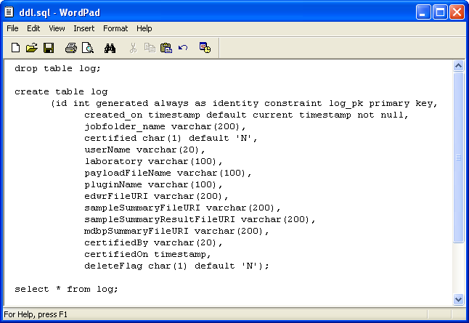
Exhibit 5. DDL Creating Log Table.

To access the database, SDWIS/LabToState uses Hibernate, which implements a programming technique, referred to as Object Relational Mapping (ORM). ORM is a framework for mapping Java objects to a relational database providing a persistent data layer.

Hibernate uses an XML document to track the mapping between Java classes and the relational database tables. Since the SDWIS/LabToState database includes a single table, the XML document defines the mapping to a single Java class. Based on the database tables, Hibernate generates the Java classes and the XML document. Hibernate also provides another XML document (hibernate.cfg.xml) containing parameters describing the database. By changing the parameters in the XML document (hibernate.cfg.xml), a site can change the database that the application is using (e.g., switch to an Oracle database from the open source database, Derby, delivered with the application).

Java Class Name:
[LabToStateHome]\WEB-INF\classes\com\hibernate\derby\Log.java

XML Document:
[LabToStateHome]\WEB-INF\classes\com\hibernate\derby\Log.hbm.xml
(Hibernate XML mapping file)
[LabToStateHome]\WEB-INF\classes\hibernate.cfg.xml
(Hibernate Database configuration file)

DDL:
[LabToStateHome]\WEB-INF\classes\db\ddl\ddl.sql

XML Document Mapping
SDWIS/LabToState uses JAXB to marshall data between XML documents and Java classes. JAXB is a specification developed by Sun Microsystems that maps an XML schema to its representation in Java code. SDWIS/LabToState uses Sun’s implementation of the JAXB v1.0 specification. In addition to runtime libraries, JAXB provides a binding compiler that generates Java classes from the XML Schemas. The generated Java classes represent different elements and complex types in an XML schema. The generated classes are located in the directory specified below.

Directory Name: [LabToStateHome]\WEB-INF\classes\org\jaxb\

Site Customization Files
To customize its deployment, SDWIS/LabToState uses several text files and XML documents containing various installation and run-time parameters. SDWIS/LabToState does not offer any components to administer these files. The user may use any standard text editor to modify or change the content. All of the site customization files are located in the directory specified below.

Directory Name: [LabToStateHome]\WEB-INF\classes\properties\

Site Properties File
The Site Properties File is a text file containing various installation and run-time parameters used by SDWIS/LabToState. The file is formatted as name-value pairs. The System Administrator changes values in this file to reflect the operational environment at a particular site. Appendix C lists the name, description, and initial setting of each name/value pair. Column 2 (Set By) of Appendix C indicates whether the value of the element is “Set By” the software, system administrator, or through delivery (the file is delivered with a value that should not be changed).

File Name: siteProperties.txt.

Data Source Registration File
The Data Source Registration File is a text file that maps the logical name of each Data-Source Plug-In to the name of the Java class implementing the functionality. The file is formatted as name/value pairs. The name is the logical name of the Data-Source Plug-In. This name is presented on the user interface allowing the user to select the file format. The logical name is mapped to the Java class implementing the data source specification. If a site implements its own data source specifications, the Data-Source Plug-Ins are registered in this file. Exhibit 6 lists the content of the Data-Source Plug-Ins Registration File for a default implementation.

File Name: plugins.txt

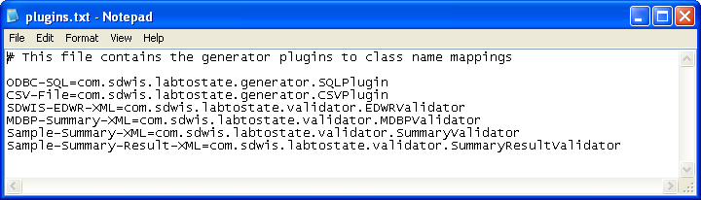
Exhibit 6. Data-Source Plug-In Registration File; Plugins.txt

Sample Data File Content Configuration
SDWIS/LabToState provides a Data-Source Plug-In to receive sample data formatted as comma separated values (CSV). The site configures the content and order of the sample data contained in the CSV file. First, the site identifies logical groupings of sample data referred to as logical objects. The logical objects are based on the following SDWIS/XML Sampling structure sets:

- Sample
- Sample Measure
- Result
- Sample Result Measure
- Sample Summary
- Sample Summary Result
- MDBP Summary

The Object Configuration File is a text file that maps logical objects to one and only one structure set. Each structure set, however, may be mapped to multiple logical objects. For example, the site may identify a logical object called TCRSample and map it to the Sample structure set. The site may also identify a logical grouping called GeneralSample and map it to the same Sample structure set. Even though both logical objects (TCRSample and GeneralSample) map to the same Sample structure set, they may contain different data in a different order. Exhibit 7 lists the default content of the Object Configuration File delivered with SDWIS/LabToState

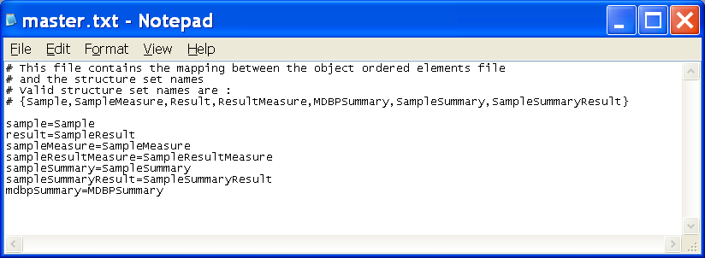

Exhibit 7. Object Configuration File

For each logical object identified in the Object Configuration File, the Element Configuration File lists the elements and their order in the CSV file. The element names are listed in the order in which they are submitted in the CSV file. The name of the element is the Staging Table Column Name as specified in the structure set documentation included in the SDWIS/XML Sampling Mapping Document and Accompanying Schemas and Accompanying XML Schemas document. The Element Configuration File is a text file and the site creates a separate Element Configuration File for each logical object. The physical name of the Element Configuration File is [logical object].txt. Using the above example in which the site configured both a TCRSample and a GeneralSample logical object, the site must also configure two Element Configuration Files named TCRSample.txt and GeneralSample.txt. Exhibit 8 lists the Element Configuration Files delivered with SDWIS/LabToState. Appendix D contains a list of the content of each Element Configuration File.

File Name: master.txt
[logicalobject].txt

Element Configuration Files
sample.txt
result.txt
sampleMeasure.txt
sampleResultMeasure.txt
sampleSummary.txt
sampleSummaryResult.txt
mdbpSummary.txt

Exhibit 8. Element Configuration Files

Exhibit 9 depicts an example of a CSV file that conforms to the default configuration delivered with SDWIS/LabToState. The first column in the CSV file is always the name of the logical object being submitted. The remainder of the line is the sample data in the order specified in the Element Configuration File for that logical object. If any alphanumeric data contains spaces, the alphanumeric data must be enclosed in quotation marks as depicted in the first line of Exhibit 9. If the alphanumeric data does not contain spaces, the quotation marks are optional as depicted in the remaining lines of Exhibit 9.

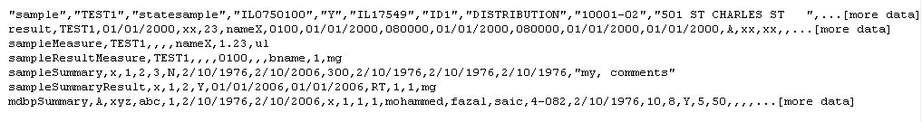
Exhibit 9. Example of CSV File

User Identification XML Document
SDWIS/LabToState provides a default implementation of user authentication. That default implementation uses an XML document to identify each User ID and assign to that User ID a password, role, PIN number, and laboratory. Exhibit 09 lists the contents of the XML document delivered with SDWIS/LabToState.

Each user is assigned one of two roles. A user assigned to the Lab role is granted access to the sample data submitted by that laboratory. A user assigned to the State role is granted access to all submissions regardless of the laboratory.

XML Document: userList.xml

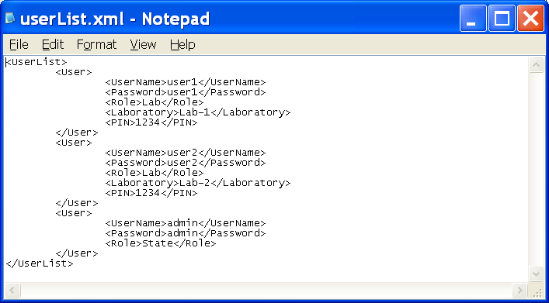

Exhibit 10. User Authentication XML Document

Release Statement File
The Release Statement File is a text file containing the text presented to the user as he/she releases the XML document to SDWIS/XML Sampling. Exhibit 11 lists the default text included in the Release Statement File.

File Name: certificationStatement.txt

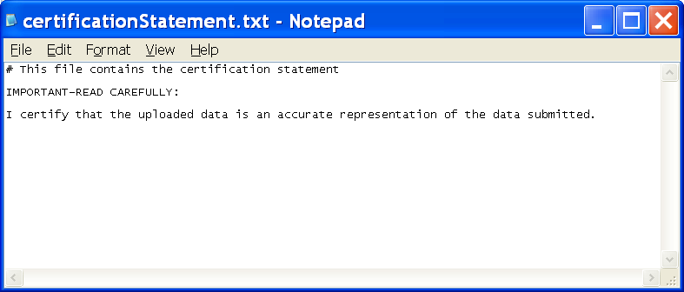
Exhibit 11. Release Statement File

Design Specifications
This section describes the layout, content, and navigation of the UI components. It also describes each of the SDWIS/LabToState components as depicted in Exhibit 2. Each component is described using class hierarchy diagrams in which each domain class is represented. Domain classes implement the application’s business logic. Domain classes additionally use utility classes to invoke general purpose functions to perform activities common to multiple domain classes (e.g., log events, manage site properties). Utility classes are not illustrated in the class hierarchy diagram; they are documented in Section 7.7, Utility Components

The detail program specifications for each Java class are automatically generated from the class code using a tool named JavaDoc. JavaDoc is a utility program supplied by Sun Microsystems, which generates API documentation from Java source programs. The JavaDoc tool requires comments in the code following a specified format. This format enables the tool to scan the Java code and pick up comments for rendering using HTML. Appendix F contains the output from this tool.

User Interface Components
This section describes the layout, content, and navigation of the SDWIS/LabToState UI components. The UI components are constructed using JSP pages, servlets, and servlet filters. The UI Component also includes the reports constructed based on the results of the XML Validation component. The reports are formatted as XML documents generated using Extensible Style Language Transformation (XSLT) language.

Servlet Filters
A servlet filter dynamically intercepts requests and responses in order to transform or use the information in the request or response. The following sections describe the servlet filters used by SDWIS/LabToState.

Authentication Filter
Before granting a user access to any web page, the AuthenticationFilter checks to ensure the requesting user is authenticated. When SDWIS/LabToState authenticates a user, it instantiates a session object named UserInfo (see Section 7.7, Utility Components). The UserInfo object contains metadata about the user including whether he/she is authenticated. The AuthenticationFilter checks the UserInfo object to determine whether the user is authenticated. If the user has been authenticated, the requested page is presented. Otherwise, it presents the User Login page, as described in Section 7.1.2, User Login Page. Appendix F contains the detail programming specifications.

Folder Name: [LabToStateHome]\WEB-INF\classes\com\sdwis\labtostate\servlet\
Java Class Name: AuthenticationFilter.java

Sitemesh Filter
Sitemesh is an open source tool that applies a consistent look and feel to each web page. This capability allows sites to apply a look and feel consistent with standards implemented at that site.

The decorators.xml file identifies the JSP pages applied to each web page. Each web page comprises four sections: a navigation section, a header section, footer section, and the main body section. The main.jsp page describes the look and feel of the navigation, header, and footer sections. The navigation section describes the common links included on every web page. The menu.jsp page defines a template to include dynamically additional links on the navigation section. SDWIS/LabToState generates the main body section containing the content of the web page. Sitemesh applies the navigation, header, and footer sections. To change the look and feel to meet site-specific standards, the site develops its own main.jsp page and indicates that JSP page in the decorators.xml file.

Folder Name: [LabToStateHome]\decorators
JSP Page: \decorators\main.jsp
\decorators\menu.jsp

Folder Name: [LabToStateHome]\WEB-INF\
XML Document: \web-inf\decorators.xml

Page Content and Navigation: Exhibit 12 depicts the look and feel applied to the web page as described in main.jsp. It contains the following buttons:

- Home — Presents the SDWIS/LabToState Home page.

- Log Files — Presents the LogFiles page. This link is presented only if the role of the user is “State.”

- Logoff — Terminates the user session by invoking the LoginLogoff servlet.

- Help – Presents the SDWIS/LabToState Help Index page.

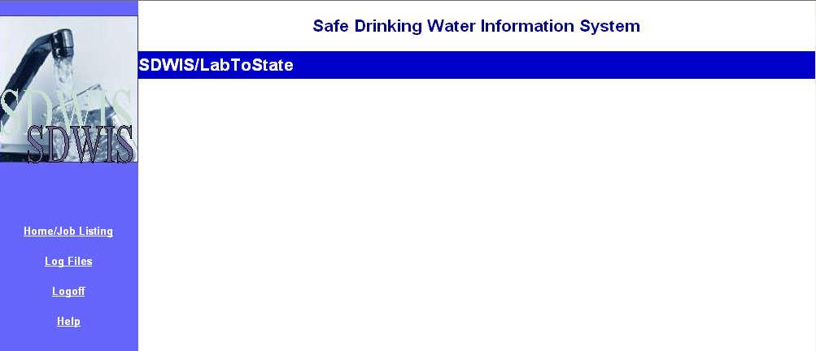
Exhibit 12. Standard Web Page Presentation.

User Login Page
The User Login page accepts the user ID and password. The AuthenticationFilter.java initiates this page if a user attempts to access any of the application’s web pages without prior authentication.

Folder Name: [LabToStateHome]\jsp\
File Name: login.jsp

Page Content and Navigation: Exhibit 13 depicts the SDWIS/LabToState User Login page. It contains the following text fields and buttons:

- User Name — Identifies the person accessing the application.

- Password — Secures the identity of the user.

- Login button — Initiates the user session by invoking the LoginServlet.

- Clear button — Clears the user-entered data from the page.

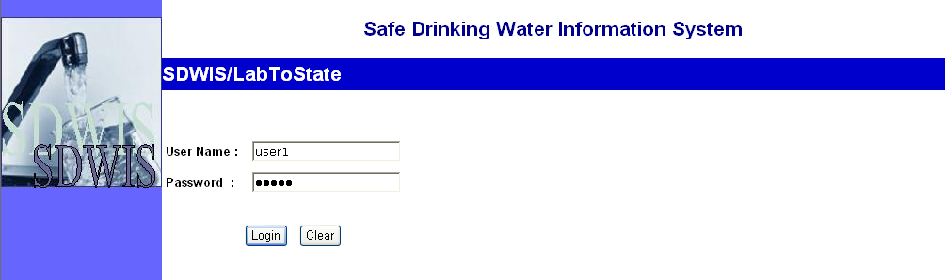
Exhibit 13. User Login Page

Job Listing Page
The SDWIS/LabToState Job Listing page lists the files submitted to SDWIS/LabToState based on the role assigned to the user. If the user is assigned to the Lab role, the list presents only those files submitted on behalf of the laboratory assigned to that user. If the user is assigned to the State role, the list presents files submitted by all laboratories. SDWIS/LabToState tracks each submitted file in a relational database. The Job Listing page retrieves the list of files from the database.

Folder Name: [LabToStateHome]\jsp\
File Name: index.jsp
indexMenu.jsp

Page Content and Navigation: Exhibit 14 depicts the SDWIS/LabToState Home page.
It contains the following text fields and buttons:

- Job ID — Lists as a hyperlink the unique ID of each submitted file. If clicked, it invokes the JobSelectionServlet.

- File Name — Lists the name of the submitted file.

- Submitted By — Lists the identification of the user that submitted the file.

- Submitted On — Lists the date and time the file was submitted.

- Laboratory Name — Lists the name of the laboratory assigned to the user that submitted the file.

- Certified — Designates whether the laboratory certified the file for processing by SDWIS/XML Sampling.

- Certified By — Lists the identification of the user that certified the file.

- Certified On — Lists the date and time the file was certified.

- Select — Allows the user to designate that the file may be permanently deleted from the list.

- Remove Jobs From List button — Removes the selected jobs from the list by invoking the JobListingServlet.

- Clear button — Clears the user entered data from the page.

Additional Buttons on the Navigation Pane
- Upload and Validate button — Presents the Upload and Validate page.

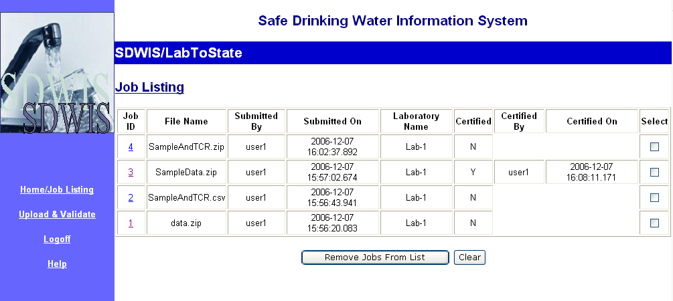
Exhibit 14. Home/Job Listing Page

Upload And Validate Page
The SDWIS/LabToState Upload and Validate page is initiated from the Upload and Validate link on the Navigation bar. The Upload and Validate page initiates request to upload and process sample data. The laboratory user identifies the name of the file, the format of the file, and the e-mail address of the user who will be notified when processing is complete.

Folder Name: [LabToStateHome]\jsp\
File Name: validate.jsp
sqlform.jsp

Page Content and Navigation: Exhibit 15 depicts the Upload and Validate page. It contains the following text fields and buttons:

- File Format — Allows the user to select the file format from the list of registered Data-Source Plug-Ins.

- File Upload — Identifies the name of the file containing the sample data. This file may be a compressed (i.e., zip) file when submitting multiple CSV files.

- Notification e-mail address — Specifies the e-mail address of the user notified when processing is complete.

- Browse button — Allows the user to look through the local file system and select the file to be uploaded.

- Process button — Initiates processing of the sample data by invoking the DispatchServlet.

- Clear button — Clears the user-entered data from the page.

- Structure Set SQL’s — Presented only if the user selects the ODBC-SQL Data-Source Plug-In. The user enters the SQL statement used to extract data from the database. The SQL statements are saved as a text file using the name of the object that is displayed next to the statement.
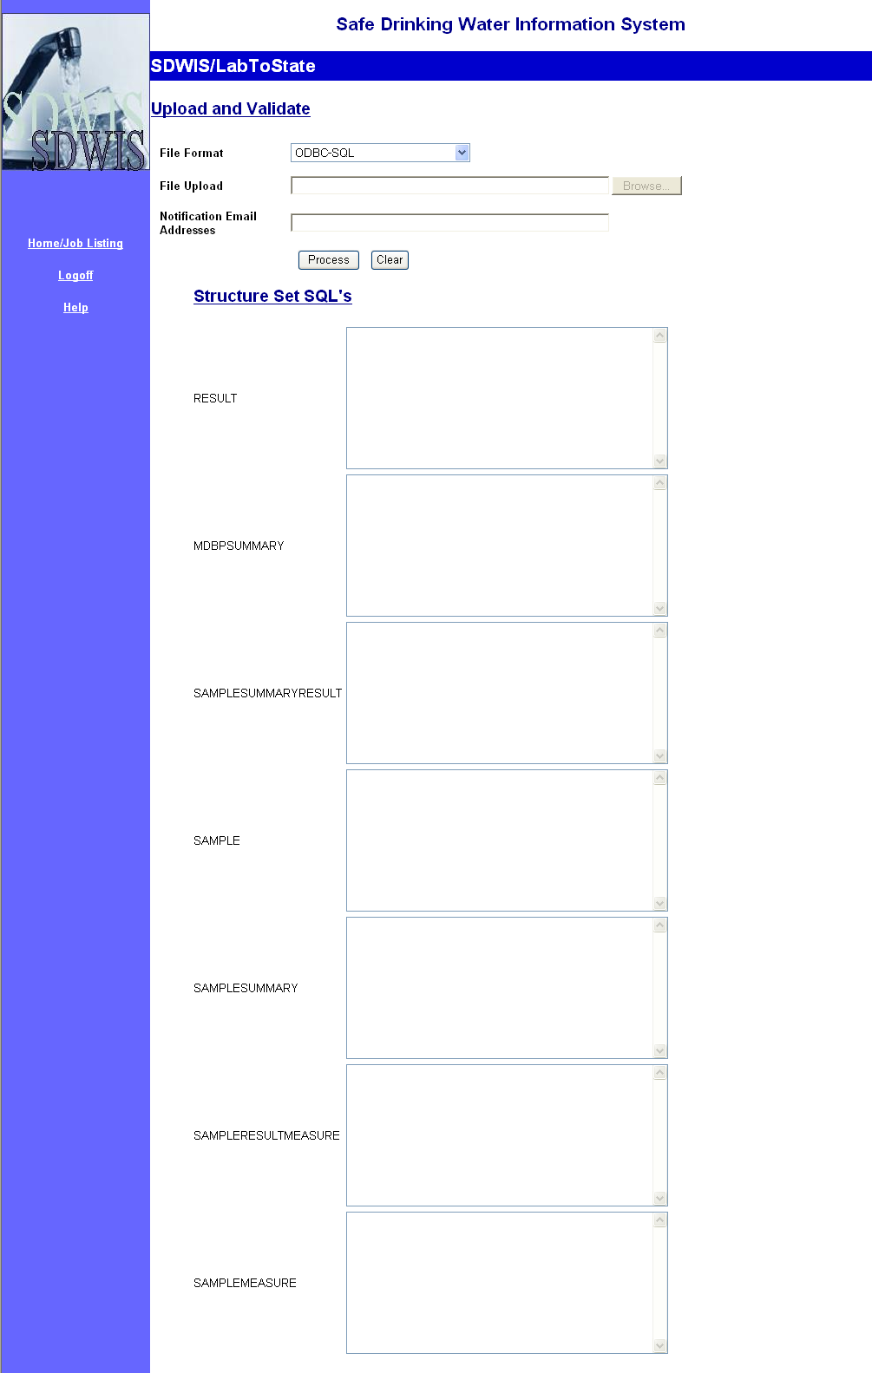
Exhibit 15. Upload and Validate Page

Confirmation Page
The SDWIS/LabToState Confirmation page indicates to the user that SDWIS/LabToState received the submitted file.

Folder Name: [LabToStateHome]\jsp\
File Name: confirmation.jsp

- Page Content and Navigation: Exhibit 16 depicts the SDWIS/LabToState Confirmation page.

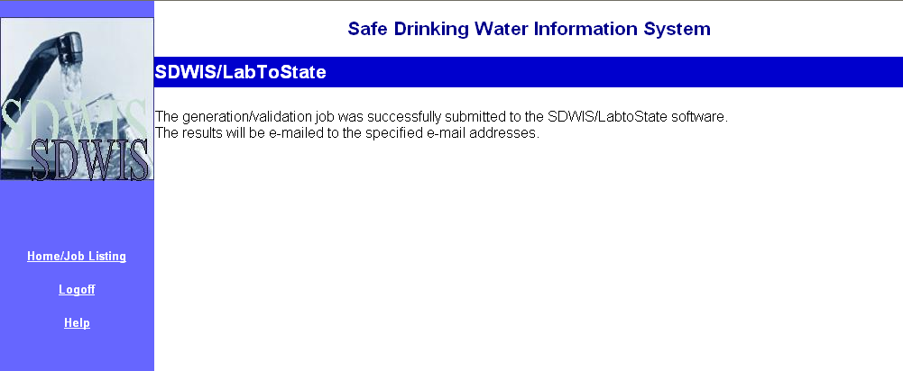
Exhibit 16. Confirmation Page

Certification Page
The SDWIS/LabToState Certification page allows the user to attest that the uploaded data is an accurate representation of the sample data submitted by the laboratory. It also provides links to the summary and detail reports and the generated XML documents.

Folder Name: [LabToStateHome]\jsp\
File Name: jobDetails.jsp
jobDetailsMenu.jsp

Page Content and Navigation: Exhibit 17 depicts the SDWIS/LabToState Certification page.

- Job Detail Section — Lists metadata regarding the Job being certified. Specifically, it displays the Job ID, File Name, Laboratory, and whether the Job was certified.

- Certification Text — Presents the statement configured by the site during installation.

- I Agree checkbox — Allows the user to designate whether he/she agrees with the certification statement.

- PIN Number — Allows the user to enter a protected PIN Number.

- Submit File(s) button — Initiates transfer of the sample data to SDWIS/XML Sampling by invoking the CertifyServlet.

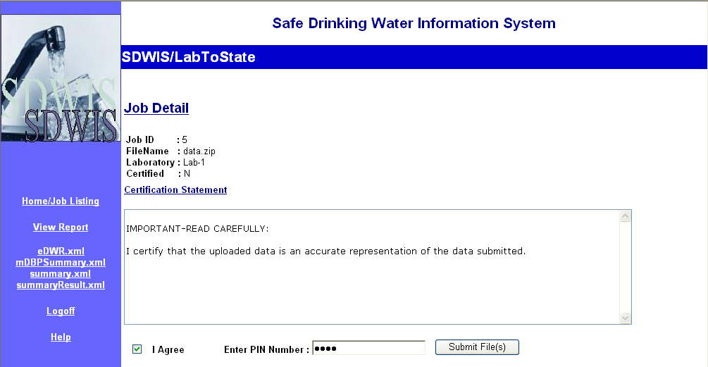
Exhibit 17. Certification Page

Daily Log Files List Page
The Daily Log Files List page provides links to each of the daily log files generated by SDWIS/LabToState processing.

Folder Name: [LabToStateHome]\jsp\
File Name: logFiles.jsp

Page Content and Navigation: Exhibit 18 depicts the SDWIS/LabToState Daily Log Files List page.

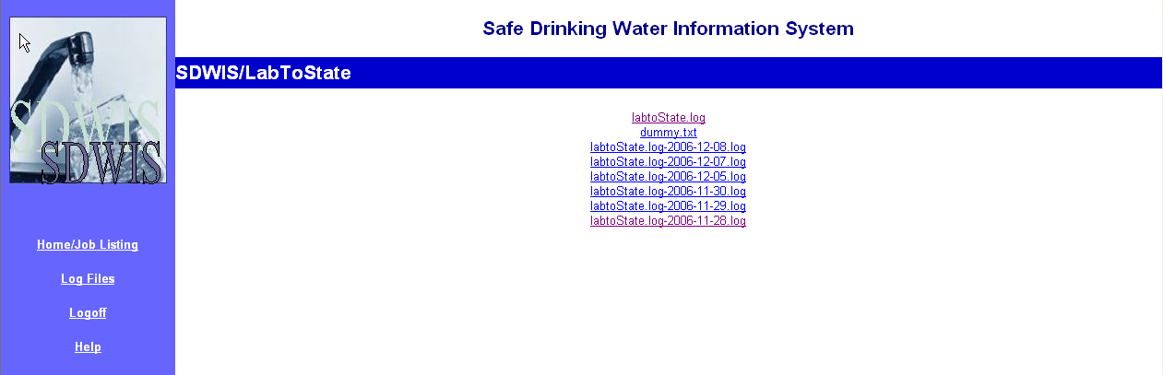
Exhibit 18. Daily Log Files Page

Servlets
This section describes the servlets used by UI Components. Appendix F contains the detail program specifications for each servlet.

LoginLogoff Servlet
The LoginLogoff servlet is initiated from the User Login page and from the Logoff link on the Navigation bar. To logon, the LoginLogoff servlet receives as an argument a user ID and password. It checks the user ID and password using the UserUtility class. If the user ID and password are authenticated, it instantiates and sets values in the UserInfo session object. Then, it presents the Home page.

To logoff, the LoginLogoff servlet receives an action command of “Logoff.” It terminates the user session by setting values in the UserInfo session object and presenting the User Login page.

Folder Name: [LabToStateHome]\WEB-INF\classes\com\sdwis\labtostate\servlet\
File Name: \LoginServlet.java

JobSelection Servlet
The JobSelelection servlet is initiated from the Job ID hyperlink on the Home Page. It presents the metadata about the submitted file on the Certification page.

Folder Name: [LabToStateHome]\WEB-INF\classes\com\sdwis\labtostate\servlet\
File Name: \JobSelectionServlet.java

JobListing Servlet
The JobSelelection servlet is initiated by clicking the Remove Jobs From List button on the Home/JobListing Page. It logically deletes selected jobs from the database. Logically deleted jobs are not listed on the Home page.

Folder Name: [LabToStateHome]\WEB-INF\classes\com\sdwis\labtostate\servlet\
File Name: \JobListingServlet.java

Dispatch Servlet
The Dispatch servlet is initiated by clicking the Process button on the Upload and Validate Page. It uploads the selected compressed file to the application server. It instantiates the UIStructure object initiating it with the values entered by the user on the Upload and Validate page. Then, it initiates the Services Manager component.

Folder Name: [LabToStateHome]\WEB-INF\classes\com\sdwis\labtostate\servlet\
File Name: \DispatchServlet.java

Certify Servlet
The Certify servlet is initiated by clicking the Submit Files button on the Certification Page. It uploads the selected compressed file to the application server. It ensures that the user entered a valid PIN Number. If the PIN Number is valid, it initiates the Document Delivery Manager component. Otherwise, it presents an error message to the user.

Folder Name: [LabToStateHome]\WEB-INF\classes\com\sdwis\labtostate\servlet\
File Name: \CertifyServlet.java

SDWIS/LabToState Reports
The SDWIS/LabToState reports are formatted as HTML files and presented to the user via a standard browser. The HTML files are generated using XSLT. XSLT is a language used in XSL style sheets to transform XML documents into other file formats, such as HTML.

Exhibit 19 lists the name of each report and the name of the XSLT stylesheet(s) used to generate it. Appendix E contains the layout and content of each report.

Report Name | XSLT Stylesheet or HTML File
Index Report and  Summary Report | Index.xsl
Object Error Report | EDWR-Errors.xsl  Sample-Errors.xsl  Sample-Summary-Errors.xsl  Sample-Summary-Result-Errors.xsl  Result-Errors.xsl
Generation Error Report | Generation-Errors.xsl  Actions_summary.xsl  Samples_summary.xsl

Exhibit 19. Report Names and XSLT Stylesheet Names

Services Manager Component
The Services Manager component performs general housekeeping and file management activities. It also manages requests and returns responses. Exhibit 20 depicts the overall class hierarchy diagram for the SDWIS/LabToState. It depicts the domain classes used by the Services Manager as well as the domain classes used by the other components. The Services Manager component is initiated from the Upload and Validate page and its initial entry point is the JobHandler class and comprises the JobHandler and the GenerationErrors classes.

The JobHandler class receives as arguments the UIStructure and UserInfo objects, which are utility classes instantiated by the UI Component. It uses utility classes to track metadata about the job, record events in the daily log file, and track site-specific parameters. All utility classes are described in Section 7.7, Utility Components. The JobHandler class moves the file to the working directory; retrieves the physical name of the requested Data-Source Plug-In, instantiates the common interface to all Data-Source Plug-Ins, and invokes the execute method of the Data-Source Plug-In.

After the Data-Source Plug-In returns to the JobHandler, the JobHandler invokes the GenerationErrors class to construct the HTML reports and the report index page. After the reports are built, JobHandler sends an e-mail to the laboratory user and terminates.

Folder Name: [LabToStateHome]\WEB-INF\classes\com\sdwis\labtostate\
Java Class Name: \JobHandler.java
\GenerationErrors.java

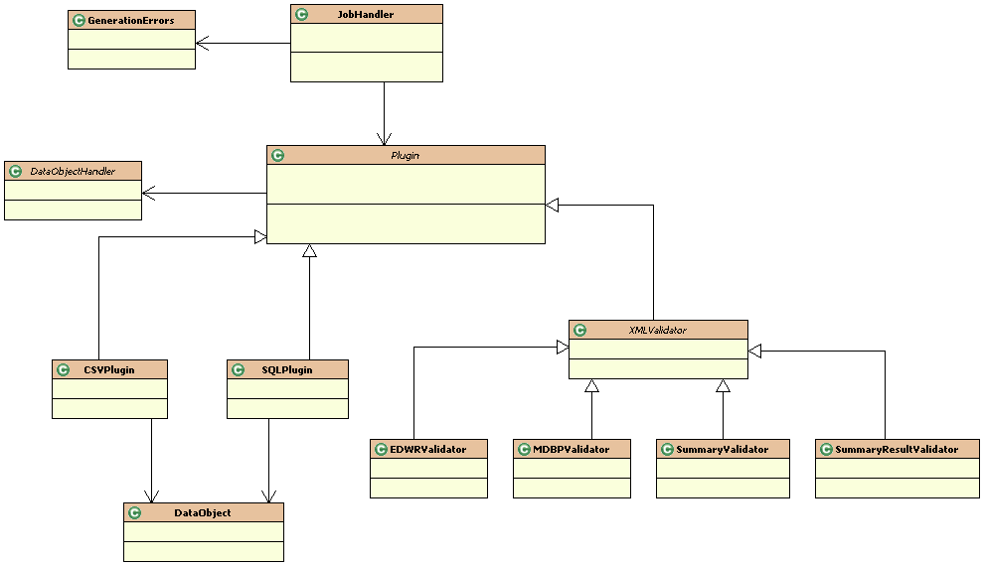
Exhibit 20. Services Manager Component Class Hierarchy Diagram

Data Source Manger Component
The Data Source Manager component comprises Data-Source Plug-Ins, which retrieve and parse sample data submitted in various formats. Exhibit 21 depicts the overall class hierarchy diagram for the SDWIS/LabToState. It depicts the domain classes used by the Data Source Manager as well as the domain classes used by the other components. The Data Source Manger component comprises the PlugIn, CSVPlugin, SQLPlugIn, and DataObject classes. The Services Manager invokes the Data Source Manager using the interface described by the PlugIn class, which is an abstract java class defining the interface to each of the Data-Source Plug-Ins. For each XML schema supported by SDWIS/LabToState, the PlugIn class establishes the chain of concrete handlers as described in the Chain of Responsibility (CoR) design pattern (see Section 5.3, Technical Architecture). Each Data-Source Plug-In inherits the characteristics of the PlugIn class and extends its functionality to support the following basic capabilities:

- Retrieve sample data from its data source.
- Instantiate and populate the DataObject class.
- Initiate the XML Generation component passing the DataObject class as an argument.

The following sections describe the design specifications for each of the Data-Source Plug-Ins delivered with SDWIS/LabToState. Appendix F contains the detail programming specifications. Appendix B describes the interface specifications to develop and deploy site-specific Data-Source Plug-In.

Folder Name: [LabToStateHome]\WEB-INF\classes\com\sdwis\labtostate\
Java Class Name: \generator\PlugIn.java

Exhibit 21. Data Source Component Class Hierarchy Diagram

CSV Plug-In
The CSV Plug-In receives and parses sample data from a text file or a compressed file (i.e., zip file) containing one or more text files. The text files contain sample data formatted as comma separated values (CSV). The CSV Plug-In determines the order and content of each line in the text file through the Sample Data Content Configuration files as described in Section 6.3, Sample Data File Content Configuration.

The CSVPlugin class inherits the characteristics of the abstract Plugin class. The Services Manager initiates the CSVPlugin class by issuing that object’s execute method. First, the CSVPlugin class uses utility classes to retrieve environment information (e.g., file name, directory structure), extract the CSV files from the compressed file and move them to the working directory assigned to the current job.

Next, the CSVPlugin parses specific data values from each line of data in the CSV file. It uses utility classes to retrieve metadata about the order and content of the CSV file. Then, the CSVPlugin instantiates the DataObject class and populates it with the values from the CSV file. For each instantiated DataObject, it initiates the XML Generation component by issuing the processobject method in the DataObjectHandler passing the DataObject to it as an argument. Section 7.4, XML Generation describes the DataObjectHandler class. The CSVPlugin continues to process each line of text in the CSV file as well as each CSV file extracted from the compressed file.

After each line of text in each CSV file is processed, CSVPlugin saves the generated XML documents to the local file system. Then, it initiates the XML Validation component to validate the XML document by passing the saved XML document path to it as an argument. Appendix F contains the detail programming specifications.

Folder Name: [LabToStateHome]\WEB-INF\classes\com\sdwis\labtostate\
Java Class Name: \generator\CSVPlugin.java
\generator\DataObject.java

SQL Plug-In
The SQL Plug-In establishes a connection to the site’s relational database using an ODBC/JBBC connection. The connection properties for the SQL Plug-In are configured using the siteProperties.txt file. The SQL Plug-In receives the sqlStatements from the User Interface and sequentially executes them for each logical object.

Using the same processing as defined for the CSV Plug-In, the SQL Plug-In iterates the result set, constructs a DataObject class for each row, and invokes the processObject method in the DataObjectHandler class. After all rows in the result set are processed, the XML documents are saved to the local file system and the XML Validation component is invoked.

Appendix F contains the detail programming specifications.

Folder Name: [LabToStateHome]\WEB-INF\classes\com\sdwis\labtostate\
Java Class Name: \generator\SQLPlugin.java

XML Generation Component
The XML Generation component constructs XML documents compatible with the XML schemas supported by SDWIS/XML Sampling. Exhibit 22 depicts the class hierarchy diagram for the XML Generation component. Following the COR design pattern, the XML Generation component includes the abstract handler as well as a concrete handler for each XML document generated.

The DataObjectHandler class is an abstract java class describing the interface to each concrete handler class. It returns the address of the instantiated object, which the Data Source Manager uses to establish the chain of concrete handlers in the CoR design pattern. It also establishes the processobject method, which the Data-Source Plug-In uses to initiate the XML Generation component. Each concrete handler inherits the characteristics of the DataObjectHandler class and extends its functionality to support the following basic capabilities:

- Determine if this handler should process the request,
- Encapsulate the JAXB components in a façade layer,
- Marshall the data to the XML document.

Folder Name: [LabToStateHome]\WEB-INF\classes\com\sdwis\labtostate\
Java Class Name: \generator\DataObjectHandler.java

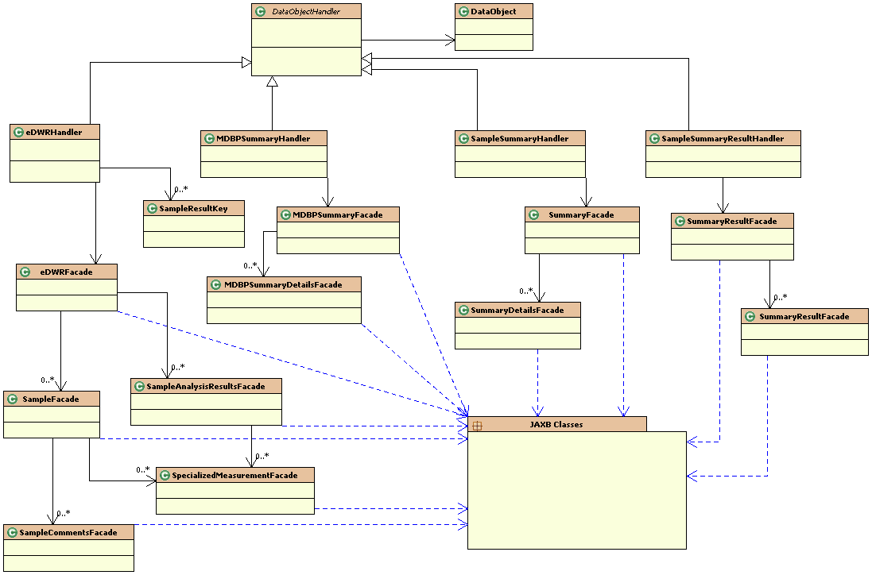
Exhibit 22. XML Generation Component Class Hierarchy Diagram

XML Document Handler
The XML Document Handler receives sample data from the Data Source Manager component when the Data Source Manager issues the processobject method passing the DataObject as an argument. Each DataObject contains a command indicating the XML Document Handler to process the object. Exhibit 23 lists each XML Document Handler, the XML schema it supports, the commands passed to it in the DataObject, and the component of the XML Validation component that it calls to validate the XML document.

XML Document Handler | XML Schema | Data Object Command | XML Validation Class
eDWRHandler.java | SDWIS_eDWR  _v1.0.xsd | Sample  SampleMeasure  SampleResult  SampleResultMeasure  Marshall | EDWRValidator.java
MDBPSummary  Handler.java | SDWIS_MDBPSummary  _v1.0.xsd | MDBPSummary  Marshall | MDBPValidator.java
SampleSummary  Handler.java | SDWIS_Summary  _v1.0.xsd | SampleSummary  Marshall | SummaryValidator.java
SampleSummaryResult  Handler.java | SDWIS_SummaryResult _v1.0.xsd | SampleSummaryResult  Marshall | SummaryResultValidator.java

Exhibit 23. XML Document Handler Responsibilities

The XML Document Handler uses utility classes to check the command it received as an argument in the DataObject. It forwards the request to the next object in the chain if it is not responsible for processing the DataObject.

To process the DataObject, the XML Document Handler instantiates the JAXB Façade for the XML document it is constructing. Next, it initiates the ReflectionUtility passing it the DataObject and the JAXB Façade object. The ReflectionUtility uses a series of text files (Element Mapping Files) to map the element names as defined in the Element Configuration file to the physical Java component. The physical name of these text files is the XML Sampling structure set name (e.g., Sample.txt).

The ReflectionUtility class uses utility classes to retrieve the order of the elements as configured by the site. It also uses utility classes to retrieve the mapping of the logical element name to the method within the JAXB Façade. Next, the ReflectionUtility class dynamically calls the method within the JAXB Façade passing to it the value of the element from the DataObject it received as an argument.

To process the marshall command, the XML Document Handler first saves the in memory data objects to an XML File and then initiates the XML Validation Component. Specifically, it initiates the Java class, as specified in Exhibit 23, which is responsible for validating the XML document it constructed.

Folder Name: [LabToStateHome]\WEB-INF\classes\com\sdwis\labtostate\
Java Class Name: \generator\edwr\eDWRHandler.java
\generator\mdbpsummary\MDBPSummaryHandler.java
\generator\summary\SampleSummaryHandler.java
\generator\summaryresult\SampleSummaryResultHandler.java
\ReflectionUtility.java

Folder Name: [LabToStateHome]\WEB-INF\classes\mappings
Element Mapping Files: MDBPSummary.txt
Sample.txt
SampleMeasure.txt
SampleResult.txt
SampleResultMeasure.txt
SampleSummary.txt
SampleSummaryResult.txt

JAXB Facade
For each hierarchical level of the XML Schema, SDWIS/LabToState includes a high-level JAXB Façade and detail-level JAXB Facades. The high-level façade encapsulates the Java classes generated by the JAXB compiler. The detail-level facades contain methods to set class properties based on values received in the DataObject.

Folder Name: [LabToStateHome]\WEB-INF\classes\com\sdwis\labtostate\
Java Class Name: \generator\edwr\eDWRFacade.java
\generator\edwr\AnalysisResultCommentFacade.java
\generator\edwr\SampleAnalysisResultsFacade.java
\generator\edwr\SampleCommentsFacade.java
\generator\edwr\SampleFacade.java
\generator\edwr\SpecializedMeasurementFacade.java
\generator\mdbpsummary\MDBPSummaryFacade.java
\generator\mdbpsummary\MDBPSummaryDetailsFacade.java
\generator\edwr\SampleResultKey.java
\generator\mdbpsummary\MDBPSummaryDetailsFacade.java
\generator\summary\SummaryDetailsFacade.java
\generator\summary\SummaryFacade.java
\generator\summaryResult\SummaryResultFacade.java
\generator\summaryResult\SummaryResultDetailsFacade.java

XML Validation Component
The XML Validation component validates XML documents against the XML schemas supported by SDWIS/XML Sampling. Exhibit 24 depicts the class hierarchy diagram for the XML Validation component. The XML Validation component may be initiated from the Services Manager and the XML Generation component.

The Services Manager detects the format of the data being submitted. If the data source is an XML document, the Services Manager initiates the component of the XML Validation component that validates the XML documents against the XML schema. It determines the component using Data Source Registration file described in Section 6.2, Data Source Registration File. If the XML Generation component creates the XML document, it initiates the XML Validation component immediately after generating the XML document.

Regardless of the calling component, the XML Validation component is always initiated using the validate method. The XML Validation component comprises a series of Java classes each validating XML documents against a specific XML schema. The foundation of the XML Validation component is the XMLValidator class. The XMLValidator class is an abstract java class, which describes the interface to the specific XML validation classes. The XMLValidator class creates a DOM XML Schema Validator for validating individual business objects inside the XML documents. It writes the errors messages using the utility classes, which groups the errors to produce user-friendly reports after validation.

Appendix F contains the detail programming specifications.

Folder Name: [LabToStateHome]\WEB-INF\classes\com\sdwis\labtostate\
Java Class Name: \validator\EDWRValidator.java
\validator\MDBPValidator.java
\validator\SummaryResultValidator.java
\validator\SummaryValidator.java
\validator\XMLValidator.java

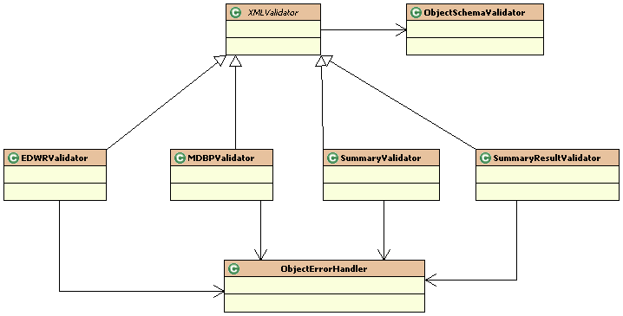
Exhibit 24. XML Validation Component Class Hierarchy Diagram

Document Deliver Manager
The Document Delivery component provides the interface between SDWIS/LabToState and SDWIS/XML Sampling. It is initiated from the Certification page. The interface may be configured by each site as follows:

- Copy the XML documents directly to the SDWIS/XML Sampling Inbox.
- Submit the XML document through the State Node.

These configuration parameters are described in Section 6.1, Site Properties File.

Appendix F contains the detail programming specifications.

Folder Name: [LabToStateHome]\WEB-INF\classes\com\sdwis\labtostate\
Java Class Name: \utility\XMLSamplingIntegrator.java
\utility\XMLSamplingFileSystemIntegrator.java
\utility\XMLSamplingWebServicesIntegrator.java

Utility Components
Exhibit 25 lists each of the Java utility class used by SDWIS/LabToState. These classes are used throughout the application to perform a discrete non-business related activity (e.g., send an e-mail, logging). Appendix F contains the detail programming specifications.

Exhibit 25. Java Utility Classes
SDWIS/LabToState Utility Classes
Located in Folder Name: [LabToStateHome]\WEB-INF\classes\com\sdwis\labtostate\
Java Class Name | Description
ConverterUtility.java | Converts strings to various data types required by the XML schema (integer, decimal, date, etc.)
EmailEngineUtility.java | Sends e-mails for notification after the completion of the upload and validation process.
Environment.java | Resolves the various file paths used by the application based on the operating system.
JobInformation.java | Maintains the file paths to the various files created for a job as part of the processing logic.
JobSummary.java | Contains and manages the job’s summary information, which is used to produce the summary statistics.
MyAuthenticator.java | Contains the authentication information for the e-mail engine.
MyResolver.java | Resolves the import and include paths used within the XML Schemas.
NamespacePrefixMapperImpl.java | Associates namespace prefixes to the namespaces declared in the XML Schemas.
ObjectErrorHandler.java | Writes the errors found during the validation process to temporary XML document for each logical object.
ObjectSchemaValidator.java | Creates a common DOM Validator for validating XML Documents.
UIStructure.java | Contains the data entered by the user in the upload and validate page.
XSLTEngine.java | Generates HTML reports from XML documents using the xalan stylesheet processor.
\generator\PropertiesManager.java | Maintains pointers to each of the site configuration files used by the application.
\generator\StructureSetConstants.java | Contains java constants used throughout the application it is analogous to enumerated values.
\generator\DatabaseConnect.java | Establishes the database connection for the SQL Plug-In using the database properties specified in the siteProperties.txt.
\utility\DefaultPasswordAuthenticator.java | Provides a default implementation of the PasswordAuthenticator interface, which is used to authenticate a user during login.
\utility\DefaultPINAuthenticator.java | Provides a default implementation of the PINAuthenticator interface, which is used to verify PIN numbers during the release of the XML document to XML Sampling.
\utility\HibernateSessionFactory.java | Obtains the hibernate connection to the application’s database.
\utility\LogUtility.java | Access the embedded derby database to retrieve metadata about the Job.
\utility\PasswordAuthenticator.java | Defines the application’s interface to authenticate users to the application.
\utility\PINAuthenticator.java | Defines the interface to validate PIN numbers.
\utility\UserInfo.java | Contains all the information relating to the user.
\utility\UserUtility.java | Contains an in-memory representation of the userList.xml file and is used by the default implementation of user authentication and PIN validation.

SDWIS/LabToSTate Testing Approach
The scope of testing for SDWIS/LabToState includes the UI Components, Services Manager, XML Generation, XML Validation, and Delivery Manger components. Testing of the SDWIS/LabToState application involves three distinct phases: Unit, Integration, and Systems testing. The SDWIS development team performs Unit testing. The SDWIS test team performs integration and systems testing.

As part of unit testing, developers exercise each Java class and evaluate its input and output results. The developer also evaluates the generated XML document and validates it against the XML schemas using an independent validation tool such as XML Spy.

After unit testing, the developer creates an installation package, which is delivered to the CM Manager with a turnover memo. The turnover memo identifies changes to the application deployment checklist and lists the events included in this software turnover. The CM Manager distributes both the package and turnover memo to the SDWIS Test Team.

After deploying the installation package in the test environment, the SDWIS test team executes a set of integration test cases that exercise the SDWIS/LabToState application. These test cases consist of a controlled set of sample data submitted to the application in different formats (e.g., CSV files, XML documents, and output from relational database tables).

For System Integration testing, the SDWIS Test Team verifies that XML documents generated by SDWIS LabToState are processed through the SDWIS/XMLSAMPLING 1.0.3 application into a SSWR1.0 database.

The SDWIS Test Team implements a set of validation tests against the final packaged software and documentation. The team deploys the installation package in the test environment using the Installation Guide and uses the software based on instructions in the User Guide. After completing these tests, the SDWIS Test Team provides updates to the Installation Guide, User Guide, and Release Notes.

Verification of 508 Compliance is conducted by running each web page through SSB Technologies’ In-Focus tool and using IBM’s Home Page Reader (Version 3.0).

The test environment for this effort is described in the SDWIS/LabToState Installation Document (Systalex-SDWIS-01-6.d3a), dated December 20, 2006.

REQUIREMENTS TRACEABILITY MATRIX
The Requirement Traceability Matrix (RTM) provides a tool to ensure that all requirements are satisfied and to locate affected system components as requirements change. This allows the impact of requirement changes on the system to be determined, facilitating cost, benefit, and schedule determinations. An RTM is used to verify that all requirements are allocated to system components (forward trace), and to determine the source of requirements (backward trace).

Appendix G contains the SDWIS/LabToState RTM. The RTM columns are described below.

- Requirement ID – A unique, consistent identification of the requirement.

- Requirement Text — Text description of the requirement statement.

- Requirement Type – The type of requirement statement (i.e., Functional, Data, Interface, Performance, Security, Operational).

- Requirement Source – The source(s) of the requirement.

- Functional Component – The functional component to which this requirement is assigned.

- Design Component – The design component that will implement this requirement.

APPENDIX A

List of Work Group Participants

This page is intentionally left blank.

The following table lists the participants in the SDWIS/LabToState Work Group. Those participants with an asterisk by their name also participated in the Focus Group.

Name | Affiliation
*Tom Becker | NY
Celine Barakat | NY
Barrett Brown | ND
Tamie Calef | IA
Eric Chai | NC
Linda Doughty | NJ
*Hal Frank | IA
*Sandy Frank | IL
Laurie Gehlsen | AZ
*Tom Hart | NY
*Laura Hardesty | NE
*Dianna Heaberlin | SAIC
*Clint Lemmons | EPA — Headquarters
*Fazal Mohammed | SAIC
Jeri Long | IL
Doug Nguyen | HI
Darrell Oserthoudt | ASDWA
Maria Ridgway | AK
Brett Shakespear | UT
*Terrie Sutch | SAIC
*Mike Wiemann | IA
*Michele White | NY

This page is intentionally left blank.

APPENDIX B

Interface Specifications

This page is intentionally left blank.

Data-Source Plug-Ins Interface Specifications

To implement a Data-Source Plug-In, the implementer will complete the following steps to create, register and integrate it with SDWIS/LabToState.

STEP 1: Develop a site-specific Data-Source Plug-in

The Java class that implements the site-specific Data-Source Plug-In extends an abstract class delivered with the standard SDWIS/LabToState software. The abstract class is com.sdwis.labtostate.generator.Plugin. The new Java class implements one method with the following signature:

public abstract void execute(UIStructure structure) throws Exception;

The argument passed to this method is the UIStructure class, which contains all the data entered by the user in the upload and validate page. It is the responsibility of the concrete data source plugin class to create the DataObject class for each logical business object for which it is receiving data. The DataObject class contains an attribute command, which holds the name of the logical business object and a string array containing the data values in the order specified by the Element Configuration File. The abstract class provides a pointer to the handler, which the custom class uses to invoke the XML Generation component of the SDWIS/LabToState application. After the new Java class creates the DataObject, it invoked the handler’s processObject method denoted by the following method signature:

abstract public void processObject(DataObject object) throws Exception;

After creating and processing all the DataObjects, the new Java class creates a special DataObject containing the “Marshall” command. This command notifies the handlers to create the XML documents from the in-memory representation of the DataObjects and to invoke the XML Validation component to check the XML documents against the XML Schemas.

STEP 2: Copy the site-specific Data-Source Plug-in

The user copies the compiled java classes under the WEB-INF/classes folder or creates a jar file from the compiled classes and copies the jar file to the WEB-INF/lib folder. This step makes the site-specific Data-Source Plug-In available to the SDWIS/LabToState application allowing it to dynamically invoke site-specific implementations.

STEP 3: Register the site-specific Data-Source Plug-In

To register the Data-Source Plug-In with SDWIS/LabToState, add a new entry to the plugins.txt file in the properties folder. The new entry contains a user-friendly logical name and the fully qualified java class name of the custom data source implementation. The user-friendly name is listed as a new option under the file format in the upload and validate page.

User Authentication Interface Specifications

To implement a site-specific User Authentication routine, the implementer will complete the following steps to create, register and integrate it with SDWIS/LabToState.

STEP 1: Create the site-specific User Authentication implementation

The custom user authentication implementation class implements the com.sdwis.labtostate.utility.PasswordAuthenticator interface class. The concrete class implements one method with the following signature:

public boolean authenticate(String userName, String password) throws Exception;

The arguments passed to this method contain the username and password entered by the user in the login page. The implementation class can validate this information using its own logic by accessing the local user repository (eg., Windows NT, LDAP etc). The return type from this method is a boolean indicating whether the user was successfully authenticated.

STEP 2: Copy the site-specific User Authentication implementation

The user copies the compiled java classes under the WEB-INF/classes folder or creates a jar file from the compiled classes and copies the jar file to the WEB-INF/lib folder. This step makes the site-specific User Authentication implementation available to the SDWIS/LabToState application allowing it to dynamically invoke site-specific implementations.

STEP 3: Register the site-specific User Authentication implementation

The user updates the siteProperties.txt file in the properties folder to change the value of the PasswordAuthenticatorClass property to contain the name of the newly created custom class. The value must be the fully qualified java class name of the custom implementation class.

The user changes the value of the PasswordAuthenticatorClass property in the siteProperties.txt file in the properties folder. The value contains the name of the newly created custom class. The value must be the fully qualified java class name of the custom implementation class.

PIN Authentication Interface Specifications

To implement a site-specific PIN Authentication routine, the implementer will complete the following steps to create, register and integrate it with SDWIS/LabToState.

STEP 1: Create the site-specific PIN authentication implementation

The custom PIN authentication implementation class implements the com.sdwis.labtostate.utility.PasswordAuthenticator interface class. The concrete class implements one method with the following signature:

public boolean validatePIN(String userName, String laboratory, String PIN) throws Exception;

The arguments passed to this method contain the username, laboratory, and the PIN entered by the user on the certification page. The implementation class validates this information using its own logic to verify the PIN number for a specific user. The return type from this method is a Boolean indicating whether the PIN was successfully verified.

STEP 2: Copy the site-specific PIN Authentication implementation

The user copies the compiled java classes under the WEB-INF/classes folder or creates a jar file from the compiled classes and copies the jar file to the WEB-INF/lib folder. This step will make the site specific PIN Authentication available to SDWIS/LabToState application allowing it to dynamically invoke site-specific implementation.

STEP -3: Register the custom PIN authentication class to the LabToState application

The user changes the value of the PINAuthenticatorClass property in the siteProperties.txt file in the properties folder. The value contains the name of the newly created custom class. The value must be the fully qualified java class name of the custom implementation class.

APPENDIX C

Site Properties File Name/Value Pairs

This page is intentionally left blank.

SDWIS/LabToState Site Property Names and Description
Name | Description | Initial Setting | Set By
TurnOnEmail | Contains an indicator allowing a site to eliminate the delivery of e-mail messages after upload and validation. The permitted values for this property are “true” and “false.” | true | Email Administrator
EmailHost | Contains the IP Address of the SMTP (Simple Mail Transfer Protocol) Mail Server. This value is used to connect to the mail server in automate the delivery of e-mails. This value must be set during installation. | sdc-ex2 | Email Administrator
EmailPort | Contains the port number of the e-mail server. The default value of 25 is used for a standard e-mail server installation. For non-standard e-mail server installations, this value should be changed to the port number of the e-mail server. This value is set during installation and can be changed by the System Administrator. | 25 | Email Administtrator
EmailAuthenticationRequired | Contains an indicator allowing a site to require e-mail authentication. The permitted values for this property are “true” and “false.” This value is set during installation and can be changed by the System Administrator. | false | Email Administrator
EmailUserid | Contains the user name that must be supplied if the e-mail server requires authentication. If e-mail server does not require authentication, the value is set to null. This value is set during installation and can be changed by the System Administrator. | <no value> | Email Administrator
EmailPassword | Contains the Password that must be supplied if the e-mail server requires authentication. If e-mail server does not require authentication, the value is set to null. This value is set during installation and can be changed by the System Administrator. | <no value> | Email Administrator
EmailFromAddress | Contains the e-mail address for the SDWIS/LabToState administrator. This e-mail address is used to send e-mails. | LabToState | Email Administrator
DateFormat | Contains a mask indicating the format in which date values are submitted. The default mask is MM/dd/yyyy. | MM/dd/yyyy | System Administrator
TimeFormat | Contains a mask indicating the format in which time values are submitted. The default mask is hhmmss. | HHmmss | System Administrator
DatabaseDriverClassName | Contains the JDBC-ODBC bridge class name, which connects to the client’s database using the ODBC data source. This value must not be changed. If the site is running on UNIX, this value can be changed to the jdbc driver class name (Refer to your local database manual for “connecting using jdbc”).  sun.jdbc.odbc.JdbcOdbcDriver | sun.jdbc.odbc.JdbcOdbcDriver | This value can be overriden by the Database Administrator
DatabaseConnectionURL | Contains the string used to establish a database connection The default DSN name is set to SDWIS. If the site is using a different DSN then this value must be changed. If the site is running on UNIX, this value can be changed to the jdbc connection url (Refer to your local database manual for “connecting using jdbc”).  jdbc:odbc:SDWIS | jdbc:odbc:SDWIS | This value can be overriden by the Database Administrator
DatabaseUserID | Contains the User ID used to connect to the client’s database schema. This value must be set during installation if the site is using the SQL Plug-in. | XMLSAMPLER10 | Database Administrator
DatabasePassword | Contains the Password used to connect to the client’s database schema. This value must be set during installation if the site is using the SQL Plug-in. | XMLSAMPLER10 | Database Administrator
PasswordAuthenticatorClass | Contains the name of the Java class used to authenticate User IDs and Passwords. If the site implements its own authentication utilities, the implementation must follow the interface specifications documented in the SDWIS/LabToState Installation Guide. SDWIS/LabToState includes a default implementation of user authentication in the Java class com.sdwis.labtostate.utility.DefaultPasswordAuthenticator. | com.sdwis.labtostate.utility.DefaultPasswordAuthenticator | This value can be overriden by the System Administrator
PINAuthenticatorClass | Contains the name of the Java class used to verify a User’s PIN Number. If the site implements its own PIN Number verification utilities, the implementation must follow the interface specifications documented in the SDWIS/LabToState Installation Guide. SDWIS/LabToState includes a default implementation of user PIN Number verification in the Java class com.sdwis.labtostate.utility.DefaultPINAuthenticator. | com.sdwis.labtostate.utility.DefaultPINAuthenticator | This value can be overriden by the System Administrator
NodeURL | Contains the URL to the State Node offering the web services defined by the WSDL document. This parameter must be used when using the State Node for integrating with SDWIS/XMLSampling. | http://localhost:10000/DNC/services/NetworkNodePortType_V10 | Node Administrator
NodeUserId | Contains the UserID required to connect to the State Node. This parameter must be used when using the State Node for integrating with SDWIS/XMLSampling. | <no value> | Node Administrator
NodePassword | Contains the password used to connect to the State Node. This parameter must be used when using the State Node for integrating with SDWIS/XMLSampling. | <no value> | Node Administrator
DataFlowNameForWebService | This value will be used as the dataflow name when invoking the web service. This parameter must be used when using the State Node for integrating with SDWIS/XMLSampling. | XMLSampling | Node Administrator
XMLSamplingIntegratorClass | Contains the name of the Java class that delivers the XML documents to the State Node, which in turn delivers the XML document to SDWIS/XMLSampling. This name/value pair and the name/value pairs that identify the SDWIS/XML Sampling Inbox are mutually exclusive. Therefore, for delivery, this name/value pair is commented. To implement this feature, you remove the comment from this line and comment the lines associated with the SDWIS/XML Sampling Inbox (SDWIS_EDWR_Inbox, Sample_Summary_Inbox, Sample_Summary_Result_Inbox, and MDBP_Summary_Inbox). | com.sdwis.labtostate.utility.XMLSamplingFileSystemIntegrator | System Administrator
SDWIS_EDWR_Inbox | Contains the full path and folder name of the SDWIS eDWR XML Document Inbox used by SDWIS/XML Sampling. This name/value pair and the name/value pair (XMLSamplingIntegratorClass) that identifies the Java Class for the State Node submission are mutually exclusive. Therefore, if you implement the State Node approach to SDWIS/XML Sampling integration, you must comment this line and remove the comment from the XMLSamplingIntegratorClass line. | C:\\jakarta-tomcat-5.0.28\\webapps\\XMLSampling\\SampleFolder | System Administrator
Sample_Summary_Inbox | Contains the full path and folder name of the SDWIS Sample Summary XML Document Inbox used by SDWIS/XML Sampling. This name/value pair and the name/value pair (XMLSamplingIntegratorClass) that identifies the Java Class for the State Node submission are mutually exclusive. Therefore, if you implement the State Node approach to SDWIS/XML Sampling integration, you must comment this line and remove the comment from the XMLSamplingIntegratorClass line. | C:\\jakarta-tomcat-5.0.28\\webapps\\XMLSampling\\SummaryFolder | System Administrator
Sample_Summary_Result_Inbox | Contains the full path and folder name of the SDWIS Summary Result XML Document Inbox used by SDWIS/XML Sampling. This name/value pair and the name/value pair (XMLSamplingIntegratorClass) that identifies the Java Class for the State Node submission are mutually exclusive. Therefore, if you implement the State Node approach to SDWIS/XML Sampling integration, you must comment this line and remove the comment from the XMLSamplingIntegratorClass line. | C:\\jakarta-tomcat-5.0.28\\webapps\\XMLSampling\\SummaryResultFolder | System Administrator
DMBP_Summary_Inbox | Contains the full path and folder name of the SDWIS MDBP Summary XML Document Inbox used by SDWIS/XML Sampling. This name/value pair and the name/value pair (XMLSamplingIntegratorClass) that identifies the Java Class for the State Node submission are mutually exclusive. Therefore, if you implement the State Node approach to SDWIS/XML Sampling integration, you must comment this line and remove the comment from the XMLSamplingIntegratorClass line. | C:\\jakarta-tomcat-5.0.28\\webapps\\XMLSampling\\MDBPSummaryFolder | System Administrator

APPENDIX D

Object and Element Configuration Files

This page is intentionally left blank.

Sample Object

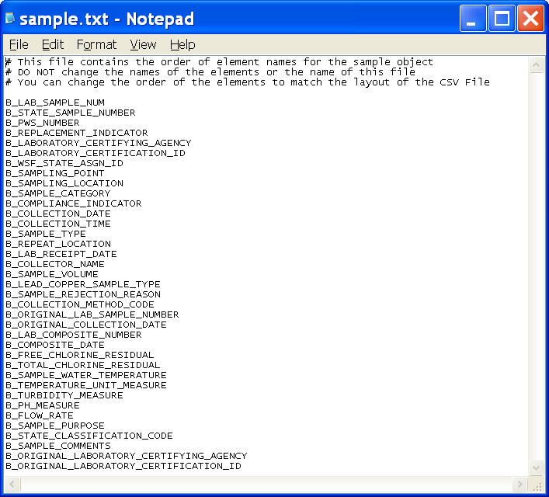

Sample Measure Object

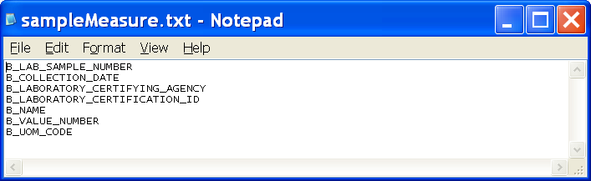
Result Object

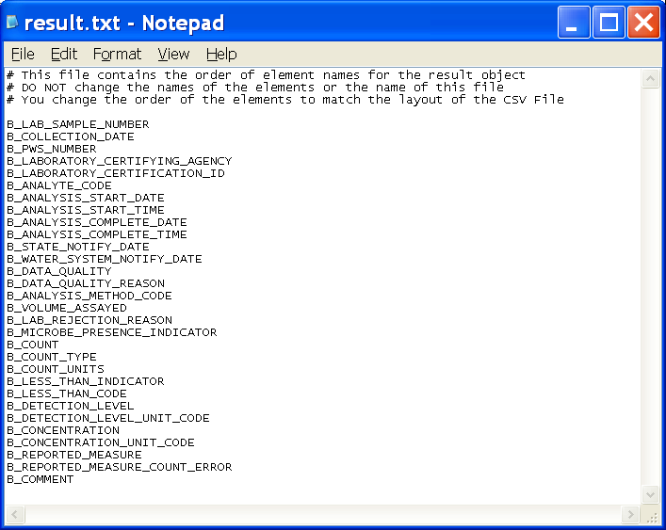
Sample Result Measure Object

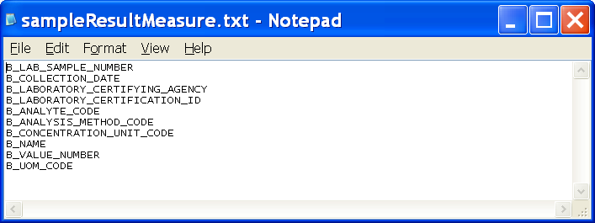
Sample Summary Object

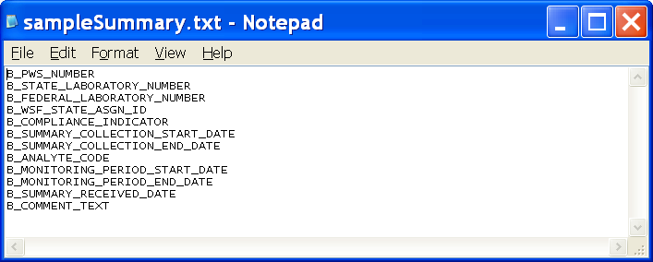
Sample Summary Result Object

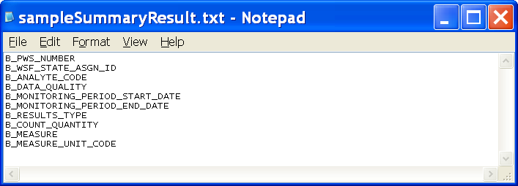

MDBP Summary Object

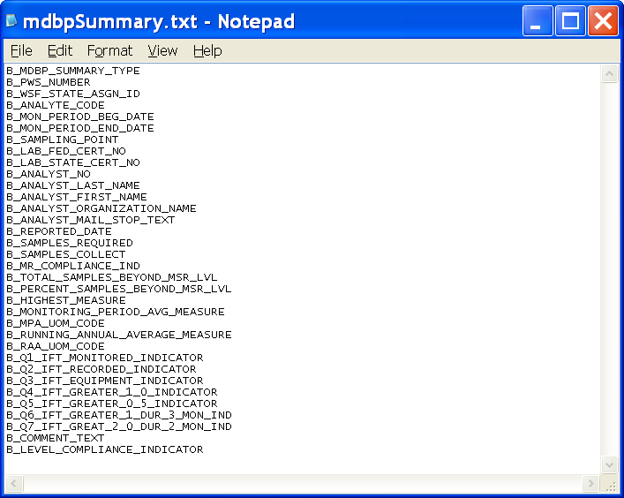

This page is intentionally left blank.

APPENDIX E

Report Content and Layout

This page is intentionally left blank.

Index and Summary Report
The Index and Summary Report is formatted as illustrated below. The physical filename for this report is Index.html. It provides hyperlinks as follows:

Links
- Generation Errors. Presents the errors detected during XML Generation and is illustrated later in this Appendix.

- [XML Schema]-Errors. Presents the errors detected during XML Validation. A separate link is presented for each supported XML Schema.

Columns
Structure Set. Identifies the name of the structure set.

Generation Record Count. Counts the number of logical objects submitted for generation.

Generation Error Count. Counts the number of logical objects in which an error is detected.

Validation Record Count. Counts the number of logical objects submitted for XML Schema validation.

Validation Error Count. Counts the number of logical objects in which an XML Schema validation error is detected.

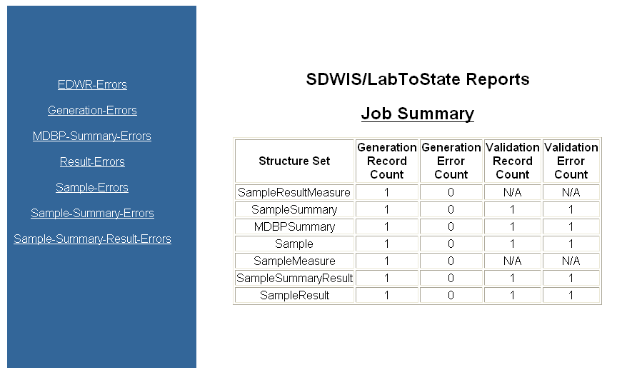
Generation Errors Report
The Generation Error Report is formatted as illustrated below. The physical filename for this report is Generation-Errors.html. It contains a list of the errors detected during XML Generation.

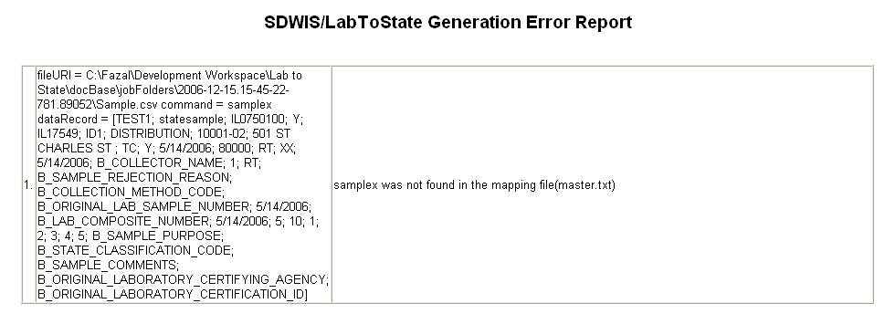

XML Schema Errors Report
The XML Schema Errors Report is formatted as illustrated below. A separate report is generated for each XML Schema supported. The physical filename for this report is [XMLSchema]-Errors.html. It contains a list of the errors detected during XML Validation.

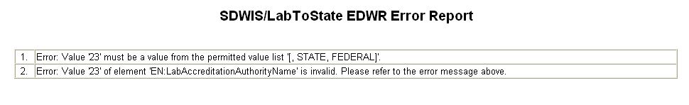

This page is intentionally left blank.

APPENDIX F

Java Detail Program Specifications

This page is intentionally left blank.

Detail Programming Specifications

The detailed design specifications were automatically generated from the class code using a tool named JavaDoc. JavaDoc is a utility program supplied by Sun Microsystems, which generates API documentation from Java source programs. The JavaDoc tool requires comments in the code following a specified format. This format enables the tool to scan through the Java code and pick up comments for rendering using an HTML or a PDF template. The HTML output from this tool is included in this Appendix. It is embedded as a zip file at the end of this description.

The generated API documentation contains the description for the various packages and the classes within those packages. Each package has a page that contains a list of its classes and interfaces, with a summary of each. Each class, interface, nested class, and nested interface has its own separate page. Each of these pages has three sections consisting of a class/interface description, summary tables, and detailed member descriptions (i.e., constructor and methods).

The class/interface description contains the description of the class or the interface and details the responsibilities of the class.

The summary tables contain a table listing the names of the methods and constructors belonging to the class. In addition to a one-line description for each method and constructor, the name is a hyperlink to the detailed member descriptions.

The constructor is a method in the class and is invoked when an object is created by instantiating the class. The constructor contains a series of initialization steps, which it performs before the object becomes ready to interact with other objects.

The methods represent the operations a class performs. Each method is a reusable piece of code. The methods represent the functional capability. The methods have a signature in three parts. The first part depicts the return data type, which indicates to the calling programming what to expect after a call to this method. The second part is the name of the method and is case-sensitive. The third part has the arguments with data types required by the method to execute.

This page is intentionally left blank.

Click on the icon below to use viewing the electronic file for Appendix E

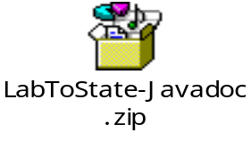

This page is intentionally left blank.

APPENDIX G

Requirements Traceability Matrix

This page is intentionally left blank.

Requirement  ID | RequirementText | RequirementType | RequirementSource | Functional  Component | Design Component
R95000 | SDWIS/LabToState shall receive sample data from the laboratory as defined in the SDWIS/XML Sampling XML schemas (i.e., SDWIS_eDWR_v1.0.xsd, SDWIS_Summary_v1.0.xsd, SDWIS_SummaryResult_v1.0.xsd, SDWIS_MDBPSummary_v1.0.xsd). The XML schemas are fully documented in the SDWIS/XML Sampling Mapping Document and Accompanying XML Schemas. | Data | XMLWriter Prototype | Data Component | XML Schema
R95010 | SDWIS/LabToState shall format the laboratory’s sample data as XML documents compatible with the SDWIS/XML Sampling XML schemas (i.e., SDWIS_eDWR_v1.0.xsd, SDWIS_Summary_v1.0.xsd, SDWIS_SummaryResult_v1.0.xsd, SDWIS_MDBPSummary_v1.0.xsd). The XML schemas are fully documented in the SDWIS/XML Sampling Mapping Document and Accompanying XML Schemas. | Functional | XMLWriter Prototype | Generation | XML Generation Component
R95020 | SDWIS/LabToState shall validate the XML documents against the SDWIS/XML Sampling XML schemas (i.e., SDWIS_eDWR_v1.0.xsd, SDWIS_Summary_v1.0.xsd, SDWIS_SummaryResult_v1.0.xsd, SDWIS_MDBPSummary_v1.0.xsd). The XML schemas are fully documented in the SDWIS/XML Sampling Mapping Document and Accompanying XML Schemas. | Functional | XMLWriter Prototype | Validation | XML Validation Component
R95030 | SDWIS/LabToState shall detect and log errors during the parsing, formatting, and validating of the sample data. | Functional | XMLWriter Prototype | Other | XML Validation Component
R95040 | SDWIS/LabToState shall provide the ability for an installation to register routines, referred to as Data-Source Plug-Ins, that receive and parse sample data from the laboratory. | Functional | XMLWriter Prototype | Data-Source Manager | Services Manager
R95050 | SDWIS/LabToState shall dynamically call the registered routines, referred to as Data-Source Plug-Ins, based on the selection by the user. | Functional | XMLWriter Prototype | Data-Source Manager | Services Manager
R95060 | SDWIS/LabToState shall provide Data-Source Plug-Ins to receive sample data formatted in comma separated values (CSV) files. — SDWIS/LabToState shall dynamically call the registered routines, referred to as Data-Source Plug-Ins, based on the selection by the user. | Functional | XMLWriter Prototype | Data-Source Manager | Data Source Manager
R95070 | SDWIS/LabToState shall provide Data-Source Plug-Ins to retrieve sample data from a relational database. | Functional | XMLWriter Prototype | Data-Source Manager | Data Source Manager
R95080 | SDWIS/LabToState shall provide Data-Source Plug-Ins to receive sample data formatted in XML documents compatible with the XML schemas supported by SDWIS/XML Sampling (i.e., SDWIS_eDWR_v1.0.xsd, SDWIS_Summary_v1.0.xsd, SDWIS_SummaryResult_v1.0.xsd, SDWIS_MDBPSummary_v1.0.xsd). | Functional | XMLWriter Prototype | Data-Source Manager | Data Source Manager
R95090 | SDWIS/LabToState shall deliver the XML documents to the Inbox used by SDWIS/XML Sampling based on site configuration parameters. | Interface | XMLWriter Prototype | Software Interface | Document Delivery Manager
R95100 | SDWIS/LabToState shall deliver the XML documents to the primacy agency’s State Node based on site configuration parameters. | Interface | XMLWriter Prototype | Software Interface | Document Delivery Manager
R95110 | SDWIS/LabToState GUI interfaces and status and summary messages shall comply with EPA’s Section 508 standards that require federal agencies’ electronic and information technology be accessible to people with disabilities. | Interface | XMLWriter Prototype | User Interface | UI Component
R95120 | SDWIS/LabToState shall provide a GUI interface allowing users to initiate requests, submit arguments, and receive responses for the following capabilities:  - Upload and validate sample data.  - List the uploaded files containing sample data.  - Release data to SDWIS/XML Sampling.  - List Log Files | Interface | XMLWriter Prototype | User Interface | UI Component
R95130 | SDWIS/LabToState shall notify the user through an e-mail that the submitted sample data is ready for review and approval. | Interface | XMLWriter Prototype | User Interface | UI Components, Services Manager
R95140 | SDWIS/LabToState status and summary messages shall be formatted as HTML documents. | Interface | XMLWriter Prototype | User Interface | UI Components, Services Manager
R95150 | SDWIS/LabToState shall provide the status and summary messages in a printer-friendly format. | Interface | XMLWriter Prototype | User Interface | UI Components, Services Manager
R95160 | SDWIS/LabToState shall provide a login interface for users to enter a User ID and password. | Security | XMLWriter Prototype | Other | UI Components
R95170 | SDWIS/LabToState shall deny access to any user failing to supply a valid User ID and password. | Security | XMLWriter Prototype | Other | UI Components
R95180 | SDWIS/LabToState shall restrict access to data based on the laboratory name assigned to the user. | Security | XMLWriter Prototype | Other | UI Components
R95190 | SDWIS/LabToState shall deny the release of an XML document to SDWIS/XML Sampling to any user failing to supply a valid PIN Number. | Security | XMLWriter Prototype | Other | UI Components
R95200 | SDWIS/LabToState shall create a daily log files containing the major processing events. | Logging | XMLWriter Prototype | Other | Services Manager

