[Editor's Note: This chapter provides an example of a cost/benefit study prepared by a State and maintained in State files. It simply serves to illustrate, in comparison to Chapter 3, that the information submitted to ACF can be a summary of or extracts from the State's study. This section in no way implies a standard, approach, or format that States must use.]

State Cost/Benefit Analysis
Part 1. General Information

1.1 Summary

The system being assessed is the State's program benefits information system. The current system has been in place for eight years, no longer meets program requirements, will soon require sole source support contracts, and is technically obsolete and operationally expensive. It is not a viable alternative for future program operations.

This status quo system is written in COBOL and is running on an eight year old IBM compatible (VM) mainframe. This system will be unable to keep up with forecast increases in caseload. Further, this system will require an expensive engineering upgrade in peripherals and systems software during year 3. This upgrade is required by the manufacturer, in order to continue hardware and software maintenance services beyond year 3. The status quo system requires operation of a raised-floor "data center," a moderate sized staff of systems programmers and operators, and a moderate number of contract support personnel.

Alternative 1 is based on the development of a LAN-based distributed (client/server) relational database management system (RDBMS). This alternative uses low-cost PC-based hardware and a network-server version of a large-capacity RDBMS.

Alternative 2 also represents a LAN-based client/server relational data management system, but it differs from Alternative 1 in one important aspect. Alternative 2 involves the use of a symmetric multi-processing (SMP) RISC super-minicomputer as the RDBMS server.

[Editor's Note: This section identifies the existing system and all alternatives evaluated for costs and benefits. System requirements for the status quo and each alternative are briefly summarized. More comprehensive descriptions are typically a part of the feasibility study and requirements analysis.]

1.2 Environment

This project will support the future operations of the program benefits information system for a five-year systems life. A competitively selected contractor will develop the system under the supervision of the State's management information systems staff. System programmatic operations will be distributed by a client/server architecture supporting . . .

[Editor's Note: This section identifies the project sponsor(s), developers, users, and computer center or network where the software will be implemented; summarizes the system input, output, processing, and security/privacy requirements; and describes interactions with other systems or organizations. Information flow and physical diagrams ease presentation of the information.]

1.3 References

The primary references supporting and related to this cost/benefit study include:

· State feasibility study and alternatives analysis, dated . . .

· Planning Advance Planning Document (APD) approval dated . . .

· State Budget (1994-1999)

· State project requisition, approved by . . .

· Time Distribution of Casework and Time Distribution of Clerical Duties dated . . .

· Performance Audit of Caseworkers, dated . . .

· Historical and Demographical Trends in Casework, Effect on the Future, dated . . .

· State Caseworker Staffing Master Plan, dated . . .

[Editor's Note: This section references the project request or authorization, feasibility study, alternatives analysis, decision criteria, operational performance requirements, estimation parameters, and other related project documentation.]

Part 2. Management Summary

The State evaluated the feasibility of and alternatives for modernizing the information technology and processing procedures supporting its benefits programs. As detailed in the feasibility study, this systems project has the following primary objectives:

· Reduce system operational costs, primarily in the area of caseworker and clerical salaries,

· Eliminate delays caused by obsolete technology and system bottlenecks, and

· Provide more timely services to the public.

During the alternatives analysis, the State selected (and justified the selection of) two alternatives for evaluation of costs and benefits in comparison to the status quo. Both alternatives are considered viable solutions, serving to distribute processing and to achieve the system objectives with equivalent quantitative benefits. Alternative 1 is the State's selected approach for implementation because it is cost-beneficial and will breakeven in the fifth year of the systems life. See Figures 1 and 2.

Although the status quo (central data processing center and dumb terminals) is not a viable alternative, it is costed out as required by ACF instructions.

[Editor's Note: This section presents a concise overview of the cost/benefit analysis, including a comparative summary such as that in Figure 1.]

2.1 Scope

The purpose of this cost/benefit analysis is to determine the most cost-beneficial alternative over a five year systems life for modernizing the information technology and processing procedures supporting the benefits program and for operating the system. The analysis assesses two alternatives, both of which distribute processing power closer to the desktop. Once developed, the application will no longer be supported by the State's central data processing facility.

COMPARISON OF ALTERNATIVES
Description | Status Quo | Alternative 1 | Alternative 2
Total Present Value Benefits | 0 | 8,690,663 | 8,690,663
Less Total Present Value Costs | 7,658,159 | 8,497,668 | 10,651,811
Net Benefit (Cost) | -7,658,159 | 192,995 | -1,961,148
Benefit/Cost Ratio | 0 | 1.02 | 0.82
Breakeven (Months) | N/A | 52 | N/A

Figure 1

[Editor's Note: This section states the purpose of the cost/benefit analysis, the system life, and the ultimate effect of system development on current operations.]

2.2 Performance and Characteristics

Under the current system, caseload processing is only marginally within system capabilities. The workload is achieved at the expense of significant delays for clients, support from outside processing services to meet system overloads, and caseworker overtime.

Unfortunately, the current workload is not expected to remain level. It will increase, from 55,200 to an estimated 80,800 cases annually. See Figure 3.

The projected caseloads were analyzed in a study conducted this year with contractor assistance, Historical and Demographical Trends in Casework: Effect on the Future.
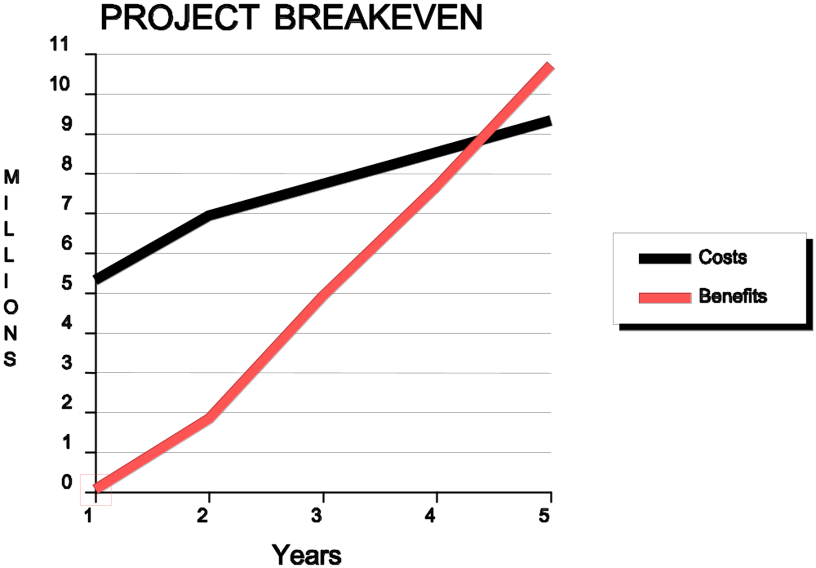

Figure 2
Both caseload burden and system inefficiency dramatically and negatively affect caseworker productivity. Updated technology is expected to reduce program and system operational costs in the areas of clerical and caseworker salaries, elimination of outside service bureau support and courier fees, and cancellation of the system engineering upgrade required in three years for the current system.

[Editor's Note: This section states current and projected operational problems and introduces the anticipated benefits of the project.]

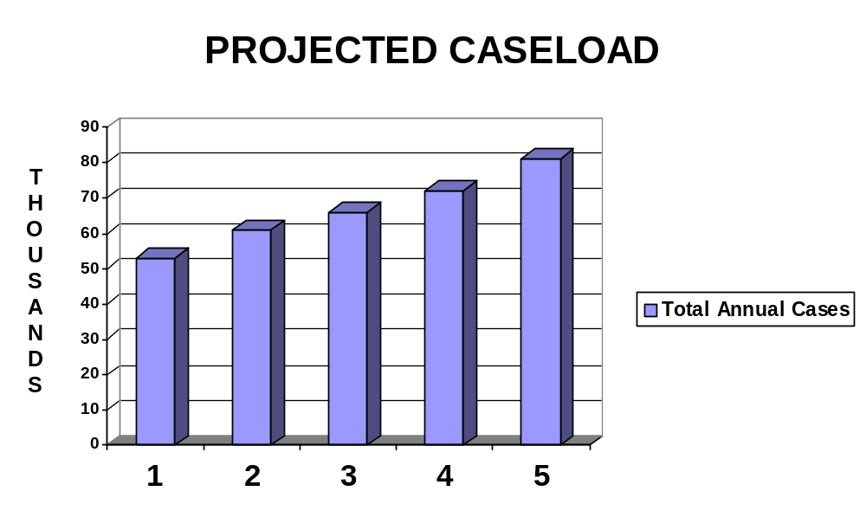
Figure 3

2.3 Assumptions

There are five major assumptions related to this cost/benefit analysis:

· No major changes will take place in the duties assigned to caseworkers over the systems life.

· Workload growth will remain within the projections stated in Benefit 3.

· There will be no new legislative or regulatory program mandates requiring overtime.

· Commercial network services will be installed by mid-year in the first year, cutting courier service costs in half.

· The system can be developed and implemented in a year and will remain operationally effective for at least another four years — resulting in a five year systems life.

[Editor's Note: This section states the assumptions under which the cost/benefit analysis was conducted.]

2.4 Methodology

This cost/benefit analysis was conducted by a team represented by the State program office, the budget and accounting office, and the office of economic analysis. The data was obtained by numerous methods, including estimation, comparison, simulation, observation, and quotation — and from various sources, including the budget, current obligations, work measurement (time and motion) studies, management records, and current contracts.

For example, current operational costs . . .

[Editor's Note: This section first summarizes and then details the procedures used for developing the cost/benefit analysis and the techniques used in estimating and computing costs and benefits.]

Part 3: Description of Alternatives

3.1 Current System

The current system is written in COBOL and is running on an eight year old IBM compatible (VM) mainframe. As a condition to continuing maintenance support, the manufacturer requires an expensive system engineering upgrade in peripherals and systems software during year 3. This upgrade will only affect maintainability, not increase system capacity or capability to keep up with forecast increases in caseload. The status quo system resides in a central data processing facility. It requires operation in a large, raised-floor site, supported by a moderate sized staff of
systems programmers and operators and a moderate number of contract support personnel . . .

[Editor's Note: This section first summarizes and then details the technical and operational characteristics of the current system. System diagrams or schematics simplify the presentation of information.]

3.2 Alternative 1

Alternative 1 is a LAN-based distributed (client/server) relational database management system (RDBMS). This alternative uses low-cost PC-based hardware and a network-server version of a large-capacity RDBMS . . .

[Editor's Note: This section first summarizes and then details the technical and operational characteristics of the first alternative. System diagrams or schematics simplify the presentation of information.]

3.3 Alternative 2

Alternative 2 is a LAN-based client/server relational database management system, but it differs from Alternative 1 in one important aspect. Alternative 2 involves the use of a symmetric multi-processing (SMP) RISC super-minicomputer as the RDBMS server . . .

[Editor's Note: This section first summarizes and then details the technical and operational characteristics of the second alternative. System diagrams or schematics simplify the presentation of information.]

3.4 Proposed Alternative

The State has chosen Alternative 1 because it meets the system objectives, is cost-beneficial, and will breakeven in the fifth year of the systems life.

[Editor's Note: This section summarizes the basis for selection of the chosen alternative.]

Part 4: Costs

The costs evaluated in this analysis are those which directly relate to the systems design, development, conversion, implementation, and operation. For the status quo, recurring costs include site and facility, equipment and software lease and maintenance, travel, training, supplies, security, and personnel salaries and benefits and support services directly supporting systems operations. The same categories are evaluated for the alternatives.

Non-recurring costs for the status quo include a systems engineering upgrade planned and budgeted for the third year of the systems life. Non-recurring costs for the alternatives include costs for new site and facilities, equipment, system testing, conversion, studies, procurement, database preparation, and overhead. Figure 4 provides a table of non-recurring and recurring costs.

As provided in ACF's cost/benefit guide, total project costs are analyzed regardless of funding source (State and Federal) and regardless of cost allowability for purposes of Federal Financial Participation, both of which are addressed by other documents.

[Editor's Note: This section summarizes the developmental and operational costs of the status quo and each alternative.]

4.1 Non-Recurring Costs

Non-recurring costs for the status quo are generated by the hardware and software upgrade required by the manufacturer at year 3. The cost categories affected are equipment purchase and fees, software purchase, system testing, procurement and database preparation.

Non-recurring costs for the alternatives are caused by and relate to the new system procurement in year one. The cost categories affected are site and facility, equipment purchase and fees, system testing, conversion, studies, procurement, database preparation, and training. See Figure 5 for definitions.

[Editor's Note: This section provides more detail on non-recurring costs applying to the status quo and each alternative.]

Non-Recurring Costs
Cost Categories | Fxd | Cost Categories | Fxd
Site and Facility  · Purchase  · Site Preparation/Modification  · Other  Equipment Purchase/One Time Fees  · ADP  · Data Communications  · Environ. Conditioning  · Security  · Other  Shipping  Installation  Software Purchase/One Time Fees  · Operating System  · Applications  · Utilities  · Other  System Testing  Conversion  · Data  · Software  · Services | •  •  •  •  •  •  •  •  •  •  •  •  • | Studies  Procurement  · Cost of Planning  · Cost of Conducting  Database Preparation  Personnel  · Salaries  · Benefits  · Contract Support Services  · Extraordinary Personnel Costs  Travel  Training  · Development  · Trainee Expenses  · Trainer Expenses  Overhead / Indirect Costs  · Project and Technical  · Management  · Incremental  · Lost Productivity | •  •  •  •

Recurring Costs
Cost Categories | Var | Adj | Fxd | Cost Categories | Var | Adj | Fxd
Site and Facility  · Lease  · Maintenance Fees  · Other  Equipment Lease / Maintenance  · ADP  · Data Communications  · Environ. Conditioning  · Security  · Other  Software Lease / Maintenance  · Operating System  · Applications  · Utilities  · Other |  |  | •  •  •  •  •  •  •  •  •  • | Personnel  · Salaries  · Benefits  Direct Support Services  · Contract  · Detailed/Tasked  Travel  Training  Supplies  Utilities  Security  · Primary Facilities  · Back-up Facilities  Overhead / Indirect Costs |  |  | •  •  •  •  •  •  •  •  •  •  •  •

Figure 4

NON-RECURRING COSTS
Cost Category | Description
Site and Facility | Includes site preparation and purchase of office furniture.
Equipment Purchase / One Time Fees | Includes the purchase of computer systems, peripherals, and local communications equipment. Also includes the costs of bundled software, maintenance, and fees.
Installation | Includes the installation and set up of equipment, software, furniture, and materials.
Software Purchase /  One Time Fees | Includes the purchase or one-time licensing of systems programs, utilities, and applications programs for ADP and telecommunications equipment.
System Testing | Includes all costs over and above normal operational costs expended to test newly installed equipment.
Conversion | Includes one-time costs related to "clean up" and conversion of software, data, information, and media, not charged to other categories (such as personnel).
Studies | Covers the cost of one-time studies conducted during the systems design, development, and implementation.
Procurement | Includes the cost of planning for and conducting procurements.
Database Preparation | Covers the cost of preparing information for database management systems.
Training | Includes one-time costs to train staff on new equipment, software, testing procedures, and operational processes.

Figure 5

4.2 Recurring Costs

Recurring costs for the status quo and alternatives affect the following cost categories: site and facility, equipment lease and maintenance, software lease and maintenance, personnel salaries and benefits, direct support services, travel, training, supplies, and security. See Figure 6 for definitions.

[Editor's Note: This section provides more detail on recurring costs applying to the status quo and each alternative.]

RECURRING COSTS
Cost Category | Description
Site and Facility | Includes the cost of space and a prorated amount for building maintenance.
Equipment Lease / Maintenance | Includes maintenance fees for computer systems and peripherals, data and voice communications equipment, and telecommunications lines.
Software Lease / Maintenance | Entails recurring licensing fees for systems programs and a prorated amount for new releases of commercial off-the-shelf software.
Personnel | Includes costs of staff (salaries, overtime, and benefits) devoted in full or in part to the system.
Direct Support Services | Includes contract support services staff costs (labor hour, contract G&A costs, and profit) dedicated in full or part to the project or system.
Travel | Includes monthly travel allocations for in-house personnel and contractors.
Training | Includes regularly scheduled training related to equipment, software, testing, and operational processes, initial and refresher.
Supplies | Includes monthly allocations to cover costs of supplies.
Security | Includes prorated costs related to security staff, not included under personnel costs above. Includes the prorated costs of support under the State's back-up contract and regular testing of disaster recovery sites.

Figure 6

Part 5: Benefits

Both alternatives are expected to generate the same specific quantitative benefits:

· Reduction in clerical staff,

· Reduction in caseworkers' overtime pay,

· Controlled staff expenditures in meeting caseload growth,

· Reduction in service bureau's processing costs,

· Reduction in courier service costs, and

· System upgrade cost savings.

The program and system cost avoidances and cost savings offset the systems development cost, thereby achieving net benefits for the project. No benefits were identified for the status quo.

[Editor's Note: This section summarizes the benefits related to the status quo (if any) and each alternative.]

5.1 Non-Recurring Benefits

Both alternatives would generate one non-recurring benefit: cost savings in the third year resulting from de-obligating in the budget a planned system engineering upgrade of the current system. Benefit 6 under narrative descriptions of benefits in section 5.4 provides details.

There are no non-recurring benefits for the status quo.

[Editor's Note: This section summarizes the non-recurring benefits applying to the status quo and each alternative.]

5.2 Recurring Benefits

Both alternatives would generate the same recurring benefits:

· Reduction in clerical staff (Benefit 1),

· Reduction in caseworkers' overtime pay (Benefit 2),

· Controlled staff expenditures in meeting caseload growth (Benefit 3),

· Reduction in service bureau's processing costs (Benefit 4), and

· Reduction in courier service costs (Benefit 5).

Note that three benefits address the effect of the new system on clerical and caseworker staff costs. Specifically, they project the effect of the new system on:

· Current clerical staff,

· Caseworker overtime expenses, and

· Future caseworker staffing requirements.

By establishing three distinct benefits for the effect of the system on staffing, the State has established three discrete, meaningful, quantitative performance goals and measurement factors as well. In addition, the effect of caseworker productivity improvements without an immediate budgetary effect — the State will not decrease current staff — will be measured as a qualitative benefit. The State values staff productivity as both a system goal and performance measurement goal.

The narrative descriptions of benefits in section 5.4 provide details.

There are no non-recurring benefits for the status quo.

[Editor's Note: This section summarizes the recurring benefits applying to the status quo and each alternative.]

5.3 Non-Quantifiable Benefits

Both alternatives are expected to generate qualitative benefits in addition to productivity improvement:

· Eliminating processing delays caused by obsolete technology,

· Providing more timely services to the public,

· Providing strategic support of agency program goals,

· Implementing systems architecture compatible with long-range strategies,

· Ensuring system flexibility, and

· Implementing proven technology with access to off-the-shelf software.

Although these qualitative benefits cannot be measured in dollars for offsetting systems development costs, several provide performance measurement goals and will be measured by the State. These goals are addressed by the State's cost/benefit measurement plan described in part 8 of this cost/benefit analysis.

[Editor's Note: This section summarizes the non-quantifiable (intangible) benefits applying to the status quo and each alternative. The status quo may not necessarily generate benefits.]

5.4 Narrative Descriptions of Benefits

The narrative descriptions of benefits begin on the next page.

[Editor's Note: This section summarizes in detailed narrative the benefits expected from the systems project. The basis for the calculations and the supporting documentation are provided or referenced. In addition, the State addresses how it will measure performance against the benefit.]
Benefit 1:
Reduction in Clerical Staff
[Effect of New System on Current Staff]

Scenario: | Under the current system, clerical staff support caseworkers in routine clerical functions, such as filing, typing letters, and copying. The new system will reduce the need for these services through capabilities such as centralized electronic files, automatic notice generation, and on-demand, on-site printing.  These improvements will result in a clerical staff reduction of 13 positions. [Clerical staff will be reassigned from the benefits program to the State's consumer services program.]

Basis for  Numbers: | Clerical workload distribution was documented using automated work measurement techniques and time and motion analysis conducted over two week intervals at four separate review periods during the last fiscal year. Management records and observation were used to verify that the performance of duties did not vary significantly from the norm during this time period.  Once the distribution of work by category and time was known, the effect of elimination of certain functions through automation was assessed. With automated filing, notice, and printing, the State has planned to transfer thirteen clerical staff outside the benefits program.  The analysis and findings are documented in the State's study, Time Distribution of Clerical Duties. A copy of this study will be retained in the State's files as an aid to future cost and benefit measurement.
Assumptions: | No major changes will take place in the duties assigned to clerical staff over the systems life.

Initial  Calculations of Benefit's  Value: | The current average clerical salary of $25,100, times the State's average fringe rate of 25.5%, times 13 clerical positions, yields an annual cost savings of $409,507.  [Data on average salary and current fringe rate were provided by the State's personnel office.]  This information is shown in the cost/benefit analysis for both alternatives, as indicated by the following excerpt. There is no corresponding benefit for the status quo. [Note that constant dollars are used, since State personnel salary increases over the time period have not been approved by the legislature and budgeted.]

SYSTEM LIFE BENEFITS PROFILE: ALTERNATIVES
Description | Year 1 | Year 2 | Year 3 | Year 4 | Year 5 | Total
Benefit 1 | - | 409,507 | 409,507 | 409,507 | 409,507 | 1,638,028

Measurement Plan: | Once the new system is operational, clerical staff workers will be reassigned and the benefits claimed as program cost savings.

Quantified Benefits Worksheet: Systems Life

BENEFIT CATEGORY / DESCRIPTION
Benefit Number: 1
Description: Reduce Clerical Staff
STATUS QUO BENEFIT VALUE
Assumptions: None. No benefit is claimed for the status quo

Numbers |  |  |  | Basis |  |  |  | Source
Current Measure/Volume:

Projected Increase /Decrease Over Time:

Current Value:
System Life Benefits Profile: Status Quo
Year 1 |  | Year 2 | Year 3 | Year 4 | Year 5 | Year 6 |  | Year 7 | Year 8 | Total
0 |  | 0 | 0 | 0 | 0 | 0 |  | 0 | 0 | 0
ALTERNATIVE 1 BENEFIT VALUE
Numbers |  |  |  | Basis |  |  |  | Source
Measure/Volume  at Implementation: 13 clerical staff transferred |  |  |  | Staff reduction projected as result of automated system support improvements. |  |  |  | "Time Distribution of Clerical Duties" (program office)
Projected Increase/Decrease  Over Time: Stable |  |  |  | No change anticipated |  |  |  | "Time Distribution of Clerical Duties" (program office)
Initial Value at Implementation: $409,507 |  |  |  | $25,100 average annual salary X 1.255 to calculate loaded rate X 13 staff = $409,507 |  |  |  | Loaded hourly rate from personnel office
Systems Life Benefits Profile: Alternative 1
Year 1 | Year 2 |  | Year 3 | Year 4 | Year 5 |  | Year 6 | Year 7 | Year 8 | Total
- | 409,507 |  | 409,507 | 409,507 | 409,507 |  | - | - | - | 1,638,028

Benefit 2:
Reduction in Caseworkers' Overtime Pay
[Effect of New System on Overtime Expenses]

Scenario: | Under the current system, caseworkers spend 20% of their time performing routine administrative functions, including tickler file maintenance, routine work scheduling, and manual tracking of cases. (See graph below.)  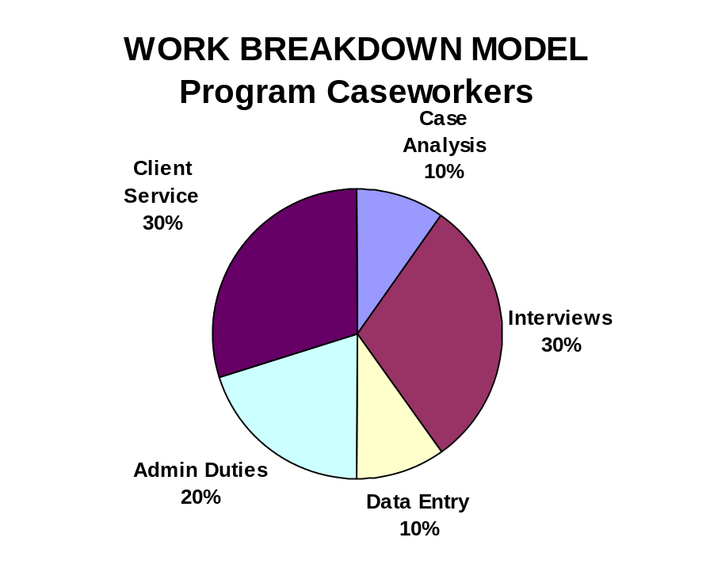  The new system will automate these functions, reducing caseworker administrative overhead 50%, to 10% of their time, enabling more time to be spent on case analysis. The most immediate effect of productivity improvement will be the reduction in caseworkers' overtime pay.  Under the current system, the State budgets $150,000 annually for overtime pay to caseworkers. The State projects that overtime pay for caseload processing will not be required after system implementation, due to reductions in administrative duties.
Basis for  Numbers: | The workload distribution information was documented using automated work measurement techniques and time and motion analysis conducted over two week intervals at four separate review periods during the last fiscal year. Management records and observation were used to verify that the performance of duties did not vary significantly from the norm during this time period. The analysis and findings are documented in the State's study, Time Distribution of Casework. A copy of this study will be retained in the State's files as an aid to future cost and benefit measurement.  Components of the administrative duties category include maintaining tickler files, performing work scheduling, manually tracking cases, and reporting to management. The time distribution of administrative duties, by caseworker per week, is shown in the table below. Expected improvements are reflected in the column to the right. (These improvements will be monitored and measured as qualitative benefits under the State's Cost/Benefit Measurement Plan.)

Average Weekly Distribution of Administrative Duties
in Hours by Caseworker
Description | Current | Proposed
Maintaining Tickler Files | 1 | 0
Work Scheduling | 2 | 1
Manual Tracking | 2 | 1
Internal Reporting | 3 | 2
TOTAL | 8 | 4

Assumptions: | Projected overtime is based on the State's most recent five-year budget (1994 - 1999), except that figures are expressed here in constant dollars. Copies of budgetary materials remain archived in the State.  No major changes will take place in the duties assigned to caseworkers over the systems life.  [This assumption is supported by a prior assessment of caseworkers' duties, conducted in 1987 as part of a personnel audit. The study, Performance Audit of Caseworkers, is attached to the time and motion study and will be retained in State files.]  Workload growth will remain within the projections stated in Benefit 3 and there will be no new program mandates requiring overtime.

Initial  Calculations  of Benefit's  Values: | The current average caseworkers' salary of $42,000, divided by 2080 hours (working hours in year), yields an average salary rate per hour of $20.19. With the addition of the State's average fringe rate of 25.5%, the average loaded pay rate per hour of caseworkers' time is $25.34.  Given an average of 46 weeks worked per year, times 4 hours saved per week, each worker can be projected to have 184 hours freed from routine administrative duties. Multiplying 184 hours times 120 caseworkers yields 22,080 hours times the loaded hourly rate of $25.34 equals annual savings of $559,507, more than enough to eliminate budgeted overtime expenditures of $150,000. No claim is made for the additional "savings" since current staff will not be reassigned or laid off. Instead, the effect of productivity improvement on future staffing is set forth in Benefit 3.  [Data on average salary, current fringe rate, and average weeks worked were provided by the State's personnel office.]  This benefit has an annual program cost savings value of $150,000. There are no benefit values for the status quo.

SYSTEM LIFE BENEFIT PROFILE: ALTERNATIVES
Description | Year 1 | Year 2 | Year 3 | Year 4 | Year 5 | Total
Benefit 2 | 0 | 150,000 | 150,000 | 150,000 | 150,000 | 600,000

Measurement Plan: | The State is preparing to adopt a new procedure for approving overtime work which will track overtime against a set of standard work categories. Under the new procedure, overtime requests which specify the purpose of "caseload processing" will require explanation and special management approvals. Since the new system is intended to reduce overtime caseload processing, management controls can ensure that other measures, such as reallocating workload, are taken before overtime is approved. Records will be kept and evaluated annually to determine whether this benefit has been achieved.
 | Productivity improvements will be measured as qualitative benefits under the Cost/Benefit Measurement Plan. Once the new system is operational, the caseworkers' workload distribution will be reassessed annually, using the same measuring tools and methodology used for projecting these benefits.

Quantified Benefits Worksheet: Systems Life

BENEFIT CATEGORY / DESCRIPTION
Benefit Number: 2
Description: Reduction in Caseworkers' Overtime Pay
STATUS QUO BENEFIT VALUE
Assumptions: None. No benefit is claimed for the status quo. Figures below on current performance were used to determine cost savings for the alternatives.
Numbers |  |  |  | Basis |  |  |  | Source
Current Measure/Volume: |  |  |  | State Budget (1994-1999) |  |  |  | Budget office
Projected Increase /Decrease Over Time: |  |  |  | State Budget (1994-1999) |  |  |  | Budget office
Current Value: |  |  |  | State Budget (1994-1999) |  |  |  | Budget office
System Life Benefits Profile: Status Quo
Year 1 |  | Year 2 | Year 3 | Year 4 | Year 5 | Year 6 |  | Year 7 | Year 8 | Total
0 |  | 0 | 0 | 0 | 0 | 0 |  | 0 | 0 | 0
ALTERNATIVE 1 BENEFIT VALUE
Numbers |  |  |  | Basis |  |  |  | Source
Measure/Volume  at Implementation: $150,000 annually |  |  |  | State Budget (1994-1999) |  |  |  | Budget office
Projected Increase/Decrease  Over Time: Stable |  |  |  | State Budget (1994-1999) |  |  |  | Budget office
Initial Value at Implementation: $150,000 annually |  |  |  | State Budget (1994-1999) |  |  |  | Budget office
Systems Life Benefits Profile: Alternative 1
Year 1 | Year 2 |  | Year 3 | Year 4 | Year 5 |  | Year 6 | Year 7 | Year 8 | Total
- | 150,000 |  | 150,000 | 150,000 | 150,000 |  | - | - | - | 600,000

Benefit 3:
Controlled Staff Expenditures in Meeting Caseload Growth
[Effect of New System on Future Staff Requirements]

Scenario | Under the current system, caseload processing is only marginally within system capabilities. The workload is achieved at the expense of significant delays for clients, support from outside processing services to meet system overloads, and caseworker overtime. (The latter was described in Benefit 2.)  Unfortunately, the current workload is not expected to remain level. It will increase, from 55,200 to an estimated 80,800 cases annually. See the graph below.  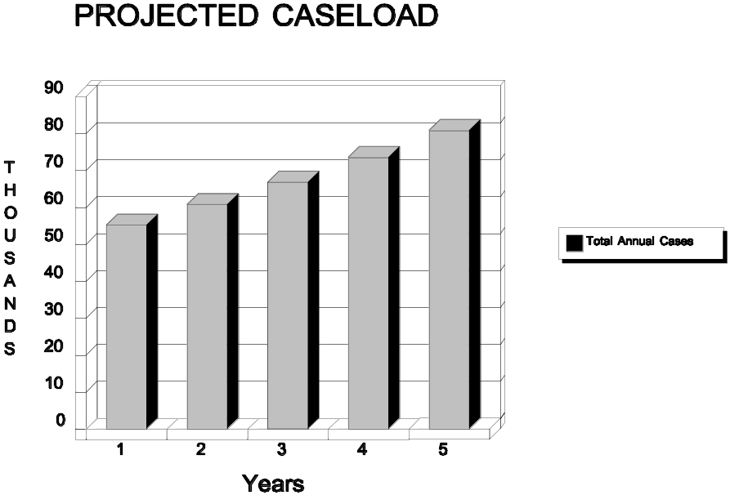  If management were to take no action, the caseworker burden would increase approximately 10% annually, from 460 to 673 cases per year. See the chart on the following page for the annual projected burden by caseworker, if no action is taken.  This situation is considered untenable by State management. The problem was analyzed and addressed in an internal State staffing plan. This plan addresses the number and timing of additional required staff and the manner in which they would be recruited and trained.  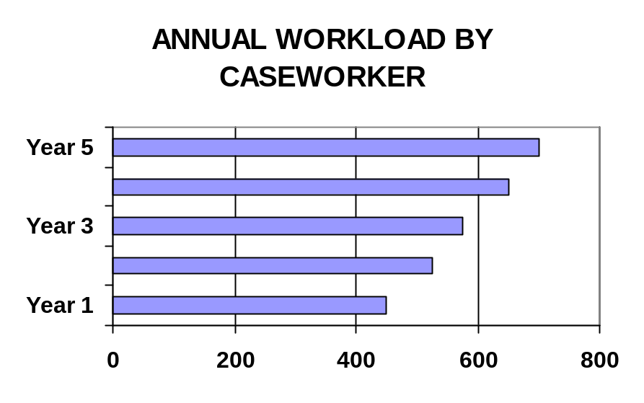  The results of this plan, showing the projected staff increase for the  status quo, is depicted in the top chart on the next page. In order to maintain a ratio of about 460 cases annually per caseworker, staffing would increase from 120 caseworkers to 176 over five years.  However, with the new system, reductions in administrative duties (described in Benefit 2) would enable staff to handle more cases per year — from 460 cases annually per year to 560 cases per year. This would reduce the overall staff requirements projected as necessary — down from 176 in the fifth year to 144 — and delay recruitment of additional personnel until the fourth year of the system life. See the bottom chart on the following page for a comparison of projected staffing between the status quo and the alternatives. [Both alternatives would support the same staffing pattern.]  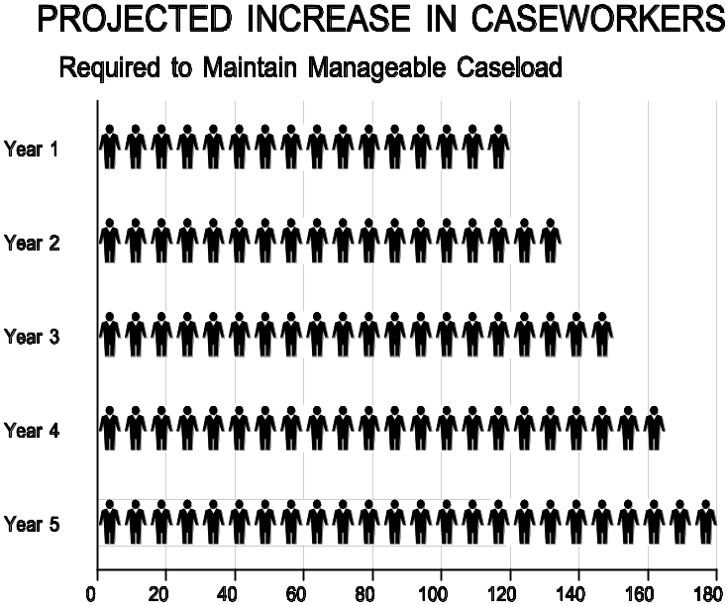  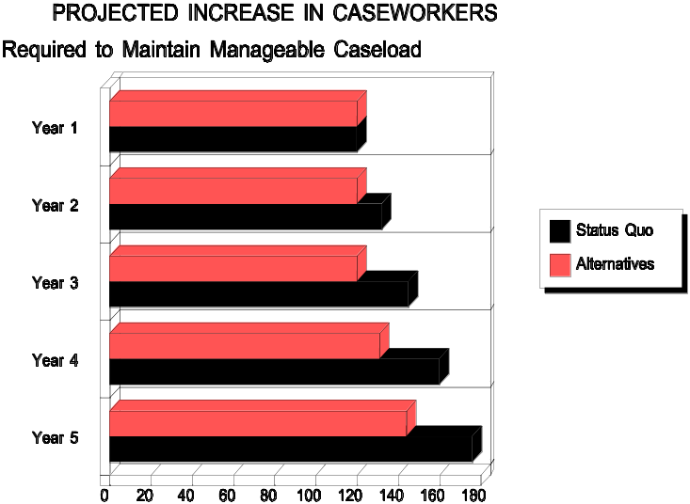

Basis for  Numbers: | Projected caseloads are documented in a study conducted this year with contractor assistance, Historical and Demographical Trends in Casework: Effect on the Future. Next the State examined the effect of the projected caseload increase on current staff and devised a strategic staffing plan. The State Caseworker Staffing Master Plan was developed by a team represented by State management, personnel specialists, caseworker professional organization representatives, and contractor specialists. These studies will remain on file in the State throughout the development, implementation, and operation of this project.  Average case processing time is currently just over three hours, based on program management records on file in the State. Under the current system, caseworkers working 46 weeks per year at 32 hours per week on casework would have 1,472 hours, allowing them to process about 460 cases. Given the weekly gain of four hours for case processing that will accrue from the elimination of administrative duties (see Benefit 2), current staff working 46 weeks per year, 36 hours per week, with an average case processing time of under 3 hours, will be able to process management's projected goal of 560 cases per year. These figures are considered conservative based on the fact that other system improvements have not been factored in — and based on other States' records of processing similar cases in 2.5 hours, once modern technology was employed.
Assumptions: | No major changes will take place in the duties assigned to caseworkers over the systems life. Workload growth will remain within the projections cited herein. There will be no new program mandates.
Initial  Calculations  of Benefit's  Values | If no action is taken, the State's caseworker staff will increase from 120 to 176 over five years. The average annual salary for the current staff is $42,000. According to the State's staffing plan, new caseworkers would be hired under the State's three-year training program with annual salaries of $32,000, $34,000, and $36,000, for the first, second, and third years respectively. All dollars are constant dollars. No cost-of-living adjustments

or other salary increases are currently approved and, therefore, have not been factored into these calculations. See the top table on the following page.

If the new system is adopted, the State's caseworker staff will remain stable for three years, then increase by 11 in year 4 and 13 in year 5 to a total of 144 caseworkers. See the bottom table on the following page.

The difference between the total loaded salary projections establishes the estimated program cost avoidance reported as a benefit for the alternatives. See below. There is no corresponding benefit for the status quo.

SYSTEM LIFE BENEFITS PROFILE: ALTERNATIVES
Description | Year 1 | Year 2 | Year 3 | Year 4 | Year 5 | Total
Status Quo Salaries | 6,325,200 | 6,807,120 | 7,359,320 | 8,024,470 | 8,737,310 | 37,253,420
Alternatives' Salaries | 6,325,200 | 6,325,200 | 6,325,200 | 6,766,960 | 7,316,650 | 33,059,210
Benefit 3 | 0 | 481,920 | 1,034,120 | 1,257,510 | 1,420,660 | 4,194,210

[Note that caseworker costs are not included on the cost side of the cost/benefit analysis, since those costs do not directly support the systems project. The program cost differential effected by the systems project is claimed as a cost avoidance of the alternatives.]

Measurement Plan: | The State will measure actual staffing salaries at the loaded rate and deduct the actuals from the projected status quo salaries, to determine whether the projected cost avoidance benefit has been achieved.

Projected Caseworker Expenses: Status Quo
Year | Staff | Salary | Total | Annual Salary | Total Staff | Fringe Rate | Loaded Salary
1 | 120 | 42,000 | 5,040,000 | 5,040,000 | 120 | 0.255 | 6,325,200
2 | 120 | 42,000 | 5,040,000 | 5,424,000 | 132 | 0.255 | 6,807,120
2 | 12 | 32,000 | 384,000
3 | 120 | 42,000 | 5,040,000 | 5,864,000 | 145 | 0.255 | 7,359,320
3 | 12 | 34,000 | 408,000
3 | 13 | 32,000 | 416,000
4 | 120 | 42,000 | 5,040,000 | 6,394,000 | 160 | 0.255 | 8,024,470
4 | 12 | 36,000 | 432,000
4 | 13 | 34,000 | 442,000
4 | 15 | 32,000 | 480,000
5 | 120 | 42,000 | 5,040,000 | 6,962,000 | 176 | 0.255 | 8,737,310
5 | 25 | 36,000 | 900,000
5 | 15 | 34,000 | 510,000
5 | 16 | 32,000 | 512,000

Projected Caseworker Expenses: Alternatives
Year | Staff | Salary | Total | Annual Salary | Total Staff | Fringe Rate | Loaded Salary
1 | 120 | 42,000 | 5,040,000 | 5,040,000 | 120 | 0.255 | 6,325,200
2 | 120 | 42,000 | 5,040,000 | 5,040,000 | 120 | 0.255 | 6,325,200
3 |  |  |  | 5,864,000 | 145 | 0.255 | 7,359,320
4 | 120 | 42,000 | 5,040,000 | 5,392,000 | 131 | 0.255 | 6,766,960
4 | 11 | 32,000 | 352,000
5 | 120 | 42,000 | 5,040,000 | 5,830,000 | 144 | 0.255 | 7,316,650
5 | 11 | 34,000 | 374,000
5 | 13 | 32,000 | 416,000

Quantified Benefits Worksheet: Systems Life

BENEFIT CATEGORY / DESCRIPTION
Benefit Number: 3
Description: Controlled Staff Expenditures in Meeting Caseload Growth (See narrative for further detail on calculations.)
STATUS QUO BENEFIT VALUE
Assumptions: None. No benefit is claimed for the status quo. Figures below on projected staffing costs for the status quo were used to determine cost avoidance for the alternatives.
Numbers |  |  |  |  | Basis |  |  |  | Source
Current Measure/Volume: 120 caseworkers |  |  |  |  | State Staffing Plan |  |  |  | State Caseworker Staffing Master Plan
Projected Increase/Decrease Over Time: 10% to 176 |  |  |  |  | State Staffing Plan |  |  |  | State Caseworker Staffing Master Plan
Current Value: $6,325,200 with variable cost increase |  |  |  |  | State Staffing Plan |  |  |  | State Caseworker Staffing Master Plan
System Life Projected Caseworker Costs: Status Quo
Year 1 |  |  | Year 2 | Year 3 | Year 4 | Year 5 | Year 6 |  | Year 7 | Year 8 |  | Total
6,325,200 |  |  | 6,807,120 | 7,359,320 | 8,024,470 | 8,737,310 | - |  | - | - |  | 37,253,420
ALTERNATIVE 1 BENEFIT VALUE
Assumptions: Workload growth will stay within the projections stated in Benefit 3. No new program mandates requiring overtime.
Numbers |  |  |  |  | Basis |  |  |  | Source
Measure/Volume  at Implementation: 120 |  |  |  |  | State Staffing Plan |  |  |  | State Caseworker Staffing Master Plan
Projected Increase/Decrease  Over Time: Stable til year 4 |  |  |  |  | State Staffing Plan |  |  |  | State Caseworker Staffing Master Plan
Initial Value at Implementation: $6,325,000 |  |  |  |  | State Staffing Plan |  |  |  | State Caseworker Staffing Master Plan
System Life Projected Caseworker Costs: Alternatives
Year 1 |  | Year 2 |  | Year 3 | Year 4 | Year 5 | Year 6 |  | Year 7 |  | Year 8 |  | Total
6,325,200 |  | 6,325,200 |  | 6,325,200 | 6,766,960 | 7,316,650 |  |  |  |  |  |  | 33,059,210
Systems Life Benefits Profile: Alternative 1
Year 1 | Year 2 |  |  | Year 3 | Year 4 | Year 5 |  | Year 6 | Year 7 | Year 8 |  | Total
0 | 481,920 |  |  | 1,034,120 | 1,257,510 | 1,420,660 |  |  |  |  |  | 4,194,210

Benefit 4:
Reduction in Service Bureau's Processing Costs

Scenario: | Under the current system, backlogs in caseload processing are transferred to an outside service bureau. This is required since current processing resources are unable to handle peak processing loads at certain times of the year. See the chart below.
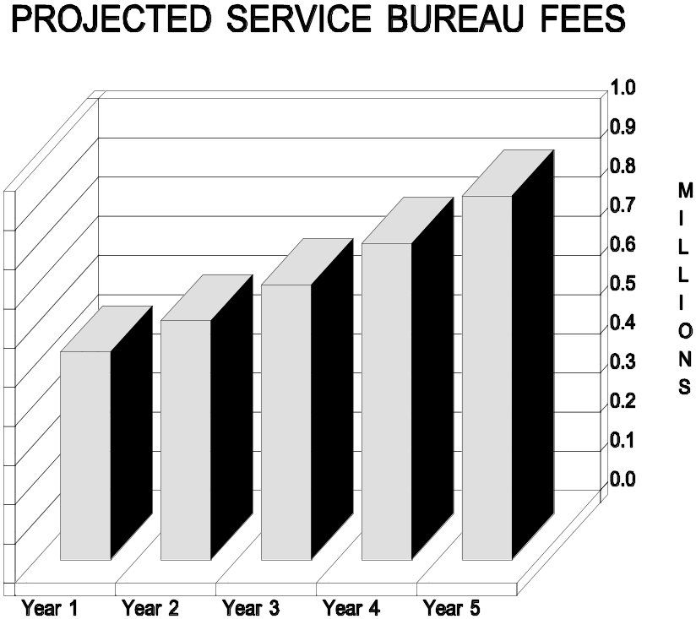

The new system will have sufficient capacity and capability to process all workload.

Basis for  Numbers: | The information in the chart was provided by the State's procurement office, based on the State's current five-year service bureau contract. (This contract is used for other purposes, so eliminating service for caseload processing will not result in contract termination charges.) Between program workload and service bureau fixed-fee contract rates, the fixed

 | price costs for service bureau processing will increase at about 15% per year. The contracts are maintained in the State's procurement office.
Assumptions: | No major changes will take place in the duties assigned to caseworkers over the systems life. Workload growth will remain within the projections cited in Benefit 3. There will be no new program mandates.
Initial  Calculation of  Benefit's  Value: | Figures are from the State's five-year, fixed-price contract, and are in the State's current budget. (Dollars stated reflect fixed price contract rates and have not been adjusted by the State for inflation.) Since these figures are budgeted and approved systems-related costs, they are shown as costs for the status quo and first year of the alternatives and as system cost savings benefits for years 2 - 5 of the alternatives.

SYSTEM LIFE COST PROFILE: STATUS QUO
Description | Year 1 | Year 2 | Year 3 | Year 4 | Year 5 | Total
Support Services: Service Bureau Fees | 531,300 | 610,995 | 702,644 | 808,041 | 929,247 | 3,582,227

SYSTEM LIFE COST PROFILE: ALTERNATIVES
Description | Year 1 | Year 2 | Year 3 | Year 4 | Year 5 | Total
Support Services: Service Bureau Fees | 531,300 | 0 | 0 | 0 | 0 | 531,300

SYSTEM LIFE BENEFIT PROFILE: ALTERNATIVES
Description | Year 1 | Year 2 | Year 3 | Year 4 | Year 5 | Total
Benefit 4 | 0 | 610,995 | 702,644 | 808,041 | 929,247 | 3,050,927

Measurement Plan: | Service bureau charges in support of program operations are projected to be eliminated by the second year. The finance department maintains records by expenditure category and program office and will be able to confirm elimination of these costs.

Quantified Benefits Worksheet: Systems Life
BENEFIT CATEGORY / DESCRIPTION
Benefit Number: 4
Description: Reduction in Service Bureau's Processing Costs
STATUS QUO BENEFIT VALUE
Assumptions: None. No benefit claimed for the status quo. Figures below on current and future service bureau processing fees were used to determine cost savings for the alternatives.
Numbers |  |  |  |  | Basis |  |  |  | Source
Current Measure/Volume: $531,000 |  |  |  |  | State Budget (1994-1999) & Service Contract |  |  |  | Budget and Procurement offices
Projected Increase/Decrease Over Time: 15% annually to $929,247 |  |  |  |  | State Budget (1994-1999) & Service Contract |  |  |  | Budget and Procurement offices
Current Value: $531,000 |  |  |  |  | State Budget (1994-1999) & Service Contract |  |  |  | Budget and Procurement offices
System Life Costs Profile: Status Quo
Year 1 |  |  | Year 2 | Year 3 | Year 4 | Year 5 | Year 6 |  | Year 7 | Year 8 |  | Total
531,300 |  |  | 610,995 | 702,644 | 808,041 | 929,247 |  |  |  |  |  | 3,582,227
ALTERNATIVE 1 BENEFIT VALUE
Assumptions: No major changes will take place in caseworker's duties. Workload growth will remain within the projections stated in Benefit 3. No new program mandates.
Numbers |  |  |  |  | Basis |  |  |  | Source
Measure/Volume  at Implementation: $531,300 |  |  |  |  | State Budget (1994-1999) & Service Contract |  |  |  | Budget and Procurement offices
Projected Increase/Decrease Over Time: Eliminated in second year. |  |  |  |  | State Budget (1994-1999) & Service Contract |  |  |  | Budget and Procurement offices
Initial Value at Implementation: -$531,000 |  |  |  |  | State Budget (1994-1999) & Service Contract |  |  |  | Budget and Procurement offices
System Life Projected Costs Profile: Alternatives
Year 1 |  | Year 2 |  | Year 3 | Year 4 | Year 5 | Year 6 |  | Year 7 |  | Year 8 |  | Total
531,300 |  | - |  | - | - | - | - |  | - |  | - |  | 531,300
Systems Life Benefits Profile: Alternative 1
Year 1 | Year 2 |  |  | Year 3 | Year 4 | Year 5 |  | Year 6 | Year 7 | Year 8 |  | Total
- | 610,995 |  |  | 702,644 | 808,041 | 929,247 |  | - | - | - |  | 3,050,927

Benefit 5:
Reduction in Courier Service Costs

Scenario: | Since the current system lacks statewide telecommunications support, the program relied on courier services last year to deliver time-sensitive material to meet new mandates for information timeliness. Since these costs were not anticipated nor budgeted, the expenses could only be met by reprogramming funds from a State emergency operating expense account.  To meet this expense in current or future years, funds would have to be reprogrammed from the program accounts. However, with the new system, electronic transmission will be used, eliminating the need to budget for this expense — resulting in a system cost avoidance.  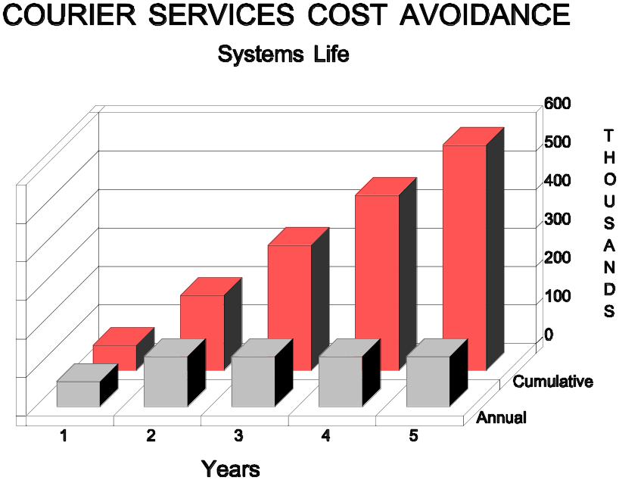

Basis for  Numbers: | Projected courier service costs are based on the State's most recent expenditures. Figures are expressed in constant dollars. Spending records are archived in the State. (A management study conducted at the time that courier services were adopted indicated that there were no more economical alternatives to meet this requirement, given the State's current technological limitations.)
Assumptions: | Commercial network services will be installed by mid-year in the first year, cutting courier service costs in half.
Initial Calculations of Benefit's Value: | The benefit has an average yearly value of $130,000, based on past expenditures. There are no benefit values for the status quo; however, costs are reflected since they are direct systems operational costs requiring funding. See the following excerpts.

SYSTEM LIFE COST PROFILE: STATUS QUO
Description | Year 1 | Year 2 | Year 3 | Year 4 | Year 5 | Total
Courier Service Fees | 130,000 | 130,000 | 130,000 | 130,000 | 130,000 | 650,000

SYSTEM LIFE COST PROFILE: ALTERNATIVES
Description | Year 1 | Year 2 | Year 3 | Year 4 | Year 5 | Total
Courier Service Fees | 65,000 | 0 | 0 | 0 | 0 | 65,000

SYSTEM LIFE BENEFIT PROFILE: ALTERNATIVES
Description | Year 1 | Year 2 | Year 3 | Year 4 | Year 5 | Total
Benefit 5 | 65,000 | 130,000 | 130,000 | 130,000 | 130,000 | 585,000

Measurement Plan: | Courier service charges in support of program operations are projected to be eliminated by mid-year in the first year. The finance department maintains records by expenditure category and program office and will be able to confirm elimination of these costs.

Quantified Benefits Worksheet: Systems Life

BENEFIT CATEGORY / DESCRIPTION
Benefit Number: 5
Description: Reduction in Courier Service Costs
STATUS QUO BENEFIT VALUE
Assumptions: None. No benefit is claimed for the status quo. Figures below on current and future courier service fees were used to determine cost savings for the alternatives.
Numbers |  |  |  |  | Basis |  |  |  | Source
Current Measure/Volume: $130,000 |  |  |  |  | State Budget (1994-1999) |  |  |  | Budget office
Projected Increase/Decrease Over Time: Stable |  |  |  |  | State Budget (1994-1999) |  |  |  | Budget office
Current Value: $130,000 |  |  |  |  | State Budget (1994-1999) |  |  |  | Budget office
System Life Costs Profile: Status Quo
Year 1 |  |  | Year 2 | Year 3 | Year 4 | Year 5 | Year 6 |  | Year 7 | Year 8 |  | Total
130,000 |  |  | 130,000 | 130,000 | 130,000 | 130,000 |  |  |  |  |  | 650,000
ALTERNATIVE 1 BENEFIT VALUE
Assumptions: Commercial network services will be installed by mid-year in the first year, cutting courier service costs in half.
Numbers |  |  |  |  | Basis |  |  |  | Source
Measure/Volume  at Implementation: $130,000 |  |  |  |  | State Budget (1994-1999) |  |  |  | Budget office
Projected Increase/Decrease Over Time: Halved first year, eliminated second year. |  |  |  |  | State Budget (1994-1999) |  |  |  | Budget office
Initial Value at Implementation: -$65,000 |  |  |  |  | State Budget (1994-1999) |  |  |  | Budget office
System Life Projected Costs Profile: Alternatives
Year 1 |  | Year 2 |  | Year 3 | Year 4 | Year 5 | Year 6 |  | Year 7 |  | Year 8 |  | Total
65,000 |  | - |  | - | - | - | - |  | - |  | - |  | 65,000
Systems Life Benefits Profile: Alternative 1
Year 1 | Year 2 |  |  | Year 3 | Year 4 | Year 5 |  | Year 6 | Year 7 | Year 8 |  | Total
65,000 | 130,000 |  |  | 130,000 | 130,000 | 130,000 |  | - | - | - |  | 585,000

Benefit 6:
System Engineering Upgrade Cost Savings

Scenario: | Under the current system's plans and budgets, the status quo computer system is scheduled for a hardware and software engineering upgrade in the third year. This upgrade is required by the manufacturer, in order to continue hardware and software maintenance services beyond year 3. This upgrade does not affect the capacity or capability of the system's processing power. It simply makes the equipment eligible for continued maintenance support.  The upgrade is budgeted at $655,000, with expenditures for equipment and software purchase and fees, installation, system testing, studies, and procurement. See the graph below.  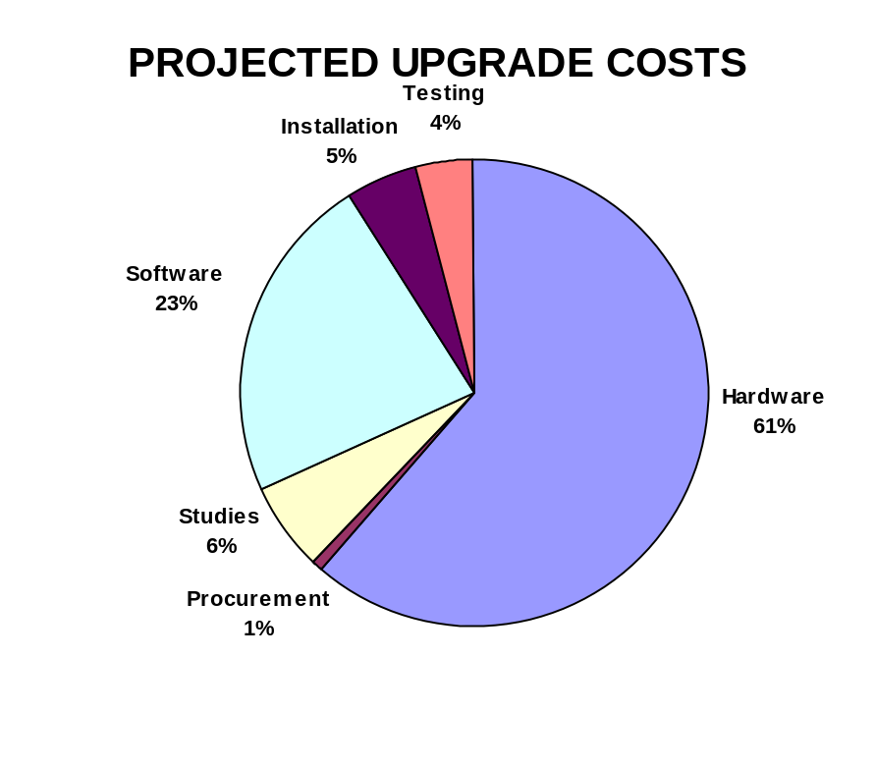

 | By implementing the alternative, the upgrade will not be made — resulting in a system cost savings.:
Basis for  Numbers | The figures were taken from the latest approved State budget. A copy will be maintained in the State.
Assumptions: | None.

Initial  Calculation of  Benefit's  Value: | The benefit has a value of $655,000, as a cost-savings from the status quo.

SYSTEM LIFE COST PROFILE: STATUS QUO
Description | Year 1 | Year 2 | Year 3 | Year 4 | Year 5 | Total
System upgrade | 0 | 0 | 655,000 | 0 | 0 | 655,000

SYSTEM LIFE BENEFIT PROFILE: ALTERNATIVES
Description | Year 1 | Year 2 | Year 3 | Year 4 | Year 5 | Total
Benefit 6 | 0 | 0 | 655,000 | 0 | 0 | 655,000

Measurement Plan: | None required. Budgeted funds will be de-allocated and cost savings claimed in the third year.

Quantified Benefits Worksheet: Systems Life

BENEFIT CATEGORY / DESCRIPTION
Benefit Number: 6
Description: System Upgrade Cost Savings
STATUS QUO BENEFIT VALUE
Assumptions: No benefit is claimed for the status quo. Figures below reflect costs budgeted for the status quo and used to determine cost savings for the alternatives.
Numbers |  |  |  | Basis |  |  | Source
Current Measure/Volume:  $655,000 (third year) |  |  |  | State Budget (1994-1999) |  |  | Budget office
Projected Increase/Decrease Over Time: Non-recurring |  |  |  | State Budget (1994-1999) |  |  | Budget office
Current Value: $655,000 |  |  |  | State Budget (1994-1999) |  |  | Budget office
System Life Costs Profile: Status Quo
Year 1 |  | Year 2 | Year 3 | Year 4 | Year 5 | Year 6 | Year 7 | Year 8 |  | Total
- |  | - | 655,000 | - | - | - | - | - |  | 655,000
ALTERNATIVE 1 BENEFIT VALUE
Assumptions: None
Numbers |  |  |  | Basis |  |  | Source
Measure/Volume  at Implementation: None |  |  |  | State Budget (1994-1999) |  |  | Budget office
Projected Increase/Decrease Over Time: Non-recurring (third year) |  |  |  | State Budget (1994-1999) |  |  | Budget office
Initial Value at Implementation: None — $655,000 (third year) |  |  |  | State Budget (1994-1999) |  |  | Budget office
Systems Life Benefits Profile: Alternative 1
Year 1 | Year 2 |  | Year 3 | Year 4 | Year 5 | Year 6 | Year 7 |  | Year 8 |  | Total
- | - |  | 655,000 | - | - | - | - |  | - |  | 655,000

Part 6: Comparative Cost/Benefit Summary

The table below summarizes the total present value costs and benefits, net benefit (or cost), benefit/cost ratio, and breakeven for the status quo and two alternatives. Alternative 1 is the State's chosen alternative because it yields a net benefit and will breakeven in the fifth year.

COMPARISON OF ALTERNATIVES
Description | Status Quo | Alternative 1 | Alternative 2
Total Present Value Benefits | 0 | 8,690,663 | 8,690,663
Less Total Present Value Costs | 7,658,159 | 8,497,668 | 10,651,811
Net Benefit (Cost) | -7,658,159 | 192,995 | -1,961,148
Benefit/Cost Ratio | 0 | 1.02 | 0.82
Breakeven (Months) | N/A | 52 | N/A

The following pages provide cost/benefit profiles for the status quo and each alternative. These tables indicate annual and system life non-recurring and recurring cost, annul and system life total costs, annual and system life present value cost, annual and system life projected benefits, annual and system life present value benefits, cumulative total projected costs, and brief descriptions of quantitative benefits.

[Editor's Note: This section provides the comparative costs and benefits for the status quo and each alternative.]

Cost/ Benefit Profile: Status Quo

SYSTEM LIFE COST PROFILE: STATUS QUO
Description | Year 1 |  | Year 2 | Year 3 |  | Year 4 |  | Year 5 |  | Total
Non-Recurring Costs | 0 |  | 0 | 655,000 |  | 0 |  | 0 |  | 655,000
Recurring Costs | 1,621,868 |  | 1,621,868 | 1,621,868 |  | 1,721,868 |  | 1,821,868 |  | 8,409,340
Total Projected Costs | 1,621,868 |  | 1,621,868 | 2,276,868 |  | 1,721,868 |  | 1,821,868 |  | 9,064,340
Total Present Value Costs | 1,567,860 |  | 1,465,358 | 1,922,587 |  | 1,358,726 |  | 1,343,628 |  | 7,658,159
SYSTEM LIFE BENFITS PROFILE
Description | Year 1 |  | Year 2 | Year 3 |  | Year 4 |  | Year 5 |  | Total
Total Projected Benefits | 0 |  | 0 | 0 |  | 0 |  | 0 |  | 0
Total Present Value Benefits | 0 |  | 0 | 0 |  | 0 |  | 0 |  | 0
CUMULATIVE BENEFIT/COST PROFILE
Description | Year 1 |  | Year 2 | Year 3 |  | Year 4 |  | Year 5 |  | Total
Cumulative Total Projected Benefits | 0 |  | 0 | 0 |  | 0 |  | 0 |  | N/A
Cumulative Total Projected Costs | 1,621,868 |  | 3,243,736 | 5,520,604 |  | 7,242,472 |  | 9,064,340 |  | N/A
QUALITATIVE BENEFITS
Benefits |  | Related System  Objectives |  |  | Measure of Effectiveness
 |  |  |  |  | Very  Effective |  | Effective |  | Minimally  Effective |  | Not  Effective
None

Cost/ Benefit Profile: Alternative 1

SYSTEM LIFE COST PROFILE
Description | Year 1 |  | Year 2 | Year 3 |  | Year 4 |  | Year 5 |  | Total
Non-Recurring Costs | 3,700,000 |  | 0 | 0 |  | 0 |  | 0 |  | 3,700,000
Recurring Costs | 1,621,868 |  | 1,621,868 | 796,145 |  | 796,145 |  | 796,145 |  | 5,632,171
Total Projected Costs | 5,321,868 |  | 1,621,868 | 796,145 |  | 796,145 |  | 796,145 |  | 9,332,171
Total Present Value Costs | 5,144,650 |  | 1,465,358 | 672,265 |  | 628,238 |  | 587,157 |  | 8,497,668
SYSTEM LIFE BENFITS PROFILE
Description | Year 1 |  | Year 2 | Year 3 |  | Year 4 |  | Year 5 |  | Total
Total Projected Benefits | 65,000 |  | 1,782,422 | 3,081,271 |  | 2,755,058 |  | 3,039,414 |  | 10,723,165
Total Present Value Benefits | 62,836 |  | 1,610,418 | 2,601,825 |  | 2,174,016 |  | 2,241,568 |  | 8,690,663
CUMULATIVE BENEFIT/COST PROFILE
Description | Year 1 |  | Year 2 | Year 3 |  | Year 4 |  | Year 5 |  | Total
Cumulative Total Projected Benefits | 65,000 |  | 1,847,422 | 4,928,693 |  | 7,683,751 |  | 10,723,165 |  | N/A
Cumulative Total Projected Costs | 5,321,868 |  | 6,943,736 | 7,739,881 |  | 8,536,026 |  | 9,332,171 |  | N/A
QUALITATIVE BENEFITS
Benefits |  | Related System  Objectives |  |  | Measure of Effectiveness
 |  |  |  |  | Very  Effective |  | Effective |  | Minimally  Effective |  | Not  Effective
Enhanced use of technology to speed up input, processing and transmission  Support program goals and long range strategies  Ensure flexibility and proven technology |  | Eliminate processing delays  Provide more timely service |  |  | √  √  √  √

Cost/ Benefit Profile: Alternative 2
SYSTEM LIFE COST PROFILE
Description | Year 1 |  | Year 2 | Year 3 |  | Year 4 |  | Year 5 |  | Total
Non-Recurring Costs | 5,765,000 |  | 0 | 0 |  | 0 |  | 0 |  | 5,765,000
Recurring Costs | 1,621,868 |  | 1,621,868 | 862,745 |  | 862,745 |  | 862,745 |  | 5,831,971
Total Projected Costs | 7,386,868 |  | 1,621,868 | 862,745 |  | 862,745 |  | 862,745 |  | 11,596,971
Total Present Value Costs | 7,140,885 |  | 1,465,358 | 728,502 |  | 680,792 |  | 636,274 |  | 10,651,811
SYSTEM LIFE BENFITS PROFILE
Description | Year 1 |  | Year 2 | Year 3 |  | Year 4 |  | Year 5 |  | Total
Total Projected Benefits | 65,000 |  | 1,782,422 | 3,081,271 |  | 2,755,058 |  | 3,039,414 |  | 10,723,165
Total Present Value Benefits | 62,836 |  | 1,610,418 | 2,601,825 |  | 2,174,016 |  | 2,241,568 |  | 8,690,663
CUMULATIVE BENEFIT/COST PROFILE
Description | Year 1 |  | Year 2 | Year 3 |  | Year 4 |  | Year 5 |  | Total
Cumulative Total Projected Benefits | 65,000 |  | 1,847,422 | 4,928,693 |  | 7,683,751 |  | 10,723,165 |  | N/A
Cumulative Total Projected Costs | 7,386,868 |  | 9,008,736 | 9,871,481 |  | 10,734,226 |  | 11,596,971 |  | N/A
QUALITATIVE BENEFITS
Benefits |  | Related System  Objectives |  |  | Measure of Effectiveness
 |  |  |  |  | Very  Effective |  | Effective |  | Minimally  Effective |  | Not  Effective
Enhanced use of technology to speed up input, processing and transmission  Support program goals and long range strategies  Ensure flexibility and proven technology |  | Eliminate processing delays  Provide more timely service |  |  | √  √  √  √

Part 7: Sensitivity Analysis

The sensitivity analysis conducted as part of this cost/benefit analysis centered on the factors expected to have the most effect on the net present value determination:

- Cost estimates for new equipment

- Workload projections and effect on staffing, and

- Project implementation schedule.

The results of the sensitivity analysis indicate that the selected alternative remains the best choice, even considering a range of factors …

[Editor's Note: this section introduces the State's approach to the sensitivity analysis, indicating the factors tested and the results]

7.1 Methodology

The state used four steps in testing the sensitivity of each factor and assessing its effect on the cost/benefit determination:

- Select the factor to be tested
- Hold all other factors in the analysis constant
- Rework the analysis, varying the estimates for the factor under consideration; and
- Check the results to see if the ranking of alternatives is materially affected.

[Editor's Note: this section describes the approach, assumptions and the model used for conducting the sensitivity analysis. This section describes in more detail than the introductory passage the factors tested. Examples of factors which could be considered during the sensitivity analysis are length of system life: volume, mix, or pattern of workload; requirements; system configuration and assumptions]

7.2 Sources of Information

The information used to test the factors …

[Editor's Note: this section details the sources of data used in the sensitivity analysis]

7.4 Results

The results of the sensitivity analysis indicate that the selected alternative remains the best choice within a range of factors …

[Editor's Note: this section details the results of the sensitivity analysis in more detail than the introductory passage. Normally a complete description and complete set of spreadsheets testing the effect of a range of numbers are included as a discreet section or an appendix to a cost/benefit analysis.]

7.5 Evaluation and Conclusion

The State has determined that the chosen alternative has a high probability of cost-effective implementation and will breakeven in the fifth year of the systems life. The selected system is expected to have a useful life of at least five years, and will more likely be in operation for six years. Detailed information on the sensitivity analysis is retained in the State files for reference during cost/benefit measurement.

[Editor's Note: This summarizes the results of the State's sensitivity analysis and chosen course of action]

Part 8: Cost/Benefit Measurement Plan

Actual Costs will be measured against the selected alternative's projected costs by the finance office, subject to review and approval by the program office. Costs will be measured by category, but reported in the aggregate annually to ACF. Variances of over 10% will be explained by supporting documentation which addresses expenditures by category.

Th chart and tables below depict the cumulative and annual baselines against which actual project costs will be measured.

Benefits will be measured in accordance with the measurement plan listed at the end of each narrative benefit description in the preceding pages. The chart and table below depict the cumulative and annual baselines against which actual project benefits will be measured. | 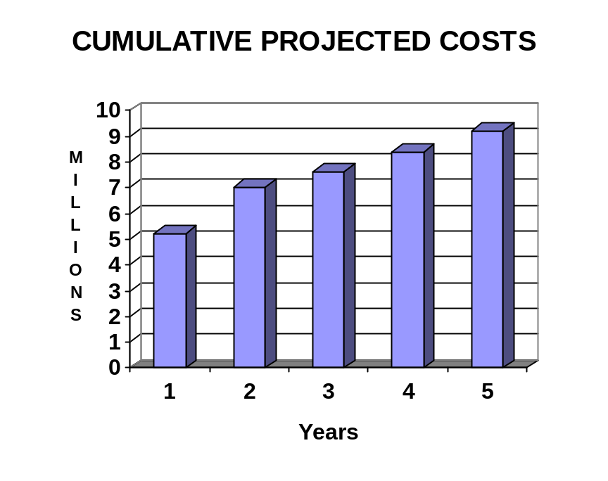

SYSTEM LIFE ANNUAL COST BASELINE
Description | Year 1 | Year 2 | Year 3 | Year 4 | Year 5 | Total
Projected Costs:  Alternative 1 | 5,321,868 | 1,621,868 | 796,145 | 796,145 | 796,145 | 9,332,171

ANNUAL AND SYSTEM LIFE BENEFITS BASELINE
Description | Year 1 | Year 2 | Year 3 | Year 4 | Year 5 | Total
Benefit 1 | 0 | 409,507 | 409,507 | 409,507 | 409,507 | 1,638,028
Benefit 2 | 0 | 150,000 | 150,000 | 150,000 | 150,000 | 600,000
Benefit 3 | 0 | 481,920 | 1,034,120 | 1,257,510 | 1,420,660 | 4,194,210
Benefit 4 | 0 | 610,995 | 702,644 | 808,041 | 929,247 | 3,050,927
Benefit 5 | 65,000 | 130,000 | 130,000 | 130,000 | 130,000 | 585,000
Benefit 6 | 0 | 0 | 655,000 | 0 | 0 | 655,000
Total | 65,000 | 1,782,422 | 3,081,271 | 2,755,058 | 3,039,414 | 10,723,165

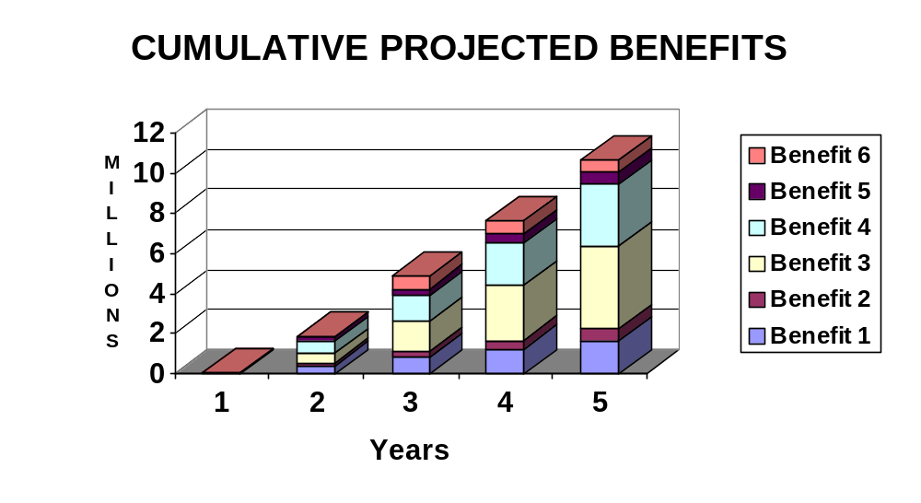

The State also plans to measure whether qualitative improvements are achieved. Specifically, the State has established project goals to improve productivity, eliminate processing delays, and provide more timely services to the public.
Currently, the State experiences processing delays in three categories: input processing, internal control checks, and report transmission. Input processing is the time taken from receipt of information from the client until the data has been entered into the central database. Internal control checks involve the steps taken to verify client identity and eligibility and cross-check for duplicative entry. Report transmission begins after system processing is complete and continues until receipt of the information by the requesting party.
Regarding more timely provision of services to the public, two measures are critical: the time elapsed from initial client contact until (1) notification of acceptance of client data and (2) delay until provision of benefits.
The table on the next page shows the current operational performance and the target performance for the new system. Current data was developed based on management records on file in the State.

PERFORMANCE BASELINE AND TARGET
Category | Baseline Average | Target Average
Administrative overhead | 8 hours per week | 4 hours per week
Input Processing | 7 days | Same day
Internal control checks | 3 days | 1 day
Report transmission | 4 days | Same day
Delay to notification | 3 weeks | 1 week
Delay to benefits | 3 months | 1 month

In summary, this cost/benefit measurement plan provides that the State will measure performance against both program and system goals - and against cost and benefit values. (See the table on the next page.) This information will serve as the baseline for reporting "actuals" in future APD Updates.

SYSTEM LIFE COST BASELINE
Description | Year 1 | Year 2 |  | Year 3 |  | Year 4 |  | Year 5 |  | Total
Non-Recurring Costs | 3,700,00 | 0 |  | 0 |  | 0 |  | 0 |  | 0
Recurring Costs | 1,621,868 | 1,621,868 |  | 796,145 |  | 796,145 |  | 796,145 |  | 5,632,171
Total Projected Costs | 5,321,868 | 1,621,868 |  | 796,145 |  | 796,145 |  | 796,145 |  | 9,332,171
SYSTEM LIFE BENFITS BASELINE
Description | Year 1 | Year 2 |  | Year 3 |  | Year 4 |  | Year 5 |  | Total
Total Projected Benefits | 65,000 | 1,782,422 |  | 3,081,271 |  | 2,755,058 |  | 3,039,414 |  | 10,723,165
CUMULATIVE BENEFIT / COST BASELINE
Description | Year 1 |  | Year 2 |  | Year 3 |  | Year 4 |  | Year 5 |  | Total
Cumulative Total Projected Benefits | 65,000 |  | 1,847,422 |  | 4,928,693 |  | 7,683,751 |  | 10,723,165 |  | N/A
Cumulative Total Projected Costs | 5,321,868 |  | 6,943,736 |  | 7,739,881 |  | 8,536,026 |  | 9,332,171 |  | N/A
[Editor's Note: Note that only projected - not present value - numbers establish the baseline. Present value numbers and present value discounting are not used once the most cost-beneficial alternative is chosen.]

? Further information on the effect of projected workload increases on staffing is detailed in Benefit 3.
? This assumption is supported by the fact that caseworkers' duties have been stable since 1987, proven by review of a personnel audit conducted at that time — "Performance Audit of Caseworkers."
? This assumption is supported by the study "Historical and Demographical Trends in Casework: Effect on the Future."
? This assumption is based on the current project management plan.
? Details on system specifications are provided in the requirements analysis.

