USDA Foreign Agricultural Service
GAIN Report

Global Agriculture Information Network
Template Version 2.09

Required Report - Public distribution
Date: 9/20/2007
GAIN Report Number: CH7814
CH7814
China, Peoples Republic of
Market Development Reports
Wenzhou: Am Emerging Market on China's East Coast
2007

Approved by:
Wayne Batwin
U.S. Consulate
Prepared by:
Susan Zhang

Report Highlights:
Wenzhou, with a recorded civilization dating back 4,000 years, has become a catchword for the entrepreneurial spirit sweeping China in the past couple of years. With a population of 7.5 million but only a small amount of arable land per capita, Wenzhou has developed a strong trading culture. Wenzhou was the first city to set up individual and private enterprises in China after the free-market reforms started in the early 1980s, and currently over 95% of businesses in Wenzhou are privately owned. Starting out with distinct disadvantages, Wenzhou is now one of the richest cities in China. While infrastructure improvement and direct foreign investment have been modest in recent years, prospects for imported foods are changing. It is good potential market with high consumption levels, though it will take some time and a lot of eduction and promotional efforts to make it a ready market for American food and beverage products.

Includes PSD Changes: No
Includes Trade Matrix: No
Annual Report
Shanghai ATO [CH2]
[CH]
Introduction - The Birthplace of the Non-State Owned Economy in China

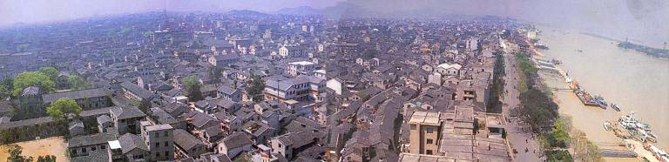

Wenzhou, with a recorded civilization dating back 4,000 years, has become a catchword for the entrepreneurial spirit sweeping China. Located at the south-eastern coast of Zhejiang Province, one of the wealthiest provinces in China, Wenzhou is famous for its well-developed light manufacturing industry and commerce. About 500 kilometers south of Shanghai, Wenzhou is encircled by mountains and the East China Sea. Unlike its sister cities Hangzhou or Ningbo, Wenzhou has enjoyed little investment in infrastructure either from the central or provincial government due to its special strategic location in the China-Taiwan confrontation. Until a small airport was opened in 1990, visitors had to take a ferry from Shanghai and the trip took 24 hours.

Lack of natural resources, shortage of farmland and difficult overland transport not only forced Wenzhou to develop a strong trading culture, but also helped foster the characteristics of Wenzhou people, including perseverance, self-reliance, pragmatism, and solidarity.

Wenzhou was the first city to set up individual and private enterprises in China after the free-market reforms began in the early 1980s, and currently over 95% of the enterprises in Wenzhou are private businesses according to official statistics. Starting with distinct disadvantages, Wenzhou people developed a native instinct to do business even on a very small scale. Today, one quarter of all shoes bought in China come from Wenzhou and the city makes 70% of the world’s cigarette lighters.
Wenzhou Economic Data
Population | 7.5 million
GDP | $ 21 billion
GDP Growth Rate | 13.8%
Annual per capita income/growth rate | $ 2800/13.2%
Major Industries | Clothes, leather products, footwear, glasses, lighters and low-voltage electrical appliance, razor, locks, spectacle frame, pens, plastics products and packaging printing.
Key Agricultural Products | Rice, fruit (mandarin oranges), sea products, tea
Major Food Retailers | C&U, Century Lianhua, Lotus, Trust-Mart
Source: Zhejiang Statistical Yearbook 2005/2006 2006
Exchange rate USD vs. RMB: 1: 7.6

Wenzhou at a Glance

With a jurisdiction covering three districts, two county-level cities and six counties, Wenzhou encompasses a total land area of 11,784 square kilometers(4,550 Square miles), about 11.6% of Zhejiang province. The population in 2005 was 7.5 million, including 2 million urban residents. Wenzhou has a coastline of 339 kilometers(211 miles) from north to south, and Wenzhou Harbor has been listed as one of the 20 main hub ports along the coastal area of China by the National Ministry of Communications.

Wenzhou has maintained high economic growth in recent years and ranks itself the third largest economy in terms of GDP in Zhejiang province after Hangzhou and Ningbo. Its average annual GDP growth during the past five years reached 14.3%.

Wenzhou and Wenzhou People: Imbalanced Development of Personal Wealth and Public Infrastructure

Almost everybody in Wenzhou, man or woman, wants to be his or her own boss. The phrase “rather be a big fish in a small pond than a small one in a big pond” is widely valued in Wenzhou.

The Wenzhou people were among the first group of Chinese who reacted to the government's call to develop individual private businesses when China initiated its economic reforms in early 1980s. The nationally famous “Wenzhou Model” represents the dynamics of the private sector – Wenzhou people excel in the manufacturing as well as trading of light consumer goods, though generally they develop small-scale, often family owned manufacturing plants and distribution networks between producers and consumers all over the country. These companies often have their own sources of financing and their own way of marketing and management styles.

The success of Wenzhou can also be attributed to the tradition for Wenzhou people to travel extensively in conducting trade business. Statistics show that currently approximately 2 million people from Wenzhou are doing business while living in other areas across China. Many Wenzhou people are also traveling to work or conduct business in overseas countries. It is estimated that there are about 0.5 million Wenzhou people living in Europe. The large number of Wenzhou people networks both in China and overseas contributed to the development of Wenzhou’s trading activities. These people created over half of Wenzhou’s GDP according to Wenzhou’s government statistics.

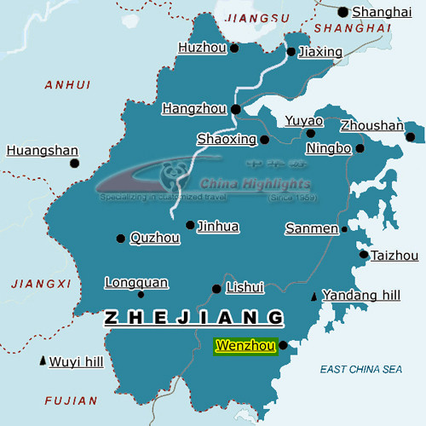
By contrast, the wealth in Wenzhou people’s pockets has not been reflected in the city’s infrastructure. Touring in Wenzhou, there is an inconsistency between the appearance of its commercial and business districts and the city known in China for its wealth. This imbalance can be attributed to several factors:
- Wenzhou, located very close to Fujian Province and therefore close to Taiwan, has occupied a precarious yet strategic role since the founding of the PRC. As a result, it has not received financial investment in infrastructure from the central and provincial governments as much as other cities in Zhejiang.
- Wenzhou people are known for their strong desire to set up businesses of their own and their ability to endure hardships and hard work during this process. On the one hand, this has created a large number of vital private businesses; on the other hand, however, this has meant that the industrial structure of Wenzhou tends to be small in size, focusing on lower-end production.
- The spirit of pragmatism that is deeply rooted in Wenzhou culture and the pursuit of more personal wealth has encouraged Wenzhou people to keep working hard and investing in business, instead of driving them to improve the region’s infrastructure and enjoying life more.
- As a consequence, foreign direct investment and investment from other parts of China has not played an active role in Wenzhou due to its outdated infrastructure and transportation conditions.
Sector Analysis

Retail Sector
Major Food Retailers in Wenzhou
Company | Format | No. of Stores
Lotus | Hypermarket | 1
Trust-mart | Supermarket | 4
Century Lianhua | Supermarket | 3
C&U (Ren Ben) | Hypermarket &Supermarket | 45
C&U (Ren Ben) | Convenience Store | 100
Min Feng | Supermarket | 30
D&L (Danlu Plaza) | Department store | 1

According to Wenzhou Municipal Government officials, Wenzhou is identified as a second-tier city in China’s commitment to the WTO Agreement; it therefore only became open to international retail giants in 2006. This partly explains why until recently there were no Carrefour, Metro, or Auchan stores in this city. Currently only 1 international retailer, Lotus, operates a store in the economic development zone in the suburbs of Wenzhou. Trust-mart plans to have 4 stores and has already opened 3 of them, but their scale is modest and similar to local stores such as Lianhua.

The retail sector development in Wenzhou has also been hindered by several other factors:

1. Undeveloped infrastructure and high land prices
Wenzhou suffers both from an existing underdeveloped infrastructure and skyrocketing land prices. In fact, the global retail giants have been paying attention to this rich city for a long time. According to Wenzhou officials, senior executives from certain global retail giants visited Wenzhou four times last year to discuss the issue of opening stores there. Unfortunately, they never reached an agreement with the Wenzhou Municipal Government on the location to open their stores.

2. The traditional consumption habits of Wenzhou people
A lot of Wenzhou people still prefer to give a phone call to the convenience stores in their community and have the commodities delivered directly to their homes. When touring inside the recently opened Lotus store, one would hardly notice the difference between it and any other Lotus store in Shanghai; however, its business has never been satisfactory since its opening due to its remote location from the downtown area. Although 20% of households in Wenzhou own family cars, the highest percentage in Zhejiang Province, it appears that they have not yet become accustomed to the habit of driving to a hypermarket to purchase necessities for the week.

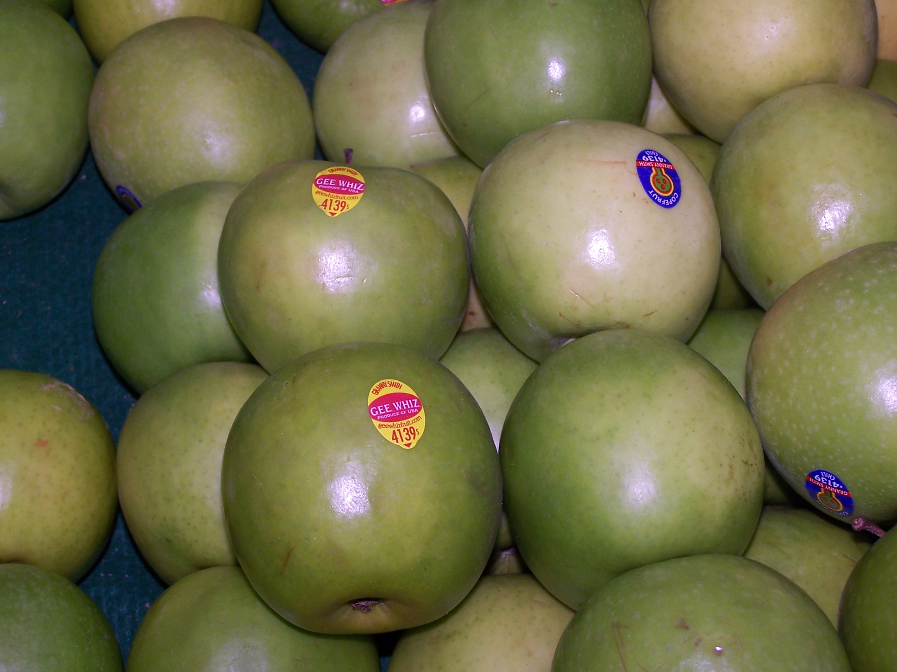
The local retailer C&U (Ren Ben) enjoys the highest market share in the food retail sector in Wenzhou. Entering the retail business in 1997 in Wenzhou, C&U has successfully expanded its business to Taizhou and Jinhua, the other two cities in Zhejiang Province, and Ningde of Fujian Province. It currently has 220 stores in total, including 80 supermarkets, 125 convenience stores and about a dozen hypermarkets. Despite its dominant position in the food retail sector, imported products are rarely found in C&U stores. There are only a few brands of imported infant-formula milk powder from New Zealand and Europe, and a few wines from France on the shelves. Some tree nut products such as almonds and pecans claim to be from the U.S., but they are processed and packaged in China under local brands. Red Delicious apples, Granny Smith apples and Sunkist oranges and lemons are found in the fresh product area, but most of them are not very professionally displayed; for example, some green-color apples produced in Chile are mixed with Granny Smith apples from the U.S., and the presentation of the products is unattractive due to moisture loss.

Lack of mature distribution channels for imported food products is one of the major barriers for the very limited availability of imported food products in the local retail sector. During ATO Shanghai’s interviews, C&U reported that they had tried to increase imported food SKUs for trial sales in their supermarkets, but these efforts confronted many difficulties: on the one hand, they are unfamiliar with many foreign food product brands and there are no qualified local importers in Wenzhou, so they had to rely on importers and distributors from larger cities like Shanghai for product sourcing; on the other hand, since C&U can only place small quantity orders and at their current stage of development cannot commit to long-term cooperation, they were often asked to make cash orders with these importers and distributors from Shanghai. In addition, it takes time and money to educate local consumers to try and accept imported food products. Wenzhou people are willing to spend a lot of money on famous brand products that can reflect their wealth and social status, such as watches, shoes and jewelry, or even a car license plate with lucky numbers, but they will hesitate to buy an imported food product whose brand is not familiar to them and with a price often double that of its domestic counterpart. These difficulties and risks are also faced by other local food retailers like Lianhua and Minfeng.

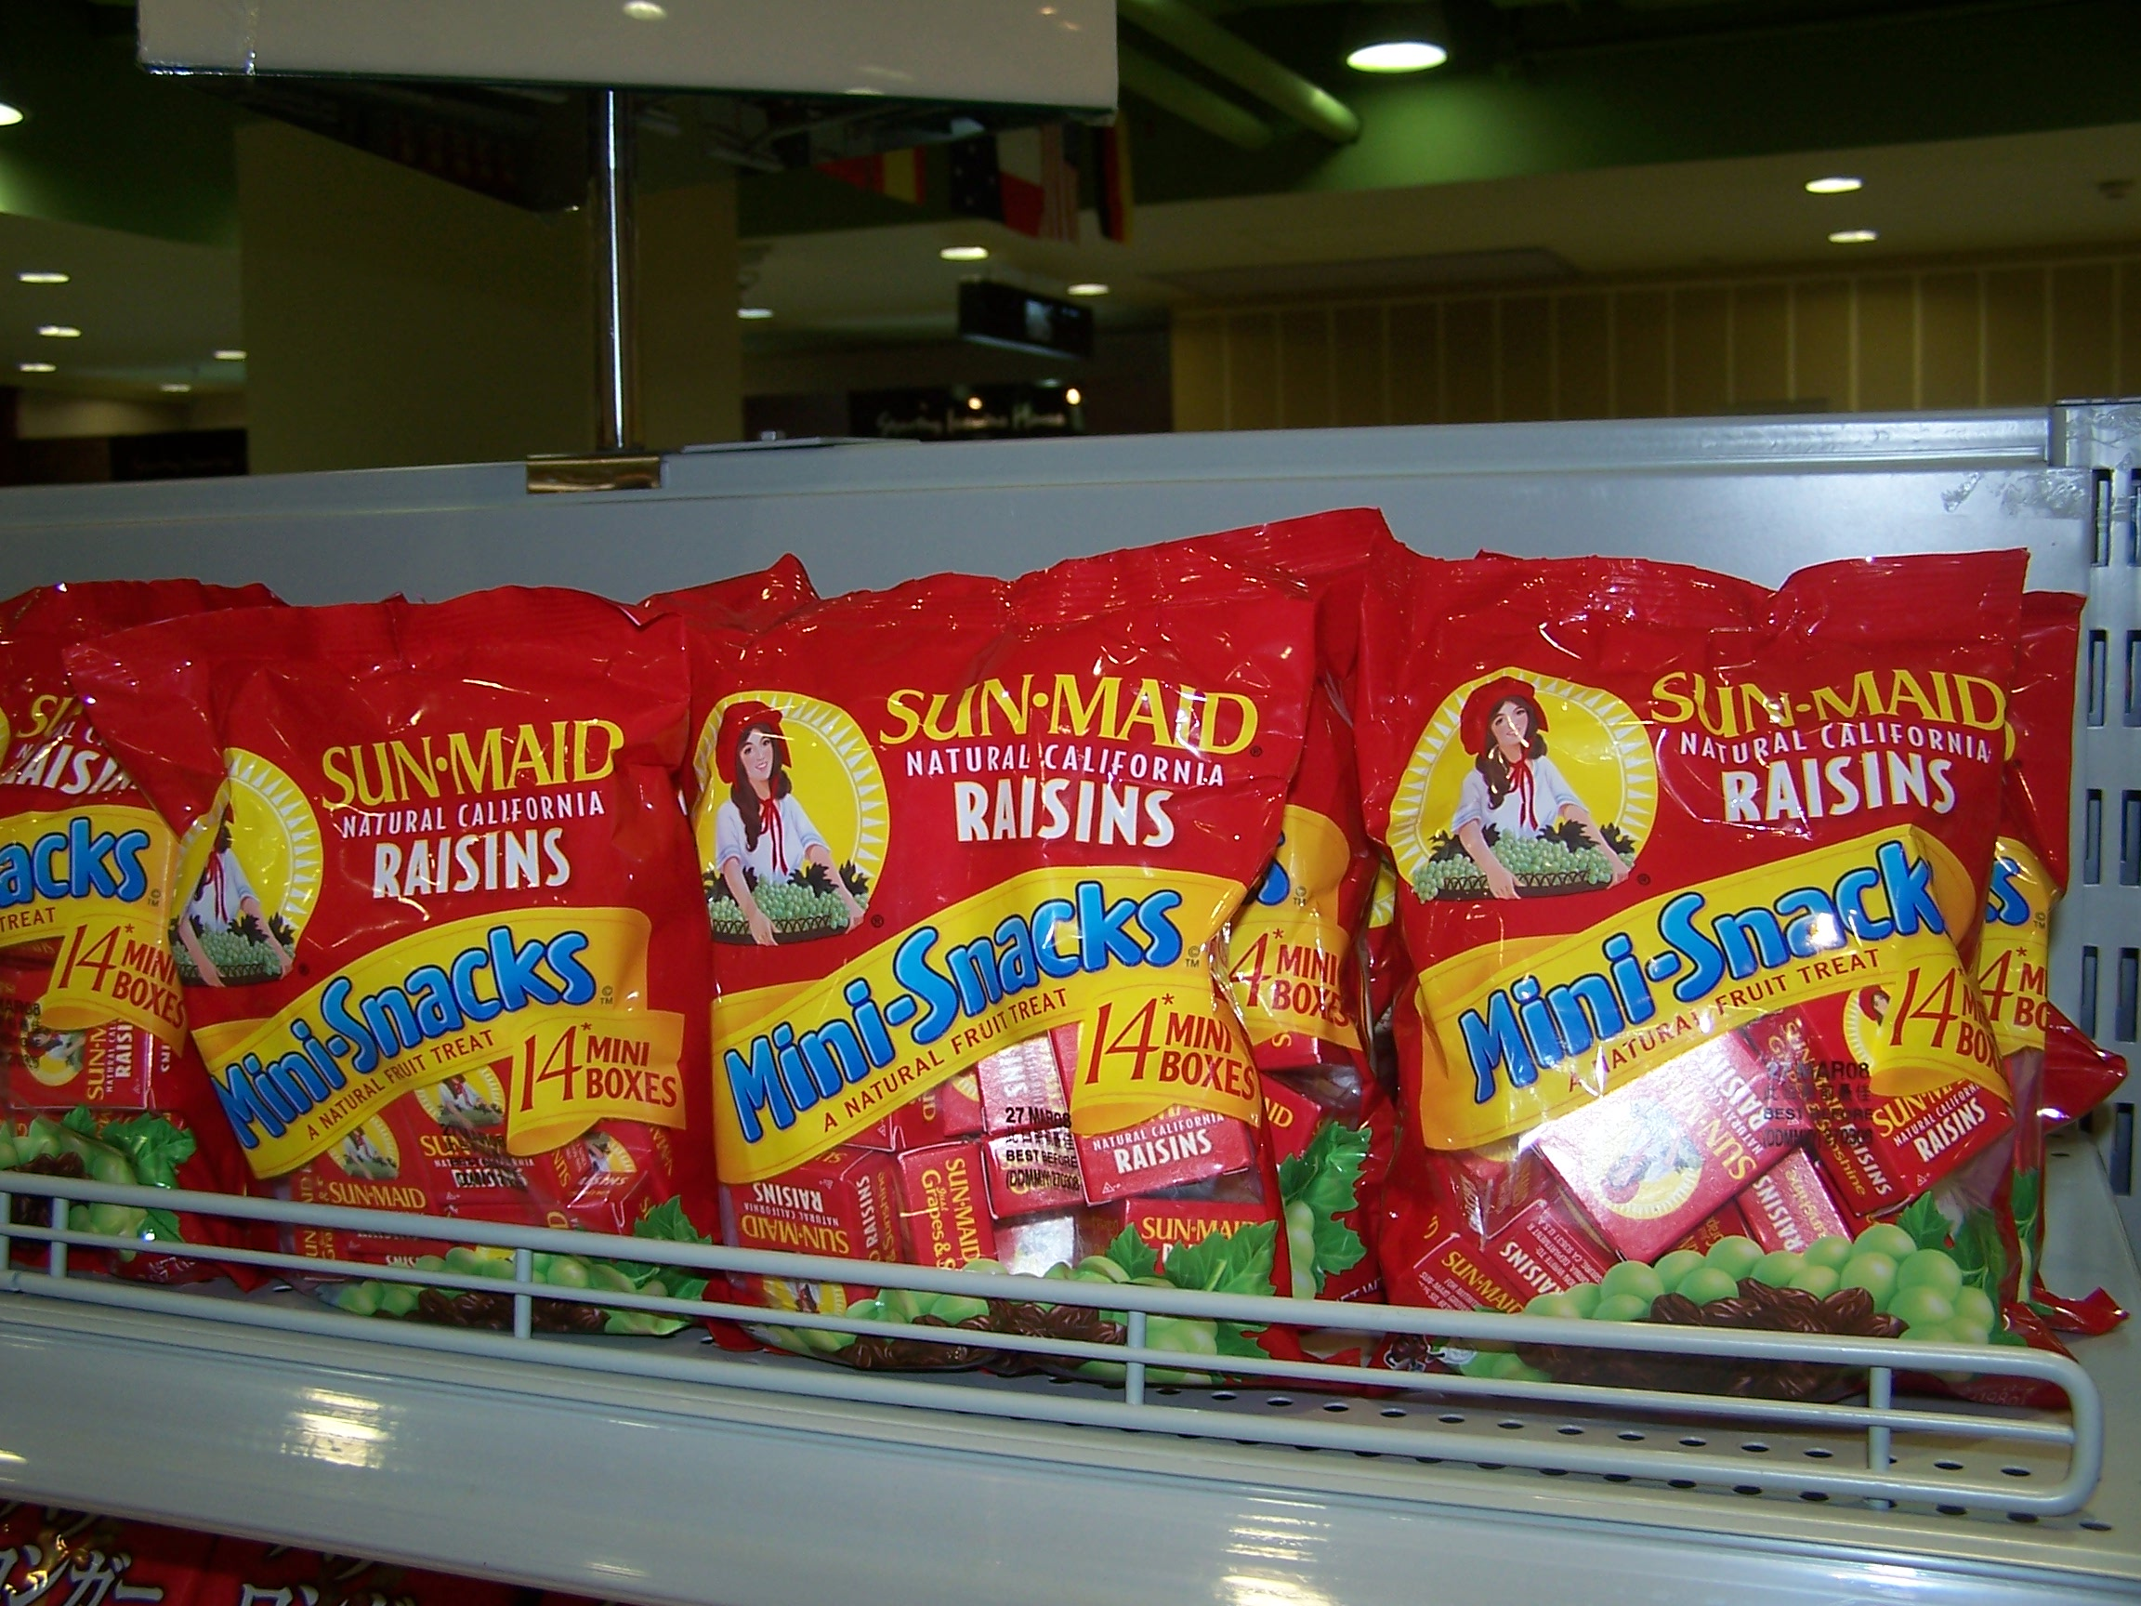
The supermarket in D&L Mall, a high-end department store specializing in famous brand commodities from around the world, is the only store where 70% of its food products are imported. Frozen Alaska king crabs, Land ‘O Lakes cheese, Heinz sauces and baby food, California plums, prunes, table grapes, Sun Maid raisins, Post cereals, and Carlo Rossi wines are beautifully and professionally displayed on the shelves of this store. According to the management we interviewed in the store, these food products are distributed by importers from Shanghai, Shenzhen and Beijing, and their main consumers are expatriates and local people who have traveled overseas. However, the managers of D&L Mall admitted that since its opening in late 2006, sales have been sluggish, attributing this to an inconvenient location, high prices of the food products, and the consumption habits of Wenzhou people.

Despite all these difficulties and barriers, professional retailers in this “fast moving train” of Wenzhou are seeing the light at the end of the tunnel – greater attention to food safety and health are driving consumers to purchase food more frequently in specialized food stores and supermarkets with good reputations, while the market share of small-scale mom and pop stores and wet markets is shrinking, and high quality imported products and western lifestyles are becoming ever more popular among the younger generation with active lifestyles. According to the Wenzhou Retail Association, a “Sourcing Alliance” consisting of all the important retailers in Wenzhou will be organized in 2008 to consolidate the sourcing of imported food products, to strengthen the bargaining power of Wenzhou retailers against food importers.

It is also widely recognized by industry insiders that the mass consumers need guidance and education on where to buy, what to buy and how to buy in terms of food selection. Although the education, as well as the infrastructure improvement, will take time and enormous energy, it should not be too long before we see a much more prosperous retail sector in Wenzhou, thanks to its already high consumption level and the enthusiasm of the international retailers in this market.

Food Service Sector

As a land of fish and rice, Wenzhou enjoys more than 400 varieties of seafood delicacies. Locally produced live seafood such as swimming crab, grouper, eel, anchovy, prawn and jelly fish are well known. Wenzhou cuisine features the use of less oil and less starch, and attaches great importance to freshness. Many high-end restaurants do not have a menu; instead, they have a display area where customers can see all kinds of fish and lobsters swimming in water tanks, bubbling tanks filled with fresh crabs, or fish laying beautifully on ice that were still alive 1 or 2 days ago.

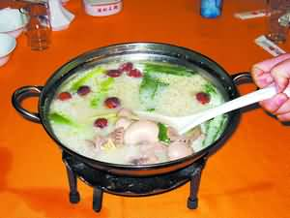
The Wenzhou Restaurant Service Association has around 150 corporate members, including most star-rated hotels and famous restaurants in Wenzhou. There is 1 five star hotel and around 10 four star hotels and all of them are locally owned. Currently no international hotel chains have locations in Wenzhou, although Shangri-La is building its first hotel due to be completed by the end of 2008. Wu Ma Restaurant, Xin Ding Xiang Restaurant and A Wai Lou Restaurants are the most famous restaurants engaging in Wenzhou cuisine, known as the “Ou Cuisine”, with a long history.

Nowadays, local consumers tend to dine out more frequently. The younger generation has developed a strong interest in western food, and they can afford it. Currently the most frequently used imported food ingredients in the Wenzhou HRI sector are beef from New Zealand and Brazil, salmon from Norway, lobsters from Australia, and abalone and bird’s nest from South Africa and Thailand. U.S. food products such as Alaska seafood have a very low awareness level due to the lack of promotion efforts.

According to the statistics of the Wenzhou Restaurant Service Association, the total revenue of its member restaurants reached RMB 7.0 billion (US$933 million) in 2006, and the actual figure could be double this official number. Wenzhou people spend a lot of money on food when they think it is necessary. For example, wedding banquets in hotels are no cheaper than those in Shanghai, and one Australian lobster per table is widely regarded a must-serve dish for a decent wedding banquet, which normally has 40-50 tables. Wenzhou people also favor shark’s fin, abalone and bird nests. Restaurants specializing in sharks’ fin and abalone are mushrooming in this city, mainly as business banquet venues.

Local distribution channels are under-developed. According to the Wenzhou Restaurant Service Association, there are only 3-4 large scale comprehensive distributors for the food service sector in Wenzhou, but none of them directly import food ingredients from overseas. Instead, they completely rely on domestic importers from bigger cities such as Guangzhou and Shanghai for imported food ingredients. Imported meat products are mainly distributed by importers in Shenzhen, and imported seafood products come mainly from distributors in Guangzhou. With the absence of big retailers like Metro or Carrefour, hotels and restaurants also rely heavily on wet markets for aquatic products, though meat products like pork are regularly supplied by local distributors. For beverages, most imported wines are from France, Spain and Italy. American wines and beers have a very low awareness level as few distributors have promoted them. Local beers and wines both enjoy good market shares.

Distributors do not have enough knowledge of imported foods and beverages, not to mention U.S. food & beverage products. The market is not well regulated either. Beef for example, currently imported from Brazil or New Zealand, normally does not have a certificate of origin; instead, distributors judge from the credibility of the importers whether the beef is truly from its claimed origin.

The interest of Wenzhou people in high quality and nutritious food need guidance and further education to facilitate the sales of American food ingredients. Improving the status of American food products, fostering the consumer market demand and educating the distribution channels to increase product varieties need to be addressed in parallel. Local food service professionals recommend that U.S. products should start with star-rated hotels with menu promotions and chef training, aimed at educating the professionals and building up the brand for U.S. products among the high-end market segments, then utilize popular restaurants to foster the atmosphere of consuming U.S. products among the mainstream population.

“The Capital of Footwear in China”

Though not a big consumer yet for American foods, Wenzhou is a huge market for non-food agricultural products including hides & skin, and leather products from United States.
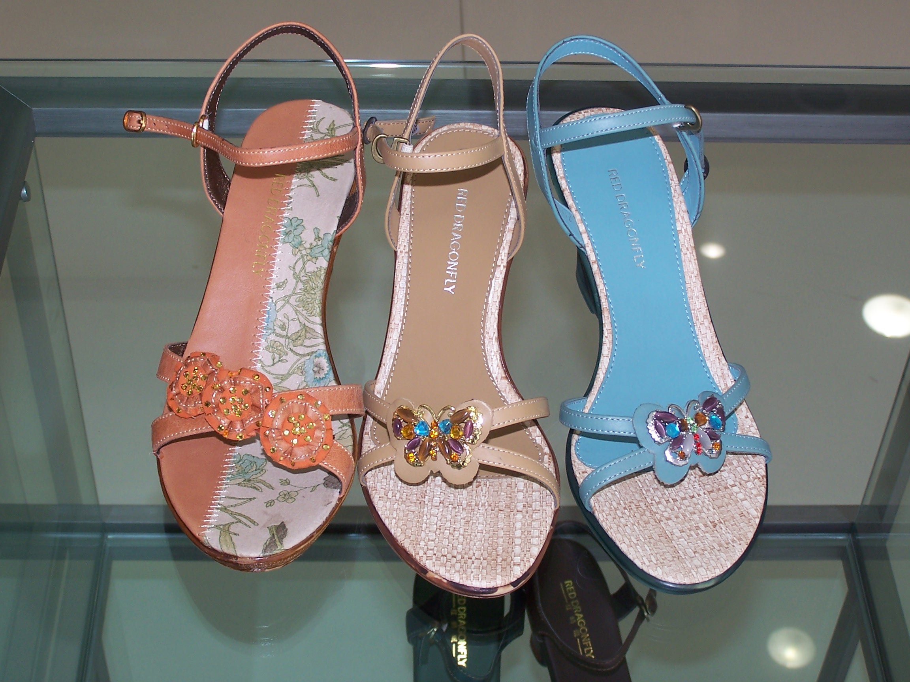
The quality of Wenzhou-made products has improved significantly in the past decade, and some of their products have become national brands. Footwear is a representative industry seeing this amazing transition. Moving from the notorious “fake and low-quality shoemaker” to the major famous brand shoemaker and even the largest shoe exporter to overseas markets took only ten years in Wenzhou. Meanwhile supportive industries including hides and skins processing, components and complimentary materials for shoe-making are well developed, and there are more than 10 different trade associations related to footwear production in Wenzhou. Many local shoe-making companies have opened plants in other countries like Italy as well as several African countries and sell their products directly to these markets to avoid export barriers.

Unlike Haining, Wenzhou has only small and medium-scale leather processing plants, whose development has been restricted by the local government due to environmental concerns. Therefore the vibrant shoe making industry relies not only on the locally processed leather but leather produced from other parts of China and even from overseas.

Local leather processing plants report that around 70% of their raw hides and skins are imported from the U.S., and the rest from Australia, South American countries and domestic suppliers. However, they are very concerned about the ever-rising price and ever-dropping quality of U.S. hides and skins with increased scratches, holes and scores in recent years. They warned that U.S. hides will lose their leading position in the China market if this trend continues. To address these concerns, eight major leather processors in China have reached a preliminary agreement to have a serious discussion with U.S. hides exporters during the All China Leather Show in September in Shanghai.

Best sales prospects for U.S. products in Wenzhou

Wenzhou: Best Product Prospects
Product | Market Segment | Notes
Fruits | Retail | Already present in the market and have built up awareness. Product damage due to limited cold chain during transport and storage need to be improved. More professional in-store display required.
Nuts | Retail and HRI | Already present in the market. Brand awareness needs to be strengthened. Main competition is from domestic counterparts.
Beverages | Retail | Younger generation between ages of 18-35 show stronger interest in beverages with new flavors. Children are also good potential consumers.
Cereals | Retail | With increasing health consciousness, breakfast with milk and cereal is becoming popular, hence consumption is on the rise.
Wine | HRI and Retail | Imported wine consumption is on the rise especially in HRI sector. Competition is mainly from the “old world wines” of Europe.
Snack Foods | Retail | Imported by major importers/distributors in Shanghai. Becoming popular among the younger generation who are greatly influenced by TV commercials advocating western lifestyles.
Infant food and milk powders | Retail | The one-child policy has made Chinese parents very generous in baby food purchases. Main competition is from European and Australian brands. Local brands are very weak.
Beef | HRI | With more and more steakhouse and western restaurants established, food service professionals and eventually consumers will become more brand sensitive and demanding on quality– a good trend for U.S. beef once it regains access to the China market.
Potato products | HRI | Mashed potato and other potato products are especially well received in western restaurants, and increasingly in coffee bars.

ATO activities planned

ATO Shanghai is planning a multi-level promotion in Wenzhou in May 2008. The activities will include a seminar, cooking demonstration, food tasting reception, one-on-one meetings with local traders, and an in-store promotion. This will help U.S. food suppliers and American food importers set up direct trade contacts with local distributors, restaurants and retailers, and expose local consumers to the enormous variety of American high-value food products. A PR campaign will be designed to educate consumers about American food products and build consumer confidence in and demand for these products.

Contact Information

Agricultural Trade Office, Shanghai
Shanghai Center, Suite 331
1376 Nanjing West Road
Shanghai 200040, China
Phone: 86-21-6279 8622
Fax: 86-21-6279-8336
E-mail: ATOShanghai@fas.usda.gov
Website: www.USDAChina.org

