FAA’s Pete McHugh Share’s his Iraq Experience
By Janet Kinsell
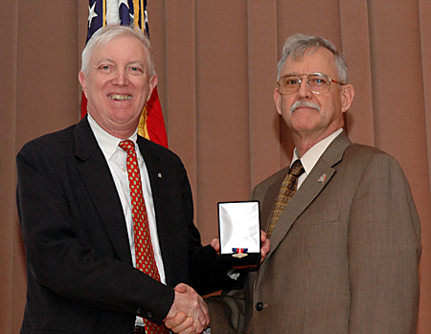
Technical Center Director, Dr. Wilson Felder, presents Pete McHugh with the Department of Transportation’s War On Terrorism Medal
Pete McHugh was introduced by Fred Snyder as a humble man, with 40 years of government service in both the military and civilian sector. McHugh, who traveled from Virginia through an icy snowstorm, was the Technical Center’s guest speaker on February 14, presenting “FAA In Iraq – Reconstruction In Combat.”
Just prior to the presentation, and on behalf of the Secretary of Transportation, Dr. Wilson Felder, Technical Center Director, awarded McHugh the prestigious honor of the Department of Transportation’s War On Terrorism Medal. Dr. Felder said, “this medal is awarded for contributions above and beyond the call of duty in protecting and securing the nation in the fight against terrorism.” McHugh, named Interagency Chair of the Joint Force Staff College in September of 2005, began his presentation by thanking Dr. Felder while removing the pinned-on medal stating, “if you know me you’ll appreciate that I believe there are others in Iraq who deserve this award far more than me.”
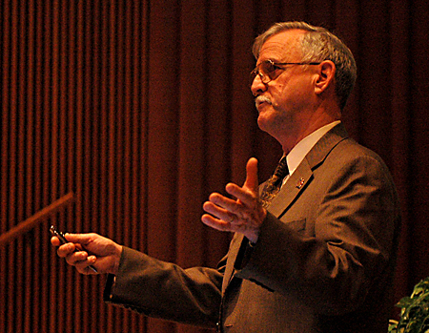
“You cannot understand Iraq by what you read in the paper or what you see in the media,” McHugh stated. “And those of us, who have been there, have an obligation to share our experiences.” McHugh continued with a caveat of being in Iraq a very short time, having a small window to look through and stating his observations were biased and limited. “Anything I say is not intended to be critical or political, but rather a way of just passing on some of my valued experience, while recognizing the work that is being done. There are some 35 FAA employees who have been there to date.”
McHugh attended a 13-week course preparing him to plan and execute jointly with DOD; Army, Air Force, Navy and Coast Guard, since, as he says, “all must learn to play together nicely.” The question was asked: what competencies and capabilities do government agencies bring to the war fight? And after securing the title, Senior Aviation Advisor to the Embassy in Iraq, a position he won over 80 applicants, and spending 10 months in Iraq among the troops, he was in a position to answer. “We have a number of very important roles. A global war on terror is not just a war in Iraq, or Afghanistan, or South Africa. It is a war against a dedicated enemy of over a billion people across the globe.” He then warned the audience that if we don’t get serious, our children would pay the price.
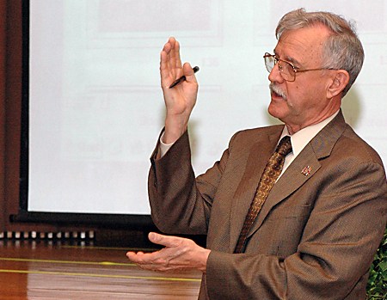
With an impressive slide presentation, McHugh pointed out that Iraq and its neighboring states do not cooperate with each other. Villages have no running water. Education is not a valued opportunity. He explained that transportation is difficult and usually limited to helicopters. He showed video clips of sand storms of 60 knots, lasting up to 12 hours, creating darkness and obstacles for our troops. Another slide, depicted angry soldiers removing statues of Sadam after learning he had over 60 exclusive palaces. This was followed by photos of bombs, home made rockets, and explosions, too close for comfort. He explained pictures of T-Walls, concrete bunkers that both protect people from explosions, but also stop us from communicating with Iraqis. McHugh said he believes there will be no resolution until the T-Walls are removed.
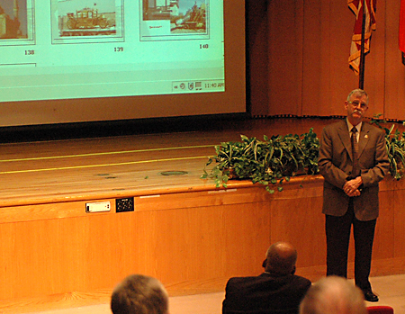
McHugh continued explaining how our troops work in 130-degree weather, anywhere from 12 to 17 hours a day, seven days a week. Their pride in protecting our country seems coupled with their amazing sense of humor. He said he was amazed at their dedication. They are the hardest working people he has ever seen. He shared a story of visiting a palace with a painting on the ceiling. Taking the Saudi Director of Aviation to see the painting, he noticed tears in his eyes and asked if he was emotionally moved? The director replied, “No, I am saddened to think the artist received only $2 a month to paint this scenery.”
The presentation ended with McHugh expressing, “there are major cultural differences between our countries and we need to be sensitive to that. It is an important part of the diplomatic relationship…all the non-governmental agencies, like Save the Children and the Red Cross, and all governmental agencies are needed. They all contribute to success. We must create a network; a joint planning, education, and execution process that brings all the important capabilities of government to bear on any given problem, in a responsive way. That’s the model. If you walk out of here and can be a champion of that, I have succeeded today.”
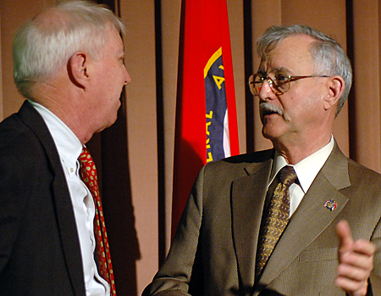
Profile: Dave Blake - Accident Investigations and the Future of Fire Suppression
By Pete Castellano

Dave Blake
On December 26, The Press of Atlantic City featured a front-page story about David Blake, an engineer and fire safety researcher with the Operations Panning, Research and Development Fire Safety Group at the Technical Center. The profile focused on Blake’s longtime experience and efforts assisting in aircraft accident investigations led by the National Transportation Safety Board (NTSB). Blake has participated in 39 accident investigations worldwide, more than any one else, documenting the fire damage from accidents where fire was a factor. This is in addition to his normal job leading and working on several key FAA fire safety projects.
The story can be found at: http://www.pressofatlanticcity.com/news/story/7050219p-6908532c.html
We thought it would be of interest to our readers to recap the highlights of the story, with perhaps some additional thoughts and insights, so we sat down with Dave, along with his boss, the ‘Fire Chief’ here at the Center, Gus Sarkos. But in addition, we wanted to focus on the truly meaningful breakthroughs in fire suppression technology that this group has pioneered as a result of such investigations, and, perhaps even more significant, their goals and objectives for future improvements in the safety of air travel.
Blake is a Drexel University engineering graduate, who first worked at the Technical Center as a co-op. As The Press put it, “ Blake is a soft-spoken man in his 40s with an unobtrusive bearing and a quiet smile, who has spent much of his time recently working on new fire-control technology in the hollowed-out cabin of an old FedEx cargo plane next to Building 275. Tomorrow, though, he might be rushing to Brazil, Canada or Indonesia, to help decipher the world's latest terrible plane crash…. He largely works alone. His most constant companion, these days, is the FedEx 727, with its musty-smelling bowels and dangling wires. Here, Blake is experimenting with the use of nitrogen to extinguish fires in an airplane's walls, a technology that could someday save hundreds of lives. Today, figuring out how to save lives. Tomorrow, figuring out what ended them. This is Dave Blake's career.”
According to Sarkos, the Center began its involvement with accident investigations in 1980. Group member Dick Hill was the first to participate, and Dave took over from there. “By participating in crash investigations, the FAA is able to get ahead of the curve, since NTSB recommendations often come from an accident,” says Sarkos. “Working directly with NTSB ‘working level’ personnel allows us to gain information, and exchange ideas – this benefits the Technical Center as well as the FAA,” added Blake.
Sarkos went on to add, “Accident investigation may seam to be ‘glamorous’ work, however, it is really hard and tedious work – sifting through 16 pallets of cargo to try to find out what started a fire. It is also dangerous, because you never know what materials burned, and what types of gas or chemicals you can be exposed to.” We do know, however, that it has proved to be invaluable work in leading to improved aircraft safety.
Blake’s first investigation involved A Sikorsky S76 helicopter that crashed in Hartford, Connecticut, and burst into flames. It was a charter helicopter, and the crash might have attracted little attention, except that the king of Jordan was scheduled to ride in the same helicopter the following day. The Press went on to highlight Blake’s work investigating some of the most significant crashes in history, including: The Nov. 27, 1989 Boeing 727 which exploded above Bogota, Colombia; The 1991 Boeing 767 Lauda Air crash near Bangkok, Thailand; the infamous Flight 800 crash over Long Island in 1996; and the May 1996 crash of a ValuJet DC-9 in the Florida Everglades.
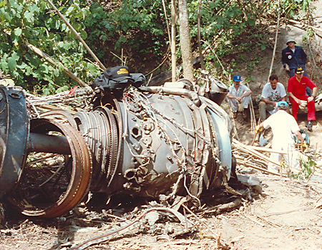
Lauda Airlines 767 in Suphan Buri province, Thailand, near the Burma border, on 5/26/1991. Aircraft broke up in-flight and crashed into the jungle after an uncommanded deployment of the left engine thrust reverser. Left engine shown.
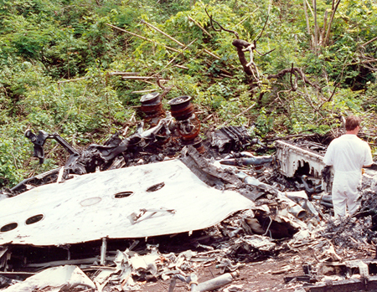
Lauda Airlines 767. Left wing shown.
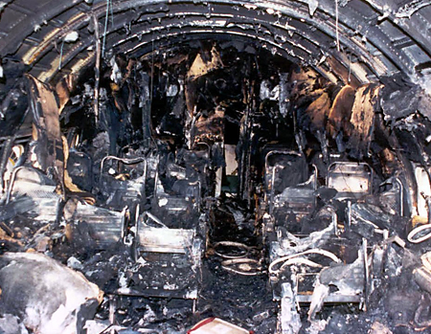
DC-9 in Barranquilla, Columbia on 3/17/1995. A fire ignited in the area of the flush motor of the aft right lavatory shortly after the APU was started while the aircraft was parked at the gate.
The Press concluded “The last few years have been quiet for Blake. So far in 2006, he's investigated only one incident, involving a cargo fire in a UPS plane in Philadelphia that claimed no lives. But frankly, that's the way Blake likes it. It leaves him more time to concentrate on his main mission: preventing fires and fatalities by making aircraft safer.”
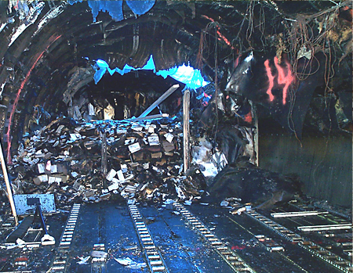
Philadelphia airport on 2/7/2006. An in-flight main deck cargo fire of the main deck of a UPS DC-8 – the accident is still under investigation.
And that is where we wanted to pick up the story. The Fire Safety group has had a long and distinguished record of accomplishment in making aircraft safer. The group was responsible for recommending the process of inerting, to protect aircraft from accidental fuel tank explosions using inert gases . They have also completed research here at the Center on the fire safety implications of pre-packaged self–heating meals (MREs) designed for military use. They have done work on lithium batteries, which were in the news recently with a nation-wide recall of lap tap batteries. The UPS fire in Philadelphia last year had implications as to the severity of that issue . Members of the group have been instrumental in solving crimes though investigation and expert testimony. They were also successful in banning the shipment of flammable Chemical Oxygen Generators along with cargo.
As a result of the Value Jet investigation, some 3,000 aircraft have been retrofitted with fire suppression systems in all hardened compartments. And as Sarkos proudly points out, “Dave has personally lectured the International Society of Air Safety Investigators, and testified before the NTSB on numerous occasions, and Dave has participated in 39 accident investigations worldwide, more than any one else .” The group sponsors and participates in numerous national and international groups devoted to fire prevention and safety. Click here to view a video of the actual Value Jet fire simulation conducted at the Technical Center.
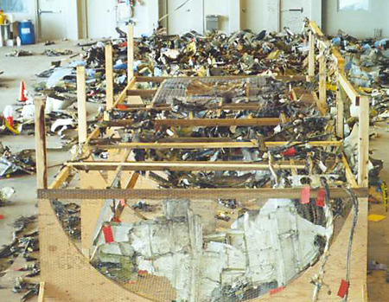
DC-9 crash near Miami on 5/11/1996. The aircraft crashed in the Everglades outside of Miami, due to a fire initiated by improperly packaged and shipped solid oxygen generators in the forward cargo compartment. This mockup was done at Tamiami Airport, southwest of Miami.
One area on which the group is very focused is that of improving insulation material, to slow the burnthrough rate. One of the most common causes of fatalities is after a crash, fuel leaks from the tanks and catches fire. The group is setting the standard to make sure that an external fire will take at least 4 minutes to burnthrough the fuselage, giving the passengers and crew a crucial window of time to escape. The group has pioneered the use of Kapton insulation to achieve this goal. As of September 2009, all new aircraft will use this insulation. In addition, Airbus has decided to certify the use of Kapton ahead of this deadline for its A380 aircraft.
Looking ahead, the Fire Safety Group will continue to work on preventing hidden in-flight fires by developing tougher flammability standards for all materials in hidden areas, and by improving firefighting tactics. Work will also continue on structural composite flammability issues. Fire protection against shipment of hazardous materials is also a top priority. Halon is the agent used today for fire suppression. It is not being manufactured any longer due to environmental issues, so the group is testing replacement agents to make sure they are effective. Work will also continue on long-range research on ultra-fire resistant materials.

The IEEE Affinity Group, Women in Engineering Speaker Series
Deborah Germak, Program Manager, FAA Technology Transfer Program
By Holy Cyrus
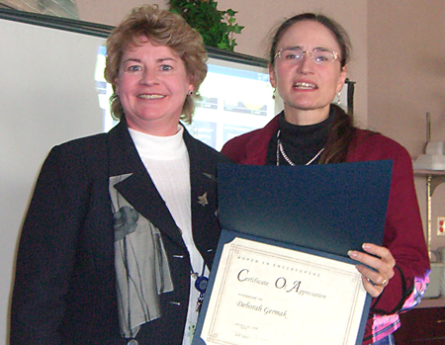
Featured Speaker Deborah Germak, Program Manager, FAA Technology Transfer Program, receives a certificate from Holly Cyrus
The IEEE Affinity Group, Women in Engineering, hosted a Speaker Series luncheon on February 13, 2007, at the East Bay Crab and Grille Restaurant. The honored guest was Deborah Germak, Program Manager, FAA Technology Transfer Program, who discussed the activities being conducted under the direction of Dr. Wilson Felder, Director of the Technical Center, in order to benchmark the Technical Center as a test and evaluation center for the FAA.
There are several important purposes of the exercise. Goals include fiscal accountability, alignment of the Center with ATO and NGATS work, and focusing on the “T” in the Technical aspect of the Center’s name.
A team of Technical Center employees with a wide variety of administrative, technical, and financial experience are engaged in a study to perform a quantitative and qualitative comparison of the Technical Center facilities and resources to other prominent facilities, such as NASA Ames Research Center, Edwards Air Force Base, Sandia National Laboratory, the Air Force Operational Test and Evaluation Center, the Naval Air Warfare Center, Aberdeen Test Center, and the Mike Monroney Aeronautical Center. The team will also provide recommendations to maintain the Technical Center as a world-class facility for aviation research, development, and verification/validation.
With the many FAA organizations located at the Technical Center, including Terminal Tower & TRACON, System Engineering, Flight Inspections, Operations Support, FAA Research & Development, and the many other organizations on the Center campus including the Federal Air Marshals, US Coast Guard, NJ Air National Guard 177 th Fighter Wing, Transportation Security Lab, and the Atlantic City Int’l Airport, along with our core of NAS Laboratories, the Tech Center is uniquely positioned with NAS Automation, Communication, Flying Laboratories, Traffic Flow, Human Factors, Weather, Navigation, Surveillance and Modeling/Simulation capabilities all under one roof.
The team is visiting the various facilities and gathering data from each of the sites in order to compare and contrast with the Tech Center. Areas of interest include general facility information, mission, recognition, workforce, physical facilities, communications, fiscal data, technology transfer, and local processes. The report is due later this spring.
National Engineering Week
By Jason McGlynn
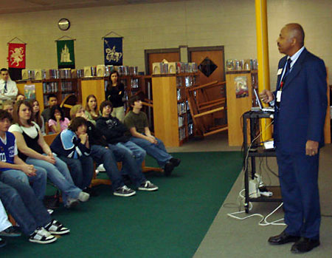
Rodney Guishard, Program Director, Office of Knowledge Management, speaking about engineering at the Davies Middle School in Hamilton Township.
On February 22, 2007, in celebration of National Engineering Week, two teams of engineers and computer scientists from the Technical Center went to two schools in the community to get kids interested in the engineering field. Jensyl Guy, Latasha Reddick, Jamaal Lipscomb, Jeffery Henderson, and Michael Ogundoju went to the science lab at Pleasantville High School and showed a 13-minute DVD documentary entitled “Who Are Engineers” followed by a PowerPoint presentation entitled “Exploring Engineering.” The presentation was used to brief the students on the different types of engineers, why engineering is important, the different work phases of engineering, the technology of a couple of engineering products, the major fields of engineering and what each field involves, and the steps necessary to become an engineer. The event was conducted twice and approximately 45 students ranging from grade nine to grade twelve attended each session. The students were very receptive to the documentary and presentation and most of them showed interest by answering and asking questions during and after the presentation.
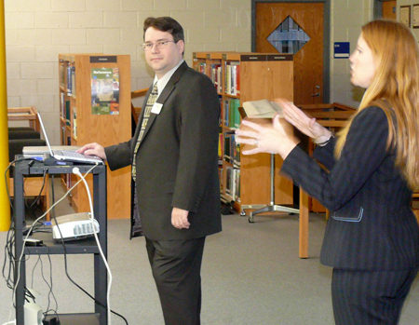
Jennifer Morris and Andy Lamb from Capacity Modeling and Analysis, speaking about engineering at the Davies Middle School in Hamilton Township.
Rodney Guishard, Program Director, Office of Knowledge Management, and Jennifer Morris and Andy Lamb from Capacity Modeling and Analysis gave a presentation about engineering at the Davies Middle School in Hamilton Township to three 8 th-grade classes containing about 120 students each. The presentation covered the definition of engineering, how engineers contribute to society, what they do, the various types of engineers, as well as some of the requirements for becoming an engineer. Jennifer and Andy presented an in-house developed airport simulation model as an example of a Software Engineering product. Jennifer described and demonstrated how the model is being used to assist airport authorities in determining the impact and airport design modifications needed to accommodate the new super sized Airbus 380 passenger aircraft at selected airports. At the conclusion of the presentations students asked questions and were provided a handout about engineering. The students and faculty from both schools were appreciative and thanked the presenters.
Employee Profile: Thomas F. Wood, Director, Human Resource Management Office
By Carolyn McKinney-Bobo
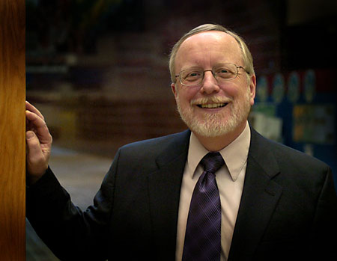
Tom Wood, Director, Human Resource Management Office
On October 16, 2006, Thomas F. Wood started in his new position as Director, Human Resource Management Office at the FAA Technical Center. In this capacity, he is responsible for advising and assisting the Technical Center managers in directing, coordinating, communicating, and ensuring the adequacy of FAA plans, programs and initiatives associated with: employment, compensation, human resources information and automation, learning and development, labor and employee relations, benefits, workplace environment and operational human resources services. His office services the following organizations: ATO-P, ATO-T, ATO-E, ATO-W, and all ACT (AJP-7) organizations at the Technical Center.
Tom previously served as Program Manager for the Labor and Employee Relations Program in the Human Resource Management Office at the Center for 16 years before his selection as Director. Prior to coming to the Technical Center, Tom served as Labor Management Specialist for the Department of the Navy, Civilian Personnel Management, Northeast Region for 6 years.
Tom’s vision for his organization is to become more of a strategic partner with the managers being serviced.
Tom mentioned that, in the very near future, all employee personnel folders would be electronic. He says it will be good for the employees because their files will be at their disposal for review at any time. He feels this will be a help to the HR office in that they will be able to get more into the consulting business for the management team and employees, as well, here at the Center.
The Technical Center management team and employees extend our congratulations to Tom, and wish him much success in his new position.
Opportunities at the Technical Center Capture Full Attention of Honors Students from the New Jersey Institute of Technology (NJIT)
By Ginger Cairnes
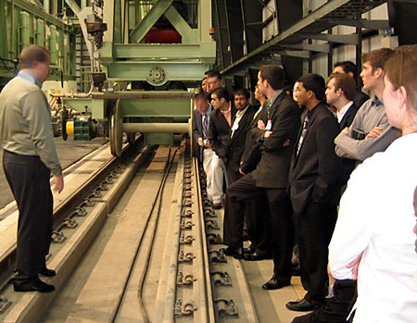
NJIT Students tour the National Airport Pavement Test Facility with Jim Patterson
“The strength of the United States is not the gold at Fort Knox or the weapons of mass destruction that we have, but the sum total of the education and the character of our people.” B.F. Skinner
About a year ago Professor Paul J. Dine and a group of students from NJIT Albert Dorman Honors College visited the Federal Aviation Administration (FAA) Headquarters in Washington, DC and had the opportunity to meet with former Intergovernmental Affairs Manager, Quentin Burgess. Extremely impressed with the students, Burgess highly recommended that the college contact the Technical Center to set up study tours and meetings with experts in technical fields here. Paul contacted Visitor Program Manager, Ginger Cairnes who set the wheels in motion. Greg Rasnake, Congressional Liaison, as well as the office of Congressman Donald Payne, N.J., 10th District, both of whom fully supported this visit, also contacted Ginger.
The New Jersey Institute of Technology is a major public technological university whose mission is education, research, economic development and service. It offers programs to prepare students towards a “technology dependent economy of the 21 st century”. Public and private partnerships are often explored. There are six schools. Among these is the Albert Dorman Honors College. Approximately 600 students in the honors program excel in engineering, aerospace studies, computer science, architecture, sciences and liberal arts.
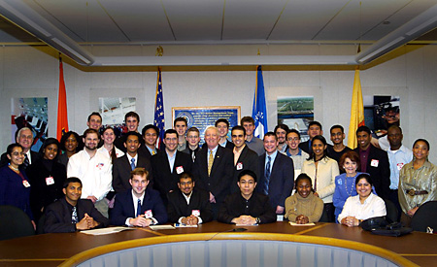
NJIT Students, with Center Director Dr. Wilson Felder, Kaye Jackson and Ginger Cairnes of the Congressional Liaison Staff, along with NJIT Professors Paul Dine and Lois Hulin
The mission of the Albert Dorman Honors College is to “Offer excellent students a superior academic program, hands-on research activities and projects, and meet with specialists at major corporations in their respective fields in order to prepare them to be leaders in their fields,” and help them achieve their full potential. Courses offered are in all majors offered at NJIT, but are specially designed to meet the minds of the students enrolled in honors school.
From the moment the students arrived their interest never wavered. They had the opportunity to visit labs, experience hands-on demos, and attend a lunchtime panel discussion on the Tech Center’s Role in aviation and opportunities for students. Later they were briefed on some of the latest information regarding the Airport Technology Branch’s current research and their Aircraft Rescue and Fire Fighting (ARFF) Program, especially as it relates to the New Large Aircraft (NLA).
A special thanks goes out the following presenters and their staffs for helping make an extremely memorable visit and creating challenges for the future: Flying Laboratories, Armando Gaetano; Standard Terminal Automation Replacement Systems (STARS) Lab, Ed Gaguski; Enhanced Traffic Management System (ETMS), John Hensyl; Automated Dependent Surveillance – Broadcast (ADS-B) System, Mike McNeil; Lunch Panel Discussion, Facilitator, Janet Kinsell; Panelists, Nelson Miller, Fred Snyder, Rodney Guishard, Steve Salvati, and Pat Watts; Fire Safety, Dave Blake; R & D Airport Technology and Aircraft Safety, Jim Patterson and Murphy Flynn.
The students proved Skinner’s quote that education goes beyond the books. Their quest for knowledge, their questions and intensity merely skimmed the surface of what their characters will show in the not too distant future.
Women’s History Month - Sea Isle School Honors Outstanding Women
By Mary Lou Dordan
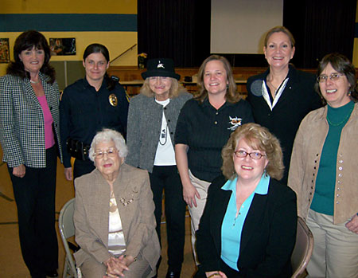
Shown after the program are the guests of honor and their areas of expertise: (Seated) Dr. Mary Caruso, education; Ellen Byrne, attorney; (Standing) Linda Layton, tourism/hospitality; Misty Kingsland, law enforcement; Dr. Irene Jameson, public relations; Martha Parish, flight inspector pilot, FAA; Mary Tumolo, fashion; Suzanne Spinic, air traffic control specialist, FAA. Not shown: Angela Bacher, science; Patricia Bourgeau, author; Joan Barron, NCIS.
The Sea Isle City Public School celebrated Women's History Month this year with an outstanding program held for their students in grades 3 - 8 on March 30. Local women, who had achieved great success in various careers, described their professions to the students, gave advice about job interviews, and stressed the importance of volunteerism to "get your foot in the door." Each speaker encouraged the students to find their "passion" and not to let anything or anyone stand in their way of achieving their goals. Another key message each speaker stressed was the importance of getting a good education. Aviation Education & Outreach Program Manager, Mary Lou Dordan, coordinated FAA's participation in this event that included two outstanding speakers from the Technical Center . Martha Parish and Sue Spincic were the most popular speakers of the day with their exciting comments about how aviation impacted their lives. The Q & A session from the students at the conclusion of the presentations was mostly focused upon aviation-related questions.
New Jersey Department of Transportation’s Division of Aeronautics Visits the Technical Center
By Ginger Cairnes
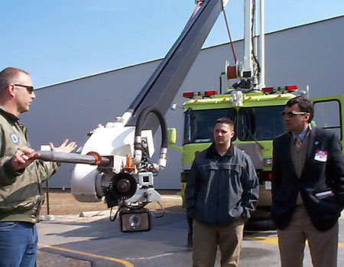
Keith Bagot shows the ‘snozzle’ feature of the HPRV
The New Jersey Department of Transportation (NJDOT) has the responsibility to promote aviation safety statewide and help “foster the development of an efficient transportation system” to meet the needs of its users. Within the NJDOT, the Division of Aeronautics oversees 48 public-use airports and 362 heliports.
The State Legislature had originally created the State Department of Aviation, the State Aviation Commission and the Office of the State Director of Aviation in 1931 due to the increasing popularity of the airplane in New Jersey . The Division of Aeronautics joined NJDOT in 1966 when the Highway Department officially became the Department of Transportation. The Bureau of Licensing and Aircraft Operations within the division employs 4 Aeronautical Operations Specialists and 1 Chief. Although these employees wear many hats their primary tasks are conducting safety inspections of airports and heliports, and accident investigation.
Because of their area of responsibility, they paid a visit to the Technical Center in order to increase their personal knowledge, and to see first hand what developments in safety they can look forward to seeing in the future. Their focus was on Airport and Aircraft Safety R & D Programs.
Attending from the Division of Aeronautics were: John Kaiser, Engineer, Division of Aeronautics; Robert Draper, Aeronautical Operations Specialist; Gerard Leipfinger, Aeronautical Operations Specialist; Ronald Harbist, Aeronautical Operations Specialist; and Bart Ritorto, Aeronautical Operations Specialist – all of whom except Mr. Kaiser are pilots. Also in Attendance from the Department of Homeland Security, was Lou Illiano, Aviation Security Safety Inspector, Newark, NJ.
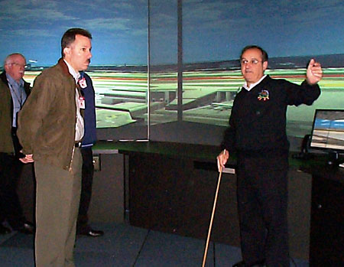
The NJDOT group visits the AFTIL lab with John Pallante
Among the labs that “wowed” the visitors was the Airport Facilities Terminal Integration Laboratory (AFTIL). This facility provides vital information on both tower siting in its structures lab, as well as a 360-degree tower view that displays a realistic Air Traffic Control Tower environment in order to study safety procedures such as visibility for the controller and possible runway incursions. John Wilks, John Pallante, and Rodger Bawgus brought the group into several towers to illustrate the capabilities and realism of the program.
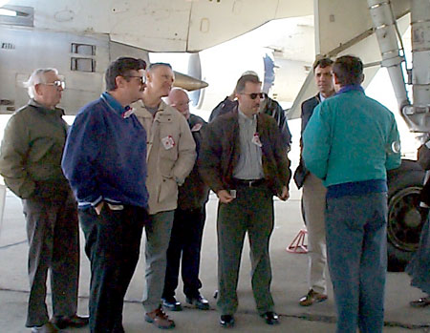
Bill Cavage explains the fuel inerting process
In spite of heavy winds that day out on the aircraft ramp, Bill Cavage’s presentation on the Boeing 747SP Ground Test Article proved to be time well spent. This aircraft was decommissioned from service and acquired from Boeing by the FAA for use to develop and test Ground Based Inerting (GBI) systems as well as to investigate fuel vapor flammability in heated center wing tanks. It will also be used in other safety efforts.
As part of an agency goal to reduce the number of fatal aircraft accidents by 80% in 2007, the FAA developed the FAA’s Aging Transport Non-structural Systems Plan, which calls for research into the effects of aging on electrical and mechanical systems. Among the areas being researched under this program is safe operation of aircraft electric systems. Mike Walz and Caesar Gomez demonstrated some of the research being done with circuit breakers, arcing on a “line” and other types of electrical faults.
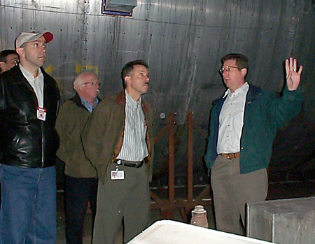
Dave Blake provides a tour of the Full Scale Fire Test Facility
The Technical Center can proudly boast about its Full-Scale Fire Test Facility. It is the largest U.S. Government operated facility of its kind, where both post-crash and in-flight fires are being studied. Dave Blake, who is called in by the NTSB to assist on many of its investigations discussed work currently being done in this building such as fuel inerting, burn-through resistance, and studies in preparation for the new large bodied A380 aircraft. He also discussed the Fire Safety Branch’s role in investigations.
To further explain burn-through resistance and the Fire Resistant Materials Program, Nelson Miller took the group into one of the labs currently doing tests on the development of new fire safe materials for use on commercial aircraft. One of the goals of the Fire Resistant Materials Program is to eliminate use of hazardous materials and improve current materials in the next 10 to15 years that can cause death in aircraft accidents.
Satish Agrawal welcomed the group and gave a brief overview of the many programs under his Airport Technology R & D Branch. The recent arrival of the Airbus A380 and the FAA Airport Technology R & D Branch’s Operation of New Large Aircraft (NLA) Program is of great relevance and presents challenges to rescue personnel – not only because of the size of the aircraft, the number of passengers (873 passengers and crew) it will be carrying, the high upper passenger deck, but also because of the composite materials from which it is constructed.
In conjunction with the Operation of NLA Research Program, Keith Bagot (image at the top of the page) of the Aircraft Rescue and Firefighting (ARFF) Research Program demonstrated the FAA’s High Performance Research Vehicle (HPRV) with its 50 ft. high reach extendible turret (HRET) and skin-penetrating nozzle, along with several other new technologies that are on airport firefighting vehicles. Several members of the group got a chance to climb in the driver’s seat of the HPRV to experience some of the vehicle’s controls and features.
Nick Subbotin gave a presentation on the many new challenges that the FAA is currently researching with the operation of NLA. The FAA will conduct testing on many of these firefighting challenges at the NLA Fire Test Site at Tyndall Air Force Base in Panama City, FL where the FAA has constructed a 60 ft. section steel mock-up of a second level aircraft including the leading edge of a wing and first inboard engine nacelle. The mock-up is located inside a 100 ft. diameter fire pit where live fire testing and other NLA related research tasks can be completed. Other tasks include the evaluation of a 65 ft. HRET for reaching second level aircraft, developing new firefighting strategies unique to second level aircraft, and evaluating access so that airport firefighters can assist during passenger evacuations, extinguish interior fire, and rescue passengers.
Research in Air Traffic Management and in most of the Airport and Aircraft Technology Branches is interrelated as we work toward not only the NLA, but also toward the future safety of both airports and aircraft – which was in keeping with the purpose of this visit by the NJ Division of Aeronautics, and the Homeland Security Inspector.
New Jersey Youth ChalleNGe Academy visits the Technical Center
By Ginger Cairnes
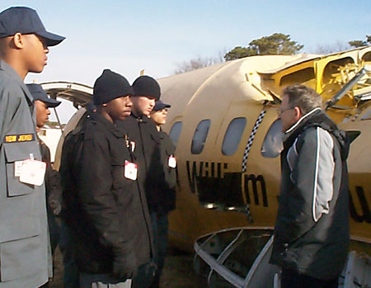
Allan Abramowitz explains the drop test process
Today’s youth are faced with many challenges; among them are trying to complete a High School education, and possibly plan to continue on to some form of higher education. Standard public school systems are not always the answer. Lifestyles, problems at home, and outside influences often stand in the way of a student being able to achieve that which he or she is really capable. Frustration often leads to dropping out of school, and the student can easily further slip away with few, if any, goals.
There are alternatives – not necessarily a “normal alternative school”, but other institutions that provide not only courses of study, but also other knowledge leading toward success and a good self-image.
An example is the New Jersey Youth ChalleNGe Academy, whose mission is to “provide a highly disciplined environment fostering academics, leadership development, physical training and personal growth to educate and train unemployed youth who have ceased to attend high school” – for whatever reason.
This voluntary program, in a military type setting, run by the New Jersey Air National Guard and the State of New Jersey is designed to “develop well-educated, well-rounded and productive citizens.” Studies include: Math, Science, Reading, English, History, Writing Skills, Computer courses, and Life Coping Skills. In addition to the standard studies there is a focus on life style changes, community service, self-discipline, and self-esteem. Students must be drug and alcohol free, officially withdrawn from High School and have no pending “legal involvements.”
The program has three phases. The Pre-ChalleNGe Residential Phase, the ChalleNGe Residential Phase, and the ChalleNGe Post Residential Phase.
The two-week Pre-ChalleNGe Residential Phase is probationary and teaches conduct, teamwork, leadership skills, health and hygiene, physical fitness and assesses the potential for successfully completing the program. After this phase the applicant will be considered a “cadet.” The Pre-ChalleNGe Residential Phase lasts five months during which the student also becomes part of a mentoring program. Once passing a GED and successfully passing the life skill/discipline components the student will receive a NJ State High School Diploma. During the ChalleNGe Post Residential Phase students work together with their mentors to “sustain their life style changes” and increase the chances for continued success.
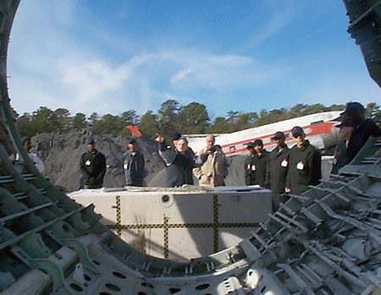
The Cadets get a view through a 10-foot section of a B737 fuselage used for testing in the late 90s
After being contacted by Colonel Kenneth Prossick (RET) of the Academy, Al Jefferson called upon Ginger Cairnes to provide tours and possibly a workshop for the students.
Jim Patterson and Nick Subbotin from the Airport Technology R & D Branch welcomed the group in the auditorium at which time presentations were also made on the Aircraft Rescue and Firefighting (ARFF) Program, airport lighting, and the New Large Aircraft. After this presentation students traveled to the R & D area where Keith Bagot provided a demonstration of the ARFF’s High Performance Research Vehicle. Also while visiting the R & D area, Allan Abramowitz explained the Crashworthiness Program and showed results from previous Drop Tests.
Air Traffic Control (ATC) also peeked the students’ interest. They were able to actually sit at the Standard Terminal Automation Replacement Systems (STARS) displays, feel the experience of “controlling traffic” and handing-off aircraft.” Assisting the students were: Ed Gaguski, Madurai Vaidyanathan, JT Skarda, Dave Cognata, John Lawson, Sue Kleva, Lee Wong, Allan Manalang, Dave Pagan, and Ernie Heinz. In addition, they had the opportunity to go up into the mock ATC Tower located in the STARS lab area.
As part of the Aviation and Space Education Programs the FAA and NASA have the SMART SKIES interactive program, a tool in which five ATC problems challenge students to safely separate two planes. ATC terminology is introduced and math, reasoning, and computer skills are called to task in “real-life” situations. Mary Lou Dordan directed the students at this workshop.
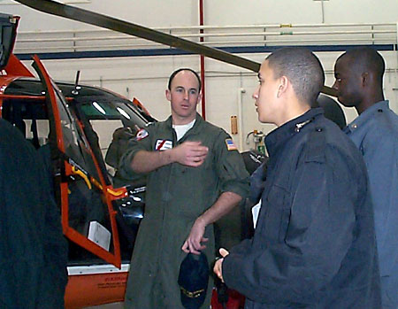
A Coast Guard pilot explains search and rescue techniques
The final event for the day was a trip to the United States Coast Guard (USCG) Ground Air Station located at the Tech Center. The demos and presentations by LTZachary Mathews and staff gave the group the opportunity to learn about the USCG program, climb into the choppers, and see a “search, drop, and rescue” demo. While visiting this building an actual live rescue “call” was sounded.
The pace of the day did not seem to affect the students. Not only was the discipline they receive evident, but the group also displayed a tremendous amount of enthusiasm for everything they saw taking place at the Technical Center.
Technical Center Hosts Annual Meeting for the Mid-Atlantic Institute for Simulation and Analysis
By Tammy J. Lusk, Esq.

On March 29, 2007, Deborah Germak, Program Manager, FAA Technology Transfer Program hosted the Mid-Atlantic Institute for Simulation and Analysis (MAISA) Annual Meeting at the Technical Center. Dr. Wilson Felder, Director of the Technical Center welcomed the attendees. John Wiley, Managing Director of FAA Integrated Engineering Services gave an overview of the Technical Center. Dr. John Lacontora, from Boeing/MAISA is the group’s leader. Dr. Peter Kincaid from the University of Central Florida discussed “Trends in Modeling and Simulation.” Guy Higgens, Vice President at Boeing Company discussed “Modeling and Simulation at Boeing.” After lunch, panel discussions were held on “The Growing Importance of Modeling, Simulation & Analysis and its Impact on the Future of Aviation” and “The Aviation Research and Technology Park.”
The Institute’s initial focus is on Modeling, Simulation and Analysis (MS&A) for Unmanned Aerial Vehicles. They provide educational opportunities, research and development capabilities, and professional services to meet regional and national requirements. It is also established to foster regional economic development where appropriate.
The MAISA creates a vehicle that brings regional organizations (government, industry and academia) together to enable the growth and maturity of a national MS&A capability. The mission of MAISA is to promote economic and cultural development by extending MS&A literacy, research, resources, and application knowledge. Their goal is to develop and sustain a regional MS&A institute with the capability to link and support MS&A professionals throughout the region, to create an MS&A institute with the capability to link and support MS&A professionals throughout the region, to create an MS&A virtual knowledge center, to leverage and provide national MS&A resources to organizations that are in need that would not otherwise have the resources available to them, to promote MS&A educational programs at all levels of education (K-PhD.), provide training and professional development opportunities, and to provide an outlet for technology transfer.
Organizing members of the group include; SMART (Strengthening the Mid-Atlantic Region for Tomorrow), FAA, U.S. Army, U.S. Navy, Carnegie Mellon University, Drexel University, New Jersey Institute of Technology, Richard Stockton College, University of Pennsylvania, Breakaway Ltd, Environmental Tectonics Corporation, The Boeing Company, CACI, and NAVMAR.
Center Passes Environmental Management System Audit
By Greg Falzetta

During the week of March 26, the Technical Center underwent an International Organization for Standardization (ISO) 14001 registration audit for its Environmental Management System (EMS). The Center successfully passed this rigorous five-day evaluation and is on its way to becoming EMS Certified. There are several different forms of EMS, but the most widely used and accepted is the ISO 14001 format.
The Center started its EMS implementation process in December 2002 as a result of Executive Order 13148, “Greening the Government through Environmental Management.” The Center was one of two pilot EMS projects in the FAA and is the first FAA facility or organization to achieve third party EMS certification.
Some may not be aware of what EMS is and why we are pursuing certification. An Environmental Management System is a process designed to enable an organization to integrate environmental decision-making into its everyday business process. The result being that our products, services, and operations follow established environmental principles to avoid harmful human exposure, conserve energy and resources, and minimize the use of ecologically detrimental materials. In practical terms what this means to you is that we take a proactive approach to recycle our trash, dispose of our chemicals, conserve energy, and preserve our facilities and natural resources. An easy way to remember the Center’s goals under EMS is CONSERVE, COMPLY, PREVENT (CCP).
It’s important to understand that EMS certification is a continuous process with internal and surveillance audits required several times pert year. Everyone’s involvement is needed to insure that our EMS Processes are working. All employees are encouraged to learn what they can do to make the Center’s work environment a healthy and safe one. For more information, visit the Earth Day exhibit in the Building 300 Atrium the week of April 16, visit the Centers EMS website at http://environmental.act.faa.gov/ems or contact Greg Falzetta, EMS Coordinator at 485-5787.
José Benítez Bids Farewell to the Technical Center
By De Anne C. Adams-Jefferson
By the time this article goes to publication, Hispanic Employment Program Manager, José E. Benítez, will no longer be an employee of the Technical Center. José accepted a promotional position as a Senior Contract Specialist at the U.S. Customs and Border Protection Office in Washington, DC. He leaves behind a long and accomplished career with the FAA.
José started his FAA employment in 1983 at the Technical Center as a Contract Specialist for the Acquisition Materiel Division. His contracting talents grew over the years, as he became one of the key Contract Specialists at the Technical Center. He was selected as Manager for the Contracts Pre-Award Section in 1999 and continued to perform these duties through 2002. The pinnacle of his FAA career was his appointment as the Acting Manager for the OT&A Acquisition Group in February 2002, and he performed those duties through July 2003. With 23 years as a Contract Specialist, he was both highly valued and revered throughout the FAA.
His good work also extended beyond his responsibilities as a Contract Specialist. This was evident through his volunteer activities. He joined the National Hispanic Coalition of Federal Aviation Employees (NHCFAE) in 1984. He became an EEO Counselor in 1986, and performed this duty through February 2007. While in this role, he successfully worked many diverse EEO cases for both the Technical Center and the Eastern Region. He also acted in a collateral duty assignment for the Office of Civil Rights as Hispanic Employment Program Manager from 1987 through 1989, and again from 2004 through 2007. Similarly, he performed the duties of Grievance Examiner, another collateral duty assignment, from 1990 through 1992. Also, in 1992, he was selected as the Chairperson for the Technical Center’s America’s Quincentennial Committee.
José was appointed as the Administrative Officer for the newly formed National Hispanic Coalition of Federal Aviation Employees (NHCFAE) Technical Center Chapter in 1990 and served in that capacity until 1992, when he was elected as the NHCFAE’s Regional Chapter Director. He served in that capacity through 1997. In addition, during José’s tenure as Technical Center Chapter Director, the chapter hosted the NHCFAE’s National Training Conference held in Atlantic City in August 1996. The Technical Center Chapter was awarded the Chapter of the Year Award in 1997. Additionally, he was appointed as the NHCFAE National Director of Education in 1997 and served through 2000. José stayed involved in volunteer activities throughout his FAA career and helped countless Hispanics and others in many ways.
The members of the NHCFAE Technical Center Chapter would like to thank José for his dedication and hard work over the years. He will be missed by all of us.
Thank you, José! Good luck in your new endeavors and may God bless and watch over you and your family.
Technical Center Training – Enhancing our Technical Stature
By Roxy Mays
The Technical Center is continuing to realize its vision of being a world leader in aviation technology. A component of this stature is a well-trained workforce. Under the Air Traffic Organization’s “organizational excellence” goal, the Technical Center is pursuing a workforce development initiative to ensure our professional and support staff under the Vice President for Operations Planning (ATO-P) maintains currency and competency in basic skills and develop new ones as demanded by emerging technology and operating practices.
Various Center employees have conducted needs assessments, researched sources and costs to fulfill the needs, and requested and obtained supplemental funding to implement educational and training activities to achieve the workforce development initiative. To make employees aware of and available to participate in the scheduled activities, the Organizational Excellence Group and the Acquisition Workforce Council have jointly prepared and will update and publish the “ATO-P Technical Center Training Calendar” on a frequent basis.
Employees should discuss their interest in attending any of the published educational and training events with their manager and coordinate with their respective training coordinator when official calls for enrollment/participants are issued.
The following courses have been scheduled:
Contract Management for CORs/COTRs (Slots Allocated – 30 Participants)
Three-Day Course on May 22, 23 and 24, 2007 Time: 0830 – 1600 (4:00 pm)
Location: HR Training Room
Throughout the course, attendees will learn to apply core responsibilities and how they apply to contract management; identify key requirements and clauses under FAA AMS that affect technical reviews and inputs; take appropriate action to develop a sound and ethical business relationship with the contractor; plan for quality and schedule assurance of the contractor’s performance; identify common areas of direction authority and practical steps and safeguards for issuing directions; distinguish between their authority to technically direct the contractor’s performance versus the need to work through the Contracting Officer; Identify areas of assistance and input to placing task orders, modifying or terminating contracts, and reviewing contractor requests for equitable adjustment; and know how to perform invoice review on fixed price and cost type contracts.
Target Audience: AJP 7000 Federal Employees Assigned as COTR or Alternate COTR Currently Working on Active Contracts and Have Not Received Training
POC: Roxie.Mays@faa.gov or ext 4206

Key Ingredients of System Engineering Course (Details in Progress)
Two Day Course in June 2007 0800 - 1630
Location: CVA Conference Room
The course provides an overview of the system engineering process as defined by the FAA System Engineering Council; defines each of the basic elements in the system engineering process; describes how system engineering fits into AMS; and applies consistent methodology and tools for using system engineering principles across a system’s Life cycle.
Target Audience: ATO Federal Employees
POC: Roxie.Mays@faa.gov or ext 4206

Intro to FAA Risk Management Course (Details in Progress)
Two Day Course in June 2007 0800 - 1630
Location: CVA Conference Room
The course provides detailed step-by-step training of the risk management process. This training takes a participant through the entire process, both as a practitioner and as management. The participant will learn how to create the work products that are generated from the risk management process, which products are to be delivered and how they are to be used for decision making (especially AMS investment decisions and OMB Exhibit 300).
Target Audience: ATO Federal Employees
POC: Roxie.Mays@faa.gov or ext 4206

