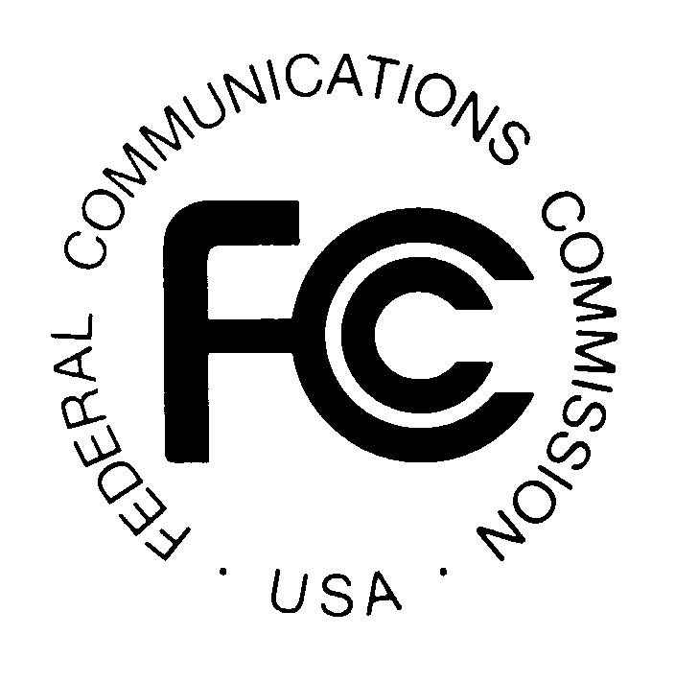PUBLIC NOTICE

News media information 202 / 418-0500
Fax-On-Demand 202 / 418-2830
TTY 202 / 418-2555
Internet: http://www.fcc.gov
ftp.fcc.gov

Federal Communications Commission
445 12th St., S.W.
Washington, D.C. 20554

REPORT NO: 0230 SPECIAL RELIEF AND SHOW CAUSE PETITIONS November 5, 2007

Portions of this Public Notice have been produced by the Media Bureau’s computer-based Data Management systems.
This Public Notice is intended to list only special relief requests, petitions for order to show cause and related petitions for reconsideration
or applications for review. CSR (cable special relief) petitions and CSC (cable show cause) petitions refer to cable-related matters pursuant
to Part 76. The newly-designated BSR (broadcast special relief) petitions refer to certain non-application-related broadcast matters pursuant
to Part 73.

Parties seeking special relief pursuant to Part 76 are advised that such requests must be initiated through the special relief provisions of
Section 76.7 of the Rules. Many of these filings are subject to the pleading cycle rules set forth in Section 76.7, while others have their
own pleading cycle relative to the particular rule involved. For BSR petitions filed pursuant to Part 73, the pleading cycle
will be the same as that mandated by Section 76.7 unless stated otherwise.

Please note that petitions for reconsideration and applications for review are listed for informational purposes only. The applicable pleading cycles for these types of petitions are found in Sections 1.106 and 1.115 of the Commission’s rules, respectively.

Files containing these petitions can be reviewed in the Commissions Reference Information Center, CY-Level, 445 12th Street, SW Washington, DC 20554. The letter code following a CSR Number refers to the particular subject of the petition. Those currently in use are: A – ADI/DMA; M – must carry; E – effective competition; C – retransmission consent; P – program access; R – rate regulation; F – rate freeze; L – commercial leased access;
Z – technical; S – significantly viewed; N – nonduplication/syndicated exclusivity/sports deletion; D – small system definition; O – otard; and X – cross ownership. If no letter appears after the CSR number, the petition is considered to be in the miscellaneous category. CSC and BSR petitions do not
have letter code designations.

It is requested that all responses or statements refer to the file number assigned to the petition.

For further information about this Public Notice contact the Media Bureau at (202) 418-7200

REPORT NO: 0 230 SPECIAL RELIEF AND SHOW CAUSE PETITIONS November 5, 2007

CSR Number Petitioner Respondent Special Relief Request Communities Code

CSR-7625-Z* Millennium Digital Media Systems, LLC Chesterfield, MO No Code

CSR-7626-E Comcast Cable Communications, LLC Bensalem, Lower Southampton, No Code
Hulmeville, PA et al

CSR-7627-E Comcast Cable Communications, LLC Hatfield Township No Code
and Hatfield Borough, PA

CSR-7628-E Comcast Cable Communications, LLC Ambler, Lansdale, Horsham, PA et al No Code

CSR-7629-E Comcast Cable Communications, LLC East Goshen, Easttown, No Code
Birmingham, PA et al

CSR-7630-E Comcast Cable Communications, LLC Charlestown, East Hoshen, Westtown No Code
and Pocopson, PA

CSR-7631-E Comcast Cable Communications, LLC Lower Moreland & Upper Moreland, PA No Code

CSR-7632-E Comcast Cable Communications, LLC Lower Gwynedd, PA No Code

CSR-7633-E Comcast Cable Communications, LLC Radnor, PA No Code
CSR-7634-E Comcast Cable Communications, LLC Whitpain, PA No Code

CSR-7635-E Comcast Cable Communications, LLC Chelsea, Clinton, Dexter, MI et al No Code

CSR-7636-M KVMD Licensee Co., LLC Time Warner Cable Los Angeles, CA No Code

CSR-7637-E Comcast Cable Communications, LLC Ada, Alpine, Byron, MI et al No Code

CSR-7638-E Comcast Cable Communications, LLC Lowell City, Vergennes, & Lowell Township, MI No Code

REPORT NO: 0 230 SPECIAL RELIEF AND SHOW CAUSE PETITIONS November 5, 2007

CSR Number Petitioner Respondent Special Relief Request Communities Code

CSR-7639-E Time Warner Cable San Antonio LP Murrieta, Pomana, & Temecula, CA No Code

CSR-7640-E Time Warner Cable San Antonio LP Blanco, TX No Code

CSR-7641-E Time Warner Cable San Antonio LP Balcones Heights, Bulverde, No Code
China Grove, TX et al

CSR-7642-E CAC Exchange I, LLC d/b/a Time Warner Cable Sierra Madre CA No Code

CSR-7643-E Time Warner Cable LLC San Fernando and South Pasadena, CA No Code
CSR-7644-E CAC Exchange I, LLC d/b/a Time Warner Cable Moreno Valley and Perris, CA No Code
CSR-7645-E CAC Exchange I, LLC d/b/a Time Warner Cable Hemet and San Jacinto, CA No Code
CSR-7646-E Time Warner NY Cable LLC Newport Beach, CA No Code
CSR-7647-E Time Warner Cable San Antonio LP Stockdale and Bandera, TX No Code

REPORT NO: 0 230 SPECIAL RELIEF AND SHOW CAUSE PETITIONS November 5, 2006

CSR Number Applicant Community Type Date Code

CSR-7350-A/ CoxCom, Inc. d/b/a Cox Broadview Heights, Recon/Motion 10/18/07 No Code
CSR-7211-M Communications/Christian Faith Brooklyn Heights, for Stay
Broadcast, Inc. Seven Hill, OH et al.
(WGGN-TV)

**This proceeding will be treated as "permit but disclose" for purposes of the Commission's ex parte rules. See generally 47 C.F.R. §§ 1.1200-1.1216. As a result of the permit-but-disclose status of this proceeding, ex parte presentations will be governed by the procedures set forth in Section 1.1206 of the Commission's rules applicable to non-restricted proceedings. 47 C.F.R. § 1.1206.

-FCC-

