ENHANCING FOREIGN
LANGUAGE PROFICIENCY IN THE UNITED STATES: PRELIMINARY RESULTS OF
THE NATIONAL SECURITY LANGUAGE INITIATIVE
U.S. Department of Education
Margaret Spellings
Secretary

Office of Postsecondary Education
Cheryl A. Oldham
Acting Assistant Secretary

August 2008

This report is in the public domain. Authorization to reproduce it in whole or in part is granted. While permission to reprint this publication is not necessary, the citation should be: U.S. Department of Education, Office of Postsecondary Education, Enhancing Foreign Language Proficiency in the United States: Preliminary Results of the National Security Language Initiative, Washington, D.C., 2008.

To obtain copies of this report,

Visit: http://www.ed.gov/about/inits/ed/competitiveness/nsli/about.html

On request, this publication is available in alternate formats, such as Braille, large print, or computer diskette. For more information contact the Department’s Alternate Format Center 202-260-0852 or 202-260-0818.

Contents
Introduction 5

Active NSLI Programs and Initiatives, by Agency and Pipeline Target 8

U.S. Department of Education Programs 9

Foreign Language Assistance Program 10

Teacher-to-Teacher Initiative 12

Advancing America Through Foreign Language Partnerships 13

U.S. Department of State Programs 14

Intensive Summer Language Institutes 14

Fulbright Critical Language Enhancement Awards for U.S. Students Program 15

Gilman Scholarship for Study Abroad 15

NSLI–Youth 15

Intensive Summer Language Institutes for Teachers 16

Fulbright Foreign Language Teaching Assistants 16

Teachers of Critical Languages Program 16

U.S. Department of Defense Programs 17

The Language Flagship 17

The National Language Service Corps 18

Office of the Director of National Intelligence Program 20

STARTALK 20

Moving Ahead 23

Appendix 1: Map of NSLI Programs, by State: 2007 24

Appendix 2: NSLI Programs, by State: 2007 25

Appendix 3: NSLI Funding, by Agency: FY 2007 and 2008 27

Appendix 4: Contacts and Program Links, by Agency 28

Figures and Tables

Figures
Figure 1. National Security Language Initiative Pipeline 6

Tables
Table 1. Active NSLI Programs and Initiatives, by Agency 8
and Pipeline Target
Table 2. Growth in Critical Language Programs Supported by
FLAP, by Language and Year 11
INTRODUCTION
__________________________________________
Learning a language—somebody else’s language—is a kind
gesture. It’s a gesture of interest. It really is a fundamental way
to reach out to somebody and say, I care about you. I want you
to know that I’m interested not only in how you talk but also in
how you live.
—President George W. Bush

In January 2006, President Bush announced the National Security Language Initiative (NSLI), an inter-agency effort coordinated by the White House to increase dramatically the number of U.S. residents learning, speaking, and teaching critical-need foreign languages. This initiative represents recognition that foreign language skills are essential for engaging foreign governments and peoples, especially in critical world regions, and for promoting understanding, conveying respect for other cultures, and encouraging reform. These skills are also fundamental to the economic competitiveness and security interests of the nation.

The secretaries of state, education, and defense, and the director of national intelligence (DNI) launched this comprehensive and coordinated national initiative. The launch was based on a strategy developed during more than a year of joint advance planning to expand U.S. critical foreign language education beginning in kindergarten and continuing through elementary, secondary, and postsecondary education and into the workforce. NSLI programs target the Arabic, Chinese, Japanese, Korean, and Russian languages and the Indic, Persian, and Turkic language families, as determined by the four agencies.

NSLI represents an extraordinary partnership among four federal agencies under the leadership of the White House. It focuses federal resources and expertise to strengthen critical language capacity across key components of the K–16 pipeline. Ongoing consultation and collaboration among the agencies promotes cohesive and coordinated work, avoids redundancies in programs and funding, and engages a large community of stakeholders. At the same time, the four agencies fulfill their individual missions, leverage their individual and collective strengths, and use models that fit their institutional mandates.
Goals
NSLI is committed to making a long-term investment in the nation’s critical foreign language learning capabilities and competencies by accomplishing the following goals:
- Increase the number of U.S. residents studying critical-need languages and starting them at an earlier age;
- Increase the number of advanced-level speakers of foreign languages, with an emphasis on mastery of critical-need languages; and
- Increase the number of teachers of critical-need languages and providing resources for them.

The NSLI goals and the targeted effort by the four federal agencies to achieve them through investments across the learning continuum, from K–16 through graduate education and professional programs, provide a shared purpose and framework for language education; promote strategic thinking and analysis; and strengthen individual programs and the overall effectiveness of the initiative.

Figure 1.

National Security Language Initiative Pipeline

K-12 programs: The Language Flagship K-12 Programs (DOD), Expanded/Refocused FLAP Programs (ED), NSLI – Youth Study Abroad (State), STARTALK (ODNI). University Programs: Gilman Scholarship for Study Abroad (State), Intensive Summer Language Institutes overseas for beginning and intermediate/advanced study by U.S. students (State), The Language Flagship Undergraduate Programs (DOD). Graduate Programs: Fulbright Critical Language Enhancement Awards for U.S. Students Program (State), Intensive Summer Language Institutes Overseas for beginning and intermediate/advanced study by U.S. students (State), The Language Flagship Graduate Program (DOD). Work/Professional Programs: STARTALK (ODNI), National Language Service Corps (DOD), Teachers of Critical Languages in U.S. primary and secondary school (State), Teacher-To-Teacher Initiative (ED), Intensive Summer Language Institutes for Teachers (State). The graphic below provides a visual depiction of this pipeline.

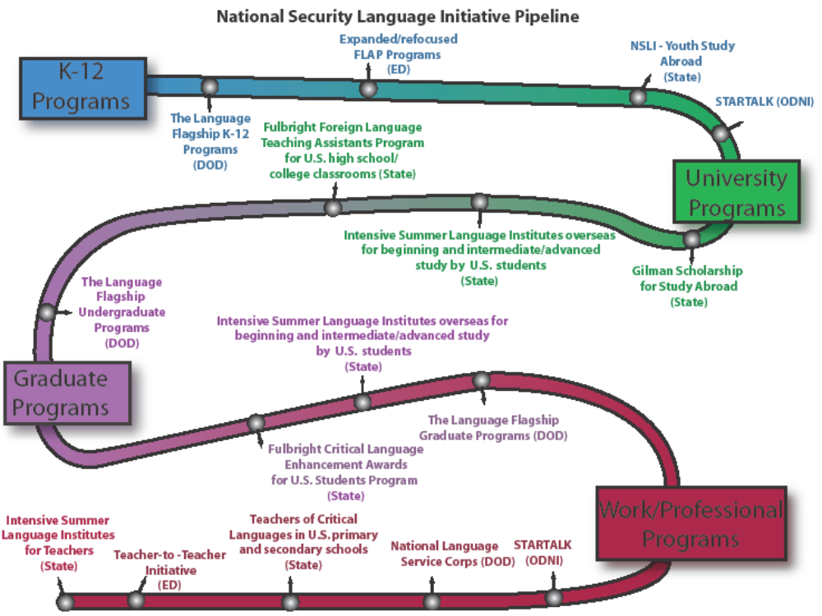

Highlights of Success

Highlights of NSLI’s initial success include the following:

- The Department of State is providing new opportunities for more than 1,000 U.S. high school students, teachers, and undergraduate and graduate students from all 50 states to study critical languages abroad each year. One program, the 2007 Intensive Summer Language Institutes for U.S. university students, received more than 6,000 applications for 363 scholarships to study NSLI languages overseas.
- The Defense Department’s National Security Education Program (NSEP) has increased the number of undergraduate Flagship centers from three to 13 since the first grants were awarded in 2002, including three centers that support K–12 programs involving nearly 3,000 students in 62 elementary, middle, and high schools in the Ohio Public Schools, the Dearborn Public Schools in Michigan, and the Portland Public Schools in Oregon.
- Since 2006, the Department of Education’s Foreign Language Assistance Program (FLAP) has served more than 47,000 students in U.S. school districts, including through first-ever grants for Hindi and Turkish instruction and new grants for Arabic, Chinese, Russian, and Korean.
- The Office of the Director of National Intelligence successfully launched the STARTALK summer language programs in 2007, which have reached 1,322 students and teachers in 21 states and Washington D.C., greatly exceeding program goals.
- A STARTALK grant and Department of Education Teacher-to-Teacher Workshop at DePaul University in June 2007, helped prepare teachers to implement a new K–12 language program supported by a FLAP grant. The university then responded to demonstrated local need by initiating a master of arts in teaching program in Arabic and Chinese language instruction.

The full benefits of NSLI are demonstrated not only by the number of high-quality programs that have been launched or expanded under the president’s leadership, but also by the synergies that have evolved for participants and communities.

There are several early indicators of NSLI’s success in meeting its long-term goals, including enthusiastic feedback and transformative personal stories of student and teacher participants, strong bipartisan support from members of Congress, and initial positive program assessments. The NSLI partners are committed to sustaining this national effort.

What follows is a description of the programs that each agency has developed, implemented, or expanded in support of the NSLI goals. It is important to note that NSLI programs are, in many ways, linked to or built upon a foundation of longer-term government efforts that have supported the advancement of foreign language and international studies for decades. These include, for example, the Fulbright-Hays programs administered by the departments of State and Education, as well as the Title VI International Education and Foreign Language Studies programs, the Fund for the Improvement of Postsecondary Education, and various teacher preparation programs administered by the Department of Education.
__________________________________________
Full participation in this new global economy will require
not just competency in reading, mathematics, and science,
but also proficiency in foreign languages and deep
knowledge of other countries and cultures. Our efforts in
education reform must be harmonized with global realities
if we are to confront successfully a multitude of new and
growing challenges to America’s security and prosperity.

Our education system must be strengthened to produce globally
competent citizens. Foreign language learning needs to begin
in elementary school and continue through higher education.
Elementary and secondary schools as well as universities and
professional schools must instill in all students a more in-depth,
sophisticated, and profound understanding of America’s place
in the world, of issues and cultures of other regions of the
world, and of the international forces that affect their lives and
livelihood.
—Committee for Economic Development

Table 1. Active NSLI Programs and Initiatives, by Agency and Pipeline Target

 |  | Elementary | Middle | High School | Undergraduate | Graduate | Workforce | Teacher and Professional Development
Education | Foreign Language Assistance Program | X | X | X |  |  |  | X
Education | Teacher-to-Teacher |  |  |  |  |  |  | X
State | Intensive Summer Language Institutes |  |  |  | X | X
State | Fulbright Critical Language Enhancement Awards for U.S.  Students Program |  |  |  |  | X
State | Gilman Scholarship for Study Abroad |  |  |  | X
State | NSLI-Youth (includes Summer Language Institutes for High School Students) |  |  | X
State | Intensive Summer Language Institutes for Teachers |  |  |  |  |  |  | X
State | Fulbright Foreign Language Teaching Assistants Program |  |  | X | X | X
State | Teachers of Critical Languages | X | X | X | X |  |  | X
Defense | The Language Flagship | X | X | X | X | X |  | X
Defense | National Language Service Corps |  |  |  |  |  | X
ODNI | STARTALK |  |  | X |  |  |  | X

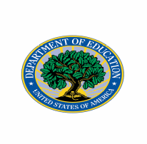
U.S. DEPARTMENT OF EDUCATION PROGRAMS
__________________________________________
The world is changing at a rapid pace and may of our
students lack the skills to succeed in the global knowledge
economy. Our students are facing an education and ambition
gap and they’re on the wrong side. This is not just an education
issue, it’s also an economic issue, a civic issue, a social issue, a
national security issue and it’s everybody’s issue.
— Secretary of Education Margaret Spellings

Update on Activities for the National Security Language Initiative

The key to the long-term success of foreign language education in America is to expand the number and improve the quality of foreign language learning experiences available to students, beginning in elementary school and continuing through graduate education. Toward that end, the Department is working to support improved teacher training and professional development; curriculum development and evaluation; student-faculty mobility and study-abroad opportunities. The Department is also working to engage undergraduate and graduate students in a wide range of academic disciplines—business, education, science, technology, engineering, mathematics—in foreign language and area studies education so that they are better equipped to succeed in the global workplace.

The U.S. Department of Education sponsors a number of programs aimed at improving foreign language and international education. For example, the Department of Education’s Title VI programs have, for decades, been a resource for institutions of higher education to maintain and expand academic departments and resource centers in order to advance foreign language and area studies education. The Fund for the Improvement of Postsecondary Education has provided resources for student-faculty mobility, teacher preparation, and increased collaboration between U.S. institutions of higher education and their international peer institutions. Although those programs continue to serve a broad range of foreign languages and world regions, the Department has emphasized the NSLI critical languages.

In addition to those foundational foreign language and area studies programs are the Department’s funded NSLI programs—the Foreign Language Assistance Program (FLAP) and the Teacher-to-Teacher Initiative—and a recently authorized program, Advancing America through Foreign Language Partnerships.
Two other elements of the Department’s NSLI proposal are the Language Teacher Corps and E-Learning Language Clearinghouse. The Language Teacher Corps would offer those with proficiencies in critical languages the opportunity to teach, with the goal of having 1,000 new foreign language teachers before the end of the decade. The E-Learning Language Clearinghouse would serve as a clearinghouse of foreign language education resources to teachers and students across the country through a central repository of materials and Web-based programs in critical-need languages. The administration requested funding for these purposes in the FY 2009 budget and continues to work with Congress to ensure these programs will be funded in FY 2009.

Foreign Language Assistance Program

Purpose and Description

The Foreign Language Assistance Program (FLAP) is the only federally funded program that exclusively targets foreign language instruction to elementary and secondary schools. Funded under Title V of the Elementary and Secondary Education Act, and as reauthorized by the No Child Left Behind Act (NCLB), FLAP provides three-year grants to local school districts and states to establish, improve, or expand innovative kindergarten through 12th_grade model programs.

The FLAP program was initiated in 1988 with passage of the Foreign Language Assistance Act, directing the secretary of education to make grants to state education agencies for foreign language study in elementary and secondary schools. Under NSLI, the FLAP program has given new priority to instructional programs in the five NSLI languages and three language families. Today, FLAP funds 15 grants to states and 122 grants to local school districts to support a broad range of activities, including classroom instruction, professional development, teacher recruitment, curriculum development, student assessment, program evaluation, and parent involvement.

Grants to local education agencies (LEAs) range from $50,000 to $300,000 each year and support programs that show promise of sustainability and innovative dissemination. Grants to state education agencies (SEAs) range from $50,000 to $400,000 per year and support systemic approaches to improving foreign language instruction. To build capacity at the local and state levels, FLAP grants require a 100–percent match from non-federal sources (although waivers may be granted to local education agencies for part, or all, of the matching requirement).

Consistent with the principle of local flexibility, FLAP permits grantees to choose instructional approaches that best meet local needs and represent a variety of models and approaches, such as foreign language exploratory programs (FLEX), foreign language in the elementary school (FLES), secondary advanced placement coursework, language immersion and two-way immersion programs, content-mastery programs for teachers, and programs to better utilize the skills of heritage language speakers.

Regardless of the instructional approach, FLAP gives special consideration to applicants that address any of the following priorities:

- Creating intensive summer foreign language programs for teachers;
- Linking native language, or heritage, speakers in the community with schools;
- Promoting the sequential study of K–12 foreign language instruction;
- Using technology effectively;
- Promoting innovative activities (i.e. content-based instruction or immersion); and
- Collaborating between state and local education agencies.

Accomplishments in 2006 and 2007

Refocused by NSLI in 2006, FLAP awarded competitive priority points for applicants proposing to provide instruction in critical foreign languages—Arabic, Chinese, Japanese, Korean, Russian, and languages in the Indic, Iranian, and Turkic families.

As a result of the competitive priority, the majority of FLAP LEA grants funded in 2006 and 2007 addressed critical foreign languages (58 of 70 grants in 2006; 31 of 52 grants in 2007). Of those that planned instruction in critical languages, the majority proposed Chinese. Other proposed critical languages included Arabic, Korean, and Russian.

FLAP grants funded in 2006 served 10,866 students during the first year of the program and increased to 24,062 students during their second year of instruction. It should be noted that grantees may use their first year as a planning period. Grants funded in 2007 served 12,600 students in critical language instruction in the first year. In 2007, grants were, for the first time in the history of FLAP, awarded to Hindi and Turkish programs.
_____________________________________________
Our Chinese Immersion Program was made possible by building
upon by the successes of the 3E International Kindergarten in
China and the Michigan School Readiness Program preschool
model at the Lansing School District. By utilizing these two
known and highly successful preschool programs we were able
to create and develop the Chinese Immersion educational model
and thereby prepare students to become educated for global
citizenship. As a result we have been able to develop strong
partnerships with Michigan State University, the Michigan
Department of Education, U.S. Department of Education and the
Lansing School District. The Foreign Language Assistance Program
grant has allowed us to expand the program to meet the needs
of students for the duration of their educational experience with
the Lansing School District.
—Sergio Keck, Lansing School District,
Bilingual, MRSP and FLAP project director, 2007

FLAP Growth in Critical Language Programs

In 2008, the FLAP program was expanded to include district-led partnerships between LEAs and institutions of higher education, thereby recognizing the need for sufficient preparation and professional development to ensure competent K–12 foreign language teachers, and to provide stimulating opportunities for students along the full educational continuum.

Table 2. Growth in Critical Language Programs Supported by FLAP, by Language and Year

Languages* | 2003 | 2006 | 2007**
Arabic | 3 | 4 | 3
Chinese | 9 | 48 | 22
Korean | 2 | 5 | 2
Russian | 3 | 6 | 5
Japanese | 5 | 7 | 8
Hindi |  |  | 1
Turkish |  |  | 1
*Some grantees are serving more than one language.
** 2007 numbers are in addition to continuing 2006 grants.

Teacher-to-Teacher Initiative

Purpose and Description

A key to improving student achievement is access to well-qualified, capable teachers who can help each child maximize his or her potential to meet high academic standards and succeed in school. In 2004, the Department created the Teacher-to-Teacher Initiative (T2T), which supports efforts, designed by teachers for teachers, to provide technical support, professional development opportunities, and recognition of teachers in all content areas and grade levels.

In 2006, the Department added a NSLI component to T2T to provide support for foreign language instruction and professional development opportunities, including summer workshops, conferences, and recognition of teaching excellence.

The Teacher-to-Teacher Initiative seeks to serve the needs of teachers by:
- Providing access to free professional development activities, digital learning opportunities, and updates in areas of vital importance;
- Sharing proven strategies for raising student achievement through the Teacher Training Corps;
- Working with states and school districts to ensure that teachers receive credit for the professional development opportunities in which they participate; and
- Recognizing teachers for their hard work and dedication through the American Stars of Teaching award.

Accomplishments in 2006 and 2007

Specific accomplishments relating to NSLI include:
- Regional Workshops for Foreign Language Training: Four foreign language summer workshops were offered in 2007, including 20 general foreign language learning sessions and seven NSLI-specific sessions;
- Foreign Language Workshops at the 2007 American Council of Teachers of Foreign Language (ACTFL) conference: Teacher-to-Teacher foreign language trainers delivered professional development sessions to roughly 1,500 educators.
- Teacher-to-Teacher Training Corps: Since 2004, 100 teachers have been accepted into this prestigious program, which provides training in adult-learning theory and effective presentation techniques to enable training corps members to serve as valuable facilitators, mentors, and coaches to other teachers. Of the 100 teachers currently in the Training Corps, 21 are experts in foreign language learning.

Advancing America Through Foreign Language Partnerships

Purpose and Description

Authorized in 2007 by the America COMPETES Act (P.L. 110-69), Title VI, Subtitle C, the Advancing America Through Foreign Language Partnerships program is intended to significantly increase the number of U.S. students who achieve the highest level of proficiency in critical foreign languages by providing opportunities to study critical foreign languages and the environments in which those languages are spoken.

If funding is appropriated for this program, it will award grants to institutions of higher education for partnerships with one or more local education agencies. Together, the partnerships will establish articulated programs of study in critical foreign languages to enable students to advance successfully from elementary school through postsecondary education to high levels of proficiency in critical foreign languages. Programs will be designed to train participants to reach “professional working proficiency,” as measured by the Federal Interagency Language Roundtable (ILR) Level 3, or by other generally recognized measures of superior standards. Students trained at this level are capable of reading the most sophisticated texts, understanding formal as well as colloquial and dialectal speech, and speaking with sufficient structural accuracy and vocabulary to participate effectively in most formal and informal conversations on practical, social, and professional topics.

Grants under this program will be competitively awarded for up to five years, of which two years may be used for planning and development. Successful and effective grants may be renewed for up to two additional five-year periods at the discretion of the Department. Grantees will be required to match 20 percent of the amount of the grant in the first year in cash or in-kind. The match requirements will increase by 10 percent each year to 50 percent in each of the fourth and fifth years of the grant.

The Department will also enter into a contract to establish a technical assistance center to assist partnerships in the development and evaluation of critical foreign language instructional materials and assessments and disseminate promising foreign language instructional practices.

The administration requested $24 million for this program for FY 2007, FY 2008 and FY 2009. Although Congress has authorized this program, it has not yet provided appropriations to support its implementation.

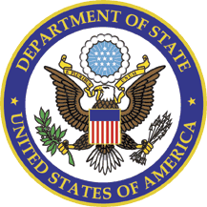

U.S. DEPARTMENT OF STATE PROGRAMS

_________________________________________
We have not as a country made the kind of intellectual
investment that we need to make in the exchange of peoples,
in the exchange of ideas, in languages and in cultures and
our knowledge of them that we made in the Cold War ... The
language initiative that is being announced today, the Critical
Languages Initiative, will give earlier instruction in language
to our children, K through 12. It will encourage students in
university and in graduate school to take on the hard and
critical languages. And it will press forward to bring people into
the Foreign Service and into the Defense Department and into
our intelligence agencies, who are competent in those languages.
—Secretary of State Condoleezza Rice

Update on Activities for the National Security Language Initiative
Purpose

To further the president’s goal under the National Security Language Initiative (NSLI) to dramatically increase the number of U.S. residents learning and teaching critical-need languages, the Department of State is providing new opportunities to more than 1,000 American high school students, teachers, and undergraduate and graduate students in all 50 states to study critical languages abroad each year, and is strengthening foreign language teaching in hundreds of classrooms in the U.S. through exchanges and professional development.

Description and Accomplishments

PROGRAMS FOR U.S. UNDERGRADUATE AND GRADUATE STUDENTS

Intensive Summer Language Institutes

The Department of State is supporting intensive summer language institutes overseas for undergraduate and graduate students in Arabic, Chinese, Indic, Korean, Persian, Russian, and Turkic languages.

Accomplishments
- In the program’s first year in 2006, State received more than 4,000 applications for 167 scholarships to 15 intensive study institutes in seven countries.
- In 2007, State doubled the number of scholarships awarded and received more than 6,000 applications for 363 scholarships to 33 institutes in 13 countries.
- In 2008, State will expand the program again to award more than 500 scholarships for intensive summer study.

Fulbright Critical Language Enhancement Awards for U.S. Students Program

The Department of State, through an enhancement to its Fulbright U.S. Student Program, is providing American graduate Fulbright students the opportunity to undertake intensive study overseas in a critical-need language for up to six months before their regular Fulbright grant begins.

Accomplishments

- In this program’s pilot year in 2006, 40 U.S. students augmented their Arabic, Indic, and Turkic language skills through this award before embarking upon their Fulbright grants.
- In 2007, 145 awards were made for study in Arabic, Chinese, Indic, Korean, Persian, Russian, and Turkic languages.
- State awarded a similar number of scholarships in 2008.

Gilman Scholarships for Study Abroad

The Department of State, through the Benjamin A. Gilman Scholarship Program, is providing scholarships to financially disadvantaged American undergraduate students to pursue study abroad for up to one academic year, with an emphasis on non-traditional destinations.

Accomplishments

- In each of the last two years, State has awarded more than 200 Gilman scholarships to American students for study in critical-need language countries.
- In addition, each year, State awards 25 Gilman students a Critical Need Language Supplement to support additional language study.
- In 2008, State will double to 50 the number of Critical Need Language Supplements awarded.

PROGRAMS FOR U.S. HIGH SCHOOL STUDENTS

NSLI-Youth (includes Summer Language Institutes for High School Students
and Semester and Year Abroad)

The Department of State is providing intensive language study and cultural immersion programs for high school students to study critical languages abroad.

Accomplishments

- In the pilot year in 2006, 46 American students participated.
- In 2007, State nearly tripled the program and 129 students increased their Chinese and Arabic language skills and cultural understanding through six institutes in four countries.
- In 2008, State again expanded the number of participants; developed semester and academic year
exchange programs; and expanded the languages taught to include Arabic, Chinese, Farsi, Hindi,
Korean, Russian, and Turkish.

Programs for U.S. Teachers and K-12 Schools, Colleges, and Universities

Intensive Summer Language Institutes for Teachers

The Department of State is supporting intensive summer language study institutes overseas for American secondary school teachers, teaching degree students, and community college instructors of Chinese, Arabic, and Russian.

Accomplishments

- In its pilot year in 2007, six American teachers studied in China.
- In 2008, State expanded the program to support intensive summer institutes for teachers of Chinese, Arabic, and Russian.

Fulbright Foreign Language Teaching Assistants

The Department of State, through the Fulbright Foreign Language Teaching Assistant Program, is placing native-speaking foreign language teaching assistants in hundreds of U.S. universities, colleges, and high schools for one academic year to serve as language resources to U.S. students.

Accomplishments

- In academic year 2006–07, State funded the placement of more than 200 foreign teaching assistants in critical-need languages in U.S. classrooms.
- In 2007–08, State increased this number to nearly 300 teaching assistants in critical-need languages, while also increasing its overall support for teaching assistants in other important languages.

Teachers of Critical Languages Program

The Department of State, through the Teachers of Critical Languages Program, is bringing native-speaking foreign language teachers to teach critical languages in U.S. K–12 schools for one academic year.

Accomplishments

- Over the past two years, 24 primary and secondary schools have expanded their Chinese and Arabic programs for 4,500 students by hosting native-speaking Chinese and Arabic language teachers under this program.
- In academic year 2008–09, State will increase the size of the program.

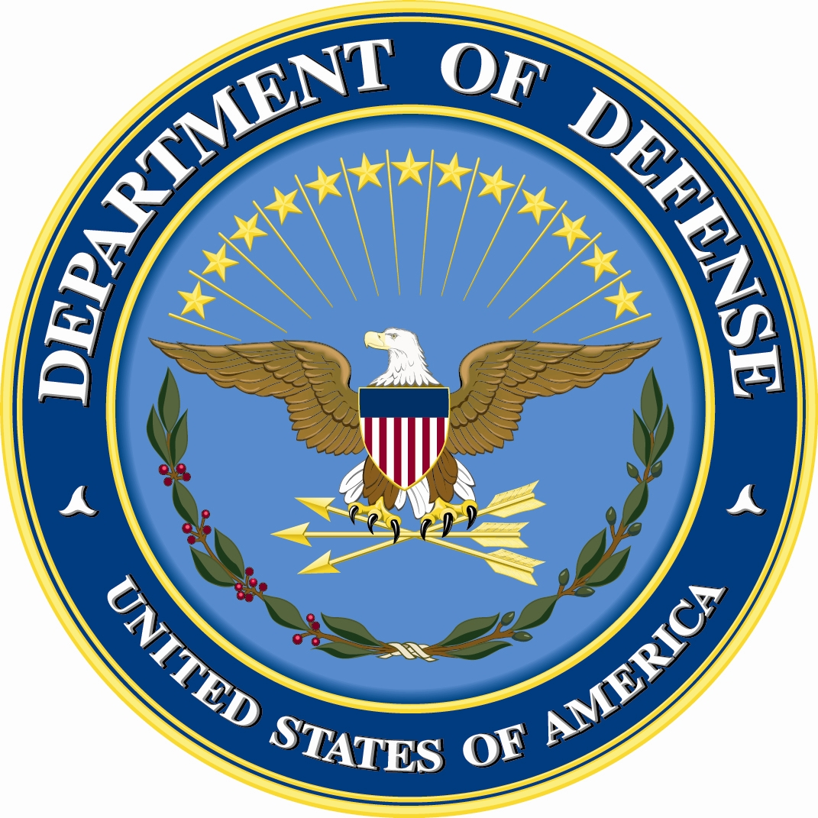

U.S. DEPARTMENT OF DEFENSE PROGRAMS
____________________________________________
The Language Flagship is exactly what the country needs
to integrate ourselves in the global economy and to guarantee
for ourselves a future of peace, security, and prosperity as one
of the nations of a global world.

—David Chu, undersecretary for personnel and
readiness at the U.S. Department of Defense.

Update on Activities for the National Security Language Initiative

The Language Flagship
Purpose and Description

The Language Flagship represents a bold and innovative strategic partnership between the federal government, U.S. education, and business. Motivated by a compelling need for professionals with advanced competencies in critical languages, the Language Flagship is committed to graduating students, at both the undergraduate and graduate level, with unparalleled proficiencies in one of the many languages critical to U.S. competitiveness and security.
The Language Flagship is administered by the National Security Education Program (NSEP) in the U.S. Department of Defense, and is an integral part of the National Security Language Initiative. NSEP has long understood the need for professionals who can conduct high-level work in critical languages. To answer the call for such experts, NSEP formed strategic partnerships with recognized leaders in foreign language education.
Through a combination of innovative and intensive campus curriculum and overseas immersion, The Language Flagship supports K–12 initiatives, and undergraduate and graduate programs. Programs are designed to produce students at the “Superior” proficiency level in the targeted language. The Language Flagship seeks to:
- Establish dedicated administrative structures (e.g., campus centers) for the teaching of critical languages to the Superior (3) level and beyond;
- Develop curricular and instructional models for advanced language learning;
- Identify or establish institutional recruitment mechanisms to broaden the base of eligible students;
- Develop, where appropriate, collaborative arrangements with summer intensive and study abroad programs;
- Establish assessment procedures for measuring superior-level language proficiency; and
- Stimulate institutional support and long-term commitment to “raising the bar” for language learning on campuses to the Superior (3) level.
Flagship language programs are now available in Arabic, Chinese, Central Asian Turkic languages, Hindi/Urdu, Korean, Persian/Farsi, and Eurasian (Russian) languages. Postsecondary programs are open to students matriculated at designated degree-granting institutions.

When the National Security Language Initiative was announced by President Bush on Jan. 5, 2006, the National Security Education Program proposed to:
- Increase the number of programs in Arabic, Chinese, Eurasian languages, Hindi/Urdu, and Persian/Farsi;
- Expand the K–16 pipeline model to three experimental programs; and
- Increase the national reach of Flagship Programs to additional colleges.

Accomplishments in 2006 and 2007

Based on these goals, The Language Flagship has accomplished the following:
- Increased in 2007 the number of undergraduate Flagship Centers from three to 13, including undergraduate programs in Arabic (Michigan State University, University of Texas, University of Maryland); Chinese (Ohio State University, Arizona State University); Eurasian (American Councils, a non-profit for international education); Central Asian Turkic languages (American Councils); Hindi/Urdu (University of Texas-Austin); Korean (University of Hawaii) and Persian/Farsi (University of Maryland). Collectively, these programs have enrolled nearly 250 undergraduate students in their first year alone. The long-term goal is to enroll 2,000 students by the year 2010.
- Expanded the K–16 pipeline model. In addition to the original University of Oregon and Portland Public School K–16 program, added an integrated Language Flagship center in Chinese (Ohio State and Ohio Public Schools) and in Arabic (Michigan State University and Dearborn Public Schools). Collectively, these programs involve 62 elementary, middle, and high schools in the Ohio Public Schools, the Dearborn Public Schools District in Michigan, and the Portland Public Schools in Oregon. Nearly 3,000 students are enrolled in Flagship-funded K–12 programs in all three programs.
- Increased the national reach of the Language Flagship program to additional colleges through the development of new centers and the development of Flagship partners through the 1) creation of a new Diffusion of Innovation grant program, and 2) the support of the development of three state-level Language Roadmaps in Ohio, Oregon, and Texas. These Roadmaps are available on the Language Flagship Web site at www.thelanguageflagship.org.

National Language Service Corps

Purpose and Description

The National Language Service Corps (NLSC), formerly known as the “Civilian Linguist Reserve Corps,” is a public civilian organization composed of volunteers engaged on-call to provide diverse language services across a broad range of local, state, and federal government departments and agencies. The opportunities for service will vary from emergency relief to international crises to immediate national need—wherever language skills are needed.

The NLSC is a pilot program, authorized by Congress in 2006, and represents a vital new approach to addressing the nation’s need for professionals with highly developed language skills. It is an integral component of the Defense Department’s comprehensive language roadmap and of NSLI. Language-capable experts represent a national asset to support the nation’s emergency responders when they must communicate with local populations during times of need. The nation also will draw on paid NLSC members to address homeland and national security requirements as well as international emergency and relief efforts. State and local users also will have the capacity to draw from a common pool of paid NLSC members for temporary and/or part-time assistance. This pilot corps effort is overseen by the National Security Education Program (NSEP) at the Department of Defense.

The pilot corps will include two pools of certified language proficient professionals: a national and a dedicated pool. The national pool will consist of a broader array of talent that will be maintained to be drawn upon during times of need. The dedicated pool will be a smaller, more specialized cadre of individuals who enter relationships with specific organizations and who agree to be available to those organizations should the need arise.

Goals

For its role in NSLI, the National Security Education Program proposed to undertake the following activities:
- Develop and implement a pilot National Language Service Corps program;
- Recruit a minimum of 1,000 members for the National Language Service Corps by 2009;
- Partner with federal organizations to test the language corps concept; and
- Develop legislation to establish a permanent language corps.

Accomplishments in 2006 and 2007

Based on these goals, NSEP has accomplished the following:
- Awarded a competitive contract to General Dynamics Information Technology as the prime contractor to work in close partnership with NSEP to conduct a three-year pilot NLSC program. General Dynamics has assembled a project team composed of nationally recognized experts in language program development, language proficiency certification, program management and administration, and federal human resources.
- Officially launched the NLSC pilot effort in April 2007.
- Completed a concept of operations for the pilot NLSC.
- Completed branding and marketing studies, and an NLSC logo design.


OFFICE OF THE DIRECTOR OF NATIONAL INTELLIGENCE PROGRAM
_________________________________________
We are ecstatic about the prospect of having as many as
30 high school students from Mississippi on our campus this
summer studying intensive Chinese. The STARTALK program
will provide us with a unique opportunity to be innovative and
to enhance what has become a deep curriculum in the study
of Chinese language and culture here at the University of
Mississippi. Very few, if any, states are doing the kinds of things
we are in Chinese language instruction at the high school
and college level, and we are all very proud of that.

—Donald Dyer, chair of the Department of Modern
Languages, University of Mississippi

Update on Activities for the National Security Language Initiative

STARTALK

Purpose and Description

STARTALK is an innovative new program to provide summer language learning experiences for students and professional development for teachers in the full range of languages under the National Security Language Initiative. The purpose of the student programs is to interest students in studying languages critical to national security, and to provide opportunities to enhance school-year programs in communities where those programs are available. The teacher programs are focused on expanding the supply of trained, certified teachers in critical languages, a key NSLI goal.

STARTALK has been developed under the direction of the Office of the Director of National Intelligence (ODNI), in partnership with the National Security Agency (NSA), which serves as executive agent. The National Foreign Language Center (NFLC) at the University of Maryland served as the prime contractor to develop and implement the program in 2006 and 2007.

Goals

The goals of the STARTALK program are:
- To be a national program operating in all 50 states by 2011, with programs in up to 10 languages;

- To increase the quality and supply of teachers of critical languages throughout the nation;
- To stimulate significant increases in the number of students enrolled in the study of critical languages; and
- To improve the quality and effectiveness of critical language curriculum.
Accomplishments in 2006 and 2007
In 2007, STARTALK awarded 34 grants averaging $100,000 each for summer programs serving teachers and high school-age learners of Arabic and Chinese in 21 states and the District of Columbia. Grants were awarded to a diverse group of public and private institutions of higher education, as well as to school districts, community colleges, high schools, camps, and community-based organizations. They enrolled 448 teachers and 874 students, 350 of whom were in Arabic programs and 972 in Chinese programs. Those programs ranged from one week to nine weeks, and included summer camps, classroom learning experiences, resident and non-resident programs, and workshops. This significantly exceeded the original 2007 program goals of 400 students and 400 teachers in five states, with no increase in budget.

In addition to holding programs in 21 states and D.C. and reaching 1,322 participants in 2007, STARTALK laid a robust groundwork for the follow-on years by:
- Establishing a network of programs and educators across the country;
- Beginning a database of research and curricular needs that will continue to grow as STARTALK continues;
- Providing a valuable resource for teachers, students, administrators, parents, and communities;
- Creating STARTALK Advisory Boards of leading language educators from throughout the nation in each language, ensuring a high level of quality for the programs;
- Supporting diversity in enrollment in critical language programs, including inner-city programs in New York, Chicago, Los Angeles, and Seattle, with scholarships provided to ensure access to a wider range of participants;
- Offering intensive courses lasting up to nine weeks in which students earned as much as a full year of college credit;
- Providing teacher professional development programs ranging from short workshops to courses of several weeks duration that enabled participants to earn credits for certification;
- Stimulating valuable spinoffs (for example, DePaul University in Chicago, which sponsored both student and teacher STARTALK programs for the Chicago Public Schools, is now offering master of arts in teaching programs in both Chinese and Arabic to aid the development of fully certified teachers); and
- Multiplying the benefits of hundreds of teachers who participated in the 2007 summer programs, thus bringing newly developed skills to thousands of students during the school year.

After only one year of operation, the STARTALK program has been very favorably reviewed by major professional associations in the language teaching field, such as the American Council on the Teaching of Foreign Languages (ACTFL) and the Chinese Language Teachers Association.

STARTALK is on track in FY08 to expand to at least 30 states, to add programs in new languages, including Hindi, Urdu, and Persian, to expand enrollment at the middle school level, and to increase the number of programs and participants in the original languages of Chinese and Arabic at the high school level. STARTALK will also sponsor a major conference on teacher certification in critical languages and is supporting original research to improve assessment capabilities for students at the novice level. This latter effort should help provide better means to measure student progress for both summer and academic-year programs.
MOVING AHEAD

In Washington D.C., Puerto Rico and every state in the nation, the National Security Language Initiative is providing leadership, opportunities, and incentives to increase the number of Americans learning, speaking, and teaching critical need foreign languages. Thousands of students, teachers, and professionals have already benefited from participation in NSLI programs. Their enthusiasm is sparking interest within their communities and beyond in building on and replicating these programs—thereby helping to leverage the federal investment.

To help meet the increased demand for language opportunities, the NSLI partner agencies are expanding their existing programs to accommodate a greater number of grantees and participants. They are also evaluating initial results and outcomes to gain a more concrete understanding of program efficacy and best practices in foreign language instruction. Building on their program-specific work, the NSLI agencies are exploring other ways to advance and measure foreign language learning, such as enhanced assessments of language proficiency, and additional resources and materials for teachers.

In these ways, NSLI is supporting communities that recognize the critical need to ensure their students are equipped to succeed in the global economy, and encouraging other communities to follow suit. In so doing, NSLI is helping to ensure America’s security and competitiveness—and the partner agencies remain committed to sustaining and strengthening this important national effort.

Appendix 1. Map of NSLI Programs, by State: 2007

This appendix provides a map showing on a state-by-state basis the funded programs in each state. Appendix 2 provides this same information in table form.

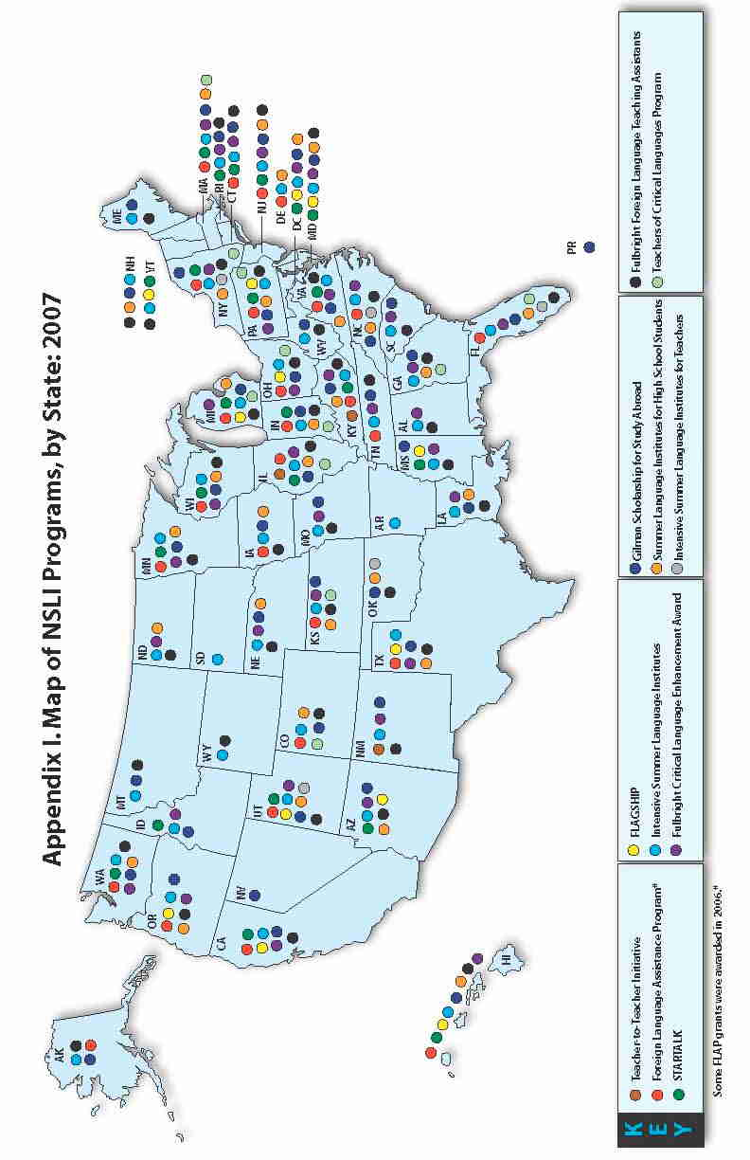
Appendix 2. NSLI Programs, by State: 2007

 |  |  |  |  |  | Residence of U.S. Participants  in Overseas Programs |  |  |  |  | Placement of Foreign Participants  in U.S. Programs
 | T2T | FLAP* | Startalk | Flagship | NLSC | Intensive Summer Language Institutes | Fulbright Critical Language Enhance-ment Award | Gilman Scholar-ship for Study Abroad | Summer Language Institutes for High School Students | Intensive Summer Language Institutes for Teachers | Fulbright Foreign Language Teaching Assistants | Teachers of Critical Languages Program
Alabama |  |  |  |  |  | X | X |  |  |  | X
Alaska |  | X |  |  |  | X |  | X |  |  | X
Arizona |  |  | X | X |  | X | X | X | X |  | X
Arkansas |  |  |  |  |  | X |  |  |  |  | X
California |  | X | X | X |  | X | X | X | X |  | X | X
Colorado |  | X |  |  |  | X |  | X |  |  | X
Connecticut |  | X | X |  |  | X | X | X | X |  | X
D.C. |  |  | X | X |  | X | X | X | X
Delaware |  | X |  |  |  | X |  |  | X
Florida |  | X |  |  |  | X | X | X | X | X | X | X
Georgia |  |  |  |  |  | X | X | X | X |  | X | X
Hawaii |  | X | X | X |  | X | X | X |  |  | X
Idaho |  |  |  |  |  | X | X | X
Illinois | X | X | X |  |  | X | X | X | X |  | X | X
Indiana |  | X | X |  |  | X |  | X | X |  | X | X
Iowa |  | X |  |  |  | X |  | X | X |  | X
Kansas |  | X |  |  |  | X | X | X | X |  | X | X
Kentucky | X | X | X |  |  | X | X | X | X |  | X
Louisiana |  |  |  |  |  | X | X | X | X |  | X
Maine |  |  |  |  |  | X |  | X |  |  | X
Maryland |  |  | X | X |  | X | X | X | X |  | X | X
Massachusetts |  | X | X |  |  | X | X | X | X |  | X | X
Michigan |  | X | X | X |  | X | X | X | X |  | X
Minnesota |  | X | X |  |  | X | X | X | X |  | X
Mississippi |  |  | X | X |  | X | X | X |  |  | X
Missouri |  |  |  |  |  | X | X | X |  |  | X
Montana |  |  |  |  |  | X |  | X |  |  | X
Nebraska |  |  |  |  |  | X | X | X | X |  | X
Nevada |  |  |  |  |  |  |  | X
New Hampshire |  |  |  |  |  | X |  | X | X |  | X
New Jersey |  | X | X |  |  | X | X | X | X |  | X
New Mexico | X |  |  |  |  | X | X | X |  |  | X
New York |  | X | X |  |  | X | X | X | X | X | X | X
North Carolina |  | X |  |  |  | X | X | X | X | X | X
North Dakota |  |  |  |  |  | X | X |  | X |  | X
Ohio |  | X |  | X |  | X | X | X |  |  | X | X
Oklahoma |  |  |  |  |  | X |  | X | X | X | X
Oregon |  | X |  | X |  | X | X | X | X |  | X
Pennsylvania |  | X | X | X |  | X | X | X | X |  | X | X
Rhode Island |  |  | X |  |  | X | X | X |  |  | X
South Carolina |  |  |  |  |  | X | X | X |  |  | X
South Dakota |  |  |  |  |  | X
Tennessee |  | X |  |  |  | X | X | X |  |  | X
Texas |  | X |  | X |  | X | X | X | X |  | X
Utah |  | X | X | X |  | X | X | X | X | X | X
Vermont |  |  | X | X |  | X |  |  |  |  | X
Virginia |  | X | X |  |  | X | X | X | X |  | X
Washington |  | X | X |  |  | X | X | X | X |  | X
West Virginia |  |  |  |  |  | X |  | X |  |  | X
Wisconsin |  | X | X |  |  | X | X | X | X |  | X
Wyoming |  |  |  |  |  | X |  |  |  |  | X
Puerto Rico |  |  |  |  |  |  |  | X
* Some FLAP grants were awarded in 2006
Appendix 3. NSLI Funding by Agency: FY 2007 and 2008

Appendix 3. NSLI Funding, by Agency: FY 2007 and 2008 (in millions of dollars)
Activity |  | FY 07* | FY 07 | FY08 | FY08
 |  | Final Approp. | (Budget Request) | Final Approp. | (Budget Request)
Education | Foreign Language Assistance Program | $24 | ($24) | $26.5 | ($24)
Education | Advancing America Through Foreign Language Partnerships | $0 | ($24) | $0 | ($24)
Education | Language Teacher Corps | $0 | ($5) | $0 | ($5)
Education | E-Learning Language Clearinghouse | $0 | ($1) | $0 | ($1)
Education | Teacher-to-Teacher Initiative | $0 | ($3) | $0 | ($3)
Education | *Or redirected funds
ODNI | STARTALK | $4.9 | ($4.9) | $12 | ($10)
Defense | Expanding K-16 pilot to 3 programs | $3 | ($3) | $3 | ($3)
Defense | Expanding the National Flagship Language Initiative | $11.3 | ($7.2) | $11.2 | ($8.7)
Defense | National Language Corps | $6.5 | ($9) | $6.5 | ($9)
State | Intensive Summer Language Institutes | $6 | ($6) | $9 | ($9)
State | Gilman Scholarships for Study Abroad Enhancement | $1.1 | ($1) | $1.1 | ($1.1)
State | Fulbright Critical Language Enhancement Awards for U.S. Students | $1.5 | ($3) | $1.5 | ($1.5)
State | Fulbright Foreign Language Teaching Assistant Program | $5 | ($5) | $5 | ($5)
State | Teacher Exchange Program | $.9 | ($2.6) | $1.5 | ($1.5)
State | NSLI-Youth | $1.3 | ($1) | $5 | ($5)
State | NSLI-Youth (Semester and Year Abroad Programs) | $0 | ($8) | $3.6 | ($3.6)
 | NSLI Total All programs | $65.5 | (107.7) | $85.9 | ($114.4)

Appendix 4. Contacts and Program Links, by Agency

U.S. Department of Education

Betsi Shays
Betsi.Shays@ed.gov
202-219-7032

Foreign Language Assistance Program:
http://www.ncela.gwu.edu/oela/OELAprograms/4_FLAP.htm

Teacher-to-Teacher Initiative:
http://www.ed.gov/teachers/how/tools/initiative/index.html

U.S. Department of State

Jessica Roberts
Robertsjs2@state.gov
202-453-8111

Intensive Summer Language Institutes:
http://www.clscholarship.org

Fulbright Critical Language Enhancement Awards for U.S. Student Program:
http://us.fulbrightonline.org/thinking_type.html#lang

Gilman Scholarship for Study Abroad:
http://www.iie.org/programs/gilman/index.html

NSLI-Youth (includes Summer Language Institutes for High School Students and Semester and Year Abroad):
http://www.exchanges.state.gov/education/citizens/students/programs/nsli.htm

Intensive Summer Language Institutes for Teachers:
https://apps.americancouncils.org

Fulbright Foreign Language Teaching Assistants:
http://www.flta.fulbrightonline.org/home.html

Teachers of Critical Languages Program:
http://www.americancouncils.org/TCLP/index.php

U.S. Department of Defense

Robert Slater
Slaterr@ndu.edu
703-696-1991

The Language Flagship:
http://www.thelanguageflagship.org

The National Language Service Corps:
http://www.nlscorps.org

Office of the Director of National Intelligence

Hugh McFarlane
Hgmcfar@nsa.gov
443-479-7164

Rusty Shugart
rustyes@dni.gov
703-275-3048

Benjamin Thomas
Benjamlt@dni.gov
703-482-4873

STARTALK:
http://www.nflc.org/projects/current_projects/startalk

