

FY2003 Federal Fleet Report

Dear Reader:

We are pleased to present the Federal Fleet Report for fiscal year 2003. This is the fifth year that the report has been produced through the Federal Automotive Statistical Tool (FAST), an Internet-based system that collects fleet data from Federal agencies to satisfy several distinct reporting requirements for the General Services Administration, the Department of Energy, and the Energy Information Agency.

This year, the report was produced within our target time period of four months after the close of the fiscal year. This is the earliest the Fleet Report has been available since it’s inception in 1950. The improved timeliness of the Report has significantly enhanced its value. We will continue enhancements to the Federal Fleet Report this year that will provide more helpful information, more valuable comparisons, and eliminate duplicate or valueless information.

Copies of this report are available through our Internet website at www.gsa.gov/vehiclepolicy. Please feel free to contact us at vehicle.policy@gsa.gov if you have any questions concerning the report or would like to offer suggestions on its content.

We trust that this year’s report will be of value to you.


Russ Pentz
Director
Federal Vehicle Policy Division

Internet address for the Federal Vehicle Policy Division homepage: http://www.gsa.gov/vehiclepolicy

TABLE OF CONTENTS

Cover Page 1
Table of Contents 2
Introduction 3
Executive Summary – Charts 1A, 1B, 1C 4
Federal Motor Vehicle Fleet Options 7

CHARTS AND FIVE-YEAR TRENDS: FEDERALLY OWNED MOTOR VEHICLES 8
Chart 2 – Worldwide Inventory Changes Since 1998 9
Chart 3 – Worldwide Inventory of Federally Owned and Leased Vehicles By Vehicle Type 10
Chart 4 – Worldwide Inventory of Federally Owned and Commercially Leased Sedans
By Size Classification 11
Chart 5A – Worldwide Inventory of Federally Operated Trucks 12
Chart 5B – Truck Inventory by Agency Type 13
Chart 6 – Worldwide Miles Operated 14
Chart 7A – Average Miles per Vehicle by Vehicle Type 15
Chart 7B – Average Mile Trends by Vehicle Type 16
Chart 8 – Fuel Consumed by Fuel Type Gallon Equivalent 17
Chart 9 – Alternative Fuel Consumed by Fuel Type Gallon Equivalent 18
Chart 10 – Agency Owned and Commercially Leased Worldwide Operating Cost Data By Cost Type 19
Chart 11 – Agency Owned Worldwide Operating Cost Data by Vehicle Type Including Depreciation 20
Chart 12 – Average Cost Per Mile by Vehicle Type – Domestic 21

DETAILED TABLES: FEDERALLY OWNED MOTOR VEHICLES 22
Table 1 – Worldwide Inventory of Federally Owned Motor Vehicles—All Agencies 23
Table 2 – Worldwide Inventory of Federally Owned Motor Vehicles—Foreign and Domestic 24
Table 3A – Worldwide Inventory of Federally Owned and Commercially Leased Sedans—All Agencies 25
Table 3B – Worldwide Inventory of Commercially Leased Sedans—All Agencies 26
Table 4 – Worldwide Miles Operated 27
Table 5 – Worldwide Average Miles Operated 28
Table 6 – Fuel Consumed By Fuel Type Gallon Equivalent 29
Table 7 – Worldwide Operating Cost Data, Including Depreciation—Agency Owned 30
Table 8 – Worldwide Average Cost per Mile 31
Table 9 – GSA Fleet Vehicle Lease Data by Agency 32
Table 10 – GSA Fleet Vehicle Inventory Data by Agency and Vehicle Type 33
Table 11 – Federally Purchased Vehicles 34

CHARTS, TRENDS, AND TABLES: COMMERCIALLY LEASED MOTOR VEHICLES 38
Chart 13 – Commercially Leased Vehicles: Average Number on Hand—All Agencies (Domestic) 39
Chart 14 – Commercially Leased Vehicles: Summary Cost Data (Worldwide) 40
Table 12 – Worldwide Commercially Leased Vehicles—Average Number on Hand 41
Table 13 – Worldwide Commercially Leased Vehicles—Detailed Cost Data 42

SUMMARY INFORMATION: FEDERAL MOTOR VEHICLES 43
Table 14 – Total Worldwide Federal Inventory by Vehicle Type—Federally Owned and
Commercially Leased Motor Vehicles 44
Table 15 – Total Worldwide Federal Inventory by Agency—Federally Owned and
Commercially Leased Motor Vehicles 45
Table 16 – Total Worldwide Federal Inventory and Cost Data by Agency 46

FUEL TABLES AND CHARTS: FUELS USED, ACQUISITIONS, AND CONSUMPTION 48
Chart 15 – Total Vehicle Inventory by Fuel Type 49
Chart 16 – Total Acquisitions by Fuel Type 50
Table 17 – Total Vehicle Inventory by Agency and Fuel Type 51
Table 18 – Total Vehicle Acquisitions by Agency and Fuel Type 52
Table 19 – Fuel Consumed by Gallon Equivalent, Fuel Cost and Fuel Type 53

GLOSSARY 55
FISCAL YEAR 2003 FEDERAL FLEET REPORT

INTRODUCTION

OVERVIEW
Federal departments and agencies and their contractors use motor vehicles to perform their missions. Vehicles are obtained from three primary sources: purchase, commercial lease, and lease from GSA Fleet. This report presents the inventory, utilization, cost, and fuel use associated with this large fleet of vehicles. Data are summarized by civilian, military, and Postal Service; as well as domestic, foreign, and worldwide. Tables of data, charts that display the data graphically, and trends are included as well.

Privately owned vehicles used by employees on official business are not included; neither are short-term commercial rentals (less that 60 days). Special purpose vehicles are also excluded from this Report.

DATA COLLECTION
This report summarizes data reported by Federal agencies in the Federal Automotive Statistical Tool (FAST), an internet-based reporting platform, which replaced the old Standard Form 82, Agency Report of Motor Vehicle Data. It also includes data reported by GSA’s Office of Vehicle Acquisition and Leasing Services, which includes both GSA Fleet and GSA Automotive. GSA Fleet is the component of GSA that manages a fleet of non-tactical vehicles for use by other Federal agencies and their contractors; GSA Automotive is the office that writes vehicle specifications and contracts for the purchase of non-tactical motor vehicles on behalf of all Federal activities.

As in previous editions of this report, fleet data for the General Services Administration is displayed in various ways, depending on the table or chart. In some cases, GSA reports on the vehicles it uses to perform its mission; in other cases GSA data reflect its function as a fleet service provider to other agencies, much like a commercial leasing company. Consequently, entries for GSA sometimes show a fleet of over 175,000 vehicles, with corresponding miles traveled and fuel used; and at other times GSA’s vehicles, miles, and fuel use are distributed among the agencies by which the vehicles are used.

All agencies are required to report vehicle inventory and commercial leasing information. Large fleets (over 2,000 vehicles) are also required to report on cost, mileage, and fuel used; small agencies may report these data voluntarily, in which case they are also included in this report. The determination that a fleet is large or small depends on the management structure within the agency; consequently, a single agency may have multiple fleets, including large, small, or both. In fiscal year 2003 there are 22 large and 28 small fleets represented in this report.

This year, the FAST system started collection of motor vehicle data previously reported under Office of Management and Budget (OMB) Circular A-11, Exhibit 33. Although current inventory and cost data was reported directly to OMB for this reporting period, forecast inventory and cost data was collected through FAST. Starting fall of 2004, all OMB motor vehicle reporting will be accomplished through FAST. This change was mandated to endure that all agency reports of motor vehicle data contain identical data.

DISTRIBUTION
The Federal Fleet Report is available only via the internet. Printed copies are not produced. Members of the Congress, Federal agencies, libraries, private industry, researchers, and others are welcome to view, download, or print the report from the Federal Vehicle Policy Division homepage at http://www.gsa.gov/vehiclepolicy.

Questions and comments concerning this report may be addressed to:

General Services Administration
Office of Governmentwide Policy
Federal Vehicle Policy Division – MTV
1800 F Street, NW, Room G241
Washington, D.C. 20405

or: vehicle.policy@gsa.gov

FY2003 FEDERAL FLEET REPORT

EXECUTIVE SUMMARY

PURPOSE:

This annual report is designed to provide essential statistical data for worldwide Federal motor vehicle fleet operations. Review of the report assists Government agencies in evaluating the effectiveness of the operation and management of their individual fleets in order to determine whether vehicles are being utilized properly and to identify those high cost areas where fleet expenses can be reduced. The report is also used by various segments of private industry in addition to State and local governments.

BACKGROUND:

This report summarizes statistical data on agency-owned, GSA Fleet and commercially-leased vehicles. The data also details each agency’s fleet categorizing their vehicles by civilian, military, postal service and domestic, foreign, and worldwide. This report includes sedans, station wagons, ambulances, buses, and trucks. Additional detail is provided for sedan class and truck subtypes (4x2, 4x4, medium and heavy truck). Charts and graphs present the trend and detailed table data. No data is available for privately-owned vehicles.

The accuracy of data contained in this report improves each year as more and more Federal agencies upgrade their fleet automated systems. Additionally for this year, agencies started reporting data for the Office of Management and Budget on motor vehicles that may not have been included in previous year’s reports. Accordingly, the reported size of the Federal motor vehicle fleet increased by 3.5-percent during fiscal year 2003, which may not reflect an increase in the actual number of vehicles in use by Federal agencies. Similar occurrences may appear in other categories, such as cost or miles traveled. Of continued concern is accurate reporting of alternative fuel consumption because of differences in the coding of these fuels by the fuel providers and credit card merchants. Because of these differences, agencies are not able to accurately report alternative fuel use.

SUMMARY OF DATA:

- Federally operated vehicles totaled 599,851, an increase of 3.51 percent from FY 2002 (Chart 2).

- There were 22 large fleets (over 2,000 vehicles) (Table 16).

- 36 percent of the Federal fleet is used by the Postal Service, 35 percent by civilian agencies, and 29 percent by the military (Chart 1B).

- 69 percent of the Federal fleet is owned by the using agencies, 29 percent is leased from GSA Fleet, and 2 percent is leased commercially (Chart 1C).

- Mileage decreased 4.81 percent, from 5.08 billion to 4.84 billion (Chart 6).

- Gallons of fuel consumed increased 5.05 percent, from 348.1 million to 365.7 million (Chart 8).

- Reported use of alternative fuels decreased 31.27 percent, from 8.828 million gallon-equivalents to 6.067 million (Chart 8).

- Total cost of operation increased 11.44 percent, from $2.34 billion to $2.61 billion (Chart 10).

- Domestic average cost per mile increased 19.03 percent, from $0. 4168 to $0.4961 (Chart 12). Foreign cost per mile increased 33.51 percent, from $0.4440 to $0.5928.

- The number of commercially leased vehicles decreased 0.75 percent, from 11,800 to 11,711 (Chart 2).

- The total worldwide cost of commercial leasing increased 9.05 percent from $64.0 million to $69.8 million (Chart 10).
FY2003 FEDERAL FLEET REPORT

Executive Summary (Continued)

LARGE FLEETS:

Those agencies operating fleets worldwide of over 2,000 vehicles (including GSA Fleet provided, agency-owned, and commercially leased vehicles) are listed below. Large Fleets represent 99% of the entire fleet. Please refer to Table 16 for a complete breakdown.

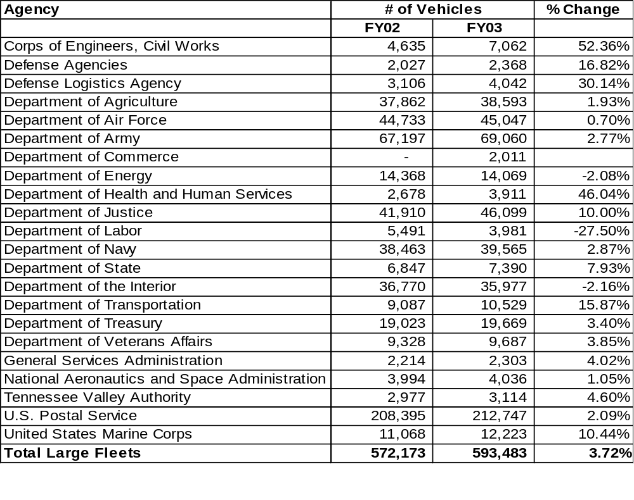
Several agencies are reporting inconsistent data when compared to previous years. This might be due to better or more accurate internal reporting systems, agencies not fully understanding their reporting requirements, or it may be an indication of where agencies need assistance with their fleet. The General Services Administration, Office of Governmentwide Policy intends to meet with agencies during fiscal year 2004 to resolve these issues.

Executive Summary (Continued)
Charts 1A-C

Chart 1A  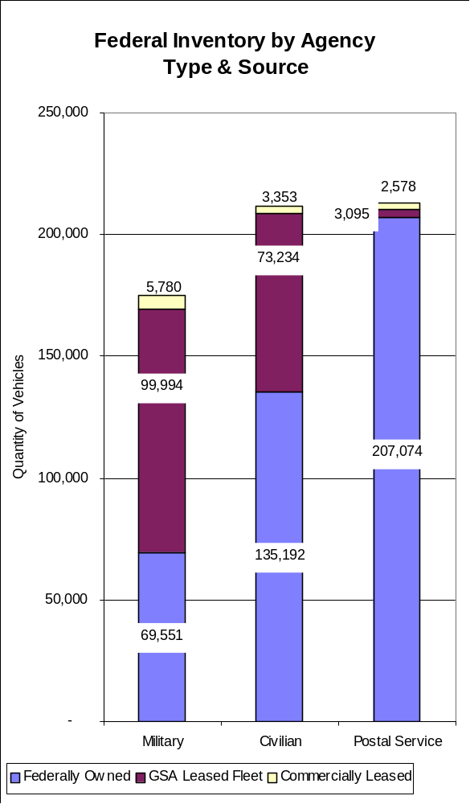 | Chart 1B  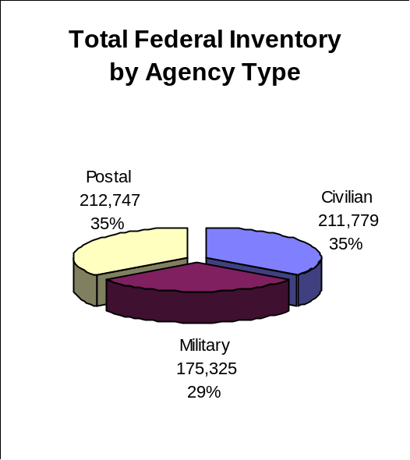
Chart 1C
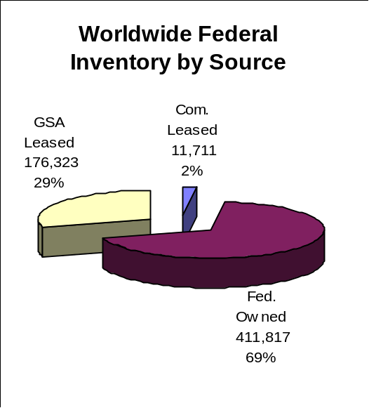

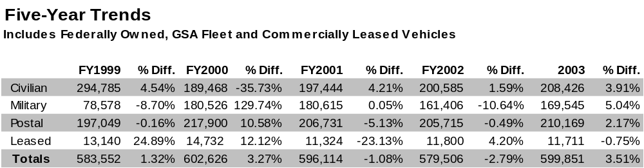
FEDERAL FLEET OPTIONS

GOVERNMENTWIDE FLEET MANAGEMENT SERVICES
The General Services Administration established the Office of Governmentwide Policy, which includes the Federal Vehicle Policy Division, in December 1995. The Division writes the regulations governing fleet operations throughout the Federal government, and provides policy guidance and advice on issues of concern to Federal fleet operators. Publication of this report is one of the services provided by the Division.

For more information, contact:
General Services Administration
Office of Governmentwide Policy
Federal Vehicle Policy Division – MTV
1800 F Street, NW, Room 1241
Washington, D.C. 20405
Or visit the Division’s website at http://www.gsa.gov/vehiclepolicy.

US GOVERNMENT CHARGE CARD PROGRAM
GSA is responsible for administering the U.S. Government Charge Card Program. The program provides an efficient and convenient method of obtaining fuel and services for Federally owned and operated vehicles, including boats and aircraft, as well as powered equipment (lawn mowers, chain saws, etc.), while adhering to all regulations, policies, and statutory requirements. Cards issued under the program are accepted at over 120,000 fueling stations across the country.

More information about the U.S. Government Charge Card Program is available from:
General Services Administration
Federal Supply Service
Support Services Division-FCFX
Washington, D.C. 20406
Or at the website http://www.fss.gsa.gov/services/gsa-smartpay.

VEHICLE LEASING
GSA Fleet is part of GSA’s Office of Vehicle Acquisition and Leasing Services, a component of the Federal Supply Service. GSA Fleet is a centralized source for obtaining fleet vehicles and management services for Federal agencies and authorized contractors. GSA Fleet provides nearly every sort of non-tactical vehicle, from sedans to heavy equipment, including alternative fuel vehicles, at monthly and per-mile rates that cover all elements of cost, including fuel and maintenance. GSA Fleet is a non-mandatory source of supply, and therefore aims to provide vehicles and services at the lowest possible cost and the greatest possible convenience. GSA Fleet services are provided through a network of Regional Fleet Management offices, local Fleet Management Centers, and a centralized Maintenance Control Center.

For additional information about GSA Fleet, contact:
General Services Administration
Federal Supply Service
Office of Vehicle Acquisition and Leasing Services
GSA Fleet – FFF
1941 Jefferson Davis Highway
Arlington, VA 22202
Or visit the GSA Fleet website, http://www.fss.gsa.gov/vehicles

Federal agencies may also lease motor vehicles from commercial sources, including vehicle manufacturers and local dealers. These vehicles are represented in this Report as Commercial Lease.

VEHICLE PURCHASING
Another component of the Office of Vehicle Acquisition and Leasing Services is GSA Automotive, GSA’s vehicle purchasing arm. This office writes the specifications for vehicles acquired by Federal agencies, and buys non-tactical vehicles on behalf of all Federal agencies, including GSA Fleet. Volume buys and skillful negotiating and contracting produce low prices.

For more about GSA Automotive, contact:
General Services Administration
Federal Supply Service
Office of Vehicle Acquisition and Leasing Services
GSA Automotive – FFA
Or see the GSA Automotive website at http://www.fss.gsa.gov/vehicles

Charts and Five-Year Trends:

Federally Owned
Motor Vehicles

Chart 2: Worldwide Inventory Changes Since 1999
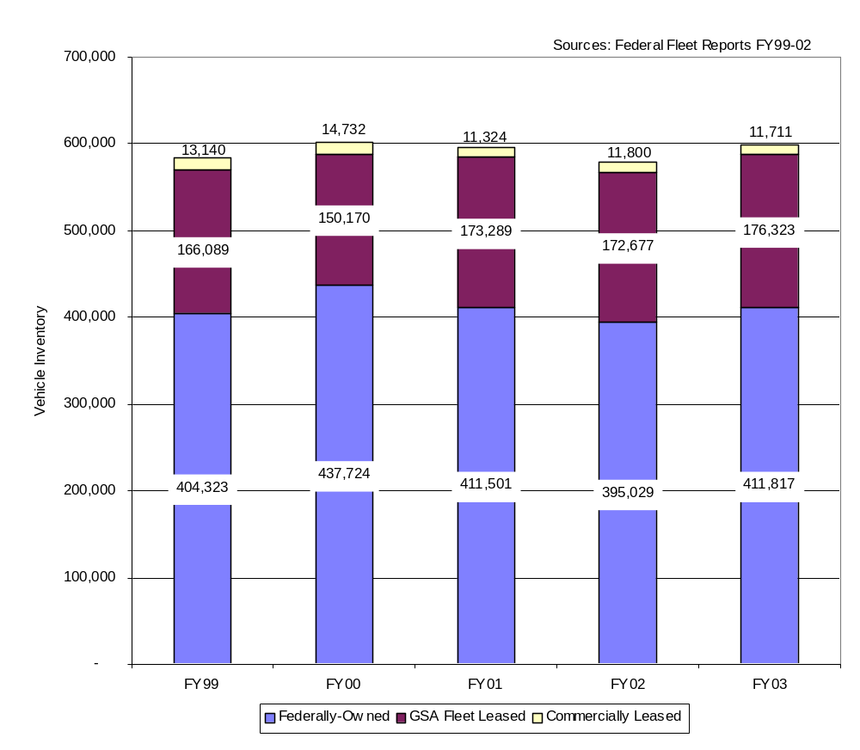

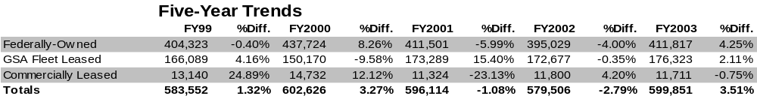

Chart 3: Worldwide Inventory of Federally Owned and Leased Vehicles by Vehicle Type
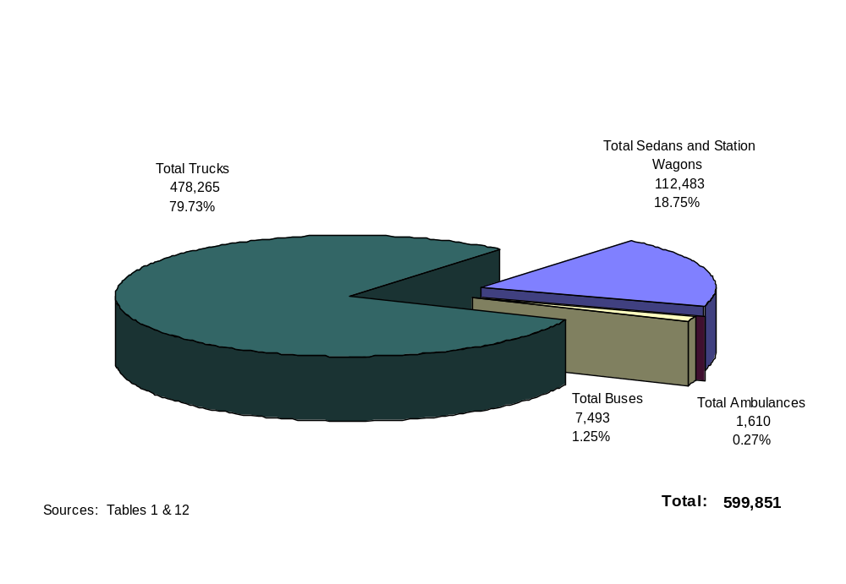

Federally owned and commercially leased vehicles were added together for each vehicle type. The Federally owned vehicles include GSA leased vehicles.

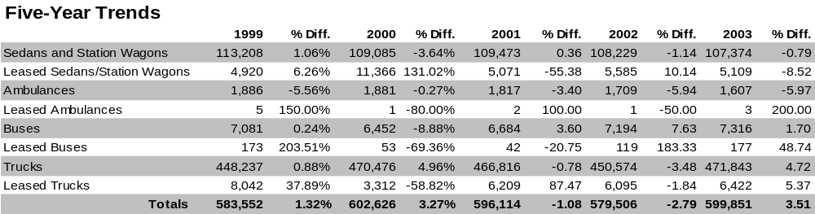

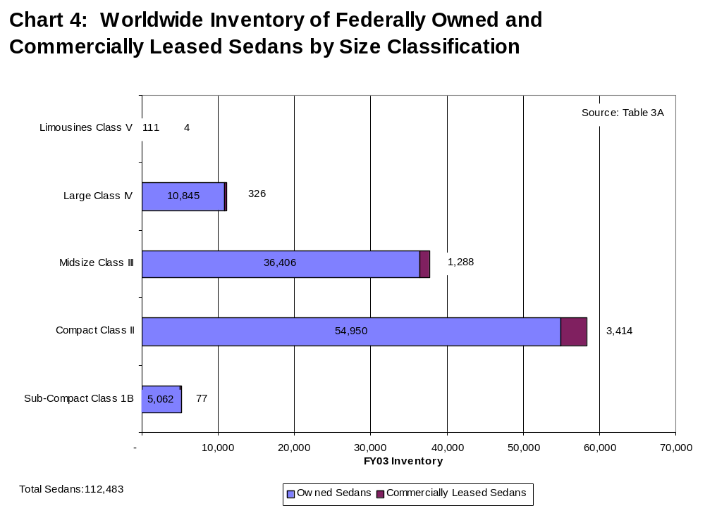

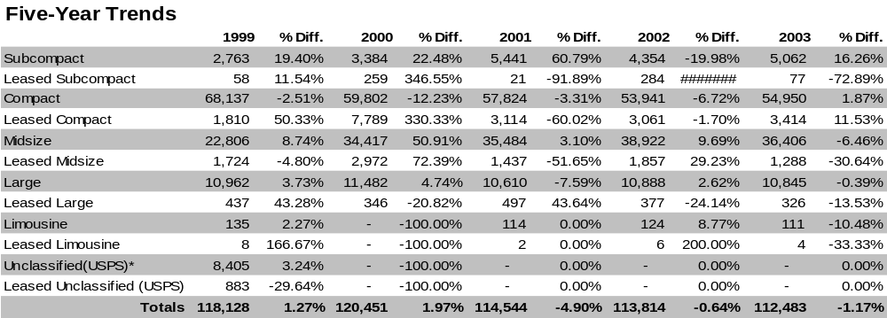

* The U.S. Postal Service reported their vehicle inventory by class starting with FY 2000
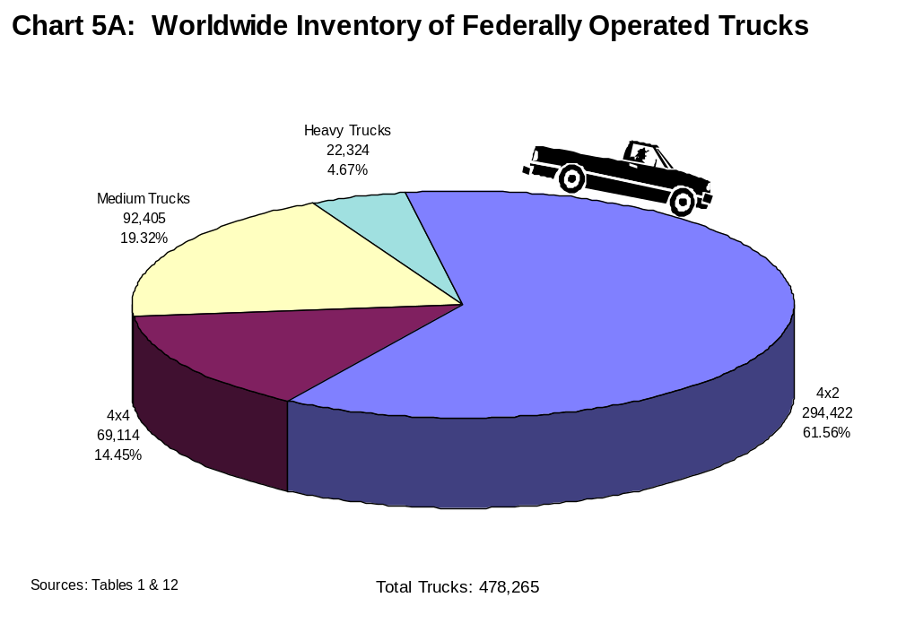

The table below shows the inventory changes over the past five years. The GSA Fleet vehicle inventory has been incorporated into the owned figures. Please refer to Tables 1, 10, 15 and 16 for a breakdown of vehicle inventory.

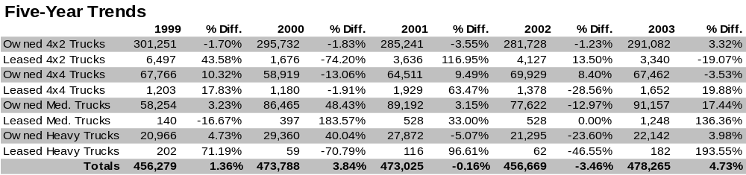

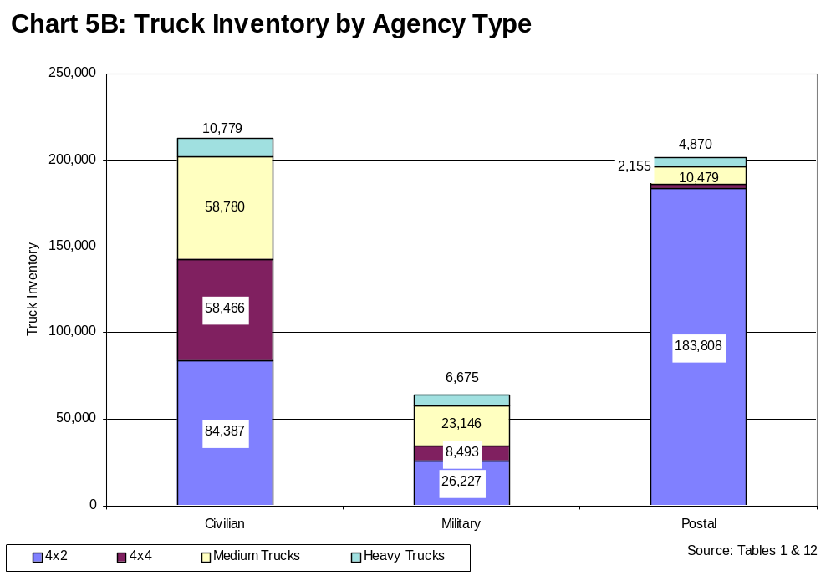

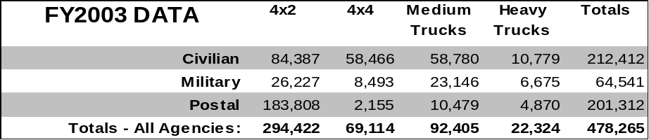

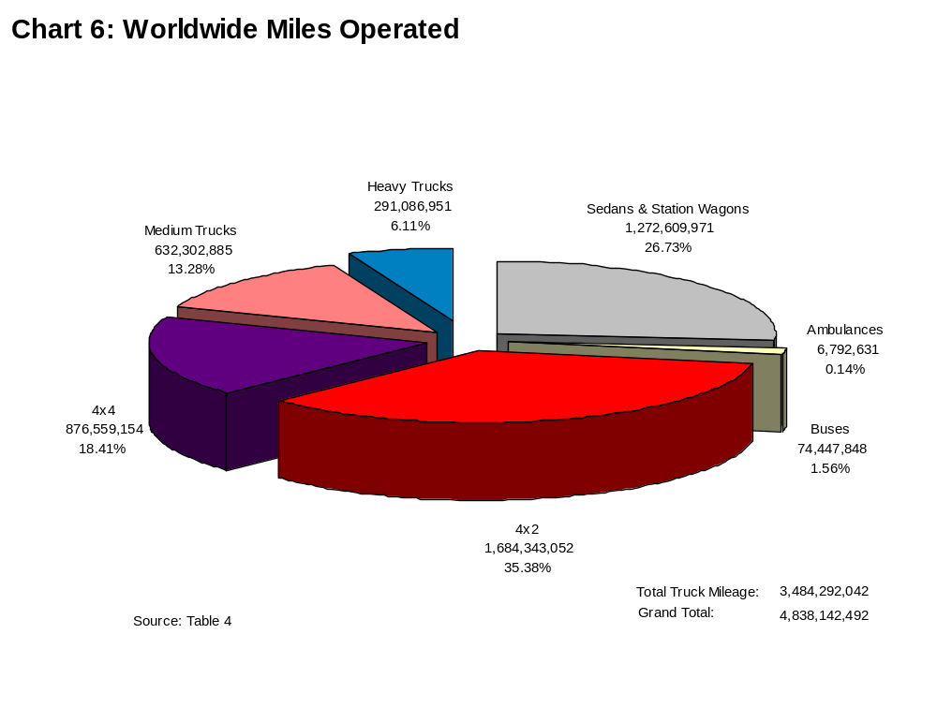

The table below shows the changes over the past five years. Please refer to Table 4 for a breakdown of miles operated by vehicle inventory. Most of the data on miles operated comes from large agency owned fleets. Small owned fleet data was included when provided. These figures include federally owned and GSA Fleet miles.

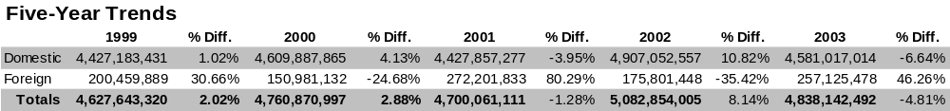

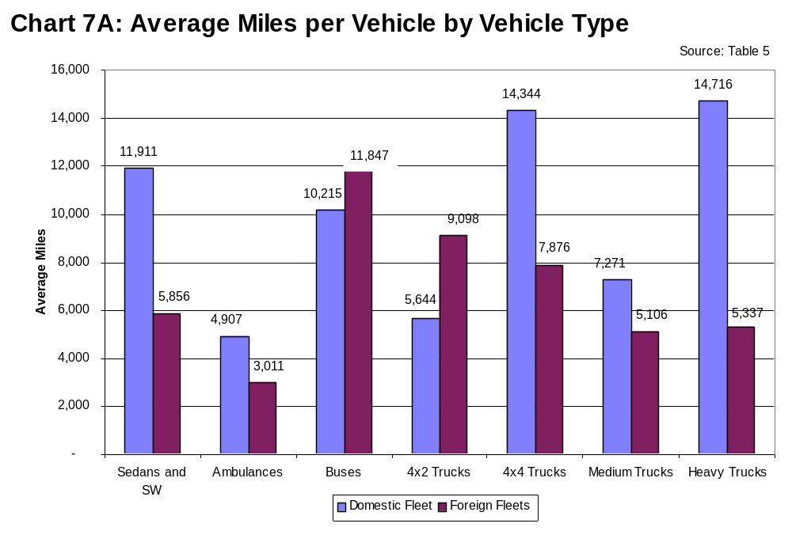

Dividing the in-use vehicle inventory (commercially leased plus federally owned) into total miles operated derives average miles per vehicle. Miles per vehicle is a primary measure of fleet utilization. The tables show the mile changes over the past five years. Please refer to Table 5 for a breakdown of the average miles per vehicle type.

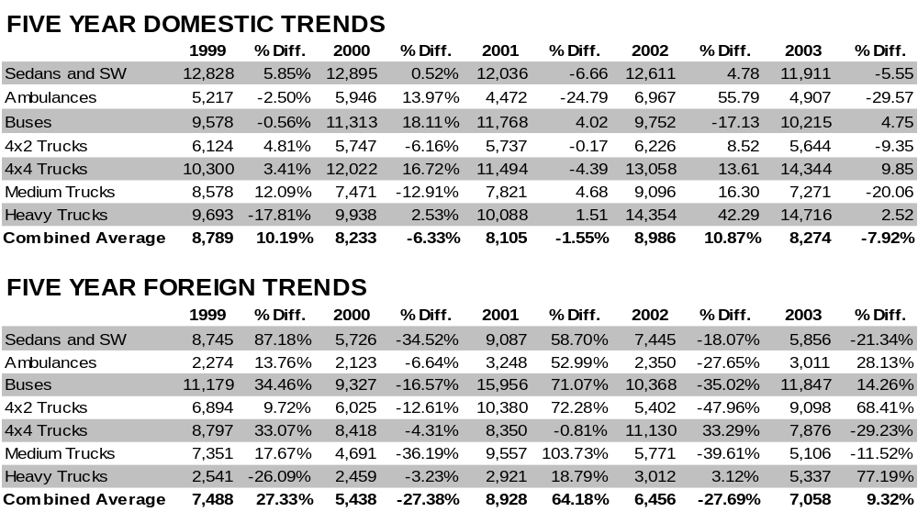

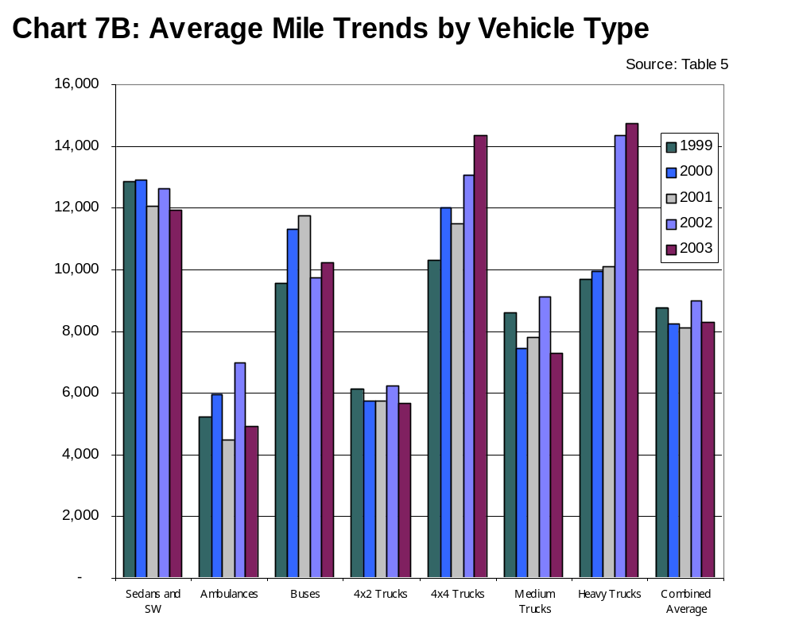

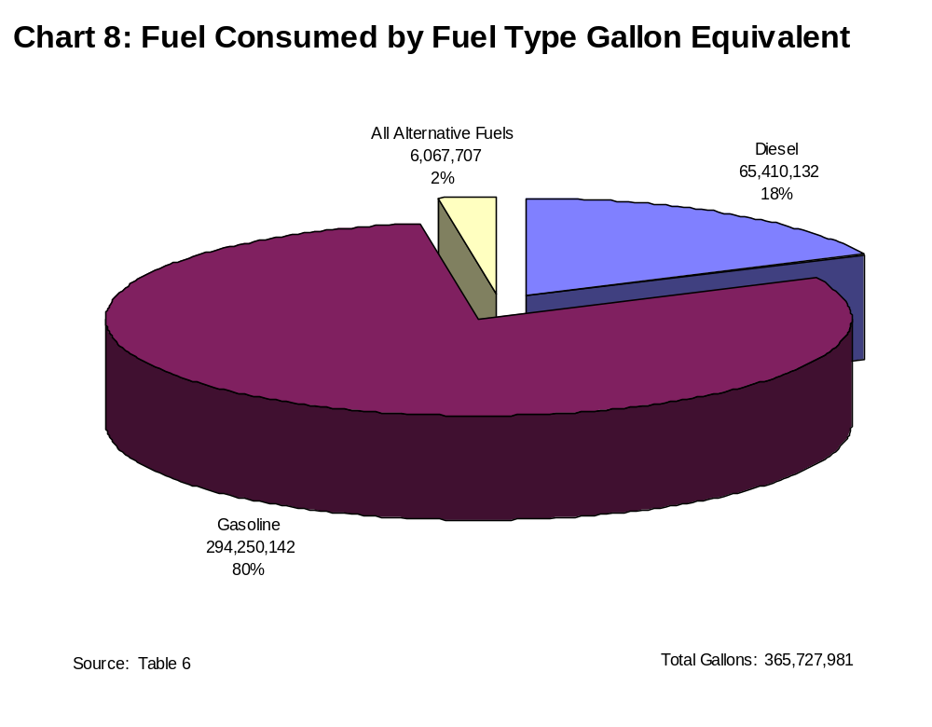

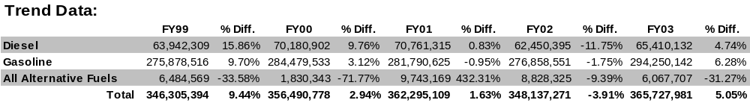

NOTE: Collecting accurate data on alternative fuel use continues to be problematic. Fuel type information transmitted between fueling stations and credit card companies is often miscoded. GSA and other agencies are working with the industry to correct this. Meanwhile, most alternative fuel use data is collected manually and may not be a true indicator of alternative fuel use.
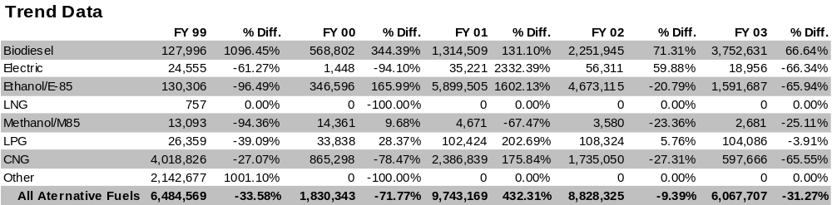
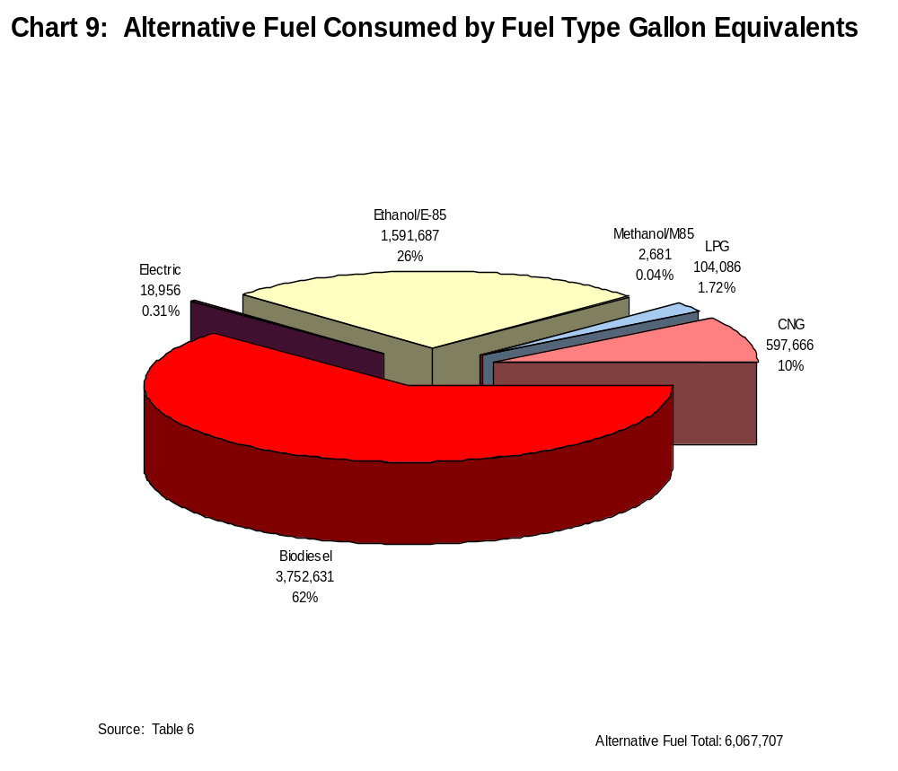

NOTE: Collecting accurate data on alternative fuel use continues to be problematic. Fuel type information transmitted between fueling stations and credit card companies is often miscoded. GSA and other agencies are working with the industry to correct this. Meanwhile, most alternative fuel use data is collected manually and may not be a true indicator of alternative fuel use.

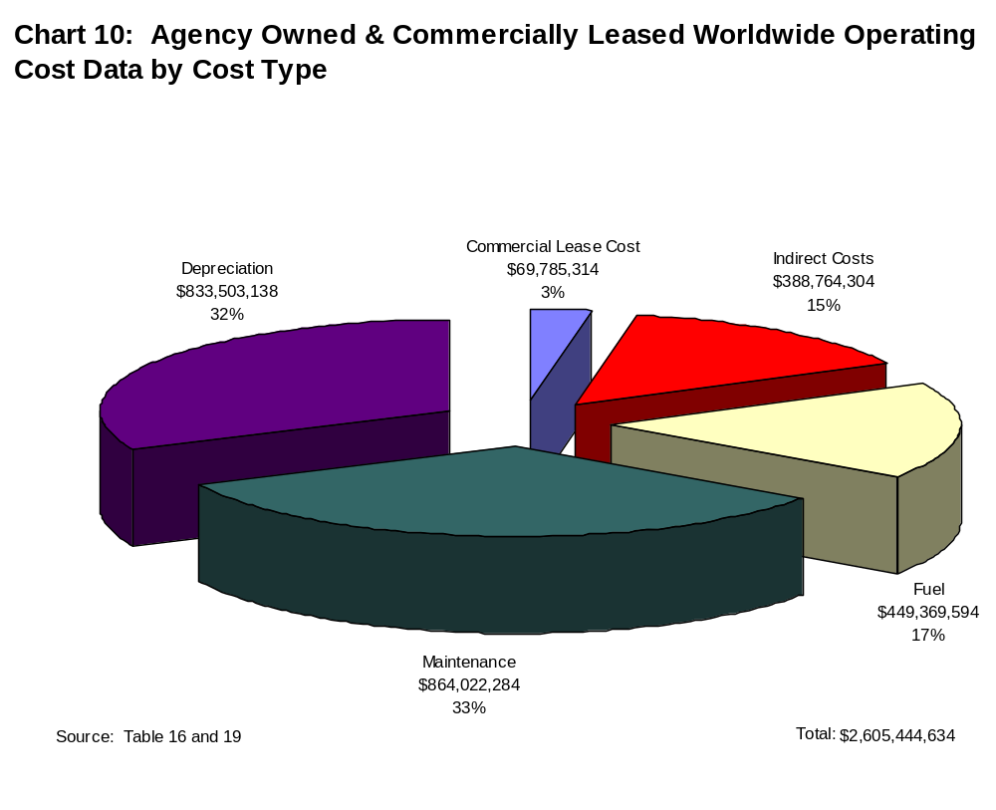

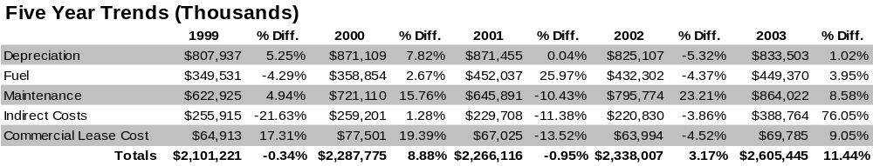

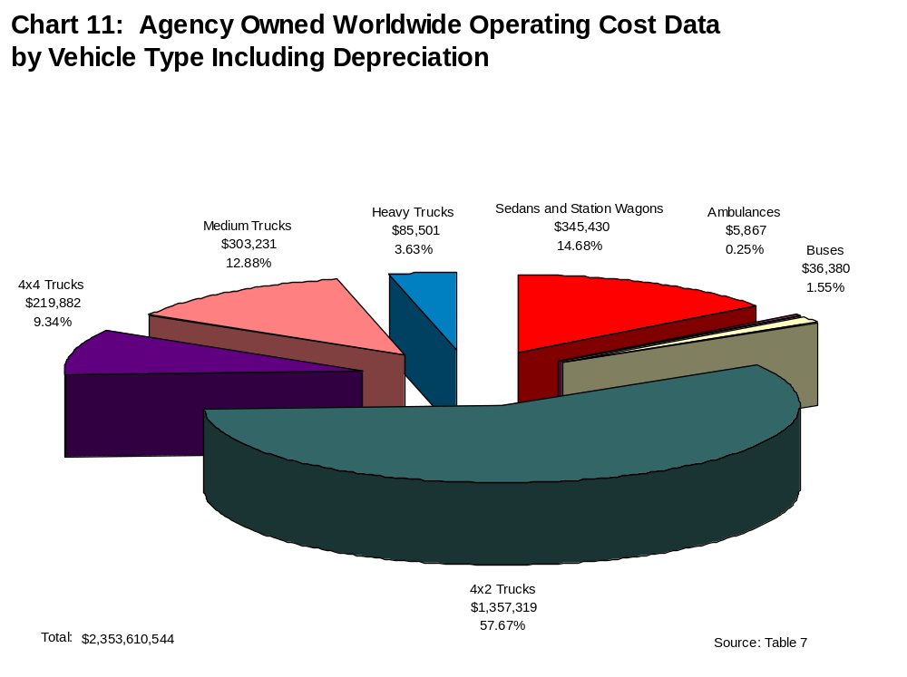

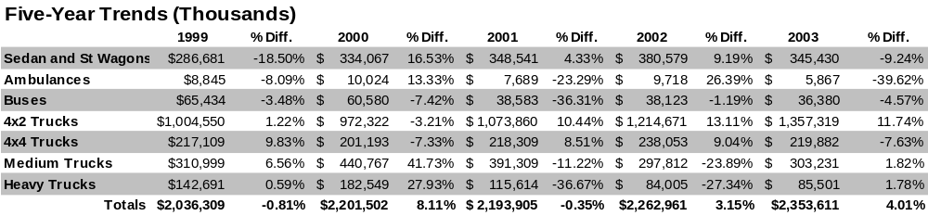

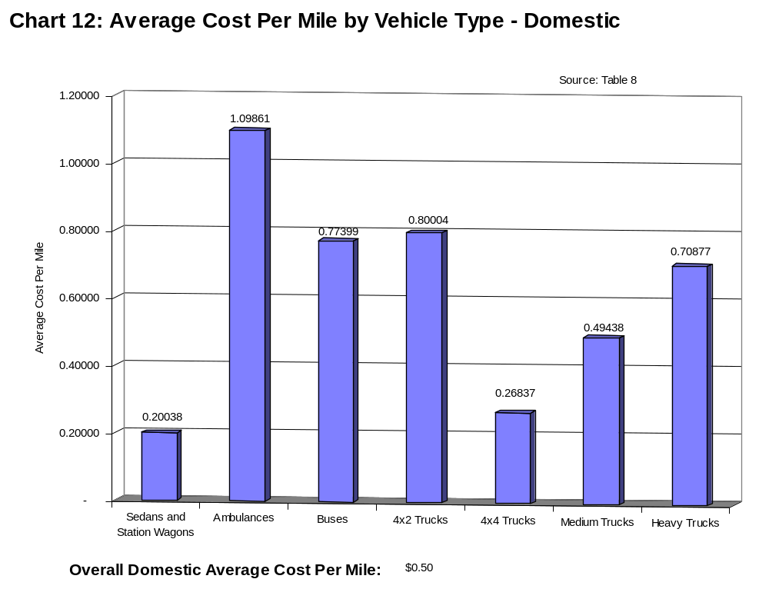

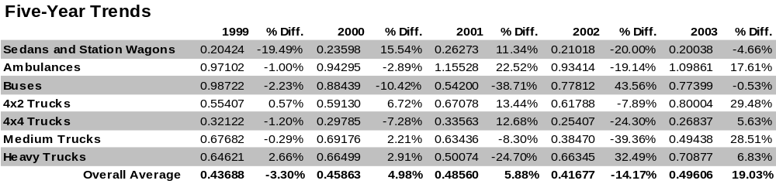

Detailed Tables:

Federally Owned
Motor Vehicles
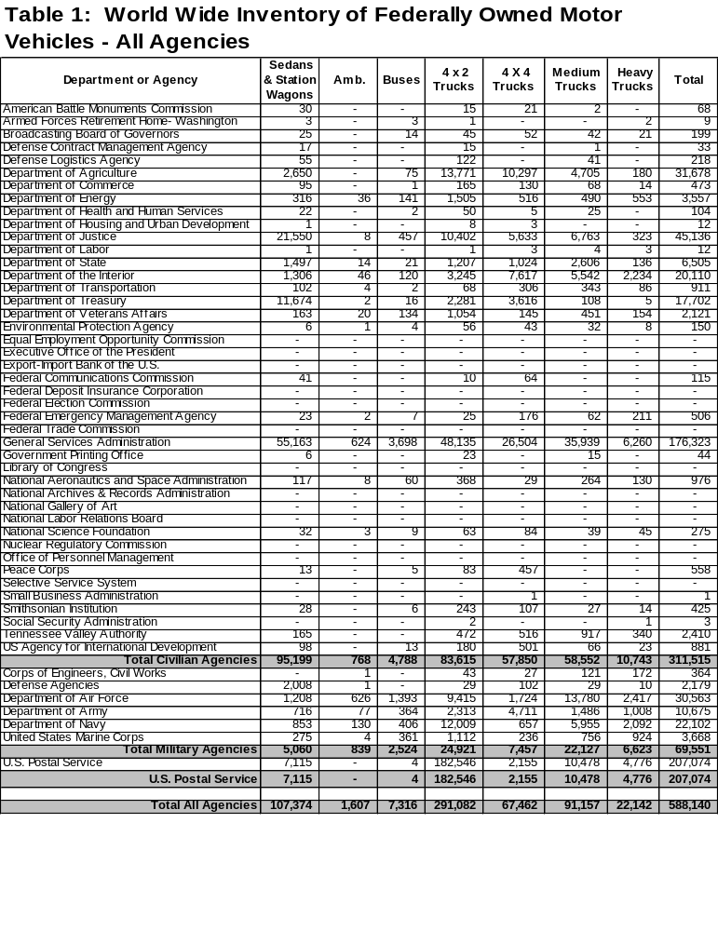
These figures include GSA vehicles, which are owned by GSA, Federal agency owned vehicles, and GSA Fleet vehicles that are leased to other agencies.
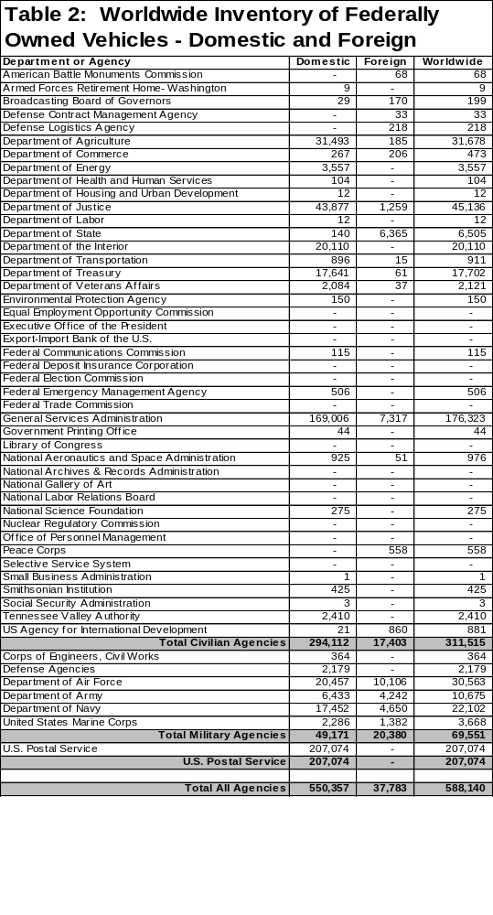
These figures include GSA vehicles, which are owned by GSA, Federal agency owned vehicles, and GSA Fleet vehicles that are leased to other agencies.
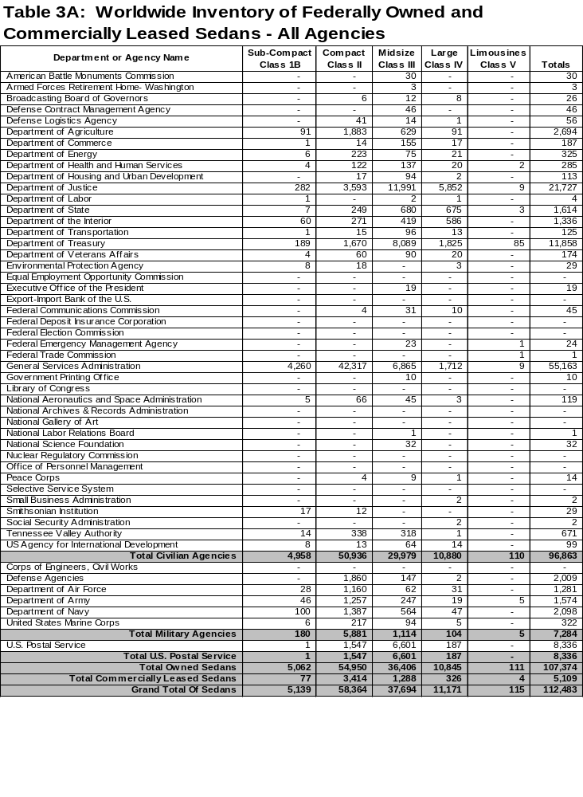
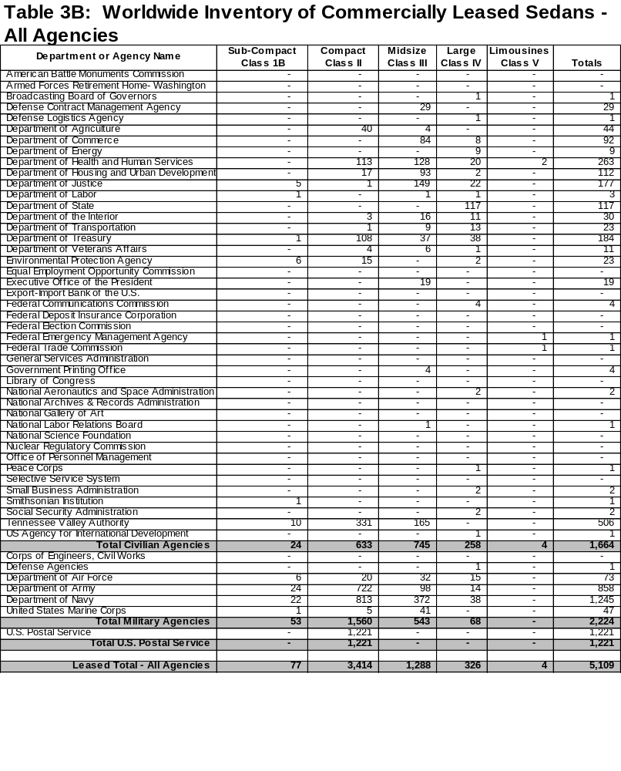

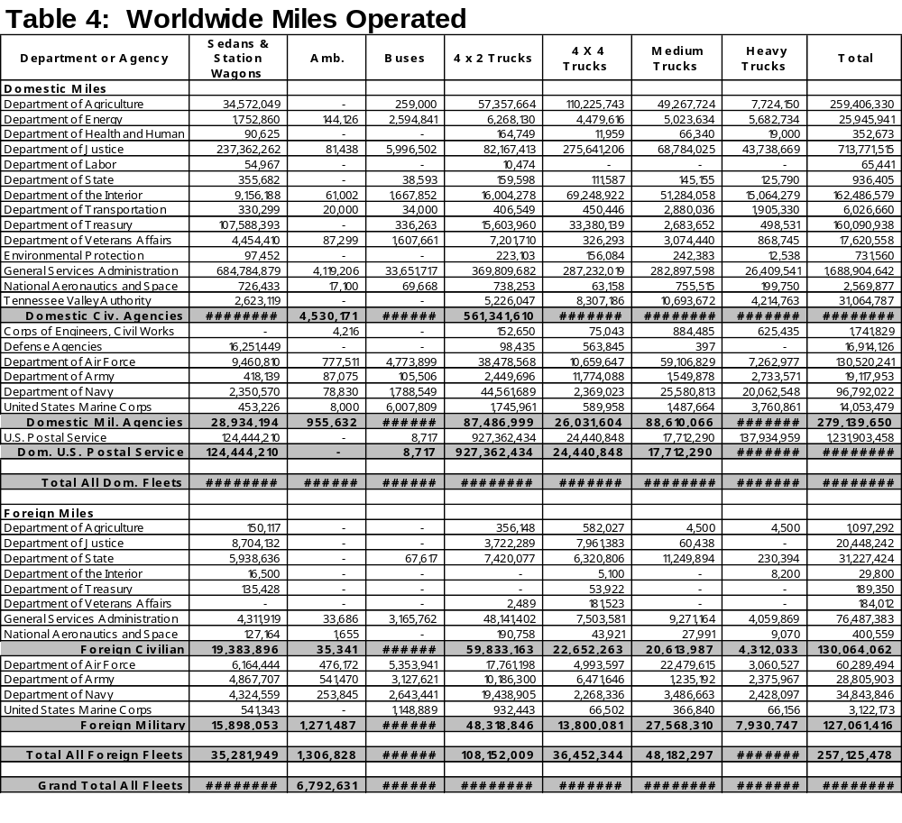

Although GSA Fleet vehicles are operated overseas, and the overseas inventory and cost is reported as “Foreign” on Tables 7 and 14, all GSA Fleet miles are reported under “Domestic.”

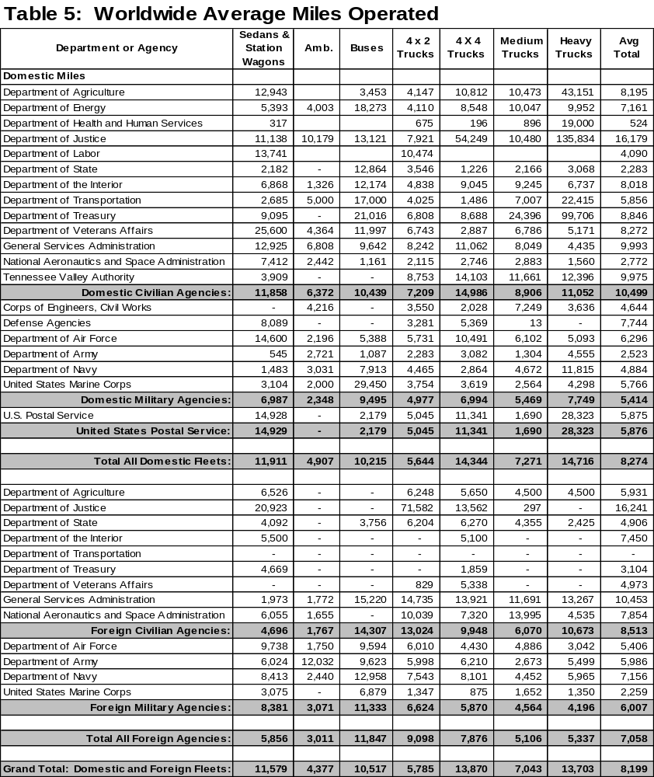

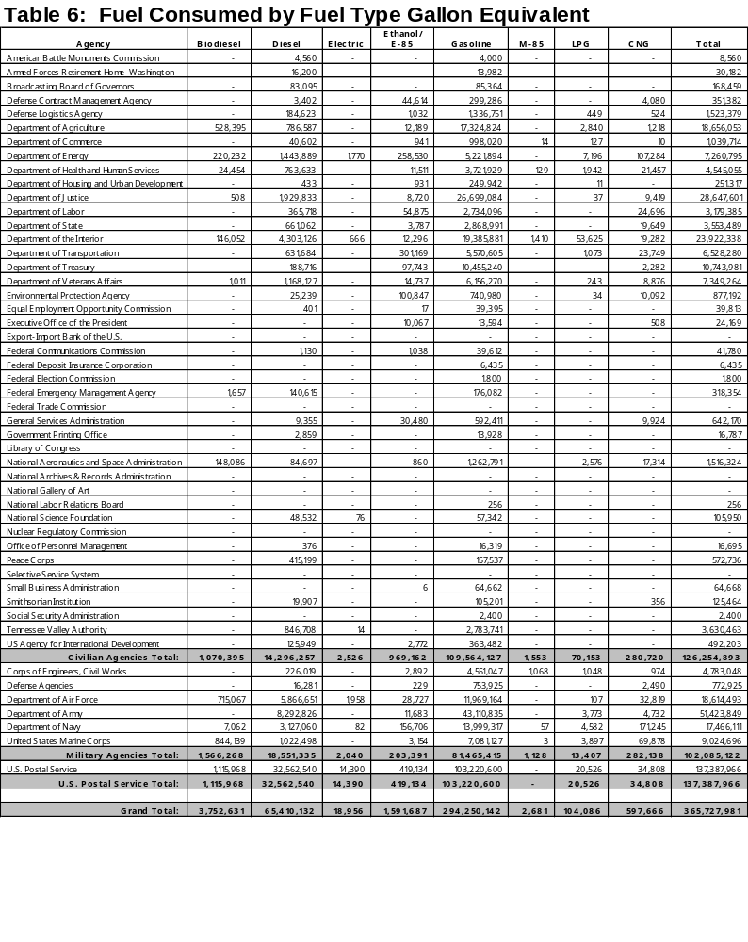
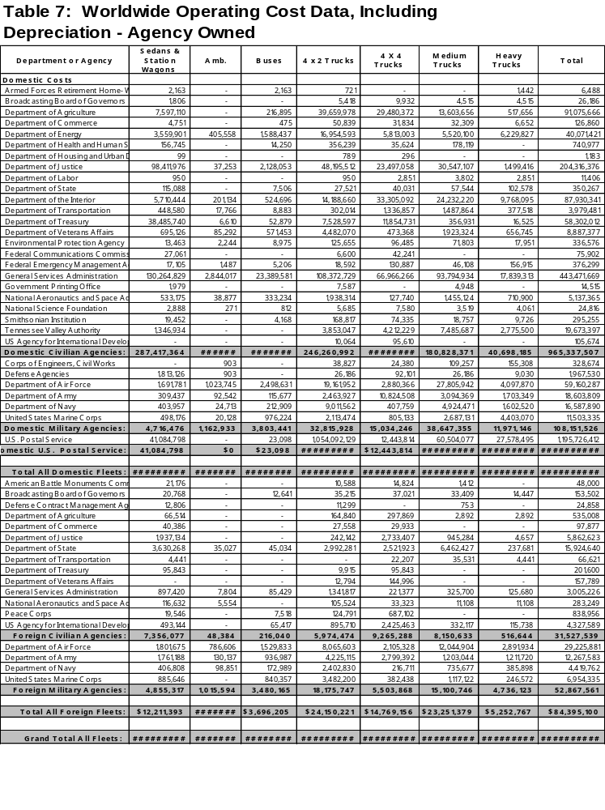

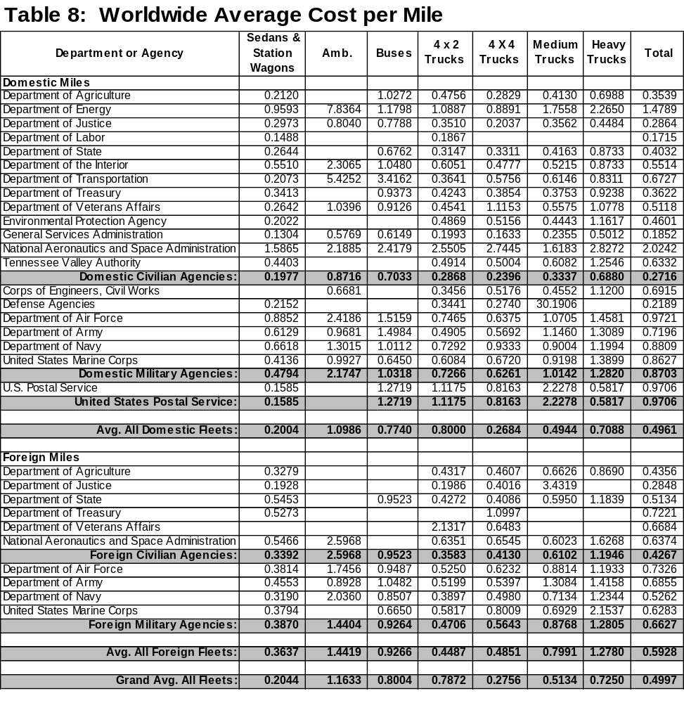

GSA Fleet is not included in Foreign Civilian Agencies because all GSA Fleet fuel is reported in domestic fleet numbers.
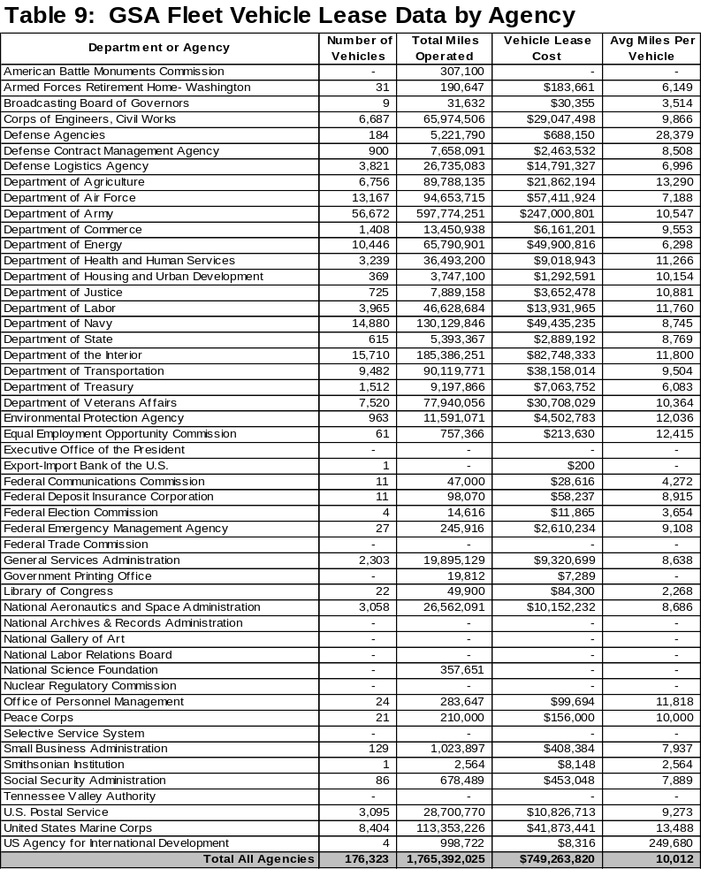

Data on this table are from two sources: GSA Fleet provided the miles and cost, while individual agencies reported the number of vehicles. Average miles were calculated from these two sources. Due to differences in reporting, anomalies result in some cases.

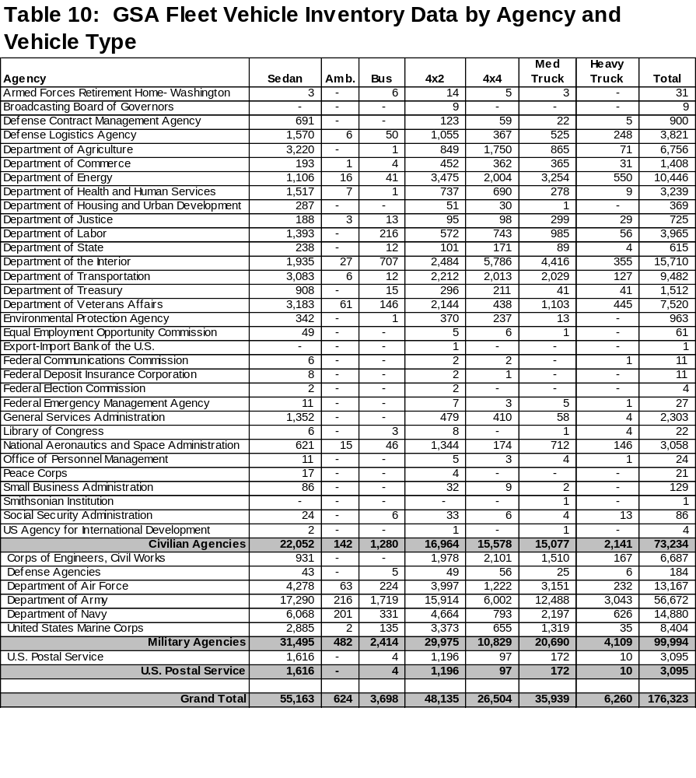

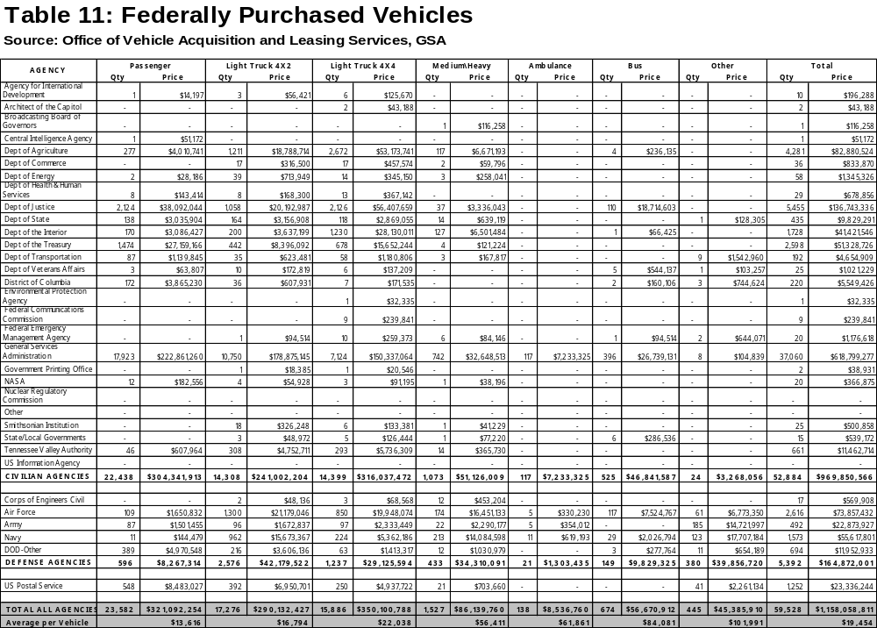

This page intentionally left blank

This page intentionally left blank

This page intentionally left blank

Charts, Trends and Tables:

Commercially Leased
Motor Vehicles
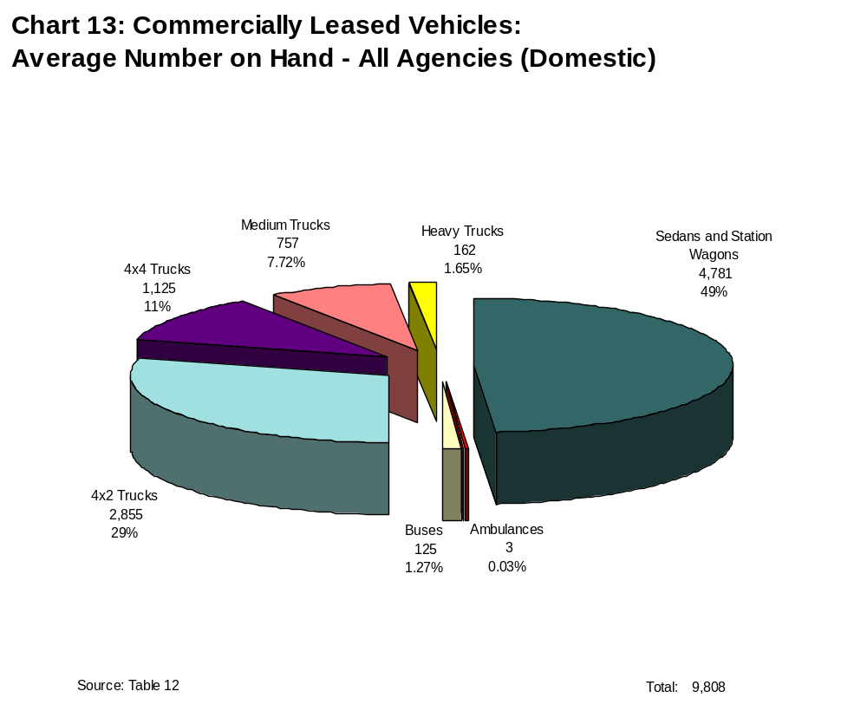

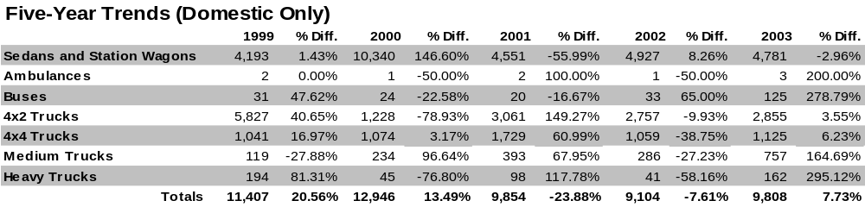

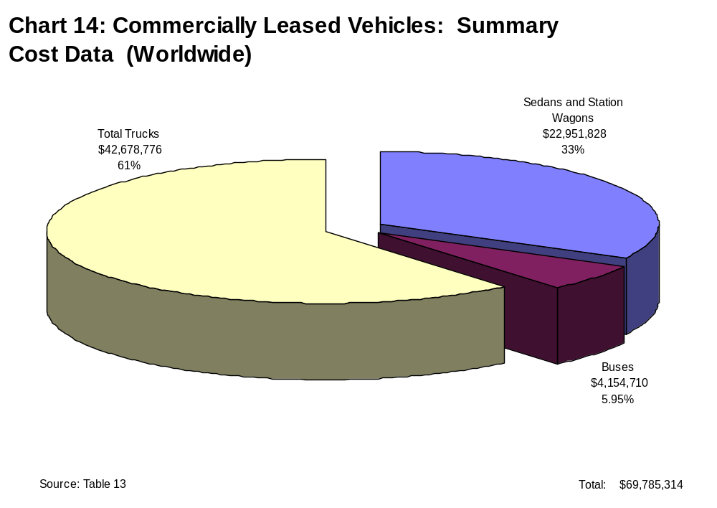

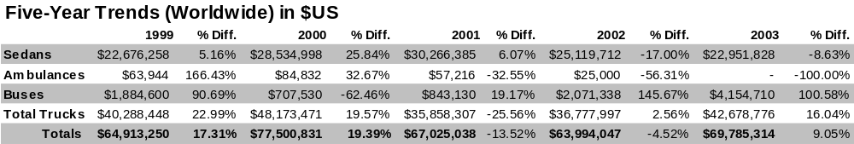

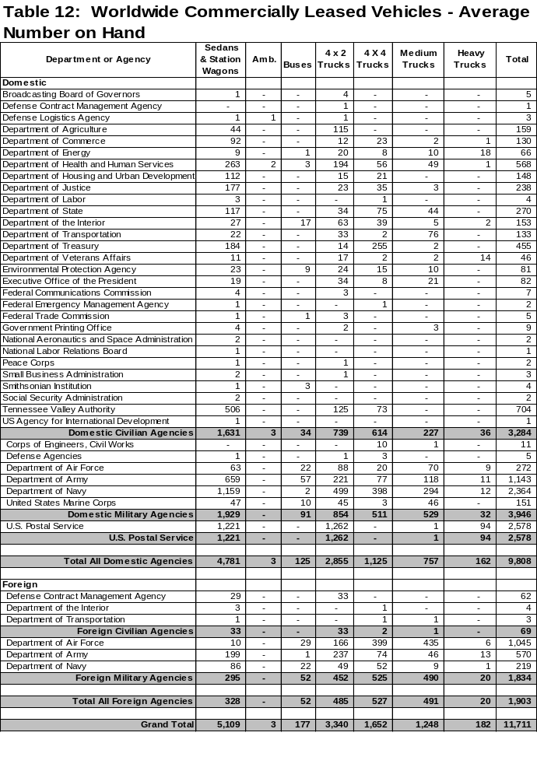

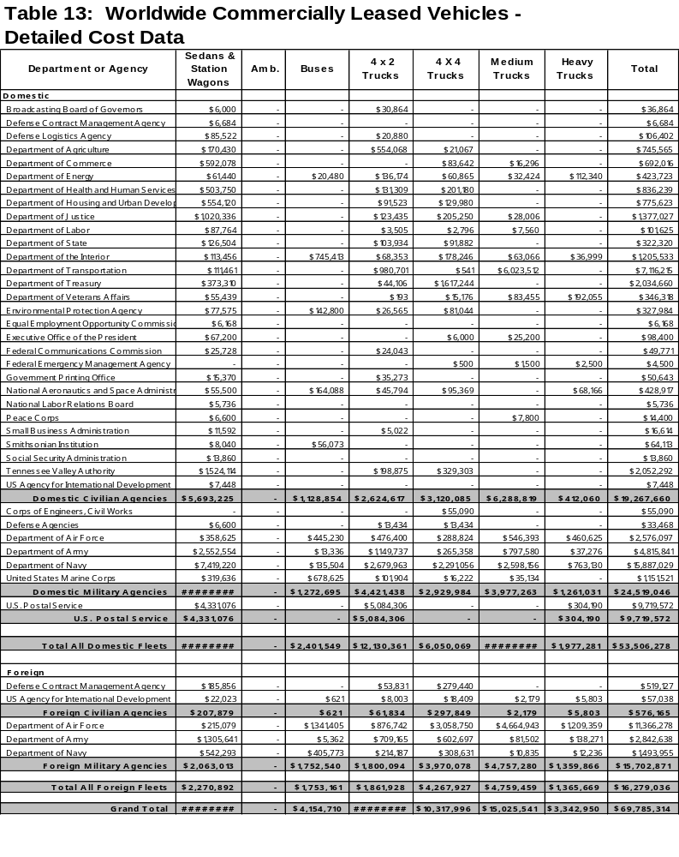

Summary Information:

Federal
Motor Vehicles
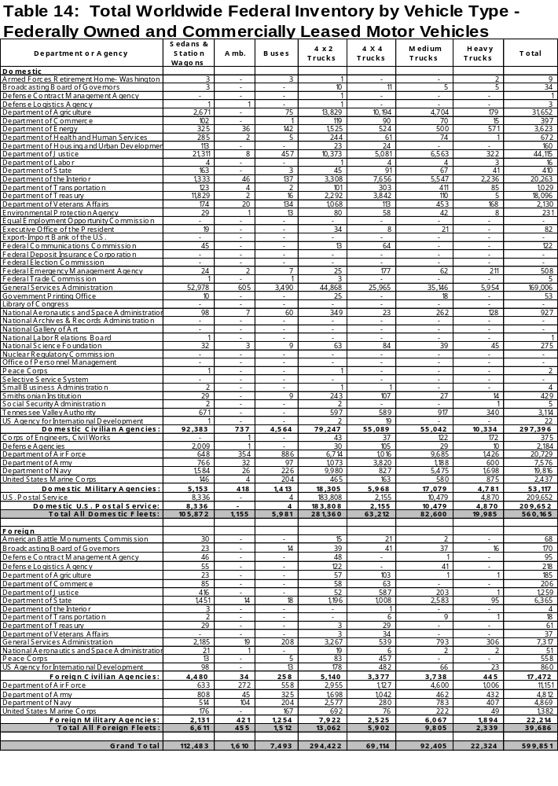
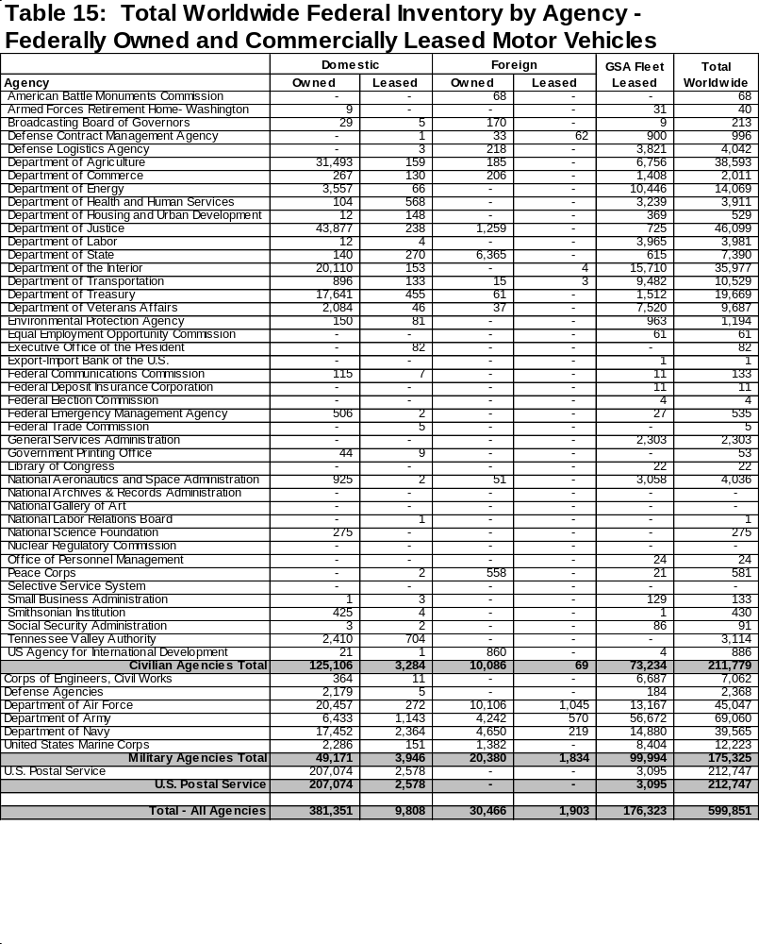
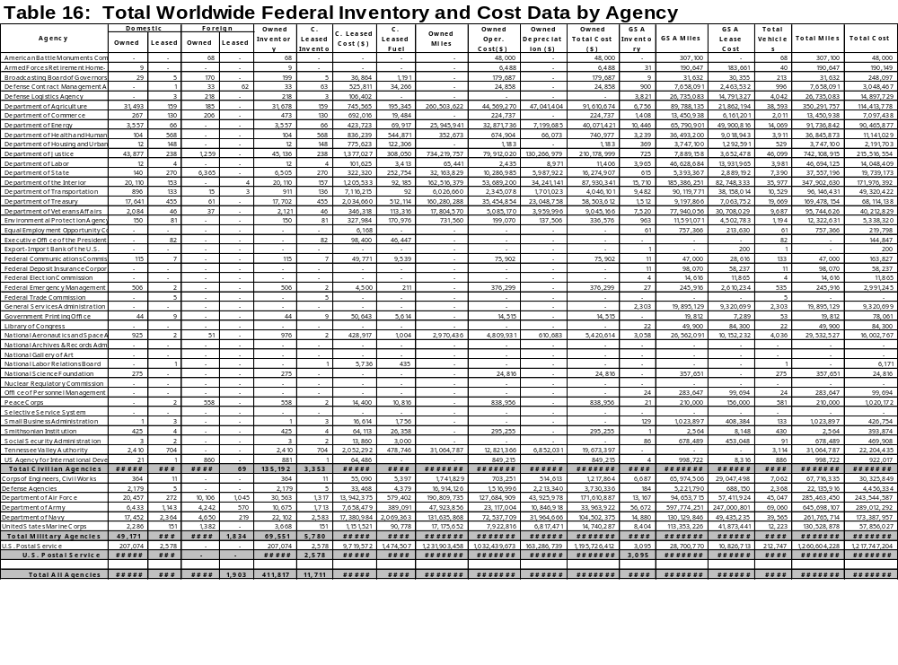

This page intentionally left blank

Fuel Tables and Charts:

Fuels Used, Acquisitions,
and Consumption
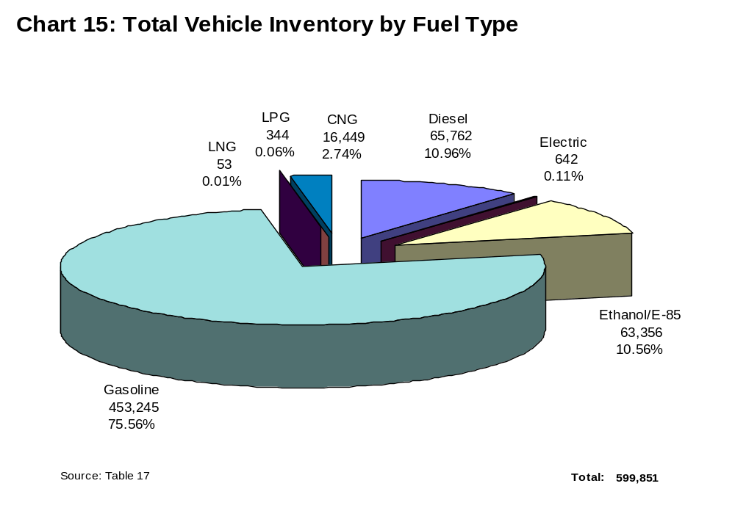

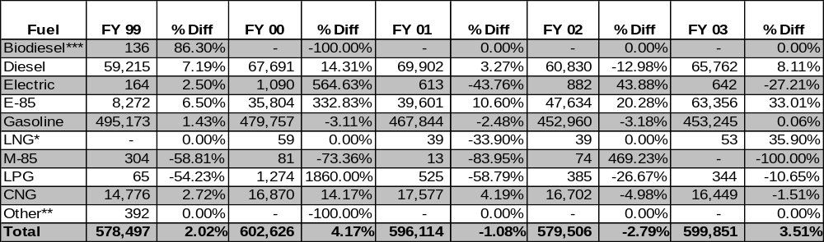

* CNG and LNG were not separately reported prior to FY 2000.

** Hydrogen use was not reported in FY2000 and dropped from this report - prior years values were consolidated under "Other."

*** For all alternative fuel vehicles except biodiesel, there is a corresponding alternative fuel vehicle for each alternative fuel. Biodiesel is unique in that it is an alternative fuel that is used in conventional diesel engines. Consequently there is no category for biodiesel as an alternative fuel vehicle. Reported acquisitions of biodiesel vehicles in prior years are erroneous.
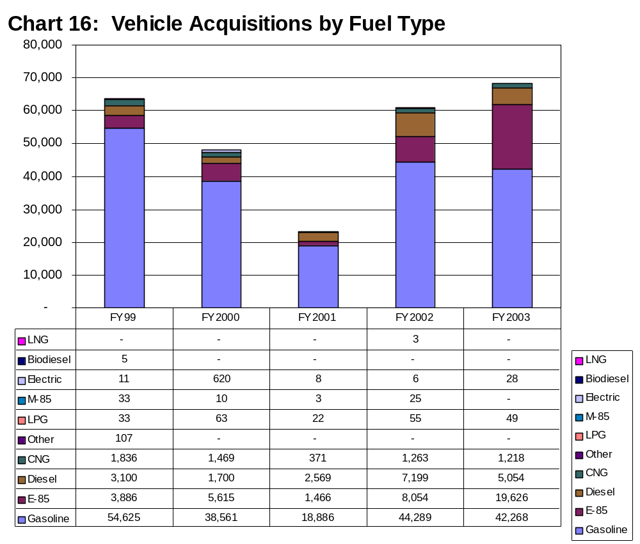
This Chart compares vehicle acquisitions by fuel type.

Acquisitions reflected here may not match those reported by GSA Automotive (Table 11). GSA Automotive acquires vehicles for entities that are not required to report, such as Legislative and Judicial Branch activities, and some agencies may have limited authority to acquire vehicles independently of GSA Automotive. Also, GSA Automotive reports vehicles ordered, whether or not they have been delivered.

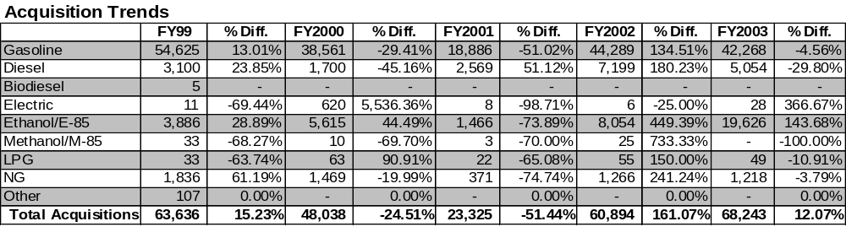
For all alternative fuel vehicles except biodiesel, there is a corresponding alternative fuel vehicle for each alternative fuel. Biodiesel is unique in that it is an alternative fuel that is used in conventional diesel engines. Consequently there is no category for biodiesel as an alternative fuel vehicle. Reported acquisitions of biodiesel vehicles in prior years are erroneous.
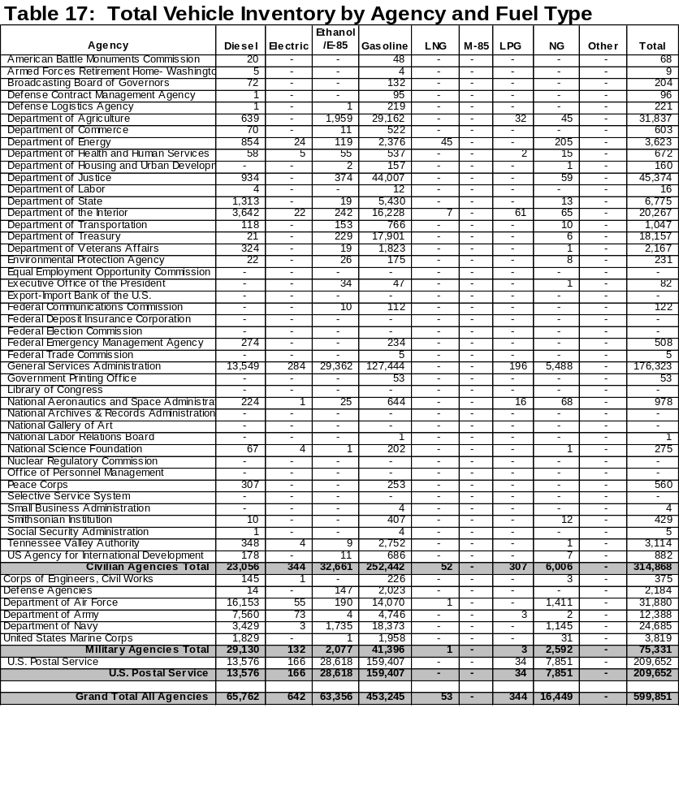
For all alternative fuel vehicles except biodiesel, there is a corresponding alternative fuel vehicle for each alternative fuel. Biodiesel is unique in that it is an alternative fuel that is used in conventional diesel engines. Consequently there is no category for biodiesel as an alternative fuel vehicle. Reported acquisitions of biodiesel vehicles in prior years are erroneous.

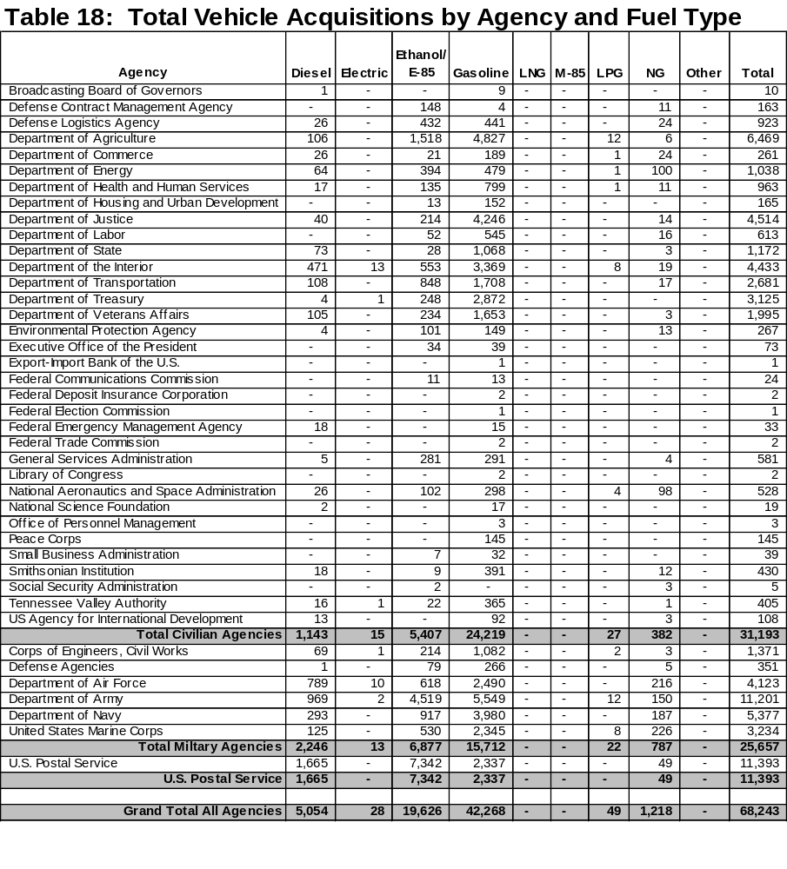

INSERT PAGES GENERATED FROM ACCESS DB FOR TABLE 19

GLOSSARY

ACQUISITION— An addition to an agency’s inventory. The source of the addition can be purchase of a new (or used) vehicle, acquiring a vehicle through a commercial lease, or from GSA Fleet. Replacements for vehicles retired and sold count as acquisitions. Vehicles transferred from one activity to another within an agency do not constitute acquisitions. Acquisitions should be reported in the year they are ordered, even though physical receipt may not have occurred until the following reporting period.

ACQUISITION COST—The initial purchase price of a vehicle, including all costs incidental to placing it in service, such as shipping and factory prep.

ASSIGNMENT—Another term for lease from GSA Fleet. Assignment can occur whenever one accountable organizational element makes its vehicle(s) available for use by another.

COMMERCIAL LEASE—Acquisition of a vehicle for 60 days or more from a commercial source. Acquisition of vehicles from commercial sources for less than 60 days is considered short-term rental, and not reported.

DEPRECIATION— A major component of vehicle cost; generally, the difference between acquisition cost and anticipated sales proceeds. For purposes of this report, GSA Fleet reports its depreciation cost expressed as a cost-per-mile, which is then applied to other agencies’ reported mileage (except Postal Service, which supplies its own depreciation cost). Agencies on appropriated funds typically do not recognize depreciation expense or account for it in their internal accounting systems.

DIRECT COST—Operating expenses attributable to an individual vehicle or class of vehicles, such as maintenance and depreciation.

DISPOSAL—Removal of a vehicle from inventory, usually by sale, but also through transfers and donations. For activities on revolving funds, proceeds from disposal are available for the purchase of replacement vehicles. For agencies on appropriations, disposal proceeds usually do not return to the fleet activity.

DOMESTIC—Referring to any State, Commonwealth, territory, or possession of the United States.

FOREIGN—Outside any State, Commonwealth, territory, or possession of the United States.

GSA FLEET LEASE—A vehicle acquired by a Federal agency or authorized contractor from GSA Fleet. Such vehicles are usually Government owned, but are treated similarly to commercial leased vehicles by using agencies.

INDIRECT COST—Expenses that cannot be readily attributed to an individual vehicle or class of vehicles because they are incurred in connection with overall fleet operation: office supplies, printing, utilities, and other general management and overhead.

LARGE FLEET—2,000 or more reportable vehicles, domestic or foreign, for which accountability is held by a Federal agency’s organizational element or by a contractor. Large fleets are required to report on inventory, commercial leasing, cost, mileage, and fuel used.

OWNING AGENCY—Federal agency or organizational element having accountability for Government owned vehicles. Characterized by the authority to take possession of, assign, reassign, or sell a vehicle, regardless of which agency or element is using the vehicle.

PASSENGER VEHICLE—Sedans and station wagons. Although passenger vans and sport utilities are sometimes considered passenger vehicles, Federal Standards and this report classify them as light trucks.

REPORTABLE VEHICLE—All commercial-design, non-tactical vehicles, excluding special-purpose equipment. Includes vehicles acquired from all sources, including owned, GSA Fleet-leased, or commercially leased.

SMALL FLEET—Less than 2,000 reportable vehicles held by an organizational element of a Federal agency. Small fleets are required to report only vehicle inventory and commercial leasing information.

USING AGENCY—The Federal agency or organizational element with day-to-day use of a vehicle that it does not own. Agencies assigned vehicles by GSA Fleet are using agencies, GSA Fleet is the owning agency.

UTILIZATION—A measurement of a vehicle’s rate of use, usually expressed in miles per vehicle per month or per year.

VEHICLE CLASS—A system of categorizing vehicles based on the Federal Standards.

