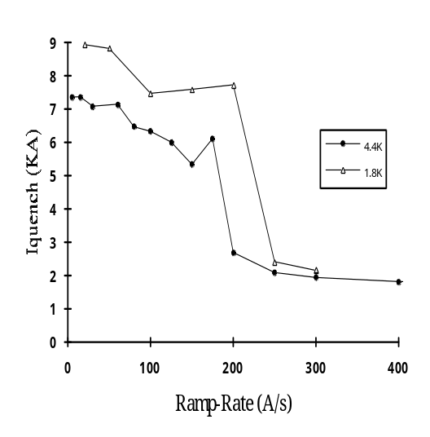
Ramp-rate sensitivity (4.4 vs. 1.8 K):. All the high 1.8K quenches still exhibited fast imbalances.

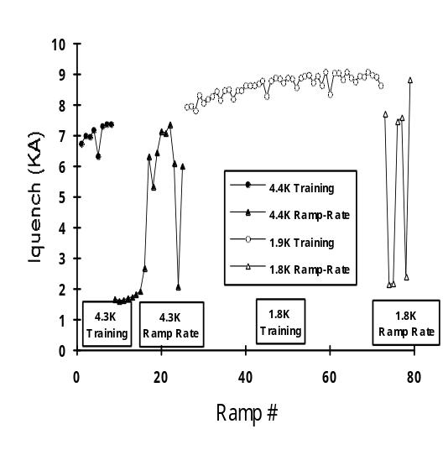
Quench History: Training and ramp-rate studies at 4.4K and 1.8K. The 1.8K training was aborted to increase the end-load.

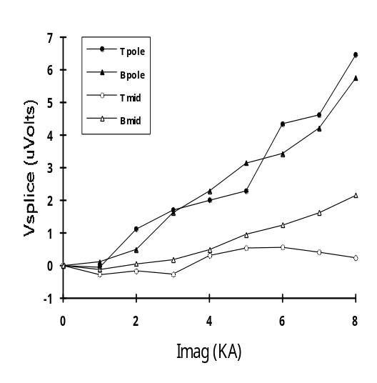
4)D19H: NbSn-NbTi Splice Voltages @ 1.8K

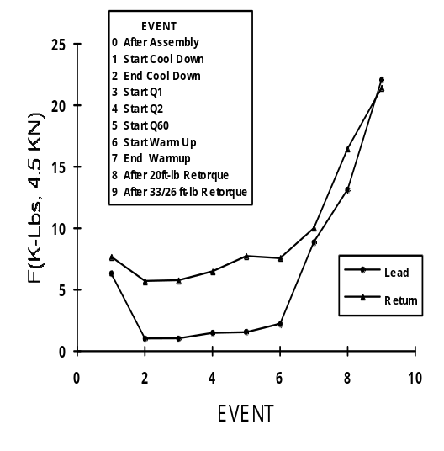
9)D19H: END LOAD HISTORY

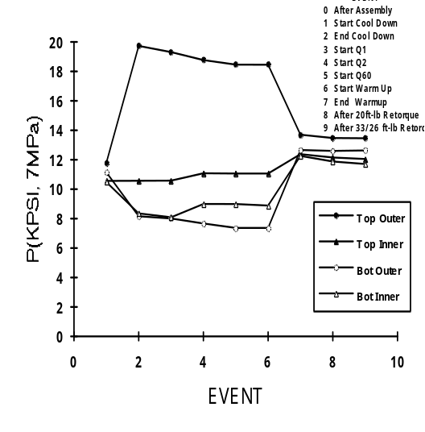
10) D19H: POLE LOAD HISTORY
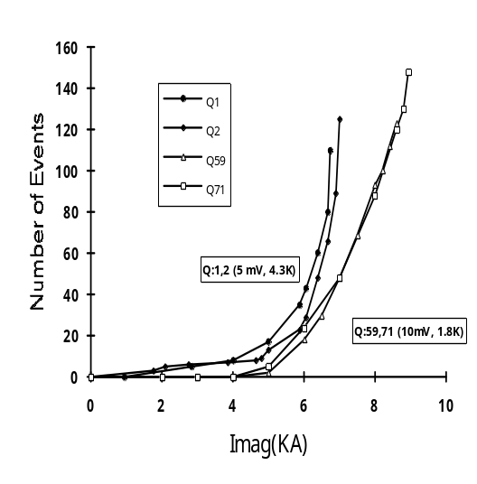
14)D19H: Fast Imbalances
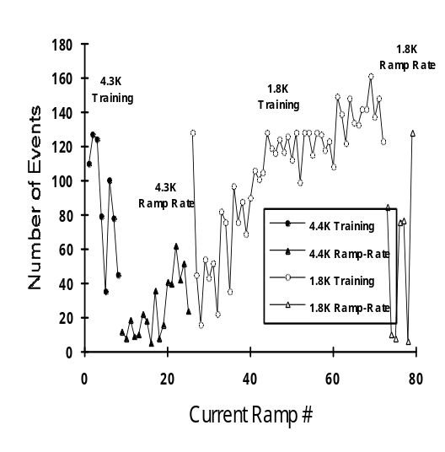
16) D19H: Fast Imbalance History

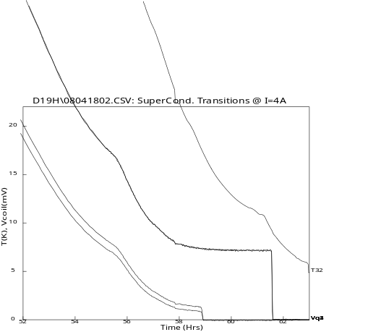

rrr.hgl

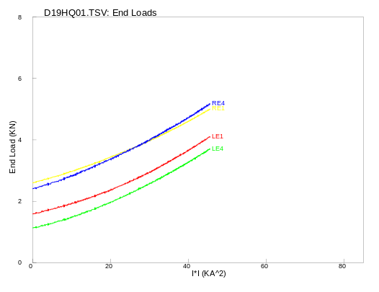

hgl from .rtf

