Section 2 — Release Detection

What Is Release Detection?
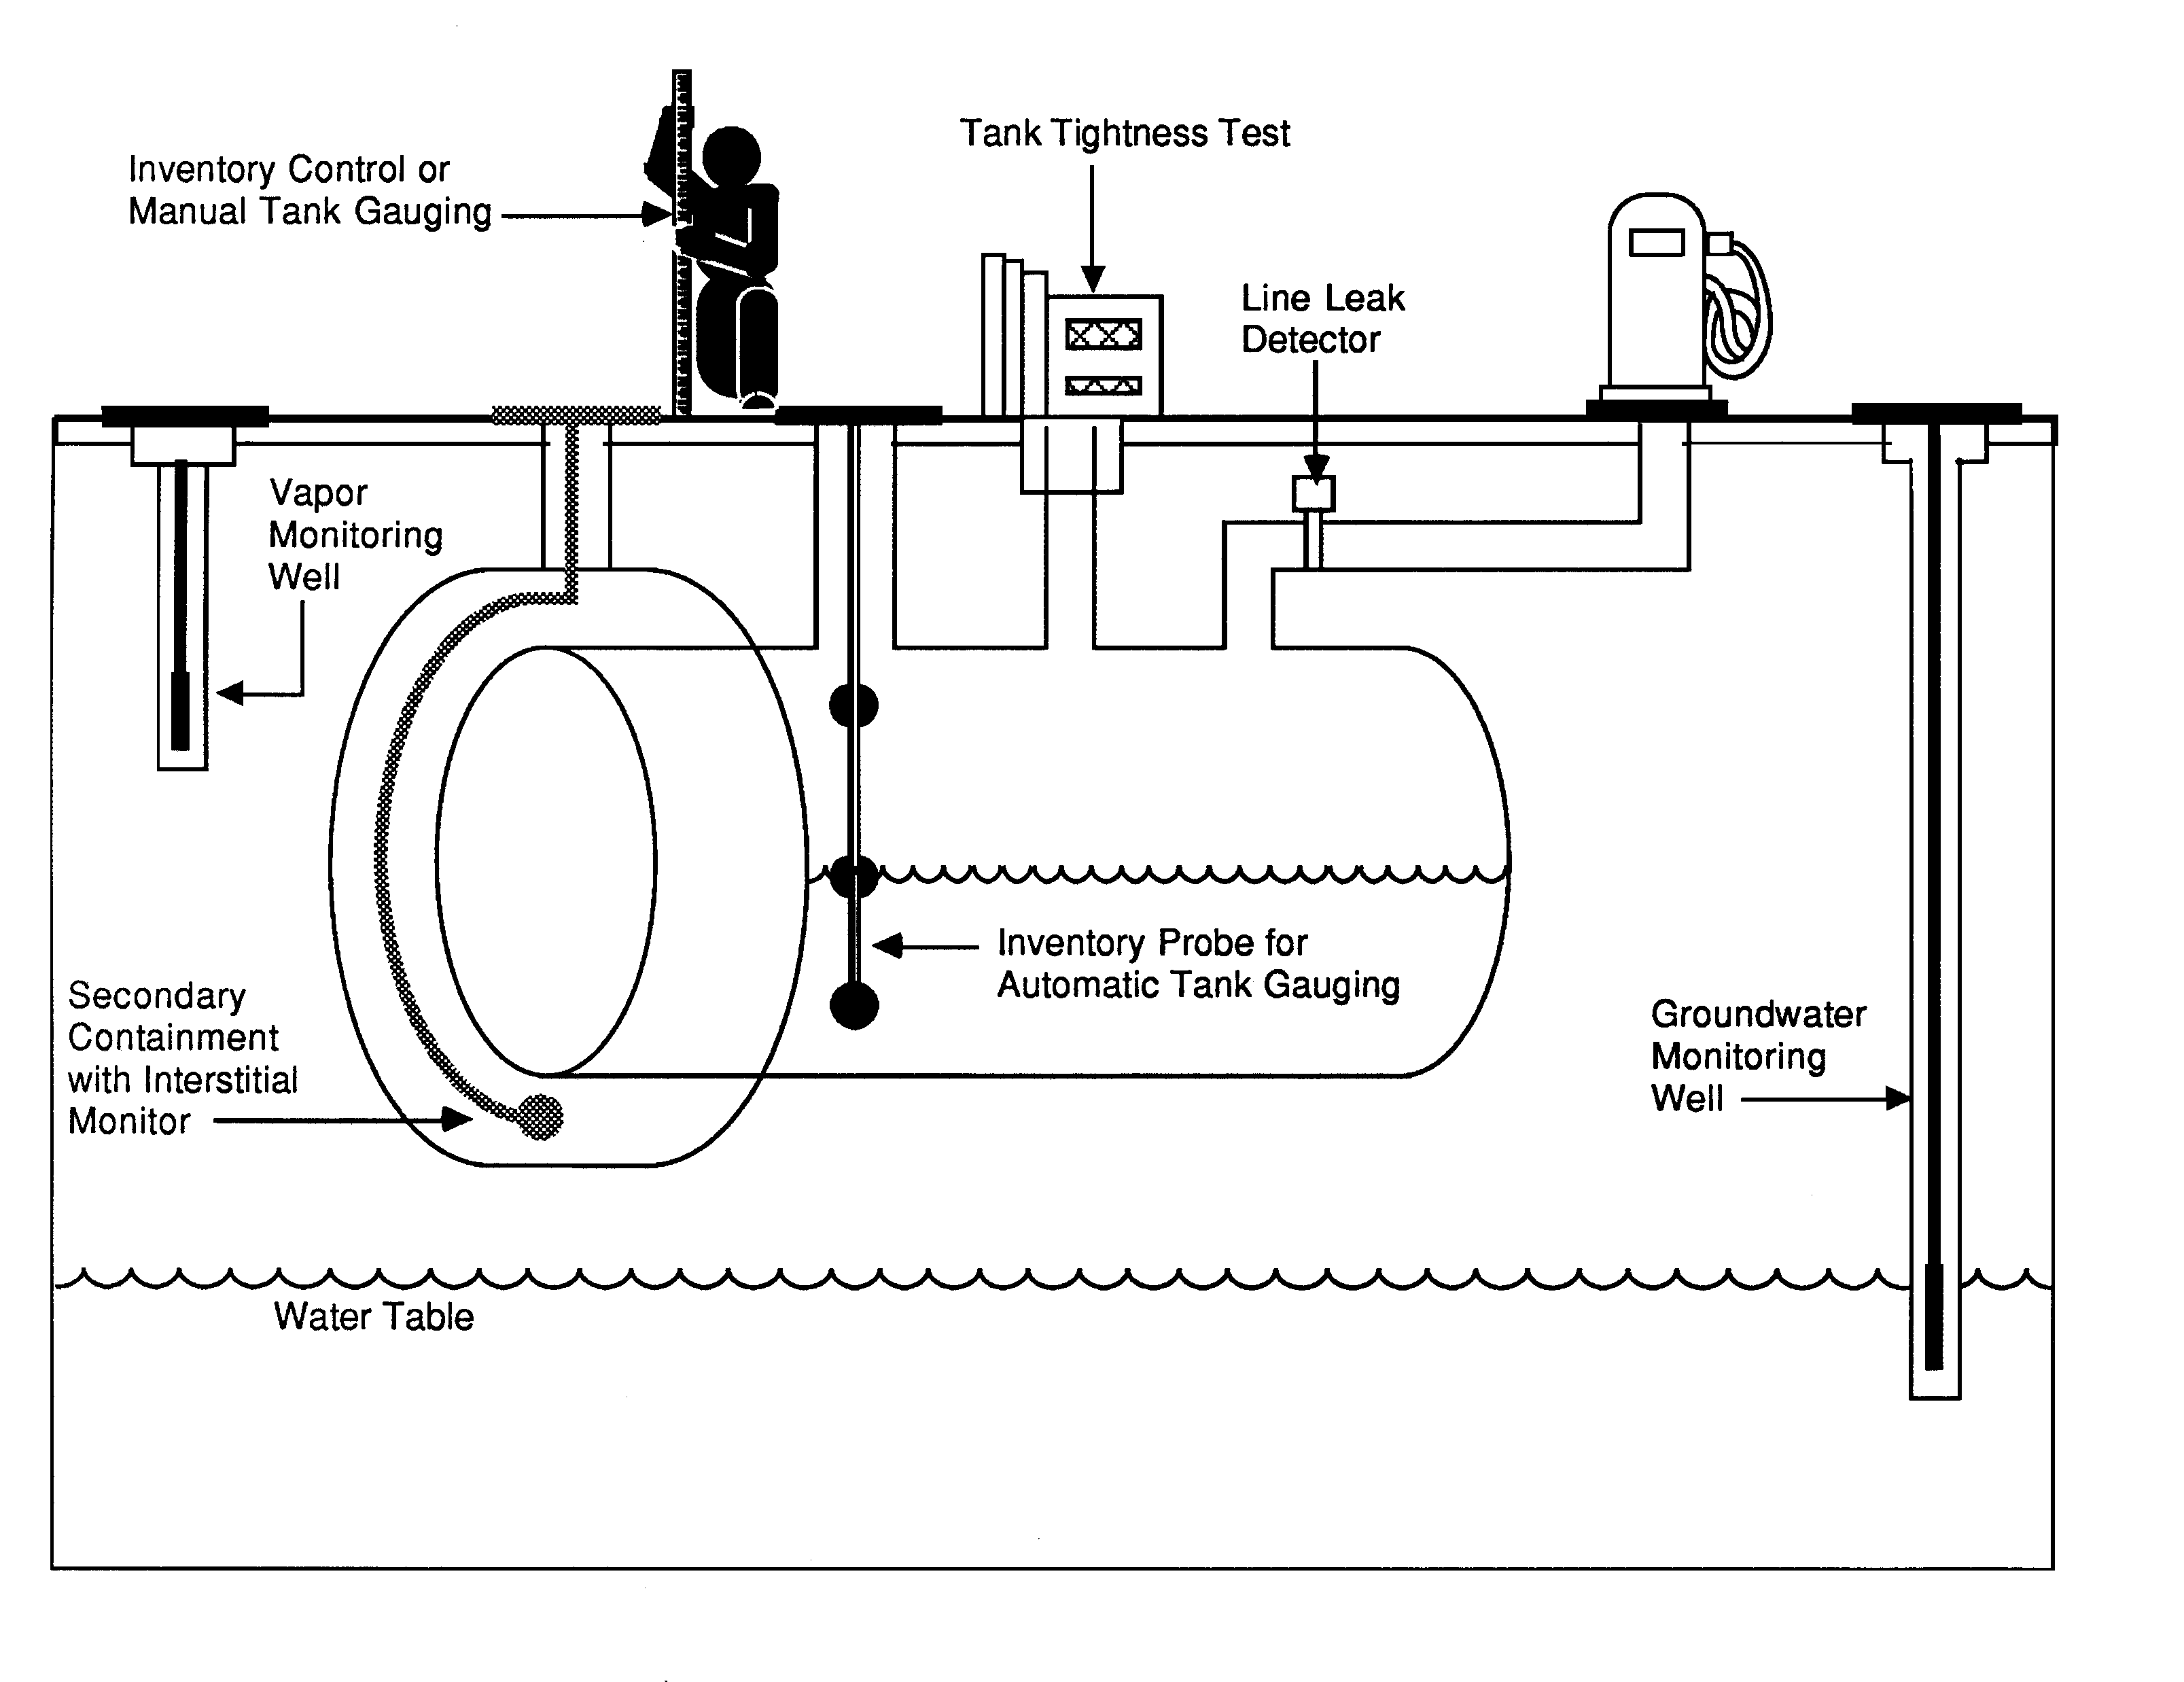
You must be able to determine at least every 30 days whether or not your tank and piping are leaking by using proper release detection methods.

Your release detection method must be able to detect a release from any portion of the tank and connected underground piping that routinely contains product.

Release detection must be installed, calibrated, operated, and maintained according to the manufacturer’s instructions.

Do You Know If Your Release Detection Is Certified To Work At Your UST Site?

Release detection must meet specific performance requirements. You should have documentation from the manufacturer, vendor, or installer of your release detection equipment showing certification that it can meet performance requirements.

Some vendors or manufacturers supply their own certification, but more often an impartial “third party” is paid to test the release detection equipment and certify that performance requirements are met. An independent workgroup of release detection experts periodically evaluates all third-party certifications, thus providing a free and reliable list of evaluations of third-party certifications for various release detection equipment. Frequently updated, this list is available on the Internet at http://www.nwglde.org/ (the publication’s title is List Of Leak Detection Evaluations For Underground Storage Tank Systems). If you can’t find the certification anywhere, contact your state regulatory agency (see Section 7 for contact information).

By checking the certification, you may discover the method you use has not been approved for use with the type of tank or piping you have or the type of product being stored. For example, you may learn from the certification that your method won’t work with manifolded tanks, certain products, high throughput, or with certain tank sizes.

That’s why you need to make sure your release detection method has clear certification that it will work effectively at your site with its specific characteristics.

How Can You Make Sure Your Leak Detection Method Is Working At Your UST Site?

If you don’t understand your O&M responsibilities and don’t know what O&M tasks you must routinely perform, you may allow your UST site to become contaminated — then you will face cleanup costs and associated problems.

To avoid these problems use the checklists on the following pages that describe each type of leak detection method, discuss actions necessary for proper O&M, and note the records you should keep.

Locate the methods of release detection you are using at your facility, review these pages, and periodically complete the checklist. You might want to copy a page first and periodically fill out copies later.

If you have questions about your release detection system, review your owner’s manual or call the vendor of your system. Your state or local regulatory agency may be able to provide assistance as well.

You will find leak detection recordkeeping forms in the following pages of this Section. Keeping these records increases the likelihood that you are conducting good O&M and providing effective release detection at your UST site. For example, see page 20 for
a 30-Day Release Detection Monitoring Record.

If you ever suspect or confirm a leak, refer to Section 3. Never ignore leak detection alarms or failed leak detection tests. Treat them as potential leaks!

Automatic Tank Gauging (ATG) Systems (for tanks only)
Description Of Release Detection | An automatic tank gauging (ATG) system consists of a probe permanently installed in a tank and wired to a monitor to provide information on product level and temperature. ATG systems automatically calculate the changes in product volume that can indicate a leaking tank.
Have Certification For Your Release Detection Method | - Make sure your ATG system is certified for the types of tanks and stored contents on which the ATG system is used. Most manufacturers have their leak detection devices tested and certified by a third party to verify that their equipment meets specific performance requirements set by regulatory agencies. If you don't have certified performance claims, have the manufacturer provide them to you.
Perform These  O&M  Actions | - Use your ATG system to test for leaks at least every 30 days. Most systems are already programmed by the installer to run a leak test periodically. If your system is not programmed to automatically conduct the leak test, refer to your ATG system manual to identify which buttons to push to conduct the leak test. Testing more often than monthly can catch leaks sooner and reduce cleanup costs and problems.  - Make sure that the amount of product in your tank is sufficient to run the ATG leak test. The tank must contain a minimum amount of product to perform a valid leak detection test. One source for determining that minimum amount is the certification for your leak detection equipment (as discussed above).  - Frequently test your ATG system according to the manufacturer’s instructions to make sure it is working properly. Don’t assume that your release detection system is working and never needs checking. Read your owner’s manual, run the appropriate tests, and see if your ATG system is set up and working properly. Most ATG systems have a test or self-diagnosis mode that can easily and routinely run these checks.  - If your ATG ever fails a test or indicates a release, see Section 3 of this booklet for information on what to do next.  - Periodically have a qualified UST contractor, such as the vendor who installed your ATG, service all the ATG system components according to the manufacturer’s service instructions. Tank probes and other components can wear out and must be checked periodically. Many vendors recommend or require this maintenance activity at least annually.  - Check your ATG system owner’s manual often to answer questions and to make sure you know the ATG’s operation and maintenance procedures. Call the ATG manufacturer or vendor for a copy of the owner’s manual if you don’t have one.  - Make sure employees who run, monitor, or maintain the release detection system know exactly what they have to do and to whom to report problems. Develop and maintain regular training programs for all employees.
Keep These O&M Records | - Keep results of your ATG system tests for at least 1 year. Your monitoring equipment may provide printouts that can be used as records. Unless you are recording actual release detection results at least every 30 days and maintaining records for at least 1 year, you are not doing leak detection right.  - Keep all records of calibration, maintenance, and repair of your release detection equipment for at least 1 year.  - Keep all performance claims supplied by the installer, vendor, or manufacturer for at least 5 years. These records include the certification of your leak detection equipment described above.

Secondary Containment With Interstitial Monitoring
(for tanks & piping)
Description Of Release Detection | Secondary containment is a barrier between the portion of an UST system that contains product and the outside environment. Examples of secondary containment include an outer tank or piping wall, an excavation liner, and a bladder inside an UST. The area between the inner and outer barriers — called the interstitial space — is monitored manually or automatically for evidence of a leak.
Have Certification For Your Release Detection Method | - Make sure your interstitial monitoring equipment and any probes are certified for the types of tanks, piping, and stored contents on which the release detection system is used. Most manufacturers have their leak detection devices tested and certified by a third party to verify that their equipment meets specific performance requirements set by regulatory agencies. If you don't have certified performance claims, have the manufacturer provide them to you.
Perform These  O&M  Actions | - Use your release detection system to test for leaks at least every 30 days. Testing more often than monthly can catch leaks sooner and reduce cleanup costs and problems.  - Frequently test your release detection system according to the manufacturer’s instructions to make sure it is working properly. Don’t assume that your release detection system is working and never needs checking. Read your owner’s manual, run the appropriate tests, and see if your system is set up and working properly. Some interstitial monitoring systems have a test or self-diagnosis mode that can easily and routinely run these checks.  - If your interstitial monitoring ever fails a test or indicates a release, see Section 3 of this booklet for information on what to do next.  - Periodically have a qualified UST contractor, such as the vendor who installed your release detection system, service all the system components according to the manufacturer’s service instructions. Tank probes and other components can wear out and must be checked periodically. Many vendors recommend or require this maintenance activity at least annually.  - Keep interstitial monitoring access ports clearly marked and secured.  - Check your interstitial monitoring system owner’s manual often to answer questions and to make sure you know the system’s O&M procedures. Call the system’s vendor or manufacturer for a copy of the owner’s manual if you don’t have one.  - Make sure employees who run, monitor, or maintain the release detection system know exactly what they have to do and to whom to report problems. Develop and maintain regular training programs for all employees.
Keep  These  O&M Records | - Keep results of your release detection system tests for at least 1 year. Your monitoring equipment may provide printouts that can be used as records. Unless you are recording actual release detection results at least every 30 days and maintaining records for at least 1 year, you are not doing leak detection right.  - Keep all records of calibration, maintenance, and repair of your release detection equipment for at least 1 year.  - Keep all performance claims supplied by the installer, vendor, or manufacturer for at least 5 years. These records include the certification of your leak detection equipment described above.

Statistical Inventory Reconciliation (SIR) (for tanks & piping)
Description Of Release Detection | SIR is typically a method in which a trained professional uses sophisticated computer software to conduct a statistical analysis of inventory, delivery, and dispensing data. You must supply the professional with data every month. There are also computer programs that enable an owner/operator to perform SIR. In either case, the result of the analysis may be pass, inconclusive, or fail.
Have Certification For Your Release Detection Method | - Make sure your SIR vendor’s methodology is certified for the types of tanks, piping, and product on which you use SIR. Most vendors have their leak detection methodology tested and certified by a third party to verify that their equipment meets specific performance requirements set by regulatory agencies. If you don't have certified performance claims, have the vendor provide them to you.
Perform These  O&M  Actions | - Supply daily inventory data to your SIR vendor (as required) at least every 30 days. The vendor will provide you with your leak detection results after the statistical analysis is completed. Otherwise, use your computer software at least every 30 days to test your tank for leaks.  - See Section 3 of this manual if your UST system fails a leak test.  - If you receive an inconclusive result, you must work with your SIR vendor to correct the problem and document the results of the investigation. An inconclusive result means that you have not performed leak detection for that month. If you cannot resolve the problem, treat the inconclusive result as a suspected release and refer to Section 3.  - If you use an ATG system to gather data for the SIR vendor or your software, periodically have a qualified UST contractor, such as the vendor who installed your ATG, service all the ATG system components according to the manufacturer’s service instructions. Tank probes and other components can wear out and must be checked periodically. Many vendors recommend or require this maintenance activity at least annually. Do this according to manufacturer’s instructions. See the checklist for ATG systems on page 7.  - If you stick your tank to gather data for the SIR vendor or your software, make sure your stick can measure to one-eighth of an inch and can measure the level of product over the full range of the tank’s height. You should check your measuring stick periodically to make sure you can read the markings and numbers and that the bottom of the stick is not worn.  - Make sure employees who run, monitor, or maintain the release detection system know exactly what they have to do and to whom to report problems. Develop and maintain regular training programs for all employees.
Keep  These  O&M  Records | - Keep results of your SIR tests for at least 1 year. Unless you are keeping records of the 30-day release detection results and maintaining those records for at least 1 year, you are not doing leak detection right.  - Keep all vendor performance claims for at least 5 years. This includes the certification of the SIR method discussed above.  - If you use an ATG system, keep all records of calibration, maintenance, and repair of your release detection equipment for at least 1 year.  - Keep the records of investigations conducted as a result of any monthly monitoring conclusion of inconclusive or fail for at least 1 year. This may include the results of a tightness test performed during the investigation or a re-evaluation based on corrected delivery or dispenser data.

Vapor Monitoring (for tanks & piping)
Description  Of Release Detection | Vapor monitoring measures product vapors in the soil at the UST site to check for a leak. A site assessment must determine the number and placement of monitoring wells that make sure a release is detected. NOTE: vapor monitors will not work well with substances that do not easily vaporize (such as diesel fuel).
Have Certification For Your Release Detection Method | - Make sure your vapor monitoring equipment is certified for the types of stored contents on which the release detection system is used. Most manufacturers have their leak detection devices tested and certified by a third party to verify that their equipment meets specific performance requirements set by regulatory agencies. If you don't have certified performance claims, have the manufacturer provide them to you.
Perform  These  O&M  Actions | - Use your release detection system to test for leaks at least every 30 days. Testing more often than monthly can catch leaks sooner and reduce cleanup costs and problems. Be sure you check all of your vapor monitoring wells.  - See Section 3 of this manual if your UST system fails a leak test.  - Frequently test your release detection system according to the manufacturer’s instructions to make sure it is working properly. Don’t assume that your release detection system is working and never needs checking. Some electronic vapor monitoring systems have a test or self-diagnosis mode. If you have components (such as monitoring equipment, probes or sensors) for your vapor monitoring system, read your manual and test your equipment to see if it is working properly.  - Periodically have a qualified UST contractor, such as the vendor who installed your release detection system, service all the system components according to the manufacturer’s service instructions. Probes and other components can wear out and must be checked periodically. Many vendors recommend or require this maintenance activity at least annually.  - Keep your vapor monitoring wells clearly marked and secured.  - Check your vapor monitoring system owner’s manual often to answer questions and to make sure you know the system’s operation and maintenance procedures. Call the system’s vendor or manufacturer for a copy of the owner’s manual if you don’t have one.  - Make sure employees who run, monitor, or maintain the release detection system know exactly what they have to do and to whom to report problems. Develop and maintain regular training programs for all employees.
Keep  These  O&M  Records | - Keep results of your release detection system tests for at least 1 year. Your monitoring equipment may provide printouts that can be used as records. Unless you are recording actual release detection results at least every 30 days and maintaining records for at least 1 year, you are not doing leak detection right.  - Keep all records of calibration, maintenance, and repair of your release detection equipment for at least 1 year.  - Keep all performance claims supplied by the installer, vendor, or manufacturer for at least 5 years. These records include the certification of your leak detection equipment described above.

Groundwater Monitoring (for tanks & piping)
Description Of Release Detection | Groundwater monitoring looks for the presence of liquid product floating on the groundwater at the UST site. A site assessment must determine the number and placement of monitoring wells that make sure a release is detected. NOTE: this method cannot be used at sites where groundwater is more than 20 feet below the surface.
Have Certification For Your Release Detection Method | - Make sure any automated groundwater monitoring equipment is certified for the types of stored contents on which the release detection system is used. Most manufacturers have their leak detection devices tested and certified by a third party to verify that their equipment meets specific performance requirements set by regulatory agencies. If you don't have certified performance claims, have the manufacturer provide them to you. (Manual devices such as bailers are not generally certified.)
Perform These  O&M  Actions | - Use your release detection system to test for leaks at least every 30 days. Testing more often than monthly can catch leaks sooner and reduce cleanup costs and problems. Be sure you check all of your groundwater monitoring wells.  - See Section 3 of this manual if your UST system fails a leak test.  - Frequently test your automated release detection system according to the manufacturer’s instructions to make sure it is working properly. Don’t assume that your release detection system is working and never needs checking. Some electronic groundwater monitoring systems have a test or self-diagnosis mode. If you have components (such as monitoring equipment, probes or sensors) for your groundwater monitoring system, read your manual and test your equipment to see if it is working properly. Manual devices should be periodically checked to make sure they are working properly.  - Periodically have a qualified UST contractor, such as the vendor who installed your release detection system, service all the system components according to the manufacturer’s service instructions. Probes and other components can wear out and must be checked periodically. Many vendors recommend or require this maintenance activity at least annually.  - Keep your groundwater monitoring wells clearly marked and secured.  - Check your groundwater monitoring system owner’s manual often to answer questions and to make sure you know the system’s operation and maintenance procedures. Call the system’s vendor or manufacturer for a copy of the owner’s manual if you don’t have one.  - Make sure employees who run, monitor, or maintain the release detection system know exactly what they have to do and to whom to report problems. Develop and maintain regular training programs for all employees.
Keep  These  O&M  Records | - Keep results of your release detection system tests for at least 1 year. Your monitoring equipment may provide printouts that can be used as records. Unless you are recording actual release detection results at least every 30 days and maintaining records for at least 1 year, you are not doing leak detection right.  - Keep all records of calibration, maintenance, and repair of your release detection equipment for at least 1 year.  - Keep all performance claims supplied by the installer, vendor, or manufacturer for at least 5 years. These records include the certification of your leak detection equipment described above.

Inventory Control And Tank Tightness Testing (for tanks only)
Description Of Release Detection | This temporary method combines monthly inventory control with periodic tank tightness testing. Inventory control involves taking measurements of tank contents and recording the amount of product pumped each operating day, measuring and recording tank deliveries, and reconciling all this data at least once a month. This combined method also includes tightness testing, a sophisticated test performed by trained professionals.  NOTE: This combination method can only be used temporarily for up to 10 years after installing a new UST or for up to 10 years after your tank meets the corrosion protection requirements.
Have Certification For Your Release Detection Method | - Make sure your tank tightness testing method is certified for the types of tanks and stored contents on which the tightness test is used. Most tightness test methods are certified by a third party to verify that they meet specific performance requirements set by regulatory agencies. If you don't have certified performance claims, have the tightness tester provide them to you.
Perform These  O&M  Actions | - Take inventory readings and record the numbers at least each day that product is added to or taken out of the tank. You may want to use the Daily Inventory Worksheet provided for you on the next page.  - Reconcile the fuel deliveries with delivery receipts by taking inventory readings before and after each delivery. Record these readings on a Daily Inventory Worksheet (see next page).  - Reconcile all your data at least every 30 days. Use a Monthly Inventory Record (see page 14 for an example).  - Have a tank tightness test conducted at least every 5 years. This testing needs to be conducted by a professional trained in performing tank tightness testing.  - See Section 3 of this manual if your tank fails a tightness test or if fails two consecutive months of inventory control.  - Ensure that your measuring stick can measure to the nearest one-eighth inch and can measure the level of product over the full range of the tank’s height. You should check your measuring stick periodically to make sure that you can read the markings and numbers and that the bottom of the stick is not worn.  - Ensure that your product dispenser is calibrated according to local standards or to an accuracy of 6 cubic inches for every 5 gallons of product withdrawn.  - Measure the water in your tank to the nearest one-eighth inch at least once a month and record the results on the reconciliation sheet. You can use a paste that changes color when it comes into contact with water.  - Make sure employees who run, monitor, or maintain the release detection system know exactly what they have to do and to whom to report problems. Develop and maintain regular training programs for all employees.
Keep  These  O&M Records | - Keep results of your release detection system tests for at least 1 year. Your monitoring equipment may provide printouts that can be used as records. Unless you are recording actual release detection results at least every 30 days and maintaining records for at least 1 year, you are not doing leak detection right.  - Keep the results of your most recent tightness test.  - Keep all certification and performance claims for tank tightness test performed at your UST site for at least 5 years.
Daily Inventory Worksheet

Facility Name: _________________________________________

Your Name: _________________________________________

Date: _________________________________________

Tank Identification
Type Of Fuel
Tank Size In Gallons
End Stick Inches
Amount Pumped |  |  |  |  | 
Totalizer Reading
Totalizer Reading
Totalizer Reading
Totalizer Reading
Totalizer Reading
Totalizer Reading
Totalizer Reading
Totalizer Reading
Today's Sum Of Totalizers
Previous Day's Sum Of Totalizers
Amount Pumped Today
Delivery Record |  |  |  |  | 
Inches of Fuel Before Delivery
Gallons of Fuel Before Delivery
(from tank chart)
Inches of Fuel After Delivery
Gallons of Fuel After Delivery
(from tank chart)
Gallons Delivered (Stick)
[Gallons After  Gallons Before]
Gross Gallons Delivered (Receipt)

Monthly Inventory Record
Month/Year :_______/______ Tank Identification & Type Of Fuel:____________________________
Facility Name:_________________________________________________
Date Of Water Check: ________ Level Of Water (Inches):______

Date | Start Stick  Inventory (Gallons) | Gallons Delivered | Gallons  Pumped | Book  Inventory  (Gallons) | End Stick Inventory  (Inches) ' (Gallons) |  | Daily Over (+) Or Short ()  [End  Book] | Initials
1 | (+) (-) (=)
2 | (+) (-) (=)
3 | (+) (-) (=)
4 | (+) (-) (=)
5 | (+) (-) (=)
6 | (+) (-) (=)
7 | (+) (-) (=)
8 | (+) (-) (=)
9 | (+) (-) (=)
7 | (+) (-) (=)
8 | (+) (-) (=)
9 | (+) (-) (=)
10 | (+) (-) (=)
11 | (+) (-) (=)
12 | (+) (-) (=)
13 | (+) (-) (=)
14 | (+) (-) (=)
15 | (+) (-) (=)
16 | (+) (-) (=)
17 | (+) (-) (=)
18 | (+) (-) (=)
19 | (+) (-) (=)
20 | (+) (-) (=)
21 | (+) (-) (=)
22 | (+) (-) (=)
23 | (+) (-) (=)
24 | (+) (-) (=)
25 | (+) (-) (=)
26 | (+) (-) (=)
27 | (+) (-) (=)
28 | (+) (-) (=)
29 | (+) (-) (=)
30 | (+) (-) (=)
31 | (+) (-) (=)
Total Gallons Pumped > |  |  |  | Total Gallons Over Or Short >

Leak Check: Compare these numbers
Drop the last two digits
from the Total Gallons
Pumped number and enter here: _____________ + 130 = ____________ gallons

Is the total gallons over or short larger than leak check result? Yes No (circle one)

If your answer is Yes for 2 months in a row, notify the regulatory agency as soon as possible.

Keep This Piece Of Paper On File For At Least 1 Year

Manual Tank Gauging (for tanks 1,000 gallons or less only)
Description Of Release Detection | This method may be used only for tanks of 1,000 gallons or less capacity meeting certain requirements. These requirements (tank size, tank dimension, and test time) are found in the manual tank gauging record on the next page. Manual tank gauging involves taking your tank out of service for the testing period (at least 36 hours) each week, during which time the contents of the tank are measured twice at the beginning and twice at the end of the test period. The measurements are then compared to weekly and monthly standards to determine if the tank is tight.
Have Certification For Your Release Detection Method | None required.
Perform These  O&M  Actions | - Once a week, record two inventory readings at the beginning of the test, allow the tank to sit undisturbed for the time specified in the Manual Tank Gauging Record on the next page, and record two inventory readings at the end of the test (use any form comparable to the one on the following page).  - Reconcile the numbers weekly and record them on a Manual Tank Gauging Record (see the next page).  - See Section 3 of this manual if your tank fails the weekly standard.  - At the end of 4 weeks, reconcile your records for the monthly standard and record the result on a Manual Tank Gauging Record (see the next page).  - See Section 3 of this manual if your tank fails the monthly standard.  - Ensure that your measuring stick can measure to the nearest one-eighth inch and can measure the level of product over the full range of the tank’s height. You should check your measuring stick periodically to make sure that you can read the markings and numbers and that the bottom of the stick is not worn.  - Make sure employees who run, monitor, or maintain the release detection system know exactly what they have to do and to whom to report problems. Develop and maintain regular training programs for all employees.
Keep  These  O&M  Records | - Keep your manual tank gauging records for at least 1 year. Unless you are recording actual release detection results weekly and at least every 30 days and maintaining records for at least 1 year, you are not doing leak detection right.

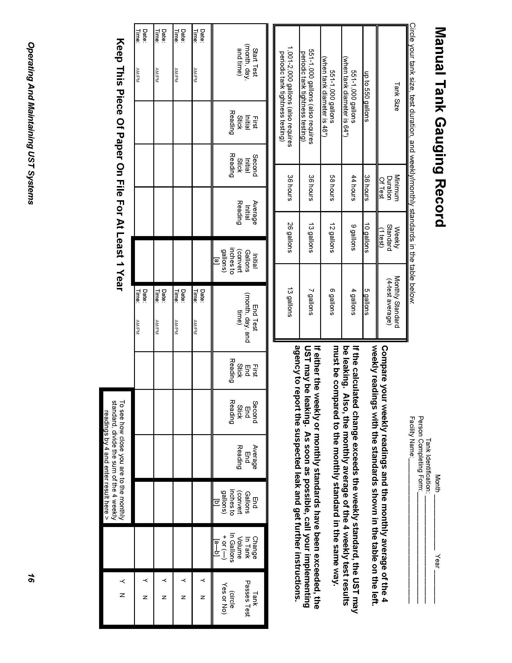

Manual Tank Gauging And Tank Tightness Testing
(for tanks 2,000 gallons or less only)
Description Of Release Detection | This temporary method combines manual tank gauging with periodic tank tightness testing. It may be used only for tanks of 2,000 gallons or less capacity. Manual tank gauging involves taking your tank out of service for the testing period (at least 36 hours) each week, during which the contents of the tank are measured twice at the beginning and twice at the end of the test period. The measurements are then compared to weekly and monthly standards to determine if the tank is tight. This combined method also includes tightness testing, a sophisticated test performed by trained professionals.  NOTE: This combination method can only be used temporarily for up to ten years after installing a new UST or for up to 10 years after your tank meets the corrosion protection requirements.
Have Certification For Your Release Detection Method | - Make sure your tank tightness testing is certified for the types of tanks and stored contents on which the tightness test is used. Most tightness test methods are certified by a third party to verify that they meet specific performance requirements set by regulatory agencies. If you don't have certified performance claims, have the tightness tester provide them to you.
Perform These  O&M  Actions | - Once a week, record two inventory readings at the beginning of the test, allow the tank to sit undisturbed for the time specified in the Manual Tank Gauging Record on page 16, and record two inventory readings at the end of the test (use any form comparable to the one on page 16).  - Reconcile the numbers weekly and record them on a Manual Tank Gauging Record (see page 16).  - See Section 3 of this manual if your tank fails the weekly standard.  - At the end of 4 weeks, reconcile your records for the monthly standard and record the result on a Manual Tank Gauging Record (see page 16).  - See Section 3 of this manual if your tank fails the monthly standard.  - Conduct a tank tightness test at least every 5 years. This testing needs to be conducted by a professional trained in performing tank tightness testing.  - See Section 3 of this manual if your tank fails the tightness test.  - Ensure that your measuring stick can measure to the nearest one-eighth inch and can measure the level of product over the full range of the tank’s height. You should check your measuring stick periodically to make sure that you can read the markings and numbers and that the bottom of the stick is not worn.  - Make sure employees who run, monitor, or maintain the release detection system know exactly what they have to do and to whom to report problems. Develop and maintain regular training programs for all employees.
Keep  These  O&M Records | - Keep your manual tank gauging records for at least 1 year. Unless you are recording actual release detection results at least weekly and every 30 days and maintaining records for at least 1 year, you are not doing leak detection right.  - Keep the results of your most recent tightness test.  - Keep all certification and performance claims for tank tightness test performed at your UST site for at least 5 years.

Automatic Line Leak Detection (for pressurized piping only)
Description Of Release Detection | Automatic line leak detectors (LLDs) are designed to detect a catastrophic release from pressurized piping. Automatic LLDs must be designed to detect a leak at least as small as 3 gallons per hour at a line pressure of 10 psi within 1 hour. When a leak is detected, automatic LLDs must shut off the product flow, restrict the product flow, or trigger an audible or visual alarm. NOTE: Mechanical automatic LLDs need to be installed and operated as close as possible to the tank (LLDs are designed to detect a leak, restrict flow, etc. only between the detector and the dispenser).
Have Certification For Your Release Detection Method | - Make sure your release detection equipment is certified for the types of piping and stored contents on which the release detection system is used. Most manufacturers have their leak detection devices tested and certified by a third party to verify that their equipment meets specific performance requirements set by regulatory agencies. If you don't have certified performance claims, have the manufacturer provide them to you.
Perform These  O&M  Actions | - Frequently test your automatic LLDs according to the manufacturer’s instructions to make sure it is working properly. Don’t assume that your release detection system is working and never needs checking. Some monitoring systems have a test or self-diagnosis mode.  - Periodically have a qualified UST contractor, such as the vendor who installed your release detection system, service all the system components according to the manufacturers’ service instructions. Components can wear out and must be checked periodically. Many vendors recommend or require this maintenance activity at least annually.  - See Section 3 of this manual if your LLD detects a leak.  - Make sure employees who run, monitor, or maintain the release detection system know exactly what they have to do and to whom to report problems. Develop and maintain regular training programs for all employees.
Keep  These  O&M  Records | - For at least a year, keep the annual test that demonstrates that the LLD is functioning properly.  - If used for monthly monitoring, keep results of your release detection system tests for at least 1 year. Your monitoring equipment system may provide printouts that can be used as records. Unless you are recording actual release detection results at least every 30 days and maintaining records for at least 1 year, you are not doing leak detection right.  - Keep all records of calibration, maintenance, and repair of your release detection equipment for at least 1 year.  - Keep all performance claims supplied by the installer, vendor, or manufacturer for at least 5 years. These records include the certification of your leak detection equipment described above.

Operating And Maintaining UST Systems 22

Line Tightness Testing (for piping only)
Description Of Release Detection | This method uses a periodic line tightness test to determine if your piping is leaking. Tightness testing can be performed by either a trained professional or by using a permanently installed electronic system (sometimes connected to an automatic tank gauging system).
Have Certification For Your Release Detection Method | - Make sure your line tightness testing or permanently installed electronic system is certified for the types of piping and stored contents on which the release detection system is used. Most tightness test methods and release detection equipment have been tested and certified by a third party to verify that the equipment or services meet specific performance requirements set by regulatory agencies. If you don't have certified performance claims, have the tightness tester or equipment manufacturer provide them to you.
Perform These  O&M  Actions | - If line tightness testing is used for pressurized piping, the test must be conducted at least annually.  - If line tightness testing is used for suction piping, the test must be conducted at least every three years. Safe suction piping as described at the bottom of page 3 may not need release detection testing.  - This tightness testing must be conducted by a professional trained in performing line tightness testing or by using a permanently installed electronic system.  - See Section 3 of this manual if your piping fails the tightness test or if the electronic system indicates a leak.  - Periodically have a qualified UST contractor, such as the vendor who installed your release detection system, service all the system components according to the manufacturers’ service instructions. Components can wear out and must be checked periodically. Many vendors recommend or require this maintenance activity at least annually.  - Make sure employees who run, monitor, or maintain the release detection system know exactly what they have to do and to whom to report problems. Develop and maintain regular training programs for all employees.
Keep  These  O&M  Records | - Keep results of your release detection system tests for at least 1 year. Your monitoring equipment may provide printouts that can be used as records. Unless you are recording actual release detection results at least every 30 days and maintaining records for at least 1 year, you are not doing leak detection right.  - If you use a permanently installed electronic system, keep all records of calibration, maintenance, and repair of your equipment for at least 1 year.  - Keep all performance claims supplied by the installer, vendor, or manufacturer for at least 5 years. These records include the certification of your leak detection equipment described above.

30-Day Release Detection Monitoring Record
(May be used for monitoring wells, interstitial monitoring, and automatic tank gauging)

Release Detection Method:___________________________________
Facility Name:___________________________________

Date | Your Name | UST System (Tank & Piping)  (Enter N for No Release Detected or Y for a Suspected  Or Confirmed Release)
Date | Your Name | UST # | UST # | UST # | UST #

Keep This Piece Of Paper And Any Associated Printouts On File For At Least 1 Year From The Date Of The Last Entry

