Implicit intent information for conflict detection and alerting
Victor Carreño, NASA Langley Research Center, Hampton, Virginia
César Muñoz, National Institute of Aerospace, Hampton, Virginia

Abstract
Conflict detection algorithms can be broadly classified as state based and intent based algorithms. State based algorithms predict the path of aircraft by projecting their current position and velocity vectors. The path predictions are then used to determine if the aircraft are in conflict within a look ahead time. That is, if loss of separation will occur in the future. Intent based algorithm use flight plans and other information, which usually resides in a flight management computer, to predict the path of aircraft. Algorithms that use intent information for conflict detection obtain the intent of other aircraft and broadcast their own intent via some type of communication link. Intent information that is exchanged among aircraft is defined as explicit intent. A conflict detection algorithm can also make use of intent information based on aircraft nominal routes, corridors, published approaches, etc., and in this case, there is no information exchange between aircraft. This kind of intent is defined as implicit intent. Implicit intent can be used very effectively in conflict detection without the added cost and complexity of communication links. The use of implicit intent, in combination with state information, reduces false alarms over a state based conflict detection algorithm and therefore increases the effectiveness of the alerting system. In this paper, conflict detection using implicit intent information is described and its performance is compared with a state based conflict detection algorithm.

Introduction
Conflict detection, alerting, and resolution is a critical part of on-board navigation tools. The trend from ground based towards airborne based navigation has sparked strong research and development in methods for conflict prediction, characterization, and analysis. The ultimate goal of conflict detection, alerting, and resolution is to provide safe separation for aerial vehicles in the national and international airspace.

Depending on the time range and distance, tools to maintain separation are called collision avoidance and conflict avoidance. Collision avoidance refers to short look ahead times and small protected zones: in the order of 20 to 30 seconds and half of a nautical mile respectively. Conflict avoidance includes times in the order of 1 minute to the duration of the mission and several miles to several thousand miles. Conflict avoidance can also be classified into tactical and strategic conflict avoidance. Tactical conflict avoidance is mainly used to prevent loss of separation. Strategic conflict avoidance uses other criteria such as routing, arrival flows, and scheduling to improve the performance of the airspace system.

Conflict detection is based on predicting the locations where aircraft are going to be for a given look ahead time. Various methods of predicting the location of an aircraft are used. These include state projection, probabilistic, worst case, and intended trajectory. State projection is the simplest method and uses the aircraft current location and velocity vector to calculate a future location [1][2]. Probabilistic methods calculate possible aircraft maneuvers based on aircraft performance and assigns probabilistic values to future location an aircraft could be [3]. Worst cases estimate the aircraft maneuvers that will cause the shortest separation between aircraft [4]. Intended trajectory creates the route of the aircraft using aircraft flight plans [5].

Conflict detection algorithms, which use intent information for trajectory prediction, must exchange flight plans, trajectory change points, and other information. The strategic intent based conflict detection and resolution proposed in [5] uses aircraft to aircraft data link for information exchange. We refer to these algorithms, which exchange their intended path, as explicit intent conflict detection.

The intent based conflict detection method described in this paper does not make use of information exchange to calculate the intended aircraft trajectory. It infers the aircraft trajectory from established data such as published routes and published approaches. We have called this implicit intent conflict detection. Obviously, this method can only be used where published data is available and loaded in the on-board navigation equipment. Implicit intent eliminates the need and associated cost, complexity, and communication bandwidth of the data link used in explicit intent conflict detection.

Intent based conflict detection has advantages over other conflict detection algorithms in moderately to highly constrained environments. In the terminal area, for example, where published approach data is readily available, intent based conflict detection significantly reduces the number of false alarms over state based conflict detection.

In the following sections, the implicit intent based algorithm is described and results of simulations, to compare the performance of intent and state based algorithms, are presented.

Implicit Intent Conflict Detection
Implicit intent conflict detection makes use of published data to predict aircraft future locations. An example of a generic FAA RNAV terminal area T approach is shown in Figure 1. An aircraft making an instrument approach to runway 18 will firsts proceed to one of the Initial Arrival Fixes (IAF) and then follow the pertinent segments of the approach.

Aircraft approaching from the upper quadrants (north side of the runway) will fly directly to waypoint TALIA and proceed to the intermediate and final segment. Aircraft approaching from the southeast quadrant will fly to waypoint BETSY and then proceed to base, intermediate, and final segments. Aircraft from the southwest will fly to waypoint GRACE, base, intermediate, and final segments. This information is used by the conflict detection logic to predict future aircraft locations.
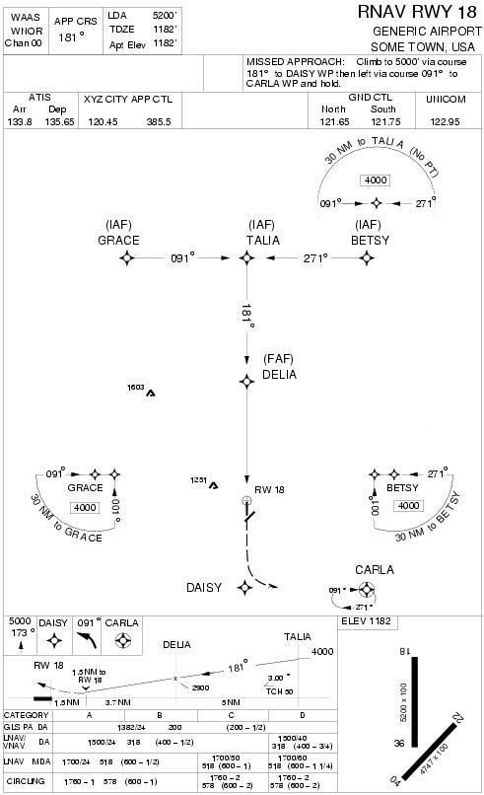
Figure 1. Terminal Area RNAV T Approach

Figures 2 and 3 show an aircraft on the base segment of the T approach and depict how the future location of the aircraft will be predicted. Figure 2 uses state based projection and Figure 3 uses implicit intent based projection. The intent projection is approximated by a sequence of straight segments. The length of the projection is determined by the look ahead time and the speed of the aircraft. The location of the aircraft at the look ahead time is represented by the “X” at the end of the projected segment.

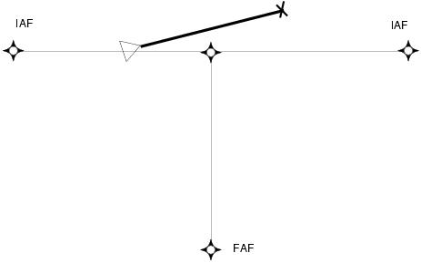
Figure 2. State Based Projection
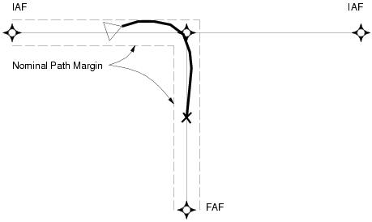
Figure 3. Explicit Intent Projection
The implicit intent conflict detection algorithm uses intent projection when the aircraft is flying a nominal path. When the aircraft diverts from its nominal path by more than a predetermined margin, then the implicit intent conflict detection algorithm reverts to state projection. In this sense, the algorithm is a hybrid conflict detection algorithm. The nominal path margin is illustrated in Figure 3.

A volume surrounding each aircraft is assigned to all aircraft in the airspace. This volume is called the protected zone. The conflict detection algorithm projects the protected zone of its own aircraft and all aircraft in the vicinity along the projected path. If the protected zones of two aircraft overlap along the predicted trajectories, then a conflict is detected.

The sensitivity of a conflict detection algorithm and as a result its safety and effectiveness is determined by the time values selected for its look ahead times and dimensions of the protected zone. In the experiment described in the next section, look ahead times and dimensions are parameters for the experiment.

Experiment
In order to compare different logics for conflict detection and alerting, a low fidelity simulation environment called ISABELLE (Intent and StAte Batch Experiments in Low fideLity Environment) was developed. ISABELLE has been written in Scilab which is a free scientific software package for numerical computations similar to Matlab.

The ISABELLE simulation environment provides:

- A low fidelity model of aircraft kinematics, where aircraft are represented as points in a 3-D space with a velocity vector.

- Two types of aircraft performances with speeds ranging from 60 to 170 knots.

- Path deviations, modeled by random uniform errors in speed, heading, and altitude.

- Pseudo-randomly generated nominal and non-nominal traffic.

- An interface for batch and interactive simulation that enables different settings of configurable variables.

The experiment covers 4 periods of 8 hours of operations. The airspace is defined by a 40 by 40 nautical miles square. Nominal traffic in this area flies a maximum deviation of 0.5 nautical miles horizontally and 200 feet vertically from a predefined trajectory configuration. The experiment considers two kinds of configurations:

- A Y configuration where two flows of aircraft come from different directions, merge in a common point, and then fly a shared segment, Figure 4.

- A T configuration where two flows of aircraft come from opposite directions, fly toward each other, and then fly parallel segments, Figure 5.

Note that the Y and T configuration not necessarily pertain to a terminal area. They could be the merging of routes at a waypoint. For the experiment, both aircraft flying the routes and non-nominal (off route) aircraft are simulated. Non-nominal traffic aircraft, such as aircraft AC1 and AC2 in Figure 4, fly randomly generated trajectories.

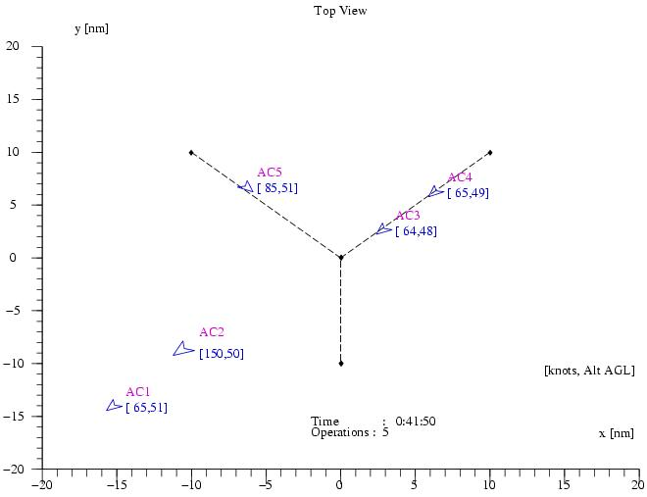
Figure 4. Y Configuration

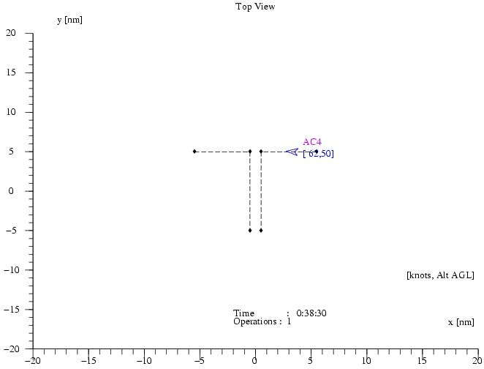
Figure 5. T Configuration
Traffic data, which include non-nominal traffic, are generated for each simulation period using simple uniform distributions. These distributions were chosen to exercise the detection logics and they do not correspond to actual distributions of traffic. In average, there were 50 nominal operations and 2 non-nominal operations per period. Figure 6 shows a typical distribution of traffic for a period of 8 hours of simulation (from 8:00h to 16:00h).
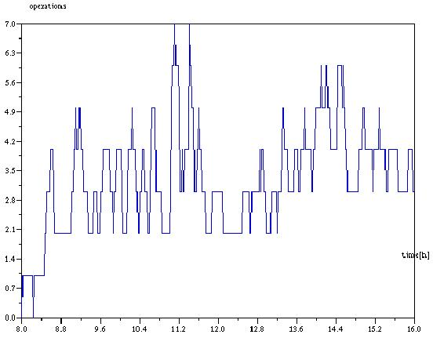
Figure 6. Eight Hours Traffic Distribution
On top of the aircraft kinematics model, ISABELLE introduces path deviations that model small navigation errors. In the case of nominal traffic, these errors are bounded by the maximum horizontal and vertical deviations for the predefined trajectory configuration.
Two different conflict detection and alerting logics are implemented in ISABELLE.

- State based: Trajectories for all traffic are predicted using linear projections of their current state.

- Hybrid: Trajectories of nominal traffic are predicted using the predefined trajectory configuration. Trajectories of non-nominal traffic are predicted using linear projections of their current state.

Conflicts that are time-wise short, i.e., about 2 seconds, are filtered out by the alerting logic. In a real system, this filtering mechanism is an effective way to cope with corrupted data. Finally, to be able to count false alarms, ISABELLE does not implement resolution maneuvers for aircraft in conflict. In case of violations, ISABELLE arbitrarily excludes one of the aircraft from the simulation.

Results
In the context of this experiment, the following concepts are defined.

- Protected zone: Cylindrical volume of diameter D and altitude H surrounding an aircraft.

- Violation: Loss of separation, i.e., overlap of the protected zones of two aircraft.

- Conflict: Predicted overlap of the protected zones of two aircraft.

- Caution: Conflict within a look ahead time Tc.

- Warning: Conflict within a look ahead time Tw.

- Alerts: Cautions and warnings issued by the alerting logic.

- False Alarm: Alerts without subsequent violation.

- Missed Alarm: Violation without preceding alert.

State and hybrid conflict detection logics are exercised and compared over the same data sets for different values of D, H, Tc, and Tw, and
different trajectory configurations. In total, the experiment consists of 288 simulations, each one of them covering 8 hours of operations for a specific configuration.

Figures 7 through 9 summarize the results for a Y configuration, while Figures 10 through 12 summarize the results for a T configuration. In all figures, the horizontal axis corresponds to the diameter of the protected zone, which varies from 0.5 to 3 nautical miles (actual data points are 0.5, 1, 2, and 3). The vertical axis corresponds to the ratio of false alarms with respect to the total number of alarms issued by the alerting logic. The smaller this ratio, the more effective the logic to avoid false alarms.

For each configuration, three different look ahead times are considered (a) Tc = 180 seconds and Tw = 60 seconds (Figures 7 and 10), (b) Tc = 60 seconds and Tw = 20 seconds (Figures 8 and 11), and (c) Tc = 20 seconds and Tw = 10 seconds (Figures 9 and 12).

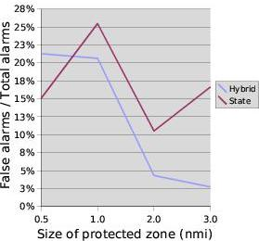
Figure 7. Y Configuration, Tc = 180 s, Tw = 60 s

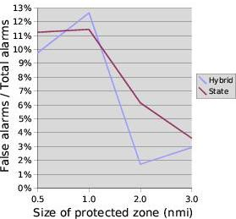
Figure 8. Y Configuration, Tc = 60 s, Tw = 20 s
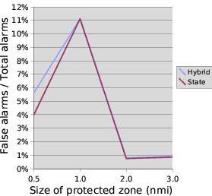
Figure 9. Y Configuration, Tc = 20 s, Tw = 10 s

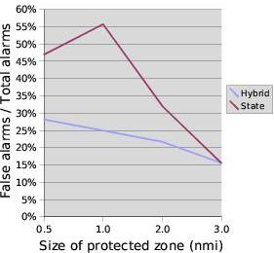
Figure 10.T Configuration, Tc = 180 s, Tw = 60 s

The figures show that the hybrid approach performs better than state only conflict detection. Furthermore, the ratio of false alarms to alarms of the hybrid algorithm is below 25% in all but one case. In contrast, the state based conflict detection algorithm may have a ratio as high as 55%. That is, in some cases, more than half of the alerts issued by the state based algorithm are false alarms.

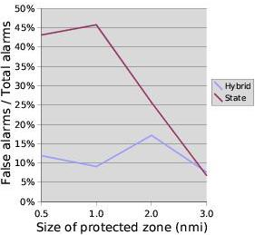
Figure 11. T Configuration, Tc = 60 s, Tw = 20 s

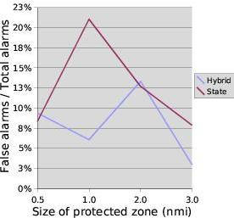
Figure 12. T Configuration, Tc = 20 s, Tw = 10 s

The configuration of the nominal trajectories seems to be a significant factor in the performance of an algorithm with respect to false alarms. Indeed, the difference in performance between the two conflict detection algorithms is less significant in the Y configuration than in the T configuration.
This is most likely due to the head on segments in the T configuration, which will cause alarms to be issued when an aircraft merges before another aircraft, but separation is not compromised. Furthermore, in parallel segments, small navigation errors could lead to state projections that intersect the opposite segment causing false alarms. In contrast, intent projections take into account that the paths are parallel.
The experiment also shows that, as expected, the shorter the look ahead time the smaller the ratio of false alarms. It is important to note that neither algorithm had missed alerts. All conflicts that lead to a loss of separation were detected by the hybrid and the state based algorithms.

Conclusions
This paper presented an innovative approach to conflict detection based on implicit intent combined with state projection. Implicit intent minimizes the communication exchange between aircraft. A preliminary experiment in a low fidelity simulation environment shows that the proposed hybrid approach is effective in reducing the number of false alarms. Implicit intent is an important component of the Conflict Detection and Alerting concept of NASA's Small Aircraft Transportation System (SATS) [6] project. The study presented in this paper is consistent with preliminary batch studies of the SATS concept [7]. Both studies show that a hybrid approach to conflict detection compares positively to state based approach with respect to false alarms. However, the results of these experiments should be considered as relative indicators rather than actual performances to be expected in a real deployment of a hybrid CD&A algorithm. High fidelity simulations and pilot-in-the-loop experiments are necessary to assess technical feasibility and safety issues of the proposed approach.

References

[1] K. Bilimoria; A Geometric Optimization Approach to Aircraft Conflict Resolution, AIAA Guidance, Navigation, and Control Conference & Exhibit, Denver, Colorado, AIAA 2000-4265, August 2000.
[2] G. Dowek, A. Geser, and C. Muñoz; Tactical Conflict Detection and Resolution in a 3-D Airspace, 4th USA/Europe Air Traffic Management R&D Seminar, New Mexico, Oct 2001.
[3] H. Kremer, B. Bakker, and H. Blom; Probabilistic versus Geometric Conflict Probing, Air Traffic Management Research and Development Seminar, Saclay, France, 1997.
[4] L. Rine, T. Abbott, G. Lohr, D. Elliott, M. Waller, and R. Perry; The Fllight Deck Perspective of the NASA Langley AILS Concept, NASA/TM-2000-209841, January, 2000.
[5] M. Ballin, V. Sharma, R. Vivona, E. Johnson, and E. Ramiscal; A Flight Deck Decision Support Tool for Autonomous Airborne Operations, AIAA Guidance, Navigation, and Control Conference & Exhibit, Monterey, California, August 2002.
[6] T. Abbott, K. Jones, M. Consiglio, D. Williams, C. Adams, Small Aircraft Transportation System, High Volume Operations Concept: Normal Operations, NASA/TM-2004-213022, 2004.
[7] M. Consiglio, C. Muñoz, and V. Carreño, Conflict Detection and Alerting in a Self Controlled Terminal Aerospace, 24th International Congress of the Aeronautical Sciences, Yokohama, Japan, 2004.

Scilab is available from http://scilabsoft.inria.fr.

