Preassessment Data Report #6:
Detection probabilities for bird carcasses on beaches of Unalaska Island, Alaska, following the wreck of the M/V Selendang Ayu

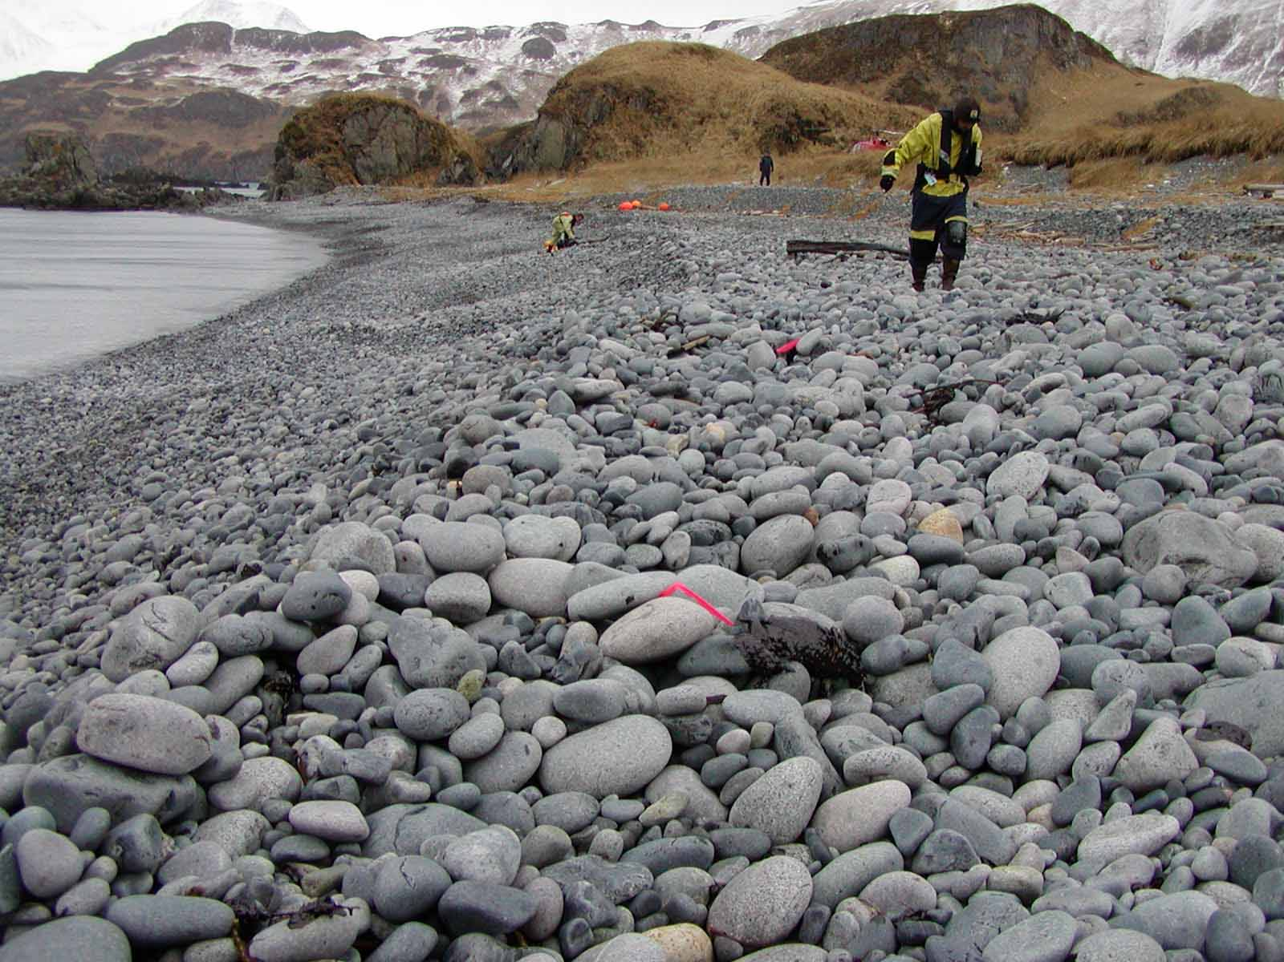

G. V. Byrd¹
J. H. Reynolds²

¹U. S. Fish and Wildlife Service, Alaska Maritime National Wildlife Refuge, 95 Sterling Highway, Suite 1, Homer, AK 99603
²U. S. Fish and Wildlife Service, Division of Natural Resources, MS-221, 1011 E. Tudor Road, Anchorage, AK 99503

This document should be referenced as:

Byrd, G.V. and J.H. Reynolds. 2006a. Detection probabilities for bird carcasses on beaches of Unalaska Island, Alaska, following the wreck of the M/V Selendang Ayu. U.S. Fish and Wildlife Service, Alaska Maritime National Wildlife Refuge, Homer, AK.

cover photo:
Carcass collection team on beach segment SKS 4, with flagged oiled bird carcass in the foreground, following the wreck of the M/V Selendang Ayu, Unalaska Island (photo taken 26 December 2004 by staff of the Alaska Maritime National Wildlife Refuge).
ABSTRACT

Bird carcass surveys were conducted as part of the pre-assessment phase of response to the M/V Selendang Ayu oil spill off the coast of Unalaska Island. The probability a survey team would detect an oiled carcass present on the beach was expected to be less than 100%. To estimate the detection probability a field study was conducted in which two survey teams each made two passes on a number of beaches. The probability of a single team detecting an oiled carcass on a single pass was then estimated using standard mark-recapture models. Less than 50% of all carcasses present on a beach segment were detected in a single pass by a survey team. The relatively low detection probability and low persistence rates (Byrd and Reynolds 2006b) indicate that only a very small proportion of all deposited carcasses were counted during beach searches on Unalaska Island.

INTRODUCTION

On 8 December 2004, the M/V Selendang Ayu ran aground and broke in half in rough seas off Unalaska Island, Alaska (53°38'N, 167° 07'W). An estimated 354,218 gallons of oil (339,538 gallons of bunker oil [IFO 380] and 14,680 gallons of marine diesel and miscellaneous oils) were discharged. Numerous bird carcasses were recovered during beach searches in the months following the spill as part of the typical pre-assessment phase of response to an oil spill, which includes collecting data from which to estimate the total number of animals affected by the event (Ford et al., 1987; Page et al., 1990; Piatt et al., 1990; Burger, 1992a, Flint et al. 1999). Recovered carcasses represent only a fraction of the total number deposited on beaches (Flint et al. 1999)

Carcasses found by observers on a specific beach at any given time after a mortality event are a result of three processes: (1) the rate at which carcasses are deposited on beaches, (2) their persistence once on the beach, and (3) the probability of observers detecting them when surveying the beach (Flint et al. 1999). These components vary depending on site and environmental characteristics present in each specific mortality event. For example, carcass deposition rate can vary with factors such as beach type (Bodkin and Jameson, 1991, Flint et al. 1999), persistence rates can vary with factors such as beach type, time since deposition, weather, tidal activity, carcass size and scavenger activity (Bodkin and Jameson, 1991; Burger, 1992b, 1993; Van Pelt and Piatt, 1995, Ford et al. 1996, Fowler and Flint 1997, Ford in press), and detection probabilities can vary with factors such as beach type and weather conditions like presence or absence of snow (Fowler and Flint 1997).

Detection probability is specifically defined as the probability that a carcass known to be on the beach will be found by a searcher. Detection probabilities of carcasses can be estimated using mark-recapture (Pollock et al., 1990).

This report summarizes carcass detection probability estimates for beach surveys on Unalaska Island, Alaska in January 2005. Carcass persistence rate estimates are reported in a companion document (Byrd and Reynolds 2006b).

Methods

Study Design

Following a reconnaissance, all beaches in the oil spill area were classified to one of four types: exposed – high impact beaches normally exposed to waves, often with steep angles indicating frequent impacts; catchment – beaches with areas where large amounts of debris had accumulated; protected – beaches not normally exposed to waves from the open sea; unavailable – segments that were either too short (< 100m) or not safely accessible by the Tiglax-based crew. . The spill area was comprised of 18% exposed beaches, 6% catchment, 31% protected, and 45% non-accessible coast (cliffs or other unwalkable segments of coastline). Beach segments were defined based on physical shore zone character following Owens and Sergy (2000).

Resources allowed implementation of the detection study on a maximum of five beach segments. Five beach segments were selected from the stratified random sample of exposed, catchment, and protected beaches selected for the Tiglax-based beached animal surveys (Byrd et al. 2005). The detection study selection was stratified in order to assess effects of beach type. The five beaches were purposively selected within each strata so that there were two exposed, one catchment, and two protected.

All beach surveys were conducted by three-person teams. Two teams (each with three members) of trained observers were used to conduct the detection study during the last few days of the first week of the pre-assessment beach surveys. The teams followed regular beach survey protocol during the detection study (Byrd et al. 2005). The detection study employed carcasses where they were naturally deposited on each study beach rather than artificially placed carcasses.

The probability that a carcass present on a beach was detected by a team on a single survey was estimated using a slight modification of the protocol outlined in Nichols et al. (2000). One team made a single pass of the selected beach segment, searching for carcasses in the normal method employed for the Pre-Assessment beach surveys (Byrd et al. 2005). Rather than immediately collecting carcasses, the team recorded each carcass’ location and subtly marked it in a manner which would not increase detection, e.g., by place flagging underneath the carcass or a nearby large rock or log so that it could not be seen, and then clearly noted its location in field notes or using a GPS receiver. The second team, having not watched the first team’s efforts, searched the same beach segment using the same process, again marking and leaving each detected carcass in place as described for the first team. Each team then independently repeated the search, making a second pass back down the beach segment, again leaving each detected carcass in place after recording its location, recording whether or not it was already marked, and by whom, and, if unmarked, subtly marking it in a manner which would not increase detection. After both teams had made two independent passes, all carcasses were collected. This design produced a set of detected carcasses each with two detection histories: one from each team’s two passes.

Analysis

Conditional on the number of carcasses detected in a beach segment, the dual-detection histories follow a Cormack-Jolly-Seber design for a closed population, allowing use of standard mark-recapture models for estimating mean detection rate (Pollock et al. 1990).
Nine models were considered, allowing for potential variation in detection probability (P) across beaches, across beach type (Catchment, Protected, Exposed), across team (1 or 2), and/or across survey pass (first, second).

Pbtp detection probability varies with b - Beach, t- Team, and p - Pass.
Pbttp detection probability varies with bt - Beach Type, Team and Pass;
Pb.p detection probability varies with Beach and Pass, remains equal across Teams;
Pbt.p detection probability varies with Beach Type and Pass, remains equal across Teams;
Pbtt. detection probability varies with Beach Type and Team, remains equal across Passes;
P.tp detection probability varies with Team and Pass, remains equal across Beaches;
Pbt.. detection probability varies with Beach Type, remains equal across Teams and Passes;
P..p detection probability varies with Passes, remains equal across Beaches and Teams;
P... detection probability remains equal for each Beach, Team and Pass.

Each model was fit, using maximum likelihood methods, in program MARK (White and Burnham 1999). When there were competing plausible models, model selection uncertainty was accounted for in the parameter estimates, standard errors and confidence intervals by model averaging using AIC (Akaike Information Criteria) weights (Burnham and Anderson 2002). Summary graphs were made in S-Plus 6.2 (Insightful, Inc., Seattle, WA.).

Results

Detection studies were conducted on 5 beach segments (Appendix 1). However, data from the catchment and protected beaches were pooled for analysis due to the small number of carcasses found. Thus the beach type factor was redefined as Catchment/Protected versus Exposed.

Models P..p and P.tp were identified as the best (Table 1), demonstrating detection systematically varied with pass and among teams. Not surprisingly, detection probability increased on the second pass, roughly from 40% to 70% (Table 2, Figure 1). While statistically significant, the magnitude of the effect of team was inconsequential compared to the effect of pass (Figure 1, Table 2). The estimated detection rate for a beach survey team making a single pass was 41% (weighted average of first pass detection probabilities across teams and beaches using weights proportional to 1/(standard error)^2, Table 2).

DISCUSSION

Carcass detection probability was less than 100% on every beach survey (Table 1). This was also observed in the only other oil spill study to estimate carcass detection probability by searching for naturally deposited carcasses in a spill zone (Fowler and Flint 1997). A single search by either team is estimated to detect less than half the carcasses known to be present (Table 2).

Bird carcass detection probabilities in natural habitats have been reported ranging from 45-93%, with generally lower probabilities on beaches than in other terrestrial habitats (Tobin and Dolbeer 1990, Philibert et al. 1993, Linz et al. 1991, Fowler and Flint 1997).

Considering detection on just beaches, the estimates reported here are lower than those reported in a study of king eider carcasses (Fowler and Flint 1997). This is likely due to study differences in carcass size and cryptic coloration. Most carcasses in the current study were of species with smaller bodies than king eiders. Additionally, most “carcasses” in the current study were heavily scavenged and consisted of only a few fragments, such as a wing, which were much more difficult to detect compared to a large, fresh and intact whole bird.

Detection probability did not vary significantly across beach type (Catchment/Protected vrs Exposed) (Table 1). While detection probability varied significantly across search teams, the effect was relatively small (Table 2) compared to that reported in other studies (Tobin and Dolbeer 1990, Philibert et al. 1993, Linz et al. 1991).

Conclusions and Recommendations

The relatively low detection probabilities and low persistence rates (Byrd and Reynolds 2006b) indicate that only a very small proportion of all carcasses would be counted during beach searches on Unalaska Island. These results emphasize the importance of estimating these parameters for each incident as such estimates are essential for modeling total mortality associated with specific events (Flint et al. 1999).

ACKNOWLEDGEMENTS

Paul Flint made essential contributions to this report. Tremendous thanks to the following individuals for the their assistance in the pre-assessment studies and in reviewing the report: the crew of the R/V Tiglax - Kevin Bell, Dan McNulty, Dennis Haunschild, John Faris, Dan Erickson, Joe Isenhour, Bob Ward, Eric Nelson; Jeff Williams, Leslie Slater, Becky Howard, Bill Schaff, Greg McClelland, Ty Wyatt, Janis Krukof, Kent Sundseth, Jeff Lewis, Cris Dippel, Andy Aderman, Don Dragoo, Arthur Kettle, Greg Thomson, Steve Kendall, Gary Wheeler, Pat Walsh, Fred Broerman, Ken Gates, Kristine Sowl, Thomas Siekaniec, Clay McDermott, Delia Person, Michael Winfree, Suzann Speckman, Merban Cebrian, Jennie Wetzel, Ingrid Harrald, and R. Glenn Ford.
REFERENCES

Bodkin, J. L., and R. J. Jameson. 1991. Patterns of seabird and marine mammal carcass deposition along the central California coast, 1980-1986. Canadian Journal of Zoology 69:1149-1155.

Burger, A. E. 1992a. The effects of oil pollution on seabirds off the west coast of Vancouver Island. In The Ecology, Status, and Conservation of Marine and Shoreline Birds on the West Coast of Vancouver Island (K. Vermeer, R. W. Butler & K. H. Morgan, eds.), pp. 120-128. Occasional Paper No. 75, Canadian Wildlife Service, Ottawa, Canada.

Burger, A. E. 1992b. Beached bird surveys in British Columbia, annual report, March 1992. Unpubl. rep., Emergency Services Branch, British Columbia Environment, Victoria, BC, Canada, 27 pp.

Burger, A. E. 1993. Beached bird surveys in British Columbia, annual report, March 1993. Unpubl. rep., Emergency Services Branch, British Columbia Environment, Victoria, BC, Canada, 19 pp.

Burnham, K. P., and D. R. Anderson. 2002 . Model Selection and multimodel inference: a practical information-theoretic approach. Second edition. Springer-Verlag, New York Inc., New York, New York.

Byrd, G.V., J. Reynolds, G. Ford, J. Piatt, and P. Flint. 2005. Beached animal surveys near the wreck of the Selendang Ayu on Unalaska Island, Alaska: a pre-assessment plan. U.S. Fish and Wildlife Service, Alaska Maritime National Wildlife Refuge, Homer, Alaska.

Byrd, G. V., and J. H. Reynolds. 2006b. Persistence rates of bird carcasses on beaches of Unalaska Island, Alaska, following the wreck of the M/V Selendang Ayu. U.S. Fish and Wildlife Service, Alaska Maritime National Wildlife Refuge, Homer, Alaska.

Flint, P. L., A. C. Fowler, and R. F. Rockwell. 1999. Modeling losses of birds associated with the oil spill from the M/V Citrus off St. Paul Island, Alaska. Ecological Modeling 117:261-267.

Ford, R. G., G. W. Page, and H. R. Carter. 1987. Estimating mortality of seabirds from oil spills. In Proceedings of the 1987 Oil Spill Conference, pp. 747-751. American Petroleum Institute, Washington, DC, USA.

Fowler, A. C., and P. L. Flint. 1997. Persistence rates and detection probabilities of oiled King Eider carcasses on beaches of St. Paul Island, Alaska. Marine Pollution Bulletin 34:522-526.

Linz, G. M., J. E. Davis, R. M Engeman, D. L. Otis, and M. L. Avery. 1991. Estimating survival of bird carcasses in cattail marshes. Wildlife Society Bulletin 19:195-199.
Nichols, J. D., J. E. Hines, J. R. Sauer, F. W. Fallon, J. E. Fallon, and P. J. Heglund. 2000. A double-observer approach for estimating detection probability and abundance from point counts. The Auk 117: 393-408.

Page, G. W., H. R. Carter, and R. G. Ford. 1990. Numbers of seabirds killed or debilitated in the 1986 Apex Houston oil spill in central California. Studies in Avian Biology 14:164-174.

Philibert, H., G. Wobeser, and R. G. Clark. 1993. Counting dead birds: examination of methods. Journal of Wildlife Diseases 29:284-289.

Piatt, J. F., C. J. Lensink, W. Butler, M. Kendziorek, and D. R. Nysewander. 1990. Immediate impact of the Exxon Valdez oil spill on marine birds. Auk 107:387-397.

Pollock, K. H., J. D. Nichols, J. E. Hines, and C. Brownie. 1990. Statistical inference for capture-recapture experiments. Wildlife Monographs 107:1-97.

Tobin, M. E., and R. A. Dolbeer. 1990. Disappearance and recoverability of songbird carcasses in fruit orchards. Journal of Field Ornithology 61:237-242.

Van Pelt, T. I., and J. F. Piatt. 1995. Deposition and persistence of beachcast seabird carcasses. Marine Pollution Bulletin 30:794-801.

White, G. S., and K. P. Burnham. 1999. Program MARK: survival estimation from populations of marked birds. Bird Study (supplement):120-138.

Table 1. Model selection for probability of detecting bird carcasses found at Unalaska Island study sites, Alaska in January 2005. AIC is the Akaike Information Criterion (Burnham and Anderson 2002).
Model | AIC | Delta AIC | AIC Weight | Model Likelihood (Relative) | Parameters
P..p | 297.52 | 0 | 0.64 | 1.000 | 2
P.tp | 300.13 | 2.60 | 0.17 | 0.272 | 4
Pbt.p | 301.62 | 4.09 | 0.08 | 0.129 | 4
Pbtp | 301.67 | 4.14 | 0.08 | 0.126 | 12
Pb.p | 305.52 | 7.99 | 0.01 | 0.018 | 6
Pbttp | 306.61 | 9.09 | 0.01 | 0.011 | 8
P… | 315.13 | 17.61 | 0.00 | 0.00 | 1
Pbt.. | 317.15 | 19.63 | 0.00 | 0.00 | 2
Pbtt. | 320.41 | 22.89 | 0.00 | 0.00 | 4
Table 2. Estimated detection probabilities for bird carcasses on beaches at Unalaska Island, Alaska in January 2005, based on AIC-weighted model-averaging (Table 1).
Beach | Pass | Team | Detection Probability | Standard Error | 95% Confidence Interval | % Variation attributable to Model Uncertainty
CNB 3,10,19 | 1 | 1 | 0.400 | 0.066 | 0.280, 0.534 | 8.18
 |  | 2 | 0.423 | 0.069 | 0.300, 0.557 | 7.56
 | 2 | 1 | 0.705 | 0.063 | 0.568, 0.811 | 9.73
 |  | 2 | 0.708 | 0.064 | 0.569, 0.817 | 19.35
KFP 9 | 1 | 1 | 0.396 | 0.064 | 0.278, 0.526 | 16.65
 |  | 2 | 0.436 | 0.070 | 0.306, 0.575 | 27.40
 | 2 | 1 | 0.683 | 0.076 | 0.519, 0.811 | 46.19
 |  | 2 | 0.710 | 0.065 | 0.569, 0.820 | 36.09
KFP 10 | 1 | 1 | 0.402 | 0.055 | 0.300, 0.514 | 8.51
 |  | 2 | 0.421 | 0.055 | 0.317, 0.531 | 7.78
 | 2 | 1 | 0.721 | 0.059 | 0.593, 0.820 | 34.56
 |  | 2 | 0.683 | 0.059 | 0.558, 0.786 | 27.7
Figures
1. Model-averaged detection probabilities (Table 2) by Beach (panel), Pass (horizontal axis), and Team: for each pass, Team 1 is shown to the left, Team 2 to the right. The effect of team and beach is minor compared to the effect of pass. CNB beaches 3, 10 and 19 were pooled for analysis. CNB – Cannery Bay beach segments; KFP – southern shore of Makushin bay, east of Cape Starichkof.

Figure 1.
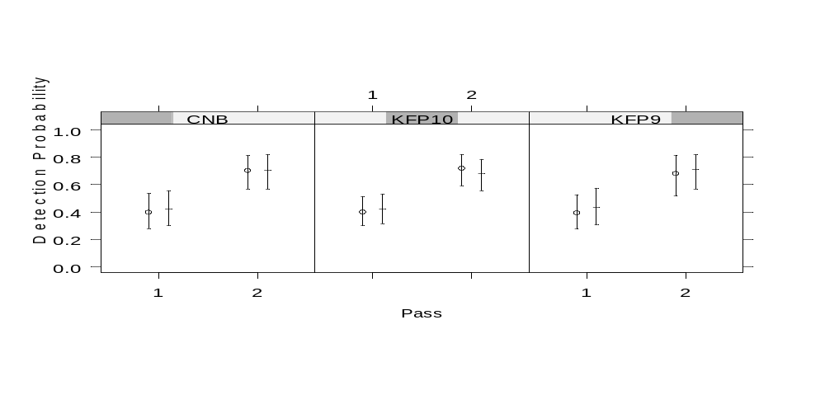

Appendix 1. Summary of bird carcasses detected at study beaches on Unalaska Island, Alaska, January 2005, by beach segment and team. Each team made two passes, classifying each detected carcass as: YY – Detected on both passes; YN - detected on first pass, not on second; NY – not detected on first pass, detected on second; and NN – not detected on either pass. Beach segments are identified in Byrd et al. (2005); CNB – Cannery Bay, KFP – southern shore of Makushin Bay, east of Cape Starichkof.

CNB 19 | Protected | Team 2
 |  | YY | YN | NY | NN | Total
Team 1 | YY | 2 | 0 | 0 | 0 | 2
Team 1 | YN | 0 | 0 | 0 | 0 | 0
Team 1 | NY | 0 | 0 | 0 | 0 | 0
Team 1 | NN | 0 | 0 | 0
 | Total | 2 | 0 | 0

CNB 3 | Protected | Team 2
 |  | YY | YN | NY | NN | Total
Team 1 | YY | 0 | 0 | 0 | 0 | 0
Team 1 | YN | 0 | 0 | 0 | 0 | 0
Team 1 | NY | 0 | 0 | 0 | 0 | 0
Team 1 | NN | 0 | 0 | 1
 | Total | 0 | 0 | 1

CNB 10 | Protected | Team 2
 |  | YY | YN | NY | NN | Total
Team 1 | YY | 1 | 0 | 0 | 0 | 1
Team 1 | YN | 0 | 1 | 0 | 0 | 1
Team 1 | NY | 0 | 0 | 4 | 0 | 4
Team 1 | NN | 0 | 0 | 2
 | Total | 1 | 1 | 6

CNB 3, 10, 19 | Catchment / Protected | Team 2
 |  | YY | YN | NY | NN | Total
Team 1 | YY | 3 | 0 | 0 | 0 | 3
Team 1 | YN | 0 | 1 | 0 | 0 | 1
Team 1 | NY | 0 | 0 | 4 | 0 | 4
Team 1 | NN | 0 | 0 | 3
 | Total | 3 | 1 | 7

KFP 10 | Exposed | Team 2
 |  | YY | YN | NY | NN | Total
Team 1 | YY | 11 | 0 | 2 | 1 | 14
Team 1 | YN | 0 | 1 | 0 | 0 | 1
Team 1 | NY | 2 | 0 | 0 | 5 | 7
Team 1 | NN | 2 | 0 | 3
 | Total | 15 | 1 | 5

KFP 9 | Exposed | Team 2
 |  | YY | YN | NY | NN | Total
Team 1 | YY | 3 | 0 | 0 | 0 | 3
Team 1 | YN | 0 | 0 | 0 | 0 | 0
Team 1 | NY | 0 | 0 | 1 | 0 | 1
Team 1 | NN | 1 | 1 | 3
 | Total | 4 | 1 | 4

