RCG-45
Impulse Noise Interference Effect on Binary Detection

Introduction
In a radar system employing automatic detection, the processing may be divided into two general classifications; signal processing and data processing. The signal processing is performed on a radar scan-by-scan basis and usually employs dedicated hardware capable of handling high computational data rates. The signal processing algorithms generate target reports (plots). These reports are then processed by the data processor and target tracks are generated.
When the data processing is employed within scanning radar, this combination is known as a Track-While-Scan (TWS) radar system. The data processing portion of a TWS radar system removes residual stationary clutter and false target reports that are not eliminated for CFAR, Doppler or MTI and provides more accurate determination of the target's position and velocity vector. The data processing handles the tracking function of radar and can be segmented into:
- Track initiate (Tentative track)
- Target Confirmation
- Track filtering and estimation
- Target maneuver-following logic
- Target correlation logic
The definition of radar target tracking is the prediction of the future trajectory of an object based on its past states. The accuracy of the predictions is dependent on how accurate a target’s past and present positions can be measured. Due to clutter and other limitations of the sensors and the signal processing algorithms, the positions of a target cannot be measured with perfect accuracy. The measurements can exhibit different random characteristics, and they can be biased depending on a target’s angle and its relative position to the radar. The fact that a target such as a fast aircraft may thrust, yaw, pitch, and roll, and that it may deviate from a constant velocity trajectory due to aircraft control and turbulence makes target tracking all the more difficult.
This analysis intends to show that the preferred method for radar test scenarios is one that is based upon the use of single pulse probability of detection and non-fluctuating (Swerling case zero) target model.

Track Initiate
Track initiate⁽²⁾ is the process of starting a track file on a new target after it is detected. The process starts with detection of a target whose reported position does not qualify as an update to an existing track. A tentative new track file is established using the initial reported location (coordinates), and a large enough correlation-gate is centered on that position to include the motion dynamics of any possible target the system is designed to detect and track. The tentative track is confirmed if M detections are received within the correlation gate over the next N scans (three out of four, or three out of five for example). Once confirmation has occurred, the tentative track file parameters become those of the new track file.
In an automatic system, the first step is to eliminate targets associated with stored stationary clutter points and those utilized in updating existing tracks. The remaining target reports are entered into tentative track files. Tentative tracks are either new targets entering the radar coverage volume or anomalous (spurious detection) targets that have been caused by noise, clutter, or interference. The validity of these targets must be confirmed before being registered as a firm track.

Example IMO Target Detection Requirements
The International Maritime Organizations’ (IMO)⁽⁵⁾ requirement for radar system detection in clear conditions, in the absence of sea precipitation and evaporation duct clutter and with an antenna height of 15 m above sea level, for long range target and shoreline detection is based on:
- an indication of the target in at least 8 out of 10 scans or equivalent; and
- a probability of a radar detection false alarm of 10⁻⁴,
This requirement is to be met as specified for X-Band and S-Band radar equipment. The detection performance should be achieved using the smallest antenna that is supplied with the radar system. It is important to note that the requirements can be interpreted to use M/N rank order (M-out-of-N) detection criteria.

M-Out-of-N Binary Detection
The M-Out-of-N (M/N) detection⁽¹⁾⁽⁴⁾ is a method based on threshold detection. This method uses an algorithm that declares target detection if a signal is reported to cross, at regular intervals, the same threshold M times out of N examination periods. This is why the M-out-of-N detection is sometimes referred as “Double Threshold Detection” and “Binary Integration”.
The M/N detection technique is as follows for each radar resolution cell:
- A first threshold 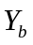 is established for the individual samples.
- The number of samples (m) exceeding is counted.
- A second threshold M, a counter of N examination periods, is established. A target is declared in the given resolution cell if 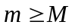.

Performance in Gaussian Noise Plus Impulse Noise
The M/N detection is effective against impulse noise. Some of the physical causes of impulse noise are:
- Pulse interference from other radars
- High and variable PRF radar signals
- High amplitude radar clutter

Mathematical Model/Procedure
In the development of the model the following assumptions are made:
- The impulse received in any given resolution cell is purely random
- Each resolution cell, for each sample, has probability 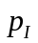 of containing an impulse
- The occurrence of the impulse is independent from cell to cell and from sample to sample
- The samples are individual pulses out of an envelope detector (a square-law detector is used). Other types of detectors maybe used, if so the value of will be different.
- A given resolution cell for a given sample may contain:
- Gaussian noise only.
- Gaussian noise plus impulse noise.
- Gaussian noise plus target signal.
- Gaussian noise plus impulse noise plus target signal.
The following are the definitions of variables used in the equations:

: | Average Signal-to-Noise ratio per sample for fluctuating target
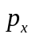: | Probability that a sample of Gaussian noise plus target exceeds the first threshold
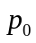: | Probability that a sample of Gaussian noise only exceeds ( for x=0)
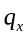: | Probability that a sample of Gaussian noise plus impulse noise plus target exceeds , given that the sample is affected by impulse noise
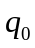: | Probability that a sample of Gaussian noise plus impulse noise exceeds , given that the sample is affected by impulse noise ( for x=0)
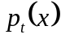: | Total probability that a sample containing a target with SNR=x exceeds
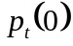: | Total probability that a sample not containing a target exceeds
: | Probability that a sample will be affected by impulse noise
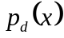: | Probability of target detection with 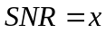
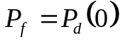: | False alarm probability 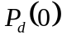

From the above definitions the equations for and may be written as

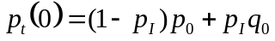, and | (1)
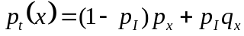 | (2)

A simplifying assumption can be made where;
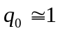, and | (3)
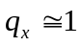. | (4)

This simplifying assumption means that the impulse noise always has amplitude sufficiently high (an example would be the impulse noise generated by a near by pulsed radar system) so that a sample containing impulse noise will exceed the first threshold with probability near unity whether or not a target is also present.
Using the formulas for Binomial trials⁽³⁾, then

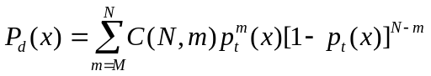 | (5)
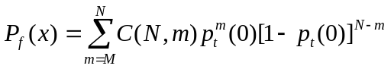 | (6)
Where
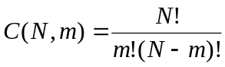 | (7)

For the probability that a sample is not affected by impulse interference, P_{I} is zero, and the equations can be simplified as follows

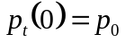, and | (8)
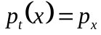 | (9)

The formulas for Binomial trials simplify to

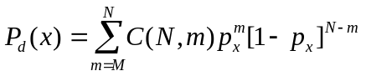 | (10)
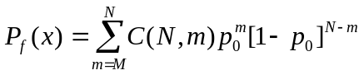 | (11)

Assuming a square law detector, the calculation of the necessary first threshold level is obtained from the formula

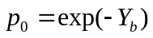, or | (12)
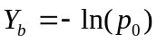 | (13)

Where ( for x=0) is the probability that a sample of Gaussian noise only exceeds the threshold voltage . is calculated iteratively from equation 11 and equation 1.
The average signal to noise ratio may be calculated using Barton’s method as outlined in reference 2.

Results
The analysis is conducted for two cases. The first case, Case 1, is for the IMO 8-Out-of-10 Binary detection with the probability of impulse interference increasing from zero to approximately 20%. This case is designed to show that, as expected, the required signal to noise plus impulse interference ratio (S/N+I) increases as the impulse interference is increased. The probability of detection is calculated using the Barton and Barton⁽⁴⁾ approximation for n-pulse detection at a background of white Gaussian noise when the envelope of signal plus noise follows a Rician distribution⁽³⁾. In this case the number of pulses is one.
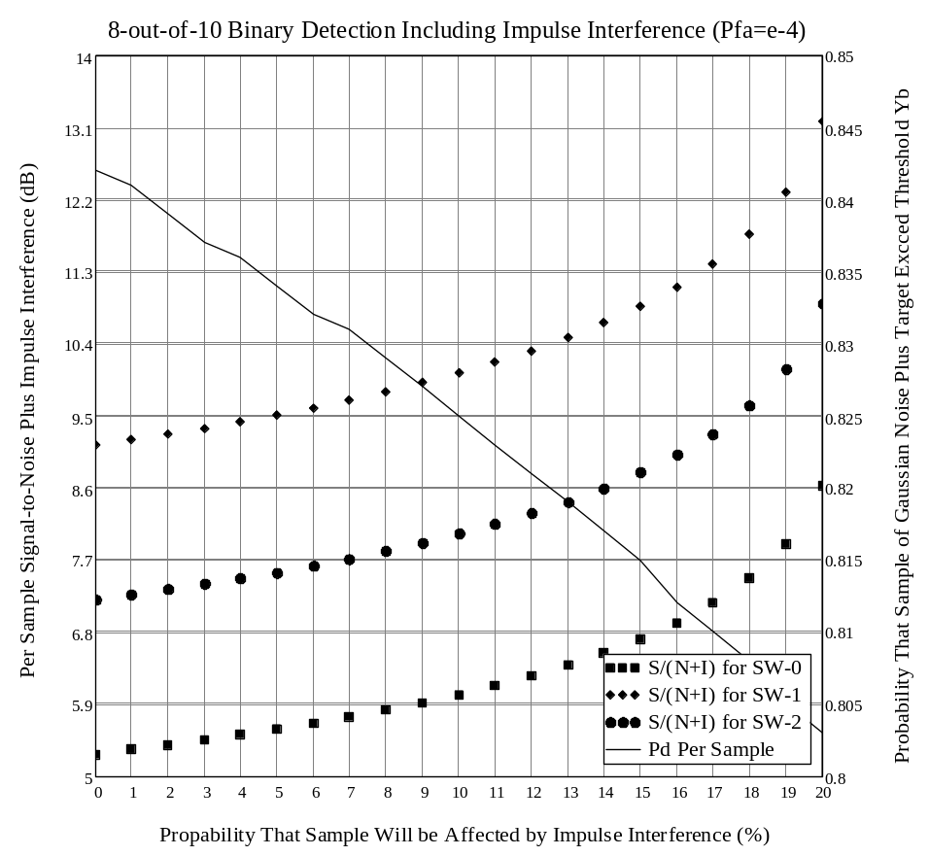
Figure 1: Case 1 - Signal/(Noise+Impulse) Interference versus Pd is Affected by Impulse Interference for M/N (8/10). P_{d}=0.8 & P_{f}=1e-4
Case 2 is designed to quantify the value of M, the optimum number of pulses that is required to give the required probability of detection with and without interference. In this case the probability of interference is set to either zero, for S/N without interference, or 10% for S/(N+I). The maximum number of pulses is set to N=30.. Optimum M is defined as the smallest value of the ratio, S/(N+I), that is required to achieve the design probability of detection for different Swerling models. Optimum M increases when impulse interference is increased.
Figure 2: Case 2 - M/N=30 versus Pd for Two Cases for Final P_{d}=0.90 & Final P_{f}=1.16e-7
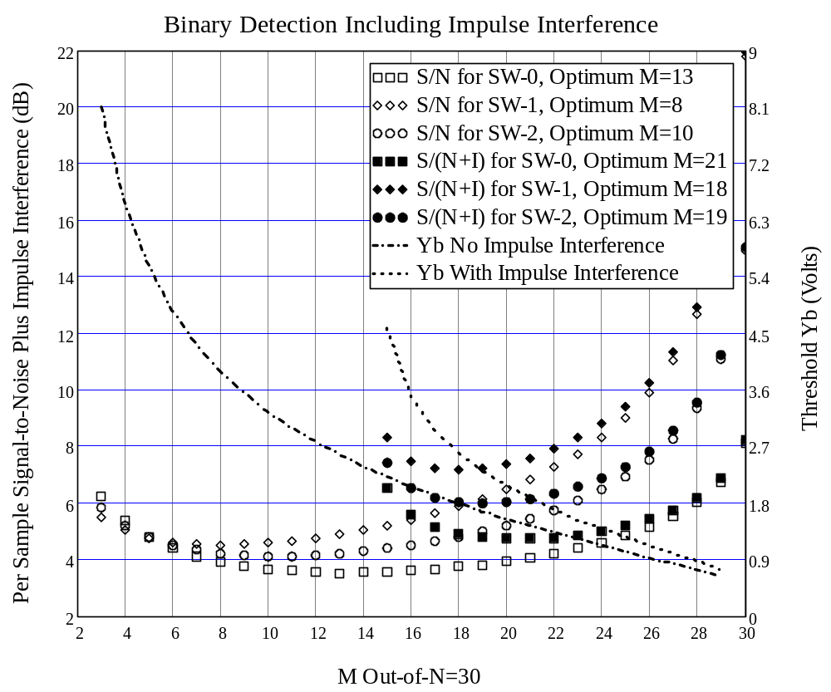

Case-1 and Case-2 demonstrate the difficulties with this type of analysis

Analysis Conclusions
The following conclusions can be drawn from the analysis of case-1 and case-2:
- The optimum M, where the signal-to-noise plus interference is minimum, depends on N, , and target fluctuation properties.
- Calculating the optimum M when impulse interference is present is complex.
- Estimating the probability of impulse interference per pulse that is required to degrade the overall probability of detection is a time consuming iterative process.
- It is much simpler to use the overall radar probability of detection than to try and calculate the per pulse SNR degradation required for a given impulse interference probability.
- The required detection threshold decreases as the number of M detections is increased.
- The required detection threshold increases as the probability of impulse interference is increased.
- Only impulse noise is considered. Other types of noise interference, such as that from wireless telephony and data communication systems, will result in increasing the overall system noise floor and thereby reducing target range and probability of detection.
- Using non-fluctuating target model (Swerling case zero) is preferred to eliminate the need for higher signal to noise ratios that are necessary for target fluctuation.

Recommendation
The analysis of Binary detection is complex, especially when the number of pulses is high. The preferred method for radar test scenarios and interference analysis/simulations is one that is based upon the use of single pulse probability of detection for a non-fluctuating (Swerling case zero) target model.

References
- D. K. Barton, Modern Radar System Analysis, Artech House, 1988.
- D. Curtis Schleher, Automatic Detection and Radar Data Processing, Artech House, 1980.
- S. Leonov and A leonov, Handbook of Computer Simulation in Radio Engineering, Communications, and Radar, Artech House, 2001.
- H. Urkowitz, Radar Detection Theory, GE Aerospace, Pre-published book notes, Chapter-22, 1992.
- IMO Resolution MSC.192(79), Annex 34 (Adopted On 6 December 2004), Adoption Of The Revised Performance Standards For Radar Equipment. www.imo.org (Section 4.0807, Navigational equipment and other aids)

