ATTACHMENT: the proposal

QUICK HIGHWAY INCIDENT DETECTION AND
INCIDENT WARNING SYSTEMS

PROBLEM STATEMENT

Highway incidents have been a major cause of highway congestions (for example, up to 75% of delays on freeways caused by incidents), and also a major source for secondary crashes, due to sudden slowdown or stopped traffic.

It has been proven in incident management practices that the early detection, quick response, and warnings to upstream traffic are the most effective ways to reduce the negative impacts of incidents, such as delays and secondary crashes.

However, due to the constrains in deployment cost, many existing incident detection and warning systems, deployed by DOTs and local traffic agencies, are not effective for early detection and quick response. Therefore, the performance of the systems has not been effective on reducing delays and avoiding secondary crashes caused by incidents.

One of the major reasons of the ineffectiveness is the spacing of the devices. Normally, detection stations and dynamic warning signs are placed with the intervals about ¼ to one mile. When an incident occurs, the existing incident algorithms have to wait until the slow traffic back up to the adjacent upstream detection stations for determining the occurrence of the incident. In practice, five to seven minutes on average are needed to detect an incident, which would cause miles of backups and long delay. And such slow detection and warning systems could not prevent secondary crashes.

The reason for having to use such large interval between detection stations and the dynamic message signs is the high costs of the system devices and communications. For years, researchers have been making great efforts to improve the systems performance by creating new algorithms and fine-tuning the existing incident detection algorithms, but due to the nature of such large intervals, no algorithms could be effective.

PROPOSED RESEARCH

In this proposal, a new incident detection and warning system is proposed to address the issues of large spacing between detection stations. The basic concept is to use multiple low-cost detection stations with very small intervals. Also low-cost wireless communication devices and LED signs can be co-installed with each detection stations. Since the stations are close to each other, it is feasible to detect and locate an incident very quickly, and also to use the LED signs to warn drivers for preventing secondary crashes. Low cost wireless short range communications can also be established through relaying from one station to another.

The key feature of the proposed systems is the low cost of the detectors and LED warning lights. Using these low cost devices, the total per-mile cost of the proposed incident detection and warning systems could be lower than the existing incident detection systems, but the coverage and performance of the new systems should be much better.

Introduction of the Proposed System and the Operations
The proposed system uses low-cost speed sensors spacing about 100 ft or less. The sensors with such small spacing in between could not only detect the changes in vehicle speeds, but also track each vehicle and the speed differentials between vehicles. Therefore the system could quickly figure out incident scenarios and provide warnings to upstream traffic using LED flashers. In this way, quick incident detection and warnings for preventing secondary crashes could be well accomplished.

For example, if an incident occurs, the nearby upstream traffic lane should be detected with very slow or stopped traffic, meanwhile the nearby downstream traffic lane should be empty. Since the detection stations are close to each other, the location of the incident could be easily determined in a matter of seconds. Once the incident is detected and located, the upstream LED flashers can be turned on automatically to warn drivers for preventing secondary crashes. In this way, the new systems can detect and locate an incident much faster than the existing systems, and also can provide real-time or near real-time warnings that the existing systems can not provide.

Figure 1 illustrates an example that an incident occurred in a highway blocking the lanes. The sensors on the roadside posts detected the slow traffic in upstream lanes, and the empty lanes in downstream lanes. Thus the location of the incident can determined, and the red flashers are activated to warn drivers in upstream lanes.

THE Proposed Research Approach

SBIR Phase I would have three major tasks
- Using a simulation tool to evaluate the effectiveness of the systems. This task may involve some human factors studies and traffic engineering studies.
- Developing a prototype system to demonstrate the concept of operations. This task includes some systems development and systems integration efforts.
- Conducting a demo using an appropriate demo site.

The outcome of phase I would build a foundation for phase II, which will get more comprehensive testing and build a commercial product.

Figure 1. CONCEPT OF OPERATIONS

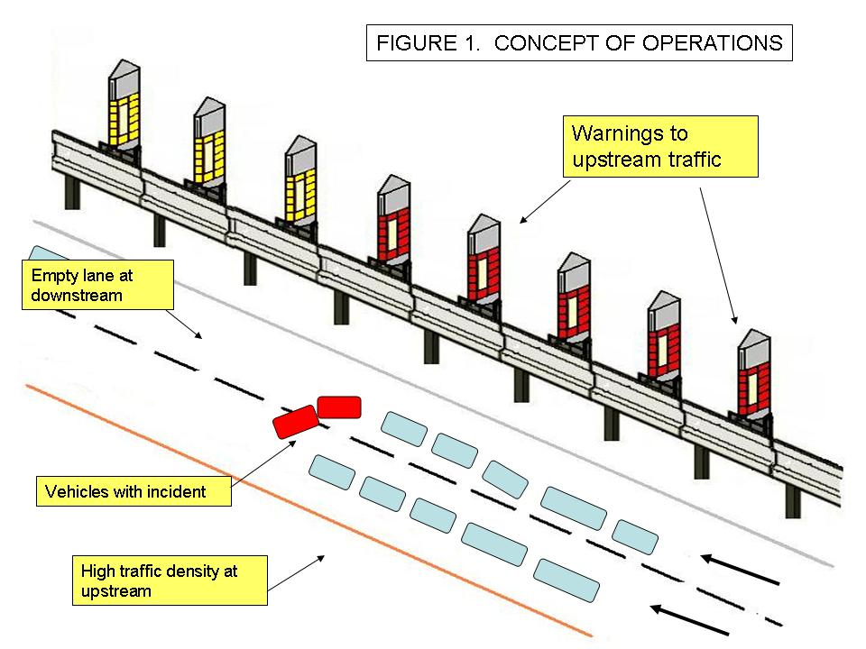

Technical Feasibility of the Proposed Research

The technologies used in this research project can be built upon many existing technologies:

First, the application of roadside flashers can be found in some Europe countries. Figure 2 is a photo of post flasher application – the flashers can be turned on manually by the highway operators when needed, such as in the situations of heavy fog, highway incidents, road blockage, etc. The system has been proven very helpful in preventing crashes.

Second, to use multiple speed sensors in a row, as proposed in this project, has been found in some SICAS research projects; for example, PATH program has used 80 mini loops to track vehicles in its research station in California, and Univ. of MN has used multiple radar units at intersection approaches in MN to measure the gaps in traffic flow.

Third, the similar operations concept for highway workzone has been demoed by UMTRI in June, 2006 at Chrysler’s proving ground (see the UMTRI final report to FHWA – 2006). The demo can be viewed at http://www-personal.umich.edu/~jsully/ (visit Play Video2 and Work Zone Video). It can be seen that when a high-speed vehicle is approaching stopped vehicles, the LED flashers are activated and increasing flashing frequency to warn the drivers.
FIGURE 2. EXAMPLE OF ROADSIDE WARNING SIGNS

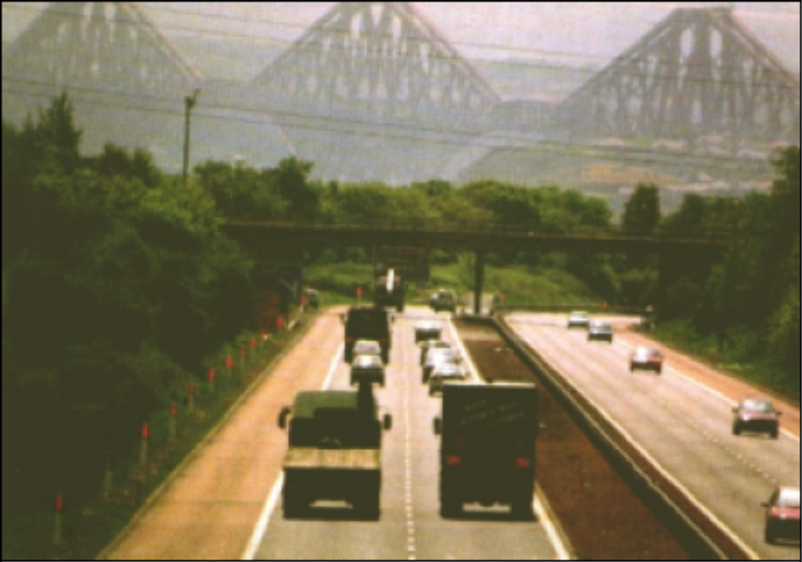
Post Warning Signs Application in Scotland, M90
4 KM section, since 1998. Average usage: 5/Mo.

[the end]

