RAPID UPDATE OF THE
MESOCYCLONE DETECTION ALGORITHM

Christopher W. Porter
Cooperative Institute for Mesoscale Meteorological Studies

- INTRODUCTION

The National Severe Storms Laboratory (NSSL) Severe Storm Analysis Package (SSAP) contains a suite of algorithms providing information on severe weather features at the end of a volume scan. Vital severe weather algorithm information often is available near the beginning of a volume scan yet algorithmic data can be as much as five minutes old once it is displayed. A new version of SSAP (version 4.0) contains a rapid update system, originally proposed by Wyatt et al. (1998), that allows algorithmic information to be disseminated at the end of each elevation sweep rather than at the conclusion of the volume scan. Thus, severe weather feature information can be disseminated in a more timely fashion providing a positive impact on the warning decision process for users such as the National Weather Service and Federal Aviation Administration.

Four algorithms within SSAP have been modified to contain a rapid update capability: the Storm Cell Identification and Tracking (SCIT) algorithm (Johnson et al. 1998), including the Hail Detection Algorithm (HDA; Witt et al. 1998); the Tornado Detection Algorithm (TDA; Mitchell et al. 1998); and the Mesocyclone Detection Algorithm (MDA; Stumpf et al. 1998). However, the rapid update capabilities in each of these algorithms have yet to be evaluated in a comprehensive fashion. In this report, the implementation of the rapid update system within MDA is described in section 2 and then evaluated in section 3. The evaluation is conducted to show the accuracy of MDA output is not adversely impacted by the rapid update system. In addition, results from the rapid update system are examined to determine the improved lead-time in detection of severe weather features. A summary of the benefit and proper use of rapid update output is given in section 4.

- RAPID UPDATE SYSTEM

The objective of the rapid update system is to identify severe weather features prior to the end of a volume scan of radar data allowing users access to critical information in a timely fashion. Three primary steps are taken to satisfy this objective:

1) Correlate locations of previously-existing severe weather features at the end of the first elevation sweep of data and update icon locations of the features on the display;

2) Display new severe weather features after feature information is available from two different elevation sweeps;

3) Update information on severe weather features once they are topped (i.e., when a feature has been completely built).

The basic difference between the rapid update and non rapid update algorithms is the use of time association to link features from two consecutive volume scans. Features are time associated after each elevation sweep in the rapid update system while time association only takes place at the end of a volume scan in the non rapid update software. The rapid update system is initiated after the first elevation sweep of data is obtained and 2D mesocyclone features are identified. The locations of the 2D features in the current volume scan are compared with forecasted locations of 3D features from the previous volume scan. Forecasted locations are produced using an average propagation speed and direction of all mesocyclone detections from the previous scan. A linearly extrapolated track for each detection is created using the average propagation vector, the location of the 3D feature from the previous volume scan, and the time difference between volume scans.

Each 2D feature from the current volume scan is matched with the closest 3D feature forecasted position. If two 2D features from the current volume scan are time associated with the same 3D feature from the previous volume scan, the closest 2D feature from the current volume scan is time associated. The remaining 2D feature(s) are then time associated with the next closest 3D feature from the previous volume scan.

Associating features after the first elevation scan allows the range and azimuth of severe weather features to be updated immediately in the current volume scan. The position of the severe weather feature icon on the display is updated as is the table attribute information, which is illustrated in Figures 1-3. Figure 1 shows the base reflectivity image taken May 4, 1999 at 0047 UTC from the Twin Lakes (KTLX) WSR-88D radar with overlaid mesocyclone detections valid at the end of the volume scan at 0051 UTC. Feature attribute information for mesocyclone detection 86 is also shown. Figure 2 displays the base reflectivity image from the next volume scan along with mesocyclone detection information after the first elevation sweep of data is obtained at 0052 UTC. At the completion of the first elevation scan, mesoscylone feature 86 from the previous volume scan is time associated with a 2D detection identified in the current
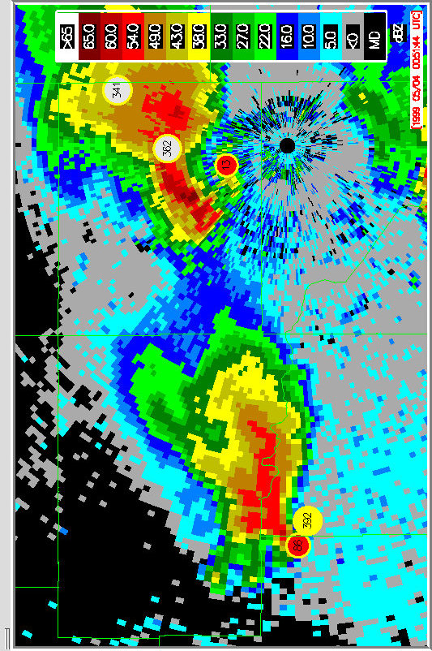
EL=19.5°

EL=0.5°
EL=0.5°
FIG. 1. Base reflectivity image at 0047 UTC, May 4, 1999 from the KTLX WSR-88D radar overlaid with mesocyclone detections. A mesocyclone feature attribute table for detection 86 valid at 0051 UTC is also shown.
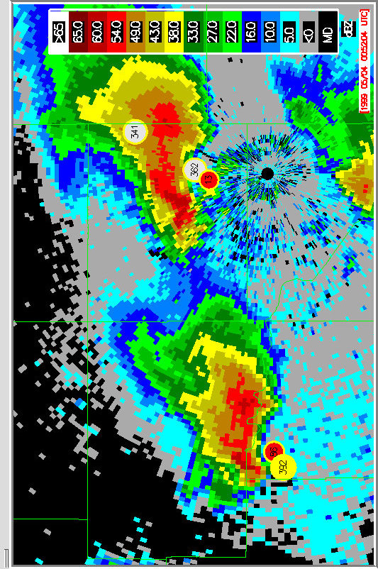
EL=0.5°
EL=1.45°
EL=4.3°
EL=5.25°
EL=6.2°
EL=0.5°
EL=0.5°
FIG. 2. Base reflectivity image at 0052 UTC, May 4, 1999 from the KTLX WSR-88D radar overlaid with mesocyclone detections. A mesocyclone feature attribute table is provided, which lists attribute information available through the rapid update system at the completion of the 0.5°, 1.45°, 4.3°, 5.25°, and 6.2° elevation scans.
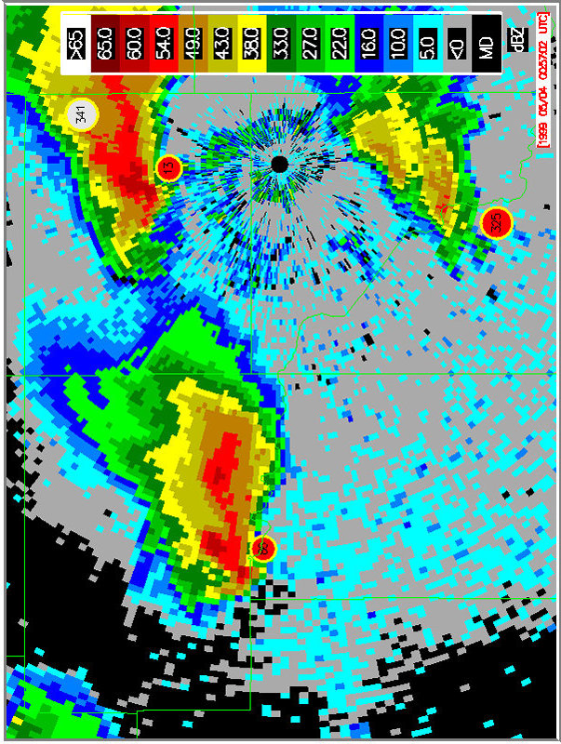
FIG. 3. Same as FIG. 2 except the base reflectivity image is valid at 0057 UTC and elevation scan information is provided from the 0.5°, 1.45°, 6.20°, 7.50°, 8.70°, and 14.0° elevation scans.
volume scan. The icon representing this detection is re-positioned on the display from an azimuth of 268.8° and range of 75.2 km to 269.0° and 66.9 km and the values within the attribute table are updated. The same process is repeated in the next volume scan at 0057 UTC (Figure 3).

Once a time association is made between features from consecutive volume scans, the feature in the current volume scan will inherit the attributes of the 3D feature from the previous volume scan. Feature attributes valid at the 0.5° elevation scan in Figure 2 should and do match feature attributes shown in Figure 1 with a couple of exceptions. Since information on low-level attributes (low-level diameter, low-level rotational velocity, low-level shear, and low-level gate-to-gate velocity difference) is available after the 0.5° elevation scan is complete, these properties are calculated and the feature attribute table is updated. If the newly calculated low-level attributes are found to be of greater magnitude than the maximum value from the previous volume scan, then the maximum value is set to the low-level value. The direction, speed, probability of tornado, and probability of severe weather are also updated because they are calculated at, and only at, the end of each volume scan. The remaining feature attributes, which are listed in Table 1, are carried over or coasted from the previous volume scan, although they can be updated after subsequent elevation scans.

As each additional elevation sweep of data is made available within the current volume scan, vertically adjacent 2D features are associated to produce a 3D feature using the same procedure employed by the non-rapid update system (Stumpf et al. 1998). Feature attributes are updated after each additional elevation angle sweep if one of the following conditions is met:

1) a new 3D feature is identified during the current volume scan;

2) feature attributes indicate a mesoscyclone is increasing in severity; or

3) all information has been obtained for a mesocyclone (i.e., the feature is topped).

New 3D features identified for the first time in the current volume scan are displayed only after 2D information from two different elevation sweeps is obtained.

Table 1 lists MDA feature attributes that are updated after each elevation scan if the attribute is increasing in magnitude, and, therefore, severity. In Figure 2, this is shown to occur several times within the volume scan. After the 1.45° elevation scan, the maximum rotational velocity increases from 35 to 39 ms⁻¹ while the maximum shear increases from 23 to 28 ms⁻¹km⁻¹. The strength rank (MesoRank) and mesocyclone strength index (MSI) are also shown to increase, and are therefore updated, during subsequent elevation scans.

And finally, feature attribute information can also be modified prior to the end of a volume scan if the 3D detection is topped and, thus, all information for the feature has been obtained. At that point, all feature attributes for the current volume scan are known and can no longer change. This occurs for the volume scan shown in Figure 2 at the completion of the 6.2° elevation scan. At this time the maximum gate-to-gate velocity difference is updated to reflect a decrease in magnitude from 57 to 53 ms⁻¹. The height of the base of the mesocyclone detection is allowed to be updated at any time within the volume scan since it is known after the time association is first established. The height of the top and the depth of the detection is only updated if they increase in magnitude or once the detection is topped.

MDA Feature Attributes
Circulation Type
Rank
Strength Index
Top
Depth
Maximum Diameter
Maximum Rotational Velocity
Maximum Shear
Maximum Gate-to-Gate Velocity Difference
TABLE 1. MDA feature attributes that are coasted from the previous volume scan and applied to a time-associated 2D feature in the current volume scan after the 0.5° elevation sweep. These specific attributes are also updated after each subsequent elevation sweep if the attribute is increasing in magnitude, and, therefore, severity.

B
A
C
D
End of VSn
Begin VSn+1
all intervening elevation
scans for VSn+1
End of
VSn+1

A • 3D features are finalized at the end of the previous volume scan n

B • After the first elevation angle sweep in volume scan n+1, 2D features are time associated with 3D features from previous volume scan n.
• Low-level feature attributes are calculated and the remaining feature attributes are coasted.
• Unassociated 3D features from the previous volume scan n are coasted to the current volume scan n+1.

C • New 3D features are displayed.
• Feature attributes updated if 3D feature is intensifying or topped

D • All 3D features are topped by this point and attributes have been updated

FIG. 4. Timeline of rapid update methodology.
The same process is again shown in Figure 3, however, during this volume scan all feature attributes decrease in severity. Thus, feature attribute information only changes after the first elevation sweep at 0.5º and once the feature is topped after the 14.0º elevation sweep. The only exception is the height of the top of the detection which increases during the volume scan.

It is important to note that all 3D features and their associated attributes from the previous volume scan are coasted to the current volume scan after the first elevation sweep is complete. Thus, elevated features from the previous volume scan are coasted even if they are not time associated with a 2D feature. Unassociated 3D features from the previous volume scan remain on the display until they become time associated. The rapid update system will continue to search for time association candidates up through 3 km above the elevated feature. If no time association candidates are found, the elevated feature is removed from the display.

A summary timeline of the sequence of events in the rapid update system in given in Figure 4.

3. EVALUATION

a. Methodology

An evaluation of the MDA rapid update system is made to accomplish three goals:

1) compare end of volume scan output from the rapid update system versus the non-rapid update system;

2) determine the number of time association discrepancies and the percentage of discrepancies produced in each elevation sweep;

3) determine the potential lead-time provided by the rapid update system for the detection of mesocyclones.

The accuracy of MDA should not be compromised in the rapid update system since the system only exists to disseminate MDA products in a more timely fashion. Thus, an evaluation of the rapid update system is undertaken to ensure MDA accuracy is not degraded. Secondly, time association discrepancies in the rapid update system are noted because the use of time association after every elevation scan is the primary difference between MDA with and without rapid update. And lastly, but most importantly, a more rapid dissemination of information should provide additional lead-time in warning of severe weather features. Hence, the potential benefit of the rapid update system is ascertained by determining the percentage of detections that occur at each elevation sweep and the lead-time associated with that particular sweep.

 | RADAR | DATE | VOL. SCANS | DETECTIONS | CASE DESCRIPTION
1 | KTLX | May 3, 1999 | 47 | 865 | Isolated Supercells /  Tornadic Outbreak
2 | KLSX | April 15, 1994 | 38 | 641 | Squall Line
3 | KMPX | October 26, 1996 | 56 | 197 | High Shear / Fast Moving /Low-Top Storm Cells
4 | KLWX | October 5, 1995 | 56 | 119 | Hurricane Opal
5 | KLZK | January 21, 1999 | 70 | 1501 | Isolated Tornadic Storms
6 | KMLB | November 15, 1994 | 56 | 205 | Tropical Tornadic Storms
7 | KLWX | April 16, 1993 | 40 | 305 | Mini Supercells
8 | KILX | April 19, 1996 | 51 | 1250 | Isolated Supercells
9 | KTBW | October 7, 1996 | 67 | 113 | Tropical Storm Josephine
10 | KJAN | April 20, 1995 | 60 | 715 | Squall Line
 |  | Totals | 541 | 5911

TABLE 2. List of case studies employed in the evaluation of the rapid update system. Radar location, date, number of volume scans and detections, and description is provided for each case.

Ten different case studies listed within Table 2 are used in the examination of the rapid update system. These cases provide different types of organized convective events including squall lines, supercellular tornadic outbreaks, high-shear, low-top, fast-moving storm cells, and tropical storms. In all, 541 volume scans are examined containing 5911 mesoscylone detections (with a strength rank of at least 1 as defined in Stumpf et al. (1998)).

b. End of volume scan output

Comparisons of the number of mesocyclone detections, locations of all detections, and table attribute information associated with each detection for both the rapid update and non-rapid update systems show that end of volume scan output matches exactly. This is an expected result given how MDA’s rapid update system is formulated. Again the primary difference between the two systems is the repeated use of time association after each elevation sweep in the rapid update system. Thus, once data is obtained from the last elevation sweep, both the rapid and non-rapid update system time associate the exact same data sets from the current and previous volume scans resulting in identical output.

The MDA rapid update software has an added time association parameter not used in the non-rapid update algorithm. The non-rapid update version time associates features from two consecutive volume scans by comparing only the horizontal distance between two features. The rapid update system uses an additional vertical distance check. If the vertical distance is set to a large value (i.e., 10 km), then both the rapid update and non rapid update systems produce identical output. However, if the vertical distance threshold is set to a more reasonable value, such as 3 km, then output from the two systems can differ. Applying a vertical distance threshold of 3 km prevents some unrealistic time associations between features as shown in Figure 5.

Reflectivity images with overlaid mesocyclone detections are shown in Figure 5a (0146 UTC) and Figure 5b (0151 UTC) on May 4, 1999 for the non-rapid update version of the MDA algorithm. A time associated mesocyclone detection is shown in these two consecutive volume scans. However, the feature at 0151 UTC is removed from the region of greatest low-level shear, which indicates these two detections should not have been time associated. Figures 5c and 5d show the same detections from the rapid update version of the MDA algorithm. The two detections are not time associated in this instance because they are separated vertically by more than 3 km.
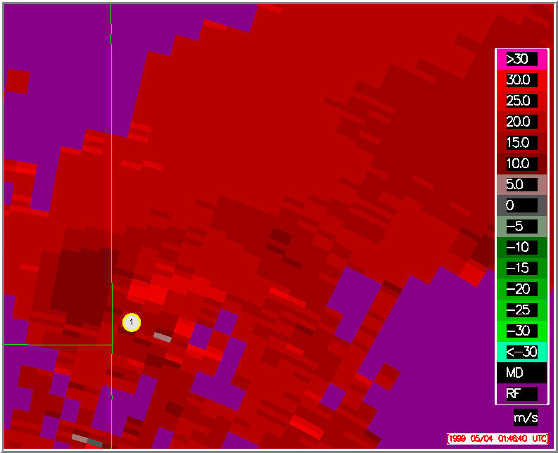
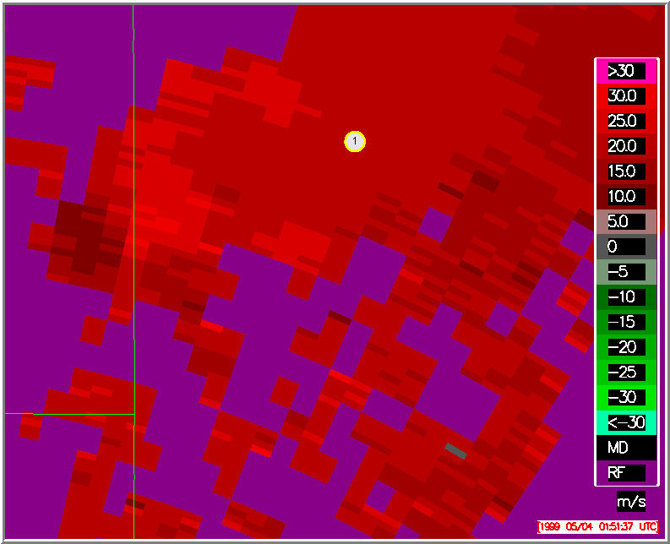
a)
FIG. 5. Base velocity image at a) 0146 UTC and b) 0151 UTC on May 4, 1999 from the KTLX WSR-88D radar with overlaid mesocyclone detections from the non-rapid update MDA algorithm.

b)
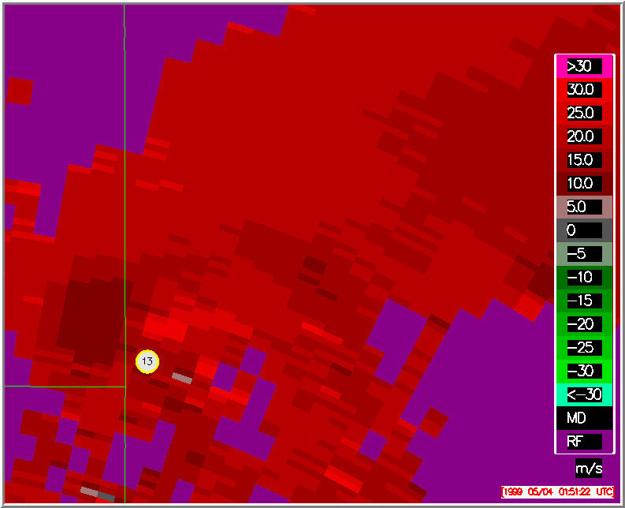
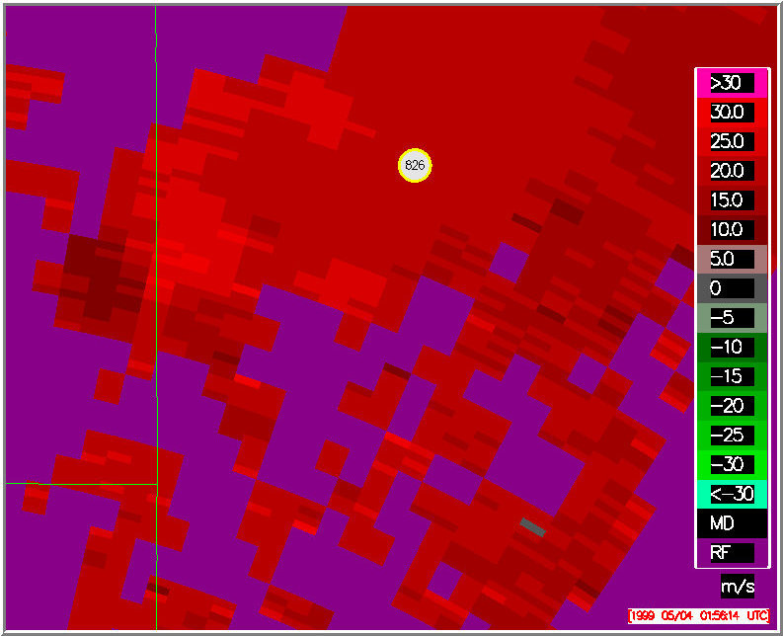
c)
FIG. 5. Same as Fig 5 a) and b) except with overlaid mesocyclone detections from the rapid update MDA algorithm.

d)
Both the rapid update and non-rapid update systems produce the same number of features in the same exact locations. However, as shown in Figure 5, the time associations can differ, which also causes differences in trend information. Figure 5 also demonstrates a case where the vertical distance threshold for time association can produce a positive result. In all, 273 pairs of time associated detections are changed by using a 3 km versus 10 km vertical distance threshold. A thorough examination of a vertical threshold in MDA time association is beyond the scope of this paper, but may be warranted.

c. Time association discrepancies

The rapid update time association process uses a data set from the current volume scan that is being built one elevation sweep at a time. Obviously, differences can exist between an end of volume scan data set and data obtained after just one or two elevation sweeps. Hence, the time association process in the rapid update system acts upon an incomplete data set after the initial elevation sweeps of a volume scan, which can lead to time association discrepancies. For this study, a time association discrepancy occurs prior to the end of the current volume scan when a 3D feature from a previous volume scan is time associated with a particular feature, but is time associated with another feature at the end of the current volume scan. The most common time association discrepancy likely results from associating with a 2D feature in the current volume scan that does not become a full 3D feature. Ascertaining the different types of time association discrepancies and how often each type occurs is beyond the scope of this work. However, the frequency of time association discrepancies as a whole is determined. Furthermore, the percentage of time association discrepancies relative to each elevation sweep is also calculated.

Figure 6 illustrates how a time association discrepancy appears on the display from one elevation sweep to the next. A single storm cell is shown for Case 10 with an associated mesocyclone detection (detection 188) at azimuth 273.5° and range 87.1 km at the end of a particular volume scan (Figure 6a). After the first elevation sweep of the next volume scan, the 3D feature is time associated with a 2D feature and the location of the detection is updated to an azimuth of 275.9° and range of 84.3 km (Figure 6b). However, after the next elevation sweep at 1.45°, the feature icon moves back to the original location at the end of the previous volume scan (Figure 6c). Thus, a time association discrepancy occurs as a result of the 3D feature from the previous volume scan being time associated to an erroneous 2D feature that does not become a 3D feature within the current volume scan. After the 4.3° elevation sweep, the 3D feature is time associated once again, this time correctly, to a 2D feature at azimuth 276.8° and 85.9 km. The time association discrepancy in this instance produces a 2.1 km distance error in the placement of the 3D feature in the current volume scan.

Table 3 lists time association discrepancies for each case used in the evaluation. A more detailed volume scan-by-volume scan listing of false alarm statistics for each case is given in Appendix A. Overall, there are 821 detections that exhibited a time association discrepancy out of the 5911 examined giving a FAR of 13.9%. The FAR ranged from 8.1% for the high-shear, fast moving, low-top storm cell (Case 3) to 19.2% for a squall line (Case 2). The two tropical storm cases (Cases 6 & 9) exhibited lower false alarm rates of 9.2% and 9.3% while supercellular events (Case 1 - 16.5%, Case 7 – 14.4%, Case 8 – 14.6%) show higher false alarm rates.

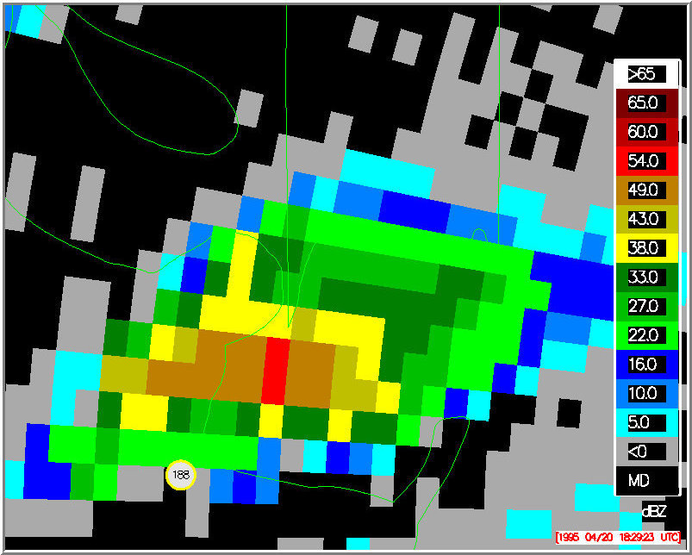
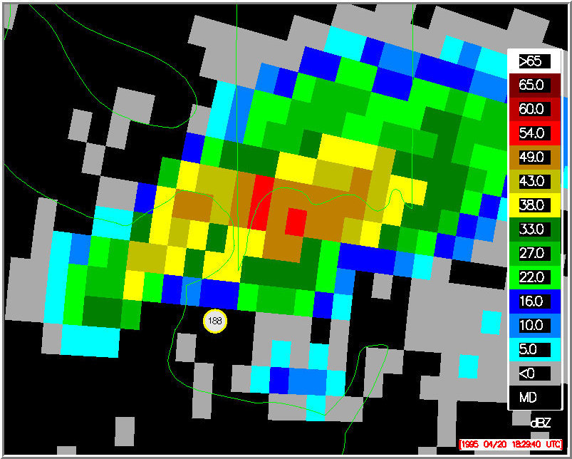
a)
FIG. 6. Base reflectivity image at a) 1824 UTC and b) 1829 UTC on April 20, 1995 from the KJAN WSR-88D radar. The overlaid mesocyclone detections are valid after the a) 19.5°and b) 0.5° elevation scans.

b)
b)
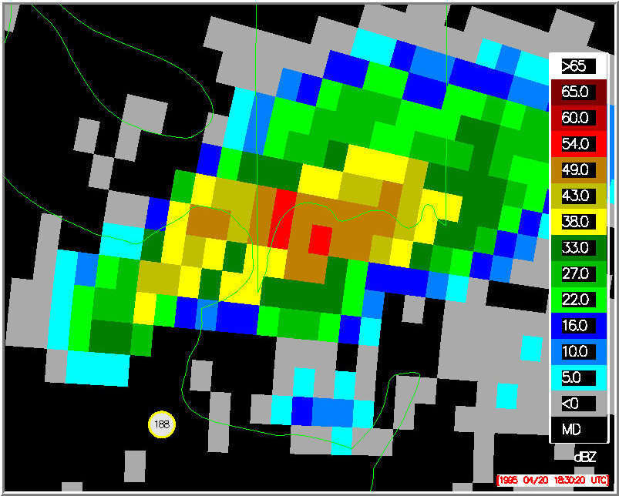
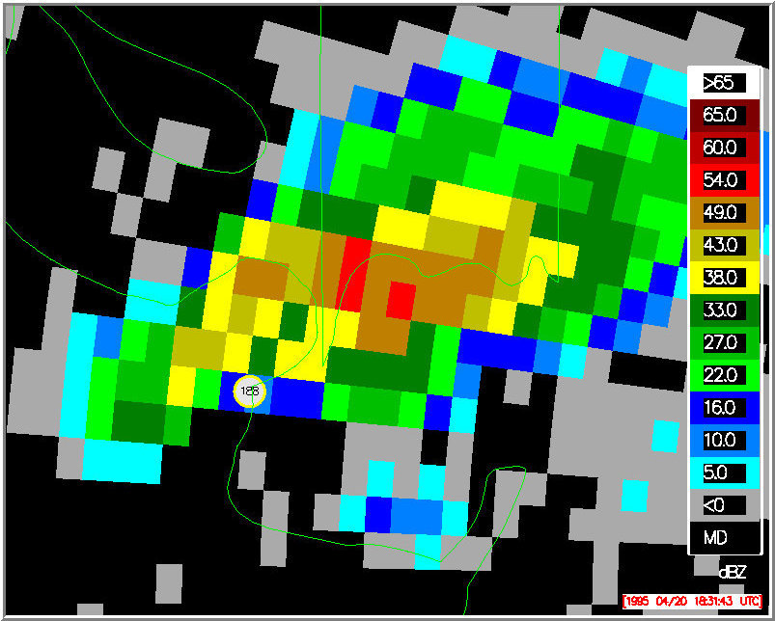
c)
FIG. 6. Same as Figure 6 a) and b) except the overlaid mesocyclone detections are valid after the c) 1.45°and d) 4.3° elevation scans.

d)

CASE | VS | DET | TA DIS |  | FAR | 0.5° Elev | DIST
1 | 47 | 865 | 143 |  | 16.5 | 90 | 6.8
2 | 38 | 641 | 123 |  | 19.2 | 91 | 9.1
3 | 56 | 197 | 16 |  | 8.1 | 100 | 10.3
4 | 56 | 119 | 11 |  | 9.2 | 100 | 8.5
5 | 70 | 1501 | 179 |  | 11.9 | 89 | 7.5
6 | 56 | 205 | 19 |  | 9.3 | 95 | 5.4
7 | 40 | 305 | 44 |  | 14.4 | 89 | 8.1
8 | 51 | 1250 | 182 |  | 14.6 | 91 | 8.6
9 | 67 | 113 | 15 |  | 13.3 | 100 | 7.8
10 | 60 | 715 | 89 |  | 12.4 | 96 | 6.5
 | 541 | 5911 | 821 | 13.9 |  | 91.2 | 7.8

TABLE 3. Listing of number of volume scans sampled (VS), number of detections sampled (DET), number of time association discrepancies (TA DIS), false alarm rate of time association discrepancies expressed as a percentage (FAR), percentage of discrepancies that occurred in the lowest elevation angle sweep (0.5° Elev), and average distance (km) associated with time association discrepancies (DIST) for all 10 cases.

False alarms typically occur randomly over the time period of interest in 8 of the 10 cases, which can be seen in the data listed in Appendix A. However, for both squall line cases, there are preferred time periods of false alarm occurrences. In Case 10, the FAR is 7.5% from 1531 to 1910 UTC on April 20, 1995. However, the number of false alarms increases significantly from 1915 to 2032 UTC and the FAR is a much higher at 19.9% during that 77 minute period. The same type of increase in false alarms also occurred in Case 2. From 0621 to 0912 UTC on April 15, 1994, the FAR is 5.7%. However, a dramatic increase in the FAR to 26.6% occurs from 0918 to 1035 UTC.
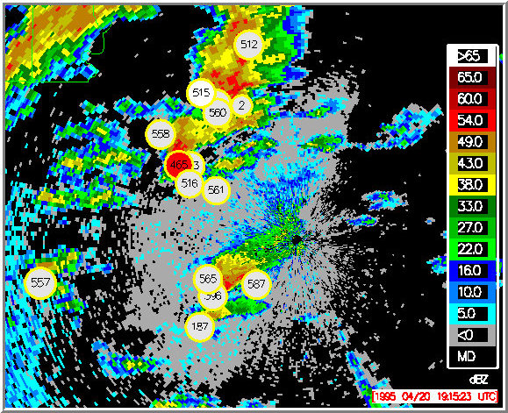
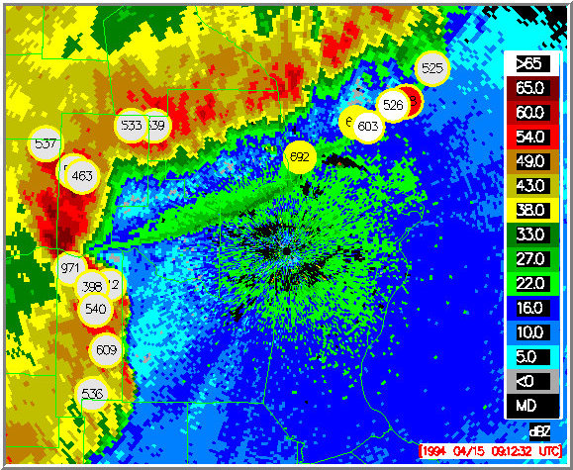
FIG. 7. Base reflectivity images from a) the KJAN WSR-88D radar at 1915 UTC, April 20, 1995 and b) the KLSX WSR-88D radar at 0912 UTC, April 15, 1994. Mesocylone detections are overlaid and are valid at the 0.5° elevation scan for both cases

a)
b)
A similarity is seen in the two squall line events through an examination of the location of convection relative to the radar immediately prior to the significant increases in the FAR. Figure 7a shows a squall line beginning to impinge on a region of increased clear-air returns immediately surrounding the radar. In addition, a small complex of convective cells is propagating northeastward within this clear-air return region. In Figure 7b, a squall line is rapidly approaching the KLSX radar site with an attendant fine line structure representing a gust front emanating from the squall line. The squall line and attendant gust front are close enough to the radar site so that reflectivity returns from these features co-exist with enhanced clear-air returns immediately surrounding the radar site. In both of these events, dramatic increases in the percentage of time association discrepancies coincide with propagation of convective systems into a region of enhanced clear-air return at the lowest elevation scan.

A vast majority of the time association discrepancies occur in the lowest elevation angle sweep. In Table 3, the column labeled “0.5° Elev” lists the percentage of false alarms that occur in the lowest elevation angle sweep for each case. The percentages range from 89% to 100% with an average of 91.2% for all 10 cases. In fact, 749 of the 821 false alarms occur at the lowest elevation angle with only 72 false alarms originating above the 0.5° elevation scan. This suggests that a significant number of time association discrepancies could be avoided simply by only examining rapid update output once the first two elevation scans are complete.

CASE | HGT1 | HGT2 | EL-2 | EL-3
1 | 16.5 | 14.3 | 7.4 | 5.3
2 | 19.2 | 18.7 | 9.7 | 6.4
3 | 8.1 | 4.1 | 0.5 | 0.0
4 | 9.2 | 8.4 | 0.8 | 0
5 | 11.9 | 9.9 | 5.6 | 3.6
6 | 9.3 | 9.3 | 5.9 | 2.9
7 | 14.4 | 13.1 | 7.9 | 5.2
8 | 14.6 | 12 | 5.9 | 3.4
9 | 13.3 | 12.4 | 7.1 | 6.2
10 | 12.4 | 12.7 | 6.9 | 4.3
Totals | 13.9 | 12.2 | 6.4 | 4.1

TABLE 4. Listing of the percentage of detections with time association discrepancies. A time association vertical distance threshold of 10 km is used for data in column HGT1, while a threshold of 3 km is used for results in all other columns. Rapid update output from all elevation sweeps is used in columns HGT 1 and HGT2, while only data from the second elevation sweep and above is used for column EL-2 and only data from the third elevation sweep and above is used in column EL-3.

Table 4 lists the percentage of detections with time association discrepancies using time association vertical distance thresholds of 10 km and 3 km as discussed in section 3b. Some time association discrepancies occur when using a relatively large vertical distance threshold of 10 km that could be prevented when using a 3 km threshold. For example, an incorrect time association can be made at the end of a volume scan even if a correct time association occurs originally at a lower elevation sweep. This is possible when a 2D MDA detection aloft is nearer (horizontally) to the 3D detection from the previous volume scan than the time associated 2D MDA detection located at a lower tilt. Time association discrepancies occur in only 12.2% of detections using a vertical distance threshold of 3 km as opposed to 13.9% of detections when using a threshold of 10 km.

Table 4 also lists the percentage of time association discrepancies that occur when using output from all elevation sweeps in a volume scan (Table 4, columns HGT1 and HGT2) as compared to only using rapid update output from all but the lowest elevation sweep (0.5°) (Table 4, column EL-2) or all but the lowest two elevation sweeps (0.5° and 1.45°) (Table 4, column EL-3). The percentage of time discrepancies decreases to only 6.4% by waiting to use rapid update output until after the second elevation sweep. Waiting until three elevation sweeps are completed reduces the percentage of time discrepancies further to 4.1%.

A distance error, which is the distance between the location of the mesocyclone detection when the time association discrepancies occurred and the location of the detection at the end of the volume scan, is also calculated for each time association discrepancy (Table 3). The average distance error associated with all 821 false alarms is 7.8 km.

d. Lead-time

The primary benefit of the rapid update system is realized through an increased lead-time in detection of severe weather features. The amount of lead-time is tied to the VCP scanning strategy used. In the ten cases examined, the VCP 11 (14 elevation angle sweeps per volume scan) scanning strategy is used in six cases and the VCP 21 (9 elevation angle sweeps per volume scan) scan mode is employed in six cases. VCP 11 and 21 are both used in Case 3 and Case 7. Table 5 shows the approximate amount of time each elevation scan is completed prior to the end of the volume scan for both scanning strategies. Hence, in VCP 11, information provided after the second elevation scan (1.45°) is completed has a lead-time of 4 minutes over information disseminated by MDA without rapid update. The lead-time is 4 minutes and 15 seconds for the same elevation scan in VCP 21 scanning mode.

As an example, by looking back at Figure 2, the maximum rotational velocity and maximum shear is shown to be greater than values from the previous volume scan. This information is known by the end of the 1.45° elevation scan and the rapid update system can provide this data 4 minutes earlier than in non-rapid update mode.

The remaining columns in Table 5 list the percentage of detections with a base located within a particular elevation scan. For instance, 45.7% of all detections in Case 1 have bases within the lowest elevation scan (0.5°). Over 75% of all detections have bases within the lowest two elevation scans in 8 of the 10 cases. Therefore, the rapid update system can provide information with a lead-time of at least 4 minutes on over 75% of detections in 8 of the 10 cases examined.

a) VCP 11
EL  Angle | Lead Time | Case 1 | Case 3 | Case 5 | Case 6 | Case 7 | Case 10
0.5° | 4:40 | 45.7 | 75.4 | 59.2 | 55.6 | 72.4 | 45.9
1.45° | 4:00 | 17.8 | 13.0 | 15.1 | 15.6 | 14.5 | 20.7
2.40° | 3:20 | 11.6 | 5.1 | 9.5 | 7.8 | 6.6 | 11.2
3.35° | 2:55 | 7.4 | 1.5 | 4.3 | 3.4 | 1.3 | 10.1
4.30° | 2:35 | 5.1 | 2.2 | 3.6 | 4.4 | 0 | 3.6
5.25° | 2:15 | 3.2 | 1.5 | 2.2 | 5.4 | 0 | 3.4
6.20° | 1:55 | 3.1 | 0 | 1.9 | 2.0 | 0 | 1.4
7.50° | 1:30 | 1.9 | 1.45 | 1.2 | 2.4 | 0 | 1.3
8.70° | 1:15 | 1.7 | 0 | 1.4 | 1.5 | 0 | 1.7
10.0° | 1:00 | 1.5 | 0 | 1.0 | 2.0 | 1.3 | 0.3
12.0° | 0:45 | 0.7 | 0 | 0.4 | 0 | 1.3 | 0.4
14.0° | 0:30 | 0.4 | 0 | 0.3 | 0 | 1.3 | 0.1
16.7° | 0:15 | 0 | 0 | 0 | 0 | 1.3 | 0
19.5° | 0:00 | 0 | 0 | 0 | 0 | 0 | 0

b) VCP 21
EL  Angle | Lead Time | Case 2 | Case 3 | Case 4 | Case 7 | Case 8 | Case 9
0.5° | 5:20 | 41.9 | 94.9 | 80.5 | 58.1 | 63.3 | 66.4
1.45° | 4:15 | 17.1 | 5.1 | 10.2 | 21.4 | 16.2 | 9.7
2.40° | 3:10 | 14.5 | 0 | 5.9 | 6.6 | 11.0 | 9.7
3.35° | 2:35 | 9.7 | 0 | 0.8 | 5.7 | 4.6 | 1.8
4.30° | 2:00 | 4.5 | 0 | 0.8 | 1.7 | 1.6 | 3.5
6.00° | 1:25 | 7.6 | 0 | 0 | 3.1 | 2.1 | 5.3
9.90° | 0:55 | 3.4 | 0 | 1.7 | 2.2 | 1.3 | 2.7
14.6° | 0:25 | 0.2 | 0 | 0 | 1.3 | 0 | 0.9
19.5° | 0:00 | 0 | 0 | 0 | 0 | 0 | 0

TABLE 5. Listing of lead-times for each elevation angle and percentage of detections whose base is located within a particular elevation angle for each case using the a) VCP 11 and b) VCP 21 scanning strategies.

4. SUMMARY

An evaluation of the MDA rapid update system has been performed to ensure end of volume scan output exactly matches MDA output without rapid update. In an examination of 541 volume scans including 5911 mesocyclone detections, the number and location of mesoscylone detections at the end of each volume scan is identical to the MDA performance without rapid update. Furthermore, the same pair of detections are time associated at the end of the volume scan for both systems, which guarantees that MDA trend information is also identical between rapid update and non-rapid update systems.

Although end of volume scan performance matches exactly, time association discrepancies are possible prior to the end of a volume scan in the rapid update mode. Nearly all time association discrepancies occur when data from only one or two elevation scans is available. In that instance, the time association scheme is acting upon a volume scan data set that is incomplete relative to the volumetric data available at the end of a volume scan. Of the 5911 mesocyclone detections, 13.9% (821) had a time association discrepancy at some point prior to the end of a volume scan.

The percentage of time association discrepancies ranged from 8.1% to 19.2% for all 10 cases. In 8 of the 10 cases, the false alarms occur throughout the time period of interest (typically on the order of 4-5 hours) and do not appear to be linked with any characteristics of the event such as mode of convection. However, both squall line cases contain a time period of relatively low number of time association discrepancies followed by a dramatic increase in time association discrepancy frequency. By examining the reflectivity images of both events immediately prior to the significant increase in the percentage of discrepancies, a link is suggested between the co-existence of lines of convective cells or individual storm cells with an enhanced region of clear-air returns immediately surrounding the radar. This may suggest that the dramatic increases in percentage of discrepancies could be alleviated by somehow taking into account the location of convective cells relative to the region of enhanced clear-air returns.

However, a much simpler solution could potentially eliminate a significant number of time association discrepancies. An assessment of the frequency of time association discrepancies reveals that occurrence of discrepancies can be reduced from 13.9% to 6.4% (4.1%) of the time if rapid update output is used only after the first two (three) elevation sweeps are completed. Thus a significant percentage of time association discrepancies can simply be avoided by waiting until after the second or third elevation scan of MDA rapid update output is made available.

An examination of the potential lead-time in dissemination of severe weather feature information (Table 5) shows that lead times of 4 minutes for VCP 11 and 4 minutes and 15 seconds for VCP 21 are possible using rapid update output at the completion of the 1.45° elevation scan. In 8 of the 10 cases studied, the lowest level of over 75% of all detections has been sampled by the 1.45° tilt. In the other two cases, 63.5% and 59% of all detections had been encountered by the second elevation scan. Therefore, vital low-level information on base height, low-level diameter, low-level rotational velocity, low-level shear, and low-level gate-to-gate velocity difference is available for a significant number of detections (greater than 75% in most cases and greater than 59% in all cases) while knowing that only 6.4% of the detections may have a time association discrepancy. A further reduction in the percentage of discrepancies is possible with a trade-off in lead-time. Only 4.1% of detections have time association discrepancies when viewing rapid update output beginning after the 2.4° tilt, but the lead-time is reduced to 3 minutes 20 seconds for VCP 11 and 3 minutes 10 seconds for VCP 21. Regardless, these data suggest that the rapid update mode of MDA should have a positive impact in aiding users in warning decision processes.

5. References

Johnson, J.T., P.L. MacKeen, A. Witt, E. D. Mitchell, G. J. Stumpf, M. D. Eilts, and K. W. Thomas, 1998: The Storm Cell Identification and Tracking Algorithm: An Enhanced WSR-88D Algorithm. Wea. and Forecasting, 13(2) 263-276.

Mitchell, E. D., S. V. Vasiloff, G. J. Stumpf, M. D. Eilts, A. Witt, J. T. Johnson, and K. W. Thomas, 1998: The National Severe Storms Laboratory Tornado Detection Algorithm. Weather and Forecasting, 13(2), 352-366.

Stumpf, G. J., A. Witt, E. D. Mitchell, P. L. Spencer, J. T. Johnson, M. D. Eilts, K. W. Thomas, and D. W. Burgess, 1998: The National Severe Storms Laboratory mesocyclone detection algorithm for the WSR-88D. Weather and Forecasting, 13(2), 304-326.

Witt, A., M. D. Eilts, G. J. Stumpf, J. T. Johnson, E. D. Mitchell, and K. W. Thomas, 1998a: An enhanced hail detection algorithm for the WSR-88D. Weather and Forecasting, 13(2), 286 - 303.

Wyatt, A. L., E. D. Mitchell, G. J. Stumpf, A. Witt, and M. Lehmann, 1998: “Rapid Update” of radar-derived severe weather algorithms. Preprints, 19th Conf. On Severe Local Storms, Minneapolis, MN, Amer. Meteor. Soc., 788-789.

APPENDIX A

The following is a detailed volume scan-by-volume scan listing of detections and false alarms for the 10 cases employed in this study. The number of detections (DET), the number of false alarms (FA), and the number of false alarms for each elevation scan (i.e., EL1 is the first elevation scan) are given for each volume scan number (VS #). Total number of detections, false alarms, and false alarms for each elevation scan is given in the row immediately following the volume scan-by-volume scan listing. The next row lists the FAR for the case as a whole and the percentage of false alarms found in each elevation scan.

CASE 1: KTLX, May 3-4, 1999 – Isolated Supercells / Tornadic Outbreak
VS # | DET | FA | EL1 | EL2 | EL3 | EL4 | EL5 | EL6 | EL7 | EL8 | EL9 | EL10 | EL11 | EL12 | EL13 | EL14
32 | 20 | 4 | 3 | 1
33 | 21 | 2 | 1 |  |  |  |  |  |  |  |  |  | 1
34 | 14 | 4 | 4
35 | 12 | 3 | 3
36 | 17 | 2 | 1 |  |  |  | 1
37 | 12 | 3 | 3
38 | 14 | 3 | 2 |  |  |  |  |  |  |  |  |  |  |  | 1
39 | 14 | 6 | 6
40 | 15 | 3 | 3
41 | 13 | 2 | 2
42 | 13 | 4 | 4
43 | 11 | 2 | 2
44 | 14 | 1 | 1
45 | 14 | 2 | 2
46 | 11 | 5 | 5
47 | 17 | 2 | 2
48 | 11 | 4 | 4
49 | 11 | 3 | 1 |  |  |  |  | 1 | 1
50 | 9 | 2 | 2
51 | 11 | 2 | 2
52 | 11 | 4 | 4
53 | 14 | 3 | 2 |  | 1
54 | 17 | 3 | 3
55 | 17 | 2 | 2
56 | 15 | 1 | 1
57 | 21 | 2 | 2
58 | 15 | 4 | 3 |  | 1
59 | 13 | 3 | 3
60 | 19 | 3 | 3
61 | 24 | 5 | 5
62 | 20 | 4 | 3 |  |  |  |  | 1
63 | 22 | 2 | 1 |  |  |  |  | 1
64 | 18 | 3 | 3
65 | 21 | 3 | 2 | 1
66 | 23 | 1 | 1
67 | 17 | 0
68 | 15 | 0
69 | 23 | 1 |  |  |  |  |  |  | 1
70 | 20 | 1 | 1
71 | 24 | 2 | 2
72 | 26 | 4 | 4
73 | 34 | 3 | 2 |  |  |  |  | 1
74 | 34 | 8 | 8
75 | 30 | 9 | 7 |  | 1 |  | 1
76 | 29 | 6 | 6
77 | 34 | 4 | 4
78 | 35 | 3 | 3
 | 865 | 143 | 128 | 2 | 3 | 0 | 2 | 4 | 2 | 0 | 0 | 0 | 1 | 0 | 1 | 0
 |  | 16.5 | 90 | 1 | 2 | 0 | 1 | 3 | 1 | 0 | 0 | 0 | 1 | 0 | 1 | 0
VS # | DET | FA | EL1 | EL2 | EL3 | EL4 | EL5 | EL6 | EL7 | EL8 | EL9 | EL10 | EL11 | EL12 | EL13 | EL14

CASE 2: KLSX, April 15, 1994 – Squall Line
VS # | DET | FA | EL1 | EL2 | EL3 | EL4 | EL5 | EL6 | EL7 | EL8 | EL9
62 | 2 | 0
67 | 1 | 0
68 | 1 | 0
69 | 1 | 0
72 | 2 | 0
73 | 3 | 0
74 | 4 | 0
75 | 11 | 0
76 | 6 | 2 | 2
77 | 5 | 0
78 | 8 | 0
79 | 9 | 0
80 | 10 | 2 | 2
81 | 11 | 1 | 1
82 | 8 | 1 | 1
83 | 11 | 0
84 | 10 | 1 | 1
85 | 14 | 0
86 | 13 | 2 | 1 |  | 1
87 | 13 | 0
88 | 13 | 1 | 1
89 | 22 | 0
90 | 18 | 3 | 3
91 | 31 | 0
92 | 27 | 7 | 7
93 | 35 | 7 | 6 |  |  |  |  | 1
94 | 39 | 11 | 9 |  |  |  |  | 1 | 1
95 | 32 | 12 | 11 |  |  |  |  | 1
96 | 37 | 17 | 15 |  |  |  |  |  | 1 | 1
97 | 33 | 13 | 13
98 | 27 | 8 | 8
99 | 29 | 5 | 5
100 | 30 | 9 | 8 |  |  | 1
101 | 30 | 6 | 5 |  |  |  |  | 1
102 | 23 | 6 | 6
103 | 26 | 3 | 3
104 | 24 | 4 | 3 |  | 1
105 | 22 | 2 | 1 |  | 1
 | 641 | 123 | 112 | 0 | 3 | 1 | 0 | 4 | 2 | 1 | 0
 |  | 19.2 | 91 | 0 | 2 | 1 | 0 | 3 | 2 | 1 | 0
VS # | DET | FA | EL1 | EL2 | EL3 | EL4 | EL5 | EL6 | EL7 | EL8 | EL9

CASE 3: KMPX, October 26, 1996 – High Shear/Fast Moving/Low-Top Storms
VS # | DET | FA | EL1 | EL2 | EL3 | EL4 | EL5 | EL6 | EL7 | EL8 | EL9
2 | 3 | 0
3 | 1 | 0
4 | 1 | 0
5 | 6 | 0
6 | 2 | 0
7 | 2 | 1 | 1
8 | 3 | 0
9 | 2 | 0
10 | 2 | 1 | 1
11 | 3 | 1 | 1
12 | 4 | 0
13 | 5 | 0
14 | 5 | 0
15 | 4 | 0
16 | 2 | 0
17 | 4 | 0
18 | 2 | 0
19 | 3 | 1 | 1
20 | 4 | 0
21 | 1 | 0
23 | 4 | 0
24 | 2 | 0
25 | 4 | 0
28 | 6 | 0
29 | 6 | 1 | 1
30 | 6 | 0
31 | 8 | 2 | 2
32 | 5 | 0
33 | 4 | 0
34 | 4 | 0
35 | 4 | 0
36 | 5 | 0
37 | 3 | 1 | 1
38 | 3 | 0
39 | 4 | 1 | 1
40 | 5 | 1 | 1
41 | 5 | 1 | 1
42 | 4 | 0
43 | 3 | 1 | 1
44 | 4 | 0
45 | 5 | 1 | 1
46 | 6 | 0
47 | 4 | 0
48 | 3 | 1 | 1
49 | 3 | 0
50 | 3 | 0
51 | 1 | 0
52 | 4 | 0
53 | 2 | 1 | 1
54 | 2 | 1 | 1
55 | 2 | 0
56 | 2 | 0
57 | 2 | 0
58 | 4 | 0
59 | 2 | 0
60 | 4 | 0
 | 197 | 16 | 16 | 0 | 0 | 0 | 0 | 0 | 0 | 0 | 0
 |  | 8.1 | 100 | 0 | 0 | 0 | 0 | 0 | 0 | 0 | 0
VS # | DET | FA | EL1 | EL2 | EL3 | EL4 | EL5 | EL6 | EL7 | EL8 | EL9
CASE 4: KLWX, October 5, 1995 – Hurricane Opal
VS # | DET | FA | EL1 | EL2 | EL3 | EL4 | EL5 | EL6 | EL7 | EL8 | EL9
301 | 2 | 0
302 | 3 | 0
303 | 2 | 0
304 | 1 | 0
305 | 5 | 0
306 | 3 | 0
307 | 2 | 0
308 | 1 | 0
309 | 1 | 0
310 | 1 | 0
311 | 4 | 1 | 1
312 | 3 | 1 | 1
313 | 4 | 1 | 1
314 | 4 | 0
315 | 6 | 1 | 1
316 | 6 | 0
317 | 3 | 0
321 | 5 | 2 | 2
322 | 3 | 1 | 1
323 | 4 | 1 | 1
324 | 2 | 0
325 | 4 | 1 | 1
326 | 2 | 1 | 1
327 | 3 | 0
328 | 4 | 0
329 | 3 | 0
330 | 4 | 0
331 | 3 | 0
332 | 2 | 0
333 | 2 | 0
334 | 3 | 0
335 | 4 | 0
336 | 2 | 0
337 | 3 | 0
338 | 1 | 0
339 | 4 | 0
340 | 2 | 1 | 1
341 | 1 | 0
342 | 4 | 0
343 | 1 | 0
344 | 0 | 0
345 | 0 | 0
346 | 1 | 0
347 | 0 | 0
348 | 0 | 0
349 | 0 | 0
350 | 0 | 0
351 | 0 | 0
352 | 1 | 0
353 | 0 | 0
354 | 0 | 0
355 | 0 | 0
356 | 0 | 0
357 | 0 | 0
358 | 0 | 0
359 | 0 | 0
 | 119 | 11 | 11 | 0 | 0 | 0 | 0 | 0 | 0 | 0 | 0
 |  | 9.2 | 100 | 0 | 0 | 0 | 0 | 0 | 0 | 0 | 0
VS # | DET | FA | EL1 | EL2 | EL3 | EL4 | EL5 | EL6 | EL7 | EL8 | EL9

CASE 5: KLZK, January 21, 1999 – Isolated Tornadic Storms
VS # | DET | FA | EL1 | EL2 | EL3 | EL4 | EL5 | EL6 | EL7 | EL8 | EL9 | EL10 | EL11 | EL12 | EL13 | EL14
141 | 19 | 7 | 7
142 | 21 | 4 | 4
143 | 21 | 5 | 4 | 1
144 | 18 | 1 | 1
145 | 28 | 3 | 2 |  |  |  |  | 1
146 | 23 | 7 | 6 |  |  |  |  |  |  |  |  | 1
147 | 28 | 3 | 2 |  |  |  |  |  |  |  |  |  | 1
148 | 22 | 4 | 3 | 1
149 | 26 | 1 | 1
150 | 21 | 2 | 2
151 | 23 | 4 | 4
152 | 26 | 2 | 2
153 | 27 | 3 | 3
154 | 29 | 7 | 6 |  |  |  |  | 1
155 | 31 | 3 | 3
156 | 19 | 2 | 2
157 | 21 | 4 | 4
158 | 20 | 1 | 1
159 | 19 | 4 | 4
160 | 20 | 3 | 3
161 | 28 | 4 | 4
162 | 29 | 3 | 3
163 | 30 | 4 | 4
164 | 23 | 5 | 5
165 | 24 | 1 | 1
166 | 30 | 2 | 1 |  |  |  |  |  | 1
167 | 25 | 2 | 2
168 | 27 | 3 | 3
169 | 32 | 5 | 4 |  |  |  | 1
170 | 30 | 3 | 2 |  |  |  |  |  | 1
171 | 37 | 4 | 4
172 | 35 | 3 | 1 |  |  |  |  |  |  | 1 |  | 1
173 | 32 | 5 | 5
174 | 35 | 8 | 6 |  |  |  |  |  |  |  |  |  | 1 | 1
175 | 32 | 6 | 5 |  |  |  |  |  |  |  | 1
176 | 28 | 4 | 3 |  |  | 1
177 | 35 | 1 | 1
178 | 35 | 2 | 2
179 | 30 | 5 | 2 |  |  | 1 |  |  |  | 1 | 1
180 | 23 | 5 | 5
181 | 27 | 1 | 1
182 | 16 | 1 | 1
183 | 18 | 0
184 | 15 | 2 | 2
185 | 23 | 1 | 1
186 | 19 | 2 | 2
187 | 17 | 1 | 1
188 | 18 | 1 | 1
189 | 21 | 1 | 1
190 | 20 | 1 | 1
191 | 17 | 1 | 1
192 | 15 | 0
193 | 12 | 0
194 | 17 | 3 | 3
195 | 14 | 1 | 1
196 | 15 | 0
197 | 14 | 2 | 1 |  | 1
198 | 13 | 3 | 2 |  | 1
199 | 16 | 2 | 2
200 | 10 | 3 | 3
201 | 14 | 0
202 | 8 | 1 | 1
203 | 6 | 2 | 2
204 | 13 | 1 | 1
205 | 13 | 2 | 2
206 | 9 | 1 | 1
207 | 7 | 0
208 | 9 | 0
209 | 13 | 0
210 | 10 | 1 | 1
 | 1501 | 179 | 159 | 2 | 2 | 2 | 1 | 2 | 2 | 2 | 2 | 2 | 2 | 1 | 0 | 0
 |  | 11.9 | 89 | 1 | 1 | 1 | 1 | 1 | 1 | 1 | 1 | 1 | 1 | 1 | 0 | 0
VS # | DET | FA | EL1 | EL2 | EL3 | EL4 | EL5 | EL6 | EL7 | EL8 | EL9 | EL10 | EL11 | EL12 | EL13 | EL14
CASE 6: KMLB, November 15, 1994 – Tropical Tornadic Storms
VS # | DET | FA | EL1 | EL2 | EL3 | EL4 | EL5 | EL6 | EL7 | EL8 | EL9 | EL10 | EL11 | EL12 | EL13 | EL14
126 | 4 | 0
127 | 1 | 0
128 | 2 | 0
129 | 1 | 0
132 | 5 | 0
133 | 5 | 0
134 | 2 | 0
135 | 1 | 0
136 | 1 | 0
137 | 4 | 1 | 1
138 | 2 | 0
139 | 3 | 1 | 1
140 | 3 | 0
141 | 5 | 1 | 1
142 | 3 | 1 | 1
143 | 5 | 0
144 | 4 | 1 |  |  |  |  |  |  |  |  | 1
145 | 3 | 0
146 | 2 | 1 | 1
147 | 4 | 0
148 | 4 | 1 | 1
151 | 5 | 0
152 | 6 | 0
153 | 3 | 0
154 | 3 | 1 | 1
155 | 3 | 0
156 | 3 | 1 | 1
157 | 3 | 1 | 1
158 | 7 | 1 | 1
159 | 4 | 1 | 1
160 | 5 | 1 | 1
161 | 6 | 0
162 | 3 | 0
163 | 4 | 0
164 | 3 | 0
165 | 3 | 0
166 | 4 | 0
167 | 6 | 0
168 | 3 | 0
169 | 4 | 0
170 | 5 | 1 | 1
171 | 3 | 1 | 1
172 | 6 | 0
173 | 3 | 1 | 1
174 | 3 | 2 | 2
175 | 4 | 0
176 | 4 | 0
177 | 4 | 0
178 | 7 | 1 | 1
179 | 4 | 0
180 | 2 | 0
181 | 3 | 0
182 | 6 | 0
183 | 3 | 0
184 | 3 | 0
185 | 3 | 0
 | 205 | 19 | 18 | 0 | 0 | 0 | 0 | 0 | 0 | 0 | 1 | 0 | 0 | 0 | 0 | 0
 |  | 9.3 | 95 | 0 | 0 | 0 | 0 | 0 | 0 | 0 | 5 | 0 | 0 | 0 | 0 | 0
VS # | DET | FA | EL1 | EL2 | EL3 | EL4 | EL5 | EL6 | EL7 | EL8 | EL9 | EL10 | EL11 | EL12 | EL13 | EL14
CASE 7: KLWX, April 16, 1993 – Mini Supercells
VS # | DET | FA | EL1 | EL2 | EL3 | EL4 | EL5 | EL6 | EL7 | EL8 | EL9 | EL10 | EL11 | EL12 | EL13 | EL14
2 | 14 | 0
3 | 13 | 2 | 2
4 | 12 | 1 | 1
6 | 13 | 1 | 1
7 | 11 | 3 | 3
8 | 12 | 1 |  |  |  | 1
9 | 8 | 0
13 | 14 | 2 | 2
14 | 8 | 2 | 2
15 | 10 | 1 | 1
19 | 3 | 0
20 | 5 | 0
21 | 2 | 0
22 | 2 | 0
23 | 3 | 0
24 | 1 | 0
25 | 5 | 0
28 | 9 | 3 | 3
29 | 9 | 0
30 | 13 | 0
31 | 17 | 5 | 5
32 | 14 | 1 |  |  | 1
33 | 10 | 2 | 2
34 | 10 | 2 | 2
35 | 13 | 3 | 3
36 | 8 | 0
37 | 13 | 2 | 1 |  | 1
38 | 5 | 2 | 2
39 | 8 | 2 | 2
40 | 7 | 2 | 1 | 1
48 | 3 | 2 | 1 |  |  | 1
49 | 5 | 0
50 | 4 | 0
51 | 3 | 0
54 | 4 | 2 | 2
55 | 2 | 0
56 | 4 | 1 | 1
57 | 4 | 1 | 1
58 | 2 | 1 | 1
59 | 2 | 0
 | 305 | 44 | 39 | 1 | 2 | 2 | 0 | 0 | 0 | 0 | 0 | 0 | 0 | 0 | 0 | 0
 |  | 14.4 | 89 | 2 | 5 | 5 | 0 | 0 | 0 | 0 | 0 | 0 | 0 | 0 | 0 | 0
VS # | DET | FA | EL1 | EL2 | EL3 | EL4 | EL5 | EL6 | EL7 | EL8 | EL9 | EL10 | EL11 | EL12 | EL13 | EL14
CASE 8: KILX, April 19, 1996 – Isolated Supercells
VS # | DET | FA | EL1 | EL2 | EL3 | EL4 | EL5 | EL6 | EL7 | EL8 | EL9
215 | 2 | 0
216 | 5 | 0
217 | 7 | 0
218 | 11 | 0
219 | 15 | 2 | 1 |  |  | 1
220 | 24 | 5 | 2 |  | 1 | 1 | 1
221 | 27 | 3 | 3
222 | 22 | 2 | 1 |  |  | 1
223 | 28 | 5 | 4 |  |  | 1
224 | 30 | 2 | 2
225 | 30 | 0
226 | 43 | 4 | 4
227 | 41 | 5 | 4 | 1
228 | 35 | 7 | 5 |  | 1 |  | 1
229 | 29 | 6 | 6
230 | 35 | 5 | 4 |  |  | 1
231 | 35 | 5 | 5
232 | 28 | 4 | 4
233 | 32 | 1 | 1
234 | 45 | 5 | 4 | 1
235 | 30 | 2 | 2
236 | 25 | 0
237 | 31 | 9 | 9
238 | 30 | 6 | 5 | 1
239 | 28 | 6 | 5 |  | 1
240 | 35 | 2 | 2
241 | 32 | 5 | 5
242 | 36 | 4 | 4
243 | 30 | 6 | 6
244 | 35 | 4 | 3 |  |  |  |  | 1
245 | 29 | 6 | 5 |  |  | 1
246 | 20 | 4 | 4
247 | 19 | 9 | 9
248 | 22 | 7 | 7
249 | 17 | 3 | 3
250 | 13 | 2 | 2
251 | 18 | 3 | 3
252 | 18 | 0 | 0
253 | 25 | 3 | 3
254 | 23 | 5 | 5
255 | 21 | 4 | 4
256 | 19 | 6 | 6
257 | 17 | 1 | 1
258 | 21 | 6 | 6
259 | 18 | 4 | 4
260 | 16 | 2 | 2
261 | 10 | 2 | 2
262 | 18 | 2 | 2
263 | 27 | 4 | 4
264 | 22 | 3 | 2 |  | 1
265 | 21 | 1 | 1
 | 1250 | 182 | 166 | 3 | 4 | 6 | 2 | 1 | 0 | 0 | 0
 |  | 14.6 | 91 | 2 | 2 | 3 | 1 | 1 | 0 | 0 | 0
VS # | DET | FA | EL1 | EL2 | EL3 | EL4 | EL5 | EL6 | EL7 | EL8 | EL9

CASE 9: KTBW, October 7, 1996 – Tropical Storm Josephine
VS # | DET | FA | EL1 | EL2 | EL3 | EL4 | EL5 | EL6 | EL7 | EL8 | EL9
2 | 5 | 0
3 | 2 | 0
4 | 1 | 0
5 | 1 | 0
6 | 2 | 0
7 | 1 | 0
8 | 0 | 0
9 | 1 | 0
10 | 1 | 0
11 | 0 | 0
12 | 0 | 0
13 | 0 | 0
14 | 1 | 0
15 | 1 | 0
16 | 0 | 0
17 | 0 | 0
18 | 0 | 0
19 | 0 | 0
20 | 0 | 0
21 | 1 | 0
22 | 0 | 0
23 | 0 | 0
24 | 0 | 0
25 | 0 | 0
26 | 0 | 0
27 | 2 | 0
28 | 1 | 0
29 | 1 | 0
30 | 1 | 0
31 | 1 | 0
32 | 2 | 0
33 | 5 | 1 | 1
34 | 4 | 0
35 | 5 | 1 | 1
36 | 5 | 0
37 | 6 | 2 | 2
38 | 6 | 0
39 | 5 | 2 | 2
40 | 2 | 0
41 | 3 | 0
42 | 5 | 1 | 1
43 | 5 | 2 | 2
44 | 5 | 2 | 2
45 | 4 | 1 | 1
46 | 4 | 1 | 1
47 | 3 | 1 | 1
48 | 1 | 0
49 | 2 | 0
50 | 0 | 0
51 | 1 | 0
52 | 1 | 0
53 | 3 | 0
54 | 3 | 0
55 | 1 | 0
56 | 0 | 0
57 | 0 | 0
58 | 0 | 0
59 | 2 | 0
60 | 1 | 1 | 1
61 | 1 | 0
62 | 0 | 0
63 | 0 | 0
64 | 3 | 0
65 | 0 | 0
66 | 2 | 0
67 | 0 | 0
68 | 0 | 0
 | 113 | 15 | 15 | 0 | 0 | 0 | 0 | 0 | 0 | 0 | 0
 |  | 13.3 | 100 | 0 | 0 | 0 | 0 | 0 | 0 | 0 | 0
VS # | DET | FA | EL1 | EL2 | EL3 | EL4 | EL5 | EL6 | EL7 | EL8 | EL9
CASE 10: KJAN, April 20, 1995 – Squall Line
VS # | DET | FA | EL1 | EL2 | EL3 | EL4 | EL5 | EL6 | EL7 | EL8 | EL9 | EL10 | EL11 | EL12 | EL13 | EL14
151 | 12 | 1 | 1
152 | 12 | 3 | 3
153 | 6 | 1 | 1
154 | 6 | 1 | 1
155 | 9 | 1 | 1
156 | 12 | 3 | 3
157 | 11 | 4 | 4
158 | 10 | 1 | 1
159 | 7 | 0
160 | 7 | 0
161 | 8 | 0
162 | 6 | 1 | 1
163 | 3 | 0
164 | 2 | 1 | 1
165 | 4 | 0
166 | 5 | 0
167 | 4 | 0
168 | 2 | 0
169 | 5 | 0
170 | 3 | 0
171 | 2 | 0
172 | 5 | 1 | 1
173 | 6 | 0
174 | 7 | 0
175 | 9 | 0
176 | 12 | 0
177 | 8 | 1 | 1
178 | 8 | 1 | 1
179 | 7 | 0
180 | 9 | 0
181 | 8 | 0
182 | 8 | 0
183 | 10 | 0
184 | 14 | 0
185 | 18 | 3 | 2 |  |  |  |  |  |  | 1
186 | 17 | 2 | 2
187 | 21 | 0
188 | 17 | 1 | 1
189 | 15 | 0
190 | 15 | 1 | 1
191 | 22 | 2 | 2
192 | 14 | 1 | 1
193 | 21 | 2 | 2
194 | 21 | 0
195 | 20 | 4 | 2 |  |  | 2
196 | 16 | 1 | 1
197 | 10 | 2 | 2
198 | 17 | 3 | 2 |  |  |  |  |  |  | 1
199 | 22 | 5 | 5
200 | 21 | 2 | 2
201 | 17 | 3 | 3
202 | 23 | 4 | 4
203 | 20 | 5 | 5
204 | 18 | 6 | 6
205 | 15 | 6 | 6
206 | 14 | 4 | 4
207 | 16 | 4 | 4
208 | 22 | 3 | 3
209 | 13 | 3 | 3
210 | 23 | 2 | 2
 | 715 | 89 | 85 | 0 | 0 | 2 | 0 | 0 | 0 | 2 | 0 | 0 | 0 | 0 | 0 | 0
 |  | 12.4 | 96 | 0 | 0 | 2 | 0 | 0 | 0 | 2 | 0 | 0 | 0 | 0 | 0 | 0
VS # | DET | FA | EL1 | EL2 | EL3 | EL4 | EL5 | EL6 | EL7 | EL8 | EL9 | EL10 | EL11 | EL12 | EL13 | EL14

