Final Technical Report
TNW2006-02
TransNow Budget No. 62-8992

Research Project Agreement No. T2695, Task 57
Improving Dual-Loop Truck (and Speed) Data: Quick Detection of Malfunctioning
Loops and Calculation of Required Adjustments

by

Improving Dual-Loop Truck (and Speed) Data: Quick Detection of Malfunctioning Loops and Calculation of Required Adjustments
Nancy L. Nihan
Yinhai Wang
Patikhom Cheevarunothai

Department of Civil and Environmental Engineering
University of Washington
Seattle, Washington 98195-2700

Report prepared for:
Transportation Northwest (TransNow)
Department of Civil Engineering
129 More Hall
University of Washington, Box 352700
Seattle, WA 98195-2700

May 2006
TECHNICAL REPORT STANDARD TITLE PAGE
1. REPORT NO.  TNW2005 | 2. GOVERNMENT ACCESSION NO. | 3. RECIPIENT’S CATALOG NO.
4. TITLE AND SUBTITLE  Improving Dual-Loop Truck (and Speed) Data: Quick Detection of Malfunctioning Loops and Calculation of Required Adjustments |  | 5. REPORT DATE  December 2005
 |  | 6. PERFORMING ORGANIZATION CODE
7. AUTHOR(S)  Nancy Nihan, Yinhai Wang, and Patikhom Cheevarunothai |  | 8. PERFORMING ORGANIZATION REPORT NO.  TNW2005
9. PERFORMING ORGANIZATION NAME AND ADDRESS  Transportation Northwest Regional Center X (TransNow)  Box 352700, 123 More Hall  University of Washington  Seattle, WA 98195-2700 |  | 10. WORK UNIT NO.
 |  | 11. CONTRACT GRANT NO.
12. SPONSORING AGENCY NAME AND ADDRESS |  | 13. TYPE OF REPORT AND PERIOD COVERED  Final Report
 |  | 14. SPONSORING AGENCY CODE
15. SUPPLEMENTARY NOTES
This study was conducted in cooperation with the University of Washington and the US Department of Transportation
16. ABSTRACT
The capability of measuring vehicle lengths makes dual-loop detectors a potential real-time truck data source for freight movement studies. However, a previous study found that the dual-loop detection system of the Washington State Department of Transportation (WSDOT) was not consistently reporting accurate truck volumes because of its sensitivity setting problems. Specifically, the sensitivity problems found were: (1) sensitivity discrepancies between the two single loops that form a dual-loop detector; and (2) unsuitable sensitivity level settings for both single loops even when discrepancies weren’t significant. Both problems can result in erroneous vehicle length estimates and, consequently, inaccurate truck counts.
As an extension of the previous study, this research project developed an algorithm for the identification and correction of such loop sensitivity problems. The algorithm identifies dual-loop sensitivity problems using individual vehicle information extracted from high-resolution loop event data and corrects dual-loop sensitivities through a two-step procedure: 1) remove the sensitivity discrepancy between the two single loops and 2) adjust their sensitivities to the appropriate level. The algorithm was also implemented in a computer application named the Advanced Loop Event Data Analyzer (ALEDA) system for convenient usage.
Elimination of dual-loop sensitivity problems significantly enhances the reliability of the dual-loop detection system and improves the quality of truck volume data. The findings and products from this study will help the WSDOT to obtain more accurate speed and truck volume data from the existing dual-loop detectors.

17. KEY WORDS  Truck Data, Dual-Loop Detectors, Loop Sensitivity, Speed |  | 18. DISTRIBUTION STATEMENT
19. SECURITY CLASSIF. (OF THIS REPORT)  None | 20. SECURITY CLASSIF. (OF THIS PAGE)  None | 21. NO. OF PAGES | 22. PRICE

DISCLAIMER

The contents of this report reflect the views of the authors, who are responsible for the facts and accuracy of the data presented herein. This document is disseminated through the Transportation Northwest (TransNow) Regional Center under the sponsorship of the U.S. Department of Transportation UTC Grant Program and through the Washington State Department of Transportation. The U.S. Government assumes no liability for the contents or use thereof. Sponsorship for the local match portion of this research project was provided by the Washington State Department of Transportation. The contents do not necessarily reflect the views or policies of the U.S. Department of Transportation or Washington State Department of Transportation. This report does not constitute a standard, specification, or regulation.

TABLE OF CONTENTS

Disclaimer………………………………………………………..………………………....ii
Table of Contents…………………………………………………………...………..…iii
List of Figures………………………………………………………..…………………….v
List of Tables………………………………………………………..……….....................vi
Executive Summary ………………………………………………………..…………..vii
CHAPTER 1 | Introduction………..……………………………………………………….1
1.1 | Research Background…………………………………………….......................1
1.2 | Problem Statement.…………………………………………..…………………3
1.3 | Research Objectives…………………………………………………………….3
CHAPTER 2 | State of the Art………………………………………………………….….5
CHAPTER 3 | Principles of Loop Detection…………………………………………….…8
3.1 | Loop Occupancy………………………………………………………………..8
3.2 | Loop Sensitivity Levels………………………………………….………….….9
3.3 | Speed Measurements……………………………………………………….….10
3.4 | Vehicle Length Measurements ……………………………...…….…………..11
CHAPTER 4 | Research Approach…………………………………………………...…..12
4.1 | Identification of Dual-Loop Sensitivity Discrepancies..………………………12
4.2 | Detection of Dual-Loop Incorrect Sensitivity Levels……...………………….16
4.3 | Development of An Algorithm for Correcting Dual-Loop Sensitivity Problems…………………………………………………………………...…..19
CHAPTER 5 | Development of the Advanced Loop Event Data Analyzer System…...…22
5.1 | Loop Event Data…...…………………………………………………………..23
5.2 | System Design and Components………………………………………………24
5.3 | System Implementation………………………………………………………..26
5.4 | User Interface………………………………………………………………….27
5.5 | Measurements of Speed and Vehicle Lengths……………………………...…29
CHAPTER 6 | System Testing and Discussion………...…………...…………………….32
6.1 | Test Data Collection...…………...…………………………………………….32
6.2 | Data Extraction………………………………………………………...………34
6.3 | System Testing…………………………………………………………..…….35
6.4 | Evaluating the Effectiveness of the Algorithm in Identifying Dual-Loop Sensitivity Problems……………………………………………..…………….36
6.5 | Evaluating the Effectiveness of the Algorithm in Correcting Dual-Loop Sensitivity Problems………………………………………………………..….41
6.6 | Truck Data……………………………….…………………………………….44
6.7 | Analysis Results Summary………………………………………………….…46
CHAPTER 7 | Conclusions and Recommendations………………………………………47
7.1 | Conclusions…………………………………………………………………....47
7.2 | Recommendations for Further Study……………………………………….....48
Acknowledgements……………………………………………………………………………..50
Bibliography ………………………………………………………………………………..…..51

LIST OF FIGURES

Figure 4-1 | The M Loop Is Over-Sensitive and the S Loop Is at the Correct Sensitivity Level...…14
Figure 4-2 | The M Loop Is at the Right Sensitivity Level and the S Loop Is Over-Sensitive……..15
Figure 4-3 | SV Length Histogram of Too-High Dual-Loop Sensitivity………………….………..18
Figure 4-4 | SV Length Histogram of Too-Low Dual-Loop Sensitivity…………………………....18
Figure 5-1. | Sample File of Event Data……………………………………………………..……....23
Figure 5-2. | ALEDA’s Component Connections……...……………………………………………25
Figure 5-3 | ALEDA’s Data Flow…………………………………………………………………..26
Figure 5-4 | ALEDA User Interface for Collecting Traffic Data……………………..…………….27
Figure 5-5 | ALEDA User Interface for Solving the Dual-Loop Sensitivity Problems……….…....28
Figure 5-6 | ALEDA’s Flow Chart for Speed and Length Calculations………………………….………………………………………………...30
Figure 6-1 | Dual-Loop On-Time Differences for Lane 1 at ES-172R…………………………......37
Figure 6-2 | Dual-Loop On-Time Differences for Lane 2 at ES-172R ……………….……………37
Figure 6-3 | Dual-Loop On-Time Differences for Lane 3 at ES-172R………………….………….38
Figure 6-4 | Estimated SV Median Length at ES-172R (SB I-5 & Metro Base)…………………...40
Figure 6-5 | Variation of DIFF% in Lane 3 at ES-172R (SB I-5 & Metro Base)…………………..42

LIST OF TABLES

Table 3-1 | Threshold Values for Percentage Change of Inductance (Eight Level System)…….....10
Table 3-2 | Threshold Values for Percentage Change of Inductance (Sixteen Level System)….….10
Table 6-1 | TDAD Volume Data at the ES-172R Station (NB I-5 & Metro Base) on November 28th, 2004……………………………………………………………………….…………....32
Table 6-2 | TDAD Volume Data at the ES-137R Station (NB I-5 & NE 45th St.) on November 28th, 2005…………………….……………………………………………………………....33
Table 6-3 | Comparison of Vehicle Count Data at the ES-137R Station (NE I-5 & NE 45th NB) on November 30, 2005…………………………………………………………………….36
Table 6-4 | The Variation of DIFF% for Lane 3 at the ES-172R Station (NB I-5 & Metro Base)…………………………………………………………………………………....42
Table 6-5 | TDAD Volume Data at the ES-137R Station (NB I-5 & NE 45th NB) on December 2, 2005…………………………………………………………………………………….43
Table 6-6 | Vehicle Count Data for Lane 1 at ES-137R (SB I-5 & NE 45th St. NB) BEFORE and AFTER the Sensitivity Tune-Up…………………………………………………….....44

EXECUTIVE SUMMARY
A previous study found that the dual-loop detection system of the Washington State Department of Transportation (WSDOT) was not consistently reporting accurate truck volumes due to dual-loop sensitivity problems. Two common types of sensitivity problems found were: (1) sensitivity discrepancies between the two single loops that form a dual-loop detector; and (2) unsuitable sensitivity level settings for both single loops. Both problems can result in erroneous vehicle length estimates and, consequently, inaccurate truck counts.
This research project developed, tested, and evaluated an algorithm for identifying and correcting dual-loop sensitivity problems. The algorithm identifies dual-loop sensitivity problems using individual vehicle information extracted from high-resolution loop event data and corrects dual-loop sensitivities through a two-step procedure: 1) remove the sensitivity discrepancy between the two single loops; and 2) adjust their sensitivities to the correct level. The algorithm was also implemented in a computer application named the Advanced Loop Event Data Analyzer (ALEDA) system for convenient usage.
The algorithm was tested at two dual-loop stations on the Interstate-5 corridor in the Greater Seattle area. The ALEDA system was applied to identify and correct the dual-loops with sensitivity problems at these two stations. The tests were conducted for approximately 24 hours at each loop station to check whether the severity of the sensitivity problems was affected by traffic conditions. The analysis results showed that the proposed algorithm was effective in identifying and fixing the dual-loop sensitivity problems and therefore could improve the performance and effectiveness of the WSDOT dual-loop detection systems.
The principal findings of this research are as follows:
- The same sensitivity level settings at the Detector Electronic Units (DEUs) cannot assure that the on-times (an on-time is defined as the duration that a loop detector is occupied by a vehicle) measured by the upstream loop (the M loop) and the downstream loop (the S loop) of a dual-loop detector are identical. Large on-time differences between the M and S loops can cause erroneous measurements of vehicle speed and hence vehicle length.
- Sensitivity discrepancies between the M and S loops may be eliminated by adjusting the sensitivity level settings at the DEUs. ALEDA makes this process easy.
- The on-time difference between the M and S loops is also impacted by other factors. For example, it can be intermittently large because of temporary cross-talk impacts.
- The sensitivities of the M and S loops may be the same (average on-time difference = 0) while both loops are at incorrect sensitivity levels (i.e., both single loops are over sensitive or under sensitive). In this case speed measurements are accurate, but measurements of vehicle lengths are incorrect because the on-times measured by the M and S loops are either too long or too short. Vehicle classification based on these imprecise lengths will be incorrect. Features of vehicle length distribution can be used to set the two single loop sensitivities to the correct sensitivity level.
- The proposed algorithm and the ALEDA system were demonstrated to be effective for tuning dual loop detectors. Further improvements on ALEDA will make it a handy tool for loop detector maintenance staffs to identify and correct dual-loop sensitivity problems.

CHAPTER 1 INTRODUCTION

1.1 RESEARCH BACKGROUND
Real-time traffic data collected by loop detectors are a primary data source for automated traffic monitoring or information systems (Al-Deek 1991; Chen and Chang 1993; Chen et al. 2001). The archived traffic data are used for a variety of transportation applications including transportation planning, infrastructure management, model calibration, and traffic simulation and operations (Clark et al. 2001; Cleghorn et al 1991; Wang and Nihan 2003, 2004).
The Washington State Department of Transportation (WSDOT) has made an enormous investment in the installation of loop detectors throughout the freeway network in the Puget Sound region. Almost half of the loop-detector stations in the central Seattle area freeway network are equipped with dual-loop detectors for the purpose of measuring speed and classified vehicle volume data. Vehicles are classified based on their lengths, and the WSDOT dual-loop detection system assigns each vehicle to one of the following four bins: (a) Bin 1 – Passenger Cars (PCs), pickups, and other smaller vehicles (length 26 ft or less); (b) Bin 2 – single-unit trucks and small vehicles pulling trailers. (26 ft to 39 ft); (c) Bin 3 - combination trucks and buses (39 ft to 65 ft); and (d) Bin 4 – multi-trailer trucks (length greater than 65 ft). Since the majority of vehicles in Bins 2 through 4 represent trucks, correct bin volume counts in those bins should yield reliable truck flow data along the freeway network. However, a preliminary study on Interstate-5 (Zhang et al. 2003) found that the WSDOT dual-loop detection system was not consistently reporting accurate truck volumes. In that study, the accuracy of dual-loop collected bin volumes was evaluated using video captured ground-truth data, and the major findings included:
- Dual-loop detectors under-count vehicle volumes. This is a very common problem in the dual-loop detection system. More than 80 percent of the dual-loop detectors have significant under-count errors.
- Dual-loop detectors misclassify vehicles across bins, especially between Bins 1 and 2, and Bins 3 and 4. For off-peak hours, observed errors in truck misclassifications ranged from 30 to 41 percent and, for peak hours, observed errors in bin assignments for trucks ranged from 33 to 55 percent.

The major cause of the poor performance of dual-loop detectors appears to be the remarkable lane-occupancy difference between the direct measurements of the two single-loop detectors that form a dual loop (Zhang et al. 2003). When the occupancy difference calculated from the direct measurements of the two single loops exceeds a certain threshold, the current WSDOT dual-loop algorithm discards the vehicle from the data set before the length calculation and classification operations are performed. Such occupancy discrepancies can be generated by any of the following factors:
- Incorrect mode setting for one or both of the single loop detectors in a dual loop system.
- Inconsistent sensitivity levels for the two loops.
- Other hardware malfunctions.

Since the sensitivity of a single-loop detector is determined by many factors (e.g. maker-specific standards, roadway material, construction method, and environmental conditions) in addition to operator judgement for the operator-set sensitivity level, it is not an easy job to place a single-loop detector’s sensitivity at the appropriate level. The empirical procedures currently used for loop sensitivity adjustments cannot usually achieve favorable results. A new tool for identifying and correcting dual-loop sensitivity problems is desired.

1.2 PROBLEM STATEMENT
Almost half of the loop stations in the central Seattle-area freeway network are equipped with dual-loop detectors for collecting speed and truck volume data. These dual-loop detectors should be a reliable data source for Advanced Traffic Management Systems (ATMS) and Advanced Traveler Information Systems (ATIS). However, previous research (Zhang et al. 2003) found that the WSDOT dual-loop detection system was not consistently reporting accurate truck volumes. More than 80 percent of the dual-loop detectors had significant under-count errors due to large differences (>10 percent) in vehicle on-times (an on-time is defined as the duration that a loop detector is occupied by a vehicle) measured by the two single loops that form each dual-loop detector. Zhang et al. (2003) showed that this remarkable on-time difference was primarily a result of dual-loop sensitivity problems. Therefore, fixing such sensitivity problems is an urgent task for collecting reliable truck and speed data using existing dual-loop detectors. The proposed algorithm would use high resolution (60 Hz) loop event data to identify and repair such dual-loop sensitivity problems. Once a dual-loop detector’s sensitivity is correctly tuned, it will be a reliable source for real-time speed and truck data.

1.3 RESEARCH OBJECTIVE
This study aims at developing a solution to detect and fix the two major types of sensitivity problems with dual-loop detectors: sensitivity discrepancy between the two single loops that form a dual loop detector and the incorrect sensitivity levels for the two single loops. Specifically, there are two major objectives for this research:
- Develop an algorithm that can identify and correct dual-loop sensitivity problems using individual vehicle information extracted from high-resolution loop detector event data; and
- Develop a computer system that can correctly tune dual-loop detectors by incorporating the proposed algorithm as its core component.

cHAPTER 2 State of the Art

Loop malfunctions are the major causes of errors in loop detector data. Erroneous loop measurements seriously degrade the performance of ATMS and ATIS. Several procedures have been proposed for detecting and correcting loop malfunctions. In general, these procedures can be classified into two categories based on the type of data used: (1) validity test based on interval-aggregated loop data and (2) high-resolution loop-event-data-based test. Sample studies of category (1) include Chen and May (1987), Nihan et al. (1990), Jacobson et al. (1990), Cleghorn et al. (1991), and Turner (2000). Data used for these studies were interval loop measurements of 20 or 30 seconds. Traffic variables calculated from aggregated volume and occupancy measurements were compared with empirical thresholds for malfunction identification. Since individual vehicle information is not available in interval loop data, these aggregated data based tests can detect only certain types of loop detector errors. For better error detections, high-resolution loop event data are necessary. Loop event data contain important individual vehicle data including actuation counts, arrival time, and departure time. Such individual vehicle information can be used to pinpoint loop detector malfunctions. Examples of category (2) studies are Coifman et al. (2004) and Cheevarunothai et al. (2005).
Since dual-loop detector data are typically aggregated into 20- or 30-second intervals to save data storage space and communication bandwidth, most traffic agencies currently use interval-aggregated loop data for checking whether loop malfunctions exist. The current WSDOT loop detection system aggregates loop measurements into 20-second intervals for archival and analysis. Based on the WSDOT 20-second interval data, a procedure to detect loop malfunctions was proposed by Nihan et al. (1990). The procedure compares collected traffic counts and volume-to-occupancy ratios with certain constant thresholds to determine the reliability of loop data. Error suspected data are marked with flags. The procedure is capable of filtering out serious malfunctions such as those caused by short pulses and chattering, but is limited to those visible from the aggregated data. Obviously, the loss of individual vehicle information in the aggregated data makes in-depth analysis of loop malfunctions more complicated and at times impossible.
High-resolution loop event data became available due to new developments in computer software and hardware technologies (Chen and May 1987; Coifman 1999; Coifman et al. 2000; Zhang et al. 2003; and Cheevarunothai et al. 2005). Such loop event data preserve information on individual vehicles and allow in-depth analyses of loop malfunctions. Nonetheless, little has been accomplished in using event data to identify and correct loop sensitivity problems.
Loop event data have been employed by the Berkeley Highway Laboratory (BHL) for loop data quality evaluations. Chen and May (1987) developed a procedure for verifying loop detector data using event data. Coifman and Dhoorjaty (2004) made another step forward by developing detector validation tests using individual vehicle information extracted from event data (e.g., on-time, speed, length, and headway). The extracted vehicle information was compared with corresponding pre-set constant thresholds to identify erroneous loop data. These studies demonstrated the values of using high-resolution event data for loop data error identifications and corrections.
Since a standard loop detector station employs a Model 170 controller in California, the California Department of Transportation (Caltrans) uses the processing capability of the Model 170 controller to collect and store event data from the field for the I-880 Field Experiment (Coifman et al. 2000). Because of the limited computing power of a Model 170 controller, outputting 60 Hz event data obstructs the normal operation of the controller. Thus, when a Model 170 controller is used for event data collection by the BHL, the normal operation of the controller will be interrupted.
To facilitate the event data collection process, a Detector Event DAta Collection (DEDAC) system was developed at the University of Washington (UW) in 2002 (Zhang et al., 2003). The system is capable of collecting event data from the Input File of a control cabinet. Since the DEDAC system taps loop events before they flow into the controller and relies on its own computing power for data processing and storing, the controller’s normal operation will not be interrupted. The DEDAC system makes loop event data collection cheap and easy. Using the event data collected by the DEDAC system, Zhang et al. (2003) found that the major cause of inaccurate dual-loop data was the incorrect sensitivity levels of a dual-loop detector. An extended analysis confirmed this result. A dual-loop sensitivity problem can result from any of the following two scenarios: (1) the sensitivity level discrepancy between the two single loops, and (2) unsuitable loop sensitivity levels on both single loops.
The accuracy of a loop detector’s measurements is significantly influenced by its sensitivity. For example, the higher the loop sensitivity, the longer a vehicle’s loop on-time. Consequently, both types of validity tests may give erroneous conclusions on loop malfunctions when sensitivity-influenced loop data are applied. Therefore, a loop’s sensitivity problems must be fixed before using its data for loop malfunction detections. High-resolution loop event data are a great information resource for identifying and correcting loop sensitivity problems.

CHAPTER 3 Principles of Loop Detection

3.1 LOOP OCCUPANCY
Loop occupancy is defined as the percentage of time that a loop is occupied by vehicles over a time period. It can be calculated by dividing the sum of vehicle on-times by the time period length. The measurement of an on-time starts when the front bumper of a vehicle arrives at the leading edge of a single loop and ends when the rear end of the vehicle passes the loop’s lagging edge.
Each loop detector is a tuned electrical circuit where the loop wire is the inductive element. Its inductance is represented by L. When a vehicle drives over the loop wire, eddy currents are induced around the peripheral metal of the vehicle. Although the iron mass of the vehicle’s engine, transmission, or differential will increase the loop inductance due to the ferromagnetic effect, the decrease in inductance from the eddy currents more than offsets the increase from the ferrous mass, and the net effect of the vehicle’s presence is an overall reduction in loop inductance denoted by ΔL. Therefore, when a vehicle is on top of a loop detector, it decreases the inductance of the loop. This decrease in inductance then triggers the Detector Electronic Unit (DEU)’s output relay or solid state circuit which, in turn, switches the output voltage to the controller to a low level (close to zero Volt Direct Current (V DC)) signifying that a vehicle’s presence has been detected (ITE 1997).
Traffic controllers located in the roadside control cabinets typically scan loop detectors at a rate of 60 times per second (Coifman et al. 2000; Zhang et al. 2003). Each scan results in a “loop occupied” or “loop not occupied” response. A scan counter in the controller is incremented once for each “loop occupied” response. A vehicle’s on-time in seconds can be converted from its Scan Counts (SCs):
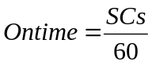 (3-1)

In the current WSDOT loop detection system, loop occupancy is calculated as:
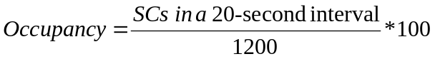 (3-2)

In this research, we use SCs of individual vehicles to calculate the on-times and then use the calculated on-times for identifying and correcting dual-loop sensitivity problems.

3.2 LOOP SENSITIVITY LEVELS
A loop detector identifies the presence of a vehicle by comparing the relative change of loop inductance (ΔL/L) caused by a vehicle traversing over a loop with a threshold value which is often referred to as loop sensitivity level. The minimum percentage change of inductance (min ΔL/L) for a DEU to respond is adjustable. A typical DEU used on freeways has eight or sixteen levels of sensitivity settings. The threshold values for these sensitivity levels are shown in Tables 3-1 and 3-2. The normal sensitivity levels for the eight- and sixteen-sensitivity-level DEU to set are 4 and 10, respectively. According to Tables 3-1 and 3-2, the higher the sensitivity level, the easier the detection of a vehicle. However, an over sensitive loop may have other detection problems, such as detecting vehicles on adjacent lanes. The main consideration for having several sensitivity levels available with a DEU is to allow the optimal sensitivity setting over a variety of loop configurations.

Table 3-1. Threshold Values for Percentage Change of Inductance (Eight Level System)
Sensitivity Level | min ΔL/L
7 | 0.01%
6 | 0.02%
5 | 0.04%
4 | 0.08%
3 | 0.16%
2 | 0.32%
1 | 0.64%
0 | 1.28%

Table 3-2. Threshold Values for Percentage Change of Inductance (Sixteen Level System)
Sensitivity Level | min ΔL/L | Sensitivity Level | min ΔL/L
15 | 0.010% | 7 | 0.160%
14 | 0.014% | 6 | 0.226%
13 | 0.020% | 5 | 0.320%
12 | 0.028% | 4 | 0.453%
11 | 0.040% | 3 | 0.640%
10 | 0.057% | 2 | 0.905%
9 | 0.080% | 1 | 1.280%
8 | 0.113% | 0 | OFF

3.3 SPEED MEASUREMENTS
A dual-loop detector system consists of two single loops separated by several feet. According to the WSDOT convention, the upstream single loop is called the M loop and the downstream single loop is called the S loop. Since the leading edge to leading edge distance between the M loop and the S loop (Dist_{MS}) is predetermined and the traversal time between the two loops can be directly measured, a dual loop detector can output vehicle speed. In Washington State, Dist_{MS} is normally 16 feet (4.8 meters). If a vehicle arrives the M loop at t_{m-on} and the S loop at t_{s-on}, then its speed can be calculated as
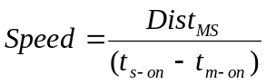 (3-3)

3.4 VEHICLE LENGTH MEASUREMENTS
A dual-loop detector classifies vehicles into bins according to their lengths. A vehicle’s length can be estimated from its speed and on-times measured by the M and S loops. The on-times for the M and S loops (Ontime_{M} and Ontime_{S}, respectively) can be expressed as
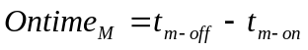 (3-4)
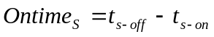 (3-5)
The WSDOT’s dual loop algorithm uses Equation (3-6) for vehicle length calculation:
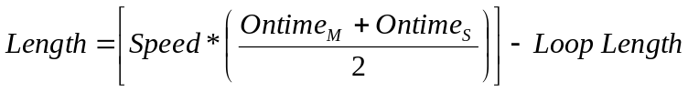 (3-6)
Since Ontime_{M} and Ontime_{S} may be different due to possible speed variations over Dist_{MS}, the mean on-time value is used for calculating vehicle length to minimize the estimation error. The loop length term is included in Equation (3-6) because the on-time of a vehicle is measured from the moment the vehicle’s front bumper reaches the leading edge of a single loop to the time its rear end leaves the lagging edge of the loop. Hence, the loop length is subtracted from the loop detector’s effective vehicle lengths to give the actual vehicle length in Equation (3-6).

CHAPTER 4 RESEARCH APPROACH

Two major types of dual-loop sensitivity problems considered in this study are: 1) sensitivity discrepancy between the M and S loops; and 2) incorrect sensitivity levels for both M and S loops, even though no discrepancy is observed. These are the two main causes of imprecise speed and vehicle length measurements in the existing dual-loop detection systems. Remedial solutions to the first and second sensitivity problems are described in Sections 4.1 and 4.2, respectively. An algorithm developed for identifying and fixing the two sensitivity problems based on the remedial solutions is presented in Section 4.3.

4.1 IDENTIFICATION OF DUAL-LOOP SENSITIVITY DISCREPANCIES
To achieve accurate measurements of vehicle speed, the sensitivity levels of the M and S loops must be approximately the same. However, the same sensitivity level settings on the DEUs of the M and S loops may not assure the same sensitivity level between the two single loops because a loop’s inductance is also affected by its environmental conditions (such as temperature, humidity, road pavement structure and conditions, etc.) which may be different from location to location. Variation in environmental conditions can cause sensitivity inconsistencies between the M and S loops, and therefore imprecise calculations of speed. The greater the difference in sensitivity between the M and S loops, the greater the inaccuracy of the speed measurements.
Since Dist_{MS} (the leading edge to leading edge distance between the M and S loops) is small (about 16 ft or 4.88 meters), speed is considered to be constant when a vehicle traverses over the M and S loops. With a constant speed, the M and S loops should have identical on-time measurements, i.e., their on-time differences should be zero if their sensitivities agree. Therefore, an on-time difference can be an indicator of a sensitivity discrepancy between the M and S loops.
The percent of on-time difference can be calculated as
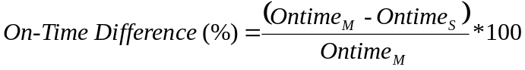 (4-1)

In accordance with Equation (4-1), if the M loop is more sensitive than the S loop, the on-time difference will be positive, and vice versa. Therefore, we can infer whether a sensitivity discrepancy problem exists and its possible causes from the calculated on-time difference. In this research, if only one of the loops has an incorrect sensitivity level, the sensitivity discrepancy problems are attributed to four main cases:
- Over-Sensitive M Loop
If the M loop’s sensitivity is higher than the appropriate level, a vehicle can be detected before it reaches the leading edge of the M loop. This is illustrated in Figure 4-1. In this case, because the travel time measurement from the leading edge of the M loop to the leading edge of the S loop is longer than the measurement that would be made if the M and S loops had the same sensitivity levels, the measured speed will be lower than the actual speed.

- Over-Sensitive S Loop
If the S loop’s sensitivity is higher than the appropriate level, a vehicle can be detected before it reaches the leading edge of the S loop. This is illustrated in Figure 4-2. In this case, the travel time measurement from the leading edge of the M loop to the leading edge of the S loop is shorter than that the measurement that would be made if the M and S loops had the same sensitivity levels. Hence, the measured speed will be higher than the actual speed.

- Under-Sensitive M Loop
Similarly, if the M loop’s sensitivity is below the appropriate level, a vehicle cannot be detected until it passes the leading edge of the M loop. The travel time measurement used for the speed calculation will be shorter than the actual value and, therefore, speed will be over-estimated.

- Under-Sensitive S Loop
Conversely, speed will be under-estimated if the S loop’s sensitivity is below the appropriate level because the travel time measurement used for the speed calculation will be longer than the actual value in this case.

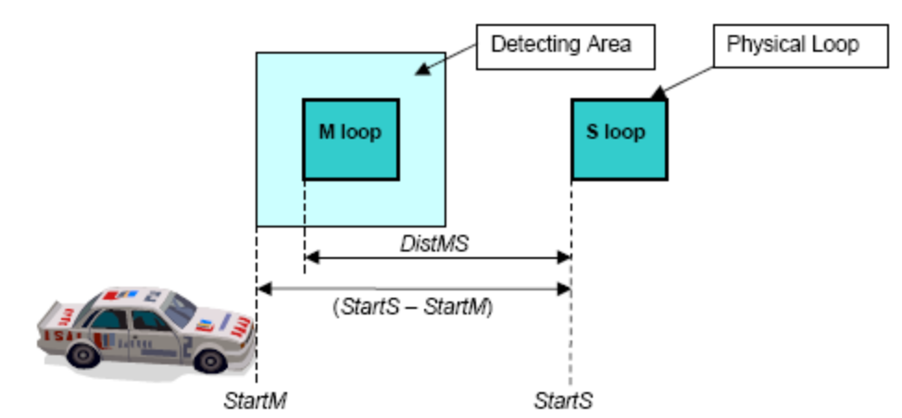

Figure 4-1. The M Loop Is Over-Sensitive and the S Loop Is at the Correct Sensitivity
Level

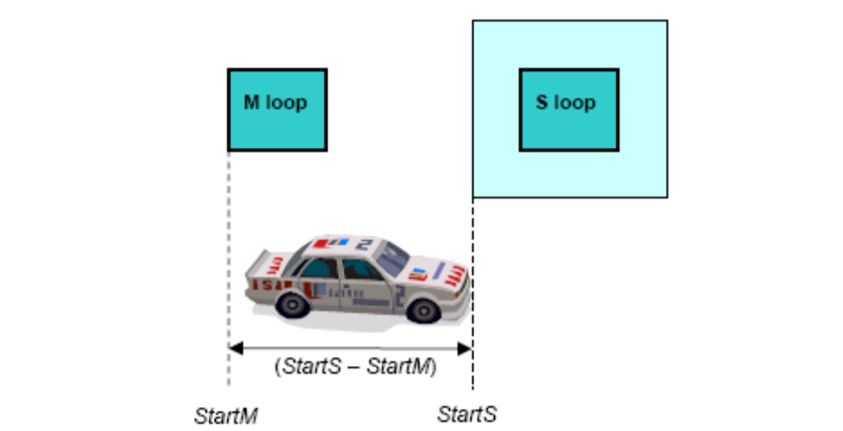
Figure 4-2. The M Loop Is at the Right Sensitivity Level and the S Loop Is Over-Sensitive

According to the WSDOT dual-loop algorithm, if a vehicle’s on-time difference is beyond ±10 percent, it is not classified (assigned to a bin) although its speed is still recorded. This threshold was originally set to screen out possible measurement errors from vehicles crossing the M loop in one lane and then the S loop in a different lane. However, Zhang et al (2003) found that the majority of the vehicles screened out by this ±10 percent criterion at dual-loop stations with serious under count problems (where the total bin volume measurements were significantly lower than the volumes counted by either the M loop or the S loop) were actually not lane-changing vehicles. They also found that sensitivity discrepancy was the main reason for the dual-loop under-count problems at the observed loop stations. Consequently, if the sensitivity discrepancy problem can be solved, dual-loop detectors will provide better speed and bin volume measurements.

4.2 DETECTION OF DUAL-LOOP INCORRECT SENSITIVITY LEVELS
Measurements of vehicle speed from dual-loop detectors will be accurate once the sensitivity discrepancy problem is corrected. However, even if the sensitivities of the M and S loops are consistent, both may be at an incorrect level, i.e., both loops may be over sensitive or under sensitive. As stated previously, incorrect sensitivity levels for a dual loop can result in inaccurate on-time measurements. As shown in Equation (3-5), the calculation of vehicle length is based on these on-time measurements. Therefore, imprecise on-times will lead to erroneous vehicle length estimates. For instance, overly high sensitivity levels on both the M and S loops will produce lengthened on-time measurements for both loops. Vehicle lengths calculated from these lengthened on-times will be longer than the actual vehicle lengths. Similarly, if the sensitivity levels of the M and S loops are not high enough, vehicle on-time measurements will be shorter than the actual values. These shorter-than-normal on-times will result in under-estimated vehicle lengths. Since the WSDOT vehicle classification algorithm classifies vehicles based on vehicle lengths, incorrect sensitivity levels of a dual-loop detection system will cause misclassification of vehicles, i.e., will assign vehicles to incorrect vehicle-length bins.
To identify an appropriate sensitivity level for the M or the S loop, information on individual vehicle lengths is needed. However, it is very difficult to obtain ground-truth length data for vehicles traveling on freeways at a specific time period. Therefore, a statistical approach is applied here using the Short Vehicle (SV) length distribution observed by Wang and Nihan (2004).
According to Wang and Nihan’s vehicle length distribution, SV (corresponds to Bin-1 vehicles) lengths follow a normal distribution with a mean = 15.21 ft (4.64 m) and a Standard Deviation (SD) = 2.20 ft (0.67 m). The small standard deviation implies that SV lengths change narrowly around the mean. Because of this attribute, the length information for SVs can be employed to trace a correct sensitivity level without significant errors. In this research, the SV-length distribution reported by Wang and Nihan (2004) was used as the ground-truth vehicle length distribution for SVs.
A calculated length from a dual-loop detector will be precise only when the vehicle speed and the on-times are accurate. Accurate speed and on-time measurements require the sensitivities of the M and S loops to be consistent and at the appropriate sensitivity level. To identify whether or not the sensitivity levels for the M and S loops are appropriate, the calculated SV lengths were compared with the ground truth SV-length distribution. The comparison was based on the histogram of calculated SV lengths and the histogram generated from the ground truth SV-length distribution. When the histogram of SV lengths measured by dual-loop detectors is significantly different from the ground truth SV-length histogram, we can conclude that the sensitivity levels for the M and S loops are incorrect.
When both loops have consistent but incorrect sensitivity levels, there are two extreme cases for this dual-loop sensitivity problem. In the first case, both the M and S loops have overly high sensitivity levels. The histogram of measured SV lengths shifts to the right side of the ground truth histogram as shown in Figure 4-3 because of unrealistically large on-times on both the M and S loops. (In Figures 4-3 and 4-4, the green bars stand for the ground truth SV length histogram, and the blue lines represent the histogram of measured SV lengths.) Conversely, if the sensitivity levels of both the M and S loops are too low, the histogram of measured SV lengths shifts to the left side of the ground truth histogram as shown in Figure 4-4 because of unrealistically short on-times.

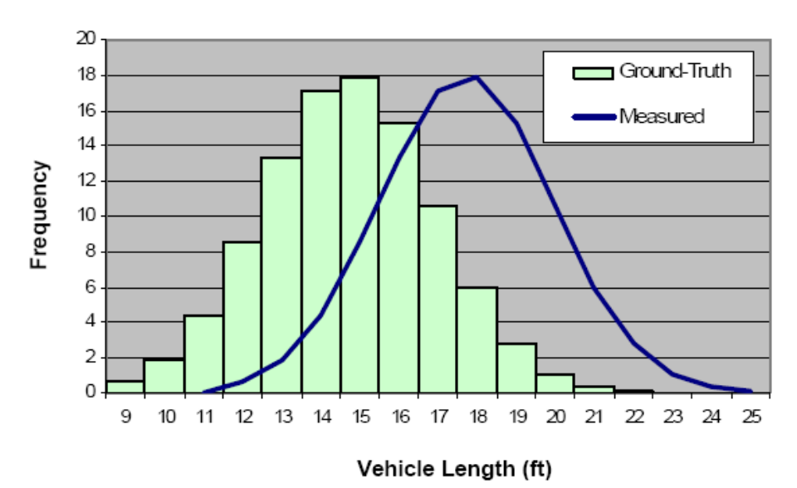
Figure 4-3. SV Length Histogram of Overly-High Dual-Loop Sensitivity
(Note: 1 ft = 0.305 m)

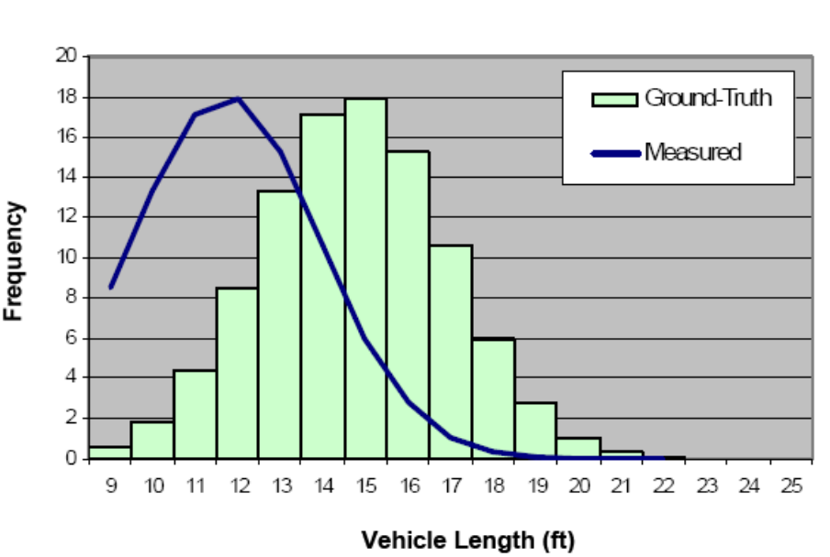
Figure 4-4. SV Length Histogram of Overly-Low Dual-Loop Sensitivity
(Note: 1 ft = 0.305 m)

4.3 DEVELOPMENT OF AN ALGORITHM FOR CORRECTING DUAL-LOOP SENSITIVITY PROBLEMS
As mentioned earlier, sensitivity discrepancies in a dual-loop detection system can be detected by calculating on-time differences between the M and S loops. If the on-time differences are close to zero, we can conclude that a dual-loop detector does not have sensitivity discrepancy problems. Thus, the dual-loop sensitivity discrepancy problem can be solved by adjusting the sensitivity levels at the DEUs until the on-times measured by both the M and S loops are the same or their on-time differences are zero. For example, if the on-time differences are positive, then the M loop is more sensitive than the S loop. We can remove the sensitivity discrepancy by increasing the sensitivity of the S loop and/or decreasing the sensitivity of the M loop. Similarly, if the on-time differences are negative, then the M loop is less sensitive than the S loop. To close the sensitivity gap, we can increase the sensitivity of the M loop and/or decrease the sensitivity of the S loop. Thus, adjusting loop sensitivity settings at the DEUs until the on-time differences of a dual-loop detector are close or equal to zero can eliminate the sensitivity discrepancy problem.
As explained in the previous section, we use a statistical approach based on the SV-length distribution observed by Wang and Nihan (2004) to check whether consistent sensitivity levels of the M and S loops are appropriate. A comparison between the histogram of calculated SV-length distribution and the histogram generated from the ground truth SV-length data was employed to identify whether or not a dual-loop detector was at an appropriate sensitivity level. When a dual-loop detector is at an inappropriate sensitivity level, the modes of the two histograms will be significantly different. To achieve an appropriate sensitivity level, the sensitivity settings at the DEUs should be adjusted until the histogram of SV-length measurements extracted from dual-loop event data is similar to the histogram of the ground truth SV-length data.
Statistically, the larger the SV sample size, the more accurate the comparison with the ground truth SV-length histogram. However, a large sample size takes a long time to accumulate. Since the sensitivity tuning process can take several iterations requiring multiple field attempts, correction of sensitivity problems may take too long if large samples of SV lengths are used. Therefore, a tradeoff between accuracy and efficiency is necessary. Efficiency and accuracy can be balanced by selecting an appropriate sample size for comparison with the ground-truth SV length histogram. Our experiments and analyses indicated that a sample of one hundred SV-length measurements was adequate for our test locations. Analyses based on this sample size provided acceptable accuracy, but further decreases in the sample size resulted in instable results due to the random impacts from vehicle arrivals. Daytime traffic volumes at our test locations were above 580 veh/hr/ln with approximately 10 percent trucks or buses. With similar traffic streams, it should not take more than thirteen minutes to collect one-hundred SV lengths for any dual-loop detector. The time duration for a sample data collection is still significant but tolerable.
For the current study, the histogram of this sample of SV lengths was then compared to the histogram generated from the ground truth SV-length data. At suitable sensitivity levels, the two histograms should match closely. The goodness of fit between the measured SV length distribution and the ground truth SV length distribution was determined by the calculated sum of squared errors. Since SV lengths range from 9 ft (2.74 m) to 25 ft (7.62 m), the measured SV lengths can be placed into seventeen categories with an increment of 1 ft (0.305m) between consecutive categories. The error for each length category is defined as the observed number of vehicles subtracted from the expected number of vehicles. If the sum of squared errors over all 17 categories is smaller than a specified threshold, we conclude that a particular dual-loop system is at the correct sensitivity level. (Our experience showed that 400 is a reasonable threshold value.) Otherwise, we recommend sensitivity adjustments to the two single loops. The sensitivity setting adjustments for the M and S loops may create a new sensitivity discrepancy problem. Before collecting another one hundred SV lengths for a new test, the M and S loop sensitivity discrepancy must be examined and corrected to make sure there is no sensitivity discrepancy problem. To ensure that a dual-loop detector is at a correct sensitivity level, the identification and correction steps for sensitivity discrepancies and incorrect sensitivity levels should be applied alternatively and iteratively until both sensitivity problems are eliminated.

CHAPTER 5 Development of the Advanced Loop Event Data Analyzer (ALEDA) System

High-resolution loop event data are not widely collected by existing freeway data collection systems. One of the reasons for this is the need to save disk space for data storage and bandwidth for data transmission to Traffic System Management Centers (TSMCs). The WSDOT loop detection system has event data available in the controllers but they are discarded after loop measurements are aggregated into 20-second intervals for archiving at the TSMC. Therefore, loop event data are not logged or stored in the current WSDOT loop detection systems. To accomplish event data collection, a complementary system that can be applied at loop detector stations was required. The Detector Event DAta Collection (DEDAC) system was developed to fulfill the requirement of event data collection by the TransNow ITS Group at UW (Zhang et al. 2003). The DEDAC system was designed to execute on a desktop computer with a Peripheral Component Interconnect (PCI) compliant data acquisition card. However, because of the size of a desktop computer and the available space in a controller cabinet, it was difficult to apply the DEDAC system in the field. A portable laptop version of DEDAC was developed to circumvent this problem.
A further improvement in event data collection and analysis is the newly developed ALEDA system. The ALEDA system developed in this study is a user-friendly, portable, and practical tool for event data collection, analysis, and dual-loop detector tuning (Cheevarunothai et al. 2005). It implements the algorithm described in Chapter 4 for sensitivity tuning of dual-loop detectors. ALEDA utilizes the latest digital Input/Output (I/O) technologies and is executable on a laptop computer running Windows 2000 or XP operating systems. Implementation details of the ALEDA system are presented in the follow sections of this chapter.

5.1 LOOP EVENT DATA
Loop event data are high-resolution loop measurements typically collected at 60 Hz or higher (Coifman, 2004). Unlike the WSDOT 20-second aggregated data, loop event data contain complete information on individual vehicles, such as vehicle arrival and departure times, and vehicle on-times. Therefore, loop event data are great information sources for in-depth analyses of loop malfunctions.
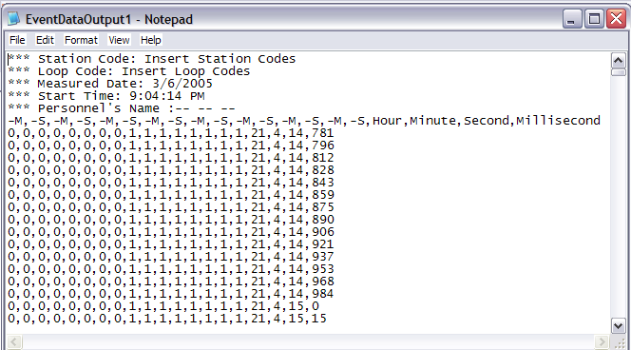
Figure 5-1. Sample File of Event Data

By default, ALEDA collects loop event data at 60 Hz, the frequency typically used by a controller to scan loop detectors. Loop event data are stored in a comma delimited data file as shown in Figure 5-1. This file contains sixteen columns of event data that correspond to the readings of M and S loops of eight dual-loop detectors. For example, the first and second columns from the left hand side of the file are for the M and S loops, respectively, of the dual-loop detector in the first traffic lane (the rightmost lane on freeways by the WSDOT convention). Following the event data columns are four columns of time data for recording the hour, minute, second, and millisecond of each poll.

5.2 System Design and Components
According to the Traffic Detector Handbook (ITE, 1997), a controller collects loop detector data by reading the voltage signals from the Input File of its control cabinet: a high voltage level (24 V DC) represents the situation when no car is on top of a loop detector (“OFF” condition), and a low voltage level (0 V DC) denotes the situation when a car occupies a loop detector (“ON” condition). The status of a loop detector at a particular moment is regarded as an event. As a loop detector event data collection and analysis system, ALEDA needs to detect such events and record them at 60 Hz or higher. To realize these functions, ALEDA is designed to have the following three hardware components:
- Laptop computer with Universal Serial Bus (USB) ports.
Recommended configurations of a laptop computer include Windows 2000 or Windows XP operating system, Pentium 4 processor, and 512 MB of Double Data Rate Synchronous Dynamic Random Access Memory (DDR SDRAM).

- Digital Input/Output (I/O) Adapter.
This adapter is required to connect a laptop computer with a USB port at one end and to connect the Input File housed in a control cabinet at the other end. In our design, we selected the SeaLINK ISO-16 Isolated Inputs Digital Interface Adapter (please refer to http://www.sealevel.com/uploads/manuals/8207.pdf for details). It has two ports with 8 input channels for each port. The turn-on logic voltage is 3.8 V DC.

- Cable Connections.
Normal 24-guage cables are used to connect the laptop computer, the digital I/O adapter, and the Input File in a control cabinet.
To detect signal voltages and transform them into binary values, ALEDA directly connects the digital I/O adapter to the Input File as shown in Figure 5-2. By this connection, ALEDA taps loop event data from the Input File without disturbing the normal operation of the controller. The digital I/O adapter uses 3.8 V DC to classify voltage signals into high or low levels. For instance, a 2 V DC signal is assigned to the low level category because it is lower than the 3.8 V DC threshold. ALEDA can poll the data address of the digital I/O adapter at 60 Hz or higher. The collected data are managed in an internal array. These data can serve as inputs for real-time calculations and analyses of individual vehicle on-times, speeds, lengths, and on-time differences or be recorded to a user-specified text file for archiving. ALEDA’s data flow is illustrated in Figure 5-3.
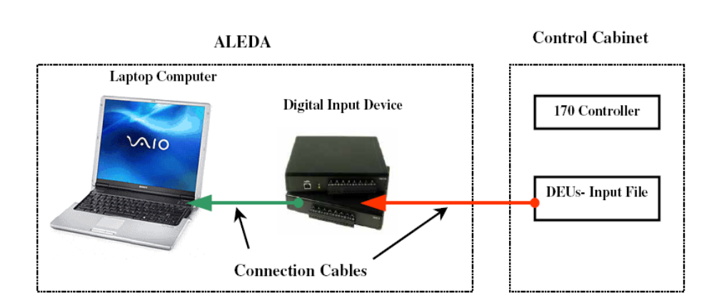
Figure 5-2. ALEDA’s Component Connections
Controller Cabinet
Data Collection Module
Data Analysis Module
Internal Array
Digital I/O Device
Event Data File
Vehicle Data File
User Interface
Figure 5-3. ALEDA’s Data Flow

5.3 System Implementation
The ALEDA system was developed in the C# programming language with the help of the Microsoft Visual C# .NET technologies and additional Universal Library documents from the manufacturer of the digital I/O adapter. It is a laptop based computer application to facilitate loop event data collection, analysis, and dual-loop detector sensitivity tune-ups.
Since a controller scans a loop detector at 60 Hz to provide inputs to various control and monitoring algorithms, the ALEDA system should have the capability of polling the data at the digital I/O adapter at 60 Hz or higher to meet practical needs. A high-resolution timer that can raise events at user-defined time intervals is needed to fulfill this requirement. The multimedia timer optimized for use in Windows applications in the Visual C#.NET technology was applied in ALEDA. The multimedia timer provides the greatest degree of timing accuracy, allowing applications to schedule timing events at a high resolution. The timing resolution of the ALEDA system can be as high as 80 Hz.
5.4 USER INTERFACE
The user interface of ALEDA has two main control windows: 1) Traffic Data Window, and 2) Sensitivity Data Window.

5.4.1 Traffic Data Window
The traffic data window (shown in Figure 5-4) displays, in real-time, the status of each single-loop and a set of commonly desired traffic data, such as vehicle count, lane occupancy, speed, and vehicle length. A group of system controls are available for this window. Users can record loop station name, register data collection date and time, and specify a directory for saving the event data file.
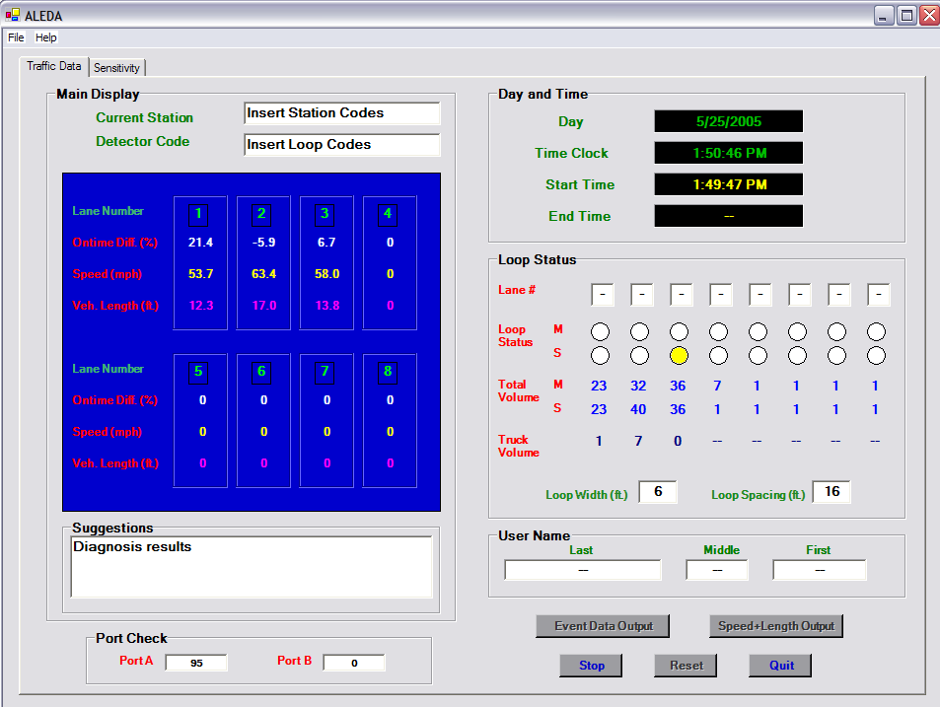
Figure 5-4. ALEDA User Interface for Collecting Traffic Data
5.4.2 Sensitivity Data Window
The sensitivity data window (Figure 5-5) shows real-time vehicle information related to loop sensitivity check up and adjustment, such as vehicle on-times, percentages of on-time differences between the M and S loops, the curve of on-time difference changes, the histogram of calculated SV lengths, and the ground-truth SV length histogram from Wang and Nihan (2004). Such sensitivity data are indispensable for detecting and correcting dual-loop sensitivity problems.
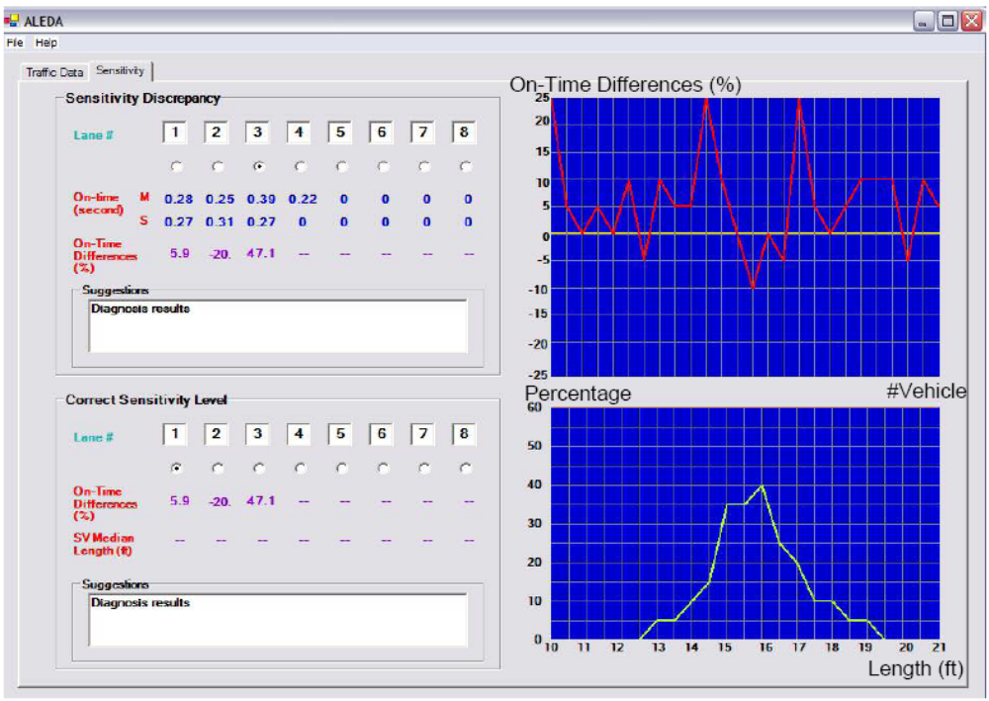
Figure 5-5. ALEDA User Interface for Solving the Dual-Loop Sensitivity Problems

5.5 MEASUREMENTS OF SPEED AND VEHICLE LENGTHS
The flow chart of the algorithm for calculating speed and vehicle length is shown in Figure 5-6. Speed is calculated from Dist_{MS}, and the time differences between the arrival time at the leading edge of the M loop (tm-on) and the arrival time at the leading edge of the S loop (ts-on), as shown in Equation (3-3). In the WSDOT’s loop detection system, the default value of the distance between the leading edge of the M loop and the leading edge of the S loop is 16 feet (4.8 meters). So Equation (3-3) can be rewritten as Equation (5-1):
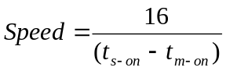 (5-1) Since lane-changing vehicles at the dual loop location may not have the correct arrival time measured by the M and S loops, such vehicles should be discarded from length calculations and length-based classifications. To screen out lane-changing vehicles, ALEDA will match tm-on with ts-on using a set of condition checks. There are three possible conditions:
- Condition one: a vehicle traverses over both the M and S loops. ALEDA will match its tm-on with the ts-on detected right after the tm-on is recorded.
- Condition two: a vehicle traverses over only the M loop but not the S loop. In this case, no ts-on match can be found for the vehicle’s tm-on within a reasonable time window. The tm-on will be dropped from speed and length calculations.
- Condition three: a vehicle runs over only the S loop but not the M loop. ALEDA will reject the ts-on because of it cannot be used as a match for any tm-on.
The above condition checks ensure that only vehicles with paired tm-on and ts-on will be used for speed calculations and length-based vehicle classifications.

Collect t_{m-on}
Collect t_{s-on}
Yes
No
Have t_{s-on}?
Calculate Speed
Calculate Vehicle Length
START
END
Figure 5-6. ALEDA’s Flow Chart for Speed and Length Calculations

An individual vehicle’s length is estimated immediately after its speed is calculated. Equation (5-2) shows how the vehicle length can be calculated for a 6 ft × 6 ft (1.8 m × 1.8 m) loop:
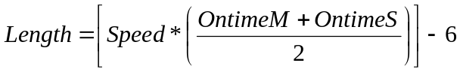 (5-2)
Vehicle length is estimated from speed and averaged on-times on the M and S loops. The on-times on the M loop are calculated from the arrival time (tm-on) and the departure time (tm-off). Similarly, the S loop’s on-time is obtained from ts-on and ts-off. Since the length is calculated from the average on-time and the on-time depends largely on the loop’s sensitivity level, the sensitivity setting plays a big role in the accuracy of vehicle length estimation. To accommodate more general situations, ALEDA provides a function for users to specify the distance between the M loop and the S loop, and input the loop length.

CHAPTER 6 SYSTEM TESTING AND DISCUSSION

6.1 TEST DATA COLLECTION
6.1.1 Test Site Selection
Data from dual-loop stations with sensitivity problems were needed to verify the proposed algorithm. Based on a preliminary analysis using the archived loop data and consultation with WSDOT technical supervisors, two dual-loop stations were selected for this test: (1) ES-172R (located at I-5 northbound & Metro Base); and (2) ES-137R (located at I-5 northbound & NE 45th St.). Traffic counts for the duration from 6:00 am to 6:00 pm on Nov. 28, 2004, at these two sites were obtained from the Traffic Data Acquisition and Distribution (TDAD) Website. Summary statistics of these counts are shown in Tables 6-1 to 6-2. Each station has three General Purpose (GP) lanes and one High Occupancy Vehicle (HOV) lane (the left-most lane). Because of the unique characteristics and low traffic volumes of the HOV lane, it was not included in this test. The GP lanes were numbered 1 through 3 from right to left. Traffic volumes recorded by the M loop, the S loop, and the dual-loop detector (ST – Speed Traps) are shown in the second, third, and fourth columns, respectively, in Tables 6-1 and 6-2. The last column of the two tables displays the percentage difference (DIFF%) between the volume counted by the M loop and that counted by the ST. The DIFF% column indicates the severity of the bin-volume undercount problem.

Table 6-1. TDAD Volume Data at ES-172R Station (NB I-5 & Metro Base) on November 28th, 2004
Lane | M loop | S loop | ST | DIFF% = (M loop – ST) / M loop * 100
1 | 15778 | 15872 | 14954 | 5.22
2 | 14082 | 14686 | 12845 | 8.78
3 | 10025 | 11186 | 567 | 94.34

Table 6-2. TDAD Volume Data at ES-137R Station (NB I-5 & NE 45th St.) on November 28th, 2005
Lane | M loop | S loop | ST | DIFF% = (M loop – ST) / M loop * 100
1 | 8961 | 8991 | 8013 | 10.58
2 | 14232 | 14283 | 13659 | 4.03
3 | 15738 | 15613 | 14999 | 4.70

As mentioned earlier, the current WSDOT dual-loop algorithm calculates vehicle length only when the on-time difference between the M and S loops is within ±10 percent. A dual-loop detector with severe sensitivity problems should have its total classified vehicle volumes significantly lower than that counted by either of its single loops. Hence, traffic lanes with a DIFF% of 10 percent or higher were considered to have serious sensitivity problems in this study. Traffic lanes identified to have serious sensitivity problems were Lane 3 at ES-172R and Lane 1 at ES-137R. For comparison purposes, all lanes at these two stations, with or without sensitivity problems, were chosen for this test.
The DEUs employed by the test loop stations were produced by either Eberle Design Inc. or Peek Traffic Limited. These DEUs had either eight levels of sensitivity (from level zero to seven) or sixteen levels of sensitivity (from level zero to fifteen). For all eight-sensitivity-level DEUs used by these selected stations, the sensitivities were set at level two except for one single loop on Lane 3 at ES-172R where the sensitivity was set at level five. For other single-loop detectors that use sixteen-sensitivity-level DEUs, the sensitivities were all set at level ten.
As shown in Table 6-1, the DIFF% on Lane 3 of ES-172R was almost 95 percent. The WSDOT dual-loop algorithm allowed the dual-loop detector on this lane to calculate vehicle lengths for only 5 percent of the total lane traffic. The large sensitivity discrepancy between the M and S loops may be caused by incorrect sensitivity level settings on one or both of the two single loops: the sensitivity settings were level two and level five for the M loop and the S loop, respectively. Whether or not the S loop sensitivity was set too high must be investigated in this test. Consistent sensitivity level settings on both the M and S loops do not assure zero on-time differences between the two single loops because a loop’s inductance is affected by surrounding temperature, humidity, road structure, etc. This implies that on-time differences may exceed 10 percent even when the M and S loop sensitivities are set at the same level. A tool to identify and fix the dual-loop sensitivity problems is needed. ALEDA can be used as such a tool.

6.1.2 Data Collection
Approximately 24 hours of event data were collected from the ES-172R station to check the impact of different traffic conditions on the sensitivity problems, and over two hours (76 minutes before the sensitivity tune-up and 84 minutes after the tune-up of the dual-loop detector) of event data were recorded at the ES-137R station to check the performance and effectiveness of the proposed dual-loop tune-up algorithm. The data collection at the ES-172R dual-loop station was conducted from 10:25:42am on December 8th to 9:41:17am on December 9th, 2004. At the ES-137R loop station, the before tune-up data were collected from 10:36:56am to 11:52:09am on November 30, 2005 and the after tune-up data were recorded from 12:24:58pm to 13:48:42am on the same day. For verification purpose, the TSMC of the WSDOT recorded two hours of video data (from 11:00am to 1:00pm on the data collection day) at each selected station.

6.2 data Extraction
All the collected event data were analyzed to extract vehicle movement data, such as volume count, loop occupancy, on-time difference, speed, vehicle length, etc. The TSMC-recorded video data were manually processed to extract bin-volume data for verification purposes. The vehicle count data obtained from the video sets were used as ground truth data for verifying the dual-loop tune-up algorithm.

6.3 SYSTEM TESTING

6.3.1 Connection Tests
Connection tests are required before ALEDA can be used to collect loop event data and aid in tuning the sensitivity levels of dual loop detectors. As the first step of ALEDA system testing, connection tests were performed to ensure that ALEDA could work together with typical traffic control devices, including the Model 332 cabinet and the Type 170 controller. ALEDA was connected to the Input File of a Model 332 cabinet at the Smart Transportation Applications and Research Laboratory (STAR Lab) of the University of Washington. This connection follows the design of ALEDA as specified in Figure 5-2. The connections for the sixteen input channels of ALEDA were tested individually to ensure that they were reliable. Then random combinations of the input channels were tested to make sure that channels did not interfere with each other. The test results showed that all sixteen input channels were successfully connected to the cabinet and were able to work independently.

6.3.2 Performance Tests
Tests were also conducted to evaluate the performance of ALEDA. Performance refers to whether loop event data can be collected and analyzed at a desired frequency without significant delays. ALEDA was used to collect and analyze event data for 24 hours at the ES-172R station. Analyses of the collected event data showed that ALEDA had no difficulties collecting and analyzing loop event data in real-time at a frequency of 60 Hz. ALEDA may be able to work at an even higher frequency, but this capability was not tested in this study.

6.3.3 Accuracy Test
An accuracy test was designed to check whether ALEDA can accurately collect vehicle volumes based on loop event data. Traffic information extracted from event data was compared with ground truth video data. The 30-minute test results (Table 6.3) indicated that vehicle volume data collected by ALEDA are very reliable, with an accuracy of more than 99% for all lanes at the ES-137R station.
Table 6-3. Comparison of Vehicle Count Data at the ES-137R Station (NB I-5 & NE 45th NB) on November 30, 2005

Lane | Video | Event Data | Accuracy%
1 | 217 | 215 | 99.08
2 | 419 | 423 | 99.05
3 | 419 | 420 | 99.76

6.4 Evaluating the Effectiveness of the Algorithm in Identifying Dual-Loop Sensitivity problems
As mentioned earlier, the dual-loop sensitivity problems can be divided into (1) the sensitivity discrepancy between the M and S loops, and (2) the incorrect sensitivity levels of both the M and S loops.

6.4.1 Sensitivity Inconsistencies
Dual-loop sensitivity discrepancies are the primary cause of bin-volume undercounts with WSDOT dual-loops. This is due to the fact that vehicles with 10% or more on-time differences between the M and S loops are dropped from the vehicle classification process. Since on-time measurements depend on a loop’s sensitivity level, the dual-loop on-time differences identify the sensitivity discrepancies between the M and S loops to a large extent. The on-time differences of all individual vehicles detected by the dual loops at ES-172R in a 15-minute interval are plotted in Figures 6-1 to 6-3 to illustrate the sensitivity discrepancy problems at these dual loops.

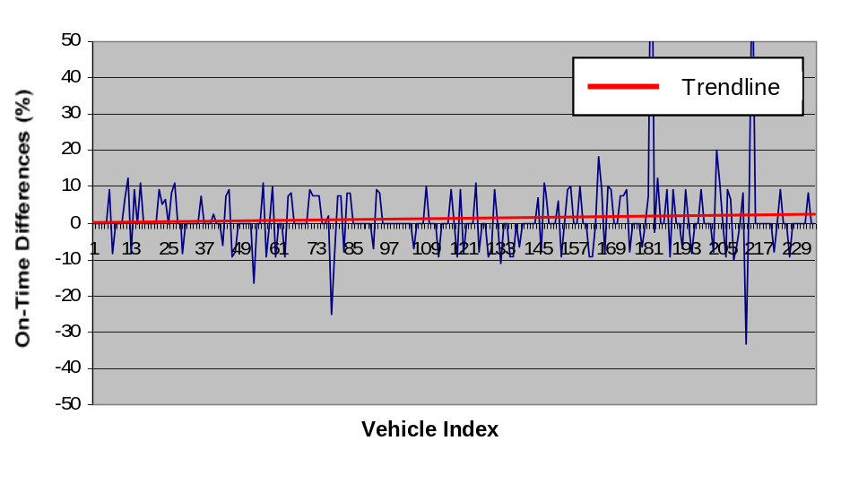
Figure 6-1. Dual-Loop On-Time Differences for Lane 1 at ES-172R
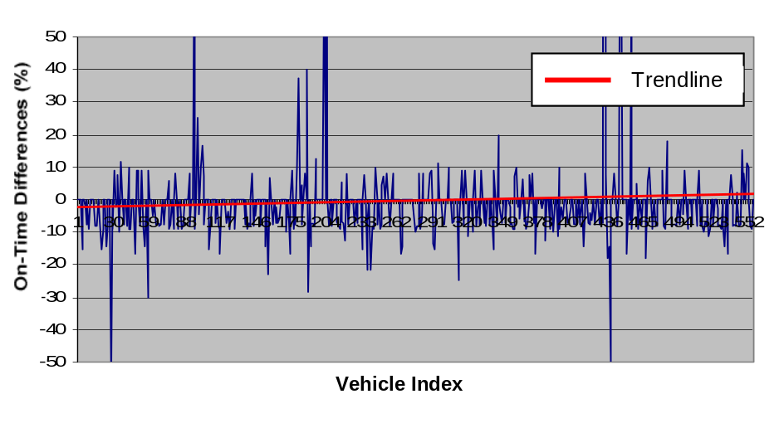
Figure 6-2. Dual-Loop On-Time Differences for Lane 2 at ES-172R

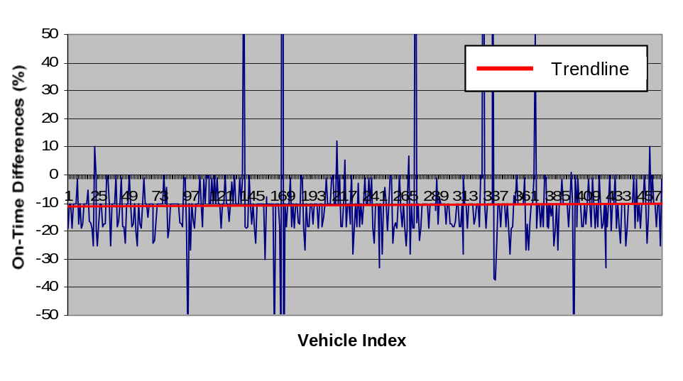
Figure 6-3. Dual-Loop On-Time Differences for Lane 3 at ES-172R

In Figure 6-1, the plotted on-time differences on Lane 1 at the ES-172R station are within ±10 percent for most detected vehicles. This conforms to the small value of DIFF% (5.22 percent) in Table 6-1. The DIFF% for Lane 2 (8.78 percent), however, is higher than that for Lane 1 (5.22 percent). This corresponds to a higher severity of sensitivity discrepancy problems that can be perceived in Figure 6-2. However, the average 15-minute on-time difference is still within the ±10 percent range according to the trendline, in spite of the increased number of on-time differences that exceed the ±10 percent range compared to Lane 1. The lane with the worst sensitivity discrepancy problems at the ES-172R station is Lane 3. The on-time differences are less than -10 percent in most cases and the average 15-minute on-time difference is outside the ±10 percent range (Figure 6-3). This identified sensitivity problem is clearly reflected by the high DIFF% value (94.34 percent) in Table 6-1.
Based on the above analyses, we can conclude that the on-time differences calculated by the proposed algorithm serve as a good indicator of dual-loop sensitivity discrepancy problems. The graphical displays of on-time differences on the user interface of ALEDA provide important information to loop maintenance staffs on whether or not a dual-loop detection system has sensitivity discrepancies.

6.4.2 Incorrect Sensitivity Levels
In addition to sensitivity discrepancies between the M and S loops, dual loops may have consistent single loop sensitivity levels that are, nevertheless, incorrect. This situation may also lead to vehicle misclassifications. Incorrect sensitivity levels of both M and S loops may result in on-time measurements that are too long or too short. Lengthened on-times will result in overestimated vehicle lengths and shortened on-times will produce underestimated vehicle lengths.
The algorithm developed in this study uses the SV length distribution observed by Wang and Nihan (2004) to check whether or not the sensitivity level of a consistent dual-loop detector is appropriate. As mentioned earlier, the algorithm will perform the analysis once one hundred SV length data are recorded.
To illustrate how the algorithm detects an incorrect sensitivity level for a consistently sensitive dual-loop detector, the median lengths of every one hundred SVs on each lane of the ES-172R station were plotted in Figure 6-4. Although the sensitivity settings at all eight-level DEUs were at level two (the sensitivity setting at the S loop’s DEU of Lane 3 was first changed from level five to two to eliminate the sensitivity discrepancy between the M and S loops), it was obvious that the calculated median vehicle lengths for Lane 2 (16.2 ft or 4.94 meters) and Lane 3 (16.0 ft or 4.88 meters) were longer than that for Lane 1 (15.5 ft or 4.73 meters). This illustrated the fact that the same sensitivity level settings for different dual-loop detectors cannot guarantee the same vehicle length measurements.
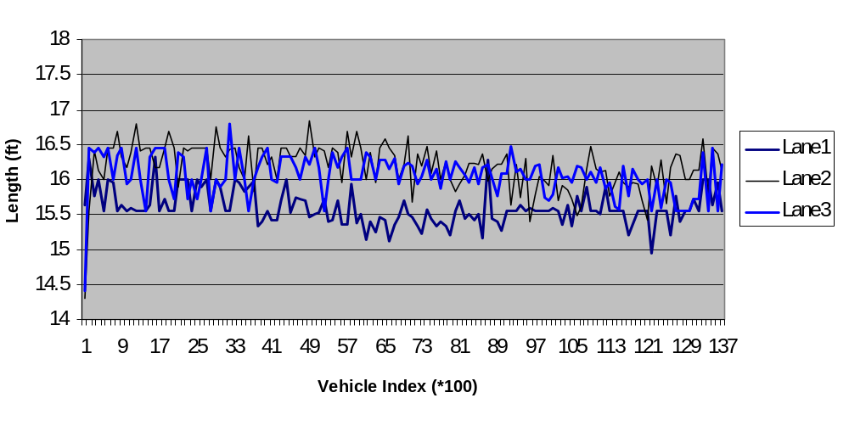
Figure 6-4. Estimated SV Median Length at ES-172R (SB I-5 & Metro Base)

Because the median length of SVs for the ground truth data were about 15.5 ft or 4.73 meters and the median lengths of SVs for Lanes 2 and 3 were about 16.2 ft (4.94 meters) and 16.0 ft (4.88 meters), respectively, measurements of vehicle lengths for Lanes 2 and 3 appeared to be too long but still within a tolerable range (the sum of squared errors of the 100-SV lengths was lower than 400 for both lanes). The measurements of vehicle lengths for Lane 1 were also considered accurate because its median lengths were 15.5 ft (4.73 meters). Therefore, the sensitivity level settings of both the M and S loops in Lanes 1, 2 and 3 were considered appropriate. By comparing the median lengths of every one hundred SVs with the ground-truth SV mean (since SV lengths are normally distributed, its population mean and median should be the same) and checking the sum of squared errors of the calculated SV lengths, the algorithm can detect whether the sensitivity level of a dual-loop detection system is appropriate.

6.5 Evaluating the Effectiveness of the Algorithm in correcting Dual-Loop Sensitivity problems

6.5.1 Case One: the ES-172R Station
As mentioned earlier, the dual-loop on Lane 3 of ES-172R had serious sensitivity discrepancy problems as indicated by its high DIFF% of 94.34%. The ALEDA system was applied to tune this dual-loop detector on December 8, 2004. The tuned dual loop has the S loop sensitivity level setting changed from five to two and the M loop sensitivity level stays at two. To evaluate the tuning effect, the DIFF% values before and after the tune up of this dual-loop detector were compared.
Fourteen days of data collection, including seven days before the tune up (December 1, 2004 – December 7, 2004) and seven days after the tune up (December 9, 2004 – December 15, 2004), were performed for the dual loop on Lane 3 of station ES-172R and downloaded from the TDAD Website. Differences between the M loop counts and the speed trap recorded total bin volumes (DIFF%) were calculated and are presented in Table 6.4 and Figure 6-5. The DIFF% values dropped from approximately 95% before the sensitivity tune up to less than 2% after the tune up. This indicates that almost all vehicles that drove over the dual-loop detector were classified after the tune-up. Consequently, the performance of the dual loop on Lane 3 of ES-172R improved significantly after the sensitivity problems were solved.
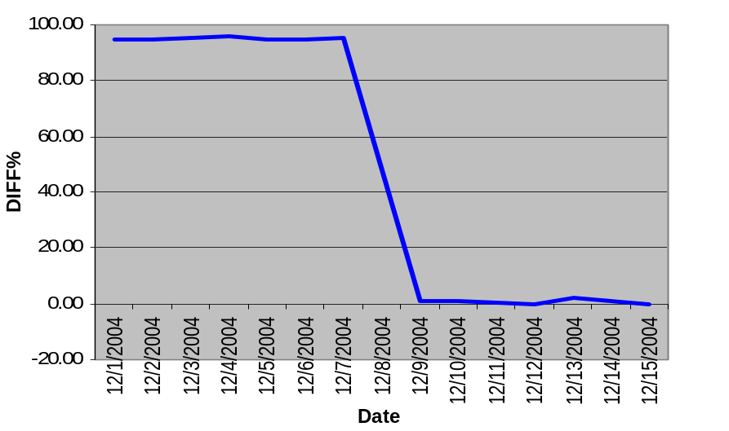

Figure 6-5. Variation of DIFF% in Lane 3 at ES-172R (SB I-5 & Metro Base)

Table 6-4. The Variation of DIFF% for Lane 3 at the ES-172R Station (NB I-5 & Metro Base)

Day | DIFF%
Day | Lane 1 | Lane 2 | Lane 3
12/1/2004 | 5.06 | 7.31 | 94.90
12/2/2004 | 6.49 | 9.84 | 94.66
12/3/2004 | 6.70 | 8.28 | 95.15
12/4/2004 | 3.57 | 7.58 | 95.66
12/5/2004 | 3.88 | 7.27 | 95.02
12/6/2004 | 6.49 | 9.80 | 94.73
12/7/2004 | 7.30 | 10.52 | 95.12
12/9/2004 | 9.54 | 15.18 | 1.08
12/10/2004 | 8.71 | 17.29 | 1.22
12/11/2004 | 4.90 | 14.06 | 0.65
12/12/2004 | 4.47 | 13.23 | -0.17
12/13/2004 | 7.93 | 15.72 | 1.85
12/14/2004 | 6.97 | 15.43 | 0.98
12/15/2004 | 6.57 | 15.84 | -0.13

At the ES-172R station, the sensitivity level settings of the Lane 1 and Lane 2 dual loops were not changed in the tune up process on December 8, 2004 because neither of them was identified to have noticeable sensitivity problems. However, after the Lane 3 dual-loop tune-up, the DIFF% on Lane 1 and Lane 2 increased slightly as shown in Table 6-4. These DIFF% changes might be caused by the changes in environmental factors or by the change of sensitivity level of the Lane 3 dual loop. Further research is needed to identify the impact of sensitivity tune-ups to loop detectors in adjacent lanes.

6.5.2 Case Two: at the ES-137R Station
Similarly, the sensitivity problems on Lane 1 at the ES-137R station were alleviated through a sensitivity tune-up using the ALEDA system. The DIFF% of Lane 1 on November 28, 2005 was about 10.58% (Table 6-2), even though the sensitivity level settings for the sixteen-level DEUs of both the M and S loops were at level ten. The sensitivity tune-up conducted on November 30, 2005 resulted in increasing the M loop sensitivity setting to level eleven and keeping the S loop sensitivity setting at level ten. The sensitivity tune-up was effective because the DIFF% dropped to 6.31% (less than 10%) according to the dual-loop measurements of December 2, 2005 (Table 6-5).

Table 6-5. TDAD Volume Data at the ES-137R Station (NB I-5 & NE 45th NB) on December 2, 2005
Lane | M loop | S loop | ST | DIFF% = (M loop – ST) / M loop * 100
1 | 8575 | 8590 | 8034 | 6.31
2 | 13643 | 13672 | 12803 | 6.16
3 | 14678 | 14527 | 13987 | 4.71

The test results in the above two cases demonstrated that the proposed algorithm implemented in ALEDA is effective to identify and correct sensitivity problems with the WSDOT dual-loop detectors.

6.6 Truck Data
The comparisons of vehicle counts for SVs (length ≤ 26ft) and trucks (length > 26ft) before and after the sensitivity tune-up of the Lane 1 dual loop at the ES-137R station (the only lane with a sensitivity adjustment at ES-137R) are shown in Table 6.6. Traffic counts extracted from the recorded videotape were used as the ground truth data for comparisons with the TDAD data and the event data. Two data sets were collected for the comparisons: one data set was from 2:00pm to 3:00pm on May 16, 2002 (before the sensitivity tune-up) and the other was from 12:24pm to 13:24pm on November 30, 2005 (after the sensitivity tune-up).

Table 6-6. Vehicle Count Data for Lane 1 at ES-137R (SB I-5 & NE 45th St. NB) BEFORE and AFTER the Sensitivity Tune-Up

 | Vehicle Types | Video (VI) | TDAD  (TD) | Event Data (EV) | VI-TD Error (%) | VI-EV  Error (%)
BEFORE | SV | 446 | 447 | 447 | -0.22 | -0.22
 | Truck | 18 | 13 | 17 | 27.78 | 5.56
 | Total | 464 | 460 | 464 | 0.86 | 0.00
AFTER | SV | 653 | 651 | 653 | 0.31 | 0.00
 | Truck | 30 | 24 | 29 | 20.00 | 3.33
 | Total | 683 | 675 | 682 | 1.17 | 0.15

Note: VI-TD Errors (%) = (Video Data – TDAD Data) / Video Data
VI-EV Errors (%) = (Video Data – Event Data) / Video Data

As shown in Table 6-6, trucks were seriously undercounted in the TDAD data of Lane 1 at ES-137R before the sensitivity tune-up. The truck counts on Lane 1 from the TDAD and ALEDA were smaller than the actual truck counts (truck counts from the video data). The TDAD and ALEDA recorded 13 and 17 trucks, respectively, instead of 18 trucks extracted from the video data. The relative error of the TDAD truck counts was about 28%, and that of the ALEDA truck counts was about 6%.
Comparisons of truck counts after the sensitivity tune-up showed that the accuracy of the TDAD truck data had improved. The results in Table 6-6 show that the differences between the actual truck counts (from the video data) and the truck counts from the TDAD data or the event data were smaller than those before the sensitivity tune-up. The relative error of the TDAD truck counts dropped from 28% to 20%. The relative error of ALEDA collected truck counts also slightly decreased from 6% (1 missing vehicle out of 18 vehicles) to 3% (1 missing vehicle out of 30 vehicles).
In Table 6-6, it is obvious that the truck counts extracted from the event data by ALEDA were much closer to the actual truck counts than those from the TDAD data. We believe that the difference was due to the way a vehicle with an on-time difference larger than 10% was treated in the ALEDA algorithm. In the WSDOT dual-loop algorithm, such a vehicle was discarded from classification. In the ALEDA application, the vehicle was classified after the on-time difference was corrected.
A comparison of the TDAD truck data and the ground-truth (video) truck data before and after the tune-up demonstrated the effectiveness of using ALEDA for dual-loop sensitivity tune-ups. Once the sensitivity problems are corrected, improved truck data can be collected from the existing dual-loop detection systems. However, the 20% truck data error after the tune up is still very significant. During the tune-up process, we were not able to further lower this error through adjusting the sensitivity levels. The fact that the ALEDA extracted truck volume data that was very close to the ground-truth truck volume data indicates that truck data can be further improved by employing a better dual-loop algorithm that treats suspicious observations more effectively.

6.7 analysis summary
The results of the analysis can be summarized as follows:
- The algorithm developed in this study can efficiently detect and correct sensitivity discrepancies between the M and S loops. Consistent sensitivity between the M and S loops enhances the performance of the WSDOT’s dual-loop detection system in measuring vehicle speed.
- Percentage differences between the volume counts on a single loop (the M or S loop) and a dual-loop system (the speed trap) were much smaller after the proposed algorithm was applied. Compared to the current WSDOT algorithm, this decreases the number of vehicles that will be discarded from classification based on the 10% threshold value of on-time difference.
- Incorrect sensitivity levels of two consistently sensitive single loops that form a dual-loop detector can be identified and eliminated using ALEDA. After the sensitivity tune-up of a dual-loop detector, the reliability and accuracy of the WSDOT dual-loop truck data can be significantly improved.
- The statistical approach that uses the features of SV-length distribution to determine whether the sensitivity level of a dual loop is appropriate has been demonstrated to be effective. The histogram of the calculated SV lengths should match closely with the histogram generated from the ground-truth SV-length distribution when a dual-loop detector is at the appropriate sensitivity level(s).

CHAPTER 7 CONCLUSIONS AND RECOMMENDATIONS

7.1 CONCLUSIONS
This study investigated dual-loop sensitivity problems and proposed a new algorithm to detect and fix such sensitivity problems using loop event data and the statistical features of SV-length distribution. High-resolution event data contain more complete individual vehicle information than interval-aggregated loop measurements and are more useful for in-depth investigation of dual-loop sensitivity problems. The analysis results showed that dual loops have two major sensitivity problems: sensitivity discrepancies between the two single loops that form a dual-loop detector, and incorrect levels of sensitivity on both single loops when there are no sensitivity discrepancies. Dual-loop sensitivity inconsistencies result in erroneous calculation of lane occupancy, speed, and vehicle length. Incorrect sensitivity levels cause imprecise measurements of vehicle lengths and hence misclassifications of vehicles. The combination of both dual-loop sensitivity problems can cause severely inaccurate measurements of vehicle speed and bin volumes.
A new algorithm for solving the two major types of dual-loop sensitivity problems has been developed using loop event data and the characteristics of SV-length distributions. This algorithm has been implemented in a computer application named ALEDA. Tests of this system showed that the two dual-loop sensitivity problems mentioned earlier can be effectively corrected with the ALEDA application. Sensitivity discrepancies can be eliminated by adjusting sensitivity levels at loop DEUs until the on-time differences between the M and S loops are close to zero. Similarly, the appropriate sensitivity level of a dual loop can be identified based on a ground-truth SV-length distribution.
Dual-loop detectors are a major source of traffic data that are vital for effective ATMS and ATIS. Dual-loop sensitivity problems must be solved to increase the reliability of dual-loop data. In practice, these sensitivity problems are typically detected and corrected manually by traffic technicians based on their experience. The process is time consuming and the result is often inaccurate. The proposed methodology with the implemented ALEDA is expected to help solve dual-loop sensitivity problems effectively.

7.2 RECOMMENDATIONS FOR FURTHER STUDY
The results from this project lead to several recommendations. First, further testing of the proposed algorithm embedded in the ALEDA system with DEUs from different manufacturers and under different weather and road geometric conditions is recommended. So far the algorithm has been tested at only two dual-loop stations on the I-5 corridor in the Seattle area.
Second, given the analysis results of the event data, an enhanced analysis function for loop error identification and solution recommendation should be developed. For example, intermittent fluctuations of dual-loop on-time differences may arise from the cross chattering of DEUs. Eliminating loop data errors and increasing the effectiveness and performance of existing traffic data collection systems will continue to be important for regional transportation authorities.
Third, the ALEDA system needs further improvements in user interface design and hardware selection to make it a standard tool for maintenance staffs to tune-up dual loop detectors with sensitivity problems.
Fourth, the effectiveness of ALEDA depends on the physical conditions of dual-loop detectors. For example, the sensitivity discrepancy problem cannot be corrected if the M and S loop sensitivity difference is beyond an adjustable range. Also, a tune-up is normally an approximate solution rather than a perfect one due to the discrete values of sensitivity levels available on a DEU.
Finally, the current dual-loop algorithm used by the WSDOT throws away many potentially useful vehicle measurements. A new dual-loop algorithm that is able to correct imperfect vehicle measurements and be less affected by loop detector noises needs to be developed to further improve truck and speed data.

Acknowledgements
The authors are grateful for the financial support to this project from Transportation Northwest (TransNow), the USDOT University Transportation Center for Federal Region 10, and the Washington State Department of Transportation (WSDOT). The authors also wish to express sincere appreciation to WSDOT’s Traffic System Management Center personnel, specifically, Mr. Mark Morse, Mr. Chitty David, and Ms. Lanping Xu for their valuable suggestions and help with the collection of freeway data. Special thanks also go to TransNow’s staff, Andrea King and Christine Fish for their compiling and editing of this final report.

BIBLIOGRAPHY

- Al-Deek, H. (1991). “The Role of Advanced Traveler Information Systems in Incident Management”, Dissertation Series Institute of Transportation. Report Number: 1-5.

- Cheevarunothai, P., Y. Wang, and N. L. Nihan (2005). “Development of Advanced Loop Event Analyzer (ALEDA) for Investigations of Dual-Loop Detector Malfunctions”, Presented at The 12th World Congress on Intelligent Transportation Systems, San Francisco.

- Chen, C. H., and G. L. Chang (1993). “A Dynamic Real-Time Incident Detection System for Urban Arterials-System Architecture and Preliminary Results”, In Pacific Rim TransTech Conference: Volume I: Advance Technologies, ASCE, 0-87262-916-3, pp. 98-104.

- Chen, C., K. Petty, A. Skabardonis, P.P. Varaiya, and Z. Jia (2001). “Freeway Performance Measurement System: Mining Loop Detector Data”, In Transportation Research Record: Journal of the Transportation Research Board, No. 1748, TRB, National Research Council, Washington, D.C., 2001, pp. 96-102.

- Chen, L., and A. May (1987). “Traffic detector errors and diagnostics”, In Transportation Research Record: Journal of the Transportation Research Board, No. 1132, TRB, National Research Council, Washington, D.C., pp. 82–93.

- Clark, D. C., W. T. Scherer, and B. L. Smith (2001). “Performance-Cost Evaluation Methodology for ITS Equipment Deployment”, Research Project Report for the National IIS Implementation Research Center, a USDOT University Transportation Center. Report Number: UVA-CE-ITS-01-2.

- Cleghorn, D., F. L. Hall, and D. Garbuio (1991). “Improved Data Screening Techniques for Freeway Traffic Management Systems”, In Transportation Research Record: Journal of the Transportation Research Board, No. 1320, TRB, National Research Council, Washington, D.C., pp. 17-23.

- Coifman, B. (1999). “Using Dual Loop Speed Traps to Identify Detector Errors”, In Transportation Research Record: Journal of the Transportation Research Board, No. 1683, TRB, National Research Council, Washington, D.C., pp. 47-58.

- Coifman, B., D. Lyddy, and A. Sabardonis (2000). “The Berkeley Highway Laboratory- Building on the I-880 Field Experiment”, Proc. IEEE ITS Council Annual Meeting, IEEE, pp 5-10.

- Coifman, B., and M. Cassidy (2002). “Vehicle Reidentification and Travel Time Measurement on Congested Freeways”, Transportation Research: Part A. Vol. 36, No. 10, pp. 899-917.

- Coifman, B., and S. Shoorjaty (2004), “Event Data Based Traffic Detector Validation tests”, Journal of Transportation Engineering, Vol.130, No.3

- ITE (Institute of Transportation Engineers) (1997). Traffic Detector Handbook. 2nd Edition, Washington D.C.

- Jacobson, L. N., N. L. Nihan, and J. D. Bender. (1990). “Detecting Erroneous Loop Detector Data in a Freeway Traffic Management System”, Transportation Research Record: Journal of the Transportation Research Board, No. 1287, TRB, National Research Council, Washington, D.C., pp. 151-166.

- Jensen, M., M. Williamson, R. Sanchez, A. Newton, C. Mitchell, and M. Hallenbeck (2003). WSDOT Intermodal Data Linkages Freight ITS Operational Test Evaluation: Final Report. Part 2, Freight ITS Traffic Data Evaluation, Final Report for Science Applications International Corporation. Washington State, U.S. Department of Transportation. Report Number: EDL#13781.

- Model SeaLINK ISO-16 Digital Input Adapter Technical Manual. http://www.sealevel.com/uploads/manuals/8207.pdf. Accessed on January 6, 2005

- Nihan, L.N., Jacobson, L.N., Bender, J.D., and Davis, G.A. (1990). Detector Data Validity. Washington State Transportation Center – TRAC/WSDOT, TransNow/WSDOT Joint Final Research Report No. WA-RD 208.1, 80 pages.

- Nihan, L.N., X. Zhang, and Y. Wang (2002). Evaluation of Dual-Loop Data Accuracy Using Video Ground Truth Data. Washington State Transportation Center – TRAC/WSDOT, TransNow/WSDOT Joint Final Research Report No. WA-RD 535.1, 35 pages.

- Smith, K., and B. L. Smith (2001). Forecasting the Clearance Time of Freeway Accidents. Center for Transportation Studies, University of Virginia, Research Report No. UVACTS-15-0-35.

- Traffic Data Acquisition and Distribution (TDAD) database. http://www.its.washington.edu/tdad/,Accessed on December 25, 2004

- Turner, S., L. Albert, B. Gajewski, and W. Eisele (2000). “Archived Intelligent Transportation System Data Quality: Preliminary Analysis of San Antonio Transguide Data”, Transportation Research Record: Journal of the Transportation Research Board, No. 1719, TRB, National Research Council, Washington, D.C., pp. 77-84.

- Wang, Y., and L.N. Nihan. (2003). “Can Single-Loop Detectors Do the Work of Dual-Loop Detectors?”, ASCE Journal of Transportation Engineering, 129(2), pp. 169-176.

- Wang, Y. and N. L. Nihan (2004). “Dynamic Estimation of Freeway Large-Truck Volumes Based on Single-Loop Measurements”, Journal of Intelligent Transportation Systems, Vol. 8, No. 3, pp. 133-141.

- Wang, Y., and N. L. Nihan (2004). “An Adaptive Algorithm for Freeway Speed Estimation with Single-Loop Measurements.” Proceedings of the 8th World Multi-Conference on Systemics, Cybernetics and Informatics, Vol. VII, 396-401.

- Zhang, X., Y. Wang, N. L. Nihan, and M. E. Hallenbeck (2003). “Development of A System to Collect Loop Detector Event (Individual Vehicle) Data.” Transportation Research Record: Journal of the Transportation Research Board, No. 1855, TRB, National Research Council, Washington, D.C., pp. 168-175.

