Individual Development Accounts
Individual Development Account (IDA) – a matched savings account used for a defined asset goal.

Modeled on IRAs and 401ks, IDAs provide lower-income workers and their families with an incentive to earn and save more, invest in themselves and join the economic mainstream. IDAs must be used for specified purposes such as homeownership, post-secondary education, or small business development. Some IDAs are available for additional assets, such as automobiles, computers, or home repair.

begin text box
IDA Example
Personal savings $1,000
Match rate $3:$1
Match funds $3,000
Total available for asset investment $4,000
end text box

IDAs are structured to offer a savings incentive, between $1 and $8 for every dollar of personal savings, with a cap on matching funds per account usually between $2,000 and $8,000. In most cases, accountholders save between $500 and $4,000 over a 6- to 36-month period. Monthly deposits range from $10 to $100 per month.

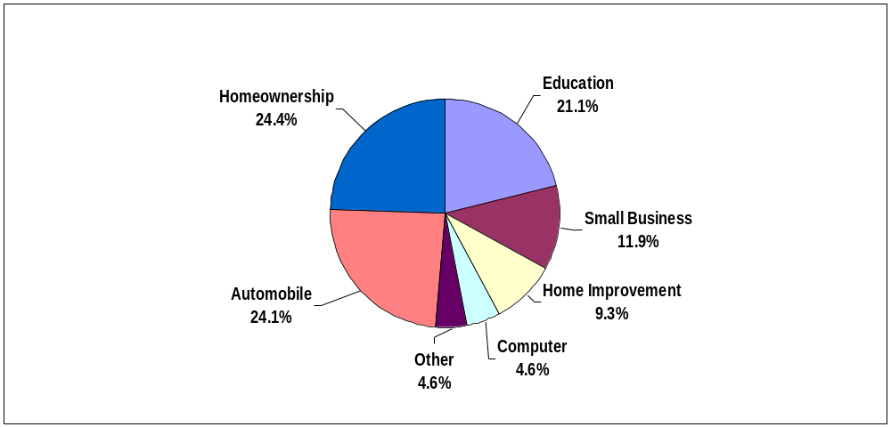
Over 500 community-based organizations, government agencies, and faith-based groups across the country have made it possible for more than 20,000 workers to save in IDAs. The majority of these IDA programs began opening accounts after 1998.
Asset Investments

Data through the end of 2002 shows that at least $14.5 million in personal savings have been invested in 8,000 assets; over $22.5 million in match funds and $130 million in loans from financial institutions leveraged these asset purchases.
2003 Survey of IDA Programs

“… we regained our self-confidence. We know we have the skills and knowledge to keep our family on solid financial ground. The things we learned are not just applicable to our one goal of homeownership – they are skills for life.”
Austin, Texas IDA Accountholder

IDAs Make Savings Work
IDAs…
- Offer Incentives – tax deductions aren’t enough for low-to-moderate income families
- Make assets attainable for working families in the near-term
- Make saving easier – access to mainstream accounts, promotes tools like direct deposit
- Build financial literacy and develop longer-term goal orientation
- Assist in overcoming obstacles – debt management, credit repair
- Build capacity to acquire, maintain, and protect productive assets
- Offer hope – transforms expectations for the future

The potential impact of idas is significant

This example illustrates the return on investment in one employee:
Employer Investment
Financial Ed/Counseling $200 -- $500
IDA (match) $2,000 -- $8000 (dependent on match rate)
Impact to the Employer
Return on Investment (ROI) Financial Education 3:1
Improvement in the Bottom Line $600-- $1,500
Impact to the Economy
Local Economic Multiplier of Asset purchase 3.0
Total Impact to Local Economy $6,000-- $24,000

“Income may feed people’s stomachs, but assets change their heads.”
Michael Sherraden, Washington University

CFED. “A Look at the Growing Individual Development Account Field: Results from the 2003 Survey of IDA Programs,” p. 4, 2003.
Garman, E T. (2003) “A Conceptual Model of the Return-on-Investment of Workplace Financial Education and Assistance Programs.”

