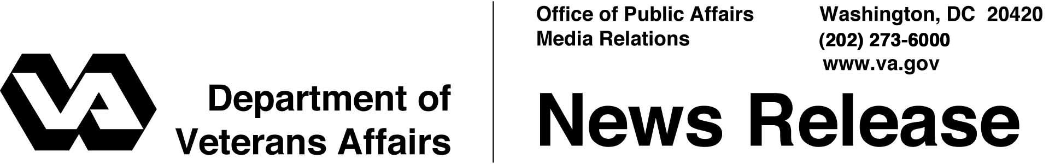

FOR IMMEDIATE RELEASE
November 7, 2007

Wear Your Medals on Veterans Day: Mansfield
“Veterans Pride Initiative” Shows Support for Service Members
WASHINGTON – For veterans to show their support of the U.S. military, especially for the men and women serving overseas in the Global War on Terrorism, Acting Secretary of Veterans Affairs Gordon H. Mansfield called on the nation’s 24 million veterans to wear their military decorations on Veterans Day.
"By wearing our decorations, we show the world the unity of our support for the U.S. armed forces and our pride in the men and women serving today on the frontlines of freedom,” said Mansfield, a decorated and wounded combat veteran of the Vietnam War. “We also teach the meaning and the value of military service to the children of America.”
Former Secretary Jim Nicholson, launched the "Veterans Pride Initiative” a year ago, urging veterans to pin on their decorations for Veterans Day, Memorial Day, the Fourth of July and other patriotic holidays and events.
Additional information about the initiative can be found at VA's Web site at http://www.va.gov/veteranspride. The site includes information about how veterans can replace lost medals or confirm the decorations to which they are entitled.
Mansfield is scheduled to take part in the national observance of Veterans Day at the Tomb of the Unknowns in Arlington National Cemetery on Sunday, Nov. 11. Most of the 125 national cemeteries operated by the Department of Veterans Affairs and many of the Department’s 153 hospitals will be holding their own observances.
Originally conceived to mark the end of World War I in 1918 – when an armistice for “the war to end all wars” began on the 11th hour of the 11th day of the 11th month – Veterans Day now honors the service of everyone who served in the U.S. military.
Attached is Acting Secretary Mansfield’s Veterans Day message.

# # #

A Veterans Day Message
From the Acting Secretary of Veterans Affairs
Gordon H. Mansfield

On this Veterans Day 2007, we come together as a Nation to thank our veterans for their service and to let them know that their service and sacrifices will never be taken for granted.
Americans are blessed to live in a Nation of democracy and freedom. For these blessings we thank our veterans. Here and in communities across this great country, we honor veterans for protecting and securing democracy and freedom throughout our history.
Veterans are everyday men and women we know as friends, neighbors, relatives and colleagues who have served our Nation in extraordinary ways. They have preserved and strengthened our country and made sacrifices beyond duty’s call. Even as we honor them this Veterans Day, their successors are courageously defending our freedoms at home and abroad. Veterans and their families are truly among our finest citizens.
At the Department of Veterans Affairs, we are proud to fulfill the solemn pledge of President Abraham Lincoln, who during his second inaugural address on March 4, 1865, set forth our obligation to care for those injured in body and spirit in their defense of our Nation and for the families of those who made the ultimate sacrifice. The VA and the over quarter-million men and women serving in it give daily endorsement of President Lincoln’s commitment, and do so in a spirit of compassion, respect, sensitivity and gratitude. Let us today, therefore, remember Lincoln’s charge to us:

“With malice toward none; with charity for all; with firmness in the
right, as God gives us to see the right, let us strive on to finish the
work we are in; to bind up the nation’s wounds; to care for him who
shall have borne the battle, and for his widow, and his orphan – to
do all which may achieve and cherish a just, and lasting peace,
among ourselves, and with all nations.”

# # #

