Archived Information

SECTION II

STUDENT CHARACTERISTICS

Modules

1. Children Ages Birth Through Five Served Under IDEA

2. Students Ages 6 Through 21 Served Under IDEA

3. The Racial/Ethnic Composition of Students with Disabilities

4. Gender as a Factor in Special Education Eligibility, Services, and Results

5. Students with Emotional Disturbance

Children Ages Birth Through Five Served Under IDEA

Purpose: To report the number of children served in both the Part C Program and the Preschool Grants Program and the settings in which these children receive services.

The infants and toddlers program, Part H of IDEA, was adopted by Congress in 1986. The 1997 reauthorization of IDEA moved the legislation to Part C of the Act. The program is designed to address the needs of infants and toddlers with disabilities ages birth through 2 through “a statewide, comprehensive, coordinated, multidisciplinary, interagency system that provides early intervention services for infants and toddlers with disabilities and their families.” (20 U.S.C. 1431(b)(1)) All States ensured full implementation of the Part C program for infants and toddlers with disabilities by September 30, 1994.

Since FY 1992, all States have been required to make a free appropriate public education (FAPE) available to all children with disabilities ages 3 through 5, in order to be eligible for an award under the Preschool Grants Program under Section 619 of IDEA and other IDEA funds targeted to children ages 3-5 with disabilities. Five States (Iowa, Maryland, Michigan, Minnesota, and Nebraska) and six jurisdictions (American Samoa, Commonwealth of the Northern Mariana Islands, Federated States of Micronesia, Guam, Palau, and Puerto Rico) provide FAPE from birth, and Virginia does so at age 2 (deFosset & Carlin, 1997). All other States provide FAPE beginning at age 3.

The Number of Children Served Under IDEA, Part C

Over the past 5 years, the number of infants and toddlers served under Part C has steadily increased from 145,179 on December 1, 1992, to 187,348 on December 1, 1996 (see figure II-1 and table AA14, on page A-44). This small but consistent annual increase resulted in an overall increase of 29 percent over the 5-year period, as States improved their ability to count children served while eliminating duplicate counts. During this same time period, the population estimates decreased from 11,911,554 to 11,382,432, reflecting a 4 percent decrease.

From December 1, 1995, to December 1, 1996, the total number of infants and toddlers served in the 50 States and the District of Columbia rose from 177,286 to 187,348, an overall increase of 6 percent. However, 18 States reported a decline in the numbers of infants and toddlers served, while 33 States reported an increase in their counts.

Among the States that reported a decline in the number of children served, several attributed the decrease to changes in data collection methods. Several States have begun using improved data collection systems that will result in the reporting of unduplicated counts.

Among the States that reported an increase in the number of children served, several cited program expansion as a primary reason for the increase. In part, agencies are now providing individualized family service plans (IFSPs) to children previously served under other State programs. Other States noted that increases were related to improved public awareness efforts. These public awareness efforts probably helped the agencies find more eligible children.
Figure II-1
Number of Infants and Toddlers Served Under IDEA, Part C, 1992 Through 1996
Source: U.S. Department of Education, Office of Special Education Programs, Data Analysis System (DANS).
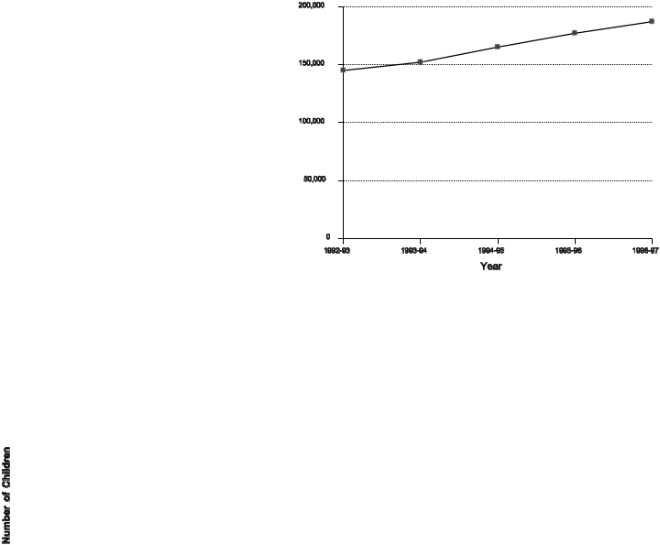

The percentage of the population ages birth through 2 served under Part C rose slightly from 1.54 percent in 1995 to 1.65 percent in 1996 (see tables AA14, p. A-44, and AF2, p. A-222). During this same period, the total population of children in that age group decreased 1.6 percent, from 11,570,316 to 11,382,432. In 1996, the majority of States (33) served 1 to 2 percent of their birth to 2 population under IDEA; 6 States served less than 1 percent; 9 States served 2 to 3 percent; and 3 States served more than 3 percent (see table AH1, p. A-228). Looking at the 5-year trend, the percentage of the population served under Part C increased from 1.21 percent in 1992 to 1.65 percent in 1996 (see tables AA14, p. A-44, and AF2, p. A-222).

Early Intervention Environments for Infants and Toddlers with Disabilities

OSEP currently uses eight different settings to collect data on where infants and toddlers with disabilities receive services. These settings are early intervention classroom, family child care, home, hospital (inpatient), outpatient service facility, regular nursery school/child care, residential facility, and other. However, not every State reports or uses each category. States’ use of the reporting categories for where infants and toddlers were served varies, as shown in table AH4 in Appendix A. OSEP collects data only on the primary setting (that is, the setting where the majority of services are provided to a child); many infants and toddlers receive services in multiple settings. Some States report zero (0) for a number of services, indicating that the category is valid in the State, but that no infants and toddlers were served there. States also use a period (.) to report missing data, indicating that the State does not use that placement category. During 1995-96, home was the category with the most valid responses. Only three Outlying Areas did not use this setting to provide services. Residential facilities were not a recognized setting for infants and toddlers in 12 States; an additional 16 States reported no services provided in this setting.

Figure II-2
Number of Infants and Toddlers Served in Different Settings, 1992-93 and 1995-96
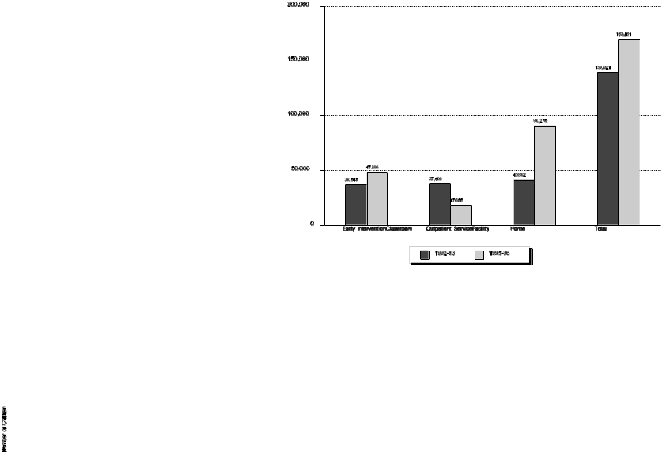

Source: U.S. Department of Education, Office of Special Education Programs, Data Analysis System (DANS).

States’ use of these categories also reflects the unique service delivery pattern for Part C. For example, Massachusetts served all children in the home setting, while Puerto Rico reported serving all children in outpatient service facilities. California reported an equal number of children in two settings, early intervention classroom and home.

Consistent with the findings above, it is not surprising that the largest number of infants and toddlers were served in the home (90,275 or 53 percent), followed by early intervention classroom (47,896 or 28 percent), and outpatient service facility (17,655 or 10 percent). The remaining settings totaled 13,940 or approximately 8 percent of the total population served. Comparing the placement data from 1992 to 1995, home has been the most frequently used setting. In 1992, home was followed by the outpatient service facility setting and then early intervention classroom setting. However, the percentage of children served at home has increased by 120 percent from 1992 to 1995, and the percentage served in early intervention classrooms rose 31 percent during the same period. The percentage of children served in outpatient service facilities has decreased by 52 percent (see figure II-2).

Figure II-3
Number of Children Ages 3-5 Served Under the Preschool Grants Program, 1992-93 - 1996-97
Source: U.S. Department of Education, Office of Special Education Programs, Data Analysis System (DANS).
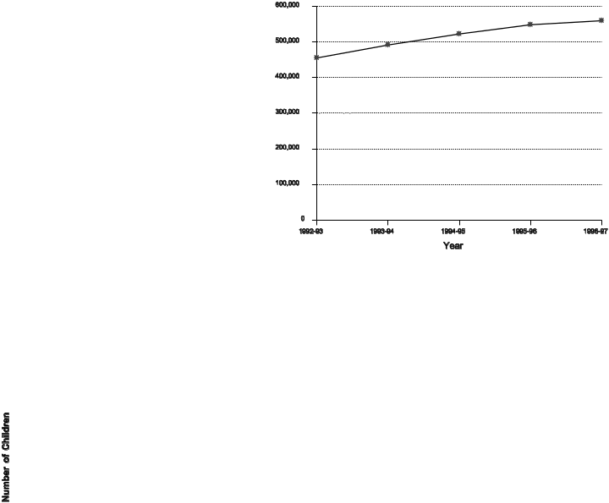

The Number of Children Served Under the Preschool Grants Program

The Preschool Grants Program, authorized under Section 619 of IDEA, Part B, was established to provide grants to States to serve preschool children with disabilities.

Over the past 5 years, the number of children served under the IDEA Preschool Grants Program increased from 455,449 during the 1992-93 school year to 559,902 during the 1996-97 school year. The steady increase that occurred during this 5-year period resulted in a total increase of 23 percent. During the 1996-97 school year, there was a modest increase of 2 percent over the 548,441 children served the previous year (see figure II-3).

Based on the estimated resident population of children ages 3 through 5 in the 50 States and the District of Columbia, 4.6 percent of the children in this age group were served under the IDEA Preschool Grants Program. The District of Columbia served the lowest percentage of its resident population (1.5 percent), and Hawaii the second lowest (2.5 percent). Kentucky served the highest percentage (9.5 percent). The remaining States served between 3.2 percent and 7.9 percent (see table AA10, p. A-33).

Educational Environments for Preschoolers with Disabilities

Six different categories and two subcategories (private and public) are used to collect data on preschoolers with disabilities who are served under IDEA. They are regular class, resource room, separate class, separate school (public and private), residential facility (public and private), and homebound/hospital. These categories were developed with school-aged children in mind and, consequently, may not reflect educational environments for preschoolers. Therefore, OSEP provides optional instructions to States for reporting counts of preschoolers in each of the categories. Table II-1 includes a definition of each category as it applies to preschoolers with disabilities.

Table II-1
Educational Environments for Preschoolers with Disabilities

Regular class includes children who receive services in programs designed primarily for nondisabled children, provided the children with disabilities are in a separate room for less than 21 percent of the time receiving services. This may include, but is not limited to, Head Start centers, public or private preschool and child care facilities, preschool classes offered to an age-eligible population by the public school system, kindergarten classes, and classes using co-teaching models (special education and general education staff coordinating activities in a general education setting).

Resource room includes children who receive services in programs designed primarily for nondisabled children, provided the children with disabilities are in a separate program for 21 to 60 percent of the time receiving services. This includes, but is not limited to, Head Start centers, public or private preschools or child care facilities, preschool classes offered to an age-eligible population by the public school system, and kindergarten classes.

Separate class includes children who receive services in a separate program for 61 to 100 percent of the time receiving services. It does not include children who received education programs in public or private separate day or residential facilities.

Separate school (public and private) includes children who are served in publicly or privately operated programs, set up primarily to serve children with disabilities, that are NOT housed in a facility with programs for children without disabilities. Children must receive special education and related services in the public separate day school for greater than 50 percent of the time.

Residential facility (public and private) includes children who are served in publicly or privately operated programs in which children receive care for 24 hours a day. This could include placement in public nursing care facilities or public or private residential schools.

Homebound/hospital includes children who are served in either a home or hospital setting, including those receiving special education or related services in the home and provided by a professional or paraprofessional who visits the home on a regular basis (e.g., a child development worker or speech services provided in the child’s home). It also includes children 3-5 years old receiving special education and related services in a hospital setting on an inpatient or outpatient basis. However, children receiving services in a group program that is housed at a hospital should be reported in the separate school category. For children served in both a home/hospital setting and in a school/community setting, report the child in the placement that comprises the larger percentage of time receiving services.

Source: OSEP Data Dictionary, 1997, Office of Special Education Programs, U.S. Department of Education.

During the 1995-96 school year, 51.6 percent of children with disabilities ages 3-5 were served in regular classes, approximately a 1 percent increase over the percentage served in regular classes during the previous year. Comparing the data from the 1992-93 school year to the 1995-96 school year, the percentage of children served in regular class, separate class, and home/hospital environments increased, while the percentage of children served in the remaining settings decreased (see figure II-4).

Figure II-4
Number of Children Ages 3-5 Served in Different Educational Environments, 1992-93 and 1995-96

Source: U.S. Department of Education, Office of Special Education Programs, Data Analysis System (DANS).

Summary

In both Part C and the Preschool Grants Program, the number of children served increased steadily over the past 5 years. Also, over this same period, there was an increase in the use of the home setting and in the use of early intervention classrooms for infants and toddlers. In the Preschool Grants Program, more preschoolers are being served in regular class settings than in any other setting. The number of children being served in the resource room category has declined.
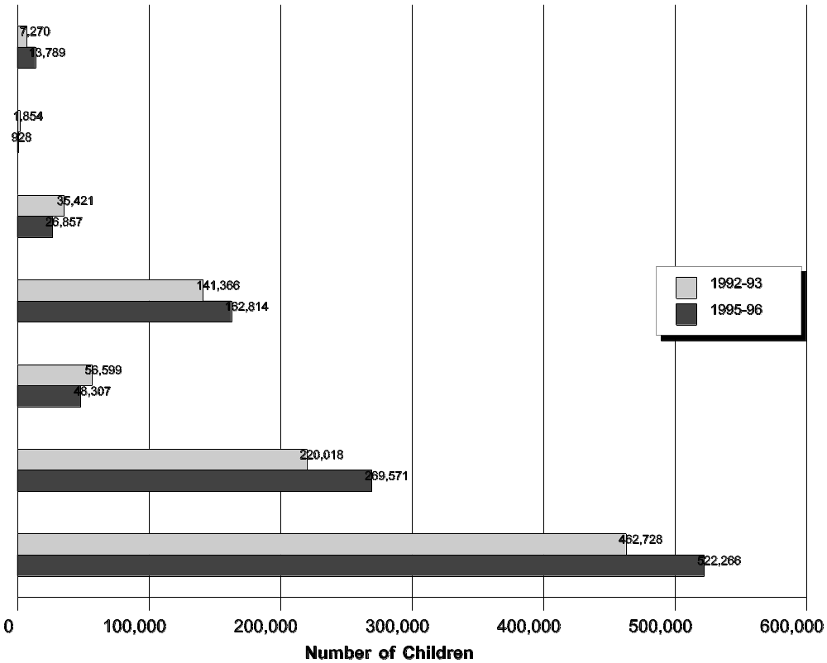

References

deFosset, S., & Carlin, M. (1997). Section 619 profile, eighth edition. Chapel Hill, NC: National Early Childhood Technical Assistance System.
Students Ages 6 Through 21 Served Under IDEA

Purpose: To describe students served under IDEA during the 1996-97 school year and compare data on the number of students served over the past 10 years.

Children with disabilities ages 6 through 21 have been receiving services through Part B of IDEA for more than 20 years. This module discusses the changes in the total number of children served, the age distribution of students served, the disability distribution of students served, and the disabilities distribution across age groups. The information is based on State-reported data required under Section 618(b) of IDEA. Through this requirement, States report data annually to OSEP on the number of children served under Part B of the law.

Changes in Numbers of Students Served

Over the past few years, the number of school-age students (i.e., ages 6 through 21 years old) with disabilities served has increased at a higher rate than the general school enrollment. During the 1996-97 school year, 5,235,952 students ages 6 through 21 with disabilities were served under IDEA, a 3.1 percent increase over the previous year. The prekindergarten through 12th grade total school-age enrollment figures showed an increase of 1.2 percent between 1995-96 and 1996-97 (see table AF6, p. A-226). The resident population showed an increase of 1.7 percent. The increase in the number of school-age children served under IDEA over the previous year was slightly more than the increase in the number of preschool students ages 3 through 5 served (2.1 percent) and slightly less than the increase in the number of infants and toddlers served (5.7 percent) (see table AA14, pp. A-43 to A-45).

Age Distribution of Students Served

The number of school-age students served under IDEA has consistently increased since the inception of P.L. 94-142 in 1975. Dividing students served into three age groups, the number of students with disabilities ages 6-11 served increased 25.3 percent, the number of students with disabilities ages 12-17 increased 30.7 percent, and the number of students with disabilities ages 18-21 increased 14.7 percent over the past 10 years.

The relative percentages in each of these age groups has remained stable over the past 10 years. Figure II-5 shows the age composition of students with disabilities in 1996-97. These percentages differ slightly from the average over the 10 years, which was 51.8 percent for children ages 6-11, 43 percent for those ages 12-17, and 5.2 percent of students ages 18-21 served under IDEA (see table AA14, pp. A-43 to A-45).

Disabilities Distribution of Students Served

Under IDEA, there are 12 disability categories--specific learning disabilities, speech or language impairments, mental retardation, emotional disturbance, multiple disabilities, hearing impairments, orthopedic impairments, other health impairments, visual impairments, autism, deaf-blindness, and traumatic brain injury--by which to report students served. However, more than 90 percent of the school-age students served under IDEA in 1996-97 were classified in one of four disability categories:

Figure II-5
Percentage of Students with Disabilities Served Under IDEA, Part B by Age Group in 1996-97
Source: U.S. Department of Education, Office of Special Education Programs, Data Analysis System (DANS).
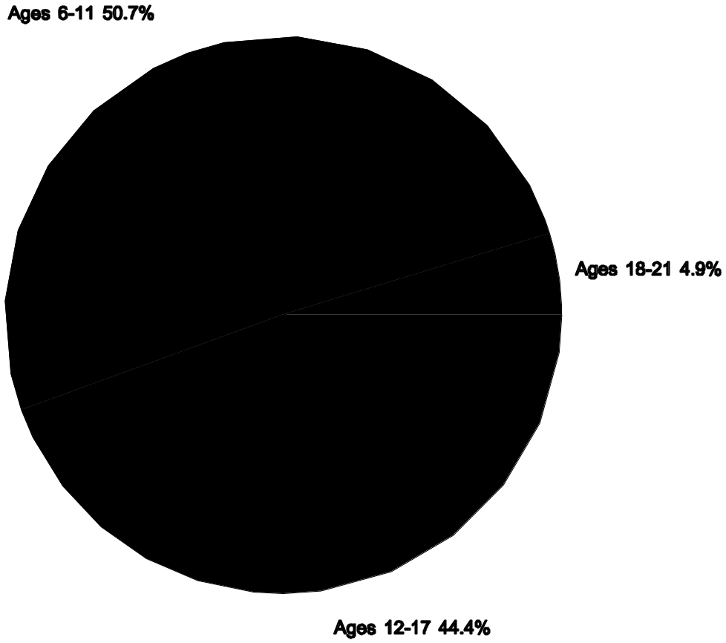

learning disabilities (51.1 percent or 2,676,299 children);

speech or language impairments (20.1 percent or 1,050,975 children);

mental retardation (11.4 percent or 594,025 children); and

emotional disturbance (8.6 percent or 447,426 children).

Figure II-6 shows the change in the number of students served under IDEA for each of these four disabilities from 1987-88 to 1996-97. The rate of increase for students with learning disabilities was greater than for students with other high-incidence disabilities. The number of students with learning disabilities has increased by 37.8 percent over the past 10 years, as compared with an increase of 10.2 percent for students with speech or language impairments and 20.1 percent for students with emotional disturbance. The number of students with mental retardation decreased by 0.8 percent between 1987-88 and 1996-97. (See also table AA14, p. AA-43 to AA-45.)

Figure II-6
Number of Children Ages 6-21 Served Under IDEA, Part B From 1987-88 to 1996-97: High-Incidence Disabilities
Source: U.S. Department of Education, Office of Special Education Programs, Data Analysis System (DANS).
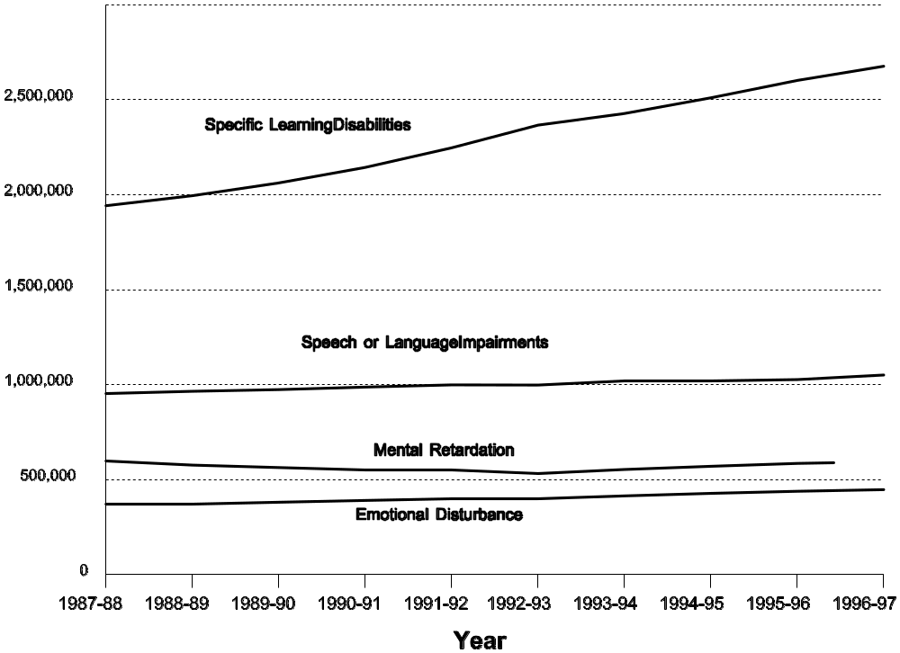

Figure II-7 shows the number of children served for six of the low-incidence disability categories. Between 1987-88 and 1992-93, the average annual increase for students with other health impairments was 7.5 percent. Between 1992-93 and 1996-97, the average rate more than tripled to 25.0 percent (see table AA14, p. A-45). This is in contrast to the more gradual increases in numbers of students served under IDEA in other disability categories. Table II-2 shows the number of students ages 6-21 served under IDEA in all 12 disability categories in 1987-88 and 1996-97 (see table AA14, p. A-45).

States’ most common explanation for the increase in the number of children served under the other health impairments category was increased identification of and service to children with attention deficit disorder (ADD) and attention deficit hyperactivity disorder (ADHD). Other large increases occurred in the newest disability categories of autism and traumatic brain injury. However, the disability categories of autism and traumatic brain injury accounted for less than 1 percent of the students served in 1996-97. Explanations for increases in these categories generally include improvements in reporting and reassignment to the new disability categories during the reevaluation process. An increase in the category of other health impairments, however, has occurred simultaneously with the separate reporting of students with autism and traumatic brain injury, many of whom may have previously been counted under the other health impairments category.

Figure II-7
Number of Children Ages 6-21 Served Under IDEA, Part B From 1987-88 to 1996-97: Low-Incidence Disabilities
Source: U.S. Department of Education, Office of Special Education Programs, Data Analysis System (DANS).
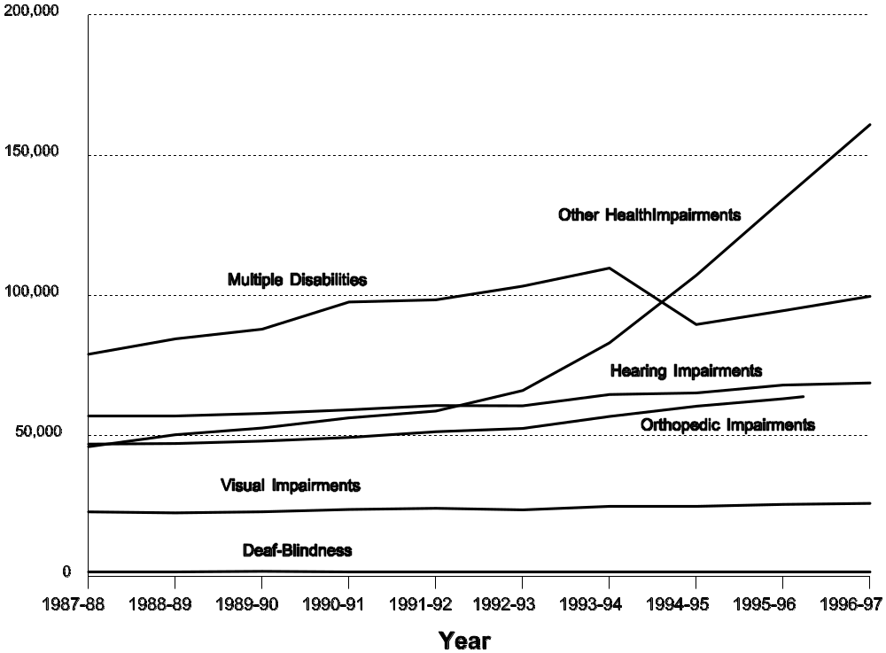

The increase in the number of students with other health impairments since 1992-93 may in part be a response to a 1991 Department of Education, Office of Special Education and Rehabilitative Services (OSERS) memorandum that explained that students with ADD (and inclusively, ADHD) should be included in the other health impairments category when ADD is a chronic or acute health problem resulting in limited alertness that adversely affects educational performance. Consequently, the growth in the other health impairments category may be a combined result of increased identification of students with ADD and the reporting of children with ADD in the other health impairments category. Prior to this time, students with ADD may have been reported in other disability categories.

Table II-2
Number of Children Ages 6-21 Served Under IDEA by Disability: 1987-88 and 1996-97

Disability | 1987-88 |  | 1996-97 |  | Change
 | Number | Percent | Number | Percent | Number | Percent
Specific Learning Disabilities | 1,942,304 | 47.1 | 2,676,299 | 51.1 | 733,995 | 37.8
Speech or Language Impairments | 953,568 | 23.1 | 1,050,975 | 20.1 | 97,407 | 10.2
Mental Retardation | 598,770 | 14.5 | 594,025 | 11.4 | -4,745 | -0.8
Emotional Disturbance | 372,380 | 9.0 | 447,426 | 8.6 | 75,046 | 20.2
Multiple Disabilities | 79,023 | 1.9 | 99,638 | 1.9 | 20,615 | 26.1
Hearing Impairments | 56,872 | 1.4 | 68,766 | 1.3 | 11,894 | 20.9
Orthopedic Impairments | 46,966 | 1.1 | 66,400 | 1.3 | 19,434 | 41.4
Other Health Impairments | 46,056 | 1.1 | 160,824 | 3.1 | 114,768 | 249.2
Visual Impairments | 22,821 | 0.6 | 25,834 | 0.5 | 3,013 | 13.2
Autism | .ª | . | 34,101 | 0.7 | 34,101 | .
Deaf-Blindness | 1,454 | <0.1 | 1,286 | <0.1 | (168) | -11.6
Traumatic Brain Injury | . | . | 10,378 | 0.2 | 10,378 | .
All Disabilities | 4,120,214 | 100.0 | 5,235,952 | 100.0 | 1,115,738 | 27.1

a/ Reporting on autism and traumatic brain injury was required under IDEA beginning in 1992-93.

Source: U.S. Department of Education, Office of Special Education Programs, Data Analysis System (DANS).

The distribution of students by disability varies across age groups. Specific learning disabilities is the largest single category for each of the three age groups, accounting for 41.2 percent of students ages 6-11, 62.3 percent of students ages 12-17, and 51.7 percent of students ages 18-21. The percentage of students with speech or language impairments decreases dramatically among older children; 35.1 percent of the students ages 6-11 were identified as having speech or language impairments, while only 5.0 percent of students in the 12-17 age group and 1.8 percent of the students in the 18-21 age group with this disability were served. Conversely, the incidence of mental retardation is more prevalent among older children. This may be in part because students with mental retardation tend to stay in school longer than students with other disabilities. Nearly one-fourth (24.4 percent) of the students ages 18-21 were classified as having mental retardation. This percentage drops to 12.6 percent for students ages 12-17, and drops again to 9.0 percent for students 6-11. Emotional disturbance is most common among teenagers; 5.7 percent of students ages 6-11 were identified with emotional disturbance compared with 11.7 percent of the 12-17 age group and 9.7 percent of the 18-21 age group.

Summary

Services to students with disabilities have continued to grow. Among the reasons for this growth are increases in the population and improvements in the identification of students with special needs. The year-to-year increase in the number of school-age children receiving services has been gradual, and increases have occurred at various rates across the disability categories. The largest percentage increases occurred in other health impairments, orthopedic impairments, and specific learning disabilities. There was a reported decline in two disability categories, mental retardation and deaf-blindness.
The Racial/Ethnic Composition of Students with Disabilities

Purpose: To present data on the number of minority students with disabilities receiving services and the disabilities of these students.

In the recent reauthorization of IDEA (P.L. 105-17), Congress expressed concern about the disproportionate representation of racial and ethnic minorities in special education and poor educational results for minority students. Congress encouraged the Federal Government to be responsive to the growing needs of an increasingly diverse society, to ensure a more equitable allocation of resources, and to provide an equal educational opportunity for all individuals. In reauthorizing IDEA, Congress found that between 1980 and 1990, the rate of increase in the number of White Americans was 6 percent, while the rates of increase for racial and ethnic minorities were much higher: 53 percent for Hispanics, 13.2 percent for African Americans, and 107.8 percent for Asians. By the year 2000, nearly one of every three Americans will be African American, Hispanic, Asian American, or American Indian. As a group, minority children are comprising an increasing percentage of public school students. (§601(c)(7)(B), (C), and (D))

Congress wrote in the IDEA Amendments of 1997 that “greater efforts are needed to prevent the intensification of problems connected with mislabeling . . . among minority children with disabilities.” (§601(c)(8)(A)) More African American children are served in special education than would be expected given the percentage of African American students in the general school population. IDEA also notes, “although African Americans represent 16 percent of elementary and secondary enrollments, they constitute 21 percent of total enrollments in special education.” (§601(c)(8)(D)) “Poor African American children are 2.3 times more likely to be identified by their teacher as having mental retardation than their White counterpart.” (§601(c)(8)(C)) In addition to being identified with specific disabilities at different rates than White, non-Hispanic students, minority students are also more likely than White students to be served in less inclusive settings (Singh, Ellis, Oswald, Wechsler, & Curtis, 1997).

Congress also noted in IDEA that minority youth with disabilities are more likely to drop out of high school: “The drop out rate is 68 percent higher for minorities than for Whites. More than 50 percent of minority special education students in large cities drop out of school” (20 U.S.C. 1401(c)(8)(f)). Dropout rates for Hispanic youth with disabilities are particularly high: 36.9 percent compared to 31.2 percent for Whites and 30.4 percent for African Americans (Valdes, Williamson, & Wagner, 1990).

In response to these concerns, Congress required States to submit special education child count, educational environment, exiting, and discipline data by race and ethnicity starting in the 1998-99 school year. The race/ethnicity data required under the IDEA Amendments of 1997 will better enable Congress and OSEP to monitor the disproportionate representation of racial and ethnic minorities in special education and dropout rates for minority youth.

Under IDEA, local educational agencies are required to use racially and culturally nondiscriminatory tests and other evaluation materials for identifying students as eligible for special education. Tests must be administered in the child’s native language or other mode of communication, unless it is not feasible to do so. Each State is also required to collect and examine data to determine if race is the basis of significant disproportionality in the identification of students with disabilities or the placement of children with disabilities in particular educational settings. If the State determines that significant disproportionality exists, it must provide for the review and, if appropriate, revision of policies, procedures, and practices used to identify or place students to ensure that they meet the requirements of IDEA.

Race/Ethnicity in Special Education

The disproportionate representation of racial and ethnic minorities in special education is a highly complex issue because it is difficult to isolate the effects of poverty, limited English proficiency, residence in inner cities, and race/ethnicity on special education eligibility.,

For many years, OCR has collected data from a sample of school districts and schools within these districts on the race/ethnicity of students with selected disabilities--mild, moderate, and severe mental retardation; specific learning disabilities; and emotional disturbance. This module presents data for students with those disabilities from the 1994 OCR Elementary and Secondary School Compliance Reports on race/ethnicity.

Discrepancies in disability prevalence and service provision across racial/ethnic categories are most apparent in the mental retardation category. A total of 2.6 percent of Black, non-Hispanic students were identified as having mental retardation. In contrast, 1.2 percent of White, non-Hispanic students were identified as having mental retardation. Hispanic students were less likely than White, non-Hispanic students to receive special education to address mental retardation.

White, non-Hispanic students; Black, non-Hispanic students; and Hispanic students were equally likely to receive services to address specific learning disabilities. American Indian students were considerably more likely to receive such services, and Asian/Pacific Islanders were less likely to do so (see table II-3).

Overall, 0.8 percent of the student population received services for emotional disturbance. The rate was slightly higher for Black, non-Hispanic students than for White, non-Hispanic students and was considerably lower for Hispanic students and Asian/Pacific Islander students.

It is often difficult to distinguish between the effects of poverty and the effects of race on special education eligibility because, in the United States, poverty and race are correlated. Poor children are more likely than wealthier children to receive special education (Wagner, 1995). African American children are more likely than White or Asian children to receive special education under some disability categories. While both poverty and racial/ethnic background may contribute to minority representation in special education, data from the National Longitudinal Transition Study suggest that race/ethnicity was not the primary contributor to the overrepresentation of African Americans in special education. Rather, the overrepresentation of African Americans was driven by the overrepresentation of very poor students in special education, at least for most disability categories (Wagner, 1995). This suggests that while some of the disproportion may be addressed through improvements in unbiased and more discriminate assessment, attention must also focus on the broader issue of child poverty.

Table II-3
Number and Percentage of Students in Special Education by Race/Ethnicity and Disability: 1994

 | White, non-Hispanic | Black, non-Hispanic | Hispanic | American Indian | Asian/  Pacific Islander | Total
Learning Disabilities | 5.7%  1,587,918 | 5.7%  407,848 | 5.7%  308,136 | 7.3%  32,413 | 2.0%  31,968 | 5.5%  2,368,283
Mental Retardation | 1.2%  350,699 | 2.6%  190,885 | 0.9%  50,091 | 1.6%  7,152 | 0.5%  8,197 | 1.4%  607,024
Emotional Disturbance | 0.8%  214,442 | 1.1%  80,253 | 0.5%  25,514 | 0.9%  4,227 | 0.2%  2,786 | 0.8%  327,222
Total Student Population by Race/Ethnicity | 28,039,068 | 7,193,038 | 5,425,976 | 445,105 | 1,588,124 | 42,691,311

Source: U.S. Department of Education, Office for Civil Rights, 1994 Elementary and Secondary School Compliance Reports.

Summary

The disproportionate representation of racial and ethnic minorities in special education has been an issue for educators for more than 25 years, yet African American students continue to be overrepresented in programs for students with mental retardation. Furthermore, relative to White, non-Hispanic students, Asian students are underrepresented in all four of the disability categories for which the OCR collects data. It has been postulated that poverty, rather than race/ethnicity, may account for some of the overrepresentation of minorities in special education programs. Therefore, without attention to poverty and its effects on children, the use of unbiased assessment alone will not eradicate the disproportionate representation described.

References

Singh, N., Ellis, C.R., Oswald, D.P., Wechsler, H.A., & Curtis, A.J. (1997). Value and address diversity. Journal of Emotional and Behavioral Disorders, 5, 24-35.

Valdes, K.A., Williamson, C.L., & Wagner, M.M. (1990). The National Longitudinal Transition Study of Special Education Students. Menlo Park, CA: SRI International.

Wagner, M. (1995). The contributions of poverty and ethnic background to the participation of secondary school students in special education. Menlo Park, CA: SRI International.

Gender as a Factor in Special Education Eligibility, Services, and Results

Purpose: To discuss differences in the characteristics of male and female students with disabilities, special education services provided to males and females with disabilities, and postschool results by gender.

Although males and females comprise equal proportions of the school-aged population, males account for approximately two-thirds of all students served in special education (Doren, Bullis, & Benz, 1996; Wagner et al., 1991). In many cases, it is not clear if females are underidentified for special education, if males are over-identified, or if real differences exist in the prevalence of disability between males and females.

Much of the research on disability has stressed commonalities among individuals with disabilities rather than addressed differences based on gender (Fine & Asch, 1988). Consequently, little is known about the different characteristics and experiences of males and females with disabilities.

Special Education Eligibility

More than two-thirds of all students receiving special education services are male (Doren et al., 1996; Wagner et al., 1991). Among secondary-aged students with disabilities, males constitute the largest proportion of each disability category except deaf-blindness, which is almost evenly divided between males and females (see table II-4). The disproportionate representation of males in special education seems greatest in the learning disability and emotional disturbance categories, which are often considered the disability categories with the most broadly defined eligibility criteria (Kratovil & Bailey, 1986).

Tables II-4 and II-5 show the percentage of males and females in different disability categories. Table II-5 includes elementary and secondary school students in three disability categories; table II-4 reports data in 11 disability categories for secondary-aged students only.

Table II-4
Gender of Secondary-Aged Students with Disabilities, by Disability Category

Disability | Percentage Male | Percentage Female
Learning Disability | 73.4 | 26.6
Emotional Disturbance | 76.4 | 23.6
Speech Impairment | 59.5 | 40.5
Mental Retardation | 58.0 | 42.0
Visual Impairment | 55.6 | 44.4
Hearing Impairment | 52.0 | 48.0
Deafness | 54.5 | 45.5
Orthopedic Impairment | 54.2 | 45.8
Other Health Impairment | 56.0 | 44.0
Multiple Disabilities | 65.4 | 34.6
Deaf/Blindness | 49.5 | 50.5
All Disabilities | 68.5 | 31.5

Source: Valdes et al. (1990). The National Longitudinal Transition Study of Special Education Students: Statistical almanac (Vol. 1). Menlo Park, CA: SRI International.

Not only are females less likely than males to be identified for special education, but the characteristics of identified females differ from those of identified males (Richardson et al., as cited in Gottleib, 1987). For example, girls in special education score lower on IQ tests than boys. The average IQ for secondary-aged females with disabilities was 74.4; the average for males was 81.6 (Gottleib, 1987; Wagner et al., 1991). According to parent reports, a greater percentage of secondary-aged females in special education began having difficulties indicative of a disability at very young ages, which may also suggest more severe disabilities (Valdes, Williamson, & Wagner, 1990). Because learning disabilities and emotional impairments are not typically associated with below-average intelligence, the over-representation of males in these categories may skew the mean IQ of males in special education.

Possible Causes of Disproportionate Representation

Researchers and advocates offer several hypotheses for the fact that more males than females participate in special education. It is likely that no single explanation accounts for all of the disproportion but that combinations of factors result in the distribution previously described. First, physiological or maturational differences between males and females may cause higher rates of disability among school-age males. Second, differences in the behavior of male and female students may predispose males to the identification of a disability. For example, female students may adapt better to the predominant school culture and norms. Teachers may also react differently to male and female students, which can result in higher rates of referral and classification for male students. Third, methods used to identify students with learning disabilities, emotional disturbances, and speech and language impairments may be biased and, as such, may contribute to the disproportionate representation of males and females in special education (Harmon, Stockton, & Contrucci, 1992).

Table II-5
Gender of Elementary and Secondary-Aged Students with Disabilities, by Disability Categoryª

 | Male | Female
Specific Learning Disability | 69.3 | 30.8
Mental Retardation | 59.0 | 41.6
Emotional Disturbance | 79.4 | 21.0

a/Percentages may not sum to 100 due to rounding or reporting errors.

Source: U.S. Department of Education, Office for Civil Rights, 1994 Elementary and Secondary School Compliance Reports.

Physiological/Maturational Differences. Some researchers cite physiological or maturational differences between males and females as a cause for some disproportionate representation. For example, girls are believed to have fewer birth defects and more rapid maturation than boys. Females may be less prone to disability because they have two X chromosomes, and one of the X chromosomes may compensate for a defect in the other. Because males have one X and one Y chromosome, they may be more susceptible to disabilities associated with chromosomal abnormalities, such as hemophilia and fragile-x syndrome, which can cause mental retardation (Harmon et al., 1992). Some researchers theorize that differences in the structure of male and female brains may also contribute to differences in disability prevalence. They speculate that male brains are more lateralized than female brains, meaning that one hemisphere is more dominant than the other (Hayden-McPeak, Gaskin, & Gaughan, 1993). For example, functional magnetic resonance imaging (FMRI) shows that phonological processing in men engages the left inferior frontal gyrus in the brain. In women, phonological processing activates both the left and right inferior frontal gyrus (Shaywitz, 1996). Parts of the corpus callosum, which connects the two hemispheres, are also more extensive in females. The exact relationships between these biological differences and disability are unclear (Hayden-McPeak et al., 1993).

Research on differences between young boys and young girls suggests that girls mature more rapidly than boys (Harmon et al., 1992). Many preschool programs stress impulse-control, small-muscle development, and language skills, but many young girls are competent in these areas before arriving in preschool. The preschool experience may raise boys’ language achievement scores, thus narrowing the gap between girls and boys (Larson & Robinson, 1989). However, maturational gaps could lead to inflated referrals of males for special education evaluation.

To determine if there are differences in vulnerability to learning failure among young children, Karlen, Hagin, and Beecher (1985) administered a series of tests to all kindergartners and first graders in a sample of elementary schools. The study showed very small or insignificant differences between the percentage of males and females at risk of school failure in urban, rural, and independent schools. However, for unknown reasons, the differences were significant in suburban schools; 31 percent of the boys and 20 percent of the girls were at risk.

Shaywitz, Shaywitz, Fletcher, and Escobar (1990) found significant differences in the percentages of boys and girls identified by their schools as having reading disabilities but found no differences based on achievement and IQ test scores. They also found that children who were identified by their schools as having a reading disability but who did not meet objective criteria for reading disabilities were more likely to exhibit difficulties in behavior, attention, fine-motor skills, and language skills. Conversely, children who were not identified as having a reading disability despite meeting eligibility criteria were likely to have no perceived problems with behavior. When students with learning disabilities also have attention deficit disorder (ADD), their learning disabilities may be more severe and resistant to intervention. Because ADD is more prevalent in males than in females, males may be more likely than females to be identified by their schools as having learning disabilities (Felton & Wood, 1989; Lubs et al., 1991; Lyon, 1996).

School Bias. Males may be referred and found eligible for special education at higher rates than females because of gender differences between female teachers and male students or differences between the dominant school culture and male behavior (Kedar-Volvodas, 1983). Women outnumber men in the general education teaching force (87 percent to 13 percent), particularly at the elementary level, when most students are referred for special education (Cook & Boe, 1995). As long ago as 1976, evidence suggested a bias in teachers’ evaluation of students’ need for special education based on the student’s gender. In a historic study, when given identical descriptions of individual children, teachers were more likely to refer boys for evaluation than girls (Gregory, 1977). Female teachers may be more likely to identify boys’ behavior and learning styles as indicative of a disability, inflating the referral of boys for special education evaluation (Gottleib, 1987).

Other researchers speculate that some educators may have higher expectations for boys than for girls. If boys do not perform to expected levels, teachers may refer them to special education in greater numbers than girls, for whom they have lesser expectations (Gottleib, 1987). However, data suggest that boys are more likely than girls to be referred for special education based on their behavior and that girls are typically referred for concerns about academic performance (Clarizio & Phillips, 1986). This finding may contradict the hypothesis that disproportion is due to differing academic expectations.

Assessment Bias. The disproportionate representation of males in programs for students with emotional disturbances may reflect a bias in the ways emotional disturbance is defined and/or the instruments used to identify students as eligible under those definitions. Some assessment tools that schools use to evaluate students do not capture depression, suicidal ideation, or suicide attempts (Caseau, Luckasson, & Kroth, 1994). Adolescent girls experience a higher rate of depression than boys (Boggiano & Barrett, 1992; Kazdin, 1990; Peterson, Sarigiani, & Kennedy, 1991), but the eligibility criteria for services under the emotional impairments category, or teachers’ tolerance of the withdrawal or depression exhibited by young women, may reduce females’ referral for evaluation and eligibility (McIntyre, 1990). Those girls who receive services for emotional impairments usually exhibit the externalizing behaviors typically associated with boys (Casau et al., 1994).

Table II-6
Percentage of Secondary-Aged Students with Disabilities Who Received Different Types of Services, by Gender

Services | Male | Female
Job Training | 63.2 | 56.8
Speech/Language Therapy | 36.6 | 43.1
Personal Counseling/Therapy | 34.6 | 33.7
Occupational Therapy/Life Skills Training | 28.9 | 46.8
Tutor, Reader, Interpreter | 32.9 | 32.2
Physical Therapy, Mobility Training | 8.5 | 12.5
Help with Transportation | 13.0 | 18.5

Source: Valdes et al. (1990). The National Longitudinal Transition Study of Special Education Students: Statistical almanac (Vol. 1). Menlo Park, CA: SRI International.

Services for Males and Females with Disabilities

Once students are identified as eligible for special education, the services they receive do not differ greatly by gender, and teachers appear to consider an individual student when selecting instructional techniques (Leinhardt, Seewald, & Zigmond, 1982; Wagner et al., 1991). No significant differences exist in the amount of funds expended on special education and related services for males and females (Singer & Raphael, 1988).

Few significant gender differences were identified in secondary course-taking for students with disabilities, although higher rates of home economics and life skills instruction for females and a higher rate of vocational education for males were noted (Wagner et al., 1991). Secondary-aged females with disabilities were more likely than males to receive some support services (see table II-6). The disproportion fell particularly in occupational therapy/life skills training, transportation, and speech therapy (Cameto, 1993).

Educational Results for Males and Females with and without Disabilities

One way to evaluate whether education services are effective in meeting students’ needs is to examine student results. These may include in-school results, such as grades and dropout rates, or postschool results, such as employment, wages, and postsecondary education.

In-School Results

Overall, girls with and without disabilities had better in-school results than boys with and without disabilities. They received better grades, were more likely to graduate from high school, and were less likely to be suspended or expelled. Boys did as well as girls on many standardized achievement tests and scored slightly better than girls on 12th grade math achievement.

Test Scores and Grades. Much has been made of perceived differences between males and females in verbal and quantitative skills. Studies of achievement test scores indicate no consistent, sizable differences in verbal ability between boys and girls (Hyde & Linn, 1988). Results on reading achievement, one aspect of verbal skills, are unclear. The National Assessment of Educational Progress (NAEP) and the National Education Longitudinal Study show girls performing better than boys on reading tests. The High School and Beyond Survey shows boys performing better than girls on reading and vocabulary. Differences in results may reflect the different ages sampled in each survey or differences in the tests given. All three surveys show very small differences in achievement between boys and girls (American Association of University Women [AAUW], 1992), except in writing; data from NAEP show girls performing consistently better than boys on writing tasks (Mullis, Owen, & Phillips, 1990).

Gender differences in math achievement appear to be small and shrinking (Friedman, 1989; Mullis, Dossey, Owen, & Phillips, 1991). A recent NAEP administration showed few differences between boys and girls in math ability at grades 4 and 8 apart from a slight advantage for boys in measurement and estimation. By 12th grade, some differences arose, and boys showed a small advantage in each area except algebra (Mullis et al., 1991).

In general education, girls typically receive better end-of-year and end-of-course grades than boys (AAUW, 1992). Again, it is not clear if girls work harder at mastering classroom material, if they have longer attention spans that permit them to acquire knowledge and skills more effectively, or if they are rewarded by teachers for good behavior. Whatever the reason, this pattern of grade accomplishment holds for students in special education as well as in general education. Despite their lower mean IQ scores and the relatively early onset of their developmental difficulties, on average girls in special education receive higher end-of-year and end-of-course grades than boys. Grade point averages for secondary-aged females with disabilities are significantly better than grade point averages for their male counterparts (see figure II-8).

Figure II-8
Percentage of Secondary-Aged Students with Disabilities with Different Grade Point Averages, by Gender
Note: Percentages may not sum to 100 due to rounding.
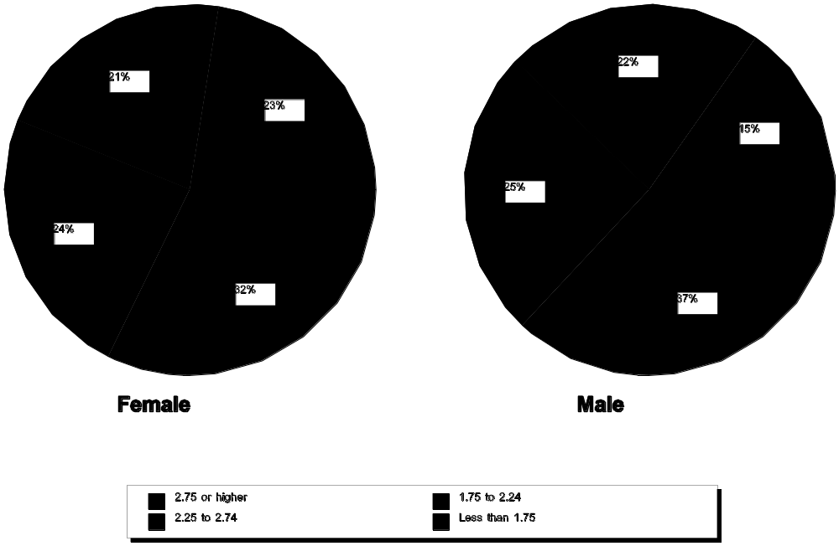

Source: Valdes et al., (1990). The National Longitudinal Transition Study of Special Education Students: Statistical almanac (Vol. 1). Menlo Park, CA: SRI International.

High School Completion. Females with disabilities are slightly more likely than males to graduate from high school and are less likely to be suspended or expelled (see figure II-9). This is also true for females without disabilities (AAUW, 1992). Although females with disabilities drop out of school at about the same rate as males, the reasons differ. Parents report that 23 percent of female dropouts leave school because of marriage or parenthood, compared with only 1 percent of male dropouts (Valdes et al., 1990; Wagner, as cited in Wagner et al., 1991). Both male and female dropouts report disliking school and doing poorly in school (Valdes et al., 1990).

Figure II-9
School Exit Status of Youth with Disabilities, by Gender

Source: Valdes et al., (1990). The National Longitudinal Transition Study of Special Education Students: Statistical almanac (Vol. 1). Menlo Park, CA: SRI International.
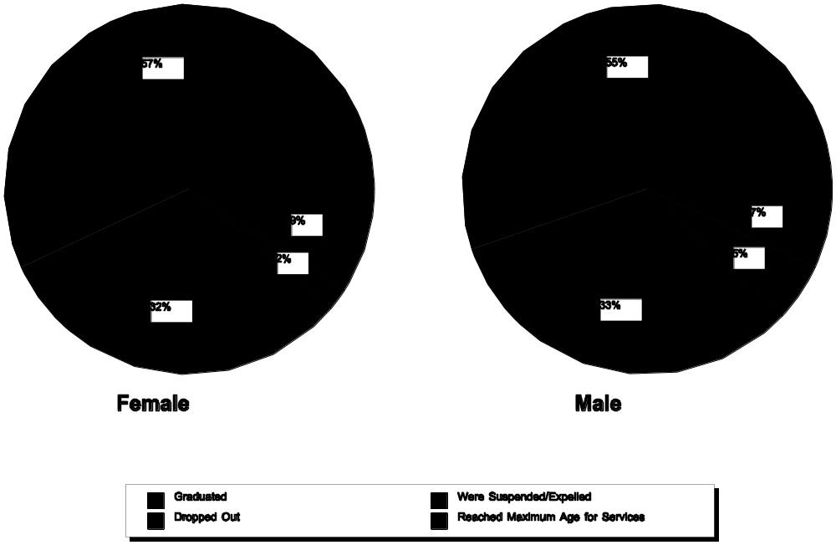

Postschool Results

Despite their better academic performance, females with disabilities have less positive postschool results than their male peers. They are less likely to be employed, have lower wages, and are less likely to enroll in postsecondary education or training.

Employment. Young men with disabilities are more likely than young women to be employed and to earn more money (Frank, Sitlington, & Carson, 1991; Hasazi, Johnson, Hasazi, Gordon, & Hull, 1989; Kranstover, Thurlow, & Bruininks, 1989; Sitlington & Frank, 1990; Wagner, 1992). After being out of high school for 3 to 5 years, 65.9 percent of males and 48.6 percent of females report having been employed in the past year. When controlling for other factors, young men with disabilities earn $1,814 more per year than young women with disabilities (Wagner, Blackorby, Cameto, & Newman, 1993). Young men earn higher hourly wages than young women and, on average, men work more hours (Sitlington, Frank, & Carson, 1992; Wagner, 1992). The wage gap between men and women is not restricted to those with disabilities, however. In general, women make up 45 percent of the work force, but they work primarily in clerical, service, or professional positions (Fullerton, 1989; Taeuber, 1991). Even when women have the same level of education as men, they earn less.

Several other factors may contribute to the lower incomes earned by women with disabilities. First, many young women with disabilities have children and, consequently, do not work full time. Three to five years after leaving high school, 41 percent of women with disabilities have children of their own, compared with 28 percent of same-aged women in the general population (Wagner, 1992). As described in the next section, young women with disabilities are less likely than young men to enroll in vocationally oriented courses in high school, which may also limit their level of job competitiveness. In addition, young women with disabilities are less likely than men to pursue additional education, training, and rehabilitation after high school.

Postsecondary Education, Training, and Rehabilitation. Fewer women than men with disabilities participate in postsecondary education and training in the years shortly after high school. A larger percentage of women take postsecondary courses at 4-year colleges while a larger percentage of men enroll in job training programs and 2-year colleges (Valdes et al., 1990). This is also true for youth without disabilities; 54 percent of all beginning postsecondary students are female (U.S. Department of Education, 1996). Women with disabilities are also less involved with vocational rehabilitation services than men; this may contribute further to women’s economic disadvantage (Gragg, 1997; Menz et al., 1989). Studies have found that the rehabilitation system is more helpful for men who are under 45 years of age, White, better educated, middle class, articulate, aggressive, and motivated (Kirchner, 1987; Stone, as cited in Fine & Asch, 1988). Women who receive vocational rehabilitation services are more likely than men to have their cases closed while not earning wages (Vash, as cited in Fine & Asch, 1988), and women are more likely than men with similar skills and aptitudes to be directed toward traditionally female occupations (Packer, as cited in Fine & Asch, 1988), which often pay low wages.

Independent Community Living. Living independently, marrying, and having children are other aspects of the transition from adolescence to adulthood. Three to five years after leaving high school, almost one-third of young women with disabilities are married, compared with 15 percent of young men. Due to their marital status, young women with disabilities are more likely than young men to live apart from their parents. However, their lower rates of employment and greater social isolation limit their overall independence (Wagner, 1992).

Compliance with community norms and laws is another measure of adjustment. Three to five years after leaving secondary school, 15.8 percent of males and 4.2 percent of females with disabilities have been arrested (Valdes et al., 1990). While in school, males with disabilities are 2.4 times more likely than females to be arrested, controlling for other variables (Doren et al., 1996).

Summary

It is not clear why males are disproportionately represented in special education, although it appears that the disproportion is greatest among those with learning disabilities and emotional disturbance. Maturational gaps between boys and girls may inflate referrals of boys for special education evaluation. It is also possible that although learning disabilities are equally prevalent among males and females, ADD, which can exacerbate the effects of a learning disability, is more prevalent in males than in females. As a result, males with learning disabilities may be more likely than females to be identified by their schools (Felton & Wood, 1989; Lubs et al., 1991; Lyon, 1996). Criteria for eligibility under the emotional disturbance category may also contribute to the overrepresentation of males in special education (Caseau et al., 1994). Consequently, in addition to enrolling fewer females in special education, those females identified with disabilities have a different disability distribution from males in special education.

Girls in special education receive more support services than boys, with the exception of job training. Girls with and without disabilities have better grades in secondary school than boys and are more likely to enroll in 4-year colleges. Boys with disabilities are more likely than girls to enroll in occupationally oriented vocational education in high school and in postsecondary vocational training or 2-year college courses. In the years after high school, young men with and without disabilities are more likely to be employed than young women, work more hours, and earn higher wages. A larger percentage of young women than young men with disabilities live independently, primarily because many women marry shortly after leaving school. Three to five years after leaving high school, almost one-third of young women with disabilities are married, and 41 percent have children. This likely contributes to their reduced employment and wages.

Issues Remaining

Many questions remain about the relationship between gender and disability. Why do female special education students receive better grades than male students, despite having more severe disabilities? To what extent, if at all, are young women with disabilities discouraged from enrolling in training and rehabilitation programs that would prepare them for higher paying jobs? Are males and females treated differently in rehabilitation programs, and, if so, what is the basis for that differential treatment? To what extent do physiological differences between males and females relate to the disproportionate representation of males in special education?

Disaggregated Data on Males and Females with Disabilities

Some steps are being taken to address these issues. Researchers in special education are beginning to recognize the need for analyses that are disaggregated by gender. General and special education research shows that males and females may experience school differently and, as a result, may react differently to interventions or instructional strategies (AAUW, 1992). Consequently, data regarding the issues of gender and disability are gradually becoming available.

Sensitivity to Gender Issues in Education

Many educators are now aware of research showing differences in teacher-student interaction based on gender. Males are more often called on in class and are asked more probing questions by their teachers (Sadker & Sadker, 1994). Increased sensitivity to gender issues in schools will likely affect special education as well as general education. For example, teacher bias in overreferring male students for special education evaluation may be targeted as one aspect of a school’s gender-related self-study. Likewise, schools may examine gender biases in counseling; enrolling more female students in vocational education classes may improve their employment and wages.

Issues related to gender in special education are closely tied to understanding gender issues in general education and contemporary culture. Understanding the differences between the behaviors of males and females and culturally defined gender roles is challenging. Awareness of the issues surrounding gender and special education is the first step in making necessary changes in educational practice.
References

American Association of University Women. (1992). How schools shortchange girls. Washington, DC: Author.

Boggiano, A.K., & Barrett, M. (1992). Gender differences in depression in children as a function of motivational orientation. Sex Roles, 26, 11-17.

Cameto, R. (1993). Support services provided by secondary schools. In M. Wagner (Ed.), The secondary school programs of students with disabilities (pp. 6:1-6:42). Menlo Park, CA: SRI International.

Caseau, D.L., Luckasson, R., & Kroth, R.L. (1994). Special education services for girls with serious emotional disturbance: A case of gender bias? Behavioral Disorders, 20(1), 51-60.

Clarizio, H.E., & Phillips, S.E. (1986). Sex bias in diagnosis of learning disabled students. Psychology in Schools, 23, 44-53.

Cook, L.H., & Boe, E.E. (1995). Who is teaching students with disabilities? Teaching Exceptional Children, 28, 70-72.

Doren, B., Bullis, M., & Benz, M.R. (1996). Predicting the arrest status of adolescents with disabilities in transition. Journal of Special Education, 29(4), 363-380.

Felton, R.H., & Wood, F.B. (1989). Cognitive deficits in reading disability and attention deficit disorder. Journal of Learning Disabilities, 22, 3-13.

Fine, M., & Asch, A. (Eds.). (1988). Women with disabilities: Essays in psychology, culture, and politics. Philadelphia: Temple University Press.

Frank, A.R., Sitlington, P.L., & Carson, R. (1991). Transition of adolescents with behavioral disorders--Is it successful? Behavioral Disorders, 13, 180-191.

Friedman, L. (1989). Mathematics and the gender gap: A meta-analysis of recent studies on sex differences in mathematical tasks. Review of Educational Research, 59, 185-213.

Fullerton, H. (1989). New labor force projections spanning 1988 to 2000. Monthly Labor Review, 112, 2.

Gottleib, B.W. (1987). Gender differences in cognitive profiles among urban children placed in special education. (ERIC Document Reproduction Service No. ED 387 972)

Gragg, F. (1997). A review of the effects of the Rehabilitation Act Amendments of 1992. Rockville, MD: Westat.

Gregory, M.K. (1977). Sex bias in school referrals. Journal of School Psychology, 15(1), 5-8.

Harmon, J.A., Stockton, T.S., & Contrucci, V.J. (1992). Gender disparities in special education. Madison, WI: Wisconsin Department of Education.

Hasazi, S.B., Johnson, R.E., Hasazi, J.E., Gordon, L.R., & Hull, M. (1989). Employment of youth with and without handicaps following high school: Outcomes and correlates. Journal of Special Education, 23, 243-255.

Hayden-McPeak, C., Gaskin, S.T., & Gaughan, L.K. (1993, April). Bad boys, good girls: A review of the research on gender differences in preschoolers and a reexamination of assessment, child rearing, and educational practices. Paper presented at the Annual Convention of the Council for Exceptional Children, San Antonio, TX. (ERIC Document Reproduction Service No. ED 363 030)

Hyde, J., & Linn, M. (1988). Gender differences in verbal ability: A meta-analysis. Psychological Bulletin, 104, 53-69.

Karlen, A., Hagin, R.A., & Beecher, R. (1985). Are boys really more vulnerable to learning disability than girls? Academic Psychology Bulletin, 7, 317-325.

Kazdin, A.E. (1990). Childhood depression. Journal of Child Psychology and Psychiatry, 31, 121-160.

Kedar-Volvodas, G. (1983). The impact of elementary children’s school roles on teacher attitudes: An interactional analysis. Review of Educational Research, 53(3), 415-437.

Kirchner, C. (1987). Assessing the effects of vocational rehabilitation on disadvantaged persons: Theoretical perspectives and issues for research. Proceedings of the Annual Meeting of the Society for the Study of Chronic Illness, Impairment, and Disability, 1984-85. Salem, OR: Willamette University Press.

Kranstover, L.L., Thurlow, M.L., & Bruininks, R.H. (1989). An analysis of the employment outcomes of young adults with mental retardation. In P. Wehman & J. Kregel (Eds.), Supported employment for persons with disabilities: Focus on excellence (pp. 257-267). New York: Human Sciences Press.

Kratovil, J., & Bailey, S. (1986). Sex equity and disabled students. Theory into Practice, 25(4), 250-256.

Larson, J., & Robinson, C. (1989). Later effects of preschool on low-risk children. Early Childhood Research Quarterly, 4, 133-144.

Leinhardt, G., Seewald, A.M., & Zigmond, N. (1982). Sex and race differences in learning disabilities classrooms. Journal of School Psychology, 74(6), 835-843.

Levine, P., & Edgar, E. (1994). An analysis by gender of long-term postschool outcomes for youth with and without disabilities. Exceptional Children, 61(3), 282-300.

Lubs, H.A., Duara, R., Levin, B., Jallad, B., Lubs, M., Rabin, M., Kushch, A., & Gross-Glenn, K. (1991). Dyslexia subtypes: Physiologicals, behavior, and brain imaging. In D.D. Duane & D.B. Gray (Eds.), The reading brain: The biological basis of dyslexia (pp. 89-177). Parkton, MD: York Press.

Lyon, G.R. (1996). Learning disabilities. The Future of Children, 6(1), 54-76.

McIntyre, L.L. (1990). Teacher standards and gender: Factors in special education referral? The Journal of Educational Research, 8(3), 166-172.

Menz, F.E., Hansen, G., Smith, H., Brown, C., Ford, M., & McCrowey, G. (1989). Gender equity in access, services, and benefits from vocational rehabilitation. Journal of Rehabilitation, 55, 31-40.

Mullis, I., Dossey, J.A., Owen, E.H., & Phillips, G.W. (1991). The state of mathematics achievement: NAEP’s 1990 assessment of the nation and the trial assessment of the states. Princeton, NJ: Educational Testing Service.

Mullis, I., Owen, E., & Phillips, G. (1990). Accelerating academic achievement: A summary of 20 years of NAEP. Washington, DC: U.S. Department of Education.

Peterson, A.C., Sarigiani, P.A., & Kennedy, R.E. (1991). Adolescent depression: Why more girls? Journal of Youth and Adolescence, 20, 247-271.

Sadker, M., & Sadker, D. (1994). Failing at fairness. New York: Touchstone.

Shaywitz, S.E. (1996). Dyslexia. Scientific American, 275(5), 98-104.

Shaywitz, S.E., Shaywitz, B.A., Fletcher, J.M., & Escobar, M.D. (1990). Prevalence of reading disability in boys and girls. JAMA, 264(8), 996-1002.

Singer, J.D., & Raphael, E.S. (1988). Per pupil expenditures for special education: To whom are limited resources provided? Cambridge, MA: Harvard University. (ERIC Document Reproduction Service No. ED 302 024)

Sitlington, P.L., & Frank, A.R. (1990). Are adolescents with learning disabilities successfully crossing the bridge into adult life? Learning Disability Quarterly, 13, 97-111.

Sitlington, P.L., Frank, A.R., & Carson, R. (1992). Adult adjustment among high school graduates with mild disabilities. Exceptional Children, 59, 221-233.

Taeuber, C. (Ed.). (1991). Statistical handbook on women in America. Phoenix: Oryx Press.

U.S. Department of Education. (1996). Descriptive summary of 1989-90 beginning postsecondary students: Five years later. Washington, DC: Author.

Valdes, K., Williamson, B., & Wagner, M. (1990). The National Longitudinal Transition Study of Special Education Students: Statistical almanac (Vol. 1). Menlo Park, CA: SRI International.

Wagner, M. (1992). Transition: Changes, challenges, cautions. In M. Wagner, R. D’Amico, C. Marder, L. Newman, & J. Blackorby (Eds.), What happens next? Trends in postschool outcomes for youth with disabilities (pp. 8:1-8:14). Menlo Park, CA: SRI International.

Wagner, M., Blackorby, J., Cameto, R., & Newman, L. (1993). What makes a difference? Influences on postschool outcomes of youth with disabilities. Menlo Park, CA: SRI International.

Wagner, M., Newman, L., D’Amico, R., Jay, E.D., Butler-Nalin, P., Marder, C., & Cox, R. (1991). Youth with disabilities: How are they doing? Menlo Park, CA: SRI International.

Students with Emotional Disturbance

Purpose: To characterize the population of children with emotional disturbance, present eligibility requirements for their participation in special edcuation, discuss the placements of and services provided to these students and the results that follow for them, and describe OSEP's efforts to improve results for them.

Children and youth with emotional disturbance are a heterogeneous group of young people with a variety of strengths and needs. Much is known about the school and community factors that place young people at risk for developing emotional disturbance and about what must be done to improve school and community results for them. This knowledge has been incorporated into OSEP’s National Agenda for Achieving Better Results for Children and Youth with Serious Emotional Disturbance (U.S. Department of Education, 1994), which has framed OSEP’s recent research and development efforts.

Unfortunately, a gap exists between what is known and what is done to identify and address the strengths and needs of these young people and their families. OSEP is addressing the gap through its Research to Practice efforts, which support the exchange and effective use of research-based knowledge on how to improve results for children and youth with emotional disturbance.

The first section of this module addresses eligibility for services and the characteristics of children with emotional disturbance. The second discusses the educational environments of and services provided to these students and the results that follow for them. The final section presents an overview of what OSEP is doing to improve results for children and youth with emotional disturbance.

Eligibility and Characteristics

Children and youth with emotional disturbance frequently require and receive services from a variety of agencies that apply different eligibility criteria. These young people are also quite diverse in terms of their needs and strengths. The students present with a complex range of disabilities, from conduct disorder to schizophrenia. Within this statistically and diagnostically diverse population, females appear to be underrepresented, and African Americans appear to be overrepresented. The following paragraphs elaborate on service eligibility for and the characteristics of these students.

Eligibility for Services

Emotional disturbance is 1 of 12 disability categories specified under IDEA. It is defined as follows:

“(i) The term means a condition exhibiting one or more of the following characteristics over a long period of time and to a marked degree that adversely affects a child’s educational performance:

(A) An inability to learn that cannot be explained by intellectual, sensory, or health factors.

(B) An inability to build or maintain satisfactory interpersonal relationships with peers and teachers.

(C) Inappropriate types of behavior or feelings under normal circumstances.

(D) A general pervasive mood of unhappiness or depression.

(E) A tendency to develop physical symptoms or fears associated with personal or school problems.

(ii) The term includes schizophrenia. The term does not apply to children who are socially maladjusted, unless it is determined that they have an emotional disturbance” (CFR §300.7 (a) 9).

Children who meet these criteria, as determined by a multidisciplinary team, may receive services under IDEA. Children under the age of 9 who exhibit delays in social or emotional development may receive services under the developmental delay category.

Other Federal agencies use different eligibility criteria for youth with emotional disturbance. Their definitions cover a broad array of mental health conditions, some of which may also lead to eligibility under IDEA:

The Center for Mental Health Services’ (CMHS) definition covers children under 18. This definition requires the presence of a diagnosable mental, behavioral, or emotional disorder of sufficient duration to meet diagnostic criteria specified within the DSM-IV (Diagnostic and Statistical Manual of Mental Disorders, 4th ed.), and which results in a functional impairment that substantially interferes with or limits the child’s role or functioning in family, school, or community activities (Substance Abuse and Mental Health Services Administration, 1993).

The Social Security Administration’s (SSA) definition of eligibility for the children’s Supplemental Security Income program is the presence of a mental condition that can be medically proven and that results in marked and severe functional limitations of substantial duration.

Children identified under these two definitions may be eligible for services under IDEA or under Section 504 of the Rehabilitation Act of 1973. However, eligibility is not automatic. A child must meet the requirements of the Department of Education’s regulatory definition of emotional disturbance to receive services under IDEA (or must meet the requirements of other IDEA eligibility categories). Therefore, identification of a child as emotionally disturbed under the CMHS or SSA definitions does not necessarily lead to identification under IDEA.

States also define emotional disturbance and specify the criteria to be used by local school districts in the identification of children with this disability. Although they must specify criteria that are not inconsistent with the Federal definition, States interpret that definition based on their own standards, programs, and requirements (McInerney, Kane, & Pelavin, 1992). In fact, many States have adopted their own specific terminology and criteria (Tallmadge, Gund, Munson, & Hanley, 1985; Swartz, Mosley, & Koenig-Jerz, 1987; Gonzalez, 1991). Local variation may affect the ability of Federal authorities to monitor the impact of the IDEA Amendments of 1997. According to a 1992 report, “The resulting differences in definition and eligibility criteria make it difficult to evaluate the identification rates of children with serious emotional disturbance” (McInerney et al., 1992, p. 46).

For example, students identified as having conduct disorder are eligible for services in some States, but not in others. Conduct disorder is a persistent pattern of anti-social, rulebreaking, or aggressive behavior, including defiance, fighting, bullying, disruptiveness, exploitiveness, and disturbed relations with both peers and adults (Cohen, 1994; Forness, 1992; Forness, Kavale, & Lopez, 1993). Research suggests that conduct disorder frequently co-occurs with attention deficit hyperactivity disorder (ADHD), reading disabilities, anxiety disorders, and depression (Clarizio, 1992; Hinshaw, Lahey, & Hart, 1993; McConaughy & Skiba, 1993; Zoccolillo, 1992). The literature also suggests that there are no valid theoretical or empirical grounds for differentiating between conduct disorders and other behavioral and emotional disorders and that there are no reliable or socially validated instruments for making such a distinction (Cohen, 1994; Nelson, 1992; Nelson & Rutherford, 1988; Skiba & Grizzle, 1992; Stein & Merrell, 1992).

Children with emotional disturbance may also be socially maladjusted, but to receive services under IDEA, they must satisfy additional requirements. Since IDEA excludes social maladjustment without emotional disturbance from the definition of emotional disturbance, some State definitions and eligibility requirements serve to exclude students with conduct disorder (Gonzalez, 1991). Alternatively, some research has found that students with conduct disorder constituted the largest percentage of students with emotional disturbance who were served in day schools and residential schools (Forness, 1992; Forness, Kavale, King, & Kasari, 1994; Sinclair & Alexson, 1992). Children with conduct disorder were the largest diagnostic group in the National Adolescent and Child Treatment Study (Silver et al., 1992). That study was co-sponsored by the National Institute for Disability and Rehabilitative Research (OSERS/NIDRR) and the National Institute of Mental Health. Its purpose was to “describe. . . children with [emotional disturbance] and their families” (Greenbaum et al., 1998, p. 21). Students with conduct disorder were also the largest group served at the 31 sites of the CMHS’ Comprehensive Mental Health Services for Children and Their Families program (Doucette, 1997).

In general, the literature documents varying orientations to children with different patterns of behavior. While some of these students are “provided access to therapeutic services, and considered victims of their disorders . . . students who are considered antisocial or socially maladjusted are usually blamed for their aversive and maladaptive behavior patterns and exposed to control, containment, or punishment strategies” (Walker, Stieber, & O’Neill, 1990, p. 62).

Student Characteristics

Students with emotional disturbance who are eligible for services under IDEA typically exhibit mood disorders, anxiety disorders, ADHD, conduct disorders, or other psychiatric disorders (Forness et al., 1994; Mattison & Felix, 1997). Comorbidity of emotional and behavioral disorders is common (Caron & Rutter, 1991; Friedman, Kutash, & Duchnowski, 1996). In addition, the co-occurrence of emotional disturbance and other disabilities may intensify students’ behavioral problems and further compromise academic performance. Many students with emotional disturbance are at great risk for substance abuse disorders (Capaldi & Dishion, 1993; Leone, 1991; Leone, Greenberg, Trickett, & Spero, 1989) and negative encounters with the juvenile justice system (Gilliam & Scott, 1987; Leone, 1991). These problems may exacerbate the impact of emotional disturbance and of any co-occurring disabilities.

In comparison with other students, both with and without disabilities, children with emotional disturbance are more likely to be male, African American, and economically disadvantaged. They are also more likely to live with one parent, in foster care, or in another alternative living arrangement (Cullinan, Epstein, & Sabornie, 1992; Marder, 1992; Wagner, 1995). Students with emotional disturbance are particularly vulnerable to environmental changes such as transitions and to a lack of positive behavioral support during transitions. These students’ presenting behavior, as well as its intensity, is episodic, subject to change over time (Strayhorn, Strain, & Walker, 1993), and may serve to direct attention away from underlying issues such as depression (McCracken, Cantwell, & Hanna, 1993; Wehby & Symons, 1996; Wehby, Symons, & Shores, 1995). These variations in behavior often result in students with emotional disturbance being blamed for disability-related behavior or subject to negative reactions from their peers and teachers (Forness, Kavale, MacMillan, Asarnow, & Duncan, 1996; Lewis, Chard, & Scott, 1994).

Identification

IDEA requires each State to have in effect a policy ensuring all children with disabilities the right to a free appropriate public education (FAPE) (20 U.S.C. 1412 (1)). Thus, it is the obligation of State educational agencies (SEAs) and local educational agencies (LEAs) to evaluate a child who is suspected of having a disability in order to determine his or her need for special education and related services (Davila, Williams, & MacDonald, 1991). But research suggests that the identification process, as implemented, is often reactive, subjective, limited by a local lack of culturally and linguistically appropriate assessment tools, driven by institutional needs, and constrained by parental concerns about pejorative labels (U.S. House of Representatives, 1997) and inappropriate placement, as well as by the inability of some professionals to collaborate with families or with each other (McInerney et al., 1992; Osher & Hanley, 1996; Smith, 1997).

Nationally, the identification rate for emotional disturbance has remained stable at approximately 0.9 percent since OSEP began collecting these data in 1976 (Oswald & Coutinho, 1995). This rate is significantly less than the predicted prevalence of emotional disturbance within schools. For example, the U.S. Department of Education’s Second Annual Report to Congress on the Implementation of P.L. 94-142 estimated a prevalence rate of 2 percent for students with emotional disturbance (U.S. Department of Education, 1980). Similarly, many experts believe that an identification rate of 3-6 percent would be more accurate (Eber & Nelson, 1994; Friedman et al., 1996; Grosenick & Huntze, 1980; Institute of Medicine, 1989; Kauffman, 1994; Smith, Wood, & Grimes, 1988). In fact, mental health epidemiological studies suggest even higher rates of diagnosable psychological and psychiatric impairments in youth (Costello et al., 1988; Friedman et al., 1996; McInerney et al., 1992). There is also great variation in State and local identification rates. One example is the 33-fold difference between the lowest and highest State identification rates of school-aged youth for the 1996-97 school year (see figure II-10 and table AA13, p. A-40, which presents the actual rates).

Identification rates are lower for girls and young women among students identified with emotional disturbance (U.S. Department of Education, 1994). In the National Longitudinal Transition Study (NLTS), more than three-fourths (76.4 percent) of secondary students with emotional disturbance were male, the highest proportion of males to females in any of the disability categories (Marder & Cox, 1991). Lower identification rates among females have been attributed to an assessment and identification process that is subjective (Walker & Fabre, 1988; Wehby, Symons, & Hollo, 1997), and largely driven by how schools operationalize behavioral norms and standards (Gerber & Semmel, 1984; Talbott, 1997; Walker & Severson, 1990). Some researchers and theorists have proposed that the apparent underidentification of girls and young women may also be due to the different ways in which emotional disturbance is manifested in females (Zahn-Waxler, 1993). Girls and young women are more likely to exhibit internalizing problems such as anxiety and depression that do not usually interfere with classroom management, while males are more likely to demonstrate the externalizing behaviors that do disrupt the classroom. Other possible explanations include the gender-specific expectations of teachers and evaluators (Caseau, Luckasson, & Kroth, 1994; Talbott & Lloyd, 1997) and a lack of gender-appropriate diagnostic criteria (Zoccolillo, 1993). Although some screening and assessment tools are available to aid in the identification of withdrawn, isolated students and others who internalize their problems, those tools are used infrequently. Teachers, the primary gatekeepers in the identification process, are more likely to identify students who exhibit externalizing behaviors (Boggiano & Barrett, 1992; Caseau et al., 1994; Gresham, MacMillan, & Bocian, 1996; Kazdin, 1990; Walker & Severson, 1990). Interestingly, a new assessment tool (Epstein & Cullinan, 1998), incorporating national norms derived from students with emotional disturbance and from their nondisabled peers, explicitly addresses the specific, multiple characteristics of emotional disturbance in the IDEA definition. The instrument also incorporates a subscale on social maladjustment, providing for distinctions between emotional disturbance with or without social maladjustment, and vice versa.
Figure II-10
Students Ages 6-21 Identified as Having Emotional Disturbance in the 50 States and the District of Columbia
Source: U.S. Department of Education, Office of Special Education Programs, Data Analysis System (DANS).

Table II-7
Percentage of Students with Disabilities Identified as Having Emotional Disturbance (1995-96)

Age | 6-7  years | 8-9  years | 10-11  years | 12-13  years | 14-15  years | 16-17 years
Percentage | 3.5% | 5.6% | 7.3% | 10.2% | 13.1% | 13.0%

Source: U.S. Department of Education, Office of Special Education Programs, Data Analysis System (DANS).

While females appear to be underrepresented among students identified with emotional disturbance, African Americans appear to be overrepresented. Research suggests that the high identification rates for African Americans may be due both to teacher expectations regarding normative behavior (Horowitz, Bility, Plichta, Leaf, & Haynes, 1998; McLaughlin & Talbert, 1992; Metz, 1994) and to a paucity of culturally sensitive and linguistically appropriate assessment instruments (Harry, 1994). Culturally competent approaches are needed to work effectively with racially and ethnically diverse students and families (Cross, Bazron, Dennis, & Isaacs, 1989; Comer, 1996; Isaacs-Shockley, Cross, Bazron, Dennis, & Benjamin, 1996). Culturally relevant and responsive techniques can increase the efficacy of both primary prevention efforts (Comer, 1996) and targeted prereferral strategies (Zins, Coyne, & Ponti, 1988).

Although many children with emotional disturbance exhibit problems at an early age (Knitzer, 1996; Marder, 1992), students with this disability are usually identified later than those with other disabilities, despite the availability of valid and reliable screening tools. Research suggests that behavioral and emotional problems identified during adolescence can often be linked to early childhood behavioral patterns (Hinshaw et al., 1993; Walker, Colvin, & Ramsey, 1995; Walker, Shinn, O’Neil, & Ramsey, 1987; Walker et al., 1990). Early intervention appears to be both possible and cost effective (Forness et al., 1996; Hinshaw, Han, Erhardt, & Huber, 1992; Knitzer, 1996; Walker, 1995; Zigler, Taussig, & Black 1992).

Table II-7 shows the percentage of students with disabilities who were identified as having emotional disturbance in 1995-96 by age.

Educational Environments and Services

Once identified, students with emotional disturbance are served in a variety of settings, with placement rates varying by States and localities. For example, in 1994-95, 80 percent of Iowa’s students with emotional disturbance and 78 percent of Vermont’s were served in regular schools. In contrast, some other States served less than 20 percent of their students with emotional disturbance in such environments. In general, educational environment and service decisions are often driven by the availability of resources (Hallenbeck, Kauffman, & Lloyd, 1995; Kauffman & Smucker, 1995).

The majority of students with emotional disturbance continue to receive most of their services in environments that separate them from students who do not have emotional disturbance. Between 1984-85 and 1994-95 the percentage of students receiving services in special classes, day schools, and residential facilities ranged from 54 percent to 57 percent. The restrictiveness of these environments contrasts with the environments of most students with disabilities. This is particularly true for students who, in the absence of appropriate school or community-based services, had to receive services in residential settings or at home. During 1995-96, 4.78 percent of students with emotional disturbance were served in residential settings, in hospitals, or at home, in contrast to 1.22 percent of all students with disabilities. The percentage of students with emotional disturbance reported to be receiving the majority of their education, special education, and related services in regular classrooms increased from 12 percent in 1984-85 to 23 percent in 1995-96. Figure II-11 displays the percentages of students with emotional disturbance served in resource rooms or regular classes from 1987-88 to 1995-96.

Figure II-11
Percentage of Children with Emotional Disturbance Ages 6-21 Served From 1987-88 Through 1995-96 in Regular Classes and Resource Rooms
Source: U.S. Department of Education, Office of Special Education Programs, Data Analysis System (DANS).

The diminished use of resource rooms may be significant because, although some students can succeed in regular classes, research suggests that many of these students and their teachers do not currently receive the supports that they need to succeed in regular class environments, particularly at a time of rising academic and behavioral standards (Eber & Nelson, 1994; Lewis et al., 1994). According to the NLTS, of the students with emotional disturbance who were served in regular education environments, only 11 percent had behavior management plans. In the same study, just 6 percent of the regular education teachers serving students with emotional disturbance received the support that teachers identify as being most important--a reduced teacher-student ratio (Marder, 1992; Wagner, 1995). Three key provisions in the IDEA Amendments of 1997 address these issues. The first provision is that regular educators and general education must be included in the development of individualized education programs (IEPs). The second is that IEP teams must explore the need for strategies and support systems to address any behavior that may impede the learning of a child with a disability or that of his or her peers. The third provision requires States to address the needs of in-service and preservice personnel, as they relate to the development and implementation of positive intervention strategies.

Some schools achieve high outcomes for students with emotional disturbance. During the winter of 1997-98, OSEP and the Safe and Drug Free Schools (SDFS) program in the Office of Elementary and Secondary Education collaboratively supported a research project to identify such schools and synthesize information that could help other schools replicate effective programs. The results of the study were included in a special report titled Safe, Drug-Free Schools, and Effective Schools for ALL Students: What Works! (Quinn, Osher, Hoffman, & Hanley, 1998). These schools have high behavioral and academic expectations and provide students and staff with the support needed to achieve those standards. They combine schoolwide prevention efforts with early intervention for students who are at risk of developing emotional disturbance, and individualized services for students already identified with emotional disturbance. These schools also provide students with positive behavioral supports, offer ongoing training and support to staff, collaborate with families, and coordinate services (Mayer, 1995; Nelson, Crabtree, Marchand-Martella, & Martella, 1998; Quinn et al., 1998; Sugai & Horner, in press).

Unfortunately, in some other schools, the support services that students and teachers receive are often fragmented, inadequate, or inappropriate (Grosenick, George, & George, 1987; McLaughlin, Leone, Warren & Schofield, 1994; Smith & Farrell, 1993). Some schools unintentionally set the stage for or reinforce inappropriate behavior (Gunter, Denny, Jack, Shores, & Nelson, 1993; Shores, Gunter, & Jack, 1993). Staff may emphasize behavioral management and a “curriculum of control” instead of engaging students’ interests and supporting their emotional needs (Knitzer et al., 1990; Zabel, 1988). Some programs frequently fail to address students’ individual needs (Cessna & Skiba, 1996; Dunlap & Childs, 1996; Reiher, 1992; Neel, Alexander, & Meadows, 1997), or use strategies that are not empirically supported (Scheuermann, Webber, Partin, & Knies, 1994; Smith & Farrell, 1993). In sum, services for students with emotional disturbance often do not provide them with the supports that would enable them to succeed: tutoring, counseling, schoolwide behavior support plans, and collaboration with families and other service providers (Cheney & Osher, 1997; Eber, 1996; Marder, 1992; McLaughlin, Leone, Meisel, & Henderson, 1997; Myles & Simpson, 1992; Nelson & Colvin, 1996; Quinn, Gable, Rutherford, Nelson, & Howell, 1998; Valdes, Williamson, & Wagner, 1990; Wagner, Blackorby, & Hebbeler, 1993).

Results

Not surprisingly, many students with emotional disturbance experience poor academic results. They fail more courses, earn lower grade point averages, miss more days of school, and are retained at grade more than students with other disabilities (Wagner, Blackorby, & Hebbeler, 1993). Fifty-five percent leave school before graduating; only 42 percent graduate (Wagner, 1995). School factors such as a lack of academic and social supports, reactive teaching styles, and frequent placement changes contribute to poor results (Kortering & Blackorby, 1992; Mayer, 1995; Munk & Repp, 1994; Osher & Hanley, 1996; Rumberger & Larson, 1994).

Gender, race, and poverty mediate service provision and results for students with emotional disturbance. (Kortering & Blackorby, 1992; Osher & Hanley, 1995; Valdes et al., 1990). Males, African Americans, and students with family income under $12,000 are more likely to be placed in restrictive settings, less likely to receive counseling in school, less likely to graduate, and more likely to drop out of school than their female, White, and more affluent counterparts. For example, students with family incomes under $12,000 are almost 2.5 times more likely to drop out of school than those whose families earn over $25,000 (Osher & Osher, 1996).

Failure to address the needs of students with emotional disturbance is a portent for poor community results as well as poor academic results. Researchers conducting the NLTS found that within 3 to 5 years of leaving school, 48 percent of young women with emotional disturbance were mothers, as compared to 28 percent of young women with other disabilities. Fifty-eight percent of the students with emotional disturbance had been arrested, versus 19 percent of those with other disabilities. And 10 percent of youth with emotional disturbance were living in a correctional facility, halfway house, drug treatment center, or “on the street”--twice as many as among the students with other disabilities (Wagner, 1995; Wagner, Blackorby, Cameto, Hebbeler, & Newman, 1993).

Improving Results

In the past two decades, researchers and practitioners have developed an extensive knowledge base about children with emotional disturbance. These intensive research efforts suggest that results for students with emotional disturbance can be improved through interventions that are sustained, flexible, positive, collaborative, culturally appropriate, and regularly evaluated. These interventions should have multiple components tailored to individual needs; they should build on the strengths of youth and their families, address academic as well as social concerns, be implemented by trained and supported practitioners, and be continually evaluated (Carpenter & Apter, 1988; Clarke et al., 1995; Eber, Nelson, & Miles, 1997; Epstein, Nelson, Polsgrove, Coutinho, Cumblad, & Quinn, 1993; Huntze, 1988; Knitzer, Steinberg, & Fleisch, 1990; McLaughlin et al., 1994; Nelson & Rutherford, 1988; Peacock Hill Working Group, 1991; Stroul & Friedman, 1996; Sugai, Bullis, & Cumblad, 1997).

OSEP continues to play an active role in developing and applying knowledge to improve results for young people with emotional disturbance. OSEP-supported research projects like the National Needs Assessment in Behavior Disorders and the NLTS have helped pinpoint problem areas in these students’ development and have made significant contributions to the development of promising approaches to early intervention and school discipline (e.g., Walker et al., 1995). OSEP research investments have developed tools such as functional behavioral assessments to identify and address the needs of individual students (Horner, 1994; Umbreit & Blair, 1997; Wehby et al., 1997). OSEP has also supported demonstration projects that build on research in children’s mental health (e.g., Stroul, Lourie, Goldman, & Katz-Leavy, 1992) to create flexible, results-driven, family responsive services and comprehensive education and support systems to reduce the need for restrictive out-of-home placements (Petr, 1994; Stroul & Friedman, 1996).

This knowledge base was influential in the development of The National Agenda for Achieving Better Results for Children and Youth with Serious Emotional Disturbance (U.S. Department of Education, 1994). To create this agenda, OSEP garnered extensive input from researchers, practitioners, and families (Smith & Coutinho, 1997) to “focus the attention of educators, parents, advocates, and professionals from a variety of disciplines on what is needed to be done to encourage, assist, and support our nation’s schools in their efforts to improve the educational process to achieve better outcomes for children and youth with serious emotional disturbance” (Osher, Osher, & Smith, 1994). The agenda featured seven interdependent targets: expanding positive learning opportunities and results, strengthening school and community capacity, valuing and addressing diversity, collaborating with families, promoting appropriate assessment, providing ongoing skill development and support, and creative comprehensive and collaborative systems (U.S. Department of Education, 1994).

The National Agenda has served as the basis for State planning and evaluation efforts such as the Serious Emotional Disturbance Network (SEDNET, 1996). It is also the foundation of Federal interagency collaboration on issues of concern to children with emotional disturbance and their families. In a cooperative effort, the Department of Health and Human Services and the Department of Justice, OSERS, the Head Start Bureau, the Children’s Bureau, CMHS, and the Office of Juvenile Justice and Delinquency Prevention (OJJDP) co-sponsored an invitational conference entitled “Making Collaboration Work for Children, Youth, Families, Schools and Communities.” This project brought together youth and their families with researchers, practitioners, administrators, and public officials. The meeting highlighted exemplary programs and documented the extent to which all service areas work simultaneously to serve children and families. The conference also delineated what is necessary to ensure effective interagency collaboration (Bullock & Gable, 1997; U.S. Department of Education, 1996; U.S. Department of Education, 1997). In the same vein, OSEP has joined with OJJDP and CMHS to fund collaborative research and technical assistance efforts on education’s role in systems of care and in the prevention of juvenile delinquency.

OSERS has made the National Agenda the basis for targeting OSEP’s research to practice investments in the field of childhood and youth emotional disturbance. OSEP currently funds projects that focus on prevention, positive approaches to learning, cultural competence, and assessment of children with emotional disturbance. In fiscal year 1998, the National Agenda became a Focus Area under OSEP’s Model/Demonstration priority, and three new awards were granted to support comprehensive programs that implement services in conformance with the seven target areas of the Agenda.

OSEP continues to address the gap between research and practice--between what is known and what is done. The Center for Effective Collaboration and Practice, housed at the American Institutes for Research, was created to promote a national reorientation toward fostering the development and adjustment of children with or at risk of emotional disturbance. The Center engages in strategic activities intended to help family members, practitioners, administrators, researchers and policy makers collaborate effectively in the efficient production and use of knowledge to improve results for children with or at risk of emotional disturbance. In the summer of 1998, the Center teamed with the National Association of School Psychologists, in a special collaborative project jointly led by the Departments of Education and Justice and in response to President Clinton’s directive, to produce Early Warning--Timely Response: A Guide to Safe Schools, which was disseminated to all American schools in the fall. The guide emphasized the importance of child-centered and school- and community-supported prevention and intervention approaches.

Summary

Children and youth with emotional disturbance have a variety of needs and receive services that vary by State. Nationally, these students often realize poor school and community results. Such results tend to reflect fragmented, inappropriate, inadequate, and tardy interventions that frequently fail to address the complex factors that contribute to emotional disturbance.

Fortunately, a great deal is known about how to improve results for students with emotional disturbance. OSEP is working to promote culturally appropriate, child-and family-centered, sustained, flexible, collaborative, positive, data-based interventions with multicomponent treatments. These interventions should be built on the strengths of youth and their families, be subject to ongoing evaluation, and be tailored to students’ individual needs. The accumulated knowledge base created and refined through various OSEP-sponsored projects is reflected in The National Agenda for Achieving Better Results for Children and Youth with Serious Emotional Disturbance. OSEP has used this agenda to target research to practice investments and as the foundation for collaboration with other Federal partners.
References

Boggiano, A.K., & Barrett, M. (1992). Gender differences in depression in children as a function of motivational orientation. Sex Roles, 26, 11-17.

Bullock, L.M., & Gable, R.A. (Eds.). (1997). Making collaboration work for children, youth, families, schools, and communities. Reston, VA: The Council for Children with Behavioral Disorders.

Capaldi, D.M., & Dishion, T.J. (1993). The relation of conduct problems and depressive symptoms to growth in substance use in adolescent boys. Eugene, OR: Social Learning Center. (ERIC Document Reproduction Service No. ED 356 077)

Caron, C., & Rutter, M. (1991). Comorbidity in child psychopathology: Concepts, issues, and research strategies. Journal of Child Psychopathology and Psychiatry, 32, 1063-1080.

Carpenter, R.L., & Apter, S.J. (1988). Research integration of cognitive-emotional interventions for behaviorally disordered children and youth. In M.C. Wang, M.C. Reynolds, & H.J. Walberg (Eds.), Handbook of special education: Research and practice: Vol. 2. Mildly handicapped conditions (pp. 155-169). New York: Pergamon.

Caseau, D.L., Luckasson, R., & Kroth, R.L. (1994). Special education services for girls with serious emotional disturbance: A case of gender bias? Behavioral Disorders, 20(1), 51-60.

Cessna, K.K., & Skiba, R.J. (1996). Needs-based services: A responsible approach to inclusion. Preventing School Failure, 40(3), 117-123.

Cheney, D., & Osher, T. (1997). Collaborate with families. Journal of Emotional and Behavioral Disorders, 5(1), 36-44.

Clarizio, H.F. (1992). Social maladjustment and emotional disturbance: Problems and positions II. Psychology in the Schools, 29, 331-341.

Clarke, S., Dunlap, G., Foster-Johnson, L., Childs, K.E., Wilson, D., White, R., & Vera, A. (1995). Improving the conduct of students with behavioral disorders by incorporating student interests into curricular activities. Behavioral Disorders, 20(4), 221-237.

Cohen, M.K. (1994, July). Children on the boundary: The challenge posed by children with conduct disorders. Alexandria, VA: Project FORUM, National Association of State Directors of Special Education.

Comer, J.P. (1996). Rallying the whole village: The Comer process for reforming education. NY: Teacher’s College Press.

Costello, E.J., Edelbrock, C., Costello, A.J., Dulcan, M.K., Burns, B.J., & Brent, D. (1988). Psychopathology in pediatric primary care: The new hidden morbidity. Pediatrics, 82, 415-424.

Cross, T., Bazron, B., Dennis, K., & Isaacs, M. (1989). Towards a culturally competent system of care: A monograph on effective services for minority children who are seriously emotionally disturbed. Washington, DC: Georgetown University Child Development Center, National Technical Assistance Center for Children’s Mental Health.

Cullinan, D., Epstein, M.H., & Sabornie, E.J. (1992). Selected characteristics of a national sample of seriously emotionally disturbed adolescents. Behavioral Disorders, 17(4), 273-280.

Davila, R.R., Williams, M.L., & MacDonald, J.T. (1991). Memorandum to chief state school officers: Clarification of policy to address the needs of children with attention deficit disorders within general and/or special education. Washington, DC: U.S. Department of Education.

Doucette, A. (1997, December). Profiling preliminary results family-research collaboration: The CMHS evaluation. Paper presented at the Comprehensive Community Mental Health Services Program for Children with Serious Emotional Disturbances Project Director’s Meeting, New Orleans, LA.

Dunlap, G., & Childs, K.E. (1996). Intervention research in emotional and behavioral disorders: An analysis of studies from 1980-1993. Behavioral Disorders, 21(2), 125-136.

Eber, L. (1996). Restructuring schools through wraparound planning: The LADSE experience. In R.J. Illback & C.M. Nelson (Eds.), School-based services for students with emotional and behavioral disorders (pp.139-154). Binghamton, NY: Haworth.

Eber, L., & Nelson, C.M. (1994). Compendium digest special education and related services for students with serious emotional disturbance. Unpublished paper.

Eber, L., Nelson, C.M., & Miles, P. (1997). School-based wraparound for students with emotional and behavioral challenges. Exceptional Children, 63(4), 539-555.

Epstein, M.H., & Cullinan, D. (1998). Scale for assessing emotional disturbance. Austin: Pro-Ed.

Epstein, M.H., Nelson, C.M., Polsgrove, L., Coutinho, M., Cumblad, C., & Quinn, K. (1993). A comprehensive community-based approach to serving students with emotional and behavioral disorders. Journal of Emotional and Behavioral Disorders, 1(2), 127-133.

Forness, S.R. (1992). Legalism versus professionalism in diagnosing SED in the public schools. School Psychology Review, 21(1), 29-34.

Forness, S.R., Kavale, K.A., King, B.H., & Kasari, C. (1994). Simple versus complex conduct disorders: Identification and phenomenology. Behavioral Disorders, 19(4), 306-312.

Forness, S.R., Kavale, K.A., & Lopez, M. (1993). Conduct disorders in school: Special education eligibility and comorbidity. Journal of Emotional and Behavior Disorders, 1, 101-108.

Forness, S.R., Kavale, K.A., MacMillan, D.L., Asarnow, J.R., & Duncan, B.B. (1996). Early detection and prevention of emotional or behavioral disorders: Developmental aspects of systems care. Behavioral Disorders, 21(3), 226-240.

Friedman, R.M., Kutash, K., & Duchnowski, A.J. (1996). The population of concern: Defining the issues. In B.A. Stroul & R.M. Friedman (Eds.), Children’s mental health: Creating systems of care in a changing society (pp. 69-96). Baltimore, MD: Brookes.

Gerber, M., & Semmel, M. (1984). Teacher as imperfect test: Reconceptualizing the referral process. Educational Psychologist, 19, 137-148.

Gilliam, J.E., & Scott, B.K. (1987). The behaviorally disordered offender. In R. Rutherford, C. Nelson, & B. Wolford (Eds.), Special education in correctional education. Columbus, OH: Merrill.

Gonzalez, P. (1991). A comparison of state policy of the federal definition and a proposed definition of “serious emotional disturbance.” Washington, DC: National Association of State Directors of Special Education.

Greenbaum, P.E., Dedrick, R.F., Friedman, R.M., Kautash, K., Brown, E.C., Lardieri, S.P., & Pugh, A.M. (1998). National Adolescent and Child Treatment Study (NACTS): Outcomes for children with serious emotional and behavioral disturbance. In M.H. Epstein, K. Kutash, & A. Duchnowski (Eds.), Outcomes for children and youth with behavioral and emotional disorders. Austin: Pro-Ed.

Gresham, F.M., MacMillan, D.L., & Bocian, K. (1996). Behavioral earthquakes: Low frequency, salient behavior events that differentiate students at-risk for behavioral disorders. Behavioral Disorders, 21(4), 277-292.

Grosenick, J.K., George, M.P., & George, N.L. (1987). A profile of school programs for the behaviorally disordered: Twenty years after Morse, Cutler, and Fink. Behavioral Disorders, 13, 108-115.

Grosenick, J.K., & Huntze, S.L. (1980). National needs analysis in behavior disorders: Human resource issues in behavior disorders. University of Missouri-Columbia, Department of Special Education.

Gunter, P.L., Denny, K., Jack, S.L., Shores, R.E., & Nelson, C.M. (1993). Aversive stimuli in academic interactions between students with serious emotional disturbance and their teachers. Behavioral Disorders, 18(4), 265-274.

Hallenbeck, B.A., Kauffman, J.M., & Lloyd, J.W. (1995). When, how, and why educational placement decisions are made: Two case studies. Journal of Emotional and Behavioral Disorders, 1, 109-117.

Harry, B. (1994). The disproportionate representation of minority students in special education: Theories and recommendations. Alexandria, VA: Project FORUM, National Association of State Directors of Special Education.

Hinshaw, S., Han, S., Erhardt, D., & Huber, A. (1992). Internalizing and externalizing behavior problems in preschool children: Correspondence among parent and teacher ratings and behavior observations. Journal of Clinical Child Psychology, 21(2), 143-150.

Hinshaw, S.P., Lahey, B.B., & Hart, E.L. (1993). Issues of taxonomy and comorbidity in the development of conduct disorder. Development and Psychopathology, 5, 31-49.

Horner, R.H. (1994). Functional assessment: Contributions and future directions. Journal of Applied Behavior Analysis, 27(2), 401-404.

Horowitz, S.M., Bility, K.M., Plichta, S.B., Leaf, P.J., & Haynes, N. (1998). Teacher’s assessments of behavioral disorders. American Journal of Orthopsychiatry.

Huntze, S.L. (1988). Cooperative interface of schools and other child care systems for behaviorally disordered students. In M.C. Wang, M.C. Reynolds, & H.J. Walberg (Eds.), Handbook of special education: Research and practice: Vol. 2. Mildly handicapped conditions (pp. 195-217). New York: Pergamon.

Institute of Medicine. (1989). Research on children and adolescents with mental, behavioral, and developmental disorders: Mobilizing a national initiative. Washington, DC: National Academy Press.

Isaacs-Shockley, M., Cross, T., Bazron, B.J., Dennis, K., & Benjamin, M.P. (1996). Framework for a culturally competent system of care. In B.A. Stroul (Ed.), Children’s mental health: Creating systems of care in a changing society (pp. 23-40). Baltimore, MD: Brookes.

Kauffman, J.M. (1994). Characteristics of behavior disorders of children and youth, fifth edition. Columbus, OH: Merrill.

Kauffman, J.M., & Smucker, K. (1995). The legacies of placement: A brief history of placement options and issues with commentary on their evolution. In J.M. Kauffman, J.W. Lloyd, D.P. Hallahan, & T.A. Astuto (Eds.), Issues in educational placement: Students with emotional or behavioral disorders (pp. 21-44). Hillsdale, NJ: Erlbaum.

Kazdin, A.E. (1990). Premature termination from treatment among children referred for antisocial behavior. Journal of Child Psychology and Psychiatry, 31, 415-425.

Knitzer, J. (1996). The role of education in systems care. In B.A. Stroul (Ed.), Children’s mental health: Creating systems of care in a changing society (pp. 197-213). Baltimore, MD: Brookes.

Knitzer, J., Steinberg, Z., & Fleisch, B. (1990). At the schoolhouse door: An examination of programs and policies for children with behavioral and emotional problems. New York: Bank Street College of Education.

Kortering, L.J., & Blackorby, J. (1992). High school dropout and students identified with behavioral disorders. Behavioral Disorders, 18(1), 24-32.

Leone, P.E. (1991). Alcohol and other drug use by adolescents with disabilities. Reston, VA: Council for Exceptional Children. (ERIC Document Reproduction Service No. ED 340 150)

Leone, P.E., Greenberg, J.M., Trickett, E.J., & Spero, E. (1989). A study of the use of cigarettes, alcohol, and marijuana by students identified as “seriously emotionally disturbed.” Counterpoint, 9(3), 6-7.

Lewis, T.J., Chard, D., & Scott, T.M. (1994). Full inclusion and education of children and youth with emotional and behavioral disorders. Behavioral Disorders, 19(4), 277-293.

Marder, C. (1992, April). Secondary school students classified as seriously emotionally disturbed: How are they being served? Paper presented at the meeting of the American Educational Research Association, San Francisco, CA.

Marder, C., & Cox, R. (1991). More than a label: Characteristics of youth with disabilities. In M. Wagner, L. Newman, R. D’Amico, et al. (Eds.), Youth with disabilities: How are they doing? The first comprehensive report from the National Longitudinal Transition Study of Special Education Students. Menlo Park, CA: SRI International.

Mattison, R.E., & Felix, B.C. (1997). The course of elementary and secondary school students with SED through their special education experience. Journal of Emotional and Behavioral Disorders, 5(2), 107-117.

Mayer, G.O. (1995). Preventing antisocial behavior in the schools. Journal of Applied Behavior Analysis, 28(4), 467-478.

McConaughy, S.H., & Skiba, R.J. (1993). Comorbidity of externalizing and internalizing problems. School Psychology Review, 22(3), 421-436.

McCracken, J.T., Cantwell, D.P., & Hanna, G.L. (1993). Conduct disordered depression. In E. Klass & H.S. Koplewica (Eds.), Depression in children and adolescents (pp. 121-132). New York: Harwood Academic Publishers.

McInerney, M., Kane, M., & Pelavin, S. (1992). Services to children with serious emotional disturbance. Washington, DC: Pelavin Associates, Inc.

McLaughlin, M.J., Leone, P.E., Meisel, S., & Henderson, K. (1997). Strengthen school and community spirit. Journal of Emotional and Behavioral Disorders, 5(1), 15-23.

McLaughlin, M.J., Leone, P.E., Warren, S.H., & Schofield, P.F. (1994). Doing things differently: Issues and options for creating comprehensive school linked services for children and youth with emotional or behavioral disorders. College Park, MD: University of Maryland at College Park, The Center for Policy Options in Special Education.

McLaughlin, M.W., & Talbert, J.E. (1992). Social constructions of students: Challenges to policy coherence. Paper presented at the American Educational Research Association Annual Meeting, Washington, DC.

Metz, M.H. (1994). Desegregation as necessity and challenge. Journal of Negro Education, 63(1), 64-76.

Munk, D.D., & Repp, A.C. (1994). The relationship between instructional variables and problem behavior: A review. Exceptional Children, 60, 390-401.

Myles, B.S., & Simpson, R.L. (1992). General educators’ mainstreaming preferences that facilitate acceptance of students with behavioral disorders and learning disabilities. Behavioral Disorders, 17(4), 305-315.

Neel, R.S., Alexander, L., & Meadows, N.B. (1997). Expand positive learning opportunities and results. Journal of Emotional and Behavioral Disorders, 5(1), 6-14.

Nelson, C.M. (1992). Searching for the meaning in the behavior of antisocial pupils, public school educators, and lawmakers. School Psychology Review, 21(1), 35-39.

Nelson, C.M., & Colvin, G. (1996). Designing supportive school environments. Special Services in the Schools, 11, 169-186.

Nelson, C.M., & Rutherford, R.B., Jr. (1988). Behavioral interventions with behaviorally disordered students. In M.C. Wang, M.C. Reynolds, & H.J. Walberg (Eds.), Handbook of special education: Research and practice: Vol. 2. Mildly handicapped conditions (pp. 125-153). New York: Pergamon.

Nelson, J.R., Crabtree, M., Marchard-Martella, N., & Martella, R. (1998). Teaching good behavior in the whole school. Teaching Exceptional Children, 30(4), 4-9.

Osher, D., & Hanley, T.V. (1996). Implications of the national agenda to improve results for children and youth with serious emotional disturbance. In R.J. Illback & C.M. Nelson (Eds.), Emerging school-based approaches for children with emotional and behavioral problems: Research and practice in service integration (pp. 7-36). Binghamton, NY: Haworth.

Osher, D., & Hanley, T.V. (1995). Troubling data and promising practices: The role that research can play in implementing the SED national agenda. SED Quarterly, 2(1), 1-6.

Osher, D.M., & Osher, T.W. (1996). The national agenda for children and youth with serious emotional disturbance (SED). In C.M. Nelson, R.B. Rutherford, Jr., & B.I. Wolford (Eds.), Comprehensive and collaborative systems that work for troubled youth: A national agenda (pp. 149-164). Richmond, KY: Eastern Kentucky University, National Juvenile Detention Association.

Osher, D., Osher, T., & Smith, C. (1994). Toward a national perspective in emotional and behavioral disorders: A developmental agenda. Beyond Behavior, 6, 4-15.

Oswald, D.P., & Coutinho, M.J. (1995). Identification and placement of students with serious emotional disturbance. Part I: Correlates of state child-count data. Journal of Emotional and Behavioral Disorders, 3(4), 224-229.

Peacock Hill Working Group. (1991). Problems and promises in special education and related services for children and youth with emotional or behavioral disorders. Behavioral Disorders, 16(4), 299-313.

Petr, C.G. (1994). Crises that threaten out-of-home placement of children with emotional and behavioral disorders. Families in Society: The Journal of Contemporary Human Services, 195-203.

Quinn, M.M., Gable, R.A., Rutherford, R.B., Nelson, C.M., & Howell, K.H. (1998). Addressing student problem behavior: An IEP team’s introduction to functional behavioral assessment and behavior intervention plans. Washington, DC: Center for Effective Collaboration and Practice.

Quinn, M.M., Osher, D., Hoffman, C.C., & Hanley, T.V. (1998). Safe, drug-free schools, and effective schools for ALL students: What works! Washington: DC: Center for Effective Collaboration and Practice, American Institutes for Research. Available online: http://cecp.air.org/.

Reiher, T.C. (1992). Identified deficits and their congruence to the IEP for behaviorally disordered students. Behavioral Disorders, 17(3), 167-177.

Rumberger, R.W., & Larson, K.W. (1994). Keeping high-risk Chicano students in school: Lessons from a Los Angeles middle school dropout prevention program. In R.J. Rossi (Ed.), Schools and students at risk: Context and framework for positive change (pp. 141-162). New York: Teachers College Press.

Scheuermann, B., Webber, J., Partin, M., & Knies, W.C. (1994). Level systems and the law: Are they compatible? Behavioral Disorders, 19, 205-220.

Shores, R.E., Gunter, P.L., & Jack, S.L. (1993). Classroom management strategies: Are they setting events for coercion? Behavioral Disorders, 18(2), 92-102.

SEDNET. (1996). SED Network annual report. State Advisory Board to the Multiagency Network for Students with Severe Emotional Disturbance, Florida Department of Education.

Silver, S.E., Duchnowski, A.J., Kutash, K., Friedman, R.M., Eisen, M., Prange, M.E., et al. (1992). A comparison of children with serious emotional disturbance served in residential and school settings. Journal of Child and Family Studies, 1, 43-59.

Sinclair, E., & Alexson, J. (1992). Relationship of behavioral characteristics to educational needs. Behavioral Disorders, 17(4), 296-304.

Skiba, R., & Grizzle, K. (1992). Qualifications v. logic and data: Excluding conduct disorders from the SED definition. School Psychology Review, 21(1), 23-28.

Smith, C.R. (1997). Advocacy for students with emotional and behavioral disorders: One call for redirected efforts. Behavioral Disorders, 22(2), 96-105.

Smith, C.R., Wood, F.H., & Grimes, J. (1988). Issues in the identification and placement of behaviorally disordered students. In M.C. Wang, M.C. Reynolds, & H.J. Walberg (Eds.), Handbook of special education: Research and practice: Vol. 2. Mildly handicapped conditions (pp. 95-123). New York: Pergamon.

Smith, S.W., & Coutinho, M.J. (1997). Achieving the goals of the national agenda: Progress and prospects. Journal of Emotional and Behavioral Disorders, 5(1), 2-5.

Smith, S.W., & Farrell, D.T. (1993). Level system use in special education: Classroom intervention with prima facie appeal. Behavioral Disorders, 18(4), 251-264.

Stein, S., & Merrell, K.W. (1992). Differential perceptions of multidisciplinary team members: Seriously emotionally disturbed vs. socially maladjusted. Psychology in the Schools, 29, 320-330.

Strayhorn, J.M., Strain, P.S., & Walker, H.M. (1993). The case for interaction skills training in context of tutoring as a preventative mental health intervention in schools. Behavioral Disorders, 19(1), 11-26.

Stroul, B.A., & Friedman, R.M. (1996). A system of care for children and youth with severe emotional disturbances, revised edition. Washington, DC: Georgetown University Child Development Center, CASSP Technical Assistance Center.

Stroul, B.A., Lourie, I.S., Goldman, S.K., & Katz-Leavy, J.W. (1992). Profiles of local systems of care for children and adolescents with severe emotional disturbances, revised edition. Washington, DC: Georgetown University Child Development Center, CASSP Technical Assistance Center.

Substance Abuse and Mental Health Services Administration. (1993). Definition of mental illness and emotional disturbance in children. Federal Register, 58(96), 29422-29422.

Sugai, G.M., & Horner, R. (in press). Antisocial behavior, discipline, and behavioral support: A look from the schoolhouse door. Archives of Pediatric and Adolescent Medicine.

Sugai, G., Bullis, M., & Cumblad, C. (1997). Provide ongoing skill development and support. Journal of Emotional and Behavioral Disorders, 5(1), 55-64.

Swartz, S.L., Mosley, W.J., & Koenig-Jerz, G. (1987). Diagnosing behavior disorders: An analysis of state definitions, eligibility criteria and recommended procedures. Chicago, IL: Council for Exceptional Children.

Talbott, E. (1997). Reflecting on antisocial girls and the study of their development: Researchers’ views. Exceptionality, 7(4), 267-272.

Talbott, E., & Lloyd, J.W. (1997). Raters’ views of the problems and competence of adolescent girls. Exceptionality, 7(4), 229-243.

Tallmadge, G., Gund, N., Munson, R., & Hanley, T. (1985). Special study on terminology, comprehensive review and evaluation report (Report No. MV-85-01). Submitted to the U.S. Department of Education, Washington, DC, by SRA Technologies, Mountain View, CA.

Umbreit, J., & Blair, K.S. (1997). Using structural analysis to facilitate treatment of aggression and noncompliance in a young child at-risk for behavioral disorders. Behavioral Disorders, 22(2), 75-86.

U.S. Department of Education. (1997). Making collaboration work for children, youth, families, schools, and communities: The town meeting [Video].

U.S. Department of Education. (1996). Making collaboration work for children, youth, families, schools, and communities: The video conference [Video].

U.S. Department of Education. (1994). National agenda for achieving better results for children and youth with serious emotional disturbance. Washington, DC: Author.

U.S. Department of Education. (1980). Second annual report to Congress on the implementation of Public Law 94-142: The Education for All Handicapped Children Act. Washington, DC: Author.

U.S. House of Representatives (1997). Report No. 105-95. Washington, DC: Author.

Valdes, K.A., Williamson, C.L., & Wagner, M.M. (1990). The National Longitudinal Transition Study of Special Education Students. Menlo Park, CA: SRI International.

Wagner, M. (1995). Outcomes for youths with serious emotional disturbance in secondary school and early adulthood. The Future of Children: Critical Issues for Children and Youths, 5(4), 90-112.

Wagner, M., Blackorby, J., Cameto, R., Hebbeler, K., & Newman, L. (1993). The transition experiences of young people with disabilities. Menlo Park, CA: SRI International.

Wagner, M., Blackorby, J., & Hebbeler, K. (1993). Beyond the report card: The multiple dimensions of secondary school performance of students with disabilities. Menlo Park, CA: SRI International.

Walker, H.M. (1995). The acting out child: Coping with classroom disruption. Longmont, CO: Sopris West.

Walker, H.M., Colvin, G., & Ramsey, E. (1995). Antisocial behavior in school: Strategies and best practices. New York: Brooks/Cole.

Walker, H.M., & Fabre, T.R. (1988). Assessment of behavior disorders in the school setting: Issues, problems, and strategies revisited. In N. Haring (Ed.), Measuring and managing behavior disorders. Seattle, WA: University of Washington Press.

Walker, H.M., & Severson, H.H. (1990). Systematic screening for behavior disorders user’s guide and administration manual. Longmont, CO: Sopris West.

Walker, H.M., Shinn, M.R., O’Neill, R.E., & Ramsey, E. (1987). A longitudinal assessment of the development of antisocial behavior in boys: Rationale, methodology, and first year results. Remedial and Special Education, 8(4), 7-16.

Walker, H.M., Stieber, S., & O’Neill, R.E. (1990). Middle school behavioral profiles of antisocial and at-risk control boys: Descriptive and predictive outcomes. Exceptionality, 1(1), 61-78.

Wehby, J.H., & Symons, F.J. (1996). Revisiting conceptual issues in the measurement of aggressive behavior. Behavioral Disorders, 22(1), 29-35.

Wehby, J.H., Symons, F.J., & Hollo, A. (1997). Promote appropriate assessment. Journal of Emotional and Behavioral Disorders, 5(1), 45-54.

Wehby, J.H., Symons, F.J., & Shores, R.E. (1995). A descriptive analysis of aggressive behavior in classrooms for children with emotional and behavioral disorders. Behavioral Disorders, 20(2), 87-105.

Zabel, R.H. (1988). Preparation of teachers for behaviorally disordered students: A review of literature. In M.C. Wang, M.C. Reynolds, & H.J. Walberg (Eds.), Handbook of special education: Research and practice: Vol. 2. Mildly handicapped conditions (pp. 171-193). New York: Pergamon.

Zahn-Waxler, C. (1993). Warriors and worriers: Gender and psychopathology. Development and Psychopathology, 5, 79-89.

Zigler, E., Taussig, C., & Black, K. (1992). Early childhood intervention: A promising preventative for juvenile delinquency. American Psychologist, 47(8), 997-1005.

Zins, J.E., Coyne, R.K., & Ponti, C.R. (1988). Primary prevention: Expanding the impact of psychological services in schools. School Psychology Review, 17(4), 542-549.

Zoccolillo, M. (1993). Gender and the development of conduct disorder. Development and Psychopathology, 5, 65-78.

Zoccolillo, M. (1992). Co-occurrence of conduct disorder and its adult outcomes with depressive and anxiety disorders: A review. Journal of the American Academy of Child and Adolescent Psychiatry, 31, 547-556.

Throughout the rest of this report, the infants and toddlers program will be referred to as Part C.
The enrollment counts are fall membership counts collected by the National Center for Education Statistics. The enrollment figures include children in prekindergarten through 12th grade.
These disability categories were first reported separately as an option in 1991-92 and as a requirement in 1992-93 as a result of P.L. 101-476, the 1990 Amendments to IDEA.
OSERS. (1991). Clarification of policy to address the needs of children with attention deficit disorders with general and/or special education. Memorandum to Chief State School Officers. Washington, DC: U.S. Department of Education, OSERS.
See the 19th Annual Report to Congress for modules on poverty and disproportionate representation of racial/ethnic minorities in special education.
OSEP intends to include a module on limited English proficiency in a future report.
One study (Levine & Edgar, 1994) noted few significant differences in postschool results for men and women with disabilities, except for parenting.
This module reports on work conducted by the Center for Effective Collaboration and Practice, one of several research centers funded by OSEP.

