D-28402

Earth Observing System (EOS)

Tropospheric Emission Spectrometer (TES)

Mission Plan

Version 1.0

Author: Reinhard Beer

April 10, 2004



Jet Propulsion Laboratory
California Institute of Technology
Pasadena, CA
D-28402

Earth Observing System (EOS)

Tropospheric Emission Spectrometer (TES)

Mission Plan

Version 1.0

Original signed by Original signed by
------------------------------------ ----------------------------------
Dr. Reinhard Beer Thomas A. Glavich
Principal Investigator Project Manager

April 10, 2004

Jet Propulsion Laboratory
California Institute of Technology
Pasadena, CA
Paper copies of this document may not be current and should not be relied upon for official purposes. The current version is in the TES library at http://tes-lib.jpl.nasa.gov/

Table of Contents

1 IDENTIFICATION 1
1.1 Identification 1
1.2 Purpose 1
1.3 Applicable Documents 1
2 INTRODUCTION 2
3 PROJECT DESCRIPTION 3
4 OPERATIONS PLANNING 4
5 MISSION MODES 4
6 COMMISSIONING PLAN (L -> L+3 months) 9
7 EARLY MISSION PLAN (L+3 -> L+9 months) 10
8 LATE MISSION PLAN (L+9 -> mission end) 11
9 SPECIAL OBSERVATIONS 12
9.1 Special Tests and Calibrations 12
9.2 Staring Mode Observations 13
9.2.1 Volcanoes 14
9.2.2 Biomass Burning & Major Industrial Accidents 14
9.2.3 Validation Sites 15
9.3 Transect Mode Observations 17
9.3.1 Down-looking Transects 17
9.3.2 Limb Transects 17
10 REFERENCES 18
11 ACRONYMS 19
APPENDIX A 20

1 IDENTIFICATION

1.1 Identification
This is the Tropospheric Emission Spectrometer (TES) Mission Plan document, version 1.0

1.2 Purpose
The purpose of this document is to provide a reference guide to the planning of TES observations through the various stages of the Aura mission.

1.3 Applicable Documents

  - JPL D-11294, Scientific Objectives & Approach, Goals & Requirements (SOAGR), version 6.0
  - JPL D-19450, Ground System Requirements (GSR)
  - JPL D-17848, Flight Operations Requirements & Plan (FORP)

2 INTRODUCTION
One of the key questions in atmospheric science is “what factors control the concentration and distribution of tropospheric ozone (O₃)?”

Tropospheric ozone is important for three reasons:

            - It is the principal component of photochemical smog. Ozone near the surface (in the so-called “boundary layer”) can be toxic to humans, plants and animals.

            - In the free troposphere (roughly 2-10 km above the surface), ozone reacts with water vapor in the presence of sunlight to form the hydroxyl radical (OH). OH, in turn, is the primary cleansing agent of the atmosphere, removing carbon monoxide (also a toxic chemical almost totally generated by industrial activity) and other harmful chemicals such as the new hydrogenated fluorocarbons (used as CFC substitutes) from the atmosphere. In the presence of nitrogen oxides, OH is also recycled back to O3, thus sustaining its concentration.

            - In the upper troposphere (just below the boundary with the stratosphere), ozone is a significant greenhouse gas.

Many of the chemicals involved in the formation and destruction of tropospheric ozone are quite short-lived (seconds to a few months). Their vertical and horizontal distributions in the troposphere are therefore very non-uniform and difficult to monitor from ground stations or the occasional balloon or aircraft campaign. Furthermore, there are only a limited number of such ground stations in the world, preponderantly in the northern hemisphere and all, of course, on land. The three-quarters of the Earth’s surface that is ocean is essentially unmeasured.

Thus there is a clear-cut role for space-based observations of the lower atmosphere - it is the cheapest and most effective way of getting a global picture of what may loosely be termed “atmospheric pollution”. Note that the problem of tropospheric ozone is quite different from the better-known stratospheric ozone problem. Tropospheric ozone appears to be increasing on a global scale whereas, of course, stratospheric ozone is decreasing with a concomitant increase in solar ultraviolet radiation reaching the surface, increasing the risks of skin cancer. Further note that a) there is roughly 10 times the amount of ozone in the stratosphere as in the troposphere and b) gas exchange between the two is slow and sporadic (indeed, the mechanisms for exchange are only poorly understood).

In order, then, to investigate tropospheric ozone and the factors that control its formation and destruction, it is necessary not only to measure ozone itself but also to determine the physical and chemical environment of the Earth’s lower atmosphere. This is the mission for which the TES experiment was devised.

3 PROJECT DESCRIPTION
The TES experiment has two parts - the TES instrument itself and a ground data system. The satellite instrument is an imaging infrared Fourier Transform Spectrometer (FTS). TES has both nadir and limb-viewing capability and covers the spectral range 650 - 3050 cm⁻¹ at either 0.08 cm⁻¹ or 0.02 cm⁻¹ spectral sample spacing.

TES has 4 co-aligned detector arrays of 1x16 elements (pixels), each array optimized for a different spectral region. Each pixel Instantaneous Field-of-View (IFOV) is 0.075 mrad high by 0.75 mrad wide. At the limb, this corresponds to about 2.3 km altitude by 23 km parallel to the horizon. In the nadir, the footprint corresponds to 0.5 x 5 km. Each of the detector arrays is equipped with a filter wheel containing filters 200 - 300 cm⁻¹ wide both to reduce instrumental background noise and to permit interferogram sampling at relatively coarse intervals in order to reduce the data rate. A complete description of the TES experiment can be found in Reference 1.

TES has two basic science operating modes: Global Surveys and Special Observations. For Global Surveys, continuous sequences of a space view and a blackbody view calibration pair, two nadir views and 3 limb views are acquired. Calibrations and nadir views require 4 seconds each, limb views 16 seconds. Adding in the times needed for accelerating and decelerating the moving element of the FTS, each sequence requires 81.9 seconds to accomplish. 72 sequences are acquired on each orbit, triggered by passage of the orbital southern apex, and an entire survey requires 16 orbits (about 26 hours). Each survey is preceded and followed by 2 orbits of pure space and blackbody views for calibration purposes. The Aura orbit has a 16-day repeat period so Global Surveys are made on a “1 day on, 1 day off” cycle, although the “off” time is significantly shorter than the “on” time. Triggering from the southern apex ensures that the same locations are observed repeatedly for the lifetime of the mission. Global Surveys are the source of TES Standard Products which will be archived at the NASA Langley DAAC and are mandated by our Level 1 Requirements.

Special (Research) Observations fall into two general categories. The first category is targeted nadir observations of specific locations such as volcanoes or biomass burning. Such observations are made for as long as the target is within ±45º of the nadir direction (up to 210 seconds). The second category is to make transect observations: up to about 950 km long down-looking and essentially indefinitely at the limb. In every case, such observations are accompanied by appropriate calibration sequences. Special Observations are made only during the 9 or 10 orbit gaps in the Global Surveys. These results will be archived at JPL.

The Ground Data System also has two parts. Standard Products are produced at the Science Investigator Processing System (SIPS), located at the Raytheon facility in Pasadena. Except for the conversion of the raw data stream back to interferograms, all Special Products are produced at the Science Computing Facility (SCF) at JPL. The SCF also supports all algorithm development and quality control.

4 OPERATIONS PLANNING
Operations Planning is, primarily, the joint responsibility of the Science Team and the Flight Operations Team. These teams will meet at least once a week (daily during the early mission) to a) review the most recent activities and b) develop a rolling plan for the following month.

Since Global Surveys are the routine observations made by TES, they are conducted according to a pre-planned schedule (see Section 8, below). Only in the event of scheduled spacecraft maneuvers etc. will the intervention of the planning teams be required. Thus most of the planning will be focused on the Special Observations. Special Observations are described in detail in Section 9.

Instrument control is via special flight software subroutines called macros. The Global Survey macros are stored on board permanently (but are, nevertheless, modifiable). All others are sent to the spacecraft by weekly command uploads. Many macros would be quite similar if there was one for each possible observation so, to keep the number reasonably small, each is accompanied by a Macro Parameter Table (MPT) which is simply populated with the needed input data (for example, latitude, longitude and height of observation, filter settings, gain settings, etc.).

5 MISSION MODES
Figure 1 shows the TES detector arrays projected to the nadir and to the limb (which is some 3000 km behind the spacecraft) and Figure 2 shows the observation geometries available to TES.

Figure 3 shows a pictorial timeline of the Global Survey mode.

Figure 4 shows a schematic of the Transect Mode (used primarily for regional pollution studies and validation campaigns). The Staring Mode (used for volcano monitoring, biomass burning observations and localized validations) is similar to the Transect Mode but with all the successive steps collapsed to a single location.

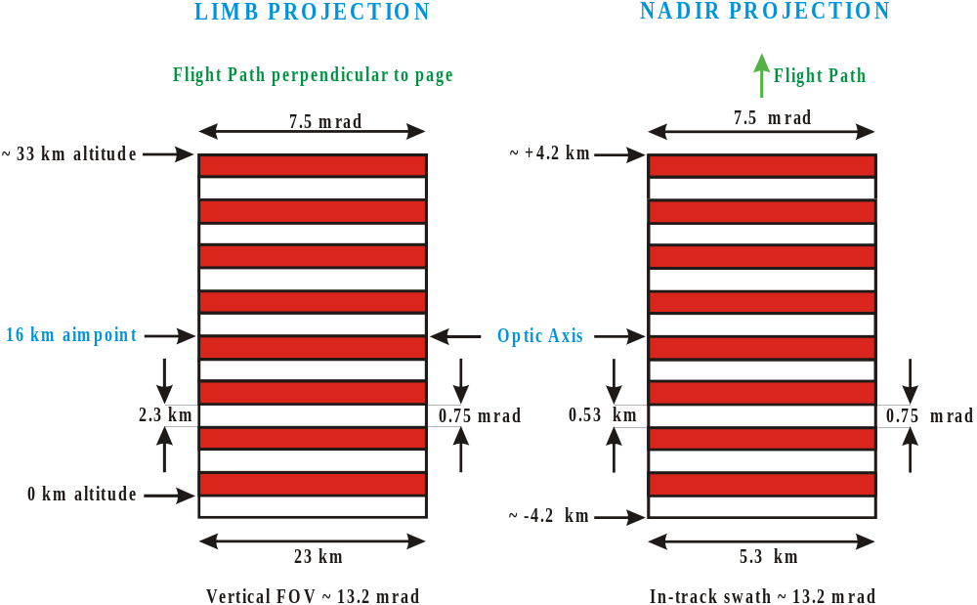

Fig. 1: TES detectors projected to nadir & limb
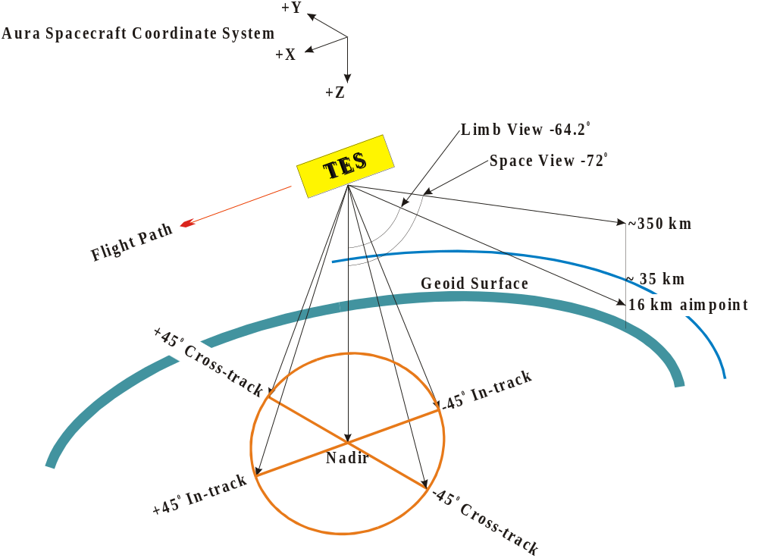

Fig. 2: TES viewing geometries

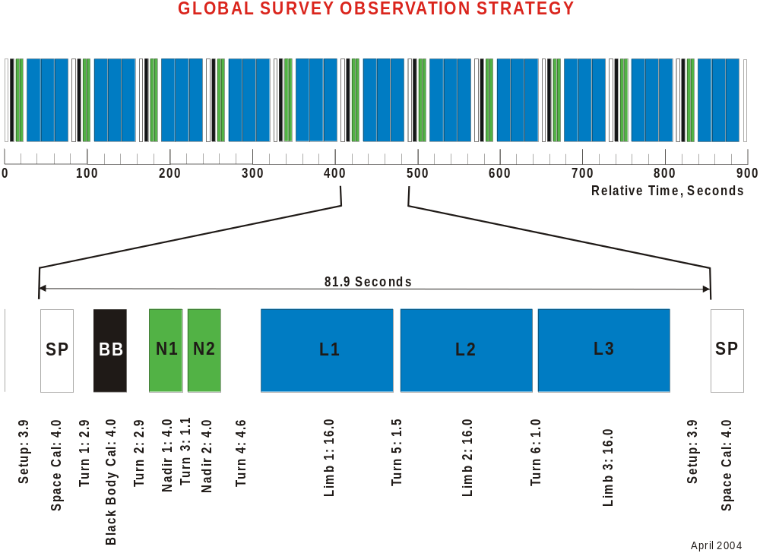

Fig. 3: Pictorial representation of a segment of the Global Survey timeline
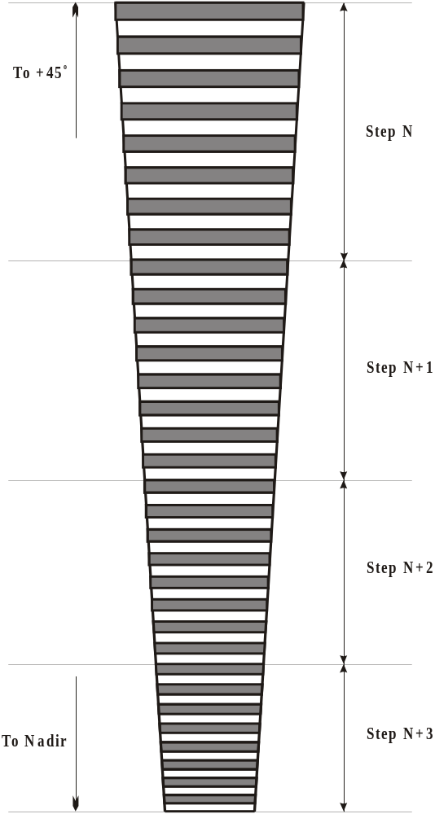

Fig. 4: Schematic of a segment of the TES transect mode (keystoning exaggerated for clarity)

6 COMMISSIONING PLAN (L -> L+3 months)
The first 90 days after launch are termed the commissioning phase. The major events happening during this time are the opening of the Earth shade, outgassing of the inevitable water vapor trapped in the thermal blankets2, detector cool-down and thermal tuning of the optical bench temperature to achieve optimal alignment (assessed by observation of the internal 340K black body). Table I shows an overview. A more detailed commissioning timeline can found in Appendix A. Most of the data generated during this time fall into the category of Special Observations (i.e., are processed beyond L1A at the SCF).

Table I: Overview of the TES Commissioning and Early Operations Plan

Relative Date | Activity
L | Aura Launch
L+2 hrs | TES Survival Bus ON
L+3 days | TES Quiet Bus ON; Start instrument activation
L+7 | TES Noisy Bus ON
L+8 | Unlatch Translator
L+10 | Unlock PCS gimbal
L+11 | Hot Quick Performance Tests
L+22 | Deploy Earth Shade; Turn on Decontamination Heaters
L+29 | Turn off Decontamination Heaters; Start instrument cool-down
L+31 | Exit Decontamination Mode
L+32 | Activate Cryocooler for detector cool-down
L+33 | Start interferometer tuning phase using calibration source and mini-Global Surveys
L+55 | Start formal calibration and initial validation at specific target sites. Transition to full 16-orbit Global Surveys
L+90 | On-orbit calibration assessment complete. Updated L1A & L1B data processing begins at SIPS. Products transferred to LaRC DAAC
L+180 | L2 Forward Model update. Includes HITRAN 2004 and closure experiments results
L+360 | Operational data processing to L2 at SIPS
L+720 | Begin data reprocessing

Notes to Table I:

1) For the first year, TES will concentrate on retrievals in cloud-free areas to facilitate comparisons to ozonesondes, aircraft and ground based campaigns, radiance comparisons with AIRS, and comparisons to chemical transport models such as GEOS-CHEM and MOZART.

2) One full Global Survey (the “golden day”) will be used for detailed verification of end-to-end processing.

3) Decontamination cycles will be done when signal loss indicates ice build-up on the detectors

            - L1B spectral radiances and L2 retrievals will be made available to the validation teams through the Aura Validation Data Center (AVDC) at the Goddard SFC.

7 EARLY MISSION PLAN (L+3 -> L+9 months)
This will be a transition phase wherein we closely monitor the instrument alignment; contamination and translator usage. This will also be a period when significant early validation is done; more-or-less routine Global Surveys are performed and data processing at the SIPS becomes routine. Note that all SIPS-processed data will be archived at the LaRC DAAC.

8 LATE MISSION PLAN (L+9 -> mission end)
For the rest of the mission, we shall perform Global Surveys and Special Observations on the schedule shown in Table II.

Table II: The 233-orbit TES Observation Cycle

Orbit Start | Orbit End | Observation Type
0 | 15 | Global Survey
16 | 17 | GS post-cal
18 | 26 | Special Obs
27 | 28 | GS pre-cal
29 | 44 | Global Survey
45 | 46 | GS post-cal
47 | 55 | Special Obs
56 | 57 | GS pre-cal
58 | 73 | Global Survey
74 | 75 | GS post-cal
76 | 84 | Special Obs
85 | 86 | GS pre-cal
87 | 102 | Global Survey
103 | 104 | GS post-cal
105 | 113 | Special Obs
114 | 115 | GS pre-cal
116 | 131 | Global Survey
132 | 133 | GS post-cal
134 | 142 | Special Obs
143 | 144 | GS pre-cal
145 | 160 | Global Survey
161 | 162 | GS post-cal
163 | 171 | Special Obs
172 | 173 | GS pre-cal
174 | 189 | Global Survey
190 | 191 | GS post-cal
192 | 200 | Special Obs
201 | 202 | GS pre-cal
203 | 218 | Global Survey
219 | 220 | GS post-cal
221 | 230 | Special Obs
231 | 232 | GS pre-cal

Notes to Table II:

1) Except for emergencies, Global Surveys will never be interrupted (e.g., by Special Observations).

2) By the same token, if some pre-planned event (e.g., a spacecraft maneuver or orbit adjustment) would interrupt a Global Survey, the survey will be skipped in its entirety. A “partial” Global Survey is an oxymoron. Furthermore, this decision forms part of the ICS translator management plan.

9 SPECIAL OBSERVATIONS

9.1 Special Tests and Calibrations
TES has a variety of test and calibration modes. Some involve the acquisition of interferograms, many do not. Among the latter are performance tests of both the ICS and the PCS. The ICS performance test is of particular importance because the translator mechanism is believed to have a limited lifetime3 and both the power consumed by the drive motor and the total distance traveled are important metrics of the health of this sub-system.

Tests that generate interferograms include radiometric assessment of the instrument. Both cold space and 340 K on-board radiometric calibration source (OBRCS) data are acquired in this process. The results have numerous uses:

- Changes in the spectral character in certain specific filters are indicators of ice build-up on the detectors.

- Changes in interferogram phase and wavelength-dependent amplitude changes are indicators of beamsplitter alignment drift.

- Noise Equivalent Spectral Radiance (NESR) is an important metric for overall instrument health and performance. NESR is also routinely derived from all calibration measurements.

Another important measurement is the co-boresight test which uses the on-board spatial calibration source (OBRCS).

All of these tests (plus many more) are performed regularly for the life of the mission.

9.2 Staring Mode Observations
Staring Mode observations are the simplest to understand. The MPT is simply loaded with a latitude and longitude and TES points to that location for as long as the nadir angle is less than 45º. Figure 5 shows the available stare time as a function of the nadir angle of the target at closest approach. The only real complication comes about when the target is at high altitude (many volcanoes, for example). Under those circumstances parallax becomes a non-negligible effect and the MPT must contain a slightly different latitude and longitude for each scan (usually short scans). It should also be noted that if the target does not lie in the ground track, the PCS will require a varying roll angle. The footprint rotates by the same amount and, since it is changing, implies that (in general) scan averaging will not be possible.

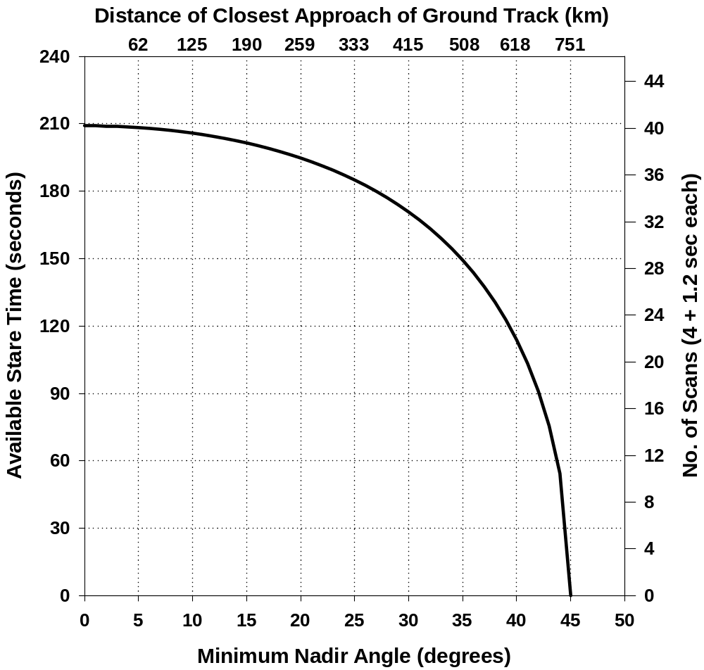

Fig. 5: Available observation time for the staring mode

9.2.1 Volcanoes
The volcanology community has identified 10 volcanoes that they would be interested in having TES monitor. Their common factor is that they emit copious amounts of gas (chiefly sulfur dioxide, but many other ones as well). It is believed that the exact mix of gases is an eruption predictor (Reference 2).

Table III: Candidate Volcanoes to be Monitored

Name | Location | Latitude | Longitude
Colima | Mexico | 19.420 | 256.280
Erebus | Antarctica | -77.525 | 167.120
Etna | Sicily | 37.730 | 15.000
Fuego | Guatemala | 14.480 | 269.120
Kilauea/Pu'u O'o | Hawai'i | 19.392 | 204.892
Lascar | Chile | -23.370 | 292.270
Masaya | Nicaragua | 11.980 | 273.850
Pacaya | Guatemala | 14.380 | 269.400
Sakurajima | Japan | 31.580 | 130.670
White Island | New Zealand | -37.520 | 177.180

Note to Table III: Depending on the specific orbits chosen for the Global Surveys, some of these volcanoes may not be accessible (they must be less than ~500 km from the closest ground track).

9.2.2 Biomass Burning & Major Industrial Accidents
Biomass burning, especially in the tropics in the September-October time frame, is a major source of atmospheric pollutants. The regions where this occurs are well known, so we can plan staring observations of those fires. Other major brush and forest fires occur frequently but in many different locations. Provided that we can get timely information on their locations, most can be observed with a delay of 48 hours or less. Major fires can, of course, burn for many days, even weeks. We already have experience in analyzing remotely-sensed data from wildfires (Reference 3).

Similarly, major industrial accidents (e.g., Chernobyl, Bhopal) can be targeted if we receive timely information. It must, however, be emphasized that TES is not intended to be part of a disaster management program – our spatial resolution is designed for regional, not local, measurements.

9.2.3 Validation Sites
There are a number of permanently-instrumented (some heavily) validation sites around the world. The ones most useful to TES are likely to be those participating in the DoE Atmospheric Radiation Measurements (ARM, Table IV) program4. All standard meteorological measurements are made continuously, together with sondes and down-welling infrared radiances.

The NASA Network for the Detection of Stratospheric Change (NDSC, Table V), although (as its name suggests) primarily aimed at the upper atmosphere, also makes useful tropospheric measurements.

We are also in the process of identifying other locations that can be used for up-welling radiance measurements (Table VI), some of which will also be useful for calibrating the Pointing Control System (PCS).

Table IV: ARM Site Locations

ARM site | TES footprint mean elevation (m) | Coordinates |  | Approx. Aura (Ascending) Overpass Time
ARM site | TES footprint mean elevation (m) | (Decimal Degrees)
ARM site | TES footprint mean elevation (m) | Latitude | E. Longitude | Local Mean Solar Time | Coordinated Universal Time
Southern Great Plains | 314 | 36.617 | 262.500 | 14:02:37 | 20:32:37
Barrow, Alaska | 2 | 71.323 | 203.384 | 15:19:04 | 1:45:32
Barrow, Alaska, off-shore pt. | 0 | 71.400 | 203.200 | 15:19:33 | 1:46:45
Atqasuk, Alaska | 18 | 70.472 | 202.592 | 15:14:01 | 1:43:49
Manus Island | 1 | -2.058 | 147.425 | 13:36:49 | 3:47:07
Manus Island, off-shore pt. | 0 | -2.180 | 147.450 | 13:36:44 | 3:46:56
Nauru Island | 5 | -0.521 | 166.916 | 13:37:42 | 2:30:02
Nauru Island, off-shore pt. | 0 | -0.500 | 166.820 | 13:37:43 | 2:30:26
Darwin Australia | 1 | -12.425 | 130.891 | 13:30:43 | 4:47:09
Darwin, Australia off-shore pt. | 0 | -12.320 | 130.780 | 13:30:47 | 4:47:39

Table V: Selected NDSC Site Locations

NDSC site | TES footprint mean elevation (m) | Coordinates |  | Approx. Aura (Ascending) Overpass Time
NDSC site | TES footprint mean elevation (m) | (Decimal Degrees)
NDSC site | TES footprint mean elevation (m) | Latitude | E. Longitude | Local Mean Solar Time | Coordinated Universal Time
Table Mountain, CA | 1905 | 34.400 | 242.300 | 14:00:41 | 21:51:29
Lauder, NZ | 379 | -45.040 | 169.680 | 13:04:46 | 1:46:03
Hilo, Hawaii | 11 | 19.720 | 204.930 | 13:49:51 | 0:10:08
Hilo, off-shore pt. | 0 | 19.800 | 205.000 | 13:50 | 0:10
Reunion Island | 10 | -21.800 | 55.500 | 13:24:46 | 9:42:46
Reunion Is. off-shore pt. | 0 | -21.400 | 55.500 | 13:25 | 9:43

Table VI: Other Radiometric Target Site Locations

Location | TES footprint mean elevation (m) | Coordinates |  | Approx. Aura (Ascending) Overpass Time
Location | TES footprint mean elevation (m) | (Decimal Degrees)
Location | TES footprint mean elevation (m) | Latitude | E. Longitude | Local Mean Solar Time | Coordinated Universal Time
Lake Tahoe, CA | 1898 | 39.100 | 239.970 | 14:04:50 | 22:04:50
Lake Tahoe, CA (N. shore) | 1905 | 39.240 | 239.940 | 14:05 | 22:05
ASTER sites (MN lakes) | TBD | TBD | TBD | TBD | TBD
Chesapeake Lighthouse | 0 | TBD | TBD | TBD | TBD
Mediterranean | 0 | TBD | TBD | TBD | TBD

9.3 Transect Mode Observations
Transects are necessarily made in the ground track. Because of the field rotation alluded to earlier it is not possible to “stack” off-track observations satisfactorily. However, since transects are intended for observation of regional phenomena and to support aircraft validation campaigns where the aeroplane simply needs to under-fly the ground track, this is not a limitation.

9.3.1 Down-looking Transects
Down-looking transects (the most common variety) use short scans. However, because each scan is individually targeted, it is possible to make multiple scans at each location. The price paid is in the overall length of the transect because of the limitation to +/- 45º nadir angle (Table VII).

Table VII: Maximum Transect Lengths

No. of scans/step | Maximum Transect Length (km)
1 | 949
2 | 349
3 | 220
4 | 132

Transects are created by pre-calculating the latitude and longitude of every step (a straightforward process) and loading the data into the MPT.

9.3.2 Limb Transects
Limb transects are primarily used for instrument intercomparisons. For example, the HiRDLS instrument on Aura covers the same spectral range as TES and can look backwards along exactly the same line-of-sight as TES. The difference is that HiRDLS is a broad-band radiometer with very good vertical resolution (~ 1 km). TES, on the other hand, has poorer vertical resolution (2.3 km) but much better spectral resolution. The combination of data from the two instruments should result in a superior joint product.

Limb transects are created simply by putting TES into its limb mode and making repetitive long scans. In principle, there is no limit to the length of such a transect.

However, long scans are costly in terms of translator life, so the mode is to be used sparingly.

10 REFERENCES

1) Beer, R., T.A. Glavich and D.M. Rider, “Tropospheric Emission Spectrometer for the Earth Observing System AURA Satellite”, Appl. Opt. 40, 2356 - 2367 (2001)

2) Realmuto, V.J. and H.M. Worden, "Impact of atmospheric water vapor on the thermal infrared remote sensing of volcanic sulfur dioxide emissions: A case study from the Pu'u 'O'o vent of Kilauea Volcano, Hawaii", , J. Geophys. Res. 105 , 21,497 – 21,507, (2000)

3) Worden, H.M., R. Beer and C.P.Rinsland, "Airborne High Resolution Infrared Spectroscopy of Western Wildfires", J. Geophys. Res. 102, 1287-1299 (1997)

11 ACRONYMS

ARM |  | Atmospheric Radiation Measurements (DoE program)
AVDC |  | Aura Validation Data Center (at the Goddard Space Flight Center)
DAAC |  | Distributed Active Archive Center
EOS |  | Earth Observing System (Aura is a component)
HiRDLS |  | High Resolution Dynamics Limb Sounder (Aura instrument)
ICS |  | Interferometer Control System
JPL |  | Jet Propulsion Laboratory, California Institute of Technology
LaRc |  | NASA Langley Research Center
MLS |  | Microwave Limb Sounder (Aura instrument)
MPT |  | Macro Parameter Table
NASA |  | National Aeronautics and Space Administration
NDSC |  | Network for the Detection of Stratospheric Change (NASA program)
NESR |  | Noise Equivalent Source Radiance
OBRCS |  | On-board Radiometric Calibration Source (TES sub-system)
OBSCS |  | On-board Spatial Calibration Source (TES sub-system)
OMIS |  | Ozone Measuring Instrument System (Aura instrument)
PCS |  | Pointing Control System
SCF |  | Science Computing Facility
SIPS |  | Science Investigator-led Processing System
TES |  | Tropospheric Emission Spectrometer (Aura instrument)

APPENDIX A

DETAILED TIMELINE FOR THE INSTRUMENT COMMISSIONING PHASE

 | Instrument Activity Description | Proc Names  (with input parameters) | Prerequisites/  Constraints/  Dependencies | Duration  of Activity | Required  S/C Attitude  (e.g., fine point) | Command  Types (e.g., real time? SCS?) | Tlm  Types | TIME  MET | Expedited Data? | Comments
TES-100 | Power to survival heaters (A&B)  This is a command to the SCE on the S/C | Commanded by S/C | As soon as practical after solar array deployment. | ? | N/A |  | any | 00/02:15 | no
TES-105 | Uplink TMONs and TMON response SCSs  TMON Groups 47-51  SCS ISC-65 |  |  |  | any | R/T | 4K or 16K
TES-101 | Enable EDRI polling  (to receive H/K TLM) |  |  |  | any | R/T | 4K or 16K | 04/01:00
TES-110 | TES Quiet Bus Powered On  (TES will be in ENG submode at power ON.) | Commanded by S/C | (Final orbit is not a constraint.)  Prerequisite:  Begin bus polling of 1553 traffic for TES | 5 mins | any | R/T activation of  SCS | 4K or 16K | 04/04:00
TES-901 | Enable TES Stale telemetry TMONs, Quiet Bus TMON, and responses.  CTC-8 & ISC-46: TES Stale Telemetry TMON set  ISC-47: Quiet Bus Current  SCS ISC-38: TES shutdown and poweroff  SCS CTC-10: Noisy Bus relay | Enable group CTC-8  Enable group ISC-46  Enable group ISC-47  Enable SCS CTC-10  Enable SCS ISC-38 |  |  | any | R/T | 4K or 16K
TES-125 | TES Noisy Bus Turn On  (No current drawn; cryocoolers and decontam htrs on NB) | Commanded by S/C | The relays must be set | 5 mins | any | R/T | 4K or 16K | 07/02:58
TES-902 | Enable TES Noisy Bus TMON.  ISC-48: Noisy Bus Current | Enable group ISC-48 |  |  | any | R/T | 4K or 16K | 07/03:08
TES-111 | Verify Quiet Bus ON initial telemetry | TES_VERIFY_ON |  |  | any | R/T | 4K or 16K
TES-130 | TES Self-Test Register Enable | TES_SELF_TEST_REG_ENABLE |  | 5 mins | any | R/T | 4K or 16K | 07/03:28
TES-910 | Enable IEM fault protection | TES_IEM_FP_ENABLE |  |  | any | R/T | 4K or 16K | 07/03:58
TES-133 | Upload macros not in EEPROM | TES_LOAD_MACRO |  |  | Earth Point or Fine Point | R/T | 4K or 16K | 07/04:28
TES-134 | Dump macros loaded | TES_DUMP_MACRO | Must occur after MACRO upload, TES-134 |  | Earth Point or Fine Point | R/T | 4K or 16K | 07/04:58
TES-136 | Upload 2000 row MPT | TES_LOAD_TABLE(‘FLTmptV20’,7) | Must occur after STEP TES-134 | 30 mins | Earth Point or Fine Point | R/T | 4K or 16K | 07/05:48
TES-137 | Dump 2000 row MPT | TES_DUMP_TABLE(‘MACRO_PARAMETER’) | Must occur after table upload |  | Earth Point or Fine Point | R/T | 4K or 16K | 07/06:18
TES-140 | Filter Wheel Ready/Activation and background heating of filter wheels | TES_FLTR_WHL_ACTIVATE  TES_SET_FW_HEATCYCLE | Eng  Submode  Validate temperature of bearing | 5 minutes | Earth Point or Fine Point | R/T | 4K or 16K | 07/06:28
TES-903 | Enable TES Translator Temperature TMON and response  ISC-49: Signal Chain, IEM, and Translator Temperatures  SCS ISC-65: TES shutdown | Enable group ISC-49  Enable SCS ISC-65 | After translator temperatures have stabilized. |  | Earth Point or Fine Point | R/T | 4K or 16K | 07/20:58
TES-153 | Configure ICS for unlatch (background heating of ICS) and unlatch translator | TES_ICS_ACTIVATE  - TES_OB_OPER_HTRS_ON | Optical bench sensors (TES_T6-OPTBENCH1 & TES_T6_OPTBENCH2) should be above 0 C. | 10 minutes | Earth Point or Fine Point | R/T | 4K or 16K | 08/08:03
TES-154 | Increment run counter and Execute ICS_QUICK_PERFORMANCE macro | TES_INC_RUNCNT TES_CALL_MACRO (321) |  |  | Earth Point or Fine Point | R/T | 4K or 16K | 08/21:58 |  | NEW!
TES-155 | Increment run counter and Execute TES_TP_QUICK macro  (Test pattern macro) | TES_INC_RUNCNT TES_CALL_MACRO(390) |  |  | Earth Point or Fine Point | R/T | 4K or 16K | 08/22:58 |  | NEW!
TES-160 | Activate Laser A | TES_LASERA_ACTIVATE | Signal chain LHPA must be below 35C | 10 minutes | Earth Point or Fine Point | R/T | 4K or 16K | 09/08:43 |  | NEW constraint!
TES-161 | Increment run counter and Execute ICS_QUICK_PERFORMANCE macro | TES_INC_RUNCNT TES_CALL_MACRO (321) |  |  | Earth Point or Fine Point | R/T | 4K or 16K | 10/??:?? |  | NEW!
TES-162 | Increment run counter and Execute TES_TP_QUICK macro  (Test pattern macro) | TES_INC_RUNCNT TES_CALL_MACRO(390) |  |  | Earth Point or Fine Point | R/T | 4K or 16K | 10/??:?? |  | NEW!
TES-210 | Align and test filter wheels | TES_FLTR_WHL_ALIGN_TEST |  | 15 minutes | Earth Point or Fine Point | R/T | 4K or 16K | 10/10:23 |  | NEW! Used to be right before step open earthshade, on day 13
TES- 200 | Unlock Gimbal | TES_PCS_UNLOCK |  | 15 minutes | Earth Point or Fine Point | R/T | 4K or 16K | 10/10:53
TES-201 | 'Wet' Gimbal | TES_PCS_PNT_GIM(TBD) |  |  | Earth Point or Fine Point | R/T | 4K or 16K | 10/10:58
TES-202 | Point to Nadir position | TES_PCS_PNT_NADIR |  | 10 minutes | Earth Point or Fine Point | R/T | 4K or 16K | 10/11:03
TES-163 | Increment run counter and Execute ICS_QUICK_PERFORMANCE macro  (Run once a day from here on) | TES_INC_RUNCNT TES_CALL_MACRO (321) |  |  | Earth Point or Fine Point | R/T | 4K or 16K | 10/21:58 |  | NEW!
TES-164 | Increment run counter and Execute TES_TP_QUICK macro  (Test pattern macro)  (Run once a day from here on) | TES_INC_RUNCNT TES_CALL_MACRO(390) |  |  | Earth Point or Fine Point | R/T | 4K or 16K | 10/22:58 |  | NEW!
TES-165 | Activate Radiometric Calibration Source  (In ambient, argument is 320) | TES_RCS_ACTIVATE(340)  - TES_RCS_ON | At least 1 contact after 202 | 10 minutes | Earth Point or Fine Point | R/T | 4K or 16K | 11/05:48
TES-230 | Activate Spatial Source | TES_SPATIAL_SRC_ACT  - TES_SPATIAL_SRC_ON | On same day as TES-165  Should occur once Rad Cal Source is at 340 K. | 10 minutes | Earth Point or Fine Point | R/T | 4K or 16K | 11/09:23 |  | Deleted comment “(for decontamination”
TES 166 | Point Mirror at RCS  Rotate pointing mirror to RCS | TES_PCS_PNT_GIM(TBD) | - at least 1 orbit after TES-230 for decontamination |  | Earth Point or Fine Point | R/T | 4K or 16K | 11/09:53
TES-204 | Set Quick-look bit to ON (to expedite data) | TES_QL_ON activity |  |  | Earth Point or Fine Point | MCL |  | 11/18:53 | EDS
TES-205 | Execute ICS_QUICK_PERFORMANCE macro  (Run once a day from here on) | TES_ICS_QUICK_PERF activity |  |  | Earth Point or Fine Point | MCL |  | 11/18:58 |  | NEW!
TES-206 | Execute TES_TP_QUICK macro  (Test pattern macro)  (Run once a day from here on) | TES_TP_QUICK activity |  |  | Earth Point or Fine Point | MCL |  | 11/19:58 |  | NEW!
TES-207 | Execute RADIOMETRIC ASSESSMENT macro  (Warm detector measurement)  (Run once a day from here on) | TES_RAD_ASSESS activity |  |  | Earth Point or Fine Point | MCL |  | 11/20:58 |  | NEW!
TES-208 | Execute PCS_QUICK_PERFORMANCE macro  (Run once a day from here on) | TES_PCS_QUICK_PERF activity |  |  | Earth Point or Fine Point | MCL |  | 11/21:58 |  | NEW!
TES-209 | Set Quick-look bit to OFF (stop expedited data) | TES_QL_OFF activity |  |  | Earth Point or Fine Point | MCL
TES-220 | Open Earth shade (may shake spacecraft)  (Do we need to disable any fault management features for spacecraft?) | TES_EARTH_SHADE_OPEN | Translator Unlatched  After the final S/C ascent burn.  After S/C outgassing has completed. | 25 minutes | Earth Point or Fine Point | R/T | 4K or 16K | 22:??:?? |  | NEW!
TES-240 | Prepare TES for Decontamination | TES_DECON_PREP  - TES_OB_OPER_HTRS_OFF  - TES_ADC_OFF  - TES_DECON_SUBMODE | Instrument Outgas period begins.  Make sure ADC off  Within 1.5 hrs after Earth shade open (TES-220) | 10 minutes | Earth Point or Fine Point | R/T | 4K or 16K | 22:??:?? |  | NEW constraint!
****** | RUN TES_PCS_QUICK_PERF and TES_TP_QUICK macros  every other day during decon period
TES-241 | TURN on decon heaters  Turn on NB decon heater  Turn on QB decon heater  Turn on FPOMA 1 decon heater  Turn on FPOMA 2 decon heater | TES_NB_DECON_HTR_ON(3,7)  TES_QB_DECON_HTR_ON(1,1,1100)  TES_FPOMA1_DECON_HTR_ON(‘HTRA_PWR,TBD)  TES_FPOMA2_DECON_HTR_ON(‘HTRA_PWR’,TBD) | Same contact as STEP 240 |  | Earth Point or Fine Point | R/T | 4K or 16K | 22:??:?? |  | NEW! Based on thermal input
TES-270  ******* | Turn off Noisy bus decon heater  Turn off QB decon heater | TES_NB_DECON_HTR_OFF(3,7)  TES_QB_DECON_HTR_OFF(1,1,100) | Roughly 7 days after TES-240 | 10 minutes | Earth Point or Fine Point | R/T | 4K or 16K | 29??:??  29/??:?? |  | New step!
TES-275  ******** | Interferometer Cool down  Turn on the OB operational heaters | TES_QB_DECON_HTR_ON(1,1,100)  TES_QB_DECON_HTR_ON(1,1,63)  TES_QB_DECON_HTR_ON(1,1,42)  TES_QB_DECON_HTR_ON(1,1,20)  TES_QB_DECON_HTR_OFF(1,1,0)  TES_OB_OPER_HTRS_ON  (“HTRA_PWR”,50) | Must occur NO more than 5 hours after STEP 270  Must occur atleast 8 hrs after STEP 270  Must occur atleast 16 hrs after STEP 270  Must occur atleast 24 hrs after STEP 270  Must occur atleast 48 hrs after STEP 270  Must occur atleast 48 hrs after STEP 270 |  | Earth Point or Fine Point | R/T | 4K or 16K | 29/??:?? |  | New step!
****** | RUN TES_PCS_QUICK_PERF  TES_ICS_QUICK_PERF and TES_TP_QUICK macros and TES_RAD_ASSESS macros daily after TES-275 is complete which would be on day 31
TES-278  ******** | Turn off all remaining Decontamination heaters | TES_FPOMA1_DECON_HTR_OFF  TES_FPOMA2_DECON_HTR_OFF |  |  | Earth Point or Fine Point | R/T | 4K or 16K |  |  | Moved to TES-270!
TES-279  ******** | Exit Decontamination  Transition out of Decontamination Submode  Turn ADC back on | TES_ENGINEERING_SUBMODE  TES_ADC_ON |  |  | Earth Point or Fine Point | R/T | 4K or 16K | 31/??:??
TES-280 | Set up Fault protection for Crycooler power-on. | TES_SET_DET_UNDERTEMP_FAULTS |  |  | Earth Point or Fine Point | R/T | 4K or 16K | 32:??:??
TES-281 | Turn the cryocooler A electronics power on (close the cooler electronics power relays). Set Communication delay and checks boot code.  TES_FPCA_ACT1_SETRELAY | TES_CALL_FPCA(300,’0’,0) | Should occur ~30 hrs after TES-275.  Need contacts scheduled at 86 deg. |  | Earth Point or Fine Point | R/T | 4K | 32:??:?? |  | Deleted AI for Padma. This is a command from the gnd to activate a macro onboard TES
TES-282 | Turn the cryocooler B electronics power on (need to verify A power on and then B power on). Set Communication delay and checks boot code.  TES_FPCB_ACT1_SETRELAY | TES_CALL_FPCB(308, ‘0’, 0) | Same contact as TES-281 | 15 minutes | Earth Point or Fine Point | R/T | 4K | 32:??:??
TES-283a | Upload the TES patch for cryocooler A operation. Upload code, execute code, and download code.  TES_FPCA_ACT2_UPLOAD | TES_CALL_FPCA(301,’0’,0) | Need contacts scheduled at 86 deg. | 15 minutes | Earth Point or Fine Point | R/T | 4K | 32:??:??
TES-283c | Load patch for cryocooler B ops. Upload code, execute code, and download code.  TES_FPCB_ACT2_UPLOAD | TES_CALL_FPCB(309,’0’,0) | Should occur in same contact as TES-283a | 15 minutes | Earth Point or Fine Point | R/T | 4K | 32:??:??
TES-284a | Upload some parameters (trip levels and enables) for cooler A. Set drive set point, changes positive and negative overstroke trips for side 1 and 2.  TES_FPCA_ACT3_SETDRIVE | TES_CALL_FPCA(302,’0’,0) |  | 10 minutes | Earth Point or Fine Point | R/T | 4K | 32:??:??
TES 284c | Cooler A: Set cooler temperatures  TES_FPCA_ACT4_SETTEMP | TES_CALL_FPCA(303,’0’,0) | Need time to verify telemetry from 284a |  | Earth Point or Fine Point | R/T | 4K | 32:??:??
TES-284d | Cooler A: Sets temperature parameters  TES_FPCA_ACT5_SETVIB | TES_CALL_FPCA(304,’0’,0) | Need time to verify telemetry from 284c |  | Earth Point or Fine Point | R/T | 4K | 32:??:??
TES-285a | Upload some parameters (trip levels and enables) for cooler B. Set drive set point, changes positive and negative overstroke trips for side 1 and 2.  TES_FPCB_ACT3_SETDRIVE | TES_CALL_FPCB(310,’0’,0) | Verify telemetry | 10 minutes | Earth Point or Fine Point | R/T | 4K | 32:??:??
TES-285c | Cooler B: Set cooler temperatures  TES_FPCB_ACT4_SETTEMP | TES_CALL_FPCB(311,’0’,0) | Need time to verify telemetry from 285a |  | Earth Point or Fine Point | R/T | 4K | 32:??:??
TES-285d | Cooler B: Sets temperature parameters  TES_FPCB_ACT5_SETVIB | TES_CALL_FPCB(312,’0’,0) | Need time to verify telemetry from 285c |  | Earth Point or Fine Point | R/T | 4K | 32:??:??
TES-287 | Activate cryocooler A. Starts cooler A and enables trips, control loops for Focal Plane Cooler A.  TES_FPCA ON | TES_CALL_FPCA(305,’0’,0) | If compressor temperatures are 0 – 35 deg C |  | Earth Point or Fine Point | R/T | 4K | 32:??:??
TES-288 | Activate cryocooler B. Starts cooler B and enables trips, control loops for Focal Plane Cooler B.  TES_FPCB_ON | TES_CALL_FPCB(313,’0’,0) | Minimum 30 minutes after TES-287  If compressor temperatures are 0 – 35 deg C |  | Earth Point or Fine Point | R/T | 4K | 32:??:??
TES-904 | Enable TES Cooler temperature Monitoring TMONs | Enable group ISC-50  Enable group ISC-51 |  |  | Earth Point or Fine Point | R/T | 4K or 16K | 32:??:??
TES-300 | Command TES to Mission Submode | TES_MISSION_SUBMODE | Spacecraft State  Must be receiving ancillary data from spacecraft – day after TES-288 | 5 minutes | Fine Point | R/T | 4K or 16K | 33/??:??
TES-301 | Execute closed filter measurement macro (1000 scans) | TES_CLOSED_FILTER activity | After step TES-300 | 6 hours | Fine Point | MCL |  | 33/??:?/
TES-302 | Execute tes_obrcs_search | TES_OBRCS_SEARCH activity | After step TES-301 | 17 mins |  | MCL
TES-370 | Execute S&R activity  (spatial_cal + rad_assess) | Spatial_cal activity + rad_assess activity every 2 orbits, 7 times | After STEP 301, 2 days after TES coolers are turned on | 2 orbits + 14 orbits |  |  |  | 34
TES-375 | Execute S&R activity  (spatial_cal + rad_assess) | Spatial_cal activity + rad_assess activity every 2 orbits, 7 times | 16 orbits after TES-370 | 2 orbits + 14 orbits |  |  |  | 35
TES-380 | Execute GS&R activity  (Rad_assess + spatial_cal+mini_GS) | Spatial_cal activity + pre_GS_cal activity + SUPER_GS activity + rad_assess activity every 2 orbits 4 times | 16 orbits after TES-375 | 2 orbits + 2 orbits+4 orbits+8 orbits=16 orbits | Fine Point Nominal orbit/ attitude | MCL |  | 36 |  | NEW step!
TES-385 | Execute S&R activity  (spatial_cal + rad_assess) | Spatial_cal activity + rad_assess activity every 2 orbits, 7 times | 16 orbits after TES-380 | 2 orbits + 14 orbits |  |  |  | 37
TES-390 | Execute GS&R activity  (Rad_assess + spatial_cal+mini_GS) | Spatial_cal activity + pre_GS_cal activity + SUPER_GS activity + rad_assess activity every 2 orbits 4 times | 16 orbits after TES-385 | 2 orbits + 2 orbits+4 orbits+8 orbits=16 orbits | Fine Point Nominal orbit/ attitude | MCL |  | 38 |  | NEW step!
TES-395 | Execute S&R activity  (spatial_cal + rad_assess) | Spatial_cal activity + rad_assess activity every 2 orbits, 7 times | 16 orbits after TES-390 | 2 orbits + 14 orbits |  |  |  | 39
TES-400 | Execute GS&R activity  (Rad_assess + spatial_cal+mini_GS) | Spatial_cal activity + pre_GS_cal activity + SUPER_GS activity + rad_assess activity every 2 orbits 4 times | 16 orbits after TES-395 | 2 orbits + 2 orbits+4 orbits+8 orbits=16 orbits | Fine Point Nominal orbit/ attitude | MCL |  | 40 |  | NEW step!
TES-405 | Execute S&R activity  (spatial_cal + rad_assess) | Spatial_cal activity + rad_assess activity every 2 orbits, 7 times | 16 orbits after TES-400 | 2 orbits + 14 orbits |  |  |  | 41
TES-410 | Execute GS&R activity  (Rad_assess + spatial_cal+mini_GS) | Spatial_cal activity + pre_GS_cal activity + SUPER_GS activity + rad_assess activity every 2 orbits 4 times | 16 orbits after TES-405 | 2 orbits + 2 orbits+4 orbits+8 orbits=16 orbits | Fine Point Nominal orbit/ attitude | MCL |  | 42 |  | NEW step!
TES-415 | Execute S&R activity  (spatial_cal + rad_assess) | Spatial_cal activity + rad_assess activity every 2 orbits, 7 times | 16 orbits after TES-410 | 2 orbits + 14 orbits |  |  |  | 43
TES-420 | Execute GS&R activity  (Rad_assess + spatial_cal+mini_GS) | Spatial_cal activity + pre_GS_cal activity + SUPER_GS activity + rad_assess activity every 2 orbits 4 times | 16 orbits after TES-415 | 2 orbits + 2 orbits+4 orbits+8 orbits=16 orbits | Fine Point Nominal orbit/ attitude | MCL |  | 44 |  | NEW step!
TES-425 | Execute S&R activity  (spatial_cal + rad_assess) | Spatial_cal activity + rad_assess activity every 2 orbits, 7 times | 16 orbits after TES-420 | 2 orbits + 14 orbits |  |  |  | 45
TES-430 | Execute GS&R activity  (Rad_assess + spatial_cal+mini_GS) | Spatial_cal activity + pre_GS_cal activity + SUPER_GS activity + rad_assess activity every 2 orbits 4 times | 16 orbits after TES-425 | 2 orbits + 2 orbits+4 orbits+8 orbits=16 orbits | Fine Point Nominal orbit/ attitude | MCL |  | 46 |  | NEW step!
TES-435 | Execute S&R activity  (spatial_cal + rad_assess) | Spatial_cal activity + rad_assess activity every 2 orbits, 7 times | 16 orbits after TES-430 | 2 orbits + 14 orbits |  |  |  | 47
TES-440 | Execute GS&R activity  (Rad_assess + spatial_cal+mini_GS) | Spatial_cal activity + pre_GS_cal activity + SUPER_GS activity + rad_assess activity every 2 orbits 4 times | 16 orbits after TES-435 | 2 orbits + 2 orbits+4 orbits+8 orbits=16 orbits | Fine Point Nominal orbit/ attitude | MCL |  | 48 |  | NEW step!
TES-445 | Execute S&R activity  (spatial_cal + rad_assess) | Spatial_cal activity + rad_assess activity every 2 orbits, 7 times | 16 orbits after TES-440 | 2 orbits + 14 orbits |  |  |  | 49
TES-450 | Execute GS&R activity  (Rad_assess + spatial_cal+mini_GS) | Spatial_cal activity + pre_GS_cal activity + SUPER_GS activity + rad_assess activity every 2 orbits 4 times | 16 orbits after TES-445 | 2 orbits + 2 orbits+4 orbits+8 orbits=16 orbits | Fine Point Nominal orbit/ attitude | MCL |  | 50 |  | NEW step!
TES-455 | Execute S&R activity  (spatial_cal + rad_assess) | Spatial_cal activity + rad_assess activity every 2 orbits, 7 times | 16 orbits after TES-450 | 2 orbits + 14 orbits |  |  |  | 51
TES-460 | Execute GS&R activity  (Rad_assess + spatial_cal+mini_GS) | Spatial_cal activity + pre_GS_cal activity + SUPER_GS activity + rad_assess activity every 2 orbits 4 times | 16 orbits after TES-455 | 2 orbits + 2 orbits+4 orbits+8 orbits=16 orbits | Fine Point Nominal orbit/ attitude | MCL |  | 52 |  | NEW step!
TES-455 | Execute S&R activity  (spatial_cal + rad_assess) | Spatial_cal activity + rad_assess activity every 2 orbits, 7 times | 16 orbits after TES-450 | 2 orbits + 14 orbits |  |  |  | 53
TES-460 | Execute GS&R activity  (Rad_assess + spatial_cal+mini_GS) | Spatial_cal activity + pre_GS_cal activity + SUPER_GS activity + rad_assess activity every 2 orbits 4 times | 16 orbits after TES-455 | 2 orbits + 2 orbits+4 orbits+8 orbits=16 orbits | Fine Point Nominal orbit/ attitude | MCL |  | 54 |  | NEW step!
TES-465 | Execute S&R activity  (spatial_cal + rad_assess) | Spatial_cal activity + rad_assess activity every 2 orbits, 7 times | 16 orbits after TES-460 | 2 orbits + 14 orbits |  |  |  | 55
TES-470 | Execute GS&R activity  (Rad_assess + spatial_cal+mini_GS) | Spatial_cal activity + pre_GS_cal activity + SUPER_GS activity + rad_assess activity every 2 orbits 4 times | 16 orbits after TES-465 | 2 orbits + 2 orbits+4 orbits+8 orbits=16 orbits | Fine Point Nominal orbit/ attitude | MCL |  | 56 |  | NEW step!
TES-475 | Special observation | TES_SAN_SITE | Day after TES-470 |  |  |  |  | 57
TES-477 | Execute tes_obrcs_search | TES_OBRCS_SEARCH activity | After step TES-301 | 17 mins |  | MCL
TES-480 | TES pre GS calibration | TES_pre_GS_CAL BAP |  | 2 orbits |  |  |  | 58 |  | Start of TES routine OPS!!!
TES-485 | Super Global Survey | TES_SUPER_GS BAP | 2 orbits after TES-480 | 4*4 orbits
TES-490 | TES post GS calibration | TES_post_GS_CAL BAP | 16 orbits after TES-485 | 2 orbits
TES-475 | Special observation | TES_SAN_SITE | 20 orbits after TES-480

S&R = SPATIAL_CAL (TES_FLT_SPATIAL_CAL_LFT + TES_FLT_SPATIAL_CAL_MID +TES_FLT_SPATIAL_CAL_RGT) once every 16 orbits + RAD_ASSESS once every 2 orbits
GS&R=RAD_ASSESS 7 times every 2 orbits + SPATIAL_CAL+MINI_GS
MINI_GS = TES_SUPER_Pre_GS_CAL (2 orbits) + SUPER_GS (4 orbits)

 | ORBIT | Activity
 | N | S&R
 | N+16 | S&R
 | N+32 | GS&R
 | N+48 | S&R
 | N+64 | GS&R
 | N+80 | S&R
 | N+96 | GS&R
 | N+112 | S&R
 | N+128 | GS&R
 | N+144 | S&R
 | N+156 | GS&R
 | N+172 | S&R
 | N+188 | GS&R
 | N+204 | S&R
 | N+220 | GS&R
 | N+232 | S&R
 | N+248 | GS&R
 | N+264 | S&R
 | N+290 | GS&R
 | N+306 | S&R
 | N+322 | GS&R
 | N+338 | Special observation
 | N+354 | Pre_GS cal
 | N+356 | SUPER_GS
 | N+372 | Post_cal GS
 | N+379 | Special observation

The term “spectral sample spacing” is preferred over the more usual “spectral resolution” because it more accurately reflects the character of the FTS output. Furthermore, spectral resolution depends on whatever apodization may be purposefully or inadvertently applied to the data.
2 Signal loss due to absorption by ice on the detectors was a significant effect during thermal vac testing
3 The life test unit failed after the equivalent of about 2 years of normal operations.
4 Two TES co-investigators are also active members of the ARM program, so we have ready access to ARM data.

