DRAFT - NWS Technical Procedures Bulletin No. xxx

The RUC 3-d variational analysis (and post-processing modifications)

Stanley G. Benjamin, Dezső Dévényi, and Stephen S. Weygandt

NOAA Research, Forecast Systems Laboratory, Boulder, CO

Geoffrey S. Manikin

Environmental Modeling Center, National Centers for Environmental Prediction, Camp Springs, MD

Abstract

An upgrade to the NCEP Rapid Update Cycle analysis from an optimal interpolation (OI) technique to a 3-d variational (3DVAR) technique is planned for May 2003. The RUC 3DVAR analysis uses the same hybrid isentropic-sigma coordinate as used in the RUC OI analysis (and RUC forecast model). The RUC 3DVAR analysis has been in testing at NOAA-FSL over the last few years and at NCEP in parallel and retrospective cycles since November 2002. Overall, the RUC 3DVAR provides
- Slight improvement or about equal skill overall in 3-h and 12-h forecasts compared to those from the previous RUC OI analysis as verified against rawinsondes.
- Closer fit to observations than the RUC OI analysis.
- A smoother analysis increment (correction to 1-h forecast field) and quieter short-range forecasts.
- Capability for assimilation of indirect observations such as radial winds, satellite radiances, and wind speed.
A few minor changes to the RUC post-processing are also being implemented with this change package, including addition of 0-1 km helicity and some small fixes.

- Introduction

A 3-dimensional variational analysis (3dVAR) technique has been developed for application in the Rapid Update Cycle (RUC). The goals for the implementation of the RUC 3DVAR are to:
- Introduce the capability for assimilation of indirect observations such as satellite radiances, radar radial winds, wind speed, and GPS wet delay (correlated with precipitable water).
- Avoid known problems with the optimal interpolation (OI) analysis, especially small-scale noise from truncation associated with observation selection for given groups of grid points. With the 3DVAR solution, all observations affect all grid points. No data thinning is needed (at present) for the 3DVAR solution, even though it is necessary with OI, so all observations now get used.
- Provide equal or improved forecast skill at forecast projections of 3 h and 12 h. The need for equal or improved forecast skill at a 3-h projection is unique for the RUC and less important for 3DVAR implementations in the EDAS or GDAS where there is not a user focus on short-range forecasts.
- Match the computational time used for the RUC OI analysis.

This Technical Procedures Bulletin provides an overview of the RUC 3dVAR and results from parallel and retrospective testing within the RUC. Other information on the RUC 3DVAR analysis can be found in a journal paper specifically about the RUC 3DVAR (Devenyi and Benjamin 2003, see link to online PDF in reference list).

- A description of the RUC 3-d variational analysis solution

The implementation of the RUC 3DVAR is simplified by the previous implementation with the RUC20 in April 2002 of a unified analysis framework that can use solvers from either OI or 3DVAR techniques. This analysis framework described in the previous RUC20 TPB (Benjamin et al. 2002) is unchanged in the 3DVAR implementation, including ingest and preprocessing of observations, the calculation of observation-background differences (innovations), quality control of observations, types of observations assimilated, assimilation of GOES cloud data, and variables analyzed. The sequence of analysis steps in the RUC 3DVAR is the same as with the RUC OI analysis. (RUC20 TPB – Benjamin et al. 2002, Devenyi and Benjamin 2003).

The RUC 3DVAR analysis uses the same hybrid isentropic-sigma coordinate as used in the RUC OI analysis (and RUC forecast model). More information on the isentropic effect on the analysis is given by Devenyi and Benjamin (2003) and Benjamin et al. (2003a). The effect of a quasi-isentropic coordinate on the RUC forecast model is described by Bleck and Benjamin (1993) and Benjamin et al. (2003b).

The background error spatial covariances in the RUC analysis (3DVAR or OI) are defined in a quasi-isentropic space (Benjamin et al. 2002). Thus, the influence of observations in correcting a background 1-h forecast is adaptive depending on the 3D thermal structure in the vicinity of the observations. The design of the three-dimensional variational (3DVAR) version of the RUC analysis closely follows that applied in the RUC OI analysis. A detailed description of RUC 3DVAR is given in Devenyi and Benjamin (2003); here we summarize only its basic features. Some of the key characteristics of the RUC 3DVAR are as follows:

- The 3DVAR procedure produces a correction (an analysis increment) to the background 1-h forecast, which is added to that background field, yielding the new analysis
- The analysis results from minimizing the standard form of a cost function (with penalty terms for ‘distance’ from observations and background).
- The control variables are streamfunction (ψ) and velocity potential (χ) (both scaled by grid spacing), unbalanced height, virtual potential temperature, and the natural logarithm of water vapor mixing ratio.
- The analysis is performed on a 56-level modification of the 50 native RUC hybrid sigma-isentropic model levels. The isentropic projection for the RUC 3DVAR is accomplished through mapping observations (and innovations) to k space (56 levels) using the 3-d pressure of the hybrid isentropic-sigma background 1-h RUC forecast. Thus, the isentropic projection is present in the RUC 3DVAR only in regions of the 3-D background resolved as isentropic levels (typically upward from 150-300 hPa above the surface). The actual variational solution is fully generalized in 3-D (i,j,k) space and has no isentropic or other coordinate dependencies.
- The analysis is performed on a coarser resolution horizontal grid (grid spacing of 80 km), and the coarser resolution analysis increment is interpolated back to the fine resolution (20-km) grid.

In the multivariate mass/wind analysis step, balancing is provided by linear regression using regression coefficients computed from a history of previous RUC runs (6-h and 12-h forecasts valid at the same time) using the so-called NMC method (Parrish and Derber 1992) in which forecast differences are used as a proxy for forecast errors to obtain correlations between streamfunction and balanced height. At present, no cross-correlation between streamfunction and velocity potential is used.

The background error correlations are approximated by convex linear combinations of digital Gaussian filters with different filter scales, a method developed at NCEP (for details see Purser et al. 2001). Based on this filtering technique (also used for the Eta/EDAS 3DVAR analysis), approximate convolutions of a SOAR correlation function are obtained for different variables and vertical levels, and increment fields are computed. Different numerical experiments were performed to obtain the optimal combination of filter weights. The full background error covariance matrix is applied in preconditioning (Derber and Rosati 1989). Minimization is accomplished using a simple conjugate gradient method.

The cycling of 3-D cloud hydrometeor mixing ratios (cloud, ice, rain, snow, graupel) modified by GOES cloud-top pressure is also accomplished in the RUC 3DVAR analysis, as is the cycling of land-surface variables (multi-level soil moisture, temperature, snow water equivalent, snow temperature) from the previous RUC 1-h forecast. The treatment of hydrometeor and land-surface variables is unchanged from the previous RUC OI analysis.

- Use of observations in 3DVAR vs. OI

A key advantage of the 3DVAR formulation compared to OI is a more complete and more ‘global’ use of the observations. Optimal interpolation analyses must select a group of observations to be used for different groups of grid points (called ‘volumes’). This introduces discontinuities in the analysis increment (difference from background forecast) at the boundaries of the grid-point volumes. The 3DVAR analysis avoids this problem by using all observations at each grid point. This smoothing effect is evident in vertical cross-sections of the analysis increment of wind vector magnitude from the OI and 3DVAR analysis for a given case, as shown in Fig. 1. Stronger horizontal and vertical discontinuities are evident in the OI analysis increment.

The smoother analysis increment using the 3DVAR analysis leads to less noisy short-range forecasts from the RUC model, as shown in Fig. 2. The RUC model applies a digital filter initialization (DFI, Lynch and Huang 1992) before the forward integration in each model run, but the 3DVAR analysis provides a slightly quieter 1-h model forecast even after DFI application. The reduction of noise is much more pronounced if DFI is not applied.

The 3DVAR analysis also avoids another shortcoming of the OI analysis, the need for observation thinning or “superobbing” (combining) of observations. Since OI is based on inversion of matrices consisting of expected forecast error covariance between different observation sites, data thinning is necessary for closely spaced observations (predominantly aircraft and surface observations). This data thinning is not necessary in the 3DVAR analysis, and the full use of all observations (including an observation density function) leads to a more representative analysis solution.

- Statistical evaluation of parallel RUC cycles (operation-OI vs. 3DVAR)

Parallel RUC cycles using the 3DVAR analysis compared to the operational OI analysis were conducted at NCEP for a cold-season period (74 days – 18 November 2002 – 30 January 2003) and a warm-season period (28 days - 8 August 2002 – 5 September 2002). These results were evaluated via statistical comparison of the forecasts from the different cycles with rawinsonde observations (wind, temperature, height, relative humidity). A limited comparison was also made against METAR observations. In addition, subjective day-to-day comparisons were made using a real-time web site established at NCEP (examples in next section).

- Analysis fit to observations

Verification against rawinsonde data showed that the 3DVAR analysis generally fits those observations more closely than the OI analysis. This is true for wind, temperature, height, and relative humidity (Fig. 3). Additional verification against METAR observations shows that the 3DVAR has an equal or slightly closer fit to those surface observations (no figure shown).

- Forecast error statistics

We first discuss results from the cold-season test period from Nov 2002 – Jan 2003. Wind forecasts from the 3DVAR cycle show slight improvements at all levels over the OI-operational cycle for 3-h forecasts (Fig. 4). For 12-h forecasts, the 3DVAR cycle gives slight improvement in the upper troposphere and slightly poorer results in the lower troposphere. For temperatures, the 3DVAR and OI cycles gave very similar forecast errors at both 3-h and 12-h projections (Fig. 5). A complete set of verification statistics from this period is available at http://www.emc.ncep.noaa.gov/mmb/ruc2/stats/. [In these figures, the 3DVAR result is the dotted line, also labeled as RUC20/236.]

Verification against rawinsonde observations was also performed for the warm-season test period from Aug- Sept 2002. These results are also available online at http://www.emc.ncep.noaa.gov/mmb/ruc2/summerretrostats/. Generally, the results were very similar, but with 3DVAR forecasts showing a slightly stronger improvement over the OI-based forecasts in this warm-season test than in the cold-season period.

- Forecast examples

In our subjective examination of fields from the 3DVAR and OI-operational cycles during the cold-season test period, analysis fields from the 3DVAR cycle often showed a slightly smoother appearance than those from the OI cycle,. The fields examined included sea-level pressure, 2-m temperature and dewpoint, 10-m wind, CAPE (convective available potential energy) and CIN (convective inhibition), storm-relative helicity, lifted index, 925 mb height/RH, 700 mb omega/wind, 500 mb height/vorticity, 250 mb wind, soil moisture availability, and visibility. Consistent with statistical comparisons, differences in forecast fields between the 3DVAR and OI cycles were generally small.

The RUC 3DVAR analysis is, overall, able to maintain fidelity to sounding structures at least as well as the previous OI analysis. An example of this is shown in Fig. 6, with a double inversion structure from the observed Shreveport, LA rawinsonde sounding for 1200 UTC 29 April 2003. The sounding taken from the RUC 3DVAR grid point data was able to match the observed structure fairly well.

A comparison of 500 mb height/vorticity fields for analysis (Fig. 7a) and 12-h forecast (Fig. 7b) shows that the 3DVAR analysis is slightly smoother than the OI analysis but that differences are smaller in the 12-h forecast. A comparison of 3-h sea-level pressure (SLP) forecasts (Fig. 8a) shows similar features between the 3DVAR and OI cycles, but a slightly strong surface low from the 3DVAR cycle over the Atlantic Ocean southeast of New England and a slightly stronger cold front trailing to the southwest across Florida. This stronger front resulted in a more organized precipitation field in the 3DVAR forecast (Fig. 8b).

More comparisons may be viewed online from the last date of comparison products from the cold-season test period (4-5 February 2003) at http://wwwt.emc.ncep.noaa.gov/mmb/ruc2/para/.

- Post- processing changes

A few changes are being made to the RUC post-processing with the 3DVAR change package, including:

- Addition of 0-1 km storm-relative helicity (in addition to the existing 0-3 km value).
- A fix to the precipitation type algorithm such that snow will be indicated when rimed snow or graupel is falling at temperatures between 2-4 C.
- A change to the combined hydrometeor mixing ratio criterion for a cloud level in the cloud fraction field to match that used by the cloud base and top computations (10⁻⁷ g/g).
- Removal of 0-h (analysis) precipitation from output.

- Summary

A three-dimensional variational analysis is being implemented into the operational Rapid Update Cycle (RUC) mesoscale assimilation/forecast system running at NCEP. This analysis technique is being implemented to replace a previous optimal interpolation technique in the operational RUC running at NCEP. The RUC 3DVAR analysis fits observations more closely than the OI but with a smoother analysis increment field, leading to quieter short-range (1-3h) forecasts. Overall, forecast skill is similar to that from the OI analyses with a slight improvement in upper-level winds. The 3DVAR formulation allows all observations to be used without any data thinning and will allow the future assimilation of indirect observations such as radial winds, satellite radiances, and wind speeds.

Finally, the adaptivity of the isentropic-sigma coordinate for maintaining air-mass continuity is advantageous in the RUC 3DVAR analysis and unique among limited-area variational methods.

8. Acknowledgments

We are grateful to Dave Parrish, Jim Purser, and Wan-Shu Wu at NCEP for their helpful discussions on 3DVAR concepts and for providing some software. We also thank John Ward, Dave Michaud, and other colleagues at NCEP Central Operations for their work on the operational implementation. This work has been supported by NOAA and the U.S. Federal Aviation Administration’s (FAA) Aviation Weather Research Program.

9. References

Benjamin, S.G., J.M. Brown, K.J. Brundage, D. Dévényi, G.A. Grell, D. Kim, B.E. Schwartz, T.G. Smirnova, T.L. Smith, S. S.Weygandt, and G.S. Manikin, 2002: RUC20 - The 20-km version of the Rapid Update Cycle. NWS Technical Procedures Bulletin No. 490. [FSL revised version available through RUC web site at http://ruc.fsl.noaa.gov]

Benjamin, S.G., D. Dévényi, S.S. Weygandt, K.J. Brundage, J.M. Brown, G.A. Grell, D. Kim, B.E. Schwartz, T.G. Smirnova, T.L. Smith, and G.S. Manikin, 2003a: An hourly assimilation/forecast cycle: The RUC. Mon. Wea. Rev., 131, submitted for publication.

Benjamin, S.G., G.A. Grell, J.M. Brown, T.G. Smirnova, and R. Bleck, 2003b: Mesoscale weather prediction with a hybrid isentropic/terrain-following coordinate model − the RUC model. Mon. Wea. Rev., 131, submitted for publication.

Bleck, R. and S.G. Benjamin, 1993: Regional weather prediction with a model combining terrain-following and isentropic coordinates. Part I: Model description. Mon. Wea. Rev., 121, 1770-1785.

Derber, J.C., and A. Rosati, 1989: A global oceanic data assimilation system. J. Phys. Oceanogr., 19, 1333-1347.

Dévényi, D., and S.G. Benjamin, 2003: A variational assimilation technique in a hybrid isentropic-sigma coordinate. Meteor. Atmos. Phys., 82, 245-257. PDF available at
http://link.springer-ny.com/link/service/journals/00703/bibs/3082001/30820245.htm.

Lynch, P. and X.-Y. Huang, 1992: Initialization of the HIRLAM model using a digital filter. Mon. Wea. Rev., 120, 1019-1034.

Parrish, D.F, and J.C. Derber, 1992: The National Meteorological Center's spectral statistical interpolation analysis system. Mon. Wea. Rev., 120, 1747-1763.

Purser, R.J., W.-S. Wu, D.F. Parrish, and N.M. Roberts, 2001: Numerical aspects of the application of recursive filters to variational statistical analysis with spatially inhomogeneous covariance. NOAA/NCEP Office Note 431, 34 pp.

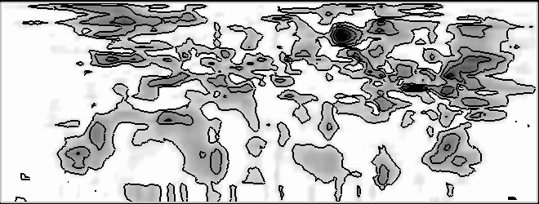
50-
K
lev

25-

1-

50-
K
lev

25-

1-
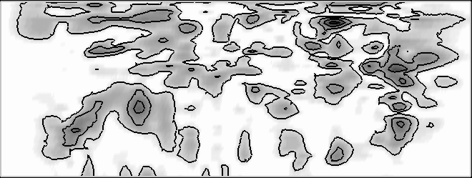

Figure 1. Vertical cross-section (west-east across RUC domain) of magnitude of vector wind (u and v) analysis increment for 1200 UTC 15 Jan 2002 using a) OI analysis, and b) 3DVAR analysis. Contour interval is 2.0 m s⁻¹. Vertical axis is RUC native coordinate level (k), and horizontal orientation is west-east at approximately 40ºN. Figure is used qualitatively only. Discontinuity near k=5 is from use of surface data only through lowest 5 levels in OI analysis and mapping of native levels 1-4 into single level in 56-level 3DVAR solution.

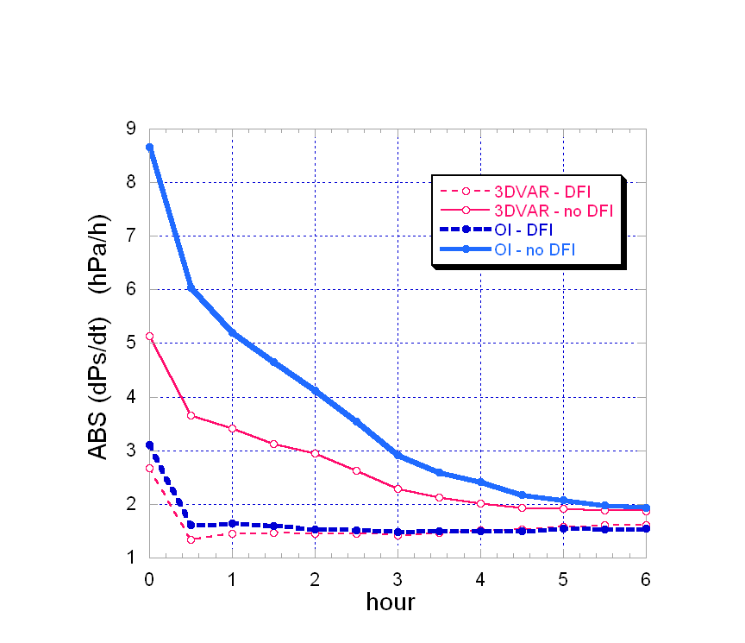

Figure 2. Noise parameter (mean absolute surface pressure tendency) over a single time step (30 s) in RUC model with 3-D variational or optimal interpolation analysis, both with and without application of digital filter initialization (DFI). For case with initial conditions at 1200 UTC 19 November 2002.

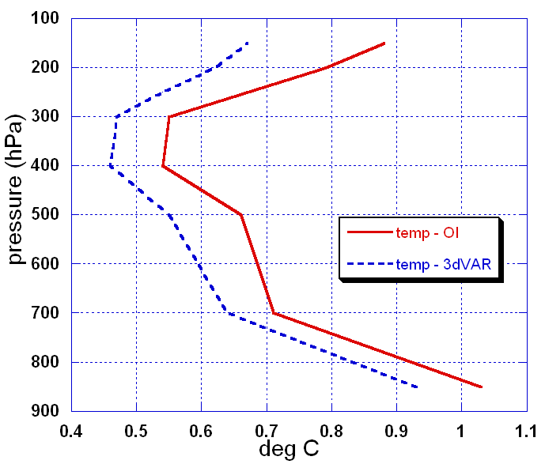
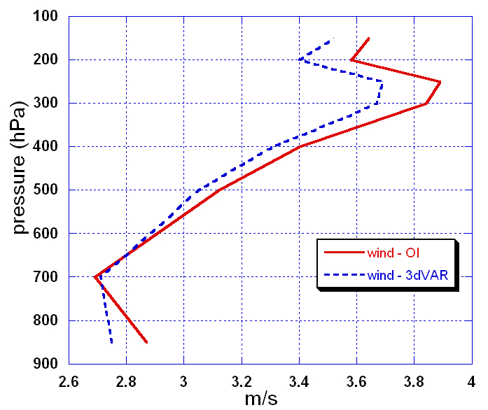

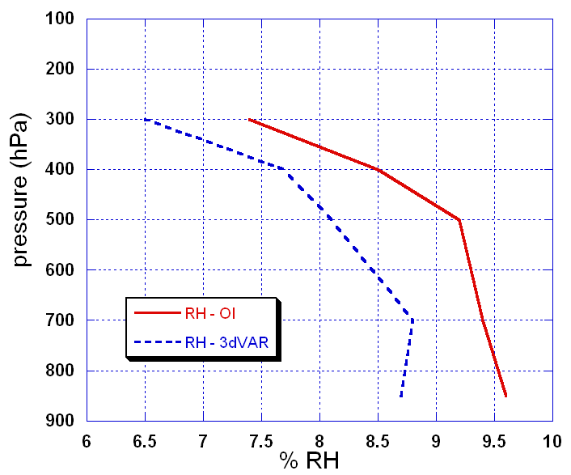
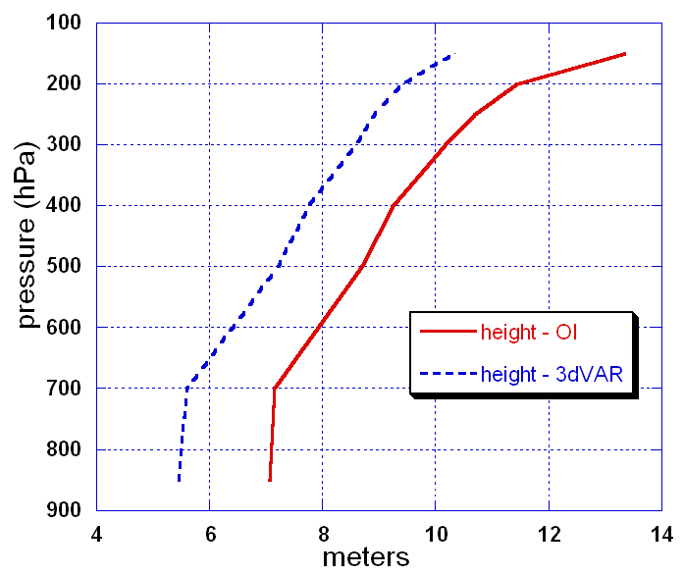

Figure 3. RUC analysis fit to rawinsonde observations for both optimal interpolation and 3-D variational versions for period from 18 Nov 2002 – 14 Jan 2003, using NCEP rawinsonde quality control flags. a) RMS vector difference or standard deviation difference between observations and analyses. a) wind (m s⁻¹), b) height (m), c) temperature (degrees Celsius), d) relative humidity (percent RH). All verification using 40-km gridded data post-processed from the 20-km RUC.

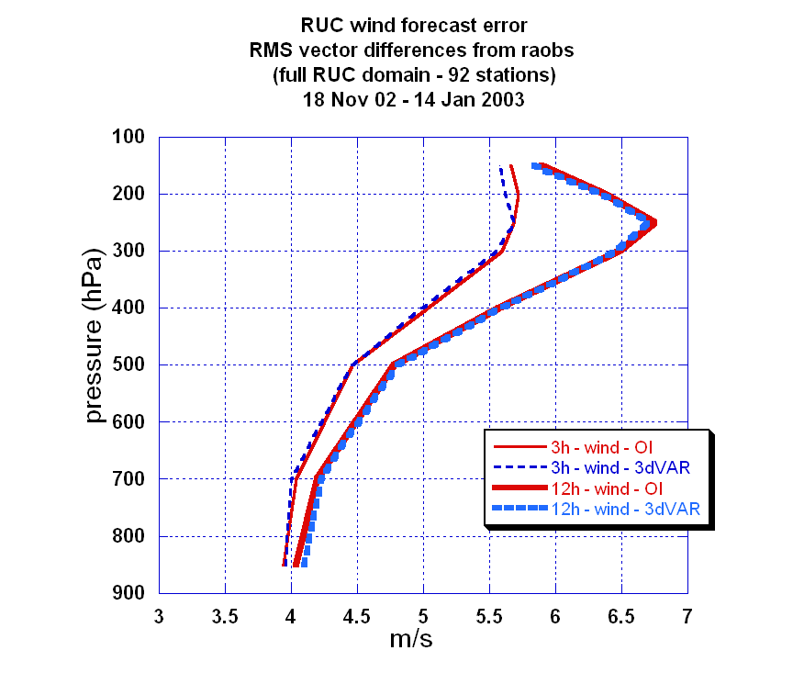

Figure 4. Same as Fig. 3, but for 3-h and 12-h RUC wind forecast errors, also verified against rawinsonde observations.

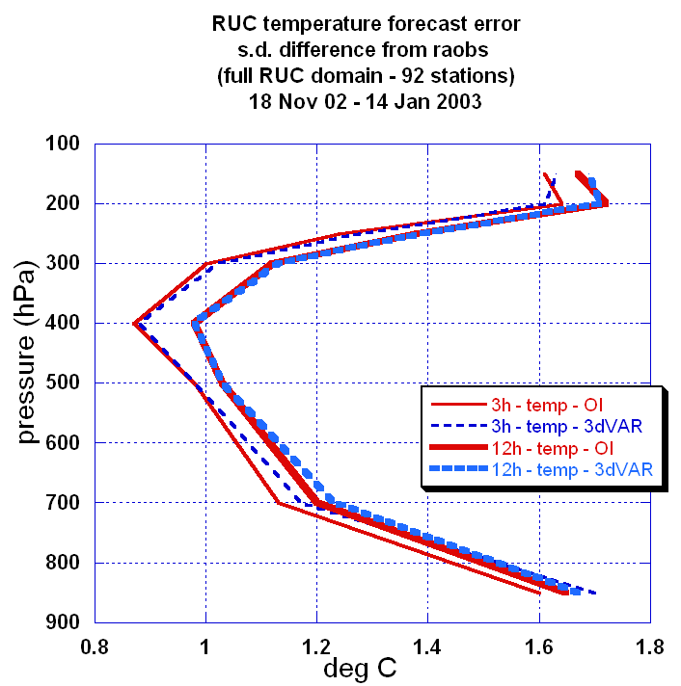

Figure 5. Same as Fig. 4 but for temperature forecasts.

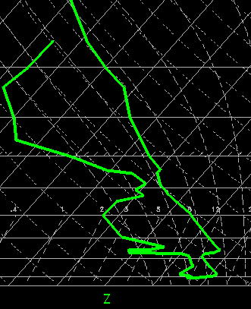
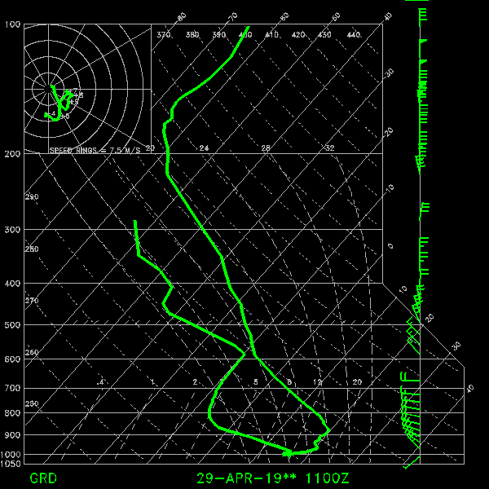
1-h fcst bkg
obs
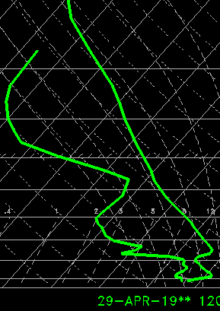
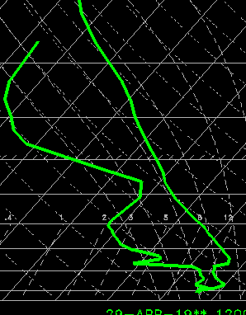
3DVAR
OI

Figure 6. Sounding intercomparison for Shreveport, LA, 1200 UTC 29 April 2003. Top right – RUC 1-h background forecast, top left – observed radiosonde profile, bottom left – RUC OI analysis, and bottom right – RUC 3DVAR analysis. Both OI and 3DVAR analyses used the same background field in this experiment.

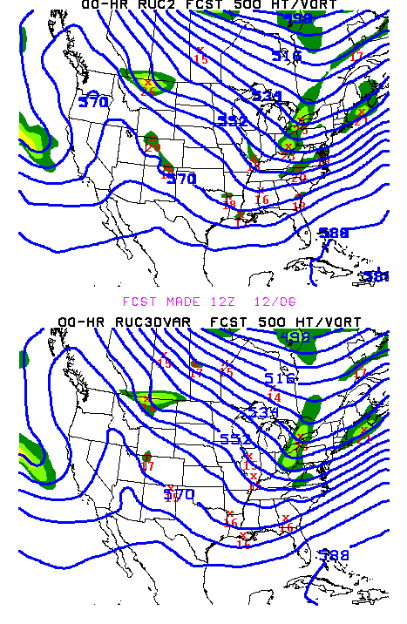
Figure 7. 500-hPa height and vorticity products from RUC OI-operational (top) and RUC 3DVAR cycles from 1200 UTC 6 December 2002. a) analysis, b) 12-h forecast valid 0000 UTC 7 December 2002.

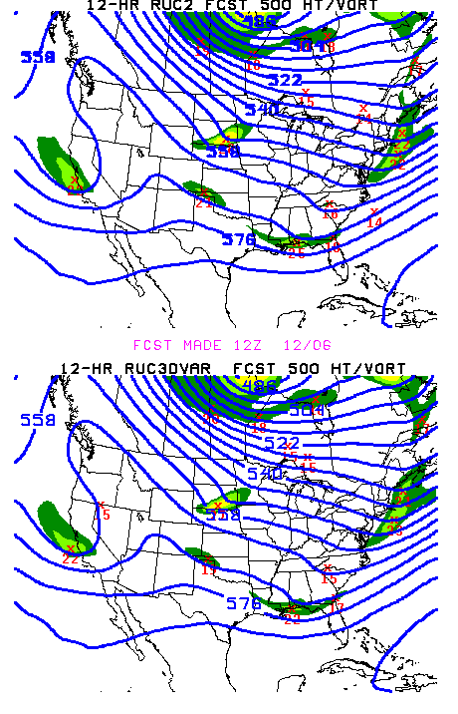

Figure 7b.

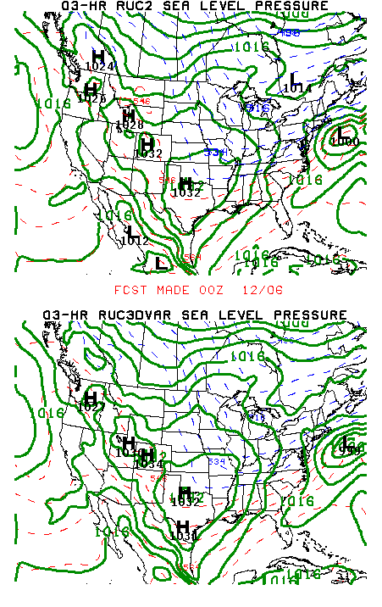
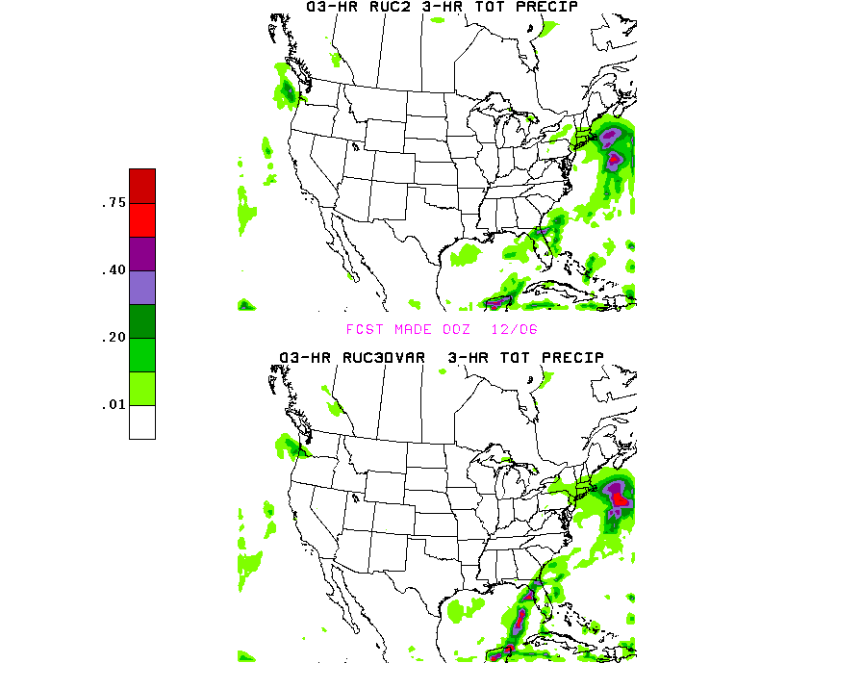

Figure 8. RUC 3-h forecasts of a) sea-level pressure and b) 3-h precipitation from RUC OI-operational (top) and RUC 3DVAR cycles, valid 0300 UTC 6 December 2002.

