Environmental Quality Incentives Program (EQIP)
Clarification for Ranking Template Questions
Updated 10/2/07

Only the conservation practices planned to be installed with EQIP funding will be considered when answering the ranking questions!

The first few screens of the ranking template require the planned land use(s), existing resource concern(s), and planned conservation practice(s) to be identified.

State Issues
NOTE: There are sets of questions within the worksheet that state “…answer “Yes” to only one...” The more elevated the question, the more points associated with the question (i.e., the value of the first question is more than the following questions within the set).

- IF APPLICABLE, ANSWER "YES" TO ONLY ONE QUESTION WITHIN THIS SET! Is the application located within a Rapid Watershed Assessment (RWA) area where the RWA Implementation Plan is being executed?
Figure 1 below identifies RWA Implementation Project Areas (gold).

- IF APPLICABLE, ANSWER "YES" TO ONLY ONE QUESTION WITHIN THIS SET! Is the application located within a RWA area where the assessment is in progress?
Figure 1 below identifies RWA Assessment Project Areas (purple).
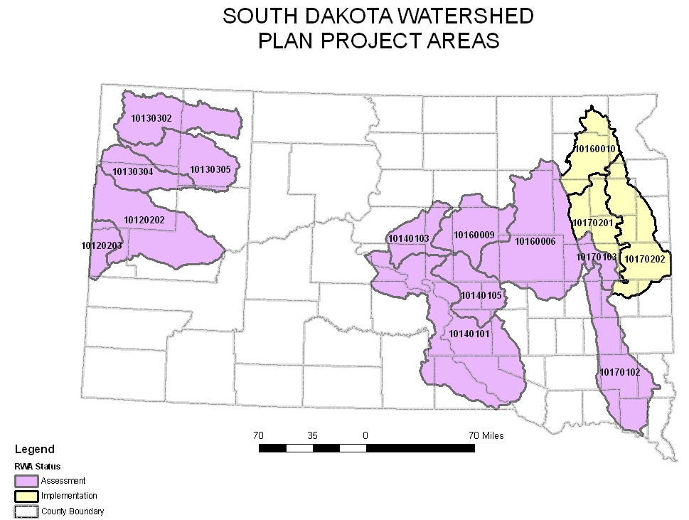
Figure 1.
- Will the contract improve habitat for a federal or state threatened, endangered, or special concern species documented on the application area since 1990? Documentation of consultation with United States Fish and Wildlife Service (USFWS) and/or South Dakota Game, Fish, & Parks (SDGF&P) is attached.
Taking these points will require consultation with a Natural Resources Conservation Service (NRCS) biologist who will assure that documentation is completed and any needed site-specific consultation with USFWS is completed. This must be attached with the application form.
There is documented use by a Threatened and Endangered (T&E) species in the project area or in the immediate vicinity in the Natural Heritage Database. The EQIP project will benefit habitat for the species. Please see database maintained in file 190-14-6 for a list of known sites or consult any NRCS biologist.

- Will the contract improve suitable habitat within the expected range of a federal or state listed threatened, endangered, or special concern species? Documentation of the consultation with USFWS and/or SDGF&P is attached.
Habitat for a particular T&E species is present in the project area and there is a reasonable chance that the species may occur there if surveys or sampling is accomplished, and the EQIP project will benefit the species.

- Will direct livestock access/contact to a lake, stream, or river that is utilized as a domestic drinking water source be eliminated? Document location and why points are taken.
Livestock must have direct access/contact to a lake, stream, or river that is utilized as a domestic drinking water source. The lake, stream, or river does not need to be named; however, the location and why points are being taken must be documented on a planning photo and/or within the assistance notes. If the staff that reviews the ranking feels the water source is not significant, they may require the points be deducted and participant signature obtained again on the Ranking Summary.

- Will at least one conservation practice be installed to address a severe water erosion concern which will improve water quality within the watershed? Must be able to document.
This question is intended to give credit for the treatment of headcuts, classic gullies, etc. Typical conservation practices that would be utilized are Channel Stabilization (584), Grassed Waterway (412), Grade Stabilization Structure (410), or Streambank & Shoreline Protection (580).

- Will the treatment you intend to implement using EQIP result in the restoration of declining or important native pollinator (e.g. solitary and/or ground nesting bees, beetles, butterflies, moths, birds, and bats) habitat?
To properly develop native pollinator habitat, plant selection should be made to ensure at least one species is blooming during the entire growing season. NOTE: Range Technical Note 4, Table 3, will be modified to include a column for “Bloom Period”; however, in the interim, a bulletin is forthcoming with the applicable information. Points can be obtained under either of the following conditions:
  - If wildflowers and/or flowering shrubs are exclusively seeded/planted (separately from a range/grassland seeding), a minimum of at least five acres of wildflower forbs or no more than five percent of any field/tract/site should be planted to pure wildflower forbs; or at least 0.1 acres of flowering shrub planting per site.
  - If the wildflowers are used in conjunction with the native grassland planting, the minimum of five percent of the seeding mixture (five percent times a full seeding rate) must be planted to native forbs.

- Will at least 40 acres of contiguous cropland be converted to a permanent range seeding (550)?
The permanent range seeding must be at least 40 contiguous acres; meet the Range Planting (550) Standards and Specifications; and be on land that was planted to an annual crop the year prior to the EQIP application.
NOTE: Fields with at least a two year history of being strip cropped are the exception to “contiguous”. The cropping history must be verified and the area to be seeded must be at least 40 acres of cropland.

- Will at least 40 acres of contiguous cropland be converted to a seeding of perennial herbaceous cover (512 or 645)?
The permanent seeding must be at least 40 contiguous acres; meet either the 512 Standards and Specifications or 645 Standards and Specifications; and be on land that was planted to an annual crop the year prior to the EQIP application.
NOTE: Fields with at least a two year history of being strip cropped are the exception to “contiguous”. The cropping history must be verified and the area to be seeded must be at least 40 acres of cropland.

- IF APPLICABLE, ANSWER "YES" TO ONLY ONE QUESTION WITHIN THIS SET! If an animal waste system is included in this application, is the proposed animal waste management system for an existing feedlot located less than ¼ mile from the nearest receiving water or over a shallow aquifer? Must document receiving water.
The existing operation must be located less than ¼ mile from the nearest receiving water or over a shallow aquifer. Please see the definitions.

- IF APPLICABLE, ANSWER "YES" TO ONLY ONE QUESTION WITHIN THIS SET! If an animal waste system is included in this application, is the proposed animal waste management system for an existing feedlot located within ¼ to ½ mile from receiving water? Must document receiving water.
The existing operation must be located within ¼ to ½ mile from the nearest receiving water. Please see the definitions.

- IF APPLICABLE, ANSWER "YES" TO ONLY ONE QUESTION WITHIN THIS SET! If an animal waste system is included in this application, is the proposed animal waste management system for an existing feedlot located within ½ to 1 mile from receiving water? Must document receiving water.
The existing operation must be located within ½ to 1 mile from the nearest receiving water. Please see the definitions.

- IF APPLICABLE, ANSWER "YES" TO ONLY ONE QUESTION WITHIN THIS SET! If an animal waste system is included in this application, is the proposed animal waste management system for an existing feedlot located more than 1 mile from receiving water? Must document receiving water.
The existing operation is located more than 1 mile from receiving water. Please see the definitions.

- IF APPLICABLE, ANSWER "YES" TO ONLY ONE QUESTION WITHIN THIS SET! If an animal waste system is included in this application, has the operation been in existence for at least five years and, if expanding, the animal unit (AU) expansion does not exceed 50 percent or 1,000 AU’s, whichever is greater? Must document on the SD-LTP-49 revised 9/07.
See below for examples of “new” versus “existing”. The existing operation has been in existence for more than five years and is not expanding more than 50 percent or 1,000 AU’s, whichever is greater. Please see the examples directly below question 15 and also in the definitions.

- IF APPLICABLE, ANSWER "YES" TO ONLY ONE QUESTION WITHIN THIS SET! If an animal waste system is included in this application, has the operation been in existence for less than five years, or meets the definition of new due to expansion beyond the 50 percent or 1,000 AU’s, whichever is greater? Must document on the SD-LTP-49 revised 9/07.
See below for examples of “new” versus “existing”. The operation is considered new if the existing operation has not been in existence for at least five years, is new, or is expanding beyond the 50 percent or 1,000 AU’s, whichever is greater. Please see the examples below and the definitions.

EXAMPLES:
  - If the system currently has 999 AU, expansion is planned for 2,000 AU, the system is defined for ranking purposes as “new” because of the expansion beyond 50 percent.
  - If the system currently has 999 AU, expansion is planned for 1,495 AU, the system is defined for ranking purposes as “existing” because the expansion is within the 50 percent allowed.
  - If the system currently has 300 AU, expansion is planned to 1,000 AU, the system is defined for ranking purposes as “existing” because of the expansion is not exceeding the 1,000 AU.
  - If the system currently has 300 AU, expansion is planned to 2,000 AU, the system is defined for ranking purposes as “new” because the expansion is beyond the 1,000 AU.

- If an animal waste management system is included in this application, does the Animal Feeding Operations (AFO) or Comprehensive Animal Feeding Operations (CAFO) have a certified complaint filed with SD DENR? The complaint is considered legitimate if it has been reviewed and certified by a SD DENR official.
SD DENR must have a certified complaint for the AFO or CAFO; however, a copy of the complaint is not required since it can be verified with the SD DENR staff, if necessary.

- If an animal waste management system is included in this application, is the facility classified as an AFO?
The facility does not need a state permit and still be defined as an AFO even after the planned expansion. Please see the definitions of an AFO versus CAFO.

- Will the installation of any system or series of conservation practices protect or improve livestock water quality on grazingland?
The practices that will improve livestock water quality are water well, pipeline, watering facility, and/or fencing out of existing pond/dam. New dams, spring developments, and ponds do not improve water quality but instead concentrate the already available water supply.

- IF APPLICABLE, ANSWER "YES" TO ONLY ONE QUESTION WITHIN THIS SET! Will livestock access to existing and dependable surface water sources (lakes, rivers, streams, ponds, or dams) be reduced or eliminated by installation of a new fence?
The installation of a new fence must reduce or eliminate access to existing and dependable surface water sources which includes lakes, rivers, streams, ponds or dams. Please see the definitions for dependable.
NOTE: This includes a cross fence(s) that will reduce access to the existing and dependable surface water source.

- IF APPLICABLE, ANSWER "YES" TO ONLY ONE QUESTION WITHIN THIS SET! Will livestock access to existing and dependable surface water sources (lakes, rivers, streams, ponds, or dams) be reduced or eliminated by the installation of water facilities, which rely on dependable water or rural water sources?
The installation of water facilities which rely on dependable water or rural water sources will reduce or eliminate livestock access to existing and dependable water sources which includes lakes, rivers, streams, ponds, or dams. The dependable water facility to be installed must be a minimum of 660 feet from an existing and dependable surface water source. This distance is consistent with the National Range and Pasture Handbook, Page 5.2-39. Please see the definitions for dependable.

- IF APPLICABLE, ANSWER "YES" TO ONLY ONE QUESTION WITHIN THIS SET! Will livestock access to existing and dependable surface water sources (lakes, rivers, streams, ponds, or dams) be reduced or eliminated by the development of alternative winter grazing pastures away from riparian areas by installing livestock shelter (fabricated or tree/shrub planting) and winter water?
The installation of livestock shelter and winter water will develop winter grazing pastures away from riparian areas. Please see the definitions for dependable.

- IF APPLICABLE, ANSWER "YES" TO ONLY ONE QUESTION WITHIN THIS SET! Will a new or existing, dependable pond(s) that is being used for livestock water be fenced to control livestock access?
The new or existing, dependable pond that presently is used as a reliable source of water will be fenced to control livestock access.

- Will a cross fence(s) be installed to improve grazing management? Pasture(s) will be developed with nearly equal productivity during the growing season.
Pastures need to be identified on a plan map.

- Did utilization of the previous year’s vegetative growth fall within a level of 50-60 percent of annual production or have an average stubble height of 3-5 inches of the key forage species?
Documentation must be included on the Conservation Planning Data Worksheet (SD-CPA-40), Forage Inventory (SD-CPA-39), assistance notes, or photos as to why points were given.

- IF APPLICABLE, ANSWER "YES" TO ONLY ONE QUESTION WITHIN THIS SET! Will a single herd of livestock be rotated through 5 or more pastures of nearly equal productivity during the growing season? In the case of multiple grazing units, rank the application utilizing the unit with the greatest acreage.
Pastures need to be identified that are in the rotation either on Time Control Grazing Worksheet (SD-CPA-15A) or Planned Grazing System Schedule (SD-CPA-15B), plan map, or assistance notes. Small lots will not count in the rotation (e.g., 4 640-acre sized pastures with one 30-acre pasture).

- IF APPLICABLE, ANSWER "YES" TO ONLY ONE QUESTION WITHIN THIS SET! Will a single herd of livestock be rotated through 2 to 4 pastures of nearly equal productivity during the growing season? In the case of multiple grazing units, rank the application utilizing the unit with the greatest acreage.
Pastures need to be identified that are in the rotation either on SD-CPA-15A or SD-CPA-15B, plan map, or assistance notes. Small lots will not count in the rotation (e.g., 4 640-acre sized pastures with one 30-acre pasture).

- Has the Forage Inventory (SD-CPA-39) been completed, before the date on the application, and is within 20 percent of NRCS suggested stocking rate?
The SD-CPA-39 must have been completed prior to the date on the application, and must also be current enough to be relevant, but not older than 5 years.

- Has the Time Control Grazing Worksheet (SD-CPA-15A) or Planned Grazing System Schedule (SD-CPA-15B) been completed, before the date on the application?
The SD-CPA-15A or SD-CPA-15B must have been completed prior to the date on the application, and must also be current enough to be relevant, but not older than 5 years.

- Has the similarity index been documented on the Determination of Similarity Index (SD-ECS-14) or Conservation Planning Data (SD-CPA-40) at a minimum of one location on rangeland, before the date on the application?
The SD-ECS-14 or SD-CPA-40 must have been completed prior to the date on the application, and must also be current enough to be relevant, but not older than 5 years.

- Has the pasture condition score been documented on the Pasture Condition Index Score Sheet (SD-ECS-15) at a minimum of one location on pastureland, before the date on the application?
The SD-ECS-15 must have been completed prior to the date on the application, and must also be current enough to be relevant, but not older than 5 years.

- Has the trend rating been documented on the Rangeland Similarity Index/Stocking Rate (SD-ECS-13) or Conservation Planning Data (SD-CPA-40) on a minimum of one location on rangeland, before the date on the application?
The SD-ECS-13 or SD-CPA-40 must have been completed prior to the date on the application and must also be current enough to be relevant, but not older than 5 years.

- Will a grassed waterway, terrace, diversion, and/or critical area planting be installed on cropland to control water erosion to "T" or below?
The reduction of water erosion must be documented and included within the case file. NOTE: If one of these practices is a secondary practices associated/required by the primary practices in order to meet the standards and specifications, these points will not be rewarded (e.g., a critical area planting is required when a sediment basin is constructed, a diversion may be required in order to meet the waste storage facility standards and specifications)!

National Priorities
- Will the treatment you intend to implement using EQIP result in considerable reductions of non-point source pollution, such as, nutrients, sediment, pesticides, excess salinity in impaired watersheds consistent with Total Maximum Daily Loads (TMDL) where available as well as the reduction of groundwater contamination or point source contamination from confined animal feeding operations?
The answer will be “NO” if any of the following are the ONLY practices planned in the EQIP application.
- Animal Trails and Walkways (575)
- Dam, Diversion (348)
- Dry Hydrant (432)
- Early Successional Habitat Development/Management (647)
- Fence (382)
- Forest Site Preparation (490)
- Irrigation Canal or Lateral (32)
- Irrigation Field Ditch (388)
- Land Clearing (460)
- Obstruction Removal (500)
- Open Channel (582)
- Pond Sealing or Lining, Compacted Clay Treatment (521D)
- Pumping Plant (533)

Answer “YES” for all other practices planned in the EQIP application.
- Will the treatment you intend to implement using EQIP result in the conservation of a considerable amount of ground or surface water resources?
Answer “YES” if EQIP Ground and Surface Water Application otherwise answer “NO.”
- Will the treatment you intend to implement using EQIP result in a considerable reduction of emissions, such as particulate matter, nitrogen oxides (NOx), volatile organic compounds, and ozone precursors and depleters that contribute to air quality impairment violations of National Ambient Air Quality Standards?
Currently, South Dakota’s only air quality concern is particulate matter (blowing soil particles). Answer “YES” if the following conditions are met and the following practices will be installed under EQIP:
  - Condition 1: The existing cropland field must be eroding (wind erosion only) above “T” before the conservation practice is installed. The documentation will include a SD-CPA-53.
AND
  - Condition 2: Any grass establishment practices (regardless if used for livestock or wildlife) or field windbreak is installed to treat wind erosion.
- Will the treatment you intend to implement using EQIP result in a considerable reduction in soil erosion and sedimentation from unacceptable levels on agricultural land?
Answer “YES” if any conservation practice installed on cropland through EQIP will reduce the risk of erosion and sedimentation.
- Will the treatment you intend to implement using EQIP result in a considerable increase in the promotion of at-risk species habitat conservation?
At-risk species include plant and animal species that are
- Federal listed threatened or endangered, proposed, or candidate species (http://southdakotafieldoffice.fws.gov/endangered_species.htm); or
- State listed threatened or endangered species (http://www.sdgfp.info/Wildlife/Diversity/TES.htm ); or
- State listed rare and special concern species (http://www.sdgfp.info/Wildlife/Diversity/RareAnimal.htm) and (http://www.sdgfp.info/Wildlife/Diversity/rareplant2002.htm ); or
- Sage grouse, for which there are numerous current initiatives to attempt to avoid a federal listing.

To take the points for “a considerable increase in the promotion of at-risk species habitat conservation”, the project must meet the criteria of items 1, 2, and 3 as follows:
- The project site must meet at least one of the following conditions:
a. Be within 1 mile of a known location as recorded in the SD Natural Heritage Database, and the record shall be less than 25 years old; or
b. Include critical habitat for piping plovers (http://mountain-prairie.fws.gov/pipingplover/sdunit1.pdf and http://mountain-prairie.fws.gov/pipingplover/sdunit2new%20plover.pdf); or
c. Provide beneficial impacts to Topeka shiner Priority Stream Zone A (including recently identified stream reaches occupied by Topeka shiners);
d. Greater than 50% of the tract containing the project site shall be within 5 miles of an active, inactive or historic lek site as recorded in the sage grouse lek site data layers that have been made available for field offices involved in the sage grouse initiative.
2. The project must provide beneficial impacts to habitat for the species present.
3. The project, practices and points must be approved by a NRCS biologist, with any needed concurrence from USFWS and/or SDGF&P. The concurrence and project implementation shall be according to the South Dakota Procedures for Threatened, Endangered and Other Special Concern Species as found in Section II of the South Dakota Technical Guide (eFOTG).

Definitions

Animal Feeding Operation (AFO) – Facility that stables, confines, and feeds or maintains livestock in either an open or housed lot for a total of 45 days or more in any 12-month period. The open lot does not sustain crops, vegetation, forage growth, or post-harvest residues in the normal growing season. Two or more AFO’s under common ownership are a single AFO if they adjoin each other (within one mile), or if they use a common area or system for the disposal of manure.
Confined Animal Feeding Operation (CAFO) – A facility with one or more of the following:
- The operation feeds or maintains more than 1,000 Animal Unit (AU).
- Local level of government requires the producer to obtain coverage under this permit; or
- The Secretary designates the feeding operation as a concentrated animal feeding operation considering the following factors:
- The size of the AFO and the amount of manure or processed wastewater reaching waters of the state;
- The location of the AFO in relation to waters of the state;
- The means of conveyance of manure and processes wastewater into waters of the state; and
- The slope, vegetation, rainfall, and other factors affecting the likelihood or frequency of discharge of manure and processed wastewater into waters of the state.
Dependable surface water source – The water source currently provides adequate water during the season of use.
Existing feeding operation – Must have been in operation for at least the last five years and may increase AU capacity up to 1,000 AU’s or 50 percent, whichever is greater.
New feedlot – New system, an expansion of a current system in excess of that described as an existing feedlot, or has been operating less than five years.
Shallow Aquifer – Depth to aquifer material less than 50 feet from the surface. County aquifer information is located in the South Dakota Technical Guide, Section I, Maps, Aquifer Information.
Receiving Water – All water bodies within the boundaries of the state. Includes streams, lakes, ponds, impoundment reservoirs, marshes, watercourses, waterways, or drainage systems.

