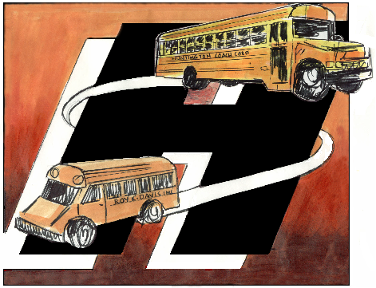
Huntington Coach L.L.C.
Safe, Dependable Transportation
1359 New York Av.
Hunt.Station, NY 11746
Phone (631)271-8931
Fax (631)427-7462

I am writing in support of Docket No. FTA-2008-0044, Notice of Proposed Rulemaking on FTA's School Bus Operations Regulations

I am a business owner on Long Island. My company provides school bus service for 15,000 students in more than 10 school districts. I employ over 350 workers, most of which are school bus drivers. We have been in the school transportation business since 2000.

Huntington Coach L.L.C. fully supports FTA’s proposed revisions to the school bus regulation and its efforts to clarify Congress’s intent. Federal funding for public transportation was never intended to support student transportation. Congress, through its directives to NHTSA and FMCSA, has made it clear that it considers transportation of students a specialized service demanding vehicles constructed to higher safety standards than transit buses and drivers trained to higher safety standards than transit drivers. In addition, Congress recognized that federal funding gives transit grantees an unfair advantage over private school bus operators, an advantage that school districts find hard to resist.

We applaud FTA’s definition of “exclusively” as it refers to school bus operations. For too long transit agencies have run routes to and from school that serve no passengers other than students, but because the agencies claim that they are open to anyone, they are not considered “exclusive” transportation. This is a sham that everyone involved is aware of, and we are pleased that FTA proposes to put an end to it.

We also support the elimination of “tripper service.” The term has become an umbrella to cover any service provided for schools, not just the fare subsidy originally intended. FTA’s proposal to allow exemptions for fare subsidies, additional capacity, and minor route deviations provides transits with the flexibility they need to accommodate students as part of the general riding public.

The proposed “Exception” process for transits that believe there is no private operator able to provide the service is a vast improvement over the current notice requirement. But we do not think that restricting responses to private operators already located in the transit service area is necessary or in the best interests of the school districts. Our company started as one, small operation in Huntington Station, but we have grown because we were able to establish new facilities to serve school districts outside our original community. We now operate in a number of different locations, providing superior transportation at a reasonable rate and in conformance with school bus safety standards. School districts benefit when companies compete; there is no competition if only the local company is eligible to provide the service.

In looking at a potential new service area, however, we would need more than thirty days to determine whether we could establish a viable operation. It generally takes us 90 days to work up a proposal for new service. We recommend that FTA increase the time period for a response from private operators to a Request for an Exception from 30 days to 90 days.

Though we agree with most of the NPRM, we object to the proposal to grandfather indefinitely transit operations where there is no charge to the school district. That proposal is entirely inconsistent with the message FTA sends throughout the NPRM: Congress intended that federally-subsidized transit agencies should not compete with private school bus operators. Private operators certainly can’t compete with free service, so we are hard-pressed to understand how allowing transits to continue operating illegal school bus routes simply because the school district does not directly pay for the service fits into that message. This grandfather clause, in fact, is in direct conflict with the rest of the NPRM and with the statute, and should be deleted.

In closing, we would like to make one further point. Transit agencies that take over school bus routes formerly operated by the school district engage in school bus operations the same as if they had taken over routes formerly operated by private companies. The service is no different; but instead of displacing private operators, they simply bypass private operators. Under the proposed rule, transits must apply for an Exception to provide that service. But there are many examples of this kind of school bus operation occurring now where the transits contend that because no private operator was involved, the service is legitimate. We dispute that assertion, and appreciate FTA’s efforts to restrain this activity through the proposed rule.

Thank you for giving us the opportunity to comment on the proposal. If you have any questions, please contact me.

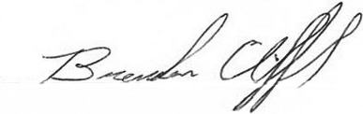
Sincerely,

Brendan Clifford
Vice President

