PUMPING PLANT
PRACTICE INTRODUCTION

USDA, Natural Resources Conservation Service–Practice Code 382

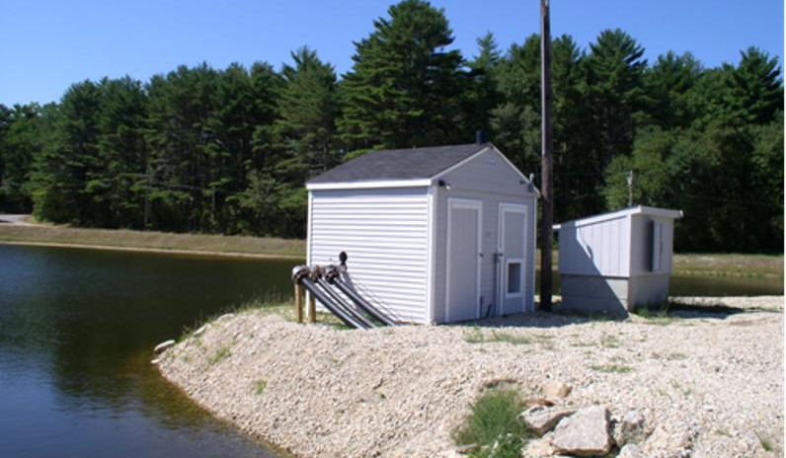

PUMPING PLANT
A Pumping plant is a facility installed to transfer water for a conservation need.
PRACTICE INFORMATION
Pumping plants provide a dependable water source or disposal facility for water management. This practice applies wherever water must be pumped to accomplish a conservation objective, which may include but is not limited to:
- Water supply for irrigation, recreation, livestock, or wildlife
- Maintenance of critical water levels in swamps, marshes, open water, or for newly constructed wetlands and ponds
- Transfer of wastewater for utilization as part of a waste management system
- Facilitation of drainage by the removal of surface runoff or ground water
COMMON ASSOCIATED PRACTICES
Pumping Plant is commonly used in a Conservation Management System with Irrigation Water Conveyance (428), Irrigation System (441, 442, 443, 447), Pipeline (516), Watering Facility (614), Waste Transfer (634).
For further information, refer to the practice standard in the local Field Office Technical Guide and associated specifications and job sheets.

Pumping Plant (533)
Initial setting: Where water transfer is needed to meet a conservation need
I.5 (+/-) Wetland and aquatic wildlife habitat
1. Pumping station with a power unit
I.6 (+) Surface or ground water use
D.4 (+) Energy use
D.5 (+) Noise
D.2 (+) Waste transfer
I.7 (-) Water availability for other competing human uses (recreation, water supply, hydropower, etc.)
I.10 (+) Public nuisance
I.8 (+/-) Greenhouse gases
I.2 (+) Plant vigor, crop production, livestock health and production
C.2 (+/-) Populations of aquatic and wetland wildlife
I.9 (+/-) Air quality of the airshed
3 (+/-) Human health and welfare (individuals and community)
Irrigation Water Management (449)
Waste Utilization (633)
D.1 (+) Cost of installation, operation, and maintenance
I.3 (+) Potential income
I.1 (+/-) Net return
I.4 (+) Flood control
Nutrient Management (590)
Alternative energy sources
Proper design, maintenance and in-field adjustment
Start
Note: Effects are qualified with a plus (+) or minus (-). These symbols indicate only an increase (+) or a decrease (-) in the effect upon the resource, not whether the effect is beneficial or adverse.

Pumping Plant 4/2007
C.1 (+/-) Income and income stability (individuals and community)
D.3 (+) Water transfer to meet a conservation need
LEGEND
#. Created by practice
D. Direct effect
I. Indirect effect
C. Cumulative effect
Pathway
(+) increase; (-) decrease
Mitigating practice
Associated practice

