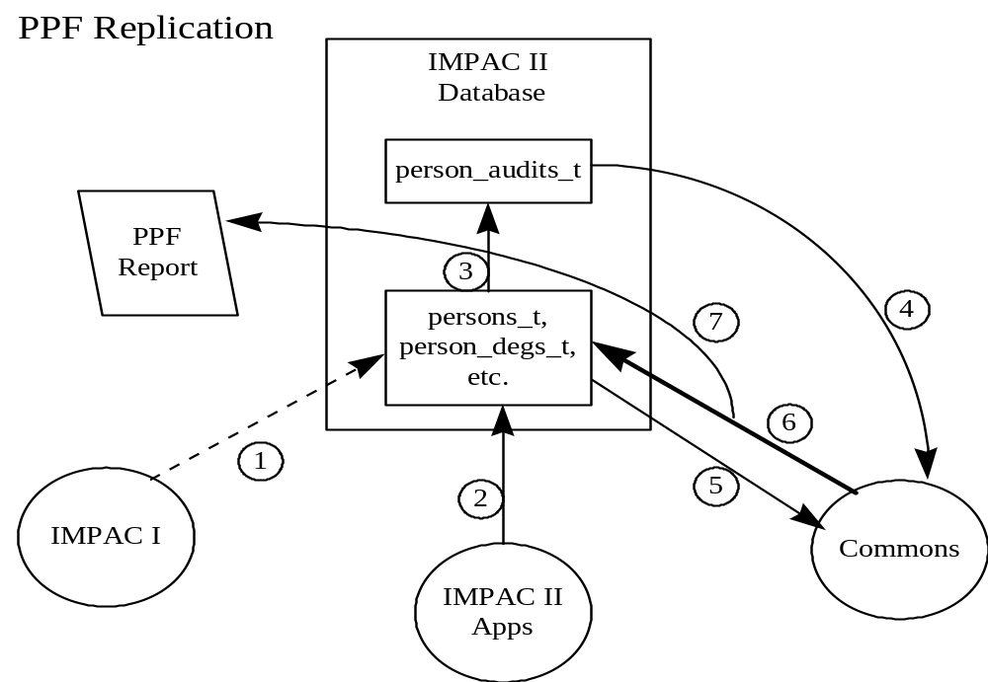

The diagram above represents the PPF specific replication data flow. Note that updating IMPAC I (flow 8 on the generic diagram) is not necessary for PPF as there is no centralized person profile concept in IMPAC II (person information is only present in IMPAC I in conjunction with a grant). The specific steps in a PPF replication are detailed below:
- IMPAC I updates are applied to a profile by the forward bridge. As mentioned above, there is no concept of a centralized person profile in IMPAC I. However, grant specific person information received from IMPAC I is used by the forward bridge to maintain the centralized profile in IMPAC II. It is important to note that IMPAC I information will only be used to update a profile if that profile has not been processed by the Commons. Once a profile has been processed by the Commons, no IMPAC I updates will be applied. For this reason the flow is shown as a dashed line on this diagram.
- IMPAC II applications are free at all times to update the person profile information. These updates will be made by the Person System, a common module shared by all IMPAC II applications. It is important to note, however, that profile changes made by IMPAC II can be overwritten by the Commons as explained in flow 6 below.
- All updates to person information (by IMPAC II applications and the Commons) will be recorded in the person_audits_t table by database triggers on the person tables.
- The Commons will poll the person_audits_t table to detect changes to person information in IMPAC II. In addition to a periodic poll, the Commons will also check for changes immediately prior to allowing a user to update the profile.
- Upon detecting changes in IMPAC II, the Commons will copy the most recent person profile from IMPAC II to the Commons.
- After the Commons user has completed their changes, the entire profile (not just the updates) will be copied to IMPAC II using the replication functions. It is important to note here that from when the Commons user begins the update process to when they release the update to IMPAC II, the Commons will not process further IMPAC II changes recorded in the audit table. This means that, assuming the Commons user does not cancel their update, when the Commons update is applied to IMPAC II it will overwrite any updates which may have been made by IMPAC II while the update was in process in the Commons. For this reason the flow is bolded on this diagram. The expected duration of the update process in the Commons is limited to one user session.
- When a PPF submission is complete, the replication functions will generate a PPF submission text document which serves as an immutable version of the submission. In addition to generating this document, the replication functions will make a copy of the person profile received in an ERA role record.

