Uncertainty and the “Sharpness” of the Performance Assessment Tool for Repository Performance Assessments Over
Increasingly Longer Time Periods
September 26, 2008

I Introduction

Performance assessment is the primary tool for making dose projections for the Yucca Mountain disposal system. An important consideration in using performance assessment (PA) analyses to evaluate the projected performance of a geologic disposal system is the role of uncertainties in framing the analyses and interpreting the results. This is particularly true for deep geologic disposal, because these assessments cover extraordinary time frames (many tens to hundreds of thousands of years) compared to other regulatory efforts. Performance assessment is the only tool available to make these long term dose projections, and the limitations of the tool should be understood if meaningful interpretations of the results are to be made. Understanding the uncertainties in the performance assessment tool is also important for framing performance standards for any disposal system in question.

Many comments on the EPA 2005 proposed standards for Yucca Mountain addressed the connection between uncertainties in making dose projections, the rationales for selecting a peak dose limit and other aspects of the rulemaking for the Yucca Mountain standards. The intent of this document is to examine available information and present analyses that will provide some insight on how various kinds of uncertainty, discussed further below, affect the level of confidence that can be placed on performance assessment results as reasonable projections of expected performance. The particular emphasis in this paper is the question of the effects of various uncertainties over time (tens to hundreds of thousands of years) in terms of the “sharpness” of the PA tool, as the term is used here, and its ability to meaningfully distinguish between alternative descriptions of disposal system performance and the associated dose projection histories.

This document is intended to support our Yucca Mountain standard setting effort by: (1) examining how various uncertainties in performance assessments over the geologic stability period influence dose projections and, (2) developing an understanding of these uncertainties and how they contribute to formulating the standard. This paper will present information we have gathered and analyses we have performed to understand the “sharpness” of the performance assessment tool in making long-term dose projections for the disposal system and, address some of the concerns articulated in the comments we received on the proposed standards, as well as to respond to the issues raised. The analyses we have performed have led us to the conclusion that any peak dose limit choice in the low hundreds of mrem/yr. will constrain the disposal system to keep releases minimal for many tens to hundreds of thousands of years. The choice of a peak dose limit of 100 mrem/yr in the final standards, the low end of the range mentioned above, is a challenging limit in that it constrains the disposal system to limit doses to very low levels for long periods of time in order to meet the peak dose limit within the geologic stability period. We also discuss the spatial and temporal uncertainties in the important processes and parameters responsible for the timing and magnitude of the peak dose, i.e., the “driver” parameters, and illustrate through our analyses that these uncertainties generally increase over time for the Yucca Mountain disposal system, in contrast to the thesis proposed in some comments on the proposed standards.

The terms precision and accuracy are commonly used to describe measurements and calculations, rather than the term “sharpness”. For performance assessments, precision can be thought of as how close multiple calculations agree, while accuracy refers to how well the results simulate actual performance. The accuracy of performance assessment calculations is not possible to verify because of the long time periods simulated, and is a matter of professional judgment about how well the conceptual model developed for the assessments is believed to simulate the disposal system’s expected characteristics and operation. For the purpose of the discussions here, the term “sharpness” will be used as a more general term which combines both the concepts of precision and accuracy, but focuses on the ability of performance assessments to distinguish between alternative conceptualizations of the disposal system. For developing a standard and making regulatory decisions against an established standard, the ability of performance assessments to meaningfully distinguish between alternative descriptions of disposal system performance is an important question, when these alternative descriptions result in different dose histories or entail differing degrees of confidence that the conceptualizations are truly the best representations of the system. Performance assessment is a tool for making analyses that provide important input to decision making. This question of “sharpness” in the analytical tool is also important in making compliance decisions against a fixed numerical standard. If the “uncertainty” band (discussed more extensively below) around a set of analyses is large and overlaps the standard, it may be difficult to confidently determine if the disposal system performs well enough to demonstrate compliance with the standard. How well the tool can distinguish between alternatives, in light of the uncertainties inherent in making assessments, is a fundamental question bearing on the use of the tool in formulating a standard and subsequent regulatory decision making. Some conclusions about the “sharpness” of the PA tool, and its application to standard setting and regulatory decisions, are also presented based upon these analyses.

The reader is assumed to have some familiarity with the process of performance assessment as applied to deep geologic disposal, i.e., to have a basic understanding of how performance assessment models are constructed and exercised. Extensive descriptions and discussions of performance assessment as applied to projecting dose histories for the Yucca Mountain disposal system are presented in other documents (DOE 1998, CRWMS M&O, 2000, BSC, 2001a, DOE 2002) that can be consulted for background information on the PA technology, as well as a more in depth study of the subject as applied to the Yucca Mountain repository site and repository design. It should also be noted that the use of the term “peak dose” in this document refers to the maximum dose delivered to the RMEI when the engineered barriers have degraded. For most of the past disposal system assessments performed by DOE for the Yucca Mountain site, this peak dose occurs within the period of geologic stability (1 million years). From a regulatory standpoint, the peak dose is regarded as the highest dose calculated during the course of the compliance period. For some more recent performance assessments published by DOE, the peak dose, as used in the discussions in this document (the maximum dose produced by the degraded engineered barrier) occurs beyond the end of the geologic stability period, and the regulatory usage of the term should be kept in mind when considering discussion of peak dose in reference to those cases.

II Types of Uncertainty

For the purposes of this paper, uncertainties of two types will be discussed and examined. These two categories are not distinctly separate in that some uncertainties concerning the characterization of the processes expected to be operative in the disposal system, and the modeling of the total system performance, can be considered to have elements of both categories. A definitive treatment of all the uncertainties involved in site characterization and numerical techniques for performance modeling is beyond the scope of this paper. The two categories to be discussed here are aleatoric and epistemic uncertainties. In practice, the treatment of uncertainties in a specific application may combine these two types of uncertainty, sometimes in ways that may make it difficult to separate effects due to randomness and those due to less than a definitive understanding of the system under consideration.

Aleatoric uncertainties, within the context of this paper, refer to uncertainties arising from randomness – more specifically the uncertainty resulting from the randomized selection of parameter values from the distributions of parameter values included in a particular performance assessment model being exercised. These uncertainties could be more simply described as “data” uncertainties. However, the term aleatoric will be used to avoid confusion with calculational errors such as rounding errors, numerical convergence errors, etc., that are inevitably present in complex numerical calculations, and sampling frequency and spatial variations and analytical errors that are inherent in doing laboratory analyses or field tests to generate data from which the parameter distributions are eventually developed. Aleatoric uncertainty in a particular conceptual model being used in a performance assessment can be reduced by increasing the number of calculations done. In practice for large complex numerical models, a compromise is struck between the number of calculations done and the reduction in this type of uncertainty.

Epistemic uncertainties in contrast refer to uncertainties resulting from the less than complete understanding of how the complex interactive processes involved in geologic disposal will operate quantitatively over the performance period. More simply put, epistemic uncertainties refer to how well we know the system being modeled and how confident we can be in its mathematical representation. Here again, a simpler term such as “model” uncertainties can be used, but the generalized term has differing connotations, some of which include aspects of the aleatoric uncertainties mentioned above. We will use the more formal term to avoid potential confusion, as defined above, remembering that it refers to uncertainties in knowledge of the processes involved in disposal system performance and the consequent possible variations in the conceptualizations of the system for modeling. Epistemic uncertainties can be reduced by more extensive efforts to study the processes anticipated to operate, but at some point these efforts can reach a point of diminishing returns, i.e., the remaining uncertainty cannot be removed, or argued to be sufficiently understood that no additional effort is warranted to meet the objectives of the task – demonstrating acceptable performance of the disposal system.

Often, optimization exercises are done with performance assessment codes to examine the comparative effects of either improving the data base for various components of the disposal system or design changes in the engineered components. For example, if engineering design changes produce a more dramatic effect on projected dose histories than that produced by additional extensive characterizations of the ground-water flow system in the natural barrier, the disposal system designers may elect to change the design elements rather than expend additional resources for field studies. Uncertainties involved in these optimization studies factor into the design choices and also into the question of carrying the design and performance projections into a regulatory compliance decision process. Chapter 3 of the EPA economic impact assessment for the 2001 Yucca Mountain standards (EPA, 2001), discusses the use of performance assessments in the evolution of the Yucca Mountain repository engineered barrier design.

In summary, it is not possible to know everything definitively, nor is it absolutely necessary, to adequately execute the goal of establishing acceptable confidence in the assessment of disposal system performance, i.e., deciding “how much is enough” and when do we decide the task is finished. This goal involves both the applicant as well as the regulator. Each must determine when enough information has been gathered and analyses performed to make confident representations of the disposal system performance. While these concerns are not directly relevant to the standard setting effort before EPA, understanding the uncertainties in making long-term dose projections for the Yucca Mountain disposal system is important in formulating a standard that can be clearly and convincingly implemented in a licensing process. This paper will address the aspects of uncertainty in site performance and how they impact our standard setting effort.

Making the decision about “how much is enough” for regulatory decisions is the purview of the Nuclear Regulatory Commission and exercised within the licensing process. For our standard setting task, an understanding of the uncertainties and how they play into the performance assessments provides a necessary insight for the Agency, so that a standard can be crafted that will be a reasonable test of the disposal system’s performance, and one that can be clearly implemented in a licensing process. Without an understanding of the uncertainties in projecting dose histories over the exceptionally long time periods involved, we could easily formulate the standards in ways that would not allow them to be implemented clearly. For example, if a requirement in the standards were stated in terms of either/or measures for compliance (i.e., satisfy one measure or the other for the requirement depending on which is more restrictive), but the uncertainties were such that the tool (performance assessments) used to examine the two alternative measures could not distinguish between them meaningfully, the standard requirement would not be implementable in a meaningful way.

III NAS Perspectives on Uncertainties Over the Post-Closure Performance Period

The Energy Policy Act of 1992 (EnPA) directed the Agency to develop a standard for public health and safety specifically for the Yucca Mountain candidate repository site. The EnPA also directed that the Agency to contract with the National Academy of Sciences (NAS) to prepare advice on the technical bases for the Yucca Mountain standards and directed that the standards be “based upon and consistent” with the NAS recommendations. The National Academy of Sciences report (NAS 1995), providing recommendations on standards for the Yucca Mountain site, discusses uncertainties in terms of spatial and temporal uncertainties (NAS, pgs. 70-81).

The Committee believed that spatial uncertainties would always be present in the disposal system, and that these uncertainties could be addressed adequately by studies of the present conditions at the site, and the assumption that the site is “geologically stable”. An example of these types of uncertainties would include those in characterizing the ground-water flow system in and around the repository from localized hydrologic testing in the field, i.e., going from measurements at discrete places to developing flow models for areas of many square kilometers in heterogeneous rock masses. This particular uncertainty is inherent in any hydrologic field characterization effort, and would be present whether the effort is being done today or at some point far into the future. As a practical matter, characterization studies must always come to a point where a professional judgment is made about “how much is enough” in terms of field and laboratory testing to adequately characterize the site for the task at hand. Inherent in that decision is a level of uncertainty about the natural variations in the site captured by the characterization activities. We agree with the NAS characterization of spatial uncertainties in that sense. However, there is also a time element in these uncertainties concerning spatial characterization, as discussed in more detail below, for processes that are important in determining the timing and magnitude of the peak dose. A geologically stable site should not be considered immutable over time frames of hundreds of thousands of years, in terms of its physical characteristics. While the NAS characterized the Yucca Mountain setting as being geologically stable for period a “on the order of a million years” (NAS Report pp. 2, 9, 68-69), this should not be understood as meaning no changes in its characteristics are possible. Stability simply means that the processes currently active in and around the site are anticipated to continue at their current rate for the foreseeable future (“on the order of a million years”) and are believed to be boundable by site characterization studies. The continued operation of these processes may, over long time periods, alter conditions around the site that could affect performance to some degree. Such changes are also anticipated to be incorporated into the development of parameter value distributions derived from field studies and used in performance assessment models. These parameter distributions are, in fact, called probability distribution functions, connoting that a probability estimate based on measurements and other considerations is incorporated into the parameter value variations within the distributions. Therefore, some degree of uncertainty is inherent in these parameter value distributions because the actual cumulative extent of slow changes to the site’s characteristics over these extended time periods cannot be predicted with certainty. This uncertainty is epistemic in nature since it concerns the limitations of how well we can know and simulate the details of the disposal system. We cannot be completely sure that site conditions measured today will be exactly the same if they were measured hundreds of thousands of years in the future (i.e., the uncertainty in field measurements). Out of necessity, field studies sample only a limited portion of the three-dimensional volume of the natural barrier, and therefore, there is a degree of randomness in the sampling locations, although they are selected on the basis of professional judgment with the intent of generating representative parameter values. These are the sampling uncertainties mentioned above in the definition of aleatoric uncertainties in that there is a degree of randomness involved in selecting locations for field measurements.

The uncertainties in using field information in developing hydrologic models of the ground-water flow field can also be considered epistemic in nature since these measurements may be such that alternate conceptual models of the flow processes could be consistent with the available field evidence, or alternative conceptualizations of the disposal system might require alternative parameter characterizations.

In terms of temporal uncertainties, the NAS committee expected that in general uncertainties would increase over time (NAS Report Chapter 3). The committee reasoned that some sources of uncertainty may well decrease, making the task of projecting total system performance easier because of their removal. The example used was the eventual failure of the waste package containment (well within the stability period), which would remove uncertainties in modeling radionuclide releases from the engineered barrier in the repository when that performance is complicated by the complex coupled effects of the thermal period as the repository heats up and then cools down as a function of the decay of short half-life radionuclides. When all the packages have failed, all the packages could be assumed to be contacted by ground water and releasing radionuclides for transport. There would be little need to incorporate progressive failures of the packages in the very long-term dose projections, with all the attendant uncertainties in deriving such model inputs (e.g., differing corrosion rates and mechanisms operative under the various thermal states in the repository, coupled thermal, mechanical and chemical processes during the thermal pulse early in the repository’s post-closure history).

As one would intuitively suspect, failure of the waste packages is a major “driver” of disposal system performance, and the predicted performance of the metal waste package components to corrosive failure will have a dominating effect on the magnitude and timing of the peak dose, as illustrated by modeling results presented here. Modeling the progressive failure of waste packages, and the engineered barrier system in general over time, is additionally complicated by the thermal pulse during the early portion of the post-closure period, where higher temperatures are present from the decay of short half-life fission products in the wastes. Modeling the disposal system after the thermal pulse has passed is easier in some respects since the complex coupled interactions driven by temperature excursion would not be part of the model. However, although the modeling problem could be considered simpler in some respects after the thermal pulse, the thermal pulse has the potential to change physical and chemical conditions in and around the underground facility. These changes have the potential to significantly alter the behavior of the system (SC&A, 2005, Chapter 11). For example, the thermal pulse may cause significant movement of pore waters in the host rock in response to the heat, causing possible precipitation of minerals in fractures around the emplacement drifts which could then affect the movement of pore waters back into the drifts after the thermal pulse ends and then their outward movement into the natural barrier after interacting with the waste packages and the materials in the emplacement drifts. These changes can affect the flow rates and amounts of ground water that could enter and leave the emplacement drifts and contact the waste packages, which in turn can affect release rates. Modeling the post-thermal pulse behavior of the repository after complete waste package failure has occurred would appear to be a simpler problem. However the difficultly of predicting the characteristics of the disposal system around the repository from the effects of the thermal pulse and waste package failure adds additional areas of speculative assumptions that must be addressed in the modeling. The actual uncertainties and their effects are not as simple as they might appear from a limited look at the disposal system. Additional discussion on some of these issues will be presented below in Section V). Lengthier discussion of the uncertainties involved in modeling the engineered and natural barriers for the disposal system are discussed in another document supporting the rulemaking (SC&A, 2005).

IV Aleatoric Uncertainties in Yucca Mountain Performance Assessments

Numerous performance assessments for the Yucca Mountain disposal system have been performed and reported in the literature. The process of performing the assessments with a complex performance model is called Total System Performance Assessment (TSPA). For these assessments, the simulation model is exercised repeatedly. Each calculation, or “realization”, represents a possible “future” charting the dose received by the defined receptor (the Reasonably Maximally Exposed Individual, the RMEI) over the time frame of the modeling exercise. For the case at hand, this would be a 1 million year geologic period over which the peak dose is to be calculated for regulatory compliance. This section of the paper will examine the nature of this types of uncertainty in performance assessments and implications for regulatory decision making and standard setting.

The models used to simulate disposal system performance are complex and contain many hundreds of variable parameters. For each realization, a set of parameter values is chosen from the distribution of possible values (the probability density functions - pdfs) developed through the site characterization activities and incorporated into the performance model. Consequently the possible combinations of values for all the parameters that can be chosen for the “realizations” can number into the many millions. From practical considerations, only a much smaller number of realizations are calculated, typically numbering in the hundreds, since the calculations are lengthy and time consuming. Statistically based sampling techniques are used to select values with the intention of generating a “representative” group of realizations. Once completed, a dose versus time curve of each realization (a dose history for a particular set of parameter values) is prepared. These diagrams are often called “horse hair” plots. A performance measure is calculated, such as the mean or median of the dose estimates at each time step, using the data from many realizations, and plotted along the time line. The calculations are repeated with new sets of realizations and plotted the same way until a “stable” measure is observed (i.e., a relatively unchanging result is obtained – as defined by the analyst, e.g., no more than 10% variation in the calculated performance measure of interest, for example the mean of results at each time step for the individual realizations ). While the performance measure chosen (such as the mean, i.e., the average) may become stable across many sets of realizations, there is variation within each set of realizations. For example, one set of realizations may contain high and low end doses that another set may not, but the mean value may be the same as another set of realizations that does not have counterbalancing high and low end numbers. While mathematically equivalent in terms of the mean value, these different sets of realizations may represent physically different conceptualizations of the disposal system performance, with differing uncertainties attached and consequent levels of confidence that they are more or less realistic or defensible representations of the disposal system’s performance (i.e., the confidence we may have in one conceptualization versus another may differ significantly although mathematically they are indistinguishable).

Since each set of realizations is only a small fraction of all the possible combinations of parameter values and the PA calculations are repeated until a measure of stability is observed, in this context the aleatoric uncertainty refers to how well any separate set of realizations can be distinguished from another set. This question becomes important when considering alternative conceptualizations of the disposal system performance as mentioned above. If alternative conceptualizations cannot be statistically distinguished from each other, the regulatory compliance decision is made more difficult in that the confidence that we understand the system performance is lessened. Although different conceptualizations may not be statistically separable, there may be significant differences in the confidence that can be placed in one conceptualization versus another, as truly representing the likely performance as well as identifying uncertainties that might significantly affect performance projections. Distinguishing between alternative sets of realizations is also an issue when comparing sets of realizations from the same calculational model and comparing the results against a fixed numerical standard, such as a mean dose limit. For example, if a given performance assessment yields a mean peak dose estimate of 85 mrem/yr. but the aleatoric uncertainty for that assessment is ± 10 mrem/yr., (at a fixed level of statistical confidence, e.g.., 95% typically) another dose distribution (a different set of realizations) calculated with the same model and showing a mean peak dose of 91 mrem/yr. would be considered statistically indistinguishable from the first at that confidence limit. If the means of these two distributions are well below the regulatory standard, there is little concern in that both conceptual alternatives meet the standard. If the means of the two distributions straddle the regulatory limit the compliance decision is more complicated in that some decision must be made about the relative confidence of one conceptualization over another. For a case like this, additional model development and assessments make resolve the difficulty.

To examine the nature of aleatoric uncertainties in some Yucca Mountain performance projections, two sets of model results were examined from two different models for disposal system performance. The first is taken from the Department of Energy (DOE) Final Environmental Impact Statement (FEIS) for the Yucca Mountain site (DOE, 2002), and the second model is the DOE Peak Dose Model (PDM) (EPA-HQ-OAR-2005-0083-0352). We obtained data from DOE for the performance assessment results presented in the FEIS. Those data are included in the Yucca Mountain docket entry containing this document. The DOE Peak Dose Model was developed to examine uncertainties in the peak dose calculations for the repository, and was submitted by the DOE as part of its comment package on the EPA proposed standards for Yucca Mountain, as referenced above. The results of the analyses we performed to examine aleatoric uncertainties in these two models is discussed more fully in Appendix A.

The analyses examined the arithmetic means for different numbers of realizations produced by both of the models. The FEIS data set was for 300 realizations of the large site model, a TSPA performance model used for the FEIS analyses. The DOE PDM was exercised to produce a set of 300 realizations and a larger set of 1000 realizations from which the arithmetic mean and other calculations were done. Table 1 shows the result of these calculations (discussed more fully in Appendix 1). The two sample Student t-test was used to determine bounds of uncertainty around the estimated mean for each set of realizations). Results of these statistical analyses can be interpreted as follows. For the DOE PDM set of 1,000 realizations (n=1000 in Table 1), the upper and lower bounds indicate that, at the 95% confidence level, the mean of another equivalent set of realizations, e.g., if another set of 1000 realizations with the DOE PDM were calculated, the second set of realizations would not be interpreted as significantly different than the mean of the first set unless the mean of the second set fell outside the bounds shown in the Table 1. This result illustrates the level of aleatoric uncertainty (that due only to the random sampling of the parameter distributions in the model) in any given set of realizations. This uncertainty is present in any set of realizations produced, but will vary in magnitude depending on the number of realizations in the sample set and the distribution of the actual realizations. When the DOE PDM was exercised at 300 realizations (n=300 in Table 1) the bounds were observed to be considerably wider around a higher peak dose. These variations are to be expected, since the number of realizations sampled in the analyses is only a small fraction of all the possible combinations of possible parameter values. If enough realizations were done, the results would converge on the true mean for the population of all possible combinations and aleatoric uncertainty would be minimal. Increasing the number of realizations usually will decrease the uncertainty of the estimated mean, as measured by the standard error of the mean, which may increase or decrease before stability is reached. In practice, the number of realizations performed with large PA codes is a compromise between efficiency and confidence building in the model’s output. Doing large numbers of realizations easily consumes large blocks of time. If the results of various “runs” (sets of realizations) of equivalent size do not show results significantly different, a professional judgment may be made that no new insights into the system performance would be obtained by ever increasing larger runs of the model.

The results in Table 1 for the FEIS results are based on 300 realizations. The uncertainty range for this model is ± 45 mrem/yr., approximately one-third of the mean. In exercising the FEIS model, the number of realizations was determined by obtaining a “stable” mean, i.e., one that did not move significantly after a certain number of realizations were included (with 300 realizations the mean was observed not to differ significantly with the addition of more realizations). The FEIS model is a larger and more comprehensive model than the DOE PDM, (which is a simplified site performance model), and may have the effect of damping down the variations shown in the simpler DOE PDM, which was developed to assess the impacts of the major “driver” parameters affecting peak dose. The larger changes in the mean for the DOE PDM may well reflect the effects of driver parameters not otherwise constrained by all the other parameters contained in the larger FEIS model.

While the results of these two model exercises are illustrative of the nature of the aleatoric uncertainty, the results should not be directly transferred to another model. For another model, more specifically a model DOE will use for the performance assessments submitted for the licensing process, the magnitude of the aleatoric uncertainty will be different, varying as a function of the number of realizations needed to observe a “stable” mean and the inherent characteristics of the model itself (the details of the processes included in the model and the specific pdfs used in the model). However it is interesting that the FEIS analyses, which were done using a complex total system performance model, carried an aleatoric uncertainty around the mean that is a significant percentage of the estimated mean dose. The larger the aleatoric uncertainty in a given model results, the more likely an alternate conceptual models of the disposal system performance may be statistically indistinguishable from the given model results.

Table 1. Comparison of 2-Sample Student t-test Results for Three Sets of Model Calculations
Model Run | Peak Mean Dose  (mrem/yr) | Year of Peak Dose | Standard Deviation  (mrem/yr) | Lower Bound  (mrem/yr) | Upper Bound  (mrem/yr) | Range  (mrem/yr)
DOE PDM  (n=1000) | 125 | 730,000 | 300 | 99 | 151 | 52
DOE PDM  (n=300) | 160 | 835,000 | 438 | 90 | 230 | 140
FEIS  (n=300) | 152.5 | 476,000 | 290.6 | 106 | 199 | 93

There is an intersection of both aleatoric and epistemic uncertainty involved in the example discussed above. The large model used in the DOE TSPA analyses combines a number of alternative conceptualizations for some the operative processes in the disposal system. While it is considered a single model for the purposes of the examination above, the model is actually a combination of alternative conceptualizations of various processes involved in the total system performance. For example, corrosion of the waste packages is a function of the mechanisms that operate under various physical and chemical conditions. Knowledge of the exact corrosion rates for the various possible mechanisms operating over the lifetime of the disposal system may be lacking for any number of reasons. To simulate the effects of these various mechanisms, the parameter distributions used in the model may be an amalgamation of estimates for the individual processes based on the expert judgment of the modelers. To represent the different mechanisms the corrosion rate variations compiled from laboratory testing would be expanded to simulate the possible effects of the lesser know processes. The corrosion rates chosen for each realization may then be reflective of different corrosion mechanisms rather than a single mechanism consistently used for all the realizations. Similar bounding type approaches to developing parameter value distributions are used for radionuclide solubility in ground waters in the emplacement drifts, radionuclide sorption coefficients in the natural barrier, hydrologic parameters describing the flow field, etc. This combination of alternate conceptualizations in a single model must be understood to avoid erroneous comparisons of different models.

Some conclusions about aleatoric uncertainties in performance assessments can be formulated from the analyses described above. Aleatoric uncertainties can be a significant portion of the calculated dose for assessments with a limited number of realizations, in the examples examined above 30 percent for different dose models were observed. Since separate sets of assessments using the same conceptual/calculational model are of equal statistical validity (they are both equally defensible projections of performance from which a mean value can be calculated), it would be difficult to make a regulatory compliance decision if the two sets of realizations straddle the regulatory marker. In such case, additional numbers of realizations could be done to reduce the uncertainty and make a compliance decision less difficult. Performing additional sets of realizations for large performance models is time consuming and typically sets of realizations are performed and compared to examine the “stability” of the calculated mean doses. A professional judgment may be required to determine when increasing the number of realizations no longer results in a meaningful reduction in the aleatoric uncertainty. There may remain a minimal level of aleatoric uncertainty judged by regulatory authorities to be sufficient for the purpose of compliance decisions. This decision rests with the compliance decision makers and is a function of the specific performance model involved in the applicant’s safety assessment.

For the purpose of our standard setting, aleatoric uncertainty in performance assessments is not a major determinant in evaluating the implementability of particular dose limits, because additional realizations can be performed to lower it. Observing that aleatoric uncertainty in assessments using a large site performance model can be a relatively high proportion of the peak dose (as noted above), it is not unreasonable to conclude that for a two-tiered standard the tiered dose limits should be sufficiently separated that aleatoric uncertainties do not cloud the compliance evaluation for either marker. In the case of the Yucca Mountain standard, this would suggest that a separation of 10-20 mrem/yr would be a reasonable adjustment to minimize the potential for aleatoric uncertainty alone to cloud the compliance decision. It must be stressed that setting the actual standard is a decision on the protectiveness of the respective dose limits and not predicated on an assumption of any particular level of aleatoric uncertainty in the performance assessments, which in fact cannot be determined a priori.

Moving from the consideration of aleatoric uncertainty, a more important area of uncertainty relative to standard setting and regulatory decision making are the epistemic uncertainties – those arising from how well we understand and can confidently quantify the expected behavior of the disposal system over the compliance period. These uncertainties are discussed below. Many of the comments on the proposed standards addressed this topic, i.e., the proposition that uncertainties in modeling site performance increase with time over the geologic stability period.

V Epistemic Uncertainties in Yucca Mountain Performance Assessments

Epistemic uncertainties, those concerning our understanding of the disposal system’s anticipated performance, are the most important source of uncertainty in disposal system performance projections. This section will examine these kinds of uncertainties for the Yucca Mountain disposal system. Results from our modeling efforts will be discussed in terms of the effects of the assumptions about the processes used in the modeling the disposal system and their inherent uncertainties spatially and temporally. The confidence we have in understanding the processes that will operate over the compliance period is key to establishing confidence that the disposal system will perform satisfactorily and meet the requirements in the standard. Understanding these uncertainties is also important in setting performance standards in that a standard must be capable of implementation for successful regulatory decision making. An extensive discussion of the epistemic uncertainties in modeling the Yucca Mountain disposal system and assumptions used in DOE modeling can be found in SC&A 2005. Many of the comments received on the 2005 proposed standards (referenced in the introduction to this document) concerned the nature of these uncertainties and their variation over time. The treatment below addresses these comments, and describes the insights we gained through our modeling of the disposal system.

V-1a Modeling Approach for Uncertainty Analyses

Our modeling focused on uncertainties involved the use to two site models that are closely related. In response to requests for comment on the 2005 draft of the Yucca Mountain standards (EPA 2005), DOE submitted a Yucca Mountain site model designed to examine the behavior of driver parameters contributing to the peak dose. This model, referred to here as the DOE PDM, is a smaller scale model in contrast to the larger TSPA models used in previous disposal system performance assessments performed by DOE. We used this model to explore alternative conceptualizations of the processes operative in the disposal system, the results of which are described and discussed below. For the second model, the Agency modified the DOE PDM and used it (referred to as the EPA Uncertainty Model in SC&A, 2006) to examine the effects of uncertainties in the natural barrier performance for a hypothetical disposal system. As part of the Agency’s Quality Assurance process supporting the studies reported in SC&A 2006, the DOE PDM was reviewed for its capabilities to model the disposal system and found adequate for that purpose (SC&A, 2007). The DOE PDM model proved useful in examining the relative performance of alternative conceptual models for the disposal system, as discussed below.

V-1b Modeling Uncertainties – Results and Discussion of Uncertainties

For the purposes of the analyses reported here, the DOE PDM was used as submitted to the Agency without any additional modifications. The DOE PDM (DOE, 2005) offers a useful tool for examining the epistemic uncertainties involved in assessing peak doses from the disposal system. The DOE PDM has a useful feature for examining the impact of some epistemic uncertainties on peak dose calculations. A number of “switches” (Checkboxes) are built into the model, which allows various components of the model to be changed, effectively examining alternate conceptualizations of the system. This is an important point for interpreting the results presented here. Each of the Checkboxes in the DOE PDM should be regarded as allowing an alternative conceptualization of the disposal system performance. By examining the results of various combinations, it is possible to see the effects of uncertainties arising from these alternatives, i.e., to the extent to which we “know” how the system could operate over the very long-term.

To establish a baseline, the DOE PDM was run initially with no checkbox selections. This base case model forecasts a peak mean dose of 125 mrem/yr at 730,000 years. The 1,000 realizations span the range of results shown in Figure 1. Using this model as the baseline, a series of one-off sensitivity scenarios was conducted using of the checkbox controls (provided on the model “Dashboard” `feature).

The checkbox scenarios programmed into the model include:

A. Deterministic Infiltration Scenarios
1. Deterministic Infiltration Rate: Low Infiltration
2. Deterministic Infiltration Rate: Medium Infiltration
3. Deterministic Infiltration Rate: High Infiltration

B. Corrosion Scenarios
4. Full General Corrosion Rate Temperature Dependence for WPs
5. Waste Package (WP) General Corrosion Rates Increased by a Factor of 5
6. Drip Shield (DS) General Corrosion Rates Increased by a Factor of 5
7. WP and DS General Corrosion Rates Increased by a Factor of 5

C. Other Uncertain Parameters/Conceptual Models
8. Secondary Phase Neptunium Solubility Control;
9. Non Collapsed Drift Seepage Conditions
10. Saturated Zone Transport Pathway Length Set Equal to 0
11. Drip Shield Performs No Function
12. Pu-242 Biosphere Dose Conversion Factor (BDCF) by +20%

The sensitivity scenarios include three deterministic long-term average infiltration cases: Low, Medium and High. In the base case model, the infiltration case for each realization is selected randomly from these three alternatives with probabilities 0.24, 0.41, and 0.35, respectively. In the infiltration sensitivity scenarios, the case selected with the checkbox is used in all realizations.

Four scenarios address the general corrosion rate of the waste package (WP) and drip shields (DS). These include increasing the WP general corrosion rate by a factor of 5, increasing the DS general corrosion rate by a factor of 5, increasing both WP and DS general corrosion rate by a factor of 5, and using the full temperature dependence general corrosion model rather than assuming that the dependence of corrosion rate on temperature is limited to a maximum of 45 º C.

Five additional sensitivity scenarios were examined: non collapsed drifts, complete removal of drip shield functionality, setting the length of the transport pathway in the saturated zone (SZ) to zero, using secondary phase neptunium solubility controls, and varying the Pu-242 Biological Dose Conversion Factor (BDCF) by +20%. In this study, all but two sensitivity runs from the list above were run using a single checkbox selection. One run (#7 in Table 2) was conducted using two checkbox selections. This scenario is only one of the many possible checkbox scenarios that could be created using multiple checkbox selections. The first eleven scenarios are discussed in the PDM report (OCRWM 2005). The Pu-242 scenario was not included in the PDM report. The scenario was implemented manually by adding a multiplicative factor of 1.2 in the BDCF table entry for Pu-242 in the DOE PDM. The Pu-242 sensitivity scenario was added since this radionuclide is a major contributor to long-term doses.

The DOE PDM was run initially with no checkbox selections to establish a baseline (#0 in Table 2). This base case model forecasts a peak mean dose of 125 mrem/yr at 730,000 years. The 1,000 realizations span the range of results shown in Figure 1. Using this model as the baseline, a series of one-off sensitivity scenarios was conducted using of the checkbox controls provided on the model Dashboard (see DOE 2005 for a description of the Dashboard feature of the DOE PDM).

The mean annual dose projections from the set of three infiltration cases are compared with the base case forecast in Figure 2. The low infiltration rate scenario has a peak dose of 84 mrem/yr at 870,000 years, while the high infiltration rate scenario has a peak dose almost twice as high, 162 mrem/yr at 690,000 years. As expected, these values bound the peaks for the medium infiltration scenario and the base case.

The mean annual dose estimates from the four general corrosion rate sensitivity scenarios are compared with the base case in Figure 3. The two sensitivity scenarios which include increasing the WP general corrosion rate by a factor of 5 have earlier and large peak doses mainly due to the release of Pu-239. Figure 4a shows the mean annual dose by radionuclide for the scenario with the WP general corrosion rate multiplied by a factor of 5. This may be compared with the same plot for the base case in Figure 4b. In the base case and in all other sensitivity scenarios, this nuclide has essentially decayed away before the waste packages begin failing. The full-temperature-dependence sensitivity scenario (Table 2, ID #5, Figures 3, 6 and 7) rises to a peak dose of 3 mrem/yr at 1,000,000 years, the end of the time period covered by the model. A higher peak dose occurs after this time. The Supplemental Environmental Impact Statement (SEIS) recently published by DOE (DOE, 2008) used the assumption of full temperature dependence for the waste package corrosion rates and calculated that only 10% of the waste packages were breached by general corrosion within the 1 million year geologic stability period, illustrating a consistent with the DOE PDM. Doses projections for this scenario in the SEIS show a mean value of approximately 2 mrem/yr. at 1 million years.

Mean annual dose estimates from the five additional sensitivity scenarios are compared with the base case in Figure 5a, and in a zoom view in Figure 5b. Based on examination of Figure 5a, the most significant change in the magnitude of the peak dose occurs for the Saturated Zone (SZ) Transport Pathway Length set to 0 scenario with the highest peak dose estimate of all scenarios examined in the study at 2,497 mrem/yr. In this scenario, the lack of actinide retention in the saturated alluvium leads to relatively large doses occurring at approximately the same time as the peak in the base case, near 750,000 years. This scenario has no direct physical meaning in reality since the saturated zone cannot be eliminated from the disposal system. However it provides two useful insights into the functioning of the disposal system. The dose level can be regarded as approaching an upper limit for the doses that could possibly come from the system, in that the results represent a complete failure of the saturated zone to provide any retardation. For this scenario essentially the leachate from the failed waste packages is delivered directly to the biosphere pathway for the dose projections to the RMEI. This is of course an impossible situation, but illustrates the contribution of the natural barrier to the disposal system performance. The second insight from this scenario comes from comparison of the high dose to the base case result (125 mrem/yr.). The difference is an indication of the magnitude (semi-quantitative due to the simplifications and assumptions in the DOE PDM) of the contribution of the natural barrier to total system performance, illustrating that the natural barrier plays a very significant role in reducing doses. These results also illustrate that epistemic uncertainties concerning the retardation capabilities of the natural barrier can have dramatic effects on the timing and magnitude of the dose projections. This bounding, but unrealistic scenario, can also serve as a measure against which to compare the effects of uncertainties contained in other scenarios as they affect dose projections.

All twelve sensitivity scenarios are compared with the base case using a logarithmic vertical scale in Figure 6a. The most significant changes from the base case in the timing of the peak mean dose occur for the three WP general corrosion rate sensitivity scenarios (#’s 4, 5, & 11 in Table 2) – WP Rate times 5, WP and DS Rate times 5, and the Full Temperature Dependence scenarios. Increasing the WP general corrosion rate by a factor of 5 leads to initial WP failures at times that are approximately a factor of 5 earlier, resulting in higher, earlier peak doses than in the base case. Reduced corrosion rates are encountered in the Full General Corrosion Temperature Dependence scenario in the later years when the repository has cooled. The reduced corrosion rates lead to a distribution of initial failure times with only a few WP failures occurring before the end of the 1,000,000-year time frame used in the current model. It must be remembered that the DOE PDM uses an abbreviated travel path, and therefore the times for peak dose to the RMEI are artificial and of relevance only in comparing the results of various variations within the model. They do not indicate the actual time to peak dose projections for the site models used in the past to simulate actual site performance.

A summary of the results of the analysis is shown in Table 2. The results include the peak mean dose, the year it occurs, and selected percentiles of the distribution of annual dose estimates from each of the 1,000 realizations at the time of the peak. In most cases, the peak dose occurs during the time period before all the waste packages have failed. This is the reason for the 5th percentiles values of 0 for all scenarios and the 25th percentiles values of 0 for almost all scenarios. The sole exception is the multiple checkbox scenario with WP and DS corrosion rates increased by a factor of 5. The ratio of the 95th percentile to the 50th percentile provides one measure of the spread of the realizations at the time of peak dose. The spread ratios range from a low of 11 to a high of 250 for the non-collapsed drifts scenario. The geometric mean of the spread ratios is 51. The final column of Table 2 shows the ratio of the peak mean dose to the 75th percentile. These ratios are generally near 1, indicating that the peak mean dose often is near the 75th percentile of the realizations.

The peak mean doses in Table 2 are shown in a bar graph in Figure 7. Omitting the dramatically low full-temperature-dependence scenario which has a higher peak after 1 million years, the next lowest peak dose estimate in Table 2 (non-collapsed drifts) is a factor of 3.4 lower than the Base Case peak dose of 125 mrem/yr. Omitting the extreme SZ Transport Length 0 scenario, the next highest peak dose estimate (WP and DS corrosion rates times 5) is a factor of 6.1 higher than the base case.

A log normal distribution was fit to the 11 middle peak mean dose estimates shown in Table 2, with a geometric mean (GM) of about 145, and a standard deviation (GSD) of 2.44. The upper limit of the corresponding 95% confidence interval would b 834, or about 5.75 times greater than the GM, and about 5.75 ² = 33 times greater than the lower limit. This is reasonably consistent with the “central” base case peak dose of 125 mrem/yr. and the approximate range of values as suggested by inspection of Table 2. In summary, peak dose estimates in the DOE PDM may range higher or lower by a factor of 5 to 6 from the 125 mrem/yr. base case peak dose as a result of reasonable one-off variations in modeling assumptions and parameters. The effect of simultaneous variation of two or more sensitivity scenario parameters is expected to generate a broader range of peak dose estimates, depending on whether the effects of the assumptions compound or compensate for each other. These results are specific to the assumptions and alternatives included in the DOE PDM. The DOE PDM does not consider all possible alternative assumptions that can be made in a total system performance model. A discussion of additional possibilities, and how uncertainties in the disposal system’s behavior and evolution over long time frames, is presented below.

Another approach to characterizing and quantifying the variability of the mean dose estimates is to average the mean dose functions shown in Figure 2 at each time to construct an ensemble mean for the scenarios examined. An estimate of the uncertainty of the ensemble mean was derived based on the standard deviation of the 13 forecasts at each time. A plot of the ensemble mean and fits 75% confidence interval is shown in Figure 9. The peak of the ensemble mean annual dose is 290 mrem/yr at 685,000 years. The lower and upper bounds of the 75% confidence interval for the ensemble mean ranges from 159 to 422 mrem/yr at this time. The “Remove DS Function” scenario was not included in the data for this plot due to the close similarity with the DS Rate time 5 scenario results seen in Figure 7 and Table 2. Inclusion of both would over-weight the drip shield scenarios.

It can be seen from the two statistical treatments of the sensitivity scenarios analyzed that there is considerable spread in the mean dose estimates across the scenarios examined, even with some scenarios excluded because of their large deviations from the rest. Except for the scenario excluding the saturated zone, all the scenarios are reasonable assumptions about possible behavior of the disposal system. The spread of mean dose projections can vary over a range of several hundreds of mrem/yr. It should be borne in mind that the DOE PDM was developed to examine the sensitivity of the peak dose to the driver variables included in the model, and not as a tool for examining the performance of the disposal system in detail. The larger total system models used for that purpose will produce different results because more parameters and more of the detail of the operative processes are built into these models. It is possible that the more complex model may show less spread in the mean estimates because other processes, or a more rigorous treatment of the same processes, may attenuate the effects, producing less variation in the means. It is also possible that a more complex model may contain synergistic effects not modeled in the DOE PDM which could increase or decrease mean dose variations to some degree A further discussion of uncertainties over time is presented below.

Table 2. Peak Mean Dose and Selected Percentiles in Year of Peak Dose for Base Case and 12 Alternative Scenarios
ID | One-Off Scenario | Peak Mean Dose (mrem/y) | Year of Peak Dose | 5th  (mrem/y) | 25th  (mrem/y) | 50th  (mrem/y) | 75th  (mrem/y) | 95th  (mrem/y) | Ratio  95th/50th | Ratio  Mean/75th
0 | Base Case | 125 | 730,000 | 0 | 0 | 5 | 126 | 570 | 121 | 1.0
1 | Low Infiltration Case | 84 | 870,000 | 0 | 0 | 31 | 104 | 339 | 11 | 0.8
2 | Medium Infiltration Case | 136 | 690,000 | 0 | 0 | 0 | 124 | 639 | - | 1.1
3 | High Infiltration Case | 162 | 690,000 | 0 | 0 | 0 | 151 | 770 | - | 1.1
4 | WP Corrosion Rate times 5 | 253 | 225,000 | 0 | 0 | 0 | 130 | 1,144 | - | 1.9
5 | Full Temperature Dependence (FTD) | 3^{(a)} | 1,000,000 | 0 | 0 | 0 | 0 | 0 | - | -
6 | DS Corrosion Rate times 5 | 151 | 690,000 | 0 | 0 | 7 | 156 | 664 | 92 | 1.0
7 | Remove DS Functionality | 154 | 690,000 | 0 | 0 | 8 | 157 | 674 | 80 | 1.0
8 | 2nd Phase Np Solubility Control | 111 | 865,000 | 0 | 0 | 36 | 126 | 484 | 14 | 0.9
9 | SZ Transport Length Set to 0 | 2,497 | 775,000 | 0 | 0 | 288 | 2,719 | 11,139 | 39 | 0.9
10 | Non Collapsed Drifts (NCD) | 37 | 860,000 | 0 | 0 | 0.7 | 28 | 183 | 250 | 1.3
11 | WP & DS Corrosion Ratex5 | 768 | 180,000 | 0 | 0.1 | 106 | 486 | 3,819 | 36 | 1.6
12 | Vary Pu242 BDCF +20% | 138 | 730,000 | 0 | 0 | 5 | 140 | 648 | 133 | 1.0
(a) A higher peak is reached after the end of the one-million-year timeframe used in the current model.

Table 3. Peak Mean Dose and Selected Percentiles in Year of Peak Dose for 4 Combined Scenarios

ID | Combined Scenario | Peak Mean Dose (mrem/y) | Year of Peak Dose | 5th  (mrem/y) | 25th  (mrem/y) | 50th  (mrem/y) | 75th  (mrem/y) | 95th  (mrem/y) | Ratio  95th/50th | Ratio  Mean/75th
1 | NCD & WP Corrosion Ratex5 | 55 | 420,000 | 0 | 0 | 0.2 | 31 | 283 | 1,415 | 1.8
2 | NCD & WP+DS Corrosion Ratesx5 | 118 | 190,000 | 0 | 0 | 1.5 | 34 | 401 | 267 | 0.3
3 | FTD & WP Corrosion Ratex5 | 209 | 390,000 | 0 | 0 | 5 | 198 | 1,052 | 210 | 0.9
4 | FTD & WP+DS Corrosion Ratesx5 | 304 | 390,000 | 0 | 11 | 108 | 347 | 1,216 | 11 | 0.9

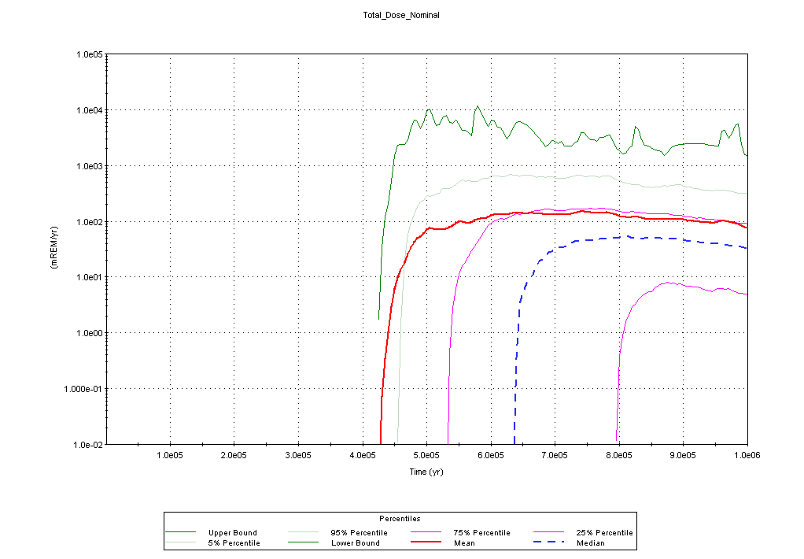

Figure 1. Mean and Percentiles of Base Case Annual Dose Forecasts
(Peak mean dose is 125 mrem/yr at 730,000 yr)

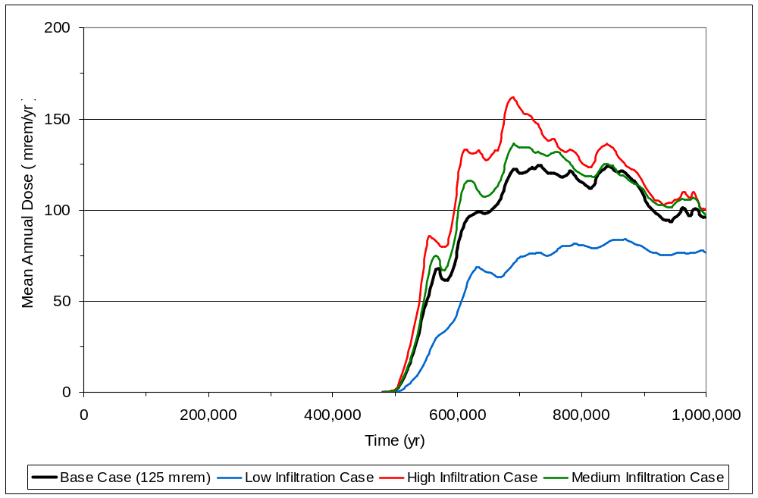

Figure 2. Mean Annual Dose, Base Case and Three Infiltration Rate Scenarios

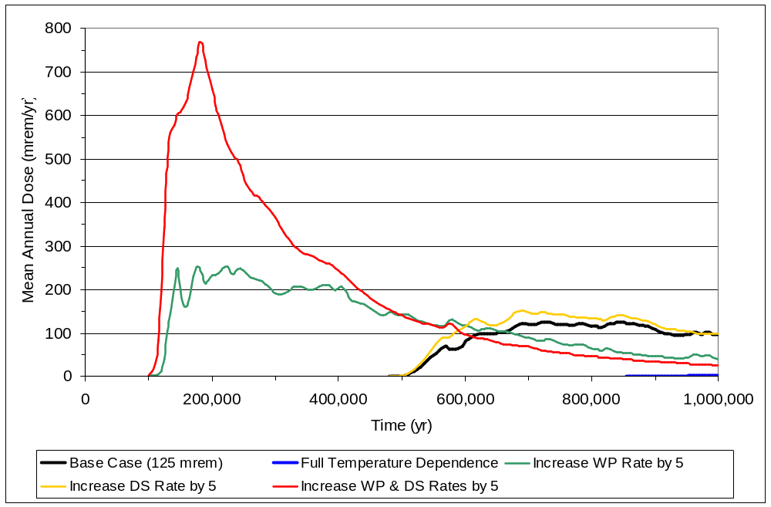

Figure 3. Mean Annual Dose, Base Case and Four General Corrosion Rate Sensitivity Scenarios

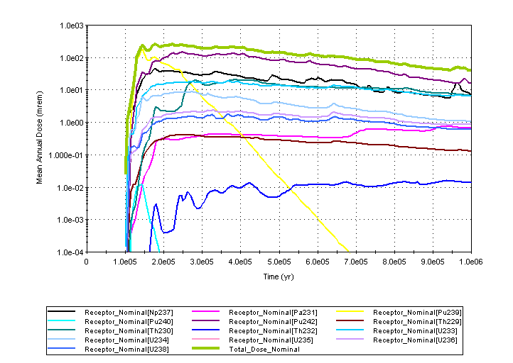

Figure 4a. Mean Annual Dose by Radionuclide for the Increase WP General Corrosion Rate by a Factor of 5 Sensitivity Scenario

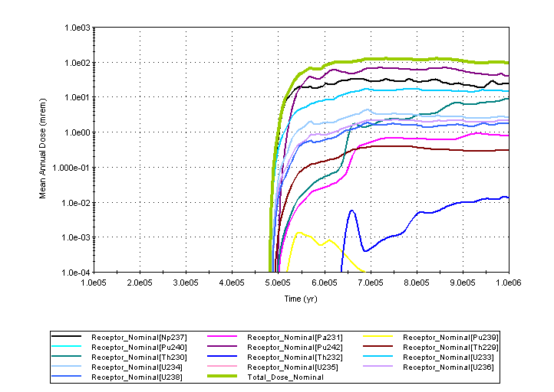

Figure 4b. Mean Annual Dose by Radionuclide for the Base Case Scenario

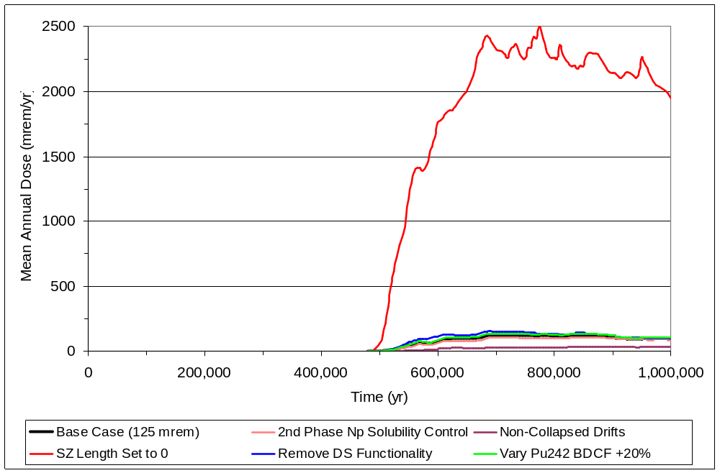

Figure 5a. Mean Annual Dose, Base Case and Five Uncertain Parameter Sensitivity Scenarios

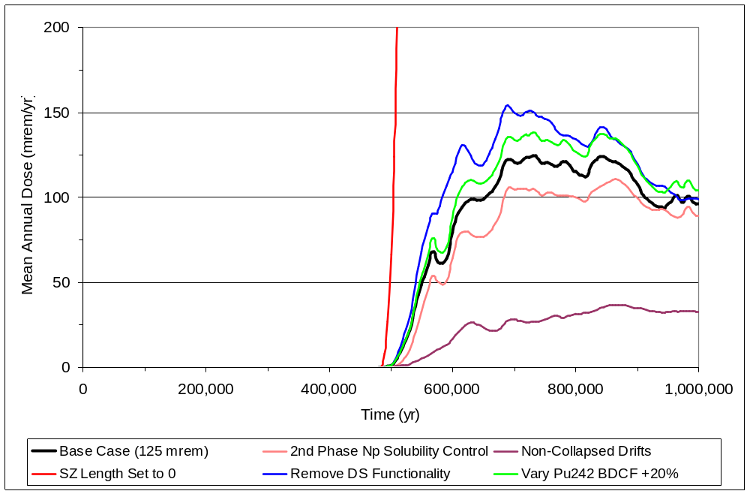

Figure 5b. Mean Annual Dose, Base Case and Five Uncertain Parameter Sensitivity Scenarios (Enlarged view)

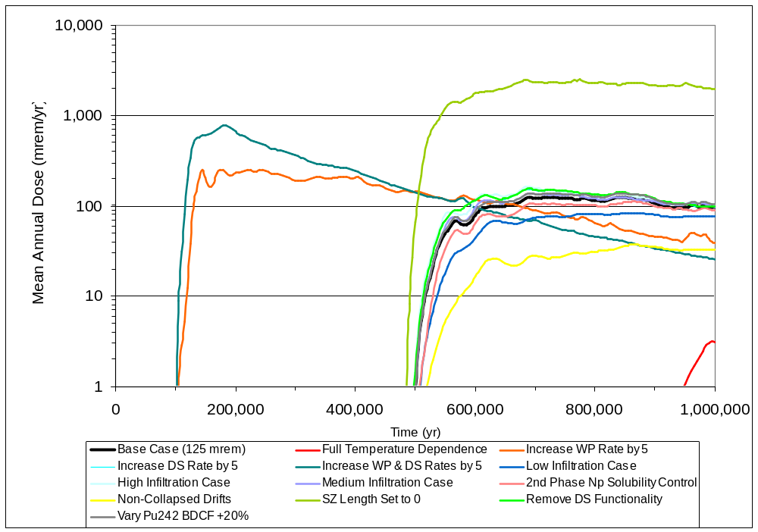

Figure 6a. Mean Annual Dose, Base Case and 12 Alternative Sensitivity Scenarios

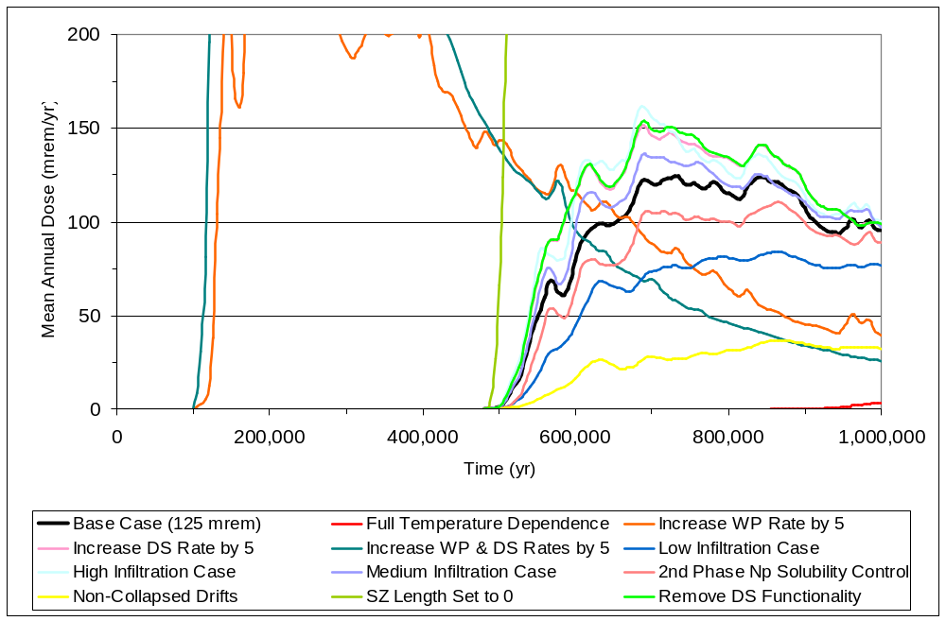

Figure 6b. Mean Annual Dose, Base Case and 12 Alternative Sensitivity Scenarios
(Enlarged view)

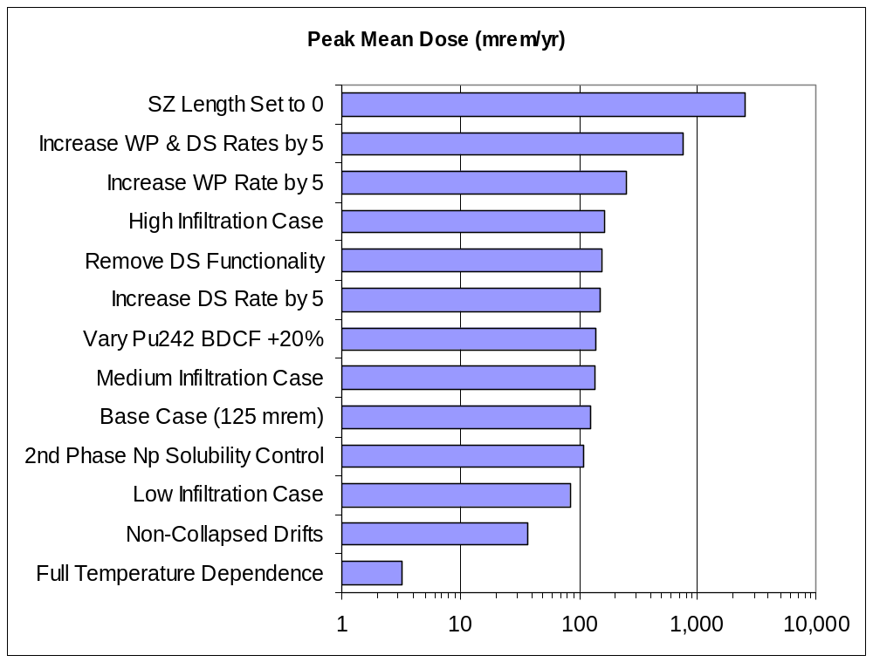

Figure 7. Comparison of 12 Peak Dose Model Sensitivity Scenarios with Base Case

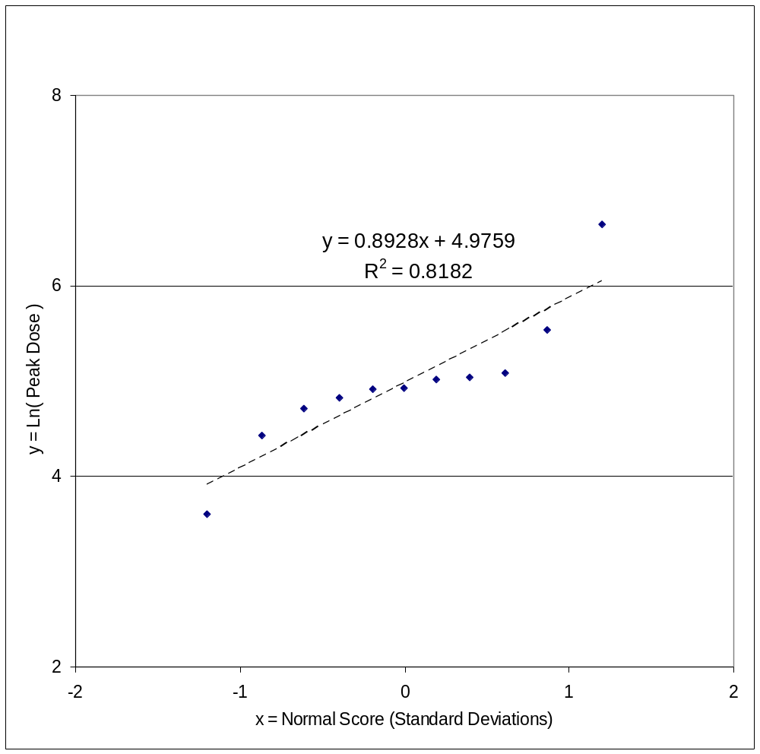

Figure 8. Normal Score Plot of Middle 11 Peak Dose Estimates with Best-Fitting Regression Line

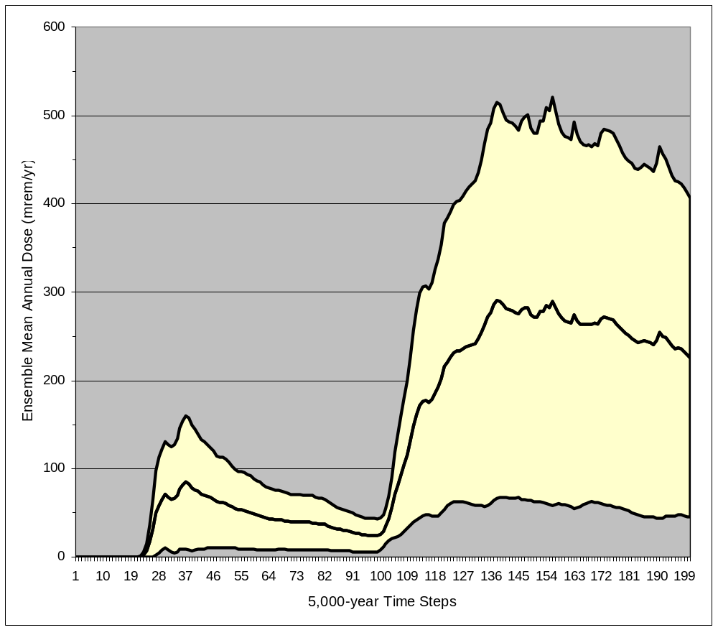

Figure 9 Plot of Ensemble Mean Annual Dose for Base Case and 11 Alternative Scenarios with 75% Confidence Interval for Mean

V-2 Some Significant Uncertainties in the Disposal System Performance (DOE-PDM)

An examination of the results of these sensitivity studies with the DOE PDM points to some significant uncertainties that affect the degree of confidence that can be placed on the results of performance assessments. These uncertainties are discussed more extensively below. Some cannot be reduced entirely by additional field and laboratory studies (such as field studies of the flow system around the repository and the far-field). Others reflect the inherent uncertainty in extrapolating field and laboratory data far into the future and for conditions that can only be approximated from relatively short-term laboratory and field studies (such as the extrapolation of corrosion rates into the tens to hundred of thousands of years). The spatial and temporal nature of these uncertainties is also discussed under each of the alternative scenarios examined with the DOE PDM.

V-2.1 Corrosion and Drip Shield Performance- Modeling Results

The largest dose estimates for the DOE PDM studies (Fig. 7) were observed for runs where increased corrosion rates for the drip shields and waste packages were used (ID#’s 4, 5, 6, 7, &11 in Table 2). Variations in performance ranged from the Full Temperature Dependence scenario (ID# 5) where doses were below 10 mrem/yr., to scenarios where doses close to 800 mrem/yr. were projected (ID# 11), approximately a six-fold increase over the base case results. For these latter scenarios, the high doses result from a factor of five increase in the waste package and drip shield corrosion rate (using the switches” in the DOE PDM). For these higher rates, Figure 4a shows that the peak dose is moved forward into the 100,000 year time-frame, and the peak dose is higher. This is not an unexpected result since more packages fail earlier in time and release more radionuclides into the natural barrier. Examination of these alternatives indicates that the corrosion rate is the dominant variable controlling the timing and magnitude of the peak dose. Variations of hundreds of mrem/yr are projected depending on the corrosion rates assumed for any assessment. The rest of the alternative scenario results in Fig. 7 show much smaller differences from the base case results. The spread in projections illustrates a fundamental uncertainty in making projections over these extremely long periods (discussed more fully in the temporal and spatial uncertainty heading below). The only other alternative that produces a dramatic effect on the DOE PDM projections is the drift collapse alternatives discussed below.

Temporal and Spatial Aspects of the Uncertainties In Drip Shield Performance. For drip shield performance, the temporal and spatial uncertainties involved in assessing performance are closely aligned and involve the degree of contact with intruding ground water during the post-closure period. Corrosion failure rates for the drip shields are determined by the amount of water contacting them, and will vary depending on their location within the heterogeneous fractured repository host rock. Over long time periods, the drip shields will also be subjected to damage from roof collapse occurring primarily as a consequence of seismic activity. This uncertainty has a temporal aspect in that the degree of damage to the drip shields, and their susceptibility to failure from rock falling from the emplacement drift ceiling, will vary with time. A drip shield that has experienced significant thinning from corrosion is more likely to fail from the impacts of roof collapse than one that has its original thickness and mechanical strength. Both the corrosion failures and failures from roof collapse would be expected to increase with time over the stability period as the repository area is subjected to repeated seismic events during the stability period. The exact history of the failures would be difficult to impossible to predict with high confidence because the seismic events affecting the repository have considerable uncertainty. Bounding assumptions would probably be used to simulate these processes in performance assessments, but considerable uncertainty is present within any bounding assumptions.

Temporal and Spatial Aspects of the Uncertainties in Waste Package and Drip Shield Corrosion Performance Making projections of metal barrier performance is a site-specific task, particularly under the unique conditions at the site, i.e., an unsaturated zone with varying thermal and fluid flow conditions in the emplacement drifts (see SC&A, 2005, Chapter 5, and BSC, 2001b for an extensive discussion of the uncertainties and assumptions used in DOE PA of corrosion processes and total system performance).

Spatial uncertainties involved in projecting waste package performance involve both the placement of the packages in the emplacement drifts within the repository, and also the distribution of pathways by which ground water can intrude into the drifts. These uncertainties can be resolved to an extent by noting the configuration of fractures in the emplacement drifts and avoiding placing packages where fracture densities are high. However it is not possible to eliminate all uncertainty, since it is not possible to predict with certainty which fractures will conduct ground water into the drifts and to what extent. Attempting such predictions is also complicated by the potential for thermal effects to alter fracture characteristics around the drifts and alter pre-thermal pulse behavior patterns that may be observed in testing within the repository, adding a temporal aspect to this particular uncertainty. Seismic activity over long time periods also has the potential to alter the transmissive behavior of the fractures in the repository host rock. Seismic activity causing roof fall at long time periods when the drip shields are significantly thinned and loose their structural integrity can directly damage waste packages, adding another time dependent aspect to the effects of seismic activity.

Another aspect of spatial uncertainties involves extrapolating corrosion testing results to waste package performance in the repository. Laboratory testing is of necessity performed on small pieces of metal, sometimes put under stress to simulate expected in-service conditions, but the results of such testing remains an extrapolation that cannot be verified practically. Here again, an extrapolation must be made from industrial experience with container fabrication and weld failure mechanisms in various in-service environments, which are limited to time frames of decades at most. As noted by some comments, the highly corrosion resistant alloy used for the waste packages has only been in existence for a short time and little real time experience is available from industrial applications. Extrapolating laboratory performance is unavoidable, but the longer the extrapolation the more uncertainty is involved. The strength of welded metals can also be tested on the laboratory scale, but again using such data for performance projections for full-size waste containers containing many long welds done in fabrication remains an extrapolation that cannot be verified in any practical sense.

Temporal uncertainty in the use of corrosion rate data arises from extrapolating the corrosion rates measured for specific corrosion mechanisms into unprecedented time frames, i.e., how confident can we be that we fully understand, and can confidently predict, which corrosion mechanisms will predominate over the times spans involved and changing conditions in the emplacement drifts. Corrosion rates are derived from relatively short-term laboratory testing for various potential corrosion mechanisms, but their use in the performance assessments is an extrapolation of these data both in time and scale (extrapolation of tests on small pieces of metal to behavior of full-size welded containers). Laboratory corrosion testing is also typically done under “accelerated” conditions, where higher temperatures or more corrosive fluids are used in the testing relative to those anticipated in the in-service environment. There is an inherent uncertainty in using such data, in that the data are intended to be deliberately conservative. How conservative such data actually will be is largely speculative since projections of container performance in the repository environment cannot be confirmed in practical time frames. Without an a priori understanding of all possible corrosion mechanisms operative for the physical and chemical conditions evolving over time, important mechanisms may be ignored inadvertently. Lower temperature testing to measure very low corrosion rates is also difficult due to measurement uncertainties and always limited by available time frames for testing. For the highly corrosion resistant alloys used for the waste package, the amounts of metal removed from the test samples is so small that analytical sensitivity is close to, and sometimes below, the ability of the techniques to measure (CRWMS M&O, 2000, sec 5.2.3.3). Synergistic effects involving the actual in-service environment may not be addressed by laboratory testing at all. The projections of performance cannot be confirmed in any real time sense, whereas performance for engineered materials placed in service can be confirmed over the operational time scales concerned. Although additional laboratory testing can always be performed, the extrapolation uncertainty will always be present. Intuitively one would suspect that the longer the time frame of the extrapolation the higher will be the uncertainty in the performance projections and dose assessments. Therefore, we are presented with an essentially irresolvable uncertainty involving the data extrapolations.

Uncertainty in data extrapolation is present whether the performance projections are made over a 10,000 year time frame or a 1 million year time frame. In that sense, this uncertainty could be likened to the uncertainties in projecting natural processes, such a seismicity, over the stability period. However in the case of geologic processes, the geologic record at the site provides some confirmation of the effects of ongoing processes, by allowing examination of what has taken place in the site’s geologic record. Industrial applications of corrosion data deal with in-service life times of decades typically, whereas for deep geologic disposal the operational life time is essentially unbounded in practical terms. For the case of corrosion rate data for the C-22 alloy used in the DOE waste packages, we have no such record for testing our extrapolations from a backward look at what’s happened in the past.

In summary, the uncertainties in the application of corrosion rates in performance projections is one that can only be limited to a degree, and becomes more uncertain with time as the extrapolations extend to progressively longer time frames, and conditions in the repository that limit access of intruding ground waters to the waste packages degrade over time. From the variations shown in the DOE TSPA results published in the past, corrosion rate assumptions are the dominant control on peak dose timing and the magnitude of the projected doses. Results of various DOE TSPA efforts using differing waste package designs and corrosion rate assumptions are listed in Table B1 in Appendix B. Additional results of sensitivity studies for a TSPA analyses are given in Table B2.

V-2.2 Drift Collapse Modeling Results

From the sensitivity analyses presented here, the second most important variable for projecting dose histories is the extent of emplacement drift collapse over time. The properties of the host rock in the repository are such that for intact cylindrical walls in the emplacement drifts, water moving through the unsaturated zone is significantly deflected around the drifts as long as the walls remain intact, thereby limiting the amount of ground water that can enter the drifts (BSC, 2001b, sec 4.2). Collapse of the drift walls may occur as a consequence of seismic activity around the site, and the timing and extent of such collapse is uncertain because there is considerable uncertainty in the recurrence intervals of larger seismic events around the site ( TRW, 2000, Fig.2-10, also in EPA Docket No. EPA-HQ-OAR-2005-0083-0379, DOE 2007). There is also a significant uncertainty involved in extrapolating the results of laboratory testing of the mechanical strength of solid rock cores to predicting the behavior of the heterogeneous fractured rock mass of the repository host rock Over very long periods of time, increasingly greater drift wall collapse should be anticipated, but the rate and extent of collapse will remain uncertain. Roof collapse is an example of the type of uncertainty that can only be reduced to an extent by laboratory testing and seismic event frequency analyses. Conservative approaches assume extensive drift collapse, allowing “worse case” situations to be analyzed, but these bounding analyses must be considered cautiously. While a degree of roof collapse can be assumed, the nature of the collapse will also have an effect on performance estimates. If large blocks result from collapse, they may deflect much of the intruding ground waters away from contact with the waste packages in comparison to small blocks which might act more as a porous flow medium in the collapsed drift. However, larger blocks may physically damage the drip shields causing rupture and more immediate access for the ground water to the waste packages and the release of radionuclides.

Results from the modeling show that releases for the non-collapse situation produce doses in the tens of mrem/yr at peak dose (#10 in Table 2). Similar results were observed in modeling using the EPA Uncertainty Model (SC&A, 2006, Fig. 11). These results illustrate the significant effect roof collapse can have on performance. Intuitively one might expect maximum roof collapse to precede and be the initiator for the peak dose, under that the assumption that the greater the degree of collapse, the higher the ground water influx into the emplacement drifts with consequent increased corrosion induced failure of the waste packages and release and transport of radionuclides into the natural barrier, as well as physical breaching of weakened packages by the falling rock. While this scenario appears reasonable, it may not occur in that way since general corrosion will occur even under potentially reduced water influx and the highly corrosion resistant metals may maintain waste package integrity even with significant roof collapse if the packages are not physically breached by the fallen rock. The calculations for the full temperature-dependence scenario (#10 - results shown in Fig 7) include a degree of roof collapse, but the results show greatly reduced doses controlled by the slow corrosion rate temperature dependence.

Temporal and Spatial Aspects of the Uncertainties. The question of predicting the deterioration of emplacement cavities in repository host rock is a generic issue for any geologic setting, not only temporally but spatially as well since the repository host rocks are not homogeneous and fractured uniformly. For a saturated zone site, eventual drift deterioration may be a minor issue since the emplacement drifts would be assumed to become flooded quickly after closure. However, the uncertainties connected to roof collapse are unique to the Yucca Mountain setting because of the nature of the setting in the unsaturated zone, and the important effect intact drifts have on keeping doses low. The complexity of flow through the unsaturated zone around the emplacement drifts makes the prediction of water movement into the drifts uncertain and the uncertainty in predicting the timing and magnitude of roof collapse adds to the overall uncertainty in projecting water movement into and out of the emplacement drifts over the long-term as some collapse inevitably will take place in the drifts. Projecting the effects of large block versus small block collapse on the physical integrity of the drip shields and waste packages over long time spans adds another layer of uncertainty to performance projections. A conservative approach, assuming widespread collapse, can be taken to make bounding projections, but that does not decrease the inherent uncertainty in the total system analyses. Such a conservative assumptions may significantly overestimate releases since intact drift walls significantly reduce ground water entry into the drifts, as suggested by the results from the DOE PDM modeling described above.

In summary, the timing and extent of roof collapse and its effects on waste package corrosion rates and failure is an uncertainty that would be difficult to reduce dramatically, and can have significant effects on projected dose levels. Relative to the base case results shown on Fig 7 (peak dose of about 125 mrem/yr.), reduced roof collapse lowers the projected mean dose calculations by about 90 mrem/yr., a significant decrease from the base case.

V-2.3 Infiltration Rates/Climatic Fluctuations – Modeling Results

Infiltration rates do not appear to be a controlling variable for site performance. The difference between the high and low infiltration rate cases is approximately 60 mrem/yr., a level well below the hundreds of mrem/yr variations caused by alternate corrosion rates for the waste packages and drip shields (Table 2, scenarios ID#s 1-3). This is not unexpected since the natural barrier above the repository location tends to attenuate the effect of increased precipitation on the surface (BSC 2001b, Chapter 3), both because of the inbibition effects in the unsaturated zone (the tendency of water moving down fractures to be drawn into the porous tuff) and lateral diversion along discontinuities between the volcanic rock units in the stratigraphic column above the repository.. The largest uncertainty for infiltration rate input to the performance assessments is in the magnitude of infiltration rate changes from climate fluctuations over the long term. There is relative certainty that climate changes will occur and fairly high certainty in the pattern of cyclical variations that can happen. This uncertainty could be addressed by bounding approaches for infiltration data since the most uncertain aspect is the magnitude of the changes. Relative to the base case results shown in Fig 7, changes in infiltration rates to higher or lower rates results in changes in the mean dose estimates of about 40 mrem/yr on either side of the base case estimate of about 125 mrem/yr. This uncertainty is about the same as the aleatoric uncertainty seen in the FEIS data set, suggesting that the uncertainty due to infiltration rate assumptions may not be distinguishable from the uncertainty arising solely from random selection of parameter values from the sampled distributions in the larger models used for the FEIS calculations and the licensing performance assessments. In light of the ability of the rock units above the emplacement drifts to damp out sharp variations in infiltration through lateral flow toward thru-going fractures/faults (BSC, 2001b, Sec 3.2.3), an approach to performance modeling that uses averaged infiltration rates to approximate the changes anticipated from climatic fluctuations would be a way of removing an uncertainty that does not appear to be a significant driver for the estimates.

Temporal and Spatial Aspects of the Uncertainties for Infiltration The general question of how ground water can move through the geologic strata above and below the repository is a generic issue applicable to any geologic setting. Projecting ground water infiltration rates is a uniquely site-specific issue for any geologic setting and would produce site-specific uncertainties. The technical challenges are unique for the Yucca Mountain site because of its unique geologic setting, in fractured rock, in a thick unsaturated zone, and in an arid climate. For a repository location in a saturated zone, the uncertainties would not be as great since the ground-water flow through a saturated zone repository location would not be as strongly affected by climatic fluctuations. The spatial uncertainties controlling infiltration, and also ultimately the movement rates of ground water in the unsaturated zone, include: the degree of homogeneity of the rock, soil and vegetation cover across the repository site; and the fractures exposed on the surface. These variants will probably remain relatively constant over time with some changes in soil cover properties over time from erosive processes and the development of poorly permeable soils typical of arid environments, as well as from precipitation variations due to climatic changes. While rates of erosion and soil development in an arid setting are low, over the course of a million year period, some changes in the soil cover over the repository and its permeability, as well as that of the near surface fractures can be reasonably expected in response to climatic fluctuations. It is not possible to predict such changes with certainty, but they would be expected to be relatively small, using the geologic record around the site as a guideline.

The temporal uncertainty in precipitation variations is due to climatic fluctuations and is more important than spatial variations. While the cyclical nature of climatic fluctuations is reasonably certain, the magnitude and exact timing of the fluctuations will always remain uncertain, also reflecting the uncertainty about the effects of carbon dioxide increases in the atmosphere (SC&A, 2005, sec.1.2, 1.4). Modeling performed by DOE to examine the impact of climate variations on projected doses (CRWMS M&O, 2000) showed increases of as much as 2-3 fold increase in the peak dose estimate (SC&A, 2005, Table I-5), but these analyses did not consider the moderating effect of seepage behavior of the unsaturated zone around the emplacement drifts.

V-2.4 Radionuclide Solubility and Transport – Modeling Results

The DOE PDM assumes that the release of radionuclides into the natural barrier is limited by the thermodynamic solubility controls for the various actinides in the wastes. This assumption limits the concentrations of various actinides leaving the repository to levels dictated by the chemistry of waters in the repository and the actinide phases determined to be the thermodynamically stable phases under those conditions. The results of the sensitivity assessments involving changing neptunium solubility control show little effect relative to the base case results. The change in the mean dose level is only slightly different (see Table 2, mean dose of 111 mrem/yr. for scenario ID# 8) than the base case results (125 mrem/yr.). While this result is suggestive of a small effect from this source of uncertainty, these results should not be taken too literally as demonstrating that this source of uncertainty (i.e., thermodynamic control on radionuclide solubility and mobilization in ground water) is insignificant, or extending the result of the single alternative solubility control assumption to all possible alternative controls. Only one solubility control alternative for one actinide was examined in the DOE PDM.

There are a number of uncertainties involved in making assumptions about solubility controls on the actinides, all of which can affect performance calculations. These uncertainties include: (1) determining how physical and chemical conditions in the repository environment will evolve and affect the solubility controls; (2) identifying what actinide phases, and secondary phases that could incorporate actinides, could form in the waste package/repository environment over time and; (3) determining the stability constants for these very low solubility actinide phases or secondary phases. Uncertainties about thermodynamic phases that control actinide solubility exist for all the actinides, and their effects on projected dose are not evaluated in the analyses reported here. Only one example among many possibilities for actinide solubility control variations was analyzed in the results reported here. Extensive discussions about the evolution of ground water chemistry in the emplacement drifts and the repository are contained in BSC 2001b. These discussions focus on changes in pH and CO₂ while mentioning the uncertainty in predicting which particular phases will control actinide solubility. The combined effects of assuming different thermodynamic solubility controlling phases is a more complex effort, beyond the scope of our relatively limited analyses. The combined effects may be greater, less or about the same as the dose projections for solubility controls assumed in the base case. The analyses reported here do not explore the full range of possibilities, they examine only one alternative.

In addition to the uncertainties associated with the thermodynamic solubility control assumption, there is a fundamental uncertainty in assuming that the solubility - (i.e., the concentrations of radionuclides entering the natural barrier) will be controlled by the thermodynamically stable phase(s) under the varying physical and chemical conditions in the repository over time. It is very common in nature for the precipitation of solids to be controlled by metastable phases rather than the thermodynamically prescribed phases. This often happens because the nucleation kinetics for precipitation of the thermodynamically favored solid are too slow and another phase with faster nucleation kinetics precipitates more rapidly. Whether this will happen for some or all of the actinides over the course of the geologic stability period is unknowable, since the physical and chemical environment in and around the waste packages is not possible to duplicate in a laboratory because of the many variables that will control it and their variations with time. If metastable phases control some or all of the actinide solubilities, higher concentrations of actinides would be present in ground waters exiting the repository and transporting radionuclides into the natural barrier. The extent of changes in concentrations is not easily estimated for many reasons (complex and varying chemistry in the near-field, difficulties in measuring actinide concentrations in very dilute solutions, etc.). Along with the uncertainties in the near-field, the solubility constraints on concentration levels along the far-field flow path can differ, i.e., the thermodynamically stable phase could control the concentration levels in the far-field thereby lowering them to levels that would have resulted if the same phase controlled the near-field concentrations. This alternative would give dose results essentially equivalent to the thermodynamic control assumption.

Another mechanism for enhanced radionuclide transport is colloidal transport, either as a radionuclide colloid or adsorption of radionuclides on other colloidal particles developed in the repository environment. Colloid formation in the near-field also can play a role in the mobility and transport of certain radionuclides released from the wastes (SC&A, 2005, Chap. 4). The tendency for radionuclides to form colloidal particles has been investigated, primarily for plutonium, and the conditions under which the colloidal material can form are reasonably well known. The potential for radionuclides to adsorb on other colloidal materials is less well known, and the question of when and to what extent these colloids can form in the repository and how well they can migrate through the natural barrier has many uncertainties involved.

As the engineered barriers degrade over long time frames and corrosion products (e.g., iron oxides of various types from the oxidation of ferrous materials - SC&A, 2005, sec, 4.2.2) become more abundant, the potential for colloids to form and to adsorb and transport radionuclides would seem to increase, but the extent and rate of this process is highly uncertain. These processes are highly dependent on the micro-scale changes in the waste package metal containers, the dissolution behavior of the spent fuel and the flow conditions for ground waters entering and exiting the packages. Another uncertainty in this potential transport mechanism is the extent to which the rocks along the transport path act to “filter out” colloidal material due to pore size and electrostatic effects. Although over the long-term it might appear reasonable to expect greater potential for colloidal transport, the fracture pathways and pore spaces leading away from the repository may well become “clogged” with material from the degradation of the engineered barrier components and inhibit or completely block colloidal transport. The degree to which these processes will affect radionuclide transport in the very long-term is uncertain and not amenable to reliable quantification, because the exact conditions in and around the waste packages over the very long-term cannot be duplicated in laboratory testing.

In summary, the sensitivity results shown here for the variation of neptunium concentration limiting phases lies well within the aleatoric uncertainty (~ 50 mrem/yr., see Table 1)) shown for these analyses. This result suggests that the DOE PDM could not meaningfully distinguish between the two alternative actinide concentration limiting scenarios examined. However this result should not be broadened to conclude that the uncertainties in projecting solubility controls cannot be demonstrated to have a significant effect on dose projections. This is because of the fundamental, and in many respects irreducible, uncertainties in determining the mechanisms that will control the mass transfer of actinides through the disposal system. In addition, the release and transport of radionuclides in the near-field is determined by the evolving chemistry of the ground water entering the emplacement drifts and its interaction with the components of the engineered barrier system (EBS). Temporal and spatial uncertainties are discussed below and more extensively in the SC&A, 2005 report mentioned above.

Temporal and Spatial Aspects of the Uncertainties in Radionuclide Chemistry The question of controls on the concentration of radionuclides that may move from the engineered barrier into the natural barrier is a generic question applicable to any geologic setting. Thermodynamic versus metastable phase controls on solubility levels, as well as the potential for colloid formation and transport, are part of the broader issue of understanding the evolution of ground water chemistry as these waters enter the repository, react with cement and ferrous metal components of the EBS, and exit the repository. The Yucca Mountain disposal system presents some very unique additional difficulties because of its location in an unsaturated zone setting. In an unsaturated zone setting, changes in physical and chemical conditions due to heat effects and drying may have significant kinetic effects on the nucleation of solid phases or their dissolution, which would affect transport rates into the natural barrier for instance. These physical changes will also produce changes in the chemistry of the ground water entering the emplacement drifts. After entering the drifts, reaction with the cement and ferrous metal components of the EBS would further alter the ground water’s initial chemistry.

Spatially, the seepage water in the drifts may contact the drip shields or may not. The water may run down along the drift walls with minimal contact with the EBS components and retain a chemistry reflecting its loss of CO₂ upon entering the drift and contact with the invert material on the drift floor. More ground water is likely to fall on the drip shields and have its chemistry changed by the corrosion process and eventual interactions with the waste packages and their contents. All these waters will also undergo chemical changes from heat generated by the wastes. Upon beginning to exit the EBS, these various differing water chemistries will be mixed while traveling through the invert to reach the surrounding host rock. The exact chemistry of these waters can only be approximated because of the heterogeneity of their travel paths and the EBS materials they encounter. The chemistry of these waters will differ, reflecting their unique travel paths through the emplacement drifts, and can only be approximated with bounding assumptions made about their “average” or alternatively “worst case” composition.

Temporally, as the repository moves through its thermal period the chemistry of the ground waters will change in response to lessening temperatures and the build up of corrosion products from the degradation of the metallic EBS components. In the long-term, the questions of what phases will control the concentration of radionuclides in the ground waters becomes more difficult. Higher temperatures favor reaching predictable thermodynamic equilibria. At lower temperatures, metastable phases are more likely to form and the increased amounts of corrosion products present after the waste packages have breached lessen the confidence in predicting exactly what phases will determine the aqueous concentrations of radionuclides, what phases will sorb radionuclides in the emplacement drifts, or become mobile in the ground water to allow transport away from the EBS. All these variables create increasing uncertainties as the EBS degrades over time. Conservative bounding assumptions can be made for these various processes to simplify calculations, but these kinds of assumptions simply mask the actual uncertainties and may result in a significant over-estimation of radionuclide mobility and transport out of the EBS. It is not possible to confirm assumptions about the actual variations in chemical conditions in the degrading EBS because of the time frames involved and the slow rates at which these processes operate.

V-2.5 Changes in Assumptions about Ingestion Pathway Doses – Modeling Results

Like the neptunium solubility variation analyses, results from varying the BDCF for plutonium-242 showed changes in the peak dose within the aleatoric uncertainties (peak dose of 138 mrem/yr.). These results suggest that the assumptions about dietary intake are not significant in terms of driving the dose estimates out of the envelope of the aleatoric uncertainty. This may be true in that the dose to the RMEI is largely controlled by two requirements in the rule, i.e., that the RMEI is located over the center line of the contamination plume and consumes a fixed amount of contaminated drinking water. These two requirements overweigh the relatively smaller input from food ingestion assumptions. Also, the rule directs that the ingestion profile for the RMEI be based on present-day consumption patterns. Food items produced with potentially contaminated ground water are produced at distances greater than the RMEI location and would use less contaminated ground water.

Temporal and Spatial Aspects of the Uncertainties for Ingestion Pathways Uncertainties about biosphere pathways and exposures apply to any biosphere dose model for a disposal system, but must be considered on a site-specific basis due to differences in relevant biosphere parameters at any specific site. While the standard approach for biosphere exposure modeling has many fixed parameters, such as drinking water consumption, the exposure pathways arising from the use of contaminated ground waters are site-specific. For example, the standards mandate that food consumption patterns for the RMEI be based on present day local food consumption patterns in the area down gradient from the repository. These characteristics would be different for a farming area in a temperate location as opposed to the arid environment in Amargosa Valley. It is believed that assuming current day conditions for ingestion patterns is a conservative measure (overestimating doses) because of the heavy use of well water for irrigation. It could be argued that in future times when rainfall is more abundant, food could be produced closer to the repository location and consequently become more contaminated than present day conditions where food is produced farther down gradient from the RMEI location. However under such a scenario, less well irrigation water may be necessary, possibly counterbalancing the effect of producing food closer to the repository. Because population dynamics are not possible to forecast confidently, even into the relatively near future period of hundreds of years, it is reasonable to assume that the uncertainties in the biosphere pathways model component of dose projections cannot reliably be reduced.

V-2.6 Removal of the Saturated Zone – Modeling Results

This alternative (setting the saturated path length to zero – ID #9, Table 2) is largely hypothetical in nature since the saturated zone cannot really disappear. Effectively this scenario takes the contaminated water from the floor of the emplacement drifts and delivers it immediately to the well supplying ground water to the RMEI. (The DOE PDM excludes the unsaturated zone below the waste packages and the fractured volcanic rocks in the saturated zone and considers only the presence or absence of the alluvial portion of the saturated zone.) However this scenario illustrates some important points. The scenario quantitatively describes the contribution of the natural barrier beyond the repository boundary to the dose projections. Without this contribution, the peak dose rises to well over 2 rem/yr., showing that the natural barrier is a major contributor to total performance. The scenario also illustrates the potential effects of a generic uncertainty – the confidence that can be placed on the retardation properties of the far-field.

Radionuclide retardation on the rocks along the flow paths to the RMEI location is estimated primarily by laboratory testing of radionuclide “sorption” on the rocks. The extrapolation of such laboratory test results to field conditions has always been a controversial subject, as is the more immediate question of how the tests are designed and executed to simulate expected conditions along the ground water flow paths. A conservative approach is generally taken in using the laboratory data in contaminant transport modeling, usually by biasing the selection of lab results to low-end values for use in the contaminant transport calculations. The issue of whether the laboratory results are meaningful at the process level (do they actually test retardation mechanisms under true site conditions), and to what extent can they be used in modeling, is a generic uncertainty that can only be addressed in a limited way for any site-specific application. Regardless of the geologic media under consideration, a significant uncertainty will be present in the extrapolation of laboratory test data to the field situation.

Field testing using sorbing and non-sorbing tracers can be performed to test the transferability of laboratory data. However such tests have significant uncertainties themselves concerning how well the tested domain represents the entire flow path. The questions typical for such testing include: comparisons of test flow rates versus in-situ ground water flow rates; heterogeneity within the test domain in contrast to the actual flow paths; kinetics of sorption processes and ability to model the test domain flow paths precisely enough. Multiple field tests at the same or different locations can be performed but many of the uncertainties will remain.

Temporal and Spatial Aspects of the Uncertainties – Far-Field Radionuclide Sorption The uncertainties involved with transferring laboratory retardation data, as well as field test data, to contaminant transport assessments are largely spatial in nature. Laboratory measurements are done on isolated systems with few variables left uncontrolled, and with fewer variables than are present in the actual disposal system in nature. The transferability of such data is always uncertain to a significant degree, leading to the conservative approach of using lower-end values for modeling applications. Field testing of retardation is difficult and time-consuming and subject to all the uncertainties mentioned above in attempting to scale up such data for modeling purposes. The conservative approach of using lower-end values would tend to overestimate doses, however since it is not possible to confirm the results of these calculations, the uncertainties remain only partially resolved.

Temporal uncertainty is introduced when the radionuclide inventory changes with time. However for the long-lived actinides which constitute the overwhelming majority of the peak dose, their low solubility and relative abundance in the wastes minimizes the consequences of changing inventory after the shorter-lived radionuclide inventory is depleted. After a long-period of time, a more constant mix of radionuclides is released into the natural barrier, consisting of long-lived radionuclides. Colloidal transport is proposed for some radionuclides, either on natural colloids or colloids formed from the degradation of the engineered barrier materials (BSC 2001b, Chapters 9-12). The gradual degradation of the engineered barrier may introduce some temporal variation in the radionuclide load delivered into the natural barrier through colloid formation and transport, however it is not possible to reliably quantify this source. Intuitively, one would expect colloidal transport to increase as the repository EBS components progressively degrade over time and more colloid material (such as iron hydroxides and oxide compounds from the oxidation of the waste packages) becomes available to “sorb” radionuclides and move through the disposal system. As mentioned previously, there is a potential that at long time frames the fractures and pores in the rocks around the repository may become “clogged” with degradation products and impede radionuclide movement into the far-field. It is not possible to reliably estimate the amounts of colloidal material available as a discrete function of corrosion of the waste packages. Another temporal uncertainty in far-field transport may derive from long-term changes in the ground water flow rates in the saturated zone, due to climate fluctuations and changes in regional recharge and flow patterns. A conservative approach to modeling transport is usually taken to compensate for the uncertainties, but the approach does not remove the uncertainties or increase the confidence that can be placed on the assessments as “predictors” of future behavior.

V-3 Summary of Epistemic Uncertainties in the DOE-PDM Results

The analyses performed with the DOE PDM illustrate the potential effects on dose projections of a number of alternate descriptions of how the Yucca Mountain disposal system would operate. The dominant uncertainties concern the projected performance of the waste package and drip shield metal components, and the stability of the emplacement drifts to collapse. Relative to the base case performance (~125 mrem/yr peak dose), the most dramatic range in dose projections arise from assumptions for faster corrosion rates for the waste package and drip shields (5X faster) and assumptions of slower rates (the full temperature dependence alternative). The range of dose projections range from 3 to 768 mrem/yr., essentially no significant doses at one end of the spectrum to doses significantly higher than the 100 mrem/yr peak dose limit in the final standards. The analyses presented here were done looking only at the variations (alternate conceptualizations) separately and a few variations in combination (Table 3). For example the combination of non-collapsed drifts and increased corrosion rates (Table 3, # 1) produced lower doses than the corrosion rate increase alone (Table 2, #4). This is understandable since the non-collapsed drift limits the amount of ground water that can flow through the emplacement drifts and transport radionuclides into the natural barrier. Analyses looking at more combinations may give different results. The combination of full temperature dependence for corrosion rates and limited roof collapse may produce essentially minuscule doses within the stability period and beyond, where as a combination of increased corrosion rates with added factors such as high infiltration or less retardation in the far field would produce higher doses than the increased corrosion rates alone.

With the exception of removing the saturated zone from the disposal system, all the variations examined with the DOE PDM are reasonable alternatives for the processes that may operate in the long-term and contribute to the peak dose. Considering the aleatoric uncertainty in the DOE PDM model for sets of 1000 realizations is approximately 50 mrem/yr. (25 mrem/yr. on either side of the mean value, or approximately 20 % of the dose), many of the alternatives examined would not be distinguishable from the base case results statistically (at the 5% probability level). However the uncertainties for some of the processes in the PDM may well be more significant than the limited options built into the DOE PDM allows, for example the uncertainties in solubility controls for all of the radionuclides significantly contributing to the dose projections. It should be noted that these conclusions refer to this model. A more complex model may give different results, although the trends show in these results should be the same as long as the significant processes are included in the model. Note that the aleatoric uncertainty for the more elaborate model used for the FEIS analyses is 45 mrem/yr. on either side of the mean – or approximately 30% of the dose. However this illustrative exercise shows the approximate limits of an assessment model to make meaningfully projections over the time frame involved. The epistemic uncertainties in the DOE-PDM analyses are more difficult to define precisely, but they are the dominant ones. Corrosion rate assumptions can reduce the base case (125 mrem/yr at peak) to insignificant levels or increase the dose many times over.

VI Uncertainty Propagation Over the Very Long-Term

In another report, the propagation of uncertainty over long time frames was examined (SC&A 2006). For that exercise, the DOE PDM was modified as described in that report to allow the analyses to be done. A hypothetical disposal system was developed that was at the “edge of compliance”, i.e., gave a mean dose to the RMEI of 15 mrem/yr. at 10,000 years, by allowing a fixed number of waste packages to fail within the 10,0000 year time frame. This group of failed packages was kept constant through the simulation (no additional failures were allowed), and the dose histories were followed through peak dose. The spread in the dose histories (realizations) for the failed packages (difference between the 5 and 95 percentiles) increased from one and a half orders of magnitude at 10,000 years to three and a half orders of magnitude at the time of peak dose (SC&A 2006, Table 10). These results illustrate that as the time frame for the assessments increases into the tens to hundred of thousands of years the uncertainty in the dose histories also increases as reflected by the spread in dose projections.

Peak doses for various modeling variations (number of realizations, sampling strategies, etc.) varied between a low of about 160 mrem/yr., to slightly over 400 mrem/yr (SC&A 2006, Table 2)., also illustrating the “sharpness” of the PA tool (the EPA Uncertainty Model as modified from the DOE PDM) for modeling the hypothetical disposal system. It is worth noting that the spread in peak dose estimates due to these modeling variations (and not the underlying model itself) is significant - more than a factor of two from the lowest to highest dose estimate. These analyses could be considered a low-end approach to forecasting a peak dose for an “edge-of-compliance” system, since no additional waste package failures were allowed after ten thousand years. In reality for a disposal system that might be actually at the 15 mrem/yr mean dose limit at ten thousand years, additional failures beyond that time would be expected with corresponding increases in dose above those seen for the fixed number of failed waste packages in the hypothetical system. An obvious conclusion of these analyses is that a peak dose limit in the range of several hundred mrem/yr. would constrain the disposal system to produce performance well below the 15 mrem/yr. level within the ten thousand year compliance period, in light of the uncertainties inherent in very long-term dose projections. The addition of a peak dose limit to the 10,000 year dose limit has the practical effect of constraining the disposal system to limit waste package failures and consequent releases to extremely low levels for well in excess of 10,000 years in order to meet the peak dose limit (Docket number for WM08 paper).

This conclusion is also supported by the results of the DOE PDM exercise reported here. For increases in corrosion rates from those used in the base case, the time for the peak dose changes dramatically from the 700-800 thousand year range to less than 200 thousand years. With corrosion rates even faster, the time of peak dose would decrease further and the peak dose would rise higher still. At some point, the rapidly rising part of the dose history curve would generate doses approaching or exceeding the 15 mrem/yr limit at 10,000 years as the time to peak dose continues to decrease due to the faster corrosion rates. The two tiered standard can then be seen as doubly constraining. While the 10,000 year standard limit constrains performance within that period, the peak dose limit is a second measure that constrains performance within 10,000 years. The disposal system must perform below the 10,000 year dose limit in order to demonstrate compliance with a peak dose limit in the range of several hundred mrem/yr.

While the results of the uncertainty study (SC&A 2006) support the generalized conclusion that over-all uncertainties increase with time for these complex simulations, another important question remains. How much confidence can be placed in PA analyses as reliable “forecasts” of disposal system performance and consequent dose potential? While overall uncertainty may increase, does the PA tool give a reasonably reliable picture of the most probable outcome? The “sharpness” of the PA tool in these long time frames is central to answering that question. Examining an actual site performance model (the FEIS results) illustrates that the results for a given set of realizations has a significant level of uncertainty in terms of how well alternative conceptualizations of the disposal system can be distinguished from each other. For the FEIS analyses from Table 1, the mean dose was approximately 150 mrem/yr., with an uncertainty band of about 45-50 mrem/yr. on either side of the mean. The band indicates the “sharpness” of the FEIS model for aleatory uncertainties. For a mean of 150 mrem/yr., there is a relatively wide band around the mean value. If we contrast this uncertainty with the aleatoric uncertainty for the DOE PDM (for the 300 and 1,000 realizations sets) we can see a similar aleatoric uncertainty would arise for assessments with realization numbers between 300 and 1,000.

For the DOE PDM model exercise (Table 1 and Figs 1-7), the alternate conceptualizations produce a wide range in mean dose levels, from less than 10 to close to 800 mrem/yr. The alternatives scenarios examined (the various “switches” in the model) are reasonable alternatives, suggesting that, depending on which ones are considered credible possibilities in the licensing assessments, the dose assessments could differ dramatically and perhaps in ways that cannot be resolved. For example, assuming faster corrosion rates than those shown in short-term laboratory test could be considered a more defensible approach than simply assuming the laboratory testing results can be extrapolated confidently to times in the many hundreds of thousands of years. The resulting dose projections would be much higher than the base case (see Figs. 3, 4 & 6). However if drift wall collapse were assumed to be minimal or minor in extent, a compensating process would operate to lower doses (by restricting ground water access into the drifts), with the net result being little different than the base case. This case is illustrated by combined scenario #2 in Table 3 which links the non collapsed drift (NCD) scenario from Table 2 with waste package and drip shield corrosion rates accelerated by a factor of 5. The forecasted peak mean dose for this combined scenario is 118 mrem/yr. This value is approximately the same as the peak mean dose in the base case in Table 2, but occurs much earlier at 190,000 years versus 730,000 years in the base case. If the corrosion rate is accelerated for the waste packages, but not the drip shields, then the peak mean dose is reduced in half to 55 mrem/yr at 420,000 years, as shown in combined scenario #1 in Table 3. The difficulty with this situation in a licensing process is that the two alternatives (high releases from faster corrosion versus low releases due to limited roof collapse) cannot be confidently predicted relative to each other. The uncertainties cannot be reduced significantly making it very difficult to discount either scenario or give them relative weights for decision making against a fixed numerical dose limit.

In moving from the ten thousand year standard dose limit of 15 mrem/yr. to the question of an appropriate peak dose limit for the Yucca Mountain disposal system several points are relevant. The peak dose limit should offer a measure of meaningful protection. The engineered barrier cannot be assumed to provide essentially complete containment indefinitely, at some point releases beyond the 15 mrem/yr. level should be expected. As the results of the sensitivity studies reported here show, without the natural barrier contribution doses easily exceed 2 rem/yr. A robust metal barrier can constrain releases to levels well below that, but the uncertainties in extrapolating the relevant laboratory data will remain, and are generic uncertainties shared by any repository design and geologic setting. The uncertainties in very long-term assessments of the Yucca Mountain system limit the degree of confidence that can be placed on simulations and limit the degree to which they can be used to define the “protectiveness” of the system relative to the 10,000 year standard (as well as mandate a specific repository design or set a peak dose limit for a particular design). As an example, an assessment assuming full temperature dependence for the corrosion rates (Table 2 – peak dose 3 mrem/y) combined with a assumption for limited drift collapse (Table 2 – peak dose 37 mrem/yr.) would give extremely low peak doses. However this scenario could not be argued as more likely, or even as likely, as one with higher corrosion rates and more extensive drift collapse that would give doses in the many hundreds of mrem/yr. Clearly the performance assessments, when uncertainties are considered, should be regarded as only rough approximations to demonstrate the “protectiveness” of the disposal system and the designated peak dose limit. Rather than deriving a peak dose limit from the range of performance assessments for the site, another measure for an acceptable dose limit should be derived. The proposed rule offered the alternative of deriving a peak dose limit based on natural background level of exposure. This route to setting a peak dose limit avoids the issue of uncertainties in performance site projections, but still allows these assessment to play their appropriate role as measures of how well the system could meet the limit, giving consideration to the applicable uncertainties.

VII Aleatoric and Epistemic Uncertainties – Uncertainty and Conservatism in Performance Assessments for the Yucca Mountain Site

The aleatoric uncertainties in a given performance assessment play a role in determining the degree of confidence with which alternate conceptualizations of the disposal system processes can be distinguished from one another. For the FEIS analyses shown in Table 1 (300 realizations to obtain a “stable” mean) the aleatoric uncertainty is approximately 90 mrem/yr. This suggests that dose histories produced from alternate conceptualizations of the disposal system performance could not be clearly distinguished from the nominal FEIS conceptualization unless the results were different by more than 90 mrem/yr. (45 mrem/yr on either side of the mean value). For interpreting the implications of aleatoric uncertainty, it should be noted that this uncertainty is unique to each individual performance assessment exercise. In the case of the FEIS analysis used here, 300 realizations using the large TSPA model produced the level of uncertainty shown in Table 1. This level could be reduced by increasing the number of realizations in the analysis (this effect can be seen in Table 1, by comparing the spreads for the DOE PDM results shown for two sets of realizations, n = 300, 1000). Presumably the aleatoric uncertainty for the higher number of realizations would be lower to some degree.

In examining epistemic uncertainties in the DOE PDM, the aleatoric uncertainty for 1,000 realizations of the model was about 50 mrem/yr (see Appendix A, Table A1). From this starting point, the performance assessments for alternative conceptualizations (the various “switches” in the DOE PDM that allow realizations for alternate scenarios – such as non-collapse of the drifts), could not be statistically distinguished from the base case unless the mean dose for the alternative scenario was more than approximately 25 mrem/yr. on either side of the base case mean of approximately 125 mrem/yr. From an examination of the variations analyzed for the DOE PDM modeling (Fig. 7), many of the alternatives could not be distinguished statistically from the base case (e.g., changes in the Pu -242 BDCF, neptunium solubility controls, medium infiltration). If an alternative scenario were examined separately, i.e., a thousand realizations performed, there would be an aleatoric uncertainty associated with it and an uncertainty band around the mean. It may be possible, for certain combinations of parameters, for an alternative to have some results fall outside the aleatoric band of the base case. In that case, there would be a greater chance that the alternative may be distinguishable from the base case for the realizations where the projected dose is close to or outside of the base case aleatoric uncertainty band. But there would be combinations of parameter values for which the alternative would still be indistinguishable from the base case. These relationships create a situation that lessens the over-all confidence in the performance assessment tool to make confident projections of how the disposal system will actually behave in the long-term. This results from the ambiguity created when the performance assessment tool can sometimes tell the difference between alternative scenarios and sometimes not. This ambiguity is essentially the “sharpness” of the tool for use in confidently projecting performance and doses and subsequently making regulatory compliance decisions, i.e., that the actual processes operative at the site are understood sufficiently to have high confidence that the projections are true representations of how the disposal system will operate over time.

The epistemic uncertainties examined indicate that the “sharpness” of the PA tool is not sufficient to distinguish between some alternative scenarios (e.g., neptunium solubility control and plutonium BDCF) and may not always be able to distinguish between some of the alternatives (high and low infiltration scenarios). For the FEIS PA analyses, the aleatoric uncertainty around the mean value of approximately 45 mrem/yr., with added uncertainty in terms of how well that model can distinguish between alternate conceptualizations. Without an exhaustive examination of uncertainties in that model, it is not possible to be exact about the total range of uncertainty, as reflected by dose variations, but it would not be surprising for the combination of aleatoric and epistemic uncertainty to exceed the 45 mrem/yr. level significantly. This is a significant portion of the total dose estimates shown in published assessments for the Yucca Mountain site (DOE,1998, 2000, 2008, BSC, 2000 a&b, CRWMS, 2000), and has important implications for interpreting the results of these assessments, as discussed below.

The recognition that the PA tool has inherent limitations brings up another relevant aspect of using performance assessment to project doses for the disposal system. To address uncertainties that are not possible to reduce completely by laboratory and field studies, such as the degree of drift wall collapse, or the solubility controlling phases for actinides (see previous discussions on epistemic uncertainties), conservative assumptions are often incorporated into the construction of the PA model. Conservative assumptions and associated uncertainties in Yucca Mountain performance assessments were examined critically in report supporting the proposed rulemaking (SC&A, 2005). Conservatism should not be confused, or thought of as synonymous, with uncertainty. The intent of conservative assumptions is to examine “worst-case” or “high-end” situations to determine if projected performance can still meet targeted levels in spite of the “worst-case” or “high-end” assumptions. Whereas uncertainties concern the limits of our knowledge to construct and execute mathematical simulation models and interpret their output. If performance projections are well below a regulatory limit, the uncertainty in the assessment may still be high with respect to how much confidence can be given that the model is a reliable description of how the disposal system will perform in the long-term.

Depending on how conservative assumptions and modeling approaches are incorporated into the site PA model, it may be difficult to determine the effect of uncertainties in the associated assumptions on the projected doses. If conservative assumptions are incorporated implicitly by modifying parameter distributions alone, it may not be possible to separate aleatoric from epistemic uncertainties. In this case the aleatoric uncertainty (estimated as described in Appendix A) in a given set of realizations would be a mixture of both kinds of uncertainty. If many alternative scenarios are constructed and weighted, and the parameter distributions used are tied to alternative conceptualizations for system performance, it would be possible to examine the alternatives separately in a transparent manner and clearly identify the uncertainties and their effects on dose projections. The published Yucca Mountain assessments treat igneous intrusion scenarios in this way (DOE, 2008) because the probability of these scenarios is very low, potential exposures are very high, and the exposure pathways so different from the nominal expected case that separate treatment of the scenarios is unavoidable. For other alternative conceptualizations, such as infiltration rates, parameter distributions are simply modified to incorporate the parameter ranges associated with the alternatives into the nominal case data base. For these approaches it is more difficult to identify and quantify the uncertainty attributable to alternative conceptualizations. In addition, the “abstraction” process used by DOE to develop the over-all total system performance model from more detailed subsystem process models selects the “driver” parameters and processes from the lower tier models for inclusion into the next level of the model abstraction process. In doing this, a measure of simplification is incorporated at every level of the abstraction with an associated loss of “sharpness” in terms of scientific rigor in the simulations and detailed quantification of the uncertainties on the subsystem behavior. For an abstraction process, care must also be taken to examine the relative role of conservative or bounding assumptions at different levels of the abstraction. It may be possible that a conservative assumption at one level of the abstraction may not be a conservative assumption at a higher level.

VIII Uncertainties in Performance Assessments – Implications for Standard Development and Regulatory Decisions

A peak dose standard limit must be derived from considerations of acceptable health impacts and safety not on how a particular disposal system is “forecast” to perform. Many of the questions surrounding decisions about what is an acceptable dose limit over the extremely long time frames in question are outside of the scope of this discussion, which is focused more narrowly on the ability of the performance assessment tool to distinguish between alternative conceptualizations of the disposal system performance (epistemic uncertainties), as well as the inherent uncertainties in making dose projections for a given conceptualization (aleatoric uncertainties). However, these uncertainties have implications for the repository applicant and regulatory decision maker in that both parties are concerned with having a credible safety case for the disposal system. Understanding the “sharpness” of the performance assessment tool is important in this respect. As the time frame extends into hundreds of thousands of years, uncertainties will increase and may well lessen the confidence that dose projections are reliable simulations of repository performance and challenge the credibility of a safety case relying heavily on performance assessment results.

The sharpness of the performance assessment tool represents the limit of the science concerning dose projections for the compliance period. Performance assessment technology has advanced over the course of the repository effort since the late 1970s, as illustrated by the progressively more complex models used in the disposal system assessments over that time. In parallel, site characterization studies have generated considerably more information than available for assessments performed early in the program and the design of the disposal system has evolved in consort with the increased understanding (EPA, 2001). However considering the uncertainties discussed above, there are some uncertainties that can never be completely reduced to insignificance, and some that may not need to be studied further in consideration of their relative effects on dose projections. For a two-tiered standard for the disposal system, the ability of the performance assessment tool to distinguish between the two dose limits is an important consideration in compliance decision making. If projected performance over the entire stability period is well below the standards, there is little difficulty in making a compliance decision as long as the performance model has been demonstrated to acceptably simulate the processes controlling peak dose to the RMEI. If the dose projections overlap the standard to some degree, a compliance decision is potentially problematical. In formulating a standard, attention should be directed to understanding the limits of the tool, so that dose limits, judged to be protective, are not so close together that it is unlikely the tool can meaningfully distinguish relatively short-term performance (within 10,0000 years) from performance over the entire 1 million year geologic stability period.

There are still some important implications of uncertainty in the performance assessments that have a bearing on standard setting. Understanding these effects is also relevant to designing the structure of a standard, so that uncertainties in dose projections do not compromise the ability to make confident decisions about the safety of the disposal system. Performance assessment is the only tool available to project performance of the disposal system over the regulatory time frame in a standard. As such, an understanding of the uncertainties on a site-specific basis is necessary to avoid setting standards that cannot be implemented with reasonable confidence that the disposal system will perform adequately. More specifically for example if tiered standards are under consideration (e.g. different dose limits at varying times), if the difference between these dose limits is well within the uncertainty of the assessment tool to distinguish between them for the various scenarios in the assessments, making a confident compliance decision would be very difficult to impossible

The site-specific aspects of aleatoric and epistemic uncertainties present the applicant with the challenge of designing a disposal system that can confidently be shown, through performance assessments of its anticipated behavior, to meet the regulatory standards with a reasonable degree of confidence. From that perspective, the “sharpness” of the performance assessment tool for regulatory decision making is a critical issue. If the projected performance of the disposal system, considering the uncertainties, is below the regulatory limits the uncertainties should not be an issue in the compliance decision. If however the envelope of uncertainties overlaps the regulatory markers, the nature of the uncertainties will play a significant role in reaching a compliance decision. The analyses presented and discussed above illustrate the quantitative effects of aleatoric and epistemic uncertainties on dose projections for the complex Yucca Mountain disposal system. These results present a reasonable picture of the capabilities of performance assessments performed for exceedingly long time periods to confidently distinguish between alternative conceptualizations of how the disposal system may perform.

In terms of formulating a standard and making compliance decisions, the sharpness of the PA tool and the role of conservative assumptions in the performance modeling both come into play. For setting a standard, understanding how well the assessment tool can distinguish between alternatives is important to determine how well a standard can be implemented for decision making. Understanding the uncertainties involved in an assessment submitted to the regulatory decision maker is an important component in sound decision making. As the results and discussions in this report illustrate, there is considerable uncertainty in the confidence that can be placed in any given performance assessment. Many of these uncertainties cannot be significantly lowered by additional testing because of the spatial and temporal complications involved in extrapolating test data. Implications concerning the “sharpness” of the performance assessment tool on various aspects of the standards are discussed below.

From the results of the examination of uncertainties, we have drawn some conclusions about how they affect performance assessments, and their interpretation in a regulatory process. These conclusions are summarized below.

- A standard must be based on a societal decision on acceptable levels of radionuclide release in the future. The “protectiveness” of the dose limits (i.e., the risks posed by radionuclide releases) is not determined by the ability of the disposal system to meet pre-set limits nor the ability of the measurement tool to generate meaningful results. For the peak dose limit, a dose limit of 100 mrem/yr to the RMEI was chosen as a protective standard, for reasons articulated in the preamble to the final standards and in the Response to Comments document accompanying the final rule, not from a consideration of disposal system performance assessments performed by the Agency or those published in the open literature.

- Performance assessment is the main tool for assessing potential performance of the disposal system. Uncertainties inherent in the understanding and mathematical modeling of the system should be understood as they impact both the standard setting and compliance decision process.

- Uncertainties in the functioning of the disposal system and in making simulations of its performance over the geologic stability period do increase over time, particularly time periods extending into the many hundreds of thousands of years. These uncertainties compromise the use of performance assessments as highly confident predictors of disposal system performance and dose histories over the geologic stability period.

- For a tiered standard (multiple dose levels) as a function of time, implementability of the standard is in part dependent on the “sharpness” of the performance assessment tool. If the difference between the tiered dose limits is too small for the tool to meaningfully distinguish between reasonable alternative performance scenarios when the uncertainties in the model are taken into account, (i.e., the uncertainty band around the calculated mean dose over time overlaps the standard’s dose limits), confidence in the compliance decision may be minimal, depending on the level of the projected doses and the uncertainty. The same consideration applies to a given safety case being evaluated against a tiered standard. If the tool cannot adequately distinguish performance relative to the separation in the tiered standard, the implementability of the standard is highly suspect. Other considerations beyond the numerical results of performance assessments would become important, if not deciding, factors in a compliance decision.

- A degree of aleatoric uncertainty may persist even if the number of realizations used in calculating mean doses is increased, simply for practical considerations of time and resource allocation in doing TSPA type assessments. With some effort to minimize this source of uncertainty, the aleatoric uncertainty should not make a compliance decision difficult as long as the difference between the two standards is more than 10-20 mrem/yr. Epistemic uncertainties in contrast can amount to many tens to hundreds of mrem/yr depending on the specific causes and may prove difficult to lower for some sources.

- Corrosion rates and drift collapse are the major driver parameters for the peak dose estimates examined here. A peak dose limit of 100 mrem/yr provides sufficient separation between the 15 mrem/yr 10,000 year limit and the dose limit for the remainder of the stability geologic period to allow the performance assessment tool to distinguish between the 10,000 year safety case and that for a peak dose occurring at a later time. The 100 mrem/yr peak dose limit also imposes a significant burden to understand and reduce epistemic uncertainties as low as possible to establish a level of confidence that the assessments are meaningful representations of the disposal system in the very long term.

- An important insight gained from the modeling work we have performed, is that a peak dose limit in the low hundreds of mrem/yr constrains the disposal system to keep waste package failures low and minimal for many tens and even hundreds of thousand of years to meet the peak dose standard. The choice of a 100 mrem/yr peak dose limit places a heavy constraint on the disposal system performance assessment in that epistemic uncertainties, as illustrated by our modeling, can be larger than the 85 mrem/yr difference between the 10,000 year and peak dose limits. Considerable effort must be expended to demonstrate in the safety case that the epistemic uncertainties have been reduced to a level that permits the performance assessment tool to make meaningful assessments for comparison against the standards and distinguish between alternative conceptualizations that may be proposed.

- A relatively low peak dose limit should not be considered as a weakening of the standard, but more correctly as recognition of the uncertainties that develops and evolves over the course of the stability period, and an understanding of the “sharpness” of the performance assessment tool over these time frames. This is essentially recognizing the limits of the science relative to making these very long-term dose projections. Performance assessments of the site indicate that that a peak dose limit not exceeding several hundred mrem/yr. would constrain the disposal system to perform well enough to meet the 15 mrem/yr. 10,000 year standard by a large margin, and perform well enough to keep doses to relatively low levels in the longer term. The constraint would focus primarily on the need for a highly corrosion resistant waste package and drip shield design, and the ability to support the use of laboratory corrosion data in a licensing process where it will get critical examination. The protectiveness of the 100 mrem/yr dose limit is explained in the preamble to the final standards.

- Conservative assumptions are commonly used in performance assessments for areas where uncertainty cannot be reduced significantly or where judgments are made that the additional efforts to reduce uncertainties would not significantly change the projected dose histories. However, they should be evaluated with a degree of caution in that they may influence regulatory decision making more than their inherent uncertainties would warrant.

- Many of the significant uncertainties in very log-term dose projections are generic in nature although their magnitude can be determined by site-specific conditions. Some uncertainties, such as drift wall collapse rates and extent cannot be reduced dramatically, and can have a significant effect on dose projections.

Definitively assessing the magnitude of aleatoric and epistemic uncertainties for a specific site performance assessment model is possible only after an extensive assessment using the site data base and all reasonable alternate conceptual models for the operative processes at the site over the assessment period. Understanding the nature and role of these uncertainties in the licensing safety case for the Yucca Mountain disposal system will be a major part of the licensing process. The insights gained from our examination of the site and the uncertainties inherent in performance assessments, are important and useful in developing a standard for the extremely long time period covered by the Yucca Mountain standard. Uncertainties in the understanding the performance of the disposal system do change over the million year stability period, as described in this paper. Some uncertainties decrease while others increase, and some uncertainties can only be reduced, not eliminated, by site characterization and laboratory testing efforts.

As discussed in the introduction to this document, the analyses and discussions presented here were done to provide insights into the import of uncertainties in performance assessments of the Yucca Mountain disposal system and their implications for our rulemaking. We believe these insights demonstrate that uncertainties become progressively greater during the course of the geologic stability period, and more important in making performance assessments and compliance decisions over the geologic stability period.

References

BSC, 2001a. FY01 Supplemental Science and Performance Analyses, Vol. 2, Performance Analyses. TDR-MGR-PA-000001 REV 00. Las Vegas, Nevada: Bechtel SAIC Company. Prepared for the Office of Civilian Radioactive Waste Management.

BSC, 2001b, FY01 Supplemental Science and Performance Analyses, Vol.1, Scientific Bases and Analyses, TDR-MGR-MD-000007 REV 00 ICN 01, Las Vegas, Nevada: Bechtel SAIC Company. Prepared for the Office of Civilian Radioactive Waste Management.

CRWMS M&O, 2000. Total System Performance Assessment for the Site Recommendation. TDR-WIS-PA-000001 REV 00 ICN 01. Las Vegas, Nevada: CRWMS M&O.

EPA 2001, Public Health and Environmental Radiation Protection Standards for Yucca Mountain, Nevada – Final 40 CFR 197, Evaluation of Potential Economic Impacts of 40 CFR Part 197, EPA 402-R-01-004, June 2001.

EPA 2005. Public Health and Environmental Protection Standards for Yucca Mountain, Nevada: Proposed Rule, Code of Federal Regulations, Monday, August 22,2005, 49014-49065.

DOE (U.S. Dept. of Energy), 1998. Viability Assessment of a Repository at Yucca Mountain - Total System Performance Assessment, vol. 3, DOE/RW-0508, Office of Civilian Radioactive Waste Management, Washington, D.C.

DOE (U.S. Dept. of Energy), 2002. Final Environmental Impact Statement for a Geologic Repository for the Disposal of Spent Fuel and High-Level Radioactive Waste at Yucca Mountain, Nye County, Nevada. DOE/EIS-0250. Washington, D.C.: U.S Department of Energy, Office of Civilian Radioactive Waste Management.

DOE (U.S. Dept. of Energy), 2005. Management and Technical Support - Peak Dose Sensitivity Analysis, contained in EPA Docket No. OAR-2005-0083-0352. Department of Energy, Office of Civilian Radioactive Waste Management.

DOE (U.S. Dept. of Energy) 2008, Final Supplemental Environmental Impact Statement for the Disposal of Spent Fuel and High-Level Radioactive Waste at Yucca Mountain, Nye County, Nevada. DOE/EIS-0250F-S1. Department of Energy, Office of Civilian Radioactive Waste Management.

Sanford Cohen & Associates, 2005. Conservatisms, Assumptions, and Uncertainties in Yucca Mountain Performance Assessments. EPA Docket No. EPA-HQ-OAR-2005-0083-0085.

Sanford Cohen & Associates, 2006. Modeling Uncertainty on a Reference Dose Level – Task 4, Final Report. EPA OAR Docket No. OAR-2005-0083-0386

Sanford Cohen & Associates, 2007. Quality Assurance Audit Report , QARR 3-06, Support to the Revision of 40 CFR Part 197 (“Yucca Mountain”), in EPA Docket No. OAR 2005-0083-0400.

National Academy of Sciences (NAS), National Research Council (NRC), 1995. Technical Bases for Yucca Mountain Standards, Washington, D.C., National Academy Press, TIC: 217588.

TRW Environmental Safety Systems Inc, 2000. Disruptive event Process Model Report, TRD-NBS-MD-000002 REV00 ICN 1, Civilian Radioactive Waste Management System Management & Operating Contractor.

Appendix A

Aleatory Uncertainty in Performance Assessment Analyses of Disposal System Performance

Two models of the Yucca Mountain disposal system and their results were examined to estimate the aleatoric uncertainties. This exercise is intended to examine the “sharpness” of the PA tool to distinguish between sets of realizations produced by these individual models simulating site performance. The two models examined here differ significantly in complexity. The DOE model used for the Final Environmental Impact Statement (FEIS) analyses is very complex, with the number of variables extending into the many hundreds. It contains complex submodels addressing subsystem performance by components of the engineered and natural barrier system, such as corrosion models, models for water movement into and out of the emplacement drifts, etc. The DOE Peak Dose model is less complex. It was developed to examine the relative effects of the most important “driver” parameters on calculations of the peak dose. The number of variable parameters in the DOE PDM is about a hundred. These two models offer an opportunity to examine and compare the aleatoric uncertainties for two models that can be used for the same purpose, calculating the peak dose, but differ significantly in complexity. Both of these models address various scenarios for system performance. The data bases sampled by the models contain parameter distributions derived from site and laboratory investigations performed during the site characterization studies. Both models should be considered site-specific performance models for the disposal system therefore, differing only in the level of detail imbedded within the models.

Parameter distributions in the models were derived considering the alternative physical and chemical conditions anticipated to operate under the scenarios. In that sense, the data bases in the model address many individual scenarios for performance. In developing the data bases for specific parameters, the possible values of parameters attributable to different scenarios (such as changed water flow rates through the mountain reflecting differing precipitation/infiltration rates from climate changes) are aggregated into parameter distributions. The probability of parameter values for various scenarios are aggregated into a single probability density function (pdf) which is sampled by the model for each individual calculation (“realization”) generating a dose history.

For each model, the analyses presented here attempt to determine with what level of confidence can two sets of realizations (done with the same model) be identified as statistically different from each other. The mean of the dose distributions was used as the performance measure, and a two-sample Student t-test was used to determine the degree to which the means for separate sets of realizations from each model could be identified as statistically different, i.e, representing something other than random variation produced by simply sampling the parameter distributions. This is one way to examine the “sharpness” of the PA tool to make meaningful discrimination between alternative sets of realizations. The other aspect of examining the “sharpness” of the PA tool is to examine how well the model can distinguish between alternative conceptualizations of disposal system performance. This aspect is related to the aleatoric uncertainty examined here in that the aleatoric uncertainty will be present to greater or less extent in any PA model. Should the dose variations from modeling one conceptualization fall within the range of the aleatoric uncertainty, the different conceptualizations can not be distinguished from each other, and the performance of the disposal system would be considered equivalent – regardless of which conceptualization is more likely in reality. The aleatoric uncertainty alone is a measure of the “sharpness” of the PA model. Results for the DOE Peak Dose Model and the FEIS model are described below.

The DOE Peak Dose Model Calculations

The peak dose from the DOE Peak Dose Model (DOE PDM) was found to be approximately 125 mrem/y at 730,000 years based on the arithmetic average of 1,000 realizations. The frequency distribution of 1,000 realizations at the time of the peak dose is shown in Figure A1. There are 467 realizations which forecast an annual dose equal to 0 mrem/y at that time, while the remaining 533 realizations range up to a dose of 5,098 mrem/y. As noted in the figure, the mean annual dose is 125 mrem/y and the standard deviation is 300 mrem/y. It is of interest to compare the mean of this distribution with the mean of other possible distributions of peak dose forecasts with a similar uncertainty. The 1,000 DOE PDM peak dose forecast realizations will be referred to as Population 1. The mean of Population 1 will be compared to the mean a second hypothetical population of annual dose forecasts with the same variance as the DOE PDM peak dose forecast but with a different mean, which may be higher or lower than that of Population 1.

The distribution in Figure A1 is not normally distributed, but consists of a substantial probability (0.467) at a dose of zero, while the distribution of positive dose forecasts has a long tail to the right. Despite the lack of normality, the large sample size permits a possibility of comparing mean annual dose forecasts using a 2-sample t-test. Figure A2 shows the p-level of a 2-sided, 2-sample t-test as a function of the mean of Population 2. The p-level of the test measures that probability that the two means differ by chance alone.

The t-test compares the means of the two populations using the standard error of the mean as a measure of the ability to distinguish between the two means. For determination of a statistically significant difference it is generally required that the p-level for the test be 0.05 or less, i.e., a 5% or less chance that the observed difference would happen by chance alone. As shown in Figure 2, a p-level of 0.05 is achieved when the mean of Population 2 is below 98.7 mrem/yr. Symmetrically on the upper end, the 0.05 p-level is achieved when the mean of population 2 exceeds 151.3 mrem/yr. If the Population 2 mean is between 98.7 and 151.3 mrem/yr, the t-test will conclude there is no significant difference in the means of the two populations since the p-level exceeds 0.05 in this interval.

Although the t-test is known to be fairly robust with respect to deviations from normality, the results in Figure A2 must be considered as only an approximation of the true power to distinguish between the two population means. The large number of realizations at a dose of 0 mrem/yr is the main concern in this respect. The non-normality issue may be addressed using nonparametric statistical tests for a difference in means, or using a simulation model based on the empirical distribution shown in Figure A1. If Population 2 also contains a large number of zeros, it may be even more difficult to distinguish between the two populations using popular nonparametric methods like the Mann-Whitney or the Wilcoxon Ranked Sum test because of the large number of ties in rank at zero and a substantial degree of overlap between the two distributions at higher dose levels

FEIS Peak Dose

The peak dose from the FEIS model (the large model with many hundreds of variable parameters) is approximately 152.5 mrem/yr at 476,000 years based on the arithmetic average of 300 realizations (the typical number of realizations calculated to obtain a “stable” mean, as described previously). The standard deviation is 290.6 mrem/yr. In this section, we compare the mean of this distribution with the mean of other possible distributions of peak dose forecasts with a similar uncertainty. The 300 FEIS peak dose forecast realizations will be referred to as Population 1. The mean of Population 1 is compared to the mean a second hypothetical population of annual dose forecasts with the same variance but with a different mean, which may be higher or lower than that of Population 1. Again, the large sample size permits a possibility of comparing mean annual dose forecasts using a 2-sample t-test. Figure A3 shows the p-level of a 2-sided, 2-sample t-test as a function of the mean of Population 2. The p-level of the test measures that probability that the two means differ by chance alone. For determination of a statistically significant difference it is generally required that the p-level for the test be 0.05 or less, i.e., a 5% or less chance that the observed difference would happen by chance alone. As shown in Figure A3, a p-level of 0.05 is achieved when the mean of Population 2 is below 106 mrem/yr. Symmetrically on the upper end, the 0.05 p-level is achieved when the mean of population 2 exceeds 196 mrem/yr. If the Population 2 mean is between 106 and 196 mrem/yr, the t-test will conclude there is no significant difference in the means of the two populations, since the p-level exceeds 0.05 in this interval.

The FEIS mean comparison is based on a run with 300 realizations, while the DOE PDM uses 1,000 realizations. A better comparison of the uncertainty in the two forecasts may be obtained when the DOE PDM model also is run for only 300 realizations. However, the DOE PDM results for 300 realizations are quite different than the results based on 1,000 realizations. Based on the arithmetic average of 300 realizations, the peak dose from the DOE PDM is approximately 160 mrem/yr at 835,000 years. The standard deviation is 438 mrem/yr at the time of the peak dose. With 1,000 realizations, the peak dose from the DOE PDM was approximately 125 mrem/yr at 730,000 years, with a standard deviation of 300 mrem/yr. The p-level plot for the DOE PDM run with 300 realizations is shown in Figure A4. With 300 realizations, the PDM has a higher peak dose occurring 100,000 years later with a larger standard deviation at that time.

The two DOE PDM runs are compared with the FEIS results in Table 1. The large standard deviation for the DOE PDM model when there are 300 realizations results in a much broader range of values for the mean of Population 2 for which there is no significant difference. Results of the DOE PDM for two different numbers of realizations (n =300 or 1000) illustrate an important point. By doing higher numbers of realizations, the ability to distinguish between sets increases, i.e., the range where no statistical differentiation can be made decreases (140 to 52 mrem/yr as shown in Table I). To increase the “sharpness” of the PA model relative to the aleatoric uncertainties, larger numbers of realizations must be done. For a smaller model like the DOE PDM, calculating more realizations is not difficult, but for very large models the extra computer time demands can be excessive. A judgment is often made concerning the time demands and the added precision to be obtained. Theoretically, if all the possible combinations of parameter values were calculated there would be no uncertainty in the value of the mean for the modeled system performance.

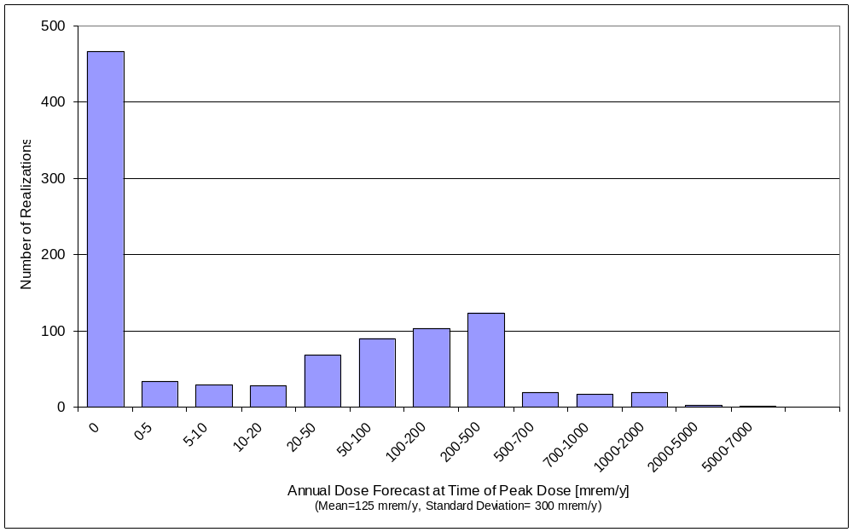

Figure A1. DOE PDM Annual Dose Frequency Distribution at Time of Peak Dose (n=1000 realizations)

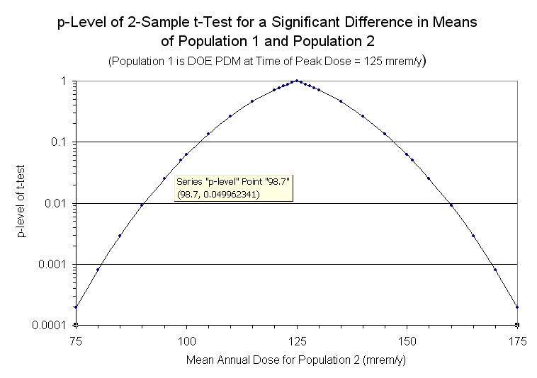
Figure A2.

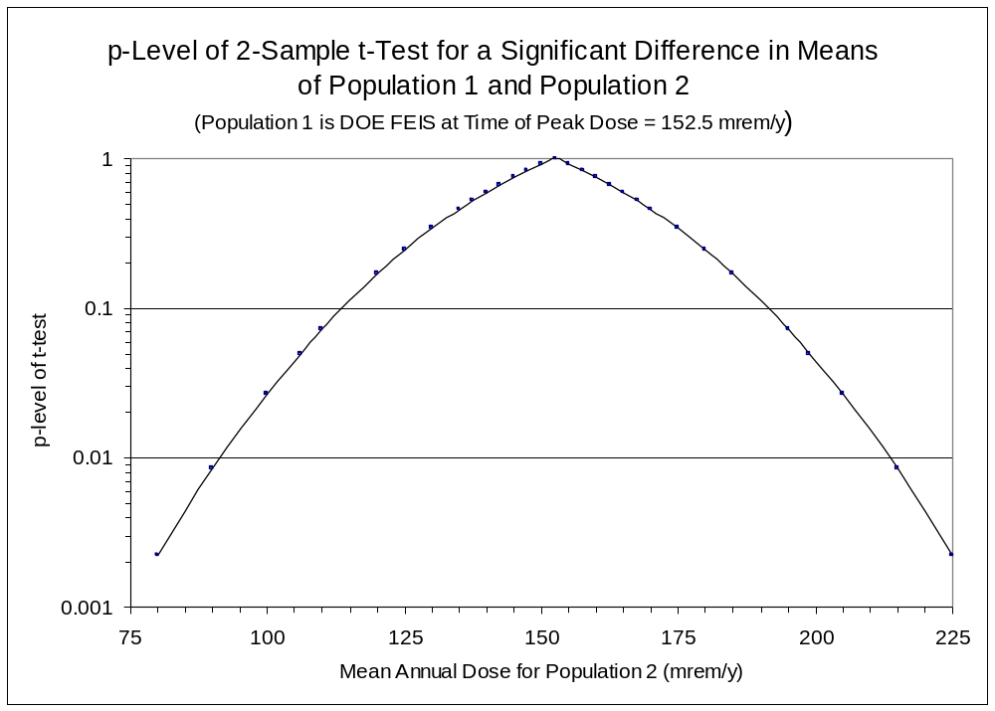
Figure A3

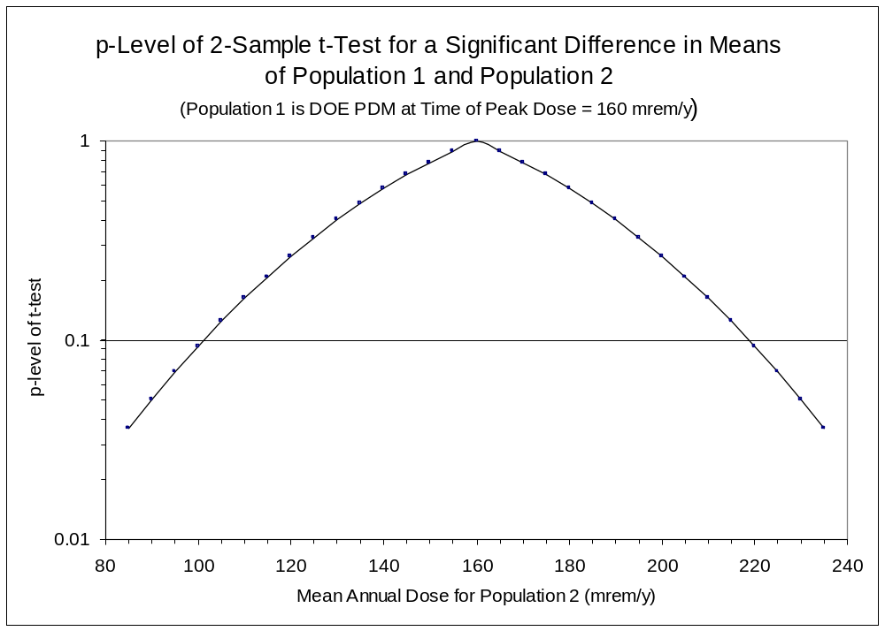
Figure A4.

Table A1. Comparison of 2-Sample t-test Results for Three Models

Model Run | Peak Mean Dose  (mrem/yr) | Year of Peak Dose | Standard Deviation  (mrem/yr) | Lower Bound  (mrem/yr) | Upper Bound  (mrem/yr) | Range  (mrem/yr)
DOE PDM  (n=1000) | 125 | 730,000 | 300 | 99 | 151 | 52
DOE PDM  (n=300) | 160 | 835,000 | 438 | 90 | 230 | 140
FEIS  (n=300) | 152.5 | 476,000 | 290.6 | 106 | 199 | 93

Appendix B

DOE-TSPA Analyses with Varying Corrosion Rate Assumptions

Confirmation of the importance of corrosion rate assumptions on dose projections and some additional insight into the importance of corrosion rate uncertainty can be obtained from examining the results of previous TSPAs published by DOE. These assessments were done with the larger, more detailed, assessment models than the DOE PDM, which contain more complex inter-relationships between the model components and represent the “state-of-knowledge” in terms of available data bases when they were performed. The TSPA models evaluated stress-corrosion cracking (SCC) as well as general corrosion and other failure mechanisms for the metallic components of the EBS.

Table B1 describes briefly the waste package performance assumptions used in DOE TSPA analyses, beginning with the Viability Assessments (VA) published in 1998 (DOE, 1998) up to the recently published Supplemental Environmental Impact Statement (SEIS) analyses (DOE, 2007). The structure of these assessment models is basically the same, i.e., the total system model is developed from abstractions of more complex sub-system models and incorporates many assumptions to simplify the integrated total system modeling. Mean peak dose projections from the various TSPAs range from a low of 2 mrem/yr in the most recent assessment (DOE, 2007) to 120-150 mrem/yr in earlier analyses, with one assessment going as high as 490 mrem/yr (DOE, 2000). (This high number came from an analysis that extended the calculations in a model, designed only for processes active within the 10,000 year period, to the one million year time frame. It should not be considered as a realistic simulation for the one million year stability period since many assumptions were made for the 10,000 year analyses that are not valid for much longer time periods, such as climatic fluctuations, cladding failure rates, seismic activity and drift degradation rates.

The most important aspect of the various TSPA models is the corrosion rate assumptions used in each. The full temperature dependence case shown on Fig 7 (ID # 5 in Table 2 for the DOE PDM analyses) involves using corrosion rate data that matches the thermal profile of the repository over the performance period. The most recent performance assessments published by DOE (DOE, 2008) also used this assumption. Very low failure rates from general corrosion were calculated, with mean doses at one million years below 10 mrem/yr. During the early times when repository temperatures are relatively higher, higher corrosion rates are used, followed by progressively lower corrosion rates corresponding to the decreasing repository temperature. In the very long-term, the low corrosion rates in this conceptualization result in delaying waste packages failures significantly beyond the end of the stability period, with an eventual peak in the dose projections (due to the eventual degradation of a large portion of the waste packages) occurring beyond one million years. Ideally, this is a more realistic approach since the corrosion rates should reflect the thermal history of the repository. However there is significant uncertainty in assuming that the low-temperature corrosion rates can be reliably extrapolated to these time frames, as discussed more below. In contrast, if a more skeptical view is taken on how reliably laboratory measurements can be extrapolated to repository in-service conditions, assuming a five-fold increase in corrosion rates might not be an unreasonable assumption (as was illustrated by the DOE PDM analyses shown in Fig. 7). This case is illustrated by combined scenario #3 in Table 3 which combines the Full Temperature Dependence (FTD) scenario from Table 2 with the assumption that waste package corrosion rates are accelerated by a factor of 5. The peak mean dose for this combined scenario is 209 mrem/yr, which is significantly higher than the peak mean dose in the Base Case in Table 2. The peak dose occurs much earlier, at 390,000 years versus 730,000 years in the base case. If the corrosion rate also is accelerated for the drip shields, then the peak mean dose is increased to 304 mrem/yr at 390,000 years in the combined scenario #4 in Table 3. The results from the DOE PDM and the DOE SEIS analyses are in good agreement concerning the implications of the full temperature-dependent assumption and its effect on dose projections.

For the cases where the lowest corrosion rate was not assumed, higher dose projections were calculated. For the TSPA-SR and FEIS analyses (Table B1), temperature independent corrosion rates were used and higher peak dose projections resulted in time frames in the hundreds of thousands of years. For these analyses, corrosion rates were assumed to be independent of temperature in the long-term, meaning that the corrosion rate used after the repository had cooled significantly corresponded to higher temperatures than the actual projected temperatures in the very long-term.

Along with the TSPA-SR results, Table B1) also contains the TSPA results from the follow-on Supplemental Science and Performance Analysis (SSPA) model. For the SSPA modeling, the DOE TSPA-SR model was modified in various ways and “one-off” sensitivity studies of the modified model were performed to assess the impact of changes to the SR model. Results of these sensitivity studies were reported in the DOE TSPA-SSPA (DOE, 2001) document. In the SSPA analyses, a temperature dependent corrosion assumption was analyzed and results showed that the time for peak dose moved outward to the end of the stability period, reflecting the slower degradation of the waste packages, in agreement with the DOE-PDM and the SEIS models .

Unfortunately most of the sensitivity analyses in the SSPA report compared the modified model results against the TSPA-SR results only to the 100,000-year time line rather than to the later peak dose. Since most of the sensitivity studies only extended to 100,000 years, it is not possible to quantitatively assess their individual contribution to the spread of peak dose estimates. However, the results offer some insights into the effects. Differences from the SR model results are listed in Table B2 for the components of the TSPA-SR model that were modified significantly. A number of factors affect seepage rates into the emplacement drifts. Intuitively, it could be assumed that these effects would amplify, to some extent, the effects of using the full temperature-dependent corrosion rates, reducing dose estimates still further. Solubility control assumptions also contribute significantly to mobilization of radionuclides from the waste package and transport out of the EBS.

Results of these sensitivity studies on the TSPA-SR model show variations in some parameters can cause changes in dose estimates of many 10s of mrem/yr. It is not possible to extrapolate these dose changes from 100,000 years to the time of peak dose with high confidence, but the trends in these results would probably continue as the time frame extends outwards to the time of peak dose. These results generally confirm the observations made from the DOE-PDM modeling exercise results discussed in the main body of this paper – that epistemic uncertainties have the most significant effects on dose projections and corrosion rate assumptions are the major driver in determining the timing and magnitude of the peak dose.

Table B1 Waste Package Performance Assumptions and Dose Projection Results in Various DOE Total System Performance Assessments (TSPA)
DOE TSPA | Peak Dose Time (years) | Mean Peak Dose (mrem/yr) | Corrosion/Radionuclide Release Assumptions for EBS Releases | Waste Package Performance Results
TSPA-VA 1998  (DOE, 1998) | ~ 300 K | ~ 140 | Considered general, local, pitting; rates span 25-100 ºC; general corrosion by dripping proportional to seepage with flow focusing from seeps onto failed metal, corrosion rates correlated to dripping variations; juvenile failures (1-10) included; cladding credit taken; volumetric flux through failed package scaled with increasing corroded areas on the package | Relatively rapid failure of pkgs. because corrosion resistant metal is inside and more susceptible to localized corrosion after stainless steel outer metal is degraded
TSPA –SR  2000  Three separate models used  (DOE, 2000) | (1) 270 K  (2) 1,000 K  (3) ~ 700 K | ~ 490  ~ 30  ~ 120 | General corrosion, local corrosion, SCC; Temperature independent corrosion rate used; cladding credit taken; no credit for inner stainless steel container, diffusion thru SCC (assumed continuous pathway) and advective flow, volumetric flux through failed package scaled with increasing corroded areas on the package | Three different models used as follows: (1) 10 K model simply extrapolated to peak dose beyond 10 K yrs., (2) secondary actinide phases control solubility in the very long-term, (3) multiple glacial periods.
TSPA – SSPA  2001  (DOE, 2001) | ~ 120 K  1,000 K | ~140 (TI)  ~110 (FTD) | General corrosion, local corrosion, SCC; Full temperature dependent (FTD) and temperature independent (TI) corrosion rates used; cladding credit taken; volumetric flux through failed package scaled with increasing corroded areas on the package | SR models modified for newer data/assumptions, Peak shown for nominal case (no disruptive events), SSPA analyzed a high-temp model (HTOM) and a lower-temp model (LTOM) – both with dose history still rising at one million yrs.
TSPA-FEIS  2002  (DOE, 2002) | ~475 K | ~120-150 | General corrosion. Local corrosion, SCC; Temperature independent corrosion rate used (faster rates assumed); cladding credit taken; volumetric flux through failed package scaled with increasing corroded areas on the package | FEIS analyses assumed larger repository than SR and SSPA analyses, also assumed different BDCFs and 3,000 acre-ft rep vol. not used in previous PAs
TSPA-FSEIS 2008  (DOE, 2008) | >1 million yrs. | ~ 2 | General corrosion – full temperature dependence enhanced by microbial corrosion, local and stress corrosion cracking; juvenile failures considered; no cladding credit; volumetric flux through failed package scaled to drip rate through failed shield and increasing corroded areas on the package | 10% of packages get general corrosion breaches by one million yrs. Only 0.4% of package surface removed; SCC failures begin at 400 K yrs – no flow through SCC failures; releases from gen. corr. Failures are well after one million years, releases within one million years largely from disruptive scenarios

Table B2 Modifications to the DOE TSPA-SR Model for Sensitivity Analyses Presented in the DOE TSPA-SSPA

Post TSPA-SR Modifications to the TSPA-SR Sub-Models | Nature of Modification to TSPA-SR Model | Effect on Projected Performance (From DOE, 2001, Chapters 3. 2 & 4) against TSPA-SR base case model (~60 mrem/yr at 100 K yrs. reference mark)
Climate | Includes post-10K climate fluctuations in the nominal case | Seepage increases with higher infiltration. Only 20% increases in waste packages experiencing seepage over the SR base case
Seepage | More data for repository rock units | No significant increase in dose over SR base case estimates
Seepage Flow Focusing | Used non-heterogeneous permeability field in simulations to derive focusing factor | Increased seepage but only a small difference from the SR base case – less than10 mrem/yr.
Episodic Seepage | New factors for episodic changes in seepage from fractures | Raised 100 K yr. dose ~ 30 mrem/yr over the SR base case
Thermal Properties | Included newer data on rock units and invert properties | Changes affect relative humidity in drifts – high temp. case and SR base case very similar results, low-temp case significantly different than the SR base case – longer time to failure
Thermal-Hydrologic Effects and Seepage | Calculations include newer data on rock properties | Changes affect seepage rates – general lowering relative to the SR base case
In-Drift Chemistry | Used smaller range of thermodynamic data and host rock mineralogy | No significant increase in dose over SR base case
Stress Corrosion Cracking | Newer data on crack shape and propagation, uncertainty and threshold values | Longer time to SCC failures, resulting in lower doses than SR base case at 100 K yrs. ~ 10 – 30 mrem/yr. (greater difference at less than one million yrs.)
General Corrosion | Include temperature dependence of corrosion rate | Reduces doses by 60 mrem/yr. at 100 K yr.. over SR base case, peak dose extends beyond one million yrs.
Evaporative Seepage Reduction | New model added | No significant change over the SR base case
Flow through Waste Package | Flow through drip shield not always on package breaches, bathtub effect | Lower dose than the SR base case at 100 K yrs. ~20 mrem/yr
In-Package Chemistry | Considers waste form and iron degradation products on chemistry | Raises dose as much as 50 mrem/yr. at 100 K yrs. – elevated solubility for actinides
Cladding Degradation | Newer data on creep, SCC, local corrosion and unzipping | Slightly lower doses up to 100 K yrs – no significant difference from the SR base case at one million years.
In-Package Solubility Limits | Increased uncertainty on controlling phases | Lower dose at 100 K yrs. by ~ 60 mrem/yr. relative to SR base case
EBS Diffusive Transport | Diffusive transport included | No significant difference from the SR base case
EBS Sorption | Includes sorption on waste package degradation products and the invert | Reduces dose at 100 K yrs. By ~ 10 mrem/yr
UZ Transport in Drift Shadow | Modified flow mechanisms | Delays transport by 10 K yrs. Relative to SR base case, lowers 100 K yr. dose by ~ 25 mrem/yr.
SZ Transport | Modified bulk density and I and Tc coefficients in the alluvium, other assumptions | No significant differences through entire dose history to 100 K yrs relative to the SR base case
Biosphere Dose Conversion Factors | Modified factors used | Small lowering ( less than 10 mrem/yr )  relative to the SR base case
Total System Releases from TSPA-SSPA Model | Effects of all modifications to the TSPA-SR model | Releases delayed in time relative to the SR base case for the low-temp model and projected doses lower than the SR base case by 10-80 mrem/yr. at one million years

There is an earlier, lower peak of 153 mrem/yr at 635,000 years, not used in this analysis.

