USDA Foreign Agricultural Service
GAIN Report

Global Agriculture Information Network
Template Version 2.09

Voluntary Report - public distribution
Date: 1/15/2004
GAIN Report Number: BR4602
BR4602
Brazil
Market Development Reports
Pet Food Report
2004

Approved by:
William W. Westman, Agricultural Counselor
U.S. Embassy
Prepared by:
Andrea F. Stevenson

Report Highlights:
The Brazilian pet population is estimated at 28 million dogs and 12 million cats. The market for pet food has shown an annual growth of 10 to 12 percent, and is expected to remain the same for the next 7 years. This expectation is based on the fact that 64 percent of the pet owning population does not feed their animals with prepared food. The import potential for pet food in Brazil is in the premium and canned foods sector. Despite the decrease of imports, the United States is still the major supplier of imported pet food in Brazil.

Includes PSD Changes: No
Includes Trade Matrix: No
Unscheduled Report
Brasilia [BR1]
[BR]

BRAZILIAN ECONOMIC OVERVIEW

Brazil, like other developing economies, is vulnerable to exchange rate fluctuations, and large capital inflows and outflows. Intense pressure on the exchange rate and Brazil’s high debt to GDP ratio exacerbates this situation. If investors lose confidence, the flows register a downward trend, weakening the local currency, which leads investors to limit lending. Therefore, the cost of money increases. A reduction in the dependence on foreign capital seems desirable; however, for the foreseeable future, Brazil will continue to rely on foreign investment. For now, the Brazilian economic and political outlook is guardedly optimistic. Though Brazil’s new president Luiz Ignacio Lula da Silva, known as Lula, hails from Labor Party, he continued the sound macroeconomic policies of his predecessor, Fernando Henrique Cardoso, since taking power in January 2003. In addition, Lula has shown an ability to press forward with reforms in the Brazilian Congress, which at least in the short run is more likely to ensure growth and expand tax revenues.

In 2002, according to the Brazilian Institute of Geography and Statistics (IBGE), GDP totaled R$1.32 trillion, 1.5 percent growth compared to 2001. The modest economic growth of 2002 and into 2003 has been, to some extent, due to uncertainties with the new government, impacting the exchange rate and the official interest rate – SELIC – which equalizes interest rates applied to the local market. The depreciation of the local currency over the past five years has clearly affected Brazil’s imports. In January 2002 the dollar was trading at US$1=R$2.6, but by December 2002 the exchange rate had reached US$1=R$3.7, with SELIC climbing from 19 percent to 25 percent in the same year. However, as of early December 2003, the SELIC had decreased 16.5 percent and the exchange rate to US$1=R$2.92

Economic Indicators

 | 1998 | 1999 | 2000 | 2001 | 2002 | 2003*
GDP Growth (%) | 0.1 | 0.9 | 4.0 | 1.5 | 1.5 | 0.5
Inflation (%)  (IPCA/OBGE) | 1.7 | 8.9 | 6.0 | 7.7 | 12.5 | 9.6
Average Exchange  Rate (R$/US$) | 1.16 | 1.81 | 1.83 | 2.35 | 2.96 | 3.10
Total Exports  (US$ billion) | 51.1 | 48.1 | 55.0 | 58.2 | 59.6 | 72.0
Total Imports  (US$ billion) | 57.5 | 49.2 | 55.7 | 55.5 | 55.3 | 48.0

Sources

 Brazilian Ministry of Development, Industry, and Commerce (MDIC)/Secretariat of Foreign Trade (SECEX) – Trade databases (1998-2002)

 Brazilian Institute of Geography and Statistics (IBGE) (1998-2002)
 Brazilian Central Bank trade data
 Current Analysis
* Projections for 2003 are taken from the Central Bank of Brazil (FIPE)

TRENDS IN BRAZILIAN PET FOOD PRODUCTION AND MARKET

The Brazilian Pet Food Manufacturers Association (ANFAL) only started compiling statistics on the Brazilian pet food production separately from other animal feed in 1995. According to ANFAL, the pet population in Brazil is estimated at 28 million dogs and 12 million cats. This population is increasing, as small pets become more popular. The two main reasons for the growth are the increasing proportion of Brazilians living in apartments and the use of small pets for companionship of older people. However, only 36 percent of the Brazilian pet population is fed with prepared pet food. The industry’s goal is to achieve 50 percent of the potential consumption. This goal is based on the premise that 50 percent of Brazilians who own pets have the income to purchase pet food

The Brazilian market for pet food has shown an annual average growth of 10 to 12 percent in the past 5 years. The local industry believes that if the country’s financial situation doesn’t register any dramatic change in the upcoming years, the annual growth should remain the same for the next 7 years. It is estimated that by the year 2010, 45 percent of the Brazilian pet population will only be fed with prepared pet food. At that point, Brazil will place third in the world estimates of pet food consumption, after England with 70 percent of their pets only being fed with pet food, and the United States, with 55 percent.

Brazilian domestic pet food production in 2002 was 1.23 million tons. The 2003 forecast production is 1.3 million tons, or US$651 million. Brazil is the first producer of pet food in Latin America with a share of 48.4 percent of the total production, and third in the world, after the United States and China. Total Brazilian consumption is estimated at 3.2 million tons, and expected to increase in 2003. It is also considered the world’s third largest market for pet food. Consumption is concentrated in the Southeast region, with 43 percent of the total country consumption; the Northeast region comes in second, with 28 percent, followed by the South, Center-South, and North regions, with respective shares of 15, 7, and 7 percent.

The local market is comprised of many companies, rather than a few large players, since the big companies cannot avoid paying high production and commercial taxes, like the smaller ones, which makes the competition unbalanced. Accounting for 47 percent in value, the amount of taxes incurred by pet food products continues to represent a barrier that keeps manufacturers from reaching 1.6 million tons of pet food production. Considering that Brazilian consumers are highly price sensitive, Brazilian trade associations such as ANFAL are working with the Brazilian government in an effort to cut taxes in half.

The main Brazilian manufacturers are Nutriara, Nestlè, and Effem. In 2001, Nestlè acquired Ralston Purina, which was the number one Brazilian manufacturer of pet food. With an investment of approximately US$10 billion and the consequent inclusion of the successful Purina products to its portfolio, Nestlè became the market leader, followed by Effem and Nutriara. Following is a list of the main Brazilian manufacturers and their products.

BRAND | PRODUCT
NUTRIARA | DOGS - Dogui, Dogui Jr., Dog Show (adult and puppies), Dog Show Gourmet, Dunga, Foster (original, junior, and mix), Pitukão, and Pitukinha (for puppies)  CATS – Gatto (beef, liver, and fish), Pitukats (beef, chicken, fish, and mix)
NESTLÈ / RALSTON PURINA | DOGS – Pro Plan, Beneful, Alpo, Bonzo, Canina, Deli Dog, Dog Biscuits  CATS – Pro Plan, Friskies, Cat Chow, Gatsy, Fancy Feast, Cat Snacks
EFFEM | DOGS – Pedigree (beef, vegetables, marrowbone), Pedigree Jr., Pedigree Small Breeds, Pedigree Senior, Pedigree Biscuits, Frolic (barbecue, chicken, vegetables),  Frolic Jr., Frolic Snack  CATS – Whiskas
GUABI | DOGS – Receitas da Natureza(Nature’s Recipes), Heroi, Heroi Mascote (puppies), Sabor Vida, Biriba, Faro, Fiel, and Gorjeio.\  CATS – Top Cat, Cat Meal, Limpi Cat

Despite the economic difficulties, the market for commercially manufactured pet food over the long term is still attractive in Brazil and has room for expansion, particularly since 64 percent of the pet-owning population does not feed their animals with prepared pet food. Niche opportunities for imports remain in the premium pet food sector for dogs and cats, for regular and canned cat food, and for therapeutic foods for dogs and cats since most of these categories of pet food consumed in Brazil are imported.

Both ANFAL and the pet food manufacturers agree that the premium pet food sector has shown a sharper rate of growth, compared to regular pet food. The largest market share is held by economy brands, which account for an estimated 46 percent. The next largest is the standard dry products which typically are sold at hypermarkets, supermarkets, and animal feed stores, estimated at 39 percent of the market. Demand for canned products is low because of higher costs compared to dry pet foods.

MARKETING ACTIVITIES

Marketing efforts are aimed at veterinarians, who are recommending to customers the use of prepared pet food rather than home made food, as in the past. Marketing activities are mostly held at pet shops and at some veterinarian clinics that specialize in small animals, in an effort to educate pet owners about the nutritional value of prepared foods

The top Brazilian pet food manufacturers that target the higher income public are promoting their products at alternative events, such as fashion shows and interior design events. According to them, pet owners tend to transfer their own life styles to their pets, and the best way to make these consumers familiar with the brands is to associate it with situations that represent their life styles, such as beauty, sophistication, and modernism. Other companies are using sports events to market their brands, by sponsoring local teams. During those events, they use the breaks of the games for presentations with pets.

These marketing activities are expected to stimulate sales growth, which is expected to increase by 12.9 percent annually over the next several years.

THE BRAZILIAN MARKET FOR IMPORTED PET FOOD

Import potential for pet food in Brazil is small and mainly restricted to the premium, super premium, therapeutic, and canned food sectors. It represents only 2 percent of the total consumption. In the past years, imports of dog and cat food accounted for 7 to 8 percent of the total consumption. However, most exporters found it more profitable to establish their factories in Brazil, or in South America in general, where material and work force is cheaper.

Despite the decrease of imports of pet food, the United States is still the major supplier of imported pet food to Brazil, placing first among other exporters.

TOTAL IMPORTS OF PET FOOD X IMPORTS FROM THE U.S.,
IN VOLUME (Metric Tons) *

 | TOTAL | U.S. IMPORTS | U.S. SHARE
2000 | 7,228 | 5,726 | 79%
2001 | 5,491 | 4,999 | 91%
2002 | 5,099 | 4,759 | 93%
2003 | 4,548 | 1,511 | 33%
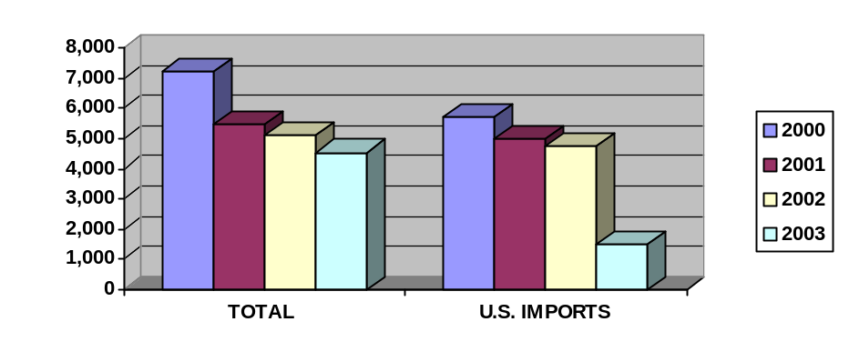

TOTAL IMPORTS OF PET FOOD X IMPORTS FROM THE U.S.,

IN PRICE (US$ FOB) *

 | TOTAL | U.S. IMPORTS | U.S. SHARE
2000 | 6,447 | 5,424 | 84%
2001 | 4,953 | 4,443 | 90%
2002 | 4,657 | 4,177 | 90%
2003 | 4,127 | 1,352 | 33%
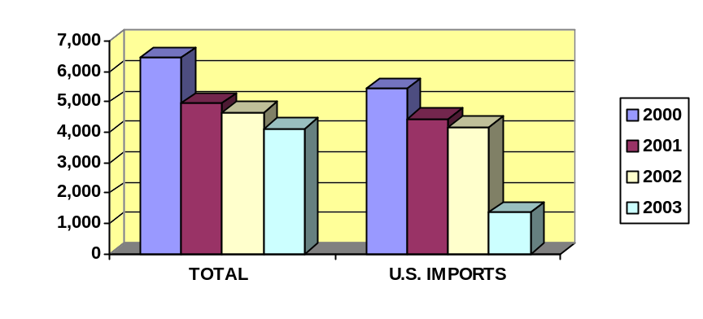
* - SOURCE – Brazilian Ministry of Development, Industry, and Science

DISTRIBUTION CHANNELS

Supermarkets and hypermarkets have been showing a constant growth in their share of pet food sales. They are the preferred channels for purchases of mid-priced and economy pet food. These stores are responsible for a 40 percent share of the national retail sales of dog food and 39 percent of cat food, because of the wide range of variety found is those stores, and the convenience that they offer. Other places for distribution of pet food are pet shops, veterinary clinics, and animal feed stores, where premium, imported and therapeutic foods can be found. Those establishments are responsible for 19 percent of both dog and cat food. Pet food is mostly consumed in the South and Southeast regions of Brazil (states of São Paulo, Rio de Janeiro, Minas Gerais and Espírito Santo), due to the higher income in these regions. These regions are the best markets for imported foods for this same reason.

Prices among national brands are very competitive, while imported products cost almost three times as much. This is the main reason claimed by most supermarkets not to carry imported brands, as they prefer to keep their prices lower and competitive.

PACKAGING AND LABELING

In general, packaging for the retail consumer is more elaborate in Brazil than in other South American countries. Packaging from the United States is well accepted by Brazilian consumers. U.S. exporters should be aware that the preferred type of packing is individual and small-size packs, due to consumer preference and higher prices of imports.

Brazilian regulations require that all food products provide precise, clear, and easily readable information in Portuguese about the product, including quantity in metric measurements, composition, expiration date (shelf life or best-if-used-by), and country of origin. If no original label is designed for the Brazilian market, it is customary for the importer to affix a label in Portuguese with the translation of the original label in English.

Products containing more than 1 percent of Genetically Modified Organisms (GMOs) in its ingredients, must also show this information on the label, and carry the Brazilian symbol for transgenic products.

The Brazilian importer must be formally registered with the Brazilian Ministry of Agriculture, Livestock, and Food Supply (MAPA), and will be responsible for registering the product to be imported, its original label, its translation, and will have to file a descriptive memorandum of the product, with all of its technical and nutritional information. Those are all requisites for the importation of pet foods. Each label and product to be imported has to be registered individually.

OAA Brasilia advises U.S. exporters interested in doing business with Brazil to check with the Brazilian authorities or a local consultant on the status of the legislation and technical regulations in place, or advise their importers to do so, prior to shipping their products Brazil.

COMPOSITION AND QUALITY – GUARANTEE LEVELS

The Brazilian Ministry of Agriculture, Livestock, and Food Supply (MAPA), through the Normative Instruction Number 009, dated July 9, 2003 determines the identity and quality standards (guarantee levels) for complete and special dog and cat food. These standards must be observed in order to have complete and special dog foods registered with MAPA. The “Special” category refers to dog and cat snacks and biscuits. According to the mentioned regulation, the guarantee levels must also appear on the product label, as well as all the specific nutrients associated to the denomination indicated or its components.

I- NUTRITIONAL VALUES FOR:
1. Complete Dog Food – Puppies (%)
 | Dry Foods | Semi-Humid Foods | Humid Foods
Humidity (max) | 12.0 | 30.0 | 84.0
Gross protein (min) | 22.0 | 18.0 | 4.0
Ethereal extract * (min) | 7.0 | 6.0 | 1.3
Fibrous material (max) | 6.0 | 5.0 | 2.0
Mineral material (max) | 12.0 | 10.0 | 2.5
Calcium (max) | 2.0 | 1.6 | 0.4
Phosphorus (min) | 0.8 | 0.6 | 0.1
* - The determination of the ethereal extract must be previously submitted to a acidic hydrolysis.

2. Complete Dog Food – Adult Dogs (%)
 | Dry Foods | Semi-Humid Foods | Humid Foods
Humidity (max) | 12.0 | 30.0 | 84.0
Gross protein (min) | 16.0 | 13.0 | 3.0
Ethereal extract * (min) | 4.5 | 3.6 | 1.0
Fibrous material (max) | 6.5 | 5.2 | 2.0
Mineral material (max) | 12.0 | 10.0 | 2.5
Calcium (max) | 2.4 | 2.0 | 0.4
Phosphorus (min) | 0.6 | 0.5 | 0.1
* - The determination of the ethereal extract must be previously submitted to a acidic hydrolysis.

3. Complete Cat Food – Kittens (%)
 | Dry Foods | Semi-Humid Foods | Humid Foods
Humidity (max) | 12.0 | 30.0 | 84.0
Gross protein (min) | 28.0 | 23.0 | 5.3
Ethereal extract * (min) | 8.0 | 6.5 | 1.5
Fibrous material (max) | 4.5 | 3.6 | 2.0
Mineral material (max) | 12.0 | 10.0 | 2.5
Calcium (max) | 2.0 | 1.6 | 0.4
Phosphorus (min) | 0.8 | 0.6 | 0.1
* - The determination of the ethereal extract must be previously submitted to a acidic hydrolysis

4. Complete Cat Food – Adult Cats (%)
 | Dry Foods | Semi-Humid Foods | Humid Foods
Humidity (max) | 12.0 | 30.0 | 84.0
Gross protein (min) | 24.0 | 19.0 | 4.4
Ethereal extract * (min) | 8.0 | 6.5 | 1.5
Fibrous material (max) | 5.0 | 4.0 | 2.0
Mineral material (max) | 12.0 | 10.0 | 2.5
Calcium (max) | 2.4 | 2.0 | 0.4
Phosphorus (min) | 0.6 | 0.5 | 0.1
* - The determination of the ethereal extract must be previously submitted to a acidic hydrolysis

5. Special Dog Food (%)
 | Dry Foods | Semi-Humid Foods | Humid Foods | Liquid Foods
Humidity (max) | 12.0 | 30.0 | 84.0 | 95.0
Gross protein (min) | 7.0 | 5.6 | 1.3 | 0.4
Ethereal extract * (min) | 4.0 | 3.2 | 0.7 | 0.3
Fibrous material (max) | 26.0 | 21.0 | 5.0 | 1.5
Mineral material (max) | 12.0 | 10.0 | 2.5 | 0.7
Calcium (max) | 2.5 | 2.0 | 0.5 | 0.2
Phosphorus (min) | 0.1 | 0.08 | 0.02 | 0.02
* - The determination of the ethereal extract must be previously submitted to a acidic hydrolysis

6. Special Cat Food (%)
 | Dry Foods | Semi-Humid Foods | Humid Foods | Liquid Foods
Humidity (max) | 12.0 | 30.0 | 84.0 | 95.0
Gross protein (min) | 24.0 | 19.0 | 4.4 | 1.4
Ethereal extract * (min) | 7.0 | 5.6 | 1.3 | 0.4
Fibrous material (max) | 16.0 | 13.0 | 3.0 | 1.0
Mineral material (max) | 12.0 | 10.0 | 2.5 | 0.7
Calcium (max) | 2.5 | 2.0 | 0.5 | 0.2
Phosphorus (min) | 0.3 | 0.2 | 0.02 | 0.02
* - The determination of the ethereal extract must be previously submitted to a acidic hydrolysis

II – CALORIC VALUES FOR SPECIAL FOODS FOR:

1. Adult Dogs (%)
Denomination | Caloric Value
Light; Low Calories, Reduced Calories, Low Energy, Low Fat | Maximum of 3,100 Kcal/Kg for foods formulated with up to 12% humidity.  Maximum of 900 Kcal/Kg for foods formulated with more than 65% humidity  Level of ethereal extract – maximum of 10%

2. Adult Cats (%)
Denomination | Caloric Value
Light; Low Calories, Reduced Calories, Low Energy, Low Fat | Maximum of 3,250 Kcal/Kg for foods formulated with up to 12% humidity.  Maximum of 950 Kcal/Kg for foods formulated with more than 65% humidity  Level of ethereal extract – maximum of 10%

IMPORT REGULATIONS AND DUTIES

The Brazilian import duty for dog and cat food is 15.5 percent. Products from MERCOSUL member countries (Argentina, Uruguay and Paraguay) are duty free and Chile, an associate country, enjoys preferential access.

USEFUL ADDRESSES:

ANFAL - National Feed Manufacturers Association
Rua Claudio Soares, 160
Bairro Pinheiros
05422-030 São Paulo - SP
Tel./Fax: (55 11) 3031-3933

ANCLIVEPA - São Paulo Association of Veterinarian Clinics for Small Animals
Av. Helade, 205 - sala 04
04634-000 São Paulo - SP
Tel.: (55 11) 5564-6351

Ministerio da Agricultura, da Pecuária e do Abastecimento - MAPA
SDR/DFFPA/CGPA
Esplanada dos Ministerios, Bloco D
2o andar, sala 251
70044-901 Brasilia - DF
Attention: Sr. Francisco Pereira de Lucena
Tel.: (55 61) 218-2720 / 218-2307 Fax: (55 61) 218-2727 / 321-4524

Pet Food, Health & Care Magazine
Diretoria de Alimentos para Animais de Estimação
Rua Claudio Soares, 160 - Pinheiros
05422-970 Sao Paulo - SP
Tel/Fax: (55 11) 3815-9396 / 3037-7244

USDA IN BRAZIL

Office of Agricultural Affairs – OAA/Brasilia
U.S. Embassy, Brasilia, Brazil
SES – Av. das Nações, Quadra 801 – Lote 03
70403-900 Brasília, Brazil
Tel.: (55 61) 312-7101
Fax: (55 61) 312-7659
e-mail: AgBrasilia@usda.gov

Agricultural Trade Office – ATO São Paulo
Alameda Santos, 2224
Edifício Suarez Trade, Conj. 11
01418-200 São Paulo - SP
Tel.: (55 11) 3082-3528
Fax: (55 11) 3083-7535
E-mail: ATOSaoPaulo@usda.gov

