DROUGHT MONITORING TASK FORCE
Drought Status Report
March 14, 2002

The Virginia Drought Monitoring Task Force held a conference call on March 8, 2002 to discuss the current moisture conditions in the Commonwealth. The Department of Environmental Quality compiled the following report from information provided by the State Climatologist, the Virginia Departments of Agriculture and Consumer Services, Health, Forestry, Emergency Services, Game and Inland Fisheries; the Virginia Cooperative Extension Service, Farm Service Agency-USDA, the National Weather Service, and the U. S. Geological Survey.

OVERVIEW
Drought conditions remain relatively unchanged since the report of February 21, 2002. Current drought conditions have been persistent since the fall of 1999 with minor periods of improved moisture conditions within that period. Three consecutive winters of below average precipitation have resulted in significant reductions in ground water recharge and ground water monitoring wells for near surface aquifers show the lowest ground water levels for the period of record. These historic low ground water levels have resulted in a condition where there is little ground water discharge available to support stream flows. Stream flows across the Commonwealth were less than the 95th percentile for stream flow exceedance on March 8 (historically 95% or more of the time stream flows have been greater than those measured for March 8). New record minimum daily flows for March are expected at approximately half the streamgages across the State except for those streamgages in southwest Virginia. Discharges from large reservoirs such as Smith Mountain Lake, Lake Anna, and Lake Moomaw have been reduced in an attempt to fill these reservoirs for future water demands. Low stream and reservoir levels are impacting recreational opportunities due to lack of access (water levels below boat ramps) and cancellation of stream trout stockings. Livestock producers began feeding hay two to three months earlier than usual due to poor pasture conditions. Winter small grain crops are making little progress due to dry conditions and should these conditions persist, impacts are expected on spring plantings. Many farm ponds that are used for livestock watering and irrigation are at very low levels or dry, especially in the Shenandoah Valley. Public water supplies, both ground water based and surface water based, are in relatively good condition with only a few cases of voluntary and mandatory water use restrictions. While little is known on private ground water based supplies, it is anticipated that individual domestic users, especially those that utilize water table aquifers, have been or will be impacted by low ground water levels. Forest fuel moisture conditions at the moment are not quite as dry as what they were in the fall. As the state returns to warmer daytime temperatures over the next month, forest fuels will dry out quickly resulting in the potential for significant forest fire threats.

CLIMATOLOGICAL CONDITIONS

National Weather Service
Rainfall this past weekend (March 9 and 10) ranged from a trace to .10 across the Commonwealth, which continues to leave the region with below average precipitation for the month and year. There are two opportunities for rain during the next ten days. The first is Tuesday (March 12) into early Wednesday, then this coming weekend (March 16 and 17). Amounts of one-half inch are possible on March 12 and 13, especially in central and southern Virginia. Over the next 7-10 days (March 14 through 23), two weather systems are forecast to affect the region. The first system will arrive Saturday. A cold front associated with this system will cross and stall to the south of Virginia. A wave of low pressure is expected to develop and move east along the front. Preliminary rainfall amounts are estimated to be less than two-tenths (.20) of an inch. The next chance for measurable rainfall is forecast for the Wednesday and Thursday (March 20 and 21) time frame. If this system evolves, more widespread precipitation is possible which would be beneficial, however it is too early to determine specific amounts for next weeks system. One item of note is that we appear to have undergone a pattern change in the last 2-3 days, with the computer models suggesting a more favorable pattern for rain during the next 2 weeks. Whether the rainfall will be widespread and/or significant remains to be seen. There is, however, more short-term hope than existed on Friday March 8.
The latest NOAA drought monitor expanded the coverage of category D-3 (extreme drought) to include the Virginia Blue Ridge, Northern Neck, and Eastern Shore. The drought monitor is included as Appendix A. The NOAA seasonal drought outlook remains unchanged from the February 21 report and is included as Appendix B.

Report of the State Climatologist

Virginia’s severe drought continues, with conditions generally worsening in an east-to-west transect of the state. Conditions are especially severe in the Western Piedmont, the Shenandoah Valley and surrounding mountains, and Northern Virginia. In these regions, this drought is severe both from short and long-term perspectives.

Included are six-month (Appendix C) and 43-month (Appendix D) accumulated departures for a sample of Virginia stations. The six-month deficit is especially large in Northern Virginia, and it is the second largest six-month deficit in the Washington DC record that goes back to 1870. The six-month deficit of record is in 1930, which is the short-term drought of record in Virginia. (The Washington record is a composite of Reagan National Airport and downtown data and can be thought of as “Northern Virginia”).

Notably the current Northern Virginia deficit is already very close to that of 1930, with 13 inches this year vs. 14 inches in 1930. Six-month deficits in the Shenandoah Valley station with the longest period of record, Dale Enterprise (near Harrisonburg) were only exceeded in 1930 and in the mid-1960’s drought. The latter event is the largest long-term drought in the Virginia record, although it was not as severe in the shorter term as the 1930 event.

Note that the six-month deficits for both Dale Enterprise and Northern Virginia are very similar to those observed in 1999, which is why the long-term figures for these locations are so low.

The longer-term shortages maximize at 43 months, beginning in the summer of 1998. They are also worth noting because of the abundance of moisture that preceded this drought, peaking in the late 1990’s. Arguments have been made that this excess was a result of higher-than normal El Niño frequencies, although long-term statistical tests do not support a substantial El Niño-precipitation link in Virginia. The start of another El Niño in recent weeks is therefore either positive or neutral for Virginia precipitation.

The table included in Appendix E breaks down precipitation departures into the six Virginia climatological divisions for one, two, three, six and twelve month periods.

One month (February) deficits average the 4th-greatest for all Februarys in the Virginia 107-year record, with again the Northern and Shenandoah Valley (officially known as the “Central Mountain” Division) divisions showing the greatest deficits, at 19% of the long-term average. As noted above, the deficits maximize at 6 months in terms of absolute amount of precipitation. The recent September-February period is the driest September-February in the record, but note that there are 12 possible six-month combinations each year.

Palmer Index values for the week ending March 9, 2002 are shown in Appendix F and range from –2.33 to –3.66. They place the Tidewater, Eastern Piedmont and Central Mountain Climatic Divisions in the "Severe Drought" category and the rest of the state in the "Moderate Drought" category. It is important to remember that the Palmer Index provides a general description of drought conditions. The classifications assigned by Palmer Index values appear reasonable for the Tidewater and Eastern Piedmont. Existing conditions indicate that it would be more accurate to describe much of the Western Piedmont as being in "Severe Drought" and much of Northern Virginia and the Shenandoah Valley (Central Mountain Division) as in "Extreme Drought”.

PROVISIONAL ASSESSMENT OF HYDROLOGIC CONDITIONS IN VIRGINIA

United States Geological Survey
Streamflows across the State are well below the normal range of flow expected during winter months despite recent rain on March 2-3, 2002. Streamflows are at levels expected during the late fall months when flows generally are at annual minimums.

New record minimum daily flows for March are expected at approximately half the streamgages across the State except for those streamgages in southwest Virginia. The minimum flows occurred on March 1-2, 2002, before the statewide rainfall elevated streamflows slightly. Statistically, March has the highest minimum streamflow values for the year.

The drought of 1930-32, was the worst drought in Virginia in at least 100 years. Current streamflow, while low, is not consistently at the low levels experienced during the 1930’s drought. Appendix G contains a hydrograph for the North Fork Shenandoah River at Strasburg, Va., and compares current streamflow values with streamflow values during 1931. Ground-water levels also are not at levels experienced during the early 1930’s; however, ground-water data in Virginia are very limited. Only one well in Virginia has measurements that date back to 1931. Appendix H contains a hydrograph for a well in Arlington County, Va. (53V 1). The data show that the well was basically dry in 1931. Low water levels also are shown for the droughts in 1942, 1955, 1966, and 1982. Currently, the well water level is 5 or 6 feet above the minimum level observed in 1931 and approximately 2 feet above minimum water levels observed in the 1942, 1955, 1966, and 1982 droughts. Appendix I contains a hydrograph for a well in Colonial Heights, Va. (51G 1). The data show ground-water levels during the droughts in 1942, 1964-1966, and 1982. Currently, the well water level is approximately 1 foot above the minimum water levels observed during 1942 and 1964.

Appendix J gives flow duration and current flow conditions for selected U.S. Geological Survey and Virginia Department of Environmental Quality surface-water gaging stations. Data are provisional and subject to revision. The normal range of flows is defined as flows in the middle two quartiles (between those flows equaled or exceeded 75 percent of the time and those flows equaled or exceeded 25 percent of the time).

Department of Environmental Quality, Status of Major Reservoirs
Smith Mountain Lake near Lynchburg is 3.8 feet below normal and mostly stable with inflow equal to outflow. Minimum releases are 250 cfs. Normal releases would be 650 cfs. The minimum release has been authorized under a variance since September 3rd. The current variance expires April 15th. DEQ will have to take action at that time to extend the variance. Recreation at the lake could be severely impacted and the annual release to support the Striped Bass spawning run is in severe jeopardy.

Lake Moomaw in western Virginia is 19 feet below full with only 28% of the conservation storage remaining. The lake is stable with a minimum release of 100 cfs and inflow approximately the same. The minimum releases would normally be 171 cfs. This current variance expires April 30th.

Kerr Reservoir in Southside is at 294.6 feet above mean sea level and very slowly rising. The Wilmington District has been operating the Lake under reduced releases since December. The lake is only currently about one foot below the guide curve. However the guide curve target rises 5.5 feet in March, so by the end of the month, the lake will probably be six feet below its guide curve target. Low inflows and low lake levels may jeopardize the ability to release up to 4000 cfs into the lower Roanoke River to enhance the spawning run of Striped Bass. Inflows to the lake are only on the order of 3000 cfs.

Philpott Reservoir near Martinsville is 10 feet below normal and rising slowly. Minimum releases have been cut back to one fourth of their normal condition.

FISHERIES AND RECREATIONAL IMPACTS

Virginia Department of Game and Inland Fisheries
In spite of last week’s widespread rainfalls, water levels for many rivers, streams and impoundments are at record low levels for this time of year. As reported at last month’s meeting, stockings of trout to some small streams in the Shenandoah Valley have been cancelled, and more widespread cancellations in small streams can be expected if water flows do not improve. Daily information on trout stocking is posted on the Department web page at www.dgif.state.va.us or by calling 1/434/525-3475. Fortunately for anglers, most of the trout stocking waters are larger streams and small impoundments, which remain at levels high enough to support stocking and fishing. To date, cancellations have been limited to less than 10% of the scheduled stockings.

Stream and river levels may pose a problem for canoeists and float fishermen in some areas. The upper reaches of the Shenandoah and Rappahannock Rivers as well as many tributaries across the state may be difficult to float through.

Most large reservoirs are significantly below scheduled water levels. Boating access is available at all reservoirs, however, some public and private boat ramps are closed due to low lake levels. Of particular concern are levels at Smith Mountain Lake and Lake Moomaw. Spring spawning of striped bass begins in April and additional flows from Smith Mountain/Leesville are required to operate the Vic Thomas Striped Bass hatchery and to enhance natural spawning.

The drought will have impacts on natural wildlife populations. Breeding populations of most amphibians have declined significantly in recent years. Most frog and salamander species depend on seasonal ponds and pools created by winter and spring rains for breeding habitat. Likewise, many fish species move upriver and utilize springtime runoff for spawning.

As the state agency with ownership of the greatest number of acres of land (195,000), we are concerned with the potential for wildfires and the impacts on outdoor recreation. Hunting, fishing, boating and wildlife related outdoor recreation generate more than three billion dollars annually toward Virginia’s economy. Spring and summer are the primary seasons for angling and boating. April 13 marks the beginning of spring turkey season when over 70,000 hunters from both Virginia and other states plan vacations and hunting trips. The one-month spring turkey season is restricted to morning hours when fire danger is lowest. March, April and May are the most popular months for trout anglers with over 100,000 fishermen visiting the rivers, streams, and lakes in Virginia’s western mountains. Additionally, thousands of visitors to our public and private lands will begin taking trips outdoors for picnicking, camping, bird watching and many other outdoor activities. Outdoor users need to be reminded to be extremely careful with the use of fire.

As a special fund agency, VDGIF does not have access to emergency fire fighting funds, and subsequently absorbs fire suppression costs from existing operations.

PUBLIC WATER SUPPLY SYSTEMS

Virginia Department of Health
Public water supply conditions have remained relatively stable since the last report with some improvement in the central and southeast portions of the Commonwealth. Conditions have continued to deteriorate in the Shenandoah Valley. Portsmouth, Chesapeake, Suffolk, Front Royal, James River Correctional Center, Spotsylvania, Fredricksburg, and Stafford have initiated voluntary water conservation. The City of Roanoke and Craigsville have initiated mandatory water conservation requirements. Ground water based public water supplies have shown few adverse impacts due to ground water level declines. Appendix K contains detailed reports of public water supply conditions in the six field offices.

VIRGINIA AGRICULTURAL SITUATION

Virginia Department of Agriculture and Consumer Services
Local Requests for Disaster Designation
The Governor of Virginia has received requests for drought disaster designation from eleven Virginia counties. They are Augusta, Bland, Brunswick, Buckingham, Cumberland, Fluvanna, Goochland, Louisa, Prince Edward, Rockingham and Wythe. Requests from the Governor have been sent to the Secretary of Agriculture for Goochland and Prince Edward. On March 1, 2002, the Secretary approved the gubernatorial request that Goochland be declared a primary disaster area. The Secretary also gave contiguous designation to the counties of Chesterfield, Cumberland, Fluvanna, Hanover, Henrico, Louisa, and Powhatan. On behalf of Governor Warner, the Commissioner of Agriculture and Consumer Services has requested that the United States Department of Agriculture prepare damage assessment reports on the nine counties whose requests are pending. It is anticipated that additional counties will seek drought disaster designation.

General Comments about Drought Impact
An important question being asked is what is the status/outlook for the various crop sectors as we approach the coming spring. The dry conditions did hamper planting activities last fall. Some plantings did not germinate, but it does not appear that this was widespread. The persistent dry conditions since the fall may have an affect on the winter wheat crop, but it is too early to tell. As long as the crops remain dormant, lack of moisture is not a major factor. Once crops break dormancy (usually in mid-March), the moisture situation will become critical. For most farmers, plans for planting row crops in 2002 have not yet changed. Row crop producers will begin to worry about moisture when it becomes time to plant, and when the crop is in the ground. Livestock producers who rely on pasture to feed their livestock are currently impacted. These producers are probably feeding hay to their livestock at a greater than normal rate, or are culling their herds. The Virginia Department of Agriculture and Consumer Services, through its livestock marketing program, is helping these producers with sales to make sure they get the most for their cattle. When producers need to find sources of hay, VDACS will also provide that information about the availability and price through the Division of Marketing.

Probably the biggest concern for livestock producers is the possible loss of water for their livestock. The persistent dryness has lowered water levels in streams, ponds and some wells. For farmers whose farms are irrigated by water from rivers in the Tidewater area, reduced precipitation may affect their ability to use river water to irrigate. It is reported that reduced flow in the Northern Neck area has already allowed salt water to intrude further upstream, making the river water too salty for irrigating crops.

In general, farmers across the state are trying to keep a positive attitude and hoping that Virginia gets the precipitation it needs to turn the situation around.

Grain Crops
Currently, the statewide drought is having a limited impact on grain crops. Small grains (soft red winter wheat and six-rowed barley) are now in a dormant stage. Once spring is here, the small grain crop will need some moisture to head out, but small grains are relatively drought tolerant. Corn, however, needs significant levels of moisture and, if conditions continue, it may even be too dry to plant this spring. This would cause a serious cutback in corn planting and production in the state. These unplanted acres then would go into soybeans.

Vegetables and Fruits
It is too early to tell the degree of impact that the lack of rain will have on fruit and vegetable production. Most vegetable growers are not too concerned with the drought conditions at this time. Potatoes are the only crop being planted now and they prefer dry conditions, although, some rain would loosen the dirt and keep the dust down. Also, dry conditions will retard Fusarium Tuber Rot infection of the potato seed pieces.

Fruit growers are concerned with the impact the dry conditions may have on their apple and peach trees. Apple trees may not be affected yet, as they have a deeper root system than peach trees. Growers are concerned that the stress put on the trees will affect the size of the fruit and production.

Most commercial growers have irrigation ponds and will be able to water for a while, although, the level of these ponds is beginning to get quite low. Most areas are reporting about a seven-inch shortfall in rain over last year.

Peanuts, Cotton, Soybeans and Tobacco
There is still time for conditions to improve before farmers begin to plant their peanuts, cotton, soybeans and tobacco. In recent droughty years timely rains have helped farmers make a decent crop. Dry weather would affect crops like peanuts and cotton more in late July and August, when the plants are maturing, than at any other time. Peanuts and cotton are actually fairly drought resistant. Drought conditions in the past have encouraged more farmers to purchase irrigation equipment. Much of the state's tobacco acreage is irrigated.

This year peanut farmers are facing an uncertainty that overshadows the current drought conditions. The 2002 Farm Bill as drafted will make very dramatic changes in the national peanut program. The changes offered by the House and the Senate have caused Virginia's peanut farmers to be very concerned about the future of one of Virginia's top cash crops.

Livestock
In the northwest area of Virginia, cattle in backgrounding operations are gaining weight ahead of schedule because of the mild and dry weather and will be coming to market sooner than normal. It is expected that large numbers will be marketed this month. Farmers in this area have not seen any winter growth of their pastures. Where cattle have been grazing, the pastures have been grazed to the ground. There is ample hay for the time being. Ponds are almost dry or dry. Streams are barely running. Up until now, there has not been much selling of cattle because of the dry weather, but if conditions continue, some producers will start selling their livestock. Well, digging operations in the area are busy. Well drillers are reporting drilling to depths that are 100-300 feet deeper than normal to find ample water. In the northern Piedmont area, farmers are also concerned about the dry conditions. Those with failing water sources have serious problems. Some farmers are moving their cattle to other pastures. (In previous drought years, some farmers actually relocated their cattle to other states.) There are reports that small farm ponds are drying up and that some streams are very low. Cattle have been gaining weight well, thanks to the warmer than usual weather. Hay supplies are still adequate, and prices for grass/cattle type hay is lower than usual. There has been no increased movement of cattle to market thus far, but the situation could change if dry conditions continue.

The Valley region of Virginia is extremely dry. If it were summer, the area would be a dust bowl. There is little or no pasture for livestock, although, in some areas, there has been minimal winter growth due to mild weather. Hay supplies going into winter were adequate, but farmers have had to feed hay to their cattle at a faster than normal rate. Farmers report that for the first time in memory some springs and streams have stopped running. The first confirmed reports of selling cattle caused by a lack of water supply took place at Staunton near the end of February. Some producers are hauling water to cattle. More cattle sales are planned. Some local stock buyers are limiting purchases. There are reports that fertilizer applications to pastures are being delayed or cancelled due to dry weather.

Virginia Cooperative Extension Service
Agricultural conditions have not improved significantly since the last Drought Monitoring Task Force meeting on February 15, 2002. Recent rains (March 1-2, 2002) have improved agricultural conditions somewhat; however, Virginia agriculture continues to be affected by droughty conditions. Small grains and forage grasses are depressed because of lack of moisture. Farmers in some parts of the state are reducing herd numbers as a result of significant reduction in forage and lack of drinking water for animals. Some farmers are hauling water to livestock. Hay feeding began 2-3 months earlier than normal for lack of pasture.

Stream flows are critically low over much of the state. Many ponds are either very low or dry. This will create critical conditions for crops, which need irrigation. Dry wells are reported in numerous counties across the state; Fluvanna County reports that 80 wells have been re-drilled since September 1, 2001.

The Warsaw Agriculture Research and Extension Center (AREC) reports the following departures from normal rainfall:

- September, 2001 - .93 inches
- October, 2001 -2.25 inches
- November, 2001 -2.90 inches
- December, 2001 -1.22 inches
- January, 2002 - .54 inches

Appendix L contains recommendations and educational information supplied to agricultural producers by Agriculture and Natural Resources Extension Agents.

FOREST FIRE SITUATION IN VIRGINIA

Virginia Department of Forestry
The Department of Forestry has now entered our spring fire season. The extended drought has left forest fuels in a condition that will potentially create very severe wildfires should weather patterns continue. The normal wet winter did not develop, and the agency has experienced wildfire activity on a periodic basis since the first of the year. There has been a significant increase in wildfire activity over the course of the last three weeks, as would normally be expected with weather conditions changing to more of a springtime influence. The statewide nature of the drought and wildfire conditions has lead to some difficulty in moving agency resources around the state to respond to wildfire emergencies, as activity has been occurring in all regions of the state. This problem could potentially lead to a serious shortage of wildfire resources as spring conditions become more severe, or if multiple large fires develop in several different geographical areas of the state. The DOF is making preparations to deal with this potential problem by establishing contract resources, maintaining cooperative agreements with in state resources such as the National Guard and other agencies, and by keeping in close communications with federal cooperators, and other eastern states. The DOF has already responded to more than 850 wildfires for more than 6000 acres, and this is close to three times the normal average for this point in the calendar year.

APPENDIX A

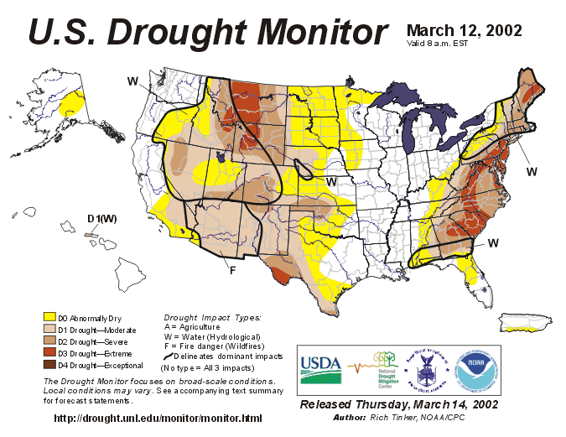

National Drought Summary – March 14, 2002

The East: Moderate precipitation fell on parts of upstate New York and northern New England while light amounts fell on the Northeast, southern Appalachians, central North Carolina, the Georgia and South Carolina Piedmont, and the western slopes and foothills of the Appalachians. Little or none fell elsewhere. As a result, dryness and drought remained unchanged in the Northeast, and expanded or intensified in parts of the mid-Atlantic, Southeast, and the central and southern Appalachians. D3 conditions were extended to cover central North Carolina, the Virginia Blue Ridge and Northern Neck, eastern West Virginia, and the entire Delmarva Peninsula while D0 to D2 conditions made new forays into parts of Kentucky, Tennessee, north Georgia, Alabama, and northern Florida. In addition, the approach of the growing season and above-normal temperatures prompted the removal of the (W) designation from the mid-Atlantic, central Appalachians, and Carolinas. Precipitation totals for the last 30 days were 2 to 4 inches below normal from southern Virginia and central Kentucky southward through western South Carolina, northern Georgia, and Alabama while 90-day totals 4 to 8 inches below normal were measured in southern New England, the lower Northeast, the mid-Atlantic, and portions of central South Carolina, southwestern Georgia, southern Alabama, and the Florida Panhandle. Relative to historic data from the National Climatic Data Center, September 2001 through February 2002 was the driest of any 6-month period in 107 years of records for the states of Connecticut, New Jersey, Delaware, and Virginia.

APPENDIX B

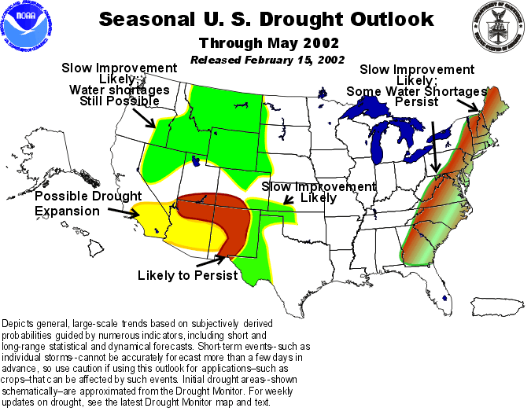

Latest Seasonal Assessment - In mid-February, moderate to severe drought extended from Georgia to Maine, with drought reaching extreme levels in Maine and South Carolina. Storms during the past 30 days have eased dryness in some areas, such as northern New England, upstate New York, northern Georgia and the Carolinas, but dryness intensified over the mid-Atlantic region and southern New England. The latest forecast indications present a mixed picture for the East Coast. Occasional storms should provide slow overall improvement, but water shortages will continue in a few areas. With recent near-record low streamflows and reservoir levels for this time of year being reported over portions of the mid-Atlantic and New England states, it will take some time for the region to work its way out of drought conditions.

APPENDIX C

Accumulated six-month precipitation departures from the long-term average for representative Virginia stations.

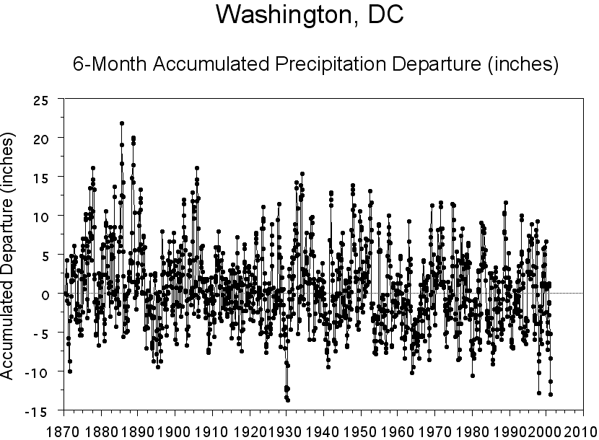

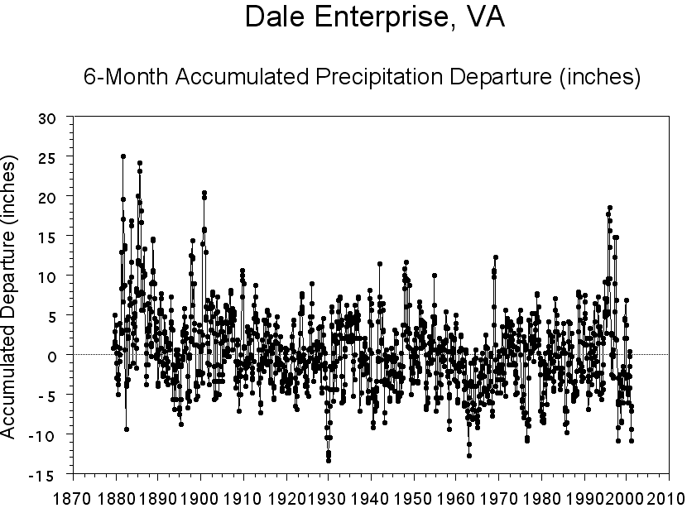

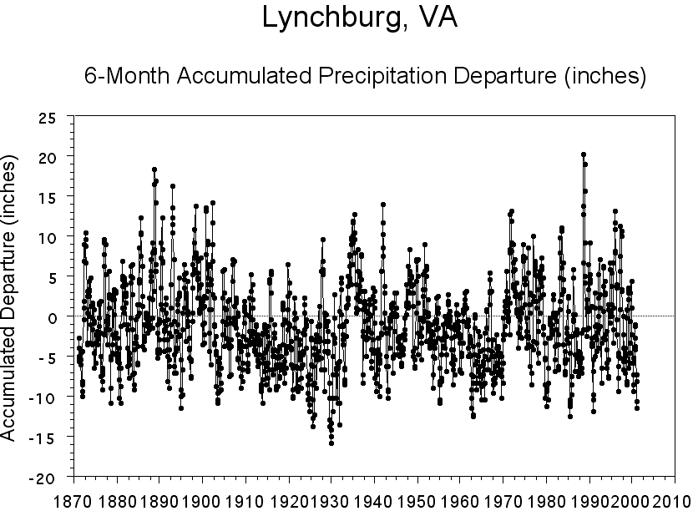

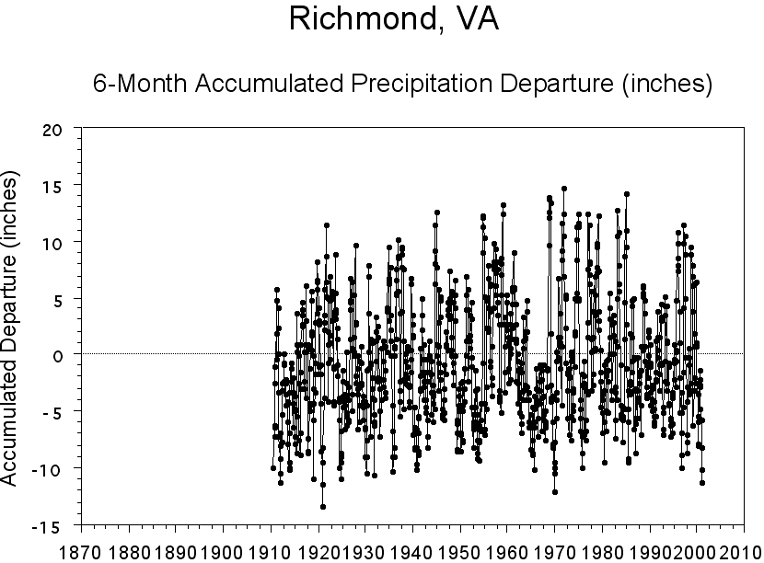
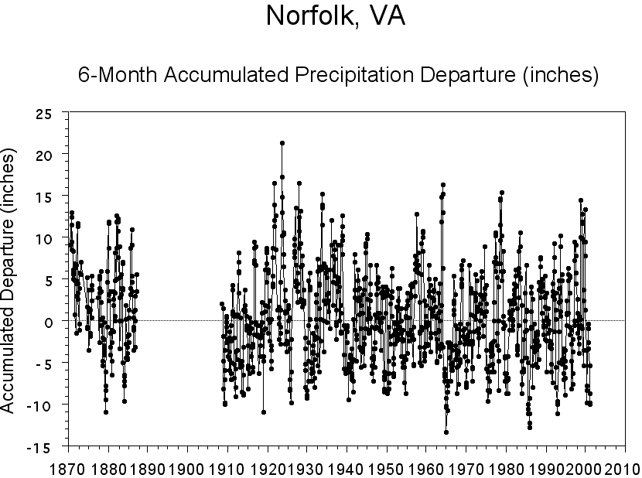

APPENDIX D

Accumulated forty three-month precipitation departures from the long-term average for representative Virginia stations.

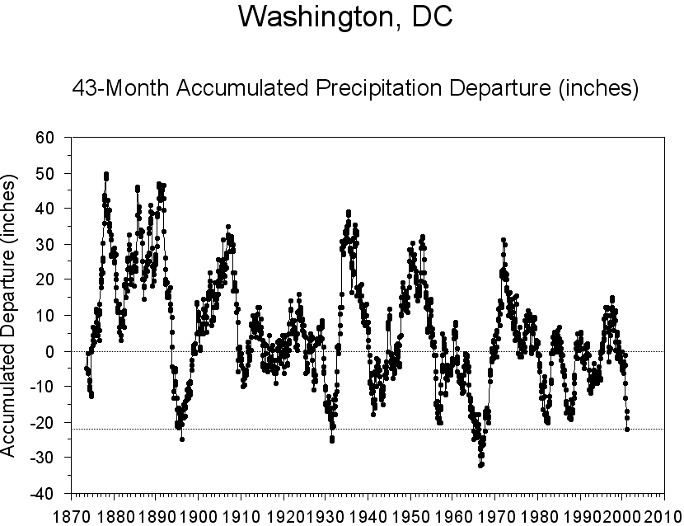

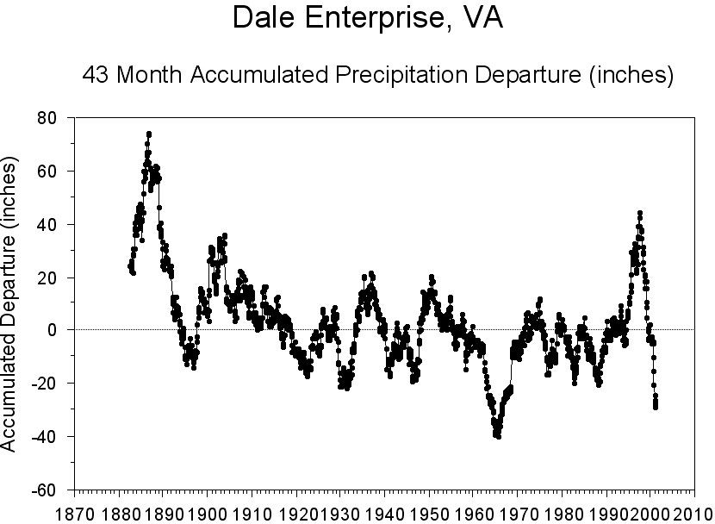
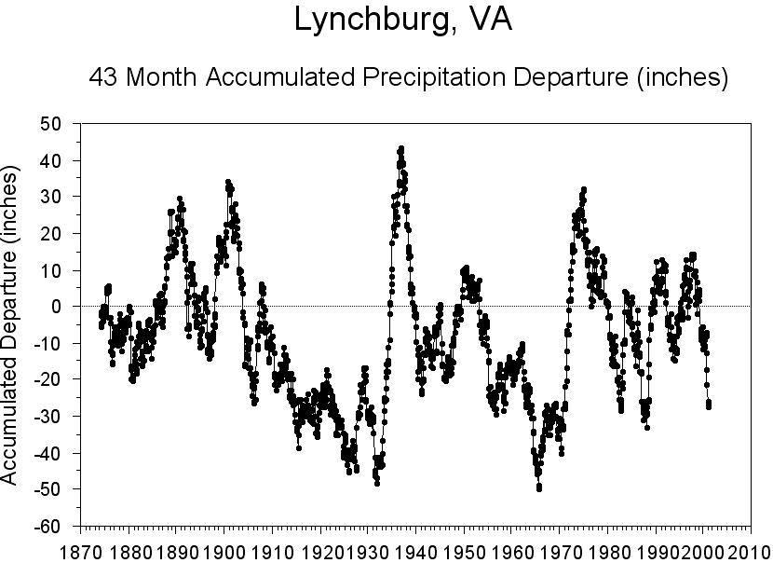

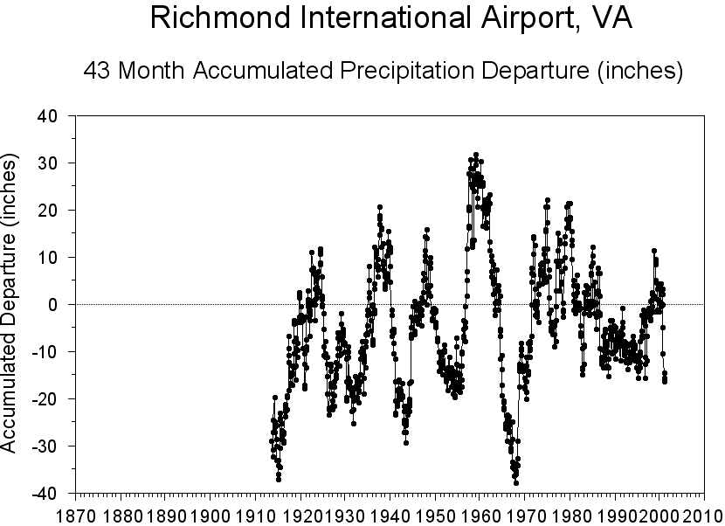
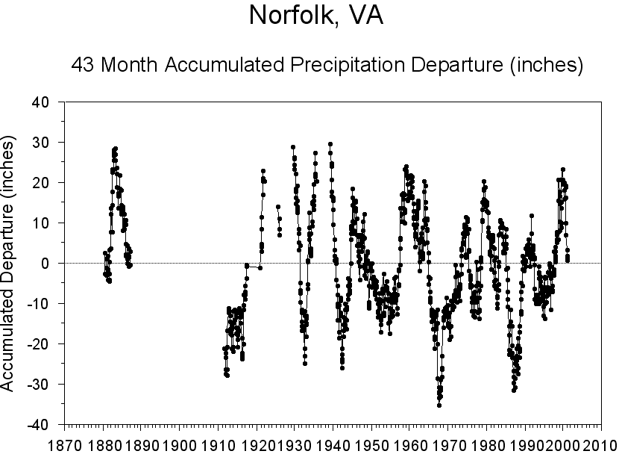

APPENDIX E

One, two, three, six and twelve-month precipitation departures by Climatological Division.

 | PRELIMINARY PRECIPITATION SUMMARY
Climatic Division | FEB | FEB | FEB | FEB
 | 2002 | NORMAL | DEPARTURE | % DEPART.
Tidewater | 1.1 | 3.4 | -2.3 | 33%
Eastern Piedmont | 1.0 | 3.3 | -2.3 | 31%
Western Piedmont | 1.1 | 3.3 | -2.2 | 33%
Northern | 0.5 | 2.7 | -2.2 | 19%
Central Mountain | 0.5 | 2.7 | -2.2 | 19%
Southwestern Mountain | 0.9 | 3.3 | -2.4 | 27%
Statewide | 0.8 | 3.0 | -2.2 | 27%
Climatic Division | JAN-FEB | JAN-FEB | JAN-FEB | JAN-FEB
 | 2002 | NORMAL | DEPARTURE | % DEPART.
Tidewater | 5.4 | 7.0 | -1.6 | 77%
Eastern Piedmont | 4.8 | 6.6 | -1.8 | 73%
Western Piedmont | 3.5 | 6.5 | -3.0 | 54%
Northern | 1.5 | 5.4 | -3.9 | 28%
Central Mountain | 1.2 | 5.3 | -4.1 | 23%
Southwestern Mountain | 5.7 | 6.4 | -0.6 | 90%
Statewide | 4.0 | 6.2 | -2.2 | 64%
Climatic Division | DEC 2001 - | DEC-FEB | DEC-FEB | DEC-FEB
 | FEB 2002 | NORMAL | DEPARTURE | % DEPART.
Tidewater | 7.6 | 10.3 | -2.7 | 74%
Eastern Piedmont | 5.8 | 9.9 | -4.1 | 59%
Western Piedmont | 7.0 | 9.8 | -2.8 | 72%
Northern | 3.3 | 8.4 | -5.1 | 40%
Central Mountain | 4.3 | 8.1 | -3.8 | 53%
Southwestern Mountain | 6.7 | 9.6 | -2.9 | 70%
Statewide | 6.0 | 9.4 | -3.4 | 64%
Climatic Division | SEP 2001 - | SEP-FEB | SEP-FEB | SEP-FEB
 | FEB 2002 | NORMAL | DEPARTURE | % DEPART.
Tidewater | 12.0 | 20.3 | -8.3 | 59%
Eastern Piedmont | 8.7 | 20.5 | -11.8 | 43%
Western Piedmont | 10.9 | 20.9 | -10.0 | 52%
Northern | 7.6 | 18.9 | -11.3 | 40%
Central Mountain | 7.8 | 18.3 | -10.5 | 43%
Southwestern Mountain | 10.4 | 19.7 | -9.3 | 53%
Statewide | 9.8 | 18.6 | -8.8 | 53%

Climatic Division | MAR 2001 - | MAR-FEB | MAR-FEB | MAR-FEB
 | FEB 2002 | NORMAL | DEPARTURE | % DEPART.
Tidewater | 34.5 | 43.7 | -9.2 | 79%
Eastern Piedmont | 32.3 | 43.3 | -11.0 | 75%
Western Piedmont | 33.2 | 44.8 | -11.6 | 74%
Northern | 33.5 | 40.8 | -7.3 | 82%
Central Mountain | 30.1 | 39.4 | -9.3 | 76%
Southwestern Mountain | 36.5 | 43.3 | -6.8 | 84%
Statewide | 33.6 | 42.2 | -8.6 | 80%

APPENDIX F

Palmer Drought Severity Index values for week ending March 9, 2002.

Climatic Division | Palmer Drought
 | Severity Index
Tidewater | – 3.66
Eastern Piedmont | – 3.01
Western Piedmont | – 2.65
Northern | – 2.70
Central Mountain | – 3.42
Southwestern Mountain | – 2.33

APPENDIX G

Hydrograph of the North Fork of the Shenadoah River near Strasburg, Virginia

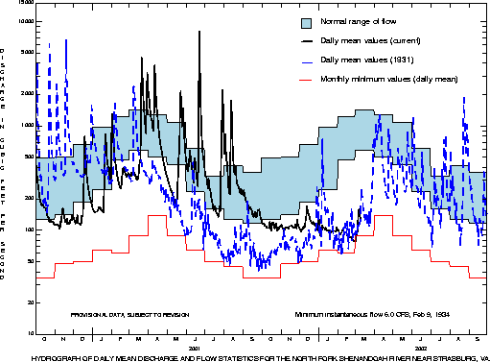

APPENDIX H

Hydrograph of a well in Arlington, Virginia

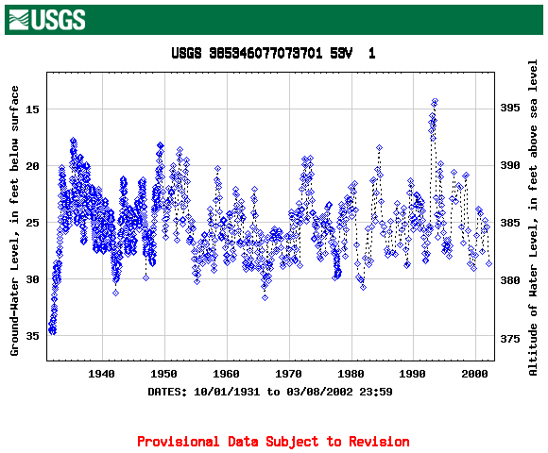

APPENDIX I

Hydrograph of a well in Colonial Heights, Virginia

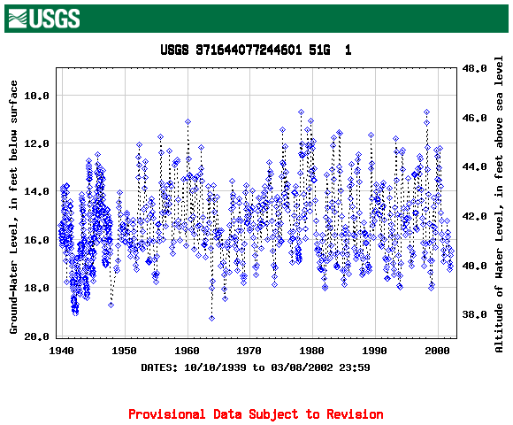

APPENDIX J

Flow duration and current flow conditions for selected U.S. Geological Survey and Virginia Department of Environmental Quality surface-water gaging stations

 | MINIMUM DAILY  FLOW,  PERIOD OF RECORD  (CFS) | MINIMUM MAR FLOW,  PERIOD OF RECORD  (CFS) | 7Q2  (CFS) | 7Q10  (CFS) | PERCENT OF TIME FLOW EQUALED OR EXCEEDED FOR MAR DAILY MEAN FLOWS (CUBIC FEET PER SECOND) |  |  | CURRENT CONDITIONS FLOW (CFS)/ DURATION (PERCENT)
 |  |  |  |  | 75% | 50% | 25% | March 08, 2002
SHENANDOAH RIVER BASIN
South River near Waynesboro, Va. | 17 | 36 | 30 | 24 | 125 | 192 | 318 | 44/>95
South Fork Shenandoah River at Front Royal, Va. | 107 | 268 | 344 | 235 | 1,280 | 1,990 | 3,240 | 424/>95
North Fork Shenandoah River at Cootes Store, Va. | 0.2 | 11 | 3.2 | 0.77 | 116 | 213 | 408 | 60/93
North Fork Shenandoah River near Strasburg, Va. | 35 | 89 | - | - | 442 | 713 | 1,280 | 139/>95
POTOMAC RIVER BASIN
Goose Creek near Leesburg, Va. | 0.4 | 24 | 12 | 2.5 | 263 | 422 | 690 | 60/>95
RAPPAHANNOCK RIVER BASIN
Rappahannock River at Remington, Va. | 2.9 | 185 | 50 | 11 | 564 | 848 | 1,340 | 222/>95
Rapidan River near Culpeper, Va. | 2.2 | 94 | - | - | 430 | 611 | 957 | 174/>95
YORK RIVER BASIN
Pamunkey River near Hanover, Va.* | 47 | 180 | - | - | 816 | 1,230 | 2,070 | 279/>95
Mattaponi River near Beulahville, Va. | .78 | 149 | 48 | 14 | 545 | 868 | 1,330 | 183/>95

 | MINIMUM DAILY  FLOW,  PERIOD OF RECORD  (CFS) | MINIMUM MAR FLOW,  PERIOD OF RECORD  (CFS) | 7Q2  (CFS) | 7Q10  (CFS) | PERCENT OF TIME FLOW EQUALED OR EXCEEDED FOR MAR DAILY MEAN FLOWS (CUBIC FEET PER SECOND) |  |  | CURRENT CONDITIONS FLOW (CFS)/ DURATION (PERCENT)
 |  |  |  |  | 75% | 50% | 25% | March 08, 2002
JAMES RIVER BASIN
Jackson River near Bacova, Va. | 13 | 47 | 26 | 20 | 146 | 230 | 419 | 55/>95
Potts Creek near Covington, Va. | 15 | 31 | 24 | 17 | 156 | 242 | 411 | 69/>95
Cowpasture River near Clifton Forge, Va. | 40 | 120 | 73 | 54 | 432 | 668 | 1,210 | 225/>95
Craig Creek at Parr, Va. | 25 | 50 | 43 | 31 | 326 | 515 | 883 | 124/>95
James River at Buchanan, Va.* | 257 | 400 | 378 | 271 | 2,190 | 3,290 | 5,680 | 885/>95
Maury River near Buena Vista, Va. | 22 | 154 | 89 | 62 | 576 | 922 | 1,580 | 197/>95
Hardware River below Briery Run near Scottsville, Va | 0.1 | 26 | 24 | 7.5 | 104 | 146 | 227 | 34/>95
Rivanna River at Palmyra, Va. | 5.2 | 164 | - | - | 534 | 784 | 1,270 | 169/>95
James River at Cartersville, Va. | 330 | 1,840 | 1,120 | 584 | 6,440 | 9,640 | 15,300 | 2,740/>95
Appomattox River at Farmville, Va. | 6.3 | 93 | 52 | 21 | 211 | 297 | 469 | 100/>95
Appomattox River at Mattoax, Va. | 13 | 230 | 86 | 30 | 536 | 766 | 1,390 | 251/>95
Chickahominy River near Providence Forge, Va. | 0.07 | 55 | 16 | 4.0 | 236 | 382 | 581 | 143/ 95
CHOWAN RIVER BASIN
Nottoway River near Sebrell, Va. | 14 | 268 | 82 | 24 | 1,352 | 2,250 | 3,540 | 605/>95
Blackwater River near Franklin, Va. | 0.07 | 117 | - | - | 668 | 1,040 | 1,600 | 138/>95
Meherrin River near Lawrenceville, Va. | 4.2 | 127 | 52 | 16 | 377 | 543 | 884 | 150/>95

 | MINIMUM DAILY  FLOW,  PERIOD OF RECORD  (CFS) | MINIMUM MAR FLOW,  PERIOD OF RECORD  (CFS) | 7Q2  (CFS) | 7Q10  (CFS) | PERCENT OF TIME FLOW EQUALED OR EXCEEDED FOR MAR DAILY MEAN FLOWS (CUBIC FEET PER SECOND) |  |  | CURRENT CONDITIONS FLOW (CFS)/ DURATION (PERCENT)
 |  |  |  |  | 75% | 50% | 25% | March 08, 2002
Roanoke River at Roanoke, Va.* | 19 | 73 | 58 | 35 | 295 | 474 | 750 | 72/>95
Pigg River near Sandy Level, Va. | 25 | 153 | 96 | 47 | 277 | 368 | 539 | 149/>95
Roanoke River at Randolph, Va.* | 179 | 598 | 847 | 426 | 2,140 | 3,520 | 5,690 | 880/>95
Dan River at Paces, Va. | 244 | 1,140 | - | - | 2,140 | 3,020 | 4,680 | 1,230/>95
Hyco River near Denniston, Va.* | 2.5 | 31 | - | - | 148 | 253 | 579 | 25/>95
KANAWHA RIVER BASIN
New River at Allisonia, Va. | 453 | 960 | 1,040 | 725 | 2,920 | 3,900 | 5,570 | 1,540/>95
Little River at Graysontown, Va. | 47 | 60 | 109 | 69 | 307 | 416 | 577 | 152/>95
Walker Creek at Bane, Va. | 24 | 50 | 44 | 33 | 299 | 458 | 778 | 120/>95
BIG SANDY RIVER BASIN
Russell Fork at Haysi, Va. | 0.2 | 35 | 8.7 | 1.0 | 259 | 430 | 795 | 102/>95
TENNESSEE RIVER BASIN
South Fork Holston River near Damascus, Va. | 40 | 156 | 99 | 73 | 463 | 667 | 1,010 | 175/>95
North Fork Holston River near Saltville, Va. | 2.0 | 61 | 34 | 24 | 267 | 398 | 666 | 103/>95
Clinch River at Cleveland, Va. | 37 | 131 | 81 | 54 | 625 | 973 | 1,624 | 196/>95
Powell River near Jonesville, Va. | 18 | 82 | 42 | 24 | 454 | 716 | 1,234 | 194/>95
* indicates some regulation

APPENDIX K

Virginia Department of Health Field Office Reports for Public Water Systems

 | Abingdon Field Office 3/02/02 |  | N-No | B-Better
 |  |  | M-Mandatory | S-Stable/Same
 |  |  | V-Voluntary | W-Worse
PWSID | Waterworks | Source Name | Restrictions | Situation
1195050 | Appalachia |  | N | Reservoir is full.
1195100 | Big Stone Gap |  | N | Both reservoirs are full.
1195950 | Wise |  | N | 262 days left, no alternate source in use, no conservation measures.
1720076 | Norton |  | N | Both reservoirs are full.
1155635 | Pulaski |  | N | Both reservoirs are down a few feet but nothing abnormal.
 | Note: No significant impact from the drought at this time.

 | South East Virginia Field Office 3/02/02 |  | N-No | B-Better
 |  |  | M-Mandatory | S-Stable/Same
 |  |  | V-Voluntary | W-Worse
PWSID | Waterworks | Source Name | Restrictions | Situation
3700500 | Newport News | Little Creek, Diascund, Skiffes Creek, Harwoods Mill and Lee Hall Reservoirs | N | As of 03/07/02, reservoirs were 84% full and rising. RO plant at 1.7 mgd. No Restrictions-Situation is Better than previous report (previous report 83% full and RO plant at 2 mgd)
3830850 | Williamsburg | Waller Mill Reservoir | N | As of 03/06/02, Waller Mill reservoir is 17 inches below the primary spillway and is tending to rise very slowly (in the previous report it was 18.5 inches below the primary spillway). Williamsburg is still purchasing 2 mgd of raw water from Newport News. No restrictions. Situation is Better
3650150 | Ft. Monroe | Big Bethel Reservoir System | N | The water plant was shut down in mid-December for replacement of valves, and switched to Newport News water. Plant is scheduled to be back on line near the end of this month (March 26).
3095490 | James City Service Authority Central System |  | N | No significant impact on water levels in wells.
3670800 | Virginia-American, Hopewell | Appomattox River/James River | N | Both rivers continue to be low. No problems with water quantity as yet. TDS, sodium, and alkalinity are still at increased levels. Situation is Stable.
3183550 | Jarratt | Nottoway River | N | Markings on an adjacent bridge piling indicate a level of approximately 0.75 feet, although it is unknown if 0 feet is at the river bed. No quality or quantity problems noted. Situation is Stable.
3595250 | Emporia | Meherrin River | N | The reservoir levels are still at "normal". No recent restrictions to power plant (see item 3, below). Situation is Stable.
3710100 | Norfolk |  | N | As of 03/06, reservoirs are at 84.3% of total capacity (minor improvement). Historic level at this time of year is 94.9% full. Pumping from Lake Gaston, at rate of 27.0 mgd. Wells are OFF Not currently considering conservation measures, but that could change with continued dry weather.
3740600 | Portsmouth | Lakes Cohoon, Meade, Kilby, and Speights Run | V | As of 5 Mar 02, reservoirs are at "77% of useful capacity". This is a +1% change since last report. Median capacity for this time of year is 100%, average capacity is 98% (period of 1969-2001). Emergency wells are OFF. City Council voted to establish Voluntary Conservation at meeting of 11/27/01. The restrictions took effect on 11/30/01. Marginally Better.
3550050 | Chesapeake - Western Branch system | Western Branch system | V | This portion of the city is consecutive to (receives water from) the city of Portsmouth. Because Portsmouth decided to go on voluntary restrictions, Chesapeake has decided to follow Portsmouth's lead, for ALL residents of the city. City Council voted to establish Voluntary Conservation at the meeting on 11/27/01. The restrictions took effect on 11/30/01.
3550052 | Chesapeake - South Norfolk system | South Norfolk system | V | This portion of the city is consecutive to (receives water from) the city of Norfolk. Because Portsmouth decided to go on voluntary restrictions, Chesapeake has decided to follow Portsmouth's lead, for ALL residents of the city. City Council voted to establish Voluntary Conservation at the meeting on 11/27/01. The restrictions took effect on 11/30/01.
3550051 | Chesapeake - NW River system | NW River system | V | As of 3/7, chloride levels in the Northwest River are back to normal and well water levels have been recovering due to increased production from the surface WTP. Because a portion of the city (a separate system from the NW River system) is served from Portsmouth, Chesapeake has decided to follow Portsmouth's lead, for ALL residents of the city. City Council voted to establish Voluntary Conservation at the meeting on 11/27/01. The restrictions took effect on 11/30/01.
3800805 | City of Suffolk | Central System | V | As of 3/7, reservoir system is 71% full in Crumps Mill and 81% full in Lone Star Lakes. These levels are lower than in the last report. The city also purchase finished water from Portsmouth, which enters the central system in downtown Suffolk. As such, this system has followed the lead of the Portsmouth system and has adopted Voluntary Conservation. Suffolk will rescind Voluntary Conservation following Portsmouth's lead. Situation is stable.
3800787 | City of Suffolk | Route 17 Corridor | V | This system is consecutive to (purchases water from) the Portsmouth system. As such, this system has followed the lead of the Portsmouth system, and has adopted Voluntary Conservation. If Portsmouth goes to Mandatory Conservation, Suffolk will probably switch the supply source to their Central System (groundwater).
 | Notes:
 | 1. Systems listed for the first time are shown in bold.
 | 2. As of this date, SEVFO has not received any reports of impacts to groundwater systems.
 | 3. (Note added on 11/28/01) While there have been no lasting drought-related impacts to the waterworks at the City of Emporia, there have been impacts at the power plant located immediately across the reservoir from the water plant. When the power plant operates at full capacity, it withdraws sufficient water to cause the water level in the reservoir to drop, to the point where water stops going over the dam. This in turn has an impact on the water plant. The water plant and power plant have a "gentlemen's agreement" that, at such times, the water plant notifies the power plant and the power plant shuts down. This allows the water level in the reservoir to build back up. Currently, the power plant is operating about 10 to 12 hours per day. (Update as of 2/19/02) No recent restrictions on power plant operations.

 | Lynchburg Field Office 3/02/02 |  | N-No | B-Better
 |  |  | M-Mandatory | S-Stable/Same
 |  |  | V-Voluntary | W-Worse
PWSID | Waterworks | Source Name | Restrictions | Situation
2770650 | Roanoke City - Carvins Cove | Carvins Cove Reservoir/Tinker Creek/Catawba Creek | M | W:  Reservoir level 23.9' below spillway - situation steadily worsening. Partial Mandatory restrictions imposed when reservoir level is between 22 and 26 feet below spillway. (restricts outdoor usage between 10 am and 7 pm). (Stage 3)
2015150 | Craigsville |  | M | S:  Craigsville spring production off-well production off-pursuing emergency construction to connect to Augusta springs-plans and specifications for 6700 feet of interconnecting water line have been approved, and construction started.
2015575 | South River S.D. (ACSA) | Coles Run | N | S:  Coles Run reservoir level down 5-6 feet-no impact on system due to multiple sources.
2091150 | Monterey |  | N | S:  Monterey well production off. New well construction completed, testing operation of components.
2790600 | Staunton |  | N | S:  Staunton-middle river flow reduced.
2187406 | Front Royal |  | V | B:  Operating under voluntary water conservation per VWPP requirements. Conservation controls implemented at 30% (voluntary), 17% (mandatory), 15% (emergency), and 13% (rationing) of mean stream flow based on 14-day running average. At present, 14-day running average stream flow is 19% of mean stream flow.
2003250 | Albemarle County / Crozet | Beaver Creek Reservoir | N | W:  Beaver Creek Reservoir is currently down nearly 8 feet from normal "full". This low level has exceeded the all time low water level on record.
2003600 | Charlottesville/Albermarle County | Sugar Hollow (Observatory WTP) | N | S:  The Sugar Hollow reservoir (Observatory WTP) is 22 feet below normal levels and remains out of service. Ragged Mountain reservoir is 6.0 feet below normal. Overall source water availability is at 77.7% of "full available capacity" (this includes both the South Rivanna system and the Suggar hollow/Ragged Mountain system). Mandatory conservation is being considered if the situation does not improve.
2003725 | Charlottesville/Albermarle County | South Rivanna (South Rivanna WTP) | N | B:  Their main reservoir-South Rivanna (South Rivanna WTP) is full and silghtly overflowing.
2065250 | Fluvanna Correctional Center | Mechunk Creek | N | W:  The Fluvanna Correctional Center is still unable to withdraw raw water from Mechunk Creek on most days. Following the rainfall event of March 2 they did begin to pump raw water but the river flow is dropping. Their raw water storage impoundment has approximately 20 days of available water remaining. The DOC requested amendment to their water withdrawal permit from DEQ was finalized on March 2. This will allow additional pumping from Mechunk Creek and should result in improvements to the raw water impoundment levels.
2125650 | Schulyer | Johnson's Branch | N | S:  The Johnson's Branch flow is stable since our last report. While not back to normal flows there is ample water to meet daily demands.

 | East Central Field Office 3/01/02 |  | N-No | B-Better
 |  |  | M-Mandatory | S-Stable/Same
 |  |  | V-Voluntary | W-Worse
PWSID | Waterworks | Source Name | Restrictions | Situation
4041845 | Swift Creek WTP | Swift Creek Reservoir | N | W - The reservoir level is currently 3.6 feet below the top of the dam.
4041035 | Appomattox River Water Authority | Lake Chesdin | N | B -The reservoir level is currently flowing over the top of the dam. There are no drought related restrictions on the production of the WTP.
4075735 | James River Correctional Center | Beaverdam Creek and the James River | V | S - the water level in Beaverdam Creek is currently 2 inches above the dam. Water conservation is still being practiced to some degree. The average WTP production was 0.761 mgd for February 2002.
4075630 | Pagebrook (Goochland) |  | N | B - Sydnor is no longer hauling water.
4073311 | Gloucester | Beaverdam Reservoir | N | B -The Beaverdam Reservoir water overflow elevation is 40.5. The reservoir is full and overflowing. The current water level is 40.65. Note that about a million gallons of water is allowed to flow through the reservoir every day.
4760100 | City of Richmond | James River | N | S - The James River is still very low for this time of year, but Richmond is having no problems with water withdrawals. We are not aware of any use restrictions in place in the Richmond area.

 | Culpeper Field Office |  | N-No | B-Better
 | March 7, 2002 |  | M-Mandatory | S-Stable/Same
 |  |  | V-Voluntary | W-Worse
PWSID | Waterworks | Source Name | Restrictions | Situation
6033425 | Lake Caroline | Lake Caroline | N | Lake Caroline is 2 feet below normal. No conservation measures in place. (B)
6177280, 6177300 | Spotsylvania County | Ni River Res., Motts Run | V | Spotsylvania County declared a water emergency in mid November and instituted voluntary conservation. Ni River Reservoir is over 6.5 feet below normal. Motts Run Reservoir is 10 feet below normal and is releasing water occasionally to Rappahannock River for withdrawal by Motts Run WTP. (W)
6630050 | City of Fredericksburg | Mott's Run | V | City of Fredericksburg (consecutive system to Spotsylvania County) has asked for voluntary conservation based on Spotsylvania County's action.(S)
6179100, 6179775 | Stafford County | Smith Lake, Abel Lake | V | Stafford County has asked residents to voluntarily conserve water. Smith Lake is 12 feet below normal and Abel Lake is over 5 feet below normal. Dept. of Utilities is scheduled to ask Board of Supervisors (on 3/5/02) to consider "limiting non-essential water usage"..They will put out a press release accordingly...(W)
6061200 | Fauquier County | Marshall Waterworks | N | Low water levels in existing wells resulted in water hauling to system in January 2002. New well brought on-line in late January has alleviated shortage problem.
 | Notes:
 | 1. PD 8 - No surface water or groundwater supply problems or conservation plans in effect at this time.
 | 3. PD 9 - No surface water problems known at this time.
 | 4. PD 16 - No groundwater problems known at this time.

 | Danville Field Office 3/6/2002 |  | N-No  M-Mandatory  V-Voluntary | B-Better  S-Stable/Same  W-Worse
PWSID | Waterworks | Source Name | Restrictions | Situation
5007030 | Amelia Academy | Well No.1(bored) | N | B-No reported problems since October
5009050 | Town of Amherst | Buffalo River | N | B - River has overflow, level up slightly with 1.2" weekend rain
5009250 | Amherst County Service Authority | Graham Creek Res., Harris Creek | N | S - Drawing completely from creek - reservoir 3" low - received over 1" of rain on weekend
5019250 | Eagle Eyrie | Unnamed Reservoir | N | W - 4'2" below overflow - level still dropping, even with rain on weekend, but still drawing from uppermost intake
5019400 | High Point Subdivision | Smith Mountain Lake | N | B - Lake level up slightly with weekend rain, but still 4-5' down
5025450 | Town of Lawrenceville | Great Creek | N | S-Great Creek Reservoir full
5029085 | Buckingham County Waterworks | Troublesome Creek Reservoir | N | B-Reservoir full
5031050 | Town of Altavista | Staunton River, Reed Creek | N | S - River level OK, Creek still a little low
5031150 | CCUSA | Otter River | N | B - River is full
5031175 | Town of Brookneal | Phelps Creek Reservoir | N | S - Reservoir has 1/2" overflow
5031200 | Dan River, Inc. - Brookneal Plant | Falling River | N | B - River up slightly with weekend rain
5067840 | Town of Rocky Mount | Blackwater Creek | N | W - dropped from 1" overflow at check dam beginning Feb. to 1/4" now
5083550 | Town of Halifax | Banister River | N | S
5089376 | Fieldcrest Cannon WTP | Smith River | N | S - flow subject to release from Philpott Dam-understood release has been reduced recently
5089487 | Marrowbone Cr. WTP | Marrowbone Creek | N | S- flow over check dam ~2" which is lower than last report and reflects rain received over 3/1-3/3 weekend-still pretty good for this source
5089852 | Upper Smith River WTP | Smith River | N | S - flow subject to release from Philpott Dam- understood release has been reduced recently
5111450 | Town of Kenbridge | Flat Rock Creek & reservoir | N | B-Reservoir full
5111800 | Town of Victoria | Nottoway Falls & Lunenburg Lake | N | B-Reservoir full
5117310 | Town of Clarksville | Kerr Lake | N | B
5117800 | Town of South Hill | Meherrin River | N | S
5135160 | Town of Crewe | Lazerretto Creek/Crystal Lake | N | B-Reservoir full
5141640 | Town of Stuart | South Mayo River | N | S- improved some with recent rainfall over 3/1-3/3 weekend
5143114 | Town of Chatham | Cherrystone Creek | N | S - reservoir and stream levels are steady
5143210 | Town of Gretna | Georges Creek | N | S - Reservoir is full
5515050 | City of Bedford | Stoney Creek Reservoir | N | S - Reservoir has 1 - 1.5" overflow
5590100 | City of Danville | Dan River, Schofield Dam | N | S -
5680200 | City of Lynchburg | Pedlar Reservoir | N | B - Pedlar Reservoir is about 140" down. City is drawing entirely from reservoir.
5690400 | City of Martinsville | Beaver Creek Reservoir | N | S- reservoir level down 6.3 feet as of 2/25 (is 0.2 feet lower than previous report period) - however, area received 1.18" rain over 3/1 - 3/3 weekend and level does not reflect this additional rain
5780600 | Town of South Boston | Dan River | N | S - using both intakes
 | Notes:

APPENDIX K

The following is educational information provided by Agriculture & Natural Resource Extension Agents to agricultural producers relative to coping with drought:

Livestock producers are encouraged to use the Standardized Performance Analysis that measures the production and financial performance of their enterprise. This tool is especially helpful during a drought year.

Agents stress the importance of good management of cropping systems (field selection, Integrated Pest Management Practices, etc.) to reduce the affects of drought.

Agents have helped beef and dairy producers develop rations using alternative feeds such as corn gluten, hominy, crop residues, soybean hay and grass hays. Another recommendation is the use of soybean and peanut hulls mixed with grains and fed with low quality fiber sources i.e. corn fodder to provide appropriate nutrition.

The Virginia Tech Forage Testing Lab has been used for diagnostic work to determine if drought stressed crops can be fed to animals or if they are too high in nitrates/nitrites.

Drought and irrigation management has been included in field days.

Recommendations have been made on reseeding pastures and hayfields. Fewer nutrients are required as a result of drought; they are retained in the soil. Pasture renovation programs have been conducted (fall fertilization to maintain sod). Also, summer perennial grasses are recommended in the mix of pasture systems to enhance summer performance.

Agents are recommending rotational grazing to maintain pastures.

Agents have recommended that farmers take inventory of feed and recommended purchasing the amounts needed for the winter months. Agents have run rations to help farmers predict feed needs.

Recommendations have been made to cull low producing cattle. Grouping and feeding cattle according to their nutrient requirements is recommended.

Agents have recommended selecting grazing varieties of rye that are more suitable for late fall and winter grazing. Also, over seeding pastures and hay fields with winter grains enhances early spring grazing and hay production.

Agents recommend no-till planting to reduce loss of moisture in soil.

