CONCEPT PAPER
CAADP Pillar 4

Improving agricultural research, technology dissemination and adoption

1. Introduction

The Comprehensive Africa Agricultural Development Programme (CAADP) was established by the African Union’s New Partnership for Africa’s Development (AU/NEPAD) in July 2003. The overall goal of CAADP is to “Help African countries reach a higher path of economic growth through agriculturally-led development, which eliminates hunger, reduces poverty and food insecurity, and enables expansion of exports.”

CAADP aims at increasing agricultural growth rates to six percent per year to create the wealth needed for rural communities and households in Africa to prosper. To achieve this goal, CAADP directs investment to four mutually reinforcing 'pillars' (i) extending the area under sustainable land management and reliable water control systems; (ii) improving rural infrastructure and trade-related capacities for improved market access; (iii) increasing food supply and reducing hunger; and (iv) agricultural research, technology dissemination and adoption. Each of these pillars incorporates policy, institutional reform and capacity building.

This concept paper outlines how COMESA, through ASARECA, FARNPAN and other regional stakeholders, is poised to lead in the identification and prioritization of agricultural research, technology, dissemination and adoption constraints and challenges in the region. This paper, based mainly on ASARECA’s strategy 2005-2015 which is in line with NEPAD’s Framework for African Agricultural Productivity (FAAP) which responds directly to achievement of CAADP’s pillar four.

2. Problem

High and sustained rates of agricultural growth, largely driven by productivity growth, will be necessary if African countries are to accelerate poverty reduction. This is because agricultural growth has powerful leverage effects on the rest of the economy, especially in the early stages of development and economic transformation, when agriculture accounts for large shares of national income, employment, and foreign trade. Growth in agriculture enables general patterns of development that are employment intensive and hence favourable for the poor. Agricultural growth benefits both rural and urban poor by providing more food and raw materials at lower prices; freeing up foreign exchange for the importation of strategic industrial and capital goods; providing growing amounts of capital and labour for industrial development; providing a growing domestic market for nascent national industries; and reducing poverty by increasing labour productivity and employment in rural areas.

The poor performance of the agricultural sector explains much of the slow progress towards reducing poverty and hunger in Africa. Agricultural growth has barely kept up with population growth rates such that the growth in per capita agricultural output has lagged far behind other developing regions. To reverse this trend and meet the Millennium Development Goal (MDG) of halving poverty by 2015, the sector needs to grow much faster and maintain annual growth rates of about 6.2 percent Some countries will require even higher growth rates, given many years of neglect. Increasing agricultural productivity implies a transformation from traditional to modern agriculture, which “involves both technical change and the presence of input, seasonal finance and marketing systems to increase farm production and deliver it to consumers at a competitive price.

At the production level, agricultural productivity measures the value of output for a given level of inputs. To increase agricultural productivity, the value of output must increase faster than the value of inputs. Gains in overall agricultural productivity can therefore come from changes in the physical productivity level through change in technology employed in the production process, which results in more output (yields) per unit of input such as land or labour, or from changes in production and market costs and hence the increased profitability of farmers. Thus, increasing agricultural productivity not only relies on improved production efficiencies, such as through adoption of modern or improved technologies and practices, but also critically relies on many other factors such as adequate access to productive resources, well functioning markets and infrastructure, and a conducive policy environment (e.g. stable macro-economic policies).

Productivity levels in Africa, in terms of both land and labour productivity, still lag far behind other developing regions. Within Africa, the situation is especially marked in Southern and Eastern Africa (excluding South Africa). Low growth rates in cereals yields and production in Africa have translated over the years into falling per-capita food production and increased imports, contributing to high levels of food insecurity at both national and household levels (20 percent of African cereal consumption depends on imports, including food aid).

Much of the growth of output in Africa, including the COMESA region, has been due to expanded use of land, labour and livestock, until the 1990s, when recent estimates imply that productivity growth has played an increasingly larger role. Total factor productivity grew at an annual rate of 1.3% on average during the 1990s, accounting for approximately 40% of the 3.1% annual growth in agricultural output. Growth in the traditional inputs of land, labour, and livestock accounted for the other 60% of agricultural output growth. To achieve the desired agricultural growth rate of 6% or more will require total factor productivity growth rates of 4.4% per year. This is because the growth in land and labour inputs are unlikely to continue to grow at the same rate as in the past, and productivity must increase at a faster rate for output to grow. The expansion of the labour force is tied to the demographics of the region and changes in the recent past show a reduction in the growth of labour. While the economically active population in SSA increased at an average growth rate of 2.1% during 1981-1990, this growth was reduced to 1.9% per year in the 1990s. The estimated expansion of productivity at an average annual growth rate of 4.4% assumes that labour and capital will continue to grow as in the 1990s, contributing 1.8 percentage points to growth in agriculture.

Lessons learned from the success of agricultural-led growth strategies elsewhere in developing countries show that productivity and overall growth in agriculture has been technologically driven. However, one measure of productivity, the share of areas planted to modern varieties in Africa, is only a small fraction of those in other regions and genetic improvement accounts for only 28% of yield growth compared to 88% in Asia. In addition to technology, adequate access to rural infrastructure has been essential for promoting growth in agriculture as well as in the non-farm economy and rural towns, and for strengthening rural-urban demand linkages. Equally important is that growth must be broad-based, so the majority of smallholders also benefit from technology innovation. Distortions in prices also need to be removed to provide incentives for farmers to invest and produce.

3. FAAP

NEPAD has requested the Forum for Agricultural Research in Africa (FARA) to take the lead in developing a framework through which the challenges prioritized by the CAADP Pillar IV might effectively and efficiently be achieved. In response to the NEPAD's request, FARA has, in consultation with stakeholders, developed the Framework for African Agricultural Productivity (FAAP). This framework aims to achieve strengthened agricultural knowledge systems delivering profitable and sustainable technologies and that are widely adopted by farmers resulting in sustained agricultural growth. This will require major improvements in African capacity for agricultural research, technology development, dissemination and adoption, together with enabling policies, improved markets and infrastructure.

The consultation process through which FAAP was developed concluded that the priorities of CAADP Pillar IV for agricultural research, technology dissemination and adoption require significant changes in and approaches to: (i) strengthening Africa's capacity to build human and institutional capacity; (ii) empowering farmers, and (iii) strengthening agricultural support services. By addressing these factors and actively integrating the private sector into the process as well as undertaking the necessary reform of public sector institutions, Africa will establish the capacity of making a paradigm shift away from a principally technological package approach to a truly integrated agricultural research approach and to ensure that researchers (national and international) work together with smallholders, pastoralists, extension agencies, the private sector and NGOs to have impact on the ground.

FAAP is facilitator of institutional changes and capacity building that will empower farmers. It will encourage different actors such as research to support the development of viable producer organisations that can represent the interests of farmers and pastoralists in public policy making, open new market opportunities for their members with the required inputs and services.

Application of the FAAP guiding principles will help agricultural extension systems evolve so as to be increasingly provided through performance-based contractual arrangements, rather than by civil servants. Potential extension service providers may include combinations of private sector, NGOs, farmers’ associations, universities, or any other entities with the capacity to provide extension services.

On agricultural research, FAAP will encourage end-users to be actively engaged in the processes of agricultural research priority setting, planning and managing the work programs. Establishment of national agricultural research strategies through participatory and multi-disciplinary processes – and their endorsement of these at national level through inclusion in the Poverty Reduction Strategies (PRSs). Greater emphasis should be given to human resource development and in the agricultural research system, through improved salaries, performance related pay, better working conditions, and training opportunities.

FAAP supports the agenda for harmonisation and alignment not only at country level, but also at sub-regional and continental level, as it will enhance the overall impact of government funding and development assistance to agricultural productivity activities by committing to joint objectives, as well as reducing transaction costs in planning, reporting and procurement. This should also contribute toward more comprehensive and sustained funding for activities based on national and sub-regional priorities.
In order to move towards harmonization, the following gradual changes are expected at national, sub-regional and continental levels:
- Moving from “project” mode (under which donors support specific activities) to programmatic support (possibly with notional earmarking) for most of the budget of recipient institutions (including recurrent costs);
- Adoption of common processes for strategic dialogue and for planning the activities to be supported by donors – these to be made consistent with the institutional schedules and time horizons of the recipient institutions;
- common financial management procedures, monitoring and evaluation, reporting and review systems – consistent with those of the recipient institutions;
- establishment of multi-donor trust funds (basket funds) or pooling of funds in the accounts of recipient institutions, including unrestricted core funding (budget support).

At sub-regional level, ASARECA will seek support from member countries, FARA, NEPAD, COMESA and donors for political, technical, methodological, and financial support to programs that are developed along the lines advocated by the FAAP and its principles. ASARECA has prepared and adopt a long term strategy and is in the process of developing a medium-term operational plan for the strategy. In the operation plan, donors will align and coordinate their support through pledging joint support for the strategy.

Building on this consensus, FAAP sets out what African stakeholders think is needed to get African agriculture back on track. The emerging African agenda for improving agricultural productivity, profitability, and sustainability through innovation highlights three principal elements: (i) institutional reform, including the efficient use of resources for activities that are most likely to achieve productivity increases; (ii) increasing total investment; and (iii) harmonising funding.

4. The goals of ASARECA and other research institutions in COMESA:

Research entities in COMESA aim at having increased economic growth and improved livelihoods in COMESA while enhancing the quality of the environment. This would be achieved through enhanced productivity, value added and competitiveness of the regional agricultural system. As an example, ASARECA aims to achieve this by working in four result areas:
1. promoting generation of demand driven technologies and /innovations
2. facilitation of regional and national policy options for enhancing agricultural systems
3. strengthening of regional and national capacity for implementing agricultural research in the IAR4D paradigm and
4. enhancing the availability of information on agricultural research and development.
A special role for ASARECA in particular, lies in facilitating collective action that would not take place without a sub-regional mechanism that is owned by its members. ASARECA will facilitate, for example, the mobilization of financial and scientific human resources for collective action. It will also ensure that small national agricultural research centres (NARS) gain equitable access to participate in and benefit from research, and facilitate a research response to emergencies in the sub-region: disease (coffee wilt, cassava mosaic), drought, floods and post-conflict rehabilitation of NARS. Specific roles include:
- Services to members: 1) Support small NARS, 2) Create rapid task forces in response to emergencies, 3) Support members in post-conflict rehabilitation, 4) Represent the ECA region in regional and international fora
- Planning and management: 1) Monitor external technical and institutional environments: 2) Inform members of implications of global conventions, 3) Source and allocate new donor funds, 4) Reduce transactions costs for all parties: costs of information, costs of entry by new partners, and costs of monitoring, evaluation and impact assessment
- Facilitate Research: 1) Coordinate regional research, 2) Help create regional research facilities, 3) Manage institutional arrangements for the production of regional public goods.
- Forum Function: 1) exchange experiences and knowledge on S&T policies and institutional change.

5. Integrating planning approaches

ASARECA’s strategy 2005-2015 serves as the framework for integrating the various networks, programs and projects that ASARECA has created or adopted on behalf of the region. The strategic planning process works within an innovation systems framework that encompasses new concerns with policy and institutions, production-to-consumption chains, and broader economic and political influences. In the final analysis, the strategy is the point of reference for priority setting for the networks, programs and projects. It will provide the necessary space for them to be entrepreneurial while providing a framework for an eventual rationalization of efforts.

6. Agriculture in the ECA region: The need for “business unusual”

The ASARECA/IFPRI studies of agricultural prospects in the ECA region outlined two key scenarios that became critical inputs to ASARECA’s positioning. First they elaborated what would happen if current trends in productivity and growth of areas planted continued. Second, they elaborated the growth and productivity trends required to achieve the MDGs.

The ten countries of eastern and central Africa are among the poorest of Africa. The bulk of the region’s population resides in rural areas and depends on agriculture for income and sustenance. Given the low levels of productivity growth in the sector, hunger and malnutrition have deepened in ECA in recent years. Following a “business as usual” strategy, none of them will achieve the MDGs and, more alarmingly, most will be worse off or only marginally better off in 2015 than at present. Cereals imports will rise by almost 50%.

The required growth rate by commodity sector (staples, cash crops, and livestock) to achieve the MDGs on poverty and hunger are shown in Table 1. This favourable scenario is termed “Business Unusual” scenario because it departs from historical experience. It would imply in some cases a trebling of the historical growth rates. While in some countries, the reestablishment of peace and security would allow a rapid recovery from a diminished baseline, growth rates generally will have to almost double in staples and livestock and more than double in cash crops if the MDGs are to be achieved.

Table 1: Required sector and GDP growth rates to 2015 under “Business-Unusual” scenario
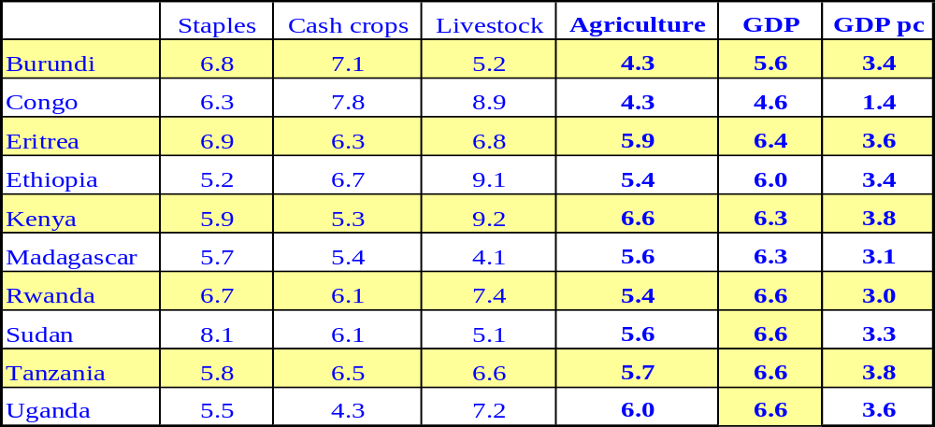

The analysis goes beneath the high-level sectors and identifies the growth and poverty impacts that will be achieved to 2015 assuming a one percent additional growth in selected commodity group. The results identify key staple food crops (maize, sorghum, cassava) and commodity sub-sectors (milk, oilseeds, and horticulture) that rank high in consumption and have a strong income elasticity of demand (Figure 1). While traditional exports and niche products may help some producers, they are not likely to generate the mass move out of poverty.

Figure 1: Cumulative GDP gains in ECA to 2015 from 1 percent additional growth in selected commodity group sub-sectors (US$ million)
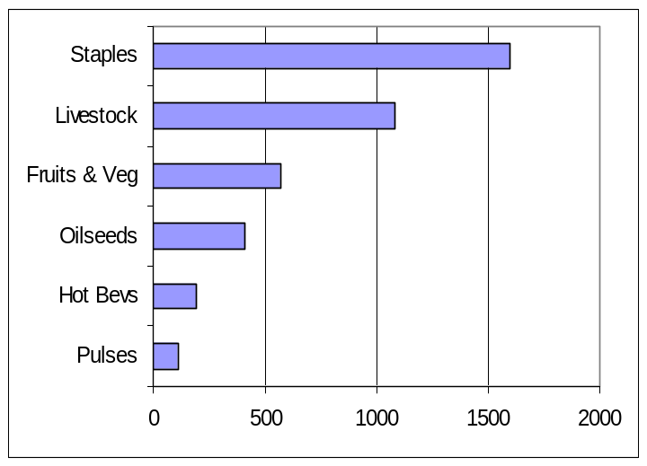

7. Choice of commodity sub sectors and commodities

ASARECA’s survey of NARS priorities identified a compatible set of commodity and thematic priorities by sector that are widely shared regionally. In each commodity sub-sector, ASARECA member-NARIs have identified the first, second and third commodity priority for them. Taken at a regional level, the order of priority is based on the number of countries citing the commodity and the priority rank they gave to it. Some commodities such as, maize, sorghum are priority for many countries; other commodities like bananas, cassava) are concentrated in a few countries. ASARECA provides mechanisms for countries with like problems to work together without requiring all 10 countries to share the problem.

- Cereals: maize, sorghum, rice
- Pulses: beans, chickpeas, pigeon peas
- Oil crops: groundnut, sesame, soybean
- Stimulant crops: coffee, tea, cacao,
- Horticulture: tomatoes, onions, peppers
- Industrial crops: cotton, sugarcane,
- Roots and tubers: cassava, sweet potato, potato
- Ruminants: traditional cattle, dairy cattle, goats
- Non-ruminants: pigs, rabbits, guinea pigs
- Pack animals: camels, donkeys, horses
- Poultry: indigenous chicken, industrial layers, industrial broilers.

While the investment requirements to achieve the required growth are not estimated, the implications for research for development institutions are enormous: “business unusual” calls for productivity and production gains that have not been realized across the member countries and sustained in the past.

Productivity growth as a result of research will not lead to economic growth and poverty reduction without roads, markets, and access to information. Growth linkages include value added along the producer-to-consumer chain as well as backward linkages to the seed industry and other input suppliers. Liberalization of trade at the global level will contribute less to poverty reduction than gains from concentrating on major staples satisfying growth in demand from internal markets and intra-regional trade. Strategic investment should prioritize efforts to satisfy the internal demand.

The strategy should recognize and exploit opportunities for regional collaboration. Potential spillovers from research are important and countries can reduce learning costs by sharing information

8. Enhancing services to NARS and their development partners

ASARECA will expand its initiatives and leadership in linking research to the political dialogue possible in COMESA, NEPAD and the G-8. To do this ASARECA will monitor political and institutional change in the global research environment and provide representation in such for a. ASARECA will take an active role in the CAADP-Support Group at the regional level to ensure that agricultural R4D is appropriately represented in debates on technical, institutional and policy issues. If AU/NEPAD and key donors are debating key issues in a CAADP framework, ASARECA must be an informed and key player. ASARECA will help its member countries prepare early action proposals with a regional dimension. ASARECA will engage in the NEPAD/CAADP process with COMESA. ASARECA will work with other regional research partners such as FANRPAN in order to ensure COMESA has a complete agenda for the whole region in terms of policy priority setting. Early association with COMESA will help COMESA strengthen its role at the policy level and ensure that the R4D agenda is not marginalized.

Improve collaboration with the Consultative Group on International Agricultural Research (CGIAR). The sub-regional organizations are being called upon by the CGIAR to provide clear signals on regional needs that allow an effective division of labour and partnerships based on complementarity. ASARECA studies have shown the spillover potential among countries of the region and the subsets of countries sharing particular commodity and thematic concerns. Regional public goods are usually generated by collective action as close to the problem as possible; ASARECA being a membership association can set up mechanisms owned by the sub-region to produce regional public goods. This is already happening with the recent joint development of the regional medium term plan for eastern and southern Africa. This will be operated through network clusters, hub units and flagships to tackle specific and programmatic issues in the region. The flagships will consist of combination of three elements - alignment, integrated projects and platforms.

ASARECA’s study of development partners has identified five broad policy themes affecting research:
- Trade liberalization: 1) collaboration with COMESA and East African Community, 2) ECAPAPA projects on harmonization of biosafety, seed, dairy and fertilizer policies, 3) institutional innovations favouring sub-regional collaboration on commodities and animals crossing national borders
- Agricultural transformation and markets: 1) Viewing regional agricultural planning in a multi-market framework, 2) highlighting market access as a criterion in prioritizing development domains, 3) identifying marketing as a cross-cutting theme for capacity building
- Poverty reduction: 1) identification of commodities (e.g., major staples, livestock products) with the largest poverty reduction impact; 2) use poverty reduction indicators in scoring activities in commodity and thematic priority setting in the NPPs.
- Stakeholder participation: full participation of NARS, IARCs, Civil Society Organizations, and Farmer Organizations in NPP priority setting, ASARECA strategic planning and calls for proposals under competitive grants.
- Regional collaboration in agricultural research: ASARECA’s strategy has refined the basis for regional collaboration in terms of 1) production of regional public goods, 2) services to members, 3) collective action and sub-regional solidarity, 4) achievement of economies of scope and scale and 5) the increased attractiveness of the region for investment in research by governments and donors as a result of the above.

9. Meeting program challenges: commodities and themes

ASARECA’s strategic planning has identified priorities by commodity sub-sector, development domain, and theme.

Commodities: To have a large impact on the Millennium Development Goals of reducing poverty and hunger, ASARECA’s Networks, Programs and Projects (NPPs) will continue to address basic staples and commodities with a growing domestic market (cereals, livestock, dairy products, edible oils). These offer a larger impact and broader distribution of gains than either traditional exports with mature markets or niche exports with thin markets. ASARECA will move to strengthen its coverage of commodities with the capacity to reduce poverty. The prominent role of livestock calls for strengthening support to the work of its animal agriculture network which has a broad range of priorities but narrow funding. ASARECA will study the opportunity to undertake an initiative in oilseeds, a commodity sub-sector that has demand potential but its potential for regional action may be more limited. Fruits, vegetables and horticultural crops are the third area in which increased attention is indicated.

Themes: ASARECA has identified three thematic areas, (which by extension, have relevance to the COMESA region given the consultations, commissioned papers and surveys undertaken) that are critical areas for strengthening: 1) applied social sciences in agricultural research, 2) integrated and participatory approaches associated with natural resources management, and 3) technology uptake and technology up-scaling.

NARIs and the NPPs are faced with the challenge of mainstreaming critical issues like HIV/AIDS, gender, and climate change. Although ASARECA will never have the capacity to lead the technical response, it is imperative that it spearheads internalization of the implications of these topical issues in AR4D systems of the ECA.

The three thematic issues highlight in a more general way the need for greater regional integration of agricultural research issues.. ASARECA Commodity networks have moved vigorously to incorporate the production-to-consumption chain in their analysis. They have all tried experiences with technology uptake in some fashion and have all identified weaknesses in their capacity to do policy analysis, applied social sciences and marketing. Institutional analysis is absent. The strengthening of technology transfer will benefit from the participatory approaches of the natural resources management-oriented networks and programs.

ASARECA will move to address these weaknesses through strengthening its own capacity to 1) identify cross-cutting problems, 2) effectively find and recruit partners and consultants to initiate new activities, and 3) manage cross-network collaboration on policy, economic and institutional constraints.

10. Conclusion:

Agricultural Research Institutions such as ASARECA, FARNPAN, and others need to strengthen their program management and program integration, and partner with COMESA more strongly to ensure policy support for the agricultural research agenda. This is a precursor and a precondition for serious efforts to rationalize the portfolio, structure and management of NPPs. In the case of ASARECA, this will be implemented through the merger of the existing 17 Networks Programmes and Projects to seven programmes. Capacity development and institutional strengthening including innovation processes for technology uptake and upscaling; forestry and natural resource management; policy and advocacy; agro-biodiversity and biotechnology; livestock and fisheries, and staple crops and non-staple priority crops. Overall, in all these areas, ASARECA will need to work closely with COMESA to agree on ways to ensure broader policy action is taken and Governments are delivering the AU recommended minimum of 10% of public sector budget to agriculture, particularly key agricultural research areas that will drive sector growth.

