DEPARTMENT OF HEALTH AND HUMAN SERVICES

ADMINISTRATION FOR CHILDREN AND FAMILIES

HELP GUIDE

REVENUE STREAM MODEL

COST/BENEFIT ANALYSIS ILLUSTRATED
FOR CHILD SUPPORT ENFORCEMENT SYSTEMS

AUGUST 2000
Revised June 2004

Change Sheet

Date | Change
March 15, 2001 | Provided System Development Costs clarification in paragraph Model Description.
 | To prevent the loss of base year projections, with actual Year1 data input. Added an additional Base Year data screen.
 | Updated the Revenue Stream Model Tutorial to reflect changes made in the model.
 | The original Revenue Stream Model.xls, file is renamed Revenue Stream Model V2.xls to reflect the current version.
 | The only opportunity to save will be on ‘Exit’ from Revenue Stream Model V2.xls.
March 26, 2002 | ADP to Admin Percentage limited to 100%
 | File is renamed Revenue Stream Model V3.xls to reflect the current version.
 | References to v2 changed to v3
June 1, 2004 | Revenue Stream Model v4.xls accommodates up to 15 years of system life, allows projected data to be restored, provides additional status information on the chart, provides entry-driven status of actual vs projected data, allows printing of multiple RSM pages from the main menu, displays all Base Year values on each Benefit Year spreadsheet.  The current version of the Revenue Stream Model software is Revenue Stream Model v4.xls.

Table Of Contents

Cost Benefit Analysis Using the Revenue Stream Model 1
1. Introduction to the Revenue Stream Model 1
1.1 Revenue Stream Model Description 1
1.2 Data Used in the RSM 2
1.3 RSM Menus and Functions 4
2. Revenue Stream Model Tutorial 5
2.1 Revenue Stream Model (RSM) Tutorial 6
2.1.1 Preparing and Using the RSM After System Implementation 6
2.1.1.1. Project Data 7
2.1.1.2. Base Year Data 9
2.1.1.3. Baseline Growth Rates 11
2.1.2 Case Study #1––Setting up the RSM After the System has been Implemented. 16
2.1.3 Case Study #2—Updating Cost Benefit Data and Reporting after Implementation. 28
2.1.4 Preparing and Using the RSM Prior To System Implementation 33
References 38
APPENDIX A: Definition of Terms and Data Sources 39
APPENDIX B: Sources for Data, FFY 1991 to FFY 2002 44

Table Of Figures

Figure 1. Baseline Data Menu Option 6
Figure 2. Input Area for Baseline Project Data 7
Figure 3. Input Area for Base Year Data 10
Figure 4. Input Area for Baseline Growth 11
Figure 5. Determining Caseload and Collections Growth Rates 14
Figure 6. Determining Net Administrative and ADP O&M Growth Rates 15
Figure 7. Case Study #1—ACSES Project Data 16
Figure 8. Case Study #1— ACSES Base Year Data, Baseline Growth Rates, and FFY Annual Data 17
Figure 9. Case Study #1— Step 1. Enter Baseline Data. 18
Figure 10. Case Study #1— Completed Baseline Data Entry 19
Figure 11. Case Study #1— Base Year Projections 23
Figure 12. Case Study #1—Benefit Year 1 24
Figure 13. Case Study #1—Printer Setup Menu 25
Figure 14. Case Study #1—Benefit Year 2 26
Figure 15. Case Study #1—Print One or More Benefit Years 27
Figure 16. Case Study #2— Update System Development Cost 29
Figure 17. Case Study #2—Benefit Year 3 31
Figure 18. Case Study #2—RSM Cost Effectiveness Chart 32
Figure 19. Estimating Growth Rates and Base Year Values 37

Cost Benefit Analysis Using the Revenue Stream Model
Introductory sections in this Help Guide include a level of detail not included in introductory sections in ACF Companion Guide 3: Cost/Benefit Analysis Illustrated for Child Support Enforcement Systems, revised June 2004. They are followed by tutorial materials that were not included in other ACF documents.

Introduction to the Revenue Stream Model

The Revenue Stream Model (RSM) is a spreadsheet-based software application using Microsoft Excel to conduct a cost benefit analysis of a statewide Child Support Enforcement (CSE) system. The RSM uses a methodology developed by OCSE specifically to model system benefits for automated CSE systems. The RSM estimates the increase in revenue due to automation for the system as a whole, without trying to determine what new or specific system functions contribute to the increase. Revenue Stream Model costs and benefits do not correspond to those in Chapter 2 of Companion Guide 3.

The strength of this cost benefit model is that it is easy to predict, measure and verify changes in revenue. Because it works with total system revenues and costs; the RSM includes the effects of all changes to the CSE system environment, automated and non-automated, even those that are difficult to predict and/or quantify. Qualitative benefits (such as re-organizations and program changes) can and should still be acknowledged, measured and described using the most meaningful measurements, whether or not these are on a monetary scale.

The weakness of the RSM is that it does not differentiate the benefits of individual system enhancements. For example, the RSM does not differentiate the various effects on collections attributable to improved Interstate Enforcement, Wage Withholding, Driver's License Suspension or Passport Denial.

OCSE designed this application to be used as part of the Advanced Planning Document (APD) process. The RSM and supporting narrative provide the content required for the Cost Benefit Analysis Section of each APD submitted by the State.

Revenue Stream Model Description
Using baseline data and historical growth patterns prior to system implementation, the RSM projects how collections will continue to grow throughout the active life of the system. The RSM designates a portion of the collections increase as the benefit revenue stream. The benefit revenue stream is considered to result from the effects of the administrative functions of the CSE Program as well as the effects of the automated system.

Each year, the RSM attributes the benefit revenue stream appropriately to the administrative CSE functions and to the automated CSE system. To do this, the RSM calculates the ratio between the Net Administrative Expenditures (Program expenditures less costs related to automated data processing, or ADP) and the total annual system cost. The annual cost of the automated system consists of a portion of the total development cost (amortized over the number of years of system life) plus the actual cost of operations and maintenance for each year.

The RSM divides the benefit revenue stream for the year by the percentages represented in the Net Administrative to ADP ratio. The RSM tracks and accumulates the annual costs and the annual revenues attributed to the automated system. When the cumulative benefit from the revenue stream exceeds the cumulative total of system development and ongoing operations and maintenance costs, the system has paid for itself or broken even.

The RSM calculates the breakeven point each year based on actuals to date plus current year projections. The RSM maintains data for each Benefit Year separately for historical purposes.

The RSM also charts an overall breakeven point graphically, updating chart data with each year’s actual input. The RSM Cost Effectiveness Chart legend identifies the last actual year of data, and the related statistical summary of costs and benefits.

In the APD submitted by the State, the Cost Benefit Analysis should include the current RSM Cost Effectiveness Chart, as well as printouts of the current and prior Benefit Years. The narrative portion of the CBA section should highlight significant RSM data statistics, and include explanations of data that varies significantly from original projections.

Data Used in the RSM
As the basis for its calculations, the Revenue Stream Model uses initial input of the following data:
- the Base Year identified by the State
- actual values for Base Year
Caseload
Collections
Net Administrative Expenditures
ADP Operations and Maintenance costs
- historical rates of growth prior to system implementation
- the estimated cost to develop the automated system from planning through completion (PRWORA certification or completion of significant future enhancements)
- the expected useful life of the system in years

Once entered, the Base Year data and pre-implementation growth projections should not be modified through the life of the RSM. They constitute a snapshot of growth “before” system implementation.

The RSM uses initial data input to create projections for each Benefit Year for which actual data is not yet available.

To use the RSM, each year the State must update the estimated system development cost if this has changed during the year, and must enter the actual caseload, collections, net administrative costs, and system operations and maintenance costs for the year. The RSM does the rest, automatically projecting annual benefits and monitoring the overall breakeven status of the system.

RSM Menus and Functions
The RSM is designed to simplify viewing, entering, and printing cost benefit data. The main menu offers view/entry and printing options.

RSM MAIN MENU
View or Enter Data | Access Baseline input, each of the 15 Benefit Years and the RSM Cost Effectiveness Chart
Input Baseline Data | Enter project data, Base Year data, Growth data
Close | Return to Main Menu
Base Year | View Base Year projections
# Copies to Print | Enter number of copies to print (1 to 99)
Print Current Year | Select printer and print Base Year projections
Return | Return to Main Menu
Input Benefit Year Data | Enter caseload, collections, net administrative cost, ADP O&M cost
Restore projections | Erase data entered, restoring RSM formulas
# Copies to Print | Enter number of copies to print (1 to 99)
Print Current Year | Select printer and print this Benefit Year only
Return | Return to Main Menu
RSM Chart | View RSM Cost Effectiveness Chart
# Copies to Print | Enter number of copies to print (1 to 99)
Print | Select printer and print this Chart only
Return | Return to Main Menu
Print One or More Benefit Years | Print any or all Benefit Years and Chart
(Checkboxes) | Click one or more Benefit Years and/or Chart
Select All/Clear All | Toggle to select all or clear all checkboxes
# Copies to Print | Enter number of copies to print (1 to 99)
Print | Select a printer and queue the selected years to be printed
Save and Close | Save changes and close application.
Close without Saving | Exit RSM application without saving changes.

Revenue Stream Model Tutorial

The Microsoft Excel application accompanying this help guide contains an integrated spreadsheet designed for entering and summarizing Child Support Enforcement Cost/Benefit Analysis data. The application consists of one Excel workbook with 15 Benefit Year worksheets and a Cost Effectiveness Chart. The application will accommodate a system life up to 15 years after implementation. The RSM will calculate the annual revenue stream for each benefit year and attribute a portion to the automated system, calculate the cumulative benefit, calculate the cumulative costs, and monitor the breakeven point. Each time the State updates the spreadsheet to add Benefit Year data or to correct prior year data, the application will recalculate the costs, benefits, and breakeven point based on the new values.

Before running Revenue Stream Model V4.xls for the first time, it is recommended that you make separate copies of the application to complete the tutorial in this Section, and draft a working Revenue Stream Model for inclusion with State APDU submissions.

The application is written in Excel, using native Excel functions supplemented by macros and Visual Basic for Applications. In use, data formulas are replaced with actual input values each year. A restore function is offered to correct entry errors within a particular Benefit Year, but this is not intended to erase or roll back data for multiple years.

RSM software tolerates ‘what-if’ changes to most of the Base Year Input parameters, including System Life, Growth Percentages, and Total System Development Cost. The one notable exception is the choice of Base Year. Once actual data has been input to any Benefit Year, the chosen Base Year must not be changed. Separate copies of the Revenue Stream Model should be used to create different Base Year scenarios.

It is recommended that you change two settings on your Excel software before you use the Revenue Stream Model.

- Uncheck the AutoSave feature in Tools, since it may impede the operation of the RSM.

- This application uses macros in its normal operation. Therefore, answer Enable Macros when the Excel warning message appears, or uncheck the Macro Virus Protection in Tools / Options / General before running the application.

Revenue Stream Model (RSM) Tutorial

This tutorial is divided into two demonstrations. The first demonstration illustrates setting up and using the RSM after the system has been implemented for end users. For most states, this has been the more common situation, and is therefore treated first in this Help Guide.

The second demonstration covers how to set up and use the RSM prior to system implementation, during the period of time between approval of the Implementation APD and system implementation for end users.

Preparing and Using the RSM After System Implementation
Whether being set up for immediate or future use, the RSM requires some basic data to make initial projections of cost effectiveness, including:

- Project Data
- Base Year Data
- Baseline Growth Rates

Baseline data is entered to the Baseline Data screen in the RSM, reached by selecting the first item on the RSM View or Enter Data Menu:
Figure 1. Baseline Data Menu Option

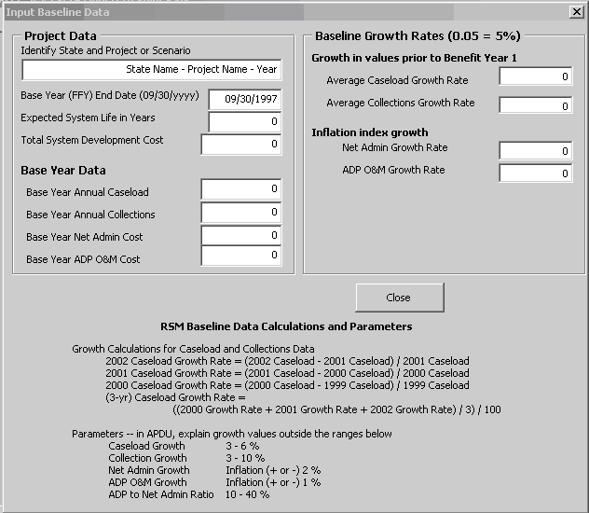
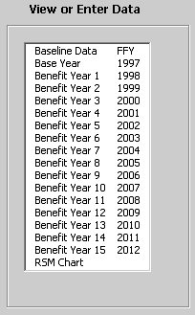

The following paragraphs describe data needed by the RSM, whether it may be changed after input, and how the RSM uses it.

Project Data

Project Data derives from project files and should be consistent with data in the Planning APD (PAPD) and Implementation APD (IAPD). Project data includes the name of the project, the expected total cost and useful life of the system, and the intended year of implementation. The Input Baseline Data screen in RSM software has a designated area for Project Data input:

Figure 2. Input Area for Baseline Project Data
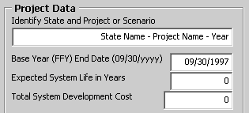

- Project identifier. Up to 40 characters that will appear and print as part of the title on each RSM sheet. Recommendations for use include a combination of state name, project name, and FFY that is being reported. For example:

NewState ACSES Project – IAPD
NewState ACSES Project – FFY 2003
NewState ACSES Project – FFY 2004

These examples would appear in RSM displays as

NewState ACSES Project – IAPD Cost Benefit Analysis – Revenue Stream Model for (Year #)
NewState ACSES Project – FFY 2003 Cost Benefit Analysis – Revenue Stream Model for (Year #)
NewState ACSES Project – FFY 2004 Cost Benefit Analysis – Revenue Stream Model for (Year #) NewState ACSES Project – FFY 2004 - Revenue Stream Model Cost Effectiveness Chart

Data update. The project identifier may be changed at any time. The RSM will automatically change all titles for all displays.

- Base Year. The Federal Fiscal Year (FFY) prior to the year in which users gain access to the system. This is generally the year that the Child Support Enforcement (CSE) system was finalized for use. Base Year activities generally include data migration, user testing and system rollout. For simplicity, the date entered to the RSM is the end date of the Federal Fiscal Year that the State determines as the Base Year for the system.

Ex. 1 The system is implemented for users during FFY 1997 (between October 1, 1996 and September 30, 1997). The Base Year for the system is FFY 1996. RSM Base Year End Date is 9/30/1996.
Ex. 2 The system is implemented for users during FFY 2000 (between October 1, 1999 and September 30, 2000). The Base Year for the system is FFY 1999. RSM Base Year End Date is 9/30/1999.

The Base Year is used in a series of calculations to identify the specific month that benefits exceed costs attributed to the automated system. Base Year is also used to create menu titles and sequential FFY column headers for each benefit year and the graphic chart.

Data update. Once the RSM is populated with actual data, the BASE YEAR MUST NOT BE CHANGED. Caution: If the Base Year is changed, Year titles and FFY column headers for each Benefit Year will recalculate. Any actual data already entered to the RSM will instantly appear to belong to the wrong year. Once data has been entered to the RSM, if it is necessary to change the Base Year, start with a new copy of the RSM software.

- Expected System Life in Years. The number of years, as identified in the IAPD, that the State expects will be the useful life of the system after it is implemented for users.
The RSM uses the number of years identified for system life to amortize the development cost of the system in breakeven calculations. The Federal Office of Child Support Enforcement (OCSE) expects a CSE system to have a useful life of 8 or more years after implementation.

Data update. The expected System Life may be extended at any time to accommodate changes in the development schedule or to allow for additional enhancements to the system. The RSM will automatically recompute all breakeven calculations.

- Total System Development Cost. Total cost anticipated to complete the development or enhancement of the CSE system. This is the total cost to complete the efforts identified in the APD, not the cost incurred to date. The Total System Development Cost should include all planning costs identified in the PAPD, and both actual and estimated costs involved with concept design, hardware and software implementation and installation, and system test and training.

As noted in Companion Guide 3, up to the point at which the automated system begins accumulating benefits, all costs associated with the system are considered to be development costs. In particular, the costs to operate and maintain the developing system are included in the system development costs, as those efforts serve to support the work of developers, not end users (and therefore do not have an effect on increasing collections.) When the system is implemented for users, operations and maintenance efforts support the end users and the accumulation of system benefits. From that point onward, O&M costs must be tracked and reported separately in the Revenue Stream Model and must no longer be added to the Total System Development Cost. (Double-counting O&M costs serves to delay the system breakeven point.)

The Total System Development Cost must be consistent with budget data reported in the Advance Planning Document.

The RSM uses the Total System Development Cost to calculate the point at which the system becomes cost effective, i.e., breaks even.

Data update. The Total System Development Cost should be updated on an annual basis. The RSM will automatically recompute all breakeven calculations whenever the Total System Development Cost is updated.

Base Year Data

Until the system is implemented for use, Base Year data may be estimated, as shown later in the Help Guide in Section 2.1.4, Preparing and Using the RSM Prior to System Implementation.

Once the system has been implemented for use, actual values for caseload, collections, net administrative costs, and Automated Data Processing (ADP) Operations and Maintenance (O&M) costs are used in the RSM as the Base Year dataset.

For simplicity, the Revenue Stream Model makes use of the same data required on quarterly OCSE Forms or APD documents. For example, the State should derive Base Year Data from project files and data reported to ACF on OCSE Forms 34A, 131, 157, and 396A. (Prior versions of these forms are identified in Appendix B.) Selected data reported on OCSE Forms also appears in CSE Annual Reports to Congress and Annual Statistical Reports. CSE Annual Reports to Congress for FFY 1993 and Annual Statistical Reports for subsequent years may be researched online on the ACF website at: http://www.acf.hhs.gov/programs/cse/prgrpt.htm.

RSM data must be consistent with data reported previously by the State. Where RSM data varies by more than ten percent from data on OCSE Forms or Annual Reports, a brief justification should be included in the narrative portion of the CBA section of the APDU or As-Needed APD.

Data update. Should it become necessary, Base Year caseload, collections, net administrative costs and ADP O&M cost data may be updated at any time. Changes should be identified and explained in the CBA narrative.

The RSM uses Base Year input to populate the Base Year display and initial projections. The Input Baseline Data screen in RSM software has a designated area for Base Year Data input, as shown in Figure 3.

Figure 3. Input Area for Base Year Data
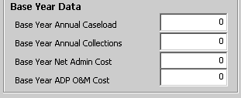

- Base Year Annual Caseload. Total annual caseload as reported on OCSE Form 157 (Lines 1 and 3), formerly OCSE Form 156 (Lines 4 and 5), formerly OCSE Form 56 (Line 4). Specific data years for each form are listed in Appendix B, Data Sources.

- Base Year Annual Collections. Total distributed collections as reported on OCSE Form 34A (Line 8), formerly OCSE Form 34 (Line 13). Specific data years for each form are listed in Appendix B, Data Sources.

- Base Year Net Administrative Cost. Total cost to administer the CSE Program, less any costs related to the automated system. Until FFY 1999, Net Administrative costs were not reported separately on OCSE Forms or reports. Net Administrative costs prior to FFY 1999 must be derived from State data sources. Starting in FFY 1999, Net Administrative costs have been reported on OCSE Form 396A (Line 3).
CAUTION: The “Total Administrative Expenditures” reported in Annual Reports to Congress and Statistical Reports include the system development cost and operations costs for the automated system. If Total Administrative Expenditures were to be used in the RSM, system costs would be counted twice, effectively delaying the point at which the system breaks even. Only Net Administrative costs should be used in the RSM.

- Base Year ADP O&M Cost. The cost to operate and maintain the automated system for the Base Year. This figure is used by the RSM to provide a baseline for O&M projections. However, the Base Year ADP O&M cost must also be included in the Total System Development Cost for RSM calculations.

CAUTION: After the system is implemented for users, ADP O&M costs should not be included in the Total System Development Cost. Otherwise, O&M costs will be counted twice, effectively delaying the point at which the system breaks even.

Baseline Growth Rates

Baseline Growth Rates are the average growth rates prior to system implementation. The State determines the number of years needed in the baseline period to fairly represent the ‘normal’ rate of change prior to system implementation (in most cases, three to five years). Growth rates should all be calculated for the same time period.

Whenever caseload, collections, administrative costs or ADP O&M costs are entered to the RSM, Baseline Growth Rates are used to (re)calculate future projections for costs and benefits. The Input Baseline Data screen in RSM software has a designated area for Baseline Growth Rates:

Figure 4. Input Area for Baseline Growth
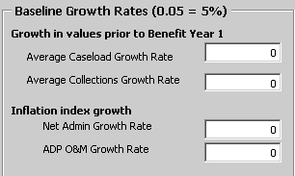

Baseline Growth Rates may be entered in decimal or percentage format (five percent may be entered either as “0.05” or as “5%”).

It is helpful to create a worksheet to record actual values and determine growth calculations. (See Section 2.1.1.2 on Base Year Data for information on sources for historical caseload, collections, net administrative cost and ADP O&M cost data.) The methodology shown in the following paragraphs implements the formulas shown in Companion Guide 3. ACF does not mandate that States use this particular methodology. Should the State choose an alternative method of calculating growth, an explanation must be included in the CBA narrative of the APD.

For caseload and collections data, growth is calculated on the change in actual annual totals over the baseline period. For net administrative expenditures and ADP O&M costs, growth is calculated on the change in a chosen inflation index over the baseline period.
Companion Guide 3 noted that the demands of developing an automated system have significant effects on the staffing and budget of the CSE program prior to system implementation. In many areas, growth prior to system implementation does not provide a good basis for estimating future expenditures. This is true of Net Administrative Expenditures, and also of ADP Operations and Maintenance. To estimate growth in these areas, the Revenue Stream Model is designed to use an index of inflation to calculate growth.

Formulas for calculating RSM growth rates for caseload or collections are discussed in Companion Guide 3. Although caseload data is shown below, the same formulas apply to collections data.

- Average Caseload (or Collections) Growth
Calculate the growth rate for each specific year.
1995 Growth Rate = (1995 Caseload - 1994 Caseload)1994 Caseload
1996 Growth Rate = (1996 Caseload - 1995 Caseload)1995 Caseload
1997 Growth Rate = (1997 Caseload - 1996 Caseload)1996 Caseload

Determine the Average Caseload (or Collections) Growth Rate.
Average Caseload Growth = ((1995 Growth Rate + 1996 Growth Rate + 1997 Growth Rate)3)

An example worksheet is shown in Figure 5, Determining Caseload and Collections Growth Rates.

Average Caseload growth is determined in Figure 5 as follows:
Line 4 -- actual caseload data for FFYs 1994 to 1997.
Line 5 -- formula to calculate the caseload growth rate for each year.
Line 6 -- formula to calculate the average growth rate for 3 years.
Use this rate as the RSM Baseline Growth Rate for Caseload.

Average Collections growth is determined in Figure 5 as follows:
Line 10 -- actual collections data for FFYs 1994 to 1997.
Line 11 -- formula to calculate the collections growth for each year.
Line 12 -- formula to calculate the average growth rate for 3 years.
Use this rate as the RSM Baseline Growth Rate for Collections.

Formulas for calculating RSM growth rates for net administrative or ADP O&M costs are discussed in Companion Guide 3. Although net administrative data is shown below, the same formulas apply to ADP O&M data.

- Average Net Administrative (or ADP O&M) Growth
Calculate the Growth Rate for each specific year.
1995 Growth Rate = 1995 Annual Inflation Rate
1996 Growth Rate = 1996 Annual Inflation Rate
1997 Growth Rate = 1997 Annual Inflation Rate

Determine the Average Net Administrative (or ADP O&M) Growth Rate.
Net Administrative Growth = ((1995 Inflation + 1996 Inflation + 1997 Inflation)3)

An example worksheet is shown in Figure 6, Preparing Net Administrative and ADP O&M Growth Rates for the RSM.

Average Net Administrative Cost growth is determined in Figure 6 as follows:
Line 18 -- actual net administrative cost data for FFYs 1994 to 1997.
Line 19 -- inflation rates for the years 1994 to 1997.
Line 20 -- formula to calculate growth rate for 3 years.
Line 21 – additional factor for local influences on growth
Line 22 – average growth rate for 3 years to use in RSM
Use this rate as the RSM Baseline Growth Rate for Net Administrative Cost

Average ADP O&M Cost growth is determined in Figure 6 as follows:
Line 25 -- actual ADP O&M cost data for FFYs 1994 to 1997.
Line 26 -- inflation rates for the years 1994 to 1997.
Line 27 -- formula to calculate growth rate for 3 years.
Line 28 – additional factor for local influences on growth
Line 29 – average growth rate for 3 years to use in RSM
Use this rate as the RSM Baseline Growth Rate for ADP O&M Cost

Figure 5. Determining Caseload and Collections Growth Rates
Gather actual Caseload and Collections data from OCSE forms – starting 3 (or more) years prior to Base Year
Calculate Growth -- actual change, percentage of change, average growth over time – using OCSE formulas

 |  | RSM Data Worksheet
A | B | C | D | E | F
1
2 |  |  |  |  | Base Year
3 | Annual Caseload | FFY 1994 | FFY 1995 | FFY 1996 | FFY 1997
4 | Caseload Data | 286,631 | 292,826 | 302,503 | 322,503 |  | Caseload data consistent with OCSE Forms (see Appendix B)
5 | Growth Rate | 8.71% | 2.16% | 3.30% | 6.61% |  | Formula “( 1997 – 1996 ) / 1996” = ( F4 – E4 ) / E4
6 | Av Growth 3 Yrs | 6.78% | 6.49% | 4.73% | 4.03% |  | 3-Yr Formula “(1995 Rate + 1996 Rate + 1997 Rate) / 3” = SUM ( D5 : F5 ) / 3
7 |  |  |  |  |  |  | Use Av Growth for 3 or more years as Baseline Growth Rate in RSM
8 |  |  |  |  | Base Year
9 | Annual Collections | FFY 1994 | FFY 1995 | FFY 1996 | FFY 1997
10 | Collections Data | 156,198,554 | 165,612,461 | 174,127,769 | 197,289,914 |  | Collections data consistent with OCSE Forms (see Appendix B)
11 | Growth Rate | 15.70% | 6.03% | 5.14% | 13.30% |  | Formula “(1997 – 1996 ) / 1996” = ( F10 – E10 ) / E10
12 | Av Growth 3 Yrs | 9.18% | 8.40% | 8.96% | 8.16% |  | 3-Yr Formula “(1995 Rate + 1996 Rate + 1997 Rate) / 3” = SUM ( D11 : F11 ) / 3
13 |  |  |  |  |  |  | Use Av Growth for 3 or more years as Baseline Growth Rate in RSM

Growth Calculations for Caseload Data |  | Parameters – In APDU, explain values outside these ranges:
1995 Caseload Growth = (1995 Caseload -1994 Caseload / 1994 Caseload)
1996 Caseload Growth = (1996 Caseload -1995 Caseload / 1995 Caseload) |  | Caseload Growth 3 – 6 %
1997 Caseload Growth = (1997 Caseload -1996 Caseload / 1996 Caseload) |  | Collections Growth 3 – 10 %
(3-yr) Caseload Growth Rate = ((1995 Growth + 1996 Growth + 1997 Growth) / 3)
Growth Calculations for Collections Data
1995 Collections Growth = (1995 Collections -1994 Collections / 1994 Collections)
1996 Collections Growth = (1996 Collections -1995 Collections / 1995 Collections)
1997 Collections Growth = (1997 Collections -1996 Collections / 1996 Collections)
(3-yr) Collections Growth Rate = ((1995 Growth + 1996 Growth + 1997 Growth) / 3)

Figure 6. Determining Net Administrative and ADP O&M Growth Rates
Gather actual Net Administrative and ADP O&M data from OCSE forms or project records – starting 3 (or more) years prior to Base Year
Calculate Growth -- actual change, percentage of change, average growth over time – using OCSE formulas
Determine local influence on Inflation factor – modify inflation growth percentages to reflect local historical conditions

 |  | RSM Data Worksheet
A | B | C | D | E | F
16 |  |  |  |  | Base Year
17 | Net Administrative | FFY 1994 | FFY 1995 | FFY 1996 | FFY 1997
18 | Net Admin Cost | 38,890,596 | 42,226,965 | 44,168,978 | 45,998,417 |  | Net Admin data consistent with OCSE Forms (see Appendix B)
19 | Inflation Rate | 2.60% | 2.76% | 2.96% | 2.35% |  | Inflation rates – no formula needed
20 | Growth 3 Yrs | 2.86% | 2.78% | 2.77% | 2.69% |  | Av Inflation Growth 3 Yrs “(1995 + 1996 + 1997) / 3” = SUM ( D19 : F19 ) / 3
21 | Local Factors |  |  |  | 0.05% |  | Local: Factor in local historical conditions, i.e., State economy better than national
22 | Av Net Admin Growth Rate |  |  |  | 2.74% |  | Reasonable Baseline Growth Rate for RSM
23
24 | Annual ADP O&M | FFY 1994 | FFY 1995 | FFY 1996 | FFY 1997
25 | ADP O&M Cost | 2,848,996 | 3,678,633 | 4,990,590 | 5,510,682 |  | ADP O&M data consistent with APD budget and OCSE Form data (see Appendix B)
26 | Inflation Rate | 2.60% | 2.76% | 2.96% | 2.35% |  | Inflation rates – no formula needed
27 | Av Growth 3 Yrs | 2.86% | 2.78% | 2.77% | 2.69% |  | Av Inflation Growth 3 Yrs “(1995 + 1996 + 1997 ) / 3” = SUM ( D26 : F26 ) / 3
28 | Local Factors |  |  |  | 0.10% |  | Local: Factor in local historical conditions, i.e., quicker rise of data center costs
29 | Av ADP O&M Growth Rate |  |  |  | 2.79% |  | Reasonable Baseline Growth Rate for RSM

Growth Calculations for Net Administrative Costs |  | Inflation Rates Published for 1990 – 2001
1995 Net Admin Growth = (1995 Inflation Rate) |  | 1990 5.39% | 1995 2.76% | 2000 3.38%
1996 Net Admin Growth = (1996 Inflation Rate) |  | 1991 4.22% | 1996 2.96% | 2001 2.86%
1997 Net Admin Growth = (1997 Inflation Rate) |  | 1992 3.01% | 1997 2.35%
(3-yr) Net Admin Growth Rate = |  | 1993 2.98% | 1998 1.51% | Estimate for 2002 3.1%
((1995 Growth + 1996 Growth + 1997 Growth) / 3) |  | 1994 2.60% | 1999 2.21%
 |  | EXAMPLE URL FOR INFLATION RATE: http://www.eh.net/ehresources/howmuch/inflationq.php
Growth Calculations for ADP O&M Data |  | Parameters – In APDU, explain values outside these ranges:
1995 ADP O&M Growth = (1995 Inflation Rate)
1996 ADP O&M Growth = (1996 Inflation Rate) |  | Net Admin Cost Growth Inflation (+ or - ) 2%
1997 ADP O&M Growth = (1997 Inflation Rate) |  | ADP O&M Cost Growth Inflation (+ or - ) 1%
(3-yr) ADP O&M Growth Rate = |  | ADP to Admin Ratio 10 – 40 %
((1995 Growth + 1996 Growth + 1997 Growth) / 3)

Case Study #1––Setting up the RSM After the System has been Implemented.

Upon approval of its Implementation Advance Planning Document (IAPD), NewState began developing an automated child support enforcement system in FFY 1995, and implemented the Automated Child Support Enforcement System (ACSES) in FFY 1998.

NewState has used the Functional Model to document cost effectiveness since the beginning of the project. The current year is FFY 1999, and NewState is preparing to change CBA methodologies to the Revenue Stream Model.

NewState staff gathered the project data in Figure 7 for the NewState RSM.
The ACSES Data Worksheet in Figure 8 was used to determine growth rates and record actual caseload, collections, net administrative and ADP O&M cost data through FFY 1999.

In this case, the RSM is being set up after the system has been implemented. Therefore, actual data is available for growth formulas and Base Year entries.

Create a copy of the RSM application with a new filename, such as Case_Study_1.xls
When complete, save the Case Study RSM; more data will be added in a later example.

Figure 7. Case Study #1—ACSES Project Data
Project: | NewState – ACSES Project – FFY 1999
Base Year: | FFY 1997
System Life: | 13 years
Total System Development Cost | $82,294,578

Figure 8. Case Study #1— ACSES Base Year Data, Baseline Growth Rates, and FFY Annual Data
 |  |  | NewState ACSES Data Worksheet
A | B | C | D | E | F | G | H | I | J
1
2 |  |  |  |  | Base Year
3 | Annual Caseload | FFY 1994 | FFY 1995 | FFY 1996 | FFY 1997 | FFY 1998 | FFY 1999 | FFY 2000 | FFY 2001
4 | Caseload Data | 286,631 | 292,826 | 302,503 | 322,503 | 333,015 | 321,026
5 | Growth Rate | 8.71% | 2.16% | 3.30% | 6.61%
6 | Av Growth 3 Yrs | 6.78% | 6.49% | 4.73% | 4.03%
7
8
9 | Annual Collections | FFY 1994 | FFY 1995 | FFY 1996 | FFY 1997 | FFY 1997 | FFY 1999 | FFY 2000 | FFY 2001
10 | Collections Data | 156,198,554 | 165,612,461 | 174,127,769 | 197,289,914 | 221,386,560 | 242,795,516
11 | Growth Rate | 15.70% | 6.03% | 5.14% | 13.30%
12 | Av Growth 3 Yrs | 9.18% | 8.40% | 8.96% | 8.16%
13
14
15
16
17 | Net Administrative | FFY 1994 | FFY 1995 | FFY 1996 | FFY 1997 | FFY 1997 | FFY 1999 | FFY 2000 | FFY 2001
18 | Net Admin Cost | 38,890,596 | 42,226,965 | 44,168,978 | 45,998,417 | 48,987,718 | 55,840,065
19 | Inflation Rate | 2.60% | 2.76% | 2.96% | 2.35%
20 | Growth 3 Yrs | 2.86% | 2.78% | 2.77% | 2.69%
21 | Local Factors |  |  |  | 0.05%
22 | Av Net Admin Growth Rate |  |  |  | 2.74%
23
24 | Annual ADP O&M | FFY 1994 | FFY 1995 | FFY 1996 | FFY 1997 | FFY 1997 | FFY 1999 | FFY 2000 | FFY 2001
25 | ADP O&M Cost | 2,848,996 | 3,678,633 | 4,990,590 | 5,510,682 | 6,105,882 | 7,896,772
26 | Inflation Rate | 2.60% | 2.76% | 2.96% | 2.35%
27 | Av Growth 3 Yrs | 2.86% | 2.78% | 2.77% | 2.69%
28 | Local Factors |  |  |  | 0.10%
29 | Av ADP O&M Growth Rate |  |  |  | 2.79%

Step 1. Open the CaseStudy1 RSM.
From the Main Menu, choose to View or Enter Baseline Data

Figure 9. Case Study #1— Step 1. Enter Baseline Data.

Step 2. Enter Project data.
Using data from Figure 7, enter project data:
Project Name. Up to 40 alphanumeric characters.
Base Year. Use four-digit year format “YYYY”
System Life. Numeric data only. Up to two digits, normally less than 15 years.
Total System Development Cost. Numeric data only.
Do not enter dollar sign or commas.

Step 3. Enter Base Year Data
Using data from Figure 8, enter actual values for the Base Year, FFY 1997.
Caseload. Total caseload for FFY 1997. Numeric data only. Do not enter commas.
Collections. Total distributed collections for FFY 1997. Numeric data only. Do not enter dollar sign or commas.
Net Administrative cost. Net administrative cost for FFY 1997 (total administrative costs less ADP-related expenditures). Numeric data only. Do not enter dollar sign or commas.
ADP O&M cost That portion of the Total System Development Cost attributed to operation and maintenance of the system for FFY 1997. Numeric data only. Do not enter dollar sign or commas.

Step 4. Enter Baseline Growth Rates
Use 3-year average growth data from Figure 8.
Caseload. Average growth for caseload in FFY 1995 – 1997.
Enter as decimal number or using the percent sign (e.g., enter “.0403” or “4.03%”)
Collections. Average growth for collections in FFY 1995 – 1997.
Enter as decimal number or using the percent sign (e.g., enter “.0816” or “8.16%”)
Net Administrative cost. Average growth for inflation FFY 1995 – 1997, including local factors. Enter “.0274” or “2.74%”
ADP O&M. Average growth for inflation FFY 1995 – 1997, including local factors.
Enter “.0279” or “2.79%”

Figure 10. Case Study #1— Completed Baseline Data Entry

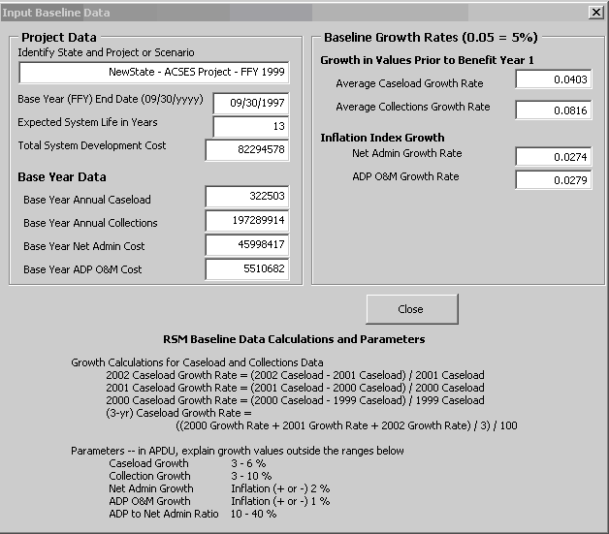

Step 5. Close and return to the Main Menu

Step 6. View Base Year data
From the Main Menu, choose to View Base Year data.
Base Year values appear at the lower left of the Benefit Year display. They are visible on every Benefit Year display, and on the RSM Cost Effectiveness Chart. These are dynamic displays, and will change whenever Baseline data is modified. (Refer to your CaseStudy1 and Figure 11, Base Year Projections, at the end of this Case Study.)

Verify that Base Year values have been entered correctly from Figure 7 and Figure 8.

The RSM applied the Baseline growth to Base Year values, and created projections for succeeding Benefit Years for caseload, collections, net administrative costs and ADP O&M costs.
The RSM calculated accumulating costs and benefits. At the end of FFY 2003, the RSM estimates that the accumulated costs will be $118,741,776, and accumulated benefits will be $93,998,683. (If the Print Menu obscures breakeven data on your monitor display, move the menu box down or aside. Put the cursor on the title bar and click-and-drag the box to a new place.)

At this point in time, based on these estimates, benefits should exceed costs during FFY 2004. The breakeven point will occur in August 2004, when benefits reach $124,976,321. The Base Year display serves as a historic snapshot of these projections.

Click Return to Main Menu on the Print Base Year Data Menu.

Step 7. Enter actual data for Benefit Year 1, FFY 1998.
From the Main Menu, choose to View or Enter Data for Benefit Year 1. As Benefit Year 1 displays, a small input menu pops up at the lower right of the screen.

The menu may be moved to another spot on the screen (by dragging the title bar with the mouse), but the cursor will remain in the input menu.

Using data from Figure 8, enter caseload, collections, net administrative cost and ADP O&M cost for FFY 1998.

The RSM recalculates accumulating costs and benefits. At the end of FFY 2003, the RSM now estimates that the accumulated costs will be $121,582,248, and accumulated benefits will be $108,614,222.

At this point in time, based on these estimates, benefits should exceed costs during FFY 2004. The breakeven point will occur in March 2004, when benefits reach $127,070,875.
(See Figure 12, Benefit Year 1, at the end of this Case Study.)

The Input Benefit Year 1 Data menu allows from 1 to 99 copies of the current year display to print on any printer defined on your PC. Entering a zero or a null value will not change the default value of one copy.

Print one copy by clicking the Print Current Year button.

The Excel printer setup menu will pop up on the Benefit Year display. (See Figure 13, Printer Setup Menu, at the end of this Case Study.) The Printer Setup menu displays printers currently defined on the PC. Depending on the printer chosen, it may be possible to change one or more settings for the current print job. This printer setup menu is an Excel function. Available choices depend on the resident version of Excel and the setup of network and local printers.

Highlight a printer. Double click the printer, or click the OK or Enter button to print Benefit Year 1 and return to the Main Menu.

Step 8. Enter actual data for Benefit Year 2, FFY 1999.
From the Main Menu, choose to View or Enter Data for Benefit Year 2.

First, make a note of the projected values for caseload, collections, net administrative cost and ADP O&M cost. Note that the column header for FFY 1999 reads “Projected FFY 1999,” but the column header for FFY 1998 has changed to “Actual FFY 1998,” signaling that actual data was entered for that year.

To see how that happens, for Caseload, enter “400500” instead of the FFY value from Figure 8. Note that as soon as data has been entered and the cursor leaves the caseload entry field, the column header changes from “Projected FFY” to “Actual FFY.”

Re-enter FFY 1999 Caseload as it was projected in the prior year (“321026”).
Note that as soon as data again equals the value projected in the prior year, and the cursor leaves the entry field, the column header changes from “Actual FFY” to “Projected FFY.”

If ANY ONE of the four input entries (caseload, collections, net administrative cost, or ADP O&M cost) differs from the value projected in the prior year, the column header will appear as “Actual.”

When ALL FOUR of the input entries (caseload, collections, net administrative cost, and ADP O&M cost) are equal to the values projected in the prior year, the column header will appear as “Projected.”

These changes affect only the values on the current year.

Using data from Figure 8, enter caseload, collections, net administrative cost and ADP O&M cost for FFY 1999.

The RSM again recalculates accumulating costs and benefits. At the end of FFY 2003, the RSM now estimates that the accumulated costs will be $130,149,851, and accumulated benefits will be $115,677,699.

At this point in time, based on these estimates, benefits should exceed costs during FFY 2004. The breakeven point will occur in March 2004, when benefits reach $135,195,035.

(See Figure 14, Benefit Year 2, at the end of this Case Study.)

Click Return to Main Menu on the Input Benefit Year 2 Data menu.

Step 9. RSM Cost Effectiveness Chart.
From the Main Menu, choose to View Data for RSM Chart.
Baseline data appears below the RSM Cost Effectiveness Chart in the leftmost box. Note that the Total System Development Cost has been updated to the new value.

Note that the Baseline Growth Rates in the middle box have not changed from initial input.

Statistics in the rightmost box include the last year of actual data entered. This should now appear as FFY 1999.

Click Return to Main Menu.

Step 10. Print the Base Year and Benefit Year 2.
On the Main Menu, examine the area titled Print One or More Benefit Years.

Select the Base Year for printing by clicking the Base Year checkbox. Note that this is a toggle function. Clicking again will clear the checkbox.

Also select Benefit Year 2 for printing.

Below the list of benefit years is the Select All/Clear All checkbox. This is also a toggle function. Clicking it will alternately select and clear all of the checkboxes.

Experiment with clearing and selecting several Benefit Years. When done, re-select the Base Year and Year 2 for printing.

Enter the number of copies to print (1 to 99). (Null value or zero will resolve to the default value of one copy.)

Press Print to select a printer and start the print process. The RSM will automatically clear all checkboxes.

(See Figure 15, Print One or More Benefit Years, at the end of this Case Study.)

Step 11. Close the RSM and save the case study.

Figure 11. Case Study #1— Base Year Projections
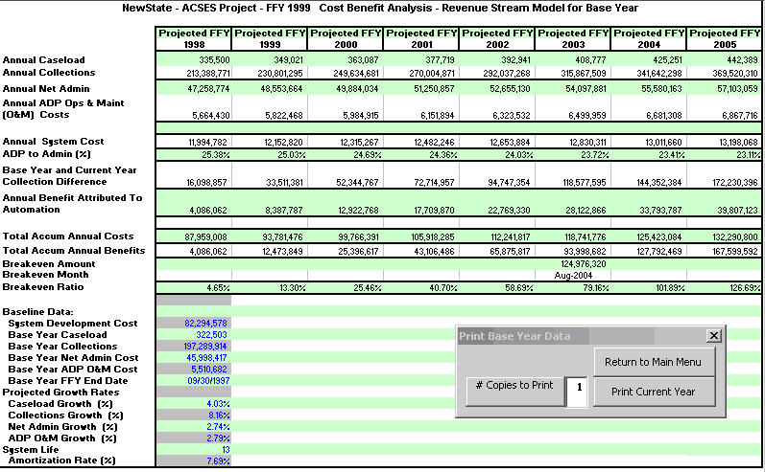

Figure 12. Case Study #1—Benefit Year 1

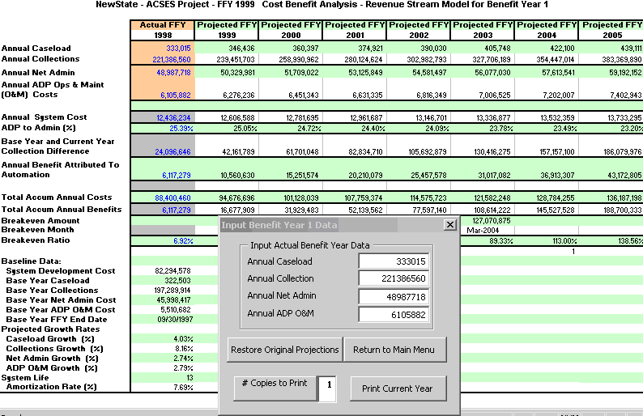
Figure 13. Case Study #1—Printer Setup Menu
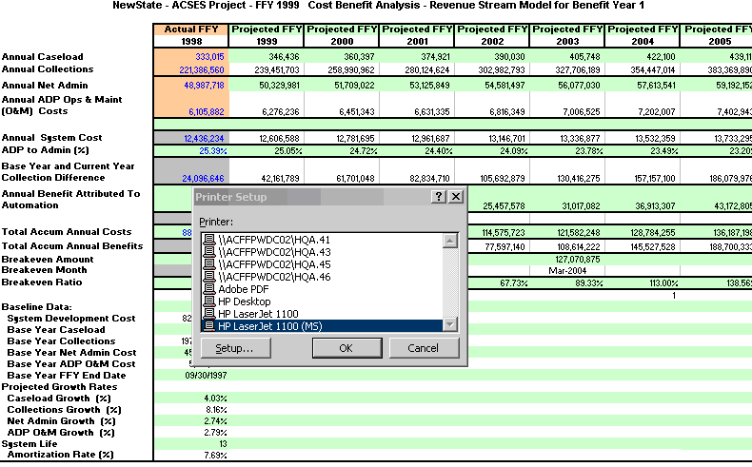
Figure 14. Case Study #1—Benefit Year 2
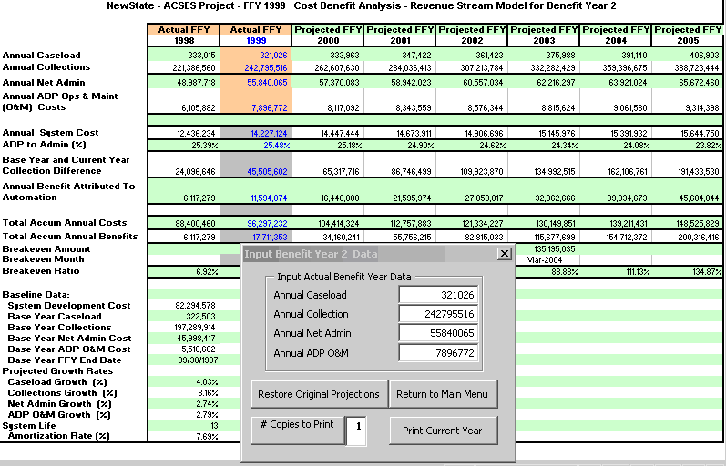

Figure 15. Case Study #1—Print One or More Benefit Years
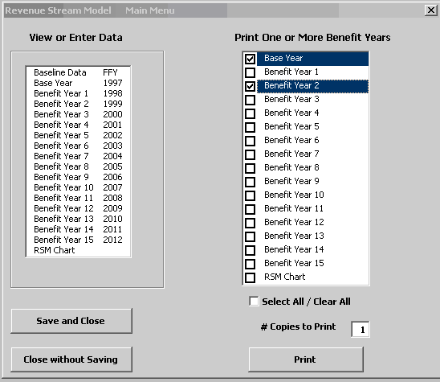

Case Study #2—Updating Cost Benefit Data and Reporting after Implementation.

Case Study 2 updates the RSM started in Case Study 1. Update the existing RSM, or create a copy of the Case Study 1 file to modify for Case Study 2.

The following paragraphs are from a hypothetical APD submitted by the example state of NewState. In its APDU for FFY 2000, NewState included a Cost Benefit Analysis consisting of a brief statement of the factual updates, augmented with a narrative description of the other-than-monetary benefits being monitored, and a summary of the positive effects that the ACSES system has had on the CSE program. The CBA Section concluded with current excerpts from its Revenue Stream Model.

NewState FFY 2000 APDU excerpt:

NewState changed from the Functional Model for Cost Benefit Analysis to the Revenue Stream Model with the FFY 1999 APDU, submitted on December 10, 1999, and subsequently approved in the ACF approval letter of March 2000.

This APDU updates the NewState ACSES RSM with actual data from FFY 2000. The following data was updated in the FFY 2000 RSM:

Total System Development Cost increased to a total of $85,487,224 with this RSM.

Caseload, collections, net administrative cost data, and ADP O&M data was consistent with data reported on OCSE Forms for FFY 2000.

 | FFY 2000
Caseload | 325,892
Collections | $258,597,013
Net Administrative Costs | $ 68,931,905
ADP O&M Cost | $ 8,956,774

Caseload was lower than projected, due to efficiencies in case closure provided by the automated system. Collections were higher than estimated, due to the rapid acceptance of Income Withholding by NewState employers. Remaining data was within expected parameters for the year.

The RSM indicates the ADP-to-Admin ratio for FFY 2000 is 22.53%. As a result, $14,039,919 was attributed as a benefit of the automated system for the year.

Total accumulated costs to date are $108,446,652
Total accumulated benefits are $ 32,072,211

At this point in time, the system has a breakeven ratio of 29.57%, indicating that ACSES is making good progress toward becoming cost effective. The RSM projects that ACSES will achieve breakeven in February 2005, with a breakeven amount of $153,479,028.

Step 1. Open the CaseStudy2 RSM.
From the Main Menu, choose to View or Enter Baseline Data.
Figure 16. Case Study #2— Update Total System Development Cost

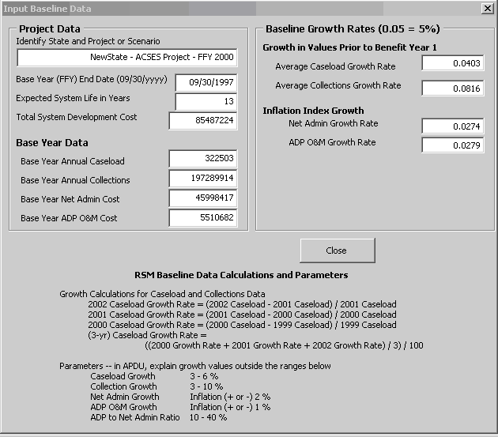

Step 2. Update Total System Development Cost
Update the Total System Development Cost to $85,487,224.
Enter as numeric data only. Do not enter dollar sign or commas. (See Figure 16 above.)

Step 3. Close and return to the Main Menu.

Step 4. Enter actual data for Benefit Year 3, FFY 2000
Using data from NewState FFY 2000 APDU excerpt, enter actual values for the Benefit Year 3, FFY 2000.
Caseload. Total caseload for FFY 2000. Numeric data only. Do not enter commas.
Collections. Total distributed collections for FFY 2000. Numeric data only. Do not enter dollar sign or commas.
Net Administrative cost. Net administrative cost for FFY 2000 (total administrative costs less ADP-related expenditures). Numeric data only. Do not enter dollar sign or commas.
ADP O&M cost Enter ADP Operations and Maintenance Cost. Numeric data only. Do not enter dollar sign or commas. Ensure this cost is NOT included in Total System Development Cost.

Using the increased Total System Development Cost and additional data for FFY 2000, the RSM recalculates accumulating costs and benefits. At the end of FFY 2004, the RSM estimates that the accumulated costs will be $146,843,387, and accumulated benefits will be $136,838,815.

At this point in time, based on these estimates, benefits should exceed costs during FFY 2005. The breakeven point will occur in February 2005, when benefits reach $153,479,028. (See Figure 17, Benefit Year 3, at the end of this Case Study.)

Step 5. Print the Current Year.
Print one copy of the current year by clicking Print Current Year and return to Main Menu.

Step 6. View and Print the RSM Cost Effectiveness Chart
From the Main Menu, choose to View Data for RSM Chart.
View the RSM Cost Effectiveness Chart (or refer to Figure 18 at the end of this Case Study.) In the baseline data that appears below the chart in the leftmost box, note that the Total System Development Cost has been updated to the new value.

Baseline Growth Rates in the middle box have not changed from initial input.

Statistics in the rightmost box include the last year of actual data entered. This should now be identified as (FFY) 2000. The Breakeven Month identified in FFY 2000 (Benefit Year 3) is January 2005.

Breakeven Amount and Actual Cumulative Cost and Benefit data are repeated from the Benefit Year 3 display.

Print the RSM Cost Effectiveness Chart from this display, or return to the Main Menu and print from there.

Step 7. Close the RSM and save the case study.

NOTE: Each APD (annual update or as-needed update) should include a copy of the current year from the Revenue Stream Model, and a copy of the RSM Cost Effectiveness Chart, as in Figure 17 and Figure 18 below.

Figure 17. Case Study #2—Benefit Year 3

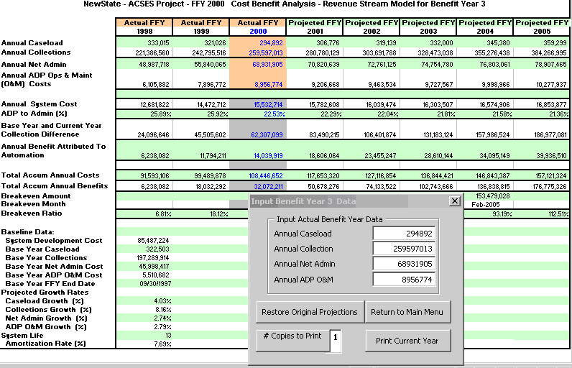

Figure 18. Case Study #2—RSM Cost Effectiveness Chart

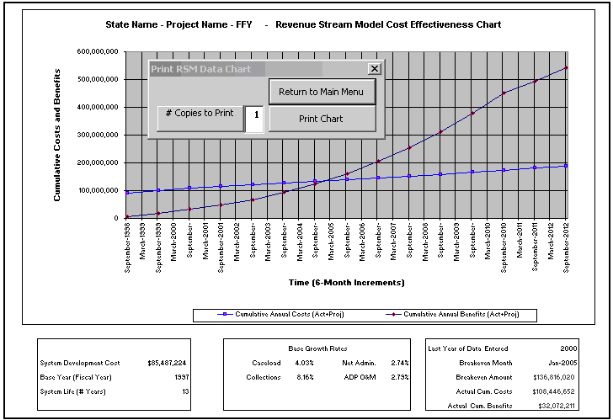

Preparing and Using the RSM Prior To System Implementation

This section discusses how to set up a Revenue Stream Model with estimated data and growth rates for use in an Implementation APD. This section further illustrates how to use the estimated RSM during the period of time between approval of the Implementation APD and system implementation for end users.

At the time of the Implementation APD, the Base Year for RSM purposes is generally several years into the future. Therefore, there is no “actual” data to use for baseline growth calculations. The State must create initial estimates of growth and performance data for use in the interim RSM.

CAUTION: ACF does not mandate that States use this particular methodology. Should the State choose an alternative method of estimating data and growth rates, an explanation must be included in the CBA narrative of the APD.

First, identify a recent period of time for which actual data is available. Treat this period as an estimated baseline. Use the same procedures discussed earlier to calculate baseline growth rates. For caseload and collections, calculate growth rates on the change in actual annual totals over the estimated baseline. For net administrative expenditures and ADP O&M costs, calculate growth on the change in a chosen inflation index over the same estimated baseline.

Next, estimate values for the future Base Year. Use the estimated growth rates to project annual values for caseload, collections, net administrative costs and ADP O&M costs for each year up to the Base Year. Use these estimated Base Year projections in the RSM until the system is implemented.

As noted earlier in the Help Guide, it is helpful to create a worksheet to record actual values and determine growth calculations. (See Section 2.1.1.2, Base Year Data, for information on sources for historical caseload, collections, net administrative cost and ADP O&M cost data.) The methodology shown in this section implements the formulas shown in Companion Guide 3. In the following examples, the worksheet and formulas are extended to create projections of Base Year caseload, collections, net administrative costs and ADP O&M costs.

Formulas for calculating RSM growth rates for caseload or collections are discussed in Companion Guide 3. Although caseload data is shown below, the same formulas apply to collections data.

- Average Caseload (or Collections) Growth
Calculate the growth rate for each specific year.
1993 Growth Rate = (1993 Caseload - 1992 Caseload)1992 Caseload
1994 Growth Rate = (1994 Caseload - 1993 Caseload)1993 Caseload
1995 Growth Rate = (1995 Caseload - 1994 Caseload)1994 Caseload

Determine the Average caseload (or collections) Growth Rate.
Average Caseload Growth = ((1993 Growth Rate + 1994 Growth Rate + 1995 Growth Rate)3)

- Project caseload and collections values for each year up to the Base Year.
Multiply the last actual caseload and collections figures by the Average caseload (or collections) Growth rate to project the values for each specific year.
1996 Caseload = (1995 Caseload) x (1+ Average Caseload Growth Rate)
1997 Caseload = (1996 Caseload) x (1+ Average Caseload Growth Rate)

1996 Collections = (1995 Collections) x (1+ Average Collections Growth Rate)
1997 Collections = (1996 Collections) x (1+ Average Collections Growth Rate)

An example worksheet is shown in Figure 19, Estimating Growth Rates and Base Year Values

Average Caseload growth is determined in Figure 19 as follows:
Line 4 -- actual caseload data for FFYs 1992 to 1995, and
projected caseload data for FFYs 1996 and 1997
Line 5 -- formula to calculate the caseload growth rate for each year.
Line 6 -- formula to calculate the average growth rate for 3 years.
Use this rate as the RSM Baseline Growth Rate for caseload.
Multiply 1995 caseload by this rate to project 1996 caseload.
Multiply 1996 caseload by this rate to project 1997 caseload.
Use projected FFY 1997 caseload as RSM Base Year input.

Average Collections growth is determined in Figure 19 as follows:
Line 9 -- actual collections data for FFYs 1992 to 1995, and
projected collections data for FFYs 1996 and 1997
Line 10 -- formula to calculate the collections growth for each year.
Line 11 -- formula to calculate the average growth rate for 3 years.
Use this rate as the RSM Baseline Growth Rate for collections.
Multiply 1995 collections by this rate to project 1996 collections.
Multiply 1996 collections by this rate to project 1997 collections.
Use projected FFY 1997 collections as RSM Base Year input.

Formulas for calculating RSM growth rates for net administrative or ADP O&M costs are discussed in Companion Guide 3. Although net administrative cost is shown below, the same formulas apply to ADP O&M data.

- Average Net Administrative (or ADP O&M) Growth
Calculate the Growth Rate for each specific year.
1993 Growth Rate = 1993 Annual Inflation Rate
1994 Growth Rate = 1994 Annual Inflation Rate
1995 Growth Rate = 1995 Annual Inflation Rate

Determine the Average Net Administrative (or ADP O&M) Growth Rate.
Net Administrative Growth = ((1993 Inflation + 1994 Inflation + 1995 Inflation)3)

- Project Net Administrative and ADP O&M cost values for each year up to the Base Year.
Multiply the last actual Net Administrative and ADP O&M cost figures by the Average Growth rate to projected the values for each specific year.
1996 Net Admin = (1995 Net Admin) x (1+ Average Net Admin Growth Rate)
1997 Net Admin = (1996 Net Admin) x (1+ Average Net Admin Growth Rate)

1996 ADP O&M = (1995 ADP O&M) x (1+ Average ADP O&M Growth Rate)
1997 ADP O&M = (1996 ADP O&M) x (1+ Average ADP O&M Growth Rate)

Refer to the example worksheet shown in Figure 19, Estimating Growth Rates and Base Year Values.

Average Net Administrative Cost growth is determined in Figure 19 as follows:
Line 14 -- actual net administrative cost data for FFYs 1992 to 1995.
Line 15 -- inflation rates for the years 1992 to 1995.
Line 16 -- formula to calculate growth rate for 3 years.
Line 17 – additional factor for local influences on growth is optional at this point
Line 18 – average growth rate for 3 years to use in RSM
Use this rate as the RSM Baseline Growth Rate for Net Administrative Cost
Multiply 1995 Net Administrative Cost by this rate to project 1996 Net Admin.
Multiply 1996 Net Administrative Cost by this rate to project 1997 Net Admin.
Use projected FFY 1997 net administrative cost as RSM Base Year input.

Average ADP O&M Cost growth is determined in Figure 19 as follows:
Line 21 -- actual ADP O&M cost data for FFYs 1992 to 1995.
Line 22 -- inflation rates for the years 1992 to 1995.
Line 23 -- formula to calculate growth rate for 3 years.
Line 24 – additional factor for local influences on growth is optional at this point
Line 25 – average growth rate for 3 years to use in RSM
Use this rate as the RSM Baseline Growth Rate for ADP O&M Cost
Multiply 1995 ADP O&M Cost by this rate to project 1996 ADP O&M.
Multiply 1996 ADP O&M Cost by this rate to project 1997 ADP O&M.
Use projected FFY 1997 ADP O&M Cost as RSM Base Year input.

Create an RSM using these growth rates and base year values, along with the total system development cost and system life identified in the IAPD.

Each year until system implementation:
- Update the worksheet with the latest actual values
- Recalculate the growth rates based on latest actual inflation index
- Recalculate Base Year caseload, collections, net administrative cost and ADP O&M cost.

When the system is implemented, update the RSM for post-implementation use:
- Validate and update project data, i.e., system life, base year, and total system development cost.
- Replace growth estimates with rates calculated on actual data for prior years.
- Replace Base Year estimates for caseload, collections, net administrative cost, and ADP O&M with actual values.

Figure 19. Estimating Growth Rates and Base Year Values

 |  | RSM Data Worksheet
A | B | C | D | E | F | G | H
1
2 |  |  |  |  |  | PROJECTED DATA
3 | Annual Caseload | FFY 1992 | FFY 1993 | FFY 1994 | FFY 1995 | FFY 1996 | FFY 1997
4 | Caseload Data | 242,770 | 263,663 | 286,631 | 292,826 | 311,839 | 322,144
5 | Growth Rate |  | 8.61% | 8.71% | 2.16%
6 | Av Growth 3 Yrs |  |  |  | 6.49%
7 |  |  |  |  |  | PROJECTED DATA
8 | Annual Collections | FFY 1992 | FFY 1993 | FFY 1994 | FFY 1995 | FFY 1996 | FFY 1997
9 | Collections Data | 130,483,545 | 135,007,202 | 156,198,554 | 165,612,461 | 179,518,460 | 188,748,805
10 | Growth Rate |  | 3.47% | 15.70% | 6.03%
11 | Av Growth 3 Yrs |  |  |  | 8.40%
12 |  |  |  |  |  | PROJECTED DATA
13 | Annual Net Admin | FFY 1992 | FFY 1993 | FFY 1994 | FFY 1995 | FFY 1996 | FFY 1997
14 | Net Admin Data | 34,458,738 | 36,487,243 | 38,890,596 | 42,226,965 | 43,400,875 | 45,396,876
15 | Inflation Index |  | 2.98% | 2.60% | 2.76%
16 | Av Inflation 3 Yrs |  |  |  | 2.78%
17 | Local Factor |  |  |  | 0
18 | Net Admin Growth |  |  |  | 2.78%
19 |  |  |  |  |  | PROJECTED DATA
20 | Annual ADP O&M | FFY 1992 | FFY 1993 | FFY 1994 | FFY 1995 | FFY 1996 | FFY 1997
21 | ADP O&M Data | 2,201,990 | 2,482,885 | 2,848,996 | 3,678,633 | 3,780,899 | 5,129,328
22 | Inflation Index |  | 2.98% | 2.60% | 2.76%
23 | Av Inflation 3 Yrs |  |  |  | 2.78%
24 | Local Factor |  |  |  | 0
25 | ADP O&M Growth |  |  |  | 2.78%
26

References

Guidelines and Discount Rates for Benefit-Cost Analysis of Federal Programs
Circular No. A-94
Office of Management and Budget
October 29, 1992

Feasibility, Alternatives, and Cost/Benefit Analysis Guide
Office of Information Systems Management
July 1993

Companion Guide: Cost/Benefit Analysis Illustrated
Administration for Children and Families
U.S. Department of Health and Human Services
August 1994

Code of Federal Regulations 45 - Public Welfare
Office of the Federal Register
National Archives and Records Administration
October 1998

- CFR 45 Part 95.605 (2)(iv) - Cost/Benefit Analysis for IAPD
- CFR 45 Part 205.37 (a)(5) - ACF responsibility for Cost/Benefit Analysis
- CFR 45 Part 307.15(b)(11)-(14) - Approval of APD Cost/Benefit Analysis

APPENDIX A: Definition of Terms and Data Sources

Common acronyms used in the definitions of terms include:

ACF Administration for Children and Families
ADP O&M Automated Data Processing Operations and Maintenance
AFDC Aid to Families with Dependent Children
APD Advance Planning Document
APDU Advance Planning Document Update
AT Action Transmittal
CBA Cost Benefit Analysis
CFR Code of Federal Regulations
CSE Child Support Enforcement
CSES Child Support Enforcement System
FFY Federal Fiscal Year
IAPD Implementation Advance Planning Document
OCSE Office of Child Support Enforcement
PAPD Planning Advance Planning Document
RSM Revenue Stream Model
TANF Temporary Assistance for Needy Families

Base Year
The Base Year is the year prior to the first year of system benefits. The Base Year represents a snapshot of caseload, collections, etc., ‘before’ the effects of the automated system are evident. The Base Year is usually the year in which the automated system has been rolled out for statewide use. If the State had extended or incremental pilot tests of the system where significant numbers of users were migrated to the new system over time, the State may be able to claim benefits during the pilot efforts.

Baseline Growth Rates
RSM Baseline Growth Rates are rates of change over a baseline period of time prior to system implementation. The RSM uses baseline growth rates to project future growth in caseload, collections, net administrative costs and ADP O&M costs. For caseload and collections, growth is calculated on change in actual annual totals over the baseline period. For net administrative costs and ADP O&M costs, growth is calculated on change in an inflation index over the baseline period.

Source Data for Baseline Growth Rates
Actual values are needed for annual caseload and annual collections for three to seven years prior to system implementation. See the data sources above for annual caseload and annual collections values. Baseline Growth Rates are calculated using formulas in Section 2.1.1.3, Baseline Growth Rates.

Caseload
In the RSM, caseload is the Federal Fiscal Year (FFY) total of cases reported on quarterly OCSE Form 157, Lines 1 and 3. In general, this is the total caseload from AFDC-TANF/Foster Care, Arrears and Non-AFDC-TANF sources for each year. Please consult the instructions for OCSE Form 157 for more detail on qualifying cases to be included in this total (OCSE AT-99-15). Be aware that prior versions of this Form reported data on other lines. Line references for prior versions of this Form are identified in the OCSE Forms reference in Appendix B of this Help Guide.

Source Data for Caseload
Historical state caseload input data can be found in the Total Caseload tables included in the CSE Annual Reports to Congress. The 18th through the 23rd Annual Reports to Congress and the 1999 (and subsequent) Statistics Reports are located on the OCSE WEB Site at http://www.acf.hhs.gov/programs/cse/prgrpt.htm.

Data in CSE Annual Reports to Congress derives from data submitted by states quarterly on OCSE Forms. Current and prior versions of OCSE Forms, and specific Line references for RSM data are identified in the OCSE Forms reference in Appendix B of this Help Guide.

Bear in mind that data in published OCSE Annual Reports to Congress may have been updated or corrected by the State after a particular annual Report was published, due to any of a variety of reasons. It is possible that your data may differ slightly from data published in prior years. OCSE expects that the State will use the most accurate information available in the RSM, and annotate the narrative portion of the CBA section accordingly.

Collections
In the RSM, collections are the FFY total of collections reported quarterly on OCSE Form 34A, Line 8. In general, this is the total amount of collections distributed during the year on behalf of AFDC TANF/Foster Care and Non-AFDC-TANF. Please consult the instructions for OCSE Form 34A for more detail on qualifying collections to be included in this total (OCSE AT-03-04). In general, this total includes all collections distributed and disbursed during the year, including interstate collections. Be aware that prior versions of this Form reported data on other lines. Line references for prior versions of this Form are identified in the OCSE Forms reference in the Appendix to this Help Guide.

Source Data for Collections.
Historical state collections input data can be found in the Total Distributed Collections tables included in the CSE Annual Reports to Congress. The 18th through the 23rd Annual Reports to Congress and the 1999 (and subsequent) Statistics Reports are located on the OCSE WEB Site at http://www.acf.hhs.gov/programs/cse/prgrpt.htm.

Data in CSE Annual Reports to Congress derives from data submitted by states quarterly on OCSE Forms. Current and prior versions of OCSE Forms, and specific Line references for RSM data are identified in the OCSE Forms reference in Appendix B of this Help Guide.

Bear in mind that data in published OCSE Annual Reports to Congress may have been updated or corrected by the State after a particular annual Report was published, due to any of a variety of reasons. It is possible that your data may differ slightly from data published in prior years. OCSE expects that the State will use the most accurate information available in the RSM, and annotate the narrative portion of the CBA section accordingly.

Net Administrative Costs
Net Administrative Costs are the FFY total of Net Administrative Costs reported quarterly on OCSE Form 396A, Line 3. In general, this figure represent the total costs to administer the Child Support Enforcement program that are eligible for Federal funding during the year, minus any ADP-related expenditures for the automated system. Consult the instructions for OCSE Form 396A for more detail on qualifying expenditures to be included in this total (OCSE AT-03-04). Be aware that prior versions of this Form reported data on other lines. Line references for prior versions of this Form are identified in the OCSE Forms reference in Appendix B of this Help Guide.

Source Data for Net Administrative Expenditures.
The Net Administrative Costs utilized in the RSM are annual totals for data reported by States on a quarterly basis on OCSE Form 396A (formerly 396 and 131). This data has not been reported in CSE Annual Reports to Congress, but should be available from State sources. Current and prior versions of OCSE Form 396A, and the specific Line references for Net Administrative Costs used in the RSM are identified in the OCSE Forms reference in Appendix B of this Help Guide

(ADP) Operations and Maintenance
ADP O&M costs are the FFY total of ADP Operations and Maintenance Costs reported quarterly on OCSE Form 396A, Line 5. In general, this is the cost of operating and maintaining the automated system for the year, after it has been placed in active service for end users. Consult the instructions for OCSE Form 396A for more detail on qualifying the costs to be included in this total (OCSE AT-03-04). In particular, if the State reports aggregate totals for more than one project on this form, ensure that data used in the RSM represents only the CSE automated system.

ADP Operations and Maintenance costs are accounted for separately from Total System Development Cost only after the system has been deployed for end use. Operations and Maintenance costs are included with Total System Development Costs through the end of the Base Year. For the purposes of setting a baseline for the RSM, ADP O&M costs for the Base Year are identified in Base Year Input. However, the costs themselves must be included in the Total System Development Costs. Starting in Benefit Year 1 of the RSM, the ADP O&M costs are no longer included in the Total System Development Cost, and are monitored and tracked separately by the RSM.

Source Data for ADP Operations and Maintenance Costs.
Since FFY 2003, ADP Operations and Maintenance has been a separate reporting category on OCSE Form 396A. Prior to that time, OCSE Forms did not require O&M costs for the automated CSE system to be reported separately. Prior year data should be available in Budget detail submitted to OCSE in past ADPUs, or in backup detail maintained by the State.

Total System Development Cost
The Total System Development Cost is the total cost for developing the automated system from planning through completion (PRWORA certification or completion of significant future enhancements). System development costs include both actual and estimated costs involved with system planning, concept design, hardware and software implementation and installation, and system test and training. (Also see the definition of ADP Operations and Maintenance costs.)

Source Data for Total System Development Cost
Consult prior ADPUs and historical project budget data to determine total system development cost.

System Life
The System Life is the period of useful service anticipated for the CSE system. System life is initially identified in the Implementation Advance Planning Document. As a rule, OCSE expects a Child Support Enforcement System to have a useful life of 8 or more years after implementation.
A State should extend the expected System Life when there is a significant delay in the development process. The System Life should also be extended when the system undergoes significant enhancement, to include an additional period of usefulness after enhancements are completed.

The RSM accommodates a system life up to 15 years. The RSM uses the number of years identified for System Life to amortize the system development costs in breakeven calculations.

RSM allows System Life to be modified at any time, automatically adjusting all breakeven calculations.

Source for System Life Data
The Implementation Advanced Planning Document identifies the expected life of the automated system. At minimum, in preparing initial data for the RSM, the System Life should be adjusted to reflect a reasonable period of system use after PRWORA Certification is achieved.

APPENDIX B: Sources for Data, FFY 1991 to FFY 2002

Data Sources for Caseload and Collections Data
Year | Data Type | Table | Table Title |  | Data Years | Notes
Caseload -- Annual Reports to Congress for Each Fiscal Year, or OCSE Forms 56, 156, or 157 Appropriate for Year
1991 | Caseload | 34 | Average Annual CSE Caseload … |  | 1987 – 1991 | Before 1991: OCSE 56 Line 4 (A+B+C)  1991 on: OCSE 156 lines 4 & 5 (A+B+C)
1992-1996 | Caseload | 32 | Average Annual CSE Caseload FY 1992 |  | 1992, 1993, 1994, 1995, 1996 | OCSE 156 lines 4 & 5 (A + B + C)
1997-1998 | Caseload | 26 | Average CSE Caseload by… FY 1997 |  | 1997, 1998 | OCSE 156 lines 4 & 5 (A + B + C)
1999 | Caseload | 41 | Total Caseload |  | 1999 | OCSE 157 Lines 1 and 3 (10/98)
2000 | Caseload | 42 | Total Caseload |  | 2000 | OCSE 157 Lines 1 and 3 (10/98)
2001 | Caseload | 36, 39 | Total Caseload |  | 2001 | OCSE 157 Lines 1 and 3 (10/98)
2002 | Caseload | 40, 43 | Total Caseload |  | 2002 | OCSE 157 Lines 1 and 3 (10/98)
Collections – Annual Reports to Congress for Each Fiscal Year, or OCSE Forms 34 or 34A Appropriate for Year
1991- 1998 | Collections | 4 |  | Total Distributed Collections for 5 Years | 5 yr period | OCSE 34, Line 13 (A + B + C)
1999 | Collections | 4, 5 |  | Total Distributed Collections | 1995 --1999 | OCSE 34A Line 8E (10/1/98)
2000 | Collections | 4, 6 |  | Total Distributed Collections | 1996 --2000 | OCSE 34A Line 8E (10/1/99)
2001 | Collections | 4, 5 |  | Total Distributed Collections | 1997-- 2001 | OCSE 34A Line 8E (10/1/99)
2002 | Collections | 4,5 |  | Total Distributed Collections | 2002 | OCSE 34A Line 8 (10/1/99)
NOTE: Action Transmittals for OCSE 34A – AT 00-02, AT 03-04
Action Transmittals for OCSE 157 – 98-20, 99-15 10/98

APPENDIX B: Data Sources, continued

Data Sources for Net Administrative Cost and ADP Operations and Maintenance Data
FFY | Data | Source  Form |  | Form or Table Name | Data Years | OCSE Form
Net Administrative Expenditures – Best resources are APD and Project Records (and after 1999, OCSE 396A)
1991-1997 | Net Admin | 131 | All Other Expenditures (at regular FFP rate)  Note: Net Admin was not separately identified |  | 1991-1997 | OCSE 131 (Part 1) Line 9
1998 | Net Admin | 396 | All Other Administrative Expenditures  Note: Net Admin was not separately identified. |  | 1998 | OCSE 396 Line 10
1999-2003 | Net Admin | 396A | Net Administrative |  | 1999-2003 | OCSE 396A Line 3
ADP Operations and Maintenance – Best resources are APD and Project Records (and after 1999, OCSE 396A)
1991-1997 | ADP O&M | 131 | Other ADP Expenditures (at regular FFP rate)  Note: ADP O&M was not separately identified. |  | 1991 | OCSE 131 (Part 1) Line 7
1998 | ADP O&M | 396 | Other ADP Expenditures (at 66% FFP rate) Note: ADP O&M was not separately identified. |  | 1998 | OCSE 396 Line 8
1999 | ADP O&M | 396A | ADP Operations and Maintenance |  | 1999 | OCSE 396A Line 4 (10/1/98)
2000-2002 | ADP O&M | 396A | ADP Costs – No APD (66% FFP) |  | 2000-2002 | OCSE 396A Line 5 (10/1/99)
2003 | ADP O&M | 396A | ADP Costs – No APD (66% FFP) |  | 2003 | OCSE 396A Line 5 (10/1/03)
NOTE: Action Transmittals for OCSE Forms: 131 – AT 8912, AT 9311;
Action Transmittals for OCSE Form 396 – AT 97-14; 396A – AT 98-38, AT 00-02, and AT 03-04.

ACF Companion Guide 3: Cost/Benefit Analysis Illustrated for Child Support Enforcement Systems, rev June 2004
ACF Companion Guide 3: Cost/Benefit Analysis Illustrated for Child Support Enforcement Systems, rev June 2004
ACF Companion Guide 3: Cost/Benefit Analysis Illustrated for Child Support Enforcement Systems, rev June 2004
ACF Companion Guide 3: Cost/Benefit Analysis Illustrated for Child Support Enforcement Systems, rev June 2004
ACF Companion Guide 3: Cost/Benefit Analysis Illustrated for Child Support Enforcement Systems, rev June 2004
ACF Companion Guide 3: Cost/Benefit Analysis Illustrated for Child Support Enforcement Systems

