Briefing Document
Endocrinologic and Metabolic Drugs
Advisory Committee
June 10, 2003
Humatrope®
(somatropin [rDNA origin] for injection)
for Non-Growth Hormone Deficient Short Stature
Volume 1
Lilly Research Laboratories
Eli Lilly and Company
Lilly Corporate Center
Indianapolis, Indiana 46285
AVAILABLE FOR PUBLIC DISCLOSURE WITHOUT REDACTION
Table of Contents
Section Page
List of Abbreviations 10
List of Clinical Studies 15
Executive Summary 16
1. Introduction 22
1.1. Regulatory History for the Study of Non-Growth Hormone-Deficient Short Stature 22
1.2. The Rationale for GH Treatment of Non-GHD Short Stature 24
2. Overview of Clinical Studies 31
2.1. Pivotal Study: B9R-MC-GDCH 31
2.2. Supportive Study: B9R-EW-E001 31
2.3. Supportive Peer-Reviewed Literature Studies 32
3. Effectiveness of Humatrope 33
3.1. Pivotal Clinical Study: GDCH 33
3.1.1. Primary Objective 33
3.1.2. Study Design 33
3.1.3. Inclusion/Exclusion Criteria 34
3.1.4. Summary of Key Protocol Changes 35
3.1.4.1. Entry Height Criterion 35
3.1.4.2. Final Height Criterion 36
3.1.4.3. Poststudy Summary Visit 36
3.1.4.4. Termination of Blinded Treatment Period 36
3.1.5. Population Definitions 36
3.1.6. Patient Disposition 38
3.1.7. Baseline Patient Characteristics 40
3.1.8. Efficacy Data 43
3.1.8.1. Primary Efficacy Analysis (Final Height SDS) 43
3.1.8.2. Sensitivity Analyses 44
3.1.8.3. Additional Analyses of Interest 51
3.1.9. Efficacy Summary 55
3.2. Supportive Study: B9R-EW-E001 55
3.2.1. Objectives 55
3.2.2. Study Design 56
3.2.3. Inclusion/Exclusion Criteria 56
3.2.4. Population Definitions 57
3.2.5. Patient Disposition 57
3.2.6. Baseline Patient Characteristics 59
3.2.7. Efficacy Data 61
3.2.7.1. Dose-Response Effect on Height Velocity 61
3.2.7.2. Dose-Response Effect on Height SDS 62
3.2.7.3. Significant Treatment Effect on Final Height 65
3.2.8. E001 Efficacy Summary 67
3.2.9. Comparative Efficacy Summary 68
3.3. Supportive Data: Meta-Analysis of Effect of Growth Hormone Therapy on Height in Children with Idiopathic Short Stature 71
3.3.1. Growth Hormone Effect on Final Height 71
3.3.1.1. Controlled Studies 71
3.3.1.2. Uncontrolled Studies 73
3.3.1.3. Summary 75
3.4. Height SDS Gain Similar to Height SDS Gain in Turner Syndrome 75
3.5. Humatrope Dosage and Frequency of Administration 77
3.5.1. Humatrope Dosage 78
3.5.2. Frequency of Administration 78
3.5.3. Clinical Relevance of Height Gain in Non-GHD Short Stature 79
3.6. Overall Efficacy Conclusions 80
4. Safety 81
4.1. Introduction 81
4.2. Overview of Clinical Studies Included in Safety Comparison 81
4.2.1. Study GDAB 82
4.2.2. Study GDCT 83
4.2.3. Study GDCI 83
4.2.4. Study GDCH 84
4.2.5. Study E001 84
4.3. Exposure 84
4.4. Deaths 87
4.4.1. Summary Comparison 87
4.4.2. Growth Hormone Deficiency 87
4.4.3. Turner Syndrome 88
4.4.4. Non-Growth Hormone-Deficient Short Stature 88
4.5. Discontinuations Due to Adverse Events 88
4.5.1. Summary Comparison 90
4.5.2. Growth Hormone Deficiency 90
4.5.3. Turner Syndrome 90
4.5.4. Non-Growth Hormone-Deficient Short Stature 90
4.6. Serious Adverse Events 91
4.6.1. Summary Comparison 93
4.6.2. Growth Hormone Deficiency 93
4.6.3. Turner Syndrome 94
4.6.4. Non-Growth Hormone-Deficient Short Stature 95
4.7. Treatment-Emergent Adverse Events 99
4.7.1. Summary Comparison 103
4.7.2. Growth Hormone Deficiency 103
4.7.3. Turner Syndrome 103
4.7.4. Non-Growth Hormone-Deficient Short Stature 103
4.8. Adverse Events Referenced in the Current Humatrope Label 106
4.8.1. Summary Comparison 107
4.8.2. Otitis Media 108
4.8.3. Scoliosis 108
4.8.4. Hypothyroidism 109
4.8.5. Alterations in Carbohydrate Metabolism 109
4.8.6. Hypertension 109
4.8.7. Slipped Capital Femoral Epiphysis 109
4.9. Safety Information from the Literature on GH Treatment in Non-GHD Short Stature 110
4.10. Clinical Laboratory Evaluation 111
4.10.1. Carbohydrate Metabolism 112
4.10.1.1. Summary Comparison 115
4.10.1.2. Growth Hormone Deficiency 115
4.10.1.3. Turner Syndrome 115
4.10.1.4. Non-Growth Hormone Deficient Short Stature 115
4.10.2. Insulin-Like Growth Factor-I 120
4.10.2.1. Turner Syndrome 122
4.10.2.2. Non-Growth Hormone Deficient Short Stature 122
4.10.3. Thyroid Function 123
4.10.3.1. Growth Hormone Deficiency 126
4.10.3.2. Turner Syndrome 126
4.10.3.3. Non-Growth Hormone Deficient Short Stature 126
4.11. Overall Safety Conclusions 127
5. Benefit/Risk Assessment 128
6. Risk Management 133
6.1. Introduction 133
6.2. Specific Concerns 133
6.2.1. Inappropriate Prescribing 133
6.2.2. Lack of Adequate Diagnostic Evaluation 134
6.2.3. Emergence of New Adverse Events 134
6.3. Elements of the Lilly Risk Management Process 134
6.3.1. Restrictive Humatrope Labeling for Non-GHD Short Stature 134
6.3.2. Physician Education 136
6.3.2.1. Physician-to-Physician Programs (Lilly-Sponsored) 137
6.3.2.2. Continuing Medical Education 137
6.3.3. Limited Marketing 137
6.3.3.1. Limited Sales Force 137
6.3.3.2. Sales Force Training on the Humatrope Benefit/Risk Profile and Appropriate Use 138
6.3.3.3. No Direct-to-Consumer Advertising 138
6.3.4. Controlled Distribution Process 138
6.3.5. Safety Monitoring and Analysis 139
6.3.5.1. Pharmacovigilance 139
6.3.5.2. Postmarketing Surveillance Research 139
6.4. External Factors 141
6.4.1. The Pediatric Endocrine Community 141
6.4.2. Professional Physician Societies 141
6.4.3. Insurance Companies 142
6.5. Conclusions 142
7. Summary and Conclusions 145
7.1. Height Gain 145
7.2. Dosage 145
7.3. Dose Frequency 145
7.4. Safety 146
7.5. Conclusion 146
8. References 147
Table of Contents
Table Page
Table 1. Mean Height SDS of Patients with Growth Disorders at Initiation of Growth Hormone Treatment 28
Table 2. Demographics and Other Baseline Characteristics a Study GDCH 41
Table 3. Final Height Standard Deviation Score Analysis of Covariance Final Height Population Study GDCH 43
Table 4. Modified Intent-to-Treat Analysis Efficacy Evaluable Population Study GDCH 45
Table 5. Intent-to-Treat Analyses of Last Observed Height SDS All Randomized Population Study GDCH 46
Table 6. Analyses of Adult Height Protocol Complete and Final Height Populations Study GDCH 47
Table 7. Additional Endpoint Height Analyses Efficacy Evaluable Population Study GDCH 52
Table 8. Additional Final Height Analyses Final Height Population Study GDCH 53
Table 9. Additional Final Height Analyses Protocol Complete Population Study GDCH 54
Table 10. Demographics and Other Baseline Characteristics Study E001 60
Table 11. Height Velocity Changes from Pretreatment to 2-Year Endpoint Two-Year Height Velocity Population Study E001 62
Table 12. Secondary Efficacy Analyses Two-Year Height Velocity Population Study E001 63
Table 13. Final Height Standard Deviation Score Analysis of Covariance Final Height Population Study E001 64
Table 14. Final Height Characteristics Final Height Population Study E001 66
Table 15. Final Height Results: Meta-Analysis of Controlled Trials a 72
Table 16. Results of Meta-Analysis of Uncontrolled Studies from Peer-Reviewed Literature a 74
Table 17. Clinical Studies Included in Safety Comparison 82
Table 18. Time on Study 86
Table 19. Patient Deaths During and After Study 87
Table 20. Discontinuations Due to Adverse Events 89
Table 21. Serious Adverse Events 92
Table 22. Patient Diagnosed with Hodgkin Disease: Timecourse of Events 97
Table 23. Treatment-Emergent Adverse Events 100
Table 24. Summary of Treatment-Emergent Adverse Events by Clinically Relevant Categories Safety Population Study GDCH 105
Table 25. Adverse Events Referenced in Humatrope Label 107
Table 26. Somatropin Safety in Non-GHD Conditions Kabi International Growth Study (KIGS) 110
Table 27. Somatropin Safety in the National Cooperative Growth Study (NCGS) 111
Table 28. Carbohydrate Metabolism Changes from Baseline to Endpoint 113
Table 29. Insulin-Like Growth Factor-I Changes from Baseline to Endpoint 121
Table 30. Thyroid Function Changes from Baseline to Endpoint 124
Table 31. Risk Management Elements and External Factors Related to Approval of Non-GHD Short Stature 144

Table of Contents
Figure Page
Figure 1. A diagnostic algorithm for investigation of short stature. 26
Figure 2. Design of Study GDCH. 34
Figure 3. Patient disposition for Study GDCH. 39
Figure 4. Bone age versus year on study for Study GDCH. 48
Figure 5. Increase in height SDS over baseline versus year on study relative to last observed height (year=0) in Study GDCH. 49
Figure 6. Height standard deviation score by year on study for the Efficacy Evaluable Population (Study GDCH). 51
Figure 7. Design of Study E001. 56
Figure 8. Patient disposition for Study E001. 58
Figure 9. Bone age versus year on study in Study E001. 65
Figure 10. Final height minus baseline predicted height (cm) in the Final Height Populations of Studies GDCH and E001. 67
Figure 11. Comparative summary of Studies GDCH and E001: Final height SDS. 69
Figure 12. Significant number of GH treated patients achieved normal height in Studies GDCH and E001. 70
Figure 13. Mean difference in height standard deviation scores between treatment and control groups for predicted adult height (at baseline) and achieved adult height for controlled studies. 73
Figure 14. Mean adult height standard deviation scores predicted at baseline and achieved for uncontrolled studies. 75
Figure 15. Distribution of height standard deviation score change (baseline to final height) in patients treated with Humatrope (Study GDCH and Study GDCI). 77
Figure 16. Mean fasting glucose by year on study for Study GDCH. 116
Figure 17. Mean fasting insulin by year on study for Study GDCH. 117
Figure 18. Qualitative Insulin Sensitivity Check Index (QUICKI) baseline to endpoint in Study GDCH. 118
Figure 19. Analysis of covariance of last on study QUICKI using baseline QUICKI as the covariate. 119
Figure 20. No Humatrope dose effect on fasting glucose. 120
Figure 21. IGF-I increased modestly in Humatrope-treated patients in Study GDCH. 122
Figure 22. No significant GH-related change in free thyroxine in Study GDCH. 126

List of Abbreviations
Symbol | Definition
AACE | American Association of Clinical Endocrinologists
AAP | American Academy of Pediatrics
AE | adverse event
ANCOVA | analysis of covariance
ANOVA | analysis of variance
BA | bone age
BPH | baseline predicted final height
BSA | body surface area
CA | chronological age
CFR | Code of Federal Regulation
CIB | clinical investigator’s brochure
CME | continuing medical education
CRF | clinical report form or case report form
CRI | chronic renal insufficiency
CSR | clinical study report
CT | clinical trial
DHEAS | dehydroepiandrosterone sulfate
DSMB | Data and Safety Monitoring Board
ERB | Ethical Review Board
FDA | Food and Drug Administration
ELECT | Eli Lilly Event Classification Terms
FSH | follicle-stimulating hormone
GCP | good clinical practice
GeNeSIS | Genetics and Neuroendocrinology of Short Stature International Study
GH | growth hormone
GHD | growth hormone deficiency, or growth hormone deficient
GMP | good manufacturing practice
GRS | Growth Hormone Research Society
HbA1c | hemoglobin A1c (glycosylated hemoglobin)
HGHPRC | Human Growth Hormone Protocol Review Committee
HHS | Department of Health and Human Services
ICD | informed consent document
ICH | International Conference on Harmonisation
IGF-I | insulin-like growth factor-I, also known as somatomedin-C
IND | investigational new drug
IRB | Institutional Review Board
ISS | idiopathic short stature
IU | International Units
IUGR | intrauterine growth retardation
KIGS | Kabi International Growth Study
LH | luteinizing hormone
LOCF | last observation carried forward
LSM | least squares mean
MQA | Medical Quality Assurance
Continued

Symbol | Definition
NCGS | National Cooperative Growth Study
NCHS | National Center for Health Statistics
NGHDSS | non-growth hormone deficient short stature
NIH | National Institutes of Health
NICHD | National Institute of Child Health and Human Development
NOS | not otherwise specified
NVSS | normal variant short stature
OGTT | oral glucose tolerance test
pre-sNDA | pre-supplemental New Drug Application
SAE | serious adverse event
SAP | statistical analysis plan
SCFE | slipped capital femoral epiphysis
SD | standard deviation
SDS | standard deviation score
SE | standard error of mean
SGA | small for gestational age
SHOX | short stature homeobox-containing gene on the X-chromosome
TEAE | treatment-emergent adverse event
TIW | three times per week
TSH | thyroid-stimulating hormone
WWPE | World-Wide Pharmacovigilance and Epidemiology
Definitions of Terms
Adult height | See final height.
Adverse event
Clinical trial adverse event  AE | Any undesirable experience, unanticipated benefit, or pregnancy that occurs after informed consent for the study has been obtained, without regard to the possibility of a causal relationship and without regard to treatment group assignment, even if no study drug has been taken.
Clinical trial serious adverse event  SAE | Any adverse event in a clinical study patient that results in one of the following criteria:  - Death;  - Initial or prolonged inpatient hospitalization;  - Life-threatening consequences;  - Severe or permanent disability;  - Cancer* (other than cancers diagnosed prior to enrollment in studies involving patients with cancer);  - Congenital anomaly in the offspring of the patient;  - Other significant consequence.  *As of 10 January 2001, cancer was removed from the SAE list based on International Conference on Harmonisation (ICH) guidelines.
Bone age  BA | Apparent developmental age of skeleton based on hand and wrist radiograph compared to normal standards (for example, normal bone age for a 12-year old child would be approximately 11-13 years).
Declaration of Helsinki | A document that defines an international standard for the conduct of clinical trials and has been adopted as legally enforceable by many countries and jurisdictions.
Eli Lilly Event Classification Terms  ELECT | A dictionary developed by Eli Lilly and Company that was used to describe, catalog, analyze, and report all adverse events (AEs).
Enrollment Process
Screen | The act of determining if an individual meets minimum requirements to become part of a pool of potential candidates for participation in a clinical study.
Enter | The act of obtaining informed consent for participation in a clinical study from individuals deemed potentially eligible to participate in the clinical study. Individuals entered into a study are those for whom informed consent documents (ICDs) for the study have been signed by the potential study participants or their legal representatives.
Randomization | In clinical trials, the assignment of a study participant to a treatment group in such a way that all possible treatment group assignments are equally probable, serving to avoid the introduction of known or unknown bias.
Enroll | For this study, enrollment was the act of assigning an individual to a treatment group.  A person who was entered into the study was potentially eligible to be enrolled in the study, but was required to meet all inclusion/exclusion specified in the protocol before being enrolled (assigned to a treatment group). Individuals who entered into the study, but failed to meet inclusion/exclusion criteria were not eligible to participate in the study, and did not initiate therapy.
Final height | Generally a term used in clinical trials that refers to near-adult height, that is, the height at near-completion of growth. The definition may vary between trials and is often defined as advanced bone age (>16 years in boys and >14 years in girls) and/or slowing of growth rate (0.5 –2.0 cm/y).
Final Height Population | Patients on whom a final height measurement was obtained.
Height standard deviation score (SDS) | The number of standard deviations from the mean for age and gender (normal range is –2 to +2 SDS).
Height velocity (cm/y) | Gain in height per time (normal: 5-7 cm/y before puberty, and 6-12 cm/y during puberty).
Two-Year Height Velocity  Population | Patients who had a height measurement at Visit 10 in Study E001.
Incidence | The incidence of adverse events is defined as the percent of patients reporting at least one adverse event at any time after baseline.
Intent-to-treat analysis | An analysis of study participants by the groups to which they were assigned by random allocation, even if the study participant did not take the assigned treatment, did not receive the correct treatment, or otherwise did not follow the protocol. Such an analysis is sometimes referred to as “analyze as randomized” or “intention-to-treat.”
Patient-years | The sum of the days of exposure for all treated patients divided by 365.25.
Predicted Height | The predicted adult height is calculated on the basis of gender, current height, age, and bone age.
Pretreatment growth rate | The value obtained by computing the rate of growth between the height measurement taken approximately 12 months prior to Visit 2, and the height measurement taken at Visit 2.
Standard deviation score  SDS | The standard deviation score corresponding to a particular observation is a number that indicates how many standard deviations (SD) the observation is from the reference population mean. It is positive or negative according to whether the observation lies above or below the mean.
Study drug | Refers to Humatrope or placebo.
Target height | The sex-adjusted average of parent’s heights (this is the patient’s genetic target).
Treatment-emergent adverse event  TEAE | Any adverse event that was not present at baseline or any pre-existing condition or event present at baseline that increased in severity during the study.

List of Clinical Studies
STUDY | TITLE
Pivotal:
B9R-MC-GDCH  Clinical Phase 3 | Humatrope in Non-Growth Hormone Deficient Children with Short Stature.
Supportive:
B9R-EW-E001  Clinical Phase 3 | The Efficacy and Safety of Biosynthetic Authentic Human Growth Hormone in Short Prepubertal Children with Normal Growth Hormone Response to Standard Provocation Tests.
Meta-analysis  Peer-Reviewed Literature | Finkelstein BS, Imperiale TF, Speroff T, Marrero U, Radcliffe DJ, Cuttler L. 2002. Effect of growth hormone therapy on height in children with idiopathic short stature. A meta-analysis. Arch Pediatr Adolesc Med 156:230-240.

Executive Summary
This briefing document has been developed to aid the FDA Advisory Committee in evaluating Humatrope® (somatropin [rDNA origin] for injection) as a treatment for pediatric patients with non-growth hormone-deficient short stature (non-GHD short stature); meeting scheduled for 10 June 2003. Throughout this document, the term somatropin refers to all brands of recombinant growth hormone (GH). Humatrope refers specifically to the Lilly brand of somatropin. Humatrope is a recombinant DNA-derived human growth hormone, identical in amino acid sequence to the 22-kd native human growth hormone. It was approved on 08 March 1987 as replacement therapy “for the long-term treatment of children who have growth failure due to an inadequate secretion of normal endogenous growth hormone.” On 11 March 1997, Humatrope was also approved for the treatment of short stature associated with Turner syndrome. Currently these are the only two pediatric indications for which Humatrope is approved. Humatrope has been approved at dosages up to 0.375 mg/kg/wk. This document summarizes the clinical efficacy and safety data for Humatrope in pediatric patients with non-GHD short stature and the benefits and risks of such treatment.
INTRODUCTION
The 1983 International Conference on Uses and Abuses of Growth Hormone recognized a need for studies in “short children who do not have growth hormone deficiency” (Underwood 1984). In 1987, the FDA Endocrinologic and Metabolic Drugs Advisory Committee further defined this need by recommending that a study to evaluate GH treatment in this population be a randomized, placebo-controlled trial to final height.
A pivotal trial, Study B9R-MC-GDCH, was designed and conducted in the US by Lilly and the National Institutes of Health between 1988 and 2001. Study GDCH (n=71) was, as recommended by the FDA Advisory Committee, a double-blind, randomized, placebo-controlled study to final height.
Somatropin treatment is currently approved for 5 pediatric indications (growth hormone deficiency [GHD], chronic renal insufficiency, Turner syndrome, Prader-Willi syndrome, and children born small for gestational age), the latter 4 being non-GHD conditions. The average height of patients with non-GHD short stature is very similar to that of other pediatric growth disorders. Patients who do not pass the growth hormone treatment eligibility test (growth hormone response to stimulation falls above a defined threshold) and do not have one of the approved non-GHD indications have no approved treatment, despite an equivalent degree of short stature.
Over the past four decades the inequity of treatment availability for patients with non-GHD short stature led to a large volume of research (Finkelstein et al. 2002) on somatropin treatment in this patient population, culminating in Lilly’s pivotal and supporting studies, which were conducted between 1988 and 2001.
EFFICACY
Evidence for the efficacy of Humatrope treatment in pediatric patients with non-GHD short stature is presented. Data sources include: one pivotal trial - US, double-blind, randomized placebo-controlled study to final height; one supportive trial - European multicenter, 2-year, three-arm, open-label, dose-response study with extension to final height; and a published meta-analysis on the effect of growth hormone treatment on height velocity and final height in patients with non-GHD short stature (Finkelstein et al. 2002).
Humatrope was effective in increasing final height as shown by the results of the pivotal study and the supportive dose-response study. Study GDCH (0.22 mg/kg/wk, given in divided doses 3 times per week) involved patients with a baseline mean height well below the normal range (-2.8 standard deviation score [SDS]). After a mean treatment duration of 4.4 years, and at a mean age of 18.8 years, the mean final height of the Humatrope-treated group was within the normal range, at -1.8 SDS, and was significantly greater than that of the placebo-treated group, which remained below the normal range, at -2.3 SDS. The primary analysis, prespecified in the protocol, was an analysis of covariance (ANCOVA) of final height SDS, with baseline predicted height SDS as the covariate. The mean treatment effect by this analysis was 0.51 SDS (95% CI: 0.10 to 0.92 SDS), corresponding to 3.7 cm (p=0.017). Sensitivity analyses indicated a mean treatment effect of 2.8 to 5.0 cm. These included intent-to-treat analyses, by both non-parametric and parametric methods that confirmed the significantly greater height SDS of the Humatrope-treated patients. These gains in height SDS were achieved without any untoward effect on skeletal maturation or pubertal development.
Study B9R-EW-E001 (n=239) was a multicenter, 2-year, three-arm, open-label, dose-response study with extension to final height. Patients were randomized to one of three treatment regimens: 0.24 mg/kg/wk; 0.24 mg/kg/wk the first year and 0.37 mg/kg/wk thereafter or 0.37 mg/kg/wk; all dosages were given in divided doses 6 times per week. A dose-response effect for Humatrope was demonstrated by a greater increment in height velocity over the first 2 years of treatment for the patient group that received 0.37 mg/kg/wk compared with the group that received 0.24 mg/kg/wk (between-dose effect: 0.8 cm/y, 95% CI: 0.3 to 1.3 cm/y, p = 0.003). Furthermore, a greater overall height gain, by approximately 3 cm, was observed at the higher dosages (incremental effect of 0.37 mg/kg/wk versus 0.24 mg/kg/wk).
In addition to the above evidence for dose-response, within-group analyses of final height minus baseline predicted height provided an estimate of treatment effect. This is a conservative estimate of treatment effect because untreated patients with non-GHD short stature have been shown, on average, to reach an adult height below their baseline predicted height (Bramswig et al. 1990; Ranke et al. 1995; Buchlis et al. 1998; Rekers-Mombarg et al. 1999), as did the placebo-treated patients in Study GDCH. The mean treatment effect sizes for this efficacy measure were 5.4 cm, 6.7 cm, and 7.2 cm for the dosages of 0.24 mg/kg/wk, 0.24→0.37 mg/kg/wk, and 0.37 mg/kg/wk, respectively. Thus, the mean gain in adult height attributable to GH treatment with the 0.37 mg/kg/wk dosage was approximately 7 cm compared to the height that patients were predicted to achieve in the absence of treatment.
The supportive literature meta-analysis addressed the effect of GH therapy on height in children with non-GHD short stature (referred to as idiopathic short stature in the paper). The meta-analysis includes 38 studies, of which 4 studies that included a concurrent control group provide final height data. For these 4 studies, the mean weighted GH dosage was 0.31 mg/kg/wk given in divided doses 6 times per week. The mean duration of treatment was 5.3 years. The between-group differences in achieved adult height for these 4 studies suggested a mean GH treatment effect of 5 to 6 cm (Finkelstein et al. 2002). Thus, published studies support the efficacy of GH in non-GHD short stature, with the magnitude of benefit being similar to that observed in the Lilly pivotal and supportive dose-response studies.
The efficacy of Humatrope in increasing final height of patients with non-GHD short stature is similar to that seen in the approved indication for Turner syndrome. Study B9R-CA-GDCT was a randomized, open-label study in patients with Turner syndrome, with an untreated control group as the comparator. The Humatrope dosage was 0.30 mg/kg/wk, given in divided doses 6 times per week. A planned interim analysis indicated a between-group difference in final height (t-test) of 3.9 cm (p=0.001). A sensitivity analysis, an ANCOVA, with mid-parental height SDS as the covariate, indicated a treatment effect of 5.4 cm (p=0.001). Thus, in the only other study to date with a long-term randomized control group to final height, the GH treatment effect was similar to that observed in the pivotal study of patients with non-GHD short stature.
Following the recommendation of the 1987 Endocrinologic and Metabolic Drugs Advisory Committee, Lilly conducted studies of patients with non-GHD short stature and focused on the treatment of their short stature. Neither Study GDCH nor Study E001 provided evidence of potential benefits in quality of life or psychological well-being. However, several lines of evidence suggest that the magnitude of GH-induced height gain in patients with non-GHD short stature was large enough to be clinically meaningful. First, the GH-induced height gain in patients with non-GHD short stature was similar to that achieved in Turner syndrome. Second, the mean heights of Humatrope-treated patients in Study GDCH, and of the 0.37 mg/kg/wk dosage group in Study E001, moved into the normal range during the course of treatment. Third, whereas most final height SDS values of placebo-treated patients in Study GDCH were below normal, and all were below the 5th percentile, 94% of final height SDS values among the 0.37 mg/kg/wk dosage group of Study E001 were within the normal range.
SAFETY
Somatropin has a 16-year safety history and is currently approved for five pediatric indications and dosages up to 0.7 mg/kg/wk. Worldwide it can be estimated that as many as 200,000 patients have been exposed to somatropin, representing over 500,000 patient-years of treatment.
In this document, the safety of Humatrope in patients with non-GHD short stature is evaluated by comparing the data collected in the non-GHD short stature clinical trials (Studies GDCH [n=68; Humatrope=37] and E001 [n=239]) with the safety data obtained in the clinical trials of Humatrope in patients with GHD (Study B9R-MC-GDAB [n=333]) and those with Turner syndrome (Study GDCT [n=136; Humatrope=74] and Study B9R-MC-GDCI [n=230]), the two pediatric populations for which Humatrope is currently approved.
Regarding deaths, discontinuations due to adverse events (AEs), or serious adverse events (SAEs) there were no meaningful differences identified between treatment groups or across studies or conditions.
Rates of SAEs were somewhat greater in the GHD and Turner syndrome studies than in the non-GHD short stature studies. This probably relates to the higher baseline rates of serious illnesses in patients with GHD and Turner syndrome, particularly neurological disorders associated with GHD and ear and cardiac disorders associated with Turner syndrome, predisposing these patients to adverse events. The rates of serious adverse events reported for the Humatrope-treated groups are as follows: Study GDAB (GHD), n=90 (27%); Study GDCT (Turner syndrome), n=20 (27%); Study GDCI (Turner syndrome), n=41 (18%); Study GDCH (non-GHD short stature), n=5 (14%); Study E001 (non-GHD short stature), n=31 (13%).
In both the GHD and the non-GHD short stature studies, there were two cases of newly diagnosed neoplasia, described in detail in the Safety section (Section 4) of this document. Neither case of neoplasia in the non-GHD short stature studies (Hodgkin lymphoma and desmoplastic small round cell tumor) was considered causally related to Humatrope exposure.
Patterns of treatment-emergent adverse events (TEAEs) differed somewhat between patient populations, mainly due to the presence of underlying disease in the GHD and Turner syndrome populations. There were no statistically significant differences in TEAE rates between Humatrope and placebo groups in the pivotal study. Except for scoliosis, all AEs currently referenced in the Humatrope label occurred at similar or lower rates in patients with non-GHD short stature. Scoliosis was evaluated with added vigilance at the NIH and AE rates were found to be similar between the Humatrope and placebo treatment groups. There was no evidence of a Humatrope effect on parameters of carbohydrate metabolism in either of the two non-GHD short stature studies, and IGF-I concentrations, measured only in Study GDCH, remained physiologic.
Overall, the safety profile of Humatrope treatment in this new patient population does not differ in a clinically meaningful way from that seen in the currently approved pediatric indications and no new safety language is required in the label.
BENEFIT-RISK ASSESSMENT
Benefits of Humatrope treatment in patients with non-GHD short stature are improved linear growth in childhood (allowing a degree of catch-up to peers) and increased height at completion of linear growth. The magnitude of the benefit is similar to that seen in patients with Turner syndrome. The risks to pediatric patients identified in the current Humatrope label are quite low, relatively mild, readily manageable, and in some cases, transient. No new risks have been identified for patients with non-GHD short stature. The benefit-risk profile of Humatrope treatment in patients with non-GHD short stature is similar to that seen in Turner syndrome. Humatrope is safe and effective for the treatment of non-GHD short stature at a dosage of up to 0.37 mg/kg/wk.
In light of evidence for a positive benefit-risk profile, the following label indication is proposed:
Humatrope is indicated for the long-term treatment of non-growth hormone-deficient short stature, defined by height SDS ≤-2.25, in pediatric patients whose epiphyses are not closed and in whom diagnostic evaluation excludes causes of short stature that should be treated by other means.
RISK MANAGEMENT PROGRAM
Lilly has identified areas of potential concern regarding approval of this new indication: inappropriate prescribing, lack of adequate diagnostic evaluation prior to initiation of treatment, and emergence of new adverse events.
Potential concerns will be addressed by the following elements of the Lilly Risk Management Program:
[1] Lilly is proposing a restrictive label to help establish appropriate use of Humatrope for this indication; the proposed indication excludes other causes of short stature and, unlike all previous pediatric indications, defines a maximum height threshold (height SDS ≤-2.25) for initiating treatment. This is a more conservative threshold than the definition of short stature of height SDS ≤-2.0 (AAP 1997; AACE 2003).
[2] Physicians will be trained (according to FDA guidelines) regarding the changes to the label and the restrictions for this patient population.
[3] Marketing will be limited to endocrinologists only, with no direct-to-consumer advertising.
[4] A proprietary controlled distribution process contributes to assuring appropriate prescribing and distribution of Humatrope to all patients including those with non-GHD short stature.
[5] Pharmacovigilance and a post-marketing research program (Genetics and Neuroendocrinology of Short Stature International Study [GeNeSIS]) will continue to collect and analyze prospectively defined adverse events as well as spontaneously reported adverse events. These data are analyzed annually and reported to investigators.
[6] Additionally, there are a number of external factors that also mitigate these concerns independent of Lilly, including: 1) professional judgment of pediatric endocrinologists; 2) guidelines for growth hormone usage developed by professional endocrine societies; and 3) the requirement by insurance companies for demonstration of medical need.
CONCLUSION
Humatrope is safe and effective in pediatric patients with non-GHD short stature. The approval of Humatrope for pediatric patients with non-GHD short stature will correct the current inequity in treatment availability for this population.

1. Introduction
Humatrope® (somatropin [rDNA origin] for injection) is a recombinant DNA-derived human growth hormone, identical in amino acid sequence to the 22-kd native human growth hormone. Humatrope was approved on 08 March 1987 (NDA 19-640) as replacement therapy “for the long-term treatment of children who have growth failure due to an inadequate secretion of normal endogenous growth hormone.” On 11 March 1997, Humatrope was also approved for the treatment of short stature due to Turner syndrome. Currently, these are the only two pediatric indications for which Humatrope is approved.
Eli Lilly and Company submits this briefing document to the Endocrinologic and Metabolic Drugs Advisory Committee of the Food and Drug Administration in support of the application for approval of Humatrope as treatment for non-growth hormone-deficient short stature (non-GHD short stature). Lilly realizes that a number of issues and concerns exist regarding the implications of an approval for this indication. Therefore, to support this application, this briefing document, in addition to presenting detailed analysis of safety and efficacy, will address the following questions:
- Is it appropriate to treat patients whose short stature is not clearly associated with a defined “disease”?
- Is GH effective in these patients, and is the magnitude of benefit clinically relevant?
- Should psychological benefits be a required outcome of GH treatment?
- Is this treatment safe in this patient population?
- Why was the height cut-off of –2.25 SDS chosen for the label indication?
- Will this new indication obviate the need for thorough diagnostic evaluation in children with growth disorders?
- Will this new indication “open the floodgates” to inappropriate use?
These issues will be addressed within the appropriate sections of this document, and will be summarized in the Benefit-Risk (Section 5) and Risk-Management (Section 6) sections.

1.1. Regulatory History for the Study of Non-Growth Hormone-Deficient Short Stature
This section summarizes key milestones, or interactions and agreements reached between the US Food and Drug Administration (FDA) Division of Metabolic and Endocrine Drug Products and Eli Lilly and Company (Lilly) regarding Lilly studies of efficacy and safety of Humatrope in pediatric patients with non-GHD short stature. Throughout this document, once each specific protocol has been identified by its full study code, all subsequent referrals will be by the final four letters alone (for example, Study B9R-MC-GDCH will be referred to as Study GDCH).
18 June 1986: Lilly submitted an investigational new drug application (IND 28,574) to support studies of Humatrope for non-hypopituitary indications.
07 July 1987: Lilly submitted to IND 28,574 the protocol for Study GDCH. Study GDCH was a double-blind, randomized, parallel, placebo-controlled clinical study of Humatrope to final height in pediatric patients with non-GHD short stature.
28 September 1987: The Endocrinologic and Metabolic Drugs Advisory Committee of the FDA met to provide guidance for GH manufacturers regarding studies of GH treatment in pediatric patients with non-GHD forms of short stature. The committee unanimously agreed that the critical endpoint was final height and that such studies should include a control group. Although there were concerns about the type and feasibility of the control, the committee recommended, “…the control group should be a placebo-treated, parallel, randomized group of patients…” and “…the subjects should be followed until their ultimate height is reached…” (FDA 1987, Dr Philip Troen).
22 January 1988: Study GDCH was initiated by Lilly and the National Institute of Child Health and Human Development (NICHD) of the National Institutes of Health (NIH).
1992: There was a challenge to the study by a third party who asserted that the study was being conducted contrary to the principles that should be followed when using children in medical research. In response to this challenge, the NIH convened an external advisory panel, the Human Growth Hormone Protocol Review Committee (HGHPRC). The HGHPRC concluded that the protocol addressed an important public health need and did not violate any of the applicable Department of Health and Human Services (HHS) regulations cited in the challenge (45 Code of Federal Regulations [CFR] Part 46). It was recommended that a Data and Safety Monitoring Board (DSMB) be convened to conduct an independent review of the study on a regular basis. The role of the DSMB was to provide an independent review of the accumulating data in the study, and to evaluate the appropriateness of continuing the study in the context of these data and any other relevant published data. No formal statistical stopping rules were instituted. The external DSMB was subsequently convened and reviewed interim data, unblinded at the treatment group level, at each of its meetings.
28 October 1993: The external DSMB met for the first time to conduct an independent review of the study. After a detailed examination of data, the DSMB recommended continuation of Study GDCH. The DSMB convened again on 14 October 1994, 18 April 1996, 03 June 1997, 08 June 1998, and 24 June 1999, each meeting returning a recommendation for continuation of the study.
05 June 2000: The DSMB met and recommended that the placebo-controlled study be terminated, that active patients be offered the option to receive open-label treatment, and that the results be disseminated as soon as possible. At that time, patients were reaching final height at a rate of 2 patients per year and it would have required approximately 5 additional years before the remaining patients reached final height. Therefore, the DSMB unanimously concluded, “…the study is not maturing sufficiently to justify the maintenance of a placebo injection control group.” (written communication, Data Monitoring Committee Report, 05 June 2000).
31 July 2001: A pre-supplemental New Drug Application (pre-sNDA) meeting between Lilly and the FDA was held to discuss a plan by Lilly to submit a data package in support of an indication for non-GHD short stature. The FDA indicated that the planned submission appeared to be acceptable for review.

1.2. The Rationale for GH Treatment of Non-GHD Short Stature
Over the past 40 years there have been significant advances in the understanding and management of childhood growth disorders. When human growth hormone (GH) was first introduced as a therapeutic agent in 1958, its use was restricted to children with the most severe forms of growth hormone deficiency (GHD) due to hypopituitarism. Availability was limited by the supply of GH, due to both its human source and to the complex and time-consuming extraction and purification procedures required. Following the withdrawal of pituitary-derived human GH and the introduction of recombinant DNA-derived GH in the mid 1980s, treatment became available for children with less severe forms of GHD. In addition, the potential value of GH treatment for impaired growth due to other conditions began to be investigated. In 1985 recombinant methionyl GH (somatrem) was approved for treatment of pediatric patients with growth failure due to inadequate secretion of endogenous GH. Natural sequence recombinant DNA-derived GH (somatropin) was first approved for the same indication in 1987 (initial dosage approved was 0.18 mg/kg/wk; current approved dosage range is 0.18 to 0.30 mg/kg/wk). In the 16 years following its introduction, the safety and efficacy of somatropin has been established and treatment approved for four additional pediatric disorders in patients who are not GHD. These approvals allowed physicians to provide safe and effective treatment for impaired growth in children with chronic renal insufficiency, Turner syndrome, Prader-Willi syndrome, and children born small for gestational age (SGA) who fail to catch up in height. The goal of treatment in these patients is to treat the growth impairment and not the underlying condition. Currently, the approved dosage range across these pediatric indications (all brands of somatropin combined) is 0.18 to 0.70 mg/kg/wk.
Growth failure and short stature are among the most common reasons for which children are evaluated by pediatric endocrinologists. The term “growth failure” refers to the decline in the rate of linear growth (height velocity) that, if persistent, results in short stature. Various definitions of short stature can be found in the literature; however, the most commonly used and generally accepted definition is provided by the American Association of Clinical Endocrinologists (AACE) and the American Academy of Pediatrics (AAP), and defines short stature as height more than 2.0 standard deviations below the population mean (AAP 1997; AACE 2003). By US standards, this is equivalent to 5’3.6” for an adult male, and 4’11.1” for an adult female. Because there are numerous endocrine and non-endocrine causes of growth failure and short stature, careful and comprehensive investigation is required to determine the cause. The Growth Hormone Research Society (GRS) recommends investigation of children with short stature whose height falls below -2.0 standard deviation scores (SDS) (GRS 2000).
Investigation of growth failure or short stature includes detailed history, assessment of the patient’s and family’s patterns of growth over time, physical examination with specific attention to body proportions and phenotypic markers of certain syndromes, and a number of biochemical, radiological and sometimes genetic evaluations as outlined in the diagnostic algorithm presented in Figure 1.
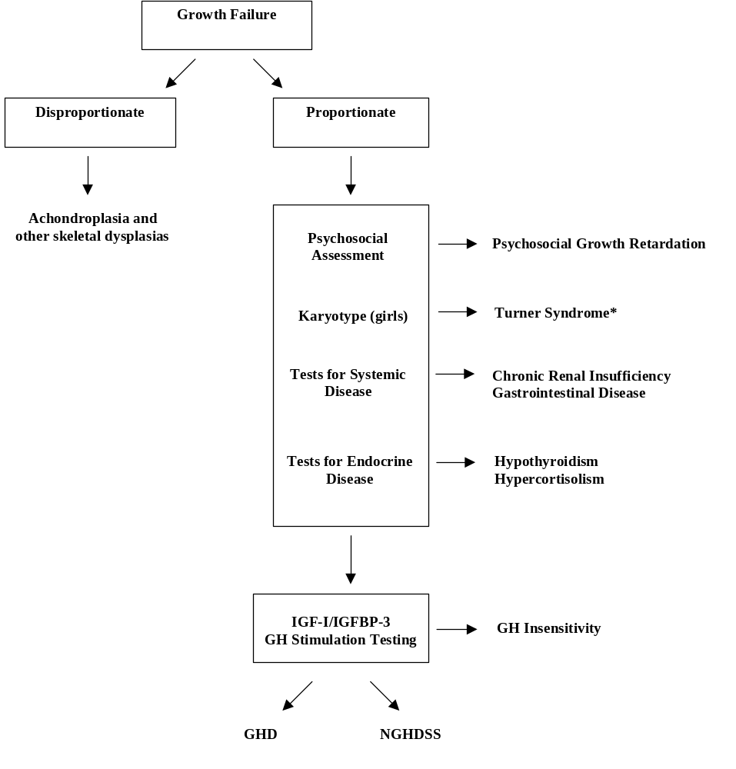
* Patients with Turner syndrome have variable shortness of the forelimbs, which becomes more apparent with age. These patients may also have other skeletal anomalies such as short fourth metacarpal, increased carrying angle, high-arched palate, and Madelung deformity.
Note: This figure was compiled from the following references: Parkin 1989; Schwartz and Bercu 1992; Van den Brande and Rappaport 1993; Blizzard and Johanson 1994; Reiter and Rosenfeld 1998; Hintz and Ritzen 1999.
Abbreviations: GH = growth hormone; GHD = growth hormone deficiency; IGF-I = insulin-like growth factor-I; IGFBP-3 = insulin-like growth factor binding protein-3; NGHDSS = non-growth hormone deficient short stature.
Figure 1. A diagnostic algorithm for investigation of short stature.
The final step in the diagnostic process is a growth hormone stimulation test, in which pharmacological agents are administered to provoke release of pituitary GH stores. Patients whose peak responses to stimulation fall below a defined threshold are classified as GHD and are eligible for GH treatment. In contrast, patients whose GH responses exceed the specified threshold are deemed non-GHD and are ineligible for GH treatment, despite phenotypes and degrees of short stature essentially indistinguishable from those with GHD. Patients, their families, and physicians find this inequity frustrating. The inequity of this situation is further exacerbated by the fact that patients with chronic renal insufficiency, Turner syndrome, Prader-Willi syndrome, and those born small for gestational age are eligible for GH treatment irrespective of their GH secretion status or degree of short stature.
The lack of approved therapy for patients who have neither GHD, nor one of the 4 non-GHD conditions listed above, led to much discussion in the pediatric endocrine community over many years, regarding why such children should or should not be eligible for GH treatment. In assessing this question, the following points should be considered:
- Children and adults with short stature may have disadvantages with respect to their peers, irrespective of the cause of the short stature.
- The growth failure in patients with non-GHD short stature is equivalent to that seen in other growth disorders.
- The majority of untreated patients with non-GHD short stature fail to achieve their adult height prediction.
- GH treatment in other pediatric conditions treats the growth failure or short stature, not the underlying condition or “disease”.
- Absence of a known etiology for the growth failure does not justify exclusion from treatment.
- The growth failure in patients with non-GHD short stature is responsive to GH treatment.
Each of the first five points above are discussed further in the following paragraphs, while the sixth point is discussed in the Efficacy Section (Section 3) of this document.
First, children and adults with short stature, irrespective of cause, may have a number of disadvantages in life relative to their normal-stature peers. Short children may be subject to juvenilization, teasing, bullying, exclusion from activities and peer groups and impairment of the normal progression toward independence (Sandberg 1999; Voss and Mulligan 2000). In adulthood there may be problems of social isolation, reduced marriage rates, perceptions of lower competence, and ineligibility for certain occupations that have specific minimum height requirements. There are a number of potential employers, such as construction companies, the aviation and aerospace industries, and the military, that have minimum height standards for employees. Furthermore, aspects of daily living such as driving a car, accessing cupboards, using kitchen or bathroom benches or sinks, and using standard height furniture in workplaces may provide additional challenges.
Second, there is marked concordance in the severity of growth failure and short stature among the various growth disorders for which somatropin treatment is typically prescribed (Table 1). In two large postmarketing research programs (the National Cooperative Growth Study [NCGS] and the Kabi International Growth Study [KIGS]), height SDS at initiation of GH treatment was well below normal across the various conditions. Table 1 shows a remarkable similarity between patients with non-GHD short stature (referred to in these reports as idiopathic short stature) and patients with conditions for which somatropin is currently approved. The values in the table represent mean height SDS ± standard deviation at the initiation of GH treatment.
Table 1. Mean Height SDS of Patients with Growth Disorders at Initiation of Growth Hormone Treatment
Condition | Mean Height SDS | Corresponding adult male height  (feet, inches) | Corresponding adult female height  (feet, inches)
Idiopathic GHD | -2.8 ± 1.1 a | 5 ft, 1.3 in | 4 ft, 9.1 in
Idiopathic Short Stature | -2.9 ± 0.9 a | 5 ft, 1.0 in | 4 ft, 8.8 in
Chronic Renal Insufficiency | -2.6 ± 0.8 b | 5 ft, 1.9 in | 4 ft, 9.6 in
Turner Syndrome | -2.8 ± 1.0 c | NA | 4 ft, 9.1 in
Small for Gestational Age | -2.8 ± 0.9 d | 5 ft, 1.3 in | 4 ft, 9.1 in
Note: Values represent mean ± SD. Conversion of height SDS to feet and inches was based on Kuczmarski et al. 2000.
Abbreviations: GHD = growth hormone deficiency; SDS = standard deviation score.
a Root et al. 1998.
b Fine et al. 1996.
c Ranke et al. 2000.
d Ranke et al. 2003.

These observational study data also demonstrate the relative severity of short stature in patients entering GH treatment compared to accepted definitions of short stature (AAP 1997; AACE 2003) and with the recommended height threshold for further investigation (GRS 2000), of –2.0 SDS. This finding reflects the fact that pediatric endocrinologists carefully evaluate children with short stature and take a conservative approach, providing GH treatment to those with the greatest need.
Third, in addition to the equivalence of their short stature at baseline, as demonstrated in a number of studies, untreated patients with non-GHD short stature achieve adult heights that fall below the adult heights predicted for them during childhood (Bramswig et al. 1990; Ranke et al. 1995; Buchlis et al. 1998; Rekers-Mombarg et al. 1999).
Fourth, GH treatment in pediatric patients with growth disorders is intended to treat the growth failure or short stature, not the underlying condition or “disease”. This is evidenced by the language of the label indication for each of the conditions for which somatropin is currently approved. Somatropin is indicated for: “the long-term treatment of pediatric patients who have growth failure due to an inadequate secretion of normal endogenous growth hormone”; “the treatment of short stature associated with Turner syndrome in patients whose epiphyses are not closed”; “treatment of growth failure associated with chronic renal insufficiency up to the time of renal transplantation”; “long-term treatment of growth failure due to Prader-Willi syndrome”; “long-term treatment of short stature in children born small for gestational age who fail to manifest catch-up growth by age 2”. Indeed, in each of the above conditions, while the etiology of the disorder itself may be known (for example, complete or partial loss of one X-chromosome in Turner syndrome), the cause of the growth disturbance is only partially understood, if at all. The key distinction between patients with non-GHD short stature and those with conditions for which somatropin is currently approved is that most of the latter have additional problems beyond their growth disturbance (such as ovarian failure in Turner syndrome) that are not addressed by somatropin. The exception is the child born small for gestational age, whose short stature is typically the only clinical abnormality.
Fifth, the fact that children with non-GHD short stature are regarded by some as having no “disease”, does not justify excluding them from effective treatment. There are many such conditions in both pediatric and adult patients that deserve and receive treatment. Examples include enuresis, hypertension, hypercholesterolemia, erectile dysfunction, alopecia, hirsutism, gynecomastia, anxiety disorder, and nicotine addiction. Whether or not any of these conditions is formally considered a “disease” appears to have no bearing on the appropriateness of treating the condition. Prevention of pregnancy is also an accepted therapeutic aim for a condition that is not considered a disease.
Recognizing the unmet medical need of patients with non-GHD short stature the 1983 International Conference on Uses and Abuses of Growth Hormone, was convened by the National Institute of Child Health and Human Development (NICHD) and issued this consensus statement: “….there is an urgent need for therapeutic trials to determine the effect of growth hormone in short children who do not have growth hormone deficiency” (Underwood 1984). Subsequently, the Endocrinologic and Metabolic Drugs Advisory Committee of the FDA provided guidance for GH manufacturers regarding studies of GH treatment in pediatric patients with non-GHD forms of short stature. The committee unanimously agreed that the critical endpoint was final height and that such studies should include a control group. Although there were concerns about the type and feasibility of the control, the committee recommended, “…the control group should be a placebo-treated, parallel, randomized group of patients…” and “…the subjects should be followed until their ultimate height is reached…” (FDA 1987, Dr Philip Troen). In the 16 years following the introduction of recombinant GH, more than 40 studies have been undertaken in the non-GHD short stature patient population. Efficacy has been demonstrated by improvements in height velocity, although few of these studies have followed patients to adult height and none have been placebo controlled (Finkelstein et al. 2002).
“Lessening the disability of severe short stature has been the goal of GH therapy for three decades” (Allen et al. 1994). However, for patients whose growth failure is not associated with one of the five conditions for which GH is currently approved, this goal is currently unattainable. To address this deficit, Lilly undertook two long-term studies of the safety and efficacy of GH treatment in patients with non-GHD short stature. The pivotal study, Study GDCH, specifically followed the FDA Advisory Committee’s 1987 recommendation and is the only randomized, double-blind, placebo-controlled study to final height in this patient population. Study GDCH unequivocally demonstrates that GH treatment is effective in patients with non-GHD short stature. The efficacy of GH in this condition is also supported by Study E001, a second large, long-term, randomized, dose-response study, and by data from a comprehensive meta-analysis of the peer-reviewed literature (Finkelstein et al. 2002).
The establishment of clear efficacy of GH treatment in patients with non-GHD short stature, in the absence of any new safety concerns, provides the scientific, medical, regulatory, and ethical justification for approval of Humatrope treatment for these patients.

2. Overview of Clinical Studies
The efficacy of Humatrope for the treatment of non-GHD short stature is addressed by: one randomized, placebo-controlled, pivotal clinical trial; one randomized, dose-response study; and a recent meta-analysis of the peer-reviewed literature. Brief summaries of these studies are provided below, while detailed information regarding study design, patient demographics, and efficacy data are provided in the following section (Section 3). The safety of Humatrope treatment in patients with non-GHD short stature is addressed (Section 4) by comparison of Lilly studies in this patient population with studies undertaken in patients with GHD and with Turner syndrome.

2.1. Pivotal Study: B9R-MC-GDCH
Study GDCH was a double-blind, randomized, parallel, placebo-controlled study to final height in pediatric patients with non-GHD short stature (n=71). The primary objective of the study was to determine whether final height of patients with non-GHD short stature treated with Humatrope (0.22 mg/kg/wk, administered in divided doses 3 times per week [TIW]) would be greater than that of a placebo-treated group. The primary efficacy variable was final height, expressed as a standard deviation score (SDS) relative to the general population of the same age and gender (final height SDS).

2.2. Supportive Study: B9R-EW-E001
Study E001 was an open-label, three-arm, randomized, parallel, dose-response study. Pediatric patients with non-GHD short stature (n=239) were randomly assigned to receive one of the following three Humatrope regimens (administered in divided doses 6 times per week):
- Dose 1: 0.24 mg/kg/wk;
- Dose 2: 0.24 mg/kg/wk for 1 year, followed by 0.37 mg/kg/wk; or
- Dose 3: 0.37 mg/kg/wk.
The primary objective of this study was to determine the efficacy of two different Humatrope dosages (0.24 versus 0.37 mg/kg/wk) in stimulating an increase in height velocity in pediatric patients with non-GHD short stature. The increase in height velocity during the initial 2 years of treatment was the primary variable used to evaluate dose-response effect among the Humatrope dosage regimens. Final height SDS was a secondary outcome measure, as were the following variables: final height minus baseline height (cm and SDS); final height minus baseline predicted height (cm and SDS); and final height minus target height (cm and SDS).

2.3. Supportive Peer-Reviewed Literature Studies
A recent meta-analysis (Finkelstein et al. 2002) provides supportive evidence from the literature for the effectiveness of GH treatment in pediatric patients with non-GHD short stature. The data reported in this meta-analysis are derived from 10 controlled studies and 28 uncontrolled studies that used recombinant GH (somatropin) from several manufacturers. Of these studies, 12 (4 controlled and 8 uncontrolled; total number of patients = 454) provide data on adult height, and will be used to support the use of Humatrope in pediatric patients with non-GHD short stature.

3. Effectiveness of Humatrope

3.1. Pivotal Clinical Study: GDCH
Study GDCH was a double-blind, randomized, parallel, placebo-controlled study to final height in pediatric patients with non-GHD short stature.

3.1.1. Primary Objective
The primary objective of the study was to determine whether final height, defined as the last height obtained after height velocity had fallen below 1.5 cm/y, would be greater in patients treated with Humatrope than in those who received placebo injections.

3.1.2. Study Design
Study GDCH consisted of a screening period and a blinded treatment period. Patients in the Humatrope group received 0.074 mg/kg Humatrope by subcutaneous injection, 3 times per week (total dose 0.22 mg/kg/wk: standard of care at the time for GHD was 0.18 mg/kg/wk); patients in the placebo group received placebo injections 3 times per week. Participation in the primary (blinded) treatment period ended either when the patient reached final height (protocol completion) or at the time of closure of the blinded study, by Lilly, at which time eligible patients were offered the opportunity to enter an optional, open-label extension phase. Figure 2 presents the study design. The open-label extension phase is omitted for clarity, since no efficacy data are being collected from the open-label, single arm (Humatrope only) extension.
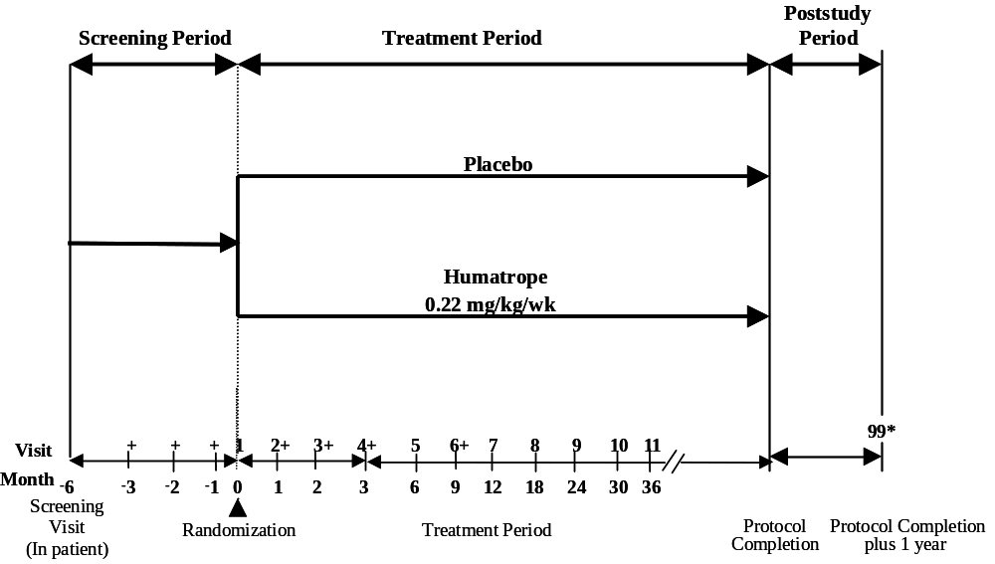

+ Only the subset of patients on whom lower leg measurements were obtained attended study Visits 2 to 4 and 6.
* Poststudy summary visit (Visit 99): 1 year after protocol completion for patients completing the protocol; at final height for patients who discontinued the study before protocol completion.
Figure 2. Design of Study GDCH.
Patients who completed the study were asked to return for a final height measurement 1 year after protocol completion. This poststudy follow-up visit was referred to as Visit 99. In addition, patients who discontinued the study prior to protocol completion were asked to return for a final height measurement after height velocity, measured locally, had fallen below 1.5 cm/y. This poststudy follow-up visit was also referred to as Visit 99.
Patient enrollment began in January 1988 and continued through July 1999, when it was ended at the request of the DSMB in view of the length of the treatment required. The blinded treatment period ended in February 2001.

3.1.3. Inclusion/Exclusion Criteria
Inclusion criteria were: age 10-16 (boys) or 9-15 years (girls); bone age ≤13 (boys) or ≤11 years (girls); Tanner stage breast or genital development ≤2; proportionate short stature; and peak stimulated GH >7 μg/L. Patients were included if their height standard deviation score (SDS) or predicted adult height SDS within 1 year prior to study entry was ≤-2.5. During the period from May 1988 to February 1993 a cutoff of -2.25 SDS was used. Section 3.1.4.1 provides a detailed explanation of these changes. Children with stimulated GH concentration >7 μg/L were considered GH-sufficient based on normative data generated with the same GH assay (Marin et al. 1994). Thus, the term, “non-GHD short stature” refers to children who have normal stimulated GH concentrations as defined above. It is not meant to imply that GH has no role in the etiology of the short stature. Patients were excluded if they had a chronic illness, a known genetic syndrome, had ever received GH, estrogen, or androgen treatment or were currently receiving other drugs likely to affect growth, including methylphenidate and similar stimulants. Patients with hypothyroidism were eligible to enroll after thyroid function tests had been normal for at least 3 months on replacement therapy.
When this study was designed in the 1980s, patients who were born small-for-gestational age (SGA) were not excluded by the protocol, and 6 of the 71 patients enrolled met criteria for SGA (birth weight SDS ≤-2.0 according to Table III of Usher and McLean [1969]). Because these patients met the inclusion criteria for the study, they are included in the study statistical analyses. At the pre-supplemental New Drug Application meeting between Lilly and the FDA, on 31 July 2001, the FDA indicated that a formal statistical analysis of SGA and non-SGA groups would not be necessary. Nonetheless, analyses showed no differential treatment effect between the effect in SGA patients and the effect in non-SGA patients.

3.1.4. Summary of Key Protocol Changes

3.1.4.1. Entry Height Criterion
In response to a suggestion by the FDA to improve the balance of the two treatment groups, a stratified randomization was added in May 1988 (a total of 3 patients had been enrolled in the study at that time), with patients grouped by gender and predicted adult height. In addition, to increase the rate of patient enrollment, the entry height criterion was changed from height standard deviation score (SDS) or predicted height SDS ≤-2.5 to height SDS or predicted height SDS ≤-2.25 (based on stature data from the National Center for Health Statistics [NCHS] Growth Charts [1976] and measured within the 12 months prior to Visit 1). Based upon current US height standards (Kuczmarski et al. 2000), a height SDS of -2.5 corresponds to an adult height of 5 feet, 2.2 inches (157.9 cm) in males and 4 feet, 9.8 inches (146.9 cm) in females. A height SDS of -2.25 corresponds to 5 feet, 2.9 inches (159.8 cm) in males and 4 feet, 10.5 inches (148.5 cm) in females. Patients with height SDS <-2.25 represent the shorter 54% of patients who meet the American Academy of Pediatrics definition of short stature (height SDS <-2.0 [AAP 1997]).
The entry criteria for upper height limit and predicted adult height were changed in February 1993. At the recommendation of the Human Growth Hormone Protocol Review Committee, an independent panel appointed by the NIH Director, the inclusion criterion of height SDS or predicted height SDS ≤-2.25 was changed back to that of the original protocol, stating that patients must have height SDS or predicted height SDS ≤-2.5. Thirty-seven patients of the final 68 who received study drug (Humatrope or placebo) were enrolled on the basis of height SDS or predicted height SDS ≤-2.25, during the period from May 1988 to February 1993. Of these 37 patients, six (2 Humatrope, 4 placebo) had a height SDS or predicted height SDS at eligibility assessment between -2.5 and -2.25.

3.1.4.2. Final Height Criterion
The original protocol defined the criterion for protocol completion as the achievement of height velocity <0.5 cm/y, based on measurements made at 12-month intervals. Two patients (1 Humatrope, 1 placebo) completed the protocol with this criterion. In January 1994 (a total of 45 patients had been enrolled in the study at that time), the criterion for protocol completion was changed from height velocity <0.5 cm/y to height velocity <1.5 cm/y. This criterion was changed to address the issue of drop-outs that occur as the height velocity slows down upon the approach of final height. As the slow-down progresses, the patient is less likely to want to continue injections and more likely to drop out of the study.

3.1.4.3. Poststudy Summary Visit
To gather height and safety data for an intent-to-treat analysis, a poststudy summary visit (Visit 99) was added in January 1994 (a total of 45 patients had been enrolled in the study at that time) for those patients who had completed the study or who had discontinued the study prior to protocol completion.

3.1.4.4. Termination of Blinded Treatment Period
In response to the recommendation made by the DSMB on 05 June 2000, the blinded treatment period of the study was terminated in January 2001 (a total of 71 patients had been enrolled in the study at that time). An open-label extension phase was implemented to provide Humatrope-treated patients the opportunity to continue on Humatrope treatment and to allow placebo-treated patients the option to receive Humatrope treatment.

3.1.5. Population Definitions
The following populations were defined in the protocol:
Randomized Patients (n=71): Seventy-one patients enrolled in the study and were randomized into treatment groups (38 Humatrope, 33 placebo). Analysis of this population serves as an intent-to-treat analysis for this study.
Safety Population (n=68): Of the 71 randomized patients, 3 patients discontinued the study prior to receiving any study drug (1 Humatrope [physician decision]; 2 placebo [protocol entry criteria not met]). The remaining 68 patients were included in the Safety Population (37 Humatrope, 31 placebo).
Efficacy Evaluable Population (n=64): Assessment of efficacy required at least 6 months study drug treatment. Of the 68 patients in the Safety Population, 3 patients discontinued without a height measurement at 6 months (Visit 5: 2 Humatrope [adverse event (1), patient decision (1)]; 1 placebo [patient decision]). One additional placebo patient (Patient 008-1201), described below, who received growth hormone (GH) outside the study, was excluded from the Efficacy Evaluable Population. The remaining 64 patients were included in the Efficacy Evaluable Population (35 Humatrope, 29 placebo). Analysis of this population serves as a modified intent-to-treat analysis for this study.
Patient 008-1201 was randomized to the placebo treatment group but was excluded from the Efficacy Evaluable and Final Height Populations. This patient discontinued the study at Visit 5, 6 months after randomization, but returned for a final height visit, as requested. Because the patient had a height measurement at Visit 5 and a final height measurement, she would have qualified for the Efficacy Evaluable and Final Height Populations. However, it was learned that this patient had received growth hormone (GH) treatment for approximately 4 years (personal communication, Ellen Leschek, MD) after discontinuing the study. Because of the documented receipt of GH treatment, this patient was excluded from the Efficacy Evaluable and Final Height Populations but was included in the Safety Population for the placebo group. Patient 008-1201 did not have any adverse events after discontinuing the study.
Protocol Complete Population (n=25): Of the 64 patients from the Efficacy Evaluable Population, 39 patients (19 Humatrope, 20 placebo) discontinued the study prior to reaching final height (height velocity <1.5 cm/y). Twenty-five patients completed the protocol (16 Humatrope, 9 placebo) and were included in the Protocol Complete Population.
Final Height Population (n=33): The 25 patients in the Protocol Complete Population form the core of the Final Height Population. In addition, 8 patients in the Efficacy Evaluable Population, who discontinued the study prior to protocol completion (after a treatment duration averaging 2.7 years) but returned for a final height measurement, while still blinded to treatment assignment (6 Humatrope, 2 placebo), were included in the Final Height Population. Therefore, there were 33 patients in the Final Height Population (22 Humatrope, 11 placebo). In addition, 4 patients returned for a final height measurement but were excluded from the Final Height Population because they were not included in the Efficacy Evaluable Population for the following reasons: did not receive study drug (1 Humatrope, 1 placebo), discontinued at Visit 1 (1 placebo), received GH after discontinuing from the study (1 placebo).
At the conclusion of the blinded phase of the study, there were 39 patients in the Efficacy Evaluable Population who had discontinued the protocol prior to protocol completion (19 Humatrope, 20 placebo). Additional information was obtained regarding these patients from the NIH investigators regarding the efforts to obtain final height data for these 39 patients. Of the 39 patients, 21 patients were still growing and were not eligible to be recalled for a final height measurement (11 Humatrope, 10 placebo). Eighteen patients were known or considered likely to have a height velocity <1.5 cm/y and to be eligible to return for final height measurement (8 Humatrope, 10 placebo). Six of the 18 patients (1 Humatrope, 5 placebo) were lost to follow-up and could not be contacted despite multiple attempts (phone calls, certified letters, and assistance of referring physicians). Of the remaining 12 patients, 4 (1 Humatrope, 3 placebo) declined to return, and 8 patients (6 Humatrope, 2 placebo) returned and were included in the Final Height Population as described above.
The role of the Final Height Population and the Protocol Complete Population is to obtain a clinically interpretable assessment and estimate of treatment effect for patients with reasonably complete data. The role of the modified intent-to-treat and intent-to-treat analyses are to demonstrate statistical existence of treatment effect and to verify that the estimates of treatment effect are comparable to estimates from the Final Height and the Protocol Complete Populations. This is the paradigm by which Final Height, Protocol Complete, Efficacy Evaluable Populations and modified intent-to-treat and intent-to-treat analyses are complementary in confirming efficacy.

3.1.6. Patient Disposition
Figure 3 illustrates patient disposition.

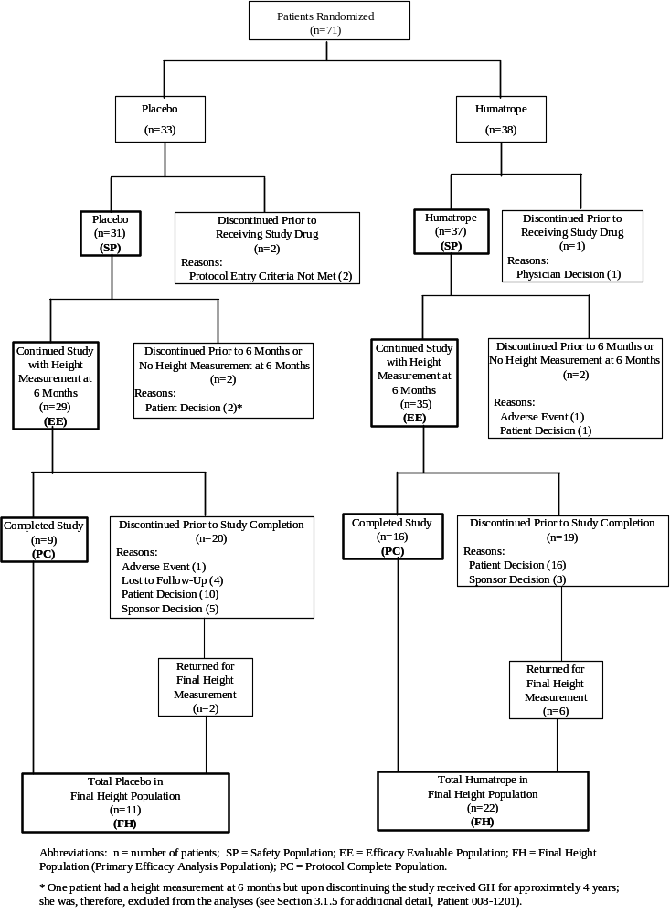
Figure 3. Patient disposition for Study GDCH.
The most common primary reason for early discontinuation in both treatment groups was patient decision. Discontinuation due to Sponsor Decision (n=8) refers to the termination of the blinded treatment period in response to the DSMB recommendation of 05 June 2000.

3.1.7. Baseline Patient Characteristics
Table 2 provides patient demographics at baseline. The Humatrope and placebo treatment groups were well balanced and comparable at baseline in the five populations. There were no significant differences between the Humatrope and placebo treatment groups for any of the variables in any of the patient populations.

Table 2. Demographics and Other Baseline Characteristics a
Study GDCH
 | All Randomized  Patients |  |  | Safety  Population
Variable | Humatrope | Placebo |  | Humatrope | Placebo
Number of patients | 38 | 33 |  | 37 | 31
Male | 29 | 26 |  | 29 | 24
Female | 9 | 7 |  | 8 | 7
Ethnic origin
African descent | 0 | 1 |  | 0 | 1
Asian | 0 | 1 |  | 0 | 1
Caucasian | 30 | 25 |  | 30 | 23
Hispanic | 7 | 4 |  | 7 | 4
Other | 1 | 2 |  | 0 | 2
Peak growth hormone concentration (μg/L) | 16.2 ± 7.5 | 17.4 ± 9.7 |  | 16.3 ± 7.6 | 17.2 ± 9.8
IGF-I concentration SDS | -2.0 ± 1.1 | -1.5 ± 1.5 |  | -1.9 ± 1.1 | -1.4 ± 1.5
Chronological age (y) | 12.5 ± 1.6 | 12.3 ± 1.4 |  | 12.5 ± 1.6 | 12.2 ± 1.4
Bone age (y) | 10.4 ± 1.9 | 10.4 ± 1.7 |  | 10.4 ± 1.9 | 10.3 ± 1.7
Height SDS | -2.7 ± 0.5 | -2.8 ± 0.5 |  | -2.8 ± 0.5 | -2.8 ± 0.5
Pre-treatment height velocity (cm/y) | 4.8 ± 1.8 | 4.8 ± 2.1 |  | 4.8 ± 1.8 | 4.8 ± 2.1
Predicted height SDS | -2.0 ± 0.8 | -2.3 ± 0.8 |  | -2.0 ± 0.8 | -2.3 ± 0.8
Target height SDS b | -1.0 ± 1.0 | -1.2 ± 0.7 |  | -1.0 ± 1.0 | -1.2 ± 0.8
(continued)
Note: Values represent mean ± standard deviation (SD).
Abbreviation: IGF-I = insulin-like growth factor-I; SDS = standard deviation score.
a There were no significant differences between the Humatrope and placebo treatment groups for any of the patient populations for any of the variables.
b Target height represents the gender-adjusted midparental height.

Table 2. Demographics and Other Baseline Characteristics a
Study GDCH (concluded)

 | Efficacy Evaluable  Population |  |  | Final Height  Population |  |  | Protocol Complete  Population
Variable | Humatrope | Placebo |  | Humatrope | Placebo |  | Humatrope | Placebo
Number of patients | 35 | 29 |  | 22 | 11 |  | 16 | 9
Male | 27 | 23 |  | 18 | 9 |  | 13 | 7
Female | 8 | 6 |  | 4 | 2 |  | 3 | 2
Ethnic origin
African descent | 0 | 1 |  | 0 | 1 |  | 0 | 1
Asian | 0 | 0 |  | 0 | 0 |  | 0 | 0
Caucasian | 29 | 22 |  | 18 | 7 |  | 14 | 5
Hispanic | 6 | 4 |  | 4 | 1 |  | 2 | 1
Other | 0 | 2 |  | 0 | 2 |  | 0 | 2
Peak growth hormone concentration (μg/L) | 16.5 ± 7.7 | 17.3 ± 10.0 |  | 17.0 ± 7.7 | 17.6 ± 13.8 |  | 17.7 ± 7.6 | 18.6 ± 15.2
IGF-I concentration SDS | -1.9 ± 1.1 | -1.5 ± 1.5 |  | -1.8 ± 1.2 | -1.7 ± 1.1 |  | -1.9 ± 1.1 | -1.8 ± 1.1
Chronological age (y) | 12.5 ± 1.6 | 12.3 ± 1.3 |  | 12.5 ± 1.6 | 12.9 ± 1.1 |  | 12.4 ± 1.5 | 12.9 ± 1.2
Bone age (y) | 10.4 ± 1.9 | 10.4 ± 1.6 |  | 10.4 ± 1.9 | 10.7 ± 1.1 |  | 10.2 ± 1.6 | 10.8 ± 1.2
Height SDS | -2.7 ± 0.5 | -2.8 ± 0.5 |  | -2.7 ± 0.6 | -2.8 ± 0.6 |  | -2.7 ± 0.6 | -2.9 ± 0.6
Pre-treatment height velocity (cm/y) | 4.9 ± 1.8 | 4.9 ± 2.1 |  | 5.2 ± 1.8 | 5.6 ± 2.4 |  | 5.2 ± 2.0 | 5.3 ± 2.2
Predicted height SDS | -2.0 ± 0.8 | -2.3 ± 0.8 |  | -2.1 ± 0.7 | -2.3 ± 0.8 |  | -2.2 ± 0.7 | -2.4 ± 0.8
Target height SDS b | -0.9 ± 0.9 | -1.2 ± 0.8 |  | -1.1 ± 1.0 | -1.3 ± 0.7 |  | -1.1 ± 1.1 | -1.4 ± 0.7
Note: Values represent mean ± standard deviation (SD).
Abbreviation: IGF-I = insulin-like growth factor-I; SDS = standard deviation score.
a There were no significant differences between the Humatrope and placebo treatment groups for any of the patient populations for any of the variables.
b Target height represents the gender-adjusted midparental height.

3.1.8. Efficacy Data
The protocol stated that the primary efficacy analysis would be an analysis of covariance (ANCOVA) of final height SDS, with baseline predicted height as the covariate, in the Final Height Population (n=33).
Protocol-specified sensitivity analyses included analysis of last observed height SDS by ANCOVA in the Efficacy Evaluable Population (n=64), which serves as a modified intent-to-treat analysis for the study, final height SDS by ANCOVA in the Protocol Complete Population (n=25); and final height minus baseline predicted height (cm) by t-test in the Final Height Population. In addition, a non-protocol specified, repeated measures analysis of height SDS at 18 years was included as an additional modified intent-to-treat analysis. The repeated measures analysis uses repeated height SDS measurements over time, rather than just the last observed height SDS. Lastly, intent-to-treat analyses, by both nonparametric and parametric methods, were performed in the Randomized Population (n=71).

3.1.8.1. Primary Efficacy Analysis (Final Height SDS)
The primary efficacy variable was final height, expressed as a SDS relative to the general population of the same age and gender (final height SDS). The primary efficacy analysis was of final height SDS for the Final Height Population. Between-group comparisons were performed using analysis of covariance (ANCOVA), with baseline predicted height SDS as the covariate (Table 3). The two-sided significance level for this analysis was set at α=0.05.
Table 3. Final Height Standard Deviation Score
Analysis of Covariance
Final Height Population
Study GDCH
Variable | Humatrope  (n=22) | Placebo  (n=10) a | Treatment  Effect b  (95% CI) | p-value
Final height SDS  (ANCOVA using BPH SDS as a covariate) | -1.81 ± 0.11 | -2.32 ± 0.17 | 0.51 ± 0.20  (0.10-0.92) | 0.017
Note: Values represent least squares mean (LSM) ± standard error (SE).
Abbreviations: ANCOVA = analysis of covariance; BPH = baseline predicted height; CI = confidence interval; n = number of patients; SDS = standard deviation score.
a Only 10 patients were included in this analysis, as baseline predicted height was missing for 1 patient due to a missing baseline bone age x-ray.
b Value represents the difference in the final height SDS between the Humatrope-treated group and the placebo-treated group.

The mean age at assessment of final height for the Final Height Population was 18.6 years for Humatrope-treated patients and 19.1 years for placebo-treated patients.
By ANCOVA, the patients who received Humatrope for 4.6 ± 1.6 (mean ± SD) years achieved a final height SDS of -1.81 ± 0.11 (least squares mean [LSM] ± standard error [SE]), while those who received placebo injections for 4.1 ± 1.7 years achieved a final height SDS of -2.32 ± 0.17, resulting in a mean Humatrope effect on final height SDS of 0.51 ± 0.20, 95% confidence interval (CI): 0.10 – 0.92 SDS (p=0.017). The Humatrope effect of 0.51 SDS corresponds to a mean difference between groups of 3.7 cm.
Because one placebo patient in the Final Height Population was not included in the primary efficacy analysis due to missing data for the covariate (baseline predicted height SDS), the analysis was re-run for the full Final Height Population (n=33) by using a linear regression estimate for the missing baseline predicted height SDS value. This analysis gave a similar mean Humatrope effect on final height SDS of 0.48 ± 0.19 SDS, 95% CI: 0.09 – 0.88 SDS (p=0.017).
The primary efficacy analysis was completed for all patients for whom final height data were available, including patients who discontinued the study before protocol completion (Final Height Population). A number of patients in the Efficacy Evaluable Population either discontinued early and did not return for a final height measurement (n = 23) or remained in the study and were still growing at termination of the blinded treatment period (n = 8). These patients are referred to as the Non-Final Height subgroup of the Efficacy Evaluable Population (n = 31). The Final Height Population (n = 33) and Non-Final Height subgroup (n = 31) comprise the total Efficacy Evaluable Population (n = 64). Since 31 of 64 patients from the Efficacy Evaluable Population were not available for final height measurement, the issue of potential dropout bias must be considered.

3.1.8.2. Sensitivity Analyses
To address the potential dropout bias described above, two modified intent-to-treat analyses (Efficacy Evaluable Population) and four intent-to-treat analyses (Randomized Population) were performed to assess the robustness of the results of the primary analysis.
The first modified intent-to-treat analysis was an ANCOVA of last observed height SDS (using baseline predicted height SDS as the covariate) for the Efficacy Evaluable Population (Table 4). The Humatrope effect for this analysis (0.52 ± 0.15 SDS, 95% CI: 0.22 – 0.82 SDS, p=0.001) was similar to that observed in the primary analysis (0.51 ± 0.20 SDS, p=0.017).
Table 4. Modified Intent-to-Treat Analysis
Efficacy Evaluable Population
Study GDCH
Analysis | Humatrope  n=35 | Placebo  n=27 a | Treatment  Effect | p-value
Last observed height SDS (ANCOVA using BPH SDS as a covariate) | -1.89 ± 0.10 | -2.40 ± 0.11 | 0.52 ± 0.15 b | 0.001
Height SDS at age 18  (Repeated measures linear model) | -1.52 ± 0.11 | -2.20 ± 0.12 | 0.69 ± 0.13 c | <0.0001
Note: Values represent least squares mean (LSM) ± standard error (SE).
Abbreviations: ANCOVA = analysis of covariance; BPH = baseline predicted height; n = number of patients; SDS = standard deviation score.
a Two of the 29 patients in the placebo group did not have a baseline predicted height due to missing bone age x-rays and were not included in this analysis.
b Value represents the difference in the last observed height SDS between the Humatrope-treated group and the placebo-treated group.
c Value represents the difference in the height SDS at age 18 years between the Humatrope-treated group and the placebo-treated group.

To further address the issue of potential bias due to missing final height data, a repeated measures analysis of efficacy for the combined Final Height Population and Non-Final Height subgroup of the Efficacy Evaluable Population was performed. Repeated measures models are useful when repeated measurements are taken on the same patient and these measurements are correlated with each other. This methodology is robust to the biases resulting from missing data (Verbeke and Molenberghs 2000). Data were incorporated from 62 patients for whom baseline predicted height and all other necessary data for the statistical model were available. A standard linear model would have used the endpoint height SDS values for each patient as the response variable, whereas this model used height SDS values throughout the course of the study (at ages 10-18). Using these measured heights, the model estimated least squares mean height SDS at each age. The comparison of interest was height SDS for Humatrope-treated patients versus placebo-treated patients at age 18 years.
Table 4 summarizes the results of the repeated measures analysis. The mean effect of Humatrope on height SDS at age 18 years was 0.69 ± 0.13 SDS, 95% CI: 0.43 – 0.94 SDS (p<0.0001), corresponding to a mean between-group height difference of 5.0 cm. Thus, the two modified intent-to-treat analyses gave similar Humatrope treatment effects as the primary efficacy analysis.
To provide further evidence against dropout bias two nonparametric and two parametric intent-to-treat analyses of last observed height SDS for the entire Randomized Population (n=71) were performed. The two non-parametric analyses were a rank analysis of covariance (ANCOVA) and a generalized Wilcoxon-Mann-Whitney test of last observed height SDS (Stokes et al. 2000). The results of these analyses demonstrated that Humatrope was superior to placebo with p=0.0024 (rank ANCOVA) and p=0.0015 (generalized Wilcoxon-Mann-Whitney test).
As a second intent-to-treat approach, an ANCOVA, with baseline predicted height SDS as covariate, of last observed height SDS was performed. This analysis yielded a Humatrope treatment effect of 0.40 ± 0.15 SDS (p=0.011) (Table 5). For this analysis, the 5 missing baseline predicted height SDS values for the covariance analysis were imputed by linear regression using baseline height SDS and age as independent variables. For patients missing postbaseline height data (n=2), their baseline height SDS was used as endpoint. Without incorporating the effect of the covariate, ANOVA indicated a Humatrope treatment effect of 0.52 ± 0.17 SDS (p=0.003). These modified intent-to-treat analyses (Efficacy Evaluable Population) and intent-to-treat analyses (Randomized Population), by their similarity to the primary efficacy analysis, provide strong evidence against dropout bias in the primary efficacy analysis.
Table 5. Intent-to-Treat Analyses of Last Observed Height SDS
All Randomized Population
Study GDCH
Analysis | Humatrope  n=38 | Placebo  n=33 | Treatment  Effect | p-value
ANCOVA (using BPH SDS as a covariate) | -1.96 ± 0.10 | -2.36 ± 0.11 | 0.40 ± 0.15 | 0.011
ANOVA | -1.90 ± 0.11 | -2.42 ± 0.12 | 0.52 ± 0.17 | 0.003
Abbreviations: ANCOVA = analysis of covariance; ANOVA = analysis of variance; BPH = baseline predicted height; n = number of patients in treatment group; SDS = standard deviation score.

The close similarity of the treatment effect results in the Final Height Population (n=33), Efficacy Evaluable Population (n=64), and Randomized Population (n=71) indicates that similar conclusions about efficacy are supported by the analyses in all 3 populations.
Two additional protocol-specified sensitivity analyses were performed (Table 6).
Table 6. Analyses of Adult Height
Protocol Complete and Final Height Populations
Study GDCH
Analysis | Humatrope | Placebo | Treatment  Effect | p-value
Final Height Analysis  (PC Population) | n=16 | n=9
Final height SDS a  (ANCOVA using BPH SDS as a covariate) | -1.86 ± 0.14 | -2.32 ± 0.18 | 0.46 ± 0.23 | 0.061
Final Height Analysis  (FH Population) | n=22 | n=10
Final height minus BPH (cm) b  (t-test) | 2.15 ± 0.84 | -0.67 ± 1.31 | 2.83 ± 1.53 | 0.075
Abbreviations: ANCOVA = analysis of covariance; BPH = baseline predicted height; FH = Final Height; n = number of patients; PC = Protocol Complete; SDS = standard deviation score.
a Values represent least squares mean (LSM) ± standard error (SE).
b Values represent mean ± standard error (SE).

First, an ANCOVA of final height SDS in the Protocol Complete Population, with baseline predicted height SDS as the covariate, indicated a mean ± SE treatment effect of 0.46 ± 0.23 SDS, corresponding to 3.3 cm, p=0.061. Second, a between-group t-test of final height minus baseline predicted height yielded a mean ± SE treatment effect of 2.83 ± 1.53 cm, p=0.075. Both of these sensitivity analyses yielded treatment effects that were similar to those of the protocol-specified primary and modified intent-to-treat analyses. Although both treatment effects failed to reach statistical significance, this was not surprising because of the reduction in statistical power due to reduced sample size for these subgroup analyses.
Given that intent-to-treat analyses are preferred in clinical trials, the question arises ‘Why the primary analysis was restricted to the final height data, which were available from only a subset of randomized patients?’ The answer relates to uncertainty about how the between-group difference in height SDS (GH-treated versus control) would change over time. Specifically, there was concern that GH might accelerate not just height velocity, but also epiphyseal fusion, perhaps producing an earlier attainment of the same final height rather than an increase in adult height. Such a result would be manifest as a transient increase in height, relative to the control group, that would not be sustained because of the earlier cessation of growth in the GH-treated patients. Thus, the maximum GH treatment effect on height SDS would occur during treatment, and the inclusion of non-final height SDS data in an intent-to-treat analysis could lead to an overestimate of what the GH treatment effect would be if measured only at final height. Concern about the possibility of overestimating the GH treatment effect led to the decision to limit the primary analysis to patients with final height measurements.
To evaluate the possibility of an earlier epiphyseal fusion during GH treatment, we examined whether or not bone maturation was accelerated by Humatrope treatment. Figure 4 illustrates bone age versus year on study for the Humatrope and placebo arms of the Final Height Population, the non-final height subgroup of the Efficacy Evaluable Population, and the entire Efficacy Evaluable Population. In each of these groups, there were no significant differences in bone age between the Humatrope and placebo arms. Thus, there is no evidence that this GH treatment regimen advanced the tempo of skeletal maturation. Consistent with these observations, there was no between-group difference in the mean age at which final height was attained (Humatrope, 18.6 ± 0.4 years; placebo, 19.1 ± 0.4 years, p=0.43).
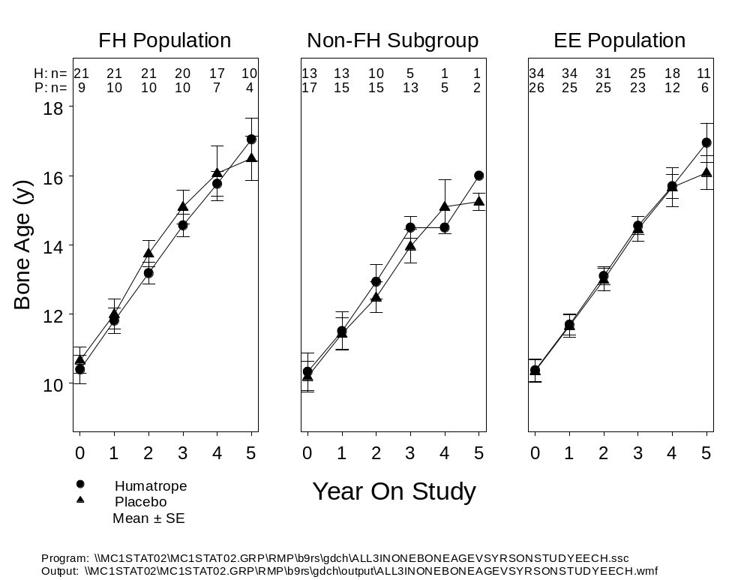
Abbreviations: EE = Efficacy Evaluable; FH = Final Height; H = Humatrope; n = number of patients; P = placebo; SE = standard error.
Figure 4. Bone age versus year on study for Study GDCH.
From these data, one would not predict that the GH-induced gains in height SDS would transiently increase and then decline, since bone age was not accelerated. To examine the actual time-course of height SDS gains, Figure 5 shows the increase in height SDS for patients in the two treatment arms, plotted against the year before the last observed height SDS for each patient. The time at which final height or last observed height was measured for each patient was set equal to zero to synchronize the observations in relation to the last height observation. This allows one to focus on the between-group differences in height SDS gain during the several years before measurement of final height or last observed height.
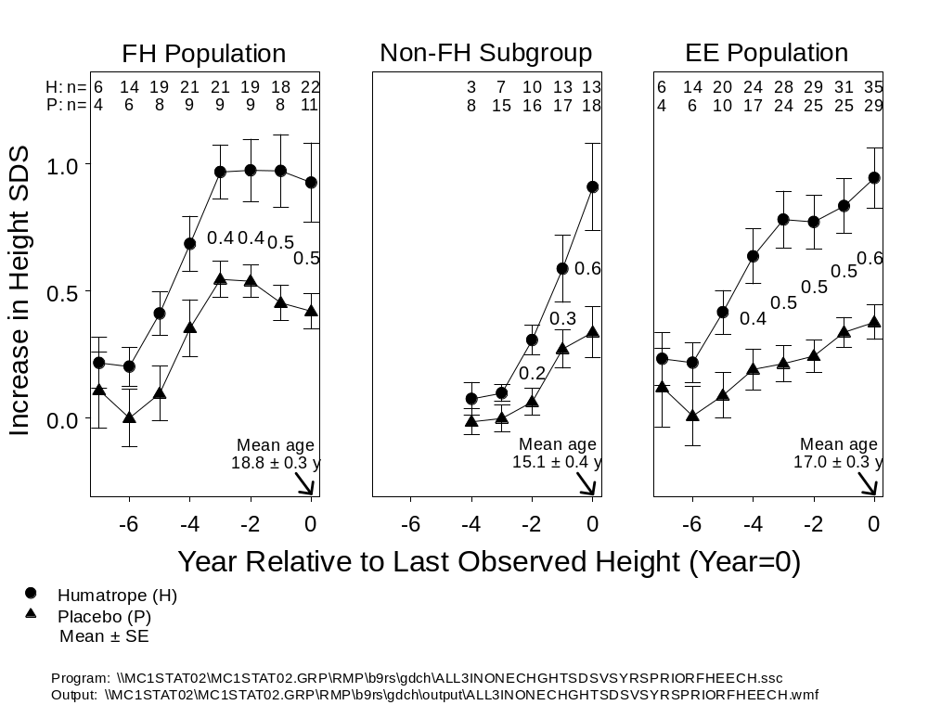
Abbreviations: EE = Efficacy Evaluable; FH = Final Height; n= number of patients; SE = standard error.
Figure 5. Increase in height SDS over baseline versus year on study relative to last observed height (year=0) in Study GDCH.
The temporal pattern of between-group differences in height SDS gain (a measure of GH treatment effect) was an increase during the early years of treatment, followed by stabilization of the GH treatment effect during the 3 years before measurement of final height or last observed height (Figure 5). For the Final Height Population (Figure 5, left panel), the mean GH treatment effect on height SDS gain was 0.42 SDS, 3 years before final height measurement (at a mean age of 15.5 years), and 0.51 SDS at final height measurement (mean age 18.8 years). For the non-final height subgroup of the Efficacy Evaluable Population (Figure 5, middle panel), the mean GH treatment effect at last observed height was 0.55 SDS (at a mean age of 15.1 years and mean treatment duration of 3.0 years). Thus, the mean GH treatment effect for the non-final height subgroup at last observed height was similar to that for the Final Height Population at final height measurement. After combining these two groups, which comprise the Efficacy Evaluable Population (Figure 5, right panel), the mean GH treatment effect on height SDS gain was 0.5495 SDS, 3 years before last observed height (at a mean age of 14.4 years), and 0.55 SDS at last observed height (mean age 17.0 years). Thus, once the between-group difference in height SDS gain had stabilized, after approximately 3 years of treatment, the GH treatment effect remained stable during the several years until attainment of final height.
The evidence in Figure 5 against a transient GH treatment effect removes the principal objection to inclusion of non-final height data in the analysis of GH treatment effect. Indeed, based on the data of Figures 4 and 5, the earlier concern that inclusion of such data would produce an overestimation of the GH treatment effect is not justified for the treatment regimen used in this study. Moreover, the efficacy analyses described previously showed similar treatment effects for the primary efficacy analysis in the Final Height Population, for the modified intent-to-treat analyses in the Efficacy Evaluable Population, and for the intent-to-treat analyses in the Randomized Population. From these observations we conclude that the Humatrope treatment effect is robust across the different study populations and that the primary efficacy analysis shows no indication of having been affected by dropout bias.
One potential misinterpretation of Figure 5 deserves comment. The fact that the GH treatment effect, during continued GH administration, stabilizes in the 3 years before attaining final height does not imply that the treatment effect would remain stable if GH treatment were to be discontinued 3 years before attaining final height. Studies have shown that such discontinuation is followed by a “catch-down” deceleration of height velocity to levels below those of the general population (Zadik et al. 1996; Lampit et al. 1998). Up to 18 months may be required before height velocity returns to baseline levels. For this reason GH administration is generally continued until a satisfactory adult height has been achieved or until the decline in height velocity indicates that near-final height has been attained.
To illustrate the mean height SDS for the two treatment arms in the initial years of treatment, Figure 6 displays height SDS by year on study for the Efficacy Evaluable Population.
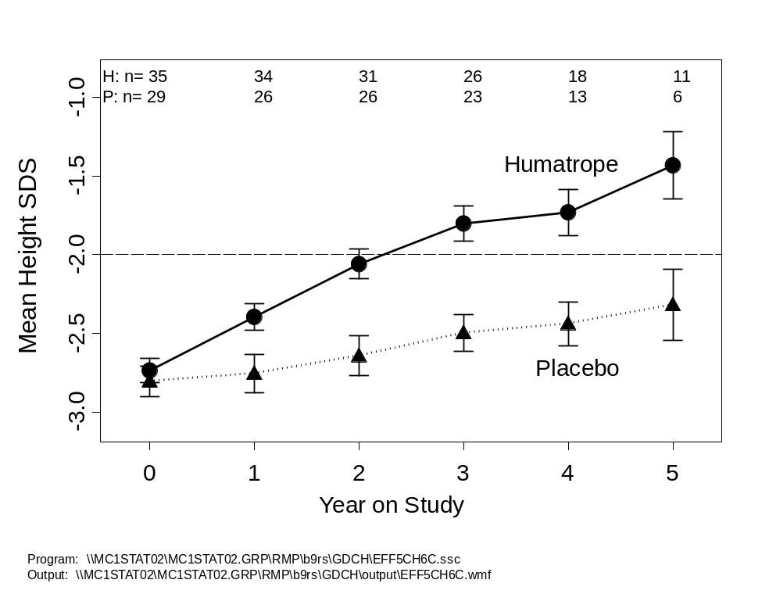
Note: This population includes all patients who received ≥6 months study drug, whether or not they achieved final height. Data are cross-sectional. The dashed line at –2 SDS represents the lower limit of the normal range for the general population (AAP 1997).
Abbreviation: H = Humatrope; n = number of patients; P = placebo; SDS = standard deviation score.
Figure 6. Height standard deviation score by year on study for the Efficacy Evaluable Population (Study GDCH).
By 2 years of treatment, the mean height SDS for the Humatrope-treated patients was close to the lower limit of the normal range. Discontinuation rates were similar during the early years of the study. For example, at 3 years of treatment, the continuation rate was 70% (23 out of 33 patients) for the placebo group compared to 68% (26 out of 38 patients) for the Humatrope group.

3.1.8.3. Additional Analyses of Interest
Tables 7-9 provide additional supportive evidence for efficacy of Humatrope in the Efficacy Evaluable, Final Height, and Protocol Complete Populations. Statistically significant differences or trends in final height characteristics were observed between the treatment groups. All of these analyses support the conclusion that Humatrope increases final height in pediatric patients with non-GHD short stature.

Table 7. Additional Endpoint Height Analyses
Efficacy Evaluable Population
Study GDCH

Analysis | Humatrope  (n=35) | Placebo  (n=29) | Treatment  Effect a (95% CI) | p-value
Endpoint Height (cm) - Baseline Predicted Height (cm) b | -2.20 ± 1.94 | -6.02 ± 1.77 | 3.82 (-1.59 – 9.23) | 0.163
Endpoint Height SDS - Baseline Predicted Height SDS b | 0.13 ± 0.13 | -0.21 ± 0.13 | 0.34 (-0.04 – 0.72) | 0.079
Endpoint Height (cm) | 157.14 ± 1.93 | 150.86 ± 1.90 | 6.27 (0.80 – 11.75) | 0.025
Height Gain (cm) (Endpoint Height - Baseline Height) c | 24.27 ± 1.56 | 19.55 ± 1.36 | 4.72 (0.49 – 8.95) | 0.029
Endpoint Height SDS | -1.83 ± 0.12 | -2.45 ± 0.10 | 0.62 (0.29 – 0.95) | 0.000
Height SDS Gain (Endpoint Height SDS - Baseline Height SDS) c | 0.91 ± 0.11 | 0.36 ± 0.07 | 0.55 (0.27 – 0.83) | 0.000
Target Height (cm) - Endpoint Height (cm) | 9.32 ± 1.89 | 13.04 ± 2.23 d | -3.73 (-9.59 – 2.14) | 0.209
Target Height SDS - Endpoint Height SDS | 0.88 ± 0.16 | 1.22 ± 0.17 d | -0.34 (-0.81 – 0.13) | 0.156
Note: Values represent mean ± standard error. P-values are from t-tests.
Abbreviation: CI = confidence interval; n = number of patients; SDS = standard deviation score.
a Value represents the mean difference between the Humatrope-treated group and the placebo-treated group.
b Two of the 29 patients in the placebo group did not have a baseline predicted height, due to missing bone age x-rays, and therefore could not
be included in this analysis.
c Height gain is from start of treatment to endpoint height.
d Four of the 29 patients in the placebo-treated group did not have a target height.
Table 8. Additional Final Height Analyses
Final Height Population
Study GDCH
Analysis | Humatrope  (n=22) | Placebo  (n=11) | Treatment  Effect a (95% CI) | p-value
Final Height SDS – Baseline Predicted Height SDS | 0.32 ± 0.12 | -0.14 ± 0.19 b | 0.46 (0.02 – 0.89) | 0.043
Final Height (cm) | 161.12 ± 1.58 | 157.46 ± 1.77 | 3.66 (-1.58 – 8.90) | 0.165
Height Gain (cm) (Final Height – Baseline Height) c | 28.30 ± 1.57 | 22.58 ± 2.08 | 5.71 (0.27 – 11.15) | 0.040
Final Height SDS | -1.77 ± 0.17 | -2.34 ± 0.17 | 0.57 (0.03 – 1.10) | 0.039
Height SDS Gain (Final Height SDS-Baseline Height SDS) c | 0.93 ± 0.16 | 0.42 ± 0.07 | 0.51 (0.04 – 0.97) | 0.034
Target Height (cm) – Final Height (cm) | 4.71 ± 1.37 | 7.10 ± 1.81 d | -2.39 (-7.23 – 2.45) | 0.321
Target Height SDS – Final Height SDS | 0.66 ± 0.19 | 1.02 ± 0.25 d | -0.36 (-1.04 – 0.31) | 0.280
Note: Values represent mean ± standard errors. P-values are from t-tests.
Abbreviation: CI = confidence interval; n = number of patients; SDS = standard deviation score.
a Value represents the mean difference between the Humatrope-treated group and the placebo-treated group.
b n=10 for placebo, as one patient did not have a baseline predicted height due to missing bone age x-ray.
c Height gain is from start of treatment to final height.
d n=10 for placebo, as one patient did not have a target height value reported.
Table 9. Additional Final Height Analyses
Protocol Complete Population
Study GDCH

Analysis | Humatrope  (n=16) | Placebo  (n=9) | Treatment  Effect a (95% CI) | p-value
Final Height (cm) – Baseline Predicted Height (cm) | 2.40 ± 1.05 | -0.04 ± 1.29 | 2.44 (-1.08 – 5.96) | 0.165
Final Height SDS – Baseline Predicted Height SDS | 0.35 ± 0.15 | -0.04 ± 0.18 | 0.40 (-0.10 – 0.89) | 0.111
Final Height (cm) | 160.69 ± 1.73 | 156.38 ± 1.96 | 4.31 (-1.37 – 9.98) | 0.130
Height Gain (cm) (Final Height – Baseline Height) b | 28.81 ± 1.69 | 22.15 ± 2.45 | 6.66 (0.65 – 12.68) | 0.031
Final Height SDS | -1.81 ± 0.20 | -2.41 ± 0.19 | 0.59 (-0.03 – 1.22) | 0.062
Height SDS Gain (Final Height SDS – Baseline Height SDS) b | 0.91 ± 0.16 | 0.45 ± 0.07 | 0.46 (-0.01 – 0.93) | 0.055
Target Height (cm) – Final Height (cm) | 5.44 ± 1.67 | 7.25 ± 2.02 | -1.81 (-7.39 – 3.77) | 0.509
Target Height SDS – Final Height SDS | 0.75 ± 0.23 | 1.03 ± 0.28 | -0.28 (-1.06 – 0.50) | 0.459
Note: Values represent mean ± standard error. P-values are from t-tests.
Abbreviation: n = number of patients; SDS = standard deviation score.
a Value represents the mean difference between the Humatrope-treated group and the placebo-treated group.
b Height gain is from start of treatment to final height.

3.1.9. Efficacy Summary
The hypothesis of Study GDCH was that treatment with Humatrope would increase the adult height of patients with non-GHD short stature. The primary analysis supports this hypothesis. By ANCOVA, patients in the Final Height Population who received Humatrope had a significantly greater mean final height SDS than those who received placebo, indicating a Humatrope effect on final height SDS of 0.51 SDS, which corresponds to 3.7 cm. Four additional analyses (3 protocol-specified and 1 nonprotocol-specified; Section 3.1.8), which were performed to investigate the robustness of the results from the primary analysis, also support the efficacy of Humatrope in patients with non-GHD short stature. These included two modified intent-to-treat analyses in the Efficacy Evaluable Population, which indicated a mean Humatrope effect of 3.8 to 5.0 cm, and two sensitivity analyses, in subpopulations of the Efficacy Evaluable Population, which indicated a mean treatment effect of 2.8 to 3.3 cm. Lastly, intent-to-treat analyses, by both nonparametric and parametric methods, confirmed the significantly greater height SDS of the Humatrope treated patients. These gains in height SDS were achieved without any untoward effect on skeletal maturation or pubertal development. In conclusion, Humatrope increases the adult height of patients with non-GHD short stature.

3.2. Supportive Study: B9R-EW-E001
Study E001 was a multicenter, randomized, dose-response study conducted in 10 European countries.

3.2.1. Objectives
The primary objective of this study was to determine the ability of two different Humatrope dosages (0.24 mg/kg/wk versus 0.37 mg/kg/wk) to increase height velocity during the first 2 years of treatment in patients with non-GHD short stature.
A secondary objective of this study was to determine whether increasing the dosage of Humatrope from 0.24 mg/kg/wk to 0.37 mg/kg/wk for the second year of treatment would sustain the first-year increase in height velocity during the second year of treatment. Ordinarily, the improvement in height velocity over baseline is smaller in the second year of treatment than in the first year. An additional secondary objective was to assess the long-term effect of different Humatrope dosages in patients who were followed to final height (defined as height measured after height velocity had fallen below 2 cm/y). The less stringent final height criterion for Study E001 compared to Study GDCH (height velocity <2 cm/y versus <1.5 cm/y) reflected the independent design of the two studies and the lack of a generally accepted criterion for final height.
As was common in clinical studies in the 1980s, the original analytical plans were described at a high level rather than as detailed statistical analysis plans. Furthermore, because the clinical study report for Study E001 was prepared after the investigators had published a substantial amount of data from this unblinded study, a prospective statistical analysis plan was not possible. For consistency with the pivotal study, the analyses performed for Study E001 conform as closely as possible, given differences in study design, to those performed for Study GDCH.

3.2.2. Study Design
The core study consisted of a screening phase of up to 12 months, during which patients were assessed for study eligibility, followed by a 2-year, three-arm, randomized, open-label, dose-response phase (Figure 7). Patients were randomized to one of three Humatrope treatment arms: Dose 1 = 0.24 mg/kg/wk; Dose 2 = 0.24 mg/kg/wk for the first year, then 0.37 mg/kg/wk (abbreviated as 0.24→0.37); Dose 3 = 0.37 mg/kg/wk. Humatrope was given in divided doses 6 times per week. Participation in the core dose-response phase of Study E001, for which the primary endpoint was the increase in height velocity measured from 0 to 2 years, ended when the patient completed 2 years on treatment (Visit 10).

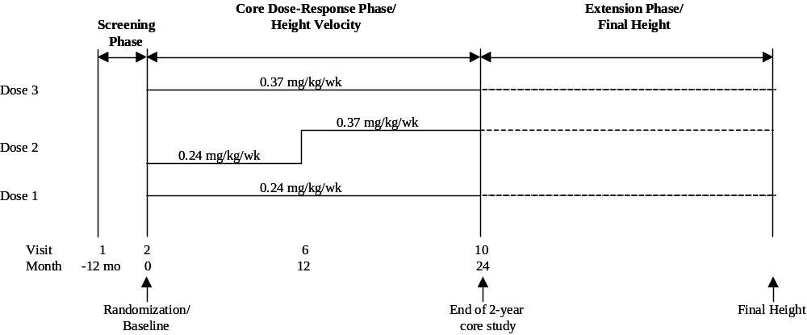
Note: Visit 11 occurred 12 months after Visit 10. Visit 11 procedures were repeated every 12 months until final height was attained.
Figure 7. Design of Study E001.

3.2.3. Inclusion/Exclusion Criteria
Patients were included who were prepubertal and had chronological age ≥5 years, height SDS ≤-2.0, plasma GH peak above 20 mU/L (10 μg/L) in response to a standard stimulation test, bone age <10 years (females) or <12 years (males), height velocity below the 25th percentile for age before age 10 years for girls and age 12 years for boys (or, if above these age limits, below the 25th percentile for bone age), and normal thyroid function. The different cutoffs used to determine sufficient GH secretion in Study E001 versus Study GDCH (>10 μg/L versus >7 μg/L, respectively) reflect the lack of a generally accepted criterion due to differences in assay characteristics and in the particular stimulation protocol employed (DTCLWPES 1995; Sizonenko et al. 2001). Patients were excluded if they had a chronic illness, a known genetic syndrome, had ever received GH, or were currently receiving other drugs likely to affect growth.

3.2.4. Population Definitions
All Randomized Patients (n=239): Of 261 patients who entered the study, 22 were ineligible or discontinued prior to randomization. The remaining 239 patients comprise the All Randomized Patients population: Dose 1, n=78; Dose 2, n=78; Dose 3, n=83.
Two-Year Height Velocity Population (n=209): Of the 239 randomized patients, 30 (13%) discontinued prior to reaching the primary 2-year endpoint. The remaining 209 patients (87% of randomized patients) comprise the Two-Year Height Velocity Population: Dose 1, n=70; Dose 2, n=67; Dose 3, n=72.
Final Height Population (n=50): Of the 209 patients who completed the core 2-year height velocity phase of the study 173 entered the final height extension phase. Fifty of these patients attained final height on study, or returned for final height measurement at a post-study follow-up: Dose 1, n=17; Dose 2, n=16; Dose 3, n=17. This includes one patient (Dose 1) who discontinued the study at Visit 3 (prior to 1 year of treatment) who was followed to final height post-treatment and was included in the Final Height Population.

3.2.5. Patient Disposition
Figure 8 illustrates patient disposition.
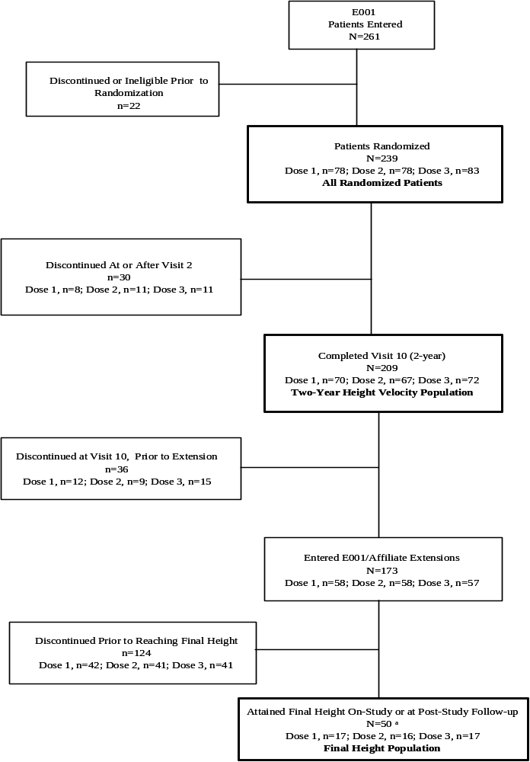

a One patient who discontinued at Visit 3 was followed to final height post-treatment and was therefore also included in the Final Height Population.
Figure 8. Patient disposition for Study E001.

3.2.6. Baseline Patient Characteristics
Table 10 provides baseline demographics for All Randomized Patients, Two-Year Height Velocity Population, and Final Height Population.

Table 10. Demographics and Other Baseline Characteristics
Study E001
Population | All Randomized Patients |  |  | Two-Year Height Velocity |  |  | Final Height
Humatrope Dosage  (mg/kg/wk) | Dose 1  0.24 | Dose 2  0.24→0.37 | Dose 3  0.37 | Dose 1  0.24 | Dose 2  0.24→0.37 | Dose 3  0.37 | Dose 1  0.24 | Dose 2  0.24→0.37 | Dose 3  0.37
Number of patients | 78 | 78 | 83 | 70 | 67 | 72 | 17 | 16 | 17
Male | 49 | 50 | 59 | 45 | 43 | 51 | 11 | 9 | 11
Female | 29 | 28 | 24 | 25 | 24 | 21 | 6 | 7 | 6
Ethnic origin
Asian | 0 | 2 | 0 | 0 | 2 | 0 | 0 | 0 | 0
Caucasian | 78 | 76 | 83 | 70 | 65 | 72 | 17 | 16 | 17
Peak GH concentration (μg/L) | 16.8 ± 7.5 | 17.6 ± 9.9 | 17.0 ± 6.2 | 16.6 ± 6.8 | 17.5 ± 10.5 | 16.9 ± 6.1 | 14.2 ± 4.7 | 16.8 ± 11.8 | 14.3 ± 3.4
IGF-I concentration (μg/L) | 89.0 ± 44.4 | 100.2 ± 65.5 | 99.4 ± 48.6 | 88.9 ± 45.4 | 103.8 ± 67.4 | 102.6 ± 49.1 | 80.4 ± 32.7 | 113.2 ± 54.6 | 109.1 ± 61.3
Chronological age (y) | 9.4 ± 2.4 | 9.9 ± 2.2 | 10.0 ± 2.2 | 9.4 ± 2.5 | 9.8 ± 2.1 | 10.0 ± 2.2 | 10.4 ± 2.3 | 10.4 ± 2.1 | 10.2 ± 2.1
Bone age (y) | 7.4 ± 2.6 | 8.1 ± 2.3 | 8.0 ± 2.1 | 7.4 ± 2.6 | 8.0 ± 2.3 | 8.0 ± 2.0 | 8.5 ± 2.1 | 8.5 ± 2.1 | 8.9 ± 1.9
Height SDS a | -3.4 ± 0.8 | -3.2 ± 0.7 | -3.0 ± 0.5 | -3.4 ± 0.8 | -3.2 ± 0.7 | -3.0 ± 0.5 | -3.3 ± 0.8 | -3.1 ± 0.8 | -2.9 ± 0.6
Predicted height SDS a | -2.7 ± 1.0 | -2.8 ± 1.1 | -2.4 ± 1.1 | -2.8 ± 1.0 | -2.9 ± 1.0 | -2.3 ± 1.1 | -2.5 ± 1.1 | -2.6 ± 0.9 | -2.3 ± 0.9
Target height SDS b | -1.3 ± 0.9 | -1.2 ± 1.0 | -1.2 ± 0.9 | -1.3 ± 0.9 | -1.1 ± 0.9 | -1.2 ± 0.9 | -1.2 ± 1.1 | -0.8 ± 1.1 | -0.9 ± 0.9
Pretreatment height velocity (cm/y) | 4.3 ± 1.1 | 4.4 ± 1.3 | 4.3 ± 1.1 | 4.2 ± 1.1 | 4.5 ± 1.3 | 4.4 ± 1.1 | 4.7 ± 1.4 | 5.1 ± 2.0 | 4.4 ± 1.5
Note: Values represent mean ± standard deviation (SD).
Abbreviation: GH = growth hormone; IGF-I = insulin-like growth factor-I; SDS = standard deviation score.
a There were statistically significant differences (p<0.05) among the three dose groups for the All Randomized and the Two-Year Height Velocity populations.
b Target height represents the gender-adjusted midparental height.

There were significant differences (p<0.05) among the Humatrope dosage groups for height SDS and predicted height SDS for All Randomized Patients and Two-Year Height Velocity Population. To account for this, analyses were performed using baseline predicted height SDS as a covariate. There were no other statistically significant differences among the dosage groups for baseline characteristics.

3.2.7. Efficacy Data

3.2.7.1. Dose-Response Effect on Height Velocity
The primary efficacy variable was increase in height velocity (cm/y) from baseline to 2-year endpoint. The protocol-specified primary efficacy analysis was of the difference in height velocity increase between the group that received the Humatrope dosage of 0.24 mg/kg/wk and the group that received 0.37 mg/kg/wk. Between-group comparisons were performed using analysis of variance (ANOVA) with a two-sided significance level of 0.05.
Table 11 presents the effect of Humatrope dosage on height velocity from pretreatment to 2-year endpoint.
Table 11. Height Velocity Changes from Pretreatment to 2-Year Endpoint
Two-Year Height Velocity Population
Study E001
Humatrope Dosage  (mg/kg/wk) | Dose 1  0.24 | Dose 2  0.24→0.37 | Dose 3  0.37
Number of Patients | 68 | 66 | 71
Baseline
Height Velocity (cm/y) | 4.23 ± 0.14 | 4.45 ± 0.14 | 4.35 ± 0.14
Difference (cm/y) | Dose 2 – Dose 1 | Dose 3 – Dose 2 | Dose 3 – Dose 1
 | 0.23 ± 0.20 | -0.10 ± 0.20 | 0.12 ± 0.20
p-value | 0.264 | 0.608 | 0.534
Endpoint
Height Velocity (cm/y) | 7.49 ± 0.16 | 7.61 ± 0.16 | 8.39 ± 0.16
Effect (cm/y) | Dose 2 – Dose 1 | Dose 3 – Dose 2 | Dose 3 – Dose 1
 | 0.11 ± 0.23 | 0.78 ± 0.23 | 0.90 ± 0.23
p-value | 0.619 | 0.001 | <0.001
Change
Height Velocity (cm/y) | 3.27 ± 0.18 | 3.16 ± 0.19 | 4.04 ± 0.18
Effect (cm/y) | Dose 2 – Dose 1 | Dose 3 – Dose 2 | Dose 3 – Dose 1
 | -0.11 ± 0.26 | 0.89 ± 0.26 | 0.78 ± 0.26
p-value | 0.672 | 0.001 | 0.003
Note: Values represent least squares mean ± standard error (SE).

By ANOVA, patients who received 0.37 mg/kg/wk Humatrope achieved a significantly greater pretreatment to 2-year endpoint increase in height velocity than patients who received 0.24 mg/kg/wk (dose effect = 0.8 cm/y, 95% CI: 0.3 – 1.3 cm/y, p=0.003) or those who received 0.24 mg/kg/wk for the first year and then 0.37 mg/kg/wk thereafter (mean ± SE dose effect = 0.9 ± 0.3 cm/y, p=0.001). There was no statistically significant difference in height velocity change between the 0.24 mg/kg/wk and the 0.24→0.37 mg/kg/wk groups (p=0.672).

3.2.7.2. Dose-Response Effect on Height SDS
To evaluate long-term outcome in the broader population of study patients, ANCOVA and repeated measures analyses of height SDS were performed for the Two-Year Height Velocity Population (Table 12). These analyses are analogous to those performed in the Efficacy Evaluable Population of Study GDCH (Table 4). The number of patients available for these analyses are less than for the primary height velocity endpoint because both the ANCOVA and repeated measures analysis used baseline predicted height SDS as a covariate. Some children were too young to perform a height prediction because the Bayley-Pinneau method requires a minimum bone age of 6 to 7 years (depending on gender and relation of chronologic age to bone age).
Table 12. Secondary Efficacy Analyses
Two-Year Height Velocity Population
Study E001
Humatrope Dosage  (mg/kg/wk) | Dose 1  0.24 | Dose 2  0.24→0.37 | Dose 3  0.37 | Dose  Effect | p-value  (Dose 1 vs Dose 3)
Variable
ANCOVA
n | 39 | 52 | 48
Last observed  height SDS a | -1.95 ± 0.13 | -1.87 ± 0.12 | -1.45 ± 0.12 | 0.51 ± 0.18 b | 0.006
Repeated measures
n | 39 | 52 | 47
Height SDS at age 18 years c | -1.26 ± 0.16 | -1.56 ± 0.15 | -0.82 ± 0.14 | 0.44 ± 0.17 d | 0.012
Abbreviations: ANCOVA = analysis of covariance; n = number of patients who had a baseline predicted height measurement, required for the ANCOVA; SDS = standard deviation score; vs = versus.
a Data are expressed as least squares mean (LSM) ± standard error (SE) from ANCOVA, with baseline predicted height (BPH) SDS as the covariate.
b Value represents the difference in the endpoint height SDS between the Dose 1 group and the Dose 3 group.
c Data are expressed as least squares mean (LSM) ± standard error (SE) from repeated measures linear model for measured or estimated height SDS at age 18 years.
d Value represents the difference in the height SDS at age 18 years between the Dose 1 group and the Dose 3 group.

Patients in the Two-Year Height Velocity Population had a mean age of 15 years at last observed height SDS after a mean treatment period of 5.1 years. By ANCOVA, patients in the Two-Year Height Velocity Population who received 0.37 mg/kg/wk Humatrope had a greater last observed height SDS than those who received 0.24 mg/kg/wk (p=0.006). The mean between-dose effect size, that is, the incremental increase in last observed height SDS for the 0.37 mg/kg/wk dose group versus the 0.24 mg/kg/wk group, was 0.51 SDS (corresponding to 3.3 cm), 95% CI: 0.15 – 0.87 SDS (p=0.006).
By repeated measures analysis of height SDS at age 18 years, for the same patients, the mean between-dose effect size was 0.44 SDS (corresponding to 2.8 cm), 95% CI: 0.10 – 0.78 SDS (p=0.012). These data indicate that the higher dose resulted in last observed height SDS and height SDS at age 18 years that were 2.8 to 3.3 cm greater for the 0.37 mg/kg/wk than for the 0.24 mg/kg/wk dose group.
The analyses of the between-dose effect size do provide insight into the overall height SDS gain in the 0.37 mg/kg/wk dosage group. The overall treatment effect of the 0.37 mg/kg/wk dosage can be conceptualized as the between-dose effect of the 0.37 mg/kg/wk dosage versus the 0.24 mg/kg/wk dosage (2.8 to 3.3 cm in the above analyses) plus the treatment effect of the lower 0.24 mg/kg/wk dosage. The treatment effect of the lower dose could be estimated roughly, based upon the results of the slightly lower (0.22 mg/kg/wk) dosage utilized in Study GDCH. The treatment effect in Study GDCH was 3.7 cm, suggesting that the overall treatment effect of the 0.37 mg/kg/wk dosage would be approximately 6 to 7 cm, or 1 SDS.
Table 13 provides the between-group dose effect analysis for final height SDS in the Final Height Population.
Table 13. Final Height Standard Deviation Score
Analysis of Covariance
Final Height Population
Study E001
Humatrope Dosage (mg/kg/wk) | Dose 1  (0.24) | Dose 2  (0.24→0.37) | Dose 3  (0.37) | Dose  Effect a | p-value  (Dose 1 vs Dose 3)
Final Height Analysis | n=13 | n=13 | n=13
Final height SDS (ANCOVA using BPH SDS as a covariate) | -1.65 ± 0.18 | -1.38 ± 0.18 | -1.19 ± 0.18 | 0.45 ± 0.26 | 0.086
Note: Values represent least squares mean ± standard error (SE).
Abbreviations: ANCOVA = analysis of covariance; BPH = baseline predicted height; n = number of patients; SDS = standard deviation score.
a Value represents the difference in final height SDS between Dose 3 and Dose 1.

After a mean treatment period of 6.5 years for the Final Height Population, and at a mean age of 18 years, the mean between-dose effect (0.37 mg/kg/wk versus 0.24 mg/kg/wk) on final height SDS, by ANCOVA with baseline predicted height SDS as the covariate, was 0.45 SDS, corresponding to 2.9 cm (p=0.09). This between-dose effect size was similar to the dose effect on last observed height SDS and on height SDS at age 18 years for the patients who completed 2 years of treatment (0.51 and 0.44 SDS, respectively). Although the effect did not reach statistical significance, this was not surprising because of the reduction of statistical power due to small sample size in this subgroup analysis.
As mentioned in relation to Study GDCH, the major rationale for continuing GH treatment studies to adult height has been the concern that GH might accelerate bone maturation, epiphyseal fusion, and cessation of linear growth, producing an earlier attainment of the same final height rather than an increase in adult height. To address this concern, we examined whether the higher GH dosage of 0.37 mg/kg/wk accelerated bone maturation compared to the 0.24 mg/kg/wk dosage (Figure 9).

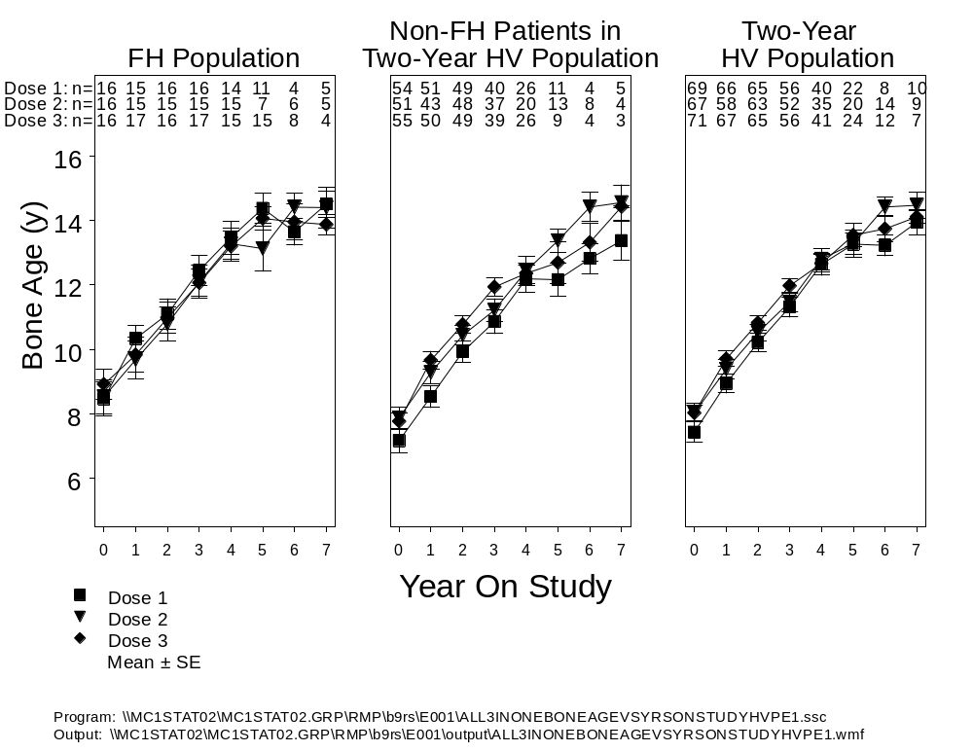
Abbreviations: Dose 1 = 0.24 mg/kg/wk; Dose 2 = 0.24 →0.37 mg/kg/wk; Dose 3 = 0.37 mg/kg/wk; FH = final height; HV = height velocity; n = number of patients; SE = standard error; Yr = year.
Figure 9. Bone age versus year on study in Study E001.
Figure 9 shows bone age versus year on study for the 0.24 mg/kg/wk, 0.24→0.37 mg/kg/wk, and 0.37 mg/kg/wk dosage groups of the Final Height Population (left panel), for patients who completed 2 years of treatment but did not have a final height measurement (middle panel), and for the entire Two-Year Height Velocity Population (right panel). In each population or subgroup, there were no apparent between-dose effects on the rate of bone age progression. Thus, the higher dosage of 0.37 mg/kg/wk had no discernible effect on bone age progression compared to the 0.24 mg/kg/wk dosage.

3.2.7.3. Significant Treatment Effect on Final Height
The previous section focused on the between-dose effect size on height velocity and on height SDS. This section will assess the overall treatment effect on final height for each of the three dosage groups. Because there was no untreated control group in this study, this was done by comparing the final height of patients in each dose group with the height that they were predicted to achieve without treatment.
Table 14 provides a summary of final height characteristics for the Final Height Population. Mean duration of treatment was 6.1 ± 2.3, 6.3 ± 2.2, and 7.0 ± 2.0 years for the 0.24 mg/kg/wk, 0.24→0.37 mg/kg/wk, and 0.37 mg/kg/wk groups, respectively.
Table 14. Final Height Characteristics
Final Height Population
Study E001
Humatrope Dosage  (mg/kg/wk) | Dose 1  0.24 | Dose 2  0.24→0.37 | Dose 3  0.37
Number of patients | 13 | 13 | 13
FH - BPH (cm) a | 5.36 ± 0.89 | 6.66 ± 1.14 | 7.21 ± 1.66
p-value b | <0.001 | <0.001 | 0.001
Number of patients | 17 | 16 | 17
FH SDS - BH SDS a | 1.55 ± 0.14 | 1.52 ± 0.27 | 1.85 ± 0.20
p-value b | <0.001 | <0.001 | <0.001
Number of patients | 17 | 16 | 17
TH - FH (cm) a | 3.78 ± 1.78 | 5.31 ± 2.42 | 1.33 ± 1.21
p-value b | 0.050 | 0.045 | 0.288
Abbreviations: BH = baseline height; BPH = baseline predicted height; FH = final height; SDS = standard deviation score; TH = target height.
a Data are expressed as mean ± standard error (SE).
b p-values refer to a within-group t test of the null hypothesis that mean value equals zero.

All three treatment groups showed a significant treatment effect, as evidenced by mean final height minus baseline predicted height that ranged from 5.4 to 7.2 cm (lower dose to higher dose) and mean final height SDS minus baseline height SDS that ranged from 1.6 to 1.9 SDS (lower dose to higher dose). Furthermore, patients who received the Humatrope dosage of 0.37 mg/kg/wk reached a final height that was not significantly below target height (gender-adjusted midparental height), indicating that they came close to achieving their genetic potential for height.
The validity of final height minus baseline predicted height as an efficacy measure depends on the accuracy of the Bayley-Pinneau method in predicting the adult height that patients with non-GHD short stature would have achieved in the absence of treatment. Since published studies in approximately 400 untreated patients show that the actual adult height of untreated patients falls short of the Bayley-Pinneau predicted height by up to 5 cm in males [Bramswig et al. 1990; Ranke et al. 1995; Buchlis et al. 1998; Rekers-Mombarg et al. 1999]), final height minus baseline predicted height should provide a conservative estimate of treatment effect. In Study GDCH, placebo-treated patients failed to achieve their baseline predicted height, consistent with the published studies cited above, whereas patients treated with 0.37 mg/kg/wk, administered in divided doses 6 times per week, exceeded their baseline predicted height by 7.2 cm (Figure 10).

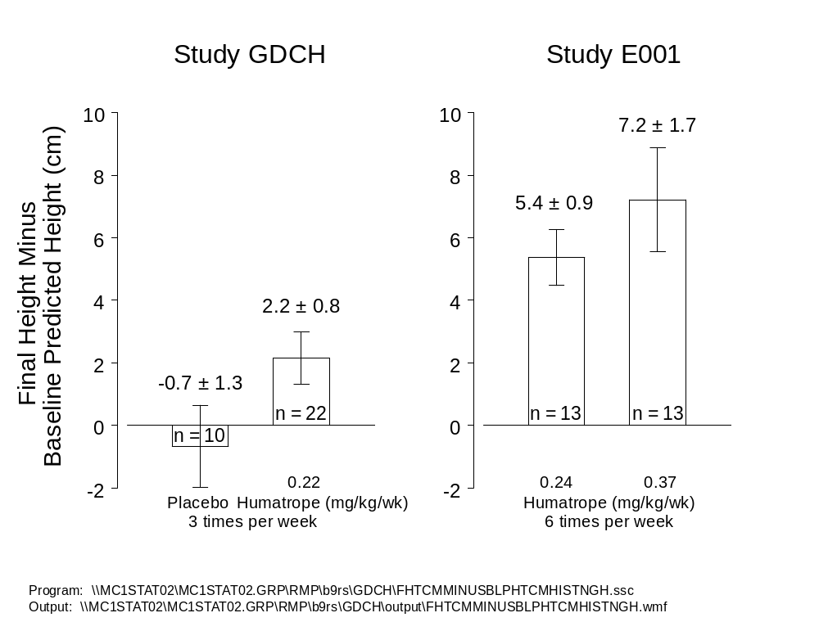
Note: Values represent mean ± SE
Abbreviations: n = number of patients; SE = standard error.
Figure 10. Final height minus baseline predicted height (cm) in the Final Height Populations of Studies GDCH and E001.
The above data support the validity of final height minus baseline predicted height as a conservative measure of GH treatment effect in patients with non-GHD short stature. From these data we conclude that the mean gain in adult height attributable to GH treatment with the 0.37 mg/kg/wk dosage is at least 7.2 cm.

3.2.8. E001 Efficacy Summary
The primary objective of this study was to determine the efficacy of two different Humatrope dosages (0.24 mg/kg/wk versus 0.37 mg/kg/wk) in stimulating an increase in height velocity during the first 2 years of treatment in patients with non-GHD short stature. By ANOVA, patients who received 0.37 mg/kg/wk Humatrope had a greater increase in height velocity after 2 years of treatment than patients who received 0.24 mg/kg/wk (between-dose effect: 0.8 cm/y, 95% CI: 0.3 – 1.3 cm/y, p=0.003). Furthermore, patients who received 0.37 mg/kg/wk from the start of treatment had a significantly greater increase in height velocity than those who received 0.24 mg/kg/wk for the first year, followed by 0.37 mg/kg/wk for the second year (between-dose effect: 0.9 ± 0.3 (SE) cm/y, p=0.001). Thus, the primary efficacy analysis supported the hypothesis that the dosage of 0.37 mg/kg/wk is more effective in increasing two-year height velocity than either of the lower dosage regimens.
Secondary analyses indicated a mean between-dose effect (incremental effect of 0.37 mg/kg/wk versus 0.24 mg/kg/wk) on last observed height SDS, height SDS at 18 years, and final height SDS corresponding to 3.3 cm, 2.8 cm, and 2.9 cm, respectively. Each of these analyses was statistically significant except for the last analysis (p=0.09), which had reduced statistical power because of the smaller size of the Final Height Population. From the above dose-response analyses, we conclude that the dosage of 0.37 mg/kg/wk is more effective than the dosage of 0.24 mg/kg/wk, producing a significantly greater height velocity, by 0.8 cm/y, and a significantly greater last observed height SDS and height SDS at age 18 years, by 2.8 to 3.3 cm.
In addition to evidence for dose-response, within-group analyses of final height minus baseline predicted height, which provide a conservative estimate of treatment effect for this population (since untreated patients on average fail to achieve their baseline predicted height [Bramswig et al. 1990; Ranke et al. 1995; Buchlis et al. 1998; Rekers-Mombarg et al. 1999]), showed that GH treatment significantly increased final height above baseline predicted height for each of the three dosage groups. The mean treatment effect size for this efficacy measure ranged from 5.4 cm at the 0.24 mg/kg/wk dosage to 7.2 cm at the 0.37 mg/kg/wk. Thus, the mean gain in adult height attributable to GH treatment with the 0.37 mg/kg/wk dosage was approximately 7 cm compared to the height that the patients were predicted to achieve in the absence of treatment.

3.2.9. Comparative Efficacy Summary
Figure 11 presents a comparative summary of final height SDS from the two studies, Study GDCH (0.22 mg/kg/wk, administered 3 times per week) and Study E001 (0.24 or 0.37 mg/kg/wk, administered 6 times per week).

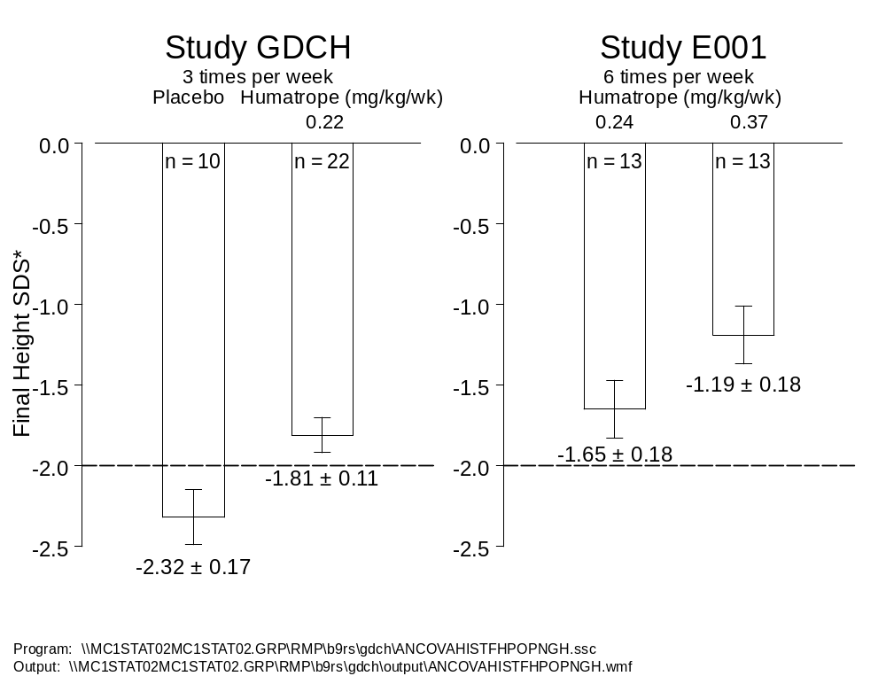
*Analysis of covariance (ANCOVA) model incorporating effect for baseline predicted height standard deviation score (SDS); values are least squares mean ± standard error (SE).
Note: The dashed line represents the lower limit of the normal range for the general population (AAP 1997).
Abbreviations: n = number of patients.
Figure 11. Comparative summary of Studies GDCH and E001: Final height SDS.
In Study GDCH the mean increase in height SDS between the Humatrope-treated and placebo-treated groups was 0.51 SDS (corresponding to 3.7 cm). In Study E001, the mean between-dose effect between the higher (0.37 mg/kg/wk) and lower (0.24 mg/kg/wk) dosage was 0.45 SDS (corresponding to 2.9 cm). Although the latter effect did not achieve statistical significance (p=0.086), analyses of last observed height SDS and height SDS at age 18 years both gave statistically significant between-dose effects of a similar magnitude (0.51 SDS [p=0.006] and 0.44 SDS [p=0.012], respectively). Thus, the overall GH treatment effect of the 0.37 mg/kg/wk dosage can be conceptualized as being comprised of 2 components: the incremental effect of the dosage of 0.37 mg/kg/wk compared to 0.24 mg/kg/wk, and the effect of the 0.24 mg/kg/wk dosage compared to the height that an untreated group would have achieved. From Figure 10, this overall treatment effect was 7.2 cm, or approximately 1 SD, obtained by comparing the final height of these patients to the height that was predicted to have occurred in the absence of treatment. Figure 12 shows the individual final height data of these patients.

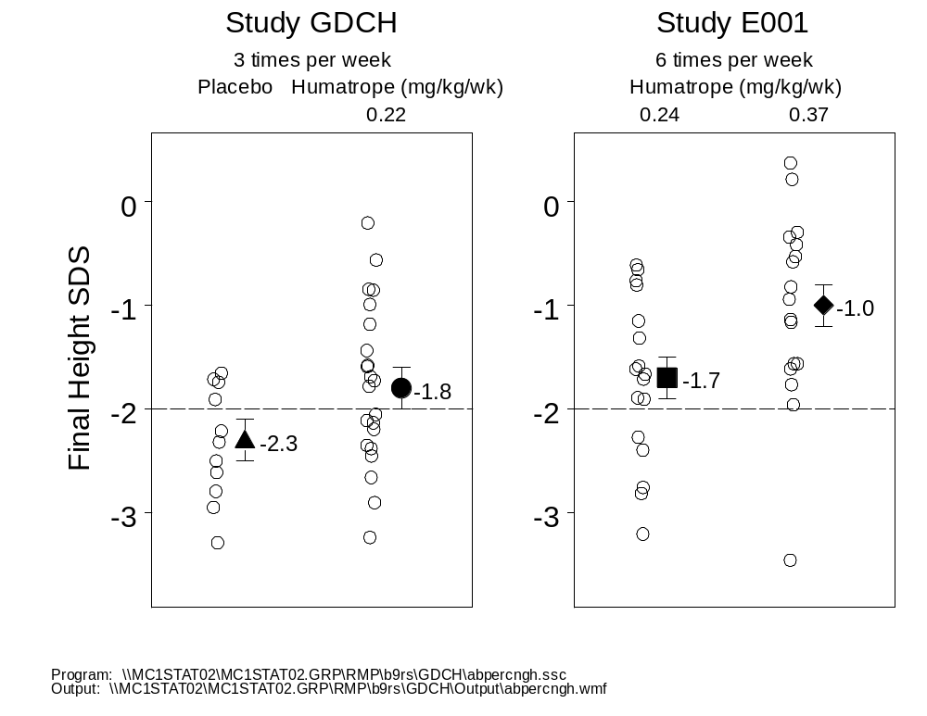
Note: Values represent mean ± standard error (SE). The dashed line at -2.0 SDS represents the normal range for the general population (AAP 1997).
Abbreviations: SDS = standard deviation score; SE = standard error.
Figure 12. Significant number of GH treated patients achieved normal height in Studies GDCH and E001.
For the placebo patients, final height SDS for most patients remained below the normal range. At the 0.22 mg/kg/wk dosage, given in divided doses 3 times per week, 55% of final height SDS values were within the normal range. At the 0.24 mg/kg/wk dosage, given in divided doses 6 times per week, 71% of final height SDS values were within the normal range. For the 0.37 mg/kg/wk dosage, all but one final height SDS, or 94%, were within the normal range. The one patient with final height SDS below normal had a gain in height SDS of approximately 1 during treatment. Thus, the 0.37 mg/kg/wk dosage resulted in nearly all adult height measurements falling within the normal range.

3.3. Supportive Data: Meta-Analysis of Effect of Growth Hormone Therapy on Height in Children with Idiopathic Short Stature
The unmet medical need of patients with non-GHD short stature has been recognized since modern GH testing enabled the differential diagnosis of GHD and non-GHD short stature in the 1960s. To address this need, a large number of studies have been undertaken. A recent meta-analysis of 38 studies, which fulfilled specific inclusion criteria, provides a careful and comprehensive analysis of recombinant GH treatment in patients with non-GHD short stature (Finkelstein et al. 2002) and is summarized here as supportive evidence of efficacy. The objective of this meta-analysis was to evaluate short-term and long-term effects of treatment with recombinant GH in patients with non-GHD short stature (referred to as idiopathic short stature [ISS] in this paper) by a review of the literature from 1985 to 2000. Thirty-eight studies (10 controlled, 28 uncontrolled) met the following principal inclusion criteria: patients’ initial height below the 10th percentile (most of the long-term studies, however, had entry criterion of height SDS≤-2.0 [2.3 percentile]); no previous treatment with GH, sex steroids or anabolic agents; normal stimulated GH concentrations (≥10 μg/L); absence of comorbid conditions; on-study treatment with recombinant GH; and inclusion of major outcome measures of height velocity or height SDS. Two types of analyses were performed: aggregate and paired. Aggregate analyses provided pooled estimates across all studies reporting each growth variable. Paired analyses provided pooled estimates across those studies reporting the given variable both at baseline and as an outcome.
Controlled studies were defined as those having a concurrent control group, either randomized or nonrandomized. For brevity, only the data reported for the controlled studies that included adult or final height as an outcome will be discussed. Similar GH treatment effects, however, were reported in the uncontrolled final height studies.

3.3.1. Growth Hormone Effect on Final Height

3.3.1.1. Controlled Studies
Among the 10 controlled studies included in the meta-analysis, adult height was measured only in the following four controlled studies, representing data from 188 children: Zadik et al. 1992, Hindmarsh and Brook 1996, Buchlis et al. 1998, and McCaughey et al. 1998. Across these four studies, the weighted mean age at study start was 10.8 years and mean duration of treatment was 5.3 years. The weighted average GH dosage for the children in these studies was 0.31 mg/kg/wk, and in each study the dosage was given in divided doses 6 times per week. Table 15 presents the final height results for the meta-analysis of the controlled studies.
Table 15. Final Height Results: Meta-Analysis of Controlled Trials a
Growth Variable | Patients (N)  (Studies [n]) | Difference Between Treatment and Control Groups:  Pooled Estimate,  Mean ± SD (95% CI)
Childhood height SDS
Baseline
Aggregate | 408 (9) | 0.02 ± 0.05 (-0.08 to 0.12)
Paired b | 36 (2) | 0.12 ± 0.11 (-0.09 to 0.33)
1 year | 36 (2) | 0.60 ± 0.18 (0.26 to 0.95)
Adult height SDS
Predicted
Aggregate | 118 (4) | 0.30 ± 0.12 (0.07 to 0.53)
Paired b | 106 (3) | 0.13 ± 0.16 (-0.18 to 0.44)
Achieved
Aggregate | 125 (4) | 0.84 ± 0.19 (0.46 to 1.22)
Paired b | 112 (3) | 0.78 ± 0.22 (0.35 to 1.21)
Abbreviations: CI = confidence interval; SD = standard deviation; SDS = standard deviation score.
a Table modified from Finkelstein et al. (2002) Table 2.
b “Paired” indicates analysis of only those studies reporting this variable at baseline and follow-up.

While no significant differences between treatment and control groups were noted at baseline, the mean difference in adult height SDS between the treatment group and the control group ranged from 0.78 (paired analysis) to 0.84 (aggregate analysis), which corresponds to 5 to 6 cm.
The between-group difference (GH versus control) for achieved adult height SDS was also compared with the between-group difference for baseline predicted height SDS. In this analysis, the adult height SDS achieved by the GH-treated patients exceeded baseline predicted height SDS by 0.54 (aggregate analysis) to 0.65 (paired analysis), which corresponds to 3.6 to 4.6 cm. Figure 13 presents this comparison of the mean difference in height SDS between treatment and control groups for baseline predicted adult height and achieved adult height.
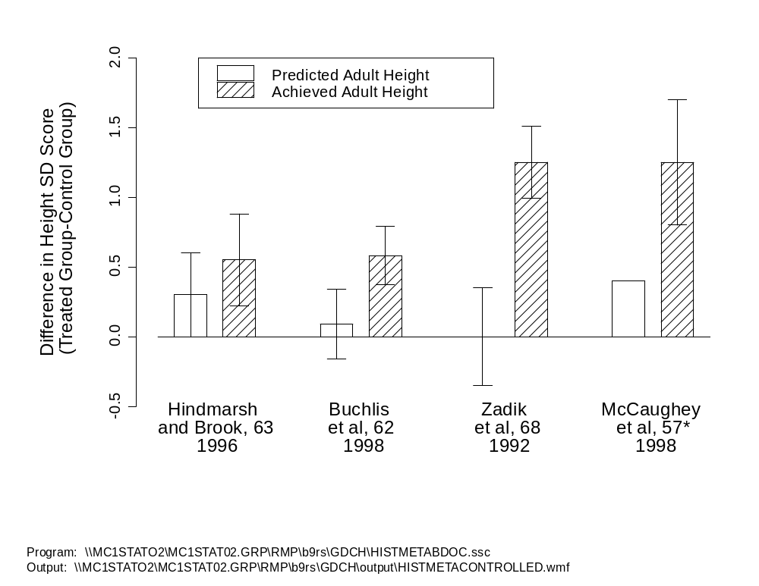
Note: Recreated from Finkelstein et al. (2002). For Government Use Only - No Further Reproduction Permitted.
* No measure of variation was provided for predicted adult height in this study; therefore, it was not included in the analysis of differences between treatment and control groups.
Figure 13. Mean difference in height standard deviation scores between treatment and control groups for predicted adult height (at baseline) and achieved adult height for controlled studies.
The GH effect on final height is reflected by the significantly greater difference between treatment and control groups for achieved adult height SDS and by the difference between groups for the gain in height SDS over baseline predicted height SDS.

3.3.1.2. Uncontrolled Studies
Adult height was measured in the following 8 uncontrolled studies: Loche et al. 1994, Lopez-Siguero et al. 1996, Zadik et al. 1996, Bernasconi et al. 1997, Schmitt et al. 1997, Zadik and Zung 1997, Hintz et al. 1999, and Pasquino et al. 2000. Across these 8 studies, the mean duration of treatment was 4.7 years, and the weighted average GH dosage was 0.27 mg/kg/wk, given in divided doses 6 times per week. Table 16 presents the results of the meta-analysis of the uncontrolled studies.
Table 16. Results of Meta-Analysis of Uncontrolled Studies from Peer-Reviewed Literature a
Growth Variable | Patients (N)  (Studies [n]) | Outcome:  Pooled Estimate,  Mean ± SE (95% CI)
Childhood height SDS
Baseline
Aggregate | 550 (25) | -2.72 ± 0.05 (-2.82 to -2.63)
Paired b | 209 (10) | -2.62 ± 0.09 (-2.79 to -2.44)
1 year | 209 (10) | -2.19 ± 0.10 (-2.39 to -1.99)
Adult height SDS
Predicted
Aggregate | 311 (9) | -2.18 ± 0.17 (-2.52 to -1.85)
Paired b | 212 (6) | -2.25 ± 0.23 (-2.74 to -1.77)
Achieved
Aggregate | 246 (8) | -1.62 ± 0.07 (-1.77 to -1.47)
Paired b | 208 (6) | -1.62 ± 0.09 (-1.80 to -1.45)
Abbreviations: CI = confidence interval; SE = standard error; SDS = standard deviation score.
a Table modified from Finkelstein et al. (2002) Table 4.
b “Paired” indicates analysis of only those studies reporting this variable at baseline and follow-up.

Analysis of the data derived from the uncontrolled studies demonstrates similar efficacy to that seen in the controlled studies. The difference between achieved adult height SDS and baseline predicted height SDS ranged from 0.56 (aggregate analysis) to 0.63 (paired analysis), which corresponds to 3.8 to 4.5 cm. Figure 14 presents the paired analysis comparison of baseline predicted height SDS versus achieved adult height SDS for the uncontrolled studies.
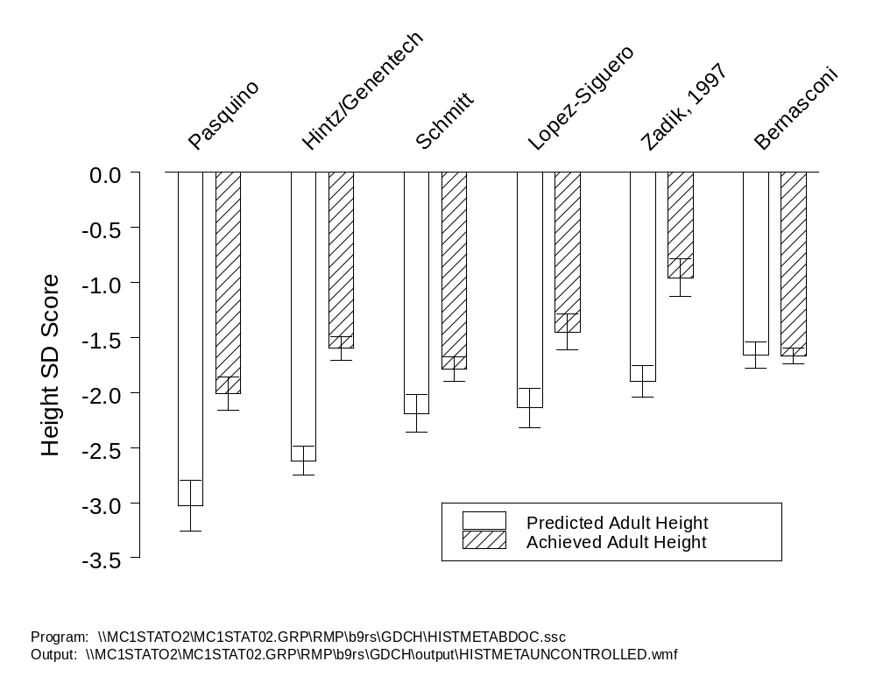
Note: Recreated from Finkelstein et al. (2002). For Government Use Only - No Further Reproduction Permitted.
Abbreviation: SD = standard deviation.
Figure 14. Mean adult height standard deviation scores predicted at baseline and achieved for uncontrolled studies.
In all but one study (Bernasconi et al. 1997), the GH-treated patients achieved a significantly greater adult height SDS than was predicted at baseline. The study in which adult height SDS did not exceed the baseline prediction was found to have the greatest baseline predicted height. The authors acknowledge that lack of apparent GH effect may have reflected a bias due to overestimation of baseline predicted height.

3.3.1.3. Summary
In summary, the studies in this meta-analysis of GH treatment in patients with non-GHD short stature demonstrate an average GH-induced gain in adult height of approximately 4 to 6 cm.

3.4. Height SDS Gain Similar to Height SDS Gain in Turner Syndrome
To compare the response to GH in patients with non-GHD short stature with that of a non-GHD patient population for whom Humatrope treatment is already approved, the magnitude of the Humatrope effect in patients with non-GHD short stature in Study GDCH was compared to that in patients with Turner syndrome. In a randomized, controlled study of Humatrope treatment to final height in patients with Turner syndrome (Study GDCT, the only study to date with a long-term randomized untreated control group), patients treated with Humatrope (0.30 mg/kg/wk, administered in divided doses 6 times per week [versus 0.22 mg/kg/wk, given 3 times per week, in Study GDCH]) were taller than untreated patients by an average of 3.9 cm (p=0.001). When final height was adjusted for midparental height (target height), Humatrope-treated patients achieved a mean final height 5.4 cm greater than that of untreated patients (ANCOVA, p=0.001). Both of these analyses are from the planned interim analysis of Study GDCT that was used to support the US approval of Humatrope treatment in patients with Turner syndrome. Thus, the Humatrope treatment effect from the primary efficacy analysis was similar to that for Study GDCH patients with non-GHD short stature (3.9 versus 3.7 cm, respectively).
As shown in Figure 15, the effect of Humatrope treatment on the distribution of height SDS change from baseline to final height was also similar in patients with non-GHD short stature (Study GDCH) and those with Turner syndrome (Study GDCI [Section 4.2.3 provides additional details of this study]). For the analysis of Study GDCI, final height was defined as the last height measured after attaining bone age ≥14 years, when more than 98% of adult height has been achieved (Greulich and Pyle 1959).
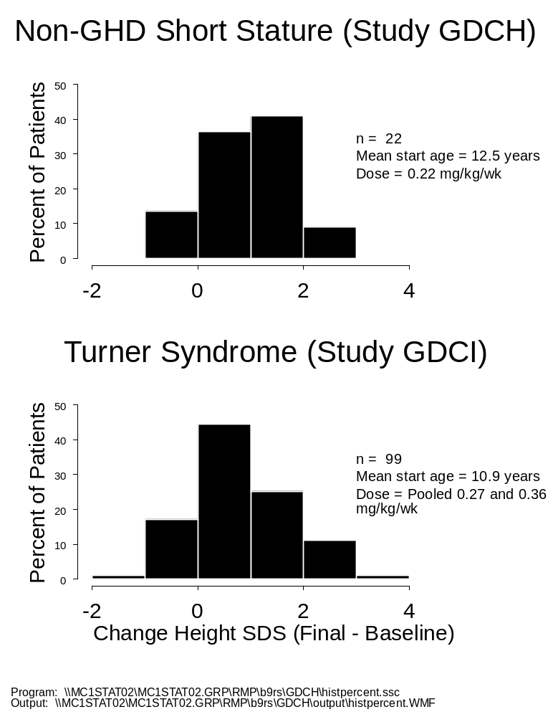
Abbreviations: n = number of patients; GHD = growth hormone deficiency; SDS = standard deviation score.
Figure 15. Distribution of height standard deviation score change (baseline to final height) in patients treated with Humatrope (Study GDCH and Study GDCI).
For both of these non-GHD patient populations, the distributions of height SDS change are unimodal with similar magnitude and variability.

3.5. Humatrope Dosage and Frequency of Administration
This section summarizes the rationale for the recommendation that in treatment of patients with non-GHD short stature, Humatrope should be administered at a dosage of up to 0.37 mg/kg/wk in divided doses 3 to 7 times per week.

3.5.1. Humatrope Dosage
Study E001 provides evidence for the dose-response effect of Humatrope in pediatric patients with non-GHD short stature. Compared with patients who received 0.24 mg/kg/wk Humatrope, the group that received the higher dosage of 0.37 mg/kg/wk achieved a significantly greater gain in height velocity at 2 years (4.0 versus 3.3 cm/y, p=0.003), greater gain in endpoint height SDS (effect: 0.51 SDS; p=0.006, ANCOVA), and a greater gain in height SDS at age 18 years (effect: 0.44 SDS; p=0.012, repeated measures analysis).
For the limited number of patients in the Final Height Population, other secondary endpoints (such as final height SDS [ANCOVA, Table 13], final height minus baseline predicted height [cm], final height SDS minus baseline height SDS, and target height minus final height [cm]) showed similar dose-dependent trends that did not reach statistical significance (Table 14). Taken together, these data support the greater efficacy of the Humatrope dosage of 0.37 mg/kg/wk compared to 0.24 mg/kg/wk for the treatment of pediatric patients with non-GHD short stature.
Dose-response studies in patients with Turner syndrome and in those with GHD provide evidence for the greater efficacy of GH at increasing dosages over the range of 0.18 to 0.70 mg/kg/wk. For example, in Study GDCI, patients who received 0.36 mg/kg/wk of Humatrope achieved a significantly greater increase in height SDS than those who received 0.27 mg/kg/wk (1.0 versus 0.6 SDS) (Quigley et al. 2002). Additionally, de Muinck Keizer-Schrama et al. (1999) reported a significantly greater gain in height SDS in patients with Turner syndrome who received higher dosages of GH (0.63 mg/kg/wk and 0.47 mg/kg/wk) compared with those who received a lower dosage (0.32 mg/kg/wk). A similar dose-response relationship has been observed in pediatric patients with GHD. In a 2-year, randomized, dose-response study, the dosages of 0.35 mg/kg/wk and 0.70 mg/kg/wk resulted in a significantly greater cumulative increase in height SDS than the dosage of 0.18 mg/kg/wk (Cohen et al. 2002). A second study of high-dosage (0.70 mg/kg/wk) versus conventional dosage (0.30 mg/kg/wk) treatment in pubertal GHD patients yielded a mean incremental final height gain for the high-dosage group compared to the conventional-dosage group of 4.6 cm (p=0.001) (Mauras et al. 2000). Thus, recent dose-response studies in patients without GHD and those with GHD support the greater effectiveness of dosages in the range of 0.35 to 0.70 mg/kg/wk compared to lower dosages.

3.5.2. Frequency of Administration
Humatrope was administered in divided doses TIW in Study GDCH, a regimen typical in the 1980s, when this study was begun. Since then, a 3-year, randomized study in patients with non-GHD short stature has shown that daily administration yields a greater cumulative height gain, by about 20%, compared to thrice-weekly administration of the same total dose (Hopwood et al. 1993). Based upon these data and similar observations in GHD patients (Smith et al. 1988; Rosenbloom et al. 1990; Blethen et al. 1993; MacGillivray et al. 1996), daily administration has become standard of care, because it is more effective, is considered more physiologic, and may improve compliance. Thus, while the TIW Humatrope regimen in Study GDCH demonstrated efficacy, better outcomes are anticipated with daily dosing. Consequently, Lilly recommends that Humatrope should be administered in divided doses 3 to 7 times per week.

3.5.3. Clinical Relevance of Height Gain in Non-GHD Short Stature
Following the recommendation of the 1987 Endocrinologic and Metabolic Drugs Advisory Committee, Lilly studies of patients with non-GHD short stature focused on the treatment of their short stature. Neither Study GDCH nor Study E001 provided evidence of potential benefits in quality of life or psychological well-being. Similarly, evidence for such benefits was not required as a basis for approval for any of the current pediatric indications. However, several lines of evidence suggest that the magnitude of GH-induced height gain in patients with non-GHD short stature was clinically meaningful. First, GH-induced height gain in patients with non-GHD short stature was similar to that achieved in Turner syndrome. Short stature in patients with Turner syndrome has been an approved indication for GH treatment since 1996, and GH is widely used to treat short stature in these patients (DTCLWPES 1995; Wilton 1999; Maneatis et al. 2000; AACE 2003). Second, the mean heights of Humatrope-treated patients in Study GDCH, and of the 0.37 mg/kg/wk dosage group in Study E001, moved into the normal range during the course of treatment. During the course of treatment, the majority of these children no longer had short stature, thereby diminishing the disadvantages of short stature during childhood, which may include being treated as younger than one’s actual age (juvenilization) (Sandberg 1999), increased risk of teasing and bullying (Voss and Mulligan 2000), and reduced opportunity to participate in age-appropriate activities. Third, whereas the final heights for placebo-treated patients (Study GDCH) were all below the 5th percentile of the normal population, and most were below the lower limit of normal, 94% of final heights for patients who received the higher dosage (0.37 mg/kg/wk) in Study E001 were within the normal range. Thus, as adults, these patients no longer had short stature, thereby diminishing or eliminating potential disadvantages of adult short stature, which may include failure to meet minimum height requirements for certain occupations, difficulty or inability to safely operate a motor vehicle or overcome structural challenges in the home or workplace, and the prejudice of being perceived as having lower competence than individuals of normal stature.
In summary, during the course of GH treatment, most patients with non-GHD short stature had a height that moved into the normal range. Additionally, GH treatment in the 0.37 mg/kg/wk dosage group of Study E001 resulted in 94% of final height measurements falling within the normal range, thus conferring on these patients the lifelong benefit of normal adult stature.

3.6. Overall Efficacy Conclusions
The efficacy of Humatrope treatment in increasing the final height of pediatric patients with non-GHD short stature has been demonstrated for the first time, through a randomized, double-blind, placebo-controlled study (Study GDCH). Study E001 and the recent meta-analysis by Finkelstein et al. (2002), which summarizes several peer-reviewed, controlled studies to final height, support the efficacy of GH treatment in this patient population. The magnitude of the treatment effect was 3.7 cm for the primary endpoint of the pivotal study, and 7.2 cm for the gain in height over baseline predicted height for the 0.37 mg/kg/wk dosage group of the dose-response study. A GH dose-response effect was demonstrated in Study E001: patients who received Humatrope at a dosage of 0.37 mg/kg/wk had significantly greater improvement in 2-year height velocity, by 0.8 cm/y, and significantly greater height SDS at age 18 years, by 2.8 cm, than those who received 0.24 mg/kg/wk. These findings are consistent with the dose-response relationship observed in patients with Turner syndrome and in patients with GHD. In conclusion, Humatrope at dosages up to 0.37 mg/kg/wk is effective in increasing the final height of pediatric patients with non-GHD short stature.

4. Safety

4.1. Introduction
During the 16 years that somatropin has been commercially available, an estimated 200,000 patients (equivalent to over 500,000 patient-years of exposure) worldwide have been exposed to somatropin. There are currently five approved pediatric indications for the use of somatropin and dosages have been approved up to 0.70 mg/kg/wk. Two large postmarketing research programs have published safety data collected over approximately 10 to 15 years. The National Cooperative Growth Study (Maneatis et al. 2000) reported safety data collected from 1985-1999 on 33,161 patients (approximately 113,000 patient-years). Adverse events (AEs) were reported for 2387 patients (7.2%) with a total of 2632 AEs, representing 23 events per 1000 patient-years. There were 156 deaths (0.5%) and serious adverse events (SAEs) were reported for 799 patients (2.4%). The Kabi International Growth Study (Wilton 1999) reported safety data collected from 1988-1998 on 25,977 patients, representing approximately 62,400 patient-years. There were 8321 AEs reported representing 133 events per 1000 patient-years. Although there are a number of uncommon, well-characterized events that have been associated with somatropin exposure, the overall safety profile is well established.
In correspondence between Lilly and the FDA, prior to submission of the sNDA, it was agreed that the safety of Humatrope in pediatric patients with non-GHD short stature would be evaluated by a comparison between the safety findings in the non-GHD short stature population and the safety in pediatric populations for which Humatrope is currently approved. Therefore, this section will compare the safety of Humatrope among pediatric patients with GHD (Study B9R-MC-GDAB) and Turner syndrome (Studies B9R-CA-GDCT and B9R-MC-GDCI) and those with non-GHD short stature (Studies GDCH and E001). These three regulatory submissions involved similar numbers of patients and similar total patient-years of exposure. Two primary safety questions are addressed: 1) What are the rates of adverse events in the non-GHD short stature population compared to the rates in patients with GHD or Turner syndrome? The key comparison will be between the Humatrope-treated patient groups across these patient populations. 2) Are there any new adverse events specific to the non-GHD short stature population? Within this safety discussion, a general summary across the three patient populations will be presented at the beginning of each section, followed by detailed review of relevant cases within each population.

4.2. Overview of Clinical Studies Included in Safety Comparison
Table 17 provides a summary of the clinical studies included in the safety comparison.
Table 17. Clinical Studies Included in Safety Comparison
Condition | Study | N |  | Age and Gender  Entry Criteria | Humatrope dose  (mg/kg/wk) | Design
GHD | GDAB | 333 |  | Males and females,  age ≥2 y | 0.18-0.24 | Open-label, single-arm
TS | GDCT | 136 (H:74) |  | Females,  age ≥7 y | 0.30 | Open-label, randomized, untreated control, to final height
TS | GDCI | 230 |  | Females,  age ≥5 y | 0.27  0.36 | Double-blind, randomized, parallel, placebo control (first 1.5 years), extension to final height
Non-GHD short stature | GDCH | 68 (H:37) |  | Males,  ages 10 to 16 y  Females,  ages 9 to 15 y | 0.22 | Double-blind, randomized, parallel, placebo control, to final height
Non-GHD short stature | E001 | 239 |  | Males and females, age ≥5 y | 0.24  0.24→0.37  0.37 | Open-label, three-arm, randomized, parallel, 2-year dose-response, with extension phase to final height
Abbreviations: GHD = growth hormone deficiency; H = Humatrope; N = number of patients in safety analysis; TS = Turner syndrome.

4.2.1. Study GDAB
Study GDAB was an open-label, single-arm study of Humatrope treatment in patients with growth hormone deficiency (GHD). The intent of the study was to evaluate efficacy of Humatrope treatment to increase height velocity in patients with GHD. Initially, Humatrope was administered intramuscularly or subcutaneously 3 times per week (TIW) in a dosage of 0.18 mg/kg/wk. The protocol was subsequently amended to allow an increase in frequency of administration up to 6 times per week, and dosage up to 0.24 mg/kg/wk based upon the patient’s height velocity. Three hundred thirty-three patients were enrolled in the study. A Safety Population was not defined in the protocol; therefore, the data provided in this safety comparison are for all enrolled patients.

4.2.2. Study GDCT
Study GDCT is an open-label, randomized, untreated control study to final height in patients with Turner syndrome. Patients were randomized to one of two treatment groups: Humatrope (0.30 mg/kg/wk) or Untreated Control. Humatrope was administered subcutaneously in divided doses 6 times per week. Ethinyl estradiol replacement therapy was given to patients in both treatment groups who were at least 13 years of age and had been in the study for at least 12 months. After 1 year of treatment with ethinyl estradiol, patients at least 15 years of age received cyclic treatment with ethinyl estradiol and medroxyprogesterone acetate. Of 140 randomized patients, 136 were included in the Safety Population. The Safety Population is defined as those patients who were randomized and either received any study drug (Humatrope, n=74) or had postbaseline safety data (Control, n=62). The data provided in this safety comparison are for the Safety Population.

4.2.3. Study GDCI
Study GDCI was a double-blind, randomized, placebo-controlled (first 1.5 years), parallel study of the effect of Humatrope at two different doses, with or without low-dose ethinyl estradiol, on height velocity in patients with Turner syndrome. After the 1.5-year placebo-controlled phase, patients entered an extension to final height. Patients were randomized to one of the following five treatment groups:
[1] Humatrope (0.27 mg/kg/wk) with oral placebo,
[2] Humatrope (0.27 mg/kg/wk) with low-dose ethinyl estradiol,
[3] Humatrope (0.36 mg/kg/wk) with oral placebo,
[4] Humatrope (0.36 mg/kg/wk) with low-dose ethinyl estradiol, or
[5] Placebo injections with oral placebo for the first 1.5 years: following a blinded interim analysis, the placebo/placebo treatment group was reassigned to Humatrope (0.36 mg/kg/wk) with oral placebo, without unblinding the patients or investigators.
For comparative purposes, treatment groups have been pooled for this Safety Summary. The group designated as “Dose 1” includes patients treated with 0.27 mg/kg/wk Humatrope and with either oral placebo or with low-dose ethinyl estradiol. The group designated as “Dose 2” includes all patients who received 0.36 mg/kg/wk Humatrope at any time during the study, including those who were originally assigned to the placebo/placebo group and were reassigned to the 0.36 mg/kg/wk group after 1.5 years on study. Study drug injections were administered subcutaneously in divided doses TIW for the first 6 years and 6 times per week thereafter, without a change in the weekly dosage. Ethinyl estradiol or its placebo equivalent was given orally on a daily basis, beginning at 8 years of age in patients weighing at least 20 kg. Of 232 randomized patients 230 were included in the Safety Population, defined as those patients who received any study drug. The data provided in this safety comparison are for the Safety Population.

4.2.4. Study GDCH
Section 3.1.9 provides a summary of the pivotal trial (Study GDCH) for this sNDA. Seventy-one patients with non-GHD short stature were randomized to receive either Humatrope (0.22 mg/kg/wk, administered in divided doses by subcutaneous injection TIW) or placebo injections. Sixty-eight of these patients received study drug and were included in the Safety Population. The data provided in this safety comparison are for the Safety Population.

4.2.5. Study E001
Section 3.2.8 provides a summary of the supportive study (Study E001) for this sNDA. Two hundred thirty-nine patients with non-GHD short stature were randomized to receive one of three Humatrope regimens, given in divided doses by subcutaneous injection 6 times per week (Dose 1: 0.24 mg/kg/wk; Dose 2: 0.24 mg/kg/wk for the first year, then 0.37 mg/kg/wk thereafter, subsequently abbreviated as 0.24→0.37; Dose 3: 0.37 mg/kg/wk). A Safety Population was not defined in the protocol; therefore, the data provided in this safety comparison are for All Randomized Patients.

4.3. Exposure
Exposure was defined as the number of years that a patient was in the study and was calculated by using dates of on-study visits. This represents the time from the first treatment visit to the last on-study visit. Patient compliance was defined as the total number of injections recorded divided by the total number of expected injections, based on the number of years the patient was in the study. Table 18 provides a summary of study drug exposure.
Study GDCI was placebo-controlled for the first 1.5 years. Thereafter, patients in the placebo injection/oral placebo treatment group were transitioned to the 0.36 mg/kg/wk Humatrope/oral placebo group without unblinding either the patients or the investigators. For this study, exposure in Table 18 represents exposure to any study drug, including both the time during which these patients received placebo treatment and the time during which they received Humatrope treatment. Thus, for Study GDCI, mean exposure to any study drug was 4.3 years, and exposure to Humatrope was approximately 4.0 years.
The number of patients and the duration of Humatrope exposure were similar in each of the three conditions. Patient numbers and total patient-years of exposure to Humatrope were: GHD – 333 patients, 1232 patient-years; Turner syndrome – 304 patients, 1219 patient-years; non-GHD short stature – 276 patients, 1212 patient-years.

Table 18. Time on Study
 | GH  Deficiency |  | Turner  Syndrome |  |  |  |  | Non-Growth Hormone Deficient  Short Stature
 | GDAB |  | GDCT |  |  | GDCI |  | GDCH |  |  |  |  | E001
 | N=333 |  | N=136 |  |  | N=230 |  | N=68 |  |  |  |  | N=239
 | Humatrope a |  | Humatrope b | Control |  | Humatrope c |  | Humatrope d | Control |  |  |  | Humatrope e
Time on study (y)
n | 333 |  | 74 | 62 |  | 229 f |  | 37 | 31 |  |  | 239
Mean | 3.7 |  | 4.1 | 3.7 |  | 4.3 |  | 3.7 | 3.3 |  |  | 4.5
Median | NR |  | 4.3 | 4.0 |  | 4.2 |  | 3.6 | 3.5 |  |  | 4.2
SD | 2.7 |  | 1.5 | 1.6 |  | 2.2 |  | 1.9 | 1.6 |  |  | 2.4
Minimum | 0.0 |  | 0.3 | 0.2 |  | 0.3 |  | 0.0 | 0.0 |  |  | 0.0
Maximum | 8.3 |  | 6.8 | 6.6 |  | 8.1 |  | 9.1 | 6.1 |  |  | 11.8
Note: The Control group for Study GDCT was a randomized, untreated control, whereas for Study GDCI and Study GDCH the group was a
randomized, placebo control.
Abbreviations: GH = growth hormone; N = number of patients in safety analysis; n = number of patients in group; NR = not reported in the original analysis submitted to the FDA; SD = standard deviation.
a Dose = 0.18 mg/kg/wk to 0.24 mg/kg/wk.
b Dose = 0.30 mg/kg/wk.
c Dosage groups have been pooled: Dose 1 = 0.27 mg/kg/wk; Dose 2 = 0.36 mg/kg/wk. The Dose 2 group includes those patients who received
placebo for the first 1.5 years and then transitioned to 0.36 mg/kg/wk Humatrope treatment. Values in the table are derived from total time on
study drug and not just on Humatrope treatment. Mean exposure for study drug (Humatrope and placebo) was 4.3 years, and mean exposure
for Humatrope was approximately 4.0 years. Thus, mean Humatrope exposure (4.0 years) was approximately 2.7 times the exposure for the placebo treatment (1.5 years).
d Dose = 0.22 mg/kg/wk.
e Dosage groups have been pooled: Dose 1 = 0.24 mg/kg/wk; Dose 2 = 0.24 mg/kg/wk for the first year, and then 0.37 mg/kg/wk thereafter; Dose 3 = 0.37 mg/kg/wk.
f One patient was lost to follow-up at an unspecified date after Visit 12. It was not possible to precisely calculate this patient’s number of years
in the study; therefore, this patient was not included in this analysis.

4.4. Deaths
Table 19 provides a summary of patient deaths that occurred both during and after the clinical trials.
Table 19. Patient Deaths During and After Study
 |  |  | During |  | After
Condition | Study | N | Humatrope | Control | Humatrope | Control
GHD a | GDAB | 333 | 1 | NA | 2 | NA
TS | GDCT | 136 | 0 | 1 b | 0 | 0
TS | GDCI | 230 | 0 | 0 | 0 | 0
Non-GHD short stature | GDCH | 68 | 0 | 0 | 0 | 0
Non-GHD short stature | E001 | 239 | 0 | NA | 1 c | NA
Note: The Control group for Study GDCT was a randomized, untreated control, whereas
for Study GDCI and Study GDCH it was a randomized, placebo control.
Abbreviations: GHD = growth hormone deficiency; N = number of patients in safety
analysis; NA = not applicable; TS = Turner syndrome.
a One patient death (due to aspiration) occurred during the study, and two additional deaths (one each due to apnea and due to surgical complications) were reported after patients discontinued from the study. Section 4.4.2 provides additional detail.
b Death due to ruptured aortic aneurysm.
c This patient, who had been diagnosed with a desmoplastic small round cell tumor [tumor karyotype: 46,XY,t(11;22)(p13;q12)], died approximately 4 years after discontinuation from the study. Section 4.4.4 provides additional detail.

4.4.1. Summary Comparison
Two patient deaths were reported during these clinical studies involving 1006 patients, 913 of whom received Humatrope: 1 patient with GHD receiving Humatrope in Study GDAB and 1 patient with Turner syndrome in the Untreated Control group of Study GDCT. Three additional deaths occurred after Humatrope-treated patients discontinued from the studies: 2 patients with GHD and 1 patient with non-GHD short stature. None of the deaths were considered by the investigators or the Sponsor to be causally related to Humatrope treatment. Details of the individual cases in each patient population are provided in the following sections.

4.4.2. Growth Hormone Deficiency
In Study GDAB, a 6-year-old male, with GHD and cerebral palsy, who had received Humatrope for approximately 6 months died due to aspiration during an afternoon nap. The investigator and the Sponsor consider this event to be causally unrelated to study drug.
Two additional deaths were reported after patients discontinued the study; neither was considered by the Sponsor to be causally related to study drug. The first patient, a 5-year-old male, was hospitalized for flu symptoms, hypoglycemia, and severe dehydration approximately 4.5 months after discontinuation from Study GDAB. After a respiratory arrest the patient was resuscitated and placed on ventilator support but died shortly thereafter. A second patient, a 20-year-old male with a history of craniopharyngioma, which had been treated 3 years prior to study entry, died approximately 3 weeks after discontinuation from the study. Following vascular complications during surgery to remove a suprasellar cyst, the patient became comatose with a flat electroencephalogram (EEG) and died after discontinuation of life support.

4.4.3. Turner Syndrome
In Study GDCT, a 13-year-old patient in the Untreated Control group, who was receiving oral ethinyl estradiol only, died due to a ruptured aortic aneurysm during hospitalization for chest pain. Neither the investigator nor the Sponsor could exclude a possible causal relationship between treatment with ethinyl estradiol and this patient’s death.

4.4.4. Non-Growth Hormone-Deficient Short Stature
In Study E001, a 12-year-old male with non-GHD short stature, who had received 0.24 mg/kg/wk Humatrope for approximately 6.4 years, died due to desmoplastic small round cell tumor approximately 4 years after discontinuing the study. As described in detail in Section 4.6.4, the Sponsor believes that the occurrence of this tumor is unrelated to Humatrope treatment.

4.5. Discontinuations Due to Adverse Events
Table 20 provides a summary of patient discontinuations due to adverse events (AEs).

Table 20. Discontinuations Due to Adverse Events
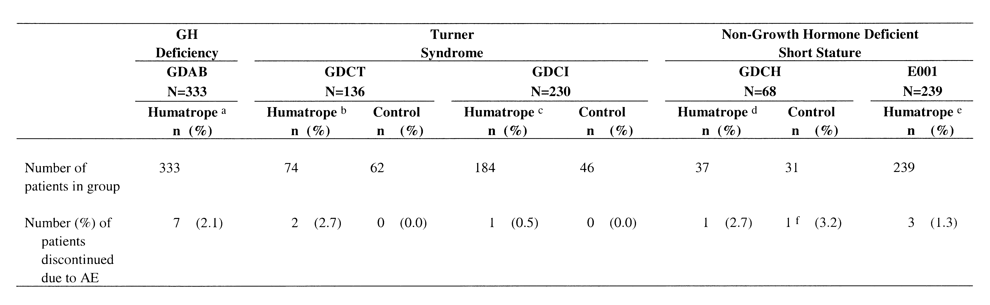
Note: The Control group for Study GDCT was a randomized, untreated control, whereas for Study GDCI and Study GDCH the group was a randomized, placebo control.
Abbreviations: AE = adverse event; GH = growth hormone; N = number of patients in safety analysis; n = number of patients.
a Dose = 0.18 mg/kg/wk to 0.24 mg/kg/wk.
b Dose = 0.30 mg/kg/wk.
c Dosage groups have been pooled: Dose 1 = 0.27 mg/kg/wk; Dose 2 = 0.36 mg/kg/wk. To facilitate comparison between Humatrope-treated patients and control patients, data are presented for the first 1.5 years, the period during which the study was placebo controlled. During the total period of Humatrope treatment (mean exposure to Humatrope was approximately 4.0 years), 4 patients (1.7%) discontinued due to an AE.
d Dose = 0.22 mg/kg/wk.
e Dosage groups have been pooled: Dose 1 = 0.24 mg/kg/wk; Dose 2 = 0.24 mg/kg/wk for the first year, and then 0.37 mg/kg/wk thereafter; Dose 3 = 0.37 mg/kg/wk.
f Although this patient was reported as discontinued due to AE, the AE, in fact, occurred after the patient had discontinued from the study. Due to site error, however, the reason for discontinuation was checked as an AE on the clinical report form (CRF).

4.5.1. Summary Comparison
There were fewer than 3% discontinuations due to AEs in any of the Humatrope-treated groups across all conditions. Rates of discontinuation due to AEs are consistent across the three patient populations and the five studies. There was no pattern suggestive of an increased frequency of discontinuation in patients with non-GHD short stature. Details of the individual cases are provided in the following sections, if not discussed in detail elsewhere (for example, under Serious Adverse Events).

4.5.2. Growth Hormone Deficiency
In Study GDAB, 7 of 333 (2.1%) patients discontinued due to AEs. Of these, 4 discontinued due to diagnosis, recurrence or progression of intracranial tumors. As these were considered serious adverse events they are discussed in further detail (Section 4.6.2). The remaining 3 of these 7 patients discontinued due to accidental injury, anxiety regarding injections, and personality disorder.

4.5.3. Turner Syndrome
In Study GDCT, 2 of 74 (2.7%) Humatrope-treated patients discontinued due to AEs. One patient who experienced intracranial hypertension due to a malfunctioning ventriculo-peritoneal shunt is discussed in further detail (Section 4.6.3). The second patient discontinued due to increased serum glutamic oxaloacetic transaminase (SGOT). The investigator and the Sponsor considered a possible causal relationship to Humatrope treatment as occasional, transient, self-limiting elevations in liver transaminases have been reported in patients with Turner syndrome receiving GH treatment (Salerno 2000).
In Study GDCI, 4 of 230 (1.7%) patients discontinued due to AEs that occurred while patients were receiving Humatrope. One patient, discussed in further detail in Section 4.8.3 discontinued due to progression of scoliosis. The other three discontinuations were due to a gastrointestinal disorder, migraine, and a vascular disorder. The Sponsor considered the gastrointestinal disorder to be causally unrelated to Humatrope treatment. The vascular disorder was originally deemed by the Sponsor to possibly be causally related to Humatrope treatment; however, the Sponsor now considers this event to be unrelated, as aortic aneurysm is a known complication of Turner syndrome. The Sponsor cannot exclude a possible causal relationship between Humatrope treatment and the reported migraine.

4.5.4. Non-Growth Hormone-Deficient Short Stature
In Study GDCH, 1 of 37 (2.7%) Humatrope-treated patients discontinued upon diagnosis of Stage 3B Hodgkin disease (discussed in Section 4.6.4). One of 31 (3.2%) placebo-treated patients discontinued the study after an accidental injury.
In Study E001, 3 patients discontinued due to AEs. One patient discontinued after diagnosis of a desmoplastic small round cell tumor [tumor karyotype: 46,XY,t(11;22)(p13;q12)]. The second patient, a 16-year-old male patient who was receiving Humatrope 0.37 mg/kg/wk, discontinued the study after diagnosis of a slipped capital femoral epiphysis following trauma. Both of these events were classified as serious they are discussed in greater detail (Section 4.6.4). The third patient, a 14-year-old female who was receiving 0.24 mg/kg/wk Humatrope, was withdrawn from the study due to decreased glucose tolerance. This event is discussed in detail in Section 4.8.5, under Alterations in Carbohydrate Metabolism.

4.6. Serious Adverse Events
Table 21 provides a summary of serious adverse events (SAEs).

Table 21. Serious Adverse Events
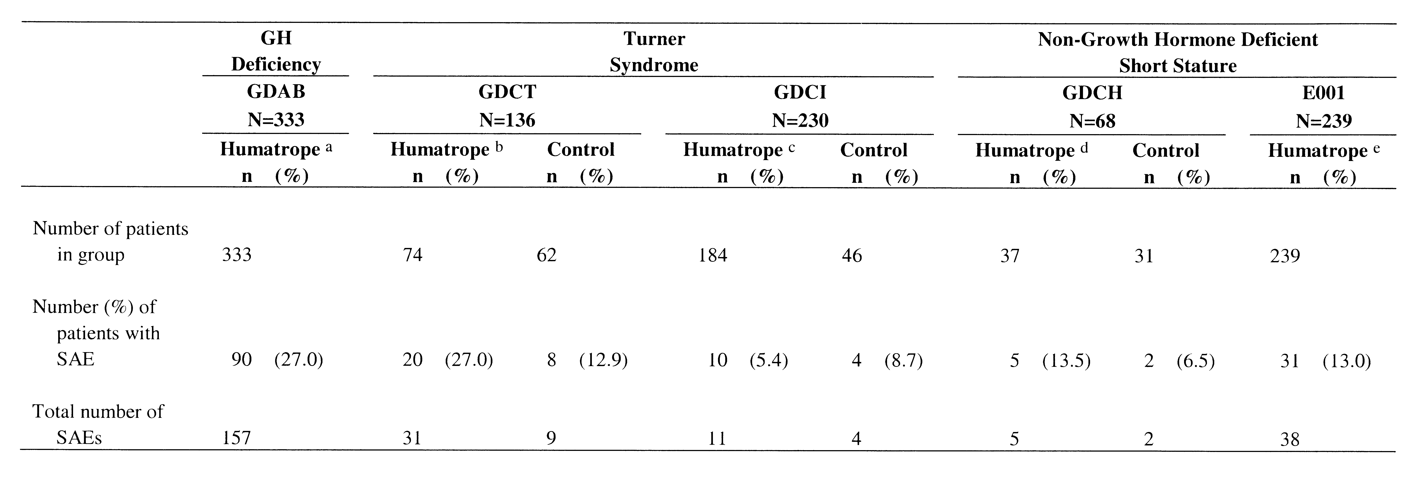
Note: The Control group for Study GDCT was a randomized, untreated control, whereas for Study GDCI and Study GDCH the group was a randomized, placebo control.
Abbreviations: GH = growth hormone; N = number of patients in safety analysis; n = number of patients; SAE = serious adverse event.
a Dose = 0.18 mg/kg/wk to 0.24 mg/kg/wk.
b Dose = 0.30 mg/kg/wk.
c Dosage groups have been pooled: Dose 1 = 0.27 mg/kg/wk; Dose 2 = 0.36 mg/kg/wk. To facilitate comparison between Humatrope-treated patients and controlled patients, data are presented for the first 1.5 years, the period during which the study was placebo controlled. During the total period of Humatrope treatment (mean exposure for Humatrope was approximately 4.0 years), 51 SAEs were reported for 41 (17.8%) patients (for 1 patient an SAE was reported during placebo treatment and during Humatrope treatment).
d Dose = 0.22 mg/kg/wk.
e Dosage groups have been pooled: Dose 1 = 0.24 mg/kg/wk; Dose 2 = 0.24 mg/kg/wk for the first year, and then 0.37 mg/kg/wk thereafter; Dose 3 = 0.37 mg/kg/wk.

4.6.1. Summary Comparison
The overall SAE rate was somewhat lower in the non-GHD short stature population than in the GHD and Turner syndrome populations, likely due to higher rates of baseline disease in the latter populations. In addition, the SAE profile varied somewhat between the populations. The majority of SAEs for the GHD and Turner syndrome populations were hospitalizations for illness or surgeries related to the underlying disease, while the majority of the SAEs reported for the non-GHD short stature patient population were hospitalizations for accidental injuries or acute illnesses. As expected, SAEs associated with neurological disorders or ear disorders were reported less frequently in the non-GHD short stature patient population than in patients with GHD or Turner syndrome. Details of the individual cases in each patient population are provided in the following sections.

4.6.2. Growth Hormone Deficiency
In Study GDAB, 157 serious adverse events were reported for 90 of 333 (27%) patients. The majority of these events were hospitalizations, with surgical procedure being the most common reason for hospitalization. Six SAEs were reported in relation to intracranial tumors: one newly diagnosed, four recurrent or progressive and one stable. A 14-year-old male patient was diagnosed with a craniopharyngioma after approximately 2.8 years of Humatrope treatment and discontinued the study because of this event. No information regarding prestudy central nervous system imaging is available for this patient and the Sponsor cannot exclude a possible causal relationship between Humatrope treatment and the diagnosis of craniopharyngioma. The four cases of intracranial tumor recurrence or progression included three cases of craniopharyngioma and one of germinoma. Two patients with history of craniopharyngioma discontinued due to recurrence of the condition after approximately 1 year and 2 years respectively, on study. One patient with recurrence/progression of craniopharyngioma remained on study. One patient discontinued after approximately 5 months of Humatrope treatment due to enlargement of a suprasellar germinoma. One additional patient was hospitalized for treatment (implantation of radioisotope) of a preexisting craniopharyngioma. However, this procedure was not performed for progression of the tumor, but rather, this was a scheduled surgical procedure to prevent future growth of the craniopharyngioma. Current studies (Moshang et al. 1996; Swerdlow et al. 2000) indicate no increase in the recurrence rate of intracranial tumors in GH-treated patients with a history of intracranial tumor.
Additional SAEs associated with neurological disorders included hospitalizations for concussion (acute brain syndrome [n=1]), cerebral vascular accident (n=1), convulsions or seizures (n=5; seven events: 2 patients [3 events] had a history of seizure disorder, 2 patients had a seizure associated with either an infection and high fever or influenza, and 1 patient with a history of craniopharyngioma was diagnosed with probable temporal lobe seizure), and dysfunction or replacement of ventriculo-peritoneal shunts (n=3; six events). One patient was monitored in hospital for intracranial hypertension after complaints of headaches and vomiting; however, no increased intracranial pressure was observed.
One patient with history of nasopharyngeal lymphoma was hospitalized because of an enlarged thymus, which was found to be non-malignant on biopsy. The Sponsor could not exclude a possible causal relationship between the thymus hypertrophy and Humatrope treatment.
Papillary carcinoma of the thyroid was reported in a patient who had a history of acute lymphoblastic leukemia treated with chemotherapy, total body irradiation, and bone marrow transplantation. After surgical removal of the tumor, the patient continued on Humatrope treatment and had no evidence of tumor at study discontinuation more than 6 years later.
SAEs related to ear disorders were reported for 3 patients (hospitalization for myringotomy [n=2] and surgery for replacement of pressure equalization tubes [n=1]).
One patient, an 18-year-old male with a bone age of approximately 13 years, was hospitalized for hip surgery following a slipped capital femoral epiphysis. After clinical deterioration, he was hospitalized approximately 1 year later for prophylactic hip pinning. Humatrope treatment was continued during the events. At the time (1986 and 1987), the events were not deemed related to study drug. In 1989, however, the Humatrope label was changed to reflect new information indicating an association between endocrine disorders, such as GHD, and slipped capital femoral epiphyses. Rapid linear growth has been proposed as a major risk factor for the development of slipped capital femoral epiphysis (Alexander 1976). Thus, the Sponsor believes that a relationship between a Humatrope-stimulated growth spurt and the slipped capital femoral epiphysis in this patient cannot be excluded.

4.6.3. Turner Syndrome
In Study GDCT, 31 SAEs were reported for 20 of 74 (27%) patients who received Humatrope treatment. The majority of these events were hospitalizations, most often for surgical procedures. There were numerous surgical procedures for ear disorders, including surgery for chronic mastoiditis, removal of a cholesteatoma, a combined mastoidectomy/nasoplasty/tympanoplasty, a tympanoplasty and ear surgery not otherwise specified (NOS). The greater occurrence of SAEs in Humatrope-treated patients (27%) compared with control patients (13%) was largely attributable to a higher rate of hospitalization in the Humatrope-treated group.
There were two events related to neurological disorders reported for 1 patient. This patient had intracranial hypertension due to ventriculo-peritoneal shunt malfunction. The patient was hospitalized for repair of the shunt, and Humatrope was discontinued. The Sponsor considered a possible causal relationship between the intracranial hypertension and Humatrope treatment. Subsequent shunt valve replacement surgery was also performed.
Study GDCI was placebo controlled for the first 1.5 years of its duration, so the SAE data are reviewed in two ways: first, by between-group comparison (Humatrope versus placebo) for the controlled phase and second, across the whole study for all Humatrope-treated patients. During the 1.5-year, placebo-controlled phase of the study the frequency of SAEs for the Humatrope-treated patients and placebo-treated patients was similar (5.4% and 8.7%, respectively). During the entire course of the study (approximately 4.0 years mean Humatrope exposure), 51 SAEs were reported for 41 of 230 (18%) patients who received Humatrope treatment. The most frequent SAE was hospitalization for surgical procedure. As in Study GDCT, there were numerous events related to ear disorders. These included surgery for chronic mastoiditis, mastoidectomy, eardrum repair and ear surgery NOS. Patients with Turner syndrome are known to have a higher rate of otitis media, deafness, and other ear disorders than patients of similar age who do not have Turner syndrome; however, these surgical procedures occurred more frequently in patients treated with Humatrope than in patients in the control groups of both studies. The relationship to Humatrope treatment is unknown; however, these data are reported in the current Humatrope label. There were no neoplasms or neurological disorders reported during this study.

4.6.4. Non-Growth Hormone-Deficient Short Stature
In Study GDCH two SAEs were reported in patients (6.5%) receiving placebo injections (injuries sustained an a motor vehicle accident [1 patient], black widow spider bite [1 patient]) and five SAEs were reported for 5 of 37 (13.5%) patients who received Humatrope treatment. Four patients were hospitalized for acute injury or illness (alcohol ingestion [1 patient], injuries sustained in a fall [1 patient], and fractured leg [2 patients]).
The fifth patient, an 11-year-old male who had received Humatrope for approximately 19 weeks, was diagnosed with Stage 3B Hodgkin disease. At the time of the initial report, a relationship between Hodgkin disease and Humatrope treatment could not be excluded. However, a number of important pieces of clinical information obtained retrospectively provide strong evidence against such a relationship (Table 22):
- First, a chest x-ray performed prior to study entry, but obtained only retrospectively, was reported by the radiologist as follows: “the mediastinum is widened somewhat I suspect probably because of thymus remnant”.
- Second, at study entry this patient had a relatively high sedimentation rate (sedimentation rate: 32 mm/h; reference range: l to 39 mm/h) and mild elevation of lactic dehydrogenase (LDH: 248 U/L; reference range: 113 to 226 U/L), a nonspecific marker of systemic disease.
- Third, 12 weeks after the start of Humatrope treatment, the patient’s sedimentation rate was elevated (58 mm/h) and LDH remained elevated (257 U/L). Lymphadenopathy was noted after 4 months of treatment, and Stage 3B Hodgkin disease was diagnosed shortly thereafter.
Stage 3 Hodgkin disease indicates an advanced stage of the disease, involving lymph node sites on both sides of the diaphragm but without evidence of extra-nodal involvement (Norris et al. 1975). The presentation with “B” symptoms (systemic symptoms such as fever, night sweats, and significant weight loss) and the advanced stage of disease (Stage 3B) suggests that the disease had been present subclinically for quite some time prior to presentation. An external pediatric oncologist reviewed the clinical, radiographic and laboratory findings for this patient, and indicated that the high normal baseline ESR and the elevated LDH were consistent with the presence of subclinical Hodgkin disease (Terry Vik, MD, Riley Hospital for Children, Indianapolis, IN). Dr. Vik also indicated that progression to Stage 3B Hodgkin disease can be expected to take approximately 6 months to 1 year when untreated and, that there are no data to support a concern that growth hormone may have increased the rate of tumor progression. Dr. Vik concluded that the clinical and laboratory evidence suggested the patient had subclinical Hodgkin disease at study entry. In light of the additional clinical information discovered retrospectively and the clinical judgment of an experienced pediatric oncologist, the Sponsor considers a causal relationship between Humatrope treatment and the patient’s Hodgkin disease unlikely. This determination is supported by the baseline findings (report of widened mediastinum on chest x-ray, elevated LDH, and borderline high ESR), the short treatment interval (19 weeks), and the advanced stage of disease (3B) at diagnosis; each factor suggests the patient had preexisting subclinical disease at study entry.
Table 22. Patient Diagnosed with Hodgkin Disease: Timecourse of Events
Date | Events | Status of Humatrope Therapy
19 Jul 1989 | LDH 207 U/L (RR: 113-226) | 5 months prior to enrollment
Oct 1989 | Chest x-ray with widened mediastinum noted | 2 months prior to enrollment
11 Dec 1989 | ESR 32 mm/h (RR: 1-39)  LDH 248 U/L | Humatrope started (Visit 1)
12 Mar 1990 | ESR 58 mm/h  LDH 257 U/L | On Humatrope for 3 months (Visit 4)
Apr 1990 | Lymphadenopathy reported | On Humatrope for 4 months
23 Apr 1990 |  | Humatrope stopped  (total = 19 weeks)
25 Apr 1990 | Hospitalized and Stage 3B Hodgkin disease diagnosed
11 May 1990 | Chemotherapy started
Abbreviations: ESR = erythrocyte sedimentation rate; GH = growth hormone; LDH = lactic dehydrogenase; RR = reference range.

Hodgkin disease is the third most common malignancy in patients under 20 years of age, representing 7.8% of all cancers, with an annual incidence of 1.3 per 100,000 population (Edwards et al. 2002). Between March 1987 and February 2002, an estimated 60,000 patients had received Humatrope. Based on an estimated average duration of exposure of 5 years, this represents approximately 300,000 patient years of exposure. This is one of only two reports of Hodgkin disease in the Lilly Pharmacovigilance database for Humatrope. Thus, for the overall Humatrope-treated patient population, there does not appear to be an excess of Hodgkin disease over that expected for the general population.
In Study E001, 38 SAEs were reported for 31 of 239 (13%) patients. The majority of the serious events were hospitalizations, predominantly for surgical procedures. There were no significant dose-related differences in the rates of SAEs reported in this study: SAEs were reported for 11 of 78 (14%) patients in the 0.24 mg/kg/wk Humatrope dosage group, 4 of 78 (5%) patients in the 0.24→0.37 mg/kg/wk dosage group, and 16 of 83 (19%) patients in the 0.37 mg/kg/wk dosage group.
There was one report of neoplasm; a desmoplastic small round cell tumor, in a 12-year-old male patient who had received 0.24 mg/kg/wk Humatrope treatment for approximately 6.4 years. This patient discontinued the study due to this event and died approximately 4 years after study discontinuation. Karyotype analysis of the tumor revealed a chromosomal translocation [tumor karyotype: 46,XY,t(11;22)(p13;q12)] and a duplication of the short arm of chromosome 1. The translocation breakpoints represent the chromosomal loci of two important tumor-related genes: 11p13 is the locus of the Wilms tumor suppressor gene (WT1) and 22q12 is the locus of the Ewing Sarcoma gene (EWS). This chromosomal translocation is a hallmark of this rare tumor type, producing a fusion gene that comprises the 5’ portion of the EWS gene and the 3’ portion of the WT1 gene (Gerald et al. 1998). This abnormal fusion gene encodes an oncogenic chimeric transcription factor that places the oncogenic transactivating power of the EWS transcription factor upstream of the gene-targeting zinc finger region of WT1. This highly oncogenic transcription factor is believed to be responsible for the development of this tumor (Gerald et al. 1998). Incidence rates for this rare tumor are not available, as only a limited number of cases have been reported in the medical literature (Gerald et al. 1998); however, this tumor has been reported to occur predominantly in adolescent males (Kushner et al. 1996; Gerald et al. 1998). At the time of the event, the tumor karyotype information was not known and causality was unassessed by the investigator; however, the Sponsor believes that the occurrence of this neoplasm is not causally related to Humatrope treatment, since previous reports suggest that the genetic event leading to the EWS-WT1 gene fusion is of primary importance in the development of desmoplastic small round cell tumor (Gerald et al. 1998). The Lilly Pharmacovigilance database contains no other report of desmoplastic small round cell tumor and furthermore, there is no case of desmoplastic small round cell tumor reported in the 16-years of literature on safety of somatropin.
There was one event of slipped capital femoral epiphysis in a 16-year-old patient who had received 0.37mg/kg/wk Humatrope for more than 5 years. During an epileptic seizure the patient, who had known epilepsy for which he was receiving valproate sodium, fell and broke the head of his right femur. A hospital examination detected slipped capital femoral epiphysis. Slipped capital femoral epiphysis occurs primarily during childhood growth spurts, with male gender, rapid growth, and puberty being postulated as risk factors for this disorder in the general population (Alexander 1976; Loder et al. 1995). Consequently, although the slipped capital femoral epiphysis in this patient occurred in the setting of a traumatic femoral fracture, the possibility that the development of slipped capital femoral epiphysis was related to a Humatrope-stimulated growth spurt cannot be excluded. A greater frequency of slipped capital femoral epiphysis has been observed in GH-treated patients with GHD than in the general population (Rappaport and Fife 1985). The occurrence of slipped capital femoral epiphysis in GH-treated patients with non-GHD short stature is similar to that of the general population (Blethen et al. 1996). The current Humatrope label includes information indicating an association between endocrine disorders and slipped capital femoral epiphysis.
With regard to neurological disorders, there were six reports of convulsions or epilepsy among 3 patients in Study E001. Five of these six events were reported for 2 patients with preexisting epilepsy (one event reported for 1 patient and four events reported for the second patient). The remaining convulsion was associated with otitis media/maxillary sinusitis. There was one SAE related to an ear disorder (hospitalization for insertion of a transtympanic drain).

4.7. Treatment-Emergent Adverse Events
Table 23 summarizes data for treatment-emergent adverse events (TEAEs), defined as any event that developed or worsened during the study. The events are presented in order of decreasing frequency for all events reported in ≥10% of Humatrope-treated patients in the pivotal study, Study GDCH. Thus, for the other studies, the events may not be in order of decreasing frequency for a particular study.

Table 23. Treatment-Emergent Adverse Events
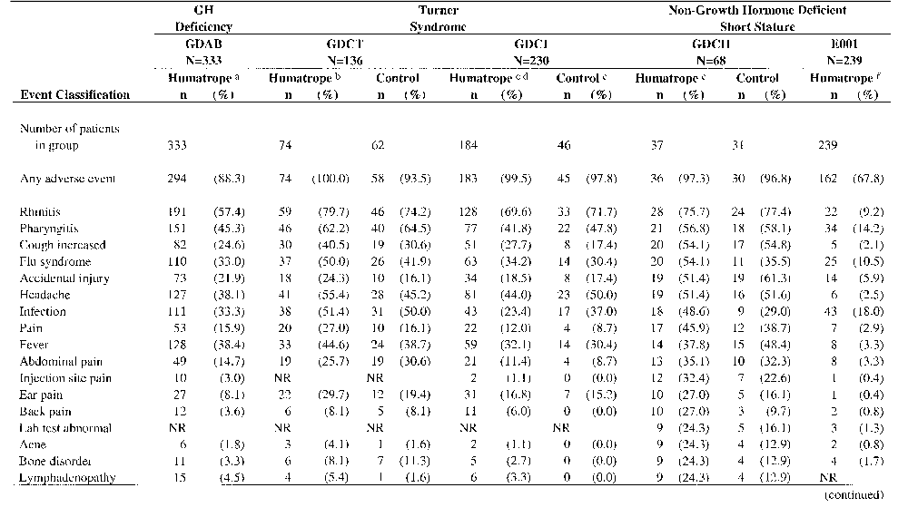

Table 23. Treatment-Emergent Adverse Events (continued)
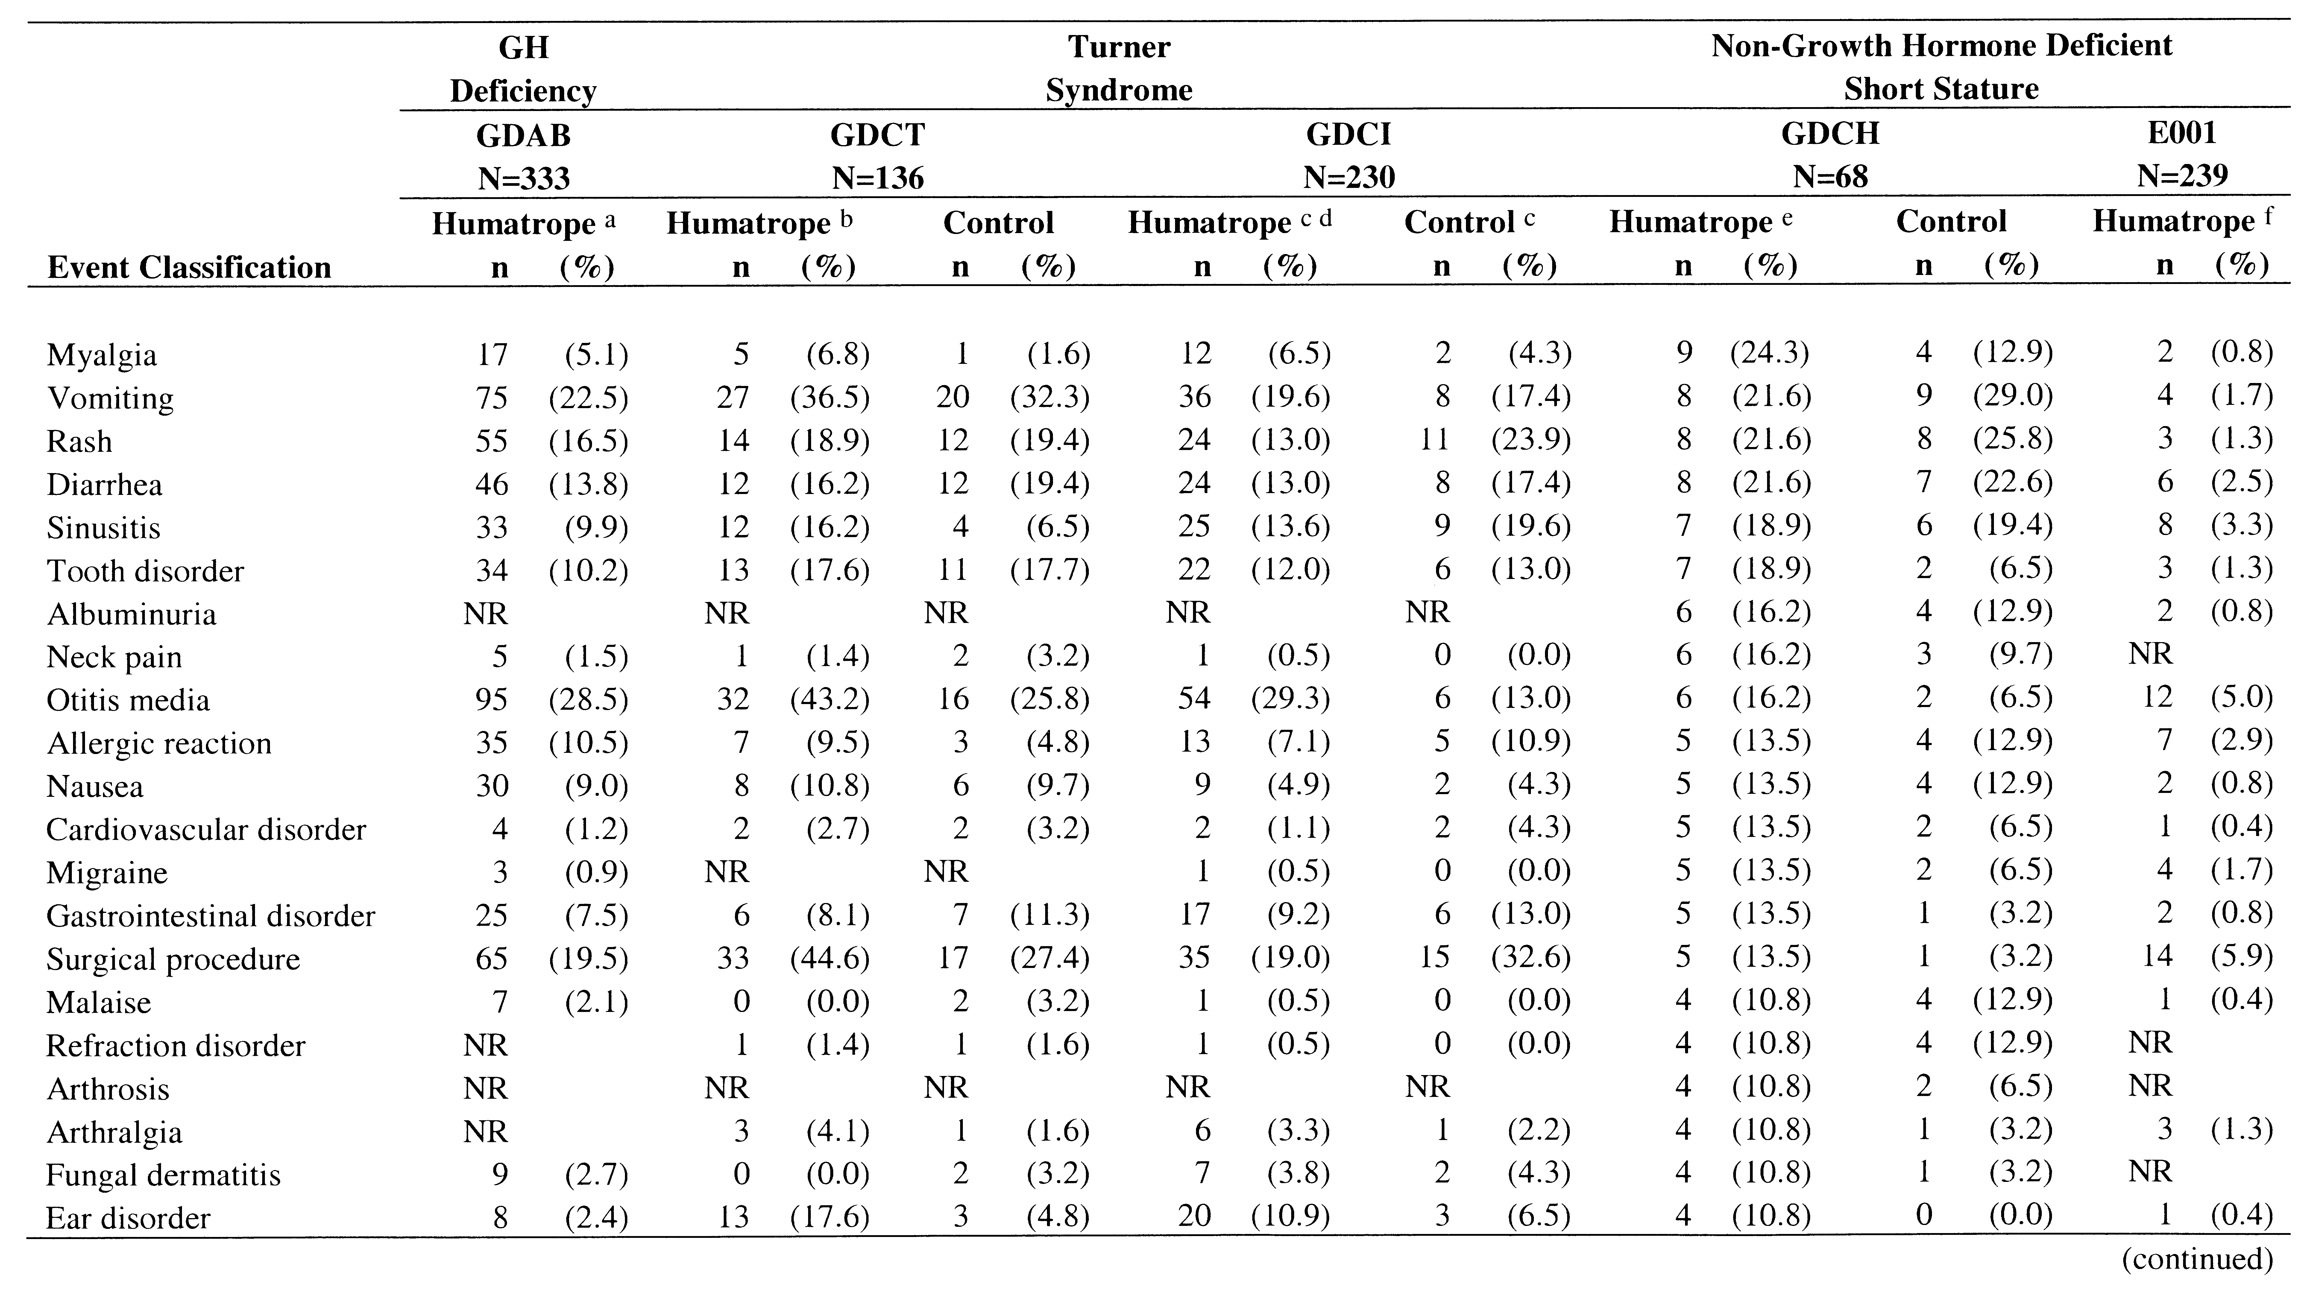
Table 23. Treatment-Emergent Adverse Events (concluded)
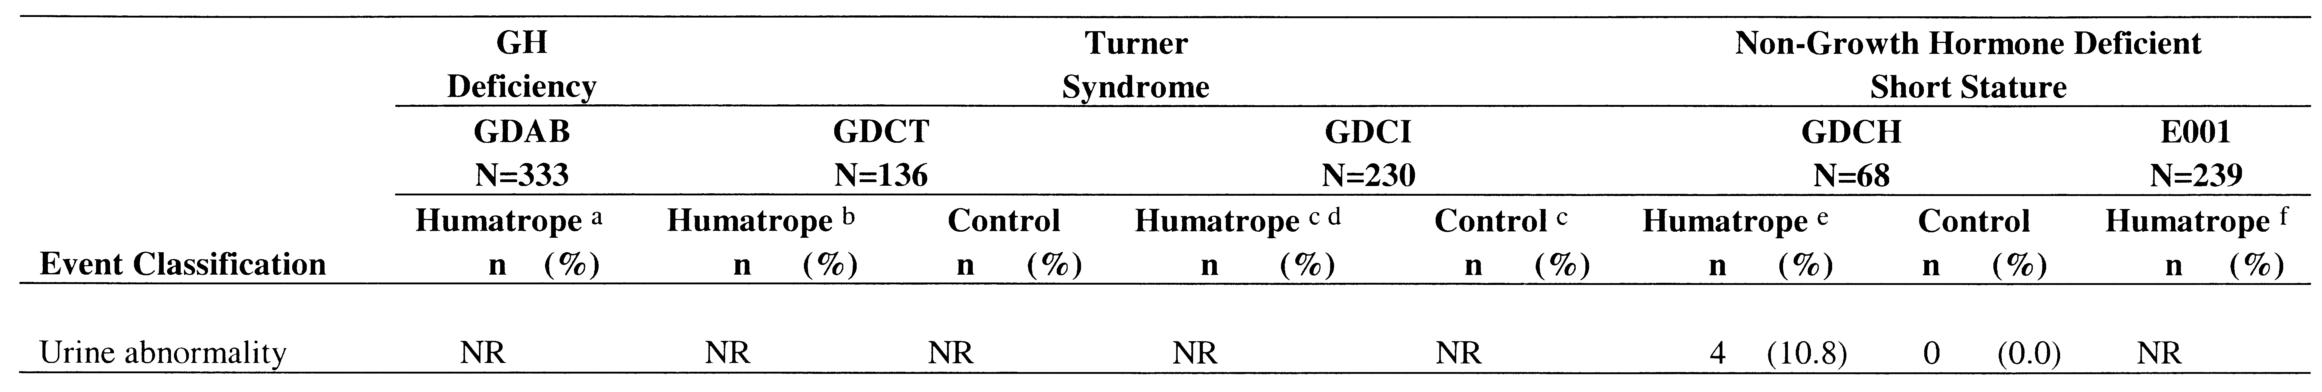
Note: Events listed in this table are ranked according to decreasing frequency in the Humatrope treatment arm of Study GDCH. The Control group for Study GDCT was a randomized, untreated control, whereas for Study GDCI and Study GDCH it was randomized, placebo controlled (Study GDCI was placebo-controlled for the first 1.5 years of study).
Abbreviations: GH = growth hormone; N = number of patients; n = number of patients with the TEAE; NR = not reported.
a Dose = 0.18 mg/kg/wk to 0.24 mg/kg/wk.
b Dose = 0.30 mg/kg/wk.
c Data include only those events reported during the placebo-controlled phase of the study (first 1.5 years).
d Dosage groups have been pooled: Dose 1 = 0.27 mg/kg/wk; Dose 2 = 0.36 mg/kg/wk.
e Dose = 0.22 mg/kg/wk.
f Dosage groups have been pooled: Dose 1 = 0.24 mg/kg/wk; Dose 2 = 0.24 mg/kg/wk for the first year, and then 0.37 mg/kg/wk thereafter; Dose 3 = 0.37 mg/kg/wk.

4.7.1. Summary Comparison
As expected in pediatric studies, TEAEs were reported for the majority of patients in each of the three patient populations. The majority of events for each patient population represented common childhood illnesses such as rhinitis, pharyngitis and flu syndrome. The overall frequency of events was similar across conditions; however, between-study comparisons of these events are difficult due to differences in study design and data collection methods. For example, Study GDCH was unique among these studies in utilizing a patient diary to collect adverse event data. Consequently, treatment emergent adverse event data collection for this study was possibly more complete than for any of the other studies. This likely explains the greater frequency of reporting of a number of events in the non-GHD short stature patient population of Study GDCH than in the GHD or Turner syndrome patient populations. There were, however, no statistically significant differences between the Humatrope and placebo treatment groups in the rate of occurrence of any of these TEAEs and no statistically significant differences in overall rates of total TEAEs between the dosage groups in Study E001.

4.7.2. Growth Hormone Deficiency
The five most frequently reported events were rhinitis, pharyngitis, fever, headache, and infection. The high frequency of these events in a pediatric clinical trial is not surprising, given the high frequency of such events in the general pediatric population.

4.7.3. Turner Syndrome
The most frequently reported events were rhinitis, pharyngitis, headache, infection, flu syndrome, and fever. In both Study GDCT and Study GDCI, otitis media was reported significantly more frequently for patients receiving Humatrope than for patients in the control group. Patients with Turner syndrome are known to have a higher rate of otitis media, hearing deficits and other ear disorders than patients of similar age who do not have Turner syndrome. The relationship to Humatrope treatment is unknown; however, this information is included in the current Humatrope label.

4.7.4. Non-Growth Hormone-Deficient Short Stature
Study GDCH was unique among these studies in utilizing a patient diary to collect adverse event data. The patient’s parent(s) completed this diary at home and study site personnel transferred data to the clinical report forms (CRFs) at each study visit. The most frequently reported events in the Humatrope-treated group of Study GDCH were rhinitis, pharyngitis, cough increased, flu syndrome, accidental injury, and headache. There were no statistically significant differences between the Humatrope and placebo treatment groups in the rate of occurrence of reported TEAEs in Study GDCH. However, while the differences in reporting rate were not statistically significant, there were a number of events reported more often in Humatrope-treated than placebo-treated patients that have potential clinical relevance and warrant further discussion.
Back pain was reported in 10 Humatrope-treated patients (27%) compared with 3 placebo-treated patients (10%). Individual case review of the Humatrope-treated patients revealed: 4 associated with injury or strain; 1 associated with viral illness; 1 in a patient diagnosed with Hodgkin disease (discussion Section 4.6.4); 3 reported as mild and at a single visit; and 1 case reported as mild and at multiple visits. Thus, the Sponsor does not believe that the higher occurrence rate of back pain in Humatrope-treated patients in Study GDCH reflects a clinically meaningful effect of Humatrope.
Acne, bone disorder, lymphadenopathy and myalgia were each reported in 9 Humatrope treated patients (24%) compared with 4 placebo-treated patients (13%). Acne was reported at multiple visits for most of the affected patients, and was of mild severity for all Humatrope-treated patients. The event term of “Bone Disorder” includes 7 reports of scoliosis in Humatrope-treated patients and 4 in placebo-treated patients. All events were reported as “trace” or “mild”. Scoliosis is discussed in further detail (Section 4.8.3). Of the 9 Humatrope-treated patients for whom lymphadenopathy was reported, this finding was associated with intercurrent infections such as pharyngitis, upper respiratory infection or infectious mononucleosis in 8 patients and was noted at only a single visit in 6 patients. One of the patients for whom lymphadenopathy was reported was the patient subsequently diagnosed with Hodgkin disease (Section 4.6.4). Of the 9 reports of myalgia in Humatrope-treated patients 4 were associated with injuries or intercurrent illness. In 4 of the remaining 5 patients the event was reported well into study (18 months or later) and was transient. In the fifth patient the event was reported only at the last visit on study.
The AEs for Study GDCH (Table 23) were further evaluated to determine if the differences in the reporting rates between the treatment groups could represent possible safety signals. Using actual terms and comments reported by the investigators, all adverse events were assessed and grouped into clinically relevant categories. For example, events contained in the “Ear” category, include reports of ear pain, otitis media, ear disorder, ear infection, etc. This evaluation and analysis was undertaken to ensure that no relevant events would be missed, and that events would not be double-counted. For example, investigator-reported otitis media, with ear pain and ear stuffiness, would not be counted as 3 events. Rather, it would be one event in the Ear category.
Table 24 summarizes data for treatment emergent adverse events, grouped into clinically relevant categories.
Table 24. Summary of Treatment-Emergent Adverse Events by Clinically Relevant Categories
Safety Population
Study GDCH
 | Humatrope |  | Placebo |  | Total
 | (N=37) |  | (N=31) |  | (N=68)
Event Classification | n | (%) | n | (%) | n | (%) | p-value a
PATIENTS WITH >= 1 TEAE | 36 | (97.3) | 30 | (96.8) | 66 | (97.1) | 1.00
PATIENTS WITH NO TEAE | 1 | (2.7) | 1 | (3.2) | 2 | (2.9) | 1.00
Infection, viral | 31 | (83.8) | 26 | (83.9) | 57 | (83.8) | 1.00
Gastrointestinal | 19 | (51.4) | 22 | (71.0) | 41 | (60.3) | 0.137
Accidental injury | 19 | (51.4) | 19 | (61.3) | 38 | (55.9) | 0.468
Headache/Migraine | 20 | (54.1) | 15 | (48.4) | 35 | (51.5) | 0.808
Skin/Hair | 16 | (43.2) | 18 | (58.1) | 34 | (50.0) | 0.330
Muscular/skeletal | 19 | (51.4) | 14 | (45.2) | 33 | (48.5) | 0.635
Systemic conditions | 16 | (43.2) | 16 | (51.6) | 32 | (47.1) | 0.626
Infection, bacterial | 17 | (45.9) | 13 | (41.9) | 30 | (44.1) | 0.809
Joint disorders/pain | 17 | (45.9) | 11 | (35.5) | 28 | (41.2) | 0.462
Hemopoetic system | 15 | (40.5) | 12 | (38.7) | 27 | (39.7) | 1.00
Ear | 15 | (40.5) | 11 | (35.5) | 26 | (38.2) | 0.803
Injection site | 13 | (35.1) | 10 | (32.3) | 23 | (33.8) | 1.00
Central nervous system | 11 | (29.7) | 9 | (29.0) | 20 | (29.4) | 1.00
Laboratory abnormality | 10 | (27.0) | 10 | (32.3) | 20 | (29.4) | 0.790
Renal/Urinary tract | 9 | (24.3) | 9 | (29.0) | 18 | (26.5) | 0.784
Eye | 9 | (24.3) | 7 | (22.6) | 16 | (23.5) | 1.00
Dental | 8 | (21.6) | 4 | (12.9) | 12 | (17.6) | 0.525
Head and neck | 6 | (16.2) | 5 | (16.1) | 11 | (16.2) | 1.00
Scoliosis | 7 | (18.9) | 4 | (12.9) | 11 | (16.2) | 0.742
Cardiovascular | 6 | (16.2) | 4 | (12.9) | 10 | (14.7) | 0.745
Reproductive | 7 | (18.9) | 3 | (9.7) | 10 | (14.7) | 0.326
Respiratory | 5 | (13.5) | 5 | (16.1) | 10 | (14.7) | 1.00
Allergy | 5 | (13.5) | 4 | (12.9) | 9 | (13.2) | 1.00
Surgical procedure | 7 | (18.9) | 2 | (6.5) | 9 | (13.2) | 0.166
Infection, fungal and parasitic | 6 | (16.2) | 2 | (6.5) | 8 | (11.8) | 0.275
Bone disorder, other | 4 | (10.8) | 2 | (6.5) | 6 | (8.8) | 0.681
Chest Pain | 2 | (5.4) | 2 | (6.5) | 4 | (5.9) | 1.00
Endocrine | 0 |  | 3 | (9.7) | 3 | (4.4) | 0.090
Benign neoplasms/growths | 0 |  | 1 | (3.2) | 1 | (1.5) | 0.456
Hypoglycemia | 0 |  | 1 | (3.2) | 1 | (1.5) | 0.456
Abbreviations: N = number of patients in treatment group; n = number of patients with event.
a Frequencies are analyzed using a Fisher’s Exact test.

There were no statistically significant differences in the frequency of treatment-emergent events, grouped into clinically relevant categories, between the Humatrope-treated and placebo-treated patients. However, Humatrope-treated patients did have a greater frequency of treatment emergent events in the categories of Reproductive, Fungal and Parasitic Infection, and Surgical Procedures.
Events in the Reproductive category occurred in 7 (18.9%) Humatrope-treated patients and 3 (9.7%) placebo-treated patients. The events in the Humatrope-treated patients included conditions that commonly occur during adolescence such as breast tenderness or soreness, painful menses, and pubertal gynecomastia. All events were rated as mild, did not result in discontinuation from study, and for the majority of patients, resolved prior to study completion.
Parasitic or fungal infections occurred in 6 (16.2%) Humatrope-treated patients and 2 (6.5%) placebo-treated patients. The events in the Humatrope-treated patients were: athlete’s foot, pinworms, tinea cruris, ringworms, fungal mouth sore, and yeast infection. All events were rated as mild, did not result in discontinuation from study, and for the majority of patients, resolved prior to study completion.
Surgical procedures were performed on 7 (18.9%) patients in the Humatrope-treated group and 2 (6.5%) patients in the placebo-treated group. The surgical procedures in the Humatrope-treated patients were: mole removal, surgery on bursa, unilateral orchidectomy, sutures, wart removal, posttraumatic surgery, lymph node removal. The diverse nature of these surgical procedures does not suggest an association with Humatrope treatment.
In Study E001 there were slight, but not significant, dose-related differences in overall rates of total TEAEs. TEAEs were reported for 47 of 78 (60%) patients in the 0.24 mg/kg/wk Humatrope dosage group, 57 of 78 (73%) patients in the 0.24→0.37 mg/kg/wk group and 58 of 83 (70%) patients in the 0.37 mg/kg/wk dosage group. Between-group comparisons of occurrence rates for individual events are of limited clinical significance since the majority of events were reported in just a single patient. Of the 41 TEAEs that were reported in more than a single patient in any treatment group, 9 events were reported with greatest frequency in the 0.24 mg/kg/wk Humatrope dosage group, 18 were reported with greatest frequency in the 0.24→0.37 mg/kg/wk group and 11 events were reported with greatest frequency in the 0.37 mg/kg/wk Humatrope dosage group; three events were reported with equal frequency in the 0.24 and 0.24→0.37 mg/kg/wk dosage groups. There were statistically significant differences among treatment groups for bronchitis, diarrhea, and anemia, but none of these differences was dose related.

4.8. Adverse Events Referenced in the Current Humatrope Label
This section discusses a number of treatment emergent adverse events that are currently referenced in the Humatrope label, as they have been reported in patients receiving somatropin. These events include otitis media, scoliosis, hypothyroidism, hypertension, alterations of carbohydrate metabolism and slipped capital femoral epiphysis. Table 25 summarizes these data. Edema, benign intracranial hypertension, and gynecomastia are also referenced in the Humatrope label. Edema and intracranial hypertension are not included or discussed here, as there were no cases reported in the non-GHD short stature population. Gynecomastia is not discussed because the 3 patients (2 Humatrope, 1 placebo) for whom gynecomastia were reported were all pubertal at the time and transient gynecomastia occurs as a physiologic event during normal male puberty. The structure of this section differs from that of the preceding sections in that each condition is discussed in summary format, rather than on a by-population basis.
Unless otherwise noted, the following discussions are restricted to patients who received Humatrope treatment.

4.8.1. Summary Comparison
Overall, patients with non-GHD short stature had a similar or reduced rate of TEAEs that are currently referenced in the Humatrope label. Compared with GHD patients, those with non-GHD short stature had similar rates of slipped capital femoral epiphysis and alterations in carbohydrate metabolism. Hypothyroidism, hypertension, and otitis media occurred less often in patients with non-GHD short stature than in those with GHD or Turner syndrome. Scoliosis was reported more frequently in the non-GHD short stature patient population of Study GDCH than in the GHD and Turner syndrome patient populations (Section 4.8.3).
Table 25. Adverse Events Referenced in Humatrope Label
 | GHD | Turner syndrome | Non-GHD short stature
Number of Humatrope-Treated Patients | 333 | 304 | 276
Number (%) of patients with event
Otitis Media | 95 (28.5) | 133 (43.8) | 22 (8.0)
Scoliosis | 5 (2.0) | 1 (0.3) | 8 (2.9)
Hypothyroidism | 78 (23.4) | 50 (16.4) | 2 (0.7)
Alterations in carbohydrate metabolism | 1 (0.3) | 1 (0.3) | 2 (0.7)
Hypertension | 1 (0.3) | 15 (4.9) | 1 (0.4)
Slipped Capital Femoral Epiphysis | 1 (0.3) | 0 | 1 (0.4)
Presented in order of decreasing frequency for the non-GHD short stature population.
Abbreviation: GHD = growth hormone deficiency.

In both Study GDCH and Study E001, there were no statistically significant differences between treatment groups (GDCH: Humatrope versus placebo; E001: Dose 1 versus Dose 2 or Dose 3) for any of the events examined.

4.8.2. Otitis Media
Otitis media was reported in 29% of patients with GHD and in more than 40% of patients with Turner syndrome receiving Humatrope. Ear disorders were reported more frequently in Humatrope-treated patients than in control patients for both of the Turner syndrome studies. The relationship between Humatrope treatment and otitis media in patients with Turner syndrome is not clear; however, this information is provided in the current Humatrope label. In the non-GHD short stature patient population, otitis media was reported in 7% of patients in Study E001, 16% of the Humatrope-treated patients in Study GDCH and 7% of the placebo-treated patients. When all forms of ear disorder (ear infection, otitis media, otitis externa, ear pain and ear disorder) are evaluated together, excluding patients who were counted twice for the same condition at the same visit (for example, “ear pain” and “otitis media”), there were similar numbers of affected patients in the Humatrope and placebo groups (Humatrope: 15 of 37 patients [41%], placebo: 11 of 31 patients [36%]).

4.8.3. Scoliosis
The occurrence or worsening of scoliosis during GH treatment is an uncommon event, and the relationship to GH treatment is uncertain. In the study of patients with GHD, scoliosis was reported for 5 of 333 (2%) patients. All cases were of mild degree. In the Turner syndrome studies, a 16-year-old patient who had received placebo injections for 1.5 years followed by Humatrope treatment for 1.7 years, discontinued after 3.2 years on study due to diagnosis and subsequent worsening of thoracic scoliosis. It could not be determined whether the scoliosis was present at study entry. Therefore the Sponsor deemed that a causal relationship to study drug could not be excluded. In the non-GHD short stature patient population, scoliosis was reported for 16% of all patients in Study GDCH (Humatrope-treated and placebo-treated combined) and for 0.4% of patients in Study E001. Because scoliosis has been reported as a possible adverse effect of somatropin therapy (Dymling and Willner 1978), the NIH investigators paid particularly close attention to this and performed a screening examination for scoliosis at each study visit. This examination consisted of the standard forward bending test used in school screening examinations, which has been reported to have a positive predictive value of 43% (Morais et al. 1985). Morais et al. reported that the screening test was positive in 11.4% of children examined and upon more rigorous investigation, idiopathic scoliosis was confirmed in 43% of those examined. Consequently, the prevalence of true scoliosis in Study GDCH was likely lower than the 19% and 13% of Humatrope-treated and placebo-treated patients, respectively, and was likely closer to that reported in the general population. Furthermore, all reported cases of scoliosis were rated as mild, often reported as “trace scoliosis”, no x-rays were performed, and no progression or treatment was reported for any patient.

4.8.4. Hypothyroidism
On-study development or worsening of hypothyroidism was reported in 23% of patients with GHD and 16% of patients with Turner syndrome. On-study development of hypothyroidism was reported in only 2 of 276 (0.7%) Humatrope-treated patients with non-GHD short stature (Study GDCH, n=0 [0%]; Study E001, n=2 [1%]). Hypothyroidism was also reported in 2 patients in the placebo group of Study GDCH.

4.8.5. Alterations in Carbohydrate Metabolism
There were few AEs related to carbohydrate metabolism reported in any of the 3 patient populations. The following terms were included in the search for conditions related to changes in carbohydrate metabolism: hyperglycemia, impaired glucose tolerance, decreased glucose tolerance, glucose intolerance, insulin resistance, and diabetes mellitus. Hyperglycemia was reported in 3 patients, one in each of the GHD, Turner syndrome and non-GHD short stature patient populations. In the Turner syndrome studies, type 1 diabetes mellitus was reported for a single patient. There were no reports of diabetes mellitus in the non-GHD short stature studies. However, there was one report of decreased glucose tolerance in a patient in Study E001. A 13-year, 11-month-old female patient who had received Humatrope 0.24 mg/kg/wk for over 8 years had a borderline high HbA1c of 6.1% (upper limit of normal on the assay was 6.0%). The patient had no clinical symptoms of glucose intolerance, however an oral glucose tolerance test was performed as specified in the protocol for any patient with above-normal HbA1c. Because serum glucose was above the cut-point of 11.0 mmol/L at the 2-hour timepoint (11.1 mmol/L [200 mg/dL]) the patient’s Humatrope was discontinued and the patient was withdrawn from the study. The HbA1c was normal (5.3%) when repeated 1 year after discontinuation of Humatrope. A second patient in Study E001 had a single reported event of fasting hyperglycemia at 6 years on study. However, fasting glucose was normal when repeated locally and it was likely that the elevated value reflected either inadequate fasting or a laboratory error.

4.8.6. Hypertension
Hypertension was reported in a single GHD patient in Study GDAB and in 15 of 304 (4.9%) patients with Turner syndrome, a patient group known to be at risk for hypertension. Two events in patients with Turner syndrome were classified as serious because the patients were hospitalized for evaluation. In patients with non-GHD short stature, Study GDCH, mild hypertension was reported in a single patient 1 week after initiation of Humatrope treatment. The hypertension resolved after approximately 5.5 months without treatment and without discontinuation of Humatrope.

4.8.7. Slipped Capital Femoral Epiphysis
One case of slipped capital femoral epiphysis was reported in each of the GHD and non-GHD short stature patient populations. Since these events were associated with hospitalization they are discussed in the Serious Adverse Events sections of this document, Sections 4.6.2, and 4.6.4 above.

4.9. Safety Information from the Literature on GH Treatment in Non-GHD Short Stature
The most recent safety update from the Kabi International Growth Study (KIGS) sponsored by Pharmacia (Wilton 1999) reports adverse event data for almost 26,000 patients entered into the global database between 1988 and 1998. This represents approximately 62,400 years of somatropin exposure. Adverse events were reported for the overall database at a rate of 130 events per 1000 treatment years. When the event rates were evaluated by condition the following rates per 1000 treatment years were found: GH deficiency 95-245 (depending on the cause of the GHD); Turner syndrome 148; chronic renal insufficiency 277; idiopathic short stature (equivalent to non-GHD short stature) 89. Table 26 presents a summary of data for patients with various non-GHD growth disorders obtained from the KIGS database (Wilton 1999) for events of special interest. For most of these events there is a trend toward greater frequency in patients with Turner syndrome or chronic renal insufficiency, likely due to the presence of underlying disease in these patient groups. Although the data should be interpreted with caution due to variation in patient numbers among the conditions, overall, there was no evidence in this database of any greater risk of adverse events in patients with non-GHD short stature than in other somatropin-treated non-GHD patients.

Table 26. Somatropin Safety in Non-GHD Conditions
Kabi International Growth Study (KIGS)
Event a | Turner Syndrome  (N=3019) | Chronic Renal Failure  (N=694) | Small for Gestational Age  (N=590) | Idiopathic Short Stature b  (N=3493)
Arthralgia | 129 | 102 | 63 | 101
Convulsions | 155 | 102 | 316 | 152
Diabetes type 2 | 26 | 102 | 0 | 13
Headache/migraine | 349 | 306 | 316 | 317
Intracranial hypertension | 78 | 204 | 0 | 0
Scoliosis | 272 | 102 | 253 | 25
Slipped capital femoral epiphysis | 39 | 102 | 0 | 25
Abbreviation: N = number of patients.
a Event rates are reported as adverse event/100,000 treatment years (from Wilton 1999)
b Equivalent to non-GHD short stature.

Additional safety data are provided from the large US Genentech-sponsored National Cooperative Growth Study (NCGS) database. Table 27 presents a summary of data for patients with various growth disorders, obtained from the most recent NCGS safety update (Maneatis et al. 2000). As noted in the KIGS data, the occurrence rate for all adverse events and those of special interest is lower in the patients with non-GHD (idiopathic) short stature than in those with other growth disorders, when the proportion of events that occurred in this population is compared with the proportion of patients with idiopathic short stature in the total database.
Table 27. Somatropin Safety in the National Cooperative Growth Study (NCGS)
 | Idiopathic Growth Hormone Deficiency | Chronic Renal Insufficiency | Turner Syndrome | Idiopathic Short Stature b
Number of patients (N)  (% of total enrollment) | N=13861  (41.8%) | N=663  (2.0%) | N=3416  (10.3%) | N=5671  (17.1%)
Event a
All adverse events | 28.5 | 4.8 | 13.0 | 10.1
All serious adverse events | 18.8 | 7.3 | 7.5 | 4.6
Deaths | 12.8 | 12.2 | 4.1 | 3.4
Leukemia | 16.0 | 4.0 | 0.0 | 4.0
Extracranial malignancy | 11.1 | 2.2 | 15.6 | 2.2
Intracranial hypertension | 30.8 | 10.3 | 15.4 | 2.6
Diabetes c | 25.4 | 8.5 | 15.3 | 13.6
Slipped capital femoral epiphysis | 31.6 | 2.6 | 13.2 | 0.0
Scoliosis | 27.0 | 0.0 | 17.2 | 9.0
a Event rates are reported as percent of total events (from Maneatis et al. 2000).
b Equivalent to non-GHD short stature.
c All patients with diabetes mellitus and glucose intolerance.

The low rates of adverse events in these two databases, which contain data for over 9000 patients with non-GHD short stature, representing over 27,000 patient-years of somatropin exposure, provide added reassurance of the safety of somatropin in this patient population.

4.10. Clinical Laboratory Evaluation
This section discusses three areas of clinical relevance with respect to the possible impact of GH treatment: 1) carbohydrate metabolism, 2) insulin-like growth factor I, and 3) thyroid function. Although other laboratory analyses were performed in many of the studies, these are not discussed, as the results were unremarkable. A detailed comparison between studies was not possible because the studies used different laboratory methodologies, with different reference ranges, and, in some cases, measured different analytes (for example, glycosylated hemoglobin versus HbA1c). In addition, the exact timing of sample collection relative to the prior Humatrope dose was not specified in the protocols and is therefore not available. In Study GDCH the laboratory results were assessed centrally, whereas in the multi-center study, Study E001, individual investigators were responsible for interpretation and follow-up of patients’ laboratory results.

4.10.1. Carbohydrate Metabolism
Growth hormone is a physiologic insulin antagonist that causes reduction in peripheral glucose disposal. Therefore, mild reduction in insulin sensitivity is an expected consequence of somatropin treatment. Table 28 provides baseline values and changes from baseline to endpoint for fasting glucose, fasting insulin and glycosylated hemoglobin or HbA1c.

Table 28. Carbohydrate Metabolism Changes from Baseline to Endpoint
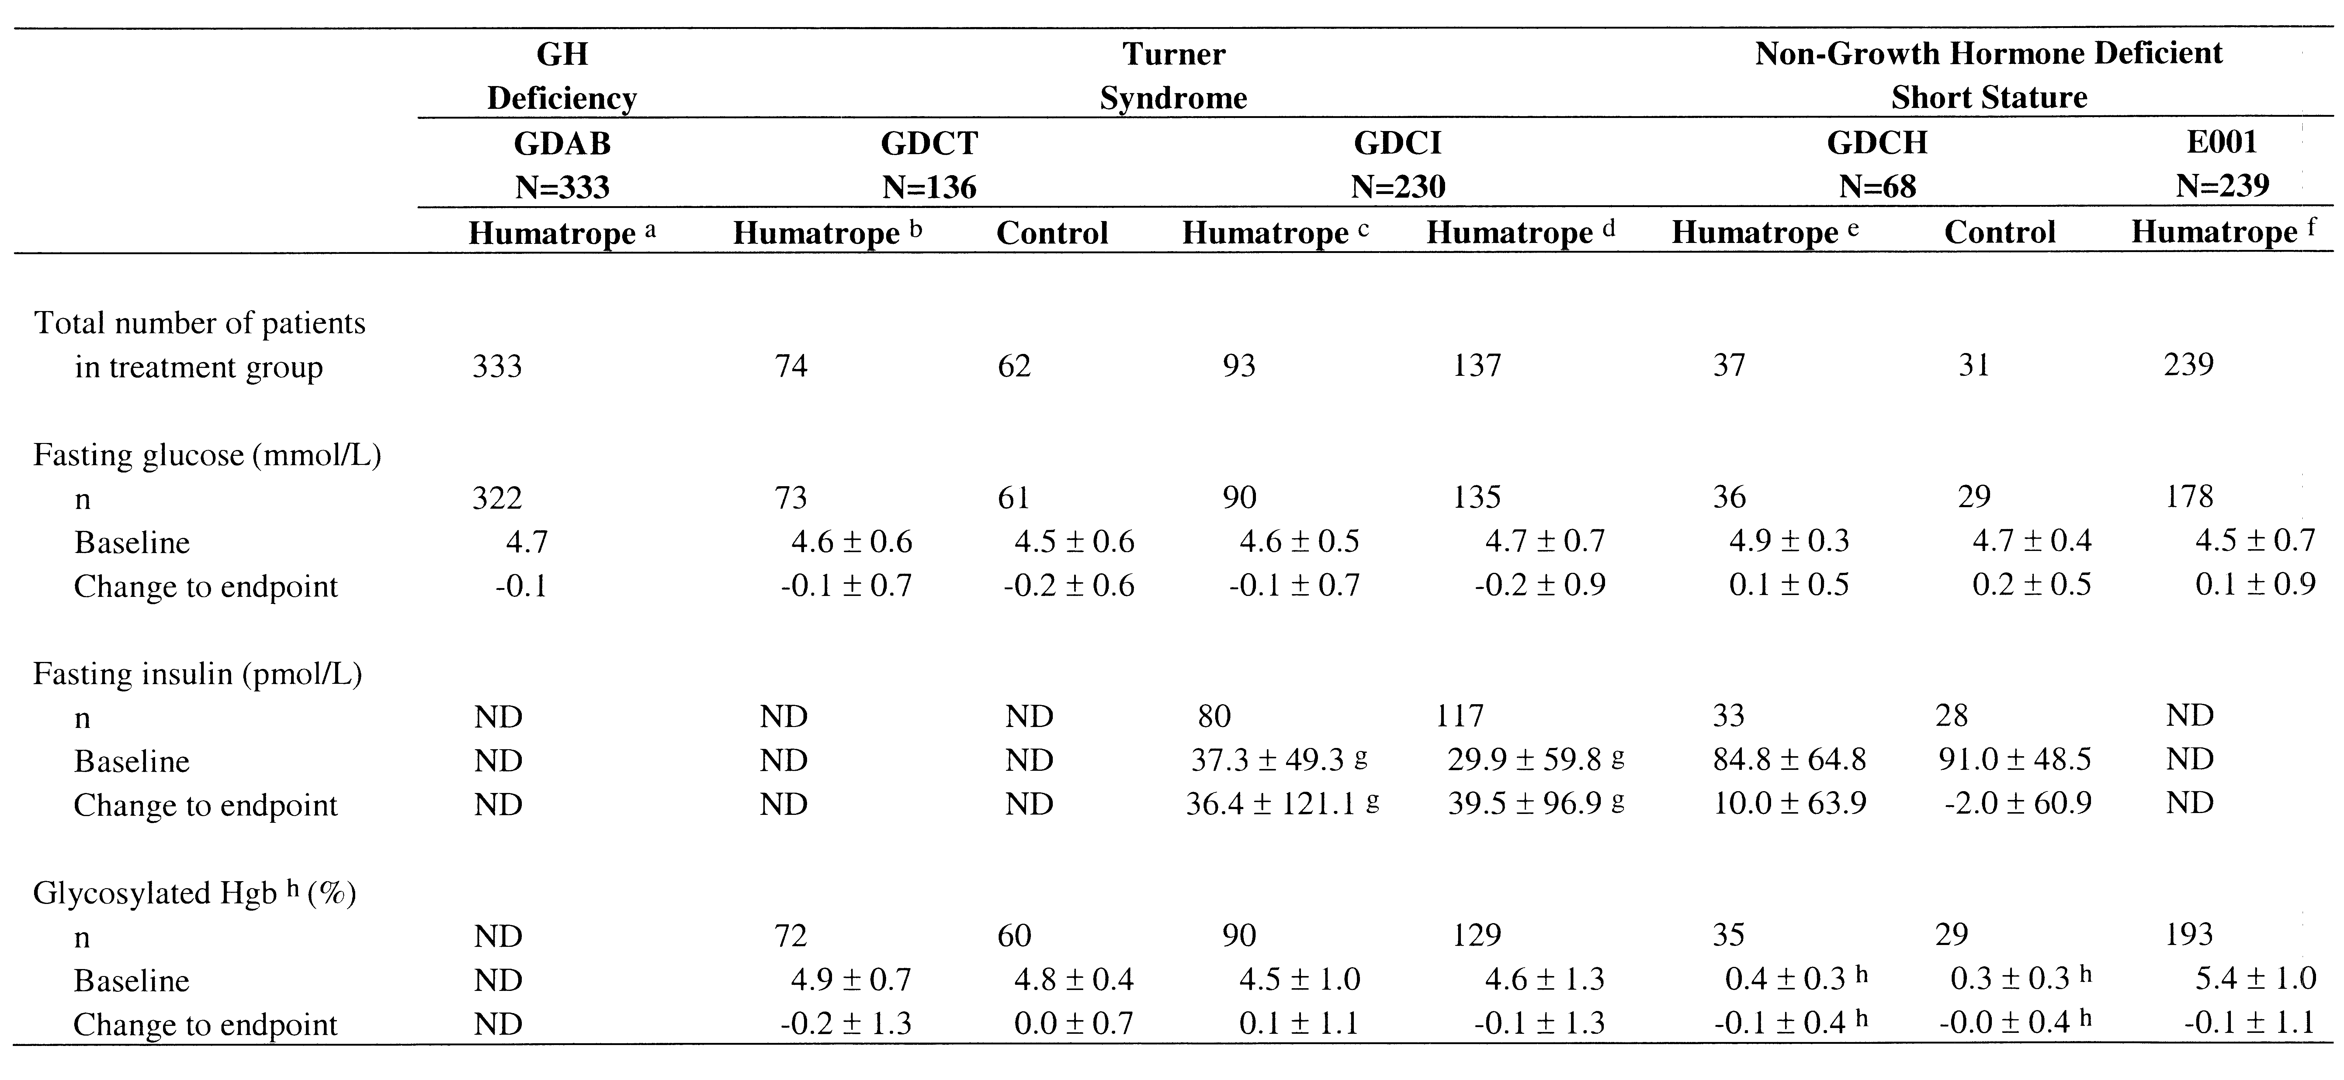
Note: Values represent mean ± standard deviation (SD), except in Study GDAB, where values represent the median. Study GDCI was placebo controlled for the first 1.5 years; however, placebo control data for laboratory values were not summarized separately in the clinical study report and, thus, placebo control data for Study GDCI are not presented in this table. For each of the studies, endpoint refers to the last visit on treatment.
Abbreviations: GH = growth hormone; Hgb = hemoglobin; N = number of patients in safety analysis; n = number of patients with baseline or endpoint value; ND = not determined.
a Dose = 0.18 mg/kg/wk to 0.24 mg/kg/wk.

b Dose = 0.30 mg/kg/wk.
c Dose = 0.27 mg/kg/wk.
d Dose = 0.36 mg/kg/wk. This column includes placebo-treated patients who were transitioned to Humatrope treatment after 1.5 years.
e Dose = 0.22 mg/kg/wk.
f Dosage groups have been pooled: Dose 1 = 0.24 mg/kg/wk; Dose 2 = 0.24 mg/kg/wk for the first year, and then 0.37 mg/kg/wk thereafter; Dose 3 = 0.37 mg/kg/wk.
g Values below the quantifiable limit of the assay were imputed to be zero.
h For Study GDCH, values represent adjusted hemoglobin A1c (HbA1c), with normal values between 0 and 1.0.

4.10.1.1. Summary Comparison
Fasting blood glucose values were similar among the three patient populations and remained essentially unchanged with Humatrope treatment. Glycosylated hemoglobin or HbA1c, available only for patients with Turner syndrome and those with non-GHD short stature, also showed essentially no change from baseline to endpoint.
Mean fasting insulin concentrations were within the reference range in both the Turner syndrome (Study GDCI) and the non-GHD short stature (Study GDCH) patient populations at study baseline; however, the values were higher in both treatment groups in Study GDCH than in Study GDCI. As the patients in Study GDCH were older at baseline than those in Study GDCI, this finding likely reflects the physiologic insulin resistance of puberty in the non-GHD short stature population. In patients with Turner syndrome, mean fasting insulin approximately doubled between baseline and endpoint, although final values remained within the reference range. In contrast, in patients with non-GHD short stature, there was a smaller increase, approximately 10% in mean fasting insulin concentration from baseline to endpoint, in the Humatrope group and again, the mean endpoint value was within the reference range. To further address any potential impact of Humatrope on insulin sensitivity in patients with non-GHD short stature a number of additional analyses were performed that specifically assess insulin sensitivity by evaluating fasting insulin in the context of blood glucose. As detailed in Section 4.10.1.4, these analyses demonstrate no statistically significant or clinically relevant difference between the placebo and Humatrope treatment groups for change in insulin sensitivity from baseline to endpoint. In Study E001, no difference was detected between Humatrope dosage groups for change from baseline to endpoint for mean fasting glucose or glycosylated hemoglobin.

4.10.1.2. Growth Hormone Deficiency
In the GHD patient population, fasting glucose values did not change appreciably during the study. Neither insulin nor HbA1c was measured in this study.

4.10.1.3. Turner Syndrome
In Studies GDCT and GDCI, there were no statistically significant between-group differences for mean fasting glucose or glycosylated hemoglobin at study endpoint (Study GDCT: Humatrope versus Untreated Control; Study GDCI: Humatrope 0.27 mg/kg/wk versus Humatrope 0.36 mg/kg/wk). Serum insulin was measured only in Study GDCI, in which mean fasting insulin values approximately doubled between baseline and endpoint. However, endpoint insulin concentrations remained within the normal range.

4.10.1.4. Non-Growth Hormone Deficient Short Stature
Figure 16 and Figure 17 display mean fasting glucose and insulin by year on study, respectively, for Study GDCH. No statistically significant or clinically meaningful differences between treatment groups were detected for either of these parameters across the duration of the study.
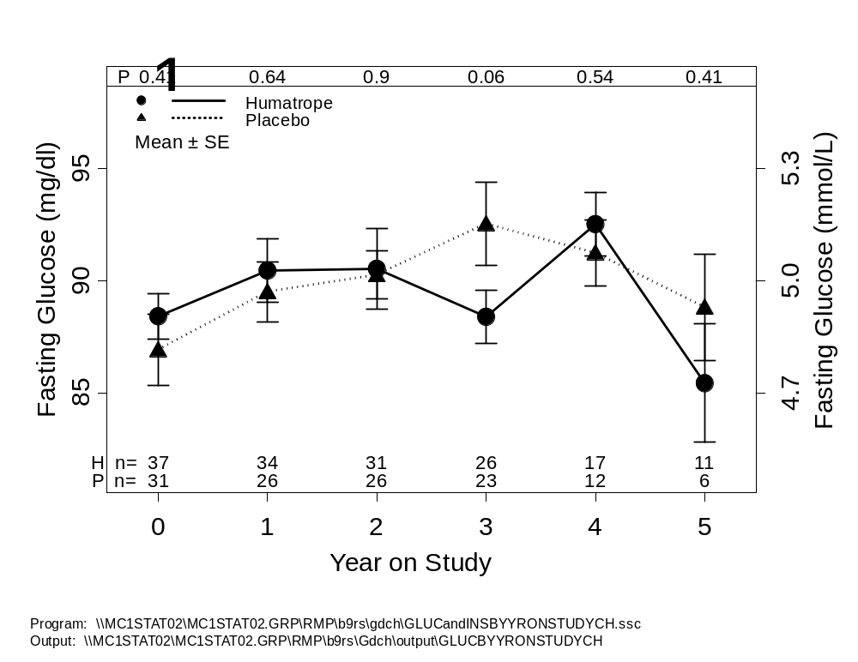
Abbreviations: H = Humatrope; n= number of patients; P = placebo; SE = standard error.
Figure 16. Mean fasting glucose by year on study for Study GDCH.
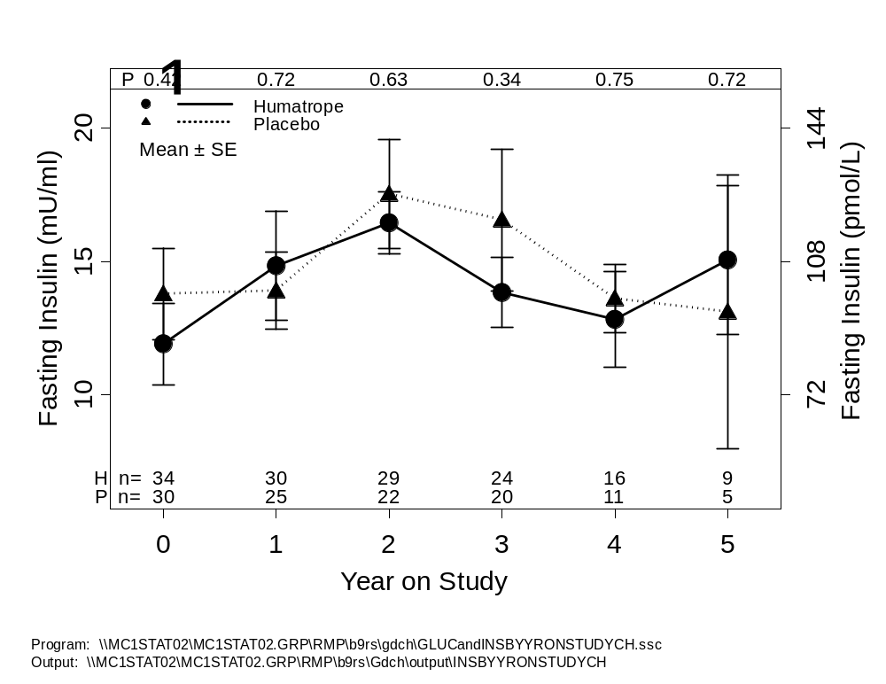
Abbreviations: H = Humatrope; n= number of patients; P = placebo; SE = standard error.
Figure 17. Mean fasting insulin by year on study for Study GDCH.
Furthermore, there were no statistically significant differences between treatment groups for change-to-endpoint values for fasting glucose, fasting insulin, or adjusted HbA1c (Table 28). However, there was a mild increase of 10% in mean fasting insulin from baseline to endpoint in the Humatrope group. To further evaluate this finding the fasting glucose and insulin values were analyzed by methods that specifically assess insulin sensitivity. While not as rigorous as clamp studies, the Quantitative Insulin Sensitivity Check Index (QUICKI) is a well-validated method of assessing insulin sensitivity either in a between-group fashion or longitudinally (Katz et al. 2000) in a given study. However, because results may be significantly affected by assay differences it is not useful for comparison across studies. This analysis showed a 6% reduction in apparent insulin sensitivity from baseline to endpoint in the Humatrope-treated group (Figure 18). However, when individual patient values are assessed there is no evidence of a clinically relevant difference in the pattern of change from baseline to endpoint across the Humatrope-treated versus the placebo-treated patient groups.

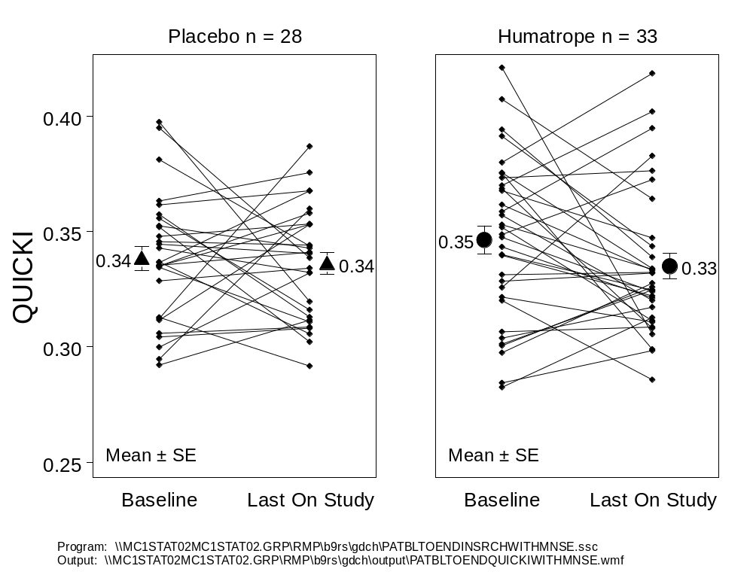
Note: QUICKI = 1/(log[Fasting Insulin (μU/mL)] + log[Fasting Glucose (mg/dL)]). If a patient has multiple results of fasting glucose or fasting insulin at a timepoint, the mean value was used.
Abbreviations: QUICKI = Quantitative Insulin Sensitivity Check Index; SE = standard error.
Figure 18. Qualitative Insulin Sensitivity Check Index (QUICKI) baseline to endpoint in Study GDCH.
Since there was a slight imbalance between the groups for QUICKI at baseline, an analysis of covariance (ANCOVA) was performed incorporating the baseline value in the model. As shown in Figure 19, this analysis demonstrated no Humatrope treatment effect on insulin sensitivity after baseline values were accounted for (p=0.67). Similar findings were obtained when the insulin and glucose data were evaluated using the homeostasis model of insulin sensitivity (HOMA-S; Bonora et al. 2000). Taken together the results provide no evidence for a clinically meaningful Humatrope effect on insulin sensitivity in this patient population.
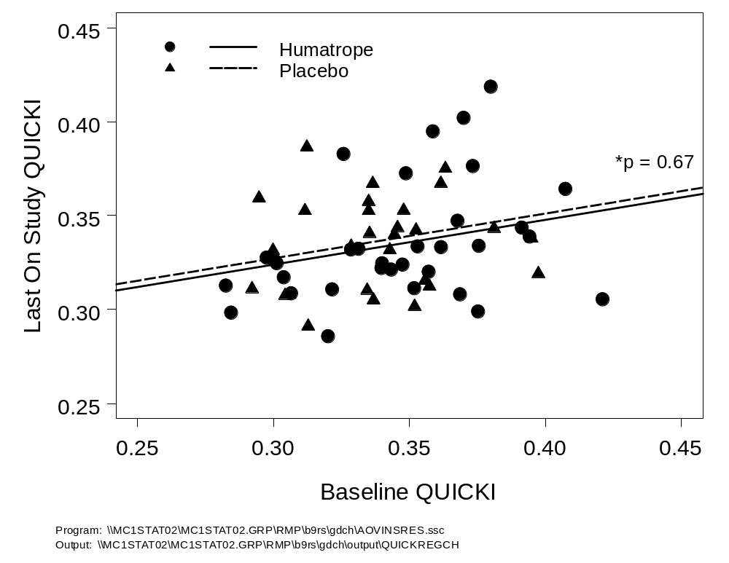
Note: p-value is between group p-value from the analysis of covariance (ANCOVA) model. QUICKI = 1/log[Fasting Insulin (μU/mL)] + log[Fasting Glucose (mg/dL)]). Line represents regression line from ANCOVA analysis (Model: Last on-study QUICKI = Therapy baseline QUICKI). Values are means at a visit, if patient had more than one result assayed.
Figure 19. Analysis of covariance of last on study QUICKI using baseline QUICKI as the covariate.
In Study E001, there were no statistically significant or clinically relevant differences between dosage groups for change from baseline to endpoint values for fasting glucose (Figure 20) or glycosylated hemoglobin. The overall patterns of fasting glucose and glycosylated hemoglobin values were similar for the three dosage groups throughout the study, indicating no evidence of dose-related Humatrope effect.

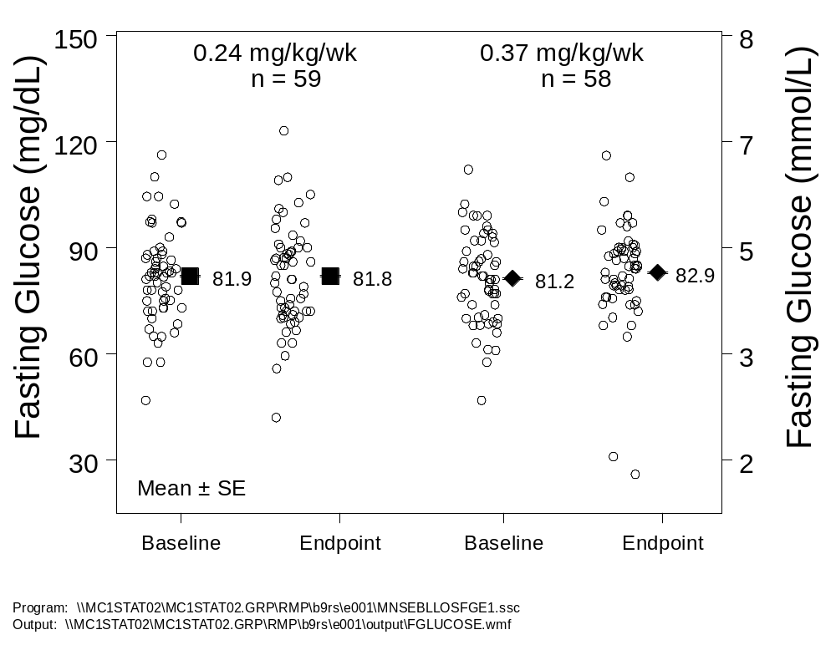
Note: No reference range shown as this varied among laboratories.
Abbreviations: n= Number of patients; SD = standard deviation.
Figure 20. No Humatrope dose effect on fasting glucose.
In summary, although GH is a physiologic insulin antagonist there was no evidence of significant somatropin-induced insulin resistance in Study GDCH and no evidence of any dose effect on fasting glucose in Study E001.

4.10.2. Insulin-Like Growth Factor-I
Insulin-like growth factor I (IGF-I) values were available only for patients with Turner syndrome in Study GDCI and those with non-GHD short stature in Study GDCH. Table 29 provides a summary of the baseline and changes from baseline to endpoint values. In the Turner syndrome study, GDCI, the expected dose-dependent rise in IGF-I from baseline to endpoint was seen. In the non-GHD short stature study, Study GDCH, the Humatrope group showed an improvement in IGF-I of 0.7 SDS, while the placebo group showed a smaller increase of 0.2 SDS.

Table 29. Insulin-Like Growth Factor-I Changes from Baseline to Endpoint
 | Turner Syndrome (GDCI) |  |  | Non-GHD Short Stature (GDCH)
 | N=230 |  |  | N=68
 | Humatrope a | Humatrope b |  | Humatrope c | Control | p-value d
Number of patients
in treatment group | 93 | 137 |  | 37 | 31
IGF-I (ng/mL)
n | 81 | 124 |  | 33 | 27
Baseline | 136 ± 76 | 142 ± 89 |  | 190 ± 74 | 226 ± 100
Change to endpoint | 188 ± 165 | 241 ± 239 |  | 187 ± 123 | 103 ± 105 | 0.007
IGF-I SDS e
n | NA | NA |  | 33 | 27
Baseline | NA | NA |  | -1.9 ± 1.1 | -1.4 ± 1.6
Change to endpoint | NA | NA |  | 0.7 ± 2.3 | 0.2 ± 1.3 | 0.273
Note: Values represent mean ± standard deviation (SD). Study GDCI was placebo-controlled for the first 1.5 years; however, placebo-control data for laboratory values were not summarized separately in the clinical study report. Therefore, placebo control data are not presented in this table for Study GDCI. For both studies, endpoint refers to the last visit on treatment.
Abbreviations: IGF-I = insulin-like growth factor-I; IGF-I SDS = insulin-like growth factor-I standard deviation score; N = number of patients in safety analysis; n = number of patients with baseline or endpoint value; NA = not applicable.
a Dose = 0.27 mg/kg/wk.
b Dose = 0.36 mg/kg/wk. This column includes placebo-treated patients who were transitioned to Humatrope
treatment after 1.5 years.
c Dose = 0.22 mg/kg/wk.
d p-values pertain to a test of between-group differences for Study GDCH.
e Insulin-like growth factor-I standard deviation score (IGF-I SDS) = (patient value – mean value) / SD. Values for mean and SD are based
on the appropriate reference range for the patient’s age and gender.

4.10.2.1. Turner Syndrome
In patients with Turner syndrome in Study GDCI, change in mean IGF-I concentration from baseline to endpoint was greater for the 0.36 mg/kg/wk dosage group than for the 0.27 mg/kg/wk dosage group, as expected, demonstrating the dose-dependent IGF-I response to GH.

4.10.2.2. Non-Growth Hormone Deficient Short Stature
In patients with non-GHD short stature in Study GDCH, mean serum IGF-I at baseline was below the 10th percentile for the age and gender matched general population and remained well below the mean value for the general population at endpoint (mean IGF-I SDS <-1.0) in both treatment groups. Thus, in this patient population, Humatrope treatment promoted partial restoration of subnormal IGF-I concentrations and did not raise mean IGF-I levels above those of the age- and gender-matched general population. Figure 21 displays the mean and individual patient IGF-I concentrations at baseline and endpoint for both treatment groups.
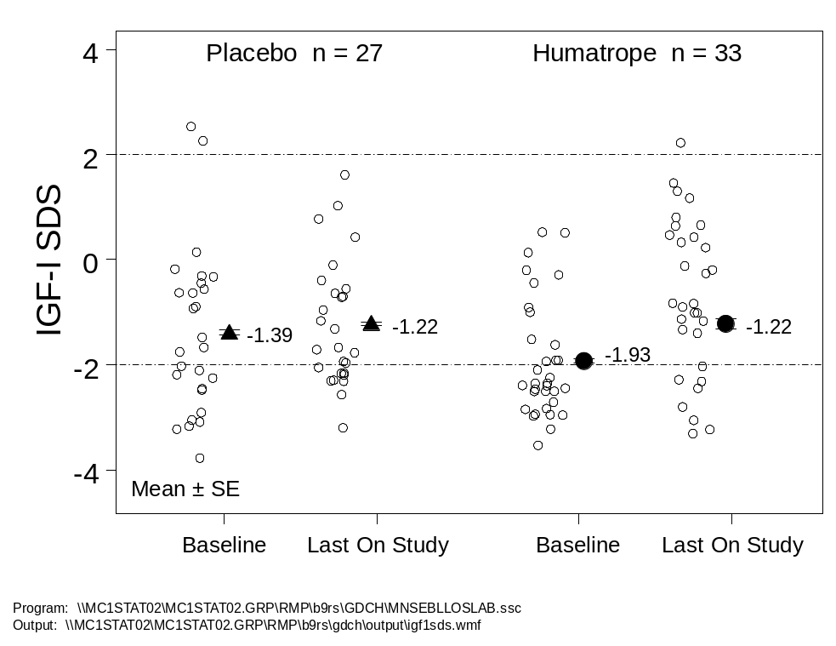
Note: Two extreme low values have been omitted from Humatrope endpoint. The area between the two dashed lines represents the normal range for the general population (AAP 1997).
Abbreviations: IGF-I = insulin-like growth factor-I; n = number of patients; SE = standard error; SDS = standard deviation score.
Figure 21. IGF-I increased modestly in Humatrope-treated patients in Study GDCH.
There was no significant difference between the Humatrope and placebo treatment groups for the proportion of patients who had serum IGF-I concentrations more than 2.0 SD above the age- and gender-appropriate mean for chronological age at any post-baseline measurement (Humatrope: 9 of 35 patients [26%]; placebo: 7 of 28 patients [25%]).

4.10.3. Thyroid Function
Table 30 provides baseline values and changes from baseline to endpoint for thyroid function tests, which were similar among the three patient populations.

Table 30. Thyroid Function Changes from Baseline to Endpoint
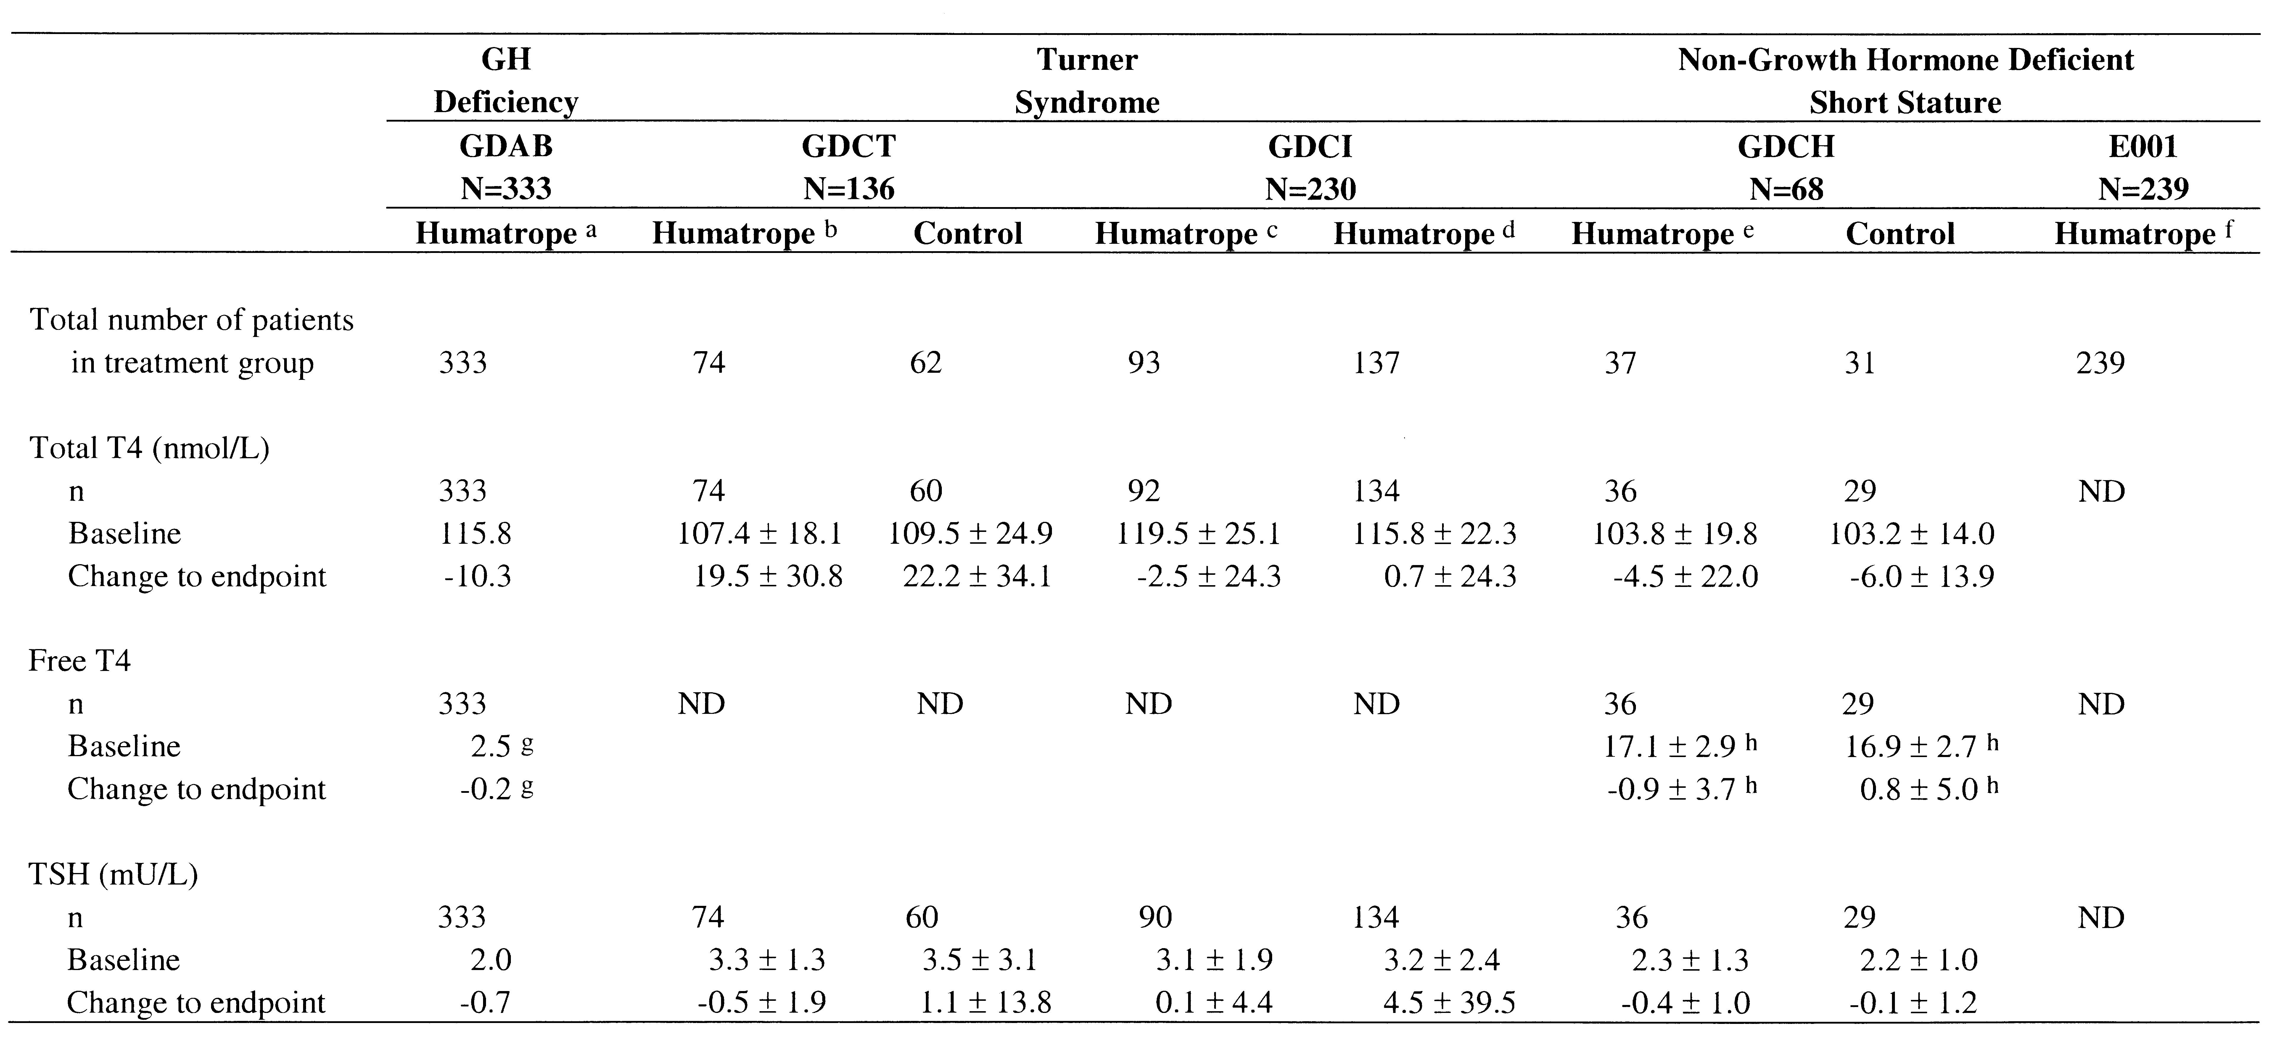
Note: The Control group for Study GDCT was a randomized, untreated control, whereas for Study GDCI and Study GDCH it was a randomized,
placebo control. Values represent mean ± standard deviation (SD), except in Study GDAB, where values represent the median. Study GDCI was placebo controlled for the first 1.5 years; however, placebo control data for laboratory values were not summarized separately in the clinical study report and, thus, placebo control data for Study GDCI are not presented in this table. For each of the studies, endpoint refers to the last visit on treatment.
Abbreviations: GH = growth hormone; N = number of patients in safety analysis; n = number of patients with baseline or endpoint value; ND = not determined; T4 = thyroxine; TSH = thyroid-stimulating hormone.
a Dose = 0.18 mg/kg/wk to 0.24 mg/kg/wk.

b Dose = 0.30 mg/kg/wk.
c Dose = 0.27 mg/kg/wk.
d Dose = 0.36 mg/kg/wk. This column includes placebo-treated patients who were transitioned to Humatrope treatment after 1.5 years.
e Dose = 0.22 mg/kg/wk.
f Dosage groups have been pooled: Dose 1 = 0.24 mg/kg/wk; Dose 2 = 0.24 mg/kg/wk for the first year, and then 0.37 mg/kg/wk thereafter; Dose 3 = 0.37 mg/kg/wk.
g Free thyroxine index. Reference range = 1.6 to 4.3.
h Free T4 (pmol/L). Reference range = 10 to 26 pmol/L.

4.10.3.1. Growth Hormone Deficiency
Median values for total T4, free thyroxine index, and TSH declined slightly from baseline to endpoint. However this finding was felt to be of minimal clinical significance.

4.10.3.2. Turner Syndrome
Mean total T4 values increased across the duration of the study by approximately 20% in both treatment groups in Study GDCT but were essentially unchanged in Study GDCI. Mean TSH doubled in the higher Humatrope dosage group of Study GDCI. However, this was predominately due to a single patient’s elevated TSH value at the final study visit and was not considered clinically relevant.

4.10.3.3. Non-Growth Hormone Deficient Short Stature
Centrally-measured thyroid function tests were available only for patients in Study GDCH. There were no statistically significant or clinically relevant differences between treatment groups for baseline or change-to-endpoint values for T4, free T4, or TSH. There was no evidence of an effect of Humatrope treatment on thyroid function in these patients. Figure 22 displays the mean and individual patient free-T4 concentrations at baseline and endpoint for both treatment groups.
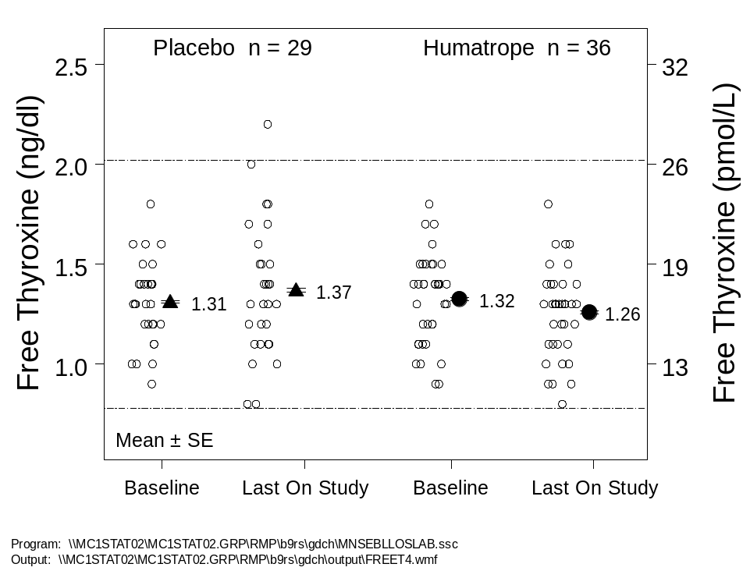
Note: The area between the two dashed lines represents the reference range
for the assay.
Abbreviation: SE = standard error.
Figure 22. No significant GH-related change in free thyroxine in Study GDCH.

4.11. Overall Safety Conclusions
The safety of Humatrope treatment in patients with non-GHD short stature is demonstrated by the similarities in rates of serious adverse events, discontinuations due to adverse events, and laboratory data, including measures of insulin sensitivity, between the Humatrope and placebo-treated groups in Study GDCH. In addition, the lack of significant difference between dosage groups in Study E001 indicates absence of a dose effect on safety in these patients. The adverse event profile for serious adverse events and discontinuations due to adverse events, in patients with non-GHD short stature, was similar to that of patients for whom Humatrope is currently approved and no new safety signals were seen. While some differences in the pattern of TEAEs were seen between patients with non-GHD short stature and those with GHD or Turner syndrome, the differences primarily reflect the underlying disease state differences between these patient groups and do not suggest any clinically meaningful change in the adverse event profile for pediatric patients being treated with Humatrope. Importantly, these conclusions are based on similar numbers of patients and similar total patient-years of exposure among these three regulatory submissions.
Data from two large postmarketing studies support the safety of somatropin in the non-GHD short stature patient population. Finally, laboratory data, including analysis of insulin sensitivity, failed to demonstrate any new findings in this patient population. In summary, patients with non-GHD short stature treated with Humatrope at dosages ranging from 0.22 to 0.37 mg/kg/week are at no greater risk from this treatment than patients with GHD treated at 0.18 to 0.24 mg/kg/wk or patients with Turner syndrome receiving 0.27 to 0.36 mg/kg/wk. The Sponsor therefore believes that the safety of Humatrope treatment in patients with non-GHD short stature has been demonstrated and the precautions listed in the current Humatrope label address the key risks of Humatrope exposure. There are no new safety concerns specific to this patient population and no new precautions should be added to the label.

5. Benefit/Risk Assessment
Since the 1960s the pediatric endocrine community has sought to understand the potential value of GH treatment in pediatric patients with non-GHD growth disorders, with respect both to short term and to long term growth. In 1987 an FDA advisory committee recommended that the efficacy of GH in patients with non-GHD short stature be assessed by a randomized, placebo-controlled trial to final height. To address the unanswered questions regarding efficacy and safety of somatropin in this patient group Lilly conducted two randomized, controlled, clinical trials between 1988 and 2001. The data obtained from these studies clearly demonstrate the efficacy and safety of Humatrope treatment in patients with non-GHD short stature. However, the potential approval of this new indication raises a number of questions that must be addressed to enable clear assessment of the benefit-to-risk relationship:
- Is it appropriate to treat patients whose short stature is not clearly associated with a defined “disease”?
- Is GH effective in these patients, and is the magnitude of the benefit clinically relevant?
- Should psychological benefits be a required outcome of GH treatment?
- Is this treatment safe in this patient population?
- Why was the height cut-off of –2.25 SDS chosen for the label indication?
- Will this new indication obviate the need for diagnostic evaluation in children with growth disorders?
- Will this new indication “open the floodgates” to inappropriate use?
The first four points will be discussed in this Benefit-Risk section and the latter three points will be discussed in the Risk Management section that follows.
Is it appropriate to treat patients whose short stature is not clearly associated with a defined “disease”? Some authors have posited that patients with non-GHD short stature should not receive the benefit of GH treatment because they do not have a “disease”. However, this cannot be regarded as a rational or ethical reason for withholding an effective therapy. There are a number of conditions, both childhood and adulthood, for which treatment is deserved and received, despite the fact that many would not accept these patients as having a “disease”. Examples include enuresis, hypertension, hypercholesterolemia, erectile dysfunction, alopecia, hirsutism, gynecomastia, anxiety disorder, and nicotine addiction. While it appears to be a moot point as to whether or not these conditions represent diseases, few would argue against the appropriateness of effective treatment for these conditions.
Furthermore, with respect to pediatric growth disorders, somatropin treatment aims to treat growth failure or short stature, not the underlying condition. Clearly, somatropin has no impact on the deficiency of X-chromosomal material and associated phenotypic and functional problems of Turner syndrome. Somatropin simply provides an increase in linear growth and adult height for these patients, with the potential for mitigating the disadvantages associated with the lifelong short stature that these patients would otherwise face. The fact that children with non-GHD short stature have an as-yet undefined etiology for their growth failure (likely a heterogeneous collection of etiologies), and are therefore regarded by some as having no “disease” does not justify excluding them from effective treatment. The key distinction between patients with non-GHD short stature and those with conditions for which somatropin is currently approved is not whether a disease is present, but rather, that most of the latter conditions have additional problems beyond their growth disturbance (such as ovarian failure in Turner syndrome) that are not addressed by somatropin. The absence of additional health problems in patients with non-GHD short stature should not penalize them with respect to their eligibility for treatment of the key problem that they share with patients with other growth disorders - short stature.
Is GH effective in these patients, and is the magnitude of the benefit clinically relevant? The second key point to be addressed in assessing the benefit-risk relationship is the efficacy of somatropin treatment in patients with non-GHD short stature, and the clinical relevance of that efficacy. The efficacy of treatment in this patient population must be assessed by evaluating the data from three key sources. First, the pivotal, placebo-controlled trial of Humatrope treatment in patients with non-GHD short stature demonstrated statistically significantly greater final height in Humatrope treated patients compared with those who received placebo injections. Second, the supportive dose-response study in this patient population demonstrated a marked and significant increase in height velocity, which almost doubled during the first 2 years of Humatrope treatment, allowing many patients to reach normal height range during childhood. Third, the supportive data from the literature meta-analysis indicate a similar improvement in final height to that seen in the Lilly clinical trials. These findings translate into two key benefits for these patients: an increase in height during childhood, allowing patients with non-GHD short stature to catch up to their normal-stature peers during childhood, and increased final height after completion of linear growth.
The magnitude of the final height benefit – a key factor in evaluation of the benefit-risk profile – should be assessed with reference to the complete package of clinical data provided. The key study for evaluation of the final height improvement is the pivotal, placebo-controlled clinical trial, Study GDCH. The most robust estimate of the average benefit is obtained from the primary efficacy analysis, which demonstrated a mean 0.51 SDS greater final height in Humatrope-treated than placebo-treated patients, equivalent to 3.7 cm. A number of sensitivity analyses and secondary analyses provide strong support, indicating a range of the mean final height effect of 2.8 to 5.0 cm.
In assessing the benefit of Humatrope in the pivotal trial, the relatively low Humatrope dosage (0.22 mg/kg/wk), injection frequency (3 times per week), and the relatively late age at initiation of therapy, should be considered. Final height data from the supportive dose-response trial allow assessment of benefit obtained from a higher Humatrope dosage (0.37 mg/kg/wk), administered in divided doses 6 times per week, starting at a younger age. Because of the difference in study design between the pivotal trial and the supportive study, the final height benefit in the latter study is evaluated in a different manner. Since there was no untreated control group in this study, treatment-related gains in final height were assessed with reference to the adult height predicted at baseline, prior to treatment. This is the standard method by which final height gain is assessed in the majority of studies in the literature, essentially using patients as their own controls. For the lower dosage Humatrope treatment group (0.24 mg/kg/wk) the gain in final height over baseline predicted height was 5.4 cm; for the higher dosage group (0.37 mg/kg/wk) the gain was 7.2 cm. These data should be evaluated in the context of previously reported data indicating that height predictions tend to overestimate the true achieved adult height in untreated patients with non-GHD short stature, potentially reducing the apparent treatment effect. The benefit of somatropin treatment, demonstrated in Lilly clinical trials in patients with non-GHD short stature, is supported by controlled studies to final height in the peer-reviewed literature summarized in a recent meta-analysis (Finkelstein et al. 2002), demonstrating an average GH-induced gain in adult height of approximately 4 to 6 cm.
Several lines of evidence indicate that the magnitude of GH-induced height gain in patients with non-GHD short stature was large enough to be clinically meaningful. First, the GH-induced height gains in patients with non-GHD short stature were similar to the final height benefit demonstrated for patients with Turner syndrome obtained in the pivotal clinical trial for Turner syndrome that formed the basis of the 1996 supplemental NDA for approval of Humatrope in treatment of short stature associated with Turner syndrome (3.9 to 5.4 cm). Second, the mean heights of Humatrope-treated patients in the pivotal trial for non-GHD short stature (Study GDCH), and of the 0.37 mg/kg/wk dosage group in the supportive study (Study E001), moved into the normal range during the course of treatment, indicating that many patients had caught up to their peers during childhood. Third, whereas the final heights for placebo-treated patients in Study GDCH were all below the 5th percentile for the general population, and most were below the lower limit of normal, 94% of final heights for patients who received the higher dosage (0.37 mg/kg/wk) in Study E001 were within the normal range.
In addition to evaluating the benefit of Humatrope treatment itself, the impact of Humatrope dose on this benefit should also be considered. The incremental final height benefit of a higher dose of Humatrope is assessed by a number of secondary analyses of dose-response data in Study E001. Patients who received the higher Humatrope dosage (0.37 mg/kg/wk) achieved an additional 2.8 to 3.3 cm of height benefit (by analysis of last observed height SDS, final height SDS and height SDS at age 18 years) above and beyond the gains achieved by the patients who received the lower Humatrope dose. These findings are consistent with the dose-response effect of somatropin treatment observed in patients with Turner syndrome (Quigley et al. 2002) and in those with GHD (Mauras et al. 2000; Cohen et al. 2002).
While adult height has been identified as the primary measure upon which benefit of somatropin treatment should be assessed, the importance of shorter term changes in growth, evidenced by increased height velocity, should not be underestimated. Improvements in height velocity provide affected children with the opportunity to catch up to their normal-stature peers during childhood, thereby reducing height discrepancies during an important period of development. Marked catch-up growth was noted in all treatment groups of Study E001, with almost a doubling of height velocity over the first 2 years of treatment. Furthermore, there was a significantly greater effect of the higher Humatrope dosage of 0.37 mg/kg/wk compared with the lower dosage of 0.24 mg/kg/wk.
To summarize the clinical relevance of the efficacy data, more than half of the patients treated at a relatively low GH dosage and frequency, started at a relatively late age, and almost all patients treated at a higher dosage and frequency, starting at a younger age, achieved normal final height, conferring on these patients the lifelong benefit of normal adult stature. Thus, as adults, these patients no longer had short stature, therefore diminishing the disadvantages of adult short stature, which may include failure to meet minimum height requirements for certain occupations, difficulty or inability to safely operate a motor vehicle or overcome structural challenges in the home or workplace, and being perceived as having lower competence than individuals of normal stature. A substantial degree of catch-up growth occurred during the course of treatment, returning many affected patients to within the normal height range during childhood. Thus, during treatment, many of these children no longer had short stature, potentially diminishing the disadvantages they may suffer during childhood. Both the long-term and the shorter-term growth effects represent clinically relevant benefits for affected patients. These two key benefits of Humatrope treatment in patients with non-GHD short stature provide affected patients the opportunity for improved growth during childhood and a similar degree of improved final height to that currently available to patients with other growth disorders. Furthermore, the magnitude of final height benefit is similar to the magnitude seen in another non-GHD growth disorder for which somatropin treatment has been approved, Turner syndrome.
Should psychological benefits be a required outcome of GH treatment? While the evidence for stature-related benefit of somatropin treatment in patients with non-GHD short stature is now clear, the question of the psychological impact of this benefit remains. Following the recommendation of the 1987 Endocrinologic and Metabolic Drugs Advisory Committee, Lilly studies in this patient population focused on treatment of their growth disorder. None of the studies that led to approval of GH for the treatment of growth failure or short stature in each of the current indications provided evidence for potential benefits in quality of life or psychological well-being. Moreover, neither Study GDCH nor Study E001 provided evidence for such potential benefits. Some authors have proposed that GH treatment of patients with non-GHD short stature is unjustified unless such benefit can be demonstrated. However, this position is ethically untenable, since it subjects children with an equal severity of impairment (short stature) to a higher burden of proof than those patients for which somatropin has been previously approved. In fact, this patient group has already been held to a higher standard than most others, by having been required to demonstrate a benefit of treatment on final height, rather than simply on short-term growth. Approvals for somatropin treatment were granted on the basis of improved height velocity alone for patients with GHD, chronic renal insufficiency, Prader-Willi syndrome, and those born small for gestational age. Only in patients with Turner syndrome were final height improvements also demonstrated and included in the application for approval.
Is this treatment safe in this patient population? In assessing the benefit-to-risk relationship, the safety of GH treatment in this patient population must be carefully evaluated. The risks associated with Humatrope treatment in patients with non-GHD short stature are similar to those encountered by other pediatric populations presently treated with Humatrope and are described in the current Humatrope label. While some differences in the pattern of TEAEs were seen between patients with non-GHD short stature and those with GHD or Turner syndrome, the differences primarily reflect the underlying disease state differences between these patient groups and do not suggest any clinically meaningful change in the adverse event profile for Humatrope treatment in pediatric patients.
Given clear evidence of benefit, similar to that for Turner syndrome, a non-GHD condition for which Humatrope is currently approved, and no evidence of greater risk of therapy in patients with non-GHD short stature, Lilly believes that the benefit-risk assessment supports the approval of Humatrope for this indication and proposes the following label indication: Humatrope is indicated for the long-term treatment of non-growth hormone-deficient short stature, defined by height SDS ≤-2.25, in pediatric patients whose epiphyses are not closed and in whom diagnostic evaluation excludes causes of short stature that should be treated by other means.
Such patients should be treated with a weekly dosage of up to 0.37 mg/kg, administered in divided doses 3 to 7 times per week. This dosage recommendation is supported by the greater efficacy of the dosage of 0.37 mg/kg/wk, which was obtained without any apparent increase in risk over the dosage of 0.24 mg/kg/wk.

6. Risk Management

6.1. Introduction
Since the 1987 approval of Humatrope for treatment of pediatric patients with growth failure due to GH deficiency, Lilly has actively addressed the potential for inappropriate use of the medication with a multi-faceted risk management approach. As the anabolic properties of growth hormone have become more widely known, somatropin has been targeted as a drug of potential abuse for non-medicinal purposes. Lilly has been and continues to be committed to assuring that prescribing and distribution of Humatrope for such non-medicinal purposes does not occur.
Lilly recognizes that an approval for treatment of children with non-GHD short stature raises several potential new concerns. The first concern is that Humatrope will be prescribed inappropriately for patients whose stature exceeds that given in accepted guidelines for short stature evaluation and treatment – that this new indication will “open the floodgates” for inappropriate prescribing. The second concern is the potential that patients with short stature will not receive an adequate diagnostic evaluation to detect illnesses that require interventions different from, or in addition to, Humatrope. Finally, there is concern about the possibility that new adverse events, unobserved in clinical trials, may emerge with the approved treatment of larger numbers of children with non-GHD short stature. In addition to these concerns, this section of the document will address the rationale for the choice of a height threshold of –2.25 SDS as the eligibility criterion for treatment in this patient population.
Since the initial approval of Humatrope for treatment of growth failure associated with GH deficiency, Lilly has had measures in place to address concerns similar to those listed above. Lilly believes that these measures, combined with a number of important external factors, will assure that Humatrope treatment is available only to appropriate patients. These measures include restrictive labeling, thorough education for potential prescribing physicians, limited marketing to a select physician group, a proprietary controlled distribution process, and post-marketing safety surveillance and monitoring.
This section begins by summarizing each of these specific concerns and concludes with details regarding the internal measures and external factors in place that address each of the concerns. These concerns and the risk management measures that address them are also detailed in Table 31 (Section 6.5).

6.2. Specific Concerns

6.2.1. Inappropriate Prescribing
The concern has been raised that a new indication for treatment of patients without a defined etiology for their growth failure will “open the floodgates” to broad prescribing of Humatrope for large numbers of children who are shorter than average but within the normal range. There is concern that parents will seek therapy for such children in the hope of offering them some perceived physical or social benefit and that physicians will be placed under pressure to prescribe somatropin inappropriately. The potential health economic impact of such inappropriate prescribing is significant.

6.2.2. Lack of Adequate Diagnostic Evaluation
The concern exists that if eligibility for somatropin treatment no longer requires a given level of GH secretion or a named disease entity then physicians will forego the appropriate diagnostic work-up in the interest of their time, the patient’s time and expense, and obtaining therapy in an expedient manner. Clearly this would place a number of patients at potential risk for failure to detect serious medical conditions that require treatments in addition to, or other than, Humatrope. Of particular concern are: 1) failure to perform screening tests for other conditions such as hypothyroidism or gastrointestinal malabsorption that require specific medical therapies; 2) the potential abandonment of laboratory investigation of GH secretion status, which could lead to failure to diagnose significant forms of severe GH deficiency due to underlying organic conditions such as intracranial tumors.

6.2.3. Emergence of New Adverse Events
The potential exists that new adverse events, unobserved in the pivotal and supportive clinical trials and in prior practice, may emerge in the new patient population. Furthermore, the occurrence rates of adverse events currently referenced in the Humatrope label may differ in the new population when larger numbers of patients are exposed to the medication.
To address these important concerns the following sections summarize the system of checks and balances currently in place, both sponsored by and external to Lilly, that will manage the risks associated with an approved indication for treatment of children with non-GHD short stature. While no single factor will entirely mitigate these potential risks, the combined effect of all of these measures will assure that Humatrope treatment is reserved for patients with the appropriate medical need.

6.3. Elements of the Lilly Risk Management Process

6.3.1. Restrictive Humatrope Labeling for Non-GHD Short Stature
The label language for this indication contains a clearly-stated height threshold above which a patient is ineligible for therapy. This restriction is unique among somatropin indications, placing a substantially greater degree of control on treatment eligibility for patients with this condition than on patients with any other condition for which somatropin is approved.
Lilly proposes the following:
Humatrope is indicated for the long-term treatment of non-growth hormone-deficient short stature, defined by height SDS ≤-2.25, in pediatric patients whose epiphyses are not closed and in whom diagnostic evaluation excludes causes of short stature that should be treated by other means.
The proposed label indication for patients with non-GHD short stature will be the most restrictive label of any in place for pediatric growth disorders in the US. None of the currently approved pediatric indications for somatropin (growth failure or short stature caused by GHD, chronic renal insufficiency, Turner syndrome, Prader-Willi syndrome, and patients born small for gestational age) include a threshold for the definition of short stature in the labeling. However, in the first four of these disorders, potential patients are identified by the existence of a generally-recognized disease or condition underlying the growth impairment; the patient whose short stature is a consequence of having been born small for gestational age is readily identified on the basis of birth weight. The number affected and therefore treatment-eligible patients with GHD, chronic renal insufficiency, Turner syndrome and Prader-Willi syndrome is limited by the prevalence of each condition. However, patients with any of these conditions are eligible for therapy irrespective of their actual attained height, height velocity (growth rate) or adult height potential. For example, a child of tall parents with an organic form of GHD diagnosed before growth failure has caused a substantial decline across the percentile channels is eligible for treatment even if current height is at the 90th percentile. Similarly, no specific slow rate of growth is defined for treatment of “growth failure associated with chronic renal insufficiency”. In the case of non-GHD short stature, the underlying cause of the growth impairment is not known, and the diagnosis is made after excluding other causes of short stature (Figure 1, Section 2.1). The key clinical feature of the condition is simply the presence of significant short stature in the absence of associated pathology; therefore, Lilly believes a quantitative definition is needed in the label to target treatment to the appropriate patient.
Although short stature has been defined as height SDS ≤-2.0 by the American Academy of Pediatrics (AAP 1997) and the American Association of Clinical Endocrinologists (AACE 2003), and this definition has been used in most published studies of non-GHD short stature (including the supportive study in this application [E001]), Lilly has selected a more restrictive definition for the label. This more restrictive definition:
- is consistent with the population studied in the pivotal study (GDCH);
The majority of patients in Study GDCH were enrolled under the entry criterion of height SDS ≤-2.25.
- discourages inappropriate use;
Lilly is aware of the concern that Humatrope may be prescribed inappropriately for children of normal stature (height SDS between -2.0 and +2.0) and believes that the targeted label indication will help focus prescribing on a more limited set of patients. Using height SDS ≤-2.25 to identify the intended population for treatment excludes from treatment all patients of normal stature and 46% of patients with non-GHD short stature who would otherwise be eligible with height SDS ≤-2.0 as the criterion (assuming a Gaussian distribution of height). This restricted definition of short stature sets a limit that discourages selection of low-normal stature patients for treatment. It achieves this goal, however, by excluding from treatment some patients with non-GHD short stature for whom pediatric endocrinologists may wish to prescribe Humatrope.
- follows FDA recommendation;
Lilly believes that the proposed non-GHD short stature label indication is responsive to an FDA request made in pre-sNDA communications that Lilly provide specific guidelines in the label regarding the target population.
- strikes the best balance;
Lilly believes that the definition “height SDS ≤-2.25”strikes the best balance between the goals of discouraging inappropriate GH use in normal-stature children and providing equitable access to safe and effective treatment for patients with non-GHD short stature. The definition also provides a limit to the number of potential patients in a way similar to the limits in place for the currently-approved indications.
- reinforces the need for appropriate diagnostic evaluation;
Lilly believes that including the language “and in whom diagnostic evaluation excludes causes of short stature that should be treated by other means” helps to ensure that a proper diagnostic evaluation is performed. Since there are other causes of short stature such as chronic illness, hypothyroidism and gastrointestinal malabsorption, to name a few, that require specific therapies that may or may not include Humatrope, this language is necessary to ensure proper diagnosis and treatment.
- establishes guidance for non-GHD short stature prescribing.
Prescribing of various brands of somatropin for patients with non-GHD short stature has occurred in the past without an approved indication (Table 1). This has resulted in a lack of consistency in diagnosis, prescribing, reimbursement, and consequently, inequitable access to treatment. Approval of Humatrope for this indication establishes restrictions for appropriate prescribing that will reduce this inconsistency.

6.3.2. Physician Education
Several informational programs will be implemented to maximize physician awareness of the appropriate criteria for diagnosis and treatment of non-GHD short stature, the importance of undertaking a thorough diagnostic work-up in patients with growth disorders, and the risks and benefits of Humatrope treatment in these patients. This information will be conveyed primarily through physician-to-physician and continuing medical education programs.

6.3.2.1. Physician-to-Physician Programs (Lilly-Sponsored)
The objective of these physician-led programs is to ensure that potential prescribing physicians understand the restrictive label, specifically the appropriate patient for treatment of non-GHD short stature and the importance of a proper diagnostic evaluation. These programs will address the diagnosis and management of non-GHD short stature and the benefits and risks of Humatrope treatment. Lilly sales specialists will organize and conduct these programs in accordance with FDA guidelines. Diagnostic criteria and safety information will be presented to physicians in a controlled and responsible manner. The materials used in the physician-to-physician programs will be derived from the pivotal and supportive study data, as well as data available from previously published studies. The potential risks to patients of omitting standard diagnostic evaluations for children with growth disorders will be emphasized.

6.3.2.2. Continuing Medical Education
Continuing medical education (CME) programs will also be available to provide qualified physicians complete, correct information on diagnosis and treatment of pediatric patients with non-GHD short stature and to ensure that they understand the benefits and risks of using Humatrope in these patients and the importance of pursuing a comprehensive diagnostic work-up in children with growth disorders. Since CME programs are well-attended and valued by physicians, these initiatives will encourage widespread understanding of the important limitations around this new indication. The programs, funded by Lilly, will be developed and controlled by independent third parties.

6.3.3. Limited Marketing
Lilly is committed to a limited marketing program for the non-GHD short stature indication. Marketing for Humatrope focuses specifically on endocrinologists. The diagnosis and treatment of pediatric growth disorders are complex, and patients require a thorough, comprehensive diagnostic evaluation. Endocrinologists are the primary medical specialists specifically trained in the evaluation and treatment of growth disorders. Promotion to these physicians is primarily provided by a limited sales force, which will be trained to educate physicians about the restrictive label for and appropriate use in patients with non-GHD short stature.

6.3.3.1. Limited Sales Force
A limited (<100), experienced group of sales specialists will call only on pediatric endocrinologists to discuss Humatrope for the treatment of non-GHD short stature. These sales specialists will focus on discussion of the FDA-approved label for the indication. Lilly Humatrope sales specialists do not call on family practitioners or general pediatricians.

6.3.3.2. Sales Force Training on the Humatrope Benefit/Risk Profile and Appropriate Use
Lilly endocrine sales specialists already have extensive relationships with pediatric endocrinologists through discussions of other indications for which Humatrope is approved. These sales specialists have been extensively trained about growth disorders and their diagnosis and management. Upon approval of Humatrope for non-GHD short stature, sales specialists will receive additional training about the label restrictions for the new indication, including the appropriate patient population for this indication, the importance of a thorough diagnostic evaluation, and the benefits and risks of Humatrope treatment for non-GHD short stature.

6.3.3.3. No Direct-to-Consumer Advertising
No direct-to-consumer advertisements (for example, television, magazine, newspaper, health fairs, billboards, sporting events) for Humatrope will be undertaken. Lilly does, however, maintain a Humatrope internet site, which will be updated to provide information about non-GHD short stature for patients and physicians when this indication is approved. Specifically, the web site will:
- provide informational materials to physicians and/or patients regarding the importance of a thorough diagnostic work-up for all patients with growth disorders;
- explain the concept of height standard deviation scores (SDS);
- explain the label-defined height SDS limit for treatment of patients with non-GHD short stature;
- provide educational materials about non-GHD short stature and the restrictions for approved use in this patient group.
The consumer portion of the internet site will focus on patients already diagnosed with non-GHD short stature and/or prescribed Humatrope and will not include content intended to bring patients into their doctors’ offices to inquire about the product.

6.3.4. Controlled Distribution Process
Lilly has had a controlled distribution process in place since Humatrope was initially approved in 1987. This process is currently being revised (independent of this application) to provide even greater control of the process. Some of the key distribution controls and evaluation steps are listed below:
- Lilly only promotes the use of Humatrope for short stature to pediatric endocrinologists.
- Lilly requires that physicians prescribing Humatrope for short stature be approved by Lilly based on a pediatric endocrine specialty.
- Insurers and Lilly require a Statement of Medical Necessity including documentation of diagnosis prior to approval of reimbursement and Humatrope shipment.
- Once medical necessity has been established and shipment is authorized, product is shipped through Lilly-approved closed specialty pharmacies.
- Data provided to Lilly will be audited regularly to identify potential problems with inappropriate prescribing and distribution.
- Lilly will investigate potential problems and take appropriate corrective action, including elimination of access to Humatrope.
Lilly has provided the FDA complete details of the Humatrope controlled distribution process. The FDA has agreed that Lilly may retain some levels of detail in confidence to maintain the integrity of the process.
Appropriate use has and will always be an important concern for Lilly. Thus, the company will continue to perform regular audits of our current system and make appropriate changes and improvements in the system over time to promote the responsible, appropriate use of Humatrope.

6.3.5. Safety Monitoring and Analysis

6.3.5.1. Pharmacovigilance
Lilly is committed to the worldwide safety monitoring of its drug products before and after marketing approval. The Lilly World-Wide Pharmacovigilance and Epidemiology (WWPE) department collects, monitors, evaluates, and communicates information about adverse events in patients treated with Lilly products. As part of this process, the WWPE safety surveillance team uses various methods to identify, assess, and evaluate potential safety signals. Adverse events associated with the use of Humatrope will be screened for specific terms of interest, driven by non-GHD short stature clinical trial findings. Included in this screening will be terms that occurred more frequently in Humatrope-treated patients than in controls, as well as terms such as neoplasm and diabetes mellitus, that have received close attention for many years. By these methods, Lilly will monitor the risks of Humatrope in patients with non-GHD short stature in order to ensure its safe and effective use, identify infrequent adverse events through post-marketing surveillance and monitor the accuracy, relevance, and usefulness of the label.

6.3.5.2. Postmarketing Surveillance Research
The Genetics and Neuroendocrinology of Short Stature International Study (GeNeSIS; Protocol GDFC) collects comprehensive efficacy and safety data on pediatric patients treated with Humatrope, and serves as a global postmarketing observational research program for Lilly. This program gathers information on adverse event frequencies by documenting, at each visit, spontaneous adverse events, and the presence or absence of protocol-identified adverse events that are either referenced in the Humatrope label or have been reported in association with somatropin use. The program also collects laboratory information regarding carbohydrate metabolism, thyroid function, IGF-I, and IGF binding protein-3 (IGFBP-3), whenever these tests are obtained by the patient’s physician. This information is reported to regulatory agencies on a regular basis.
GeNeSIS is being conducted currently in over 400 study sites in 30 countries and has enrolled more than 4000 patients. At the present time, Lilly has enlisted approximately 140 study sites in the US. Additional study sites are being enrolled on a progressive basis. All Humatrope-treated pediatric patients, including those with non-GHD short stature, are eligible to enroll in this program at active study sites. This program is ongoing and patients can enter the study at any time. At study entry detailed historical and diagnostic information is collected pertaining to the basis of the growth disorder. Since this is an observational study, patients are reviewed on the schedule under which they are usually seen by their physicians, typically once every 6 months. A variety of efficacy and safety data are collected at each study visit, including patient age, height and other growth measurements (for example, weight, sitting height, arm span), pubertal status, bone age, Humatrope dosage, concomitant medications, and occurrence of any adverse events. In addition, the presence or absence of a number of specific medical conditions are prospectively solicited: arthralgia, edema, gynecomastia, hypoglycemia, increase in skin nevi, scoliosis, slipped capital femoral epiphysis, visual field defect, otitis media, pseudotumor cerebri (intracranial hypertension), hypothyroidism, and diabetes mellitus. Laboratory data collected at each visit (where available), include: IGF-I, IGFBP-3, other IGF-I related analyses, fasting glucose, TSH, thyroxine, free thyroxine, other thyroid function tests, luteinizing hormone (LH), follicle-stimulating hormone (FSH), estradiol, testosterone DHEAS (dehydroepiandrosterone), prolactin and any other relevant analyses.
In addition to the core protocol, GeNeSIS includes four sub-studies that address specific scientific questions:
[1] DNA analysis sub-study: Characterization of gene defects associated with hypopituitarism, growth failure, or short stature.
[2] Growth-prediction sub-study: Development of accurate growth prediction models using clinical data (auxologic parameters, bone age) and biochemical data (IGF-I and IGFBP-3, urinary bone markers).
[3] SHOX deficiency sub-study: Characterization of the clinical, endocrine and other features associated with SHOX (short stature homeobox-containing gene on the X-chromosome) deficiency and related disorders including Turner syndrome.
[4] Neoplasia sub-study: Characterization of the natural history of neoplastic disease in children evaluated or treated for endocrine disorder or growth disorder.
Patients are followed throughout the duration of their treatment and physicians are encouraged to continue to follow these patients in the study after discontinuing Humatrope. The study data are analyzed annually and reported to the study investigators. Furthermore, this information is reported to regulatory agencies on a regular basis. GeNeSIS provides the mechanism by which patients with non-GHD short stature will be followed long-term in a thorough and comprehensive fashion, to provide clearer understanding of the efficacy and safety of Humatrope in the observational setting.

6.4. External Factors
In addition to the measures established by Lilly to manage the risks identified above for the new indication, a number of external factors exist that act naturally to further assure the appropriate use of somatropin in children with growth disorders. These factors include the pediatric endocrine community, professional physician societies, and insurance companies.

6.4.1. The Pediatric Endocrine Community
Pediatric endocrinologists are highly trained specialists who are professionally committed to the appropriate prescribing of somatropin. To some extent these physicians perceive themselves to be “gatekeepers” of access to this therapy and will act as a natural barrier to treatment of inappropriate patients. In addition, there has been extensive discussion within the pediatric endocrine community for many years regarding the appropriateness of treatment of various patient groups, including those with non-GHD short stature, and it can be expected that this intrinsic set of peer-related checks and balances will remain in place.
Pediatric endocrinologists recognize that the cause of a child’s growth failure must be rigorously determined and uniquely understand the sophisticated processes necessary to diagnose the basis of various growth disorders. Lilly believes that pediatric endocrinologists will continue to perform an appropriate diagnostic evaluation to seek first to understand the cause of the growth disorder before determining the appropriate therapy.

6.4.2. Professional Physician Societies
Professional organizations such as the Lawson Wilkins Pediatric Endocrine Society, the American Academy of Pediatrics, the American Association of Clinical Endocrinologists, and the Endocrine Society regularly create and publish guidelines for appropriate diagnosis and management of conditions treated with somatropin.

6.4.3. Insurance Companies
Insurance companies that provide reimbursement for the costs of medications are highly motivated to restrict the use of expensive treatments, and therefore require documentation of medical need prior to authorizing the dispensing of such medications. The vast majority of pediatric patients treated with Humatrope receive the medication with some form of third-party reimbursement. These insurers require proof of medical necessity, which includes the patient’s medical history, results of physical examination, diagnosis, and results of supporting diagnostic procedures. The insurers’ review processes (and possible appeals) average 2 months and may take longer than a year, illustrating the depth and intensity of their review.

6.5. Conclusions
Key issues raised in the introduction of this document relating to risk management for a new indication for Humatrope treatment in patients with non-GHD short stature have been addressed, specifically:
- Why was the height cut-off of –2.25 SDS chosen for the label indication?
This threshold provides a level of restriction on prescribing not previously seen in pediatric growth disorders, excluding from treatment all normal-stature children and almost half of the children that would be considered pathologically short by conventional criteria. Further, this threshold represents the height criterion under which the majority of patients in the pivotal trial were enrolled.
- Will this new indication obviate the need for diagnostic evaluation in children with growth disorders?
Lilly believes that pediatric endocrinologists, as careful clinicians focused on making an accurate diagnosis of a child’s growth disorder, will continue to follow a rigorous diagnostic process, seeking first to understand the cause of the condition before determining the appropriate therapy. In fact, because the proposed label indication contains the statement “and in whom diagnostic evaluation excludes causes of short stature that should be treated by other means” physicians will be instructed to undertake a standard, thorough diagnostic evaluation in order to confidently make the diagnosis of non-GHD short stature. Peer professional societies such as the Lawson Wilkins Pediatric Endocrine Society and others will likely publish revised guidelines that will continue to reinforce the necessity for a thorough diagnostic evaluation. In addition, through seminars, physician-to-physician education, continuing medical education programs and interaction with professional societies Lilly will ensure that the appropriateness of a thorough diagnostic workup is reinforced. Furthermore, insurance companies require proof of medical need before authorizing reimbursement for somatropin treatment.
- Will this new indication “open the floodgates” to inappropriate use?
Many factors will guard against this. First, the label language for this indication contains a clear height threshold above which a patient is ineligible for therapy. This is unique among somatropin indications, placing a substantially greater degree of control on patients with this condition than on those with other indications, and excluding from treatment all children within the normal height range and almost half of children with pathologically short stature. Second, pediatric endocrinologists are careful, highly trained specialists who, themselves, are concerned about potential for over-use of GH and perceive themselves to be “gatekeepers” of access to this therapy and will act as a natural barrier to treatment of inappropriate patients. Third, Lilly has in place a proprietary, controlled distribution process that limits and will continue to limit, access to Humatrope. Fourth, peer professional organizations such as the Lawson Wilkins Pediatric Endocrine Society, the American Academy of Pediatrics, The American Association of Clinical Endocrinologists will likely update their guidelines for prescribing of somatropin to include recommendations for appropriate prescribing for this condition. Fifth, insurance companies have a financial disincentive for reimbursement of the cost of somatropin for inappropriate patients and require a statement of medical necessity to be completed before a prescription may be filled. Sixth, Lilly promotes Humatrope only to endocrinologists and does not engage in direct to consumer marketing for Humatrope.
In conclusion, Lilly has been and remains committed to the correct uses of Humatrope for appropriate patients. To assure continued appropriate use after approval of treatment for patients with non-GHD short stature Lilly has in place a multi-level program (Table 31) to manage the potential risks associated with Humatrope treatment of this patient population. These steps include a restricted label indication, a comprehensive physician education program, continued controlled distribution, limited marketing, and safety surveillance through a worldwide pharmacovigilance system and the GeNeSIS observational research program.
Table 31. Risk Management Elements and External Factors Related to Approval of Non-GHD Short Stature
Potential Risks | Risk Management Element(s) | External Factor(s)
Inappropriate prescribing | Restrictive labeling: specific description of appropriate patient  Physician education  Limited marketing  - Marketing only to endocrinologists  - No direct-to-consumer marketing  Controlled distribution process | Pediatric Endocrinologists  Professional Societies  Insurance companies
Lack of thorough diagnostic evaluation prior to initiation of treatment | Restrictive labeling  Physician education  Marketing to endocrinologists | Pediatric Endocrinologists  Professional Societies  Insurance companies
Emergence of New Adverse Events | Postmarketing studies  Pharmacovigilance | Pediatric Endocrinologists

7. Summary and Conclusions

7.1. Height Gain
Evidence from one placebo-controlled pivotal study (Study GDCH) and one dose-response supportive study (Study E001) demonstrates that Humatrope treatment increases final height in pediatric patients with non-GHD short stature. The mean gain in final height relative to placebo was 3.7 cm for Study GDCH, and the mean gain in final height relative to baseline predicted height ranged from 5.4 to 7.2 cm for the three dosage groups in Study E001. These gains in final height are similar to the average gain in adult height of 4 to 6 cm reported in a meta-analysis of the literature on controlled studies of GH treatment of patients with non-GHD short stature (Finkelstein et al. 2002). These findings translate into two key benefits for these patients: an increase in height during childhood, allowing patients with non-GHD short stature to catch up to their normal-stature peers during childhood, and increased final height after completion of linear growth. Whereas the final heights for placebo-treated patients (Study GDCH) were all below the 5th percentile of the normal population, and most were below the lower limit of normal, 94% of final heights for patients who received the higher dosage (0.37 mg/kg/wk) in Study E001 were within the normal range. The average height gains attained in patients with non-GHD short stature were similar to that observed in the pivotal study for Humatrope treatment in Turner syndrome.

7.2. Dosage
Study E001 demonstrates greater efficacy of Humatrope at a dosage of 0.37 mg/kg/wk compared to a dosage of 0.24 mg/kg/wk (a dosage similar to the 0.22 mg/kg/wk administered in the pivotal study, Study GDCH) for the treatment of pediatric patients with non-GHD short stature. Recent dose-response studies in patients with Turner syndrome (de Muinck Keizer-Schrama et al. 1999; Quigley et al. 2002) and in patients with GHD (Mauras et al. 2000; Cohen et al. 2002) support a greater effectiveness of Humatrope in the range of 0.35 to 0.70 mg/kg/wk compared to lower dosages.

7.3. Dose Frequency
The greater gain in height SDS observed in the lower dosage group of Study E001 (0.24 mg/kg/wk), in which patients received 6 times per week dosing of Humatrope compared to the TIW dosing in Study GDCH (0.22 mg/kg/wk), supports the efficacy of 6 times per week administration of Humatrope. Daily administration has become standard of care because it is more effective, is considered to be more physiological, and may improve compliance. Daily or 6 times per week dosing is recommended for the recently approved indications of Prader-Willi syndrome and of patients born small for gestational age. In the peer-reviewed literature, one study has reported greater efficacy of daily versus TIW GH dosing in patients with non-GHD short stature (Hopwood et al. 1993), and similar observations have been reported for patients with GHD (Smith et al. 1988; Rosenbloom et al. 1990; Blethen et al. 1993; MacGillivray et al. 1996). Thus, Lilly recommends a dose frequency of 3 to 7 times per week for pediatric patients with non-GHD short stature.

7.4. Safety
Based on the review of comparative safety data from the clinical studies in the GHD, Turner syndrome, and non-GHD short stature patient populations, the overall safety profile of Humatrope for pediatric patients with non-GHD short stature is comparable to that for the approved indications, and all appropriate warnings, precautions, and contraindications are already included in the Humatrope label. Additionally, two large GH postmarketing research programs conducted by other pharmaceutical companies, with a combined total of more than 9000 GH-treated patients with non-GHD short stature, have observed lower rates of AEs associated with GH treatment in patients with non-GHD short stature than in patients with GHD or Turner syndrome (Wilton 1999; Maneatis et al. 2000).

7.5. Conclusion
Patients with non-GHD short stature are just as short, and just as deserving of treatment, as children with GHD, chronic renal insufficiency, Turner syndrome, Prader-Willi syndrome, or children born small for gestational age, and the lack of approved treatment for these children represents a major inequity and unmet need.
The results presented in this briefing document support the safety and efficacy of: Humatrope, at a dosage of up to 0.37 mg/kg/wk, administered in divided doses 3 to 7 times per week, for the treatment of non-GHD short stature, defined by height SDS ≤-2.25, in pediatric patients whose epiphyses are not closed and in whom diagnostic evaluation excludes causes of short stature that should be treated by other means.
Humatrope should be approved for patients with non-GHD short stature so that these patients, and their physicians, will have equitable access to safe and effective therapy.
After approval, Lilly will assist pediatric endocrinologists, through an effective risk-management program, to focus treatment on the appropriate patients.

8. References
[AACE] American Association of Clinical Endocrinologists. 2003. Medical guidelines for clinical practice for growth hormone use in adults and children – 2003 Update. Endocr Pract 9:65-76.
[AAP] American Academy of Pediatrics. Committee on Drugs and Committee on Bioethics. 1997. Considerations related to the use of recombinant human growth hormone in children. Pediatr 99:122-129.
Alexander CJ. 1976. Effect of growth rate on the strength of the growth plate-shaft junction. Skeletal Radiol 1:67-76.
Allen DB, Brook CGD, Bridges NA, Hindmarsh PC, Guyda HJ, Frazier D. 1994. Therapeutic controversies: Growth hormone (GH) treatment of non-GH deficient subjects. J Clin Endocrinol Metab 79:1239-1248.
Bernasconi S, Street ME, Volta C, Mazzardo G, Italian Multicentre Study Group. 1997. Final height in non-growth hormone deficient children treated with growth hormone. Clin Endocrinol 47:261-266.
Blethen SL, Compton P, Lippe BM, Rosenfeld RG, August GP, Johanson A. 1993. Factors predicting the response to growth hormone (GH) therapy in prepubertal children with GH deficiency. J Clin Endocrinol Metab 76:574-579.
Blethen SL, Rundle AC, Genentech National Cooperative Growth Study (NCGS). 1996. Slipped capital femoral epiphysis in children treated with growth hormone. A summary of the National Cooperative Growth Study Experience. Horm Res 46:113-116.
Blizzard RM, Johanson A. 1994. Disorders of growth. In: Kappy MS, Blizzard RM, Migeon CJ, editors. Wilkins the diagnosis and treatment of endocrine disorders in childhood and adolescence. 4th ed. Springfield (IL): Charles C Thomas. p 383-455.
Bonora E, Targher G, Alberiche M, Bonadonna RC, Saggiani F, Zenere MB, Monauni T, Muggeo M. 2000. Homeostasis model assessment closely mirrors the glucose clamp technique in the assessment of insulin sensitivity: studies in subjects with various degrees of glucose tolerance and insulin sensitivity. Diabetes Care 23:57-63.
Bramswig JH, Fasse M, Holthoff M-L, von Lengerke HJ, von Petrykowski W, Schellong G. 1990. Adult height in boys and girls with untreated short stature and constitutional delay of growth and puberty: accuracy of five different methods of height prediction. J Pediatr 117:886-891.
Buchlis JG, Irizarry L, Crotzer BC, Shine BJ, Allen L, MacGillivray MH. 1998. Comparison of final heights of growth hormone-treated vs. untreated children with idiopathic growth failure. J Clin Endocrinol Metab 83:1075-1079.
Cohen P, Bright GM, Rogol AD, Kappelgaard A-M, Rosenfeld RG, American Norditropin Clinical Trials Group. 2002. Effects of dose and gender on the growth and growth factor response to GH in GH-deficient children: implications for efficacy and safety. J Clin Endocrinol Metab 87:90-98.
de Muinck Keizer-Schrama SMPF, Sas TCJ, Dutch Advisory Group on Growth Hormone. 1999. Growth hormone treatment regimens in girls with Turner syndrome. Acta Paediatr Suppl 433:126-129.
[DTCLWPES] Drug and Therapeutics Committee of the Lawson Wilkins Pediatric Endocrine Society. 1995. Guidelines for the use of growth hormone in children with short stature. A report by the Drug and Therapeutics Committee of the Lawson Wilkins Pediatric Endocrine Society. J Pediatr 127:857-867.
Dymling JF, Willner S. 1978. Progression of a structural scoliosis during treatment with growth hormone. Acta Orthop Scand 49:264-268.
Edwards BK, Howe HL, Ries LAG, Thun MJ, Rosenberg HM, Yancik R, Wingo PA, Jemal A, Feigal EG. 2002. Annual report to the nation on the status of cancer, 1973-1999, featuring implications of age and aging on US cancer burden. Cancer 94:2766-2792.
[FDA] Food and Drug Administration. 1987. Meeting of the Endocrinologic and Metabolic Drugs Advisory Committee [transcript]. 1987 Sep 28-29. Rockville, MD. 169 p.
Fine RN, Kohaut E, Brown D, Kuntze J, Attie KM. 1996. Long-term treatment of growth retarded children with chronic renal insufficiency, with recombinant human growth hormone. Kidney Int 49:781-785.
Finkelstein BS, Imperiale TF, Speroff T, Marrero U, Radcliffe DJ, Cuttler L. 2002. Effect of growth hormone therapy on height in children with idiopathic short stature. A meta-analysis. Arch Pediatr Adolesc Med 156:230-240.
Gerald WL, Ladanyi M, de Alava E, Cuatrecasas M, Kushner BH, LaQuaglia MP, Rosai J. 1998. Clinical, pathologic, and molecular spectrum of tumors associated with t(11;22)(p13;q12): desmoplastic small round-cell tumor and its variants. J Clin Oncol 16:3028-3036.
Greulich WW, Pyle SI. 1959. Radiographic atlas of skeletal development of the hand and wrist. 2nd ed. Stanford: Stanford University Press. 256p.
[GRS] Growth Hormone Research Society. 2000. Consensus guidelines for the diagnosis and treatment of growth hormone (GH) deficiency in childhood and adolescence: summary statement of the GH Research Society. J Clin Endocrinol Metab 85:3990-3993.
Hindmarsh PC, Brook CGD. 1996. Final height of short normal children treated with growth hormone. Lancet 348:13-16.
Hintz RL, Attie KM, Baptista J, Roche A, Genentech Collaborative Group. 1999. Effect of growth hormone treatment on adult height of children with idiopathic short stature. N Engl J Med 340:502-507.
Hintz RL, Ritzen M. 1999. Short stature. In: Hochberg Z, editor. Practical algorithms in pediatric endocrinology. Basel (Switzerland): S Karger AG. p 4-5.
Hopwood NJ, Hintz RL, Gertner JM, Attie KM, Johanson AJ, Baptista J, Kuntze J, Blizzard RM, Cara JF, Chernausek SD, Kaplan SL, Lippe BM, Plotnick LP, Saenger P. 1993. Growth response of children with non-growth-hormone deficiency and marked short stature during three years of growth hormone therapy. J Pediatr 123:215-222.
Katz A, Nambi SS, Mather K, Baron AD, Follmann DA, Sullivan G, Quon MJ. 2000. Quantitative Insulin Sensitivity Check Index: A simple, accurate method for assessing insulin sensitivity in humans. J Clin Endocrinol Metab 85:2402-2410.
Kuczmarski RJ, Ogden CL, Grummer-Strawn LM, Flegal KM, Guo SS, Wei R, Mei Z, Curtin LR, Roche AF, Johnson CL. 2000. CDC growth charts: United States. US Department of Health and Human Services, Centers for Disease Control and Prevention, National Center for Health Statistics. Advance Data 314:1-28.
Kushner BH, LaQuaglia MP, Wollner N, Meyers PA, Lindsley KL, Ghavimi F, Merchant TE, Boulad F, Cheung N-KV, Bonilla MA, Crouch G, Kelleher Jr JF, Steinherz PG, Gerald WL. 1996. Desmoplastic small round-cell tumor: prolonged progression-free survival with aggressive multimodality therapy. J Clin Oncol 14:1526-1531.
Lampit M, Lorber A, Vilkas DL, Name T, Hochberg Z. 1998. GH dependence and GH withdrawal syndrome in GH treatment of short normal children: evidence from growth and cardiac output. Eur J Endocrinol 138:401-407.
Loche S, Cambiaso P, Setzu S, Carta D, Marini R, Borrelli P, Cappa M. 1994. Final height after growth hormone therapy in non-growth-hormone-deficient children with short stature. J Pediatr 125:196-200.
Loder RT, Wittenberg B, DeSilva G. 1995. Slipped capital femoral epiphysis associated with endocrine disorders. J Pediatr Orthop 15:349-356.
Lopez-Siguero JP, Martinez-Aedo MJ, Moreno-Molina JA. 1996. Final height after growth hormone therapy in children with idiopathic short stature and a subnormal growth rate. Acta Paediatr Suppl 417:121. Abstract.
MacGillivray MH, Baptista J, Johanson A, Genentech Study Group. 1996. Outcome of a four-year randomized study of daily versus three times weekly somatropin treatment in prepubertal naive growth hormone-deficient children. J Clin Endocrinol Metab 81:1806-1809.
Maneatis T, Baptista J, Connelly K, Blethen S. 2000. Growth hormone safety update from the National Cooperative Growth Study. J Pediatr Endocrinol Metab 13:1035-1044.
Marin G, Domene HM, Barnes KM, Blackwell BJ, Cassorla FG, Cutler Jr GB. 1994. The effects of estrogen priming and puberty on the growth hormone response to standardized treadmill exercise and arginine-insulin in normal girls and boys. J Clin Endocrinol Metab 79:537-541.
Mauras N, Attie KM, Reiter EO, Saenger P, Baptista J, Genentech, Inc., Cooperative Study Group. 2000. High dose recombinant human growth hormone (GH) treatment of GH-deficient patients in puberty increases near-final height: a randomized, multicenter trial. J Clin Endocrinol Metab 85:3653-3660.
McCaughey ES, Mulligan J, Voss LD, Betts PR. 1998. Randomised trial of growth hormone in short normal girls. Lancet 351:940-944.
Morais T, Bernier M, Turcotte F. 1985. Age- and sex-specific prevalence of scoliosis and the value of school screening programs. Am J Public Health 75:1377-1380.
Moshang Jr T, Rundle AC, Graves DA, Nickas J, Johanson A, Meadows A. 1996. Brain tumor recurrence in children treated with growth hormone: the National Cooperative Growth Study experience. J Pediatr 128:S4-S7.
[NCHS] National Center for Health Statistics. 1976. NCHS growth charts, 1976. Monthly Vital Statistics Rep 25(3 Suppl)1-22.
Norris DG, Burgert Jr EO, Cooper HA, Harrison Jr EG. 1975. Hodgkin’s disease in childhood. Cancer 36:2109-2120.
Parkin JM. 1989. The short child. In: Brook CGD, editor. Clinical paediatric endocrinology. 2nd ed. Oxford: Blackwell Scientific Publications. p 96-117.
Pasquino AM, Pucarelli I, Roggini M, Segni M. 2000. Adult height in short normal girls treated with gonadotropin-releasing hormone analogs and growth hormone. J Clin Endocrinol Metab 85:619-622.
Quigley CA, Crowe BJ, Anglin DG, Chipman JJ, US Turner Syndrome Study Group. 2002. Growth hormone and low dose estrogen in Turner syndrome: results of a United States multi-center trial to near-final height. J Clin Endocrinol Metab 87:2033-2041.
Ranke MB, Grauer ML, Kistner K, Blum WF, Wollmann HA. 1995. Spontaneous adult height in idiopathic short stature. Horm Res 44:152-157.
Ranke MB, Lindberg A, Chatelain P, Wilton P, Cutfield W, Albertsson-Wikland K, Price DA, KIGS International Board. 2000. Prediction of long-term response to recombinant human growth hormone in Tuner syndrome: development and validation of mathematical models. J Clin Endocrinol Metab 85:4212-4218.
Ranke MB, Lindberg A, Cowell CT, Wikland KA, Reiter EO, Wilton P, Price DA, KIGS International Board. 2003. Prediction of response to growth hormone treatment in short children born small for gestational age: analysis of data from KIGS (Pharmacia International Growth Database). J Clin Endocrinol Metab 88:125-131.
Rappaport EB, Fife D. 1985. Slipped capital femoral epiphysis in growth hormone-deficient patients. Am J Dis Child 139:396-399.
Reiter EO, Rosenfeld RG. 1998. Normal and aberrant growth. In: Wilson JD, Foster DW, Kronenberg HM, Larsen PR, editors. Williams textbook of endocrinology. 9th ed. Philadelphia (PA): WB Saunders Co. p 1427-1507.
Rekers-Mombarg LT, Kamp GA, Massa GG, Wit JM. Dutch Growth Hormone Working Group. 1999. Influence of growth hormone treatment on pubertal timing and pubertal growth in children with idiopathic short stature. J Pediatr Endocrinol 12:611-622.
Root AW, Kemp SF, Rundle AC, Dana K, Attie KM. 1998. Effect of long-term recombinant growth hormone therapy in children – the National Cooperative Growth Study, USA, 1985-1994. J Pediatr Endcrinol 11:403-412.
Rosenbloom AL, Knuth C, Shulman D. 1990. Growth hormone by daily injection in patients previously treated for growth hormone deficiency. South Med J 83:653-655.
Salerno M, Di Maio S, Ferri P, Lettiero T, Di Maria F, Vajro P. 2000. Liver abnormalities during growth hormone treatment. J Pediatr Gastroenterol Nutr 31:149-151.
Sandberg DE. 1999. Experiences of being short: Should we expect problems of psychosocial adjustment? In: Eiholzer U, Haverkamp F, Voss LD, editors. Growth and Psyche. Bern, Hogrefe and Huber Publishers. p 15-26.
Schmitt K, Blumel P, Waldhor T, Lassi M, Tulzer G, Frisch H. 1997. Short- and long-term (final height) data in children with normal variant short stature treated with growth hormone. Eur J Pediatr 156:680-683.
Schwartz ID, Bercu BB. 1992. Normal growth and development. In: Hung W, editor. Clinical pediatric endocrinology. St. Louis (MO): Mosby. p 13-41.
Sizonenko PC, Clayton PE, Cohen P, Hintz RL, Tanaka T, Laron Z. 2001. Diagnosis and management of growth hormone deficiency in childhood and adolescence. Part 1: Diagnosis of growth hormone deficiency. Growth Horm IGF Res 11:137-165.
Smith PJ, Hindmarsh PC, Brook CGD. 1988. Contribution of dose and frequency of administration to the therapeutic effect of growth hormone. Arch Dis Child 63:491-494.
Stokes ME, Davis CS, Koch GG. 2000. Nonparametric methods. In: Categorical Data Analysis Using the SAS System. 2nd ed. North Carolina: SAS Institute Inc. p 161-179.
Swerdlow AJ, Reddingius RE, Higgins CD, Spoudeas HA, Phipps K, Qiao Z, Ryder WDJ, Brada M, Hayward RD, Brook CGD, Hindmarsh PC, Shalet SM. 2000. Growth hormone treatment of children with brain tumors and risk of tumor recurrence. J Clin Endocrinol Metab 85:4444-4449.
Underwood LE. 1984. Report of the conference on uses and possible abuses of biosynthetic human growth hormone. N Engl J Med 311:606-608.
Usher R, McLean F. 1969. Intrauterine growth of live-born Caucasian infants at sea level: Standards obtained from measurements in 7 dimensions of infants born between 25 and 44 weeks of gestation. J Pediatr 74:901-910.
Van den Brande JL, Rappaport R. 1993. Normal and abnormal growth. In: Bertrand J, Rappaport R, Sizonenko PC, editors. Pediatric endocrinology. Physiology, pathophysiology, and clinical aspects. 2nd ed. Baltimore (MD): Williams & Wilkins. p 185-207.
Verbeke G, Molenberghs G. 2000. Linear mixed models for longitudinal data. New York: Springer-Verlag. 568 p.
Voss LD, Mulligan J. 2000. Bullying in school: are short pupils at risk? Questionnaire study in a cohort. BMJ 320:612-613.
Wilton P. 1999. Adverse events during GH treatment: 10 years’ experience in KIGS, a pharmacoepidemiological survey. In: Ranke MB, Wilton P, editors. Growth hormone therapy in KIGS. 10 years’ experience. Heidelberg: Johann Ambrosius Barth Verlag. p 349-364.
Zadik Z, Mira U, Landau H. 1992. Final height after growth hormone therapy in peripubertal boys with a subnormal integrated concentration of growth hormone. Horm Res 37:150-155.
Zadik Z, Segal N, Limony Y. 1996. Final height prediction models for pubertal boys. Acta Paediatr Suppl 417:53-56.
Zadik Z, Zung A. 1997. Final height after growth hormone therapy in short children: correlation with siblings’ height. Horm Res 48:274-277.

