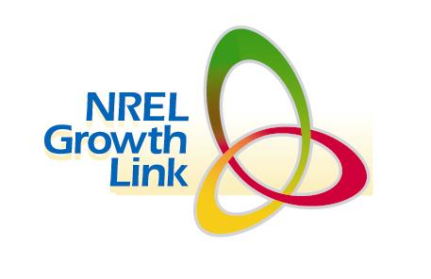

ANNOUNCING GROWTH LINK

Network Electronically with Investors,

Incubators and Strategic Partners

Growth Link is a web-based directory of clean energy companies seeking financing, partnering, and growth opportunities. Investors and energy firms can use the directory to find clean energy technologies that match their investment and strategic interests.
The directory also provides a summary of financing needs, recent news and business information that can be updated regularly to keep the investment community appraised of a company’s progress and partnering needs.

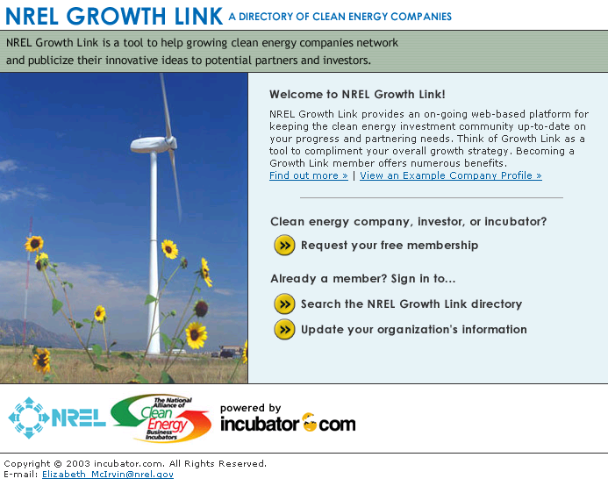

Access to Growth Link is provided free of charge to investors listed in NREL’s Investor Directory, clean energy firms, incubator members of the National Alliance of Clean Energy Incubators, and investors associated with these incubators.

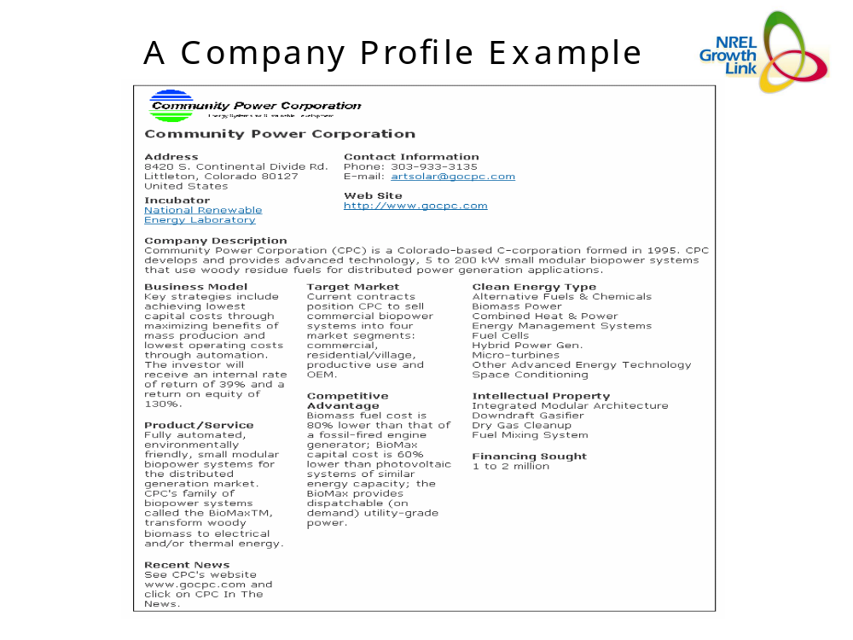

Sign up now or contact us for more information.

To sign up go to: http://nrelgrowthlink.incubator.com/

Additional information addressing common questions & answers is included in the attachment below.

Contact us for more information at:
Liz McIrvin
Phone 303-275-4469
E-Mail Elizabeth_mcirvin@nrel.gov
Or
L.M. (Marty Murphy)
Phone 303-275-3050
E-Mail Lawrence_Murphy@nrel.gov

NREL GROWTH LINK: A Directory of Clean Energy Companies for
Linking Companies and Opportunities

What is “Growth Link”? Growth Link is a business resource program designed with clean energy entrepreneurial companies in mind. It’s a company directory that provides business information to potential investors and/or strategic partners that can help a business be more successful, from start-up to accelerated growth.

- How is Growth Link related to NREL’s Industry Growth Forum’s? The NREL Growth Forums and Growth Link are complimentary programs that provide investors and potential partners with a greater awareness of your company’s future plans, products, and opportunities. The NREL Growth Forums provide face-to-face opportunities to meet and present your business case to investors. Growth Link provides an on-going web-based platform for keeping the investment community up-to-date on your progress and partnering needs. Think of our “Growth Link” as a tool to compliment your overall growth and fund raising strategy.

- What are the criteria for participation in “Growth Link? The criteria used to determine participants for the “Growth Link” Directory include, but are not limited to, the following: Companies must be technology based clean energy firms; companies must have active web sites;

- Will this participation cost me anything? No. We'll host your company on our “Growth Link” resource directory free of charge. In exchange for your participation, we'll simply ask you to keep your information updated.

- Where will the information reside? The information resides on our partner site, incubator.com,
which is a project of the Rensselaer Incubator Program (Rensselaer is an active member of the Incubator Alliance). This partnership allows us to offer a specialized site for the clean energy community that is also part of the global incubator.com community.

Is the site secure? Yes, the site and the information contained within it are secure. Only registered members will be able to access your information, and only you or an NREL administrator will be able to update your organization’s information.

Who will have access to the site? Companies that sign up on the directory will have access to the site. Also, investors that are part of the NREL Investor Directory, as well as Alliance Incubators and their investor colleagues will have access through a password. And though the access is limited, we ask that only non-proprietary information be put on the site.

- Will other clean energy companies be able to see other clean energy company inputs? Yes. But only you will be able to edit/change your information.

- How do I sign up? It's easy. Just visit our site at http://nrelgrowthlink.incubator.com/ and submit an application. You should be notified within 48 hours of your acceptance and can then begin placing your information on the website.

- What kind of companies should sign up? Entrepreneurial clean energy companies linked to producing and/or deploying clean energy technologies. Our definition for clean energy includes renewable energy, fuel cells, energy efficiency, hybrid-renewable technologies and other related technologies such as those that facilitate distributed generation options. Companies should emphasize the energy relevance for their technologies.

