TC4 ER-2 Science Flight: Aug 5, 2007
Flight Report

Flight Scientists: S. Platnick, P. Newman
Sortie: 07-9027
Pilot: Dave Wright

Takeoff (MROC): 1255 UTC (7:00 AM local)
Landing (MROC): 1740 UTC (11:30 PM local)
Duration: 4.7

Objectives:

- Obtain coordinated overflights of cirrus outflow with the WB-57 and DC-8 for microphysical retrievals and radiative closure.

Satellite Coordination:

Terra overpass of San Jose at 1600 UTC (see map below, courtesy M. Nordeen et al.). IASI (MetOp) overpass at 1527 UTC.

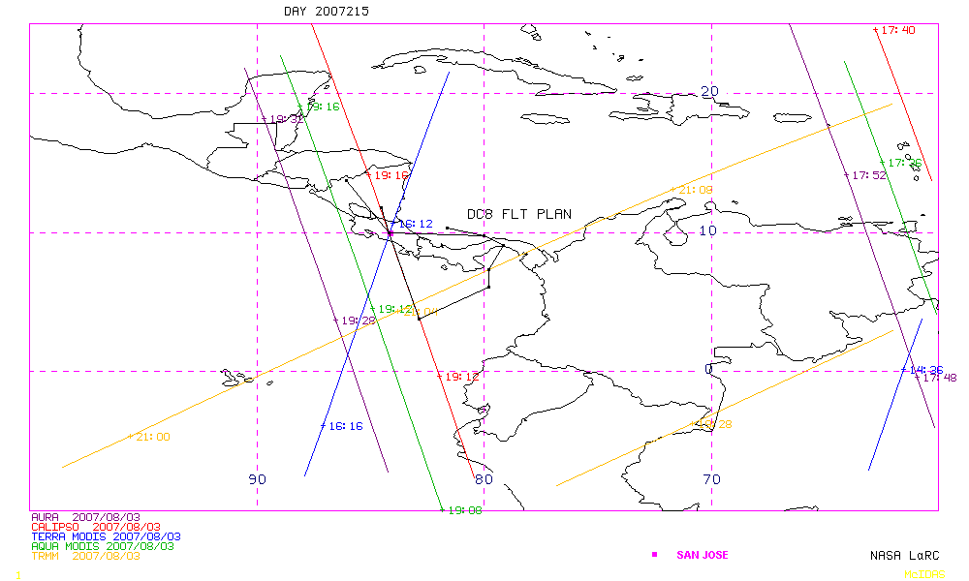

Flight Plan Summary (see RTMM maps):

All three aircraft took off 45 min early due to delays in getting the WB-57 towed out of its hangar. The racetrack was moved to an east-west orientation in the Panama Bight at about 6.5°N in order to catch outflow cirrus from a convective core at about 79°W. The ER-2 joined the DC-8 on the racetrack at about 1350 UTC. On the first leg the ER-2 extended its line about 80 km beyond the DC-8 line in order to overfly the core, however CPL/REVEAL data indicated that cirrus tops on the order of 15 km decreased to 13-14 km over what was thought to be the core.

The ER-2 broke off from the racetrack at the northeast point at about 1615 UTC and turned to the northwest to overfly a cell that had been active over the Azuero Penninsula of Panama (CPL/REVEAL indicated ~15 km max tops along that run). Then the ER-2 turned to the west to overfly a cell off the coast of the Panamanian-Costa Rican border that was associated with lightening (and associated with a line of convection off the coast that had been active all morning); CPL/REVEAL indicated strong returns at ~15.5 km over the cell). Then the ER-2 returned to San Jose.
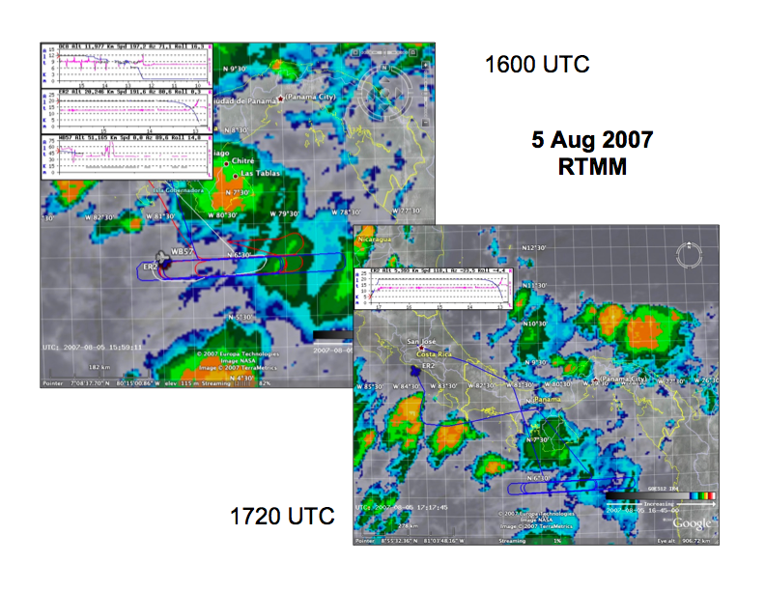

blue line: ER-2 flight track
red line: DC-8 flight track
GOES IR image

Flight track w/time code courtesy of NASA Ames Airborne Science & Technology Facility, R. Dominguez et al.

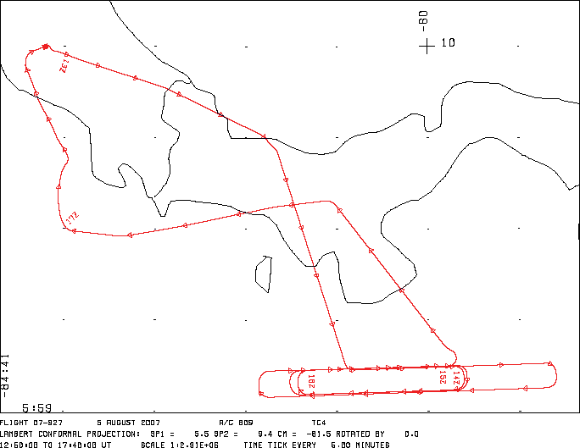

Comments:

Pilot reported turbulence towards end of flight coming off the western edge of the cell that was off the coast of the Panamanian-Costa Rican border (contained lightening and associated with a line of convection off the coast that had been active all morning). The turbulence was due to autopilot trying to follow a sudden increase in temperature (from -68° to -62°). CPL/REVEAL indicated strong returns at ~15.5 km over the cell. Temperatures elsewhere in the flight were -70° to -71°.
MODIS Terra QuickLook Imagery

MODIS Rapid Response (courtesy J. Schmaltz, GSFC): RGB = 0.87, 1.6, 2.1 µm

White clouds indicate liquid water, strong coral/redish color clouds indicate ice, slightly redish clouds might indicate larger water droplets and/or ice particles and/or cirrus overlying water clouds.

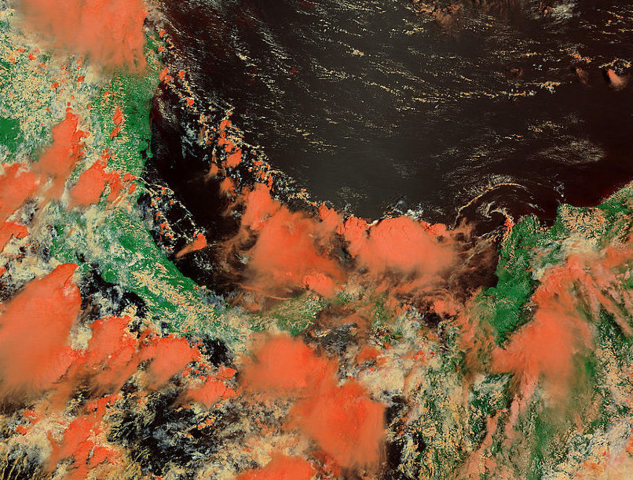
Cloud being worked at time of Terra overpass (1613 UTC)
MODIS Cloud Product Quicklooks (courtesy K. Strabala, Wisconsin CIMSS): Cloud Top Pressure.

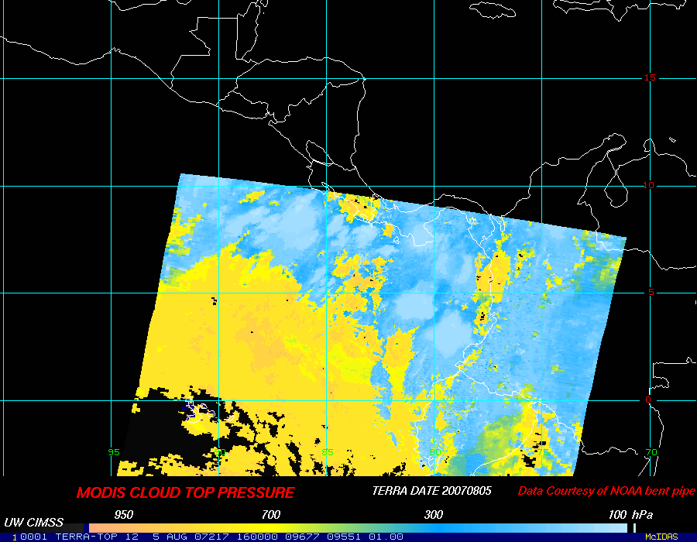
Cloud being worked at time of Terra overpass (1613 UTC)

Cloud Physics Lidar (CPL) Quicklook

CPL shows 14-15 km cirrus tops throughout the flight (courtesy B. Hart, M. McGill GSFC).

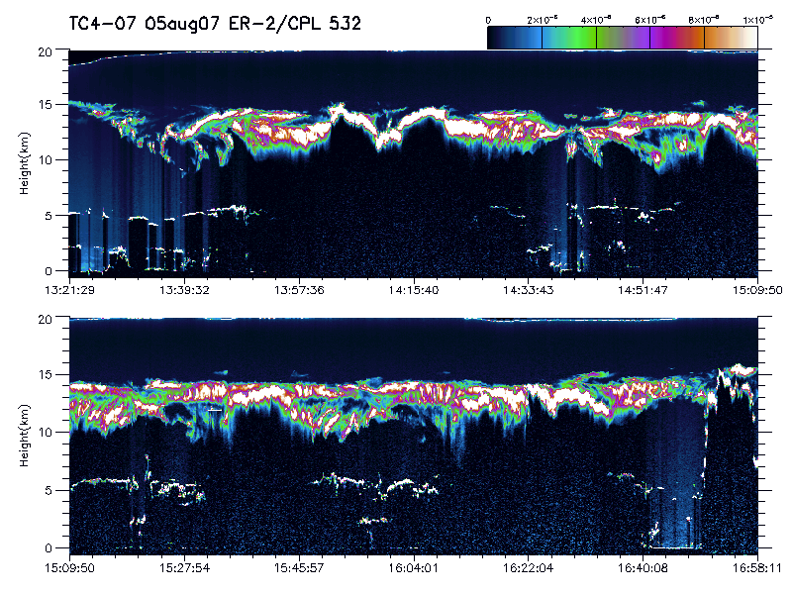
ER-2 Science Instrument Payload and Status:

Instrument | Status | Notes
CPL  Cloud Physics Lidar | G
CRS  Cloud Radar System | G
EDOP  ER-2 Doppler Radar | G
AMPR  Advanced Microwave Precipitation Radiometer | G
CoSSIR  Compact Scanning Sub-mm wave Imaging Radiometer | G | In cross-track scanning mode
MASTER  MODIS/ASTER Airborne Simulator | G
S-HIS  Scanning High Resolution Interferometer | G
IR Radiometer  Broadband flux radiometer  (nadir & zenith) | G
SSFR  Solar Spectral Flux Radiometer  (nadir & zenith) | G
MVIS  video camera | G
MTP  Microwave Temperature Profiler | G

G = good; P = partial data collected; F = failure, no data

