UnB-LOD, A Visual Tool to Work With Linked Open Data

Marcus Oliveira Silva, Rommel Novaes Carvalho, Marcelo Ladeira,
marcus.oli.silva@gmail.com, rommel.carvalho@cgu.gov.br, mladeira@unb.br,
Henrique Aparecido da Rocha, Gilson Libório de Oliveira Mendes
henrique.rocha@cgu.gov.br, liborio@cgu.gov.br

Resumo
Integrar dados heterogêneos disponíveis na Web não é uma tarefa trivial porque, em geral, os desenvolvedores devem codificar as transformações e o mapeamento a fim de obter dados integrados. Também não é incomum que usuários com conhecimento básico de TI e dos formatos de representação de dados estejam interessados em utilizar dados abertos em diferentes tarefas, por exemplo, escrever uma reportagem sobre gastos governamentais. Sem uma ferramenta de fácil utilização, os usuários não seriam capazes de tirar partido de todos os dados disponíveis, por exemplo, para utilizar na reportagem todos os dados sobre gastos governamentais disponíveis no portal www.transparencia.gov.br. Esse artigo apresenta o UnB-LOD, uma ferramenta de código aberto, em fase de protótipo, visual e fácil de usar, que permite a usuários com conhecimento mínimo sobre estruturas de dados: (1) transformar conjuntos de dados para conjunto de dados estruturados como RDF; e (2) a fusão de diferentes conjuntos de dados em um conjunto de dados consistente, seguindo os princípios e padrões de dados ligados por meio de modelagem visual e manipulação gráfica de dados.

Palavras-chave: Dados abertos, CSV, Integração de dados, RDF, GUI

Abstract
Integrating the heterogeneous data available in the web is not trivial. Developers usually need to hard code the transformation and the mapping of the data in order to make them useful. Moreover, it is not uncommon to have users, with basic IT or data knowledge, interested in consuming Open Data for different tasks (e.g., to write an article about Government expenditure). Without an easy to use set of tools, users would not be able to leverage on all the data available (e.g., all the Brazilian Government expenditure data available at www.trasparencia.gov.br). This paper introduces UnB-LOD, a visual and easy to use open source tool, still in prototyping phase, that allows users with a minimum knowledge on data structures to perform: (1) the transformation of data sets to RDF structured data sets; and (2) visual data modeling and graphical manipulations to fuse different data sources into a new and consistent one, following the Linked Data principles and patterns.

Key Words: Open Data, CSV, Data Integration, RDF, GUI

Introduction

The Open Data movement grows rapidly, countries around the world have been publishing information produced by their public bodies on the Web according with specific standards, such as Linked Data (BREITMAN et al., 2012). In what follows will be introduced the UnB-LOD a tool that use Linked Data technology to work with Open Data.
This work has the main focus of supporting the data fusion activities of the Brazilian Office of the Comptroller General (CGU). CGU is the agency of the Federal Government in charge of assisting the President of the Republic in matters which, within the Executive Branch, are related to defending public assets and enhancing management transparency through internal control activities, public audits, corrective and disciplinary measures, corruption prevention and combat, and coordinating ombudsman’s activities. CGU has a main branch located in the city of Brasília, where most of the administrative and Information technology (IT) activities are concentrated, and several others local branches, one in each Brazilian capital. Therefore, the vast majority of the CGU’s data is stored and maintained in the main branch.
Having most of the IT experts and data concentrated in the main branch has its advantages. However, the problem is how to make this data easily available to the local branches. Not only for consulting, but also for generating new knowledge when fusing with local databases, usually obtained during local auditing.
While the IT professionals have the necessary professional tools and expertise for activities related to Extract, Transform and Load (ETL) and Data Warehouse (DW) processes, they are not able to keep up with the demand of all local branches. The major problem is the lack of those IT professionals in the local branches. However, hiring more IT professionals is not an alternative. Therefore, there is a crucial need from the workers with a minimum IT knowledge to be able to consume and integrate the data. For example, during an investigation, an auditor might want to cross Internal Revenue Service data from the main branch with local public bidding data to find irregularities. Despite the main branch efforts of integrating all the different databases it acquires, it is not possible to forecast all the particularities and specific needs from all investigations in the local branches.
Due to these reasons, the ideal scene is to make the main branch data available to the local branches users and give them an easy to use tool that allow the data integration and manipulation. The following example illustrates the observations and problems presented. In the main branch server there is a database with all the federal employees, their salary, etc. However, there is no data about the local government employees. In the local branch, an auditor might have that data available or acquire it during an investigation or with a partnership with the local government. This data could be in any known format, e.g., CSV dumps or SQL endpoints, etc. In this scenario, he/she may want to combine these data in order to check if there is an accumulation of illegal public functions (in Brazil, only professors and health professionals can have more than one public job).
Section 1 introduces the UnB-LOD. Section 2 explains the architecture of UnB-LOD. An study case is detailed in the Section 3, showing different approaches to solve Open Government Data (OGD) integration problems, one of these approaches is the use of the UnB-LOD features. Section 4 shows related work and Section 5 has the conclusion.

1 The UnB-LOD Proposal
UnB-LOD is a free, open source, and easy to use tool for loading and integrating data. Although its use has been focused on government data, UnB-LOD can be used to manipulate any kind of Open Data (ACCAR, ALONSO, NOVAK, 2009). UnB-LOD adopts Linked Data (BIZER, HEATH, BERNERS-LEE, 2009) standards. One of the reasons for using Linked Data is that Brazil is one of the co-founders of the Open Government Partnership (TAUBERER, 2014), and it is committed to public transparency and the publication of official data (BREITMAN et al., 2012). Besides, as pointed by the W3C:
The desire for an open and transparent government is more than open interaction and participation, appropriate data as products of the government must be shared, discoverable, accessible, and able to be manipulated by those desiring the data. The data as well must be linked via subject, relevance, semantics, context, and more. Linked Data offers the information consumer ways and means to find relevant and pertinent information through search, queries, interfaces, or tools available today and for tomorrow (ACCAR, ALONSO, NOVAK, 2009).
UnB-LOD has a visual appeal, the user will do all the work through a graphical user interface (GUI). The UnB-LOD builds on top of other tools and frameworks, which will be described later. Among the Linked Data standards followed by UnB-LOD are the RDF (Resource Description Framework) and URI (Uniform Resource Identifier) to represent and to manipulate the data (HELBER et al., 2009). With UnB-LOD a user can import data from different sources and of different types (e.g., CSV Brazilian Government expenditure data), which will then be transformed to RDF data associated to a simple RDFS (RDF Schema) ontology to describe the meta-data. Having imported and structured the data it will be possible to integrate and fuse the data.
The following list describes the pipeline of the UnB-LOD’s work-flow:

- Preparation
  - Model and write the dataset
- Data Collection
  - Write the data importation schema
  - Import data from different sources
  - Transform data to structured RDF
- Data Integration
  - Multiple data mapping and data fusion
  - Output a new and consistent data set

UnB-LOD is implemented in Java and it is modularized using Eclipse Rich Client Application (RCP), eclipse RCP provides an easy way to create desktop applications with industry standards. UnB-LOD is still in the prototyping stage.

2 UnB-LOD architecture

UnB-LOD is divided in three main phases, preparation, collection and data integration. Figure 1 illustrates the UnB-LOD architecture and Figure 2 shows the UnB-LOD user interface.

Figure 1 – UnB-LOD architecture
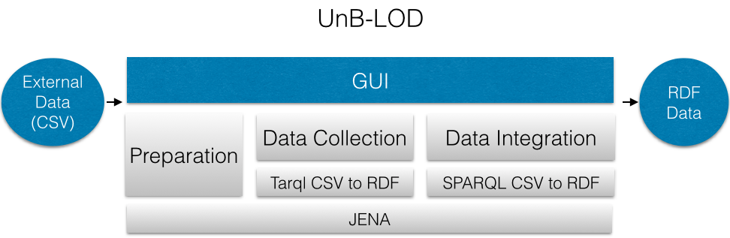

Figure 2 – UnB-LOD GUI
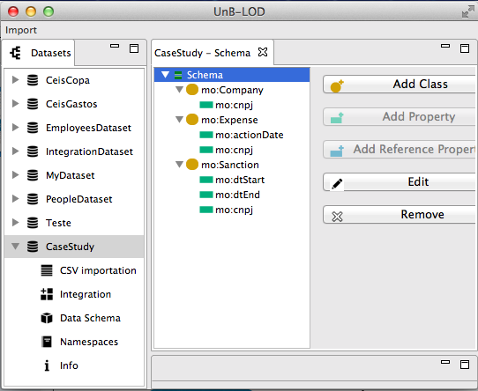

Preparation. To perform data integration using UnB-LOD it is necessary to model a data schema. Each dataset has an associated schema. This schema is similar to RDFS, but simpler. It only has the Class, Property and Reference Property components. The schema was simplified because these components are the minimum required to have an expressive data schema. Future versions will include more components of the RDFS, like inheritance and collections. Using UnB-LOD GUI it is possible to define classes, properties, and relationship between classes. Figure 3 shows the GUI to build a data schema. In the left there is tree representing the schema, there is a class named ex:Client with properties ex:name and ex:id, in the right there are the buttons to add more properties and classes to the schema.
Figure 3 – UnB-LOD Schema GUI

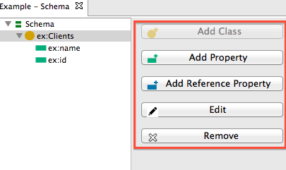

Data Collection. In this phase the user will map and transform, using the GUI, each data
entity to generate a structured RDF dataset from the CSV input only. The data collection phase works on the Tarql API, which is a tool to map CSV to RDF using SPARQL syntax.

Listing 1 – Code 1
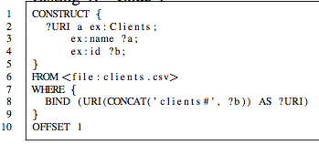

The Listing 1 shows a CSV to RDF mapping using tarql. A CSV file of clients is mapped to a RDF graph. The line 8 shows how to build a URI of the RDF resource based on column B. Columns A and B of the CSV are mapped to the properties ex:name and ex:id. Figure 4 shows the GUI to build a CSV to RDF mapping. Block 1 has a tree that is visual representation of the mapping. Block 2 shows a dialog to input/edit values of a property/column mapping. This dialog is opened when Add Property button or Edit button are clicked.

Figure 4 – UnB-LOD CSV to RDF mapping GUI
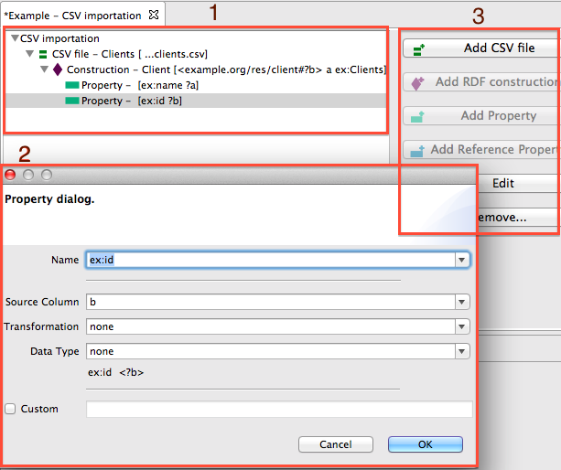

Data Integration. In this phase the user will use the newly structured RDF datasets and will define the vocabulary mappings and data fusion using UnB-LOD’s GUI. The data integration phase works on top of the Jena Framework, UnB-LOD uses the CONSTRUCT syntax from the Jena SPARQL query engine to generate new integrated RDF data.

3 Case study

The objective of this case study is to verify if companies are appearing in direct government expenses data during its period of sanction or suspension, which would be an indicator of a possible illegal action, since companies sanctioned or suspended theoretically could not be receiving money from governmental institutions.
This case study was aimed to conduct an investigation upon the integration of the following databases:

1) CEIS: this database is the national register of sanctioned/suspended companies. These companies cannot celebrate new contracts with the Government during the
time they are suspended;

2) Direct expenditures: this database has information on all Federal Government
direct expenditures since 2010. This information is updated daily.

Table I shows the CSV header from the CEIS dataset and Table II shows the CSV header from the government direct expenditures dataset.

Table 1 – CSV colunms names of CEIS data

Column | Name
A | StartSanction_Date*
B | EndSanction_Date*
C | agency
D | agency_location
E | info_origin
F | Date_Info_Origin
G | Sanction_Type
h | Company_Name
i | Company_Location
j | Company_CNPJCPF*

Table 2 – CSV colunms names of government direct expenditure data

Colunm | Name
A | CNPJ*
B | Company_Name
C | Fantasy_Company_Name
D | CNAE_Cod
E | Company_Type_Cod

The names of the columns are in Portuguese in the original file, a translation was made for better understanding of the text. The columns names followed by * are the ones used in this case study. The CNPJ is the company ID. The objective is to check if a CNPJ in the CEIS dataset match a CNPJ in of the government direct expenditures, during the period defined by the dates in the columns StartSanction_Date and EndSanction_Date.
Figure 5 shows a dataset schema which represents the fusion of the CEIS dataset and the direct expenses data. This figure explains the origin of each value.

Figure 5 – Schema CEIS/Expenses

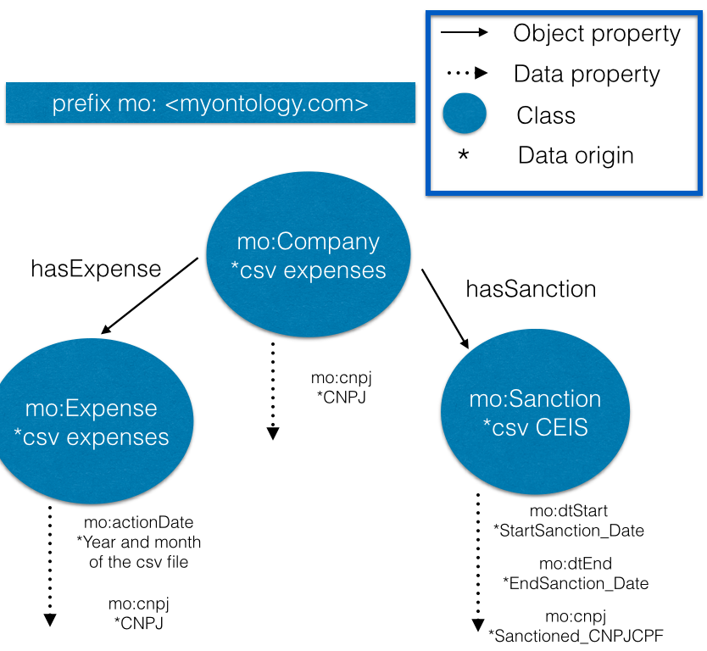

Manual approach: To accomplish this data integration example, with a common and manual approach, a basic user needs to: download all data, use some spreadsheet editing tool, making CSV joins manually, and make filters available in spreadsheets software (e.g. Excel, Google Refine). Besides, he/she needs to do all the work without a methodology or work-flow to guide the process. This approach requires a lot of manual work, it is subject to many errors and has no reuse mindset. Nevertheless, a more efficient and intelligent approach requires more knowledge and skills.
Next, an approach using SPARQL mapping codes and tools to perform the data integration in a more automated and efficient way will be presented. Moreover, it will also be shown how this task can be significantly facilitated when using the UnB-LOD GUI, making it accessible to more users.
Automated approach: In order to do the integration, a user needs to collect and transform the data to a new representation that is useful to his/her purpose. He/She can do that using some tool or coding some script, which is hard for users with little background on data integration.
The Tarql mapping (Listing 2) shows how to perform the transformation of a CSV dataset into an RDF dataset following the integration schema suggested by Figure 5. Lines 5, 18, 47, and 64 shows a CONSTRUCT query that generates RDF resources to the mo:Company, mo:Sanction and mo:Expense classes. Each row in the CSV files, specified by the FROM expression, is mapped to an RDF resource. All the columns of the CSV files can be used as variables in the CONSTRUCT query (e.g., ?CNPJ and ?sanctionStartDate). The BIND keyword binds a variable to an expressions that uses values from columns, the special variable ?URI is created by a bind expression and represents the URI of the resource.

Listing 2 – Code 2

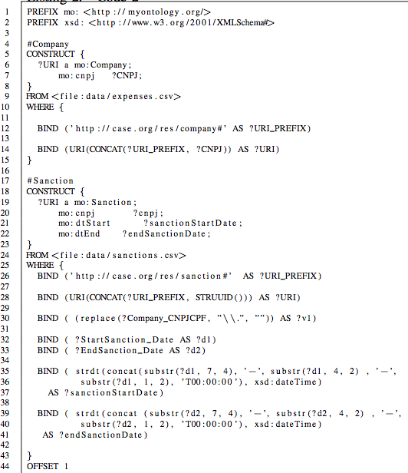
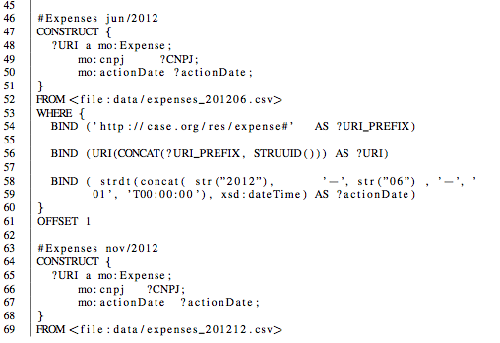

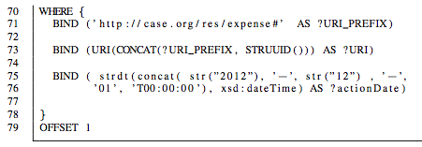

UnB-LOD makes the task of importing data more intuitive and easier. Figure 6 shows the equivalent mapping from the code above, using UnB-LOD’s GUI, a tree modeling representation. The “add CSV File” button in the figure is equivalent to writing a SPARQL FROM expression, the add RDF Construction is equivalent to writing a SPARQL CONSTRUCT query, and add Property or add Reference Property is equivalent to writing BIND expressions and using binded variables as values of the RDF properties in the CONTRUCT block.

Figure 6 – UnB-LOD CSV to RDF schema

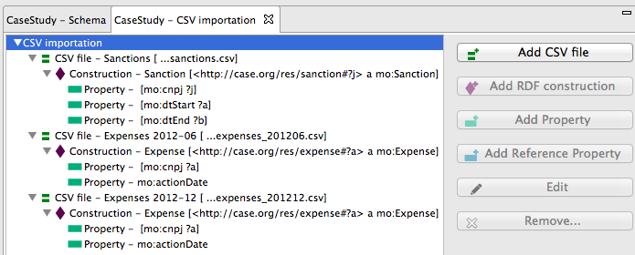

This import would generate some RDF data (show in turtle ) in the Listing 3:

Listing 3 – Code 3
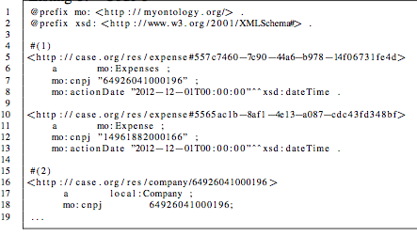

With the output code in Listing 3, since the data is now fused into a single and consistent dataset representation, the user can now perform SPARQL queries to find, for example, the sanctioned/suspended companies which were earning money from the Government in a specific time frame. Applying a SPARQL query in this integrated data it was possible to discover that 219 companies from 44579 were earning money during a sanctioned/suspended time. There isn’t a GUI to write SPARQL queries easily in the UnB-LOD yet, but it is planned to include a graphic SPARQL query builder in the future.

4 Related Work

There is an enterprise software, called Topbraid Composer, that has a semantic data integration visual environment. Topbraid Composer is a modeling tool and a collection of integrated Semantic Web solutions. But Topbraid Composer is a proprietary software and has payed licenses. Topbraid Composer is used by Semantic Web experts while UnB-LOD focuses on non-experts users, having a simple interface and more intuitive concepts to work with Linked Open Data. For more details, see http://www.topquadrant.com/tools/ide-topbraid-composer-maestro-edition/.
There are several free tools that transforms or extract RDF from spreadsheets and CSV. NOR2O is a library for transforming non-ontological resources to ontologies. The last version was released in 2010-11-26. Now a days, there is no technical support for this library. Apache Anything To Triples (Any23) is a library, a web service and a command line tool that extracts structured data in RDF format from a variety of Web documents, including CSV. RDF123 is an application and web service for converting data in simple spreadsheets to an RDF graph. RDF123 was released in 2008 at University of Maryland Baltimore County. The required background on IT to use these tools are higher than the one required to use UnB-LOD. UnB-LOD is ease to use for no IT expert because the its GUI. The UnB-LOD's user need have no deep knowledge in IT because the CSV to RDF schema is guided by buttons (as show in Figure 6).

5 Conclusion

Data collection and integration can be a challenging task. On the one hand, a manual approach requires more work, it is subject to errors, and it usually cannot be reused once new data becomes available. On the other hand, using more advanced techniques, like writing some scripts or modeling data mappings requires specific knowledge and skills. This paper presents UnB-LOD, a visual tool that can simplify the work, increase the reuse, and decrease the required knowledge, while still allowing more complex data manipulations to be performed. These manipulations can also be accomplished using tools like spreadsheets. However, it requires much more work than using UnB-LOD.
Future work will allow: exporting the data to different formats (e.g., XML, SQL); the use of inheritance in the schema modeling; scheduling tasks to make the UnB-LOD more automated; and a GUI to build SPARQL queries.

References

ACCAR, S.; ALONSO, J.; NOVAK , K. Improving Access to Government through Better Use of the Web. W3C Interest Group, 2009.

BIZER, C.; HEATH, T.; BERNERS-LEE, T. Linked Data - The Story So Far. International Journal on Semantic Web and Information Systems (IJSWIS), v.5, n.3, pp. 1-22, doi:10.4018/jswis.2009081901, 2009.

BREITMAN, K. S.; CASANOVA, P.; SARAIVA, M.A.; VITERBO, D.; MAGALHÃES, J.; FRANZOSI, R.P.; CHAVES, E. Open Government Data in Brazil. Intelligent Systems, IEEE. v. 27:3, pp. 45-49, 2012.

HELBER, J.; FISHER M.; BLACE, R.; PEREZ-LOPEZ, A. Semantic Web Programming. Indianapolis: Wiley, 2009.

TAUBERER, J. Open Government Data: The Book. 2^{sn} ed. Civic Impulse LLC, http://opengovdata.io/, 2014

http://www.w3.org/RDF/
http://www.w3.org/wiki/URI
http://www.w3.org/TR/rdf-schema/
http://www.eclipse.org/home/categories/rcp.php
http://www.w3.org/TR/rdf-schema/
https://github.com/cygri/tarql/
https://jena.apache.org/
http://www.portaldatransparencia.gov.br/ceis/Consulta.seam
http://www.portaltransparencia.gov.br/PortalComprasDiretasPrincipal2.asp
http://www.w3.org/TR/turtle/

