

Business Template

Transactions
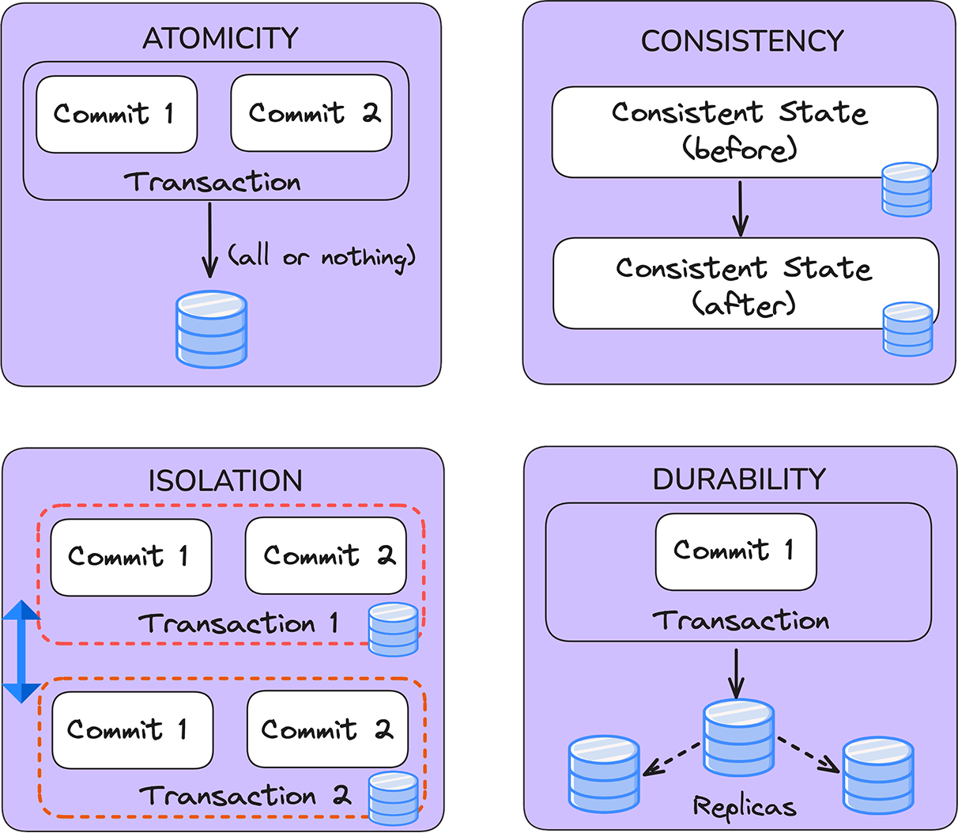

Observations & Issues Encountered
- Rollback Requirement on Query Errors: When I attempt to execute the required tasks, any mistake within a query causes the transaction to fail. I must explicitly roll back the transaction to proceed, as the transaction state remains failed until reset.
- Existing Transaction Detected: At times, I encounter the message "there is already a transaction in progress", indicating that a previous transaction was not properly closed.
No Visible Changes in System Columns: After including the required commands, I observe that system columns such as cmin and cmax consistently return 0, even when running the same code as in previous tasks. For reference:
SET TRANSACTION ISOLATION LEVEL REPEATABLE READ;
SHOW TRANSACTION ISOLATION LEVEL;
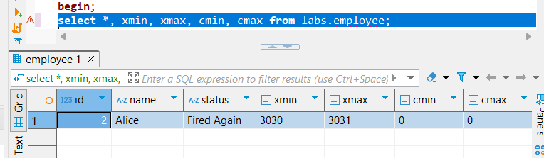
- Serializable Isolation Behavior: While testing serializable isolation, I attempted to simulate a phantom read anomaly by inserting a new row from a separate session during an ongoing transaction. The system correctly prevented the anomaly, demonstrating the expected behavior of serializable isolation.
- Read Committed Isolation Behavior:
  - When using READ COMMITTED isolation, I was unable to update an entry if another session was holding an open transaction on the same data. I had to commit the first session before proceeding with the update in the second.
  - This isolation level also appeared to introduce longer loading times in some cases.

Task Execution Steps

0) Table Creation and Row Insertion
-- Drop existing table if it exists
DROP TABLE IF EXISTS labs.employee;

-- Begin a new transaction for table creation
BEGIN;
CREATE TABLE IF NOT EXISTS labs.employee (
ID SERIAL,
name VARCHAR(255),
status VARCHAR(255)
);
COMMIT;

-- Insert initial data
INSERT INTO labs.employee (name, status) VALUES
('Alice', 'active'),
('Bob', 'inactive');

1) Serializability Anomaly (Phantom Read Simulation)
Session 1
BEGIN ISOLATION LEVEL SERIALIZABLE;

-- Read current active employees
SELECT * FROM employee WHERE status = 'active';

-- Wait...

-- Insert another active employee
INSERT INTO employee (name, status) VALUES ('Diana', 'active');

-- Inspect transaction and command metadata
SELECT *, xmin, xmax, cmin, cmax FROM employee;

COMMIT;

This scenario attempts to demonstrate a phantom read. Initially, only one active employee is visible. After the insert and before commit, more than one "active" employee is present—representing a potential serialization anomaly.
Session 2
BEGIN ISOLATION LEVEL SERIALIZABLE;

-- Insert a new active employee
INSERT INTO employee (name, status) VALUES ('Charlie', 'active');

-- Check internal transaction metadata
SELECT *, xmin, xmax, cmin, cmax FROM employee WHERE name = 'Charlie';

COMMIT;

2) Lost Update Anomaly
Session 1
BEGIN;
SET TRANSACTION ISOLATION LEVEL READ COMMITTED;

-- Read Alice's status
SELECT status FROM labs.employee WHERE name = 'Alice';

-- Attempt to update Alice's status
UPDATE labs.employee SET status = 'Active' WHERE name = 'Alice';

-- Wait...

COMMIT;

Session 2
BEGIN ISOLATION LEVEL SERIALIZABLE;

-- Insert a new employee during the other session's transaction
INSERT INTO employee (name, status) VALUES ('Charlie', 'active');

-- View metadata for inserted row
SELECT *, xmin, xmax, cmin, cmax FROM employee WHERE name = 'Charlie';

COMMIT;

