- Ideapad gaming 3:
  - Procesador: Core i7 2.30GHz
  - RAM instalada: 16GB (15,7 usable)
  - Sistema operativo: Windows
- Carga de archivos:
Consulta 1:
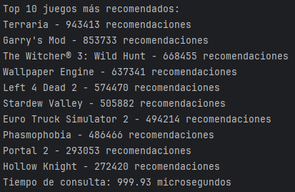
Consulta 2:
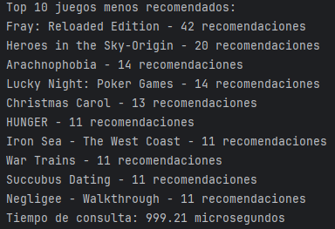
Consulta 3:
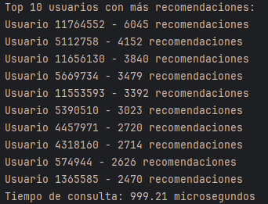
Consulta 4:
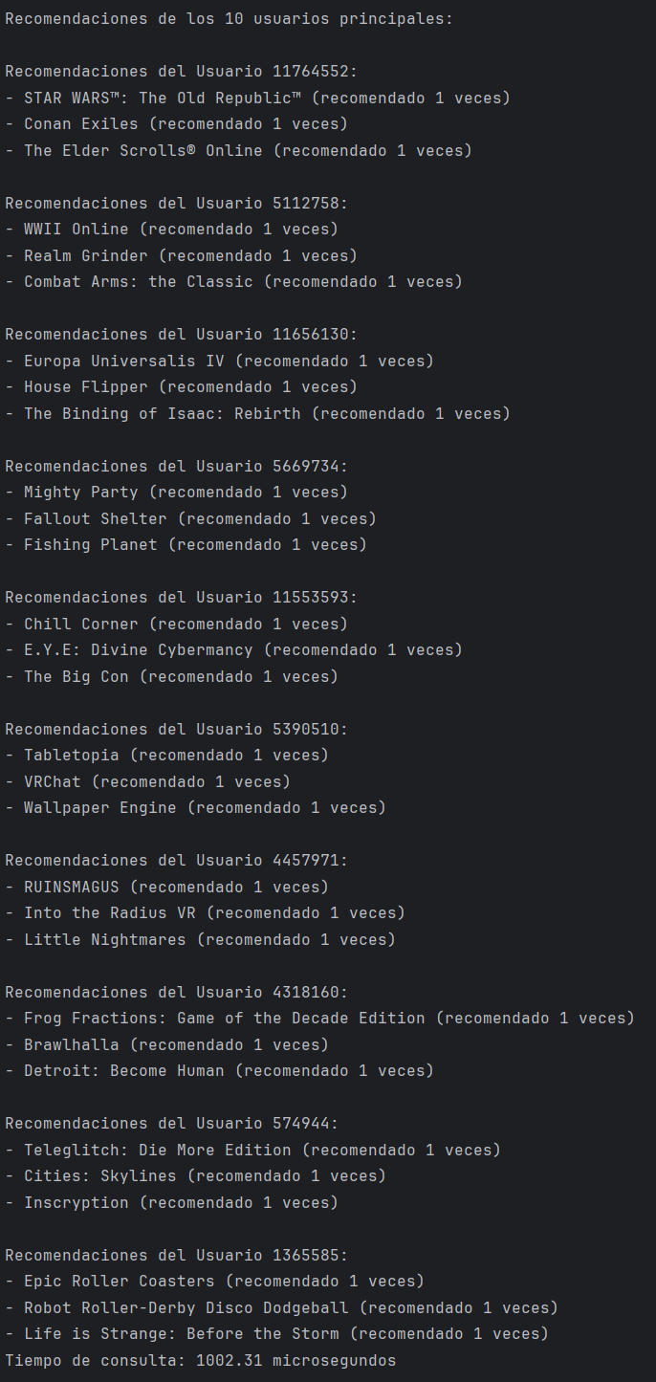

Version 1 10/04 (7:55pm)
Version 2 10/04 (8:00pm)
Version 3 10/04 (8:05pm)
Version 4 10/04 (8:10pm)

