Proiect "Firmă de recrutare"

Conținut:

* Membrii
* Introducere
* User Stories
* Operații CRUD – Echipă
* Use Cases
* System sequence diagram
* Modelul de date şi arhitectură
* Clase Entity
* EJB­uri
* Servleți
* Glassfish-web.xml
* web.xml
* Poze pagini web
  + Home
  + Despre
  + Înregistrare
  + Jobs
  + Logare
  + Candidați aleşi
  + Utilizatori
  + Poziții
  + Poziții in curs de aprobare
  + Poziții inactive
  + Comentarii
  + Adaugă comentarii la Poziții
  + Adauga comentarii la Candidat
  + Aplicanți
  + Candidați propuşi
  + Candidați aleşi
  + Internaționalizare

Membrii:

* + Cătănoiu Gabriela-Anamaria (Team Leader), grupa 235/1
  + Băluță Ionuț-Alexandru, grupa 235/1
  + Roşca Ştefania Cristina, grupa 235/1
  + Şerbănescu Andrei-Vasile, grupa 235/1

User Stories:

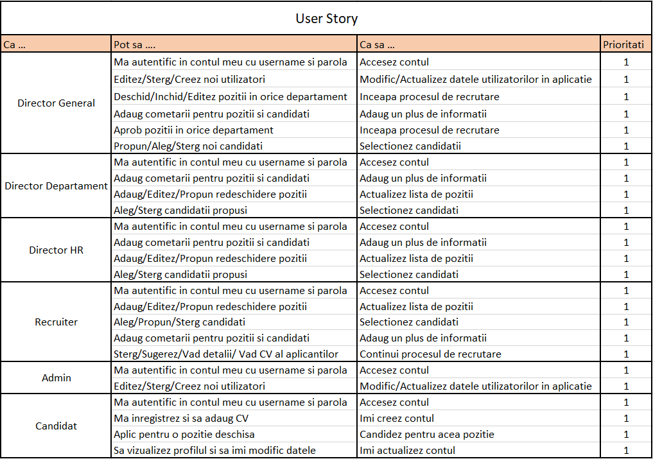

Operații CRUD - Echipă:

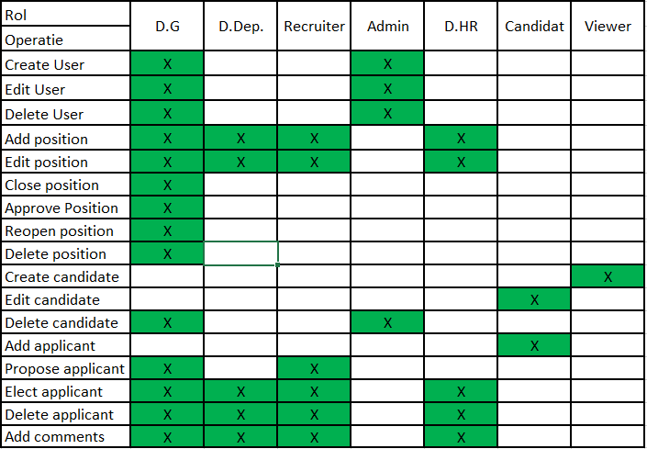

Cătănoiu Gabriela-Anamaria

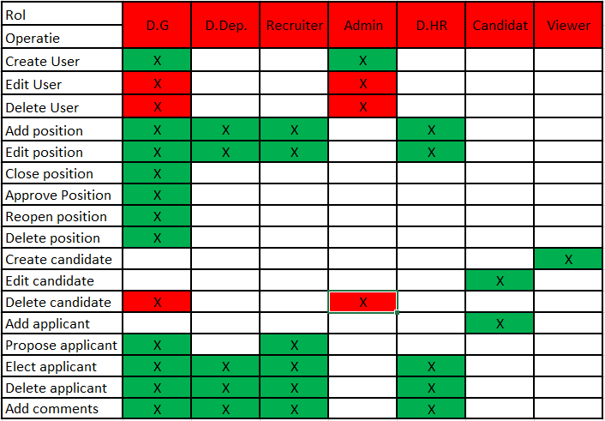

Roşca Ştefania Cristina

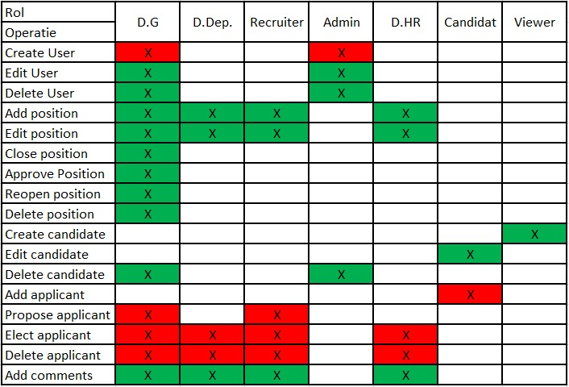

Şerbănescu Andrei-Vasile

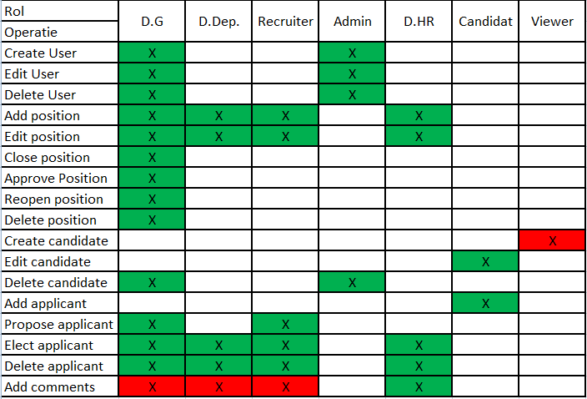

Băluță Ionuț-Alexandru

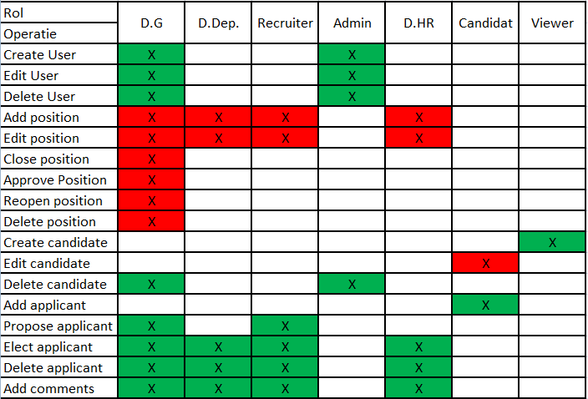

Use Cases:

Cătănoiu Gabriela-Anamaria

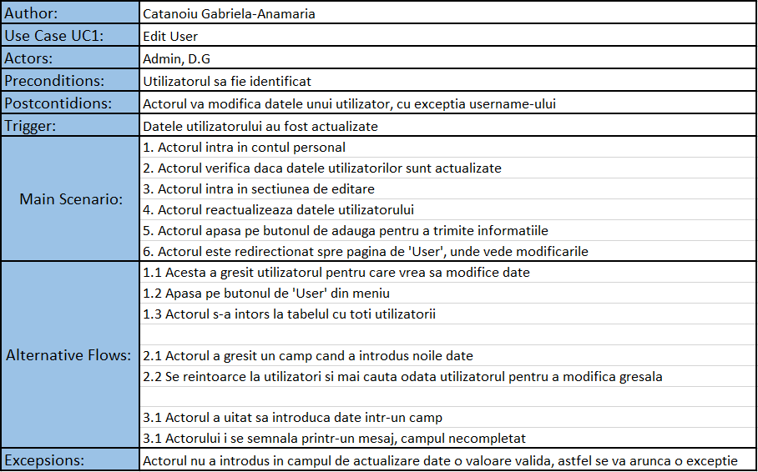

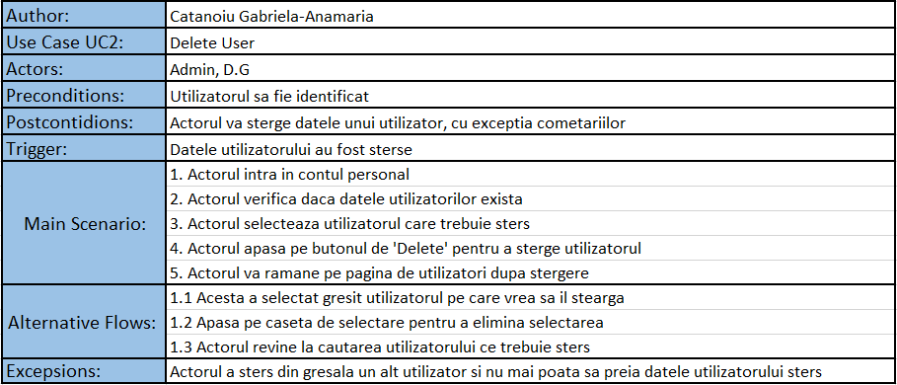

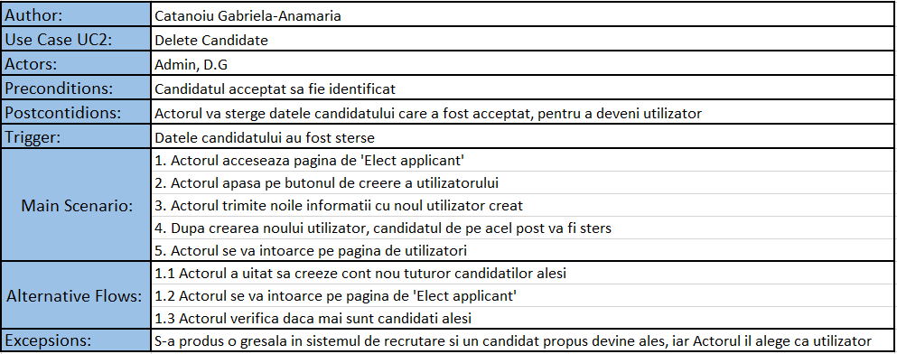

Roşca Ştefania Cristina

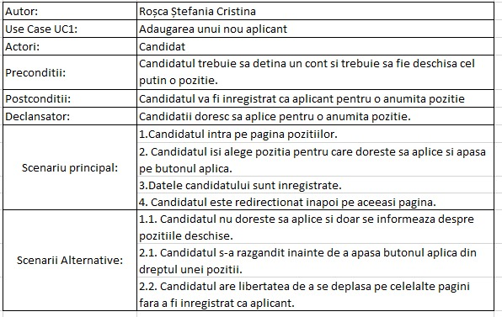

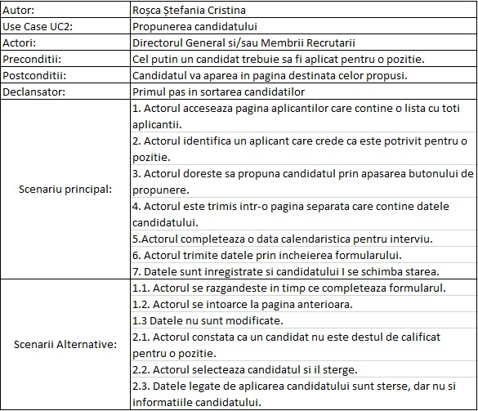

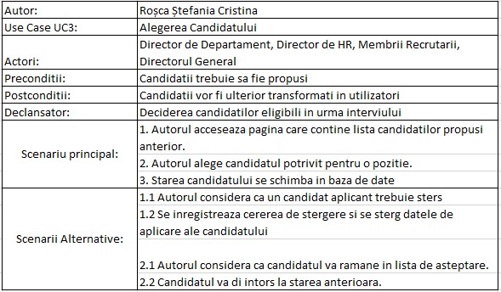

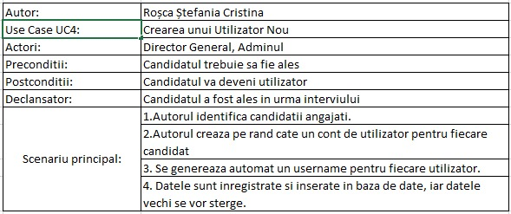

Şerbănescu Andrei-Vasile

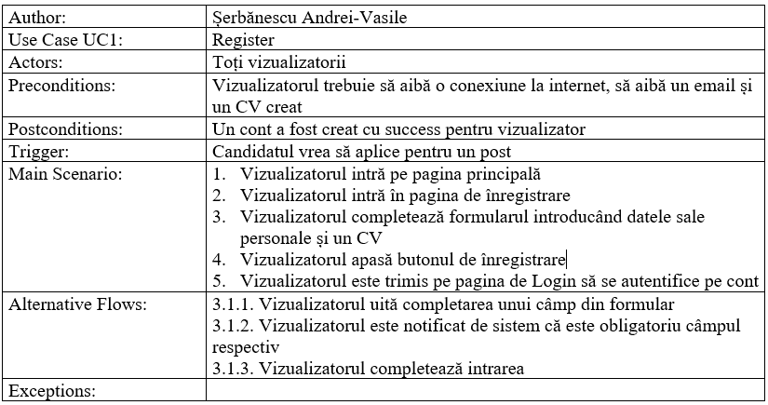

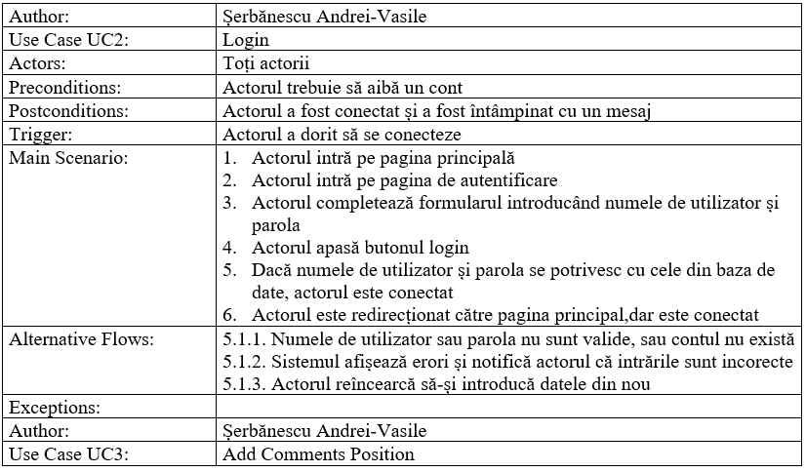

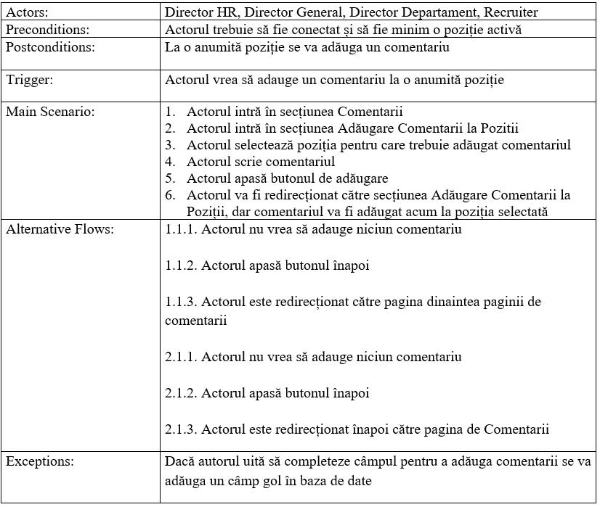

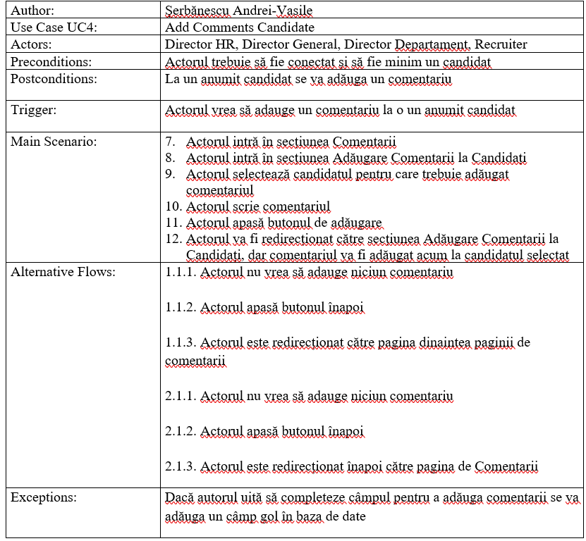

Băluță Ionuț-Alexandru

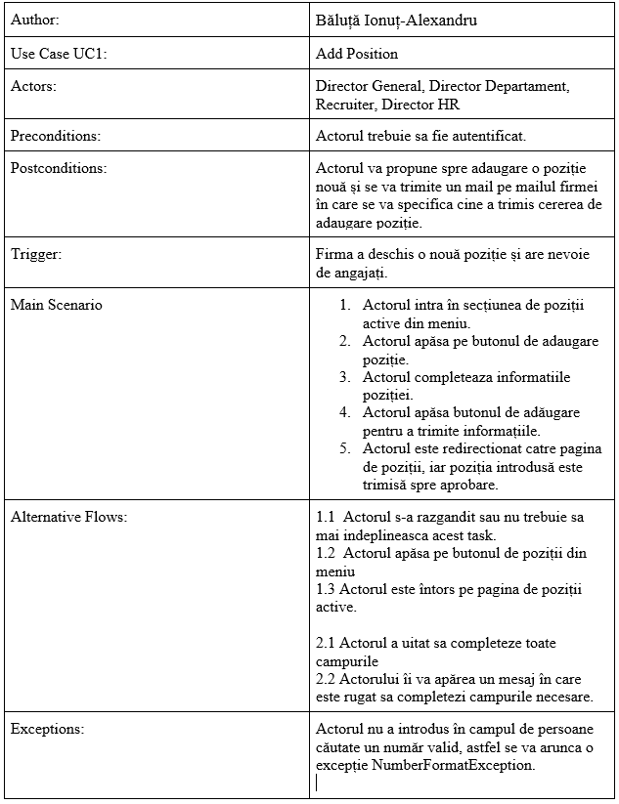

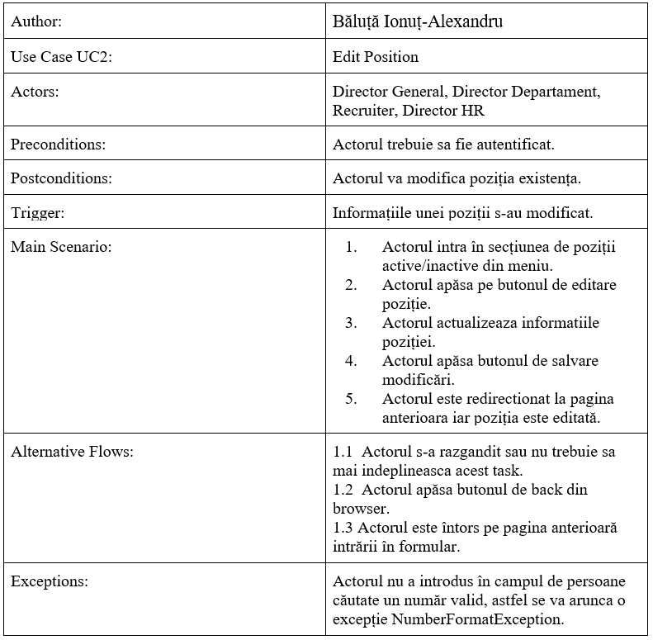

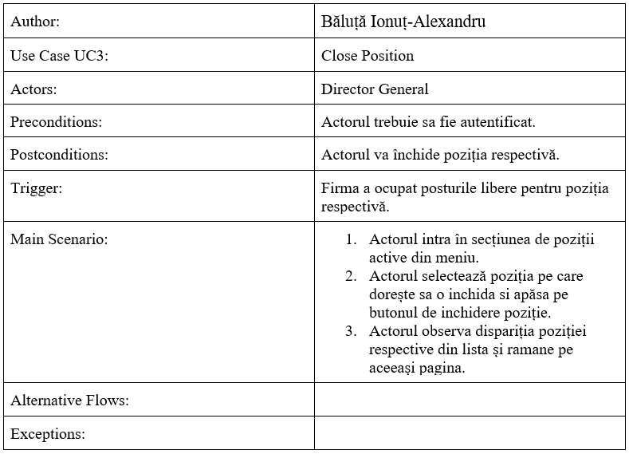

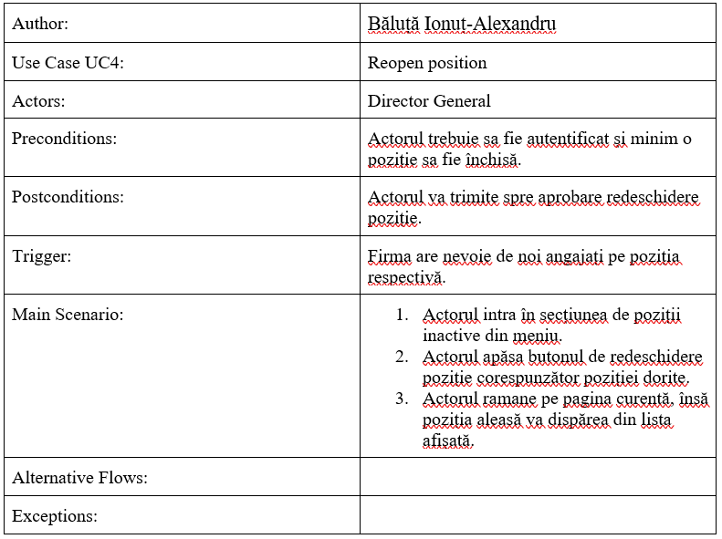

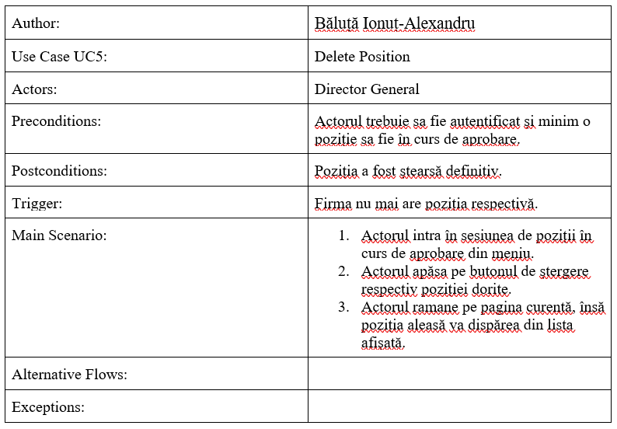

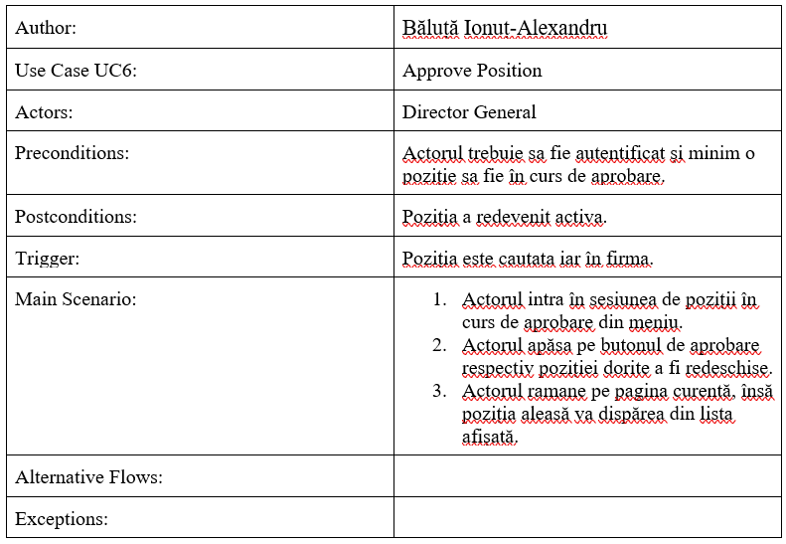

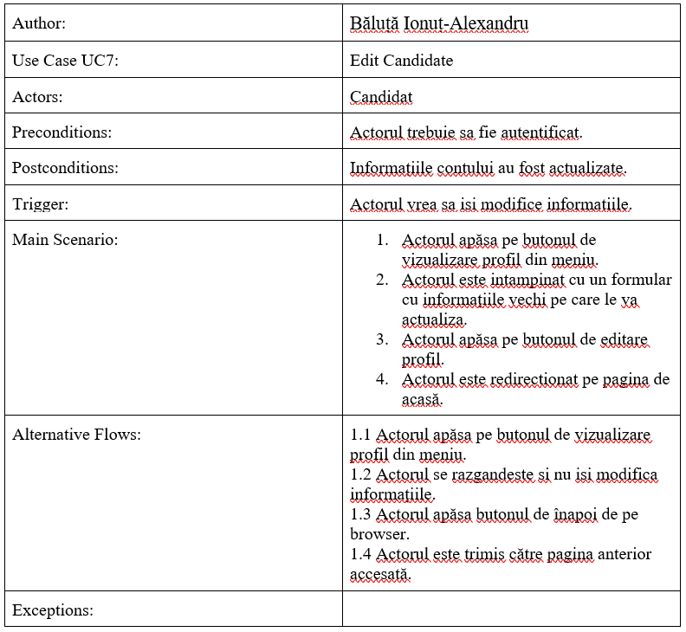

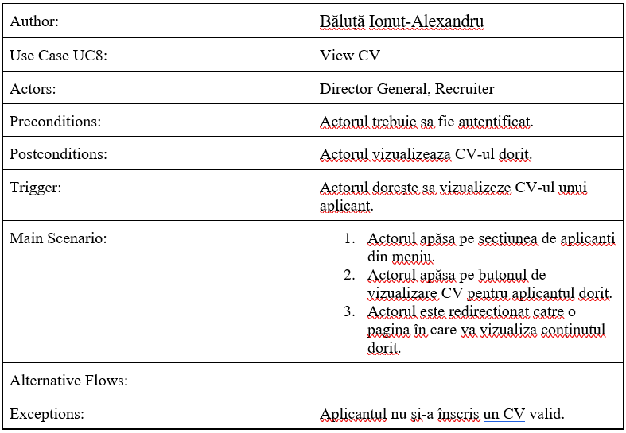

**[System sequence diagram](https://en.wikipedia.org/wiki/System_sequence_diagram)**

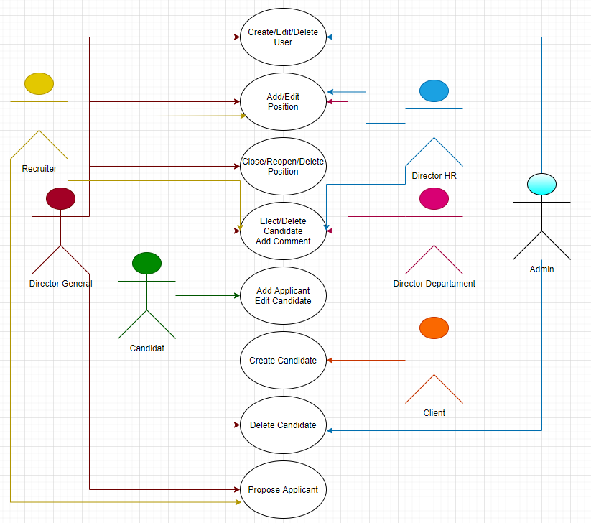

Modelul de date si arhitectură:

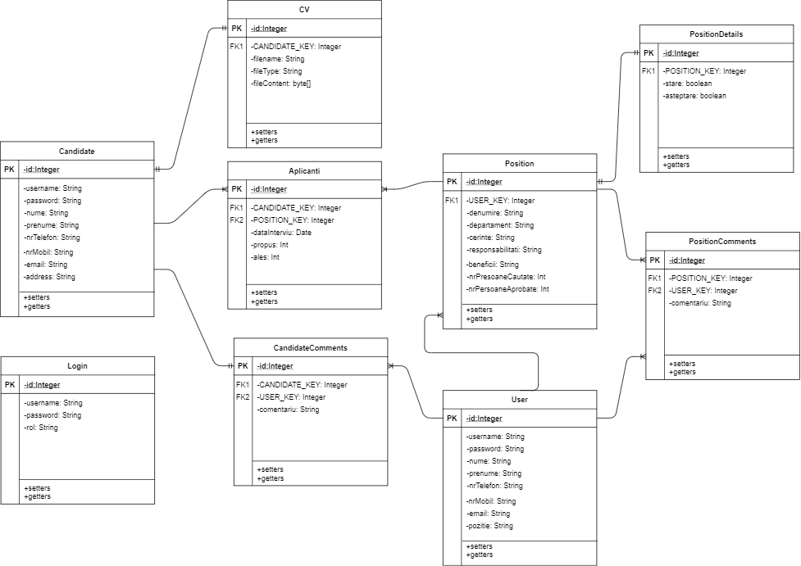

Clase Entity:

* Aplicanti
* CV
* Candidate
* CandidateComments
* Login
* Position
* PositionComments
* PositionDetails
* User

EJB­-uri:

* AplicantBean
* CandidateBean
* CommentsCandidateBean
* CommentsPositionBean
* I18n
* LoginBean
* PositionBean
* UserBean

Servleți:

* About
* AddCommentsCandidate
* Applicants
* CandidateProfile
* ChangeLanguage
* Choose
* Comments
* CommentsCandidate
* CommentsMenu
* CommentsPosition
* CreateUser
* CvFile
* EditUser
* Elect
* Home
* Login
* Logout
* Proposed
* Register
* Suggest
* UndoProposition
* User
* ViewCv

Glasshfish-web.xml

<?xml version="1.0" encoding="UTF-8"?>

<!DOCTYPE glassfish-web-app PUBLIC "-//GlassFish.org//DTD GlassFish Application Server 3.1 Servlet 3.0//EN" "http://glassfish.org/dtds/glassfish-web-app_3_0-1.dtd">

<glassfish-web-app error-url="">

<security-role-mapping>

<role-name>AdminRole</role-name>

<group-name>ADMIN</group-name>

<group-name>DG</group-name>

</security-role-mapping>

<security-role-mapping>

<role-name>DirectorGeneralRole</role-name>

<group-name>DG</group-name>

</security-role-mapping>

<security-role-mapping>

<role-name>PositionRole</role-name>

<group-name>HR</group-name>

<group-name>DD</group-name>

<group-name>DG</group-name>

<group-name>RECRUITER</group-name>

</security-role-mapping>

<security-role-mapping>

<role-name>RecruiterRole</role-name>

<group-name>RECRUITER</group-name>

<group-name>DG</group-name>

</security-role-mapping>

<security-role-mapping>

<role-name>CandidateRole</role-name>

<group-name>CANDIDATE</group-name>

<group-name>DG</group-name>

<group-name>ADMIN</group-name>

<group-name>DD</group-name>

<group-name>HR</group-name>

<group-name>RECRUITER</group-name>

</security-role-mapping>

<security-role-mapping>

<role-name>ClientRole</role-name>

<group-name>CANDIDATE</group-name>

</security-role-mapping>

<class-loader delegate="true"/>

<jsp-config>

<property name="keepgenerated" value="true">

<description>Keep a copy of the generated servlet class' java code.</description>

</property>

</jsp-config>

</glassfish-web-app>

Web.xml

<?xml version="1.0" encoding="UTF-8"?>

<web-app xmlns="http://xmlns.jcp.org/xml/ns/javaee"

xmlns:xsi="http://www.w3.org/2001/XMLSchema-instance"

xsi:schemaLocation="http://xmlns.jcp.org/xml/ns/javaee http://xmlns.jcp.org/xml/ns/javaee/web-app_4_0.xsd"

version="4.0">

<session-config>

<session-timeout>

30

</session-timeout>

</session-config>

<login-config>

<auth-method>FORM</auth-method>

<realm-name>jdbcRealm</realm-name>

<form-login-config>

<form-login-page> /Login </form-login-page>

<form-error-page> /Login </form-error-page>

</form-login-config>

</login-config>

</web-app>

Poze aplicație web

Home



Despre

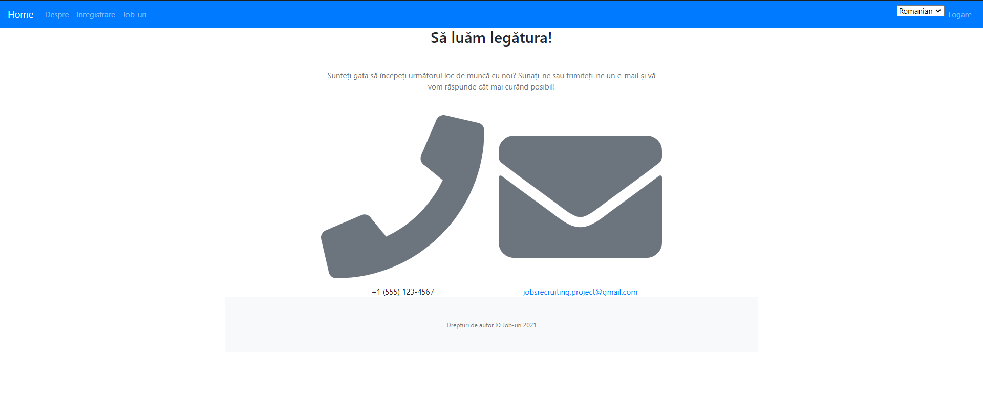

Înregistrare

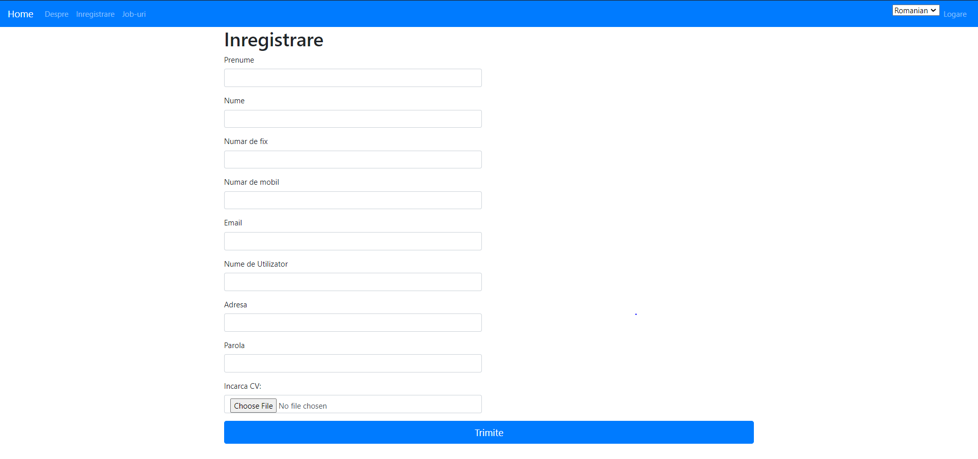

Jobs

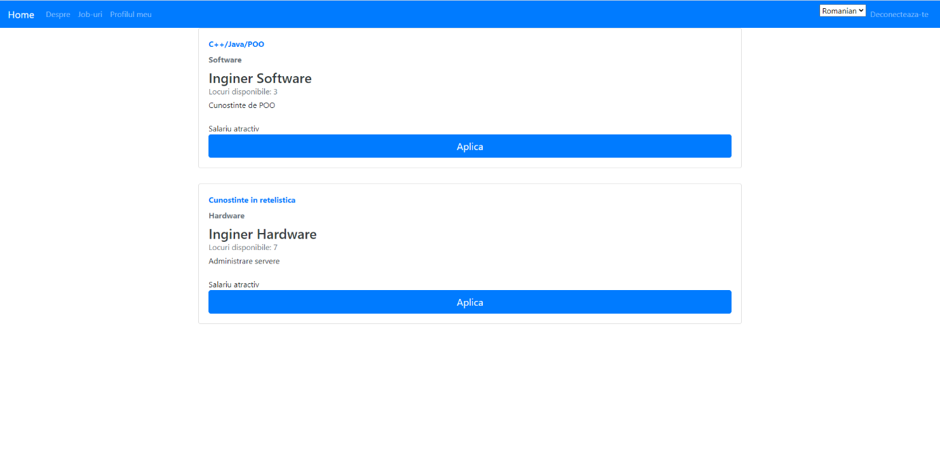

Logare

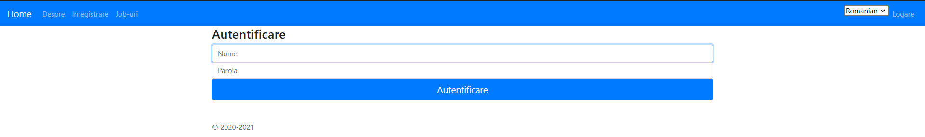

Candidați aleşi



Utilizatori

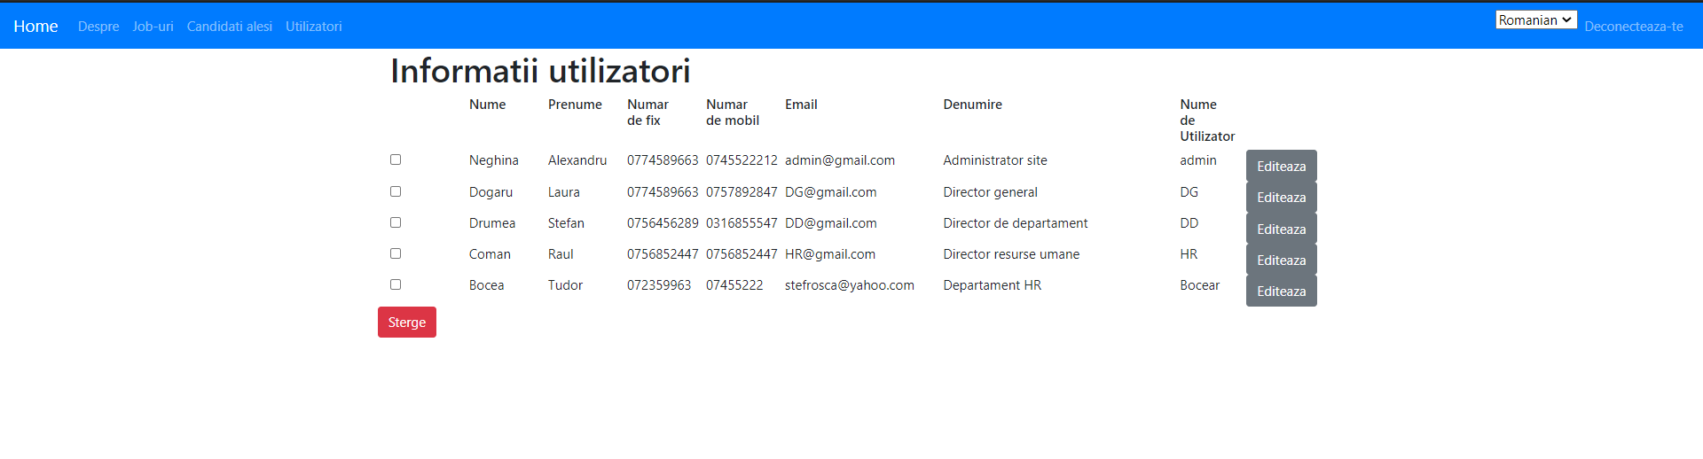

Poziții

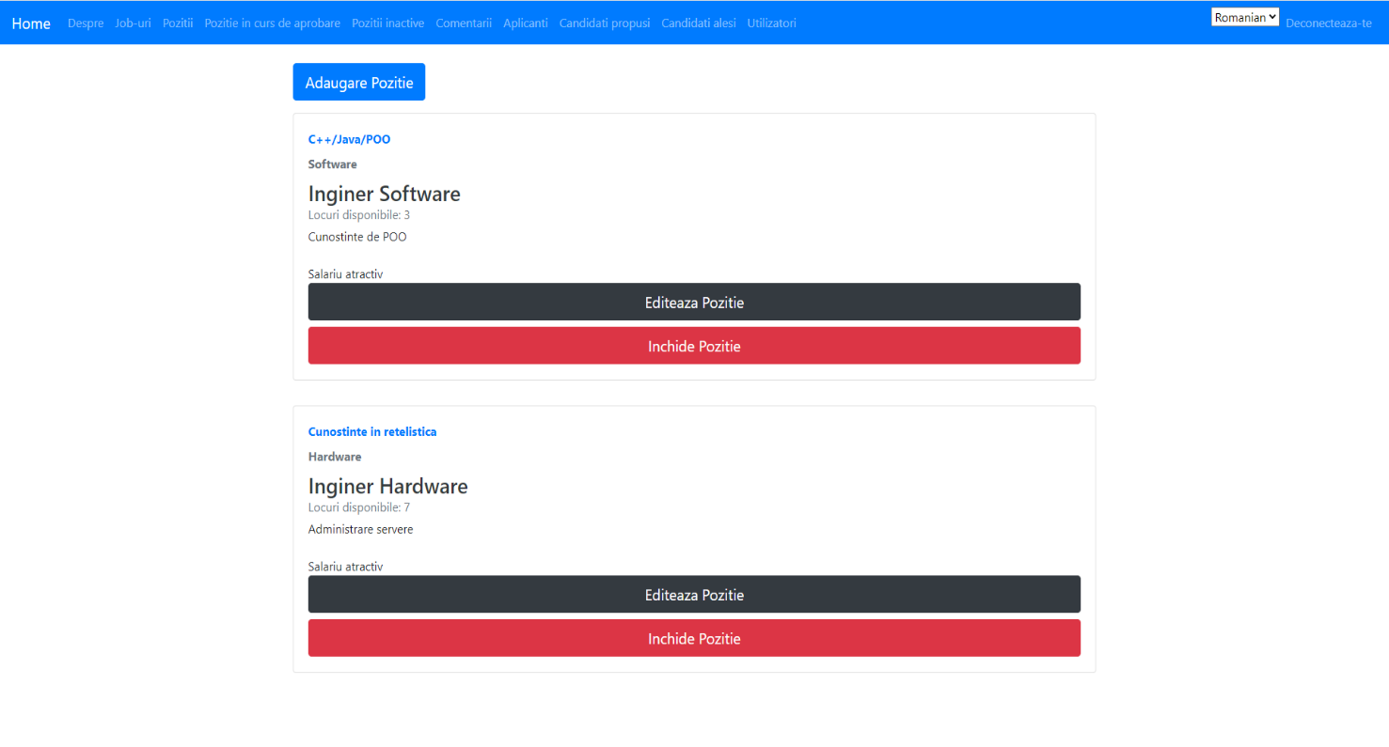

Poziție in curs de aprobare

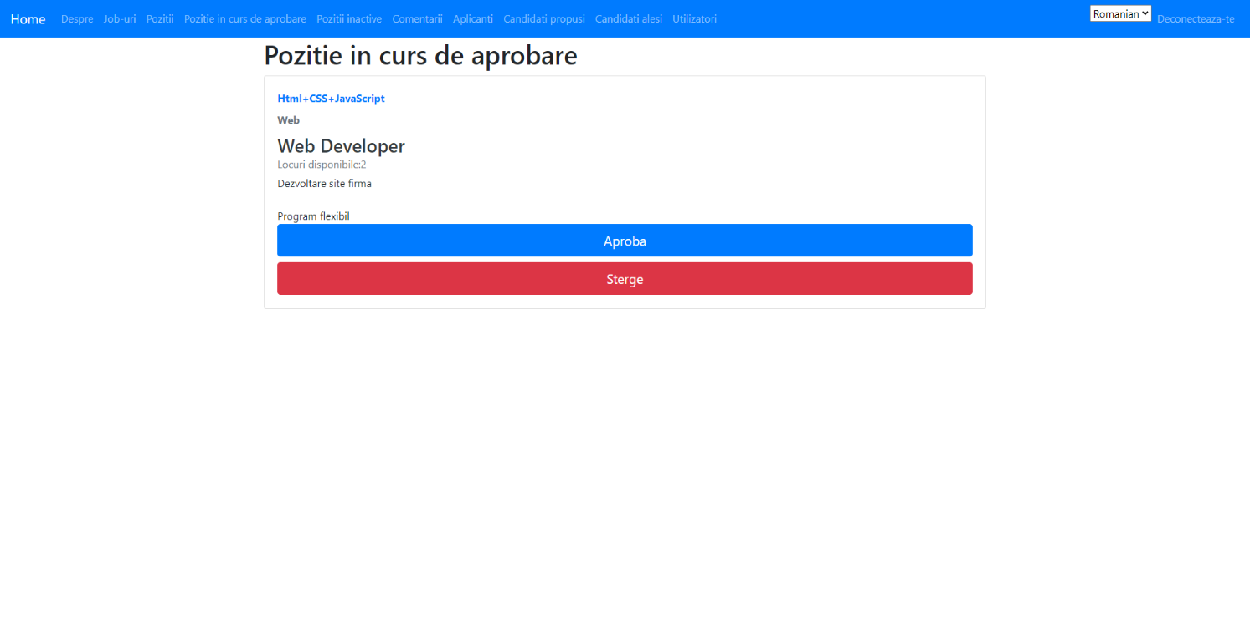

Poziții inactive

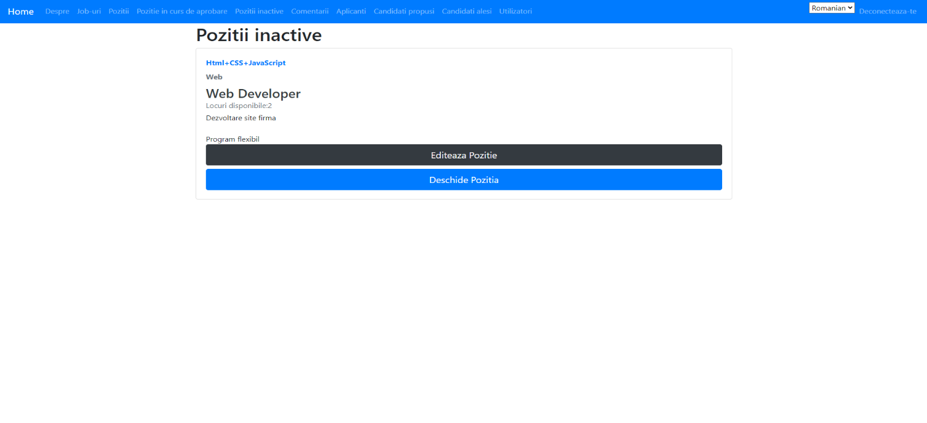

Comentarii



Adaugă comentarii la Poziții

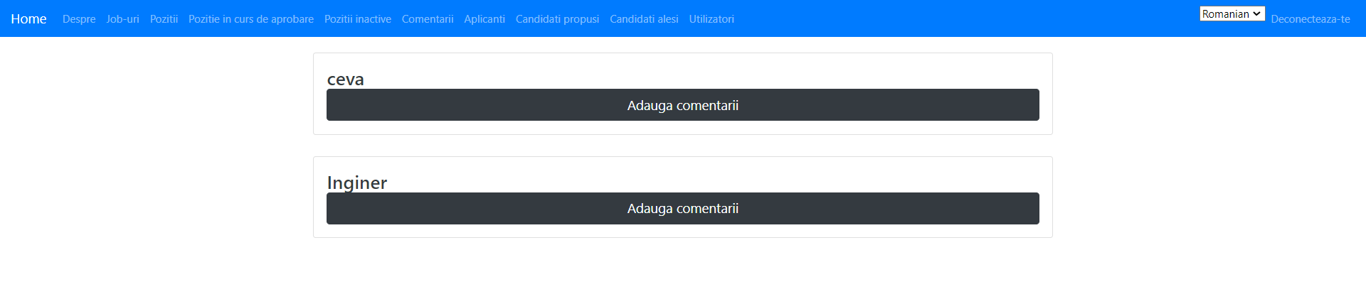

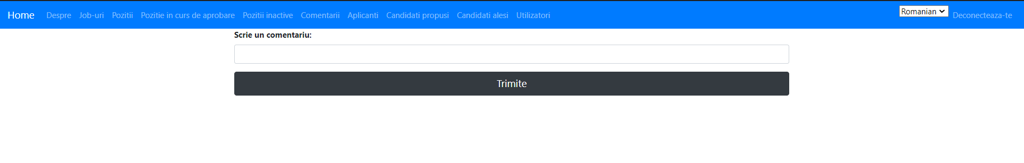

Adaugă comentarii la Candidat

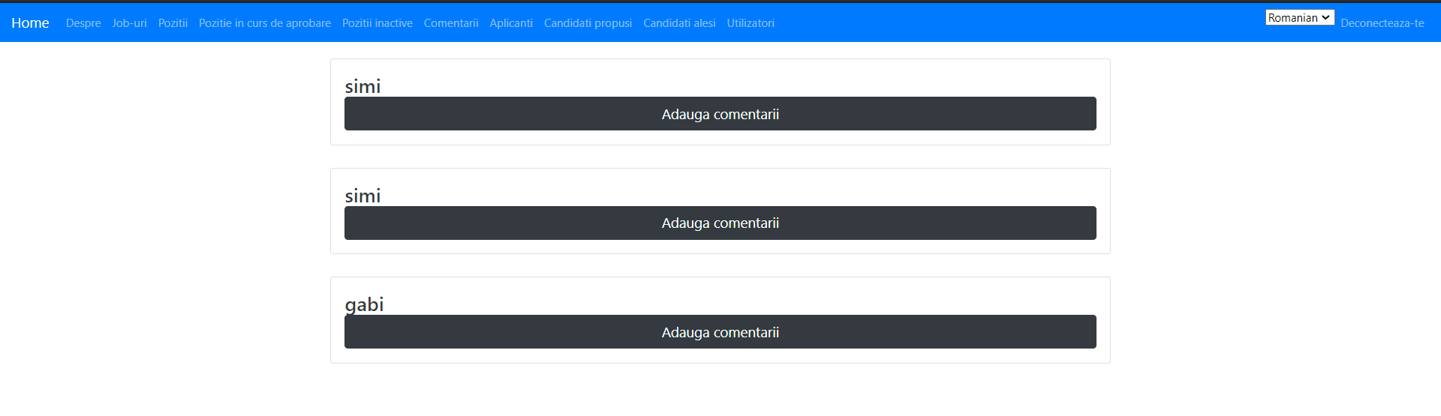



Aplicanți

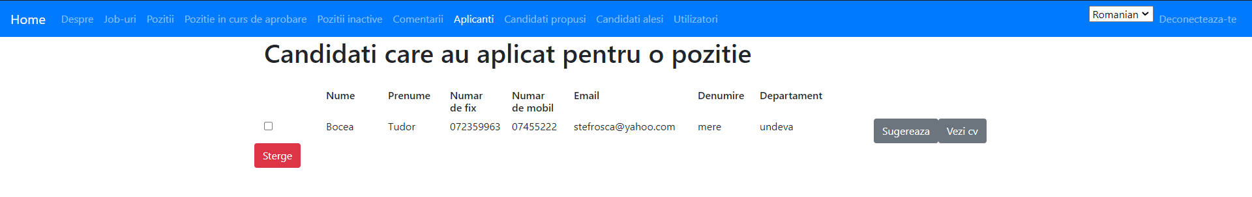

Candidați propuşi



Candidați aleşi



Internaționalizare

Română

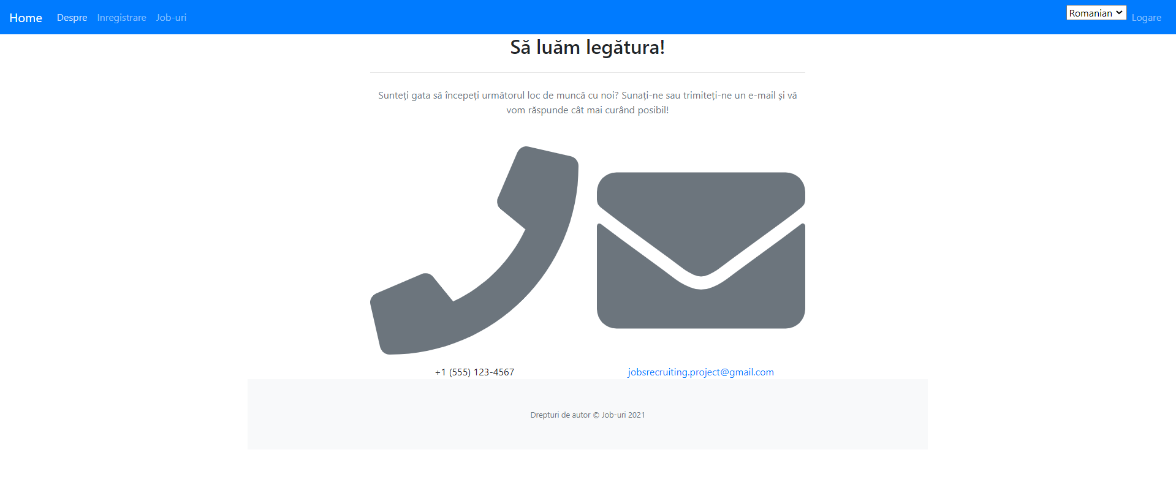

Engleză

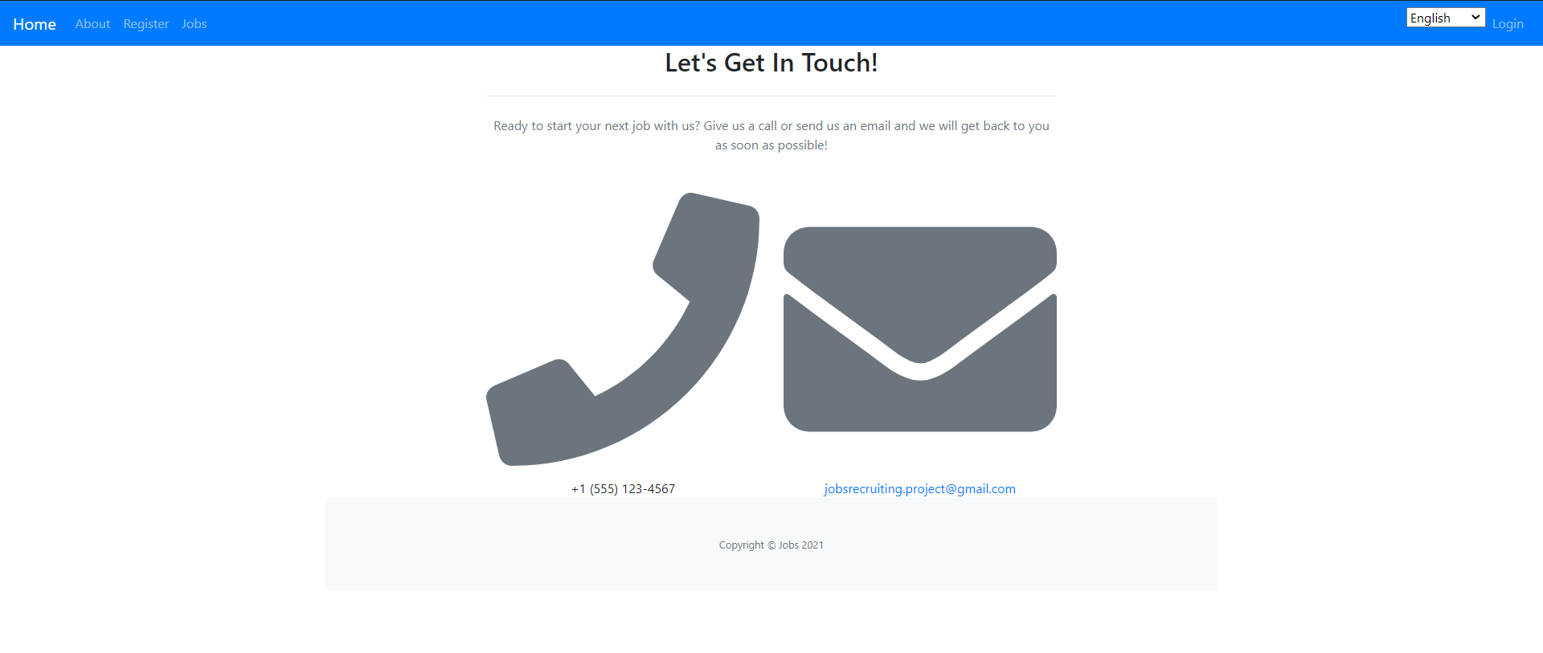

Germană

