Everyday Influencers:
Uncovering What Makes Amazon Reviews Helpful
Team DataCart
Background and Motivation
In today’s digital marketplace, customer reviews are among the most powerful forms of social proof. Amazon, the world’s largest online retailer, has recognized this influence so deeply that it built an entire influencer program around it. Customers trust other customers more than advertisements, sometimes resulting in a single well‑written review shaping perceptions, affecting sales, and even influencing brand reputation across thousands of potential buyers. Within this system, helpful reviews stand out as particularly impactful.
Despite its important role, the mechanisms behind helpfulness remain poorly understood. Prior academic and industry studies have suggested that factors such as review length, star rating, writing style, and product category may all influence perceived usefulness, but their relative weight and interactions are less clear.
Ultimately, the goal is not only predictive accuracy but interpretive insight and business value. By combining transparent statistical models with more flexible machine‑learning methods, this project aims to identify clear, actionable drivers of review helpfulness. The findings can help brands encourage review behaviors that build credibility and assist Amazon in highlighting the content that provides the most value to shoppers. In the era where online opinions can make or break a product, understanding what makes a review truly helpful is a deep, data-informed question.
Dataset and Pre-processing
Our project utilizes a sample of 20,000 Amazon Electronics reviews from 2023, which was created by extracting both the review data and product metadata from the Amazon Reviews 2023 repository. The original dataset contains ~500 million observations, which exceeded the memory and processing limits of our local machines. To work around this, we used a cloud‑based notebook environment to load the full dataset once, perform basic checks, and then draw a stratified random sample of approximately 20,000 reviews out of 22 million observations related to Electronics. This approach, stratified by helpfulness and rating, preserved the overall structure and variability of the original data while producing a smaller, more manageable working dataset. After sampling, we merged the review dataset with the corresponding product metadata using the product ASIN, producing a combined dataset with review text, ratings, helpful votes, timestamps, price, store, features, categories, and more.
After merging the review and metadata files in R, we ran basic validation checks and found no duplicate rows. However, the price field was the only variable with over 8,000 missing values. We imputed missing values using a Random Forest regression model and then removed extreme price outliers (values below $5 or at the extreme upper tail) identified via summary statistics and boxplots.
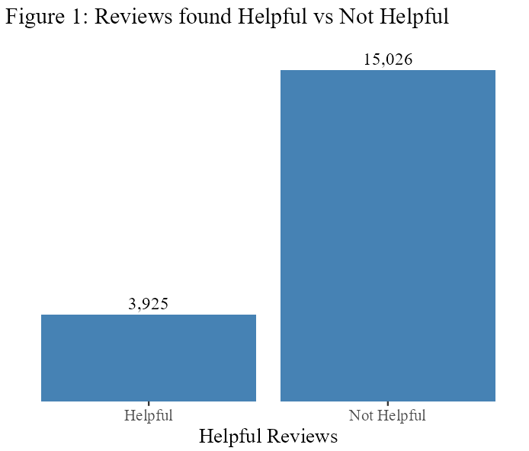
We then engineered several features to match our research questions. Helpfulness was recoded from the original vote count into a binary flag (Helpful vs. Not Helpful), focusing on whether at least one shopper endorsed the review and avoiding instability from a highly zero‑inflated, right‑skewed count distribution. Store names were grouped into large, well‑known brands (e.g., Apple, Microsoft, Samsung) versus all other brands to capture differences in baseline trust. Detailed Amazon categories were collapsed into broader electronics groups (e.g., Computers, Cameras, Audio) to reduce sparsity while preserving meaningful product‑type variation. Variables like word count of the review and price were log-transformed to reduce skewness. Finally, we derived a binary indicator capturing whether the review included at least one user‑uploaded image, treating visual evidence as a potential credibility signal. Together, these preprocessing steps produced a clean, feature‑rich dataset ready for classification models.
Exploratory Data Analysis (EDA)
Our exploratory data analysis provided the foundation for framing our modeling strategy and prioritizing the predictors. The starting point was the distribution of helpfulness itself. A histogram of helpful votes showed that most reviews receive zero or very few votes, confirming that “helpful” reviews are rare events. Collapsing this into a binary outcome indicated a substantial class imbalance, with only 21% of reviews labeled as helpful. This imbalance guided us toward approaches that explicitly handle class imbalance, such as weighted models that penalize misclassifying helpful reviews more heavily than not‑helpful reviews.
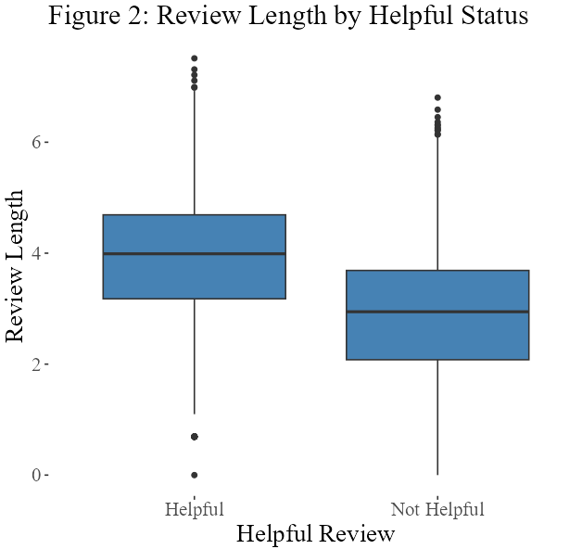
Next, the analysis focused on “effort” signals embedded in the text. The raw distribution of review word counts was extremely right‑skewed: the median review was relatively short, but a small subset of reviews was very long. Applying a log transformation yielded a more symmetric distribution, supporting the use of logged word count as a predictor. Comparing review length by helpful status using boxplots and a Welch two‑sample t‑test showed that reviews marked as helpful are statistically significantly longer than those not marked as helpful. This result strengthened the hypothesis that textual effort and depth are core components of perceived review quality.
EDA showed strong contextual structure in the data: a few electronics categories and many small brands dominate the sample, while large brands such as Apple or Samsung appear much less frequently. This supported adding category and brand indicators to control for differences in baseline helpfulness across product types and brand equity levels. Together, these exploratory results led directly to the structure of our base model.
Modeling Methodology
We selected two main approaches: a simple statistical model and a more flexible machine-learning model. The simple model (logistic regression) was chosen because it is easy to interpret and clearly shows how each review characteristic relates to helpfulness. The flexible model (random forest) was chosen because it can capture patterns and interactions that are not obvious, allowing it to better recognize what makes a review stand out as helpful. We also tested weighted versions of these models to address the fact that helpful reviews make up only a small portion of all reviews.
These methods provide limited transparency, require extensive tuning, and offer little additional value for this type of structured data. Because the goal of the project is to provide clear guidance to the client, we prioritized models that balance performance with interpretability.
Modeling Outcomes
Across all models, the same conclusions emerged: longer and more detailed reviews are far more likely to be rated helpful. Reviews for higher-priced products and certain product categories also tend to receive more helpful votes. Among the models tested, the random forest consistently delivered the strongest predictive results. However, a simplified version that used only three predictors: review length, price, and product category performed almost as well, showing that the main drivers of helpfulness are straightforward and actionable.
Evaluation Metrics and Why We Used Them
To judge how well the models performed, we relied on evaluation measures that remain reliable even when one group (“Helpful”) is much smaller than the other. The most important measure was the ROC curve and its summary score (AUC), which tells us how well a model can distinguish helpful from not-helpful reviews across many possible thresholds. This avoids misleading conclusions that can come from accuracy alone, which tends to favor the larger group. We also looked at precision, recall, and related statistics to understand the tradeoff between catching more helpful reviews and avoiding incorrect classifications. These measures helped identify which models were most dependable and how they might behave in real-world use.
Overall, the modeling suggests that improving review helpfulness does not require complex signals: length, price, and product type explain most of the variation. These insights can guide how reviews are displayed, how customers are encouraged to write them, and how businesses can better highlight the content customers find most valuable.
Key Takeaways
The analysis shows that the most powerful driver of review helpfulness is the depth and detail of the written content. Longer, more descriptive reviews consistently show a substantially higher likelihood of being marked helpful, regardless of product type or rating. This finding underscores the importance of encouraging reviewers to provide richer narratives, clearer explanations, and more contextual information about their experience. The model also demonstrates that images play a crucial role in shaping perceived helpfulness. Reviews that include even a single image are significantly more likely to be voted helpful, likely because images provide verification, clarity, and a more concrete understanding of product performance. Product category further contributes to these differences; certain categories, particularly those that are more technical or complex, naturally produce more informative and helpful reviews. These include categories such as Auto & GPS, Video, and Camera, where shoppers often seek detailed guidance and comparative insights.
Recommendations
These findings translate into clear opportunities for the client’s business. Longer reviews and photo‑rich content are not just statistically associated with the “helpful” label; they are key ingredients in the type of social proof that pushes shoppers from consideration to purchase. To generate more of this content, the company can redesign its post‑purchase communication to guide, rather than script, what customers write. For example, follow‑up emails sent after delivery can include a direct link to the Amazon review form and two or three specific prompts such as “What were you using this product for?”, “What worked well and what didn’t?”, and “What would you tell a friend who is considering this item?”. These targeted questions make it easier for customers to provide detailed, experience‑based feedback, which the analysis shows is strongly associated with review helpfulness. At the same time, encouraging customers to upload images of the product in real use reinforces credibility, giving potential buyers visual confirmation that reduces uncertainty and perceived risk.
In parallel, the client can launch incentive campaigns that reward richer contributions, especially photo reviews. Within Amazon’s policy constraints, this can include offering modest discounts, loyalty points, or early access to new products to customers who leave a review that includes at least one product image and a minimum level of detail, without specifying the rating or sentiment. Positioning these incentives encourages authenticity while shifting more reviews into the high‑effort, high‑credibility category highlighted by the model. Together, structured follow‑up emails and targeted incentives turn review collection into an intentional growth lever: they increase the volume of helpful reviews, reduce buyer hesitation on product pages, and ultimately support higher conversion rates.

Limitations and Future Opportunities
This study has several limitations that should be considered when interpreting the results. First, the analysis is restricted to the Electronics category on Amazon. While electronics products generate a large volume of reviews and represent a meaningful segment of the marketplace, consumer behavior and review dynamics may differ across different categories. Factors influencing review helpfulness may vary substantially by category, limiting the generalizability of the findings. Second, the dataset is highly unbalanced, as the majority of reviews receive few or no helpful votes, while a small fraction accumulates a disproportionate share of helpfulness signals. Models may be biased toward dominant patterns in non-helpful reviews, potentially underrepresenting rare but influential cases. Finally, the scale of the original Amazon Reviews 2023 dataset imposed computational constraints that influenced the scope of analysis. Although a stratified sample enabled efficient preprocessing and modeling, limited memory and processing capacity restricted the exploration of more computationally intensive methods and large-scale hyperparameter tuning.
Future research can build on this work in several important directions. A natural extension would be to expand the analysis to additional product categories. Such analysis could reveal whether factors operate differently in experiential versus utilitarian product domains. Secondly, future studies could explore unorthodox approaches, including both richer textual signals NLP and more complex modeling techniques such as neural networks or deep learning. Combining these approaches may reveal additional patterns in how reviewers convey trust and expertise. Another promising avenue is the detection of potentially fake or manipulative reviews. By accessing user profile and activity, understanding how artificial reviews differ from authentic ones could improve both model robustness and platform integrity. Integrating anomaly detection or reviewer behavior patterns through
Finally, incorporating user-level information, such as reviewer history, activity patterns, or inferred demographics, could enhance understanding of how reviewer identity influences perceived helpfulness.

References

Hou, Y., Li, J., He, Z., Yan, A., Chen, X., & McAuley, J. (2024). Amazon Reviews’23 dataset [Data set]. UC San Diego; Amazon Reviews 2023. https://amazon-reviews-2023.github.io/

Hudgins, T., Joseph, S., Yip, D., & Besanson, G. (2024). Identifying features and predicting consumer helpfulness of product reviews. SMU Data Science Review, 7(1), Article 11. https://scholar.smu.edu/datasciencereview/vol7/iss1/11

Yin, D., Bond, S. D., & Zhang, H. (2022). The impact of online reviews on consumers' purchasing decisions: Evidence from a meta‑analysis. Frontiers in Psychology, 13. https://doi.org/10.3389/fpsyg.2022.865702

Appendices
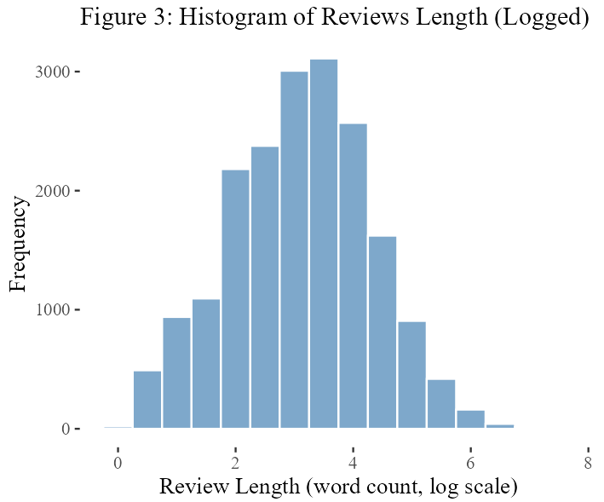
- Exploratory Data Analysis:
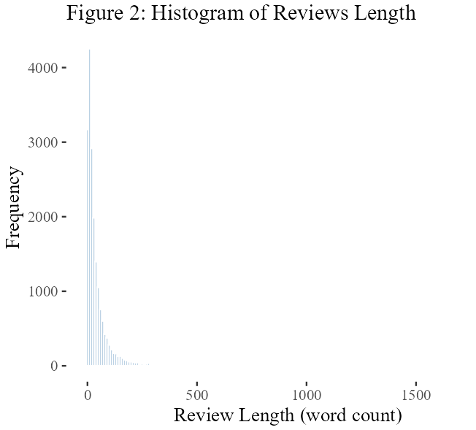
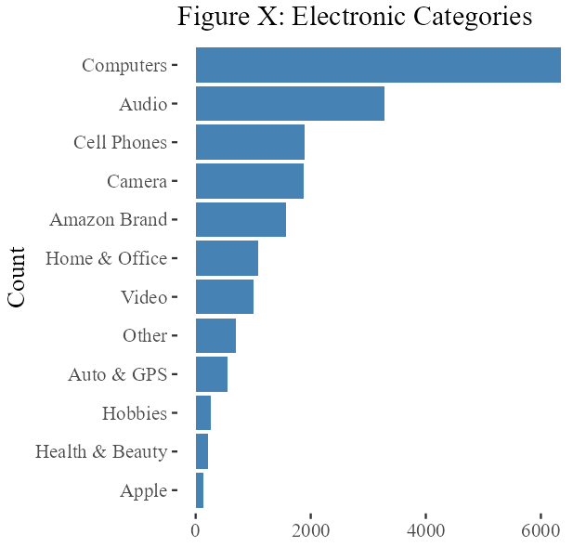

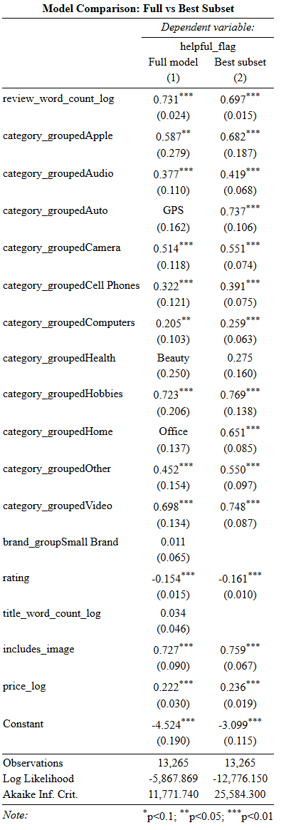
- Model Outputs:

