Program version control on local computer 🡪 creates repository with all files

Internet hosting service for git repositories, work on multiple computers, working from any computer connecting to the internet

GitHub

1. Create github project
2. The first time clone the repository into the computer, all the other times “git pull” is used to copy files into computer
3. Once you have edited your file in the local computer then it is committed into github again
4. Forking: make a copy of a repository, the pull request can be rejected by the creator of the file
5. Branching:
6. Github

Ask to be a collaborator

1. Go to the page of the project
2. Go to issues tab
3. New issue: can I be a collaborator?

Be a friend

1. Go to github principal page
2. Search the username
3. follow

Creat a to-do list

1. Go to gist.github.com
2. Create new list
3. Use code

#To Do

- [ ] project

- [x] groceries

- [ ] hw

- [x] clean

Fork a repository

1. Go to the person’s account
2. Top right 🡪 fork
3. Takes a couple of seconds
4. Go to the fork
5. Copy url
6. Git clone the url in your terminal

Create a license

1. Go to the repository
2. Create a new file
3. Name it license.txt
4. Choose a license: GNU GENERAL PUBLIC LICENSE
5. Commit file into the master branch

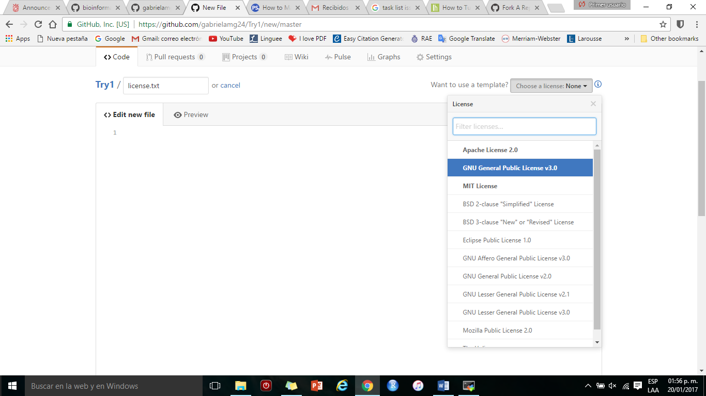

Create a Gitignore

1. Go to the repository
2. Create a new file
3. Name it touch.gitignore
4. Copy code from <https://gist.github.com/octocat/9257657>
5. Commit file into the master branch

Starring projects

1. Go to an account or find a project
2. Click the little star

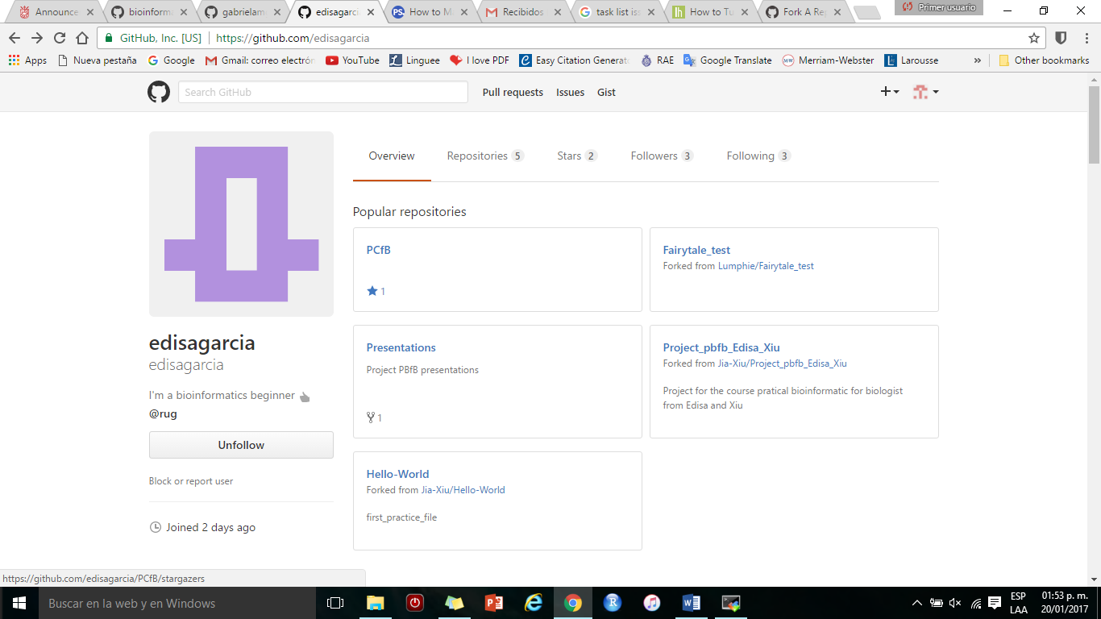

How to use

🡪Create account on github

🡪create repository

🡪go onto terminal and onto **peregrine**

>ssh [**f111552@peregrine.hpc.rug.nl**](mailto:f111552@peregrine.hpc.rug.nl)

>module load git

>git clone <https://github.com/gabrielamg24/SST.git>

>cd SST

> git add --all :/

>git config --global user.mail "gabrielamg24@gmail.com"

>git config --global user.name "gabrielamg24"

>git commit -m "MESSAGE"

>git push

>git pull

>SST git status

#When you go to github and create a new file then you go back to your terminal and

>git commit -m "MESSAGE"

>git pull

#On the github webpage you request to be a collaborator, once you have received the mail and accepted the invitation then you can go to your terminal and clone it, then pull it, then edit, then push it.

>git clone <https://github.com/Lumphie/Fairytale_test.git>

>cd Fairytale_test

>git pull

#Edit the files from your computer

>git push

#On github create a license <https://help.github.com/articles/adding-a-license-to-a-repository/> and a gitignore <https://help.github.com/articles/ignoring-files/> , these were created in a branch and not in the master branch, soooo go to terminal

>git pull

>git checkout gabrielamg24-patch-1

>ll (to check files are there)

>git checkout master

>ll

>git merge gabrielamg24-patch-1 (from the master branch you ask to merge with the branch with the files so they’re copied into master)

>ll