The title

Gabriela Elena Nicuță1 & Cristian Opariuc-Dan2,3

1 Al. I. Cuza University, Iasi, Romania

2 Bucharest University, Bucharest, Romania

3 Ovidius University, Constanta, Romania

Author note

Add complete departmental affiliations for each author here. Each new line herein must be indented, like this line. Enter author note here.

The authors made the following contributions. Gabriela Elena Nicuță: Equal contribution, Conceptualization, Writing - Original Draft Preparation, Writing - Review & Editing, Investigation, Methodology, Project administration, Resources, Supervision, Validation, Visualization; Cristian Opariuc-Dan: Equal contribution, Writing - Original Draft Preparation, Writing - Review & Editing, Methodology, Data curation, Formal analysis.

Correspondence concerning this article should be addressed to Gabriela Elena Nicuță, Toma Cosma Street, Nr.2, Iasi, Romania. E-mail: [gabriela.nicuta@uaic.ro](mailto:gabriela.nicuta@uaic.ro)

Abstract

One or two sentences providing a **basic introduction** to the field, comprehensible to a scientist in any discipline. Two to three sentences of **more detailed background**, comprehensible to scientists in related disciplines. One sentence clearly stating the **general problem** being addressed by this particular study. One sentence summarizing the main result (with the words “**here we show**” or their equivalent). Two or three sentences explaining what the **main result** reveals in direct comparison to what was thought to be the case previously, or how the main result adds to previous knowledge. One or two sentences to put the results into a more **general context**. Two or three sentences to provide a **broader perspective**, readily comprehensible to a scientist in any discipline.

*Keywords:* keywords

*Word count:* X

The title

# Introduction

## The present study

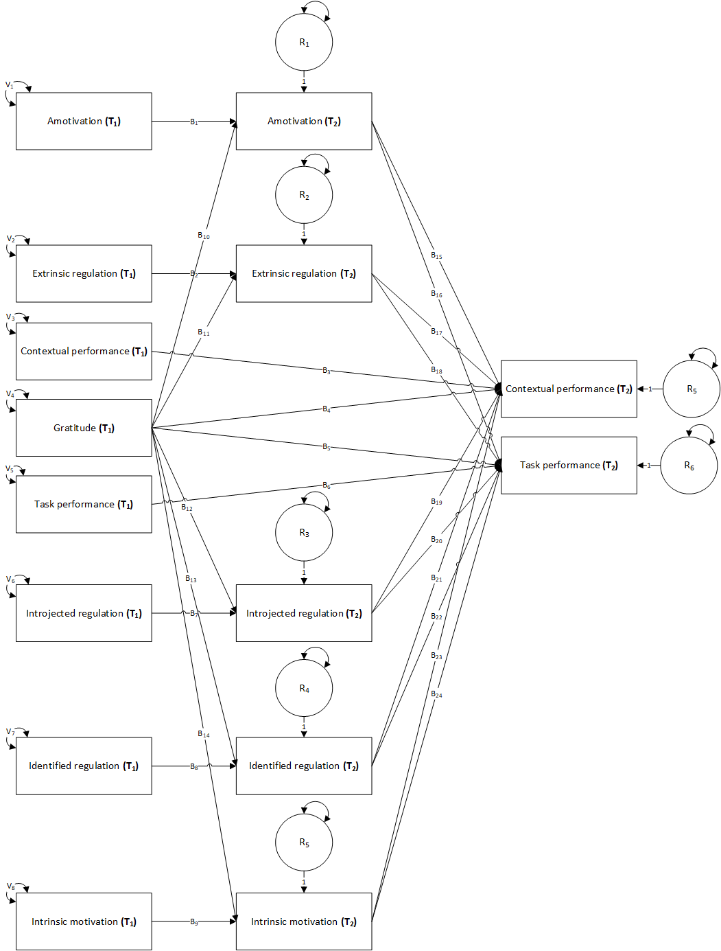 *Please Insert Fig. 1 around here*

# Methods

A path mediation model was used and the parameters were estimated using MLM (Mean adjusted Maximum Likelihood) robust method. Satorra-Bentler correction, was used for global fit testing because the assumption of multivariate normality was not fulfilled.

We used R (Version 4.4.0; R Core Team, 2024) and the R-packages *foreign* (Version 0.8.86; R Core Team, 2023), *kableExtra* (Version 1.4.0; Zhu, 2024), *papaja* (Version 0.1.2; Aust & Barth, 2023), and *tinylabels* (Version 0.2.4; Barth, 2023) for all our analyses. ## Participants and Procedure

## Measurements

# Results

## Overview of data analysis

## Preliminary analysis

## Corelation analysis

## Model analysis

The convergence was acquired after 150 iterations, estimating 78 parameters, based on 246 cases, resulting an over identified model with marginal fit indices (2=120.149, df=42, p < 0.001, CFI=0.941, SRMR=0.084, RMSEA= 0.087, p < 0.001, 90% CI [0.07, 0.104]).

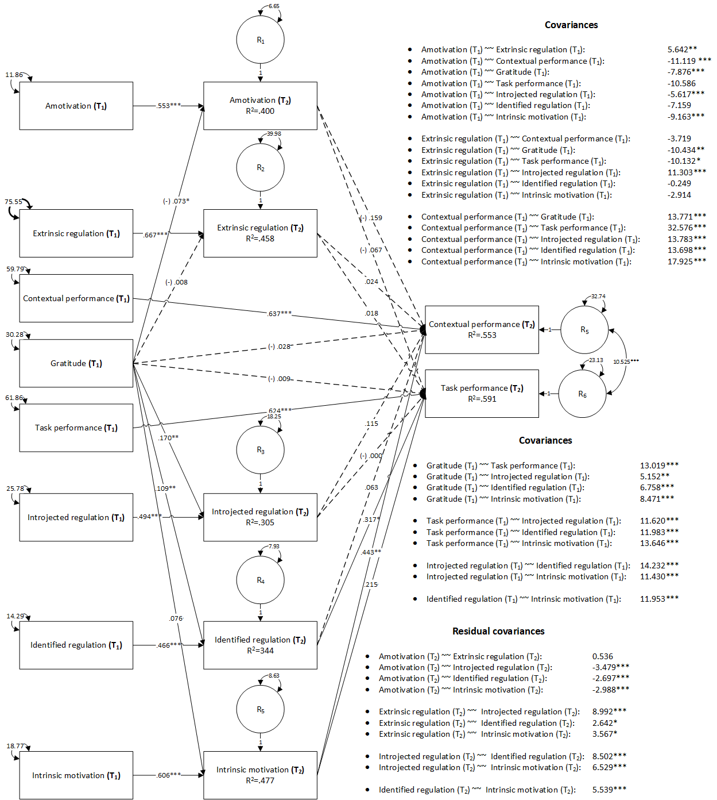

Figure 2: Mediation model. Unstandardized coefficients

*Please Insert Figures 2 and ?? around here*

Two positive and marginally significant indirect effects were identified, from the initial measurement of *gratitude* to the final measurement of *contextual performance*, mediated by the final measurement of *intrinsic motivation* (B=0.03, z=1.77, p=0.08, =0.02), and from the initial measurement of *gratitude* to the final measurement of *task performance*, mediated by the final measurement of *identified regulation* (B=0.03, z=1.83, p=0.07, =0.03). The initial measurements for *gratitude* were positively and marginally significantly associated with the final measurements for *intrinsic motivation* (B=0.08, z=1.95, p=0.05, =0.10), and the final measurements of *intrinsic motivation* were positively and statistically significantly associated with the final measurements of *contextual performance* (B=0.44, z=3.21, p=0.00, =0.21). The initial measurements for *gratitude* were also positively and statistically significantly associated with *identified regulation*, and the final measurements for *identified regulation* were positively and statistically significantly associated with *task performance* (B=0.32, z=2.32, p=0.02, =0.15), therefore both mediated effects were marginally significant and positive.

No other indirect association were observer, however our data suggested a positive and statistically significant association between the final measurements for *intrinsic motivation* and the final measurements for *task performance* (B=0.21, z=1.65, p=0.10, =0.12). Statistically significant positive associations were also observed between the initial measurements of *gratitude* and final measurements of *identified regulation* (B=0.47, z=10.81, p=0, =0.51), and *intrinsic motivation* (B=0.08, z=1.95, p=0.05, =0.10), whereas negative associations were observed with the final measurements of *amotivation* (B=-0.07, z=-2.02, p=0.04, =-0.12), and *introjected regulation* (B=0.49, z=10.65, p=0, =0.49). All longitudinal associations between the same variables measured at the initial and final moments were statistically significant and no other associations were observed.

(B=0.49, z=10.65, p=0, =0.49).

# Discussion

# References

Aust, F., & Barth, M. (2023). *papaja: Prepare reproducible APA journal articles with R Markdown*. <https://github.com/crsh/papaja>

Barth, M. (2023). *tinylabels: Lightweight variable labels*. <https://cran.r-project.org/package=tinylabels>

R Core Team. (2023). *Foreign: Read data stored by ’minitab’, ’s’, ’SAS’, ’SPSS’, ’stata’, ’systat’, ’weka’, ’dBase’, ...* <https://CRAN.R-project.org/package=foreign>

R Core Team. (2024). *R: A language and environment for statistical computing*. R Foundation for Statistical Computing. <https://www.R-project.org/>

Zhu, H. (2024). *kableExtra: Construct complex table with ’kable’ and pipe syntax*. <https://CRAN.R-project.org/package=kableExtra>