Gabriela Ramos Mariano Rosa, 2RT – 2023

Entrega final da Sprint 3 - 15/09

Equipamentos

* 6 PCs
* 4 SWTs
* 3 SRVs

IPs/PCs

* PC1 ADM: 192.168.0.10/24 G: 192.168.0.30
* PC2 ADM: 192.168.0.11/24 G: 192.168.0.30
* PC1 FIN: 192.168.1.21/24 G: 192.168.0.30
* PC2 FIN: 192.168.1.22/24 G: 192.168.0.30
* PC1 CPD: 172.17.1.20/24 G: 172.16.0.30
* PC2 CPD: 172.17.1.21/24 G: 172.16.0.30

SRVs/IPs

* Server1: 192.168.0.254/24 G: 192.168.0.30
* Server2: 172.16.0.254/24 G: 172.16.0.30
* Server3: 172.16.0.253/24 G: 172.16.0.30

--DOCUMENTAÇÃO

**DHCP**:

VLAN10

Default Gateway: 192.168.10.1

DNS Server: 172.16.0.253

Start IP Address: 192.168.10.10

Mask: 255.255.255.0

VLAN20

Default Gateway: 192.168.20.1

DNS Server: 172.16.0.253

Start IP Address: 192.168.20.10

Mask: 255.255.255.0

VLAN30

Default Gateway: 172.17.1.1

DNS Server: 172.16.0.253

Start IP Address: 172.17.1.10

Mask: 255.255.255.0

**DNS:**

Número 0:

name: adm.br

type: A Record

Address: 192.168.10.254

Número 1:

name: sistema.br

type: A Record

Address: 172.16.0.254

Número 2:

name: www.adm.br

type: CNAME

Host Name: adm.br

Número 3:

name: www.sistema.br

type: CNAME

Host Name: sistema.br

**Servidor WEB-ADM:**

IP: 192.168.10.254

Subnet Mask: 255.255.255.0

Default Gateway: 192.168.10.1

DNS Server: 172.16.0.253

**Servidor WEB-SIS:**

IP: 172.16.0.254

Subnet Mask: 255.255.0.0

Default Gateway: 172.16.0.1

DNS Server: 172.16.0.253

--SCRIPTS

**SWTCPD:**

en

conf t

hostname SWT-CORE

vlan 10

name ADM

vlan 20

name FIN

vlan 30

name CPD

vlan 300

name SRV-DHCP-DPD

int range f0/1, f0/4

switchport mode access

switchport access vlan 300

int range f0/2-3

switchport mode access

switchport access vlan 30

**SWTADM:**

en

conf t

hostname SWT-AC1

vlan 10

name ADM

vlan 20

name FIN

vlan 30

name CPD

int r f0/1-3

switchport mode access

switchport access vlan 10

int r g0/1-2

switchport mode trunk

switchport trunk all vlan all

ex

spanning-tree vlan 1-100 priority 4096

**SWTFIN:**

en

conf t

hostname SWT-AC2

vlan 10

name ADM

vlan 20

name FIN

vlan 30

name CPD

int r f0/1-4

channel-group 1 mod desirable

int port-channel1

switchport mode trunk

switchport trunk all vlan all

int r f0/1-4

channel-group 1 mode active

int r f0/5-6

switchport mode access

switchport access vlan 20

int g0/1

switchport mode trunk

switchport trunk all vlan all

ex

**SWTSERVER:**

en

conf t

hostname SWT-DISTRI

vlan 10

name ADM

vlan 20

name FIN

vlan 30

name CPD

int r f0/1-4

channel-group 1 mode desirable

int port-channel1

switchport mode trunk

switchport trunk all vlan all

int r f0/1-4

channel-group 1 mode active

interface range g0/1-2

switchport mode trunk

switchport trunk allowed vlan all

ex

**RT1/SP:**

en

conf t

hostname RT1

int g 0/0/0

ip address 10.0.0.1 255.255.255.252

no shutdown

int g 0/0/1

no shutdown

ip route 0.0.0.0 0.0.0.0 10.0.0.2

interface g 0/0/1.10

encapsulation dot1Q 10

ip address 192.168.10.1 255.255.255.0

ip helper-address 172.16.0.253

ip access-group 100 in

ex

interface g 0/0/1.20

encapsulation dot1Q 20

ip address 192.168.20.1 255.255.255.0

ip helper-address 172.16.0.253

ex

ip access-list extended 100

20 deny icmp 192.168.10.0 0.0.0.255 172.16.0.0 0.0.255.255 echo

30 deny ip host 192.168.10.11 host 172.16.0.254

100 pemit ip any any

do wr

**RT2/RJ:**

en

conf t

hostname RT2

int g 0/0/0

no shutdown

int g 0/0/1

ip address 10.0.0.2 255.255.255.252

no shutdown

ip route 0.0.0.0 0.0.0.0 10.0.0.1

int g0/0/0.30

encapsulation dot1Q 30

ip address 172.17.1.1 255.255.255.0

ip helper-address 172.16.0.253

int g0/0/0.300

encapsulation dot1Q 300

ip address 172.16.0.1 255.255.0.0

ip helper-address 172.16.0.253

IMAGENS DA ENTREGA:

1. Bloquear o ping da rede 192.168.10.0/24 para a rede 172.16.0.0/16, porém o acesso ao sistema não pode ser comprometido; verifique se a rede 172.16.0.0/16 consegue pingar também a rede 192.168.10.1/24 e a rede 192.168.20.0/24.

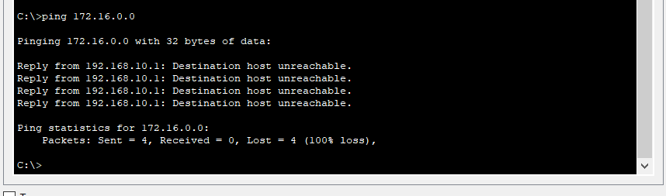

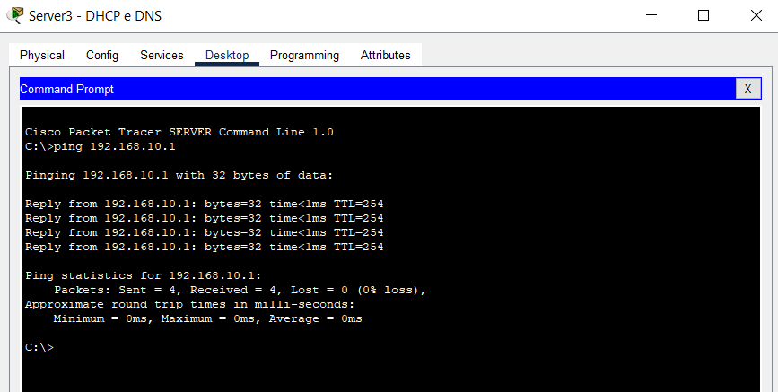

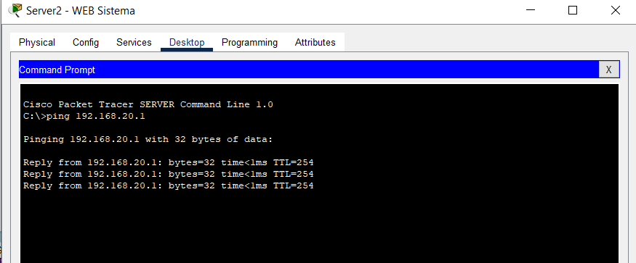

1. A estação 192.168.20.1, não pode acessar o Servidor 172.16.0.254.

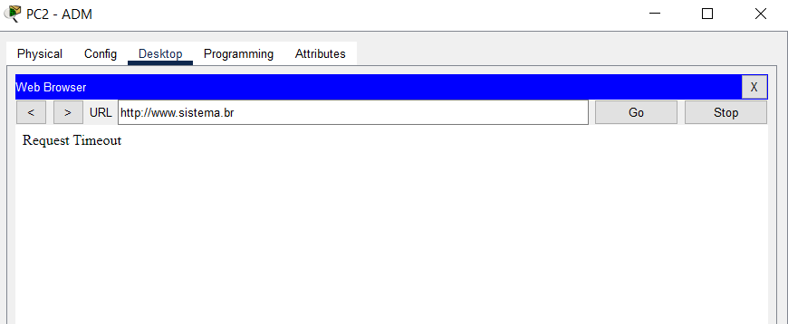

1. As estações da rede 172.16.0.0/16 podem acessar o Server1 192.168.0.254.

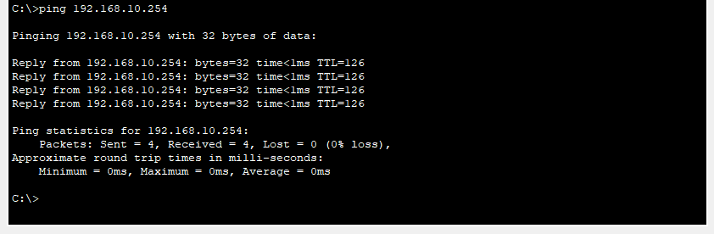

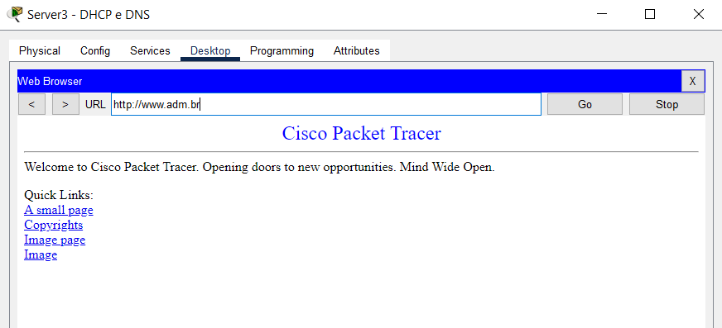

1. Ninguém sabe o porquê o DHCP e DNS não funcionam, antigamente os acessos eram feitos por nome adm.br e sistema.br

